软件开发文档

契约锁校招测试项目

项 目 名 称 ：2020校招测试项目

开 发 人 员 ：陈 旺

公 司 ：上海亘岩网络科技

项 目 日 期 ： 2020-02

**基本设计：**

|  |  |
| --- | --- |
| 开发背景 | 2020校招测试项目 |
| 开发工具 | Jdk1.8+eclipse+jetty+derby |
| 运用技术 | Spring+springMVC+servlet+jdbc+maven |

**项目结构流程图:**

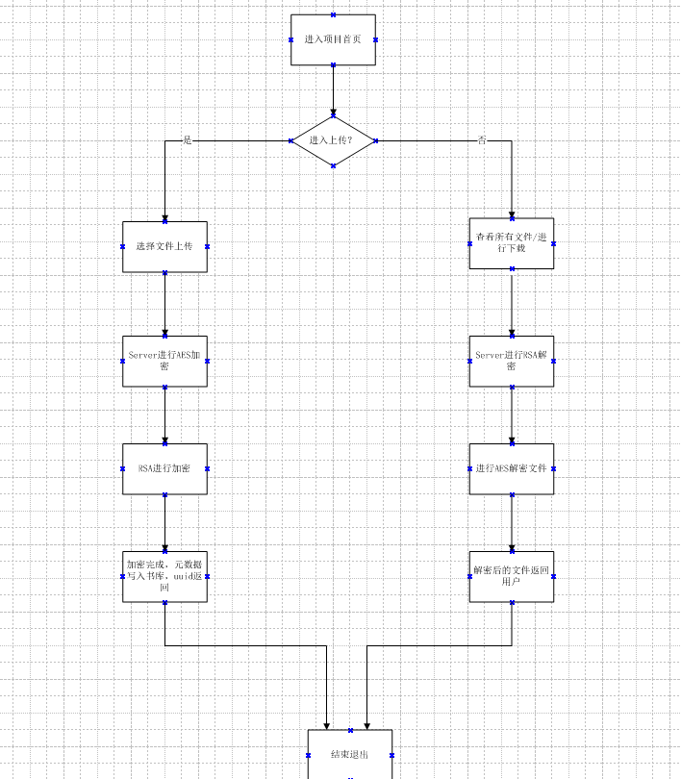

核心配置：

**Web.xml**

<?xml version=*"1.0"* encoding=*"UTF-8"*?>

<web-app xmlns:xsi=*"http://www.w3.org/2001/XMLSchema-instance"*

xmlns=*"http://java.sun.com/xml/ns/javaee"*

xsi:schemaLocation=*"http://java.sun.com/xml/ns/javaee http://java.sun.com/xml/ns/javaee/web-app_2_5.xsd"*

version=*"2.5"*>

<display-name>firstjetty_mvn</display-name>

<welcome-file-list>

<welcome-file>index.html</welcome-file>

<welcome-file>index.htm</welcome-file>

<welcome-file>index.jsp</welcome-file>

<welcome-file>default.html</welcome-file>

<welcome-file>default.htm</welcome-file>

<welcome-file>default.jsp</welcome-file>

</welcome-file-list>

<!-- 加载appliction开头的配置xml -->

<context-param>

<param-name>contextConfigLocation</param-name>

<param-value>classpath:appliction*.xml</param-value>

</context-param>

<!-- 设置监听器 -->

<listener>

<listener-class>org.springframework.web.context.ContextLoaderListener</listener-class>

</listener>

<filter>

<filter-name>encodingFilter</filter-name>

<filter-class>org.springframework.web.filter.CharacterEncodingFilter</filter-class>

<init-param>

<param-name>encoding</param-name>

<param-value>UTF-8</param-value>

</init-param>

<init-param>

<param-name>forceEncoding</param-name>

<param-value>true</param-value>

</init-param>

</filter>

<!-- 过滤器 设置post请求的编码格式 -->

<filter>

<filter-name>characterEncoding</filter-name>

<filter-class>org.springframework.web.filter.CharacterEncodingFilter</filter-class>

<init-param>

<param-name>encoding</param-name>

<param-value>UTF-8</param-value>

</init-param>

</filter>

<filter-mapping>

<filter-name>characterEncoding</filter-name>

<url-pattern>/*</url-pattern>

</filter-mapping>

<!-- 配置springMVC的前端控制器 -->

<servlet>

<servlet-name>dispatcherServlet</servlet-name>

<servlet-class>org.springframework.web.servlet.DispatcherServlet</servlet-class>

<init-param>

<param-name>contextConfigLocation</param-name>

<param-value>classpath:springMVC.xml</param-value>

</init-param>

</servlet>

<servlet-mapping>

<servlet-name>dispatcherServlet</servlet-name>

<url-pattern>/</url-pattern>

</servlet-mapping>

</web-app>

**springMVC.xml**

<?xml version=*"1.0"* encoding=*"UTF-8"*?>

<beans xmlns=*"http://www.springframework.org/schema/beans"*

xmlns:xsi=*"http://www.w3.org/2001/XMLSchema-instance"* xmlns:context=*"http://www.springframework.org/schema/context"*

xmlns:aop=*"http://www.springframework.org/schema/aop"* xmlns:tx=*"http://www.springframework.org/schema/tx"*

xmlns:mvc=*"http://www.springframework.org/schema/mvc"*

xsi:schemaLocation=*"http://www.springframework.org/schema/beans*

*http://www.springframework.org/schema/beans/spring-beans.xsd*

*http://www.springframework.org/schema/context*

*http://www.springframework.org/schema/context/spring-context.xsd*

*http://www.springframework.org/schema/aop*

*http://www.springframework.org/schema/aop/spring-aop.xsd*

*http://www.springframework.org/schema/tx*

*http://www.springframework.org/schema/tx/spring-tx.xsd*

*http://www.springframework.org/schema/mvc*

*http://www.springframework.org/schema/mvc/spring-mvc.xsd"*>

<!-- 开启controller扫描包 -->

<context:component-scan base-package=*"com.qiyuesuo.*"*></context:component-scan>

<!-- 配置HandlerMapping和HandleAdapter -->

<mvc:annotation-driven />

<!-- 配置视图解析器 ViewResolver -->

<bean

class=*"org.springframework.web.servlet.view.InternalResourceViewResolver"*>

<property name=*"prefix"* value=*"/WEB-INF/jsp/"* />

<property name=*"suffix"* value=*".jsp"* />

</bean>

<!--启用默认Servlet springMVC设置不拦截静态资源 -->

<mvc:default-servlet-handler />

</beans>

**运行截图：**

**启动**

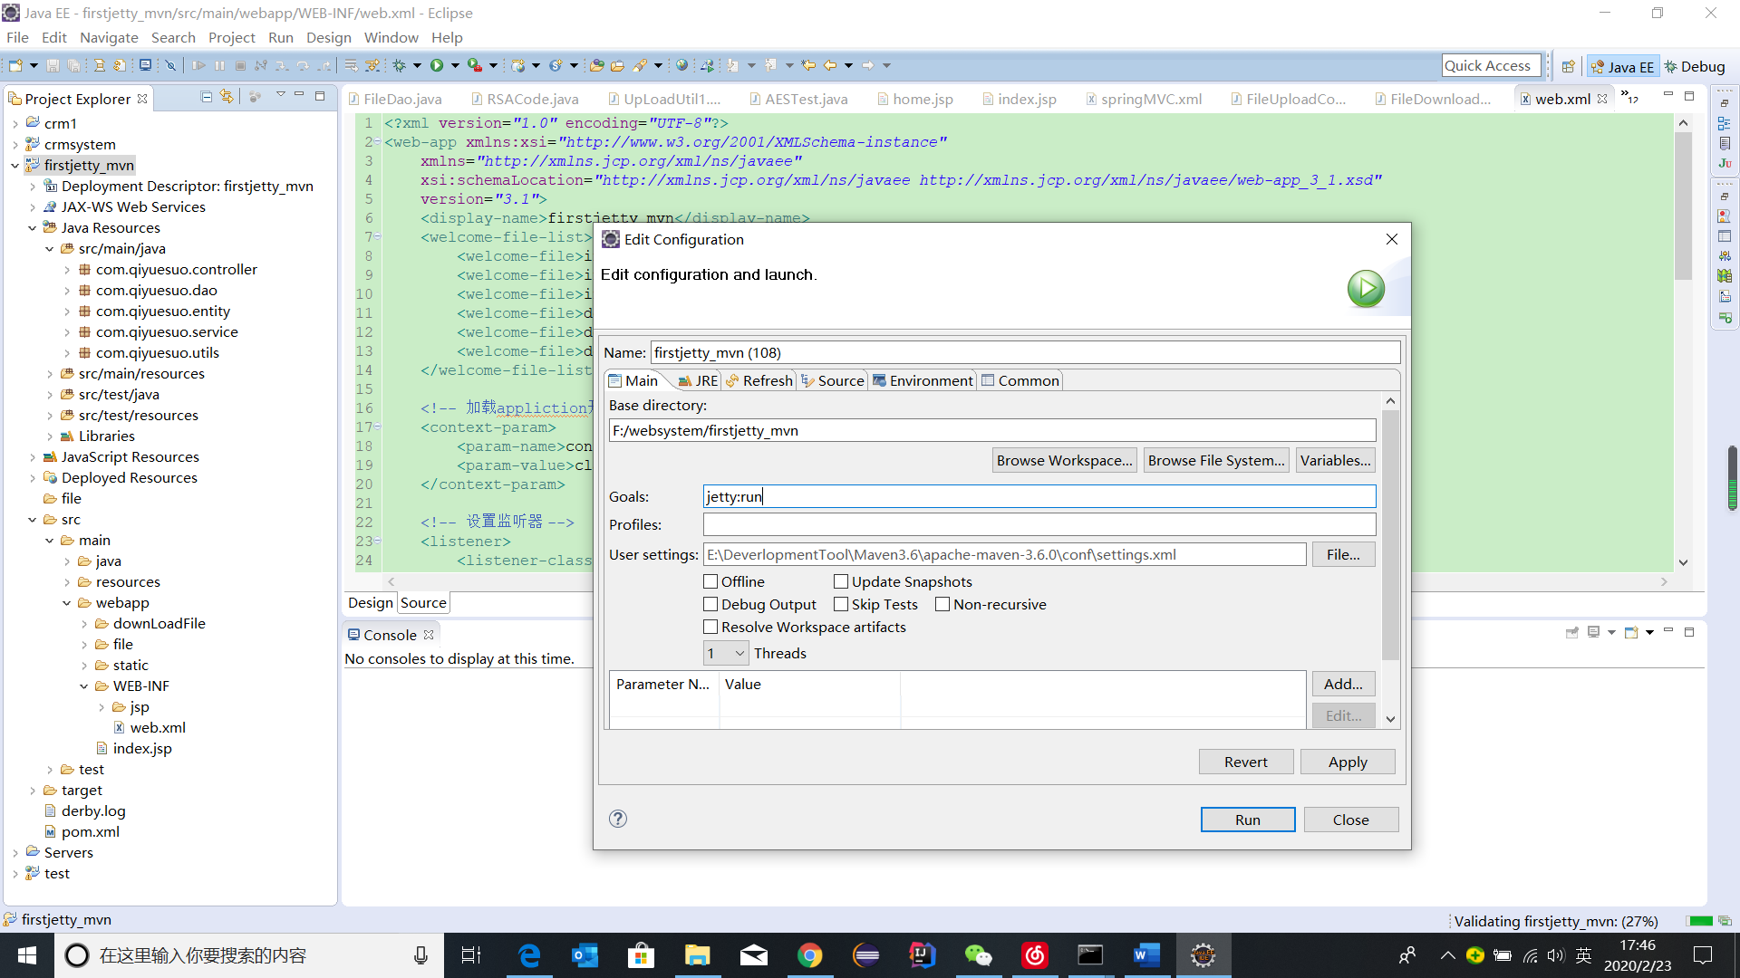

**首页**

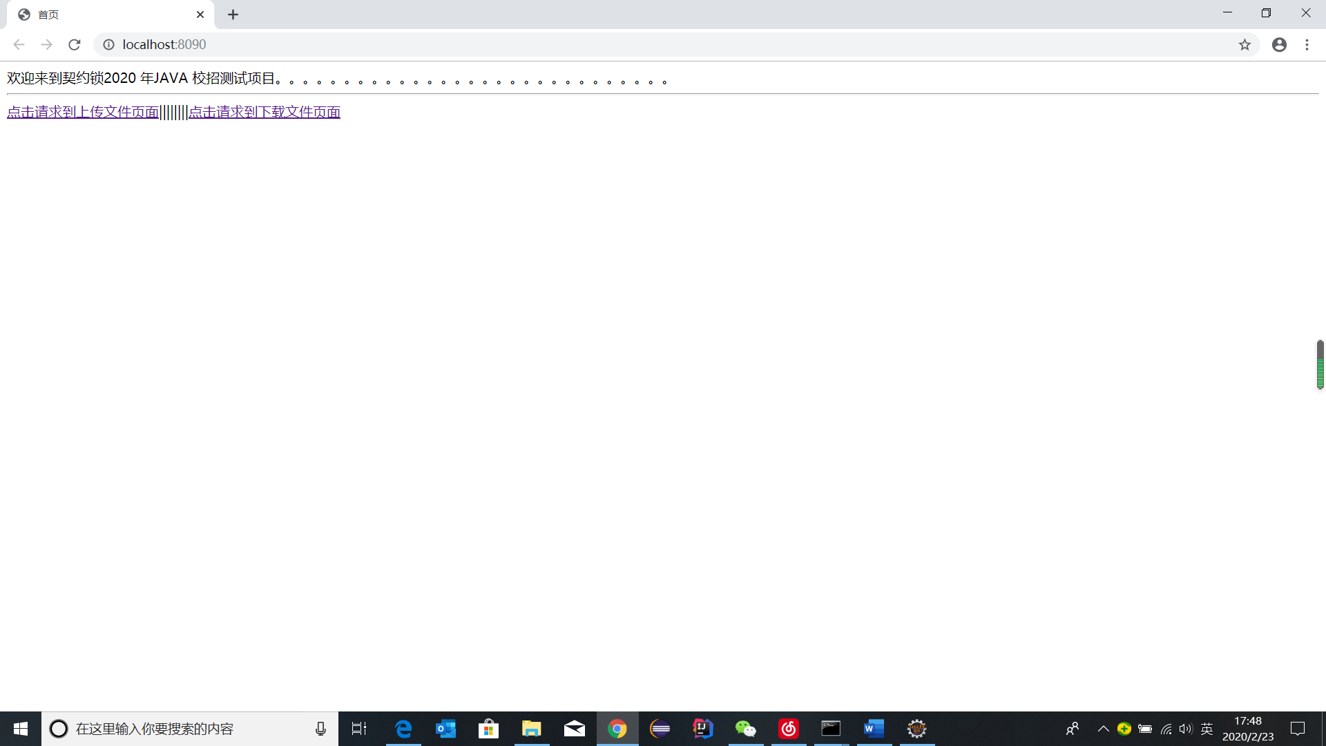

**上传：**

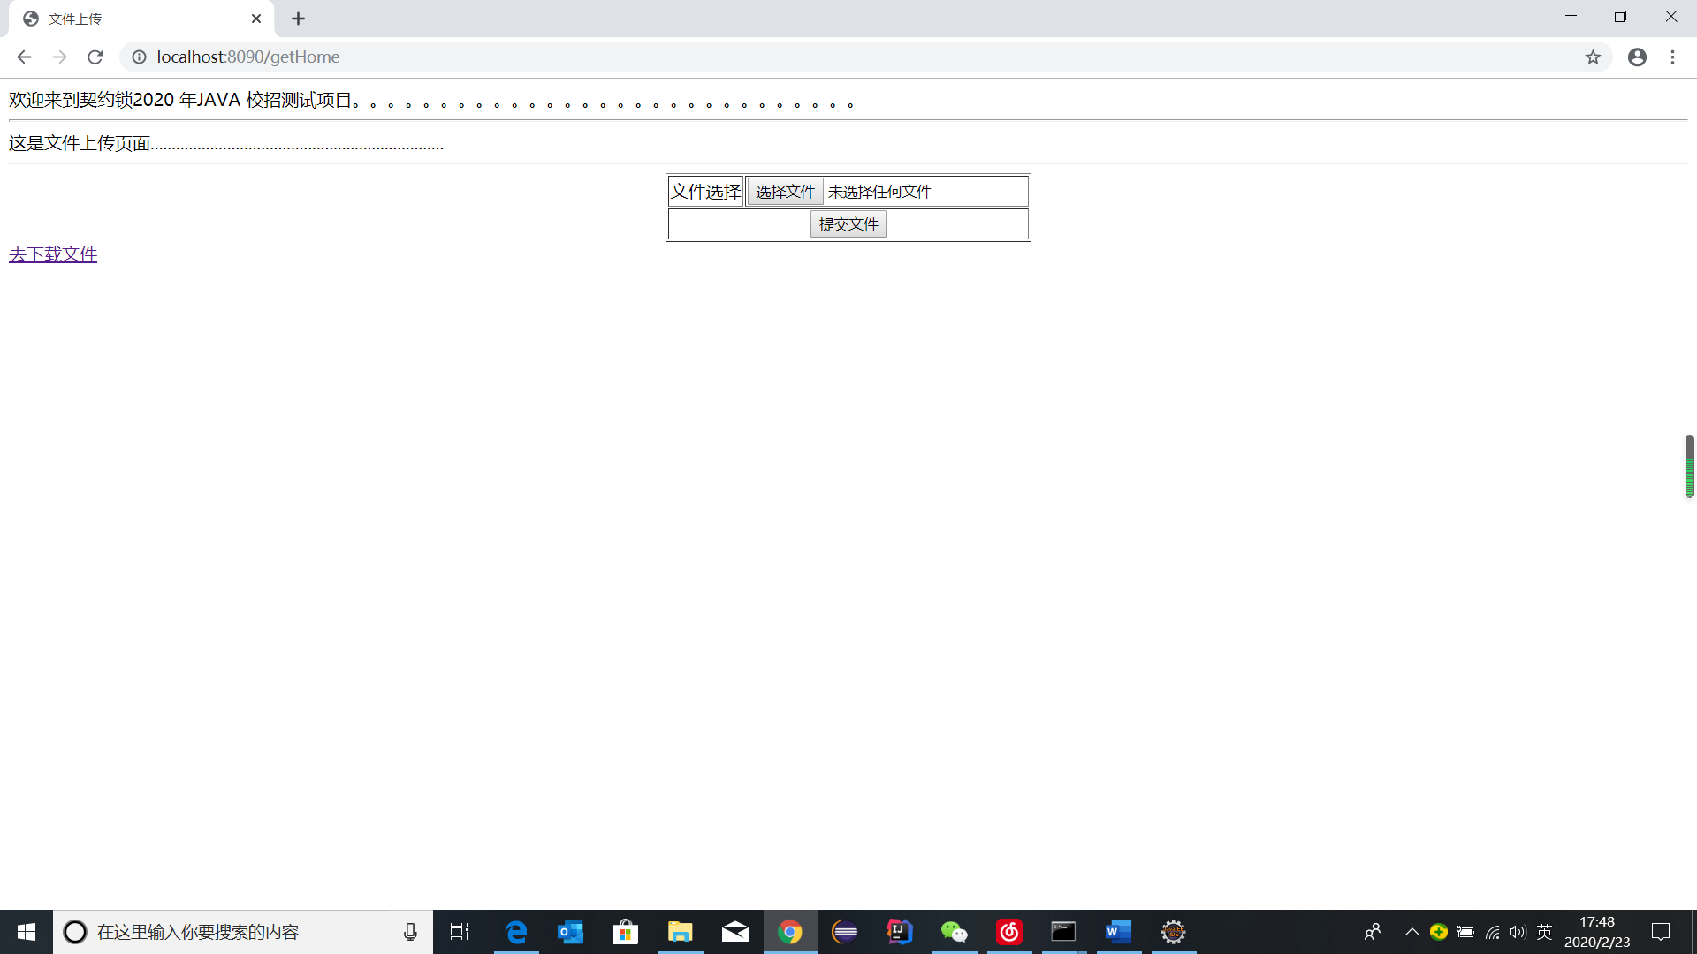

**原文件：**

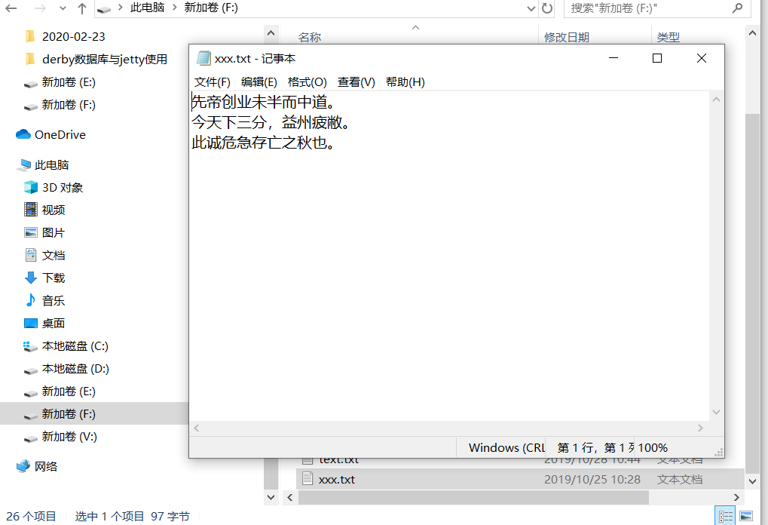

**上传成功：**

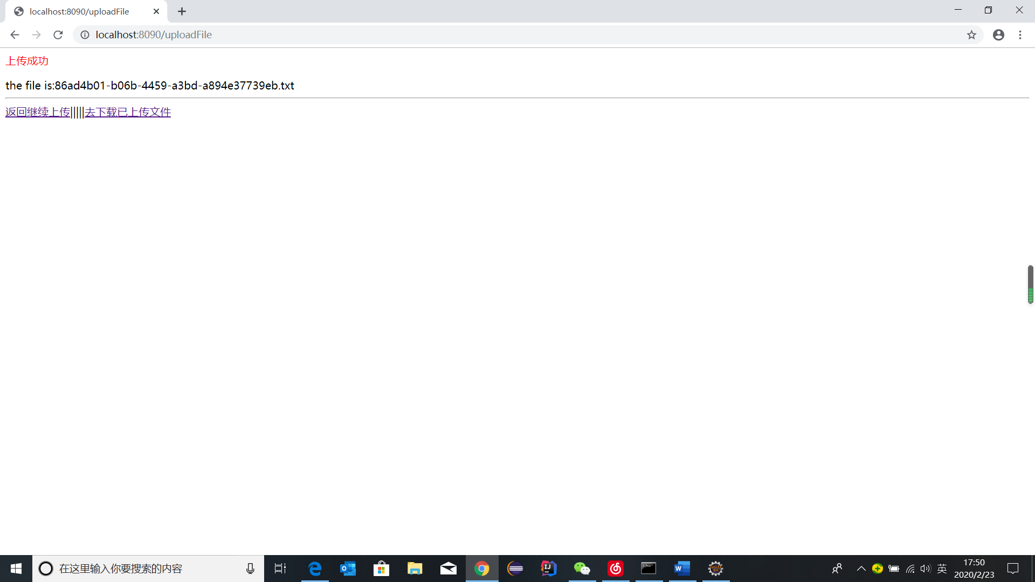

**经过AES加密存入服务器（本机）的文件：**

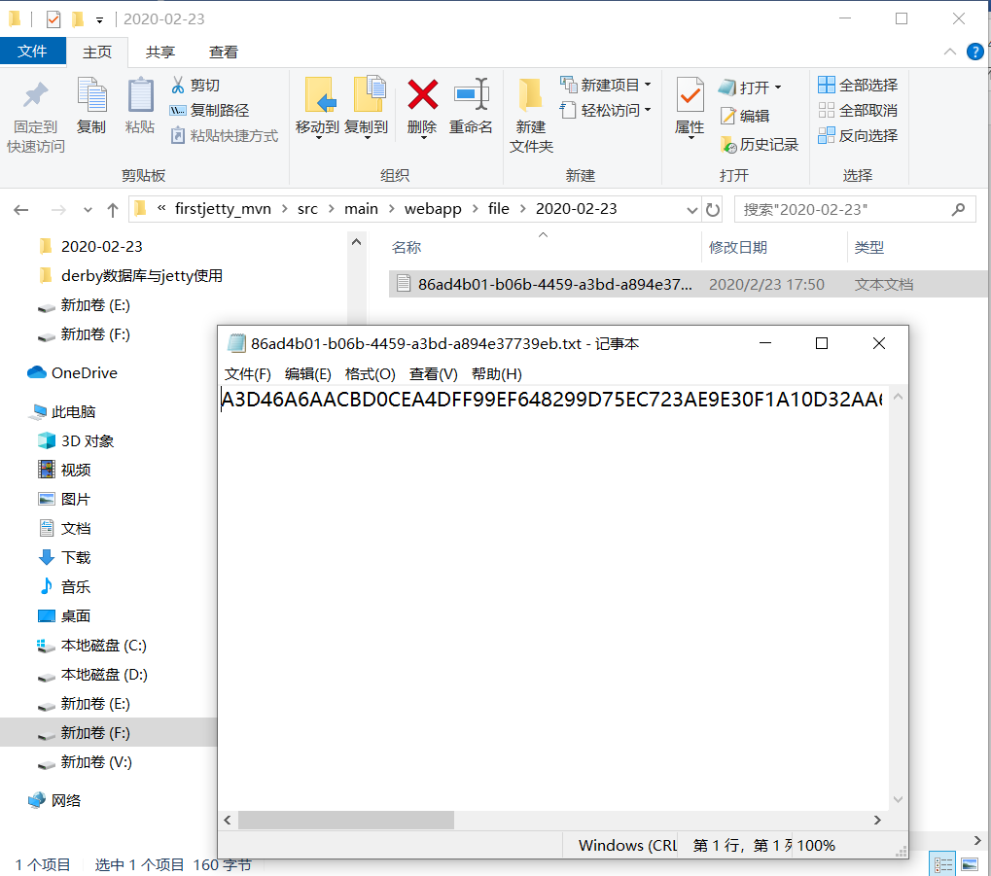

**下载页：**

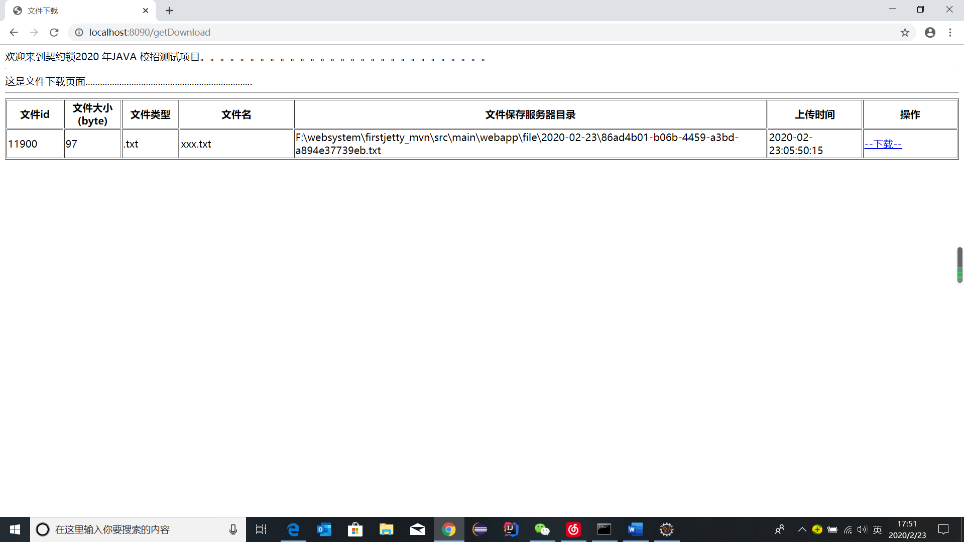

**下载后：**

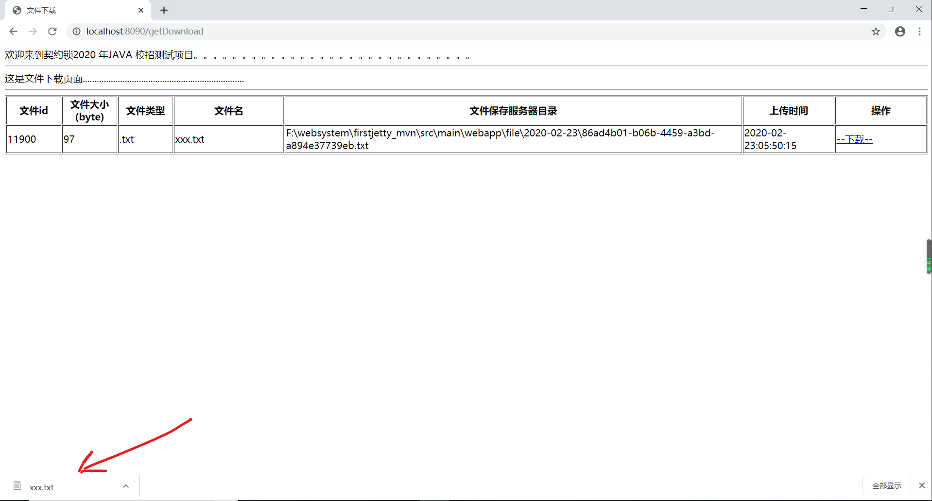

**下载后文件（经过加密解密后还原）：**

