Supplmentary Table I. List of the 30 COGs used in the study.
COG | Length | COG Name | Functional Pathway | mean gCF
COG0012 | 456 | Ribosome-binding ATPase YchF, GTP1/OBG family | Protein translation/Stress Response | 52.99
COG0016 | 802 | Phenylalanyl-tRNA synthetase alpha subunit | Aminoacyl-tRNA synthetases | 61.94
COG0048 | 308 | Ribosomal protein S12 | Ribosome Biogenesis and Function | 44.78
COG0049 | 347 | Ribosomal protein S7 | Ribosome Biogenesis and Function | 51.49
COG0052 | 717 | Ribosomal protein S2 | Ribosome Biogenesis and Function | 61.19
COG0080 | 258 | Ribosomal protein L11 | Ribosome Biogenesis and Function | 54.48
COG0081 | 518 | Ribosomal protein L1 | Ribosome Biogenesis and Function | 61.94
COG0087 | 532 | Ribosomal protein L3 | Ribosome Biogenesis and Function | 60.45
COG0091 | 579 | Ribosomal protein L22 | Ribosome Biogenesis and Function | 51.49
COG0092 | 414 | Ribosomal protein S3 | Ribosome Biogenesis and Function | 61.19
COG0093 | 173 | Ribosomal protein L14 | Ribosome Biogenesis and Function | 45.52
COG0094 | 286 | Ribosomal protein L5 | Ribosome Biogenesis and Function | 52.24
COG0096 | 167 | Ribosomal protein S8 | Ribosome Biogenesis and Function | 47.01
COG0097 | 247 | Ribosomal protein L6P/L9E | Ribosome Biogenesis and Function | 53.73
COG0098 | 566 | Ribosomal protein S5 | Ribosome Biogenesis and Function | 49.25
COG0099 | 470 | Ribosomal protein S13 | Ribosome Biogenesis and Function | 50.00
COG0100 | 210 | Ribosomal protein S11 | Ribosome Biogenesis and Function | 53.73
COG0102 | 350 | Ribosomal protein L13 | Ribosome Biogenesis and Function | 47.01
COG0103 | 775 | Ribosomal protein S9 | Ribosome Biogenesis and Function | 51.49
COG0172 | 849 | Seryl-tRNA synthetase | Aminoacyl-tRNA synthetases | 61.19
COG0184 | 760 | Ribosomal protein S15P/S13E | Ribosome Biogenesis and Function | 47.76
COG0186 | 698 | Ribosomal protein S17 | Ribosome Biogenesis and Function | 37.31
COG0197 | 605 | Ribosomal protein L16/L10AE | Ribosome Biogenesis and Function | 52.24
COG0200 | 566 | Ribosomal protein L15 | Ribosome Biogenesis and Function | 49.25
COG0201 | 744 | Preprotein translocase subunit SecY | Protein Translocation/Secretion | 66.42
COG0202 | 695 | DNA-directed RNA polymerase, alpha subunit/40 kD subunit | Transcription | 65.67
COG0256 | 274 | Ribosomal protein L18 | Ribosome Biogenesis and Function | 47.76
COG0495 | 2226 | Leucyl-tRNA synthetase | Aminoacyl-tRNA synthetases | 58.21
COG0522 | 489 | Ribosomal protein S4 or related protein | Ribosome Biogenesis and Function | 51.49
COG0533 | 1038 | tRNA A37 threonylcarbamoyltransferase TsaD | tRNA modification | 60.45

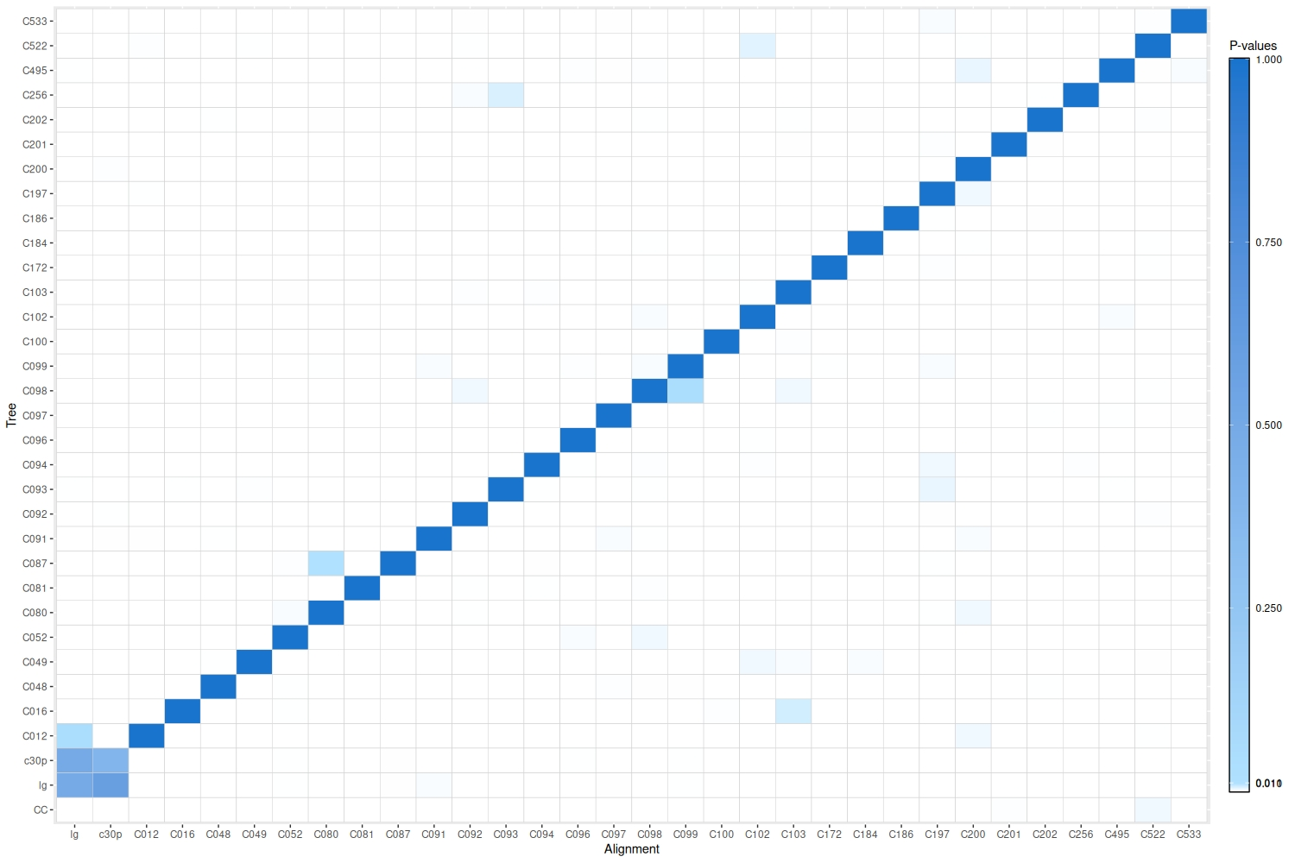
Supplementary Figure 1. Heatmap of Shimodaira-Hasegawa (SH) test p-values. Cells represent the p-values resulting from pairwise SH tests between the individual COG gene alignment on the individual COG gene trees. Significant results (p ≤ 0.01) are shown in white. Non-significant results are indicated by blue shading, ranging from light blue (p = 0.01) to dark blue (p = 1).

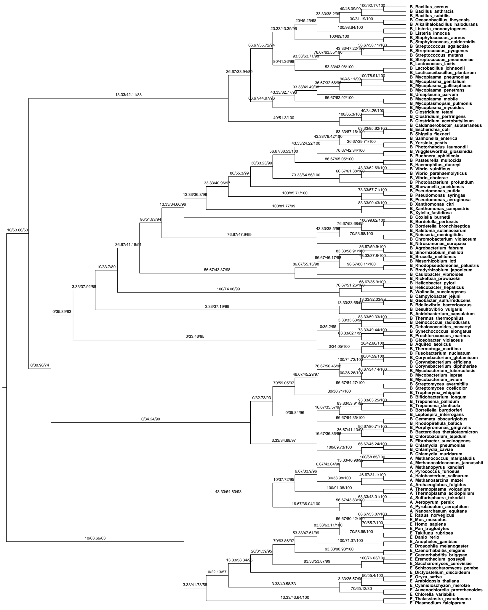
Supplementary Figure 2a. Maximum-likelihood Phylogeny of 30 COGs across the Tree of Life. The tree was the published Tree of Life (CC). Branches were labelled with Gene Concordance Factors (gCF), Site Concordance Factors (sCF), and bootstrap support values. Tip labels are prefixed by Kingdom (A: Archaea; B: Bacteria; E: Eukaryota), followed by taxonomic names. The tree is rooted on the Eukaryote-Archaea clade.

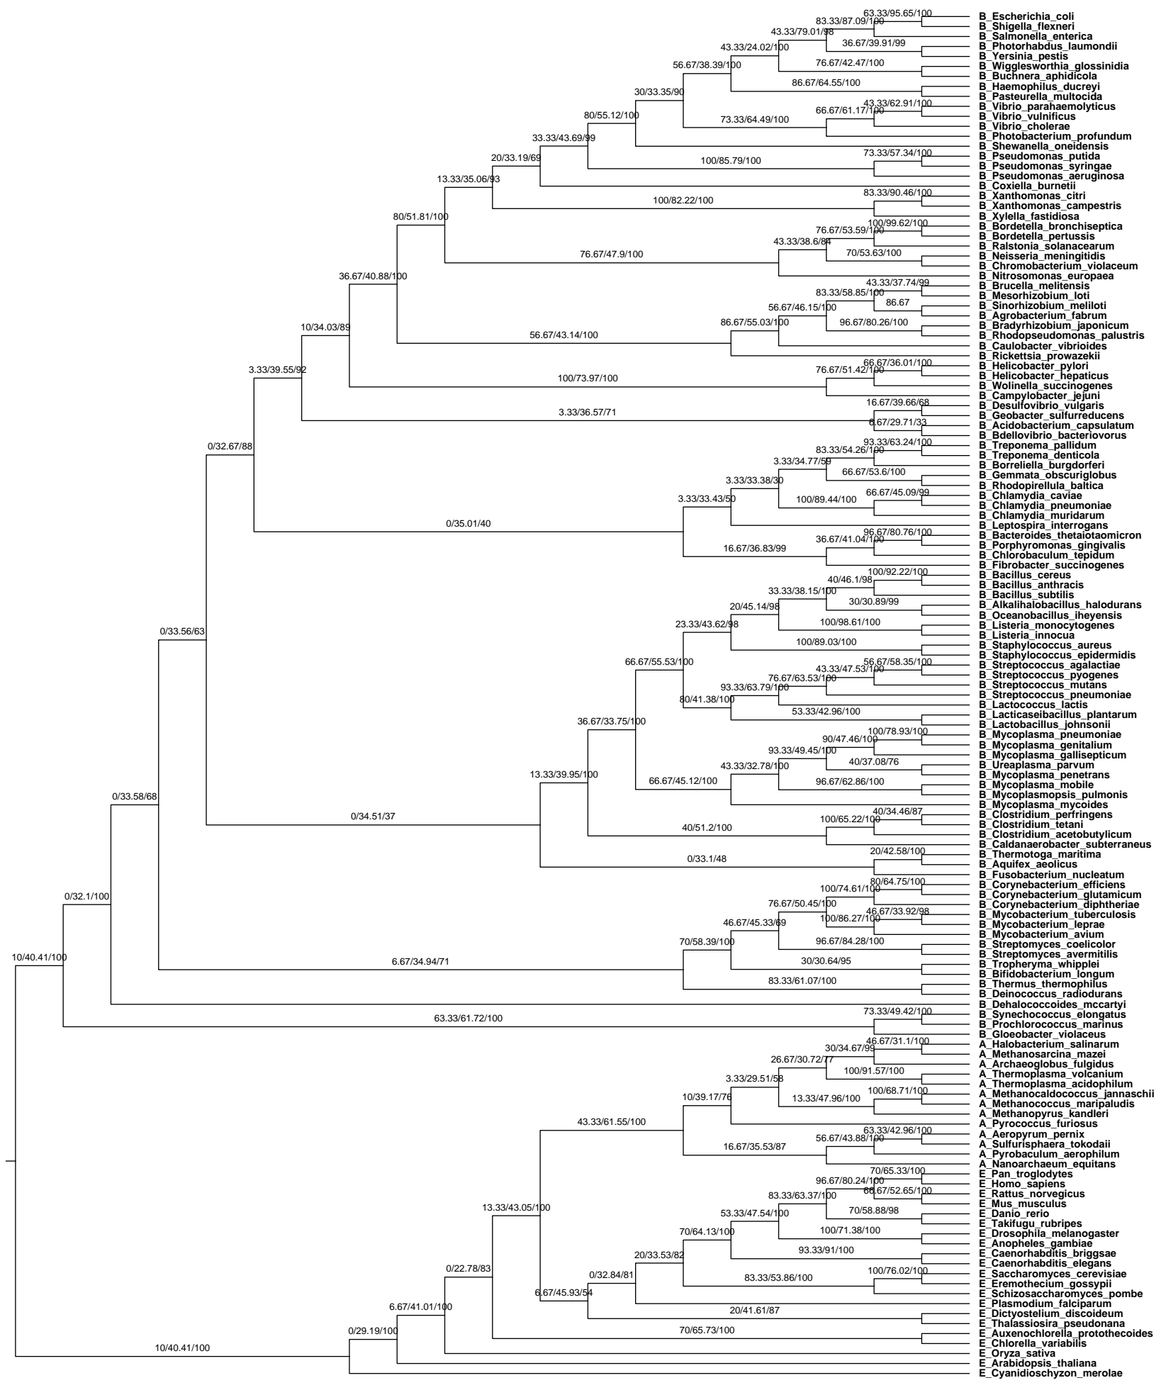
Supplementary Figure 2b. Maximum-likelihood Phylogeny of 30 COGs across the Tree of Life. The tree was inferred with a single best estimated model (LG). Branches are labeled with Gene Concordance Factors (gCF), Site Concordance Factors (sCF), and bootstrap support values. Tip labels are prefixed by Kingdom (A: Archaea; B: Bacteria; E: Eukaryota), followed by taxonomic names. The tree is rooted on the Eukaryote-Archaea clade.

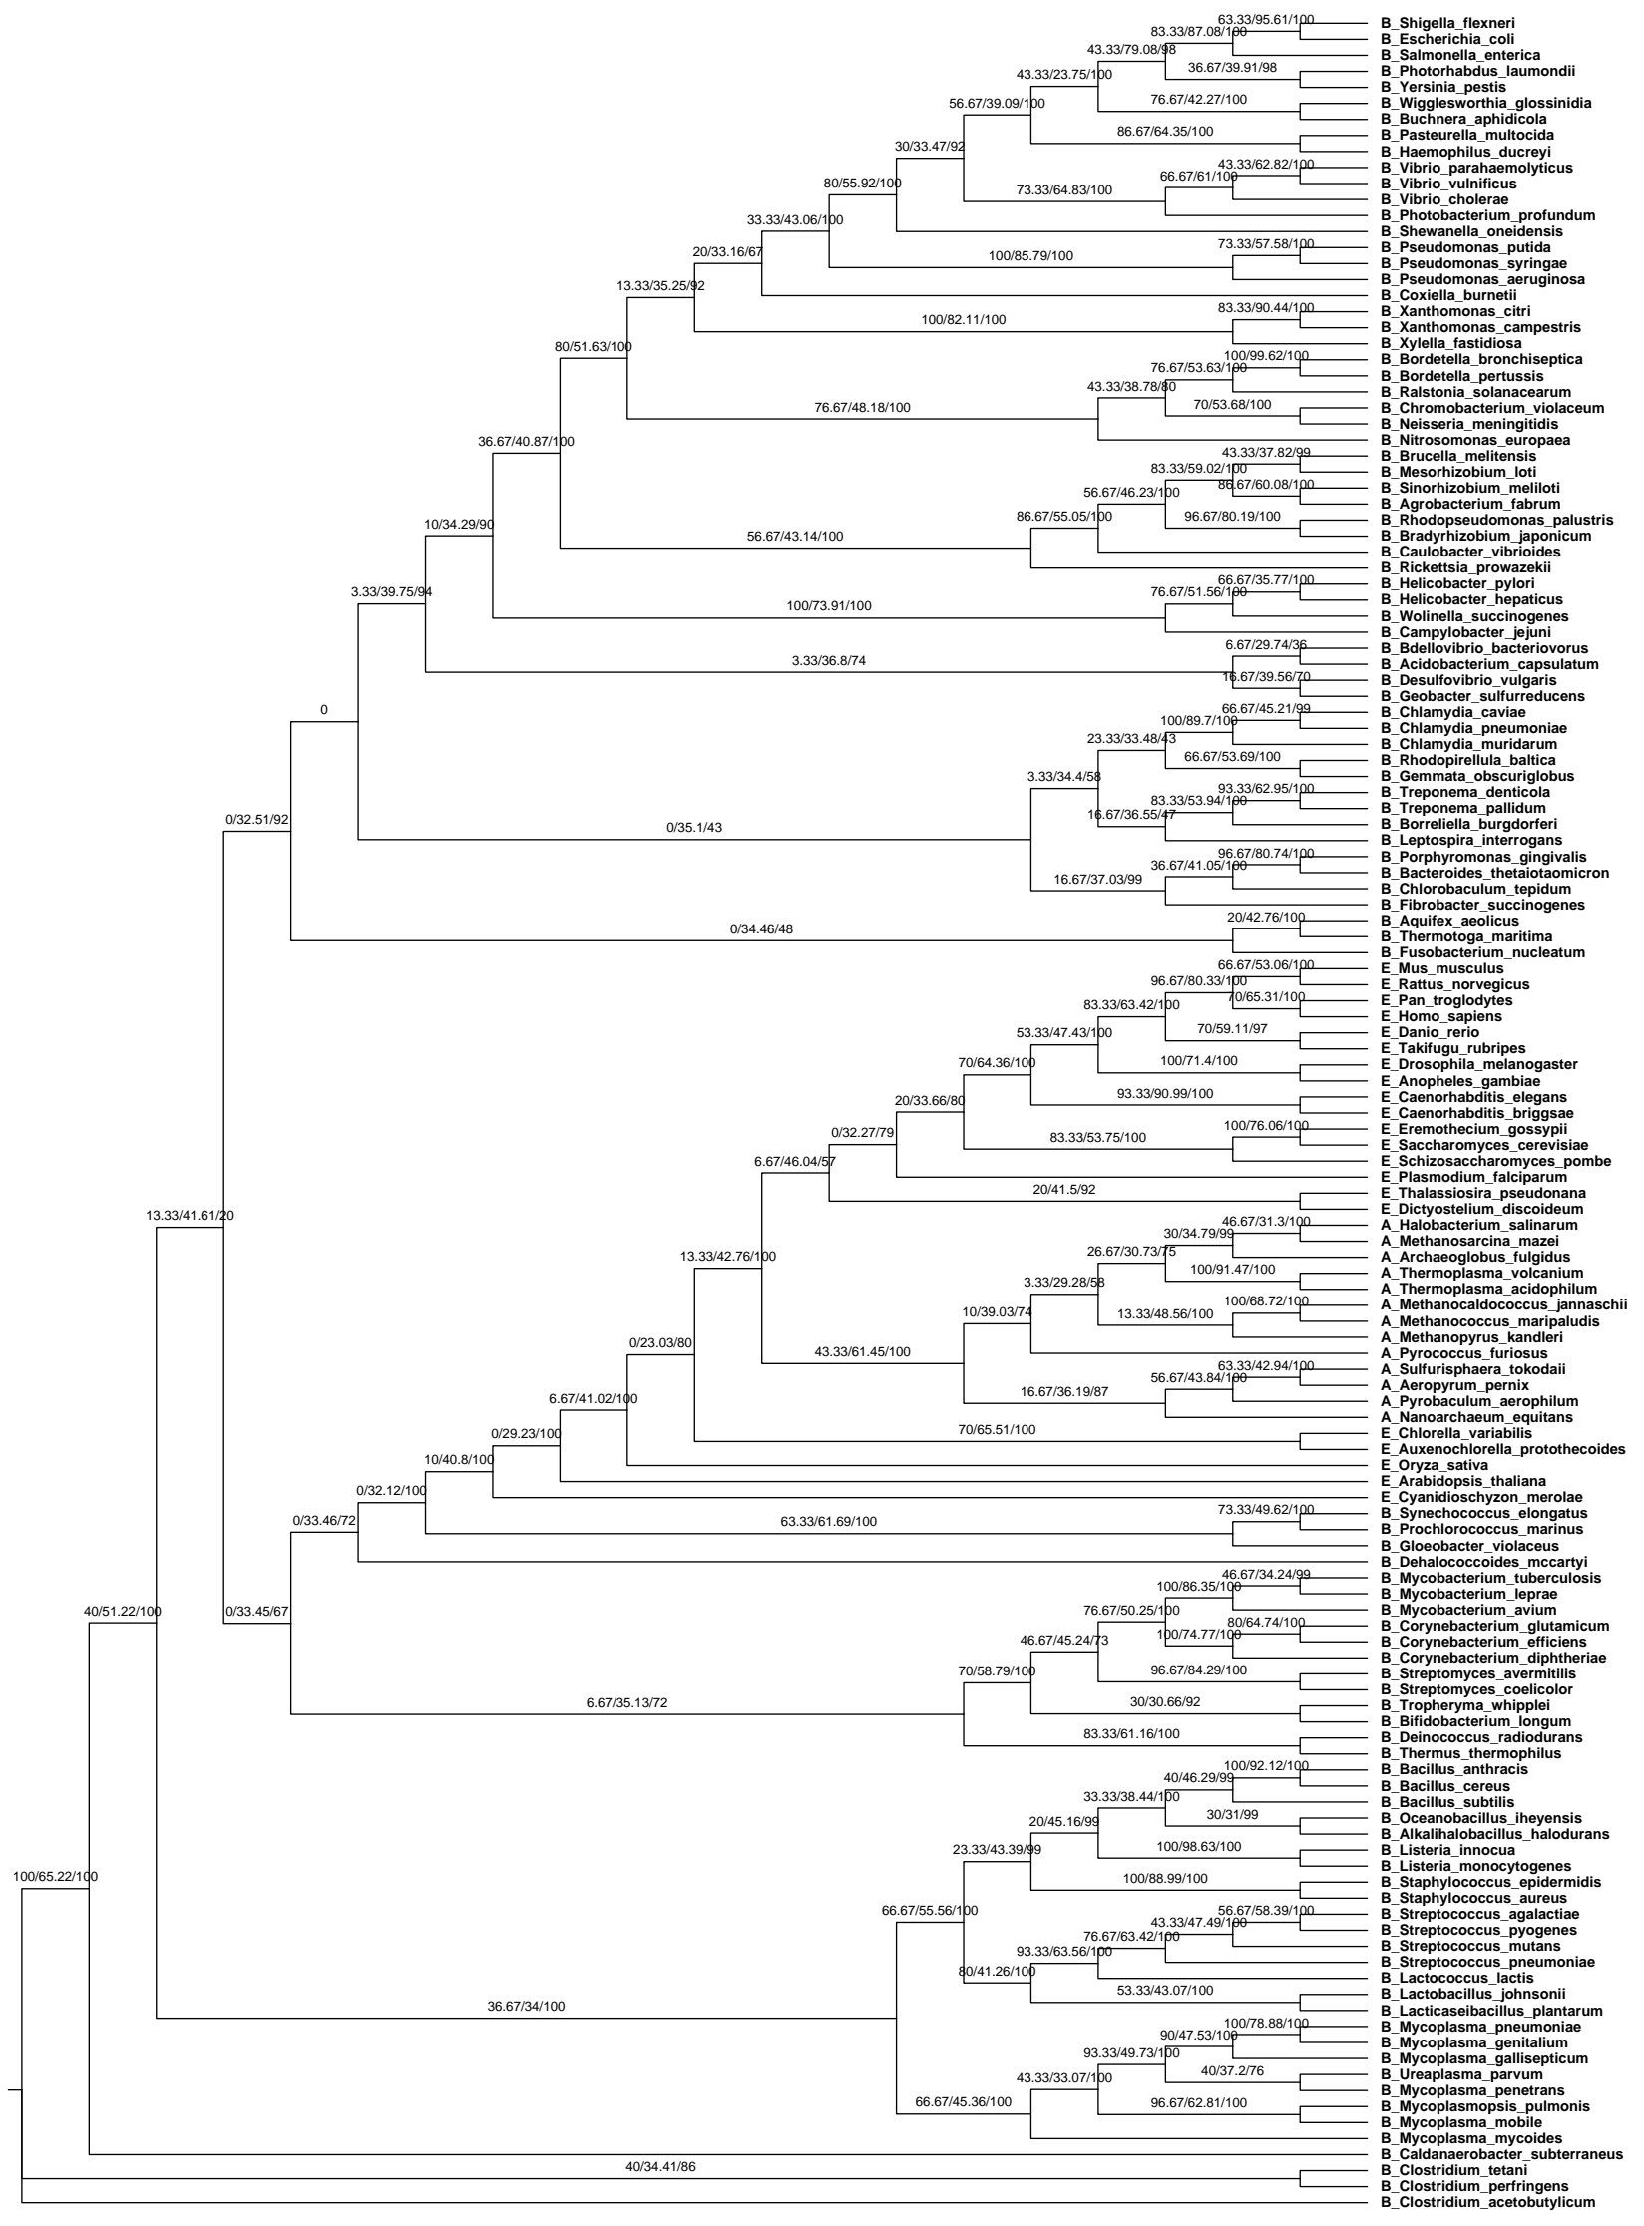
Supplementary Figure 2c. Maximum-likelihood Phylogeny of 30 COGs across the Tree of Life. The tree (C30P) was inferred with partitioned models applied to each gene locus. Branches are labeled with Gene Concordance Factors (gCF), Site Concordance Factors (sCF), and bootstrap support values. Tip labels are prefixed by Kingdom (A: Archaea; B: Bacteria; E: Eukaryota), followed by taxonomic names. The tree is rooted on the Eukaryote-Archaea clade.

Supplementary Table 2. Summary of partitioned model parameters for the C30P supermatrix tree. The table lists the 30 gene partitions in their concatenated order, including the specific substitution models (determined by ModelTest-NG and AICc), starting and ending sequence position within the supermatrix.
COG | Model | Gene Position on Concatenated Alignment
COG0016 | LG+I+G4 | 1-802
COG0102 | LG+G4 | 803-1152
COG0012 | LG+I+G4 | 1153-1608
COG0522 | LG+G4 | 1609-2097
COG0091 | LG+G4 | 2098-2676
COG0103 | LG+I+G4 | 2677-3451
COG0052 | LG+I+G4 | 3452-4168
COG0049 | LG+G4 | 4169-4515
COG0533 | LG+I+G4 | 4516-5553
COG0184 | LG+G4 | 5554-6313
COG0186 | LG+G4 | 6314-7011
COG0048 | LG+G4 | 7012-7319
COG0256 | WAG | 7320-7593
COG0087 | LG+I+G4 | 7594-8125
COG0202 | LG+I+G4 | 8126-8820
COG0093 | LG+I+G4 | 8821-8993
COG0092 | LG+I+G4 | 8994-9407
COG0201 | LG+G4 | 9408-10151
COG0099 | LG+I+G4 | 10152-10621
COG0197 | LG+G4 | 10622-11226
COG0096 | LG+I+G4 | 11227-11393
COG0081 | LG+G4 | 11394-11911
COG0098 | LG+I+G4 | 11912-12477
COG0094 | LG+G4 | 12478-12763
COG0080 | LG+G4 | 12764-13021
COG0097 | LG+G4 | 13022-13268
COG0172 | LG+I+G4 | 13269-14117
COG0100 | LG+G4 | 14118-14327
COG0200 | LG+G4 | 14328-14893

