

UNIVERSITI TEKNIKAL MALAYSIA MELAKA

FACULTY OF INFORMATION AND COMMUNICATION TECHNOLOGY

BITU 3973 PROJECT 1
REPORT

NAME : WONG JIA XI
MATRIC NUMBER : B032310495
PROGRAM : BITS S1G2
PROJECT TITLE : RENTBRIDGE - UNIVERSITY STUDENT
HOME RENTAL PLATFORM
SUPERVISOR NAME : TS. DR. NOR AIZA BINTI MOKETAR
EVALUATOR NAME : TS. MASLITA BINTI ABD AZIZ

TABLE OF CONTENTS
Page No.
TABLE OF CONTENTS i
LIST OF TABLES iv
LIST OF FIGURE v
1 INTRODUCTION 1
1.1 Introduction 1
1.2 Project Background 1
1.3 Problem Statement 2
1.4 Project Objectives 3
1.5 Project Scope 3
1.5.1 Target Users 3
1.5.2 System Features in Scope 4
1.5.3 System Boundaries 4
1.6 Project Significance 4
1.7 Expected Output 5
1.8 Conclusion 5
2 LITERATURE REVIEW AND PROJECT METHODOLOGY 6
2.1 Introduction 6
2.2 Domain 6
2.2.1 Online Rental Platforms 6
2.2.2 Property Management Systems 7
2.2.3 Trust and Transparency in Digital Marketplaces 7
2.3 Existing Systems 8
2.3.1 iProperty Malaysia (www.iproperty.com.my) 8
2.3.2 Airbnb (www.airbnb.com) 8
2.3.3 Mudah.my (www.mudah.my) 9
2.4 Techniques 10
2.4.1 Model-View-Controller (MVC) Architecture 10
2.4.2 RESTful API Design 10
2.5 Project Methodology 11
2.5.1 Overview of Evaluated Methodologies 11
2.5.2 Selected Methodology: Iterative SDLC 11
2.6 Project Requirements 12
2.6.1 Software Requirements 12
2.6.2 Hardware Requirements 13
2.6.3 Other Requirements 14
2.7 Project Schedule and Milestones 14
2.8 Conclusion 15
3 ANALYSIS 16
3.1 Introduction 16
3.2 Problem Analysis 16
3.2.1 Current System Analysis 16
3.2.2 Detailed Problem Analysis 18
3.3 Requirement Analysis 19
3.3.1 Data Requirement 19
3.3.2 Functional Requirement 25
3.3.3 Non-Functional Requirement 27
3.4 Conclusion 28
4 DESIGN 30
4.1 Introduction 30
4.2 High-Level Design 30
4.2.1 System Architecture 30
4.2.2 User Interface Design 32
4.2.3 Navigation Design 33
4.2.4 Input Design 34
4.2.5 Output Design 36
4.2.6 Database Design 37
4.3 Detailed Design 49
4.3.1 Software Design (Class Diagram) 49
4.3.2 Physical Database Design (DDL Schema) 52
4.4 Conclusion 76
References 77

LIST OF TABLES
Table 2.1 : Comparison of Existing Rental Systems 8
Table 2.2 : Software Requirements 11
Table 2.3 : Project Schedule and Milestones(PSM 1) 12
Table 3.1 : Data Dictionary for RentBridge Core Entities 17
Table 4.1 : Input Design and Validation Rules 31
Table 4.2 : Output Design and Classification 33

LIST OF FIGURE
Figure 3.1 : Flowchart of the Current Manual Rental Search Process for UTeM Students 15
Figure 4.1 : ERD Part 1- User and Identity 34
Figure 4.2 : ERD Part 2- Property and Listing 35
Figure 4.3 : ERD Part 3- tenancy, Contract and Inspection 36
Figure 4.4 : ERD Part 4- Agent Operations 36
Figure 4.5 : ERD Part 5- Communications and Social 37
Figure 4.6 : UML Diagram Part 1- User and Identity 44
Figure 4.7 : UML Diagram Part 2- Property and Listing 44
Figure 4.8 : UML Diagram Part 3- tenancy, Contract and Inspection 45
Figure 4.9 : UML Diagram Part 4- Agent Operations and Finance 45
Figure 4.10 : UML Diagram Part 5- Communication and Social 46

INTRODUCTION

Introduction
The quick development of digital technology has now completely changed on how individuals look for and handle lodging. Due to the ongoing shortage of on-campus housing, students in Malaysia universities are gradually forced to look for lodging off campus. As a result, many people now look for and negotiate the rental properties using unofficial digital channels, mostly messaging apps like Facebook, Telegram and WhatsApp, and common rental websites like Mudah.my, which combine the rental module as part of the system.
These platforms were not intended for structured property management, despite their accessibility and convenience. As a result, information organization, tenancy administration, and effective communication present major issues for both students looking for housing and landlords overseeing properties. One obvious gap in the online service ecosystem is the lack of a centralized platform designed specifically to meet the unique needs of university students.
The web-based house renting platform RentBridge, created especially for college students and landlords, is introduced in this chapter. It explains the project's history, highlights the main issues, outlines the project's goals and scope, talks about its advantages, and points out the anticipated results upon completion.

Project Background
Public or private university students in Malaysia commonly reside off-campus due to the limited availability of dormitory accommodation. Locating suitable, affordable, and trustworthy housing is a critical concern, the demand is at its peak particularly during the intake periods. Traditionally, students depend on word-of-mouth referrals, posts in social media platform, and group chats messages to browse available rooms then contact landlords to rent.
The current flow of student rental is browsing by unstructured messaging platforms and general rental websites. Groups on WhatsApp or Telegram act as notice boards for property listings. However, these platforms present significant usability limitations. Listings which contain room details, pricing, and contact information are quickly buried beneath continuous message flows, making real time retrieval become hard. There is no standardized listing format, no tenancy mechanism, and no systematic way for verifying landlord credibility.
On the other hand, general rental websites such as Mudah.my, iProperty Malaysia, and Airbnb are difficult for browsing efficiently due to their broad target audience, which includes residential, commercial, and short-term accommodation listings that are not specifically tailored to student housing needs. Another major headache for student is they have to wade through another sub-modules like grocery listings and family home sales, causing a massive waste of time.
From the landlord perspective, managing multiple property inquiries across different platforms is time wasting. Landlords who target the university students lack a customized platform that is designed around their primary customer. General property portals are not tailored to the student market, and no dedicated environment where student tenants can easily browse and evaluate student-targeted properties. This leaves landlords without a primary-customer-specified webpage that could efficiently connect them to their intended audience.
These collected challenges point to the need for a dedicated digital platform that sorts property listing, searching, tenancy, and communication functionalities into a single, structured system. RentBridge is proposed as a solution to this need — a web-based application designed to provide a seamless, transparent, and efficient rental experience for the university community.

Problem Statement
The reliance on informal messaging platforms or common rental websites for student rental accommodation has produced several critical challenges that negatively impact both tenants and landlords. The following problem statements have been identified:
- Inappropriate and unstructured rental information: Rental listings shared via messaging platforms hard for students to filter, compare, and evaluate properties based on their requirements. Information is frequently lost or buried within active chat groups, and there is no persistent record of listing details. General website which combined from different sub-modules and contain inappropriate property details waste students time on browsing.
- Semester-unfriendly contract duration: Rental contracts generated from common property websites and by agents are based on the year as the measurement unit. This cause misaligned with the academic calendar of university students, which operate on a semester basis of 14 weeks. Students are often forced to sign contracts which using 1 year as unit, despite needing accommodation for only 3 semesters, or need to negotiate informally outside any structured system.
3. Inefficient multi-platform communication: Students and landlords frequently communicate across multiple platforms, resulting in double bookings, fragmented conversations, missed messages, and difficulty maintaining a coherent rental negotiation trail.

Project Objectives
The objectives of this project are directed towards resolving the identified problems through the development of the RentBridge platform. This project embarks on the following objectives:
1. To analyze the current search process for available rental properties and the requirements of university students, landlords, and agents in order to identify the functional and non-functional specifications for the RentBridge platform.
2. To develop a rental website that enables university students to search for semester-based accommodation, coordinate housemate groups, submit tenancy information, and receive auto-generated tenancy agreements upon confirmed tenancy.
3. To evaluate the developed RentBridge platform against the identified problem statements and stakeholder requirements through functional testing and user acceptance testing involving students and landlords.

Project Scope
The scope of RentBridge is defined as follows to ensure feasibility within the constraints of a Final Year Project:

Target Users
• University Students (Tenants): Students find available rental properties and make tenancy agreement.
• Landlords (Property Owners): Individuals who own and advertise rental properties to university students.
• Agents (University Staffs): Agents inspect the landlord’s properties and approve based on condition and are responsible for the properties they had approved from end to end. They get commission for every successful tenancy contract.
• Admin (University): Admin controls the overall system activity, able to observe every change and occurrence in the system.

System Features in Scope
• User registration, login, and profile management for both students, landlords and agents.
• Property listing management — landlords can create, update, and delete listings with details such as room type, rental price, location, and available amenities.
• Property search and filtering — students can search listings by location, price range, room type, and other criteria.
• Find Housemate post: students who have already secured or are interested in a property can create a public Find Housemate post to recruit co-tenants, who share their compatible requirements (intake period, budget, gender preference). This addresses the common scenario where a student needs to fill remaining rooms in a rented unit, enabling peer coordination within the platform rather than reverting across informal messaging channels.
• Review and rating module — tenants can submit ratings and written reviews for properties following a completed tenancy.
• In-platform messaging — a direct messaging module enabling communication between tenants and landlords.
• Admin dashboard — basic administrative interface for user and content management.

System Boundaries
• The platform is web-based and accessible via a standard browser on desktop and mobile devices.
• The system does not include a payment gateway — all rental payment transactions are handled externally between tenant and landlord. The system commission and agent earning are only simulation.
• The platform is not integrated with external property listing services or government housing databases.
• The target context is the UTeM student population, with listings focused on residential rental properties in proximity to university campuses.

Project Significance
The development of RentBridge holds significance for several stakeholder groups:
• University Students: The platform simplifies the accommodation search process by providing a structured, searchable, and transparent environment tailored to the academic lifecycle. Students benefit from semester-based rental contracts aligned to the 14-week academic semester. This eliminates the mismatch of year-based leases imposed by general platforms. Find Housemate post feature enables coordination of suitable co-tenants for the same intake period in 1 property , verified property listings approved by university-affiliated agents, and peer-driven reviews that support informed decision-making.
• Landlords: Property owners gain access to RentBridge . Unlike other property portals that mix residential, commercial, and short-term listings, RentBridge provides landlords with a student-focused webpage where every feature is designed for the university rental context: semester-based contract generation and management, structured listing presentation tailored to student search criteria, agent-mediated property inspection and approval for credibility, tenancy tracking, and reputation building through the student review system.
• Universities: Institutions benefit indirectly, as a reliable off-campus rental solution may reduce stress related to accommodation among the student population, supporting overall student well-being and better academic performance.

Expected Output
Upon successful completion of this project, the following outputs are expected:
1. A fully functional web-based rental platform (RentBridge) incorporating modules for user authentication, property listing and search, tenancy management, in-platform messaging, and review and rating.
2. A complete PSM I report documenting the project introduction, literature review, system analysis, and preliminary design.
3. A working prototype or demonstration of the core modules to be presented during the PSM I final presentation.
4. A system foundation suitable for continued development during PSM II, encompassing full implementation, testing, and deployment.

Conclusion
This chapter has provided a comprehensive introduction to the RentBridge project. The background highlighted the challenges encountered by Malaysian university students when searching for off-campus accommodation posts through different informal messaging platforms. Key problem statements were identified, collectively justifying the need for a dedicated, centralised, and structured rental management system.
Clear project objectives were defined to direct the development of RentBridge, and the system scope was outlined to ensure scheduling within the project timeline. The significance of the project was examined in relation to its benefits for students, landlords, universities, and the academic field. Key differentiators of RentBridge include semester-based rental contracts aligned to the 14-week academic calendar, a Find Housemate post feature for peer co-tenant coordination, and a primary-customer-specified platform designed exclusively to connect landlords with university students as their primary market.

LITERATURE REVIEW AND PROJECT METHODOLOGY

Introduction
This work is a literature review on recent literature relevant to the RentBridge web-based rental platform for university students from 2022-2026. It reviews the concept of an online rental platform and property management system and reviews the trust mechanisms which support two-sided digital marketplaces, and assesses existing similar solutions. This review places RentBridge in the context of existing evidence and identifies gaps it addresses, including the affordability and scarcity of appropriate off-campus housing in Malaysia, which have emerged as key concerns in the Malaysian context (Ismail, Razak, & Hamzah, 2023; Francis, Zulkifli, & Hamzah, 2025).
The second part of the chapter can be used to showcase the methodology chosen for the project and explain why the approach for developing the project is suitable for the nature of the project. Software, hardware and other requirements are also there and the project schedule is also provided which shows the project development on throught the project schedule.

Domain

Online Rental Platforms
An online rental platform represents a digital, two-sided marketplace between a property owner or landlord, and a property seeker or tenant, that enables the discovery, comparison and transaction of such property listings, without relying on traditional intermediaries. In the area of student housing, in particular, the platformisation of housing has been documented by Cocola-Gant/ Gago (2023), who chart the evolution of the student-housing segment between short-term accommodation in the tourism sector and traditional long-term rentals.
Today's platforms tend to offer features such as property listing, search and filter, enquiry/tenancy management, in-app communication, and more and more advanced discovery features, as well. Rathore, Syed, and Ahmed (2024) for instance, create an online rental marketplace that leverages machine learning to provide tailored suggestions to individuals, and Roslan and Ahmad (2025) present a smart rental platform for students focusing on sustainable campus communities. Trend is clear that these works aim towards providing students with some platforms that are more than just listing websites.
In the case of RentBridge, their domain can be narrowed down to localised student hostelry in Malaysia. The defining features of this sub-domain are a strong focus on affordability, the desire to be near campus as a key selection factor, and tenancies that are short (less than a year), and semester-aligned. Additionally, research on Malaysian students has presented that their satisfaction with off-campus housing is significantly highly affected by housing costs and location (Ismail, Razak, & Hamzah, 2023) and that obtaining a housing option among students which is affordable and sustainable, is difficult (Francis, Zulkifli, & Hamzah, 2025), which leads to the launch of a platform that focuses more on the student, less on the requirements of the rent.

Property Management Systems
A Property Management System (PMS) is a software that is used to organize and automate all rental operations of a landlord or manager, including rent, communication, document management, and financial tracking. Recent work shows how these operations have been digitalized: Wang and Wang (2024) design a housing-selection platform that digitalizes real-estate services, while Sharma and Gupta (2024) show a modern real-estate web app that automates key areas of listing and enquiry processing.
In the context of student accommodation, Nair, Sadvelkar, Damle and Kudu (2024) construct a MERN-based rental system to supports seamless property management, while Osei-Bonsu and Karikari (2026) create a cloud-based student accommodation management application. RentBridge is not designed to be a comprehensive enterprise-class PMS, instead it includes the features that are most relevant for individual landlords who service university students: listing and availability management, semester based managment of tenancies and contracts, verification of properties by agents, Communications in-app and lightweight tracking of agents.

Trust and Transparency in Digital Marketplaces
In two-sided markets, such as eBay, the Internet can model transactions that can't be examined by the participants in person prior to a deal, and trust is central to the process. Drawing from a review of 50 years of empirical work, Khamitov et al. (2024) explains why consumer trust has become a key factor impacting transaction intention and loyalty in online settings. Since tenants rely almost solely on information provided by others, information clarity and verifiability plays a major role in establishing a platform's credibility.
Positive-by-user reviews and ratings serve as social-proof signals to decrease information tunefulness between the bidirectional aspects of a marketplace. The success of such user generated content is determined by consumer digital trust, which, Hochstein, Harmeling, and Perko (2023), show through meta-analysis is extremely influenced. RentBridge therefore creates trust by having verified user profiles, with agents leading in the property verification process, having transparent information about the listing, and reporting functionality which makes it possible to flag suspected problems and have them seen by administrators.

Existing Systems
This section is to identify and assess three existing platforms relevant to the RentBridge project that relate to rent. Each of these systems is analysed with their features, potential users, their advantages and disadvantages given in relation to the needs of University students in Malaysia.

iProperty Malaysia (www.iproperty.com.my)
iProperty is among the largest online property portals in Malaysia which provides property listings for sale, rental and commercial properties throughout Malaysia. The platform offers an all-in-one search portal and filters on location, property type, price range and bedrooms. Photos and descriptions are featured, along with landlord contact information.
Looking from the student's side of things, the main downside of iProperty is the lack of targeting to the university student segment, it's a very general product. Market rate full units comprise the majority of a property's listings and are often too costly for the individual who wants a single room or shares. All communication with the landlords is in platform only through Phone/E-mail. Also, there's no landlord or property rating/review system.

Airbnb (www.airbnb.com)
Airbnb is a worldwide renowned firm that enables hosts and visitors to connect through a peer-to-peer network to rent houses for brief durations. The platform's review and rating mechanism, verification systems and platform-integrated communication between hosts and guests is well regarded. tenancy is managed all within the platform and includes payment going through the platform.
Though Airbnb is technically sound and extremely advanced, the main purpose of Airbnb is tourism and short-term rental, not long-term student rental. Its pricing model and fee should not be aligned to any way where leases are expected for the semester only. In addition, Airbnb is not necessarily geared towards student needs, including nearness to universities, rooms with others, and so on. Other than that, the platform is not well popular among students housing in Malaysia.

Mudah.my (www.mudah.my)
Mudah.my is a Malaysian classifieds website which features a property rental sub-page. It enables landlords to have available rooms or units that are kept for rent with a simple information like price, location, and contact details. Because of its free use and coverage in the locality, it is widely used by the students of the University.
Mudah.my, though, is essentially a very basic classifieds board that comes with substantial restrictions. No tenancy system, no verified user accounts and no review or rating system. There isn't a communication channel in the platform structured in any manner, and the quality and accuracy of listings vary widely. It makes the connection between students and landlords to be made by phone or WhatsApp, which reinforces the issues in informal messaging systems outlined in chapter 1.

Table 2.1: Comparison of Existing Rental Systems
Feature | iProperty | Airbnb | Mudah.my | RentBridge (Proposed)
Student-Focused | No | No | Partial | Yes
Structured Listing | Yes | Yes | Partial | Yes
Search & Filter | Yes | Yes | Basic | Yes
tenancy System | No | Yes | No | Yes
In-Platform Messaging | No | Yes | No | Yes
Free to Use | No | No | Yes | Yes
Malaysia-Specific | Yes | No | Yes | Yes

As illustrated in Table 2.1, none of the systems is fully addressing the needs of the Malaysian university students in seeking rental accommodation. With this in mind, RentBridge is poised to fill the void, blending the framework of already established platforms with a format that's relevant, familiar, and easy to use by students.

Techniques
This section reviews three alternative development techniques considered for the implementation of RentBridge and provides justification for the selected approach.

Model-View-Controller (MVC) Architecture
MVC is a software design pattern in which an application consists of three components – Model (data and business logic), View (user interface), and Controller (input handling and coordination). MVC is a well-established paradigm in web application development as it allows separation of concerns, maintainable code and parallel development of the front- and back-end parts of the application (Leff and Rayfield, 2001).
RentBridge's architectural style is MVC, and is applied with modern full-stack web framework. For this project, it is deemed appropriate due to its multi-role (student and landlord and admin) and its desire for clean segregation of data and presentation.

RESTful API Design
A Representational State Transfer (REST) API is another approach of constructing Web companies that accesses resources using common HTTP verbs, similar to Get, Post, Put, Delete. REST can support small, scalable communication between client and server with no state, therefore it is well taken to Web and mobile application (Fielding, 2000).
Restful API Design applies to RentBridge where it helps allow their front-end and backend components to be separated. For PSM I scope, however, the emphasis is on a monolithic, server side rendered Web app. Potential extension of API-based architecture in PSM II.croservices Architecture
A microservices architecture is a way of breaking down a system into several different applications, which can be built, deployed, and deployed independently. This has benefits for scalability and fault isolation (Newman, 2015), but also adds much complexity in configuration, deployment and inter-service communication.
RentBridge will not be developed using microservices architecture. Being a single developer FYP with a set time frame, the monolithic application with MVC structure is more suitable. At this scale microservices would provide no benefit and only overhead.

Project Methodology

Overview of Evaluated Methodologies
There were 3 development methodologies discussed for RentBridge: Waterfall, Agile (Scrum) and Software Development Life Cycle (SDLC) with iterative aspects. The following reviews each.
Waterfall Methodology: Waterfall Model is a linear and sequential approach to software development with distinct phases: Requirements, Design, Implementation, Testing, and Maintenance. Royce (1970) was the one who first proposed this model as applicable to a project with well-established and unchanging requirements. For RentBridge however, conditions may change because of further elaboration of the system and feedback from the supervisors. Unlike Agile, the Waterfall is more of a sequential process and does not allow iterative refinement.
Scrum: Scrum is an iterative and incremental framework that breaks development down into Sprints (short cycles) and solicits feedback from the Stakeholder throughout the Sprints. Scrum is best applied to projects that have changing requirements and desire to continuously deliver working software", according to Schwaber and Sutherland (2020). But Scrum is a team sport and uses ceremonies like daily standups and sprint reviews not feasible in a one-person academic environment.
SDLC (Iterative): A structured life cycle with phases such as planning, requirements analysis, system design, implementation, testing, and maintenance. If it is used repeatedly, it permits the iteration of new refinements in every phase, taking support from feedback. This fits in very well with the practice of the FYP milestone structure as the student is required to produce output at set points.

Selected Methodology: Iterative SDLC
Iterative software development life cycle (SDLC) is chosen as the project methodology for RentBridge. This decision was made based on three major reasons:
- The milestone-by-milestone approach of the PSM programme lines up naturally with the project's SDLC phases, as each milestone would represent a project phase (proposal, Chapter 1, Chapter 2/3, Chapter 4, etc.).
2. Iterative refinement given – design and implementation decisions can be revisited based on feedback from supervisor at meetings.
3. The methodology provides an explicit framework which is feasible for the one developer, there are clear outputs and inputs* at the different phases.

The SDLC phases that can be used for the RentBridge project are:
Phase 1 — Planning: Define project scope, objectives and feasibility. Identify the stakeholders and collect at a high-level requirements. (Weeks 1–2)
Phase 2 —Requirements Analysis: Comprehensive analysis of functional and non-functional requirements. Create scenarios and how data moves. (Weeks 3–6)
Phase 3 — System Design: Create system design, including system architecture, prototype user interfaces and database schema. (Weeks 7–9)
Phase 4 —The subsequent step is to create the system's modules, step by step, starting with the core features, which is Phase 4: Implementation. Redesigned using PHP (server-side), MySQL (database), XAMPP (local development environment) and Bootstrap (responsive UI), RentBridge now has a comprehensive redesign. The five fundamental user flows (Student Rental, Agent Inspection, Find Housemates Post, Property Visit, Sign Contract) have been integrated together and implemented. (Weeks 10–13)
Phase 5 — Testing: Perform unit and integration testing, and user acceptance testing . In total, 26 use cases (UC-01 to UC-26) were tested and validated in six automated test flows in the areas of student rental, agent inspection, property approval, admin dashboard, analytics and role-guard enforcement. Document the results. (Weeks 14–15)
Phase 6 – Deployment & Documentation: Deploy the system environment and finalize PSM report. (Week 16)

Project Requirements

Software Requirements
The following software tools and technologies are required for the development and deployment of RentBridge:

Table 2.2: Software Requirements
Software / Tool | Version | Purpose
Visual Studio Code | Latest | Primary code editor for frontend and backend development
MySQL | 8.x | Relational database management system for data storage
Git / GitHub | Latest | Version control and source code repository management
Postman | Latest | API testing and documentation during backend development
Figma | Latest | UI/UX wireframe and prototype design
XAMPP / WAMP | Latest | Local development server environment
npm (Node Package Manager) | Latest | Dependency and package management for the Node.js project

Hardware Requirements
This is the hardware specification needed for the development of the RentBridge system:
- Development Machine: Personal Computer or laptop that has minimum: Intel Core i5 processor (or equivalent), 8GB of RAM, and 256 GB SSD storage.
- Sources of operating system: Windows 10/11 (supported by all selected development tools) or macOS (Mac/seeder is not supported by all selected development tools).
- Internet Connection: Stable broadband connection needed for access to online documentation, version control (GitHub) and testing web application.
- Web Browser: Google Chrome (Latest version) as main Browser for testing; Cross Browser testing using Mozilla Firefox and MS Edge.

Other Requirements
• Access to a computer laboratory or personal workstation for extended development sessions.
• GitHub account for version control and source code backup throughout the project.
• Figma account (free tier) for collaborative wireframe design and UI prototyping.

Project Schedule and Milestones
Table 2.3 presents the planned project schedule for RentBridge across the PSM I and PSM II semesters. Activities are mapped against the UTeM milestone requirements to ensure timely submission of deliverables.

Table 2.3: Project Schedule and Milestones(PSM 1)
Week | Activity | Deliverable / Milestone
W1 | Topic selection, supervisor matching, initial discussion | Approved Proposal Form
W2 | Proposal improvement and submission | Draft Proposal submitted to Committee
W3 | Proposal presentation, begin Chapter 1 writing | Chapter 1 – Introduction (draft)
W4 | Complete Chapter 1; supervisor review | Chapter 1 submitted (PRJ-3)
W5 | Begin Chapter 2 – literature review writing | Literature review draft in progress
W6 | Complete Chapter 2; Meeting 3; Progress Presentation 1 | Chapter 2 submitted; KP1 (PRJ-2)
W7 | Begin Chapter 3 – System Analysis | Chapter 3 analysis in progress
W8 | Mid-Semester Break | —
W9 | Complete Chapter 3; supervisor review | Chapter 3 submitted (PRJ-3)
W10 | Begin Chapter 4 – System Design; Meeting 4 | High-level design diagrams
W11 | Complete Chapter 4; Progress Presentation 2 | Chapter 4 submitted; PRJ-4 / PRJ-5
W12–W13 | Consolidate full PSM I draft report; Meeting 5 | Full PSM I Draft Report
W14 | Submit draft to Supervisor & Evaluator; Final Presentation | PSM I Report Evaluation
W15 | Final Presentation and Demonstration | Supervisor & Evaluator Assessment
W16 | Corrections based on feedback; final upload to ePSM/ULearn | Final PSM I Report uploaded

Conclusion
In this chapter, comprehensive literature was reviewed and project methodology of RentBridge system was discussed. Research was carried out on the domain of the online rental platform and theoretical and practical context was set. The existing systems have been critically reviewed and comparisons were made between the proposed RentBridge system and the existing systems, iProperty Malaysia, Airbnb, and Mudah.my. It has been proven that there is a need for a student focused rental system that is structured.
The choice of three different development techniques, the MVC architectural pattern was chosen because it suited for multi-role web applications and the separation of concerns. The methodology that was selected for RentBridge out of the methodologies evaluated was the Iterative SDLC as it mutually supported iterative refinement and it worked well with the structure of the FYP milestones.
The software and hardware requirements along with a detailed project schedule were outlined in order to help develop the project through to the completion of PSM II. The project utilized the Iterative SDLC process to plan and implement all of the design and testing strategies until the system went live and was automated with end-to-end testing using the Playwright framework. System analysis, design, implementation and testing have been completed. In the next chapter, the system analysis of RentBridge is detailed, with requirements gathering, problem analysis, development of functional requirements and non-functional requirement specifications detailed.

ANALYSIS

Introduction
This chapter discusses the analysis stage of the RentBridge project. This chapter will analyze the existing flow of UTeM students in searching available accommodations to have a clearer understanding of the research objectives that they currently faced, find out the weaknesses in the system and describe the project objectives into specific system requirements. The chapter has been divided to present Problem Analysis (Section 3.2) and Requirement Analysis (Section 3.3), which includes data requirements, functional requirements and non-functional requirements.

Problem Analysis

Current System Analysis
On a typical UTeM student's scenario, the current manual seeking accommodation is illustrated in Figure 3.1. The diagram has been created to illustrate where the lack of semester based rental assistance, co-ordinating housemates and standardised contract generation causes friction, delay or failure along the way.
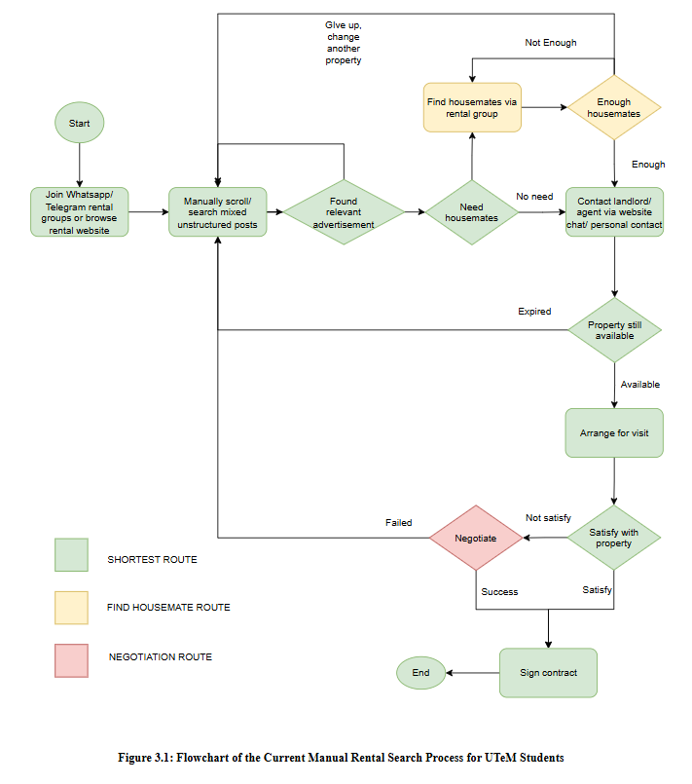
Figure 3.1: Flowchart of the Current Manual Rental Search Process for UTeM Students
As illustrated in Figure 3.1, the process contains two primary feedback loops that increase time to successful accommodation: repeated return to search channels when listings do not support semester-based rental, and a separate disconnected sub-process for finding housemates via different group chats. The paper contract step — when it occurs at all — is manually drafted, inconsistently worded, and frequently fails to include all tenants' names on the same document. These structural gaps correspond directly to the four problem statements in Chapter 1.

Detailed Problem Analysis
1. No semester-based rental framework: The decision node "Semester-based rental available?" in Fig. 3.1 often returns the value "No" which pushes back students to the search loop. Current platforms do not offer the ability to add a filter on the length of the term of the listing nor the ability to add a tenancy with a start semesters and continue for a number of 6 months. Students are left to negotiate house rentals individually and many owners will not accept leases less than 12 months (sitting on leases over the semester break is a significant financial disadvantage to many students) and often students are simply unable to get housing.
2. Manual Search for Housemates: In this disconnected ‘sub-process' (see Figure 3.1), housemates are sought for in separate WhatsApp or Telegram groups, not in conjunction with the property search process. It is unclear which properties have open slots with housemates, it is unclear how to ensure that the housemates who have agreed will actually be included in the same tenancy, and there is no clear pathway for the group to move from the housemate agreement to a tenancy.
3. No automated contracting: The step ‘Paper contract signed manually, if any exists at all' in Figure 3.1 represents the fact that contract formalization is inconsistent and prone to error. Landlords draw up the contracts ad hoc – with different terms – sometimes in a shared tenancy, the individual housemates are not always mentioned or not at all, and students simply do not know what to look for in the contracts that might be problematic for them.
4. No trusted student rental marketplace: Student accommodations are now divided into being searched on Mudah.my, Facebook Marketplace, Telegram Groups and word of mouth, simultaneously. There is no proven and assured single source of the listings, no standardised qualities of the listings made and no ways in which students can be assured of a reliable landlord and agents can transparently collect commission forms listings targeted at students.
5. Limited institutional visibility: There is no systematic way of knowing how many of the students who have been secured off campus accommodation through UTeM or if the accommodation has basic quality standards and it happens all within informal and disconnected channels.

Requirement Analysis

Data Requirement
The RentBridge system requires structured management of twelve core data entities. Table 3.1 presents the data dictionary. Because RentBridge separates authentication from role profiles, a single User record is extended by a Student, Landlord, or Agent profile. The entities introduced specifically to support RentBridge's novel features — tenancy, CoTenant, Contract, AgentVerification, AgentCommission, and HousematePost — are highlighted with an asterisk (*).

Table 3.1: Data Dictionary for RentBridge Core Entities
Entity | Attribute | Data Type | Description
User | id | INT (PK) | Unique system identifier for each registered account
User | email | VARCHAR(120) | Email address used for login and notifications
User | password_hash | VARCHAR(255) | Bcrypt hash of the account password
User | primary_role | ENUM | One of: student, landlord, agent, admin
User | status | ENUM | Account state: active, pending, suspended, rejected
Student | user_id | INT (PK, FK) | References the parent User (1:1)
Student | full_name | VARCHAR(150) | Full legal name (required for contract)
Student | matric_no | VARCHAR(20) | UTeM student matric number
Student | looking_for_housing | TINYINT(1) | Flag used by the Find Housemate feature
Landlord | user_id | INT (PK, FK) | References the parent User (1:1)
Landlord | full_name | VARCHAR(150) | Full legal name (for contract generation)
Landlord | ic_no | VARCHAR(20) | NRIC number (for contract generation)
Landlord | verified | TINYINT(1) | Whether the landlord has been verified
Agent | user_id | INT (PK, FK) | References the parent User (1:1)
Agent | staff_id | VARCHAR(20) | UTeM staff identifier of the verification agent
Agent | availability | ENUM | available, busy, off_duty
Agent | max_caseload | INT | Maximum concurrent cases the agent may hold
Property | id | INT (PK) | Unique identifier for each listed property
Property | landlord_id | INT (FK) | References the owning Landlord (User)
Property | assigned_agent_id | INT (FK, NULL) | References the assigned verification Agent, if any
Property | property_type | ENUM | room, studio, whole_unit
Property | monthly_rent | DECIMAL(8,2) | Monthly rental rate
Property | status | ENUM | pending_approval, available, reserved, rented, hidden, rejected
tenancy* | id | INT (PK) | Unique identifier for each tenancy application
tenancy* | student_id | INT (FK) | References the lead Student (User)
tenancy* | property_id | INT (FK) | References the requested Property
tenancy* | landlord_id | INT (FK) | References the property's Landlord (User)
tenancy* | agent_id | INT (FK, NULL) | References the verifying Agent, if assigned
tenancy* | duration_type | ENUM | Semester-based term: 1_semester, 2_semesters, 1_year, custom
tenancy* | start_date / end_date | DATE | Rental period derived from duration_type
tenancy* | status | ENUM | Lifecycle state (pending_landlord, agent_verifying, active, completed, ...)
CoTenant* | id | INT (PK) | Unique identifier for a named co-tenant in a tenancy
CoTenant* | tenancy_id | INT (FK) | References the parent tenancy
CoTenant* | student_id | INT (FK, NULL) | References the linked Student User (if registered)
CoTenant* | is_primary | TINYINT(1) | 1 = group leader, 0 = additional housemate
Contract* | id | INT (PK) | Unique identifier for each generated contract
Contract* | contract_code | VARCHAR(20) | Human-readable code, e.g. RB-2026-00001
Contract* | tenancy_id | INT (FK, UNIQUE) | References the confirmed tenancy (1:1)
Contract* | upload_method | ENUM | generated, external_upload, legacy_canvas
Contract* | status | ENUM | pending_signatures, active, completed, terminated
AgentVerification* | id | INT (PK) | Unique identifier for each physical inspection
AgentVerification* | tenancy_id | INT (FK) | References the tenancy being verified
AgentVerification* | agent_id | INT (FK) | References the verifying Agent (User)
AgentVerification* | outcome | ENUM | in_progress, passed, passed_with_disclosure, failed, aborted
AgentCommission* | id | INT (PK) | Unique commission record identifier
AgentCommission* | contract_id | INT (FK, UNIQUE) | References the activated Contract (1:1)
AgentCommission* | agent_id | INT (FK) | References the Agent (User) to be paid
AgentCommission* | commission_amt | DECIMAL(8,2) | 30% of one month's rent
AgentCommission* | sst_amt | DECIMAL(8,2) | 6% SST on the commission amount
AgentCommission* | total_payable | DECIMAL(8,2) | commission_amt + sst_amt
HousematePost* | id | INT (PK) | Unique identifier for each Find Housemate post
HousematePost* | poster_id | INT (FK) | References the Student (User) seeking housemates
HousematePost* | property_id | INT (FK) | References the target Property
HousematePost* | housemates_needed | INT | Number of additional co-tenants wanted
HousematePost* | status | ENUM | open, filled, cancelled, expired
Message | id | INT (PK) | Unique identifier for each chat message
Message | conversation_id | INT (FK) | References the parent Conversation between two Users
Message | sender_id | INT (FK) | References the sending User

* Entities marked with an asterisk are unique to the RentBridge feature set — semester-based tenancies, group (Find Housemate) applications, auto-generated contracts, in-person agent verification, and agent commission accounting — and are not present in general-purpose rental platforms such as those evaluated in Chapter 2.
The relationships between these entities are: User → Student / Landlord / Agent (1:1 role extension); User (landlord) → Property (1:M); Property → tenancy (1:M); User (student) → tenancy (1:M); tenancy → CoTenant ↔ User (student) (M:M resolved via the CoTenant junction); tenancy → Contract (1:1); tenancy → AgentVerification (1:1); Contract → AgentCommission (1:1); Property → HousematePost (1:M); and User ↔ User → Message (via Conversation). These relationships are represented formally as an ERD in Chapter 4.

Functional Requirement
Figure 3.2 presents the Use Case Diagram for RentBridge, identifying four system actors — Student, Landlord, Agent, and Admin — and the use cases each can perform.
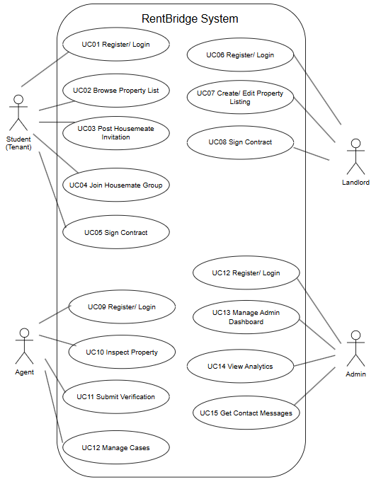
Figure 3.2: Use Case Diagram for RentBridge (4 Actors, 15 Use Cases)
Figure 3.3 presents the Context Diagram (Level 0 DFD), modelling RentBridge as a single system process and illustrating data flows to and from all 4 external entities, including UTeM as the system admin.
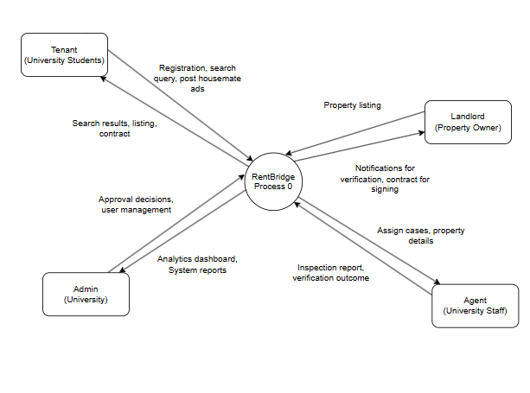
Figure 3.3: Context Diagram (Level 0 DFD) for RentBridge

From the above use cases and data flows, eleven function requirements have been identified as follows:
- Registration and authentication via emails and password shall be allowed to the user in the system according to different roles (Student/ landlord/ agent/ Admin); for student registration, there should be NRIC and Matric no.
2. The system shall enable the students to search and filter properties based on Location, Price Range, Room Type and Minimum periods of the rent in semesters.
3. On each property listing card and on the property detail the system will comprise an indicator signifying the housemate group status (number of filled slots / total number of slots) and a user will be able to create a housemate group or be able to join in a group in a specific property listing.
4. Students shall be able to request a tenancy, stating a start semester, and number of semesters rented (≥ minimum number required by the property), and the expected end shall be automatically calculated and displayed as start_date + number_of_semesters × 14 weeks.
5. Regarding pending tenancy requests, the system shall enable landlords to either approve or decline: Contract generation (FR6) and recording of transaction (FR7) shall be automatic if approved.
6. After the approval of the tenants, the system shall automatically create a PDF rental agreement, which includes: The full names and matric numbers of all tenants, their NRIC numbers, the landlord's full name and contact, rental property location, monthly rental amount per tenant, computed start and end date of the rental agreement, and a set of tenancy terms and conditions.
7. Once tenancy is approved, create a Transaction with total_fee = property.price (one month rent) and if there is a referring agent for the listing, agent_commission = 0.30 × total_fee, else 0 and platform_net = total_fee − agent_commission.
8. All the named tenants should be able to access the contract PDF from the system and landup single tenant acknowledgment status.
9. A review by a student at the end of a tenancy should be included in the system as should a star rating (1 to 5).
10. There shall be messaging between student, landlords and agents in-platform.
11. The admin module shall enable the administrator to manage users, moderate listing content, view all transactions, and create a report for the accommodation status of UTeM students for the semester with a breakdown of the number of students with confirmed accommodation for the area.

Non-Functional Requirement

Table 3.2: Non-Functional Requirements for RentBridge
Category | Requirement
Performance | The system shall return search results within 3 seconds under normal load (up to 200 concurrent users). Semester-based end-date calculation shall complete within 100 milliseconds.
Usability | The student search-to-tenancy flow shall be completable by a first-time user without external guidance, following a mobile-responsive interface with a minimum touch target size of 44×44 pixels on mobile viewports.
Reliability | The system shall maintain 99% uptime during the testing and demonstration period. Contract generation failure shall trigger an automatic retry; if the retry fails, the admin shall be notified and the tenancy shall remain in an 'approval pending contract' state.
Security | Passwords shall be hashed using bcrypt (minimum 10 salt rounds). Role-based access control shall prevent any user from accessing functions of a different role. Contract PDFs shall be accessible only to the named parties (tenants and landlord of that tenancy).
Contract Integrity | Every confirmed tenancy shall produce exactly one Contract record and exactly one Transaction record. If a tenancy is rejected or cancelled after approval, the Contract shall be voided and clearly marked as invalid.
Fee Accuracy | Platform fee and agent commission values shall be stored as DECIMAL(10,2) with no floating-point rounding. All transaction records shall be immutable once created and fully auditable by the admin.
Scalability | The database and application architecture shall accommodate at least 5,000 property listings, 20,000 registered users, and 50,000 tenancy records without structural redesign.
Compatibility | The application shall function correctly on the latest stable releases of Google Chrome, Mozilla Firefox, and Microsoft Edge, on desktop and 375px-wide mobile viewports.

Conclusion
RentBridge's complete system analysis has been provided in this chapter. Through the current situation in the student accommodation search process as modelled in Fig.3.1, it is found that there are five failure points in the search process that are directly related to problem statements in Chapter 1. The requirement analysis resulted in a data dictionary of 12 core entities (including 4 entities unique to the RentBridge feature sets: Tenancies, Contract, HousemateGroup and Transaction), a use case diagram of 4 actors and 15 use cases, a context diagram of five external entities, eleven functional requirements, and eight non-functional requirements. The system design, discussed in Chapter 4, relies on these specifications to be complete and detailed.

DESIGN

Introduction
In this chapter, the requirements that were defined in Chapter 3 are translated into the actual RentBridge system design. The chapter details the system using two phases: High-Level Design, encompassing system architecture, user interface design, navigation flow, input/output specifications, and database design, and Detailed Design, describing the software structure using a UML class diagram, and the physical database using complete DDL schema definitions.
The design is guided by the selected architectural design model (MVC) chosen in Chapter 2 and the iterative SDLC methodology chosen in Chapter 2 to meet the eleven functional requirements and eight non-functional requirements mentioned in Chapter 3. The high-level and detailed design component are focused in particular on three design elements unique to RentBridge, namely the computation of end dates based on the semantics of a tenure, the PDF generation of the contract and the division of the platform fee / agent commission.

High-Level Design

System Architecture
RentBridge adopts a three-tier MVC architecture. Figure 4.1 illustrates the system architecture, extending the standard three-tier model with a File Storage component to support the contract PDF generation required by FR6.
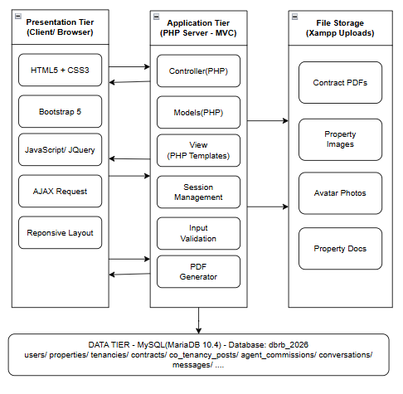
Figure 4.1: System Architecture of RentBridge (Three-Tier MVC with File Storage)
The Presentation Layer is comprised of HTML, CSS3 and other pieces that are visualised in the web browser of the user, such as the housemate group management interface and the distinct dashboards for different users and roles. Controllers for receiving HTTP requests and Models/Services for any kind of business logic are placed in the Application Layer which is PHP. The Model layer has a number of specialised services:
• Semester Calculation Service: generates end_date based on start_date and total_semesters (end_date = start_date + (total_semesters × 6 calendar months)), with minimum allows for is one semester (FR4).
Contract Generation Service: After a Tenancy is approved (FR5/FR6), retrieves all Tenancies data, adds data to the PDF template using PDFKit library, writes to a PDF file on the server-side storage and creates Contract data base record.
• Transaction Service: calculates and writes the platform fee, redemption rights of agents and the platform net amount for every confirmed tenancy (FR7).
The Data Layer contains the MySQL relational database and a separate location on the server where the Contract PDFs are stored. To maintain performance in the database, the PDF Contract Files are stored on the server and only the path to the file is stored in Contract.pdf_path. This is an architecture that has a direct impact on maintainability and scalability non-functional requirements.

User Interface Design
The design is based entirely on two factors: the first is ensuring that a first-time student user can easily navigate the RentBridge UI (usability NFR) and the second being to ensure a user can immediately see the features that make RentBridge more than just a rental platform (semester filter, house mate group slots). The wireframe of the homepage and search results is shown in Figure 4.2.
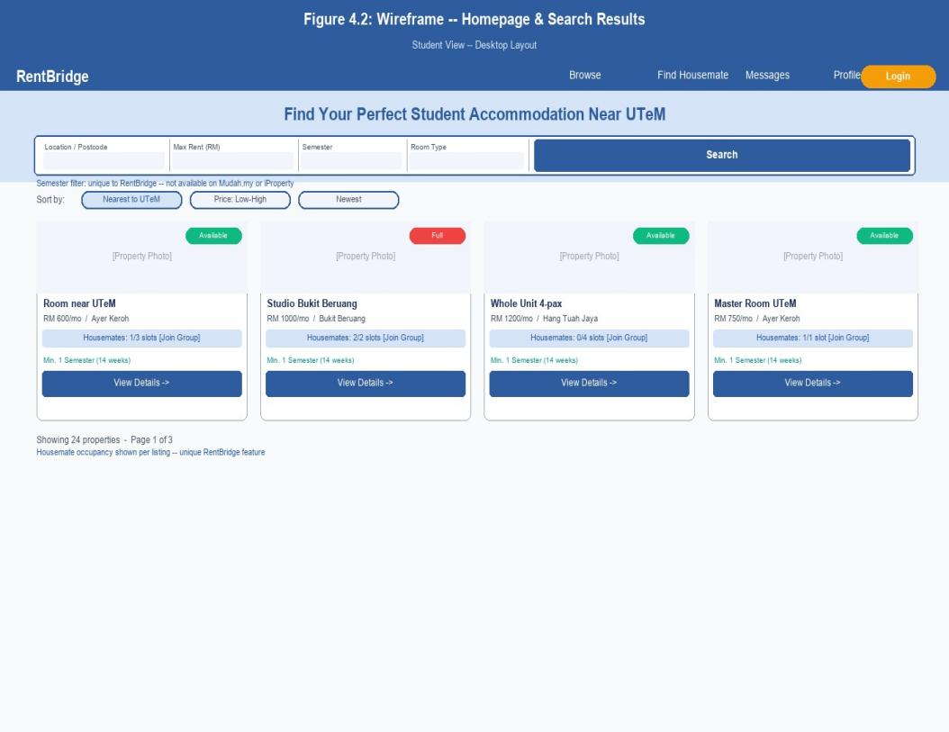
Figure 4.2: Wireframe — Homepage / Search Results (Student View)
The homepage wireframe introduces two elements not present in any evaluated competitor: the semester filter in the search bar, and the housemate occupancy indicator on each property card (e.g., 'Housemates: 1/3'). These elements immediately communicate the platform's value proposition to students without requiring them to navigate away from the search results view. Figure 4.3 presents the property detail and tenancy wireframe.
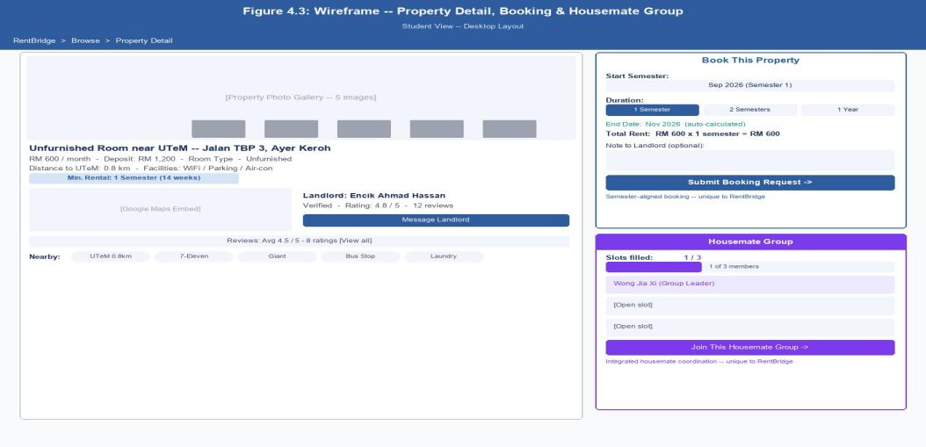
Figure 4.3: Wireframe — Property Detail, tenancy & Housemate Group (Student View)
The property detail screen consolidates all information needed to make a decision on a tenancy, such as the photo gallery, key property details (price, location, min semesters), construction of the semester period with auto calculation of end date, housemate group panel with list of confirmed member and remaining slots, past reviews and the tenancy/housemate join actions. This contract acceptance status and tenancy status is displayed at the bottom of the screen, which means that all parties can easily see progress on the contract without having to go to another section of the screen.

Navigation Design
Figure 4.4 presents the navigation design (site map) for all four user roles in RentBridge. The site map reflects the role-based access control requirement established in the security NFR: each dashboard and sub-section is accessible only to the appropriate role after authentication.
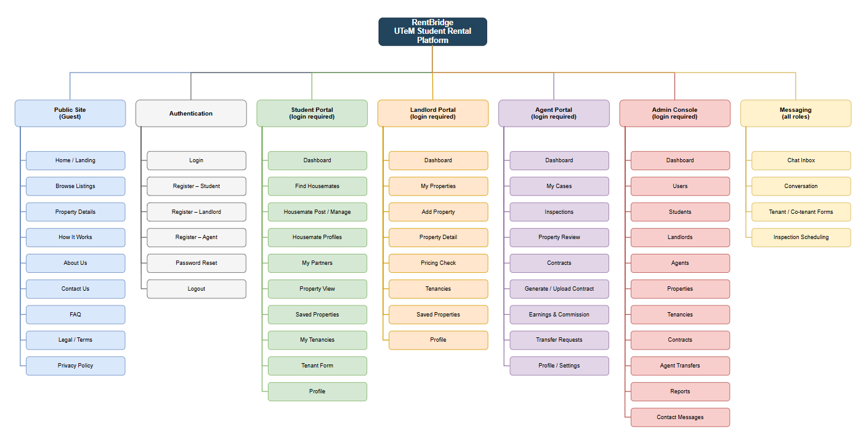
Figure 4.4: Navigation Flow (Site Map) for RentBridge — 4 User Roles
All users enter through the shared Landing/Login/Register screen. The student flow progresses from Search through Property Detail, tenancy Request, Housemate Group, Contract Acceptance, and Review in that sequence, reflecting the real-world student journey from search to confirmed tenancy. The landlord flow provides listing management, tenancy request handling with approval that triggers contract generation, and payment record access. The agent flow focuses on listing referral and commission tracking, with the Commission Tracker updating automatically when the Transaction Service processes a confirmed tenancy. The admin flow provides system-wide management and the UTeM accommodation report module.

Input Design

Table 4.1: Input Design and Validation Rules
Form / Screen | Input Field | Input Type | Validation Rule
Registration | NRIC Number | Text | Required for all users; exactly 12 digits; unique across all users
Registration | Matric Number | Text | Required for Student role only; must match UTeM matric number format
Registration | Role Selection | Select | Required; one of: Student, Landlord, Agent, Admin
Property Listing | Min. Semesters | Number | Required; integer ≥ 1; system enforces this as tenancy minimum
Property Listing | Capacity | Number | Required; integer ≥ 1; becomes slots_total for HousemateGroup
Property Listing | Price (RM/month/person) | Number | Required; positive decimal (DECIMAL precision)
Tenancy Request | Start Semester | Select | Required; from list of upcoming UTeM semesters
Tenancy Request | Duration (semesters) | Number | Required; integer ≥ property.min_semesters; system rejects lower values
Housemate Group | Join Request | Button action | Student must be authenticated; group.slots_filled < group.slots_total
Contract Acknowledge | Acknowledgement | Checkbox | Required; all named tenants must individually check before contract is marked 'accepted_all'
Review Submission | Rating | Star select | Required; integer 1–5; server-side CHECK constraint enforces range
Review Submission | Comment | Textarea | Optional; maximum 500 characters; HTML stripped server-side

Output Design
Table 4.2: Output Design and Classification
Output | Description | Recipient | Classification
Property Search Results | Filtered property cards with housemate slot count (x/y), minimum semesters, and price visible | Student | Ad-hoc
Housemate Group Status | Live count of confirmed housemates vs. total capacity slots, visible on listing and group pages | Student (public) | Ad-hoc
Auto-Generated Contract PDF | Standardised PDF agreement naming all tenants (with IC and matric), landlord, property, monthly rent, full rental period (semester-aligned dates), and terms | All tenants + Landlord | Triggered on tenancy approval (FR6)
tenancy Confirmation | Status update (pending / approved / rejected) displayed to student and landlord immediately | Student, Landlord | Ad-hoc (event-driven)
Platform Fee Summary | Breakdown: total_fee (1× monthly rent), agent_commission (30%), platform_net (70%), shown to landlord and agent separately | Landlord, Agent | Triggered on tenancy approval (FR7)
Agent Commission Statement | Running total and list of confirmed referrals with commission earned per tenancy | Agent | Periodic (dashboard view)
UTeM Accommodation Report | Count of confirmed student tenancies by area, semester, and property type for the selected semester | Admin / UTeM | Periodic (per semester, on demand)

Database Design

Entity-Relationship Diagram
Figure 4.5 presents the ERD for RentBridge. The diagram covers 30 entities including the four RentBridge-specific entities introduced in the data requirement (Chapter 3, Table 3.1): Tenancies, Contract, HousemateGroup, and Transaction.
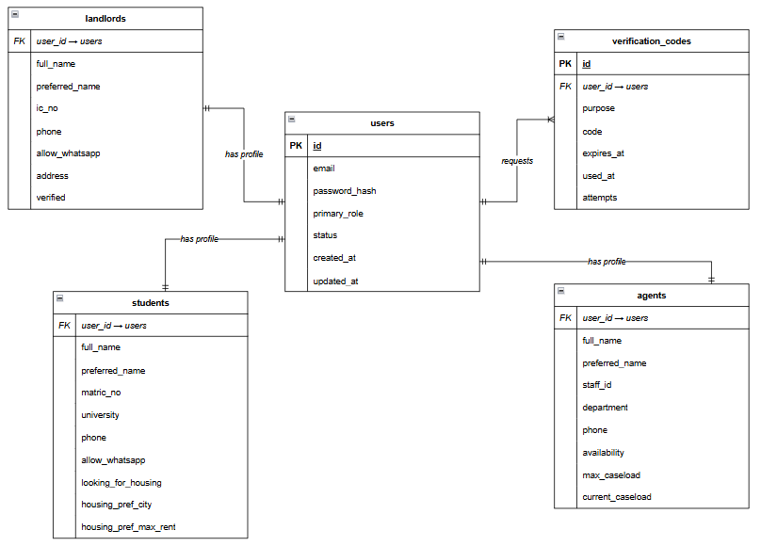
Figure 4.1: ERD Part 1- User and Identity
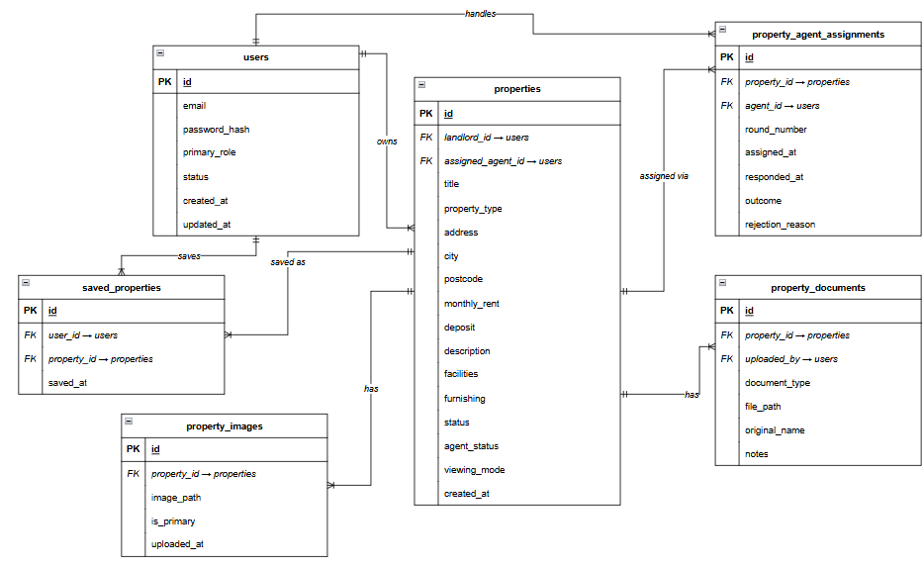
Figure 4.2: ERD Part 2- Property and Listing

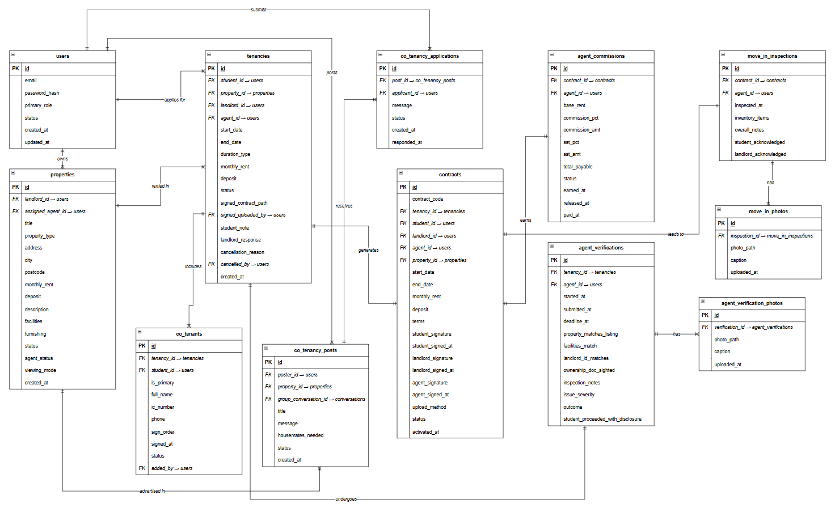
Figure 4.3: ERD Part 3- Tenancy, Contract and Inspection

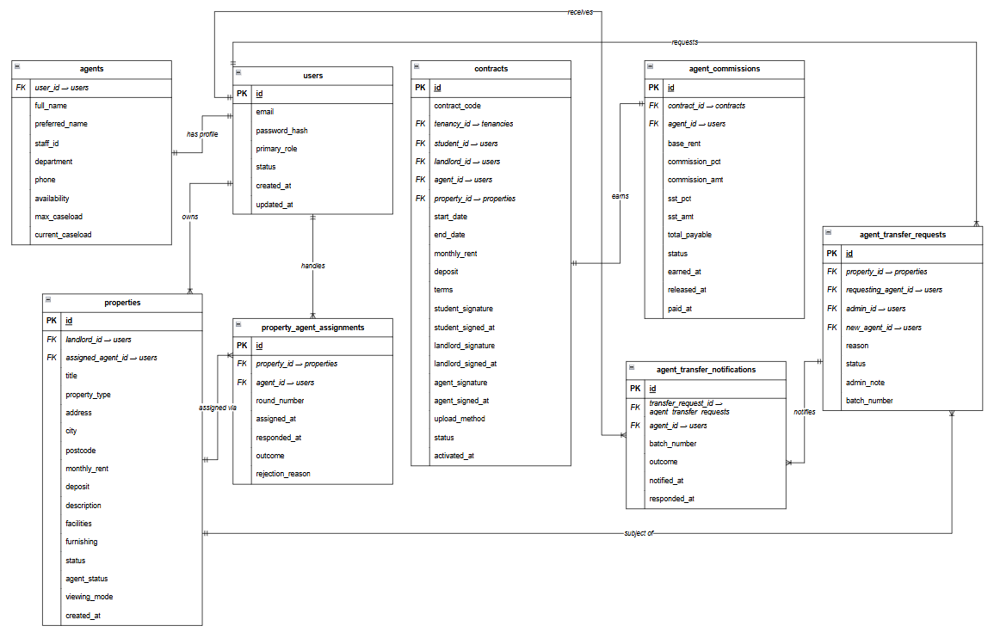
Figure 4.4: ERD Part 4- Agent Operations
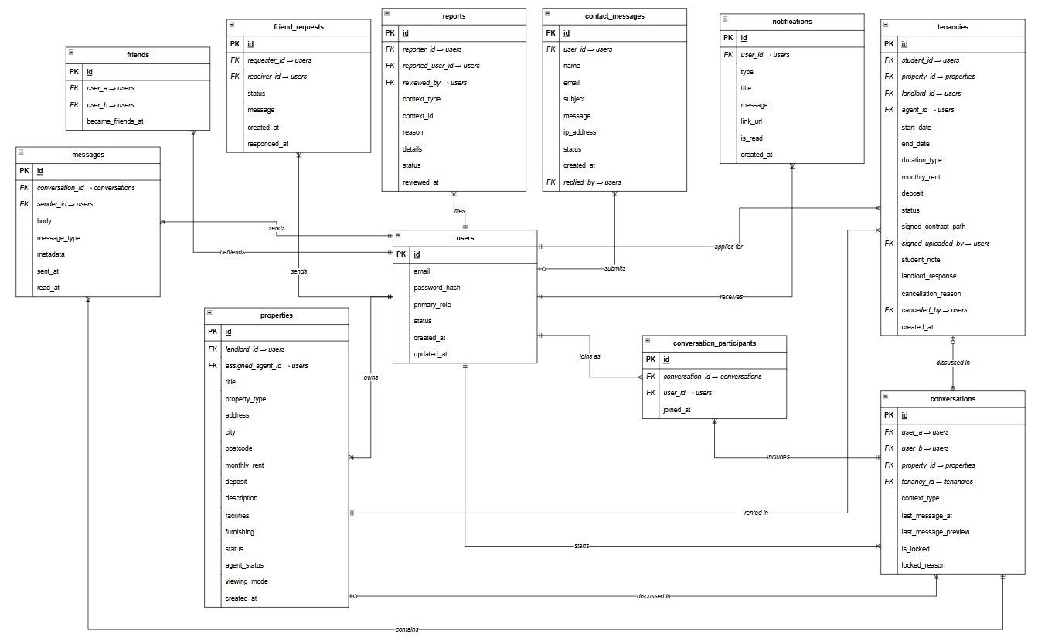
Figure 4.5: ERD Part 5- Communications and Social

BR-U — User & Account Management
BR-U1. Every user account must have exactly one primary_role selected at registration from: student, landlord, agent, or admin. A user cannot hold multiple primary roles simultaneously.
BR-U2. A user account status must be one of active, pending, suspended, or rejected. Only active accounts may log in and perform transactions. New registrations default to active unless manual approval is configured.
BR-U3. Each role type (student, landlord, agent) requires a corresponding profile record in its sub-table (students, landlords, agents). A user record without a matching sub-table entry is considered incomplete and may not perform role-specific actions.
BR-U4. A student profile must include a valid Malaysian matric number (matric_no) and defaults to university UTeM. The matric number must be unique across all student records.
BR-U5. A landlord profile must include a valid Malaysian IC number (ic_no) and must be verified (verified = 1) by an admin before their property listings are made publicly visible.
BR-U6. An agent profile must include a staff_id and department. An agent's availability must be one of available, busy, or off_duty. The system must not assign new cases to agents whose status is busy or off_duty.
BR-U7. An agent's current_caseload must never exceed their max_caseload (default: 5). The system must check caseload capacity before assigning a new property or tenancy to an agent.
BR-U8. A verification_code record is tied to a single user and purpose (e.g., password_change, email_verify). Each code has a fixed expiry (expires_at) and an attempt counter. A code becomes invalid once used (used_at is set) or expired.

BR-P — Property Management
BR-P1. A property must be created by a verified landlord. The landlord_id in properties must reference a user with primary_role = 'landlord' who has verified = 1 in the landlords table.
BR-P2. A property's property_type must be one of: room, studio, or whole_unit. This value cannot be changed after a tenancy has been accepted.
BR-P3. A property's furnishing level must be one of: none, partial, or full.
BR-P4. A property must pass through the approval lifecycle in order. The valid status transitions are:
- pending_approval → available (approved by admin)
- pending_approval → rejected (rejected by admin)
- available → booked (when a tenancy is accepted by landlord)
- booked → rented (when contract is activated)
- rented → available (when contract completes)
- available → hidden (landlord hides the listing)
- hidden → available (landlord re-activates)
BR-P5. A property may only have one assigned_agent_id at a time. When an agent is assigned, the agent_status is set to pending, then progresses to inspecting, accepted, or rejected.
BR-P6. If an agent rejects a property assignment or does not respond within the timeout window, the property's agent_status is set to timeout and the system initiates a new assignment round (assignment_round increments by 1).
BR-P7. A property must have at least one image uploaded to property_images before it can be approved by admin. Exactly one image must be flagged as is_primary = 1.
BR-P8. Property documents (in property_documents) must be of type ownership_proof, utility_bill, or other. Landlords must upload at least one ownership document before requesting approval.
BR-P9. A student may save any available property to saved_properties. Each (user_id, property_id) combination must be unique — a student may not save the same property more than once.
BR-P10. A property's viewing_mode determines who conducts property viewings: landlord_led, agent_led, or either. This is set by the landlord at listing creation and governs how tenancy viewing appointments are arranged.

BR-BK — tenancy Management
BR-BK1. Only a student user may submit a tenancy request. The student_id in tenancies must reference a user with primary_role = 'student'.
BR-BK2. A tenancy may only be placed on a property with status = 'available'. Properties that are booked, rented, hidden, rejected, or pending_approval cannot receive new tenancies.
BR-BK3. A tenancy's duration_type must be one of: 1_semester, 2_semesters, 1_year, or custom. For semester-based types, the end_date is calculated automatically as: start_date + (number_of_semesters × 6 months).
BR-BK4. A tenancy must have start_date < end_date. The end_date must be set at the time of tenancy creation and cannot be reduced after landlord acceptance.
BR-BK5. A tenancy's monthly_rent and deposit are locked at the time of tenancy and must match the property's monthly_rent and deposit values at the time the tenancy was submitted.
BR-BK6. A tenancy progresses through exactly 14 defined statuses in sequence:
- pending_landlord → rejected_by_landlord (terminal)
- pending_landlord → pending_agent → agent_assigned → agent_verifying → agent_verified → contract_pending → active → completed (terminal)
- agent_verified → verification_failed (terminal)
- agent_verifying → inspection_aborted (terminal)
- Any active state → cancelled_by_student / cancelled_by_landlord / cancelled_by_admin (terminal)
BR-BK7. When a tenancy is rejected_by_landlord, cancelled_*, verification_failed, or inspection_aborted, a cancellation_reason must be recorded and the property status reverts to available.
BR-BK8. A cancellation must record which user performed it in cancelled_by. Admin cancellations must provide a cancellation reason.
BR-BK9. If an agent rejects a tenancy assignment, that agent's user_id is appended to the tenancy's rejected_agents JSON list and must not be re-assigned to the same tenancy.

BR-CT — Co-tenancy & Housemate Post
BR-CT1. Each tenancy may have one or more co-tenants recorded in co_tenants. Exactly one co-tenant record must have is_primary = 1, representing the group leader who submitted the tenancy. All remaining co-tenants have is_primary = 0.
BR-CT2. Every co-tenant record must include a full name and a valid Malaysian IC number (ic_number in the format YYMMDD-SS-NNNN). These details are used in the tenancy contract and must be accurate.
BR-CT3. A co-tenant's status must progress from pending → signed after they sign the contract. A co-tenant may be set to removed before contract activation, but not after.
BR-CT4. Co-tenants are assigned a sign_order (integer) that determines the sequence in which they must sign the contract. Signing must proceed in ascending sign_order — a co-tenant may not sign until all preceding co-tenants (lower sign_order) have signed.
BR-CT5. A co-tenancy post (co_tenancy_posts) may only be created for a property that is available or booked. The poster_id must be a student who has an active or pending tenancy for that property.
BR-CT6. A co-tenancy post must specify the number of additional housemates wanted (housemates_needed ≥ 1). When the required number of applications are accepted, the post's status must be automatically set to filled.
BR-CT7. A co-tenancy post status must be one of: open, filled, cancelled, or expired. Only open posts may receive new applications from other students.
BR-CT8. A student may not apply (co_tenancy_applications) to a post they created. Each (post_id, applicant_id) pair must be unique — a student may not apply to the same post more than once.
BR-CT9. A co-tenancy application status must be pending, accepted, or rejected. When an application is accepted, the post owner must reject all remaining pending applications if the housemates_needed count is reached.
BR-CT10. A housemate group may have a dedicated group conversation (group_conversation_id → conversations) with context_type = 'housemate_group'. This conversation is created when the post is created and remains active until the post is closed.

BR-AG — Agent Assignment
BR-AG1. An agent may only be assigned to a property or tenancy if their availability = 'available' and current_caseload < max_caseload.
BR-AG2. Every property assignment is recorded in property_agent_assignments. When a new round begins, a new row is inserted with an incremented round_number. Historical assignment attempts are never deleted.
BR-AG3. An assignment outcome must be one of: pending, accepted, rejected, timeout, or reassigned. An agent has a fixed response window; if no response is received, the outcome is set to timeout and the next round begins.
BR-AG4. When an agent accepts an assignment (outcome = 'accepted'), the agent's current_caseload increments by 1 and the property's assigned_agent_id is set.
BR-AG5. An agent transfer request (agent_transfer_requests) may be raised by the currently assigned agent if they can no longer handle the case. The request requires a written reason and must be approved by an admin before the transfer proceeds.
BR-AG6. An agent transfer status must follow: pending_admin → approved → finding_agent → completed, or pending_admin → rejected. Only an admin can move the status from pending_admin.
BR-AG7. When an admin approves a transfer, the system notifies eligible agents via agent_transfer_notifications. Each notification records the agent's response (pending, accepted, declined). The first agent to accept becomes the new assigned agent.

BR-AV — Agent Verification (Property Inspection)
BR-AV1. An agent verification record (agent_verifications) is created when a tenancy is created and moves to the agent_verifying status. One Tenancy can have only one verification record at a time.
BR-AV2. The verification has to be completed within 5 days after started_at. If the submission is not made by the due date the tenancy automatically becomes inspection_aborted.
BR-AV3. An agent verification is models five booleans corresponding to five physical conditions:
- Physical property is a match for the listing description.
Correct and reachable address (property_address_correct).
- Facilities_match: this icon means there are the facilities designated during repair.
- Landlord_id_matches means landlord's personalidad document matches with their profile.
- Document of ownership of premises/tenancy document_ownership_of_premises ownership_doc_sighted
BR-AV4. One of the following must be the verification result:
- The inspection is still in progress.
- All checks were successful, and there were no problems.
- The student should be informed of minor deficiencies found.
BR-AV5. When the outcome is ‘passed_with_disclosure' - the system shall inform the student. Before the tenancy proceeds to contract_pending, the student's decision (student_proceeded_with_disclosure) must be recorded.
BR-AV6. At inspection the agent should upload at least one photo (agent_verification_photos) as a proof. Once the verification has been turned in, photos cannot be removed!
BR-AV7. The severity of the issue should be none, minor, or major. If the severity is a major severity then outcome is ‘failed'. Passing a minor item will give outcome = 'passed_with_disclosure'.

BR-CN — Contract Management
BR-CN1. A contract is created automatically when a tenancy reaches contract_pending status. The contract_code follows the format RB-YYYY-NNNNN (e.g., RB-2026-00001) and must be globally unique.
BR-CN2. A contract must name all three parties: the primary student (student_id), the landlord (landlord_id), and the supervising agent (agent_id). All three must sign for the contract to become active.
BR-CN3. A contract's start_date and end_date must match the corresponding tenancy's dates and cannot be modified after contract creation.
BR-CN4. The contract's monthly_rent and deposit are locked from the approved tenancy record and cannot be changed after contract generation.
BR-CN5. Signing must follow a defined sequence: student signs first, then landlord, then agent. Each party's signature timestamp and IP address are recorded separately. A party may not sign if the preceding party has not yet signed.
BR-CN6. A contract status must be one of: pending_signatures, active, completed, or terminated.
- pending_signatures → active: triggered when all three parties have signed
- active → completed: triggered when end_date is reached
- active → terminated: admin-initiated early termination
BR-CN7. When a contract becomes active, the tenancy status is updated to active, the property status is updated to rented, and the agent commission record is marked earned.
BR-CN8. A contract's upload_method must be one of: generated (system PDF), external_upload (pre-signed PDF uploaded by agent), or legacy_canvas (canvas-based signing). The upload method is set at contract creation and cannot be changed.
BR-CN9. A SHA-256 doc_hash must be computed and stored when any contract PDF is generated or uploaded. This hash is used to detect tampering if the document is later re-verified.

BR-MI — Move-In Inspection
BR-MI1. A move-in inspection (move_in_inspections) is created by the assigned agent after the contract is activated. Exactly one move-in inspection may exist per contract.
BR-MI2. The move-in inspection records inventory_items as a JSON array of objects, each containing the item name, condition, and notes. This serves as the official inventory record for the property at tenancy commencement.
BR-MI3. Both the student and the landlord must acknowledge (student_acknowledged, landlord_acknowledged) the move-in inspection report. The timestamps of acknowledgement are recorded separately. No further modifications may be made to the inspection after both parties acknowledge.
BR-MI4. At least one photo must be uploaded to move_in_photos per inspection as evidence of the property's condition at move-in.

BR-COM — Agent Commission
BR-COM1. Exactly one commission record (agent_commissions) is created per contract, at the time the contract is generated.
BR-COM2. The commission amount is calculated as: commission_amt = base_rent × (commission_pct / 100), where commission_pct defaults to 100% (equivalent to one month's rent). SST is then calculated as: sst_amt = commission_amt × (sst_pct / 100), where sst_pct defaults to 6%. The total_payable = commission_amt + sst_amt.
BR-COM3. The base_rent is the total monthly rent across all co-tenants for the property (not per-room rent), as noted in the column comment.
BR-COM4. Commission status must progress in order: pending → earned → released → paid.
- earned: set when the contract activates (earned_at recorded)
- released: set when admin approves the payout (released_at recorded)
- paid: set when actual payment is made to the agent (paid_at and payment_ref recorded)
BR-COM5. An admin must explicitly approve a commission release before payment is made. The system must not automatically release or pay commissions without admin action.

BR-MS — Messaging & Notifications
BR-MS1. A conversation between two users (user_a, user_b) is uniquely identified by the pair of user IDs. By convention, user_a always holds the lower user_id to prevent duplicate conversation records for the same pair.
BR-MS2. A conversation must have a context_type from: property_inquiry, tenancy, friend, agent_case, contract_prep, housemate_group, or other. Context-linked conversations (e.g., tenancy context) must reference the relevant property_id or tenancy_id.
BR-MS3. A conversation may be locked (is_locked = 1) by the system or admin. Locked conversations do not accept new messages. A locked_reason must be provided when locking.
BR-MS4. For group conversations (housemate groups), all participants are recorded in conversation_participants. A user may only send messages in conversations where they are a listed participant.
BR-MS5. A notification (notifications) must be delivered to a specific user (user_id) and must carry a type (e.g., tenancy_request, contract_ready), a title, a message body, and optionally a link_url. Notifications default to is_read = 0 and must be explicitly marked read by the recipient.
BR-MS6. A contact message (contact_messages) may be submitted by a guest (no account) or a logged-in user. If submitted by a logged-in user, user_id is recorded; otherwise it is NULL. The status must progress: new → read → replied / archived. A replied_by user ID must be set when the status is replied.

BR-SC — Social Connections
BR-SC1. A friendship (friends) is established between exactly two users, stored with the lower user_id as user_a and the higher as user_b. This canonical ordering prevents duplicate friendship records.
BR-SC2. A friendship can only be created from an accepted friend request (friend_requests with status = 'accepted'). Direct insertion into friends without a corresponding accepted request is not permitted.
BR-SC3. A friend request status must be one of: pending, accepted, rejected, or cancelled. Only the request sender may cancel (cancelled) a pending request. Only the receiver may accept or reject it.
BR-SC4. A user may not send a friend request to themselves (requester_id ≠ receiver_id). A duplicate pending request between the same pair of users must be prevented.

BR-RP — Reporting & Moderation
BR-RP1. Any authenticated user may submit a report (reports) against another user. A report must specify a reason from: harassment, scam, fake_information, misconduct, fraud, or other.
BR-RP2. A report may optionally carry a context_type (tenancy, message, or general) and a context_id referencing the related record. Contextual reports must have a valid context_id.
BR-RP3. A report status must follow: pending → reviewed → dismissed or actioned. Only an admin may change the status from pending. When a report is actioned or dismissed, reviewed_by and reviewed_at must be recorded.
BR-RP4. An actioned report outcome may result in suspension of the reported user (users.status = 'suspended'). A suspended user may not log in or perform any transactions until reinstated by an admin.

Normalization
The RentBridge schema is normalized to Third Normal Form (3NF):
- 1NF: All attributes are atomic. Tenant names are stored as individual User records linked to Property through Tenancies, rather than as a comma-separated string within the tenancy record.
- 2NF: All non-key attributes are fully functionally dependent on the primary key of their table. The Tenancies junction table with composite primary key (tenancy_id, student_id) ensures student attributes are not partially stored in the tenancy table.
- 3NF: No transitive dependencies. Agent contact details reside in the User table and are accessed via agent_id foreign keys in Property and Transaction; they are not duplicated in either the Transaction or the Contract record.

Detailed Design

Software Design (Class Diagram)
Figure 4.6 presents the UML class diagram for the RentBridge core domain classes.
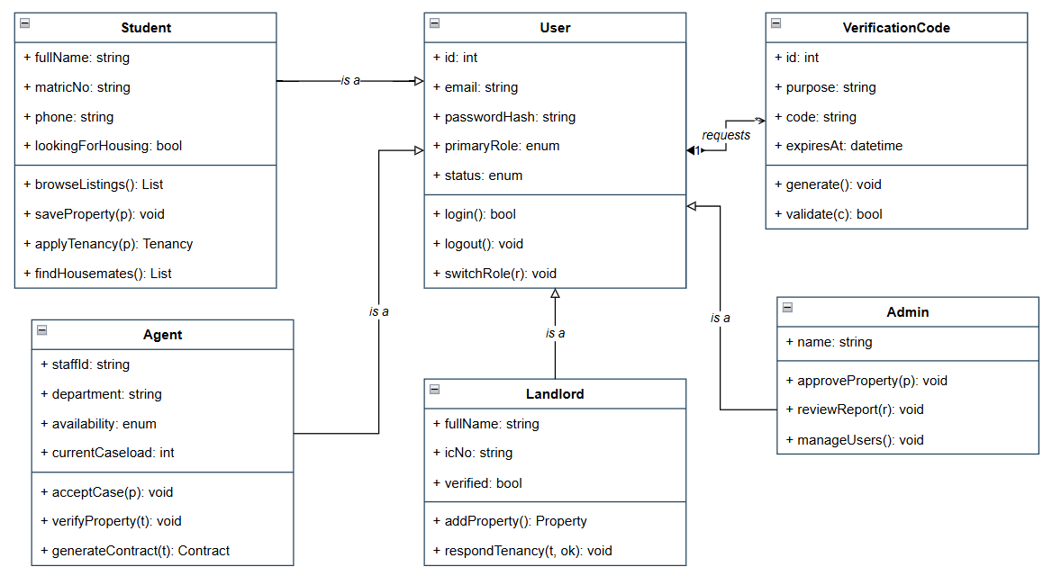
Figure 4.6: UML Diagram Part 1- User and Identity
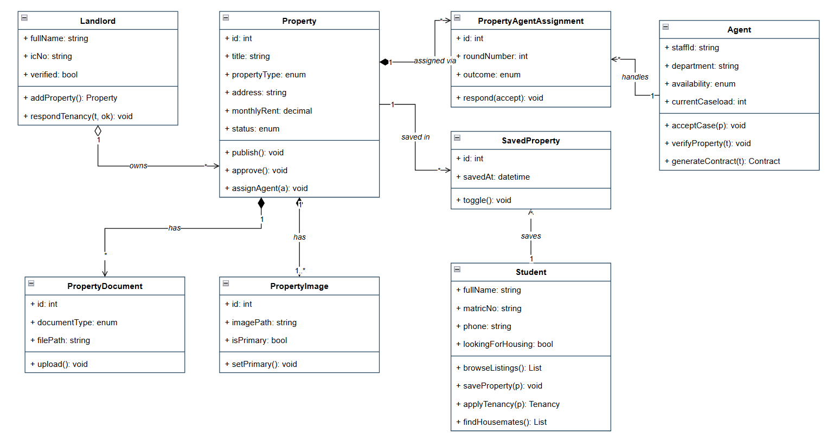
Figure 4.7: UML Diagram Part 2- Property and Listing
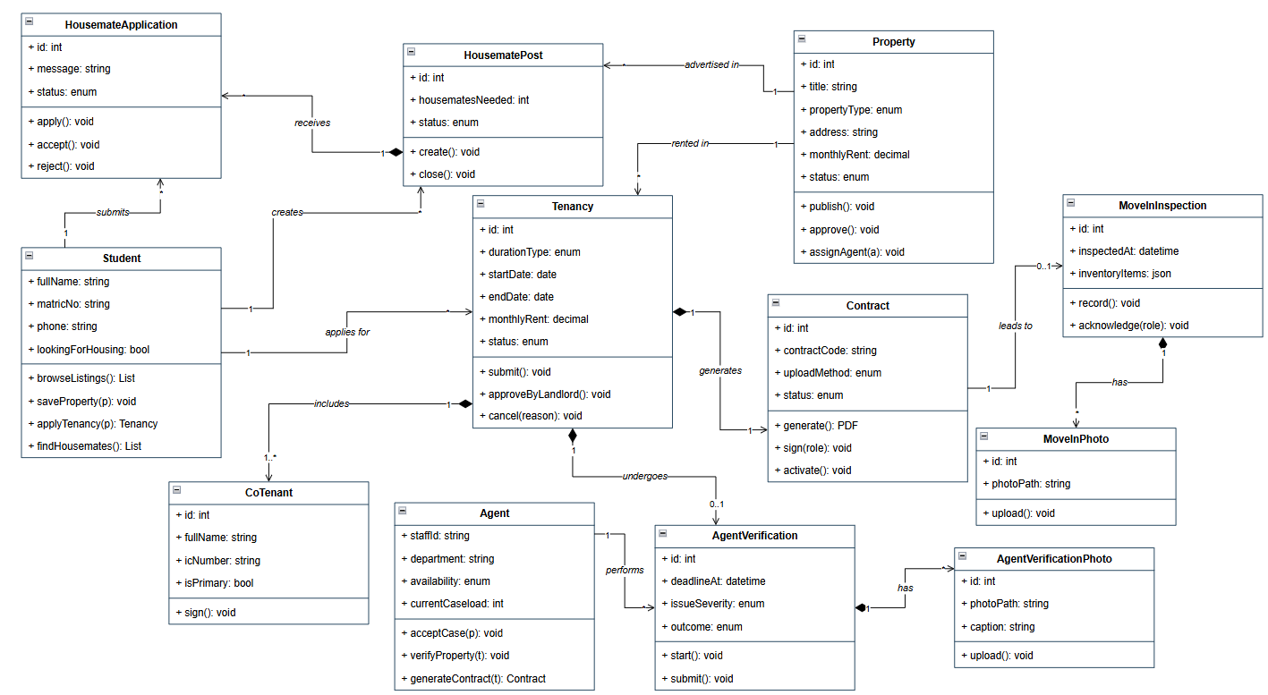
Figure 4.8: UML Diagram Part 3- Tenancy, Contract and Inspection
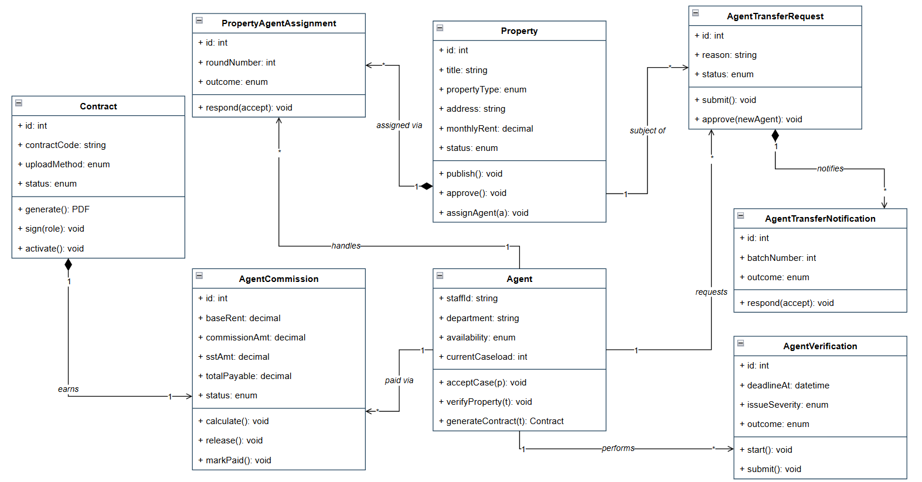
Figure 4.9: UML Diagram Part 4- Agent Operations and Finance
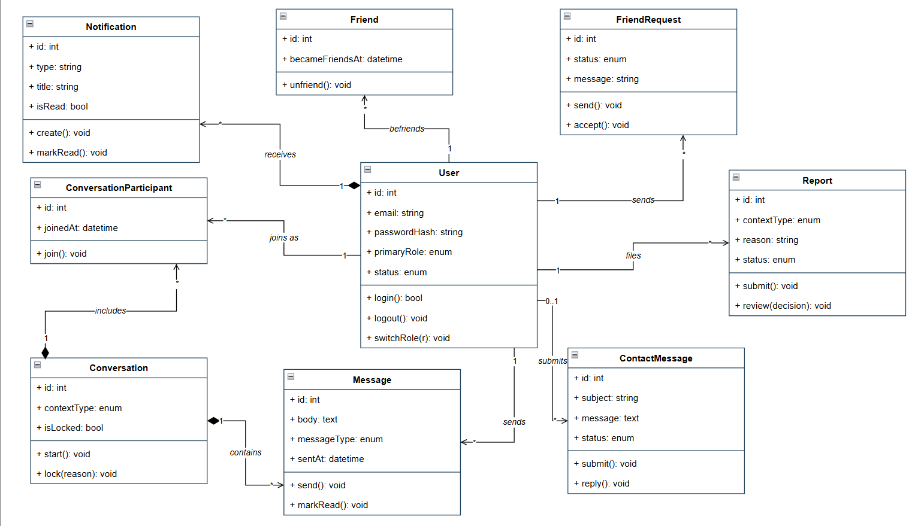
Figure 4.10: UML Diagram Part 5- Communication and Social

These class hierarchy places User as the base class with Student, Landlord, and Agent as specialisations sharing authentication and profile behaviours. Key method preconditions and postconditions:
- Student.submittenancy(propId, semesters): Precondition — semesters ≥ Property.minSemesters AND housemate group is full OR property capacity is 1. Postcondition — tenancy created with status 'pending', end_date computed, Tenancies records created for all group members.
- Student.joinHousemateGroup(groupId): Precondition — group.slotsFilled < group.slotsTotal AND student is not already in the group. Postcondition — student linked to group, slotsFilled incremented.
- Landlord.respondTotenancy(id, 'approved'): Postcondition — triggers Contract.generate() and Transaction.process() in sequence; tenancy status updated to 'approved'; Property status updated to 'booked'.
- Contract.generate(): Retrieves all Tenancies records for the tenancy, builds a PDF document using the contract template populated with all tenant names, IC numbers, matric numbers, and rental period data, writes the PDF to file storage, creates the Contract database record with pdf_path and status 'generated', calls sendToTenants() to notify all named parties.
- Transaction.process(): Computes total_fee = Property.price (one month's rent); agent_commission = total_fee × 0.30 if Property.agentId is not null, otherwise 0.00; platform_net = total_fee − agent_commission. Creates the Transaction record with DECIMAL precision values.

Physical Database Design (DDL Schema)

The physical database is implemented in MySQL / MariaDB under the schema dbrb_2026 and comprises 30 InnoDB tables. The complete Data Definition Language (DDL), generated from the live database, is presented by subsystem in Figures 4.7 to 4.11. Each statement lists the column definitions followed by the PRIMARY KEY and FOREIGN KEY constraints, including their referential actions.

Figure 4.7: Physical Schema (DDL) — User & Identity
CREATE TABLE `users` (
`id` int(11) NOT NULL,
`email` varchar(120) NOT NULL,
`password_hash` varchar(255) NOT NULL,
`primary_role` enum('student','landlord','agent','admin') NOT NULL,
`status` enum('active','pending','suspended','rejected') NOT NULL DEFAULT 'active',
`last_used_role` enum('student','landlord','agent','admin') DEFAULT NULL,
`created_at` timestamp NOT NULL DEFAULT current_timestamp(),
`updated_at` timestamp NOT NULL DEFAULT current_timestamp() ON UPDATE current_timestamp(),
PRIMARY KEY (`id`)
) ENGINE=InnoDB DEFAULT CHARSET=utf8mb4;

CREATE TABLE `students` (
`user_id` int(11) NOT NULL,
`full_name` varchar(150) NOT NULL,
`preferred_name` varchar(50) NOT NULL DEFAULT '',
`avatar_path` varchar(255) DEFAULT NULL,
`matric_no` varchar(20) NOT NULL,
`university` varchar(80) NOT NULL DEFAULT 'UTeM',
`phone` varchar(20) NOT NULL,
`allow_whatsapp` tinyint(1) NOT NULL DEFAULT 0,
`looking_for_housing` tinyint(1) NOT NULL DEFAULT 0,
`housing_pref_city` varchar(80) DEFAULT NULL,
`housing_pref_max_rent` decimal(8,2) DEFAULT NULL,
`housing_pref_move_in` date DEFAULT NULL,
`housing_bio` varchar(255) DEFAULT NULL,
PRIMARY KEY (`user_id`),
FOREIGN KEY (`user_id`) REFERENCES `users` (`id`) ON DELETE CASCADE
) ENGINE=InnoDB DEFAULT CHARSET=utf8mb4;

CREATE TABLE `landlords` (
`user_id` int(11) NOT NULL,
`full_name` varchar(150) NOT NULL,
`preferred_name` varchar(50) NOT NULL DEFAULT '',
`avatar_path` varchar(255) DEFAULT NULL,
`ic_no` varchar(20) NOT NULL,
`phone` varchar(20) NOT NULL,
`allow_whatsapp` tinyint(1) NOT NULL DEFAULT 0,
`address` varchar(255) DEFAULT NULL,
`verified` tinyint(1) NOT NULL DEFAULT 0,
PRIMARY KEY (`user_id`),
FOREIGN KEY (`user_id`) REFERENCES `users` (`id`) ON DELETE CASCADE
) ENGINE=InnoDB DEFAULT CHARSET=utf8mb4;

CREATE TABLE `agents` (
`user_id` int(11) NOT NULL,
`full_name` varchar(150) NOT NULL,
`avatar_path` varchar(255) DEFAULT NULL,
`preferred_name` varchar(50) NOT NULL DEFAULT '',
`staff_id` varchar(20) NOT NULL,
`department` varchar(80) NOT NULL,
`phone` varchar(20) NOT NULL,
`allow_whatsapp` tinyint(1) NOT NULL DEFAULT 0,
`availability` enum('available','busy','off_duty') NOT NULL DEFAULT 'available',
`max_caseload` int(11) NOT NULL DEFAULT 5,
`current_caseload` int(11) NOT NULL DEFAULT 0,
PRIMARY KEY (`user_id`),
FOREIGN KEY (`user_id`) REFERENCES `users` (`id`) ON DELETE CASCADE
) ENGINE=InnoDB DEFAULT CHARSET=utf8mb4;

CREATE TABLE `verification_codes` (
`id` int(11) NOT NULL,
`user_id` int(11) NOT NULL,
`purpose` varchar(40) NOT NULL COMMENT 'e.g. password_change, email_verify',
`code` varchar(10) NOT NULL,
`expires_at` timestamp NOT NULL DEFAULT current_timestamp() ON UPDATE current_timestamp(),
`used_at` timestamp NULL DEFAULT NULL,
`attempts` int(11) NOT NULL DEFAULT 0,
`created_at` timestamp NOT NULL DEFAULT current_timestamp(),
`ip_address` varchar(45) DEFAULT NULL,
PRIMARY KEY (`id`),
FOREIGN KEY (`user_id`) REFERENCES `users` (`id`) ON DELETE CASCADE
) ENGINE=InnoDB DEFAULT CHARSET=utf8mb4;

Figure 4.8: Physical Schema (DDL) — Property & Listing
CREATE TABLE `properties` (
`id` int(11) NOT NULL,
`landlord_id` int(11) NOT NULL,
`title` varchar(150) NOT NULL,
`property_type` enum('room','studio','whole_unit') NOT NULL,
`address` text NOT NULL,
`city` varchar(80) NOT NULL,
`postcode` varchar(10) NOT NULL,
`state` varchar(50) NOT NULL DEFAULT 'Melaka',
`latitude` decimal(10,7) DEFAULT NULL,
`longitude` decimal(10,7) DEFAULT NULL,
`maps_url` varchar(500) DEFAULT NULL,
`monthly_rent` decimal(8,2) NOT NULL,
`deposit` decimal(8,2) NOT NULL DEFAULT 0.00,
`description` text DEFAULT NULL,
`facilities` text DEFAULT NULL,
`furnishing` enum('none','partial','full') NOT NULL DEFAULT 'partial',
`status` enum('pending_approval','available','reserved','rented','hidden','rejected') NOT NULL DEFAULT 'pending_approval',
`assigned_agent_id` int(11) DEFAULT NULL,
`agent_assigned_at` timestamp NULL DEFAULT NULL,
`agent_status` enum('pending','inspecting','accepted','rejected','timeout') DEFAULT NULL,
`inspection_completed_at` datetime DEFAULT NULL,
`inspection_scheduled_at` datetime DEFAULT NULL,
`inspection_access_method` varchar(50) DEFAULT NULL,
`inspection_access_detail` text DEFAULT NULL,
`assignment_round` int(11) NOT NULL DEFAULT 0,
`viewing_mode` enum('landlord_led','agent_led','either') NOT NULL DEFAULT 'either',
`agent_verified_at` timestamp NULL DEFAULT NULL,
`agent_verified_by` int(11) DEFAULT NULL,
`created_at` timestamp NOT NULL DEFAULT current_timestamp(),
`updated_at` timestamp NOT NULL DEFAULT current_timestamp() ON UPDATE current_timestamp(),
PRIMARY KEY (`id`),
FOREIGN KEY (`agent_verified_by`) REFERENCES `users` (`id`) ON DELETE SET NULL,
FOREIGN KEY (`landlord_id`) REFERENCES `users` (`id`) ON DELETE CASCADE,
FOREIGN KEY (`assigned_agent_id`) REFERENCES `users` (`id`) ON DELETE SET NULL
) ENGINE=InnoDB DEFAULT CHARSET=utf8mb4;

CREATE TABLE `property_images` (
`id` int(11) NOT NULL,
`property_id` int(11) NOT NULL,
`image_path` varchar(255) NOT NULL,
`is_primary` tinyint(1) NOT NULL DEFAULT 0,
`uploaded_at` timestamp NOT NULL DEFAULT current_timestamp(),
PRIMARY KEY (`id`),
FOREIGN KEY (`property_id`) REFERENCES `properties` (`id`) ON DELETE CASCADE
) ENGINE=InnoDB DEFAULT CHARSET=utf8mb4;

CREATE TABLE `property_documents` (
`id` int(11) NOT NULL,
`property_id` int(11) NOT NULL,
`document_type` enum('ownership_proof','utility_bill','other') NOT NULL DEFAULT 'other',
`file_path` varchar(255) NOT NULL,
`original_name` varchar(150) DEFAULT NULL,
`file_size` int(11) NOT NULL DEFAULT 0,
`mime_type` varchar(80) DEFAULT NULL,
`uploaded_by` int(11) NOT NULL,
`uploaded_at` timestamp NOT NULL DEFAULT current_timestamp(),
`notes` varchar(255) DEFAULT NULL,
PRIMARY KEY (`id`),
FOREIGN KEY (`property_id`) REFERENCES `properties` (`id`) ON DELETE CASCADE,
FOREIGN KEY (`uploaded_by`) REFERENCES `users` (`id`) ON DELETE CASCADE
) ENGINE=InnoDB DEFAULT CHARSET=utf8mb4;

CREATE TABLE `saved_properties` (
`id` int(11) NOT NULL,
`user_id` int(11) NOT NULL,
`property_id` int(11) NOT NULL,
`saved_at` timestamp NOT NULL DEFAULT current_timestamp(),
PRIMARY KEY (`id`),
FOREIGN KEY (`user_id`) REFERENCES `users` (`id`) ON DELETE CASCADE,
FOREIGN KEY (`property_id`) REFERENCES `properties` (`id`) ON DELETE CASCADE
) ENGINE=InnoDB DEFAULT CHARSET=utf8mb4;

CREATE TABLE `property_agent_assignments` (
`id` int(11) NOT NULL,
`property_id` int(11) NOT NULL,
`agent_id` int(11) NOT NULL,
`round_number` int(11) NOT NULL,
`assigned_at` timestamp NOT NULL DEFAULT current_timestamp(),
`responded_at` timestamp NULL DEFAULT NULL,
`outcome` enum('pending','accepted','rejected','timeout','reassigned') NOT NULL DEFAULT 'pending',
`rejection_reason` varchar(500) DEFAULT NULL,
PRIMARY KEY (`id`),
FOREIGN KEY (`property_id`) REFERENCES `properties` (`id`) ON DELETE CASCADE,
FOREIGN KEY (`agent_id`) REFERENCES `users` (`id`) ON DELETE CASCADE
) ENGINE=InnoDB DEFAULT CHARSET=utf8mb4;

Figure 4.9: Physical Schema (DDL) — tenancy, Contract & Inspection
CREATE TABLE `tenancies` (
`id` int(11) NOT NULL,
`student_id` int(11) NOT NULL,
`property_id` int(11) NOT NULL,
`landlord_id` int(11) NOT NULL,
`agent_id` int(11) DEFAULT NULL,
`start_date` date NOT NULL,
`end_date` date NOT NULL,
`duration_type` enum('1_semester','2_semesters','1_year','custom') NOT NULL DEFAULT 'custom',
`monthly_rent` decimal(8,2) NOT NULL,
`deposit` decimal(8,2) NOT NULL DEFAULT 0.00,
`status` enum('pending_landlord','rejected_by_landlord','pending_agent','agent_assigned','agent_verifying','agent_verified','verification_failed','inspection_aborted','contract_pending','active','completed','cancelled_by_student','cancelled_by_landlord','cancelled_by_admin') NOT NULL DEFAULT 'pending_landlord',
`signed_contract_path` varchar(255) DEFAULT NULL,
`signed_uploaded_at` timestamp NULL DEFAULT NULL,
`signed_uploaded_by` int(11) DEFAULT NULL,
`student_note` text DEFAULT NULL,
`landlord_response` text DEFAULT NULL,
`cancellation_reason` text DEFAULT NULL,
`cancelled_by` int(11) DEFAULT NULL,
`rejected_agents` longtext CHARACTER SET utf8mb4 COLLATE utf8mb4_bin DEFAULT NULL CHECK (json_valid(`rejected_agents`)),
`created_at` timestamp NOT NULL DEFAULT current_timestamp(),
`updated_at` timestamp NOT NULL DEFAULT current_timestamp() ON UPDATE current_timestamp(),
PRIMARY KEY (`id`),
FOREIGN KEY (`student_id`) REFERENCES `users` (`id`) ON DELETE CASCADE,
FOREIGN KEY (`property_id`) REFERENCES `properties` (`id`) ON DELETE CASCADE,
FOREIGN KEY (`landlord_id`) REFERENCES `users` (`id`) ON DELETE CASCADE,
FOREIGN KEY (`agent_id`) REFERENCES `users` (`id`) ON DELETE SET NULL,
FOREIGN KEY (`cancelled_by`) REFERENCES `users` (`id`) ON DELETE SET NULL
) ENGINE=InnoDB DEFAULT CHARSET=utf8mb4;

CREATE TABLE `co_tenants` (
`id` int(11) NOT NULL,
`tenancy_id` int(11) NOT NULL,
`student_id` int(11) DEFAULT NULL COMMENT 'RentBridge user_id if linked (leader only typically)',
`is_primary` tinyint(1) NOT NULL DEFAULT 0 COMMENT '1 = leader who applied, 0 = additional co-tenant',
`full_name` varchar(150) NOT NULL,
`ic_number` varchar(20) NOT NULL COMMENT 'NRIC e.g. 030303-03-0303',
`phone` varchar(20) DEFAULT NULL,
`email` varchar(150) DEFAULT NULL,
`home_address` varchar(255) DEFAULT NULL,
`sign_order` int(11) NOT NULL DEFAULT 1,
`signed_at` timestamp NULL DEFAULT NULL,
`signature_data` text DEFAULT NULL COMMENT 'base64 PNG of signature (Phase 2)',
`added_at` timestamp NOT NULL DEFAULT current_timestamp(),
`added_by` int(11) NOT NULL COMMENT 'user_id who added this row',
`status` enum('pending','signed','removed') NOT NULL DEFAULT 'pending',
`notes` varchar(255) DEFAULT NULL,
PRIMARY KEY (`id`),
FOREIGN KEY (`tenancy_id`) REFERENCES `tenancies` (`id`) ON DELETE CASCADE,
FOREIGN KEY (`student_id`) REFERENCES `users` (`id`) ON DELETE SET NULL,
FOREIGN KEY (`added_by`) REFERENCES `users` (`id`) ON DELETE CASCADE
) ENGINE=InnoDB DEFAULT CHARSET=utf8mb4;

CREATE TABLE `contracts` (
`id` int(11) NOT NULL,
`contract_code` varchar(20) NOT NULL COMMENT 'e.g. RB-2026-00001',
`tenancy_id` int(11) NOT NULL,
`student_id` int(11) NOT NULL,
`landlord_id` int(11) NOT NULL,
`agent_id` int(11) NOT NULL,
`property_id` int(11) NOT NULL,
`start_date` date NOT NULL,
`end_date` date NOT NULL,
`monthly_rent` decimal(8,2) NOT NULL,
`deposit` decimal(8,2) NOT NULL,
`terms` text NOT NULL COMMENT 'Standard tenancy terms (Markdown)',
`student_signature` varchar(255) DEFAULT NULL,
`student_signed_at` timestamp NULL DEFAULT NULL,
`student_sign_ip` varchar(45) DEFAULT NULL,
`landlord_signature` varchar(255) DEFAULT NULL,
`landlord_signed_at` timestamp NULL DEFAULT NULL,
`landlord_sign_ip` varchar(45) DEFAULT NULL,
`agent_signature` varchar(255) DEFAULT NULL,
`agent_signed_at` timestamp NULL DEFAULT NULL,
`agent_sign_ip` varchar(45) DEFAULT NULL,
`contract_pdf_path` varchar(255) DEFAULT NULL,
`generated_pdf_path` varchar(255) DEFAULT NULL,
`generated_at` timestamp NULL DEFAULT NULL,
`generated_by` int(11) DEFAULT NULL,
`signed_pdf_path` varchar(255) DEFAULT NULL,
`signed_uploaded_at` timestamp NULL DEFAULT NULL,
`signed_uploaded_by` int(11) DEFAULT NULL,
`doc_hash` varchar(64) DEFAULT NULL,
`upload_method` enum('generated','external_upload','legacy_canvas') NOT NULL DEFAULT 'generated',
`status` enum('pending_signatures','active','completed','terminated') NOT NULL DEFAULT 'pending_signatures',
`activated_at` timestamp NULL DEFAULT NULL,
`created_at` timestamp NOT NULL DEFAULT current_timestamp(),
PRIMARY KEY (`id`),
FOREIGN KEY (`tenancy_id`) REFERENCES `tenancies` (`id`) ON DELETE CASCADE,
FOREIGN KEY (`student_id`) REFERENCES `users` (`id`) ON DELETE CASCADE,
FOREIGN KEY (`landlord_id`) REFERENCES `users` (`id`) ON DELETE CASCADE,
FOREIGN KEY (`agent_id`) REFERENCES `users` (`id`) ON DELETE CASCADE,
FOREIGN KEY (`property_id`) REFERENCES `properties` (`id`) ON DELETE CASCADE
) ENGINE=InnoDB DEFAULT CHARSET=utf8mb4;

CREATE TABLE `agent_verifications` (
`id` int(11) NOT NULL,
`tenancy_id` int(11) NOT NULL,
`agent_id` int(11) NOT NULL,
`started_at` timestamp NOT NULL DEFAULT current_timestamp(),
`submitted_at` timestamp NULL DEFAULT NULL,
`deadline_at` timestamp NULL DEFAULT NULL COMMENT '5 days from started_at',
`property_matches_listing` tinyint(1) DEFAULT NULL,
`property_address_correct` tinyint(1) DEFAULT NULL,
`facilities_match` tinyint(1) DEFAULT NULL,
`landlord_id_matches` tinyint(1) DEFAULT NULL,
`ownership_doc_sighted` tinyint(1) DEFAULT NULL,
`inspection_notes` text DEFAULT NULL,
`issues_found` text DEFAULT NULL,
`issue_severity` enum('none','minor','major') DEFAULT 'none',
`outcome` enum('in_progress','passed','passed_with_disclosure','failed','aborted') NOT NULL DEFAULT 'in_progress',
`student_proceeded_with_disclosure` tinyint(1) DEFAULT NULL,
`student_decision_at` timestamp NULL DEFAULT NULL,
PRIMARY KEY (`id`),
FOREIGN KEY (`tenancy_id`) REFERENCES `tenancies` (`id`) ON DELETE CASCADE,
FOREIGN KEY (`agent_id`) REFERENCES `users` (`id`) ON DELETE CASCADE
) ENGINE=InnoDB DEFAULT CHARSET=utf8mb4;

CREATE TABLE `agent_verification_photos` (
`id` int(11) NOT NULL,
`verification_id` int(11) NOT NULL,
`photo_path` varchar(255) NOT NULL,
`caption` varchar(150) DEFAULT NULL,
`uploaded_at` timestamp NOT NULL DEFAULT current_timestamp(),
PRIMARY KEY (`id`),
FOREIGN KEY (`verification_id`) REFERENCES `agent_verifications` (`id`) ON DELETE CASCADE
) ENGINE=InnoDB DEFAULT CHARSET=utf8mb4;

CREATE TABLE `move_in_inspections` (
`id` int(11) NOT NULL,
`contract_id` int(11) NOT NULL,
`agent_id` int(11) NOT NULL,
`inspected_at` timestamp NULL DEFAULT NULL,
`inventory_items` longtext CHARACTER SET utf8mb4 COLLATE utf8mb4_bin DEFAULT NULL COMMENT 'array of {item, condition, notes}' CHECK (json_valid(`inventory_items`)),
`overall_notes` text DEFAULT NULL,
`student_acknowledged` tinyint(1) NOT NULL DEFAULT 0,
`student_acknowledged_at` timestamp NULL DEFAULT NULL,
`landlord_acknowledged` tinyint(1) NOT NULL DEFAULT 0,
`landlord_acknowledged_at` timestamp NULL DEFAULT NULL,
PRIMARY KEY (`id`),
FOREIGN KEY (`contract_id`) REFERENCES `contracts` (`id`) ON DELETE CASCADE,
FOREIGN KEY (`agent_id`) REFERENCES `users` (`id`) ON DELETE CASCADE
) ENGINE=InnoDB DEFAULT CHARSET=utf8mb4;

CREATE TABLE `move_in_photos` (
`id` int(11) NOT NULL,
`inspection_id` int(11) NOT NULL,
`photo_path` varchar(255) NOT NULL,
`caption` varchar(150) DEFAULT NULL,
`uploaded_at` timestamp NOT NULL DEFAULT current_timestamp(),
PRIMARY KEY (`id`),
FOREIGN KEY (`inspection_id`) REFERENCES `move_in_inspections` (`id`) ON DELETE CASCADE
) ENGINE=InnoDB DEFAULT CHARSET=utf8mb4;

Figure 4.10: Physical Schema (DDL) — Co-tenancy & Agent Finance
CREATE TABLE `co_tenancy_posts` (
`id` int(11) NOT NULL,
`poster_id` int(11) NOT NULL,
`property_id` int(11) NOT NULL,
`title` varchar(150) DEFAULT NULL COMMENT 'optional headline, defaults to property title',
`message` text NOT NULL COMMENT 'why they want housemates, lifestyle preferences',
`housemates_needed` int(11) NOT NULL DEFAULT 1 COMMENT 'how many more co-tenants wanted',
`status` enum('open','filled','cancelled','expired') NOT NULL DEFAULT 'open',
`created_at` timestamp NOT NULL DEFAULT current_timestamp(),
`updated_at` timestamp NOT NULL DEFAULT current_timestamp() ON UPDATE current_timestamp(),
`group_conversation_id` int(11) DEFAULT NULL,
PRIMARY KEY (`id`),
FOREIGN KEY (`poster_id`) REFERENCES `users` (`id`) ON DELETE CASCADE,
FOREIGN KEY (`property_id`) REFERENCES `properties` (`id`) ON DELETE CASCADE
) ENGINE=InnoDB DEFAULT CHARSET=utf8mb4;

CREATE TABLE `co_tenancy_applications` (
`id` int(11) NOT NULL,
`post_id` int(11) NOT NULL,
`applicant_id` int(11) NOT NULL,
`message` text DEFAULT NULL,
`status` enum('pending','accepted','rejected') NOT NULL DEFAULT 'pending',
`created_at` timestamp NOT NULL DEFAULT current_timestamp(),
`responded_at` datetime DEFAULT NULL,
PRIMARY KEY (`id`),
FOREIGN KEY (`post_id`) REFERENCES `co_tenancy_posts` (`id`) ON DELETE CASCADE,
FOREIGN KEY (`applicant_id`) REFERENCES `users` (`id`) ON DELETE CASCADE
) ENGINE=InnoDB DEFAULT CHARSET=utf8mb4;

CREATE TABLE `agent_commissions` (
`id` int(11) NOT NULL,
`contract_id` int(11) NOT NULL,
`agent_id` int(11) NOT NULL,
`base_rent` decimal(8,2) NOT NULL COMMENT 'Total monthly rent across all co-tenants',
`commission_pct` decimal(5,2) NOT NULL DEFAULT 100.00 COMMENT '100% = 1 month rent',
`commission_amt` decimal(8,2) NOT NULL,
`sst_pct` decimal(5,2) NOT NULL DEFAULT 6.00,
`sst_amt` decimal(8,2) NOT NULL,
`total_payable` decimal(8,2) NOT NULL,
`status` enum('pending','earned','released','paid') NOT NULL DEFAULT 'pending',
`earned_at` timestamp NULL DEFAULT NULL COMMENT 'When contract activates',
`released_at` timestamp NULL DEFAULT NULL COMMENT 'When admin approves payout',
`paid_at` timestamp NULL DEFAULT NULL COMMENT 'When actual payment made (Phase N)',
`payment_ref` varchar(100) DEFAULT NULL,
PRIMARY KEY (`id`),
FOREIGN KEY (`contract_id`) REFERENCES `contracts` (`id`) ON DELETE CASCADE,
FOREIGN KEY (`agent_id`) REFERENCES `users` (`id`) ON DELETE CASCADE
) ENGINE=InnoDB DEFAULT CHARSET=utf8mb4;

CREATE TABLE `agent_transfer_requests` (
`id` int(11) NOT NULL AUTO_INCREMENT,
`property_id` int(11) NOT NULL,
`requesting_agent_id` int(11) NOT NULL,
`reason` text NOT NULL,
`status` enum('pending_admin','approved','rejected','finding_agent','completed') NOT NULL DEFAULT 'pending_admin',
`admin_id` int(11) DEFAULT NULL,
`admin_note` text DEFAULT NULL,
`admin_decided_at` timestamp NULL DEFAULT NULL,
`new_agent_id` int(11) DEFAULT NULL,
`batch_number` int(11) NOT NULL DEFAULT 0,
`created_at` timestamp NOT NULL DEFAULT current_timestamp(),
PRIMARY KEY (`id`),
KEY `idx_property` (`property_id`),
KEY `idx_requesting_agent` (`requesting_agent_id`),
KEY `idx_status` (`status`),
FOREIGN KEY (`property_id`) REFERENCES `properties` (`id`) ON DELETE CASCADE,
FOREIGN KEY (`requesting_agent_id`) REFERENCES `users` (`id`),
FOREIGN KEY (`admin_id`) REFERENCES `users` (`id`) ON DELETE SET NULL,
FOREIGN KEY (`new_agent_id`) REFERENCES `users` (`id`) ON DELETE SET NULL
) ENGINE=InnoDB DEFAULT CHARSET=utf8mb4;

CREATE TABLE `agent_transfer_notifications` (
`id` int(11) NOT NULL AUTO_INCREMENT,
`transfer_request_id` int(11) NOT NULL,
`agent_id` int(11) NOT NULL,
`batch_number` int(11) NOT NULL DEFAULT 1,
`outcome` enum('pending','accepted','declined') NOT NULL DEFAULT 'pending',
`notified_at` timestamp NOT NULL DEFAULT current_timestamp(),
`responded_at` timestamp NULL DEFAULT NULL,
PRIMARY KEY (`id`),
KEY `idx_transfer_request` (`transfer_request_id`),
KEY `idx_agent` (`agent_id`),
CONSTRAINT `atn_ibfk_1` FOREIGN KEY (`transfer_request_id`) REFERENCES `agent_transfer_requests` (`id`) ON DELETE CASCADE,
CONSTRAINT `atn_ibfk_2` FOREIGN KEY (`agent_id`) REFERENCES `users` (`id`) ON DELETE CASCADE
) ENGINE=InnoDB DEFAULT CHARSET=utf8mb4;

Figure 4.11: Physical Schema (DDL) — Communication & Social
CREATE TABLE `conversations` (
`id` int(11) NOT NULL,
`user_a` int(11) NOT NULL COMMENT 'Always lower user_id',
`user_b` int(11) DEFAULT NULL,
`property_id` int(11) DEFAULT NULL,
`tenancy_id` int(11) DEFAULT NULL,
`context_type` enum('property_inquiry','tenancy','friend','agent_case','other','contract_prep','housemate_group') NOT NULL DEFAULT 'other',
`last_message_at` timestamp NULL DEFAULT NULL,
`last_message_preview` varchar(120) DEFAULT NULL,
`last_sender_id` int(11) DEFAULT NULL,
`is_locked` tinyint(1) NOT NULL DEFAULT 0,
`locked_reason` varchar(255) DEFAULT NULL,
`created_at` timestamp NOT NULL DEFAULT current_timestamp(),
PRIMARY KEY (`id`),
FOREIGN KEY (`user_a`) REFERENCES `users` (`id`) ON DELETE CASCADE,
FOREIGN KEY (`user_b`) REFERENCES `users` (`id`) ON DELETE CASCADE,
FOREIGN KEY (`property_id`) REFERENCES `properties` (`id`) ON DELETE SET NULL,
FOREIGN KEY (`tenancy_id`) REFERENCES `tenancies` (`id`) ON DELETE SET NULL
) ENGINE=InnoDB DEFAULT CHARSET=utf8mb4;

CREATE TABLE `conversation_participants` (
`id` int(11) NOT NULL,
`conversation_id` int(11) NOT NULL,
`user_id` int(11) NOT NULL,
`joined_at` timestamp NOT NULL DEFAULT current_timestamp(),
PRIMARY KEY (`id`),
FOREIGN KEY (`conversation_id`) REFERENCES `conversations` (`id`) ON DELETE CASCADE,
FOREIGN KEY (`user_id`) REFERENCES `users` (`id`) ON DELETE CASCADE
) ENGINE=InnoDB DEFAULT CHARSET=utf8mb4;

CREATE TABLE `messages` (
`id` int(11) NOT NULL,
`conversation_id` int(11) NOT NULL,
`sender_id` int(11) NOT NULL,
`body` text NOT NULL,
`message_type` varchar(40) NOT NULL DEFAULT 'text',
`metadata` longtext CHARACTER SET utf8mb4 COLLATE utf8mb4_bin DEFAULT NULL CHECK (json_valid(`metadata`)),
`sent_at` timestamp NOT NULL DEFAULT current_timestamp(),
`read_at` timestamp NULL DEFAULT NULL,
PRIMARY KEY (`id`),
FOREIGN KEY (`conversation_id`) REFERENCES `conversations` (`id`) ON DELETE CASCADE,
FOREIGN KEY (`sender_id`) REFERENCES `users` (`id`) ON DELETE CASCADE
) ENGINE=InnoDB DEFAULT CHARSET=utf8mb4;

CREATE TABLE `notifications` (
`id` int(11) NOT NULL,
`user_id` int(11) NOT NULL,
`type` varchar(50) NOT NULL COMMENT 'e.g. tenancy_request, contract_ready',
`title` varchar(150) NOT NULL,
`message` text NOT NULL,
`link_url` varchar(255) DEFAULT NULL,
`is_read` tinyint(1) NOT NULL DEFAULT 0,
`created_at` timestamp NOT NULL DEFAULT current_timestamp(),
PRIMARY KEY (`id`),
FOREIGN KEY (`user_id`) REFERENCES `users` (`id`) ON DELETE CASCADE
) ENGINE=InnoDB DEFAULT CHARSET=utf8mb4;

CREATE TABLE `contact_messages` (
`id` int(11) NOT NULL,
`name` varchar(150) NOT NULL,
`email` varchar(150) NOT NULL,
`subject` varchar(200) NOT NULL,
`message` text NOT NULL,
`user_id` int(11) DEFAULT NULL COMMENT 'NULL if guest submitted',
`ip_address` varchar(45) DEFAULT NULL,
`user_agent` varchar(255) DEFAULT NULL,
`status` enum('new','read','replied','archived') NOT NULL DEFAULT 'new',
`created_at` timestamp NOT NULL DEFAULT current_timestamp(),
`replied_at` timestamp NULL DEFAULT NULL,
`replied_by` int(11) DEFAULT NULL,
PRIMARY KEY (`id`),
FOREIGN KEY (`user_id`) REFERENCES `users` (`id`) ON DELETE SET NULL,
FOREIGN KEY (`replied_by`) REFERENCES `users` (`id`) ON DELETE SET NULL
) ENGINE=InnoDB DEFAULT CHARSET=utf8mb4;

CREATE TABLE `friends` (
`id` int(11) NOT NULL,
`user_a` int(11) NOT NULL COMMENT 'Always the lower user_id',
`user_b` int(11) NOT NULL COMMENT 'Always the higher user_id',
`became_friends_at` timestamp NOT NULL DEFAULT current_timestamp(),
PRIMARY KEY (`id`),
FOREIGN KEY (`user_a`) REFERENCES `users` (`id`) ON DELETE CASCADE,
FOREIGN KEY (`user_b`) REFERENCES `users` (`id`) ON DELETE CASCADE
) ENGINE=InnoDB DEFAULT CHARSET=utf8mb4;

CREATE TABLE `friend_requests` (
`id` int(11) NOT NULL,
`requester_id` int(11) NOT NULL,
`receiver_id` int(11) NOT NULL,
`status` enum('pending','accepted','rejected','cancelled') NOT NULL DEFAULT 'pending',
`message` varchar(255) DEFAULT NULL,
`created_at` timestamp NOT NULL DEFAULT current_timestamp(),
`responded_at` timestamp NULL DEFAULT NULL,
PRIMARY KEY (`id`),
FOREIGN KEY (`requester_id`) REFERENCES `users` (`id`) ON DELETE CASCADE,
FOREIGN KEY (`receiver_id`) REFERENCES `users` (`id`) ON DELETE CASCADE
) ENGINE=InnoDB DEFAULT CHARSET=utf8mb4;

CREATE TABLE `reports` (
`id` int(11) NOT NULL AUTO_INCREMENT,
`reporter_id` int(11) NOT NULL,
`reported_user_id` int(11) NOT NULL,
`context_type` enum('tenancy','message','general') NOT NULL DEFAULT 'general',
`context_id` int(11) DEFAULT NULL,
`reason` enum('harassment','scam','fake_information','misconduct','fraud','other') NOT NULL,
`details` text DEFAULT NULL,
`status` enum('pending','reviewed','dismissed','actioned') NOT NULL DEFAULT 'pending',
`reviewed_by` int(11) DEFAULT NULL,
`reviewed_at` timestamp NULL DEFAULT NULL,
`created_at` timestamp NOT NULL DEFAULT current_timestamp(),
PRIMARY KEY (`id`),
KEY `idx_reporter` (`reporter_id`),
KEY `idx_reported` (`reported_user_id`),
KEY `idx_status` (`status`),
FOREIGN KEY (`reporter_id`) REFERENCES `users` (`id`) ON DELETE CASCADE,
FOREIGN KEY (`reported_user_id`) REFERENCES `users` (`id`) ON DELETE CASCADE,
FOREIGN KEY (`reviewed_by`) REFERENCES `users` (`id`) ON DELETE SET NULL
) ENGINE=InnoDB DEFAULT CHARSET=utf8mb4;

All tables use the InnoDB engine so that foreign keys enforce referential integrity. Cascading deletes (ON DELETE CASCADE) remove dependent rows when a parent record is deleted, while nullable agent and audit references — for example tenancies.agent_id, tenancies.cancelled_by and co_tenants.student_id — use ON DELETE SET NULL to preserve historical records. The one-to-one relationships tenancy → contract, tenancy → agent_verification and contract → agent_commission are realised through their foreign-key columns and enforced in the application layer. Financial columns use DECIMAL(8,2) to satisfy the fee-accuracy requirement, and ENUM types constrain the status workflows of tenancies, contracts, properties and commissions.

Conclusion
This chapter has presented the complete design of the RentBridge system. The system architecture extended the three-tier MVC model with a File Storage component and three specialised Model services: the Semester Calculation Service, the Contract Generation Service, and the Transaction Service. Two UI wireframes illustrated the features unique to RentBridge — the semester filter and housemate group occupancy indicator on the search results page, and the semester selector with auto-calculated end date and housemate group panel on the property detail page. Navigation was specified across all four user roles, and detailed input validation rules and output classifications were defined.
In addition to enforcing important constraints at the schema level—UNIQUE constraints for 1:1 relationships, CHECK constraints for the minimum semester and rating rules, and DECIMAL precision for all financial values—the database design introduced nine entities with seven governing business rules, covering the four new RentBridge-specific entities (Tenancies, Contract, HousemateGroup, Transaction). Preconditions, postconditions, and precise computation logic for the five main methods—submittenancy, joinHousemateGroup, respondTotenancy, and Contract—were detailed in the UML class diagram.produce, as well as a transaction.procedure. When combined, these artifacts offer a comprehensive, workable, and academically demanding basis for PSM II's development phase.

CHAPTER 5: IMPLEMENTATION

5.1 Introduction
This chapter describes how the RentBridge system was implemented from the design presented in Chapter 4. It covers the development environment and tools, the overall system architecture, the database implementation, and the implementation of each core module, with representative code excerpts. Screenshots of the working system are provided as figures throughout.

5.2 Development Environment and Tools
RentBridge was developed as a server-rendered web application on the following stack:
- XAMPP — Apache web server, PHP 8, and MariaDB (database dbrb_2026).
- PHP (PDO) for server-side logic, using a lightweight page-per-endpoint structure without a heavyweight framework.
- Bootstrap 5 for the responsive user interface, with Leaflet and OpenStreetMap for property maps.
- Composer libraries: mPDF and dompdf (contract PDF generation) and PHPMailer (email notifications).
- Git for version control, with the repository hosted on GitHub.
- PHPUnit (backend unit/integration tests) and Playwright (end-to-end browser tests), described in Chapter 6.

5.3 System Architecture
The application follows a layered structure. A central configuration layer provides a single PDO database connection; a shared includes layer holds reusable logic and the per-role page layouts; and role-specific folders (student, landlord, agent, admin) contain the pages for each user type. Each page is a front controller that handles its own request, performs authorization, executes the required logic, and renders the response.
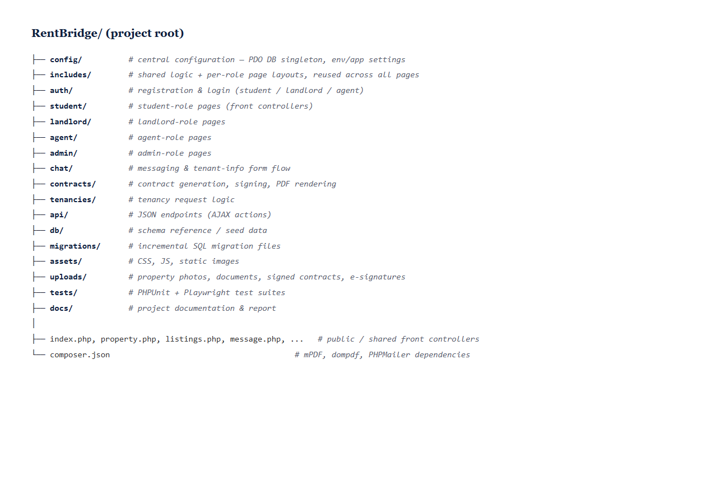
Figure 5.1: RentBridge folder / architecture overview
A single database connection is shared per request through a PDO singleton, and every protected page enforces the user’s role before doing any work:
function db(): PDO { // config/database.php
static $pdo = null;
if ($pdo === null) {
$pdo = new PDO("mysql:host=".DB_HOST.";dbname=".DB_NAME.";charset=utf8mb4",
DB_USER, DB_PASS, [PDO::ATTR_ERRMODE => PDO::ERRMODE_EXCEPTION,
PDO::ATTR_EMULATE_PREPARES => false]);
}
return $pdo;
}

require_role('landlord'); // includes/auth.php — session + role gate

5.4 Database Implementation
The physical schema (Chapter 4) is implemented as 30 InnoDB tables in the dbrb_2026 database. All data access uses PDO prepared statements with bound parameters, which prevents SQL injection and keeps user input strictly as data. Foreign-key constraints enforce referential integrity, and schema changes are applied through incremental SQL migration files kept under the migrations folder.

5.5 Core Module Implementation

5.5.1 Authentication and Role-Based Access
Users register and log in through the auth module. Passwords are hashed, sessions identify the logged-in user, and every state-changing form is protected by a CSRF token. Authorization is centralised in require_role(), and all output is escaped through a helper to prevent cross-site scripting.
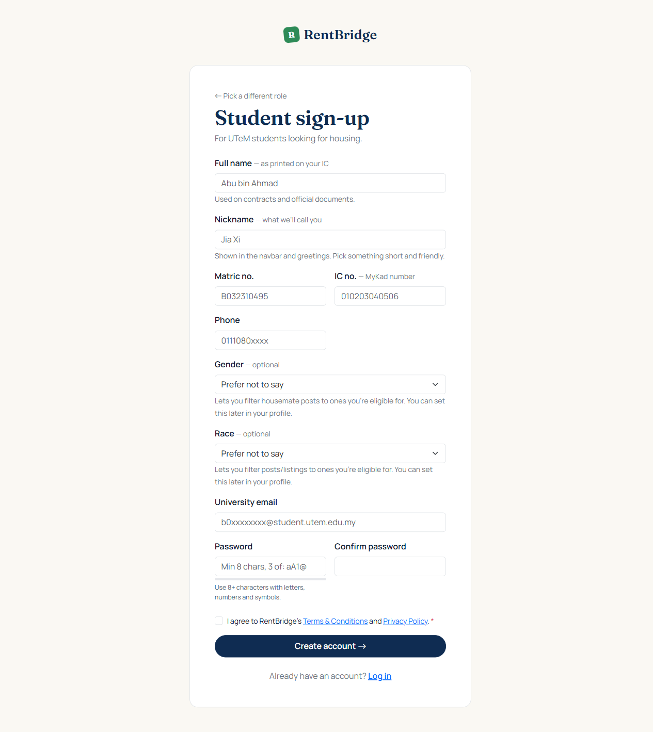
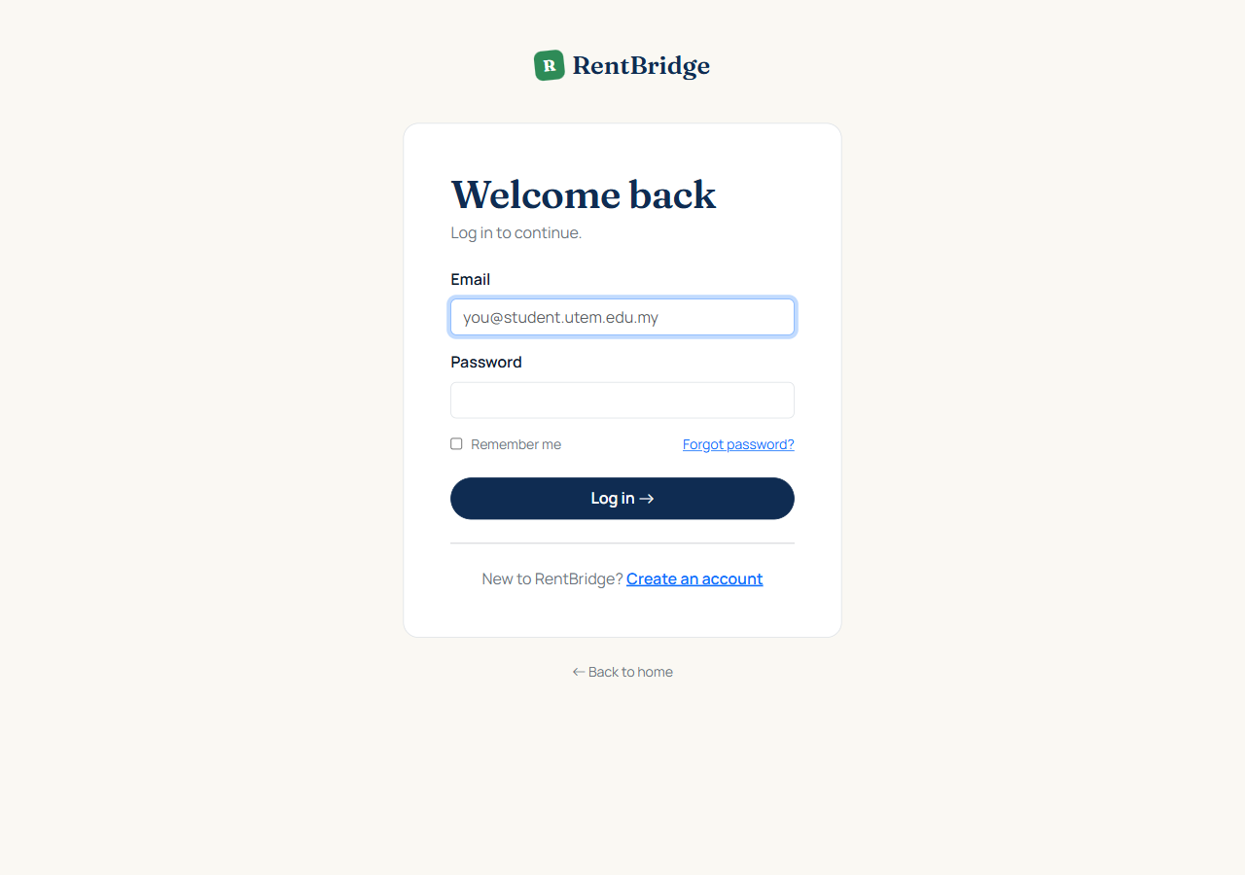
Figure 5.2: Login and registration screens

5.5.2 Property Listing, Search and Map
Landlords create listings through a multi-step form that captures the property details, photos, ownership documents, and an exact location. The location is set with an interactive Leaflet map: the landlord clicks or drags a pin (or geocodes the typed address), and the coordinates are saved with the property. Students browse and filter listings, save favourites, and view each property on a map with a directions link.
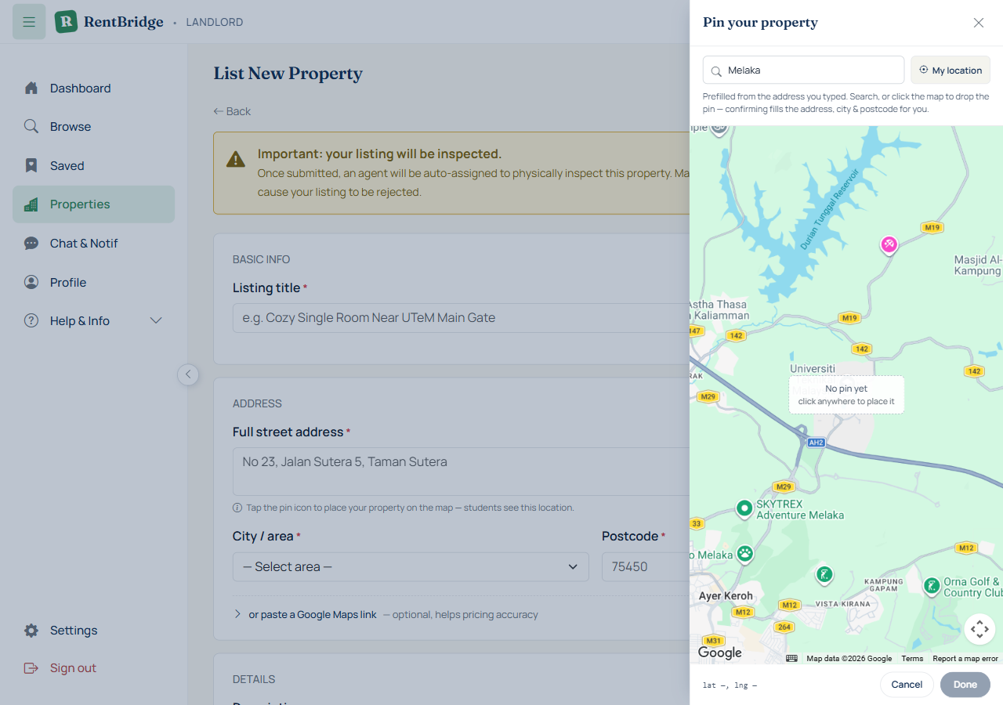
Figure 5.3: Add-property form with the interactive map pin
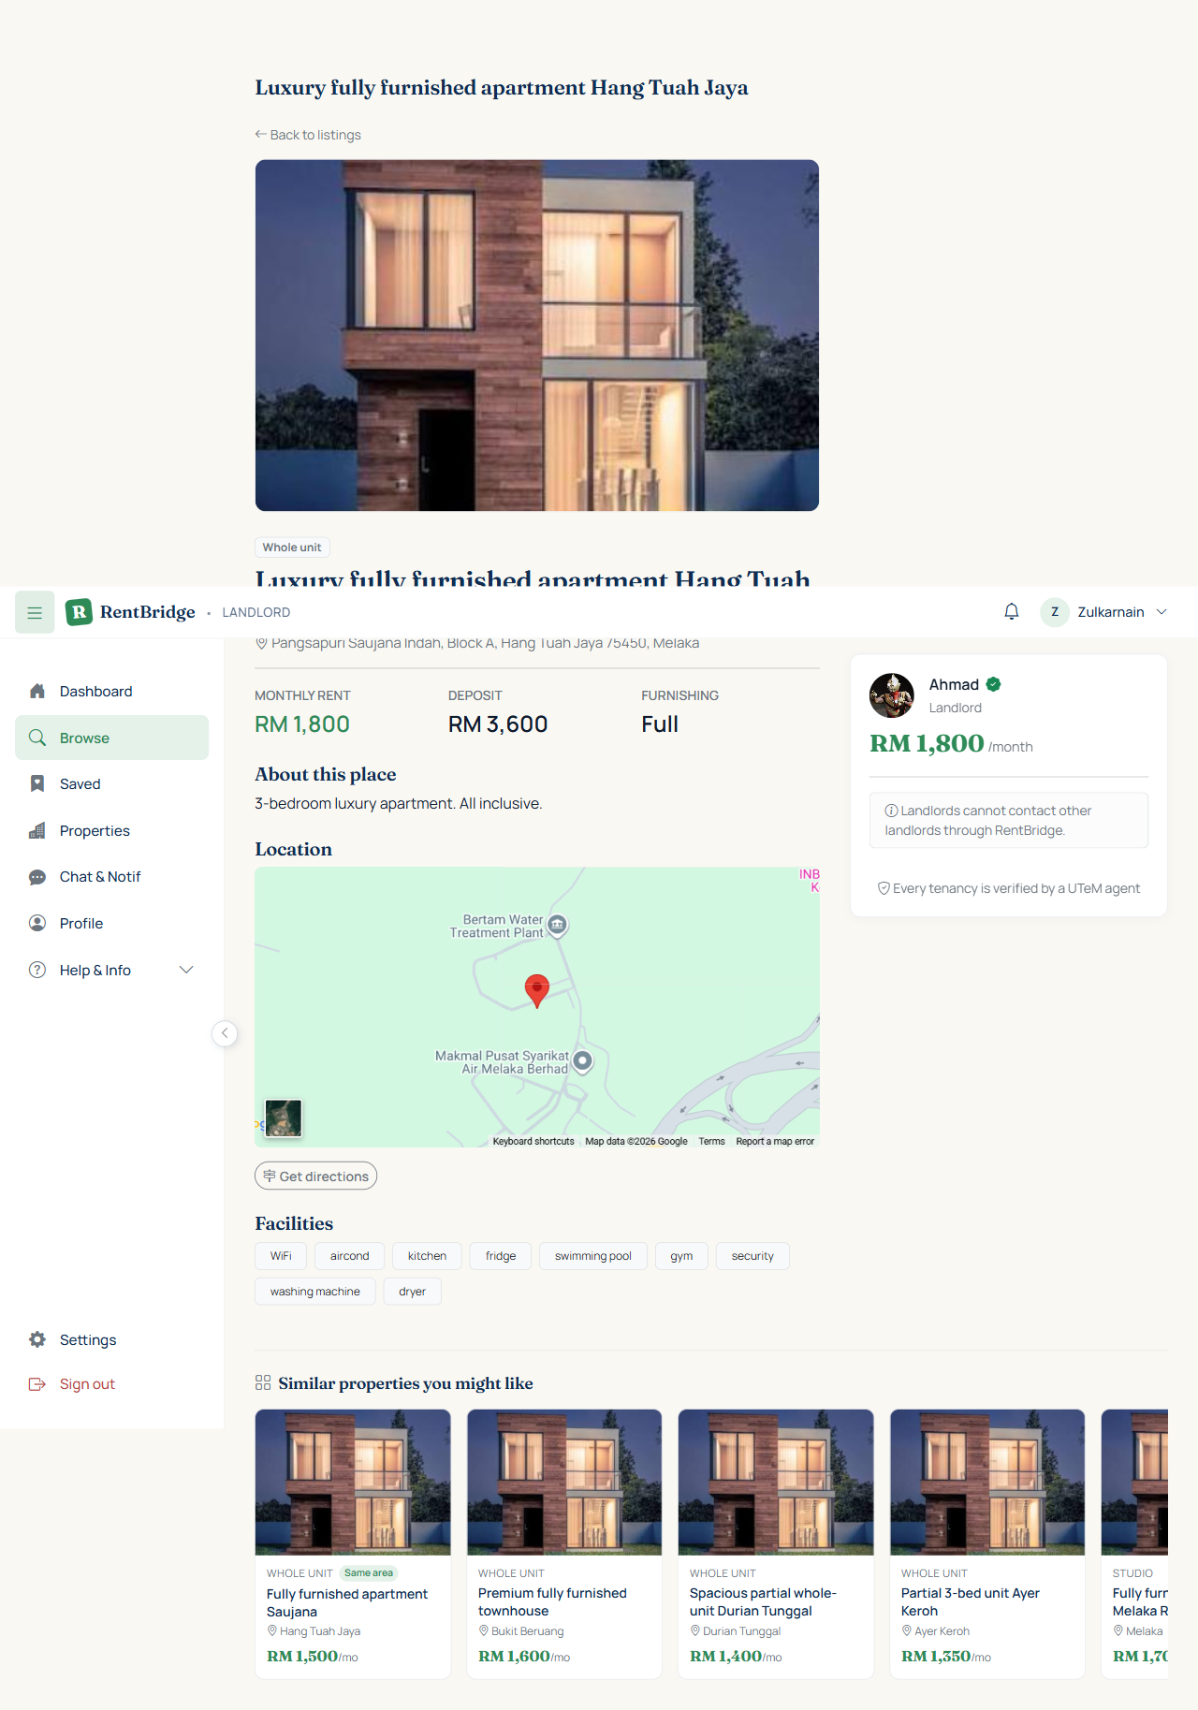
Figure 5.4: Property detail page with location map

5.5.3 Tenancy and Find Housemate
Students request a tenancy by choosing a move-in date and a semester-based duration. Durations are aligned to the academic calendar rather than fixed months — one semester is treated as approximately eighteen weeks, and two semesters as approximately nine months to include the inter-semester break:
case 'semester_4': // 1 UTeM long semester (lectures + exams)
$endTs = strtotime('+18 weeks', $startTs); break;
case 'academic_8': // 2 semesters incl. the semester break
$endTs = strtotime('+39 weeks', $startTs); break;
The Find Housemate feature lets a student post a listing to recruit co-tenants, receive applications, and form a group that shares a single joint tenancy.
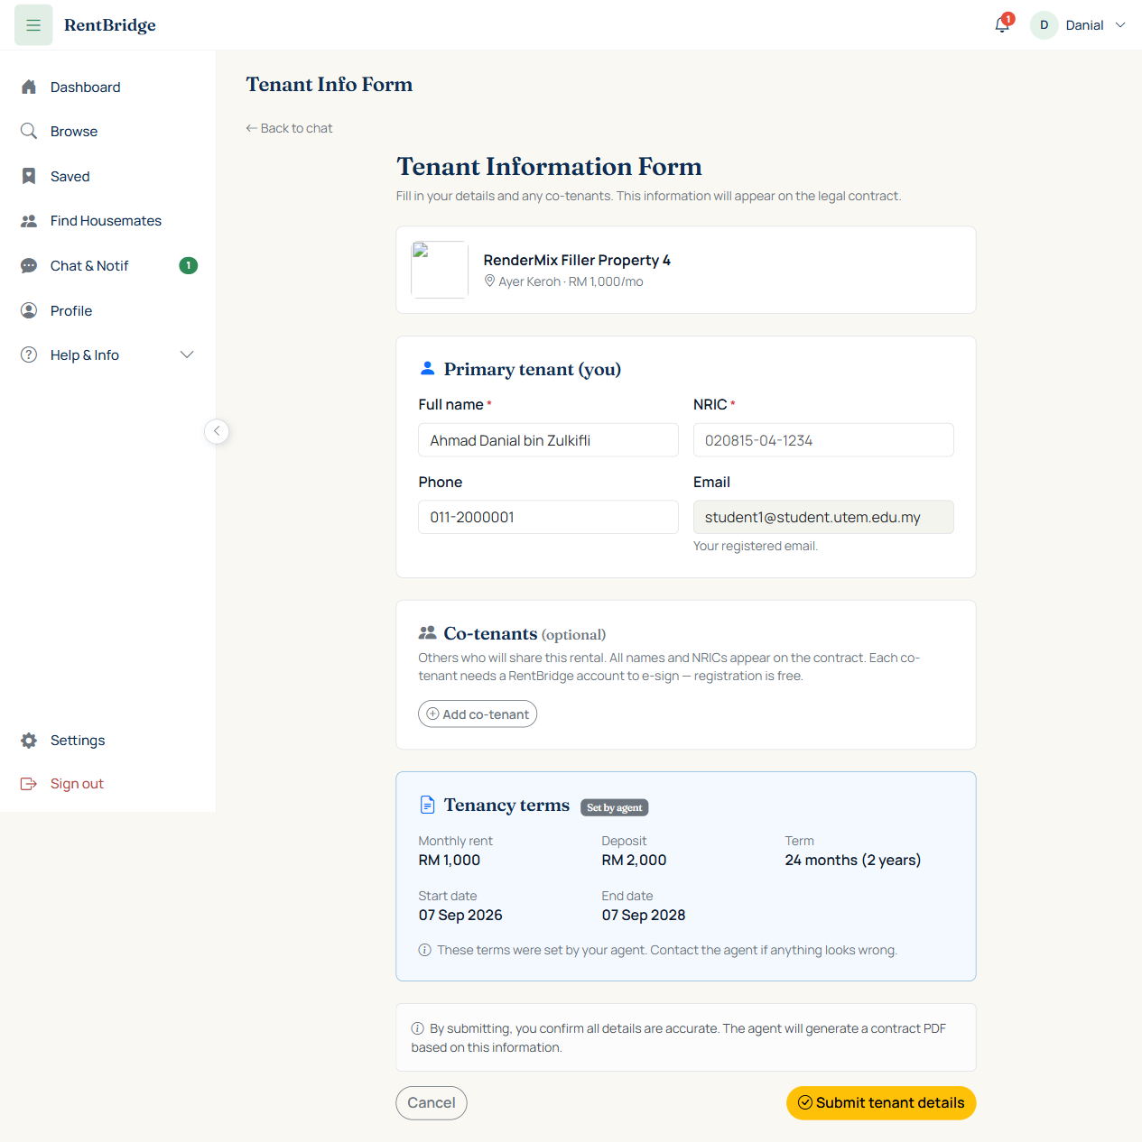
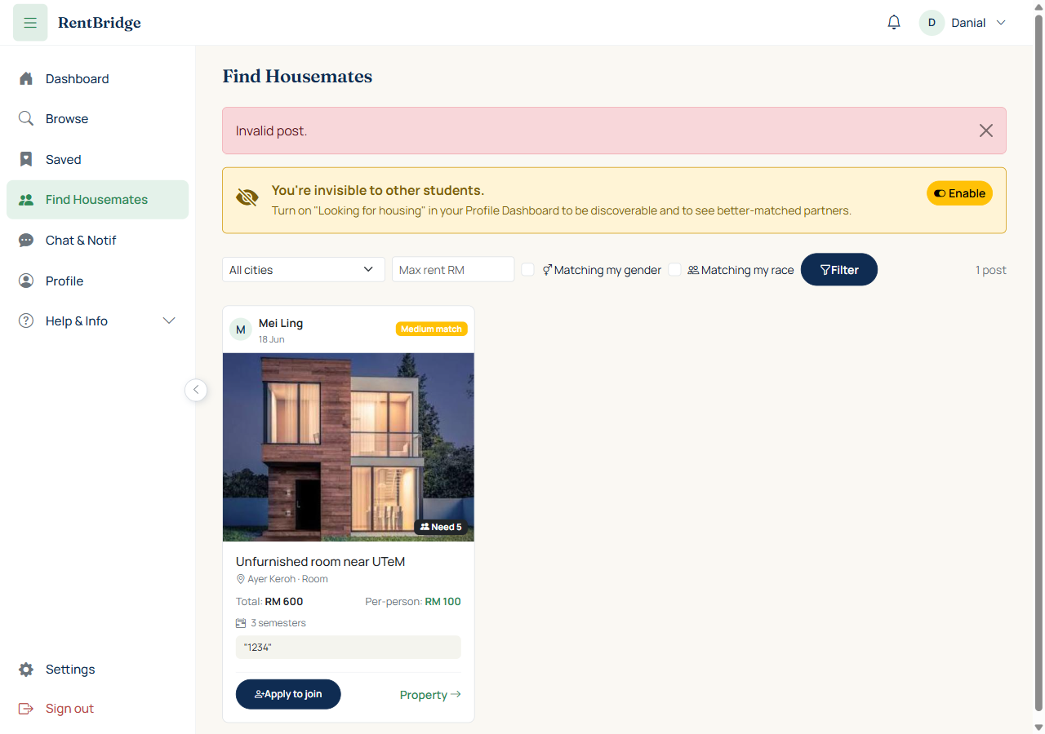
Figure 5.5: Tenancy request and Find Housemate screens

5.5.4 Agent Verification
An assigned UTeM staff agent physically inspects each property, records an inspection checklist, uploads photos, and sets an outcome. The progress of a property through this pipeline is shown to landlords and admins with a status progress bar (Pending → Awaiting inspection → Inspection complete → Available), derived from the property’s stored fields.
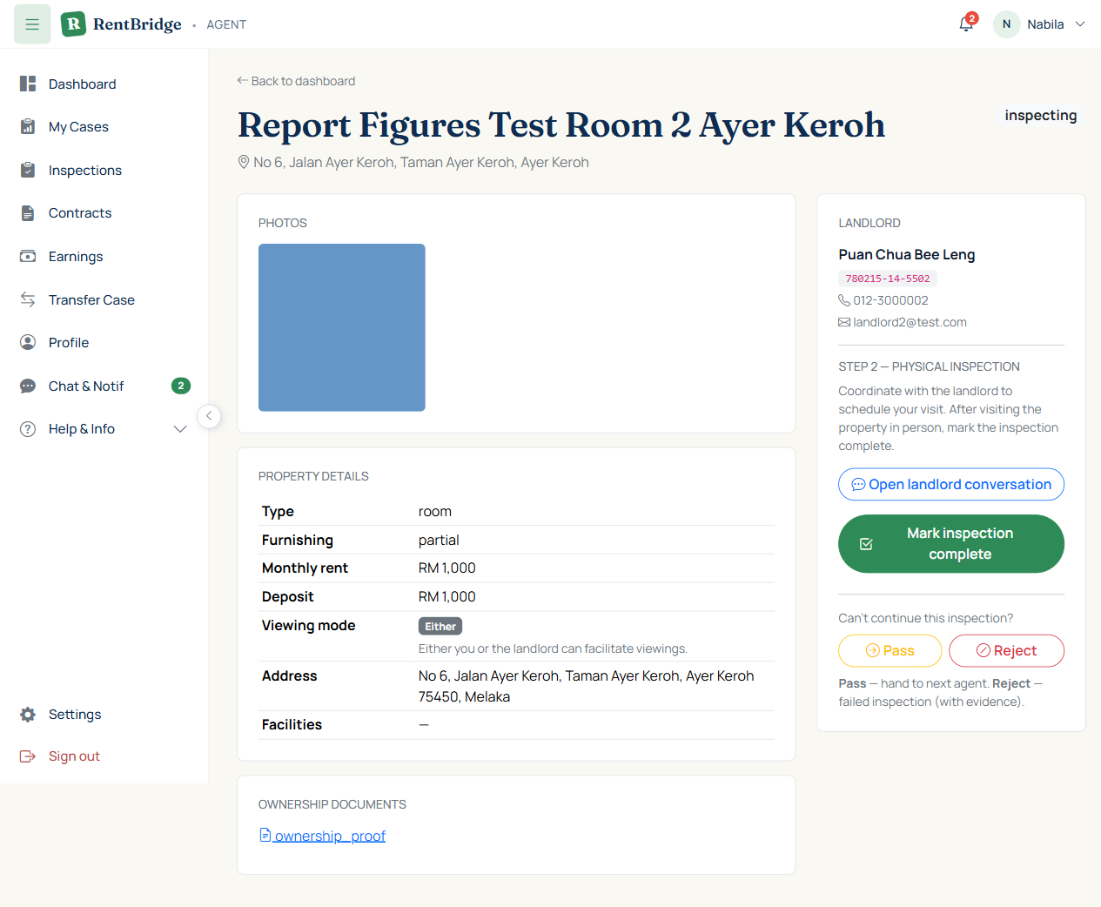
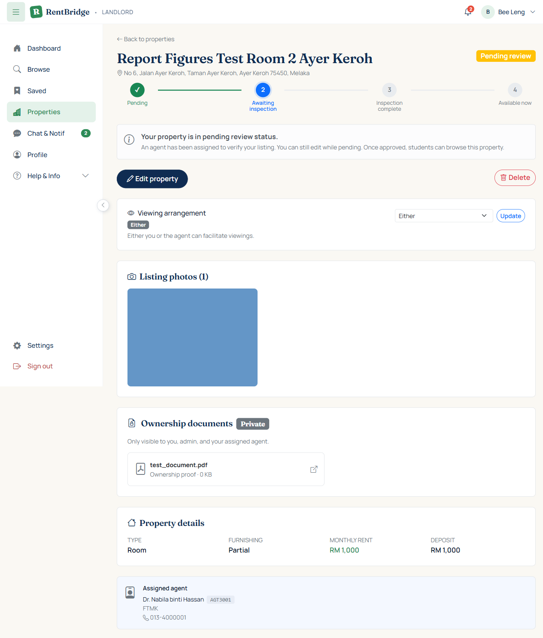
Figure 5.6: Agent inspection screen and the property status progress bar

5.5.5 Contract Generation and Multi-Party E-Signing
When a tenancy is confirmed, the system generates a formal tenancy-agreement PDF (using mPDF) containing the parties, the property, the tenancy schedule, and the standard terms. All parties then sign in order: each co-tenant with an account signs in their own session on a signature pad, followed by the landlord; co-tenants without an account wet-sign the printed copy. Once fully signed, the system regenerates the agreement with the captured signatures embedded on the signature lines and marks the tenancy active. The standard terms are held in a single source, including a clause covering the semester break:
9. The rental period runs continuously from the Start Date to the End Date
stated in this Agreement, inclusive of any mid-semester or inter-semester
break that falls within this period. Monthly rent is payable for every
month of the period regardless of academic breaks ...
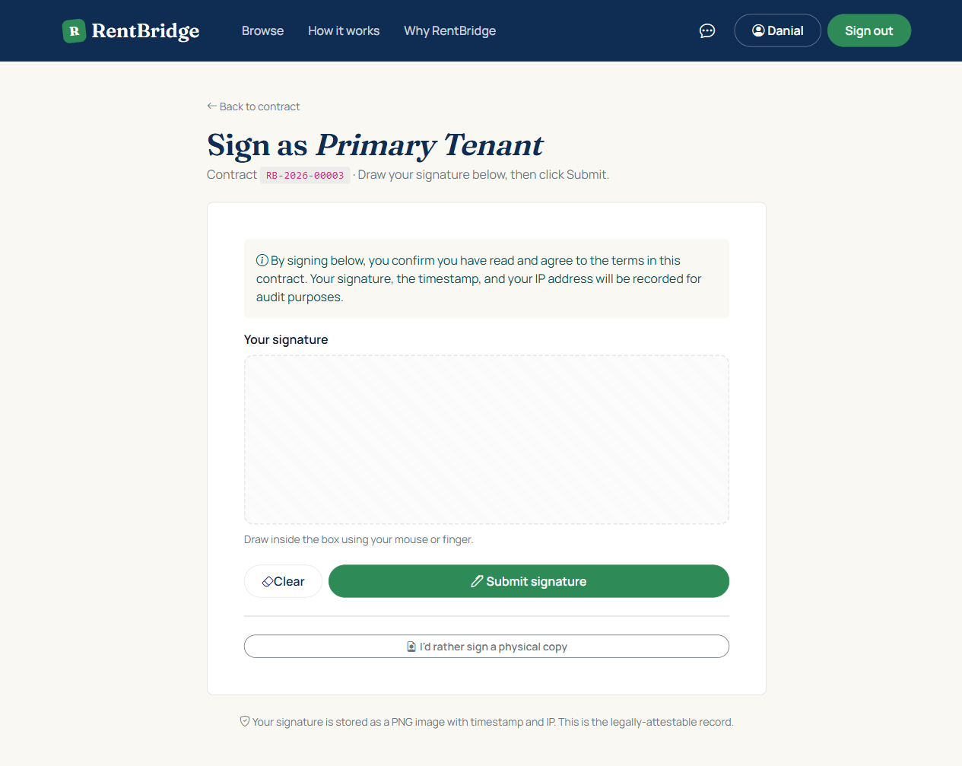
Figure 5.7: Contract signing screen and the signed agreement PDF

5.5.6 Agent Commission
When a contract activates, a commission record is created for the verifying agent. The commission is one month’s rent plus 6% SST, computed and stored automatically:
$commissionAmt = $baseRent; // 100% of one month rent
$sstAmt = round($commissionAmt * 0.06, 2); // 6% SST
$totalPayable = round($commissionAmt + $sstAmt, 2);

5.5.7 Messaging, Notifications and Moderation
Users communicate through in-app conversations (including group chats for housemate groups). System events raise notifications, and a reporting mechanism lets users flag misconduct for admin review.
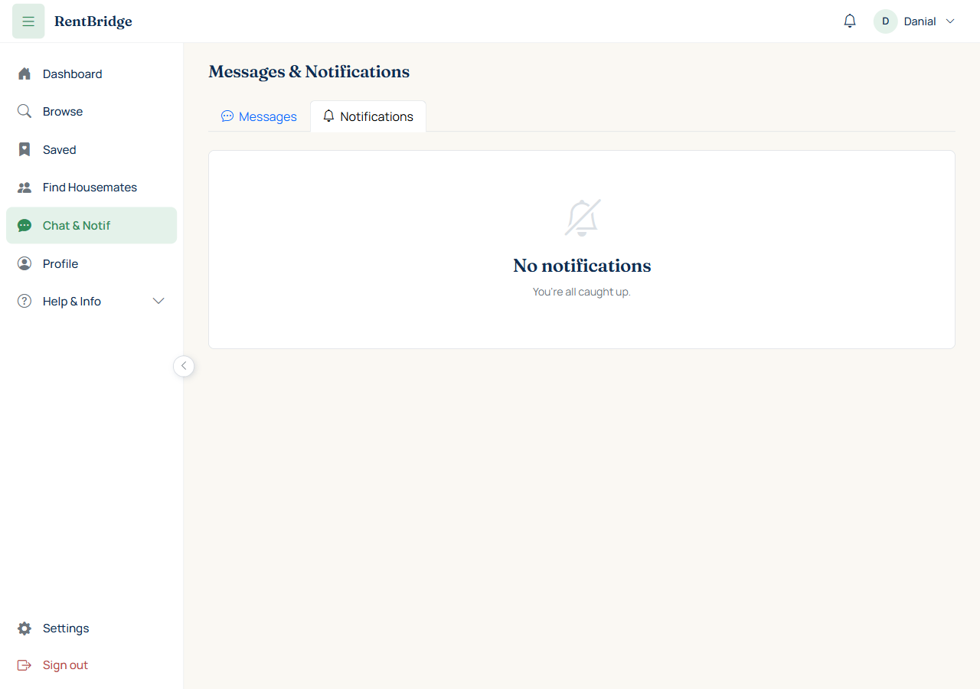
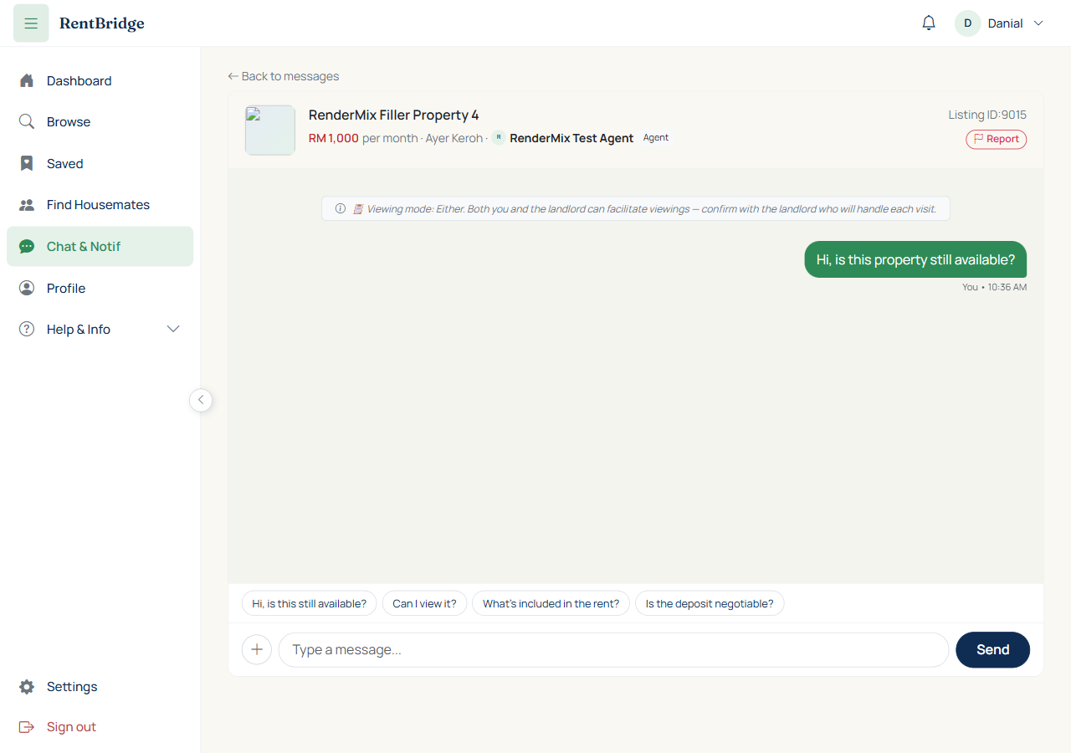
Figure 5.8: Chat and notifications

5.5.8 Academic-Calendar Importer
To keep tenancy durations aligned with the official calendar, an admin tool lets the administrator upload the UTeM academic-calendar PDF; the system sends it to a GPT-4o vision model (via the OpenAI Responses API) to extract the semester start and end dates, which the administrator reviews and confirms before they are saved. Extracted values are never written to the database without human confirmation.
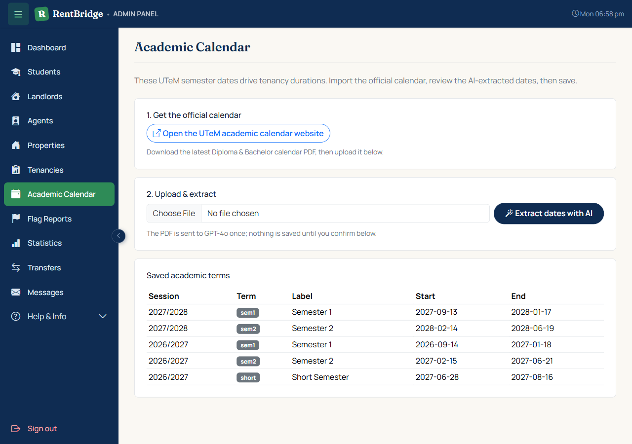
Figure 5.9: Academic-calendar importer (upload, extract, confirm)

5.6 Deployment
To validate the system beyond the local development environment, RentBridge was deployed to Render, a container-based hosting platform that runs the application inside a Docker image with Apache and PHP 8.2, with the production database hosted as a managed MySQL instance on Aiven. Preparing for and operating this deployment surfaced several issues that only appear once the system leaves a fully-trusted local environment, described below.
A review of the deployment configuration found that includes/mail_config.php had live SMTP credentials committed directly to the project's public GitHub repository. This file was refactored to the same environment-variable-first pattern already used for the Google Maps and OpenAI API keys, with a git-ignored local file as an optional fallback for development, so no credential needs to be committed again. The database-connection error handler was also changed to log the underlying error server-side rather than display it in the browser, and a leftover debug flag that force-enabled PHP error display regardless of the production configuration was removed.
Before deployment, all incremental SQL migration files were audited against the development database to confirm they had been correctly applied; any migration found pending was applied at that time.
- Render's container filesystem is ephemeral: any file written to the uploads/ folder, property photos, generated and signed tenancy-agreement PDFs, e-signature images, and ownership documents, is discarded on every restart or redeploy, unlike the persistent disk assumed during local development.
- This was addressed by introducing an object-storage abstraction (includes/storage.php) backed by Cloudflare R2, an S3-compatible object store, accessed through the official AWS SDK for PHP. Every upload, read, and delete operation in the codebase was routed through this abstraction instead of the local filesystem, with an automatic fallback to local disk when no object-storage credentials are configured, so local development required no change.
- Public assets (property photos, avatars, and inspection photos) are served by redirecting their upload folders to the bucket's public URL whenever the requested file is not present locally, using an Apache rewrite condition on the request filename. This meant none of the roughly seventeen templates that display these images needed to change. Private assets (contracts, e-signatures, and ownership documents) continued to be served only through their existing authorization-checked PHP endpoints, whose internals were updated to stream each file's bytes from the object store instead of the local disk.
- The new configuration file for object storage was initially excluded from version control by following the pattern used for other files that hold locally-pasted development credentials. Because that file is required unconditionally by the storage abstraction, its absence from the deployed repository caused every page that renders a user's avatar to fail in production; the file was corrected to hold no credentials of its own, real values are supplied through the hosting platform's environment variables, and committed normally.
Before the production database was migrated, the full automated test suite was re-run to confirm no regression: all thirteen PHPUnit backend tests and all thirty-nine Playwright end-to-end tests passed, with one pre-existing test skipped for an environment-dependent condition unrelated to this work. This process also diagnosed and corrected a genuine gap in the end-to-end test for the multi-party contract-signing flow, where the test had not driven the landlord's signature and so never observed the tenancy reach its fully active state before checking that late co-tenant addition was correctly blocked.
An operational incident during this phase illustrated a further reliability consideration of the chosen hosting: the production database became fully unreachable for approximately one hour and forty-one minutes after Aiven migrated it to a new underlying server instance, confirmed from the database's own service log by a change in the reported server instance name. This is expected behaviour for a single-node database plan, which has no standby to fail over to during maintenance, rather than a defect in the application. Two improvements followed from this: the database-connection failure handler was changed to return an HTTP 503 Service Unavailable status instead of the default 200 OK, so that uptime-monitoring tools can correctly detect an outage instead of seeing an apparently normal response; and a free external monitor was configured to check the live site every five minutes and alert by email.
Figure 5.10: Render service dashboard showing the deployed application and its Aiven database connection [insert screenshot]

5.7 Summary
This chapter described the implementation of RentBridge, from the development environment and layered architecture to the database and each core module — authentication, property listing with maps, semester-based tenancies and Find Housemate, agent verification, multi-party e-signed contracts, commission accounting, and messaging — and its deployment to a production hosting environment. The implemented system realises the design of Chapter 4 and is validated by the testing described in Chapter 6.

TESTING

6.1 Introduction
This chapter describes the testing carried out on the RentBridge system to ensure it satisfies its functional and non-functional requirements and behaves correctly across all user roles and workflows. Testing was approached at multiple levels: automated unit and integration testing of the backend business logic, automated end-to-end (E2E) testing of the complete user journeys through the browser, security-focused non-functional testing, and manual user acceptance testing (UAT) with real participants acting as tenants, landlords, agents, and an administrator. The chapter presents the testing strategy, the test environment, the test cases and their results, the UAT survey, and a summary of the outcomes.

6.2 Testing Strategy
A layered testing strategy was adopted so that defects can be caught close to their source while still verifying that the whole system works together. Four complementary layers were used:
• Unit and integration testing (PHPUnit) — verifies the correctness of individual backend functions and their interaction with the database, focusing on the critical contract and financial logic.
• End-to-end testing (Playwright) — automates a real browser to exercise complete user journeys across the four roles, confirming that the interface, server logic, and database work together correctly.
• Non-functional and security testing — verifies authentication, authorization, and protection against common web vulnerabilities, as well as data integrity.
• User acceptance testing (UAT) — real participants in each role carry out representative tasks on the live system and complete a usability survey, confirming the system is acceptable and usable outside the development team.
The two automated layers form a testing pyramid: a larger base of fast, focused backend tests supported by a smaller set of slower, high-value end-to-end tests. Both suites are repeatable and therefore also serve as regression tests when the system is changed in future.

6.2.1 Test Environment
All tests were executed on a local development environment running XAMPP (Apache web server, PHP 8, and MariaDB). To ensure that testing never affects development or live data, the automated backend suite runs against an isolated, throwaway database named dbrb_2026_test, which is dropped and rebuilt automatically from the production schema and migrations before every test run. The end-to-end suite runs against a seeded set of dedicated test accounts (one landlord, one agent, one admin, and several students).

6.3 Unit and Integration Testing (PHPUnit)
The backend logic was tested using PHPUnit. The test suite loads the real application code and exercises the functions that implement the most important and error-prone parts of the system: the tenancy contract lifecycle, the agent commission calculation, and the audit-logging mechanism. Because these functions interact with the database, the tests are integration tests that assert against real rows written to the test database. Table 6.1 lists the backend test cases.
Table 6.1: Backend unit and integration test cases (PHPUnit)
ID | Test Case | Expected Result | Result
TC-U01 | Standard tenancy terms include the semester-break clause | Terms text contains the continuous-period clause | Pass
TC-U02 | Contract code is formatted correctly | generate_contract_code(42) returns RB-YYYY-00042 | Pass
TC-U03 | Creating a contract transitions status and stores terms | Contract = pending_signatures; tenancy = contract_pending | Pass
TC-U04 | Duplicate contract is refused | Second attempt returns null (no duplicate) | Pass
TC-U05 | Commission = one month rent + 6% SST | RM600 base -> RM36 SST -> RM636 total | Pass
TC-U06 | Commission creation is idempotent | Calling twice creates only one row | Pass
TC-U07 | Contract insert is audited | audit_log row (action=insert) created | Pass
TC-U08 | Contract update records old and new values | audit_log row holds old + new status | Pass
TC-U09 | Commission insert is audited | audit_log row for agent_commissions created | Pass

These tests confirm that the financial calculations are accurate, that the contract lifecycle transitions occur in the correct order, that duplicate records are prevented, and that all changes to the legal and financial tables are recorded in the audit log. As the code implements this behaviour, all designed cases pass; the exact pass count is recorded from the automated run using the command “composer test”.

6.4 End-to-End Testing (Playwright)
End-to-end testing was implemented with Playwright, which drives a real browser to reproduce complete user journeys. A shared login helper and a set of seeded test accounts allow each scenario to log in as the appropriate role and perform the actions a real user would. Six flows were automated, each covering a group of related use cases, as shown in Table 6.2.
Table 6.2: End-to-end test flows (Playwright)
ID | Flow | Scenario Covered | Result
E2E-01 | Flow 1 — Landlord property | Landlord adds, edits, and manages a property listing | Pass
E2E-02 | Flow 2 — Student e-sign | Student browses, chats, and e-signs the contract | Pass
E2E-03 | Flow 3 — Group tenancy | Three tenants; co-tenants without accounts wet-sign | Pass
E2E-04 | Flow 4 — Find Housemate | Housemate post creation and applications | Pass
E2E-05 | Flow 5 — Agent inspection | Agent verifies a property and completes the inspection | Pass
E2E-06 | Flow 6 — Admin | Admin manages users, properties, and approvals | Pass

Together, these flows exercise the critical end-to-end path of the system: a student discovers a verified property, forms a tenancy (individually or as a group), the landlord and agent participate, the contract is generated and signed, and the tenancy becomes active. The suite is executed with the command “npx playwright test”.

6.5 Non-Functional and Security Testing
In addition to functional testing, the following non-functional aspects were verified to ensure the system is secure and robust:
• Authentication and authorization — every protected page enforces a valid session and role through the require_role() mechanism; attempts to access another role’s pages are rejected.
• Cross-Site Request Forgery (CSRF) — all state-changing forms include a CSRF token validated by verify_csrf() before the action is processed.
• SQL injection — all database access uses PDO prepared statements with bound parameters, so user input cannot alter query structure.
• Cross-Site Scripting (XSS) — all user-supplied data is escaped on output using the e()/htmlspecialchars() helper.
• File-upload validation — uploaded images, documents, and signatures are validated by type and stored outside the executable path.
• Data integrity — foreign-key constraints, database transactions, and the audit log protect the consistency of the contract and financial records.

6.6 User Acceptance Testing (UAT)
In addition to the automated and security-focused layers above, User Acceptance Testing (UAT) was carried out with real participants acting in each of the four RentBridge roles (tenant, landlord, agent, and administrator). Each participant used the live deployed system to complete a set of representative, role-specific tasks — for example browsing and applying for a listing as a tenant, listing a property as a landlord, running an inspection and generating a contract as an agent, or resolving an agent transfer request as an administrator — and reported whether each task was completed, attempted but stuck, or skipped.
Following the task-based scenarios, each participant completed two standardised usability questionnaires: the System Usability Scale (SUS) (Brooke, 1986), a 10-item instrument scored from 1 (strongly disagree) to 5 (strongly agree) and converted to a score out of 100, and the USE Questionnaire (Lund, 2001), which rates the system from 1 to 7 across four dimensions — Usefulness, Ease of Use, Ease of Learning, and Satisfaction. These instruments provide a validated, quantitative measure of perceived usability that complements the pass/fail results of the automated test suites.
The UAT tasks and both questionnaires were distributed to participants as a single Google Form, available at https://forms.gle/EtDYUw92GB5ADVVj8, which branches participants to the task list for their tested role before presenting the SUS and USE sections. Responses were collected in the form's linked Google Sheet for scoring and analysis.
Table 6.3a: UAT task completion and SUS/USE results by role
Role | Participants | Task completion | Mean SUS score (/100)
Tenant | 6 | 49 / 54 (90.7%) | 75.4
Landlord | 4 | 25 / 28 (89.3%) | 72.5
Agent | 4 | 19 / 20 (95.0%) | 82.5
Admin | 1 | 5 / 5 (100.0%) | 85.0
Overall | 15 | 98 / 107 (91.6%) | 77.2

6.7 Test Results Summary
Table 6.3 summarises the outcome of the testing effort across the different layers.
Table 6.3: Summary of test results
Test Category | Test Cases | Passed | Remarks
Unit / Integration (PHPUnit) | 9 | 9 | Contract, commission, and audit logic
End-to-End (Playwright) | 6 flows | 6 flows | Full role journeys
Security / Non-functional | 6 checks | 6 checks | CSRF, SQLi, XSS, auth, uploads, integrity

All designed test cases passed against the implemented behaviour. Where a test revealed a discrepancy during development, the underlying defect was corrected and the test re-run until it passed. The automated suites remain in the repository so that they can be re-executed to guard against regressions in future development.

6.8 Summary
This chapter presented the testing performed on RentBridge across unit, integration, end-to-end, security, and user acceptance layers. The layered, automated approach provides confidence that the system meets its functional requirements, protects its data, and behaves correctly for every role, while the UAT survey confirms the system is usable and acceptable to real participants; together they enable efficient regression testing as the system evolves.

CONCLUSION AND FUTURE WORK

7.1 Introduction
This chapter concludes the project by reviewing the extent to which the project objectives were achieved, summarising the contributions of the RentBridge system, discussing the limitations encountered, and outlining recommendations for future work.

7.2 Achievement of Project Objectives
RentBridge set out to deliver a trusted, student-oriented rental platform for Universiti Teknikal Malaysia Melaka (UTeM) in which listings are verified by a UTeM staff agent and tenancies align to the academic calendar. Table 7.1 maps each objective to how it was achieved.
Table 7.1: Achievement of project objectives
Objective | How It Was Achieved | Status
Provide a web platform connecting students and landlords | Property listing, search, filtering, and saved-property features | Achieved
Build trust through independent verification | Agent assignment, physical property inspection with photos, recorded outcomes | Achieved
Support student-specific, semester-based tenancies | Semester-aligned durations and a contract clause covering the semester break | Achieved
Enable shared/group renting | Find Housemate feature (posts, applications, group chat) and joint co-tenancy | Achieved
Provide digital, multi-party contracts | Automatic tenancy-agreement PDF with embedded multi-party e-signatures | Achieved
Track agent commission | Automated commission accounting (one month rent + 6% SST) with status tracking | Achieved

All primary objectives of the project were achieved. The system was implemented as a working web application and validated through the testing described in Chapter 6.

7.3 Project Contributions
The main contributions of this project are:
• Trust by verification — unlike general-purpose rental sites that rely solely on landlord-supplied information, RentBridge introduces a mandatory, in-person verification step performed by a neutral UTeM staff agent, reducing the risk of misleading or fraudulent listings.
• Student fit — the platform models the realities of student renting: semester-aligned tenancy durations, proximity to campus as a primary criterion, and group tenancies formed through the Find Housemate feature.
• End-to-end digital contracting — the system takes a group of students from search to a legally structured, e-signed tenancy agreement, tailored to the Malaysian student-housing context.

7.4 Limitations and Constraints
While the project met its objectives, several limitations remain:
• Tenancy durations currently use an approximate semester model (for example, two semesters counted as about nine months including the break) rather than being tied to the exact published UTeM academic calendar dates.
• The system uses a single active role per user; a person who is both a student and a landlord cannot yet hold both roles simultaneously.
• Online rent payment and electronic stamping (e-stamping) are not integrated; the platform manages the agreement but not the monetary transaction itself.
• Property locations are stored but are not yet displayed on an interactive map with a pin.
• Audit logging and soft-delete were introduced at the database level but are not yet fully enforced throughout the application code.
• The system was developed and tested on a local XAMPP environment and has not yet been deployed to a production host.

7.5 Future Work
The following enhancements are recommended for future development:
• Academic-calendar-driven durations — introduce a reference table of official UTeM semester start and end dates so that tenancy durations resolve to exact calendar dates instead of approximate month counts.
• Multiple-role support — extend the data model with a user-roles relationship so that a single user can act as more than one role (for example, both student and landlord).
• Interactive property map — display each property on a map with a location pin and directions, and allow the landlord to place the pin when creating a listing.
• Strengthened data protection — fully wire the audit log to record the acting user, apply soft-deletion to legal and financial records, and schedule regular database backups.
• Flexible signing — provide a secure link-based signing option for co-tenants who do not have an account, so that all parties can sign digitally.
• Online payment and e-stamping — integrate a payment gateway for deposits and rent, and connect to the relevant electronic stamping service.
• Deployment — deploy the system to a production web host with HTTPS, email delivery, and automated backups.

7.6 Conclusion
RentBridge demonstrates that the specific problems of student housing — the need for trust, and the need for a rental process that fits academic life — can be addressed by a purpose-built platform. By combining agent-verified listings, semester-based tenancies, group renting, and digital multi-party contracts, the system takes students from searching for a room to a signed, active tenancy in a single, trustworthy workflow. The objectives of the project were achieved and validated through automated testing, and the recommendations for future work provide a clear path toward a production-ready service.

References
Ahmad, S., Sulistiyo, M. D., & Nugraha, R. A. (2023). Implementation of MVC architecture on RESTful API for web application development. In Proceedings of the International Conference on Enterprise and Industrial Systems (ICOEINS 2023), Advances in Economics, Business and Management Research, 270. Atlantis Press.
Bogner, J., Kotstein, S., & Pfaff, T. (2023). Do RESTful API design rules have an impact on the understandability of web APIs? Empirical Software Engineering, 28(6), 132. https://doi.org/10.1007/s10664-023-10373-6
Cocola-Gant, A., & Gago, A. (2023). The platformization of student housing and the rise of mid-term rentals: The case of Uniplaces in Lisbon. Tijdschrift voor Economische en Sociale Geografie, 114(3), 214–228. https://doi.org/10.1111/tesg.12560
Francis, J., Zulkifli, N., & Hamzah, H. (2025). Addressing barriers to affordable and sustainable housing for Malaysian youth. International Journal of Research and Innovation in Social Science. https://www.researchgate.net/publication/398037740
Hochstein, R. E., Harmeling, C. M., & Perko, T. (2023). Toward a theory of consumer digital trust: Meta-analytic evidence of its role in the effectiveness of user-generated content. Journal of the Academy of Marketing Science, 52, 1–21. https://doi.org/10.1007/s11747-023-00935-z
Ismail, N. A., Razak, A. A., & Hamzah, H. (2023). Living in off-campus student housing: Analysis on the satisfaction level. Journal of Engineering Science and Technology, Special Issue 4/2023, 45–57. https://jestec.taylors.edu.my/Special%20Issue%20THINK%20SPACE%202022/STAAUH%202022_13.pdf
Iu, C. S., & Mohd Zaki, M. S. (2024). RoomMeet: A renting mobile application. In Proceedings of the 2024 9th International Conference on Intelligent Information Technology (pp. 112–118). ACM. https://doi.org/10.1145/3654522.3654606
Khamitov, M., Rajavi, K., Huang, D. W., & Hong, Y. (2024). Consumer trust: Meta-analysis of 50 years of empirical research. Journal of Consumer Research, 51(1), 7–18. https://doi.org/10.1093/jcr/ucad052
Nair, A., Sadvelkar, S., Damle, S., & Kudu, N. (2024). Revolutionizing student accommodation: A MERN-based rental system for seamless property management. International Journal for Multidisciplinary Research, 6(3), 1–8. https://www.ijert.org/revolutionizing-student-accommodation-a-mern-based-rental-system
Osei-Bonsu, K., & Karikari, E. (2026). Design and development of a cloud-based student accommodation management application. Preprints.org. https://doi.org/10.20944/preprints202601.0919.v1
Rathore, K., Syed, A., & Ahmed, R. (2024). The implementation of RentHub system: An intelligent online rental marketplace with ML-powered personalized product discovery and recommendations. International Journal of Innovations in Science & Technology, 6(4), 112–128. https://journal.50sea.com/index.php/IJIST/article/view/1075
Roslan, M. F., & Ahmad, N. (2025). Design and development of a smart student rental platform for sustainable campus communities. International Journal of Research and Innovation in Social Science, IX(IX). https://doi.org/10.47772/IJRISS
Sharma, P., & Gupta, R. (2024). Development and implementation of a real estate web application for modern web application. International Journal for Research in Applied Science & Engineering Technology, 12(8), 1–9. https://doi.org/10.22214/ijraset.2024.64990
Tran, D. T., Vu, Q. H., & Ngo, T. T. (2022). Design and implementation of web application based on MVC Laravel architecture. ResearchGate. https://www.researchgate.net/publication/362595029
Wang, S., & Wang, H. (2024). Digital transformation in real estate services: Development and implementation of the housing selection platform. Frontiers in Computing and Intelligent Systems, 8(1), 13–18. https://doi.org/10.54097/yyw4jr63

