|  |  |  |  |  |  |  |  |
| --- | --- | --- | --- | --- | --- | --- | --- |
| 方法 | 分类正确率最大值 | 分类正确率平均值 | 分类正确率最小值 | 特征数均值 | 最优分类正确率对应特征数 | 耗时均值 | 耗时最小值 |
| DE | 0.9782 | 0.9769 | 0.9753 | 23.7 | 25 | 210.6464 | 162.606 |
| ECDE | 0.9756 | 0.9747 | 0.9734 | 25.7 | 30 | 276.5097 | 242.0769 |
| GA | 0.9801 | 0.9788 | 0.9766 | 26.6 | 25 | 397.1492 | 274.1713 |
| ECGA | 0.9813 | 0.9785 | 0.9753 | 25.0 | 25 | 352.269 | 235.0232 |
| PSO | 0.981 | 0.9777 | 0.9725 | 26.4 | 28 | 254.508 | 217.4195 |
| ECPSO | 0.9804 | 0.9781 | 0.9756 | 25.0 | 26 | 247.1416 | 155.8595 |
| UCI |  |  |  |  |  |  |  |
| GA | 0.9565 | 0.9559 | 0.9534 | 18.9 | 18 |  |  |
| ECGA | 0.9524 | 0.9518 | 0.9498 | 20.0 | 20 |  |  |

DE，ECDE，迭代-适应值折线图

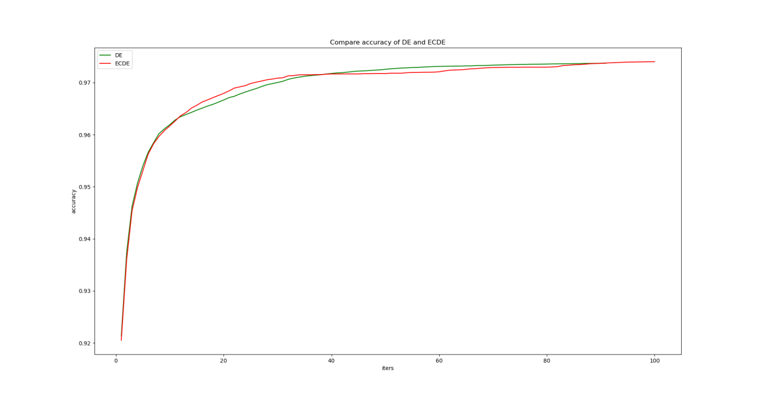

GA，ECGA迭代-适应值折线图

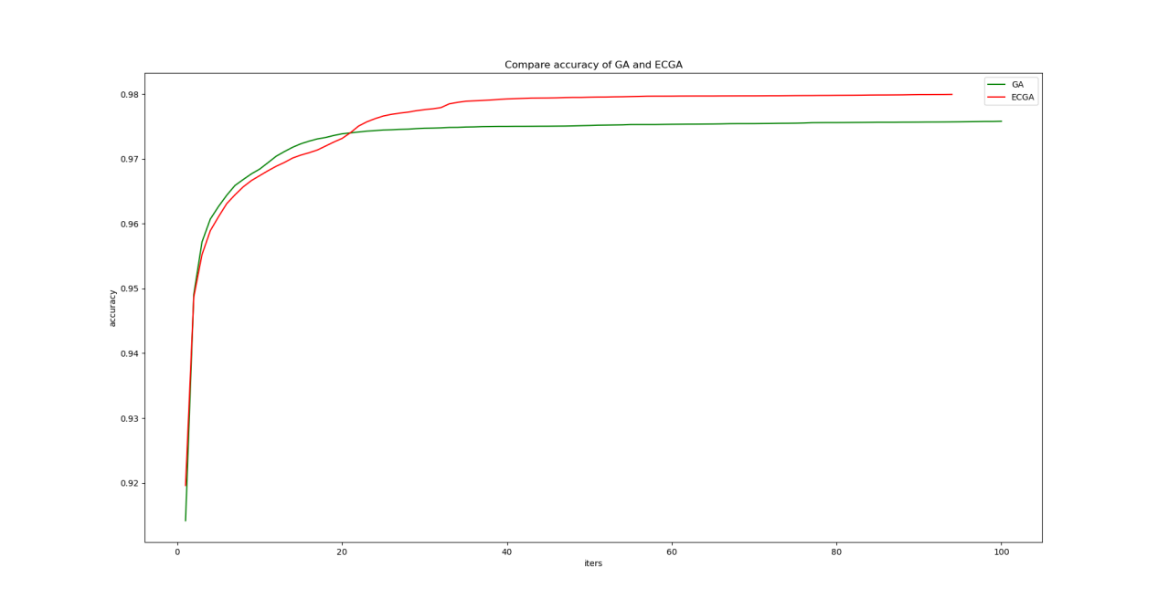

|  |  |  |  |  |  |  |  |
| --- | --- | --- | --- | --- | --- | --- | --- |
| Mendeley | F1最大值 | F1平均值 | F1最小值 | 特征数均值 | 最优F1对应特征数 | 耗时均值 | 耗时最小值 |
| 方法CART |  |  |  |  |  |  |  |
| GA | 0.9802 | 0.9785 | 0.9766 | 24.0 | 25 |  |  |
| ECGA | 0.9766 | 0.9749 | 0.9717 | 24.5 | 26 |  |  |
| random shuff |  |  |  |  |  |  |  |
| GA | 0.9796 | 0.9777 | 0.9749 | 23.5 | 26 |  |  |
| ECGA | 0.9780 | 0.9757 | 0.9730 | 26.5 | 26 |  |  |
| 10fold |  |  |  |  |  |  |  |
| GA | 0.9683 | 0.9672 | 0.9661 | 20.4 | 21 |  |  |
| ECGA | 0.9677 | 0.9668 | 0.9651 | 21.9 | 22 |  |  |
| WFS k fold | 0.9515 | 0.9508 | 0.9495 | 48 | 48 |  |  |
| WFS shuffle | 0.9649 | 0.958 | 0.953 | 48 | 48 |  |  |
| 方法KNN |  |  |  |  |  |  |  |
| WFS k fold | 0.8322 | 0.8322 | 0.8322 | 48 | 48 |  |  |
|  |  |  |  |  |  |  |  |
|  |  |  |  |  |  |  |  |

|  |  |  |  |  |  |  |  |
| --- | --- | --- | --- | --- | --- | --- | --- |
| UCI | F1最大值 | F1平均值 | F1最小值 | 特征数均值 | 最优F1对应特征数 | 耗时均值 | 耗时最小值 |
| 方法CART |  |  |  |  |  |  |  |
| 10fold |  |  |  |  |  |  |  |
| GA |  |  |  |  |  |  |  |
| ECGA |  |  |  |  |  |  |  |
| WFS k fold | 0.9227 | 0.921 | 0.9191 | 30 | 30 |  |  |
| WFS shuffle | 0.9397 | 0.9225 | 0.9042 | 30 | 30 |  |  |
| 方法KNN |  |  |  |  |  |  |  |
| WFS k fold | 0.9107 | 0.9107 | 0.9107 | 30 | 30 |  |  |
| WFS shuffle | 0.9201 | 0.9091 | 0.8914 | 30 | 30 |  |  |

DT

|  |  |  |  |  |
| --- | --- | --- | --- | --- |
| Dataset | without Feature selection  10 fold | ECGA  10 fold | LAPPSO | Person Correlation |
| UCI | 0.927 |  | 0.967 | 0.944 |
| Mendeley | 0.961 | 0.976 | 0.962 | 0.959 |

KNN

|  |  |  |  |  |
| --- | --- | --- | --- | --- |
| Dataset | without Feature selection  10 fold | ECGA  10 fold | LAPPSO | Person Correlation |
| UCI | 0.912 |  | 0.966 | 0.956 |
| Mendeley | 0.853 | 0.968 | 0.958 | 0.957 |

UCI

|  |  |  |  |  |
| --- | --- | --- | --- | --- |
| Method | without Feature selection  10 fold | ECGA  10 fold | LAPPSO | Person Correlation |
| CART | 0.927 | 0.950 | 0.967 | 0.944 |
| KNN | 0.912 | 0.940 | 0.966 | 0.956 |

Mendeley

|  |  |  |  |  |
| --- | --- | --- | --- | --- |
| Method | without Feature selection  10 fold | ECGA  10 fold | LAPPSO | Person Correlation |
| CART | 0.961 | 0.976 | 0.962 | 0.959 |
| KNN | 0.869 | 0.968 | 0.958 | 0.957 |