

Faculty of Computer Science and Information Technology

PICKLEBALL AUTOMATED POINT COUNTING USING AI

Wong Tong Yung
87100

Bachelor of Computer Science with Honours
(Network Computing)
2025

PICKLEBALL AUTOMATED POINT COUNTING USING AI

Wong Tong Yung

A thesis submitted
In partial fulfilment of the requirements for the degree of Bachelor of Computer Science with Honours
(Network Computing)

Faculty of Computer Science and Information Technology
UNIVERSITI MALAYSIA SARAWAK
2025

DECLARATION
I declare that the work in this thesis was carried out in accordance with the regulations of Universiti Malaysia Sarawak. Except where due acknowledgements have been made, the work is that of the author alone. The thesis has not been accepted for any degree and is not concurrently submitted in candidature of any other degree.

……………………………

Signature
Name: | Wong Tong Yung
Matric No.: | 87100
Faculty of Computer Science and Information Technology
Universiti Malaysia Sarawak
Date : 18 May 2026

ACKNOWLEDGEMENT

I would like to take this opportunity to express my deepest gratitude to all those who have contributed, directly or indirectly, to the completion of this final year project. My utmost appreciation goes to my project supervisor, Ts. Ahmad Hadinata bin Fauzi, whose patience, expertise, and continuous encouragement have been invaluable throughout the entire journey. His constructive feedback and thoughtful suggestions on every aspect of this project have greatly shaped my thinking and strengthened the outcome of this work. I would also like to extend my sincere gratitude to my examiner, Ts. Dr Lim Phei Chin, for her time and effort in reviewing this project and for offering insightful comments that helped improve the quality of this report. Her perspective has been greatly appreciated. I am equally grateful to my friends and fellow classmates for their encouragement, discussions, and willingness to share knowledge during challenging moments throughout this project. Finally, my heartfelt appreciation goes to my family, especially my parents, for their unconditional love, moral support, and endless patience throughout my years of study. Their belief in me has been my greatest motivation.
ABSTRACT
Pickleball is currently growing at an exponential rate globally. However, a major barrier has emerged due to its unique officiating requirements of pickleball. Pickleball utilizes a complex side-out scoring format where points are only awarded to the serving team, and the score is announced as a unique three-number. Recreational players are subjected to a significant cognitive burden due to this non-linear scoring structure, which frequently results in memory errors, on-court disputes, and a disturbed gameplay flow. While professional tournaments benefit from high-fidelity optical tracking systems like Hawk-Eye, these solutions rely on expensive multi-camera infrastructures that are financially and logistically inaccessible to the average recreational community. Similar to this, current consumer solutions either have ecosystem exclusivity issues or necessitate the purchase of expensive, specialized hardware, creating a need for an affordable substitute. This project involves the creation of an affordable Automated Pickleball Point Counting System that can run fully on a typical consumer laptop. The proposed solution integrates computer vision and artificial intelligence to track match events in real-time using a standard USB webcam. The methodology begins with the custom dataset comprising footage of local gameplay, which is annotated to fine-tune the YOLOv11-m object detection model. The detected object coordinates are subsequently processed by a custom Python-based Game Logic Engine. This engine operates as a finite state machine, enforcing the server rotation and rally termination conditions. Data persistence is managed using local SQLite database, which guarantees offline functionality and facilitates detailed post-match analytics. The final system is accessible through a lightweight web-based dashboard that visualizes the live three-number score and includes a video rewind feature for immediate dispute verification. By validating this prototype against manual scoring methods, the project demonstrates that high-level sports analytics can be democratized. Providing recreational players with a reliable, automated tool that enhances the enjoyment of the sport.

ABSTRAK
Pickleball kini sedang berkembang pada kadar eksponen di peringkat global. Walau bagaimanapun, satu halangan utama telah muncul disebabkan oleh keperluan pengadilan yang unik bagi sukan tersebut. Pickleball menggunakan format pemarkahan side-out yang kompleks di mana mata hanya diberikan kepada pasukan yang melakukan servis, dan skor diumumkan sebagai siri tiga nombor yang unik. Pemain rekreasi sering tertakluk kepada beban kognitif yang ketara disebabkan oleh struktur pemarkahan bukan linear mengakibatkan kesilapan ingatan, pertikaian di gelanggang, dan gangguan kepada kelancaran permainan. Walaupun kejohanan profesional mendapat manfaat daripada sistem penjejakan optik berketepatan tinggi seperti Hawk-Eye, penyelesaian ini bergantung kepada infrastruktur kamera yang mahal, menjadikannya sukar diakses secara kewangan dan logistik oleh komuniti rekreasi biasa. Begitu juga, penyelesaian pengguna semasa sama ada mempunyai isu eksklusiviti ekosistem atau memerlukan pembelian perkakasan khusus yang mahal, sekaligus mewujudkan keperluan untuk alternatif yang mampu milik. Projek ini melibatkan pembangunan sistem pemarkahan pickleball automatik yang kos efektif dan boleh dijalankan sepenuhnya pada komputer riba pengguna biasa. Penyelesaian yang dicadangkan mengintegrasikan visi komputer dan kecerdasan buatan untuk menjejak peristiwa perlawanan dalam masa nyata menggunakan kamera web USB standard. Sistem akhir boleh diakses melalui papan pemuka berasaskan web yang ringan, yang memvisualisasikan secara langsung dan menyertakan ciri putar semula video untuk pengesahan segera sekiranya berlaku pertikaian. Dengan mengesahkan ketepatan prototaip ini berbanding kaedah pemarkahan manual, projek ini membuktikan bahawa analitik sukan peringkat tinggi boleh didemokrasikan, sekaligus menyediakan pemain rekreasi dengan alat automatik yang boleh dipercayai yang meningkatkan keseronokan sukan tersebut.

TABLE OF CONTENTS
ACKNOWLEDGEMENT iv
ABSTRAK vi
TABLE OF CONTENTS vii
LIST OF FIGURES x
LIST OF TABLES xii
CHAPTER 1 : INTRODUCTION 1
1.1 Introduction 1
1.2 Problem Statement 2
1.3 Scope 3
1.4 Objective 4
1.5 Brief Methodology 4
1.6 Significance of Project 6
1.7 Project Schedule 7
1.8 Expected Outcome 7
CHAPTER 2 : LITERATURE REVIEW 8
2.1 Introduction 8
2.2 Pickleball Scoring 8
2.3 Review of Existing Commercial Systems 10
2.3.1 Hawk-Eye 11
2.3.2 Swingvision 13
2.3.3 In/Out 15
2.4 Comparison of Existing Commercial Solutions 16
2.5 Object Detection Algorithms 18
2.5.1 Two-Stage Detectors (Faster R-CNN) 19
2.5.2 One-Stage Detectors (SSD) 20
2.5.3 You Only Look Once (Yolov11) 21
2.5.4 Comparison of Algorithms 22
2.6 Comparative Summary 23
CHAPTER 3 : REQUIREMENT ANALYSIS AND DESIGN 24
3.1 Introduction 24
3.2 Methodology 25
3.2.1 Phase 1: Data Collection and Preparation 27
3.2.2 Phase 2: Core Detection Module (Yolov11 Training) 29
3.2.3 Phase 3: Game Logic And Database Development 29
3.2.4 Phase 4: System Integration And Testing 29
3.3 Requirements Analysis 30
3.3.1 Functional Requirements 32
3.3.2 Non-Functional Requirements 34
3.3.3 Hardware and Software Requirements 35
3.4 System Design 37
3.4.1 Use Case Diagram 38
3.4.2 Use Case Description 39
3.4.3 Sequence Diagram 45
3.4.4 Activity Diagram 46
3.4.5 Class Diagram 48
3.4.6 Entity Relationship Diagram (ERD) 49
3.4.7 Graphical User Interface (GUI) Design 50
3.5 Summary 51
CHAPTER 4 : IMPLEMENTATION 52
4.1 Introduction 52
4.2 Object Detection Module 52
4.2.1 Data Collection 53
4.2.2 Data Annotation and Augmentation 55
4.2.3 Model Training and Fine-tuning 57
4.3 Backend System 62
4.3.1 Two-Process Architecture 62
4.3.2 Ball Tracker 64
4.3.3 Court Calibration 65
4.3.4 Game Logic Engine 66
4.3.5 Database 67
4.4 Web Dashboard 69
4.4.1 Live Scoreboard and Video Stream 70
4.4.2 Match History 72
4.4.3 Post-Match Analysis 73
4.5 Summary 75
CHAPTER 5 : SYSTEM TESTING AND EVALUATION 76
5.1 Introduction 76
5.2 Object Detection Evaluation 76
5.2.1 Training and Validation Performance 76
5.2.2 Object Detection Performance 77
5.2.3 Confusion Matrix Analysis 78
5.2.4 Precision-Recall Curve Analysis 80
5.3 Functional Testing 81
5.3.1 Game Logic Engine 82
5.3.2 Database Persistence 84
5.3.3 Dashboard Interface 85
5.3.4 Non-Functional Testing 86
5.4 End-To-End System Evaluation 87
5.4.1 Test Environment Setup 87
5.4.2 Scoring Accuracy Against Manual Scorekeeping 89
5.5 Discussion Of Results 92
5.6 Summary 93
CHAPTER 6 : CONCLUSION AND FUTURE WORK 95
6.1 Introduction 95
6.2 Objective Achievement 95
6.3 Project Limitations 96
6.4 Future Work 97
6.5 Conclusion 98
REFERENCES 99

LIST OF FIGURES
Figure 1.1 Waterfall model diagram 5
Figure 1.2 Overview of Gantt Chart 7
Figure 2.1 Illustration of the three-number scoring format 9
Figure 2.2 The Side-Out Scoring Process 10
Figure 2.3 Operational diagram of the Hawk-Eye tracking system (Hawk-Eye Innovations, n.d.) 11
Figure 2.4 A Hawk-Eye camera mounted on a stadium gantry (Daily Mail, 2013) 12
Figure 2.5 Swing stick phone mount setup. (SwingVision, 2025) 13
Figure 2.6 Price of the subscription fee 14
Figure 2.7 Setup of the In/Out Net Device V4.0 (In/Out Tennis, n.d.) 15
Figure 2.8 High-level architecture of Faster R-CNN (GHOURY et al., 2019) 19
Figure 2.9 SSD architecture showing detection at multiple feature map scales (Li et al, 2021) 20
Figure 2.10 The YOLO network architecture (Redmon et al., 2016) 21
Figure 3.1 Proposed System Architecture 24
Figure 3.2 Development Framework of the Automated Pickleball Point Counting System 26
Figure 3.3 The position of camera at the rear baseline 27
Figure 3.4 Illustration of the bounding box annotation workflow using a proxy object for preliminary testing 28
Figure 3.5 System Modeling Language Diagram 31
Figure 3.6 Automated Pickleball Point Counting System use case diagram 38
Figure 3.7 Sequence diagram of Automated Pickleball Point Counting System 45
Figure 3.8 Activity Diagram of Pickleball Scoring Rules 47
Figure 3.9 Class Diagram of the Automated Pickleball Point Counting System 48
Figure 3.10 Entity Relationship Diagram of the System Database 49
Figure 3.11 Graphical User Interface of scoreboard 50
Figure 4.1 Example of bounding box annotation in Roboflow 54
Figure 4.2 Training loss curves and mAP progression for the final iteration 59
Figure 4.3 Precision-Recall curve for the final iteration 60
Figure 4.4 Normalised confusion matrix for the final iteration 61
Figure 4.5 Sample predictions on validation batch 62
Figure 4.6 the overall architecture of the two-process system 63
Figure 4.7 The live scoreboard dashboard, showing the MJPEG video feed with detection overlay (left), top-down court view (centre), and scoreboard (right) 71
Figure 4.8 shows the match history page with a list of completed matches. 74
Figure 4.9 Post-match analysis page showing the court bounce map 75
Figure 5.1 Normalised confusion matrix of the YOLOv11-m model on the test set 80
Figure 5.2 Precision-Recall curve of the YOLOv11-m model on the test set 81
Figure 5.3 Camera setup at the rear baseline 89
Figure 5.4 Resulting view from the camera 89

LIST OF TABLES
Table 2.1 Comparison of existing commercial solutions 17
Table 2.2 Comparison of Object Detection Algorithms 22
Table 3.1 List of Functional Requirements 32
Table 3.2 List of Non-Functional Requirements 34
Table 3.3 Hardware Requirements 35
Table 3.4 Software Requirements 36
Table 3.5 Use Case Description for automated game tracking 39
Table 3.6 Use Case Description for Process Object Detection 40
Table 3.7 Use Case Description for Update Game State 41
Table 3.8 Use Case Description for Save Match Log 42
Table 3.9 Use Case Description for View Live Dashboard 43
Table 3.10 Use Case Description for Rewind Video 44
Table 4.1 Composition of the custom pickleball ball detection dataset 54
Table 4.2 Training-time augmentation parameters 56
Table 4.3 Training configuration 57
Table 4.4 Training iterations and validation performance 58
Table 4.5 Database schema 69
Table 5.1 Object detection performance on the test set 78
Table 5.2 Functional Test for Game Logic Engine 83
Table 5.3 Functional Test for Database Persistence 85
Table 5.4 Functional test for Dashboard Interface 86
Table 5.5 Non-Functional Testing 87
Table 5.6 Rally-by-Rally Score Comparison 90
Table 5.7 Scoring Accuracy Summary 93
Table 6.1 Review of the Objectives and Achievements 96

: INTRODUCTION

1.1 Introduction
Pickleball is a rapidly growing paddle sport that attracts a lot of newcomers due to its easy learning curve. The origin of the pickleball was invented in 1965 in Washington, USA (Brinkerhoff, 2023). The game is a combination of few elements such as tennis, badminton, and ping pong. The court is played on a badminton-sized court with a slightly lower net similar to tennis while using an oversized paddle to hit a polymer ball. The game usually plays in doubles since it is the most common format in both recreational and competitive play.
Pickleball game consists of few serving rules to decide the scoring. The serves must starts with underhand with the paddle below the waist. Ball must travel diagonally passing the non-volley zone and bounce once by both sides. This rule is named as two-bounce rule. If a player volleys within the kitchen, hits the ball into the net, or out of bounds. It is considered as fault that leads to the end of the rally.
The common scoring system in pickleball is known as traditional side-out scoring. This is the primary scoring system adopted by the official tournament and used as a default in recreational play. The scoring mechanics awards points to the serving side if wins a rally. But if the receiving team wins, they will win a serve instead of the points (Mackie, 2024). A lot of confusion came from the doubles scoring which requires tracking three numbers. Which is the serving teams score, the receiving teams score, and the server number. Before serving, the server must announce these three-number scores. This increases the difficulty for players to remember the numbers, especially when there are long, intense rallies or distractions on or off the court.
The reliance on manual scorekeeping often leads to disrupting gameplay, increasing the likelihood of prone human error. This often led to frequent disputes that disrupt the flow and enjoyment of the game. Highlighting a clear need for a technological solution to automate the process.

1.2 Problem Statement
Pickleball is the fastest-growing sport in Malaysia, primarily due to the low barrier of entry and highly social sport. This has led to significant growth in new recreational and amateur players in recent years (Elara, 2023).
However, the supporting technology for the game has not kept pace with the current rapid growth of players. For the vast majority of recreational and amateur matches, scorekeeping remains a manual process. This system is highly prone to human error, indicating players are overload with the information since players need to track the three-number score, server rotation, and game state simultaneously while actively playing the pickleball.
The unreliability of this manual process frequently leads to disputes over the score. These conflicts not only disrupt the flow of play but also diminish the overall enjoyment of the players. While professional-grade automated systems like Hawk-Eye exist in the market, these systems are not available for vast majority of the pickleball community. They are purposely designed for professional broadcast tournaments, not for recreational and community courts.
Therefore, this project addresses the issue of lack of accessible technology between the recreational and amateur pickleball community. The aim is to develop a low-cost, reliable, and user-friendly automated point counting system for average players enhancing the players overall enjoyment and experience.

1.3 Scope
The scope of this project is to develop an Automated Pickleball Point Counting System for recreational pickleball running on a local PC. The object detection module using YOLOv11-m model and fine-tuning using the PyTorch framework. This model will be implemented in Python, using the OpenCV library to process the video feed. This project will be using SQLite database to store the game events with a timestamp. The simple graphical user interface to display in dashboard will be built with standard HTML, CSS, and JavaScript, running in a browser.
Due to the difficulty of tracking the player pose movement, this project will be limited to tracking the ball only. The foot faults or kitchen violations will not be included in the system. Currently, a single camera will be used to setup in the between on the court to detect the movement of the ball.

1.4 Objective
- To design an Automated Pickleball Point Counting System by identifying real-time object detection models and defining the complete system architecture.
- To develop a functional prototype of the system by training and fine-tuning a YOLOv11-m model on a custom dataset and integrating with a Python-based game logic engine.
- To evaluate the accuracy and reliability of the Automated Pickleball Point Counting System prototype by comparing the results against manual scorekeeping.

1.5 Brief Methodology
This project adopts the Waterfall model as the primary Software Development Life Cycle (SDLC). This model follows the sequential approach for the development of stages, ensuring that requirements data are developed and recorded before proceeding to implementation and testing. The project execution is organized into the following four phases which are data collection and preparation, computer vision model implementation, game engine and database construction and system integration and testing. Figure 1.1 below show the Waterfall diagram in the sequential approach.
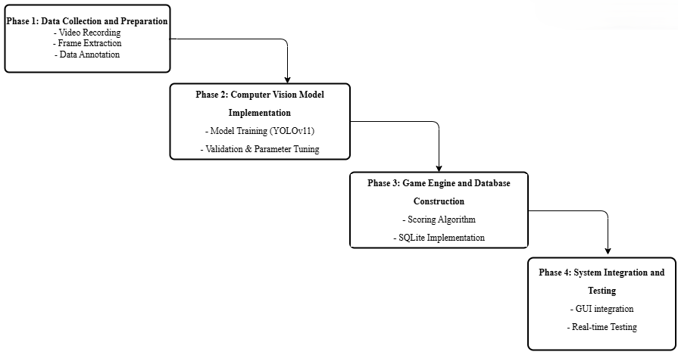
Figure 1.1 Waterfall model diagram

The development process begins with data collection and preparation. A custom dataset will be created by recording local pickleball games. Raw video footage will be processed into individual frames, which will be annotated with bounding boxes to create training data.
This next phase followed by the computer vision model implementation. YOLO object detection model will be fine-tuned on the custom dataset using the PyTorch framework. The training process in this stage will focus on maximizing mean Average Precision to ensure the model reliably outputs accurate real-time ball coordinates.
The third phase involves game engine and database construction. A Python-based game logic engine will be designed to manage side-out scoring rules, track server rotation, and maintain the overall game state. Additionally, an SQLite database will be implemented to log all game events with timestamps.
Finally, the process concludes with system integration and testing. The coordinates are fed to the logic engine to update the score and log events, allowing for real-time dashboard display and post-match analytics. This phase will be performed in real-time testing. System will be validated in a live match environment to compare the scoring accuracy against manual scorekeeping.

1.6 Significance of Project
The primary significance of this project is to enhance the player experience. By automating the process of manual scoring, the system effectively reduces human error, which minimizes on-court disputes and game interruptions. This allows players to remain fully focused on the game, thereby improving the overall experience and enjoyment of the sport.
Furthermore, the project plays a crucial role in democratizing sports technology. It addresses a significant accessibility gap by demonstrating that a low-cost, software-based solution provides a viable alternative to expensive professional systems. This approach makes advanced sports analytics accessible to the wider recreational community.

1.7 Project Schedule
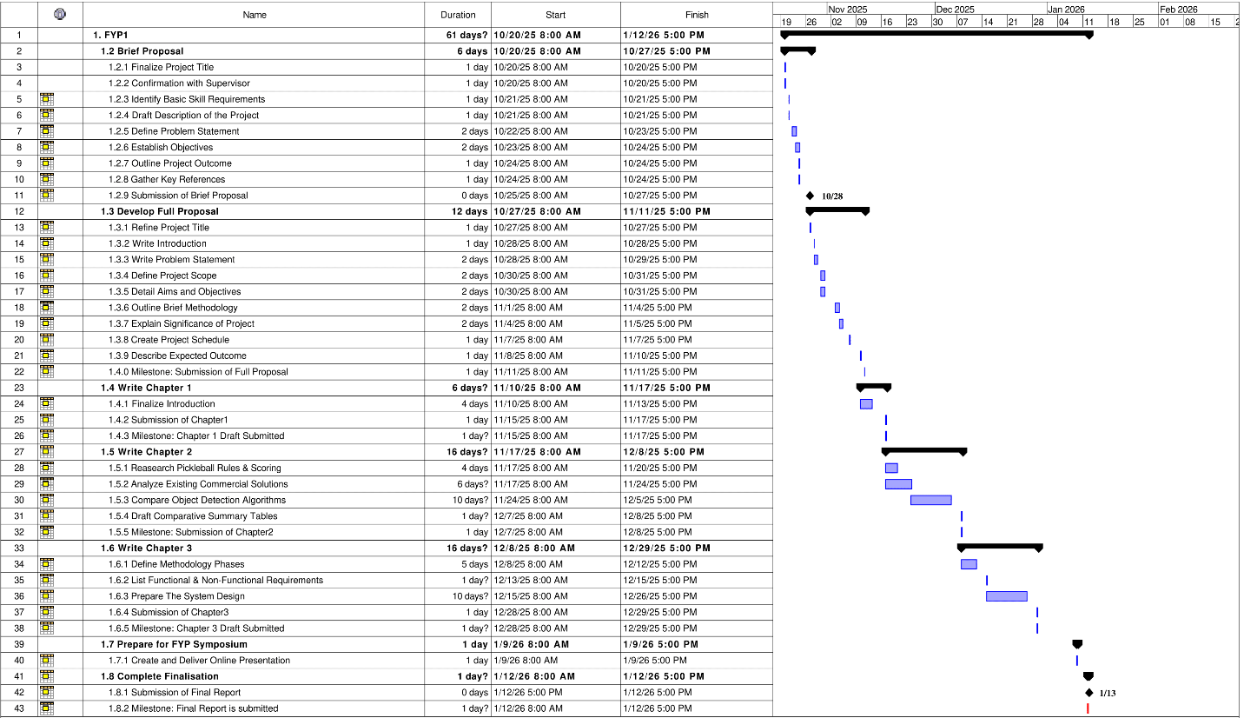
Figure 1.2 Overview of Gantt Chart

1.8 Expected Outcome
The primary delivery of this project will be a functional system prototype, which is a complete, integrated hardware and software solution capable of automatically counting points for a pickleball match. The core components consist of custom-annotated pickleball video dataset, fine-tuned YOLO model, Python-based game logic engine and the user dashboard.

: LITERATURE REVIEW

2.1 Introduction
This chapter establishes the theoretical and technical foundations necessary for developing an Automated Pickleball Point Counting System. The review begins by analyzing the rules of pickleball, specifically emphasizing the complexity of the traditional side-out scoring format. Subsequently, it conducts existing commercial solutions, from professional multi-camera systems like Hawk-Eye to mobile applications like SwingVision. This comparison highlights the accessibility and cost limitations for recreational players. Finally, the chapter reviews relevant academic research in computer vision to justify the choice of the YOLO object detection model for high-speed ball tracking.

2.2 Pickleball Scoring
In pickleball tournaments, the most widely adopted format is the three-number scoring System. Unlike tennis or badminton, which use rally scoring, pickleball awards a point for each rally won. Doubles pickleball adopts a unique side-out scoring format compared to others sport. In this system, only the serving team can score points when they win a rally. If the receiving team wins a rally, they do not score a point but gain the right to serve.
This format introduces a unique complexity where the score is announced as three distinct numbers. These numbers represent the serving teams score, the receiving teams score, and the server number, indicating which partner is serving. Figure 2.1 illustrate the components of the three-number scoring format. The first number represents the serving teams score, second is receiving teams score, and the third indicates which server is currently serving.
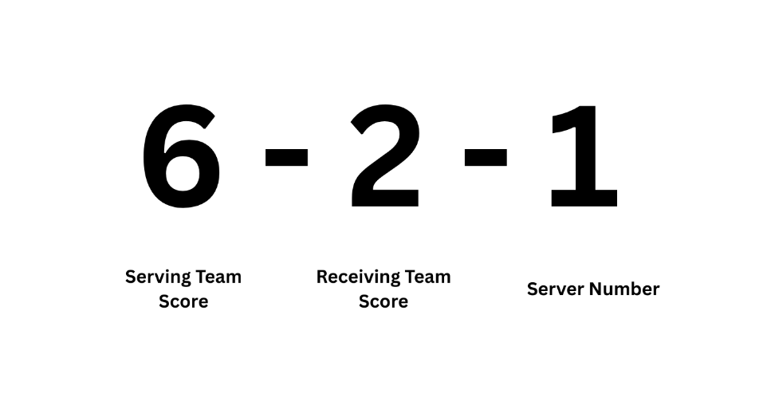
Figure 2.1 Illustration of the three-number scoring format

This system can be challenging for players, especially recreational players who want to focus on the game. The difficulty arises because players must track these three variable numbers simultaneously while actively playing. For instance, the server number applies only to the current service rotation, and players frequently forget whether they are the first or second server after a long rally. Furthermore, because the receiving team earns the serve rather than points, the scoring progression is non-linear, often leading to on-court disputes and forcing players to guess the forgotten scores. As a result, this reliance on manual memory disrupts the flow of the game. This highlights a clear need for an automated solution that can track the game state independently.
To illustrate the rotation process, Figure 2.2 shows the complete decision flow for side-out scoring. The diagram begins with the match score at 0-0-2, indicating the serving team switch partner and having another chance to serve. if the serving team wins a rally, they add a point and switch sides. Conversely, if the receiving team wins, no point is score and server will be decided whether moves to the partner or results in a side out to the opponents.
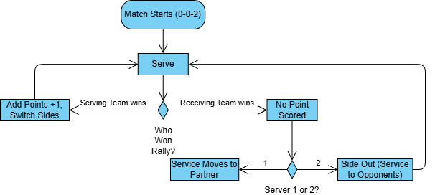

Figure 2.2 The Side-Out Scoring Process

2.3 Review of Existing Commercial Systems
The integration of Artificial Intelligence (AI) and Computer Vision has dramatically changed the landscape of sports officiating and analytics. Current market solutions for automated tracking are generally divided into three tiers based on cost, infrastructure complexity, and the intended user. These tiers include professional optical tracking systems used in tournaments, consumer mobile applications, and dedicated portable hardware designed for recreational use. The following sections will examine specific examples within each category to highlight their limitations regarding the recreational pickleball community.

2.3.1 Hawk-Eye
Advanced optical tracking technologies are currently the benchmark for sports officiating, particularly in high-profile competitions like Grand Slams and the Olympics. The Hawk-Eye system is the preferred choice for these professional events because it produces highly accurate ball tracking using a multi-camera array. It works by synchronizing video feeds from 6 to 10 high-performance cameras placed around the stadium, as shown in Figure 2.3. These cameras generate a three-dimensional model of the court to triangulate the precise position of the ball, allowing the creation of virtual replays used in challenge systems (Hawk-Eye Innovations, n.d.).
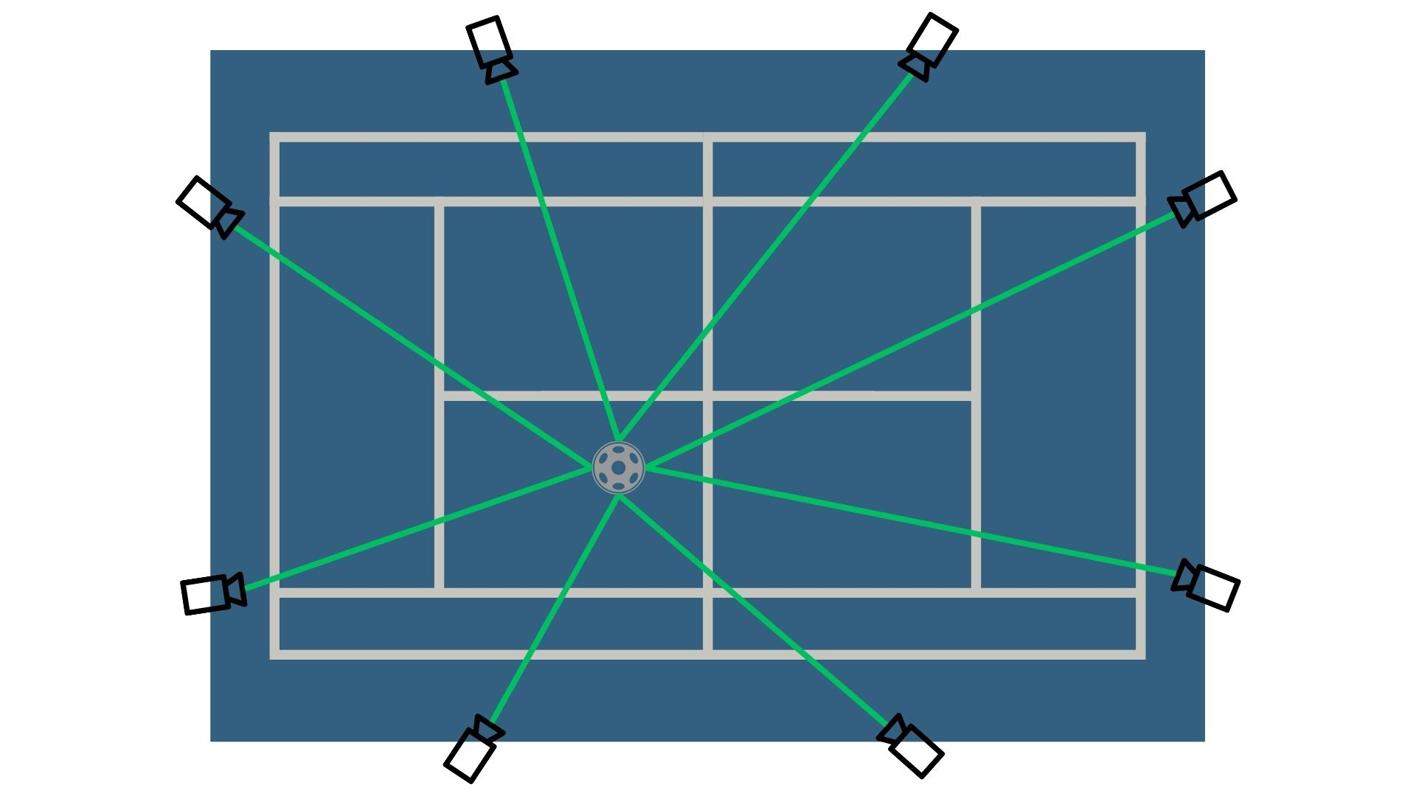
Figure 2.3 Operational diagram of the Hawk-Eye tracking system (Hawk-Eye Innovations, n.d.)

Despite the advantages of the Hawk-Eye system, the Hawk-Eye system remains largely inaccessible for recreational application due to its dependency on heavy infrastructure. As illustrated in Figure 2.4, a standard installation required permanent cabling, elevated camera mounting, and on-site data processing facilities. Moreover, the financial barrier is high, Faiza (2025) estimates installation costs at approximately $100,000 per venue, exclusive of ongoing licensing and maintenance fees. Therefore, while such systems are effective for professional broadcasting, they are not financially and logistically viable for implementation by community centers or individual stakeholders.
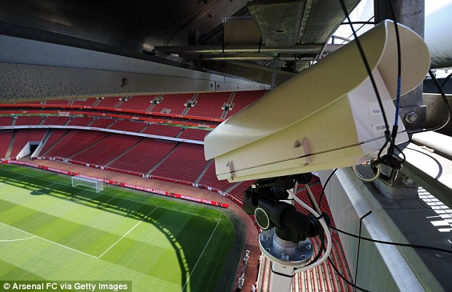
Figure 2.4 A Hawk-Eye camera mounted on a stadium gantry (Daily Mail, 2013)

2.3.2 Swingvision
In the consumer market, SwingVision stands out as the leading solution. This is a mobile application that uses the advanced computing power (NPU) of modern smartphones to track shots and referee matches. Unlike professional systems that rely on complex array of multiple cameras, SwingVision works using footage from a single camera, making it more accessible to casual players.
The parameters are simple, as shown in Figure 2.5. Users simply mount their smartphones high on the rear fence using a tripod or special swing stick. From this perspective, the artificial intelligence of SwingVision analyzes the video stream in real time, detecting the lines of the field and tracking the trajectory of the ball.
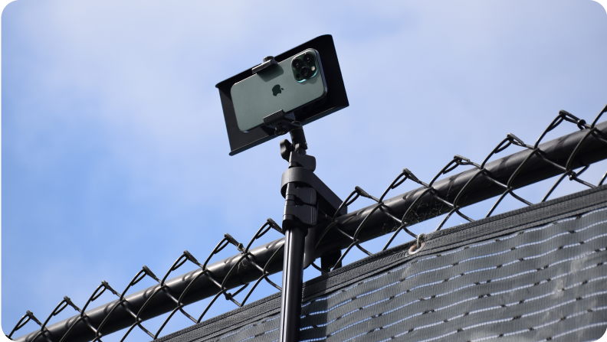
Figure 2.5 Swing stick phone mount setup. (SwingVision, 2025)
Although SwingVision provides a great solution to tackle the issue, there are significant obstacles that limit its use by casual players. The issue is the app relies entirely on Apple technology, which creates an ecosystem lock. This requirement excludes a large portion of the users who own Android devices. Moreover, SwingVision runs on a subscription model. Critical features like automated scoring are locked behind a paywall, costing users to pay approximately $14.99/month or $179.99/year. Even with the introductory offers shown in the figure 2., the price proposes a burden to casual players.

Figure 2.6 Price of the subscription fee

2.3.3 In/Out
The In/Out device is a dedicated portable hardware unit designed specifically for automated line calling. Roughly the size of a GoPro, it functions as a standalone dual-camera system that mounts directly onto the net post or using the device stand to monitor the court. As illustrated in Figure 2.7, the device utilizes two wide-angle cameras to monitor the court lines. When a ball lands, the device processes the video locally and emits a beep sound and a light flash if the ball is determined to be out. The recommended setup by manufacturer is to buy dual device so can minimize blind spots caused by players blocking the camera view.
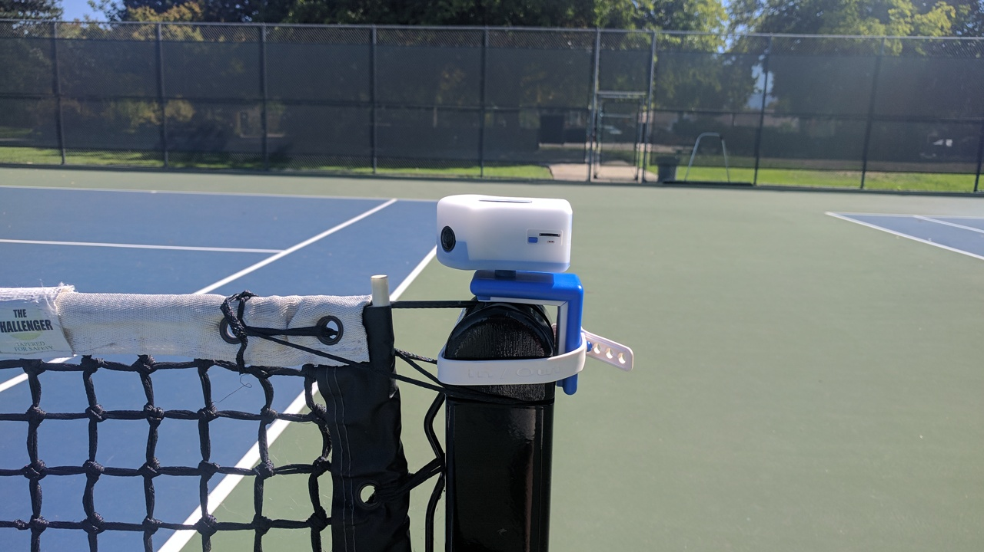
Figure 2.7 Setup of the In/Out Net Device V4.0 (In/Out Tennis, n.d.)

Despite its automation, the In/Out system presents practical barriers for recreational use. First is the cost-to-value ratio, a recommended dual-unit setup for pickleball exceeds $500 USD. Unlike a laptop or smartphone, this is a significant cost for single-purpose hardware. Second is the operational friction, users must charge and calibrate the device before every match, with performance often degrading in variable lighting conditions. Finally, attaching a fence to a post creates a physical hazard. Given the aggressive nature of pickleball games near the kitchen, placing the equipment inside the net runs the risk of being hit by rackets and being a distraction, unlike the proposed system that ensures equipment safety off the court.

2.4 Comparison of Existing Commercial Solutions
To clearly define the market landscape, a direct comparison was made against the commercial solutions reviewed in this chapter. Table 2.1 evaluates each system based on cost, hardware complexity, and accessibility for the average player.
Table 2.1 Comparison of existing commercial solutions
Feature | Hawk-Eye (Hawk-Eye Innovations, n.d.) | SwingVision (SwingVision, 2025) | In/Out (In/Out Tennis, n.d.)
Primary Target | Official Tournaments | Amateur / Recreational Players | Club / Line Calling
Hardware Required | Multi-Camera Array (6+) | High-End iPhone (A12+) | Dual Dedicated Cameras
Setup Complexity | High, Permanent installation required | Low, Mount phone on fence | Medium, Mount device on net post
Cost Model | Extreme (> RM260,000) | Subscription (~RM800/year) | Hardware Buy (~RM2200)
Platform | Proprietary Server | IOS Ecosystem Only | Embedded System
Main Limitation | Infrastructure Dependent | Subscription & Hardware Lock | Calibration required

As shown in Table 2.1, there is a clear trade-off between accuracy and affordability in today's market. Professional solutions such as the Hawk-Eye Innovations (n.d.) system provide the high precision required for officiating but demand a financial and logistical infrastructure that is unreachable for community use. On the consumer side, apps like SwingVision (2025) reduce costs but remain limited by ecosystem lock-in and subscription models. Similarly, dedicated hardware solutions such as In/Out Tennis (n.d.) solve the subscription problem, but introduce another issue of requiring users to purchase, charge, and calibrate specialized equipment for every match.
Therefore, a significant gap remains for systems that can provide reliable automated tracking on standard hardware without the monthly subscriptions or proprietary devices. This project addresses that challenge by implementing the YOLOv11 object detection algorithm to provide a real-time, low-cost alternative for recreational pickleball players using only a generic laptop.

2.5 Object Detection Algorithms
Object detection is a fundamental computer vision task that involves identifying and locating instances of semantic objects of a certain class in digital images or videos (Jiao et al., 2019). While image classification focuses on categorizing the images into a label, object detection extends this capability by simultaneously identifying the position and labelling the object (Liu et al., 2019). It transforms from identifying instance of the object to precisely determining the coordinate and classes of the object simultaneously.
The core complexity of object detection lies in the execution of two different tasks in classification and localization. Classification is responsible for determining the identity of the object and labeling it as a class. On the other hand, localization requires the model to precisely estimate the geometric coordinates of a bounding box of an object. Both requirements combined required significant computational power to process compared to the standard image classification. The model cannot simply assign a label to the whole image instead needs to scan the entire frame to identify the geometric coordinates.
In the domain of deep learning, object detection algorithms are generally categorized into two primary architectures which are two-stage detectors and one-stage detectors (Zhao et al., 2019). One-stage detectors prioritize inference speed by performing both tasks simultaneously. Two-stage detectors prioritize in accuracy by separating the localization and classification steps. To determine the most suitable architecture for real-time pickleball tracking, few algorithms are reviewed and suggested as a most potential algorithm such as Faster R-CNN, SSD, and YOLO.

2.5.1 Two-Stage Detectors (Faster R-CNN)
The Region-based Convolutional Neural Network (R-CNN) family constitutes a foundational approach in deep learning-based object detection. Its most prominent iteration, Faster R-CNN, functions through a distinct two-phase process , as illustrated in Figure 2.8. In the first phase, Region Proposal Network (RPN) scans the image to generate the object bounding boxes. In the second phase, classifies the object and refines the bounding box coordinates to ensure precision (Jiao et al., 2019).
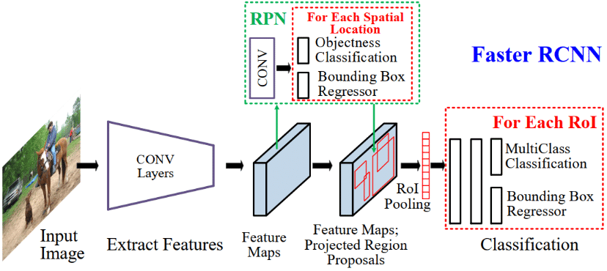
Figure 2.8 High-level architecture of Faster R-CNN (GHOURY et al., 2019)

Despite Faster R-CNN being able to offer a high accuracy performance, this two-stage architecture presents a limitation for the pickleball tracking project. Computational is very expensive when processing a large amount of data. Typically yielding speeds of only 5–7 Frames Per Second (FPS) on standard consumer laptops (Ren et al., 2017). This latency is unacceptable for the project need to track a real-time application such as high velocity pickleball, which can travel at speeds exceeding 60 km/h (Fischetti, 2024). In a low frame rate would result in significant motion gaps between detections.

2.5.2 One-Stage Detectors (SSD)
The Single Shot MultiBox Detector (SSD) was developed to address the issue of latency bottlenecks found in two-stage architectures like Faster R-CNN. It eliminates the use of the region proposal stage entirely and treats object detection as a single deep neural network regression problem (Jiao et al., 2019). Moreover, SSD can predict bounding boxes and class probabilities directly from feature maps in a single forward pass of the network, significantly reducing computational overhead (Zhao et al., 2019).
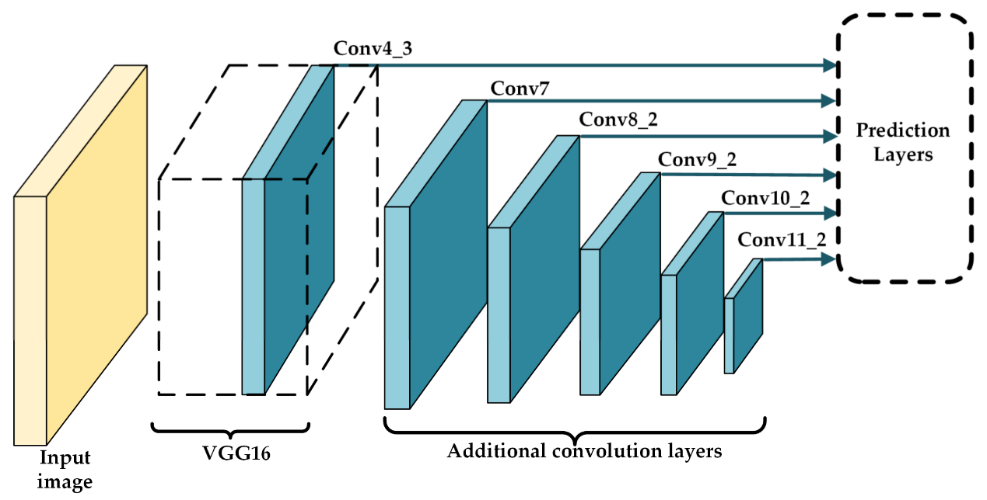
Figure 2.9 SSD architecture showing detection at multiple feature map scales (Li et al, 2021)

However, the trade-off in high accuracy is critical for this project. SSD struggles with small object detection because it relies on lower-resolution feature maps to predict objects by referring to the figure 2.9 (Liu et al., 2019). In the scenario of pickleball tracking, the ball appears as a very small object and prone to missed detections. Making it less reliable than the proposed YOLO solution.

2.5.3 You Only Look Once (Yolov11)
The You Only Look Once (YOLO) framework is a unified architecture designed to optimize object detection for real-time applications. Proposed by Redmon et al. (2016), YOLO redefines the traditional detection pipeline by framing the entire task as a single regression problem. The architecture operates by dividing the input image into a grid, as illustrated in Figure 2.10. Within this structure, each grid cell is responsible for simultaneously predicting bounding box coordinates, confidence scores, and class probabilities. This unified design allows the neural network to process the full image in a single forward pass, enabling high-speed inference without the need for complex, sequential processing steps (Redmon et al., 2016).
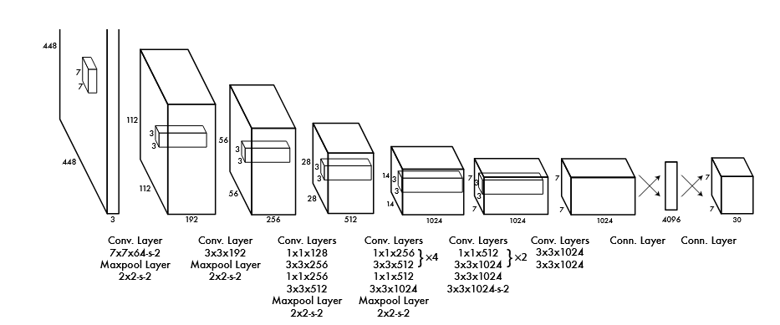
Figure 2.10 The YOLO network architecture (Redmon et al., 2016)

For this project, the YOLOv11-m (Medium) model was selected as the optimal architecture. Released by Ultralytics in late 2024, it introduces significant improvements suited for the dynamic environment of pickleball. The model utilizes enhanced feature extraction layers that allow it to capture invariant features, ensuring the ball is recognized even when its texture is degraded by motion blur or changing lighting conditions (Jocher et al., 2024).
Furthermore, YOLOv11 addresses the traditional weakness of one-stage detectors regarding small objects by employing an adaptive attention mechanism. This allows the network to dynamically scale its focus, which is vital for this project as the pickleball often occupies fewer than 20 x 20 pixels at the far end of the court. Finally, the medium variant provides a superior speed-accuracy trade-off compared to predecessors (v8 or v5), ensuring a consistent frame rate of more than 30 FPS on standard consumer hardware.

2.5.4 Comparison of Algorithms
To validate the selection of YOLOv11, Table 2.2 compares the three algorithms based on their suitability for real-time sports tracking on consumer hardware.
Table 2.2 Comparison of Object Detection Algorithms
Feature | Faster R-CNN (Ren et al., 2017) | SSD (Liu et al., 2016) | YOLOv11 (Jocher & Qiu, 2024)
Architecture | Two-Stage (Region Proposal + Detection) | One-Stage (Multi-scale Feature Maps) | One-Stage (Grid-based Regression)
Primary Strength | Highest Accuracy (mAP) | Good Speed/Accuracy Balance | Highest Speed (FPS)
Weakness | Slow inference speed; computationally heavy. | Struggles with very small objects. | Slightly lower accuracy on overlapping objects.
Inference Speed | Slow (~5–7 FPS) | Medium (~20–40 FPS) | Fast (~60+ FPS)
Suitability for Sports | Low (Too much latency for fast balls) | Medium (Good, but misses small balls) | High (Real-time tracking capable)

As shown in Table 2.2, Faster R-CNN is rejected due to its inability to run in real-time. SSD is rejected due to potential accuracy issues with small objects. YOLOv11 is selected as the optimal solution because it is the only architecture capable of achieving >60 FPS on a local PC, which is necessary to track the high-velocity trajectory of a pickleball without skipping frames.

2.6 Comparative Summary
This chapter provided a comprehensive review of the theoretical and technical foundations required to develop an Automated Pickleball Point Counting System. The investigation began by analyzing the complexities of the pickleball side-out scoring system, identifying the high cognitive load placed on recreational players.
A review of existing commercial solutions, including Hawk-Eye, SwingVision, and the In/Out device, revealed a significant gap in the market. While these systems offer advanced tracking, they remain inaccessible to the general community due to high infrastructure costs, subscription fees, or hardware exclusivity.
Technologically, the chapter evaluated various object detection architectures. While Two-Stage detectors like Faster R-CNN offer high accuracy, they lack the inference speed required for real-time tracking on consumer hardware. Consequently, YOLOv11 was identified as the optimal algorithm, offering the best balance of speed and accuracy for tracking high-velocity projectiles.

: REQUIREMENT ANALYSIS AND DESIGN

3.1 Introduction
This chapter serves as the transition from the theoretical foundations and literature review established in Chapter 2 to the practical process of the project. While the previous chapter identified the gap in existing commercial solutions and justified the selection of the YOLOv11 algorithm, this chapter focuses on the detailed planning required to implement the solution.
The primary objective of this chapter is to define the requirement analysis and design specifications for the Automated Pickleball Point Counting System. This chapter is organized into three key sections. First, this chapter detailing the methodology. Second, this chapter presents the requirement analysis, specifying the functional and non-functional requirements. Finally, this chapter details the system design, illustrating the system architecture, database schema, and user interface components.
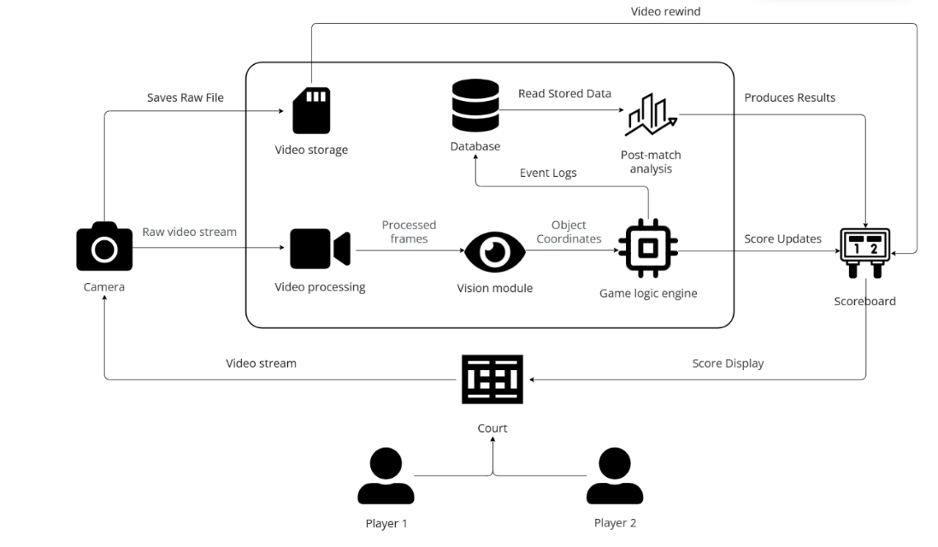
Figure 3.1 Proposed System Architecture
The high-level architecture of the proposed system is illustrated in Figure 3.1. This shows the beginning of the video input from the live camera feed, processed by the computer vision module to extract frame data. The detected coordinates are then passed to the game logic engine to determine the match state. Finally, the results are stored in the database and visualized on the dashboard interface for the user.

3.2 Methodology
The development of the Automated Pickleball Point Counting System adopts the Waterfall model. This approach organizes the project lifecycle into four different stages, which is the data collection and preparation, core detection module, game logic and database development and system integration and testing. This sequential approach ensures prioritization of the core Artificial Intelligence (AI) component before the development of the application logic. This ensures that the object detection model meets the necessary accuracy requirements before it is integrated into the final software solution. Figure 3.2 shows the waterfall model for this project.
Figure 3.2 Development Framework of the Automated Pickleball Point Counting System

3.2.1 Phase 1: Data Collection and Preparation
The first phase focuses on a custom dataset. Data collection involves recording actual gameplay using a standard USB webcam set to a 1080p resolution. As illustrated in Figure 3.3, the camera is positioned at a fixed point at the rear center of the court, elevated approximately 1.5 meters high. This specific placement ensures a complete Field of View (FOV) of the court lines and player movements while minimizing occlusion.
This specific configuration was selected based on several key factors. The longitudinal angle offers an optimal Field of View (FOV) that captures both the serving and receiving sides within a single frame. Furthermore, positioning the camera at an elevated height minimizes the risk of obstruction by the players compared to net-level or side-line configurations. Finally, the fixed position of the camera creates a uniform tracking environment, ensuring the detection algorithm can consistently monitor the ball across the entire court.
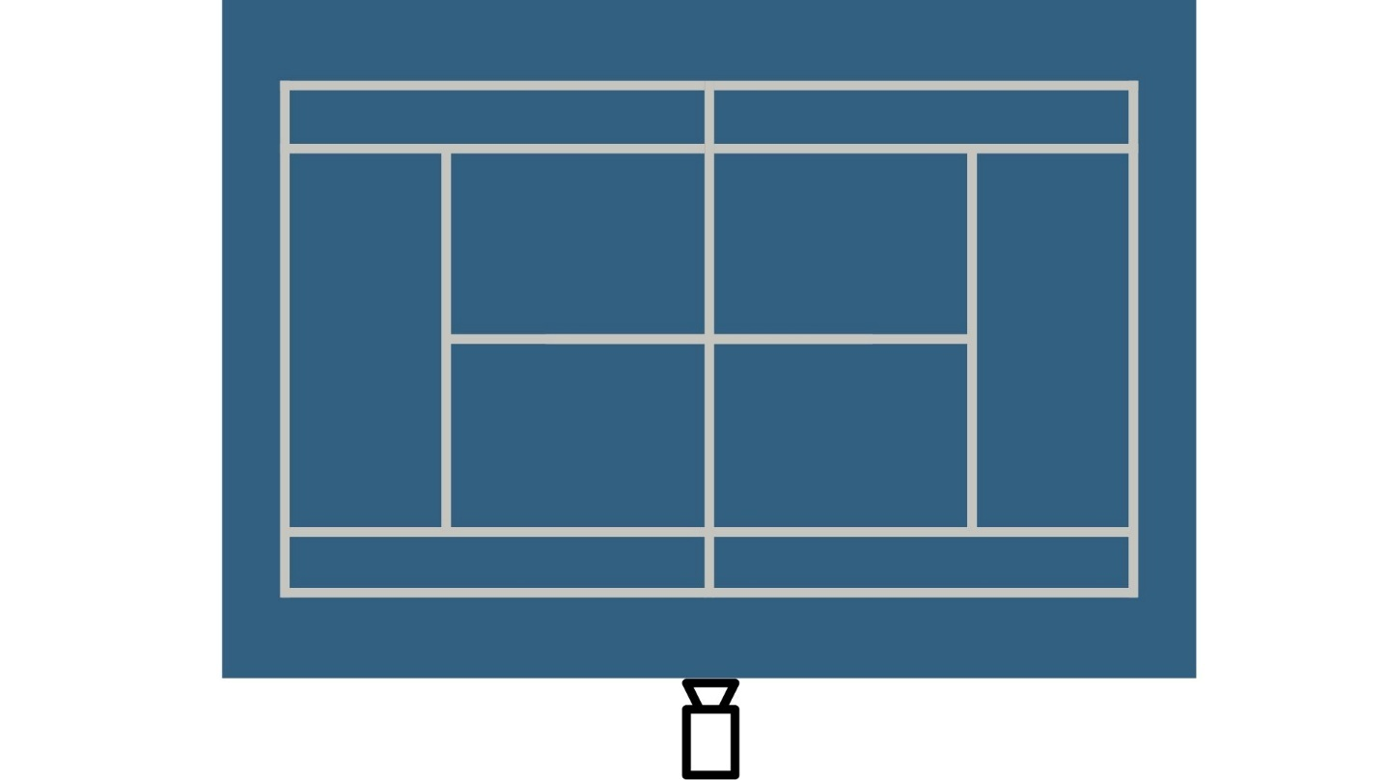
Figure 3.3 The position of camera at the rear baseline
Once the raw video footage is captured, it is processed into individual frames using the OpenCV library. These frames were manually annotated using tools of Roboflow, where bounding boxes were drawn around the pickleball in each frame to clearly define the object of interest. Preliminary validation of this annotation workflow was conducted using proxy objects, as shown in Figure 3.4, before proceeding to full-scale on-court data collection.
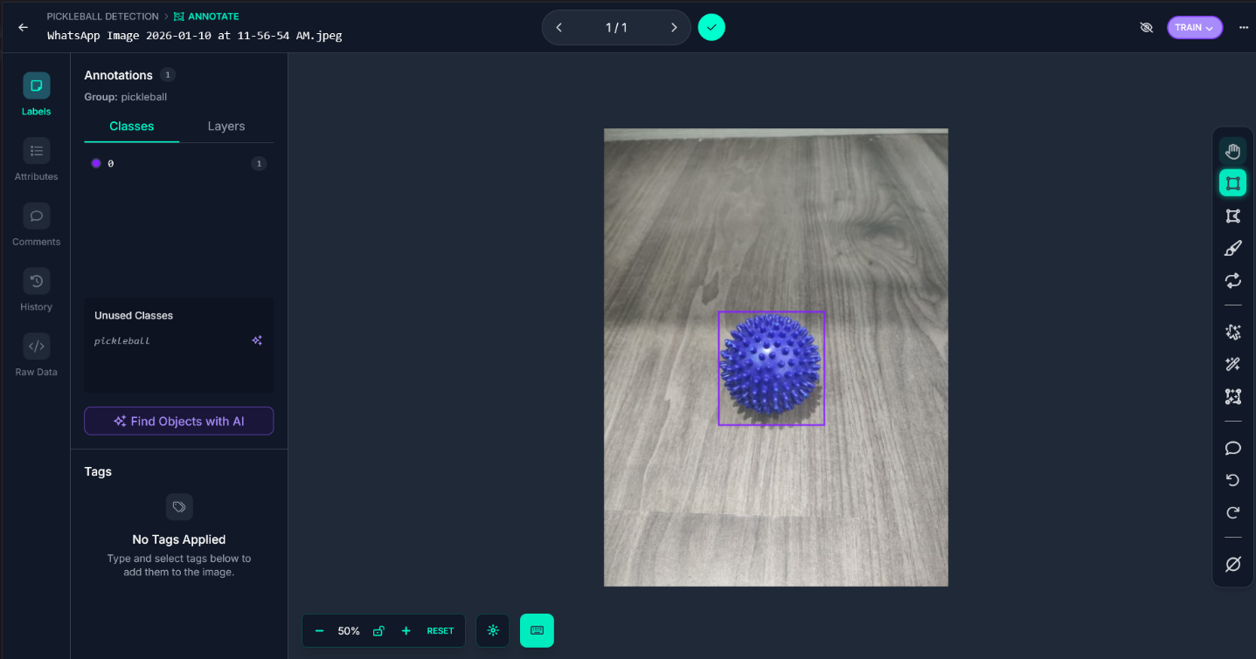
Figure 3.4 Illustration of the bounding box annotation workflow using a proxy object for preliminary testing

Finally, the annotated dataset was partitioned into three distinct subsets: Training Set of 70% for learning features, Validation Set of 20% for hyperparameter tuning during training, and Testing Set of 10% for the final unbiased evaluation.

3.2.2 Phase 2: Core Detection Module (Yolov11 Training)
In this phase, the training process focuses on maximizing the Mean Average Precision (mAP). The model is fine-tuned on the custom dataset prepared in Phase 1 using the PyTorch deep learning framework. mAP is a performance metric that calculates the average precision across various recall levels, providing a single score that balances false positives and false negatives. This metric is crucial for validating the model's consistency in detecting the small, high-velocity pickleball across different frames. Specifically, the system aims to optimize mAP@50, and hyperparameters will be iteratively adjusted to maximize this score, ensuring high-confidence tracking in real-time.

3.2.3 Phase 3: Game Logic And Database Development
A python language is used to construct a base game logic engine as a state machine. This engine is responsible for enforcing the specific rules of pickleball, particularly the traditional side-out scoring format, which requires tracking the serving teams score, the receiving teams score, and the server number. Concurrently, a local storage solution is implemented using the SQLite database engine. This database is designed to log game events accompanied by a precise timestamp. This ensures the system works entirely offline and preserves match data for post-game analysis.

3.2.4 Phase 4: System Integration And Testing
The final phase involves integrating the independent components into a unified functional prototype. The coordinates generated by the YOLOv11 module in phase 2 are fed directly into the game logic engine developed in phase 3. The engine interprets these coordinates to update the game state. Consequently, a user dashboard is developed using standard web tools to display the live score and match status. The completed system then undergoes validation testing, where the automated point counting accuracy is compared against manual scorekeeping to evaluate its effectiveness and reliability in a real-world scenario.

3.3 Requirements Analysis
This section classifies the system specifications into two categories which are functional requirements and non-functional requirements. The functional requirements are the core operations of the system. Non-Functional Requirements specify the quality attributes. These requirements serve as the validation criteria for the final prototype. To visualize the structural hierarchy and grouping of these requirements, the system modeling is illustrated in Figure 3.5.

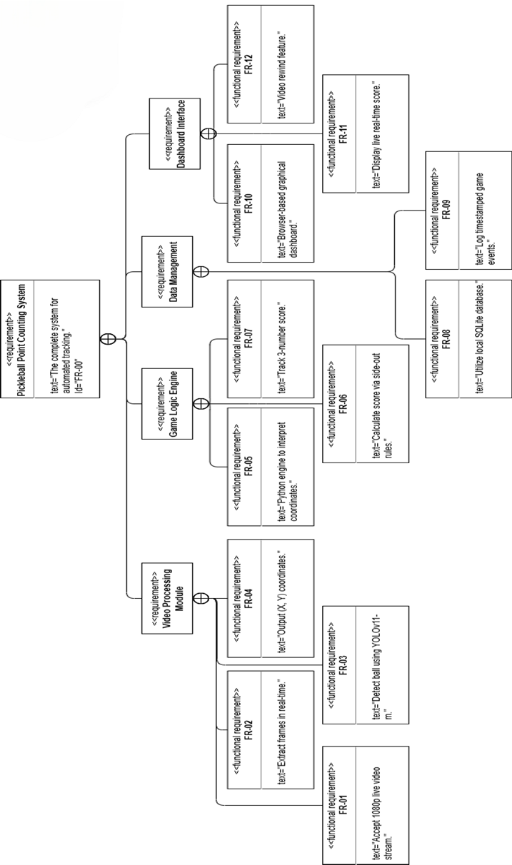
Figure 3.5 System Modeling Language Diagram

3.3.1 Functional Requirements
Functional requirements define the specific behaviors, operations, and functions that the system must execute to satisfy the project objectives. These requirements have been derived from the project scope and the official rules of pickleball side-out scoring. Table 3.1 shows the functional requirements list of the project.
Table 3.1 List of Functional Requirements
ID | Use Case | Requirement Description | Priority
FR-01 | Capture Video Stream | The system shall accept a continuous live video stream from a standard USB webcam. | High
FR-02 | Capture Video Stream | The system shall process the raw video stream by extracting individual frames in real-time. | High
FR-03 | Process Object Detection | The system shall utilize the YOLOv11-m deep learning model to detect the pickleball in video frames. | High
FR-04 | Process Object Detection | The system shall output the geometric coordinates of the detected ball for every frame. | High
FR-05 | Update Game State | The system shall implement a Python-based logic engine to interpret the coordinates of the ball. | High
FR-06 | Update Game State | The system shall automatically calculate the score using traditional side-out scoring rules. | High
FR-07 | Update Game State | The system shall track the three-number score | High
FR-08 | Save Match Log | The system shall utilize a local SQLite database to store game data and logs. | Medium
FR-09 | Save Match Log | The system shall generate a timestamped log for every significant game event. | Medium
FR-10 | View Live Dashboard | The system shall provide a graphical dashboard interface viewable in a standard web browser. | Medium
FR-11 | View Live Dashboard | The dashboard shall display the live match score to the users in real-time. | High
FR-12 | Rewind Video | The dashboard shall include a video rewind feature to replay recent footage for verification. | Low

3.3.2 Non-Functional Requirements
Non-functional requirements specify the quality attributes of the system, such as performance, reliability, and constraints. These ensure the system is usable and effective in a real-world scenario. Table 3.2 details the non-functional requirements for the project.
Table 3.2 List of Non-Functional Requirements
ID | Category | Requirement Description | Priority
NFR-01 | Performance | The system must process video at a minimum of 60 FPS to track high-speed balls. | High
NFR-02 | Constraint | The system must operate entirely on a local PC without requiring internet connectivity. | High
NFR-03 | Accuracy | The object detection model shall be optimized to maximize mean Average Precision (mAP) for small objects. | High
NFR-04 | Constraint | The system must utilize standard consumer hardware to ensure low cost. | High
NFR-05 | Usability | The user interface shall be designed for simplicity, requiring minimal configuration from the user. | Medium
NFR-06 | Reliability | The system must be robust against environmental noise such as variable lighting or motion blur. | Medium

3.3.3 Hardware and Software Requirements
To ensure the system meets the real-time performance and offline processing constraints defined in the non-functional requirements, the following hardware and software environments are specified in Table 3.3 and Table 3.4.
Table 3.3 Hardware Requirements
Component | Specification
Development PC | Laptop  - OS: Windows 10/11  - RAM: 16GB  - GPU: NVIDIA GTX/RTX Series
Camera | USB Webcam  - Resolution: 1080p  - Frame Rate: 60 FPS
Sport Equipments | Standard Pickleball Gear  - Paddles  - Polymer Balls

A high-performance laptop is selected as the primary workstation for coding and model training. A dedicated NVIDIA GPU is recommended since it provide CUDA acceleration for the PyTorch framework. This acceleration is critical to ensuring the YOLOv11 model can process video frames fast enough to exceed the 30 FPS threshold defined in NFR-01.

A standard USB webcam is chosen to provide the raw video input for the Vision Module, ensuring plug-and-play compatibility. However, a specific frame rate of 60 FPS is selected to minimize motion blur on high-velocity shots, which is necessary for accurate tracking.
Standard pickleball gear, including paddles, polymer balls, is required to record the custom dataset for training and to perform real-world validation of the point counting accuracy of system.
Table 3.4 Software Requirements
Component | Tools
Language | Python 3.9+
AI Framework | PyTorch
Vision Library | OpenCV
Database | SQLite
Data Annotation | Roboflow
Frontend | HTML, CSS, JavaScript

The core software architecture is built using Python 3.9+, selected as the primary development language to develop the backend game logic and system integration. For the computer vision component, OpenCV is used for capturing the live webcam stream and preprocessing raw video frames before detection. PyTorch framework is used to fine-tune and execute the YOLOv11-m object detection model with the leveraging GPU acceleration to ensure real-time performance.
Roboflow is use for labeling the custom dataset and generating the necessary training and validation splits. SQLite was selected as the database engine to store the necessary data without internet dependency. Finally, the user dashboard is rendered using standard web technologies.

3.4 System Design
The system design phase translates the functional and non-functional requirements into visual models that guide the implementation. This section details the systems design across three key layers, which are interaction design of use case and sequence diagrams, logic design of activity diagrams, and structural design of class diagrams, database schema, and GUI layouts. Collectively, these models provide a comprehensive blueprint for the development process.

3.4.1 Use Case Diagram
The diagram shows how the user and hardware components communicate with the system to process the live video stream. Figure 3.6 illustrates the use case diagram for the proposed Automated Pickleball Point Counting System.
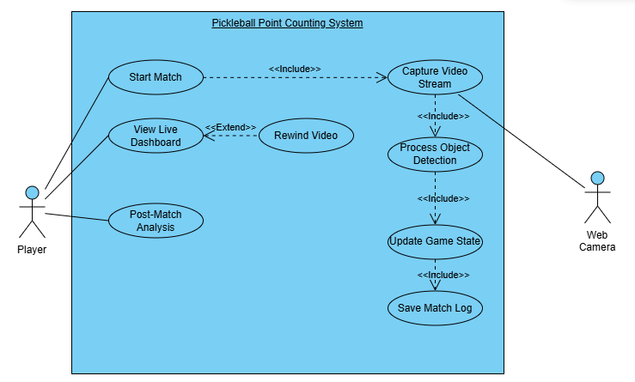
Figure 3.6 Automated Pickleball Point Counting System use case diagram

As shown in Figure 3.5, the system involved two primary actors, namely the player and the web camera. The player is involved in initiating the match, viewing live dashboard and post-match analysis. While the web camera serves as the external hardware actor that provides the video input for the object detection module.

3.4.2 Use Case Description
Table 3.5 Use Case Description for automated game tracking
Use Case Name | Capture Video Stream
Use Case ID | UC-01
Actor | Web Camera
Requirements | FR-01: System shall accept continuous live video stream.  FR-02: System shall process raw video frames.
Description | The system continuously accepts raw video frames from the hardware device to initiate the tracking process.
Pre-conditions | 1. User has initiated start match function.  2. Camera is connected via USB.
Post-conditions | A raw video frame is stored in memory and ready for processing.
Main Flow | 1. The Web Camera activates and sends a video stream signal.  2. The system receives the signal and buffers the current frame.  3. The system passes the frame to the detection module.
Alternate Flow | A1: Camera Disconnected  1. The system detects the video signal is lost.  2. The system pauses the game logic.  3. The system displays a warning on the dashboard.
Exception Flow | E2: Initialization Failure  1. The system fails to open the camera driver.  2. The system logs a critical error and aborts the start match process.

Table 3.6 Use Case Description for Process Object Detection
Use Case Name | Process Object Detection
Use Case ID | UC-02
Actor | System
Requirements | FR-03: System shall utilize YOLOv11-m model.  FR-04: System shall output geometric coordinates.
Description | The system analyzes the frame to locate the pickleball using the YOLOv11 deep learning model.
Pre-conditions | UC-01 has successfully buffered a raw frame.
Post-conditions | X and Y coordinates of the ball are identified.
Main Flow | 1. The system resizes the frame to the models input size.  2. The YOLOv11 model scans the image for the ball class.  3. The system extracts the bounding box center coordinates.
Alternate Flow | A2: No Ball Detected  1. The model confidence score is below the threshold.  2. The system returns a null coordinate.  3. The flow ends for this specific frame.
Exception Flow | E1: Model Corruption  1. The system cannot load the yolo.pt weight file.  2. The system throws a model missing exception.

Table 3.7 Use Case Description for Update Game State
Use Case Name | Update Game State
Use Case ID | UC-03
Actor | System
Requirements | FR-05: System shall interpret ball coordinates.  FR-06: System shall calculate score using side-out rules.  FR-07: System shall track the three-number score.
Description | The logic engine applies pickleball rules to the position of the ball to update the score.
Pre-conditions | UC-02 has output valid ball coordinates.
Post-conditions | The score is updated in memory.
Main Flow | 1. The engine maps the coordinates to the court zones.  2. The engine determines if the rally ended.  3. The system updates the three-number score accordingly.
Alternate Flow | A3: Match Concluded  1. The serving team reaches 11 points.  2. The system sets the game state to finish.  3. The system triggers the post-match prompt.
Exception Flow | E3: Logic Error  1. The game state becomes invalid.  2. The system resets the state to the last known valid score.

Table 3.8 Use Case Description for Save Match Log
Use Case Name | Save Match Log
Use Case ID | UC-04
Actor | System
Requirements | FR-08: System shall utilize local SQLite database.  FR-09: System shall generate timestamped logs.
Description | The system records the game event to the database for persistence and future analysis.
Pre-conditions | UC-03 has completed a score update.
Post-conditions | A new row is inserted into the Game_Events table.
Main Flow | 1. The system constructs a data object with Timestamp, Event Type, and Score.  2. The system executes an INSERT query to the SQLite database.
Alternate Flow | A2: Rapid Events  1. Multiple events occur within milliseconds.  2. The system queues them to ensure sequential writing.
Exception Flow | E2: Database Locked  1. The SQLite file is currently being read by the dashboard.  2. The system retries the write operation after 10ms.

Table 3.9 Use Case Description for View Live Dashboard
Use Case Name | View Live Dashboard
Use Case ID | UC-05
Actor | Player
Requirements | FR-10: System shall provide a graphical dashboard.  FR-11: Dashboard shall display live match score.
Description | The user monitors the real-time match status, score, and server indicator.
Pre-conditions | The match is in progress and the system is running.
Post-conditions | The user is visually informed of the game state.
Main Flow | 1. The user views the dashboard screen.  2. The system fetches the current score from memory.  3. The UI updates the scoreboard numbers and server indicator.
Alternate Flow | A3: Manual Override  1. The user notices a wrong automated call.  2. The user clicks undo on the dashboard.  3. The system reverts the score to the previous state.
Exception Flow | E3: UI Freeze  1. The browser/interface becomes unresponsive.  2. The user refreshes the page to reload the current state from the database.

Table 3.10 Use Case Description for Rewind Video
Use Case Name | Rewind Video
Use Case ID | UC-06
Actor | Player
Requirements | FR-12: Dashboard shall include Video Rewind feature.
Description | The user replays recent footage to verify a disputed call.
Pre-conditions | User is viewing the dashboard (UC-05).
Post-conditions | The video clip is replayed on the screen.
Main Flow | 1. The user clicks the rewind button.  2. The system retrieves the last 10 seconds of video from the buffer.  3. The dashboard plays the clip in a modal window.
Alternate Flow | A3: Cancel Rewind  1. The user closes the replay window before it finishes.  2. The system immediately resumes the live feed.
Exception Flow | E2: Buffer Empty  1. The user attempts to rewind immediately after the match starts.  2. The system displays not enough footage notification.

3.4.3 Sequence Diagram
To visualize the real-time data exchange within the application, the sequence diagram Figure 3.7 details the lifecycle of a video frame from capture to point counting.
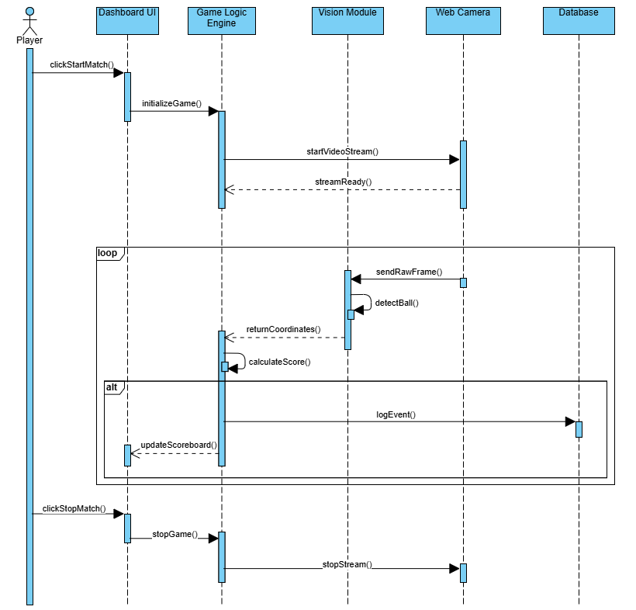
Figure 3.7 Sequence diagram of Automated Pickleball Point Counting System

The process is divided into three distinct phases, Initialization, the Main Processing Loop, and Termination. The workflow begins when the Player initiates the clickStartMatch() event on the DashboardUI. This triggers the Game Logic Engine to initialize the game state and signal the Web Camera to begin capturing footage startVideoStream().
Once the stream is ready, the system enters a continuous loop cycle. Within this cycle, the camera continuously sends raw frames to the Vision Module, which executes the detectBall() algorithm. Upon detection, the coordinates are returned to the Game Logic Engine for interpretation through calculateScore().
The Alternative fragment shows a conditional logic, if a scoring event is determined, the engine simultaneously triggers logEvent() and updateScoreboard(). This loop continues until the player triggers the clickStopMatch() event, which safely terminates the video stream and saves the final session state.

3.4.4 Activity Diagram
The activity diagram shows the system of game logic engine by figure 3.8. It illustrates the sequential flow of operations required to enforce traditional side-out scoring rules (FR-06).
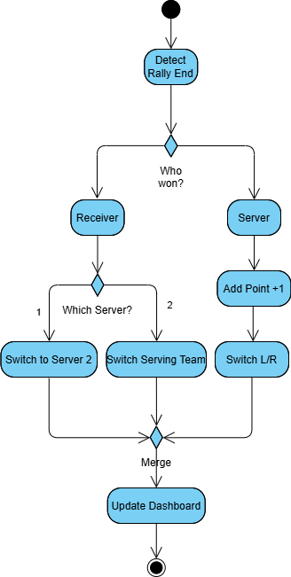
Figure 3.8 Activity Diagram of Pickleball Scoring Rules

The process is triggered automatically when the vision module identifies the termination of a rally. The logic flows make decision based on the teams, if the Serving Team wins the rally, it increments their score and updates the virtual player positions.
If the Receiving Team wins the rally, the system enters a nested decision branch to check the current Server Number (FR-07). If the current server is Player #1, the system executes Switch to Server 2, transferring the serve score. If the current server is Player #2, the system executes Switch Serving Team, resetting the server number to #1 and transferring service control to the opponents. All logical paths merge to execute the update dashboard action, ensuring the user interface immediately reflects the calculated game state.

3.4.5 Class Diagram
The structural design and component interactions are illustrated in the figure 3.9.
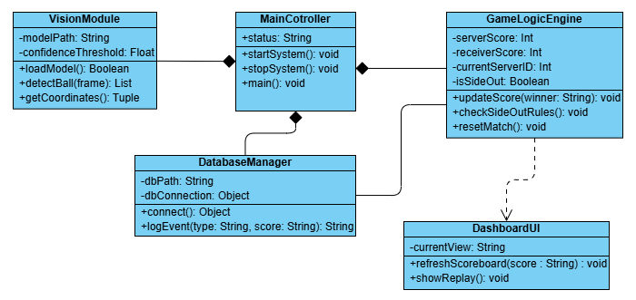
Figure 3.9 Class Diagram of the Automated Pickleball Point Counting System

The MainController act as an orchestrated for the application. This controller managing the subsystems, indicates by the composition relationships pointing to the main. If the main controller is terminated, these dependent subsystems are also properly closed.
VisionModule encapsulates the computer vision tasks, outputting coordinates to the controller. The GameLogicEngine maintains match states and enforcing side-out rules. It also maintains the direct association between the DatabaseManager, enabling the logic engine to trigger data logging events whenever a score changes. Finally, the DashboardUI is linked to the logic engine through a dependency relationship. The dashboard interface only retrieves and displays the current score from the engine.

3.4.6 Entity Relationship Diagram (ERD)
The entity relationship figure 3.10 illustrates the database schema to support the offline data persistence (FR-08) and post-match analysis.
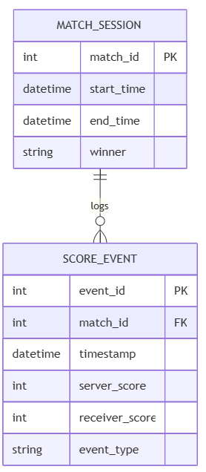
Figure 3.10 Entity Relationship Diagram of the System Database
The database design is organized into two main tables of MATCH_SESSION and SCORE_EVENT. The MATCH_SESSION entity serves as the parent record, storing match results for each game. It records the duration of the session and the winner. The SCORE_EVENT entity detailed a transaction log that occurs during gameplay (FR-09). It captures the timestamp, the specific event_type, and the state of the score at that moment. The relationship between these two entities is a one-to-many association, indicated by the crow foot notation. A single match session generates multiple score events, which are linked back to the parent session through the match_id foreign key.

3.4.7 Graphical User Interface (GUI) Design
Figure 3.11 illustrates the Graphical User Interface (GUI) design for the Automated Pickleball Point Counting System.
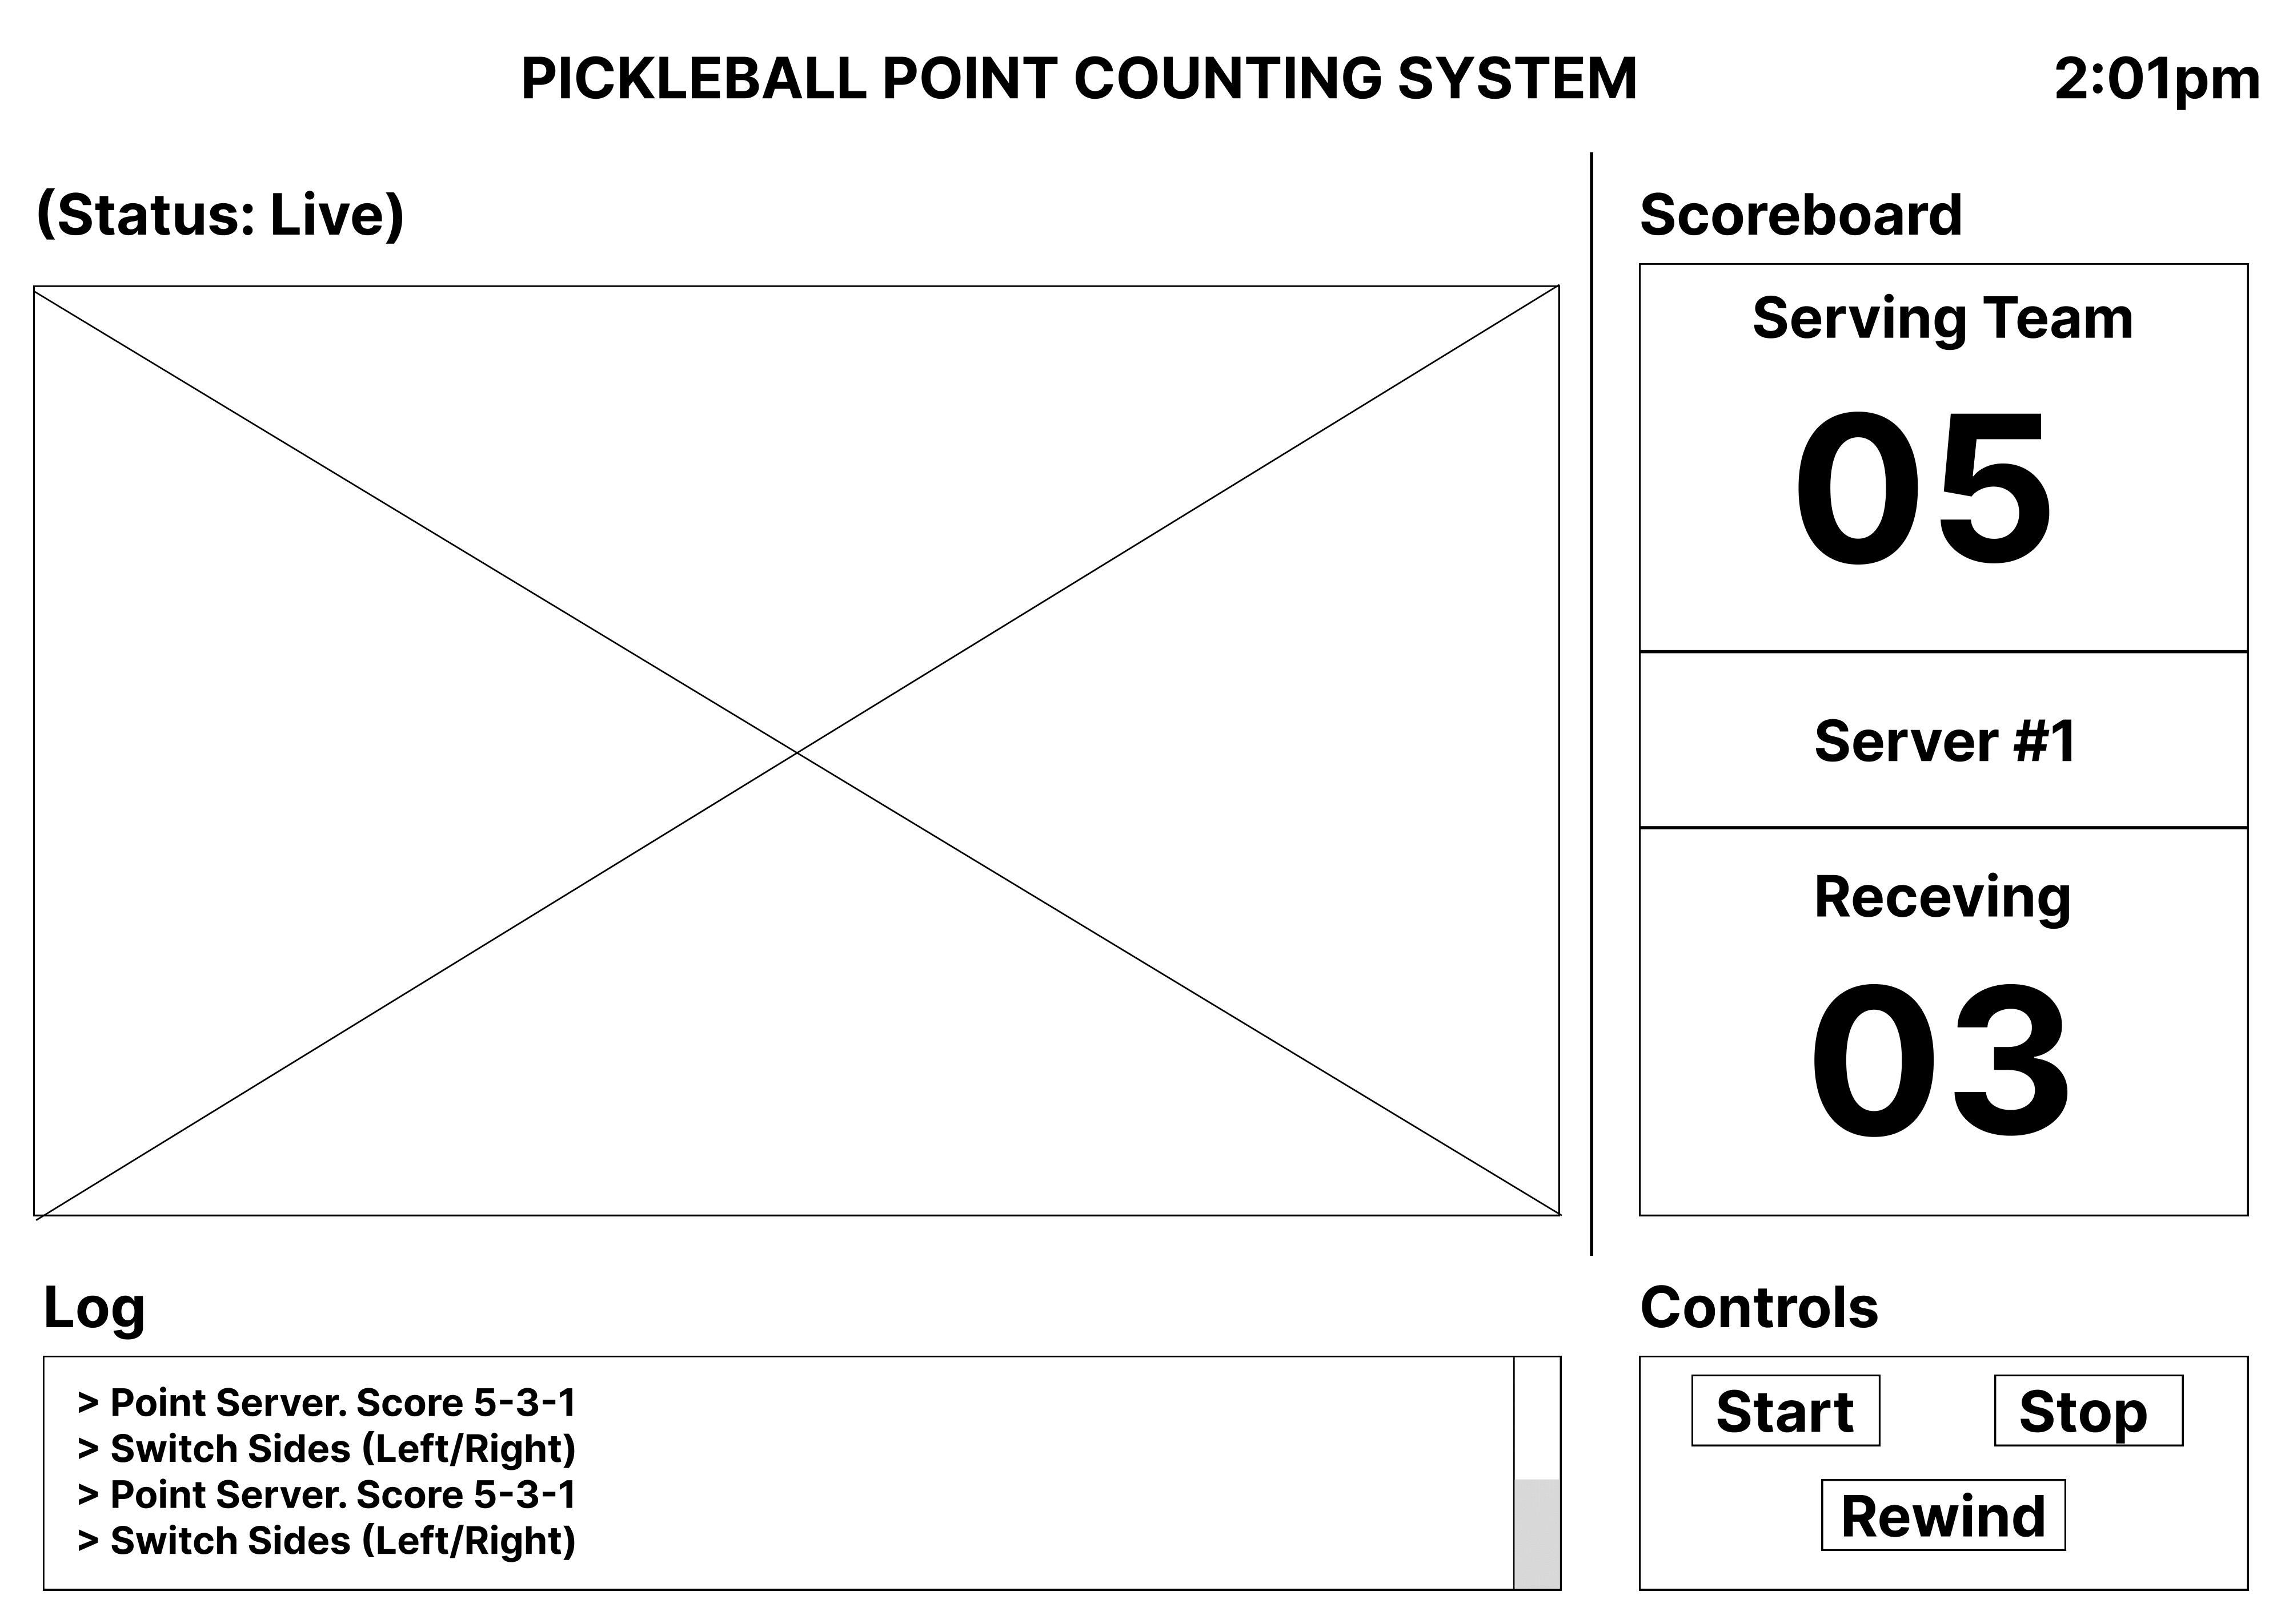
Figure 3.11 Graphical User Interface of scoreboard
The central section of the screen is reserved for the live video feed, which displays the real-time stream processed by the vision module. The right side is occupied by the dynamic scoreboard, displaying the current scores for both the serving and receiving teams. Lastly, the section below the screen features a logging panel to display timestamped game events, alongside a control panel that allows users to replay the last few seconds of gameplay to verify disputed calls.

3.5 Summary
In summary, this chapter covers the methodology, requirements analysis and system design for the proposed system. The development process adopts a Waterfall model approach, which prioritizes the training and validation of the YOLOv11-m computer vision module. The requirements analysis defined the functional and non-functional specifications of the system. Furthermore, the system design visualized the overall design architecture through various system modeling diagrams. The implementation part will be continued in the next chapter, where these specifications will be realized through code development and model training.

: IMPLEMENTATION

4.1 Introduction
This chapter documents the implementation of the Automated Pickleball Point Counting System designed in Chapter 3. The system was developed in Python on a consumer-grade laptop equipped with an NVIDIA GPU.
The implementation is organised into three main area which is object detection module, backend system and web dashboard. Section 4.2 describes the object detection module, covering dataset collection, annotation, augmentation, and model training. Section 4.3 discusses the backend system, covering the two-process concurrency architecture, ball tracker, court calibration, game logic engine, and database. Section 4.4 presents the web dashboard, including the live scoreboard, match history, and post-match analysis views. Section 4.5 summarises the chapter and transitions to Chapter 5.

4.2 Object Detection Module
This section describes the development of the ball detection model, covering the data collection process, dataset preparation, model training, and the evaluation of performance of the model.

4.2.1 Data Collection
A custom dataset was prepared to train the ball detection model. As planned in Chapter 3, local match footage was recorded at a pickleball court using the fixed camera setup shown in Figure 3.3. The positioned at the rear centre of the court and elevated approximately 1.5 metres above ground. Because a single short recording provides limited variety in court conditions, lighting, and playing styles, additional footage from public YouTube videos used for the model training. to improve model generalisation. In total, 482 images were labelled with bounding boxes for a single class, ball.
The local recording was captured using a smartphone running DroidCam, which streams the phones camera to the laptop at 1920×1080 resolution and 30 frames per second. Because a pickleball match contains many similar-looking frames during rallies and short pauses between points, labelling every frame would produce redundant data. To avoid this, a short Python script was written to extract every 60th frame from each video, giving a smaller set of representative images for labelling.
The frames were uploaded to Roboflow, an online annotation platform that supports bounding box labelling and YOLO-format export. Each frame was inspected manually, and the ball was labelled with a bounding box whenever it was visible. Frames where the ball was blocked, motion-blurred, or out of view were kept without labels to serve as negative examples. Before export, auto-orientation was applied to remove EXIF rotation metadata so that images display the same way across operating systems. Figure 4.1 shows an example of the bounding box annotation in the Roboflow interface. The dataset uses a single class, ball, matching the project scope in Section 1.3.
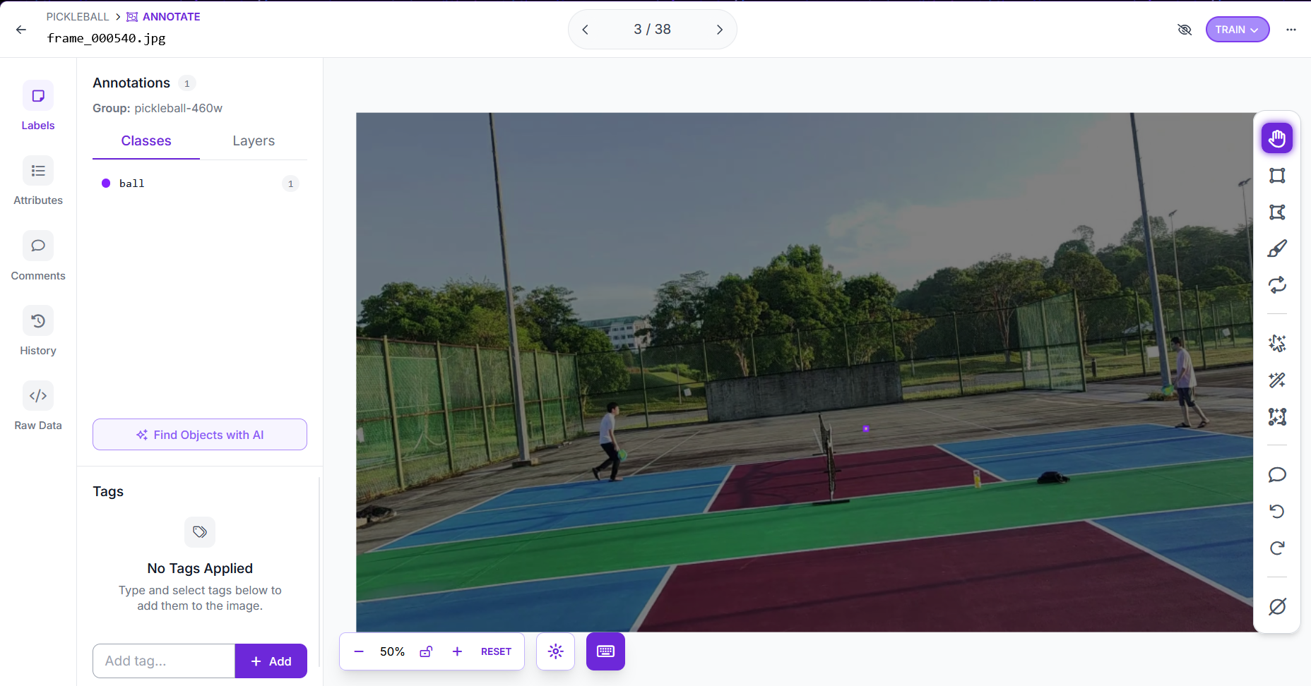
Figure 4.1 Example of bounding box annotation in Roboflow

After labelling, the dataset was split into training, validation, and test sets using a 70/20/10 ratio. Table 4.1 shows the final numbers.
Table 4.1 Composition of the custom pickleball ball detection dataset
Split | Number of Images | Proportion
Training | 338 | 70%
Validation | 96 | 20%
Testing | 48 | 10%
Total | 482 | 100%

The dataset was exported from Roboflow in the YOLOv11 annotation format. Each image is paired with a plain-text label file containing one line per annotated object, encoding the class index and the normalised x, y, width, and height of the bounding box. This format is directly consumable by the Ultralytics framework, which is used for model training in Section 4.2.3.

4.2.2 Data Annotation and Augmentation
Data augmentation is the process of applying random transformations to training images at each epoch so that the model sees a more diverse set of inputs without needing additional real data. Because the ball is a small object, this allows for more data variable under different lighting conditions, court surfaces, and camera positions. With small data size which consist only 482 labelled images available, augmentation plays a key role in preventing the model from overfitting to the specific courts and conditions present in the dataset.
Roboflow provides a built-in augmentation pipeline that applies transformations during dataset export. However, this was disabled for this project. Instead, augmentation was applied at training time through the Ultralytics framework, which generates new augmented versions of each image on-the-fly at every epoch. This approach gives a different mix of augmented samples across epochs rather than a fixed set of pre-augmented copies, and it avoids storing duplicate images on disk.
The augmentation settings used in this project are summarised in Table 4.2. The values were chosen based on the characteristics of the pickleball deployment environment.

Table 4.2 Training-time augmentation parameters
Parameter | Value | Purpose
Horizontal flip (fliplr) | 0.5 | Flips half of the training images left-to-right. Because a pickleball court is symmetric, a flipped image still looks like a valid match view. This gives the model more variety without needing to collect new data.
Rotation (degrees) | 0.0 (disabled) | The deployment camera is mounted at a fixed rear-centre position, elevated approximately 1.5 metres above the court. Because the camera does not move between matches, the orientation of the court and ball in each frame stays consistent. Training on rotated images would teach the model to detect orientations it never encounters in real games, so rotation was disabled.
Mosaic (mosaic) | 1.0 | Combines four training images into one larger tile. The model has to find the ball across all four parts, which is useful for small datasets because each training step exposes the model to more scenes at once.
Copy-paste (copy_paste) | 0.3 | Copies the ball from one image and pastes it into another, 30% of the time. This adds more ball appearances to the dataset without needing to label new images.
HSV brightness shift (hsv_v) | 0.4 | Randomly shifts the brightness of each image by up to 40%. This helps the model work under different lighting conditions, such as indoor halls, outdoor courts, or dim evening games.

The specific parameter values were set in the training configuration script. The full training configuration, including these augmentation settings alongside the optimiser and scheduler hyperparameters, is presented in Section 4.2.3.

4.2.3 Model Training and Fine-tuning
The pickleball ball detection model was developed through iterative fine-tuning rather than a single training run. Each training iteration began from the best weights of the previous iteration, allowing the model to progressively refine its understanding of the ball in different contexts. The model architecture selected was YOLOv11m with an added P2 detection head (YOLO26m-P2), which adds a stride-4 detection layer optimized for small-object detection. This architecture was chosen because a pickleball ball is often less than 20 pixels in diameter at 1920×1080 resolution and the standard YOLO detection heads tend to miss such small objects.
Training was performed using the Ultralytics framework with the configuration summarised in Table 4.3.

Table 4.3 Training configuration
Parameter | Value | Description
Base model | best26m-improved4.pt | Fine-tuned from the previous best iteration
Architecture | YOLO26m-P2 | YOLOv11 medium with added P2 small-object head
Image size (imgsz) | 640 | Input resolution used during training
Batch size (batch) | 4 | Images per gradient update (kept low to fit GPU memory)
Max epochs (epochs) | 100 | Upper limit on training cycles
Patience (patience) | 25 | Early stop if no validation improvement for 25 epochs
Initial learning rate (lr0) | 0.005 | Starting learning rate
Device | CUDA:0 | NVIDIA RTX 4050 Laptop GPU

The model went through five training iterations, each building on the previous one. Table 4.4 compares the validation results of all five iterations.
Table 4.4 Training iterations and validation performance
Iteration | Key change | Dataset | mAP50 | mAP50-95
1 (baseline) | Initial YOLOv11m training | 344 | 0.849 | 0.396
2 (improved2) | Switched to YOLO26m-P2 architecture | 344 | 0.806 | 0.331
3 (improved3) | Retuned training for 100 epochs | 344 | 0.842 | 0.408
4 (improved4) | Added 38 self-recorded images | 382 | 0.917 | 0.463
5 (improved5, final) | Added 100 self-recorded images | 482 | 0.852 | 0.445

The final model, best26m-improved5.pt, achieved a mAP50 of 0.852 and a mAP50-95 of 0.445 on the validation set of 96 images. The precision was 0.866 and recall 0.774, indicating a well-balanced detector that neither misses too many balls nor produces excessive false detections. The mAP50 of 0.852 is slightly lower than iteration 4 (0.917) because the combined validation set includes 20 additional close-range images that represent a harder detection scenario does not present in earlier iterations. The addition of 100 close-range self-recorded images in iteration 5 extended the detection capability to close-range ball positions that the previous model was unable to detect.
Figures 4.2 show the training loss curve, precision-recall curve, confusion matrix, and sample predictions from the final iteration. The training loss decreases steadily across all 58 epochs, and the best validation mAP50 observed at epoch 33, indicating that the model converged well within the training budget.
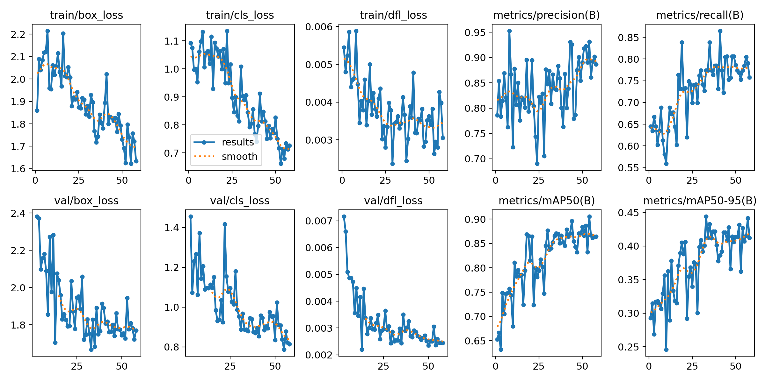
Figure 4.2 Training loss curves and mAP progression for the final iteration

Figure 4.3 shows the precision-recall curve at IoU threshold 0.5. The curve holds a precision close to 1.0 until recall reaches approximately 0.6, after which precision drops as the confidence threshold is lowered to capture more ball instances. This shape is consistent with the 0.852 mAP50 reported earlier, and it indicates that the detector is highly confident on most balls but struggles to recover harder cases such as close-range detections, heavily occluded balls, and very small balls at distance.
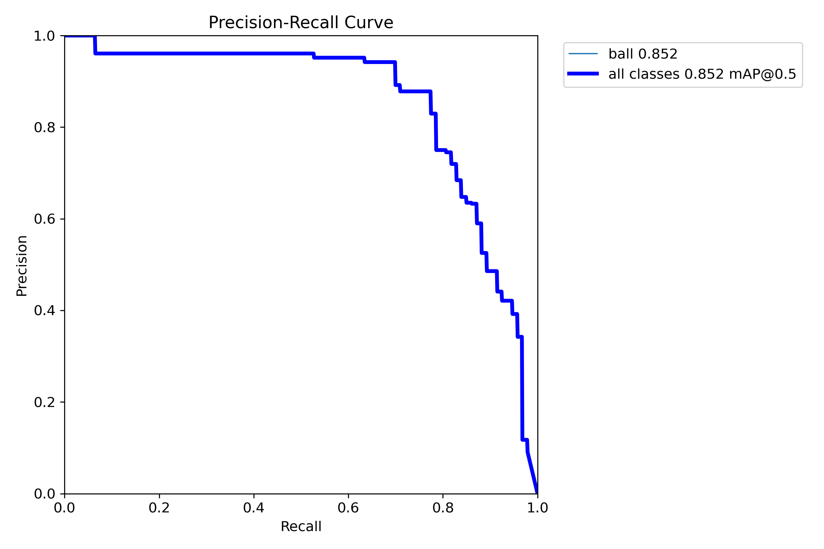
Figure 4.3 Precision-Recall curve for the final iteration

Figure 4.4 shows the normalised confusion matrix. The ball class is correctly detected in 82% of validation instances, while the remaining 18% are missed by classified as background. No class-level confusion occurs because the model has only one class with 1.00 value in the ball or background cell. The 18% miss rate is consistent with the recall of 0.774 reported earlier.
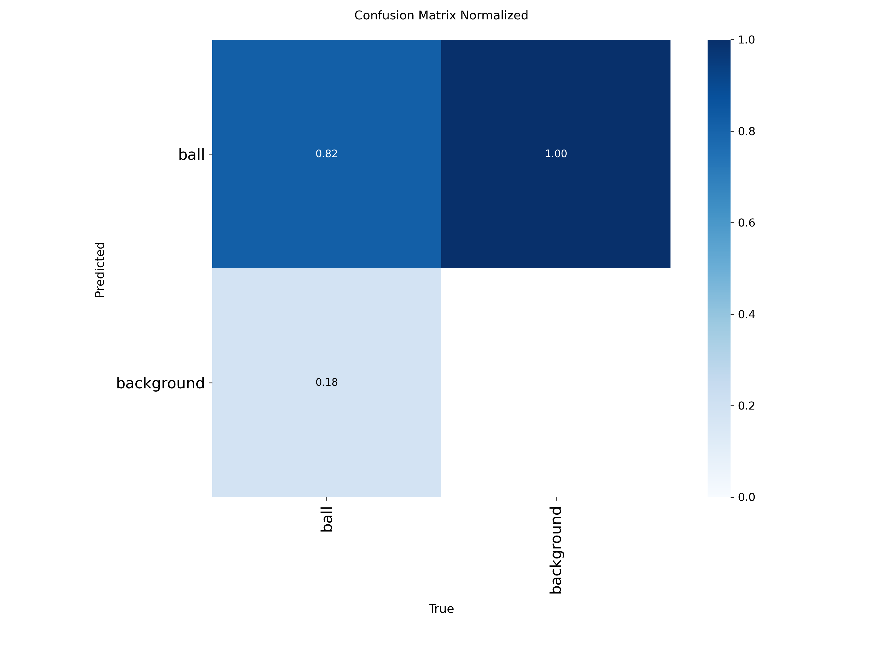
Figure 4.4 Normalised confusion matrix for the final iteration

Figure 4.5 shows a representative validation batch with predicted bounding boxes overlaid. The detector localises the ball across motion blur, partial occlusion by players, and varying ball sizes. The result show that not every frame produces a detection, which is consistent with the 0.774 recall reported earlier.
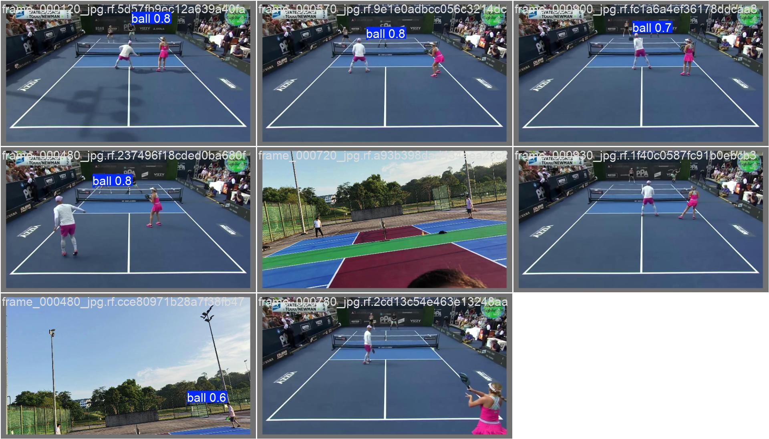
Figure 4.5 Sample predictions on validation batch

4.3 Backend System
This section describes the backend implementation of the system, covering the two-process architecture that separates tracking from display, the ball tracking pipeline, court calibration, game logic engine, and the database layer that persists match data.

4.3.1 Two-Process Architecture
The system runs as two separate operating system processes rather than a single application. Process 1 handles all tracking work such as video capture, YOLO inference, ball tracking, and game logic. Process 2 runs the Flask web server and serves the dashboard. The reason for separating them to ensure that the computationally intensive GPU inference in Process 1 does not compete with request for flask handling in Process 2. Figure 4.6 illustrates the overall architecture of the two-process system.
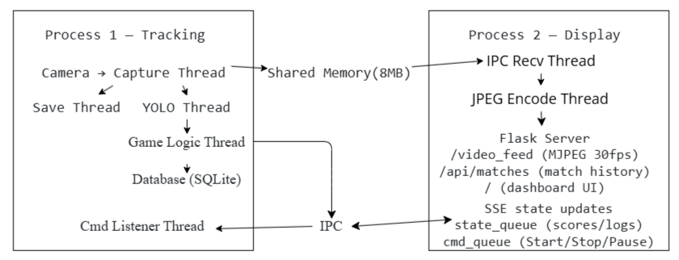
Figure 4.6 the overall architecture of the two-process system

The two processes communicate through three shared channels. Video frames travel through a shared memory block of 8 MB, large enough to hold a raw 1920×1080 frame. Shared memory is used here because passing a 6 MB frame through a standard inter-process queue on every frame would introduce significant copy overhead at 30 frames per second. All other data, including detection results, score updates, bounce events, log messages, and status changes, travels through a state queue from Process 1 to Process 2.
Commands from the dashboard travel in the opposite direction through a command queue, carrying instructions such as start, stop, pause, rewind, and recalibrate. A command listener thread of Process 1 monitors this queue and translates each instruction into threading events, keeping command handling decoupled from the main tracking loop.

4.3.2 Ball Tracker
The ball tracker adds a smoothing and gap-filling layer on top of raw YOLO detections to produce stable coordinates for the game logic engine. Without this layer, missed detections due to motion blur, occlusion, or low confidence would cause gaps in the ball trajectory, and pixel-level noise from successful detections could trigger false bounce events.
The YOLO inference runs together with ByteTrack, a multi-object tracker that associates detections across frames using predicted motion and bounding box overlap. This assigns a consistent identity to the ball across frames, reducing the impact of brief disappearances. The output of ByteTrack is then passed through a custom Kalman filter that smooths the single best ball position and generates predicted positions for frames where ByteTrack finds no detection at all.
The Kalman filter uses a constant-velocity motion model, meaning it assumes the ball continues moving in the same direction at the same speed between frames. The internal state tracks four values consisting of the horizontal position, vertical position, horizontal velocity, and vertical velocity. Only the position is directly observable from YOLO, so the velocity is estimated indirectly from how the position changes over time.
Each frame follows a predict-then-update cycle. In the prediction step, the filter projects the current state forward using the velocity estimate, producing an expected position for the next frame. When a YOLO detection arrives, the update step corrects the prediction by blending it with the measured position, weighted by how much the filter trusts the measurement relative to its own prediction. The process noise is set high to reflect that a fast-moving ball can change direction quickly, while the measurement noise is set low to indicate that YOLO detections, when they occur, are reasonably accurate.
When YOLO misses the ball entirely, the filter continues to return predicted positions using the last known velocity, bridging gaps of up to five consecutive frames. Beyond that threshold the filter stops predicting, as the accumulated uncertainty makes the estimate unreliable. Predicted positions are flagged as such so that the game logic engine can ignore them for bounce detection, since a predicted position that was never actually observed should not influence scoring decisions.

4.3.3 Court Calibration
Court calibration establishes the link between the camera image and the physical court, allowing the system to determine where the court boundaries lie and what real-world distance each pixel represents. Without this step, the system has no basis for classifying whether a ball lands in or out.
When the system starts, it checks for a saved calibration file. If one exists, it loads the stored court coordinates directly, so calibration only needs to be performed once per camera setup. If no file is found, the user is prompted to click six points on the first captured frame, consisting of the four court corners in order of top-left, top-right, bottom-right, and bottom-left, followed by the two ends of the net. The selected points and net line are saved as a JSON file for future sessions.
Using these six points, the system computes a homography matrix using OpenCV's findHomography function. A homography is a mathematical transformation that maps points from one plane to another. The four court corners are the primary input, defining a court of 609.6 cm wide and 1341.12 cm long. The two net points serve as additional constraints that improve the accuracy of the mapping.
Once the homography matrix is computed, any pixel coordinate can be converted to a court coordinate using perspectiveTransform. This is used throughout the system to determine the real-world position of each bounce and serve detection. The court polygon is also used to check whether a point lies inside the court boundary, using pointPolygonTest function of OpenCV, and to determine which half of the court the ball is on by computing the cross product of the net direction vector against the ball position.

4.3.4 Game Logic Engine
The game logic engine is responsible for interpreting ball movement into scoring decisions according to pickleball rules. It runs in a dedicated thread that continuously reads ball coordinates produced by the tracking pipeline and maintains the full state of the ongoing match, including the current score, which team is serving, and which court half the server occupies.
Pickleball uses a three-number score format consisting of the serving teams score, the receiving team's score, and the server number. In doubles, each team is allowed two serves before service changes sides, which is known as a side-out. Only the serving team can score a point. When the serving team wins a rally, their score increments. When the receiving team wins, a side-out occurs and service transfers to the next server. These rules are implemented in the GameState class, which exposes server_wins_point() and side_out() methods that update the score and broadcast the change to the dashboard through the state queue.
Bounce detection works by tracking the vertical direction of the ball across consecutive frames. When the ball transitions from moving downward to moving upward, the system records a bounce at the previous position. A cooldown of ten frames is applied after each detected bounce to prevent the same contact from being counted twice. Each bounce is classified as in-court or out-of-court using the calibrated court polygon, and the court half where it landed is recorded.
Serve detection uses a velocity-based approach. The system maintains a short history of recent ball positions and computes an average speed across that window. When the speed exceeds a configured threshold and the ball is on the servers side of the court, a serve is registered. This transitions the engine from a waiting state into an active rally state, ensuring that random ball movement before the serve is not treated as part of the rally.
When no ball has been detected for a configurable period, the engine treats the rally as ended and calls resolve_rally(). This method examines the last recorded bounce to determine the outcome. If the final bounce was in-court, the losing side is the one where the ball landed. If the final bounce was out-of-court, the losing side is the opposite half, since the ball crossed the line on their side. A rally that produced fewer than two bounces is discarded to avoid false positives from brief ball appearances or detection noise. A short cooldown is applied after each resolved rally before the engine begins tracking the next serve.

4.3.5 Database
As described in Section 3.2.3, match data persisted in a local SQLite database to support offline operation and post-match analysis. The database consists of three tables which are matches, events, and scores. All three tables are initialized automatically by the init_db() function in database file.
The matches table records the start and end timestamp of each session, with ended_at remaining NULL until the match is stopped. The events table recording every significant occurrence during a match such as ball detections, bounces, serves, and score changes at the rate the tracking pipeline produces them. The scores table captures a scoreboard snapshot each time a point changes hands, storing just enough state to reconstruct the score progression for the timeline chart. The full column definitions are shown in Table 4.5.

Table 4.5 Database schema
Table | Column | Type | Purpose
matches | id | INTEGER | Unique match identifier, primary key
matches | started_at | TEXT | Date and time the match began
matches | ended_at | TEXT | Date and time the match ended, empty while live
events | id | INTEGER | Unique event identifier, primary key
events | match_id | INTEGER | Links to matches.id
events | timestamp | TEXT | Date and time of the event
events | event_type | TEXT | Event category: bounce, serve, point, side out
events | cx, cy | REAL | Ball position in pixels, recorded if available
events | confidence | REAL | YOLO detection confidence, recorded if available
events | notes | TEXT | Additional event detail
scores | id | INTEGER | Unique score record, primary key
scores | match_id | INTEGER | Links to matches.id
scores | timestamp | TEXT | Date and time of the score change
scores | server_score | INTEGER | Server score at this moment
scores | receiver_score | INTEGER | Receiver score at this moment
scores | server_number | INTEGER | Active server number in doubles rotation

SQLite was configured to use Write-Ahead Logging (WAL) mode rather than the default rollback journal. Under the default mode, any read issued while the tracker is writing must wait until that write completes, which causes noticeable stalls on the dashboard given the 25 to 30 writes per second produced by the tracking pipeline. WAL mode allows reads and writes to proceed simultaneously, keeping the Match History and Post-Match Analysis pages responsive during a live match.
Writing concurrency within the tracking process is handled by a module-level threading lock. SQLite enforces its own file-level locking, but the database module opens a new connection per call, so multiple backend threads writing simultaneously can produce transient locked errors. Wrapping every write in a Python-level lock serialises them before they reach SQLite, eliminating the issue.

4.4 Web Dashboard
This section describes the web-based dashboard that provides the user interface for the system, covering the live video feed and scoreboard, the match history browser, and the post-match analysis page.

4.4.1 Live Scoreboard and Video Stream
The live scoreboard page is the primary interface used during a match. It is served by Flask on port 5000 and accessible from any browser on the same local network. The page is divided into four panels showing the video feed with detection overlay, the scoreboard, a live event log, and playback controls. Figure 4.6 shows the live scoreboard dashboard during an active match.
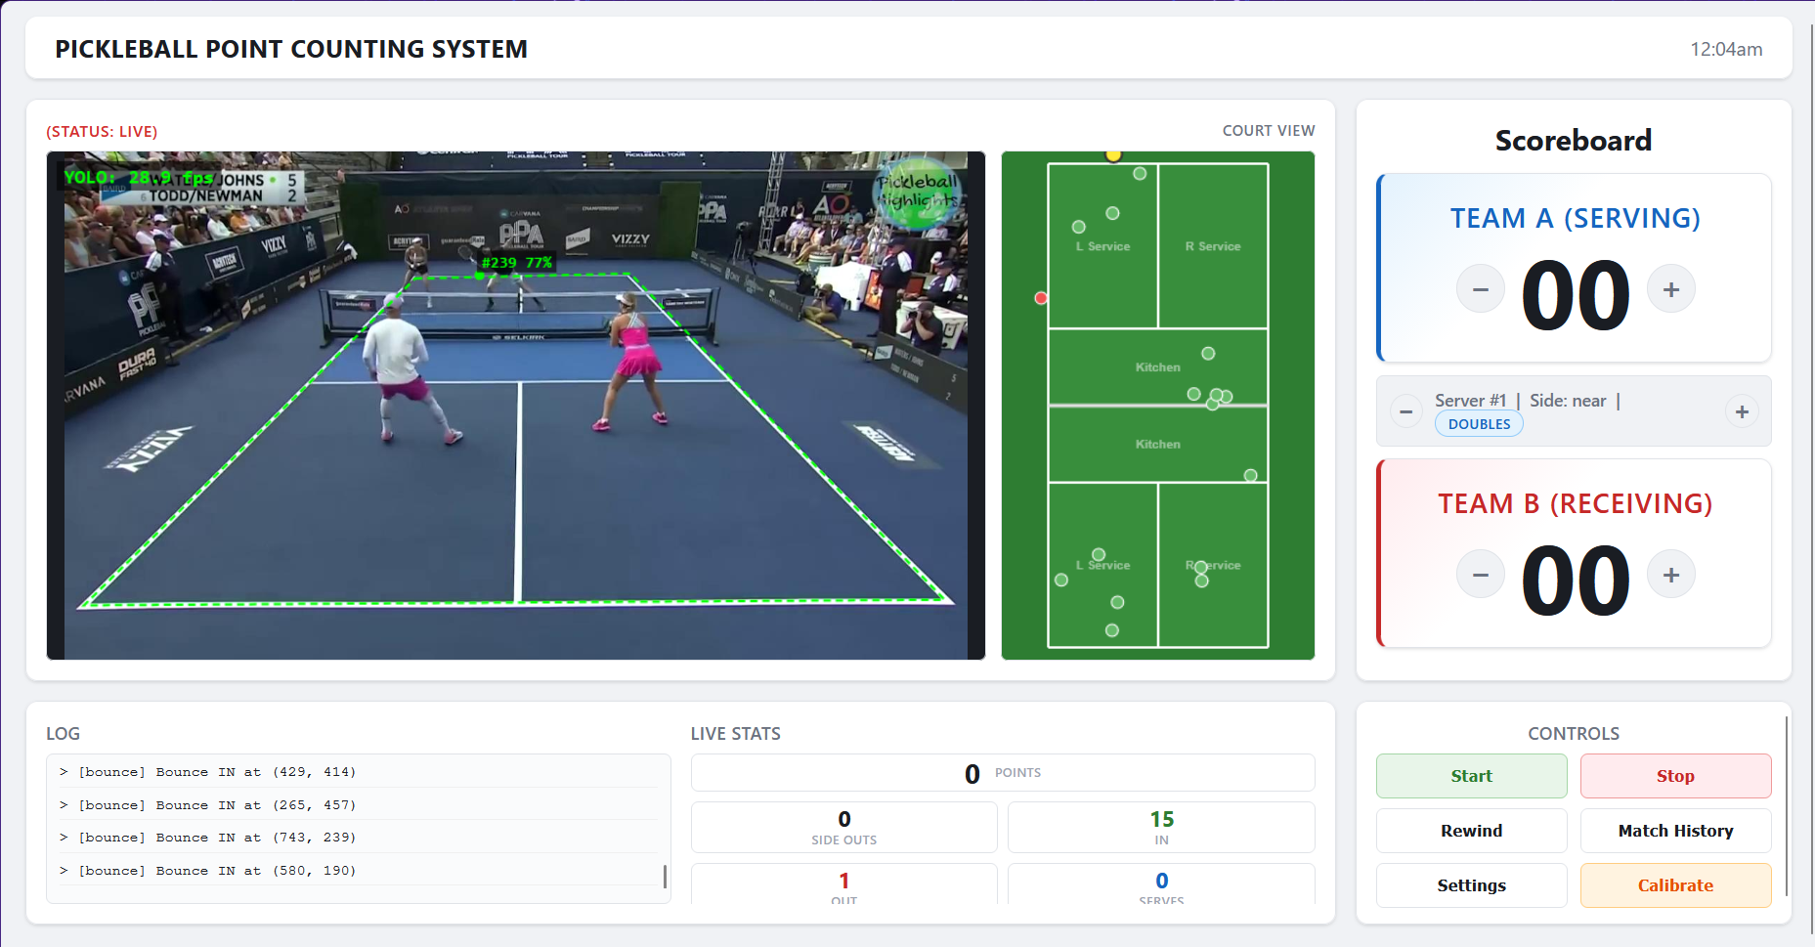
Figure 4.7 The live scoreboard dashboard, showing the MJPEG video feed with detection overlay (left), top-down court view (centre), and scoreboard (right)

The live video is streamed to the browser using MJPEG, a format that delivers a continuous sequence of JPEG frames over a single persistent HTTP connection. As each frame arrives from the tracking process, a background thread compresses it and pushes it to the browser, where it is displayed inside a standard HTML image element.
The detection boxes are drawn separately on a transparent canvas layer positioned over the video. This canvas receives its data through Server-Sent Events (SSE), a mechanism that keeps a second HTTP connection open and pushes a small JSON message to the browser for each frame containing the bounding box coordinates and their source. Boxes from direct YOLO detections are drawn in solid green. Boxes from Kalman filter predictions, which fill in frames where the model did not detect the ball, are drawn in dashed orange.
The scoreboard shows the serving score, receiving score, server number which dedicated for doubles format, and which physical side of the court the serving team currently occupies. These values are pulled from the /score endpoint every second. The system updates scores automatically via the game logic module, but manual correction is available through on-screen buttons. Every manual correction is appended to the event log and sent to the database via a POST to /update_score.
For the top-down court view, a canvas element alongside the video feed renders a real-time court scaled to actual pickleball dimensions. Kitchen zones, the net, and service boxes are drawn using the same coordinate system used by the homography module. As bounces are classified by the game logic module, their court coordinates are plotted on this view of green circles for balls landing in, red circles for balls landing out, and blue triangles for serve positions. When a detection is active, the current ball position is shown as a yellow dot using the coordinates received via SSE.
Court calibration is performed once when the system is first set up, or whenever the camera is repositioned. If a saved calibration exists, it is loaded automatically at startup without any operator input. To calibrate, the operator opens the calibration modal, captures a snapshot of the current camera frame, and clicks six points in a fixed order of the four court corners followed by the two net endpoints. The browser sends these pixel coordinates to /calibrate/save, which writes them to court.json and issues a recalibrate command to the tracking process. The tracking process reloads the homography matrix from the updated points without restarting the pipeline.
The rewind function allows the operator to review a disputed point without stopping the match record. Pressing the rewind button pauses the tracking process, which writes the preceding 15 seconds of frames to a binary clip file. The dashboard polls /rewind_status until the clip is confirmed written, then switches the <img> source to /rewind_feed, which replays the clip as MJPEG at the original capture frame rate. Pressing Start afterwards resumes the live stream.

4.4.2 Match History
The match history page lists all recorded matches and serves as the entry point to post-match analysis. It is accessible from the live dashboard via the Match History button, which pauses the tracking pipeline before navigating so that no data is lost during the transition.
The page is rendered server-side by Flask using Jinja2 templating. When the route is requested, Flask queries the database for all match records and computes a human-readable duration for each one by subtracting the start timestamp from the end timestamp. The result is passed directly to the template, which renders a table showing the match number, start time, duration, and a link to the analysis page for that match. If no matches have been recorded yet, the table displays a placeholder message in place of rows.
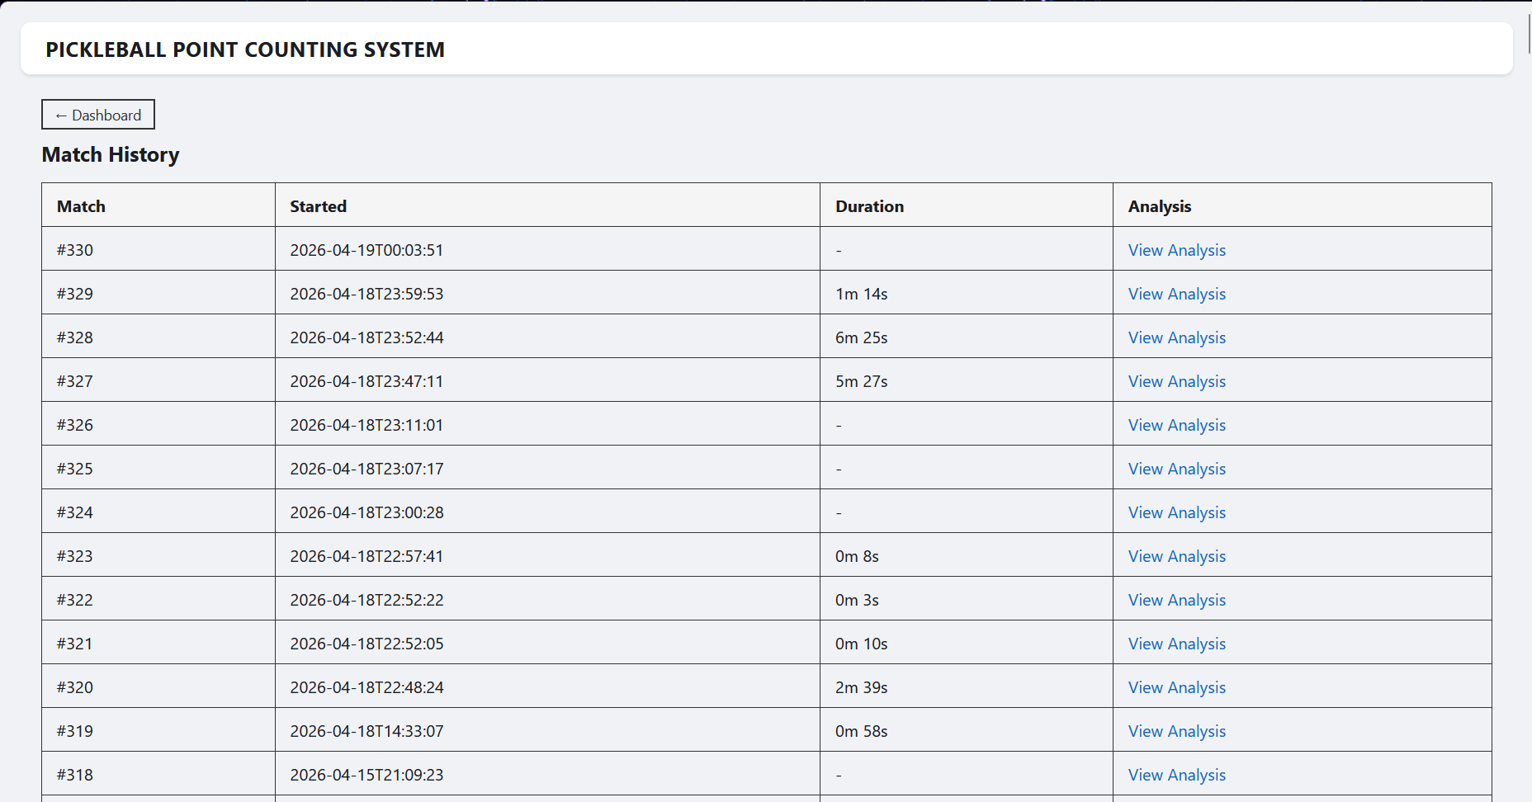
Figure 4.8 shows the match history page with a list of completed matches.

4.4.3 Post-Match Analysis
The post-match analysis page provides a summary of a completed match and is reached by clicking the View Analysis link from the match history page. When the page loads, it makes a single request to /api/analysis/<match_id>, which returns the match record, aggregate statistics, all classified bounce events, and the full score history as a JSON response. The page then renders everything client-side from that one payload.
Four summary cards at the top of the page display the match duration, total points played, total bounces tracked, and total side outs. These figures give the operator a quick overview before examining the detailed visualisations below.
The court bounce map uses the same top-down canvas drawing as the live dashboard, scaled to the actual pickleball court dimensions. Each bounce event stored in the database is plotted at its court coordinated by green circles for balls landing in, red circles for balls landing out, and blue triangles for serve positions. Because the coordinates are already stored in centimeters after homography transformation at the time of detection, no additional conversion is needed at the analysis stage.
The score timeline is a stepped line chart rendered using Chart.js, showing how the server and receiver scores changed over the course of the match. Each data point represents a score update event with its timestamp, plotted against elapsed time in seconds from the match start. The stepped line style reflects the discrete nature of scoring in pickleball, where scores only increase by one point at a time.
Figure 4.9 shows the post-match analysis page for a completed match, with the bounce map on the left and the score timeline on the right.
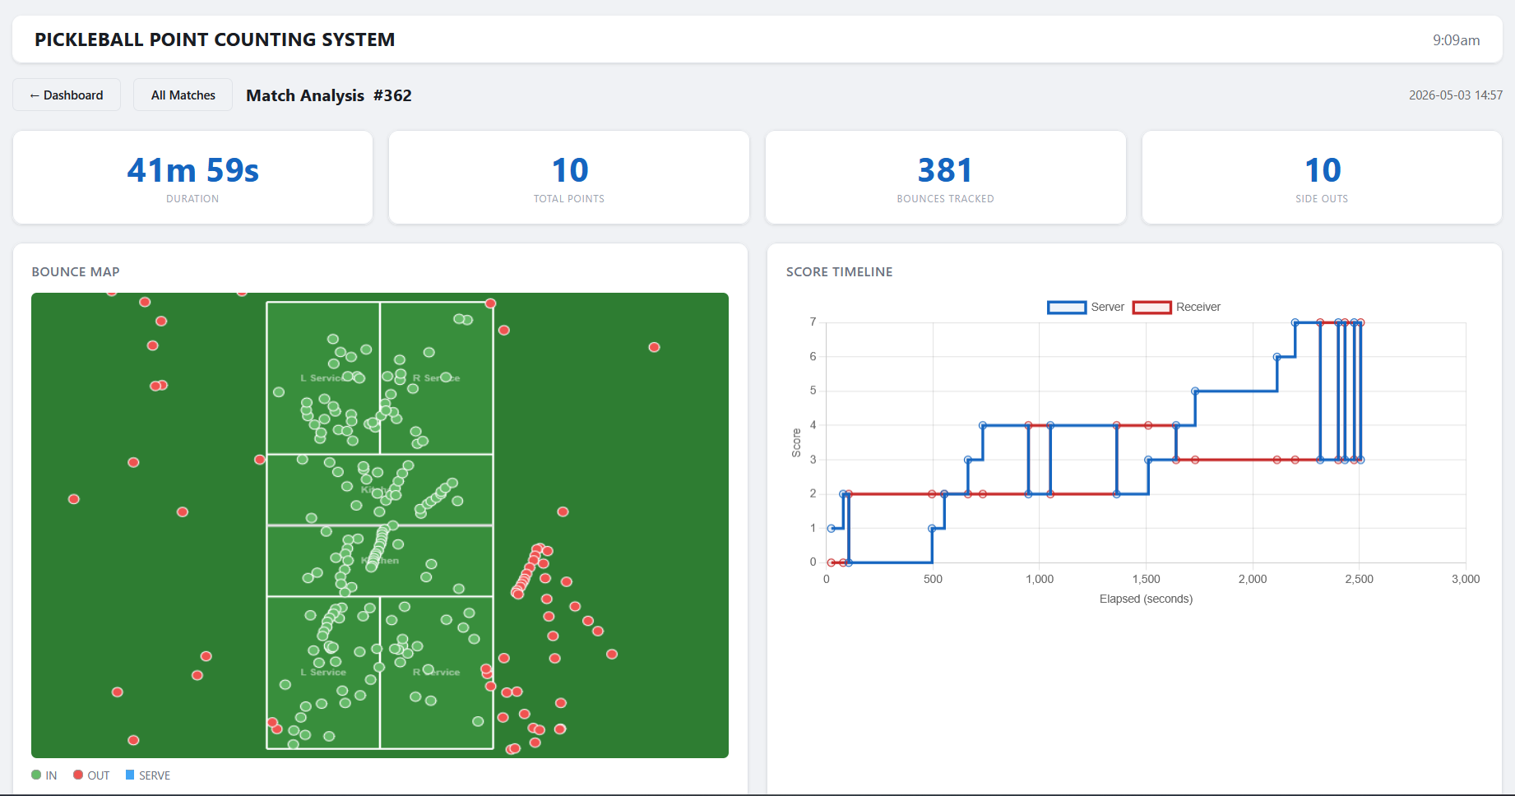
Figure 4.9 Post-match analysis page showing the court bounce map

4.5 Summary
This chapter has described the implementation of the Automated Pickleball Point Counting System in three parts which are the object detection module, the backend system, and the web dashboard. The object detection module was built around a custom-trained YOLOv11m-P2 model trained on 482 images across four fine-tuning iterations, reaching a validation mAP50 of 0.852.
The backend system runs as two separate processes connected through shared memory and message queues. The tracking process handles frame capture, YOLO inference, ball tracking, court calibration, game logic, and SQLite persistence. The display process runs a Flask web server that streams video to the browser and relays user commands back.
The web dashboard is a set of three browser pages that present the live match score and video stream, allows users to browse past matches, and provides post-match analysis charts built with Chart.js. These pages are served by the Flask web server described in Section 4.3.1.
In conclusion, these components satisfy the functional and non-functional requirements laid out in Chapter 3. The next chapter presents the testing approach and evaluation results for the integrated system.

: SYSTEM TESTING AND EVALUATION

5.1 Introduction
This chapter presents the testing and evaluation of the Automated Pickleball Point Counting System, addressing the third project objective of evaluating the accuracy and reliability of the prototype against manual scorekeeping. The remaining sections cover object detection evaluation, functional testing, end-to-end system evaluation, a discussion of results, and a chapter summary. The object detection evaluation assesses the performance of the YOLOv11-m model on the held-out test set using standard metrics including mAP, precision, recall, the confusion matrix, and the precision-recall curve. The system-level evaluation measures end-to-end scoring accuracy by comparing the system output against a human scorer during a live match.

5.2 Object Detection Evaluation
This section evaluates the performance of the YOLOv11-m model trained on the custom pickleball dataset. Evaluation is carried out on the test set, which represents 10% of the total annotated dataset and was not used during training or validation.

5.2.1 Training and Validation Performance
The YOLOv11-m model was trained for 58 epochs on the custom pickleball dataset. Training metrics were automatically recorded by the Ultralytics YOLO framework into a results.csv file at the end of each epoch, capturing training loss, validation loss, and validation metrics including precision, recall and mAP@50 throughout the training process. As shown in Figure 4.2, both training and validation box loss decreased consistently across all 58 epochs, with training box loss reducing from 1.86 at epoch 1 to 1.63 at epoch 58, and validation box loss reduced from 2.09 to 1.77 over the same period. Both the training and validation box loss curves remain closely aligned without diverging, indicating the model generalised well to unseen frames without overfitting the training data. The validation mAP@50 peaked at 90.5% at epoch 33 before stabilising around 90% through the remaining epochs, confirming that the training process produced a reliable model for the final test set evaluation.

5.2.2 Object Detection Performance
The final model was evaluated on the test set using the Ultralytics validation command with the test split. The validation output reported 48 test images. These images were not used at any point during training or validation, ensuring an unbiased evaluation of the model. Table 5.1 presents the results.
Table 5.1 Object detection performance on the test set
Metric | Value
Precision | 80.8%
Recall | 82.5%
mAP@50 | 88.9%
mAP@50-95 | 45.9%

The model achieved precision of 80.8%, indicating that most bounding boxes produced by the model correspond to an actual ball. Recall of 82.5% indicates the model successfully detected approximately four out of every five ball instances in the test frames. The slightly lower precision compared to recall suggests the model occasionally produces false detections when attempting to capture harder ball instances such as close-range or partially occluded cases.
The model achieved a mAP@50 of 88.9%, reflecting strong overall detection performance. IoU (Intersection over Union) measures the overlap between the predicted bounding box and the ground truth annotation, where a higher IoU indicates a more precise detection. The mAP@50-95 of 45.9% reflects reduced performance when stricter overlap requirements are applied, which is expected for a small fast-moving object such as a pickleball where precise bounding box localisation is more difficult.

5.2.3 Confusion Matrix Analysis
Figure 5.2 presents the normalised confusion matrix of the model evaluated on the test set. The matrix contains two classes: ball and background. The rows represent the predicted class, and the columns represent the true class.
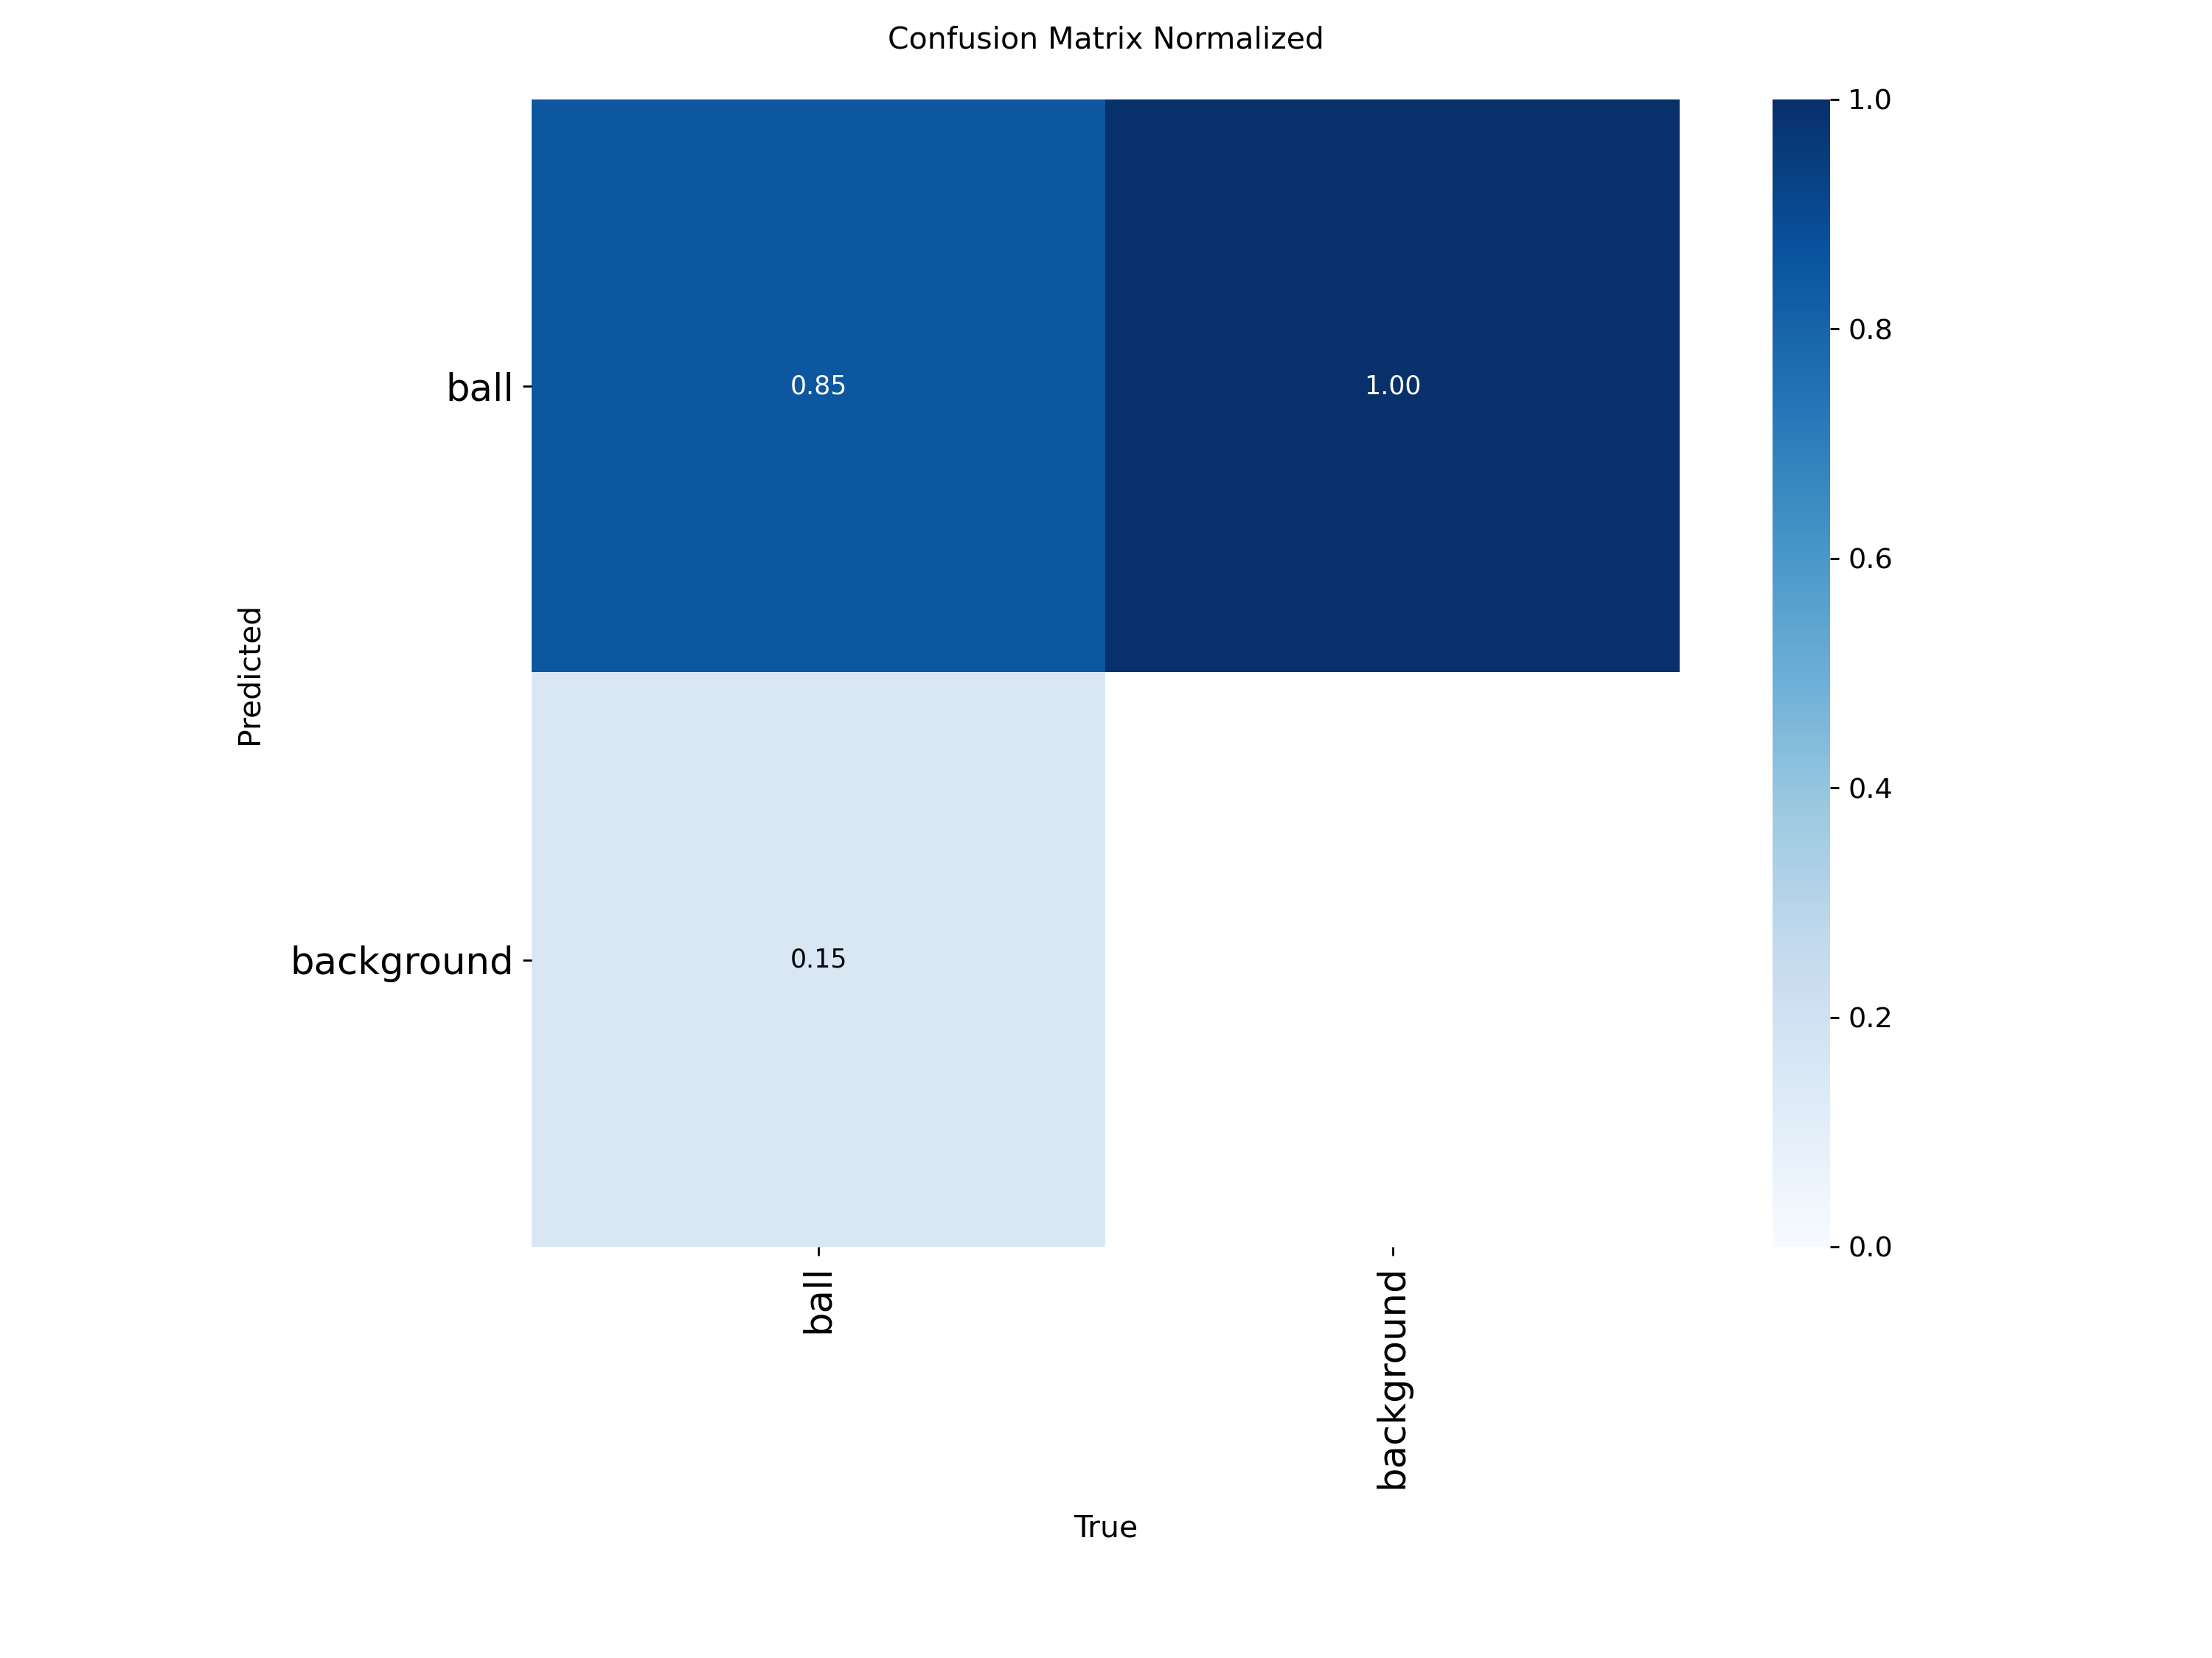
Figure 5.1 Normalised confusion matrix of the YOLOv11-m model on the test set

The matrix shows that the model successfully detected around 85% of actual ball instances. The remaining 15% of actual ball instances were predicted as background, showing false negatives when the model missed a real ball detection. This false negative rate is consistent with the recall of 82.5% reported in Table 5.1, where the small difference is attributed to IoU threshold effects applied during metric calculation.
The background column shows a value of 1.00 in the ball row, which reflects that all false positive predictions produced by the model were classified as ball. This confirms that the model never produces detections for any class other than ball because it is a single-class detection task. The near-zero false positive rate aligns with the high precision of 80.8% reported in Table 5.1.
Overall, the confusion matrix confirms that the major error pattern is due to false negatives rather than false positives. The model only detects a ball when it is highly confident, which minimizes incorrect detections by missing real ball instances during tracking.

5.2.4 Precision-Recall Curve Analysis
Figure 5.3 presents the precision-recall curve of the model on the test set. The curve is generated by varying the confidence threshold from high to low, showing how precision and recall change as the model is made progressively less selective in its detections. The area under the curve represents the mAP@50 of 0.889.
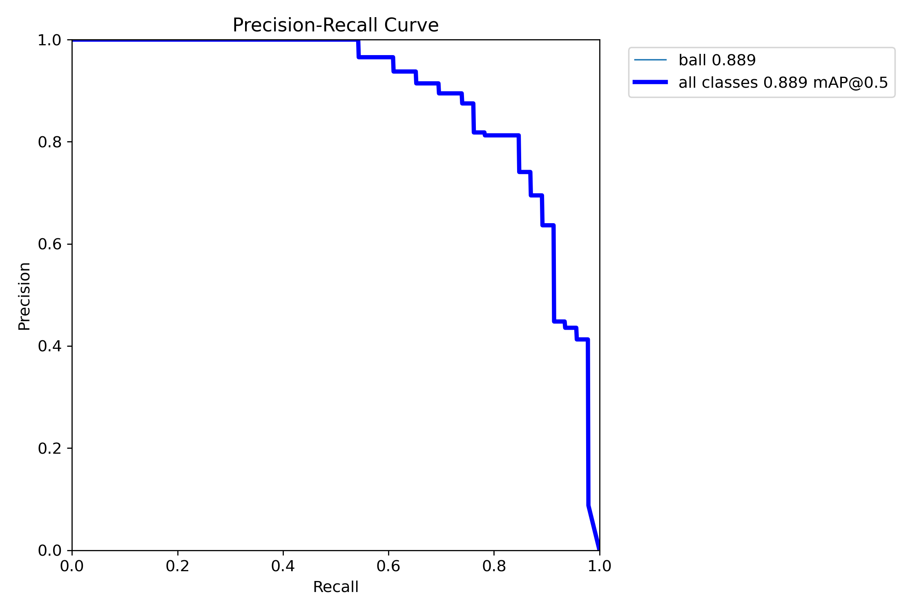
Figure 5.2 Precision-Recall curve of the YOLOv11-m model on the test set

The curve remains at a precision of 1.0 from recall 0.0 up to approximately 0.6, showing the model detects 60% of all ball instances with no false positives at higher confidence thresholds. When recall exceeds 0.6, precision drops steeply as the confidence threshold is lowered to capture more ball instances, introducing false positives into the detections. At the lowest confidence thresholds, recall approaches 1.0 but precision drops close to 0.
The curve dropping in a step format is attributed to the small test set size of 48 instances. Each of the steps represents a single detection instance crossing the confidence threshold. This is expected and does not indicate instability in the model.

5.3 Functional Testing
Functional testing verifies that each component of the system behaves according to the functional requirements in Table 3.1 and the non-functional requirements in Table 3.2. Test cases are derived from the game logic engine, database, and dashboard modules. A total of 15 test cases (TC-01 to TC-15) are executed, and the results are recorded in the tables below.

5.3.1 Game Logic Engine
Table 5.2 Functional Test for Game Logic Engine

Test Title | Game Logic Engin for Scoring and Side-out Rules
Pre-condition | System initialised with a new match session. Court calibration completed.
Test ID | Test Case | Test Procedure | Input | Expected Result | Actual Result | Status
TC-01 | Server wins rally | 1. Start a new match session.  2. Play a rally where the ball bounces last on the receiver side.  3. Allow the rally to end.  4. Observe the score on the dashboard. | Ball last bounce on receiver side, in court | Serving team score increments by 1. Updated score displayed on dashboard. | As expected | Pass
TC-02 | Server loses rally | 1. Start a new match session.  2. Play a rally where the ball bounces last on the server side.  3. Allow the rally to end.  4. Observe the score on the dashboard. | Ball last bounce on server side, in court | Side-out triggered. Service passes to next server. No score increment for either team. | As expected | Pass
TC-03 | Ball leaves play | 1. Start a new match session.  2. Play a rally with at least two bounces recorded.  3. Allow the ball to leave the camera view.  4. Wait for the rally timeout to expire.  5. Observe the score update on the dashboard. | Ball disappears from camera view after at least two bounces recorded | Rally resolved using last recorded bounce position. Score updated accordingly. | As expected | Pass
TC-04 | Side-out, first server | 1. Set match to doubles mode with first server active.  2. Trigger a side-out condition.  3. Observe the server number on the dashboard. | Doubles mode, server number = 1 | Server number changes to 2. Score unchanged. Teams do not swap. | As expected | Pass
TC-05 | Side-out, second server | 1. Set match to doubles mode with second server active.  2. Trigger a side-out condition.  3. Observe the server number and score on the dashboard. | Doubles mode, server number = 2 | Server number resets to 1. Teams swap. Score values swap. | As expected | Pass
TC-06 | Insufficient bounces | 1. Start a new match session.  2. Hit the ball with only one bounce before it stops.  3. Observe that the score does not change on the dashboard. | Only one bounce recorded in rally | Rally ignored. Score unchanged. | As expected | Pass

5.3.2 Database Persistence
Table 5.3 Functional Test for Database Persistence
Test Title | Database Persistence for Match Data and Event Logging
Pre-condition | System initialised. SQLite database file created at startup.
Test ID | Test Case | Test Procedure | Input | Expected Result | Actual Result | Status
TC-07 | Match data stored in database | 1. Start a new match session.  2. Play several rallies.  3. Stop the system by pressing Ctrl+C.  4. Open the SQLite database file and inspect the matches table. | New match session started and ended | A match record exists in the matches table with a valid started_at and ended_at timestamp. | As expected | Pass
TC-08 | Game events logged with timestamp | 1. Start a new match session.  2. Play a rally until a point is scored.  3. Open the SQLite database and inspect the events table. | Rally completed with a point scored | Events such as bounce and point scored are recorded with a valid timestamp in the events table. | As expected | Pass

5.3.3 Dashboard Interface
Table 5.4 Functional test for Dashboard Interface
Test Title | Dashboard Interface
Pre-condition | System running. Dashboard accessible in web browser. Match session started
Test ID | Test Case | Test Procedure | Input | Expected Result | Actual Result | Status
TC-09 | Dashboard accessible in browser | 1. Start the system.  2. Open a web browser.  3. Navigate to the dashboard URL. | System running on local machine | Dashboard page loads successfully in the browser with no errors. | As expected | Pass
TC-10 | Live score displayed in real-time | 1. Start a new match session.  2. Play a rally until a point is scored.  3. Observe the score on the dashboard. | Point scored during live rally | Score on dashboard updates immediately to reflect the new score without requiring a page refresh. | As expected | Pass
TC-11 | Video rewind feature | 1. Start a new match session.  2. Play several rallies.  3. Click the rewind button on the dashboard.  4. Observe the video output. | Rewind command triggered from dashboard | Recent video footage replays from a few seconds before the current position. | As expected | Pass

5.3.4 Non-Functional Testing
Table 5.5 Non-Functional Testing
Test Title | System Performance and Operational Constraints
Pre-condition | System installed on local machine. DroidCam connected via WiFi hotspot.
Test ID | Test Case | Test Procedure | Input | Expected Result | Actual Result | Status
TC-12 | Frame rate during live operation | 1. Connect DroidCam via WiFi hotspot.  2. Start the system and begin a live match session.  3. Observe the frame rate on the dashboard or terminal output. | Live camera feed from DroidCam via WiFi hotspot | System processes and streams video at 30 FPS throughout the session. | As expected | Pass
TC-13 | Offline operation | 1. Ensure no internet browser or external network access is active.  2. Start the system.  3. Run a full match session including ball detection, scoring and database logging.  4. Verify score and events are saved in the local database. | No internet connection. Camera connected via local WiFi hotspot only. | System operates fully. All data saved locally to SQLite database with no external API calls required. | As expected | Pass

5.4 End-To-End System Evaluation
This section evaluates the complete system under real-world court conditions. A live singles match is conducted and the score produced by the system is compared against a manually recorded score to assess the overall accuracy of the automated point counting.

5.4.1 Test Environment Setup
The test is conducted on an outdoor pickleball court located in UNIMAS by using a singles format match played to 11 points. The match is recorded and processed live by the system while a person manually keeps score of comparison between models. The resulting view captured by the camera is presented in Figure 5.3.
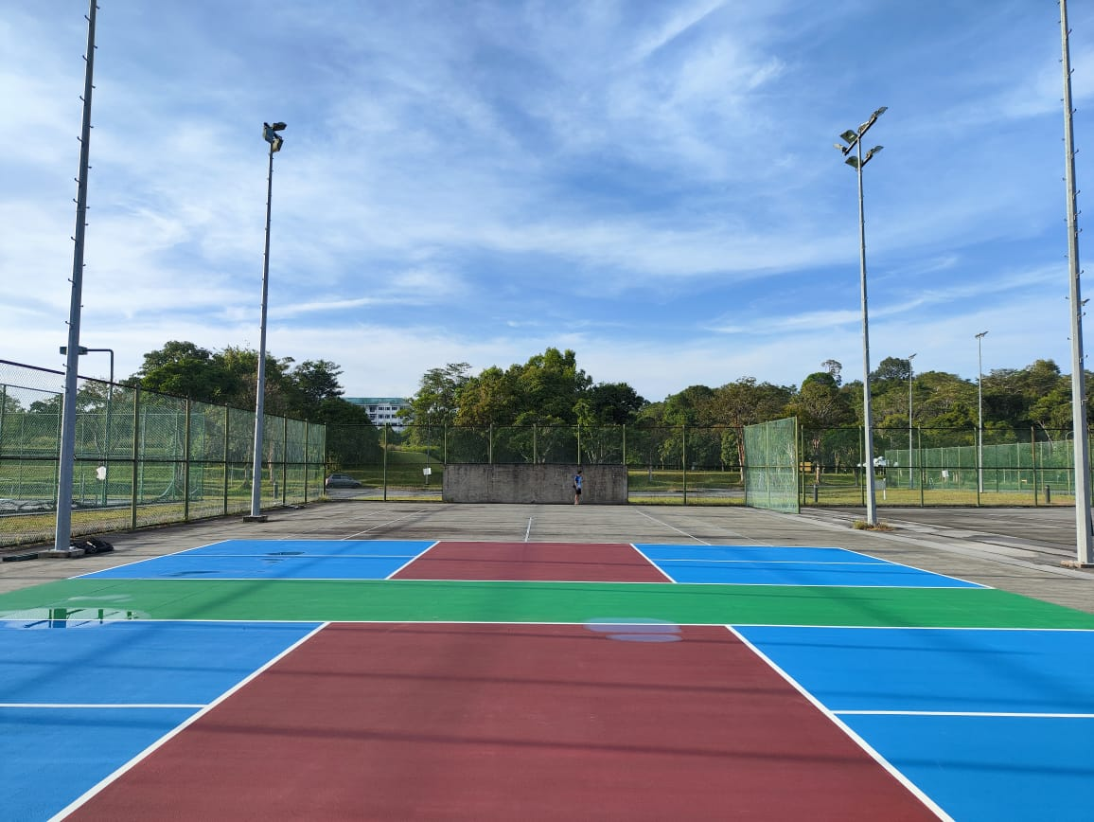
Figure 5.3 Resulting view from the camera

The phone camera is mounted on a tripod at the rear baseline of the court, elevated approximately 1.5 meters above the ground as shown in Figure 5.4. DroidCam is installed on the phone and configured in WiFi hotspot mode at a stream resolution of 1080p and a frame rate of 30 FPS. The phone broadcasts a local WiFi hotspot for the laptop to receive the video stream through DroidCam.
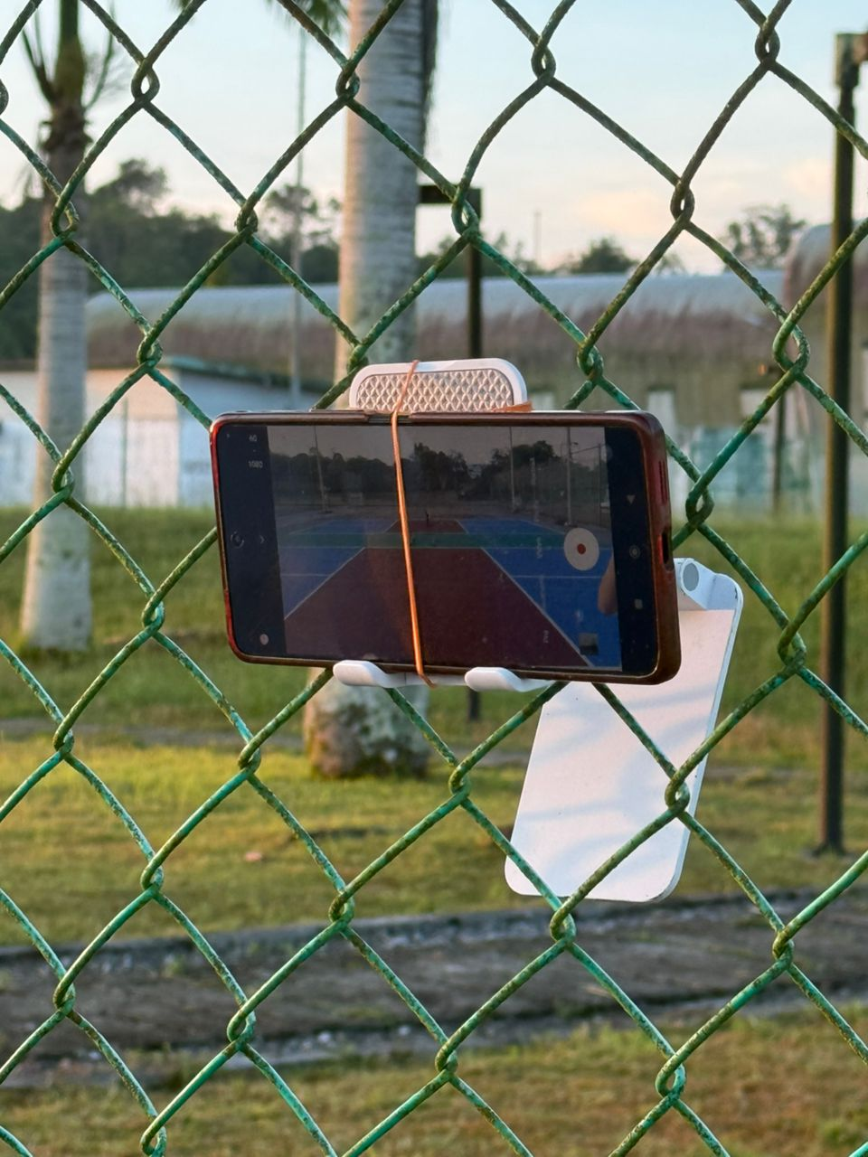
Figure 5.4 Camera setup at the rear baseline

The laptop performs a court calibration before the match by selecting the four court corners and the net line through the calibration interface. Once calibration is complete, the match session starts from the dashboard. Both scores are recorded for comparison.

5.4.2 Scoring Accuracy Against Manual Scorekeeping
The scoring accuracy of the system is evaluated by comparing the score produced by the automated logic engine against the score recorded manually by the observer. The match produced a total of 24 rallies before reaching the winning score of 11 points. A rally is considered correctly scored if the system updates the score match the manual scorer. If the system fails to detect the rally, applies the score to the wrong side, or skips a rally entirely, the rally is considered incorrectly scored. Table 5.6 presents the rally-by-rally comparison between the manual score and the system score, and Table 5.7 summaries the overall scoring accuracy.

Table 5.6 Rally-by-Rally Score Comparison
Rally | Manual Score | System Score | Match | Notes
1 | 1-0 | 1-0 (Team A won) | Correct | Rally from team A, Point to team A
2 | 2-0 | 2-0 (Team A won) | Correct | Rally from team A, Point to team A
3 | 0-2 (side-out) | 0-2 (side-out to Team B) | Correct | Rally from team A but failed to return to ball. Sideout to team B.
4 | 1-2 (Team B scores) | 0-2 (no change) | Incorrect | Rally from team B, Ball tracking lost due to background distraction. All bounces registered as OUT, rally not resolved.
5 | 2-2 (Team B score) | 1-2 (Team B won) | Correct | Rally from team B, System correctly identified Team B winning this rally
6 | 3-2 (Team B won) | 2-2 (Team B won) | Correct | Rally from team B, ball landed on the court A.
7 | 4-2 (Team B won) | 3-2 (Team B won) | Correct | Serve detected from Team B, ball landed on the court A.
8 | 5-2 (Team B won) | 4-2 (Team B won) | Correct | Serve detected from Team B, ball landed on the court A.
9 | 6-2 (Team B scores) | 4-2 (no change) | Incorrect | Team A picked up ball too quickly before rally timeout completed. Score should be for team B.
10 | 2-6 (side-out to TeamA) | 4-2 (no change) | Incorrect | Team B served and lost; system wrongly identified no changes.
11 | 6-2 (side-out to TeamB) | 2-4 (side-out to Team B) | Correct | Team A served and lost; system correctly identified side-out
12 | 2-6 (side-out to TeamA) | 4-2 (side-out to Team A) | Correct | Team B failed to return the ball, ball landed on their side.
13 | 3-6 (Team A scores) | 4-2 (no change) | Incorrect | Incorrectly identified a bounce before the rally, causing the rally to be ignored.
14 | 4-6 (Team A scores) | 2-4 (side-out to Team A) | Correct | Correctly identify the sideout.
15 | 5-6 (Team A scores) | 3-4 ( Score to team A) | Correct | Rally from team A, ball landed out court A.
16 | 6-5 (side-out to Team B) | 4-3 ( side-out to Team B) | Correct | Correct identify the sideout to Team B.
17 | 7-5 (Team B scores) | 5-3 (Score to team B) | Correct | Rally from team B, team A failed to return the ball
18 | 8-5 (Team B scores) | 6-3 (Score to Team B) | Correct | Rally from team B, team A failed to return the ball
19 | 9-5 (Team B scores) | 7-3 (Score to Team B) | Correct | Rally from team B, team A failed to return the ball
20 | 5-9 (Side-out to Team A) | 3-7 (side-out to Team A) | Correct | Team B served and lost the rally. System correctly identified side-out to Team A.
21 | 6-9 ( Team A scores) | 7-3 (side-out to Team B) | Incorrect | Team A served and scored. System incorrectly recorded side-out to Team B instead of awarding the point to Team A.
22 | 9-6 (Side-out to Team B) | 3-7 (side-out to Team A) | Incorrect | Team A served at 6-9 and lost. System wrongly identified side-out to Team A instead of Team B.
23 | 10-6 (Team B scores) | 7-3 (side-out to Team B) | Correct | Team B served and scored. System recorded side-out to Team B rather than a direct point, but correctly attributed the rally to Team B
24 | 11-6 (Team B scores) | 3-7 (side-out to Team A) | Incorrect | Team B served and scored, winning the match 11-6. System incorrectly recorded side-out to Team A instead of awarding the final point to Team B.

Table 5.7 Scoring Accuracy Summary
Total Rallies | Correctly Scored | Incorrectly Scored | Scoring Accuracy
24 | 17 | 7 | 71%

The scoring accuracy is calculated by dividing the number of correctly scored rallies by the total rallies played and multiplying the result by 100. The system achieved an accuracy of 71% across the full match. The categories of incorrectly scored rallies and their underlying causes are analysed further in Section 5.5.

5.5 Discussion Of Results
The system achieved a scoring accuracy of 71% across 24 rallies in the singles match field test, as recorded in Table 5.6. Several errors were observed during the test. The first cause is missed bounce detection due to the YOLO model failing to detect an in-court bounce. The ball moves too fast, is occluded by the player, or is partially out of frame. Without a recorded bounce, the system relies on the previous bounce in the rally, which can produce the wrong outcome or cause the rally to be ignored.
The second cause is insufficient training data coverage. The custom dataset does not fully represent all possible scenarios such as high-speed ball motion, motion blur, and partial occlusion scenarios encountered during a real match. As a result, the YOLO model occasionally fails to detect the ball, leading to missed bounce that affects rally resolution.
The third cause is player interference with the rally timeout. The system requires a two-second period after the final bounce before resolving the rally. When players retrieve the ball too quickly, the rally is interrupted before the timeout expires and no score update occurs. This is a usability constraint of the bounce-based scoring approach.
The fourth cause is the two-bounce minimum requirement built into the rally resolution logic. The system requires at least two detected bounces to resolve a rally. If a rally produces only a single in-court bounce because the model missed detections, the rally is ignored even though a real outcome existed.
The system has two additional design constraints that affect its accuracy. The first is the absence of volley detection. The scoring logic relies entirely on bounce position to determine the winner. When a player wins a rally with a volley before the ball bounces, the system has no event to resolve. The second is the camera frame rate, which is limited to 30 FPS due to the streaming constraint of the free version of DroidCam. At 30 FPS, the ball can travel several frames during a bounce or miss the exact bounce moment if the ball rises and falls within the gap between frames.
Overall, the system performs well when rallies are slow with clear in-court bounces. It struggles with fast exchanges, volley winners, and rallies where the camera misses key bounces. As summarized in Table 5.7, the majority of scoring errors originate from camera and detection limitations rather than from the scoring rules themselves, which were confirmed to be functioning correctly in Section 5.3.

5.6 Summary
In summary, this chapter presented the testing and evaluation of the Pickleball Automated Point Counting System. Functional and non-functional testing confirmed that all components behave as specified under the defined test environment. A field evaluation was then conducted using a live singles match, where the system achieved a scoring accuracy of 71% across 24 rallies. The primary causes of error were identified as missed bounce detections due to model and dataset limitations, player interference with the rally timeout, and the two-bounce minimum requirement. Chapter 6 presents the conclusion of the project and recommendations for future work.

: CONCLUSION AND FUTURE WORK

6.1 Introduction
This chapter presents the conclusion of the Pickleball Automated Point Counting System project. This chapter evaluates whether the project objectives were achieved, identifies the limitations observed during development and evaluation, and proposes recommendations for future work. A conclusion is provided to summarize the overall outcome of the project.

6.2 Objective Achievement
Table 6.1 review of the objectives and achievements of the system after going through the implementation and testing phases.
Table 6.1 Review of the Objectives and Achievements
Objectives | Achievements
To design an Automated Pickleball Point Counting System by identifying real-time object detection models and defining the complete system architecture. | YOLOv11-m was selected as the detection model following a comparative review of object detection algorithms in Chapter 2. The complete system architecture was defined in Chapter 3, covering the two-process pipeline, game logic engine, SQLite database, and web dashboard, and documented through use case, sequence, activity, class, and entity relationship diagrams.
To develop a functional prototype of the system by training and fine-tuning a YOLOv11-m model on a custom dataset and integrating with a Python-based game logic engine. | A custom dataset of local pickleball footage was annotated and used to fine-tune the YOLOv11-m model as documented in Chapter 4. The trained model was integrated with a Kalman filter tracker and a game logic engine that enforces side-out scoring rules, server rotation, and rally resolution for both singles and doubles formats. Functional testing in Chapter 5 confirmed all components behave as specified.
To evaluate the accuracy and reliability of the Automated Pickleball Point Counting System prototype by comparing the results against manual scorekeeping. | A field evaluation was conducted using a live singles match in Chapter 5. The system was tested across 24 rallies and achieved a scoring accuracy of 71% when compared against a manually tracked scoreline. The evaluation identified specific failure causes and confirmed that the core scoring rules function correctly under the tested conditions.

6.3 Project Limitations
The limitations and constraints of the proposed system are as follows:
- The system does not detect volley winners. If a player hits the ball before it bounces, no bounce event is recorded, and the rally cannot be resolved by scoring logic.
- The camera frame rate is restricted to 30 FPS by the free tier of DroidCam. A fast-moving ball can complete the bounce between two consecutive frames, causing the system to miss the detection entirely.
- The training dataset is insufficient to cover all possible scenario encounters during a real match. This includes high-speed tracking, motion blur, and player occlusion. This limits the ability of the model to consistently detect the ball across all rally scenarios.
- The rally resolution logic requires a minimum of two detected bounces. Rallies where the receiving player does not return the ball produce only one bounce and are ignored, resulting in a missed score update.
- The system does not detect kitchen violations as it only tracks the ball and has no knowledge of player positions. This was explicitly excluded from the project scope.
- The system uses a single fixed camera, which limits court coverage and may miss bounces near the far baseline or behind a player.

6.4 Future Work
There are several suggestions to improve the proposed system listed as follows.
- Implement volley detection by integrating a player pose estimation model such as YOLOv11-pose to determine whether a player contacted the ball before it bounced.
- Upgrade to a higher frame rate camera of 60 FPS or above to reduce missed bounce detections caused by fast ball movement between frames.
- Further expand the training dataset beyond the 482 images currently used, particularly for high-speed exchanges and motion blur scenarios not yet covered. A larger and more diverse dataset would improve the reliability of the model detection across different match conditions.
- Relax the two-bounce minimum rule when a serve has already been confirmed, allowing a single in-court bounce followed by a rally timeout to be treated as a valid scoring outcome.
- Add kitchen violation detection by tracking player foot positions relative to the calibrated non-volley zone boundary using the court homography already computed by the system.
- Expand to a multi-camera setup to improve court coverage and reduce blind spots caused by the current single-camera constraint.

6.5 Conclusion
All three objectives outlined in Chapter 1 have been met, since the completed system successfully detects the pickleball in real time, enforces the scoring rules through a game logic engine, and was evaluated against manual scorekeeping in a live match environment. However, there are limitations that could not be resolved within the scope of this project, including the absence of volley detection, the 30 FPS camera constraint, and the two-bounce minimum requirement. These limitations are unavoidable due to hardware and detection constraints present during development. As a result, several improvements have been identified and proposed as future work to address the current shortcomings and improve the overall scoring accuracy of the system. The proposed system demonstrates that automated pickleball point counting using a single consumer-grade camera and a trained detection model is technically feasible, providing recreational players with an accessible and low-cost alternative to manual scorekeeping.

REFERENCES
Faiza, B. (2025). Hawk-Eye explained: The $100k Tech Powering Global Sports. Trustnbet.com. https://www.trustnbet.com/sports-news/hawk-eye-explained-the-100k-tech-thats-quietly-running-global-sports/
Ghoury, S., Sungur, C., & Durdu, A. (2019). Real-Time Diseases Detection of Grape and Grape Leaves using Faster R-CNN and SSD MobileNet Architectures. International Conference on Advanced Technologies, Computer Engineering and Science (ICATCES 2019). https://www.researchgate.net/publication/334987612_Real-Time_Diseases_Detection_of_Grape_and_Grape_Leaves_using_Faster_R-CNN_and_SSD_MobileNet_Architectures
Hawk-Eye Innovations. (n.d.). Hawk-Eye Electronic Line Calling System [Computer software]. https://www.hawkeyeinnovations.com/
In/Out Tennis. (n.d.). In/Out Net Device (Version 4.0) [Apparatus]. https://inout.tennis/
Jiao, L., Zhang, F., Liu, F., Yang, S., Li, L., Feng, Z., & Qu, R. (2019). A Survey of Deep Learning-Based Object Detection. IEEE Access, 7, 128837–128868. https://doi.org/10.1109/access.2019.2939201
Jocher, G., & Qiu, J. (2024). Ultralytics YOLO11 (Version 11.0.0) [Computer software]. Ultralytics. https://github.com/ultralytics/ultralytics
Li, Q., Lin, Y., & He, W. (2021). SSD7-FFAM: A Real-Time Object Detection Network Friendly to Embedded Devices from Scratch. Applied Sciences, 11(3), 1096. https://doi.org/10.3390/app11031096
Liu, L., Ouyang, W., Wang, X., Fieguth, P., Chen, J., Liu, X., & Pietikäinen, M. (2019). Deep Learning for Generic Object Detection: A Survey. International Journal of Computer Vision, 128(2), 261–318. https://doi.org/10.1007/s11263-019-01247-4
Liu, W., Anguelov, D., Erhan, D., Szegedy, C., Reed, S., Fu, C. Y., & Berg, A. C. (2016). SSD: Single Shot MultiBox Detector. In B. Leibe, J. Matas, N. Sebe, & M. Welling (Eds.), Computer Vision – ECCV 2016 (pp. 21–37). Springer International Publishing. https://doi.org/10.1007/978-3-319-46448-0_2
Redmon, J., Divvala, S., Girshick, R., & Farhadi, A. (2016). You Only Look Once: Unified, Real-Time Object Detection. 2016 IEEE Conference on Computer Vision and Pattern Recognition (CVPR), 779–788. https://doi.org/10.1109/cvpr.2016.91
‌Ren, S., He, K., Girshick, R., & Sun, J. (2017). Faster R-CNN: Towards Real-Time Object Detection with Region Proposal Networks. IEEE Transactions on Pattern Analysis and Machine Intelligence, 39(6), 1137–1149. https://doi.org/10.1109/tpami.2016.2577031
SwingVision. (2025). SwingVision: Tennis Pickleball (Version 11.9.48) [Mobile app]. App Store. https://apps.apple.com/us/app/swingvision-tennis-pickleball/id989461317
Zhao, Z.-Q., Zheng, P., Xu, S.-T., & Wu, X. (2019). Object Detection With Deep Learning: A Review. IEEE Transactions on Neural Networks and Learning Systems, 30(11), 3212–3232. https://doi.org/10.1109/tnnls.2018.2876865
Ziegler, M. (2013, August 8). Hawk-Eye inventor Paul Hawkins says cricket didn't test system. Daily Mail. https://www.dailymail.co.uk/sport/cricket/article-2386856/Hawk-Eye-inventor-Paul-Hawkins-says-cricket-didnt-test-system.html

