|  |  |  |  |  |  |  |  |  |  |  |  |  |
| --- | --- | --- | --- | --- | --- | --- | --- | --- | --- | --- | --- | --- |
| **Mini Project – 1 Assignment 1**       |  |  | | --- | --- | | **Student Name/ID Number:** | John Doe (XXXX-YYYZZ) | | **Academic Year:** | September 20XX | | **Module Name:** | Front End Development | | **Project Title:** | Company Portfolio | | **Submission Date:** | XX/YY/ZZZZ |            |  | | --- | | **Learner**    **declaration** | | I certify that the work submitted for this assignment is my own and research sources are fully acknowledged.  Student signature: Date: XX/YY/ZZZZ | |

**1. Information Architecture**

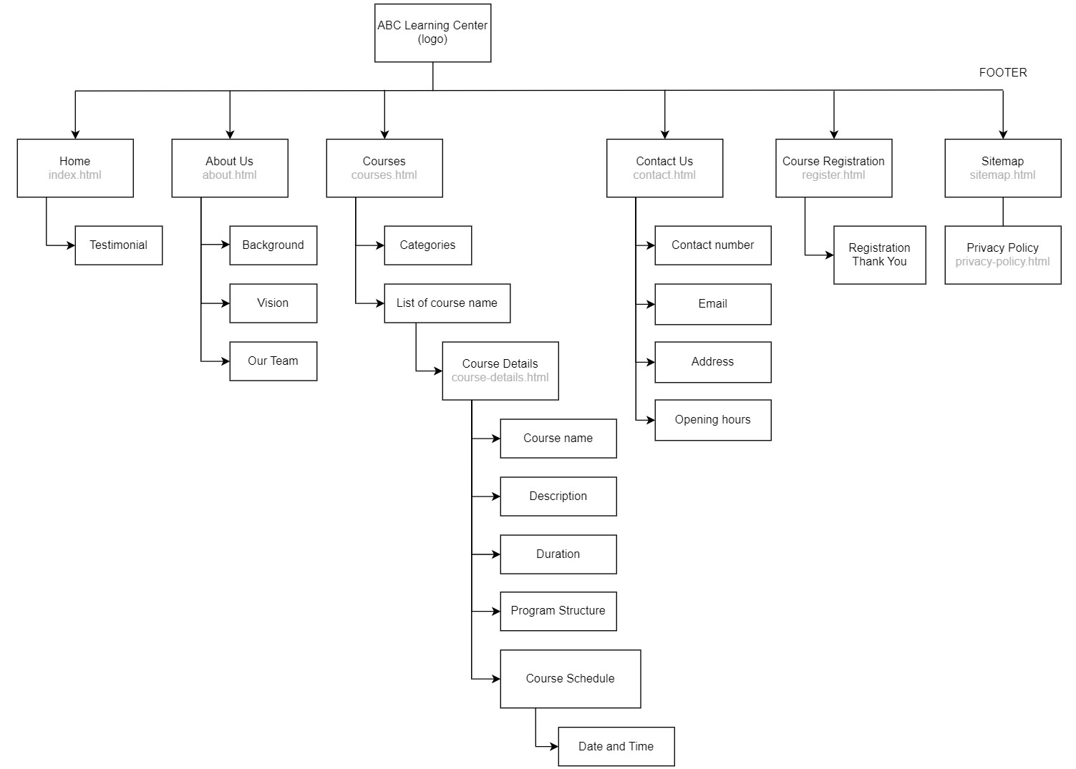

Figure 1: Information Architecture

**2. Wireframe**

2.1 Home Page (index.html)

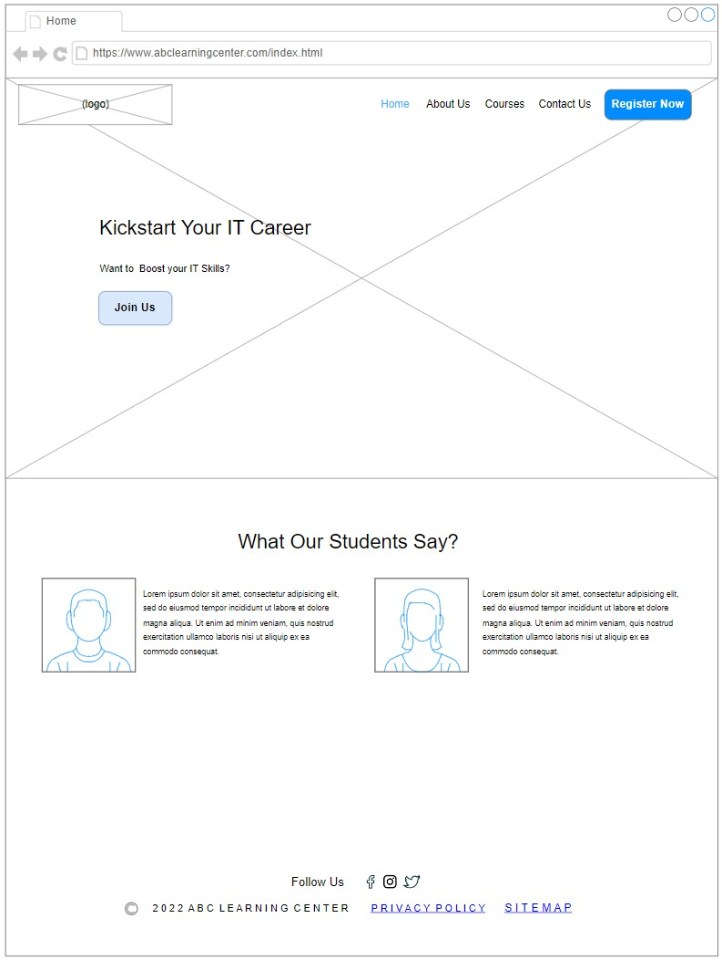

Figure 2: Home Page

Header

1. Clicking Logo or Home on navigation bar, will link to Home Page which shown in Figure 2.
2. About Us on navigation bar will link to the About Us Page which shown in Figure 3.
3. Courses on navigation bar will link to the Course Listing Page which shown in Figure 7.
4. Contact Us on navigation bar will link to the Contact Us Page which shown in Figure 4.
5. Register Now will link to the Lead Registration Page which shown in Figure 11.

Content

1. Join Us in the hero banner will link to the Lead Registration Page which shown in Figure 11.

Footer

1. Privacy Policy will link to the Privacy Policy Page which shown in Figure 6.
2. Sitemap will link to the Sitemap Page which shown in Figure 5.

2.2 About Us Page (about.html)

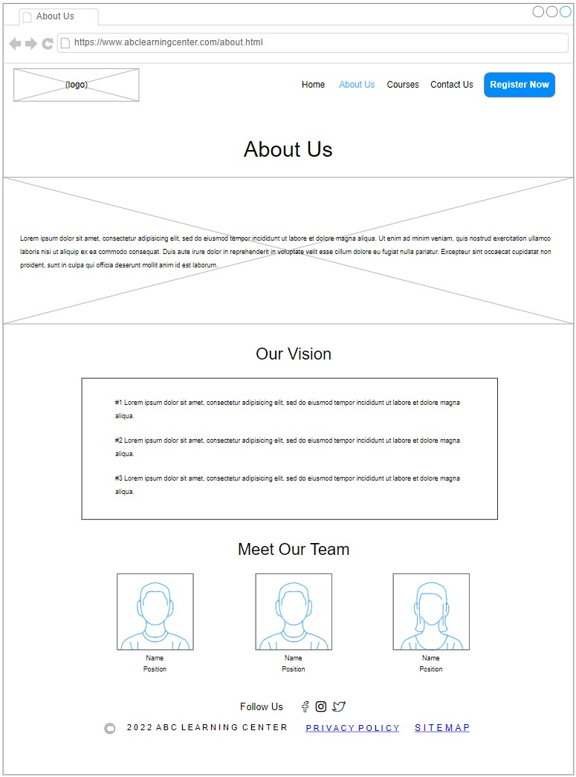

Figure 3: About Us Page

2.3 Contact Us Page (contact.html)

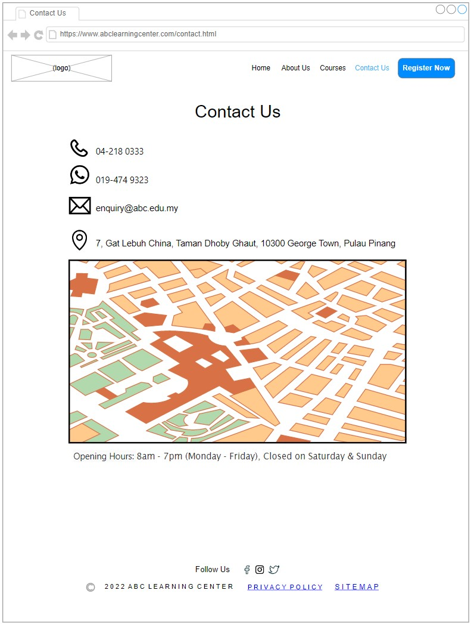

Figure 4: Contact Us Page

2.4 Sitemap Page (sitemap.html)

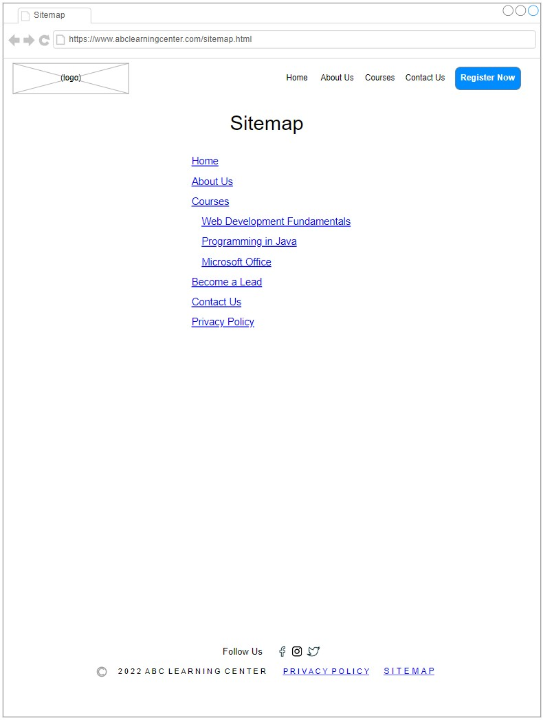

Figure 5: Sitemap Page

2.5 Privacy Policy Page (privacy-policy.html)

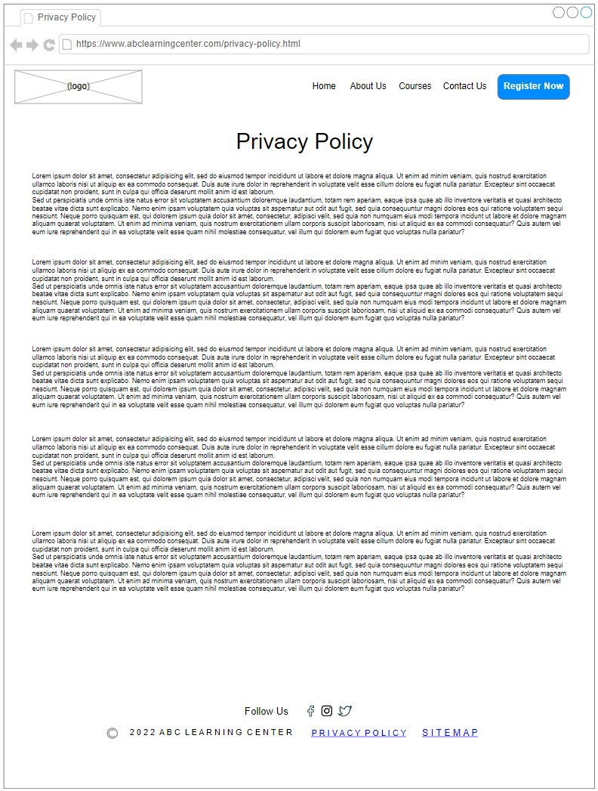

Figure 6: Privacy Policy Page

2.6 Course Listing Page

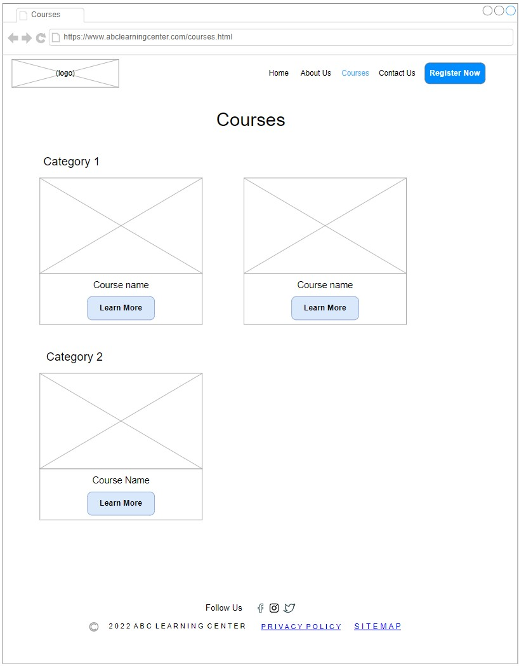

Figure 7: Course Listing Page

Learn More button will link to the following Course Details Page which shown in Figure 8.

2.7 Course Details Page

2.7.1 Overview

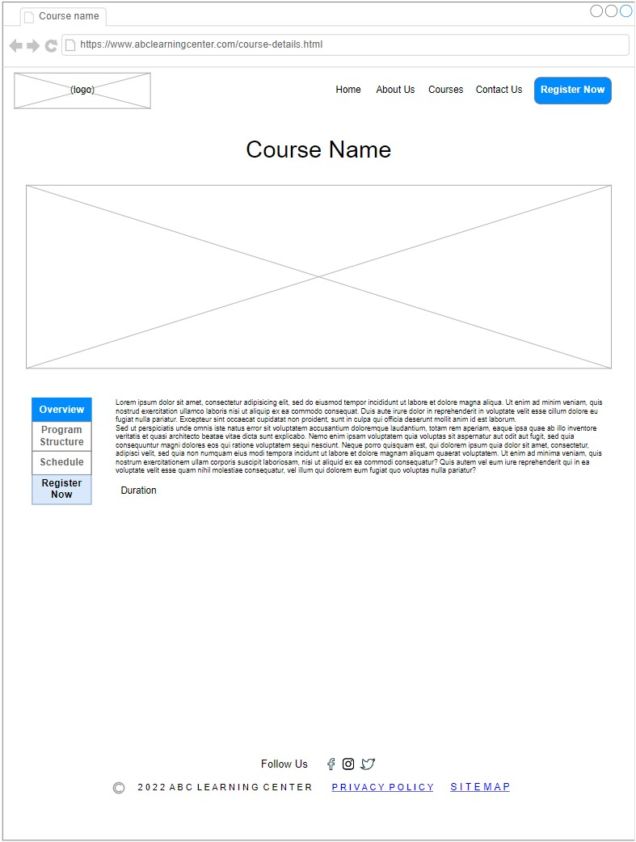

Figure 8: Course Details Page (Overview)

Program Structure tab will change the content of page which shown in Figure 9.

Schedule tab will change the content of page which shown in Figure 10.

Register Now will link to Lead Registration Page which shown in Figure 11.

2.7.2 Program Structure

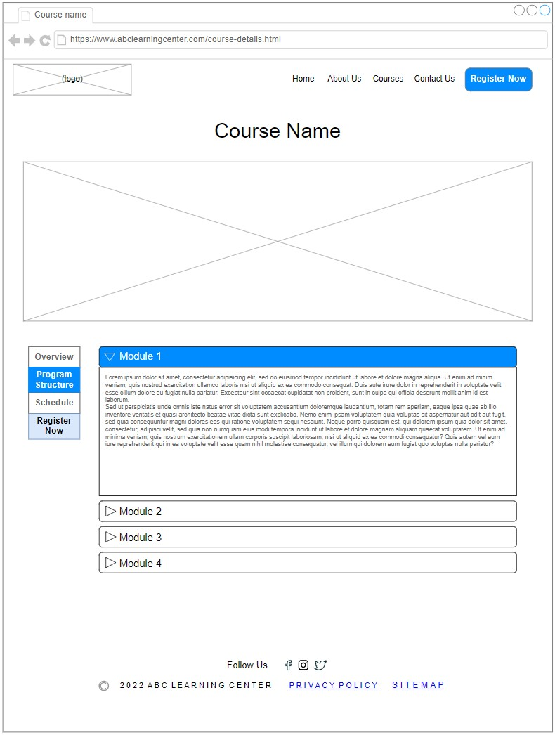

Figure 9: Course Details Page (Program Structure)

2.8 Course Schedule Page

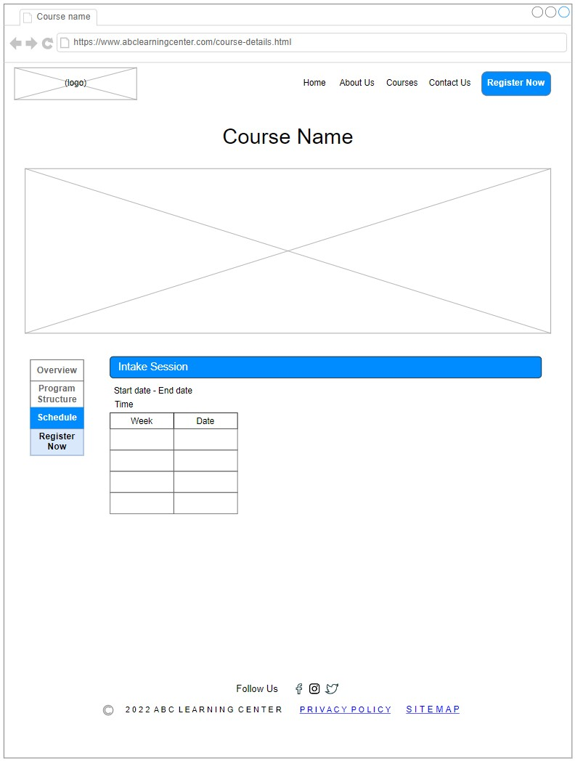

Figure 10: Course Schedule Page

2.9 Lead Registration Page (register.html)

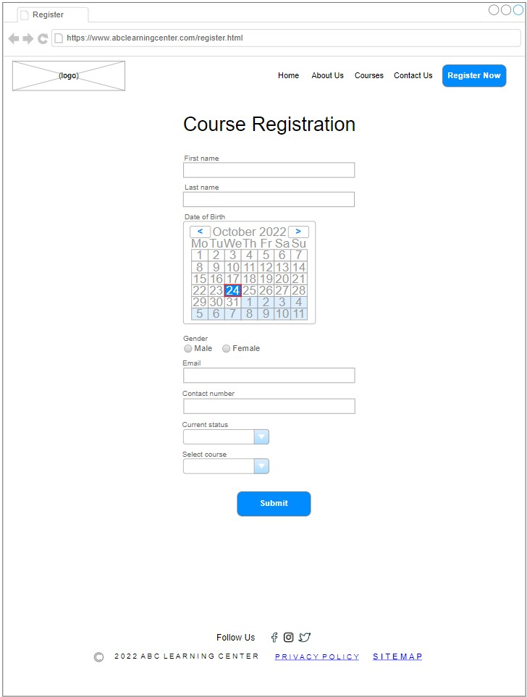

Figure 11: Course Registration Page

Submit button after form validation. will show a pop up which is shown in Figure 12.

2.10 Registration Thank You Page

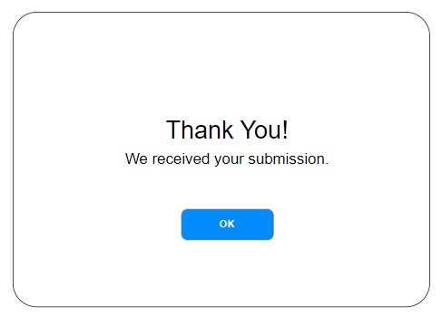

Figure 12: Registration Thank You Pop Up

3. Storyboard

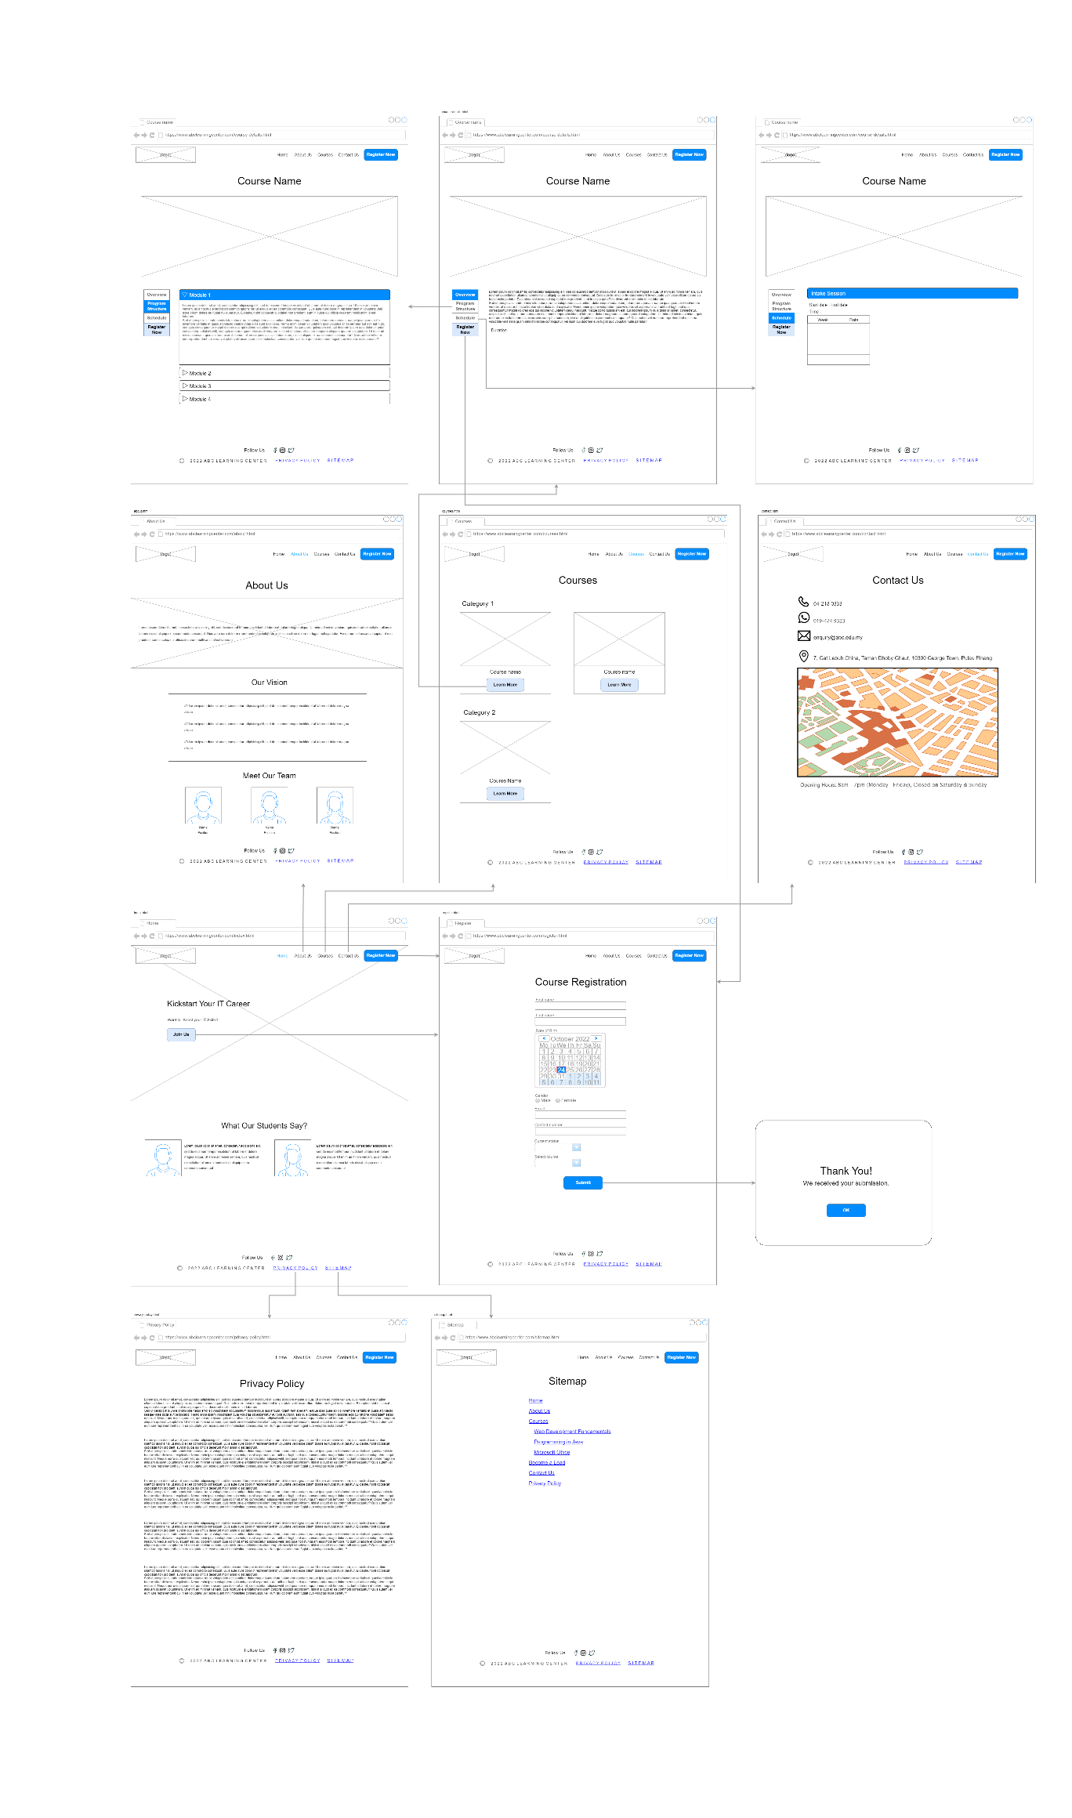

Figure 13: Storyboard

4. Screenshot of the pages

4.1 Home Page (index.html)

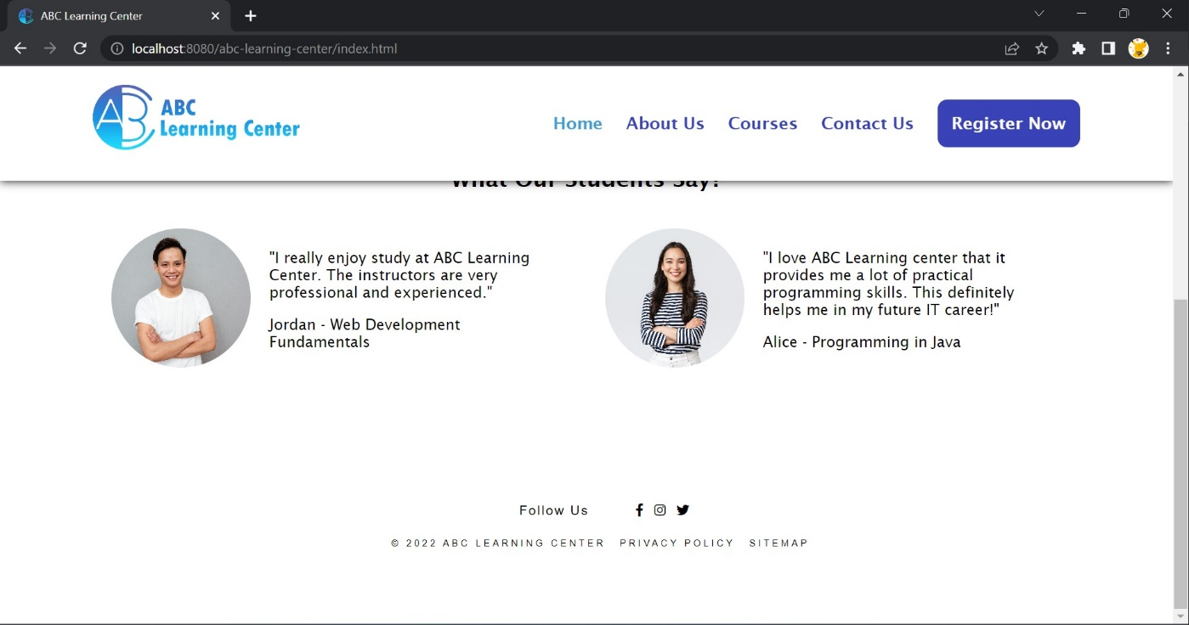

4.2 About Us Page (about.html)

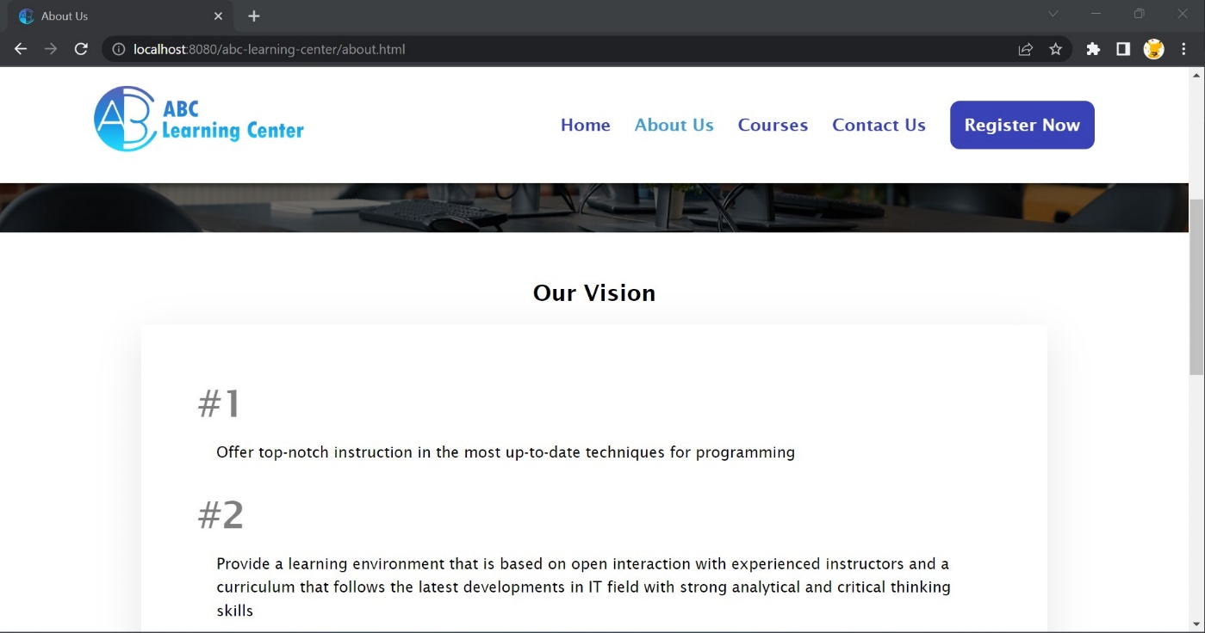

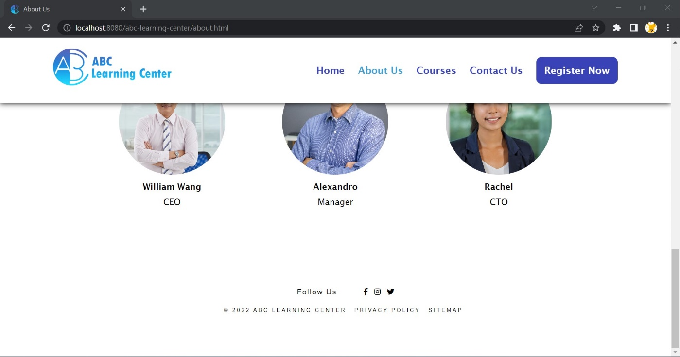

4.3 Contact Us Page (contact.html)

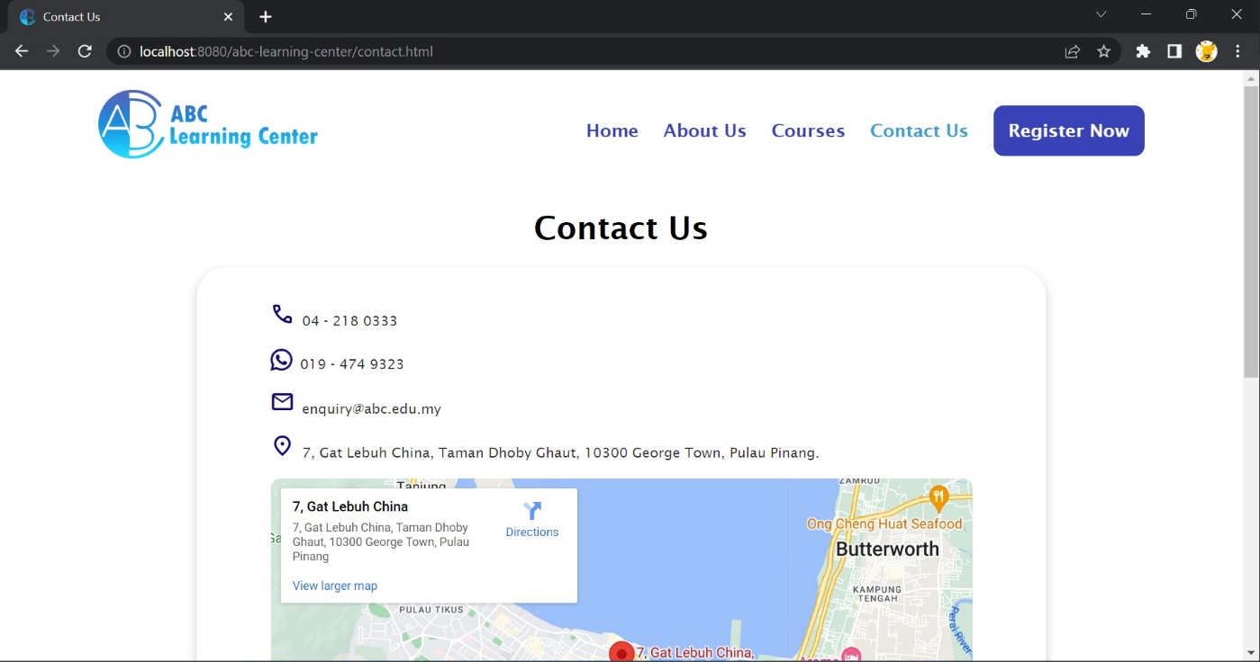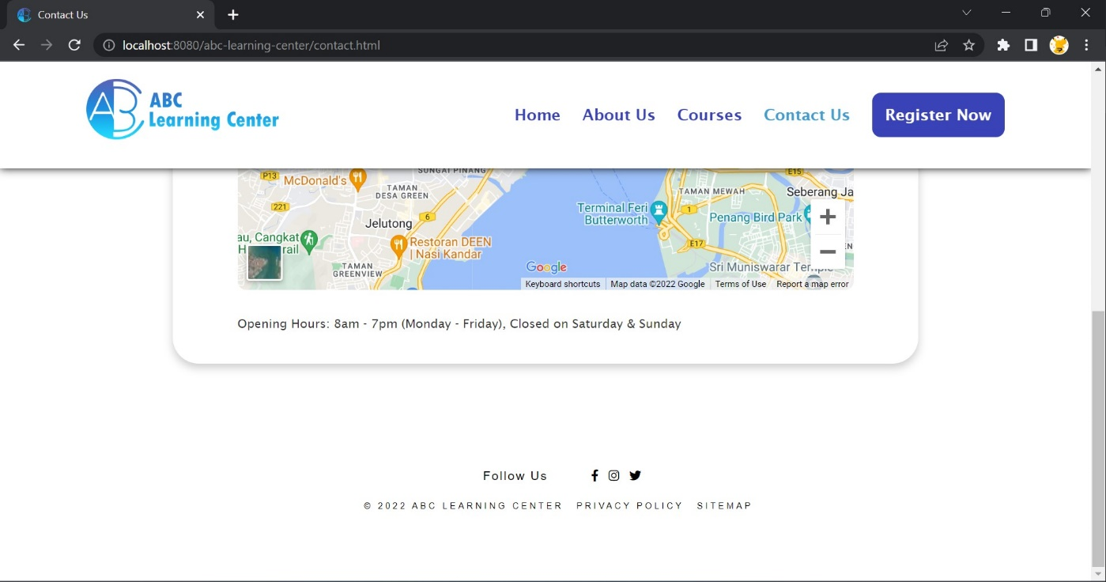

4.4 Sitemap Page (sitemap.html)

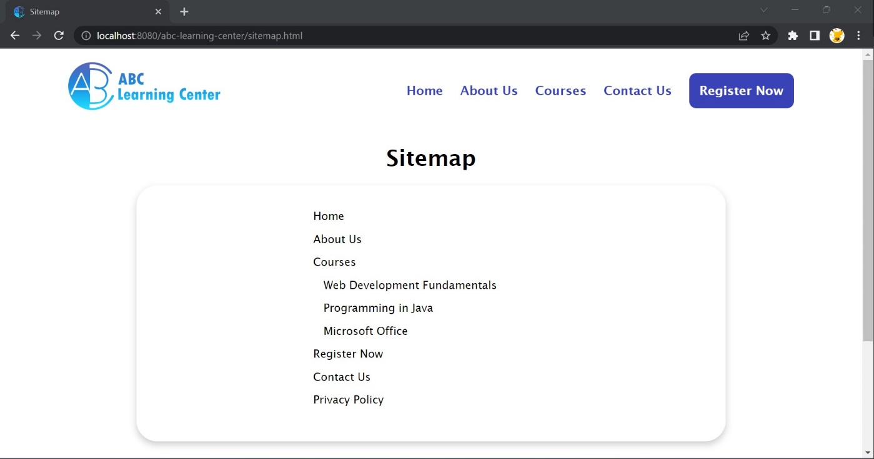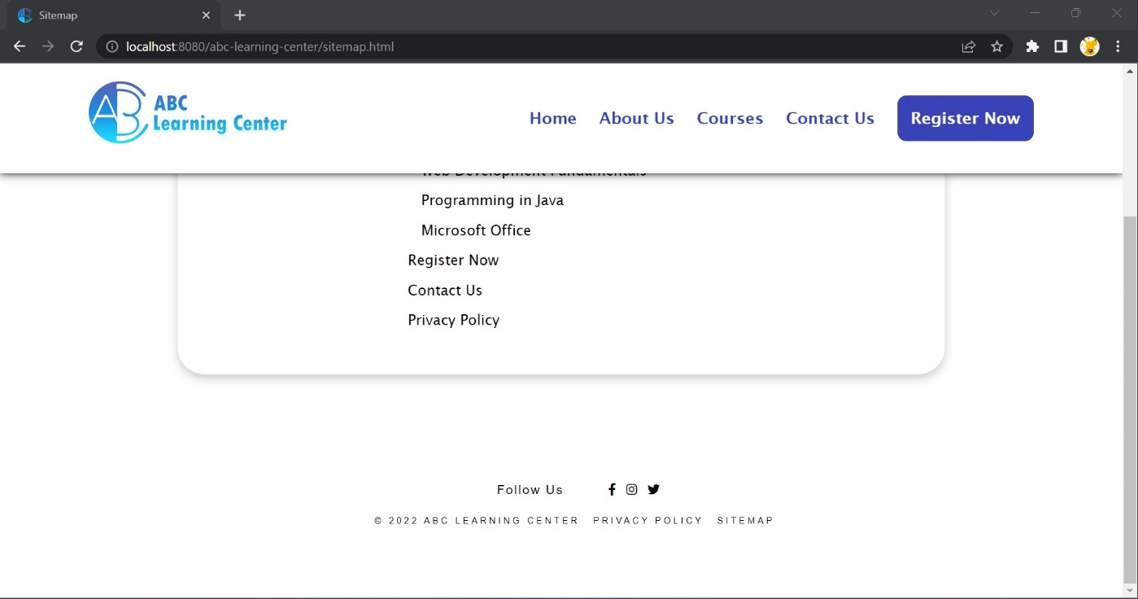

4.5 Privacy Policy Page (privacy-policy.html)

