**URL**

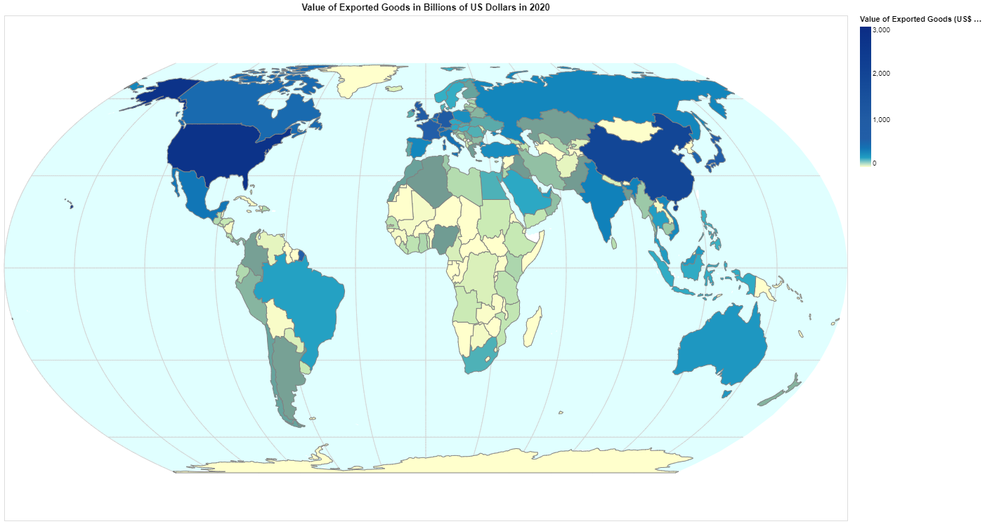

**Domain**

The domain of this visualisation is the “Value of Exported Goods in 2020 in Billions of US Dollars”. It focuses on representing the value of countries’ exports in a geographic perspective during 2020 and shows how the pandemic has affected global trade.

**Visualised Dataset:**

Attribute Types: The dataset includes geographical attributes such as country names and quantitative attributes such as the values of imports and exports, country growth and more. For this visualisation, unnecessary data is removed from the dataset to improve VegaLite performance by reducing the dataset file size. Only country names and value of exported goods remained.

Source: <https://www.kaggle.com/datasets/muhammadtalhaawan/world-export-and-import-dataset?resource=download>

Author: Muhammad Talha Awan

**Data Transformation:**

The original data shows the values of exported goods in thousands of US Dollars, which can be cumbersome for the visualisation due to the large numbers involved. Thus, the values was scaled to represent billions of US Dollars by dividing the original value by one million. Through this, the readability of the visualisation is enhanced, allowing easier comprehension of export values.

**Why Choropleth Symbol Map:**

I chose a Choropleth Symbol Map due to its effectiveness in representing the "Value of Exported Goods during 2020 in Billions of US Dollars." This map type is particularly well-suited for this task because it allows for the clear depiction of geographic variations in export values among countries. Each country is represented as a distinct region on the map, and the use of colour gradients enables an intuitive comparison of export magnitudes in a sequential order. In this context, where the goal is to visualise data for the year 2020, the Choropleth Symbol Map provides a snapshot of export values for easy evaluation and comparison of the value of exported goods between countries.