Contents

1. Introduction 3

2. Technologies used 3

3. Files and program structure 3

3.1 Assets folder 4

4. App Description 4

4.1 Root Folder Code: 4

4.1.1 main.dart 4

4.1.2 my_flutter_app_icons.dart 6

4.2 homepage Folder Code 6

4.2.1 Display 6

4.2.2 homepage.dart 7

4.2.3 promo_carousel.dart 9

4.2.4 research_promise.dart 11

4.2.5 treatment_carousel.dart 13

4.3 about Folder Code: 16

4.3.1 Display 16

4.3.2 about.dart 17

4.4 common Folder Code 19

4.4.1 bottom_bar.dart 19

4.4.2 top_bar.dart (Not Used) 21

4.4.3 top_dropdownmenu.dart 21

4.5 data Folder Code 22

4.6 model Folder Code 22

4.7 prices Folder Code 23

4.7.1 Display 23

4.7.2 prices.dart 24

4.7.3 pdfDownload.dart 25

4.7.4 prices_carousel.dart 26

4.8 Shop Folder Code (Unfinished) 29

4.8.1 Display 29

4.8.2 categories_dropdown.dart 30

4.8.3 sessions_dropdown.dart 31

4.8.4 shop.dart 33

4.9 treatment Folder Code 36

4.9.1 Display 36

4.9.2 treatment.dart 37

4.10 treatment/pages Folder 41

4.11 treatment/details Folder (Unfinished) 41

5. Things to improve 41

6. Personnel thoughts 41

# Introduction

Tasked to create a Mobile App (IOS, Android or both).

* The App should be a replica of skinlabmedspa.com with the essential menu items.
* Contents of the mobile app need not be as comprehensive as the web.

# Technologies used

Programming language : Flutter / Dart

IDE used : Visual Studio Code

Extensions used : Dart, Flutter

Devices tested : Pixel 3 API 29 (Emulator), HTC U11+ (Physical)

Github Repository : https://github.com/Wongks81/SkinLabAssignment

# Files and program structure

As most of the files are created to assist in the creation of the app, therefore I will only be mainly explaining on the files that are changed and used in the project.

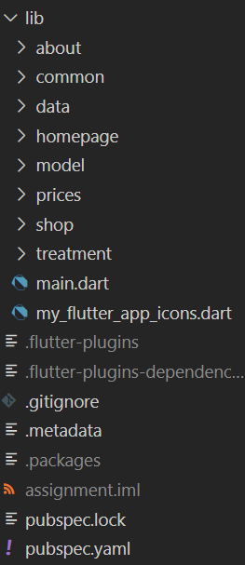Folders:

about : contains the widgets that display the contents of the

about page

common : contains the widgets that I feel that can be reused

under certain conditions

data : contains the file which have hard coded data for testing

homepage : contains the widgets that displays start up page

model : contains files which describe the objects that are used in

the app

prices : contains the widgets that display the prices page

shop : contains the widgets that display the shop page

treatment : contains the widgets that display each treatment item

Files:

main.dart : startup file for the app

my_flutter_app_icons.dart : For icons downloaded from the net.

### 3.1 Assets folder

Stores all the pictures used in the app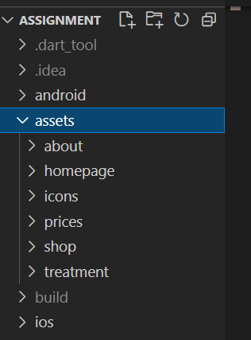.

Each name folder stores the pictures used for that page.

# App Description

## 4.1 Root Folder Code:

### 4.1.1 main.dart

The starting file for flutter to execute.

import 'package:assignment/about/about.dart';

import 'package:assignment/homepage/homepage.dart';

import 'package:assignment/prices/prices.dart';

import 'package:assignment/shop/shop.dart';

import 'package:assignment/treatment/pages/back.dart';

import 'package:assignment/treatment/pages/essential.dart';

import 'package:assignment/treatment/pages/eye.dart';

import 'package:assignment/treatment/pages/hair.dart';

import 'package:assignment/treatment/pages/neck.dart';

import 'package:assignment/treatment/pages/signature.dart';

import 'package:flutter/material.dart';

import 'treatment/pages/body.dart';

import 'treatment/pages/combo.dart';

import 'treatment/pages/premium.dart';

import 'treatment/pages/specialty.dart';

import 'treatment/treatment.dart';

void main() {

  runApp(MyApp());

}

class MyApp extends StatelessWidget {

  const MyApp({Key key}) : super(key: key);

  @override

  Widget build(BuildContext context) {

    return MaterialApp(

      title: 'Skin Lab Assignment',

      debugShowCheckedModeBanner: false,

      routes: {

        '/': (context) => HomePage(),

        '/about': (context) => About(),

        '/prices': (context) => Prices(),

        //treatment group

        '/treatment': (context) => Treatment(),

        '/treatment/combo': (context) => Combo(),

        '/treatment/specialty': (context) => Specialty(),

        '/treatment/signature': (context) => Signature(),

        '/treatment/premium': (context) => Premium(),

        '/treatment/essential': (context) => Essential(),

        '/treatment/neck': (context) => Neck(),

        '/treatment/eye': (context) => Eye(),

        '/treatment/body': (context) => Body(),

        '/treatment/back': (context) => Back(),

        '/treatment/hair': (context) => Hair(),

        //details group

        //'/treatment/combo/lumenis': (context) => LumenisDetail(),

        //shop group

        '/shop': (context) => Shop(),

      },

    );

  }

}

This page mainly contains the pre-determined routes that will be used in the app.

Each route when called will execute the widget that it is referring to.

‘/’ route will execute the base route when the app starts.

### 4.1.2 my_flutter_app_icons.dart

File which contains the icons for

* Facebook
* Instagram
* Whatsapp

Downloaded from <https://www.fluttericon.com/>

## 4.2 homepage Folder Code

## 4.2.1 Display

On execution of the app, you would see this screen

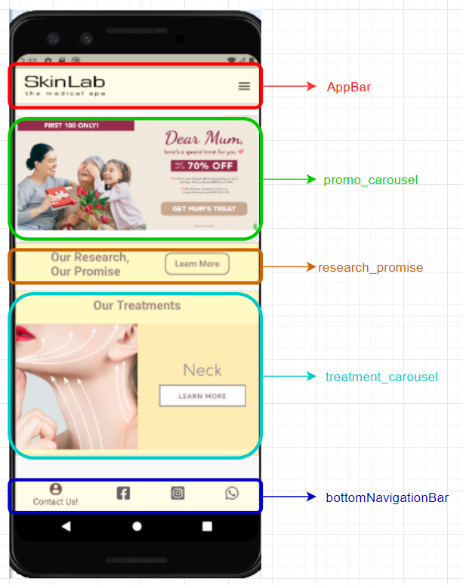

### 4.2.2 homepage.dart

The starting page that users sees when the app is loaded

import 'package:assignment/common/top_dropdownmenu.dart';

import 'package:flutter/material.dart';

import 'package:assignment/homepage/promo_carousel.dart';

import 'package:assignment/homepage/research_promise.dart';

import 'package:assignment/homepage/treatment_carousel.dart';

import 'package:assignment/common/bottom_bar.dart';

class HomePage extends StatefulWidget {

  @override

  _HomePageState createState() => _HomePageState();

}

class _HomePageState extends State<HomePage> {

  @override

  Widget build(BuildContext context) {

    return Scaffold(

      appBar: AppBar(

        title: Image.asset('assets/homepage/skinlablogo128.png',

            fit: BoxFit.contain),

        backgroundColor: Colors.yellow[50],

        actions: [

          TopDropDown(),

        ],

      ),

      body: Column(

        children: [

          //Row 1 Container for Carousel

          PromoCarousel(),

          ResearchPromise(),

          TreatmentCarousel(),

        ],

      ),

      bottomNavigationBar: new Theme(

        data: Theme.of(context).copyWith(

          canvasColor: Colors.yellow[50],

        ),

        child: BottomBar(),

      ),

    );

  }

}

Scaffold : Returns a canvas on the mobile for other widgets to be created in it.

appBar : Widget that will always be fixed to the top of the mobile screen.

TopDropDown : Calls a widget which will pop a menu which allow user to navigate to other pages

Body : contains body of the hompage

PromoCarousel : Display the top carousel item which contains all the promotion items

ResearchPromise : A widget to navigate to the about page when pressed

TreatmentCarousel : Display the bottom carousel item which will display all the treatment items

bottomNavigationBar : Widget that displays 4 buttons for social media at the bottom of the app.

### 4.2.3 promo_carousel.dart

Contains the code for the widget that displays the promotions

import 'package:carousel_slider/carousel_slider.dart';

import 'package:flutter/material.dart';

import 'package:url_launcher/url_launcher.dart';

class PromoCarousel extends StatelessWidget {

  @override

  Widget build(BuildContext context) {

    return Card(

      child: CarouselSlider(

        items: [

          Padding(

            padding: const EdgeInsets.all(0.0),

            child: TextButton(

              onPressed: () => {

                launch(

                    'https://api.whatsapp.com/send/?phone=6597703610&text&app_absent=0'),

              },

              child: Image.asset('assets/homepage/main.png'),

            ),

          ),

          Padding(

            padding: const EdgeInsets.all(0.0),

            child: Container(

              child: TextButton(

                  // navigate to shop

                  onPressed: () => {

                        Navigator.pushNamed(context, '/shop'),

                      },

                  child: Image.asset('assets/homepage/promo1.png')),

            ),

          ),

          Padding(

            padding: const EdgeInsets.all(0.0),

            child: TextButton(

              onPressed: () => {

                launch(

                    'https://docs.google.com/forms/d/e/1FAIpQLSdpnOr-2IM4aQ9gsAuQPH70tdDqxxa8Rc9yOCh1gpsxM1ssFw/viewform'),

              },

              child: Image.asset('assets/homepage/promo2.png'),

            ),

          ),

        ],

        //Slider Container properties

        options: CarouselOptions(

          autoPlay: true,

          viewportFraction: 1.1,

        ),

      ),

    );

  }

}

Imported a 3rd party dart file name carousel_slider.dart to apply the carousel effect.

Carousel contains 3 items and each item is a button

Item 1

Image : main.png

Action : launch a browser which connect to the [whatsapp api](https://api.whatsapp.com/send/?phone=6597703610&text&app_absent=0)

Item 2

Image : promo1.png

Action : navigate to the shop page

Item 3

Image : promo2.png

Action : launch a browser which connect to [google forms](https://docs.google.com/forms/d/e/1FAIpQLSdpnOr-2IM4aQ9gsAuQPH70tdDqxxa8Rc9yOCh1gpsxM1ssFw/viewform)

### 4.2.4 research_promise.dart

This section is a button that when on click of it will navigate to the about page

import 'package:flutter/material.dart';

class ResearchPromise extends StatelessWidget {

  @override

  Widget build(BuildContext context) {

    return Container(

      decoration: BoxDecoration(

        color: Colors.yellow[100],

        border: Border.all(color: Colors.brown[200]),

      ),

      child: Row(

        mainAxisAlignment: MainAxisAlignment.spaceEvenly,

        children: [

          Column(

            children: [

              Container(

                padding: EdgeInsets.all(10),

                child: Text(

                  'Our Research,\nOur Promise',

                  style: TextStyle(

                    fontSize: 20,

                    fontWeight: FontWeight.bold,

                    color: Colors.brown[300],

                  ),

                ),

              ),

            ],

          ),

          Column(

            children: [

              OutlinedButton(

                onPressed: () => {

                  Navigator.pushNamed(context, '/about'),

                },

                style: OutlinedButton.styleFrom(

                  shape: RoundedRectangleBorder(

                    borderRadius: BorderRadius.circular(10),

                  ),

                  side: BorderSide(width: 2, color: Colors.brown[300]),

                ),

                child: Text(

                  'Learn More',

                  style: TextStyle(

                    color: Colors.brown[300],

                    fontWeight: FontWeight.bold,

                  ),

                ),

              ),

            ],

          ),

        ], // 1st row Children

      ),

    );

  }

}

Navigator.pushNamed will navigate user to the about page

### treatment_carousel.dart

Contains the code for the widget that displays the available treatment

import 'package:carousel_slider/carousel_slider.dart';

import 'package:flutter/material.dart';

void main() {

  runApp(TreatmentCarousel());

}

class TreatmentCarousel extends StatelessWidget {

  @override

  Widget build(BuildContext context) {

    return Container(

      child: Container(

        margin: EdgeInsets.only(top: 10),

        decoration: BoxDecoration(

          color: Colors.yellow[100],

          border: Border.all(color: Colors.brown[200]),

        ),

        child: Column(

          children: [

            Container(

              child: Row(

                mainAxisAlignment: MainAxisAlignment.spaceEvenly,

                children: [

                  Column(

                    children: [

                      Container(

                        padding: EdgeInsets.all(10),

                        child: Text(

                          'Our Treatments',

                          style: TextStyle(

                            fontSize: 20,

                            fontWeight: FontWeight.bold,

                            color: Colors.brown[300],

                          ),

                          textAlign: TextAlign.center,

                        ),

                      ),

                    ],

                  ),

                ], // 1st row Children

              ),

            ),

            Container(

              child: CarouselSlider(

                items: [

                  Container(

                    padding: const EdgeInsets.all(0.0),

                    child: TextButton(

                      onPressed: () =>

                          {Navigator.pushNamed(context, '/treatment')},

                      child: Image.asset('assets/homepage/treatment_face.png'),

                    ),

                  ),

                  Container(

                    padding: const EdgeInsets.all(0.0),

                    child: Container(

                      child: TextButton(

                          onPressed: () =>

                              {Navigator.pushNamed(context, '/treatment/eye')},

                          child: Image.asset(

                              'assets/homepage/treatment_eyes.png')),

                    ),

                  ),

                  Container(

                    padding: const EdgeInsets.all(0.0),

                    child: TextButton(

                      onPressed: () => {

                        {Navigator.pushNamed(context, '/treatment/neck')},

                      },

                      child: Image.asset('assets/homepage/treatment_neck.png'),

                    ),

                  ),

                  Container(

                    padding: const EdgeInsets.all(0.0),

                    child: TextButton(

                      onPressed: () => {

                        {Navigator.pushNamed(context, '/treatment/body')},

                      },

                      child: Image.asset('assets/homepage/treatment_body.png'),

                    ),

                  ),

                  Container(

                    padding: const EdgeInsets.all(0.0),

                    child: TextButton(

                      onPressed: () => {

                        {Navigator.pushNamed(context, '/treatment/hair')},

                      },

                      child: Image.asset('assets/homepage/treatment_hair.png'),

                    ),

                  ),

                ],

                //Slider Container properties

                options: CarouselOptions(

                  autoPlay: true,

                  viewportFraction: 1.1,

                ),

              ),

            ),

          ],

        ),

      ),

    );

  }

}

Imported a 3rd party dart file name carousel_slider.dart to apply the carousel effect.

Carousel contains 5 items and each item is a button

Item 1

Image : treatment_face.png

Action : navigate to treatment main page

Item 2

Image : treatment_eyes.png

Action : navigate to the eye treatment page

Item 3

Image : treatment_neck.png

Action : navigate to the neck treatment page

Item 4

Image : treatment_body.png

Action : navigate to the body treatment page

Item 5

Image : treatment_hair.png

Action : navigate to the hair treatment page

## 4.3 about Folder Code:

### 4.3.1 Display

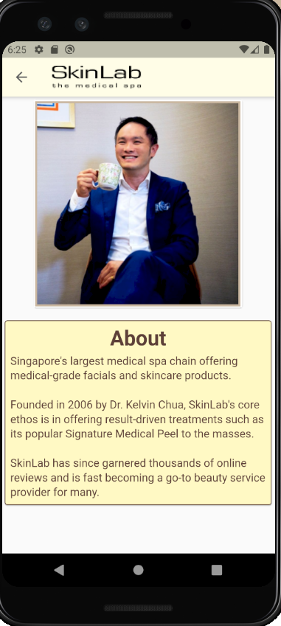

### 4.3.2 about.dart

This page displays an about page which displays information about SkinLab

import 'package:flutter/material.dart';

class About extends StatelessWidget {

  @override

  Widget build(BuildContext context) {

    return Scaffold(

      appBar: new AppBar(

        iconTheme: IconThemeData(

          color: Colors.grey[700],

        ),

        title: Image.asset('assets/homepage/skinlablogo128.png',

            fit: BoxFit.contain),

        backgroundColor: Colors.yellow[50],

      ),

      body: Column(

        children: [

          Card(

            child: Image.asset('assets/about/ceo.png', height: 300, width: 300),

          ),

          SizedBox(height: 10),

          Card(

            color: Colors.yellow[100],

            child: Padding(

              padding: const EdgeInsets.all(8.0),

              child: Column(

                children: [

                  Text(

                    'About',

                    style: TextStyle(

                      fontSize: 30,

                      fontWeight: FontWeight.bold,

                      color: Colors.brown[700],

                    ),

                  ),

                  SizedBox(

                    height: 5,

                  ),

                  Text(

                    'Singapore\'s largest medical spa chain offering ' +

                        'medical-grade facials and skincare products. \r\n\r\n' +

                        'Founded in 2006 by Dr. Kelvin Chua, ' +

                        'SkinLab\'s core ethos is in offering result-driven ' +

                        'treatments such as its popular Signature Medical Peel ' +

                        'to the masses. \r\n\r\n' +

                        'SkinLab has since garnered thousands ' +

                        'of online reviews and is fast becoming a go-to beauty ' +

                        'service provider for many.',

                    style: TextStyle(

                      fontSize: 16,

                      //fontWeight: FontWeight.bold,

                      //letterSpacing: 1,

                      height: 1.3,

                      color: Colors.brown[700],

                    ),

                  ),

                ],

              ),

            ),

            shape: RoundedRectangleBorder(

                side: BorderSide(color: Colors.brown[700], width: 1),

                borderRadius: BorderRadius.circular(4)),

          ),

        ],

      ),

    );

  }

}

Contains:

* A Card which displays the CEO picture.
* A Card text box which displays the information.

## 4.4 common Folder Code

### 4.4.1 bottom_bar.dart

This file contains the code for the bottom navigation bar

import 'package:flutter/material.dart';

import 'package:assignment/my_flutter_app_icons.dart';

import 'package:url_launcher/url_launcher.dart';

class BottomBar extends StatefulWidget {

  const BottomBar({Key key}) : super(key: key);

  @override

  _BottomBarState createState() => _BottomBarState();

}

class _BottomBarState extends State<BottomBar> {

  int _selectedIndex = 0;

  @override

  Widget build(BuildContext context) {

    return BottomNavigationBar(

      backgroundColor: Colors.yellow[50],

      items: const <BottomNavigationBarItem>[

        BottomNavigationBarItem(

          icon: Icon(Icons.account_circle),

          label: 'Contact Us!',

        ),

        BottomNavigationBarItem(

          icon: Icon(MyFlutterApp.facebook_square),

          label: 'Facebook',

        ),

        BottomNavigationBarItem(

          icon: Icon(MyFlutterApp.instagram_square),

          label: 'Instagram',

        ),

        BottomNavigationBarItem(

          icon: Icon(MyFlutterApp.whatsapp),

          label: 'Whatsapp',

        ),

      ],

      currentIndex: _selectedIndex,

      selectedItemColor: Colors.brown[500],

      unselectedItemColor: Colors.grey[700],

      onTap: _onItemTapped,

    );

  }

  void _onItemTapped(int index) {

    // setState(() {

    //   _selectedIndex = index;

    // });

    switch (index) {

      case 0:

        launch('https://skinlabmedspa.com/contact-us');

        break;

      case 1:

        launch('https://www.facebook.com/skinlabsg');

        break;

      case 2:

        launch('https://www.instagram.com/skinlabsg/?hl=en');

        break;

      case 3:

        launch('https://api.whatsapp.com/send/?phone=6597703610&text&app_absent=0');

        break;

    }

  }

}

The bottom bar displays the icons with a label when selected.

When user pressed the button, the _selectedIndex will be updated with the index value that will be passed to _onItemTapped function.

Depending on the index passed:

Index 0 (Contact Us) – launch a browser with URL :

<https://skinlabmedspa.com/contact-us>

Index 1 (Facebook) – launch SkinLab SG facebook page URL:

<https://www.facebook.com/skinlabsg>

Index 2(Instagram) – launch SkinLab SG Instagram page URL: <https://www.instagram.com/skinlabsg/?hl=en>

Index 3(Whatsapp) – launch Whatsapp API for SkinLab <https://api.whatsapp.com/send/?phone=6597703610&text&app_absent=0>

### 4.4.2 top_bar.dart (Not Used)

Supposed to replace appBar in each page but unable to get it working

### 4.4.3 top_dropdownmenu.dart

The pop out button for additional menu in the appBar 

import 'package:flutter/material.dart';

class TopDropDown extends StatelessWidget {

  @override

  Widget build(BuildContext context) {

    return PopupMenuButton<int>(

      icon: Icon(

        Icons.menu,

        color: Colors.black,

      ),

      color: Colors.yellow[100],

      onSelected: (item) => onSelected(context, item),

      itemBuilder: (context) => [

        PopupMenuItem<int>(

          value: 0,

          child: Text('About'),

        ),

        PopupMenuItem<int>(

          value: 1,

          child: Text('Treatment'),

        ),

        PopupMenuItem<int>(

          value: 2,

          child: Text('Prices'),

        ),

        PopupMenuItem<int>(

          value: 3,

          child: Text('Shop'),

        ),

      ],

    );

  }

}

void onSelected(BuildContext context, int item) {

  switch (item) {

    case 0:

      Navigator.pushNamed(context, '/about');

      break;

    case 1:

      Navigator.pushNamed(context, '/treatment');

      break;

    case 2:

      Navigator.pushNamed(context, '/prices');

      break;

    case 3:

      Navigator.pushNamed(context, '/shop');

      break;

  }

}

This is the widget for the popoutmenu in the homepage.

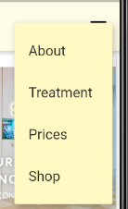Each Item in the menu will route to their respective pages

## 4.5 data Folder Code

The file contains the hard coded data that were used for the other widgets.

For future improvement, these data should be stored in a database instead.

## 4.6 model Folder Code

treatmentcategories : defines the object class for Categories

treatmentitem : defines the object class for TreatmentItems

## 4.7 prices Folder Code

### 4.7.1 Display



This page contains

* A carousel which will allow user to scroll through the price list.
* A button on the top left which will redirect user to the [URL](https://skinlabmedspa.com/index.php?controller=attachment&id_attachment=3) for them to download the pdf for the price list

### 4.7.2 prices.dart

This file is the container which defines the outline of the page and holds the display widget

import 'package:assignment/prices/prices_carousel.dart';

import 'package:flutter/material.dart';

import 'pdfDownload.dart';

class Prices extends StatelessWidget {

  Widget build(BuildContext context) {

    return Scaffold(

      appBar: new AppBar(

        iconTheme: IconThemeData(

          color: Colors.grey[700],

        ),

        title: Image.asset('assets/homepage/skinlablogo128.png',

            fit: BoxFit.contain),

        backgroundColor: Colors.yellow[50],

        actions: [

          PdfDownload(),

        ],

      ),

      body: Column(

        children: [PricesCarousel()],

      ),

    );

  }

}

* PdfDownload : the button that is on the top left which on pressed will launch the URL for the user to download the price list
* PricesCarousel : refers to the carousel that was use to display the pdf.

### 4.7.3 pdfDownload.dart

This file is for the button on the top left which on pressed will launch a browser to allow user to download the prices pdf file.

import 'package:flutter/material.dart';

import 'package:url_launcher/url_launcher.dart';

final pdfLocation =

    'https://skinlabmedspa.com/index.php?controller=attachment&id_attachment=3';

class PdfDownload extends StatelessWidget {

  @override

  Widget build(BuildContext context) {

    return TextButton(

      onPressed: () async {

        launch(pdfLocation);

      },

      child: Icon(

        Icons.picture_as_pdf,

        color: Colors.black,

      ),

    );

  }

}

This will just launch the browser with the URL where the pdf is located .

### 4.7.4 prices_carousel.dart

This file is for the carousel widget that is used in the prices page

import 'package:carousel_slider/carousel_slider.dart';

import 'package:flutter/material.dart';

class PricesCarousel extends StatelessWidget {

  @override

  Widget build(BuildContext context) {

    return Card(

      child: CarouselSlider(

        items: [

          Padding(

            padding: const EdgeInsets.all(0.0),

            child: TextButton(

              onPressed: () {},

              child: Image.asset('assets/prices/1.png'),

            ),

            // child: Text('iOS'),

          ),

          Padding(

            padding: const EdgeInsets.all(0.0),

            child: Container(

              child: TextButton(

                  onPressed: () {}, child: Image.asset('assets/prices/2.png')),

            ),

          ),

          Padding(

            padding: const EdgeInsets.all(0.0),

            child: TextButton(

              onPressed: () {},

              child: Image.asset('assets/prices/3.png'),

            ),

          ),

          Padding(

            padding: const EdgeInsets.all(0.0),

            child: TextButton(

              onPressed: () {},

              child: Image.asset('assets/prices/4.png'),

            ),

          ),

          Padding(

            padding: const EdgeInsets.all(0.0),

            child: TextButton(

              onPressed: () {},

              child: Image.asset('assets/prices/5.png'),

            ),

          ),

          Padding(

            padding: const EdgeInsets.all(0.0),

            child: TextButton(

              onPressed: () {},

              child: Image.asset('assets/prices/6.png'),

            ),

          ),

          Padding(

            padding: const EdgeInsets.all(0.0),

            child: TextButton(

              onPressed: () {},

              child: Image.asset('assets/prices/7.png'),

            ),

          ),

          Padding(

            padding: const EdgeInsets.all(0.0),

            child: TextButton(

              onPressed: () {},

              child: Image.asset('assets/prices/8.png'),

            ),

          ),

          Padding(

            padding: const EdgeInsets.all(0.0),

            child: TextButton(

              onPressed: () {},

              child: Image.asset('assets/prices/9.png'),

            ),

          ),

          Padding(

            padding: const EdgeInsets.all(0.0),

            child: TextButton(

              onPressed: () {},

              child: Image.asset('assets/prices/10.png'),

            ),

          ),

          Padding(

            padding: const EdgeInsets.all(0.0),

            child: TextButton(

              onPressed: () {},

              child: Image.asset('assets/prices/11.png'),

            ),

          ),

          Padding(

            padding: const EdgeInsets.all(0.0),

            child: TextButton(

              onPressed: () {},

              child: Image.asset('assets/prices/12.png'),

            ),

          ),

          Padding(

            padding: const EdgeInsets.all(0.0),

            child: TextButton(

              onPressed: () {},

              child: Image.asset('assets/prices/13.png'),

            ),

          ),

          Padding(

            padding: const EdgeInsets.all(0.0),

            child: TextButton(

              onPressed: () {},

              child: Image.asset('assets/prices/14.png'),

            ),

          ),

        ],

        //Slider Container properties

        options: CarouselOptions(

          height: 600,

          autoPlay: true,

          viewportFraction: 1.1,

        ),

      ),

    );

  }

}

I have snip and save each page of the price list pdf into an image.

The carousel will run through the pages in order.

## 4.8 Shop Folder Code (Unfinished)

### 4.8.1 Display

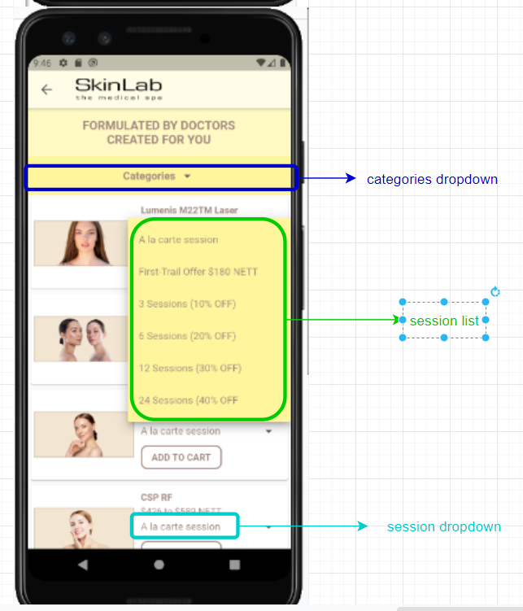

### 4.8.2 categories_dropdown.dart

Dropdown list that displays the categories

import 'package:flutter/material.dart';

class CategoriesDropDown extends StatefulWidget {

  @override

  _CategoriesDropDownState createState() => _CategoriesDropDownState();

}

class _CategoriesDropDownState extends State<CategoriesDropDown> {

  static final List<String> categories = [

    'Categories',

    'Promotions',

    'Back',

    'Body',

    'Combo',

    'Essential',

    'Eye',

    'Hair',

    'Neck',

    'Premium',

    'Signature',

    'Specialty',

  ];

  String value = categories.first;

  @override

  Widget build(BuildContext context) {

    return DropdownButtonHideUnderline(

      child: DropdownButton<String>(

        dropdownColor: Colors.yellow[200],

        value: value, //current selected item

        items: categories

            .map((categories) => DropdownMenuItem<String>(

                  child: Text(

                    categories,

                    style: TextStyle(

                        color: Colors.brown[300],

                        fontWeight: FontWeight.bold,

                        fontSize: 16),

                  ),

                  value: categories,

                ))

            .toList(),

        onChanged: (value) => setState(() {

          this.value = value;

        }),

      ),

    );

  }

}

categories.first will point to the first item in the categories list – which is “Categories”

Using the .map function, we can map the categories list to the dropdown list

### 4.8.3 sessions_dropdown.dart

This is the widget that will grab the data in ‘shop.dart’ and list accordingly the treatment items details.

import 'package:flutter/material.dart';

class SessionsDropDown extends StatefulWidget {

  List<String> sessions;

  String value;

  SessionsDropDown({List<String> sessions}) {

    this.sessions = sessions;

    this.value = sessions.first;

  }

  @override

  _SessionsDropDownState createState() => _SessionsDropDownState();

}

class _SessionsDropDownState extends State<SessionsDropDown> {

  List<String> sessionList = [];

  String value;

  @override

  void initState() {

    sessionList = widget.sessions;

    value = widget.value;

    super.initState();

  }

  Widget build(BuildContext context) {

    return DropdownButtonHideUnderline(

      child: Container(

        height: 30,

        child: DropdownButton<String>(

          dropdownColor: Colors.yellow[200],

          value: value, //current selected item

          items: sessionList

              .map((categories) => DropdownMenuItem<String>(

                    child: Text(

                      categories,

                      style: TextStyle(color: Colors.brown[300], fontSize: 15),

                    ),

                    value: categories,

                  ))

              .toList(),

          onChanged: (value) => setState(() {

            this.value = value;

          }),

        ),

      ),

    );

  }

}

The widget will grab the session value passed to it via the initState function.

Then it will populate the sessionList via using the .map function.

### 4.8.4 shop.dart

This file is the container for the page.

import 'package:assignment/data/treatmentitems.dart';

import 'package:assignment/model/treatmentitem.dart';

import 'package:assignment/shop/categories_dropdown.dart';

import 'package:assignment/shop/sessions_dropdown.dart';

import 'package:flutter/material.dart';

class Shop extends StatefulWidget {

  @override

  _ShopState createState() => _ShopState();

}

class _ShopState extends State<Shop> {

  List<TreatmentItem> allList = [

    ...listSpecialtyTreatment(),

    ...listSignatureTreatment(),

    ...listPremiumTreatment(),

    ...listEssentialTreatment()

  ];

  @override

  Widget build(BuildContext context) {

    return Scaffold(

      appBar: new AppBar(

        iconTheme: IconThemeData(

          color: Colors.grey[700],

        ),

        title: Image.asset('assets/homepage/skinlablogo128.png',

            fit: BoxFit.contain),

        backgroundColor: Colors.yellow[50],

      ),

      body: getWidgets(allList),

    );

  }

}

//get each record in card form

Widget getWidgets(List<TreatmentItem> items) {

  List<Widget> list = [];

  //title bar

  list.add(Container(

    color: Colors.yellow[100],

    padding: EdgeInsets.all(15),

    child: Text(

      'FORMULATED BY DOCTORS\nCREATED FOR YOU',

      textAlign: TextAlign.center,

      style: TextStyle(

        fontWeight: FontWeight.bold,

        fontSize: 18,

        color: Colors.brown[300],

      ),

    ),

  ));

// categories dropdown

  list.add(Container(

      color: Colors.yellow[200],

      alignment: Alignment.center,

      padding: EdgeInsets.fromLTRB(10, 5, 10, 5),

      child: CategoriesDropDown()));

  //List Row per item

  for (var i = 0; i < items.length; i++) {

    list.add(

      Card(

        child: Padding(

          padding: const EdgeInsets.fromLTRB(5, 10, 0, 10),

          child: Row(

            children: [

              SizedBox(

                width: 150,

                child: Image.asset(items[i].imageURL),

              ),

              SizedBox(width: 10),

              // Right side of card

              Container(

                child: Column(

                  crossAxisAlignment: CrossAxisAlignment.start,

                  children: [

                    Text(

                      items[i].titleText,

                      style: TextStyle(

                        color: Colors.brown[300],

                        fontWeight: FontWeight.bold,

                      ),

                    ),

                    SizedBox(height: 5),

                    Text(

                      items[i].priceRange,

                      style: TextStyle(

                        color: Colors.brown[300],

                      ),

                    ),

                    SessionsDropDown(sessions: items[i].sessions),

                    OutlinedButton(

                      onPressed: () => {},

                      style: OutlinedButton.styleFrom(

                        shape: RoundedRectangleBorder(

                          borderRadius: BorderRadius.circular(10),

                        ),

                        side: BorderSide(width: 2, color: Colors.brown[300]),

                      ),

                      child: Text(

                        'ADD TO CART',

                        style: TextStyle(

                          color: Colors.brown[300],

                          fontWeight: FontWeight.bold,

                        ),

                      ),

                    ),

                  ],

                ),

              ),

            ],

          ),

        ),

      ),

    );

  }

  return new ListView(

    children: list,

  );

}

As the data is currently in array form, it will combine all of them to an allList array value for display

The getWidget function is a function to

* Add a title widget and categories dropdown widget by using list.add
* Dynamically add items to the list by for using a for loop to loop through all the items in the array

## 4.9 treatment Folder Code

### 4.9.1 Display

Root page of Treatments – holds all the categories for the treatment

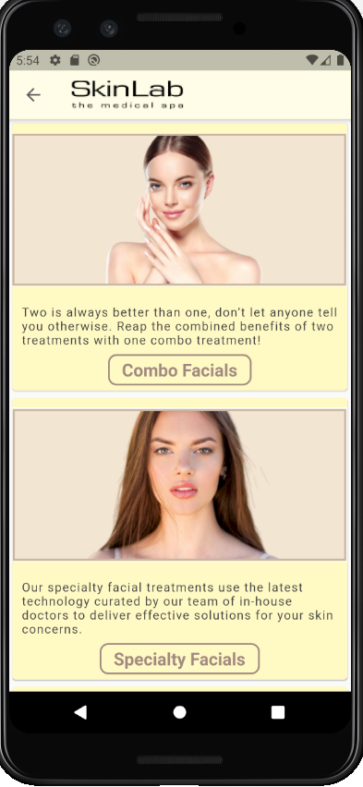

### 4.9.2 treatment.dart

This file holds the code to display the root of treatment page.

import 'package:flutter/material.dart';

import 'package:assignment/model/treatmentcategories.dart';

class Treatment extends StatelessWidget {

  final List<TreatmentCategories> treatList = listTreatmentCat();

  @override

  Widget build(BuildContext context) {

    return Scaffold(

      appBar: new AppBar(

        iconTheme: IconThemeData(

          color: Colors.grey[700],

        ),

        title: Image.asset('assets/homepage/skinlablogo128.png',

            fit: BoxFit.contain),

        backgroundColor: Colors.yellow[50],

      ),

      body: getCardWidgets(treatList, context),

    );

  }

}

Widget getCardWidgets(List<TreatmentCategories> items, BuildContext context) {

  List<Widget> list = [];

  for (var i = 0; i < items.length; i++) {

    list.add(

      Card(

        color: Colors.yellow[100],

        child: Column(

          children: [

            Image.asset(items[i].imageURL, height: 200, width: 400),

            Container(

              padding: EdgeInsets.fromLTRB(10, 10, 10, 2),

              child: Text(

                items[i].bodyText,

                style: TextStyle(

                  color: Colors.grey[800],

                  letterSpacing: 1,

                ),

              ),

            ),

            Container(

              child: OutlinedButton(

                onPressed: () => {

                  Navigator.pushNamed(context, items[i].locationURL),

                },

                style: OutlinedButton.styleFrom(

                  shape: RoundedRectangleBorder(

                    borderRadius: BorderRadius.circular(10),

                  ),

                  side: BorderSide(width: 2, color: Colors.brown[300]),

                ),

                child: Text(

                  items[i].titleText,

                  style: TextStyle(

                    fontSize: 20,

                    color: Colors.brown[300],

                    fontWeight: FontWeight.bold,

                  ),

                ),

              ),

            ),

          ],

        ),

      ),

    );

  }

  return new ListView(

    children: list,

  );

}

#### Data records

// records of the treatments

List<TreatmentCategories> listTreatmentCat() {

  List<TreatmentCategories> myList = [];

  myList.add(TreatmentCategories(

      imageURL: 'assets/treatment/combo.png',

      titleText: 'Combo Facials',

      bodyText:

          'Two is always better than one, don’t let anyone tell you otherwise. Reap the combined benefits of two treatments with one combo treatment!',

      locationURL: '/treatment/combo'));

  myList.add(TreatmentCategories(

      imageURL: 'assets/treatment/specialty.png',

      titleText: 'Specialty Facials',

      bodyText:

          'Our specialty facial treatments use the latest technology curated by our team of in-house doctors to deliver effective solutions for your skin concerns.',

      locationURL: '/treatment/specialty'));

  myList.add(TreatmentCategories(

      imageURL: 'assets/treatment/signature.png',

      titleText: 'Signature Facials',

      bodyText:

          'Developed by our in-house team of doctors, our signature treatments caters to many types of skin concerns — from acne control to skin lifting, leave it to us!',

      locationURL: '/treatment/signature'));

  myList.add(TreatmentCategories(

      imageURL: 'assets/treatment/premium.png',

      titleText: 'Premium Facials',

      bodyText:

          'Spoil yourself (or your skin in this case) for once. Indulge in our premium facials to help you achieve that radiant glow!',

      locationURL: '/treatment/premium'));

  myList.add(TreatmentCategories(

      imageURL: 'assets/treatment/essential.png',

      titleText: 'Essential Facials',

      bodyText:

          'Building good skin requires a strong foundation. Discover the essentials recommended by doctors for your skin. ',

      locationURL: '/treatment/essential'));

  myList.add(TreatmentCategories(

      imageURL: 'assets/treatment/neck.png',

      titleText: 'Neck Treatments',

      bodyText:

          'Up to your neck with double chin, loose skin & wrinkles? Let us help you catch a breather with our neck treatments.',

      locationURL: '/treatment/neck'));

  myList.add(TreatmentCategories(

      imageURL: 'assets/treatment/eye.png',

      titleText: 'Eye Treatments',

      bodyText:

          'Take care of your eyes - they are the stars that shine on your face. Reduce dark circles, droopy & puffy eyes with our eye treatments.',

      locationURL: '/treatment/eye'));

  myList.add(TreatmentCategories(

      imageURL: 'assets/treatment/body.png',

      titleText: 'Body Treatments',

      bodyText:

          'Take care of your eyes - they are the stars that shine on your face. Reduce dark circles, droopy & puffy eyes with our eye treatments.',

      locationURL: '/treatment/body'));

  myList.add(TreatmentCategories(

      imageURL: 'assets/treatment/back.png',

      titleText: 'Back Treatments',

      bodyText:

          'Take care of your eyes - they are the stars that shine on your face. Reduce dark circles, droopy & puffy eyes with our eye treatments.',

      locationURL: '/treatment/back'));

  myList.add(TreatmentCategories(

      imageURL: 'assets/treatment/hair.png',

      titleText: 'Hair Removal',

      bodyText:

          'Hairy issues? Let us help you resolve them with treatments like I2PL Hair Removal.',

      locationURL: '/treatment/hair'));

  return myList;

}

The for loop is to dynamically grab the data records and display item as a card

## 4.10 treatment/pages Folder

This folder holds the page that displays the respective categories for display on the screen

Most of the codes are similar between the pages, as they get the data list from the data folder and store it in the array. After that, the for loop will loop through the data and display the cards accordingly.

## 4.11 treatment/details Folder (Unfinished)

This folder was planned to house the details of each treatment that is shown in the shop. But due to time limitations I am unable to finish it.

## Things to improve

1. Converting all data to be records from database
2. Add in login system
3. Add in cart
4. Treatment details page
5. For Instagram, Facebook and WhatsApp, to link to users’ phone respective program.

## Personnel thoughts

I sincerely thank you for the opportunity to create this mobile app. At first, I was having doubts on whether I can do it. But after trying it, I find that I have learned a lot doing this.

I also will apologize that I am unable to finish the app.

I was learning Xamarin during the time of the interview so I have decided to try using that to code the app. But during the coding phase, I found that it is not that easy to customize a lot of things using Xamarin. So, after realizing that I have decided to look for a new solution.

I did think about using React at first, but as I took quite some time to understand what Angular has to offer so I was afraid that React would be the same.

One of my classmates introduced me to flutter and after looking at some of the tutorials on YouTube, I feel that it should be enough to code the app.