WRRA Game 1.0
Minimal Sufficient State for Complex Games and a Playable Go Engine
Constructive Omok and Go Analysis, Exhaustive Validation, and WRRA Go 0.1
Wonsik Choi
Independent Researcher
janefather@gmail.com
17 September 2026
WRRA Core 1.0 remains frozen
Integrated technical report and reproducibility archive

Abstract
WRRA Game 1.0 connects three levels of evidence under one unchanged execution contract. WRRA Game 0.1 computes a constructive forced-win phenotype in 9×9 freestyle Omok and a simple-ko counterexample in 5×5 Go. WRRA Game 0.2 exhaustively enumerates 6,036,001 reachable states of a 4×4 Connect-K system and 132,161 reachable complete states of 3×3 Go. The certified Renderer reduction has zero minimax-value mismatches over the entire Connect-K reachability graph, while 752 visible-state equivalence classes in Go have legal-action sets that depend on previous-board residue. WRRA Go 0.1 then reuses the verified Go transition system in a playable 9×9 engine, combining an explicit eleven-channel Renderer with Monte Carlo Tree Search and an auditable decision ledger.
The central methodological claim is precise: a game agent should preserve the minimum state required for exact legality and state update, then spend bounded computation on structurally informative legal continuations. Residue does not predict or preserve the future. It carries present constraint information that is absent from the visible board. Search generates and compares successor states permitted by the current rules. The archive includes source code, deterministic rule tests, exhaustive-search ledgers, paired-colour control matches, and a complete SGF self-play record.
Keywords: WRRA; Go; Baduk; Omok; Connect K; MCTS; minimal sufficient state; residue; Renderer; exhaustive search; explainable game AI; complex systems.

Executive result
Stage | Question | Executed evidence | Established meaning
Game 0.1 | Can the structure compute concrete cases? | 70 Omok replies; one ko counterexample | Constructive operation
Game 0.2 | Are value and legality preserved globally? | 6,036,001 Connect-K states; 132,161 Go states | Exhaustive finite validation
Game 1.0 | Can the same structure select actual moves? | Playable 9×9 engine and paired controls | Transition from analysis to action

Domain | Scope | Result | Interpretation
Connect K | 6,036,001 reachable states | 0 minimax mismatches | Certified reduction preserves value
Connect K | Empty-board alpha-beta | 245,560 → 32 nodes | Same exact root value
3×3 Go | 132,161 complete states | 752 residue-dependent classes | Board alone is insufficient
WRRA Go | 16 games vs uniform MCTS | 15–1 | Equal simulation budget
WRRA Go | 16 games vs random | 16–0 | Alternating colours
9×9 self-play | 82 moves | White wins; Black margin -8.5 | two consecutive passes

These match results are an action-selection evaluation, not a claim of professional Go strength. Their importance is that the same explicit legality, residue, transition, Renderer, and ledger structure runs end to end and can be compared with controls under equal computational budgets.

Contents
1. The common WRRA execution contract and exact terminology
2. WRRA Game 0.1: constructive Omok and Go analyses
3. WRRA Game 0.2: exhaustive validation
4. WRRA Go 0.1: a playable action-selection algorithm
5. Execution tests, paired controls, and 9×9 self-play
6. Scientific value, limits, and generalization
7. Reproducibility, file manifest, and release metadata

1. Common execution contract

1.1 A domain profile, not a modification of WRRA Core 1.0
The game work is a domain profile, not a revision of WRRA Core 1.0. The frozen Core fixes the execution order—SOURCE, LAW, STATE and RESIDUE, BOUNDARY, COMMON CARRIER, UPDATE, RENDERER, PHENOTYPE, and LEDGER—while each game's rules and objectives remain in its profile. Omok and Go keep their real differences but face the same diagnostic questions.
Core item | Omok / Connect K | Go | Playable Go engine
SOURCE | Placement on an empty point | Placement or pass | Human or algorithmic action
LAW | Alternation and K-in-a-row | Liberty, capture, suicide, simple ko | Executable rule functions
STATE | Board and side to move | Board, turn, residue, pass count | Adds move index and tree nodes
RESIDUE | No additional history | One previous board | Used directly for ko legality
BOUNDARY | Empty points and winning lines | Boundary of legal placements | Only legal candidates are searched
CARRIER | Finite grid | Finite orthogonal grid | Shared coordinates and occupancy
UPDATE | Place and alternate | Capture, ko test, then alternate | Immutable GoState result
RENDERER | Win threats and forced blocks | Capture, liberty, connection, cut | Prior and rollout ordering
PHENOTYPE | Win, forced loss, open search | Capture, rescue, atari, and others | Human-readable move label
LEDGER | State values and nodes | Legal sets and witness histories | Visits, values, features, record

1.2 State sufficiency
A state representation M is sufficient only if two legal histories compressed to the same M admit the same legal actions and compatible next-state updates. If identical visible boards permit different actions because of history, M omits information required by the current computation. This is the criterion for adding residue; it is not a reason to store the entire past indiscriminately.
Freestyle Omok needs the board and side to move. Go with simple ko additionally needs one previous board to reject immediate repetition. If the selected law uses positional superko, residue must grow to encode the longer repetition constraint. The law, not preference, determines the minimum memory.

1.3 Interpretation, search, and prediction
Term | Meaning in this work | Meaning explicitly excluded
State transition | Compute a next state after a legal action | Observe reality's future in advance
Successor branch | A candidate generated under current rules | An event that must actually occur
Search | Compare candidate states under an objective | Automatic empirical prediction
Residue | Current constraint information needed for legality | Storage of the future itself
Renderer score | Structural features and search priority | An unconditional prophecy of the game result

Accordingly, this report replaces earlier phrases such as ‘preserving future branches.’ The exact statement is: residue preserves the information needed to compute legal actions and exact state updates; Renderer-guided search generates and evaluates rule-permitted successors.

2. WRRA Game 0.1: constructive analysis

2.1 A forced-win outlet in 9×9 freestyle Omok
Game 0.1 evaluates every one of 71 legal candidates in a specified 9×9 position. Only the central move (4, 4) creates four immediate winning outlets for Black's following turn. All 70 legal White replies were then applied; none removed all four outlets. This is a constructive case in which a Renderer exposes a living boundary and a multiple-threat phenotype before deeper search.
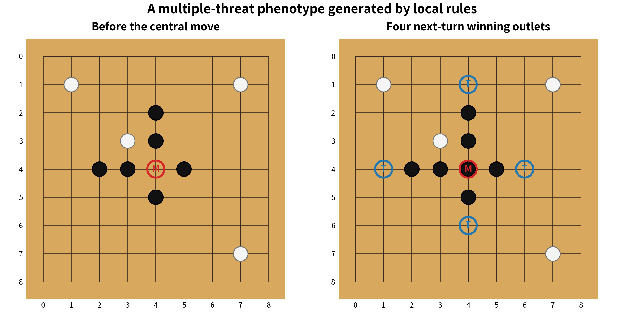
Figure 1. The central Omok move creates four next-turn winning outlets.
Item | Value | Meaning
Legal candidates | 71 | All empty points
Multiple-outlet candidates | 1 | Only the central move
Winning outlets created | 4 | Four endpoints on two lines
Defensive replies tested | 70 | Every legal White response
Replies removing all outlets | 0 | Forced-win certificate
Candidate reduction | 98.59% | Constructive Renderer example

2.2 Simple ko and residue in 5×5 Go
The Go example constructs a direct counterexample to board-only state. A capture removes one White stone. Immediate recapture would reproduce the previous board and is illegal under simple ko. With previous-board residue the position has 18 legal actions; without it the forbidden recapture enters the set, producing 19.
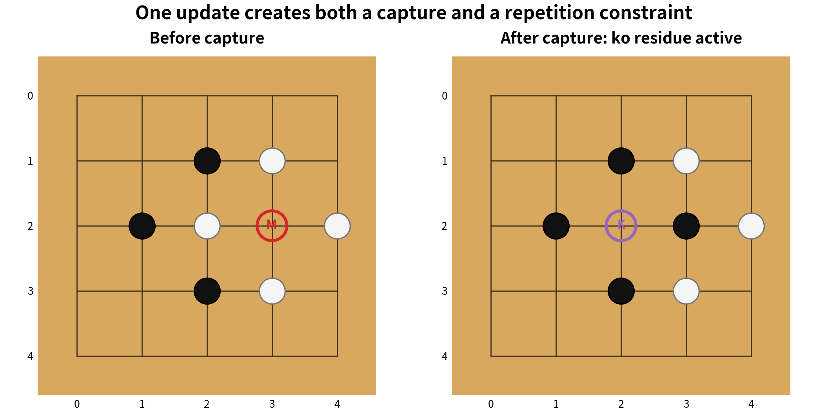
Figure 2. Previous-board residue blocks an immediate ko recapture.
Test | With residue | Without residue | Judgment
Immediate recapture | Illegal | Legal | The latter restores the prior board
Number of legal actions | 18 | 19 | One-action difference

Game 0.1 therefore ties two abstract terms to executable cases. Renderer exposes live threats and boundaries so that candidates can be ranked or safely reduced. Residue attaches a legal constraint that is absent from the current board. Game 0.2 asks whether these observations remain valid over complete reachability graphs.

3. WRRA Game 0.2: exhaustive validation

3.1 The 4×4, three-in-a-row Connect-K system
Instead of claiming exhaustive coverage of standard 15×15 Omok, the experiment uses a fully enumerable system: a 4×4 board where three in a row wins. Starting from the empty board, it closes only states reachable under alternation and early termination. The question is not playing strength on a small board. It is whether a certified Renderer reduction changes the exact minimax value at any reachable state.
Ledger item | Value | Ledger item | Value
Reachable states | 6,036,001 | Directed legal edges | 23,453,344
Terminal wins | 2,572,442 | Terminal draws | 18
Immediate-win states | 3,143,087 | Single mandatory blocks | 65,828
Multiple-threat forced losses | 232,299 | Open-search states | 22,327
All-state value mismatches | 0 | Empty-board value | 1

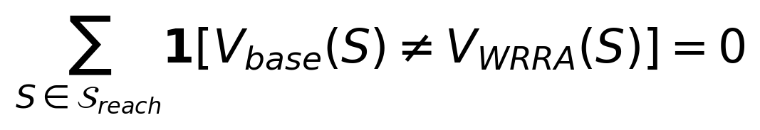
The reduction keeps only an immediate winning move when one exists; keeps the unique block when the opponent has exactly one immediate winning point; and issues a forced-loss certificate when two distinct winning points cannot both be blocked by one move. In every other state it discards nothing and changes only move order. Comparison with baseline minimax over all 6,036,001 reachable states yields zero value mismatches.
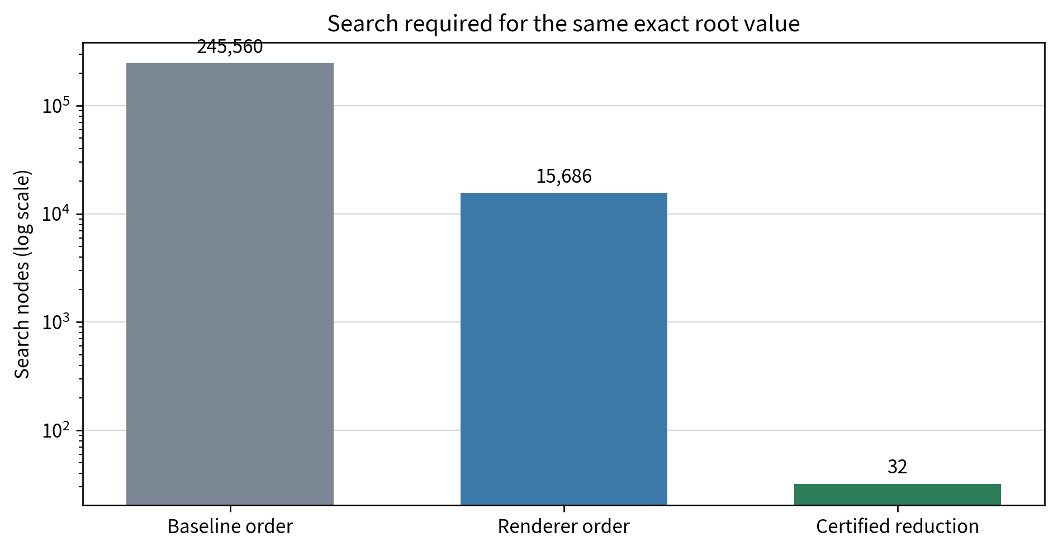
Figure 3. Alpha-beta nodes needed to recover the same exact empty-board value.
Search | Visited nodes | Reduction from baseline | Root value
Baseline row-major | 245,560 | 0% | 1
Renderer ordering | 15,686 | 93.612% | 1
Certified Renderer reduction | 32 | 99.98697% | 1

3.2 The complete reachable graph of 3×3 simple-ko Go
The Go system implements capture, suicide prohibition, simple ko, pass, and termination after two consecutive passes. A complete state contains the current board, side to move, previous-board residue, and consecutive-pass count. States with the same current board, player, and pass count are grouped; the analysis then asks whether changing only the reachable residue changes the set of legal placements.
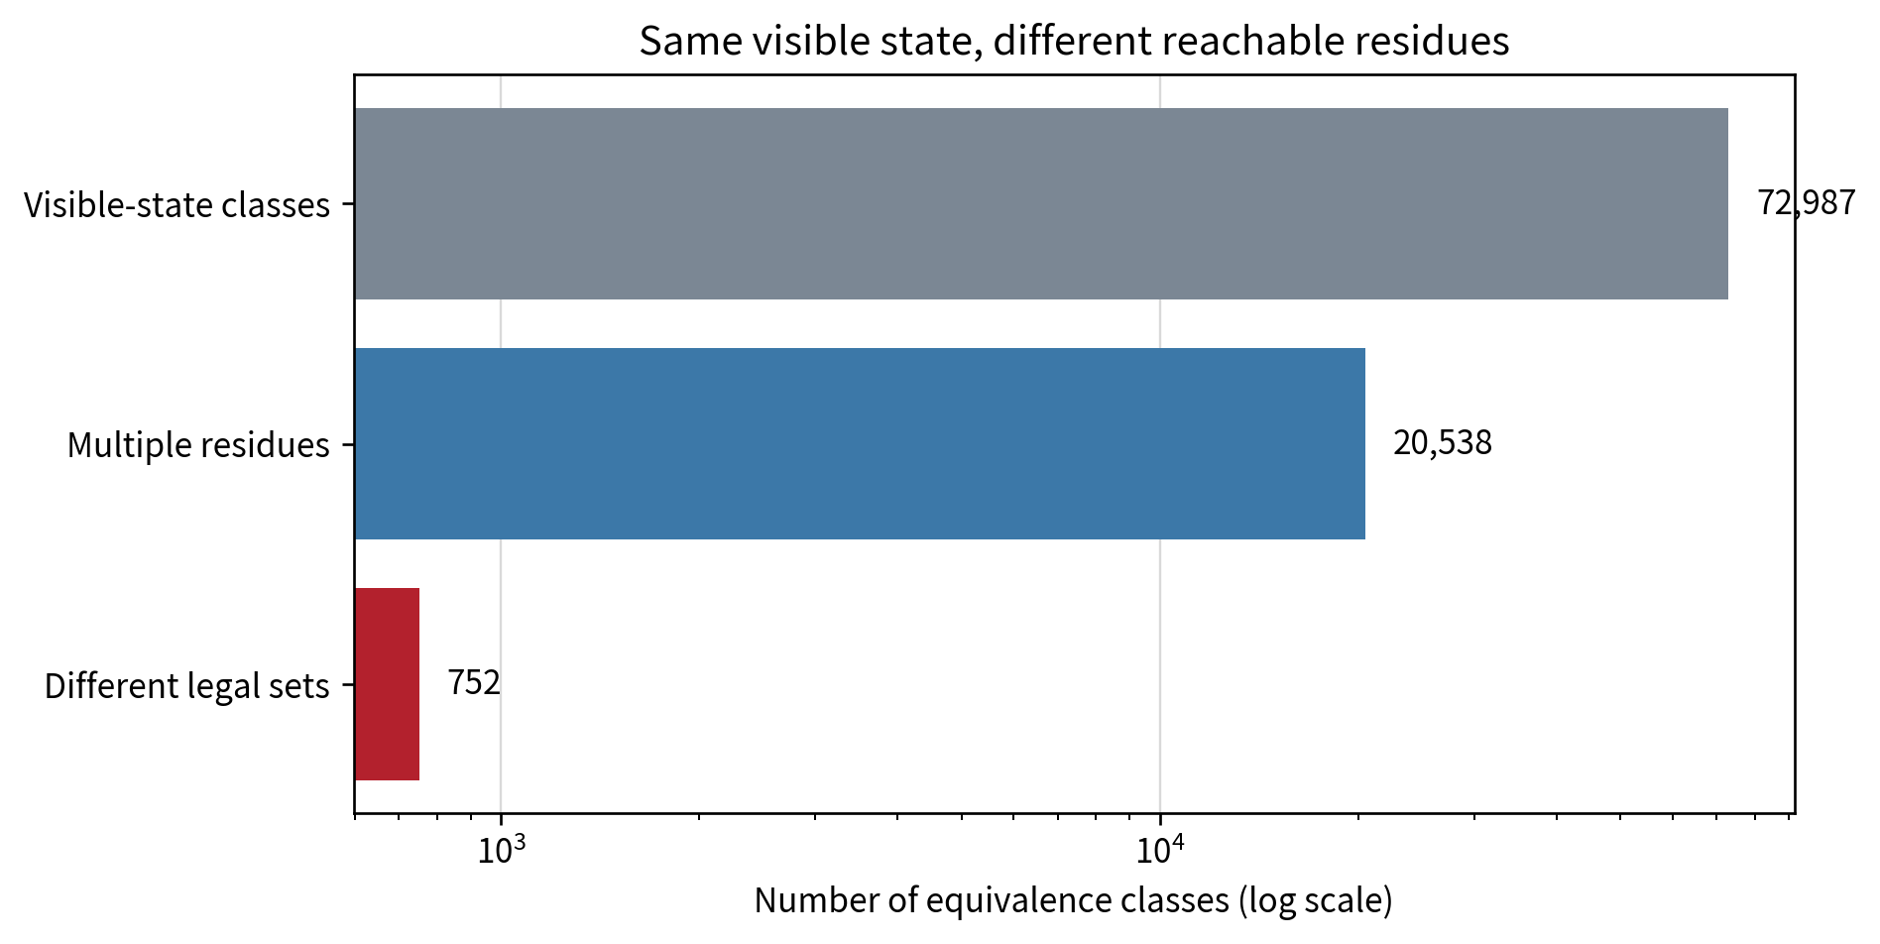
Figure 4. Visible-state classes in which reachable residues and legal sets differ.
Class | Count | Meaning
Complete states | 132,161 | Reachable states including residue
Directed legal edges | 420,710 | Placements and passes
Visible-state classes | 72,987 | Same board, player, and pass count
Classes with multiple residues | 20,538 | Different previous boards
Classes with different legal sets | 752 | Residue alone changes legality
Ko-sensitive complete states | 768 | Exactly one placement is blocked
Maximum distinct legal sets | 3 | For one visible-state class

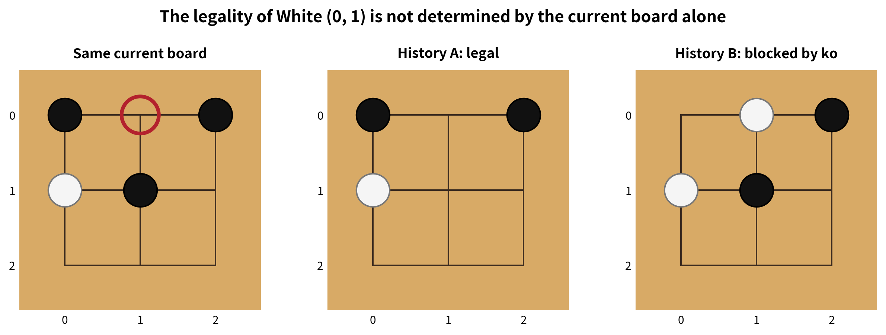
Figure 5. A shortest five-move witness pair: the same current board, different legality at White (0, 1).
This is not a result about predictive accuracy. It is a result about the information that must be present to decide whether an action is legal now. The two shortest witness histories reach the same board with the same player to move after five moves, yet White (0, 1) is legal in one state and forbidden in the other because it would recreate the latter state's previous board.

3.3 Design rules extracted from exhaustive search
Ablation | Observed change | Design judgment
Remove Renderer ordering | 15,686 → 245,560 nodes | Separate correctness from cost
Remove certified reduction | 32 → 245,560 nodes | Proven phenotypes may reduce candidates
Remove previous-board residue | One forbidden action enters 768 complete states | Residue is required for exact legality
Use one board instead of full history | Simple-ko judgment is retained | Store only what the selected law needs

4. WRRA Go 0.1: a playable algorithm

4.1 From exhaustive proof to bounded action
Full enumeration validates the state definition and rule implementation on 3×3 Go, but it cannot close the entire state space of 9×9 or larger boards. WRRA Go 0.1 retains the verified transition system, scores explicit structural properties of every legal candidate, and lets MCTS repeatedly compare candidates under a bounded computation budget. The same program runs controlled 5×5 matches and interactive 9×9 human-versus-engine games.
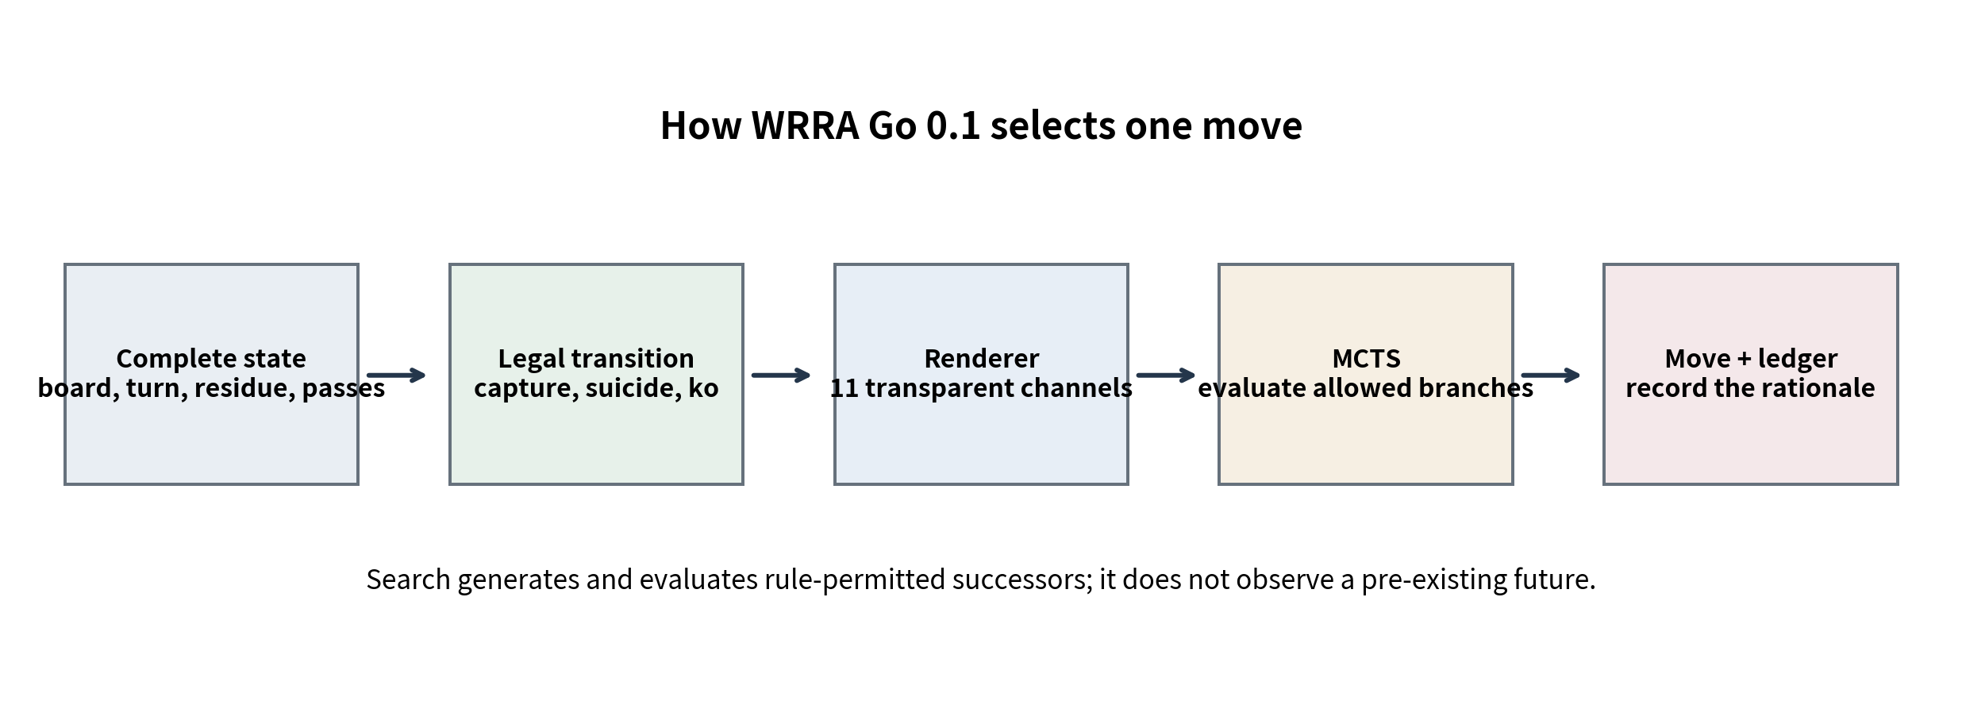
Figure 6. The end-to-end decision path in WRRA Go 0.1.

4.2 Complete state and legal transition
Symbol | Component | Why it is needed
B | Current Black/White occupancy | Groups, liberties, capture, and scoring
p | Side to move | Distinguishes actor and opponent
ρ | Previous-board array | Rejects immediate simple-ko repetition
c | Consecutive-pass count | Terminates after two passes
n | Move number | Ledger and operational search boundary

The placement function first checks vacancy, then removes adjacent opponent groups whose liberties fall to zero. It rejects the action if the newly placed player's group has zero liberties and no capture rescued it. It rejects simple ko when the resulting board equals ρ. A pass leaves the board unchanged while updating residue and the consecutive-pass counter. Two consecutive passes trigger area scoring.

4.3 Eleven transparent Renderer channels
The Renderer uses eleven explicit channels rather than hidden neural-network parameters. The weights are fixed, not learned. The score never decides legality: the rule engine first closes the legal candidate set, after which Renderer scores influence search priors and rollout order. Every candidate's score and phenotype are written to the ledger.
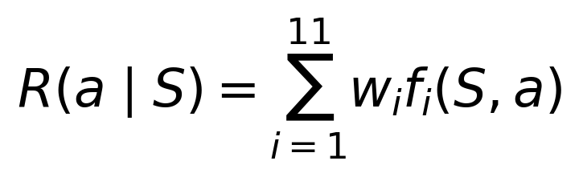
Channel | Computation | Weight
capture | Number of opponent stones captured immediately | +3.20
rescue | Structural rescue of adjacent friendly stones in atari | +2.40
atari | Opponent stones left with one liberty | +1.35
connection | Connection of two or more friendly groups | +0.72
cut pressure | Simultaneous contact with two or more opponent groups | +0.42
liberties | Liberties of the new group, capped at six | +0.20
self atari | One-liberty placement without capture | -3.25
eye fill | Filling a friendly eye candidate without capture | -2.10
area delta | Immediate change in small enclosed regions | +0.32
position | Board-size-dependent opening preference | +0.28
pass readiness | End when the opponent passed and the score is favorable | +1.00

4.4 MCTS integration
MCTS is an established search algorithm. WRRA's contribution is not to rename it, but to provide a sufficient state, exact legal transition, explicit Renderer prior, guided rollout, phenotype labels, and an auditable ledger within one execution contract. Uniform MCTS with the same simulation count is used as a control so that the difference introduced by the Renderer can be measured directly.
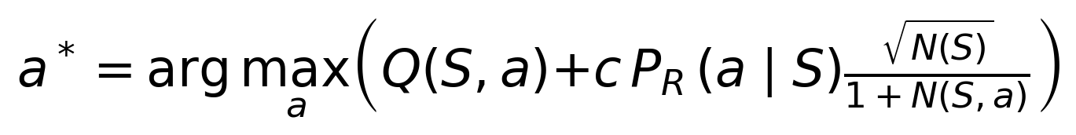
1. Generate all legal placements and pass transitions from the current complete state.
2. Normalize Renderer scores with a softmax to produce candidate priors.
3. Descend the tree using mean value Q plus a prior-weighted exploration term.
4. At a new node, run a bounded rollout biased toward high-ranked Renderer candidates.
5. Backpropagate terminal or bounded area score from the root player's perspective.
6. Select the most-visited action and record visits, value, prior, Renderer score, and phenotype.

4.5 Running the program
Purpose | Command | Output
9×9 human vs engine | python src/wrra_go_0_1.py play --size 9 --human B | Interactive coordinate input
Deterministic rule tests | python src/wrra_go_0_1.py test | Ko, capture, suicide, termination
Paired benchmark | python src/wrra_go_0_1.py benchmark | Machine-readable JSON ledger
9×9 self-play | python src/wrra_go_0_1.py selfplay --size 9 | JSON decision ledger and SGF

Human moves use standard Go coordinates such as D4 and the word pass; column I is skipped. The default 72 simulations are an executable baseline. Larger budgets examine more candidates per move. The rule engine accepts 13×13 and 19×19 boards, while the quantitative tests in this release focus on 5×5 and 9×9.

5. Execution validation

5.1 Deterministic rule tests
Test | Result
Reproduce the same-visible-board witness pair | PASS
Simple ko blocks restoration of the previous board | PASS
Removing residue admits the repetition | PASS
Different residues change legality on the same board | PASS
Two consecutive passes terminate the game | PASS
Capture removes a surrounded group | PASS
Suicide is forbidden | PASS
Area scoring is deterministic | PASS
Renderer does not mislabel an open region as territory | PASS
Coordinate conversion round trip | PASS

The key regression test replays the shortest five-move witness found by Game 0.2 inside the engine's independent immutable state object. Both histories reach the same board with the same player to move, but their previous boards differ. White (0, 1) is legal in one state and rejected by simple ko in the other. This confirms that the state condition discovered by exhaustive analysis survives in the playable code.

5.2 Paired-colour 5×5 benchmark
WRRA MCTS and each control alternated Black and White. Each move used 48 simulations. Uniform MCTS retained the same tree-search mechanism and computation budget but removed Renderer priors and guided rollouts. The random control selected one legal action uniformly.
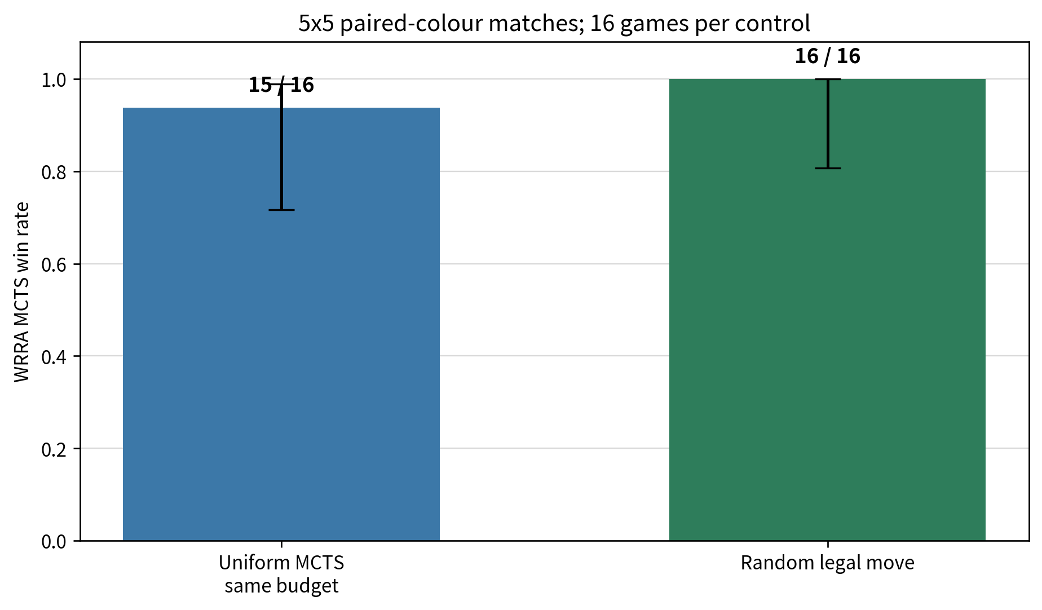
Figure 7. WRRA MCTS against controls under identical rules and alternating colours; error bars are Wilson 95% intervals.
Control | Games | WRRA W–L | Win rate | Wilson 95% interval | Mean moves
Uniform MCTS | 16 | 15–1 | 93.8% | 71.7–98.9% | 34.8
Random | 16 | 16–0 | 100.0% | 80.6–100.0% | 37.9

The justified conclusion is that the fixed Renderer produced an effective action-selection bias in this controlled sample and won more games than equal-budget uniform search. This sample does not establish superiority to professional engines or generalize playing strength to 19×19. Those are separate experiments that can be added without changing the execution contract.

5.3 A complete 9×9 self-play record
Two WRRA MCTS agents, each using 24 simulations per move, played a 9×9 game that ended after 82 moves by two consecutive passes. Black area was 38, White area was 41, and komi was 5.5. The Black-margin score was -8.5; the winner was White.
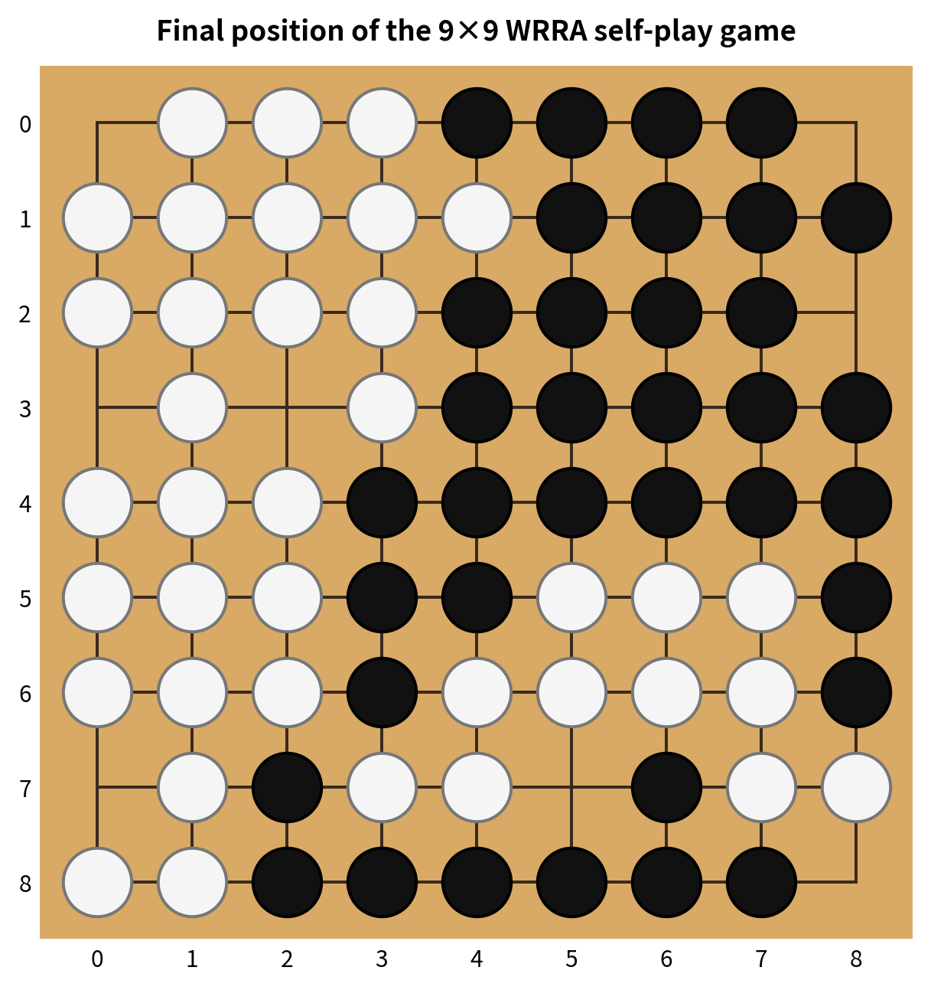
Figure 8. Final position of the 9×9 WRRA self-play game; the complete SGF is included.
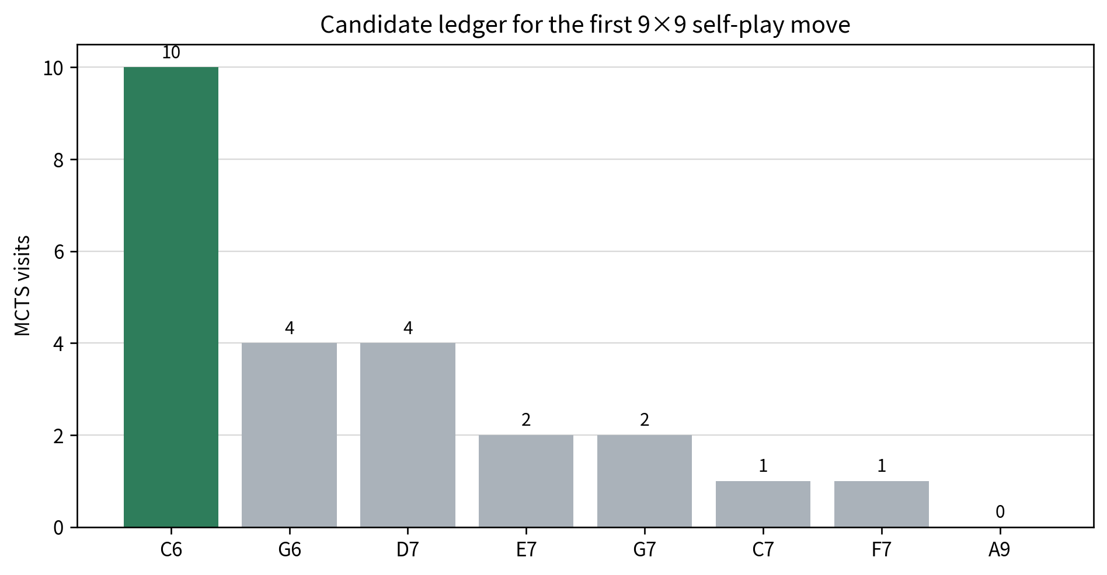
Figure 9. Candidate visits recorded for the first self-play move.
Move | Visits | Mean value | Prior | Renderer score | Phenotype
C6 | 10 | +0.000 | 0.0142 | +1.080 | extension
G6 | 4 | +0.500 | 0.0142 | +1.080 | extension
D7 | 4 | +0.000 | 0.0142 | +1.080 | extension
E7 | 2 | +0.000 | 0.0142 | +1.080 | extension
G7 | 2 | +0.000 | 0.0142 | +1.080 | extension
C7 | 1 | -1.000 | 0.0142 | +1.080 | extension
F7 | 1 | -1.000 | 0.0142 | +1.080 | extension
A9 | 0 | +0.000 | 0.0092 | +0.493 | extension

5.4 Complete move list
Move no. | Black | White
1 | C6 | G6
2 | F7 | D7
3 | D3 | C7
4 | F8 | F3
5 | E7 | D8
6 | G7 | B7
7 | G8 | B6
8 | H7 | F4
9 | H8 | G4
10 | E6 | D6
11 | F6 | G3
12 | E5 | E3
13 | E4 | C5
14 | G5 | B5
15 | G9 | B8
16 | H6 | E2
17 | D4 | H4
18 | F5 | B4
19 | E9 | E8
20 | D5 | H3
21 | C2 | D2
22 | C1 | C8
23 | J6 | J9
24 | H9 | H2
25 | J5 | C9
26 | H5 | D9
27 | D1 | B3
28 | F1 | A7
29 | E1 | C3
30 | G1 | A4
31 | J8 | B2
32 | J4 | B1
33 | A2 | F9
34 | J3 | A1
35 | H1 | A3
36 | E9 | A5
37 | F9 | J2
38 | G2 | C4
39 | A9 | B9
40 | G6 | A8
41 | pass | pass

The SGF stores the same sequence in standard coordinates. The JSON ledger stores each move's leading candidates, visits, mean value, prior, Renderer score, phenotype, and computation time. The selected action and its recorded rationale can therefore be re-examined independently.

6. Scientific and engineering value

6.1 A connected chain of evidence
1. The same Core contract is applied to different games while preserving their different residue requirements. Integration means a shared test method, not erasure of domain differences.
2. The work moves from constructed examples to complete reachability graphs, exact counterexamples, and value-preservation checks. Its explanations are therefore corrigible by computation.
3. State correctness is separated from search efficiency. Removing residue changes legality; removing Renderer guidance can preserve value while increasing cost.
4. When exhaustive search becomes impossible, the verified transition system is retained and coupled to bounded approximate search. Exact small-system proof is connected to larger-board action.
5. Renderer channels, weights, candidate visits, and phenotypes are public. A move can be traced to explicit structural evidence rather than only a final output.
6. The state–law–residue–Renderer–ledger interface is reusable for Omok, Go, Janggi, chess, and other deterministic games without modifying the frozen Core.

6.2 Additional strengths revealed by the experiments
Strength | Evidence in this release | Meaning beyond games
Automatic state-aliasing detection | 752 residue-dependent visible-state classes | Find different permitted actions behind the same observation
Proof-carrying reduction | Zero Connect-K value mismatches | Use local phenotypes as certified computation gates
Correctness/cost separation | Residue and Renderer ablations | Design memory and computation budget independently
Scale transition | 3×3 exact validation to 9×9 MCTS | Connect exhaustive tests to bounded operation
Explainable action | Eleven channels and per-candidate ledger | Reinspect why an action was selected
Core invariance | No Core modification across 0.1, 0.2, and Go 0.1 | Extend domains while preserving the upper contract

The order of validation matters. First establish rule correctness, then state sufficiency, then lossless reduction, and only then evaluate bounded-search performance. The same pattern can connect small exact models with operational systems in power-grid analysis, biological regulation, and agent behavior, where total-state enumeration is unavailable.

6.3 What is established and what remains open
Established in this release | Next extension
Legal actions and transitions under simple ko | Compressed residue for positional superko
5×5 controlled matches and 9×9 execution | Multi-seed 9×9 tournaments and timed 19×19 play
Fixed transparent Renderer channels | Weight ablation and calibrated optimization
Executable integration with MCTS | Rated GTP matches against external engines
Area score, SGF, and JSON ledgers | Dead-stone handling and separate Chinese/Japanese profiles

This table is not a retreat from the achieved result. It fixes the input and output of the next experiments. Version 1.0 is already a standalone program that a person can play; stronger tournament performance is a measurable extension on the same architecture.

7. Reproducibility and release

7.1 File lineage and SHA-256 manifest
File | Role | SHA-256
wrra_game_0_1.py | Constructive Omok and Go analysis | e5bdf92a69b7bd50c7444d099cbb5c0848fd7beb2bead2d78d5337825d36bd6c
wrra_game_0_1_results.json | Game 0.1 result ledger | 4de1c203b65a0b85dd71cc2e2988d28befedbbdc2900e25a713383e86d3c2dc4
wrra_game_0_2.py | Connect-K and 3×3 Go exhaustive analysis | ec010ec0de5f045dcf47956a9cfd223ded06a12a5933a6c51fffacfb4af95e2b
wrra_game_0_2_results.json | Game 0.2 result ledger | bed55e8efda6f8972be0cecc04f929d900fd4292278fdce82262500bc0abbab8
wrra_go_0_1.py | Playable engine and controlled evaluation | 8549c63f35fbf13d6c4d0ae48ed797132bfca8edf69177d84d35cf3d4f6328c9
wrra_go_0_1_benchmark.json | Paired-colour benchmark | 1368144e9df8a02ef391b4ddb8ed9c1a39eb45a46dba579afc5a4a162d20b98a
wrra_go_0_1_rule_tests.json | Deterministic rule regression tests | c1e6c40a6f7803285b9ab0d45f493cc136ff648b62cb9d6b7809a433ea33e376
wrra_go_0_1_selfplay_9x9.json | Complete 9×9 decision ledger | fa340a48ed25887b3bc54cc86f48df9531bfc12e3f76c5a11ace9ab101093195
wrra_go_0_1_selfplay_9x9.sgf | 9×9 self-play SGF | 6d1c86ac405e54f514c9742d93a194fc0049fc10b63b6a30219c1564df297680

7.2 Reproduction sequence
1. Run python src/wrra_go_0_1.py test and confirm that all ten rule tests are true.
2. Run python src/wrra_game_0_2.py and confirm 6,036,001 Connect-K states and zero value mismatches.
3. In the same ledger, confirm 132,161 complete 3×3 Go states and 752 residue-dependent visible-state classes.
4. Run python src/wrra_go_0_1.py benchmark --size 5 --paired-games 8 --simulations 48.
5. Run python src/wrra_go_0_1.py selfplay --size 9 --simulations 24 to create JSON and SGF outputs.
6. Start a human game with python src/wrra_go_0_1.py play --size 9 --human B.
The recorded benchmark runtime is 137.78 seconds and will vary by environment. State counts, legality tests, fixed seeds, and recorded outcomes are reproducible under the same Python behavior and inputs. The archive includes the exhaustive 0.2 ledger so that its results can be inspected without repeating the full enumeration.

7.3 Recommended repository and Zenodo metadata
Field | Value
Title | WRRA Game 1.0: Minimal Sufficient State, Exhaustive Validation, and a Playable Go Engine
Subtitle | From Constructive Omok and Go Analysis to WRRA Go 0.1
Creator | Wonsik Choi
Contact | janefather@gmail.com
Resource type | Software and technical report
Language | English; Korean companion report included
Version | 1.0
Keywords | WRRA, Go, Baduk, Omok, Connect K, MCTS, minimal sufficient state, residue, Renderer, exhaustive search, explainable game AI, complex systems
Related identifier | WRRA Core 1.0 — https://doi.org/10.5281/zenodo.22650956
License | Reports, documentation, and data: CC BY 4.0; source code: MIT

Release description
This release integrates the WRRA Game research program from constructive game analysis to exhaustive finite-state validation and a playable Go engine. Game 0.1 identifies an Omok forced-win phenotype and a simple-ko residue counterexample. Game 0.2 exhaustively enumerates 6,036,001 reachable Connect-K states and 132,161 reachable 3×3 Go states, finding zero minimax-value mismatches for a certified Renderer reduction and 752 visible-state classes whose legal actions depend on previous-board residue. WRRA Go 0.1 reuses the verified transition system in a playable 9×9 engine, combining a transparent eleven-channel Renderer with Monte Carlo Tree Search. The archive includes source code, machine-readable ledgers, deterministic rule tests, paired-control matches, and an SGF self-play record. The work evaluates rule-permitted continuations; it does not describe residue or search as prediction of a pre-existing future.

7.4 Research lineage
WRRA Core 1.0: Frozen Domain-Agnostic Execution Architecture. DOI: 10.5281/zenodo.22650956.
WRRA Game 0.1: Constructive complexity in Omok and Go. 16 September 2026.
WRRA Game 0.2: Exhaustive Connect-K validation and residue sufficiency in Go. 17 September 2026.
WRRA Go 0.1: The playable engine included in this report. 17 September 2026.

Conclusion
This work does not stop at the statement that simple rules can create complex games. In Connect K it tests, over every reachable state, which Renderer phenotypes can act as certified computation reductions without changing value. In Go it identifies, through exhaustive counterexamples, which residue must enter the state for exact legality. It then places the same transition machinery in a playable 9×9 agent that selects moves and records both SGF and candidate-level ledgers.
The central achievement of WRRA Game 1.0 is therefore a single reproducible execution system: preserve rule correctness with a minimal sufficient state, expose computationally relevant structure with a transparent Renderer, and select actual actions through bounded search.

