Record Capacity and Irreversibility in a Finite-State Model
  - Conditions for Residue Accumulation and Overflow in WRRA
Wonsik Choi and Jeongin Choi
Version 0.2 · 10 October 2026

Abstract
A current response record need not retain access to every past distinction to remain operationally adequate. We investigate this idea in a finite WRRA record model, distinguishing response sufficiency from the accumulation of inaccessible history distinctions. Sixteen binary histories require sixteen record states for exact reconstruction but only two for a declared susceptibility. Retaining this response residue does not eliminate the other distinctions: successive transfers to a finite residual tape exhaust its allocated capacity. An explicit three-cell octal tape admits three transfers and blocks the fourth; an initially occupied cell advances the event to the third new transfer. A stall policy preserves information, while overwrite is eight-to-one, showing that saturation constrains but does not select subsequent dynamics. A separate finite thermal example quantifies imperfect reset and the associated entropy–energy ledger. The motivating minimum-computation cosmology treats the universe as adequate rather than uniquely privileged or perfectly restorative. Completed physical infinity is assigned Null as an adopted execution premise, not an empirical theorem. The formal minimum is query-relative; no global minimum of cosmic computational cost or mechanism of cosmic renewal is derived. The contribution is a linked finite account of sufficient response, accumulating residue, and a policy-dependent overflow event.
Keywords: finite records; response sufficiency; logical irreversibility; finite reservoir; information residue; overflow

WRRA and the physical-realization premise
WRRA abbreviates Worldline–Residue–Resource–Action. In the present use, a worldline is an admissible event history, a residue is a retained distinction between histories, a resource is a finite set of available distinguishable states, and an action specifies preparation, response, or transition. These roles are recorded in a common state and resource ledger. A shared carrier does not imply that a coarse snapshot contains every distinction relevant to subsequent response. Here this claim is made precise by a finite preparation pair inherited from the preceding information-weight model [5].
The motivating formulation is: “Infinity has never been realized; its physical realization is Null.” We adopt this as a philosophical restriction on admitted physical execution, not as an empirically established statement about every region or epoch of the universe. Null means that an object requiring completed infinite physical resources is not assigned an executable state in this model. It is neither numerical zero nor a proof that mathematical infinity is inconsistent. The record, controller, and auxiliary spaces below are finite. The continuous probe x, its source J, and exact derivatives are effective mathematical idealizations, not infinitely resolved physical devices. Real-valued probabilities and logarithms describe ensembles; they are not granted infinite-precision physical storage. Operational comparisons require a declared finite response resolution. The restriction motivates the accounting convention, while the propositions follow from the stated finite assumptions independently of assent to the philosophy.
The accompanying interpretive proposal, minimum-computation cosmology, regards the universe as an adequate state rather than a specially privileged or flawless realization. “Adequate” here means sufficient for declared responses within available resources; it does not require a perfect record or a return to an immaculate initial condition. The formal minimum established below is the smallest record alphabet for a specified query and tolerance. It is not a theorem minimizing the universe’s total number of operations, energy expenditure, or description length. Loss of local access, persistent residue, and eventual overflow are compatible with this interpretation. Whether they describe cosmic evolution remains an open physical hypothesis.

1. The question and the contribution
Logical erasure, reversible computation, and the thermodynamic cost of information processing have established treatments [1,2]. The relevance of retained information for subsequent behavior also has an established thermodynamic role [3]. Finite reservoirs require explicit accounting rather than an implicit inexhaustible sink [4]. Our question is narrower: when a WRRA snapshot is insufficient to determine response, what finite residue restores sufficiency, where do the remaining history distinctions accumulate, and what happens when their assigned capacity is exhausted?
We distinguish three tasks: reconstruct the entire admissible history; answer a declared family of physical queries; and restore designated memory coordinates. Their resource requirements need not coincide. We combine elementary counting arguments with a response witness and a finite reset implementation. The response witness is reproduced from [5]; parity control and its reset ledger are introduced here. Neither the counting principles nor the finite-reservoir entropy equality are claimed as new general results. The conceptual error addressed is that operational sufficiency for response might be mistaken for reversible dispensability of all remaining history distinctions. Our construction follows those distinctions into a finite tape until a transfer overflows. It also separates a capacity obstruction from the transition policy chosen at that obstruction. The online response quotient belongs to the finite-automaton and future-distinguishability lineage [6]; reversible completion belongs to [2], and thermal accounting to [4]. The proposed contribution is their linked application to the WRRA witness and accumulation protocol, not a replacement of those results.

2. Finite records and query-relative residue
Let H be a finite set of admissible histories and let C be a physical record alphabet with M distinguishable states. An exact record is an injective map e: H → C. Consequently M ≥ |H|. For all binary strings of one fixed length L, |H| = 2^L. A memory with M states cannot reconstruct every such history if 2^L > M. This is an ensemble distinguishability bound. It does not say that every individual trajectory generates new information at every event. A deterministic periodic trajectory can remain describable by a small state. Any stored length, clock, or pointer must be charged separately; L is a declared finite experimental horizon here.
Let F be a declared family of real-valued queries q on H. Define h ~ h′ exactly when q(h) = q(h′) for every q in F. Write K for the number of equivalence classes. A record is query-sufficient when each query can be decoded from that record.
Proposition 1 (finite response capacity). An encoding is query-sufficient if and only if each of its fibres lies inside one response class. The smallest possible alphabet has K states.
Proof. If two histories share a code but differ on a query, a decoder given only that code cannot return both values. Conversely, constancy of every query on every code fibre defines a decoder. Distinct response classes therefore require distinct codes, and the class label attains the bound. This is the standard finite partition argument, applied to declared physical responses.
Online updating requires an additional condition. For the same admissible appended symbol a, h ~ h′ must imply ha ~ h′a. When this right-congruence condition holds, U([h],a) = [ha] is well defined. Query sufficiency at one horizon alone does not establish this condition. It follows if the query family distinguishes all allowed future continuations and those continuations have compatible admissibility. The parity construction below verifies the condition directly. Formally use Hₗ at each finite length l and compatible updates Hₗ → Hₗ₊₁; no physically completed set of infinite histories is required.
Residue is thus task-relative. Expanding the allowed queries can increase K. If scalar responses take two values R₊ and R₋, a one-state record has optimal worst-case absolute error |R₊ − R₋|/2, achieved by the midpoint. For tolerance ε ≥ |R₊ − R₋|/2 one state suffices; for smaller ε, two are necessary. Exact sufficiency and finite experimental resolution should not be conflated.

3. Reset and the location of lost distinctions
Fix a retained label r: H → Cᵣ. Suppose an auxiliary system E begins in one specified blank state. An exact reversible completion of reset must map each h to a distinct pair (r(h),j(h)). Therefore
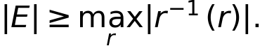 | (1)
Proposition 2 (blank auxiliary capacity). Bound (1) is necessary and attainable as a finite logical construction.
Proof. All histories in a fibre have the same retained label, so injectivity requires different auxiliary outputs for each of them. For sufficiency, number the elements in each fibre and let j be that number. The resulting map is injective on inputs with the blank auxiliary. Embed retained labels in the original record alphabet. A finite injection between equally sized selected input and output subsets extends to a permutation of the complete record–auxiliary state space by bijectively pairing their complements.
This result counts distinguishable states, not mean entropy. Unequal fibre sizes require the largest fibre, not merely an average. For a history distribution, the discarded uncertainty is H(H|r), in nats; a large possible fibre can coexist with small average uncertainty. Logical completion alone specifies no Hamiltonian, work cost, rate, or reusable thermodynamic cycle [2]. In particular, an initially pure blank auxiliary is a resource.
Proposition 3 (full-support obstruction). If the joint distribution of an M-state record and a d-state auxiliary initially has full support (as does a product of full-support marginals), a permutation cannot reset the record exactly into a fixed subset of K < M states while leaving the auxiliary dimension d and all other resources unchanged.
Proof. The input has Md occupied states. A permutation preserves this support cardinality, whereas the proposed output can occupy at most Kd states. The inequality Md > Kd is a contradiction. The same argument uses rank for a full-rank product state and a unitary in finite quantum dimensions. Full-support marginals alone are insufficient: a perfectly correlated uniform pair g = e can be transformed by (g,e) ↦ (g − e mod d,e), leaving g exactly blank. Its joint support has only d states. Initial correlations that reduce joint support, correlations with an uncounted system, postselection, extra output registers, or a non-full-support auxiliary change the assumptions and are not counterexamples.

4. A response witness with a two-state residue
We reproduce a six-microstate preparation pair from [5]. Addresses are n = (4,6,8), carriers are k = 0,1, and all quantities in this witness use dimensionless model units. Set N = 1,015,000 and α = 1.8996877935161325. Define
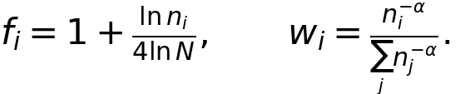 | (2)
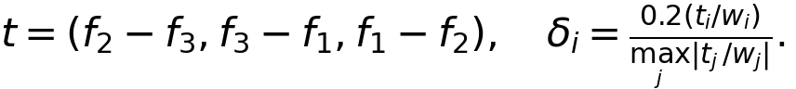 | (3)
(4)
The components are positive and normalized. The preparations differ as full probability distributions; their shared coarse variables do not imply the same complete physical state or a failure of determinism. The two preparations share the address marginal, carrier marginal, weighted carrier snapshot Σᵢ fᵢpᵢₖ, and mean load μ = Σᵢₖ pᵢₖbᵢₖ. The identities Σᵢtᵢ = Σᵢfᵢtᵢ = 0 give these equalities directly. Their load variances differ because the second-moment weighting uses fᵢ². More explicitly, let c = 0.2/maxⱼ|tⱼ/wⱼ|. Then Var₊(b) − Var₋(b) = −8c Σᵢtᵢfᵢ² = −8c(f₁ − f₂)(f₁ − f₃)(f₂ − f₃), which is nonzero because all three fᵢ are distinct. The difference therefore does not rely on floating-point evidence alone.
To make the response definition self-contained, use a scalar probe x and dimensionless potential
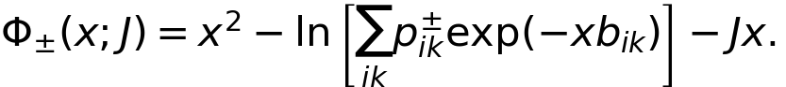 | (5)
At J = μ, x = 0 is stationary for both preparations. The local stiffness is 2 − Var±(b), positive in this example, and the differential susceptibility is R± = (∂x/∂J) at x = 0 = [2 − Var±(b)]⁻¹. These are local responses; no global equilibrium or gravitational measurement is inferred. The light-speed calibration of the preceding WRRA series is unchanged and plays no fitted role here.
Introduce a four-event binary history h = (h₁,h₂,h₃,h₄) with all sixteen histories admissible. The preparation rule is stipulated: parity r = h₁ ⊕ h₂ ⊕ h₃ ⊕ h₄ selects p⁺ for r = 0 and p⁻ for r = 1. This controller is a new modeling assumption, not a derived cosmological transition. For the declared susceptibility query and its binary continuations, parity is sufficient and updates as r′ = r ⊕ a. Since the responses differ, two record states are also necessary. The same conclusion holds for the family of local probe functions determined by the selected preparation.
Choose g = (h₁,h₂,h₃). The mapping h ↦ (r,g) is bijective, with h₄ = r ⊕ h₁ ⊕ h₂ ⊕ h₃. Thus a sixteen-state full record factors into a two-state residue and eight-state discarded coordinate. A uniform history distribution makes r and g independent and uniform; discarding g removes 3 ln 2 nats from the accessible record in the exact blank-auxiliary implementation. The costs of preparing p±, supplying the incoming symbols, and maintaining a controller are not included in the reset heat calculated in Section 6.

5. Accumulation and a finite overflow event
Perfect restoration is not the objective of the proposed interpretation. The central issue is whether distinctions no longer accessible in the current record leave a residual load that persists and eventually exhausts a finite resource. “Loss” must specify an access boundary: local loss of access can coexist with accumulation elsewhere. Fundamental destruction of a distinction, by itself, does not imply that a reservoir is filling. We model the first mechanism explicitly and leave other damage or defect accumulation mechanisms for additional dynamics.
During a phase, keep the response label r fixed. At stage j, an incoming coordinate gⱼ has eight admissible values and defines a four-bit local history with that parity by the inverse construction in Section 4. The local response is unchanged for every such input. Transferring gⱼ away makes this coordinate unavailable to the local response record but leaves it in a residual tape T. Use m = 3 tape cells, each with eight states; hence C = 8³ = 512 tape states. Unoccupied cells have a specified reference value. An occupancy pointer q has four states 0,…,3, an overflow flag has two states, and an incoming register G has eight states. Including r, the controlled registers have at most 2 × 512 × 4 × 2 × 8 = 65,536 states. The pointer and flag are not free unbounded counters.
For q < 3, the specified transfer writes G into cell q, leaves the incoming register in its reference state, and increments q. On the admissible inputs with that cell unoccupied this map is injective and can be reversibly extended as in Proposition 2. At fixed stage n, if the tape started with q₀ occupied cells and every old and new digit is independently admissible, preserving all distinctions requires 8^(q₀+n) tape states. The injective transfer fits when q₀+n ≤ 3. For independent uniform digits, the tape entropy is (q₀+n) ln 8 up to saturation. Without that distributional assumption, the state count remains valid but the entropy need not equal its logarithm.
Proposition 4 (conditional accumulation threshold). For integers b ≥ 2, m ≥ 0, and 0 ≤ q₀ ≤ m, with an m-cell b-ary tape, q₀ initially occupied cells, all digit sequences admissible, and no release or compression of their distinctions, the first transfer that cannot both preserve the distinctions and clear G occurs at n* = m − q₀ + 1. This threshold concerns the specified tape and fixed controller outputs, not the total unconstrained storage potential of all registers.
Proof. At any fixed successful horizon n ≤ m − q₀, cellwise storage realizes all b^(q₀+n) sequences in b^m tape states. At the next transfer, the occupied tape and incoming register have b^(m+1) possible inputs. Retaining their distinctions while returning G to one reference state, keeping r unchanged, and fixing the pointer and flag to their prescribed output values would leave only b^m possible outputs. No injection exists. Additional encoding in controller values would change the specified task and its resource allocation.
The fourth digit can still be received in G. Overflow means that its transfer cannot be completed under these requirements. Our primary transition rule is STALL: set the overflow flag, hold q = 3, retain the full tape and the untransferred digit in G, and accept no further inputs in this finite experiment. This produces a discrete operational state change without destroying the incoming information. No change of the WRRA susceptibility is implied: r is deliberately unchanged. A transition to another susceptibility would require a specified coupling between the accumulated load and the preparation rule, which this construction does not yet supply.
For the finite stream (1,6,3,5) with q₀ = 0, the tape fills as (1), (1,6), (1,6,3); the fourth transfer stalls and G retains 5. An already occupied cell, illustrated by initial digit 7, gives q₀ = 1 and overflow on the third new transfer. Thus complete global initialization is unnecessary for the accumulation mechanism; an existing residue advances the threshold. The concrete digit 7 is one illustrative realization of an admissible initial digit, not a claim of one-cell Shannon entropy for a known deterministic value. The experiment supplies at most four external input digits. Their source and preparation are outside this controlled model; no infinite stream or supply of fresh tape is assumed.
An alternative OVERWRITE rule at saturation would map (a,b,c;g) to (b,c,g) and clear G. This effective map is eight-to-one: the oldest digit is no longer recoverable from the listed outputs. It can retain the same local response while continuing operation, but a reversible physical completion requires at least eight further distinguishable output states per such step. The model does not silently provide those states. STALL and OVERWRITE share the same saturation condition yet give different futures. Capacity supplies the obstruction; the transition policy supplies the dynamics.
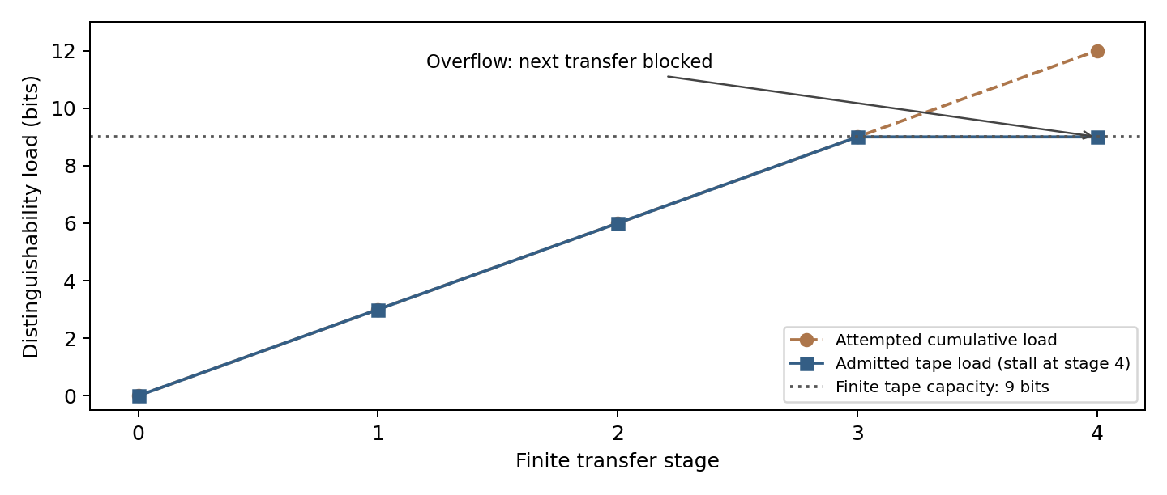
Figure 1. Residual distinguishability load for a three-cell octal tape. Each admitted independent digit contributes three bits, and nine bits exhaust the tape. At stage four the attempted transfer exceeds the allocation, so the STALL policy preserves the incoming digit outside the tape. These are bookkeeping stages, not derived cosmological times.
This ideal tape construction and the thermal auxiliary considered next are distinct resource regimes. The former has specified unoccupied cells, though not necessarily an entirely empty tape; a full-support thermal tape cannot support the same exact transfer-and-clear operation even at the first stage. Noisy or partial transfers can instead accumulate operational deficits, but their threshold requires an explicit error metric and dynamics. The sharp threshold proved here must not be transplanted into that regime without those assumptions.

6. A finite thermal comparison and its limits
Let the record S = (r,g) have degenerate energies and let an eight-state auxiliary E have energies Eⱼ = jΔ for j = 0,…,7. Initially r and g are independent uniform variables, and E is independent with Gibbs probabilities τⱼ = exp(−βEⱼ)/Z, β = 1/(kBT). Execute the permutation (r,g,e) ↦ (r,e,g) on 2 × 8 × 8 = 128 states. This swap is its own inverse and retains r exactly.
If E were initially blank, g would become blank and the previous g would be recoverable from E. At finite temperature and finite Δ, however, τ has full support. The output g has distribution τ, not a blank state; the auxiliary becomes uniform. The procedure is an entropy-reducing partial reset. It is not exact erasure and does not evade Proposition 3.
Write S(p) = −Σ p ln p, D(p||q) = Σ p ln(p/q), and u for the uniform distribution on eight states. The record entropy decrease is ΔSₛ = ln 8 − S(τ), and the energy received by the auxiliary is Q = Σⱼ Eⱼ(uⱼ − τⱼ). Direct substitution gives
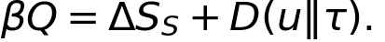 | (6)
This is a special case of the established finite-reservoir Landauer equality [4]. More generally, an initially independent system and Gibbs auxiliary undergoing a joint unitary satisfy βQ = ΔSₛ + I(S′:E′) + D(ρE′||τ). Joint entropy preservation gives ΔSₑ = ΔSₛ + I, while the Gibbs identity gives βQ = ΔSₑ + D. The swap output is a product distribution, so I = 0. The correction in (6) is the final reservoir’s departure from its initial thermal state, not an extra universal numerical constant.
For βΔ = 1, the output blank-state probability is 0.632332682812. The dimensionless ledger is βQ = 2.920707894737, ΔSₛ = 1.041809809938, and D(u||τ) = 1.878898084799. A thermal auxiliary’s finite capacity and full support both remain visible. As the record energies are degenerate, an external actuator supplies mean work W = Q for this swap with negligible endpoint interaction energy. No isolated energy-conserving swap is assumed. Returning the auxiliary to its initial Gibbs state and resetting the actuator would require an additional account; this protocol does not constitute a closed reusable cycle.
Proposition 5 (optimal partial reset in the stated permutation class). Suppose that, conditional on every r, g is uniform on d states and independent E is distributed as τ, with τ₀ = maxⱼ τⱼ. The swap maximizes blank-state probability and minimizes final g entropy among all permutations that leave r fixed, use only g and E, and keep both dimensions d.
Proof. Condition on either r. The d² initial joint probabilities are τⱼ/d, each repeated d times. Any k selected output values of g have kd joint output states, so their total probability cannot exceed the sum of the kd largest input probabilities, equal to the sum of the k largest entries of τ. Thus the output marginal p of g is majorized by τ. Shannon entropy is Schur-concave, giving S(p) ≥ S(τ), and the k = 1 bound gives P(g = 0) ≤ maxⱼ τⱼ. Swap attains both bounds. If the permutation depends on r, the same bounds hold conditionally for each r and also for the unconditional marginal. This is a direct application of standard majorization, not a new general entropy principle.
For d = 8 and βΔ = 1, the blank probability 0.632332682812 and the entropy decrease 1.041809809938 nats are therefore optimal in this class, not merely properties of an arbitrary swap. Enlarging the auxiliary, changing its initial state, using postselection, or adding resources can alter these bounds. Work optimality is not established by this argument.

7. Reproducible outputs and conditions for rejection
The evaluation order is verified inputs, WRRA transformation, outputs, and falsification conditions. “Verified” here means mathematical and computational consistency of declared inputs, not measurement of cosmological quantities.
Inputs. Equations (2)–(5), the sixteen admissible histories, uniform history distribution, parity preparation policy, degenerate record energies, and eight thermal levels are explicit. The code verifies positivity, normalization, shared snapshots, local stability, and finite permutation invertibility. The accumulation experiment additionally fixes a three-cell tape, a finite input stream, and STALL or OVERWRITE policies. No data are fitted in this paper.
WRRA transformation. The history is mapped to its response-relevant residue r; g carries the remaining distinctions. The retained label selects one of two finite preparations. Reset is completed by transferring g through a finite auxiliary, and its energy and entropy changes enter the resource ledger. Accumulation then tests how repeated local loss of access consumes the assigned tape resource, with the response label held fixed. This is a structural explanation of which distinctions matter for this response and which still consume storage, not a claim of independent numerical prediction.
Outputs. The reproduced mean is 0.823167093659. The two variances are 1.016451706290 and 1.016435565120; susceptibilities are 1.016726892208 and 1.016710206812. Their gap is 1.66853951 × 10⁻⁵. A one-state representation has minimum worst-case error 8.34269754 × 10⁻⁶. Exact history, response residue, and blank auxiliary require 16, 2, and 8 states respectively. Figure 2 compares these resource roles and displays the thermal ledger.
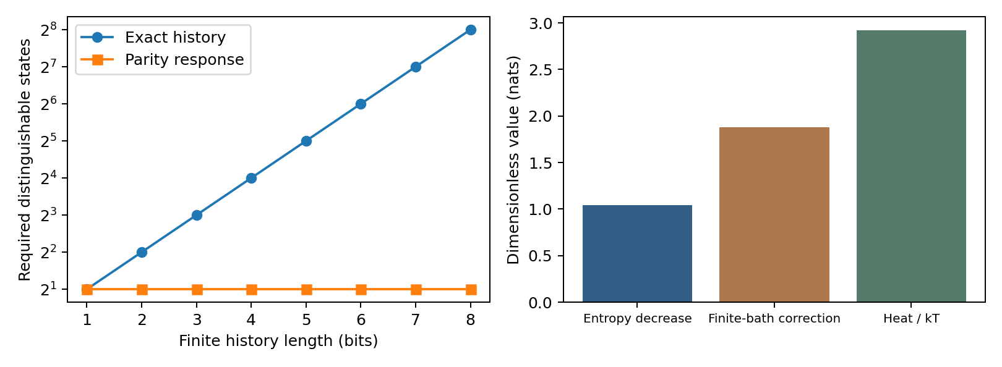
Figure 2. Left: exact binary-history capacity and parity-response capacity for finite horizons L = 1,…,8 under the stipulated preparation policy. Right: entropy decrease, final-reservoir relative entropy, and their sum βQ for the eight-state swap. The left panel does not assert a physical infinite-time limit.
Falsification and failure conditions. A decoder claiming exact one-state sufficiency must return both unequal susceptibilities, which is impossible under the declared query. An implementation with fewer than eight initially blank auxiliary states must exhibit an injective completion on all sixteen histories to overturn the counting application. The thermal calculation fails if direct enumeration violates (6) with its stated product input and swap. These are tests of formal and computational consistency, rather than empirical confirmation of WRRA as a description of nature. The overflow claim fails if a protocol preserves every digit while completing the next transfer into the fixed 512-state tape, returning G to its reference state, and preserving the specified controller outputs. Reusing those outputs as data, allowing correlations that restrict admissible digits, or releasing distinctions changes the assumptions. The digit-enumeration test verifies that OVERWRITE has exactly eight preimages per output. A residue-preserving permutation on the specified registers with blank probability above max τ or entropy below S(τ) would contradict the majorization bound. An experimental test would require actual preparations satisfying the shared-snapshot conditions, access to the probe in (5), and combined response uncertainty substantially below the reported gap. Additional queries distinguishing histories with identical parity would refute parity sufficiency for the expanded task. A non-parity preparation policy or nonuniform history ensemble changes the example; it does not refute its conditional statements.

8. Discussion and conclusion
The model separates the history that occurred, the residue needed for a declared future response, and the distinctions moved elsewhere by reset. The explicit STALL event illustrates how local loss of access can leave a growing residue even while the visible response remains adequate. Record saturation by itself specifies no particular event policy. A system may reject inputs, overwrite records, use additional resources, or retain only a sufficient residue. A rule for choosing among these policies is additional dynamics. Similarly, finite state spaces do not by themselves provide a cosmic initial condition, a mechanism of cosmic recurrence, or an arrow of time.
The event index used here orders operations in a controlled experiment. It is not a derivation of physical time from a timeless substrate. Information becomes inaccessible to the reduced record while the full permutation remains reversible; this operational irreversibility is not fundamental destruction of information in a closed finite universe. The separate probe preparation and thermal-reset accounts have not been embedded in an autonomous cosmological model.
The Null premise makes finite resources constitutive of admitted execution, but supplies no additional equality beyond the stated model assumptions. The technical result is an explicit WRRA example in which preserving response requires one bit, exact history requires four bits, and exact reset of the other three bits requires a finite blank resource. A finite thermal substitute only partially resets those bits and records the cost through (6). The accumulation construction then gives a finite, policy-dependent overflow threshold that can be advanced by pre-existing residue. This is a minimal worked expression of adequacy without perfect restoration. A mechanism coupling that threshold to a new physical preparation, or to cosmic renewal, remains to be supplied.

Data and code availability
The accompanying archive contains the bilingual manuscripts, reproduction script, numerical outputs, and both figures. Running python reproduce.py with NumPy and Matplotlib regenerates the reported outputs without network access. The preceding response witness is available in [5].

References
[1] Landauer, R. Irreversibility and Heat Generation in the Computing Process. IBM Journal of Research and Development 5, 183–191 (1961). https://doi.org/10.1147/rd.53.0183
[2] Bennett, C. H. Logical Reversibility of Computation. IBM Journal of Research and Development 17, 525–532 (1973). https://doi.org/10.1147/rd.176.0525
[3] Still, S., Sivak, D. A., Bell, A. J., and Crooks, G. E. Thermodynamics of Prediction. Physical Review Letters 109, 120604 (2012). https://doi.org/10.1103/PhysRevLett.109.120604
[4] Reeb, D., and Wolf, M. M. An improved Landauer principle with finite-size corrections. New Journal of Physics 16, 103011 (2014). https://doi.org/10.1088/1367-2630/16/10/103011
[5] Choi, W., and Choi, J. Information Weight and Effective Gravitational Coupling in a Finite WRRA Model: Response sufficiency and stability under finite address restrictions. Version 0.3, Zenodo preprint (2026). https://doi.org/10.5281/zenodo.23270998
[6] Nerode, A. Linear automaton transformations. Proceedings of the American Mathematical Society 9, 541–544 (1958). https://doi.org/10.1090/S0002-9939-1958-0135681-9

