WRRA-M Foundational Architecture and First Structural Calculation
Seven Predimensional Degrees, the Dimension Filter, and Fifteen Chiral Channels
Author | Wonsik Choi
ORCID | 0009-0001-4263-9772
Email | janefather@gmail.com
Version | WRRA-M 0.1
Date | 30 September 2026
Status | Separate from WRRA Core 1.0
Research decision
WRRA-M is opened as a separate research branch. It does not alter WRRA Core 1.0. Its first task is to test whether the seven internal dimensions used in four dimensional M theory compactification can be reinterpreted as seven predimensional degrees that are rendered through the WRRA dimension filter.

Abstract
This research note defines WRRA-M as a testable branch of the Wonsik Reality Renderer Architecture. The branch treats the seven internal dimensions of eleven dimensional M theory as a mathematical image of seven predimensional degrees rather than as seven small spatial directions. A dimension filter renders those degrees into a three dimensional spatial phenotype, a residue ordered time direction, and particle channels. Gravity is placed at the interface because it reads the total upstream kinetic and stress structure, while gauge interactions act on labels that already passed the filter. The note also records the first nontrivial structural calculation. Two copies of the seven dimensional fundamental representation of G2 together with one invariant channel give fifteen channels. Under the color subgroup SU(3), their branching multiplicities exactly match the color content of one Standard Model generation. This is an exact color sector match, not yet a derivation of weak isospin, hypercharge, chirality, masses, or three generations.

Main result
The first WRRA-M calculation produces an exact representation count in the color sector. The candidate channel space is one invariant channel plus two seven dimensional sectors. Each seven branches under SU(3) into a triplet, an antitriplet, and a singlet. The total therefore contains two triplets, two antitriplets, and three singlets. One Standard Model generation without a right handed neutrino has precisely the same color representation multiplicities.



This result raises the WRRA-M branch above a numerical coincidence between seven and fifteen. It supplies a concrete group theoretic bridge. The bridge remains incomplete until the filter also derives the SU(2) pairing and the U(1) hypercharges.

Scope and fixed evaluation rule
WRRA-M follows the fixed WRRA evaluation sequence for every claim. Known measurements and established mathematical results may calibrate the model. Once the model is fixed, outputs for unmeasured quantities count as WRRA-M predictions. Independent prediction is not imposed as a prerequisite for theoretical value.
Stage | Question
Verification input | What measured value or established mathematical result enters the calculation
WRRA specific transformation | What operation is performed by the WRRA-M architecture
Output | What value structure or relation follows
Falsification condition | What observation or failed derivation would reject the claim

External physical baseline
The following statements belong to the external baseline and are not claimed as WRRA discoveries. Superstring theories are normally formulated in ten spacetime dimensions. Witten argued that eleven dimensional supergravity appears as the low energy limit of strongly coupled type IIA string theory, providing the central route to M theory [1]. Four dimensional compactifications of M theory use seven dimensional internal spaces, often with G2 holonomy [2]. Gravity is already present in the eleven dimensional theory and is not a twelfth dimension. Singular G2 compactifications can support non Abelian gauge groups and chiral fermions in four dimensions [3][4].
WRRA-M changes the interpretation, not these mathematical inputs. It asks whether seven geometric dimensions in the external formalism are the calculational image of seven predimensional degrees in WRRA. A successful correspondence must reproduce more than the dimension count. It must recover the four dimensional metric, the fifteen chiral channels, their gauge assignments, and the universal coupling of gravity.
External formalism | WRRA-M interpretation | Current status
Eleven dimensional spacetime | Four phenotype coordinates plus seven predimensional degrees | Correspondence hypothesis
Seven dimensional compact space | Calculational representation of P7 | Defined but not derived
Compactification | Dimension filter projection | Architecture definition
Eleven dimensional metric | Universal upstream kinetic structure inherited by the phenotype | Candidate bridge
Four dimensional fields | Phenotype channels selected by the filter | Open derivation

WRRA-M ontology
The predimensional layer has no spatial coordinates and no external clock. The symbol P7 therefore does not denote a seven dimensional place. It denotes seven independent degrees needed by the renderer before space and time are expressed. This choice preserves the WRRA premise that the phenotype does not reveal the complete universe.

Symbol | Meaning | Constraint
S | Source | Finite actualizable information
L | Law | Invariant transition rule
P₇ | Seven predimensional degrees | No spatial interpretation is assumed
R | Residue | Present record of earlier transitions
DF_M | Meta dimensional filter | Produces finite phenotype outputs
Φ₃₊₁ | Rendered spacetime and fields | Incomplete phenotype

Every phenotype point is local in the output and directly connected to the same Source and Law in the upstream architecture. This does not place a complete copy of the visible universe inside each point. It means that no phenotype location has privileged access to the substrate. Every location is a dimension filter interface.

State transition and emergent time
A state transition is indexed by n only to record order. The index is not an absolute background time. The transition rule acts on the predimensional state and its residue. A quantum or otherwise irreducible selection can enter through xi.

The current phenotype is a filtered function of the present predimensional state and the residue available at the same transition.

Physical time appears when the renderer orders distinguishable residues. Without an ordered residue relation, an instant and an unlimited duration have no experiential distinction. The first filter target is therefore three spatial relations, one residue ordering, and fifteen chiral channels.


Layer architecture
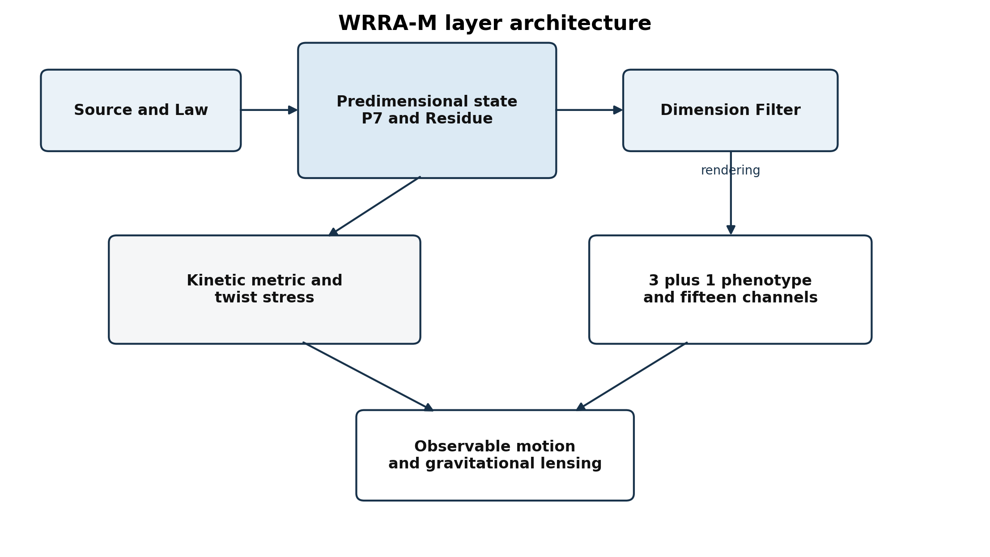
Figure 1 WRRA-M keeps the predimensional state separate from the phenotype and assigns gravity to the universal interface

Gravity as the universal upstream port
WRRA-M does not add gravity as a twelfth coordinate. Gravity is the phenotype inheritance of the total upstream kinetic and stress structure. Electromagnetic, weak, and strong interactions require labels such as charge, chirality, and color that already exist in the phenotype channel space. Gravity reads the total load before those labels are selected.
A candidate metric ansatz separates a positive spatial relation h from a residue ordering direction u. The Jacobian J connects local phenotype coordinates to the predimensional degrees after a local chart has been rendered. K is the upstream kinetic metric.

This ansatz is a construction target, not a completed derivation. It must produce one timelike and three spacelike directions, remain stable under allowed transitions, and recover the tested weak field and relativistic limits.

Dark matter as twist stress
The same interface allows an upstream state to have zero matter phenotype and a nonzero gravitational output. WRRA-M names the effective source twist stress. The familiar four dimensional field equation can be used as an interface equation while the microscopic origin of the second term is calculated from P7 and the filter.


The claim is stronger than saying that unknown matter gravitates. It says that the extra gravitational source is the failure of the phenotype to display the complete upstream geometry. The model must use one transferable stress law across galaxy rotation, lensing, cluster dynamics, and cosmological structure. Object by object tuning would not establish the claim.

First structural calculation from seven to fifteen
The central calculation begins with a G2 structured seven degree sector. The fundamental seven dimensional representation branches under the SU(3) subgroup into a color triplet, an antitriplet, and a singlet [5]. WRRA-M introduces two oriented copies of the seven sector plus one invariant channel. The two copies are provisionally interpreted as a state sector and a residue dual sector. Their physical distinction must later be derived from the transition law.
The Standard Model color content of one generation has the same decomposition. The left handed quark doublet supplies two color triplets. The left handed conjugates of the up and down singlets supply two antitriplets. The lepton doublet and the charged lepton singlet supply three color singlets.
Standard Model field | Gauge representation | Weyl count | Candidate WRRA-M placement
Q_L | (3, 2), Y = 1/6 | 6 | Two triplets from 7 A and 7 B paired by the chiral filter
uᶜ | (anti-3, 1), Y = −2/3 | 3 | Antitriplet from one seven sector
dᶜ | (anti-3, 1), Y = 1/3 | 3 | Antitriplet from the other seven sector
L_L | (1, 2), Y = −1/2 | 2 | Two singlets from 7 A and 7 B paired by the chiral filter
eᶜ | (1, 1), Y = 1 | 1 | Invariant channel

Calculated result The color representation multiplicities match exactly. Open result The present calculation does not yet derive why the triplets and two singlets pair as weak doublets while the two antitriplets remain weak singlets. It also does not derive hypercharge. Those are the next filter equations.

Null state extension
WRRA already contains the WJNS null state. Adding one sterile null channel to the fifteen visible chiral channels gives sixteen. This mirrors the difference between the minimal Standard Model generation and a sixteen channel generation containing a sterile right handed neutrino. The match is a candidate structural interpretation and is not yet a particle identification.


Calibrated anomaly benchmark
The known Standard Model hypercharges may be used as calibration values under the fixed WRRA evaluation rule. When the five field groups are assigned their observed hypercharges, all local gauge and mixed gravitational anomalies cancel. The cancellation is reproduced below as a benchmark that the eventual WRRA-M charge operator must match.
Consistency condition | Calibrated calculation | Result
SU(3)^3 | 2 − 1 − 1 | 0
SU(3)^2 U(1) | 2×(1/2)(1/6) + (1/2)(−2/3) + (1/2)(1/3) | 0
SU(2)^2 U(1) | 3×(1/2)(1/6) + (1/2)(−1/2) | 0
U(1)^3 | 6(1/6)^3 + 3(−2/3)^3 + 3(1/3)^3 + 2(−1/2)^3 + 1 | 0
grav^2 U(1) | 6(1/6) + 3(−2/3) + 3(1/3) + 2(−1/2) + 1 | 0
Global SU(2) | Three colored Q doublets plus one L doublet | 4 doublets, even

The benchmark confirms consistency after calibration. It does not show that WRRA-M has derived hypercharge. The required next result is a filter operator whose eigenvalues produce the calibrated charges and whose structure explains the cancellation rather than inserting each charge separately.

Claim ledger
Verification input | WRRA specific transformation | Output | Falsification condition
M theory uses seven internal dimensions for a four dimensional compactification | Replace ontic internal space with seven predimensional degrees represented geometrically for calculation | P7 correspondence hypothesis | A four dimensional reduction requires structures that cannot be represented by seven predimensional degrees
G2 fundamental branching gives 7 equals 3 plus 3 bar plus 1 | Use two oriented seven sectors and one invariant channel | Two triplets two antitriplets and three singlets | The filter cannot preserve the branching or cannot assign the channels to one generation
One Standard Model generation has fifteen Weyl channels | Match only the SU 3 color multiplicities | Exact color sector multiplicity match | Any channel count or color representation fails after a complete field assignment
Observed hypercharges | Calibrate the candidate charge operator and run anomaly sums | All benchmark anomalies vanish | No single filter operator can generate the charges without channel by channel insertion
Additional gravity is inferred without light | Set matter phenotype to zero while retaining twist stress | Effective dark gravitational source | A non gravitational particle signal explains all effects or one twist law cannot fit rotation lensing clusters and cosmology
Residues are ordered in the present | Use residue order as the timelike filter direction | Emergent time candidate | Lorentzian causality or observed clock relations cannot be recovered

Claim status
Code | Meaning | WRRA-M item
E | Established external input | Eleven dimensional low energy limit seven dimensional compactification G2 chirality at singularities
D | Architecture definition | Predimensional P7 residue dimension filter phenotype separation
C | Calculated within the branch | The SU 3 multiplicity equality between 1 plus 7 plus 7 and one Standard Model generation
H | Testable hypothesis | Gravity as the sole universal upstream port and dark matter as twist stress
O | Open derivation | SU 2 pairing hypercharge three generations masses and numerical dark stress law

Next calculations
- Define the two oriented seven sectors from the transition and residue equations instead of postulating two copies.
- Construct a dimension filter that pairs the two triplets into Q L and the two appropriate singlets into L L while leaving the antitriplets as weak singlets.
- Derive one hypercharge operator on the full fifteen channel space. Calibrate only its minimum free parameters and reproduce all anomaly cancellations.
- Test whether the WJNS null state naturally has the sterile quantum numbers of a right handed neutrino and whether its activation generates a neutrino mass scale.
- Specify the kinetic metric K and derive a Lorentzian three plus one metric with the residue order as the timelike direction.
- Derive a transferable twist stress profile and test it against galaxy rotation gravitational lensing cluster dynamics and cosmological structure with one parameter policy.
- Map the established WRRA fifteen channel implementation to the new one plus seven plus seven basis and identify whether the two descriptions are equivalent or one is more restrictive.

Minimum success conditions
- The filter produces rank four local spacetime with one timelike direction.
- The channel projector has rank fifteen and recovers the full Standard Model gauge assignments for one generation.
- All gauge and mixed anomalies cancel from the derived operator.
- Gravity couples to the complete upstream load while the other interactions remain current selective.
- One twist stress law covers the main dark matter observables without object specific tuning.
- The null state extension either yields a consistent sterile channel or is rejected.

Conclusion
WRRA-M begins with one exact structural result and several explicit open problems. The exact result is the color sector identity between one invariant channel plus two G2 seven sectors and the fifteen Weyl channels of one Standard Model generation. The open problems are decisive. Weak pairing, hypercharge, chirality, generations, mass, and the numerical twist stress law must be derived. The branch will remain separate from WRRA Core 1.0 until those tests are passed.
The working interpretation is concise. The seven internal dimensions of M theory may be the geometric calculation of seven predimensional degrees. The dimension filter renders their finite phenotype. Gravity is the inherited metric of the full upstream state. Dark matter is the gravitational remainder of what the phenotype does not display.

Appendix A First calculation in compact form
Color content | WRRA-M count | Standard Model one generation
Triplet | 2 | Q L contains two
Antitriplet | 2 | u c and d c
Singlet | 3 | Two in L L and one e c
Total Weyl channels | 15 | 15

Interpretive boundary The equality is exact under SU 3 color restriction. It is not yet an equality of full SU 3 times SU 2 times U 1 representations.

Appendix B References
[1] Edward Witten String Theory Dynamics in Various Dimensions Nuclear Physics B 443 1995 85 to 126
https://arxiv.org/abs/hep-th/9503124
[2] Aaron Kennon G2 Manifolds and M Theory Compactifications 2018
https://arxiv.org/abs/1810.12659
[3] Bobby Acharya and Edward Witten Chiral Fermions from Manifolds of G2 Holonomy 2001
https://arxiv.org/abs/hep-th/0109152
[4] Edward Witten Anomaly Cancellation on Manifolds of G2 Holonomy 2001
https://arxiv.org/abs/hep-th/0108165
[5] An exceptional G2 extension of the Standard Model from Cayley Dickson automorphism groups Scientific Reports 2021
https://doi.org/10.1038/s41598-021-01814-1
[6] CERN The Standard Model of Particle Physics CERN 2016 005
https://cds.cern.ch/record/1966030
[7] Particle Data Group Standard Model and Related Topics 2025
https://pdg.lbl.gov/2025/reviews/standard_model_and_related.html

