Name: Eric Woodard Mark _____________________/50

## Brief introduction __/3

My feature will manage all audio. Game objects will request playing certain sounds from the sound manager. Then the music manager will control the soundtrack playlist such as when to change tracks or mute the music.

## Use case diagram with scenario __14

### Use Case Diagrams

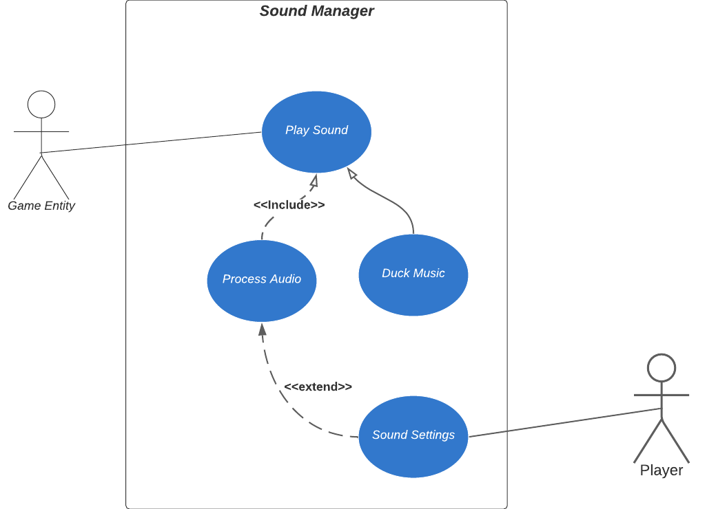

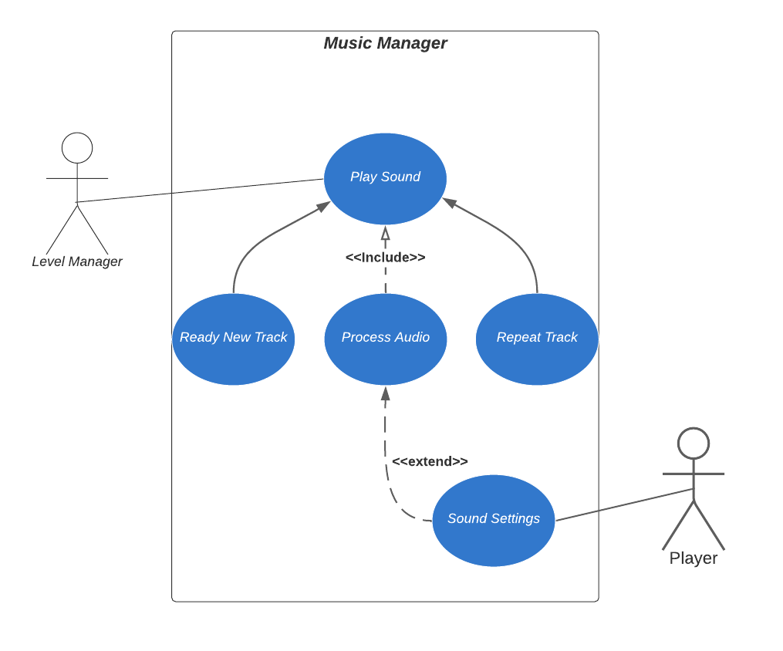

### Scenarios

**Name:** Play Sound Effect

**Summary:** A game object triggers a sound effect

**Actors:** A Game Object.

**Preconditions:** A game object triggers a sound effect

**Basic sequence:**

**Step 1:** Game object requests which sound effect should be played

**Step 2:** Processes audio.

**Step 3:** Lower the music volume for the duration of the sound effect.

**Step 4:** Play Audio

**Exceptions:**

**Step 2:** Player has muted sound

**Step 2:** To many sounds are currently playing

**Step 3:** Sound effect request denied

**Post conditions:** The Sound is played.

**Priority:** 2*

**ID:** S01

*The priorities are 1 = must have, 2 = essential, 3 = nice to have.

### Scenarios

**Name:** Play Music Track

**Summary:** The level manager queues a music track

**Actors:** The level manager

**Preconditions:** A game level is initialized

**Basic sequence:**

**Step 1:** Level manager selects which track to play

**Step 2:** Previous track is faded out.

**Step 3:** Processes audio.

**Step 4:** Play new track

**Step 5:** Track is looped when it reaches the end.

**Exceptions:**

**Step 2:** Player has muted music

**Step 4:** Player has muted music

**Post conditions:** The track is played.

**Priority:** 2*

**ID:** M01

*The priorities are 1 = must have, 2 = essential, 3 = nice to have.

## Data Flow diagram(s) from Level 0 to process description for your feature _______14

## Data Flow Diagrams

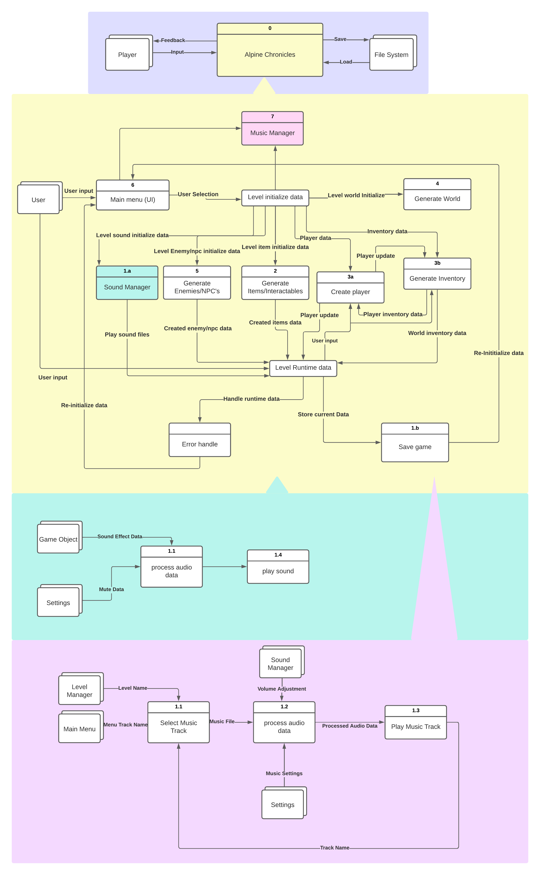

### Process Descriptions

play sound effect:

If sounds not muted and number of playing sound effects less than max allowed

Set sound effect volume and positional data

Lower music volume

Play sound effect

Restore music volume

Else

ignore sound effect request

Play music track:

If music not muted

If current track is playing

fade out current track

Select music file

Set audio volume

play new track

Else

Don’t play music

## Acceptance Tests ________9

Run feature 1000 times sending output to a file.

The output file will have the following characteristics:

* Max volume: 1.0f
* Min volume: 0

|  |  |
| --- | --- |
| Output | Volume  (float) |
| 1.0 | 1.0f |
| 0.5 | 0.5f |
| 0 | 0 |
| 1.0 | 1.3f |
| 0 | -1.0f |

## Timeline _________/10

[Figure out the tasks required to complete your feature]

Example:

### Work items

|  |  |  |
| --- | --- | --- |
| Task | Duration (PWks) | Predecessor Task(s) |
| 1. Audio System Requirements Collections | 4 | - |
| 2. Audio Manager Superclass Design | 3 | 1 |
| 3. Sound Manager Subclass Design | 2 | 2 |
| 4. Music Manager Subclass Design | 2 | 2 |
| 5. Audio Manager Programming | 3 | 3, 4 |
| 6. Sound Manager Programming | 2 | 5 |
| 7. Music Manager Programming | 2 | 5 |
| 8. Testing | 3 | 7, 6 |
| 9. Music Creation | 8 | 1 |
| 10. Sound Effect Creation | 6 | 1 |

### Pert diagram

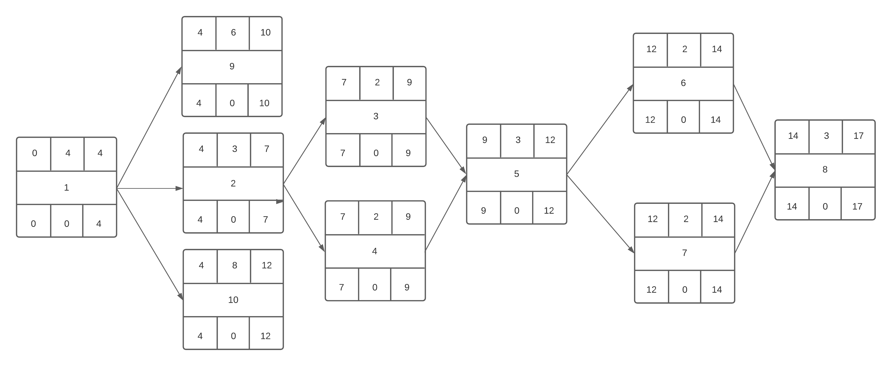

### Gantt timeline

|  |  |  |  |  |  |  |  |  |  |  |  |  |  |  |  |  |  |
| --- | --- | --- | --- | --- | --- | --- | --- | --- | --- | --- | --- | --- | --- | --- | --- | --- | --- |
|  | 1 | 2 | 3 | 4 | 5 | 6 | 7 | 8 | 9 | 10 | 11 | 12 | 13 | 14 | 15 | 16 | 17 |
| 1 |  |  |  |  |  |  |  |  |  |  |  |  |  |  |  |  |  |
| 2 |  |  |  |  | 1 |  |  |  |  |  |  |  |  |  |  |  |  |
| 3 |  |  |  |  |  |  |  | 2 |  |  |  |  |  |  |  |  |  |
| 4 |  |  |  |  |  |  |  | 2 |  |  |  |  |  |  |  |  |  |
| 5 |  |  |  |  |  |  |  |  |  | 3, 4 |  |  |  |  |  |  |  |
| 6 |  |  |  |  |  |  |  |  |  |  |  |  | 5 |  |  |  |  |
| 7 |  |  |  |  |  |  |  |  |  |  |  |  | 5 |  |  |  |  |
| 8 |  |  |  |  |  |  |  |  |  |  |  |  |  |  | 6, 7 |  |  |
| 9 |  |  |  |  | 1 |  |  |  |  |  |  |  |  |  |  |  |  |
| 10 |  |  |  |  | 1 |  |  |  |  |  |  |  |  |  |  |  |  |
|  |  |  |  |  |  |  |  |  |  |  |  |  |  |  |  |  |  |