Name__Joseph_Miller_________ Mark _____________________/50

[**Instructions**: Remove everything that is not a heading below and fill in with your own diagrams, etc.]

## Brief introduction ___/3

The background of the scene, including the walls and other obstacles that may impede player movement.

## Use case diagram with scenario ____/14

### Use Case Diagrams

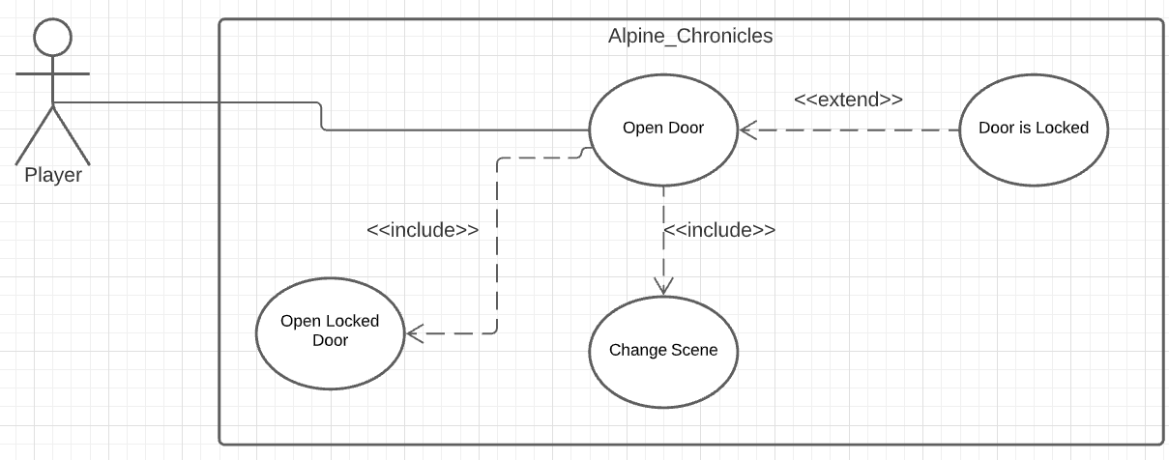

### Scenarios

**Name:** Open Door

**Summary:** The player interacts with a door.

**Actors:** Player.

**Preconditions:** Game is running.

**Basic sequence:**

**Step 1:** Interact with the door.

**Step 2:** Accept interaction command.

**Step 3:** If door is within the scene, open the door.

**Step 4:** If door is outside the scene, load the appropriate scene.

**Exceptions:**

**Step 3,4:** Door is locked and requires a key: Display that a key is required

**Step 2:** Door leads nowhere: Display that the door is locked.

**Post conditions:** Door is opened, or scene is changed.

**Priority:** 1*

**ID:** JM01

*The priorities are 1 = must have, 2 = essential, 3 = nice to have.

## Data Flow diagram(s) from Level 0 to process description for your feature _______/14

### Data Flow Diagrams

Context Diagram

Diagram 0

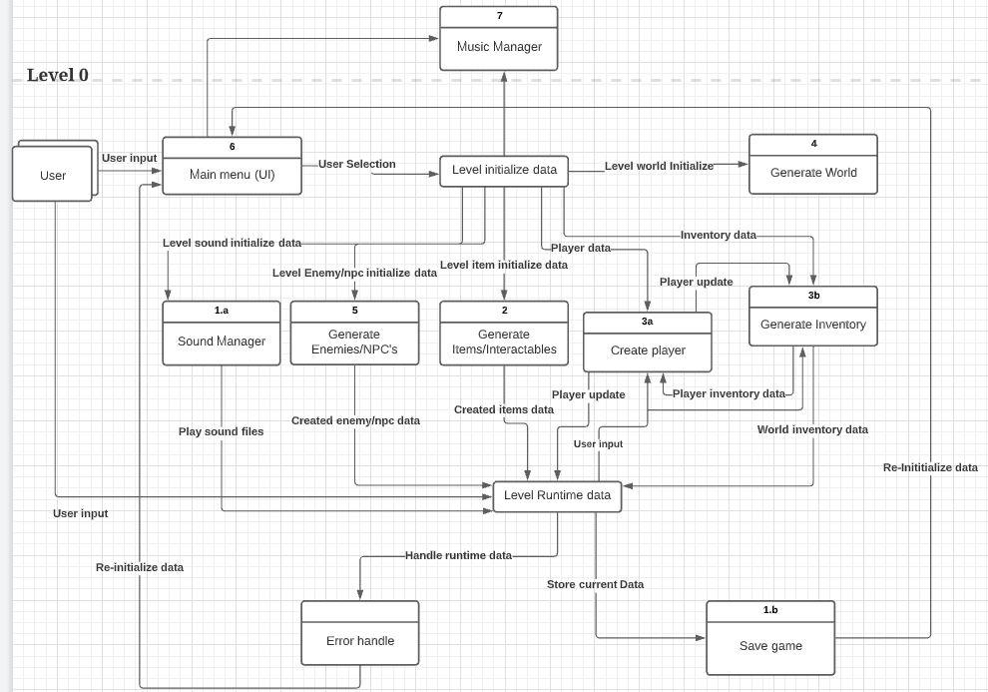



Diagram 1

### Process Descriptions

Change Scene:

IF not changeSceneAction

currentScene = newSceneNumber from default

ENDIF

ELSE

IF currentScene = level_0

currentScene = level_1 from level_0

ENDIF

ELSEIF currentScene = level_1

IF newSceneNumber = level_2

currentScene = level_2 from level_1

ENDIF

ELSEIF newSceneNumber = level_0

IF level3Complete = true

currentScene = level_0 from level_1 with finalBoss

ENDIF

ELSE

currentScene = level_0 from level_1

ENDELSE

ENDIF

ELSEIF currentScene = level_2

IF newSceneNumber = level_1

currentScene = level_1 from level_2

ENDIF

ELSEIF newSceneNumber = level_3

currentScene = level_3 from level_2

ENDIF

ELSEIF currentScene = level_3

currentScene = level_2 from level_3

ENDIF

ENDELSE

## Acceptance Tests ________/9

Load between scenes 1000 times for each scene and record the to scene and from scene in a separate file, with acceptable output being: 0->1, 1->0, 1->2, 2->1, 2->3, and 3->2.

## Timeline _________/10

### Work items

|  |  |  |
| --- | --- | --- |
| Task | Duration (PHrs) | Predecessor Task(s) |
| 1. Research Map Design | 4 | - |
| 2. Room 0 | 5 | 1 |
| 3. Room 1 | 9 | 2 |
| 4. Room 2 | 5 | 3 |
| 5. Room 3 | 7 | 4 |
| 6. Extra Levels | 15 | 5 |
| 7. Installation | 3 | 5 |

### Pert diagram

### Gantt timeline

|  |  |  |  |  |  |  |  |  |  |  |  |  |  |  |  |  |  |  |  |  |  |  |  |  |  |  |  |  |  |  |  |  |  |  |  |  |  |  |  |  |  |  |  |  |  |
| --- | --- | --- | --- | --- | --- | --- | --- | --- | --- | --- | --- | --- | --- | --- | --- | --- | --- | --- | --- | --- | --- | --- | --- | --- | --- | --- | --- | --- | --- | --- | --- | --- | --- | --- | --- | --- | --- | --- | --- | --- | --- | --- | --- | --- | --- |
| 1 |  |  |  |  |  |  |  |  |  |  |  |  |  |  |  |  |  |  |  |  |  |  |  |  |  |  |  |  |  |  |  |  |  |  |  |  |  |  |  |  |  |  |  |  |  |
| 2 |  |  |  |  | 1 |  |  |  |  |  |  |  |  |  |  |  |  |  |  |  |  |  |  |  |  |  |  |  |  |  |  |  |  |  |  |  |  |  |  |  |  |  |  |  |  |
| 3 |  |  |  |  |  |  |  |  |  | 2 |  |  |  |  |  |  |  |  |  |  |  |  |  |  |  |  |  |  |  |  |  |  |  |  |  |  |  |  |  |  |  |  |  |  |  |
| 4 |  |  |  |  |  |  |  |  |  |  |  |  |  |  |  |  |  |  | 3 |  |  |  |  |  |  |  |  |  |  |  |  |  |  |  |  |  |  |  |  |  |  |  |  |  |  |
| 5 |  |  |  |  |  |  |  |  |  |  |  |  |  |  |  |  |  |  |  |  |  |  |  | 4 |  |  |  |  |  |  |  |  |  |  |  |  |  |  |  |  |  |  |  |  |  |
| 6 |  |  |  |  |  |  |  |  |  |  |  |  |  |  |  |  |  |  |  |  |  |  |  |  |  |  |  |  |  |  | 5 |  |  |  |  |  |  |  |  |  |  |  |  |  |  |
| 7 |  |  |  |  |  |  |  |  |  |  |  |  |  |  |  |  |  |  |  |  |  |  |  |  |  |  |  |  |  |  | 5 |  |  |  |  |  |  |  |  |  |  |  |  |  |  |
|  | 1 | 2 | 3 | 4 | 5 | 6 | 7 | 8 | 9 | 10 | 11 | 12 | 13 | 14 | 15 | 16 | 17 | 18 | 19 | 20 | 21 | 22 | 23 | 24 | 25 | 26 | 27 | 28 | 29 | 30 | 31 | 32 | 33 | 34 | 35 | 36 | 37 | 38 | 39 | 40 | 41 | 42 | 43 | 44 | 45 |