The New Phenomenon of the Aging Workforce-
The Need for Accommodations and Universal Design in the Workplace Fact Sheet

Labor Force Projections 2020

- While the overall growth of the nation’s labor force is slowing, the labor force growth in the 55 and older population is rising--a demographic group with an incidence of disability higher than that of other working age populations. This creates an opportunity to retain our most experienced workers.

- The Bureau of Labor Statistics’ (BLS) new labor force projections indicate a historically slow rate of increase in the size of the nation’s labor force. BLS projects that between 2010 and 2020 the nation’s labor force will rise by just 10.7 million workers, a reduction from the 11.3 million workers during 2000-2010 and 16.7 million workers increase during the decade of the 1990s (BLS, 2012).

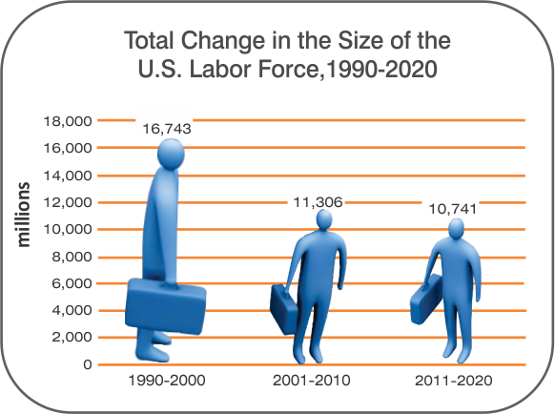

Increased Growth of Older Workers

- The growth in the size of the U.S. labor force aged 55+ of 11.4 million till 2020 will exceed the overall estimated increase in the size of the U.S. labor force of 10.7 million. Increasingly employers will utilize workers aged 55+ in meeting their staffing needs. (BLS, 2012).
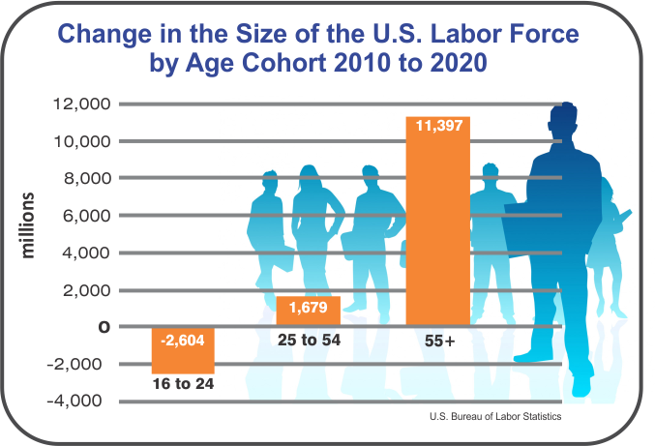

Much of the growth in the older worker population is concentrated among the 65 to 74 year old population who experienced a doubling in their labor force participation rate from 1990-2020.

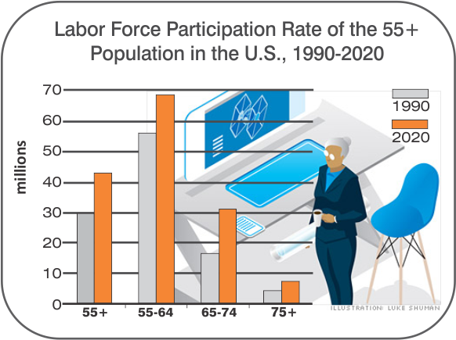
The New Definition of Disability under the Americans with Disabilities Act (ADA) Protects More Americans than Ever Before

- The latest provisions in the ADA (2009) offer a means for being more responsive to the types of conditions that cause disability, the emergence of new disabilities and the rapid increase in epidemics such as diabetes.

- The new definition of disability expands the original list of major life activities such as caring for oneself, and performing manual tasks to now include major bodily functions. For example, a person with diabetes maybe substantially limited by the functions of their endocrine systems and is covered under the ADA.

Major Life Activities Examples in the ADA
Caring for oneself | Walking | Talking
Performing manual tasks | Standing | Reading
Seeing | Lifting | Concentrating
Hearing | Bending | Thinking
Eating | Speaking | Communicating
Sleeping | Breathing | Working

Major Bodily Functions=Major Life Activities
Examples in the ADA
Immune System | Neurological
Normal cell growth | Brain
Digestive | Respiratory, Circulatory
Bowel | Endocrine
Bladder | Reproductive

However, older workers, even as they are losing functionality are least likely to self-identify as a person with a disability.

Universal Design Makes Practical Sense in the Workplace

- With more Americans needing accommodations, it makes practical sense for employers to implement principles of universal design in the workplace.

- While universal design does not replace accommodations for people with disabilities, it can minimize the effects of a gradual loss of functioning for an older population that does not identify as having a disability and improve conditions for all workers. For example, my vision has recently diminished. But flexible lighting and enlarged screen text help to continue to be productive, while at the same time reducing the need to disclose a decrease in vision. Also, a telephone headset alleviates discomfort when a torn shoulder ligament periodically acts up. Not to mention how my flexible adjustable chair alleviates neck and back discomfort.

- Out of necessity or choice, the reality of aging workers with our loss of functioning and increased disability demands a new response that supports job performance and retention until we are ready to retire. Developing a set of universal design policies can accommodate the workplace needs of both those who choose to disclose their limitations and those who opt not to disclose such limitations and ultimately creates a better workplace for all.

Resources

IHCD, with Employees Ranging from age 24-79, exemplifies a model of universal design in the workplace

The Institute for Human Centered Design (IHCD) (www.HumanCentredDesign.org) is a global leader in universal design. IHCD provides lectures, trainings, consulting and webcasts in the US and internationally, working from the World Health Organization’s contextual definition of disability in the physical, information, communication, policy and social environments. For more information, call 617-695-1225.

Oce Harrison, ED.D. Project Director, The New England ADA Center (www.NewEnglandADA.org) at IHCD has been a leader in providing information, guidance and training on the ADA to individuals, employers and businesses at the local, regional and national level since 1996. For more information, call 1-800-949-4232 in New England and 617-695-1225 outside New England.

If you have question about this document, contact Oce Harrison oharrison@IHCDesign.org or call 617-695-1225 x27

