Table of Contents
1. ls 2

LAB 1 : BASIC LINUX COMMANDS

ls
Interpretation: List information about the FILEs (the current directory by default)
Output:
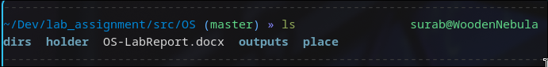

dir
Interpretation: List information about the FILEs (the current directory by default)
Output:
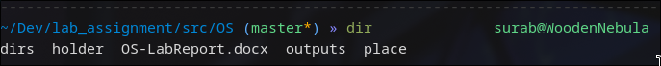

ls -a
Interpretation: Lists contents and do not ignore entries starting with .
Output:
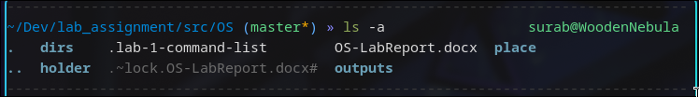

ls -l
Interpretation: use a long listing format
Output:
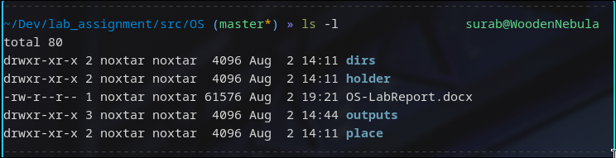

ls -lh
Interpretation:
Lists contents along with human readable size formats
Output:
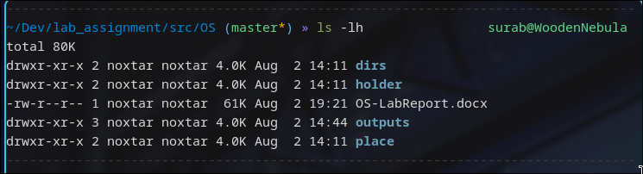

ls -F
Interpretation: append indicator (one of */=>@|) to entries WHEN
Output:

ls -r
Interpretation: reverse order while sorting
Output:
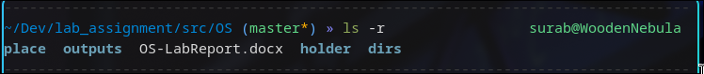

ls -R
Interpretation: recursively list the directories
Output:
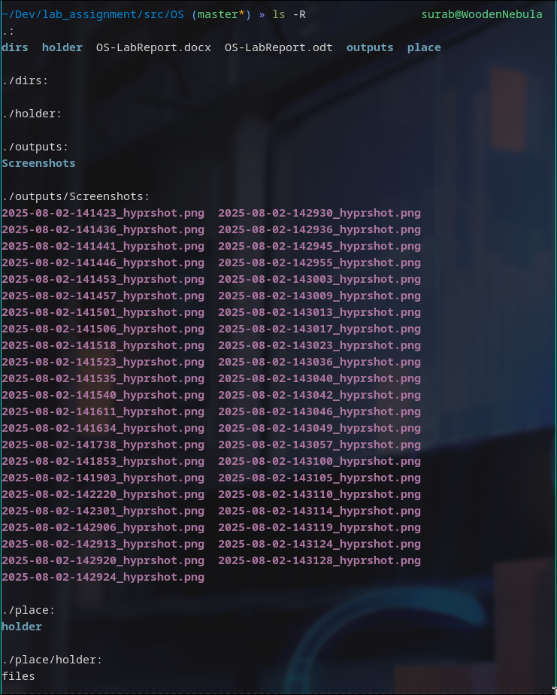

ls -ltr
Interpretation: Lists contents in long listing sorted by time in reverse(oldest first) order
Output:
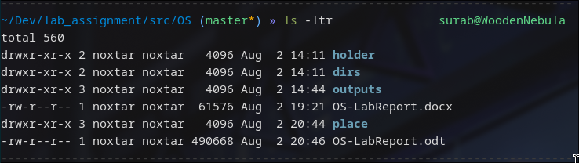

ls -i
Interpretation: print the index number of each file
Output:
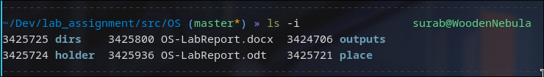

ls --version
Interpretation: output version information and exit
Output:
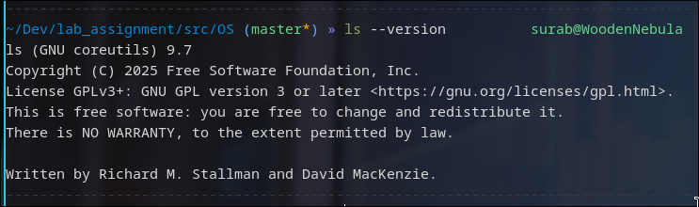

ls --help
Interpretation: displays man/help page for the command ls
Output:
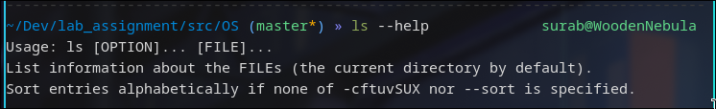

ls -n
Interpretation: like -l, but list numeric user and group IDs
Output:
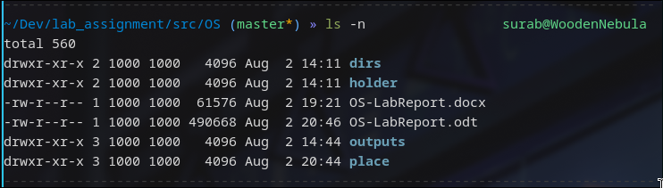

clear
Interpretation: clears the terminal screen to default prompt
Output:

mkdir
Interpretation: creates a directory with the provided name in current or supplied directory
Output:
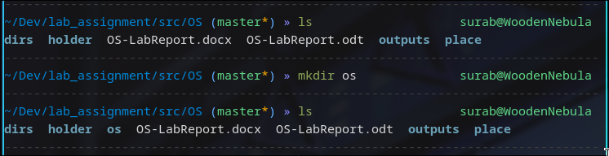

cd
Interpretation: changes current directory to the supplied directory
Output:
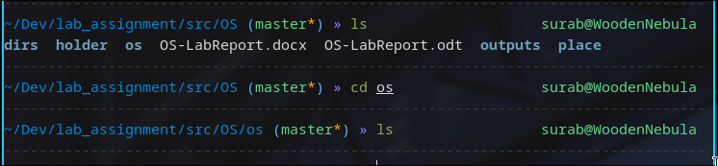

touch
Interpretation: Updates the access and modification times of each FILE to the current. As a side effect, it creates the FILE if it doesn’t exist yet
Output:
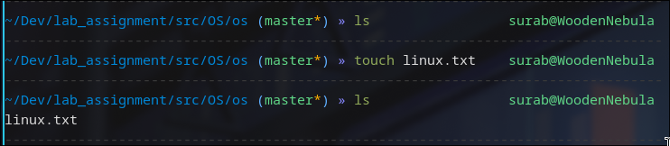

text editing
Command: nano/vi/vim/nvim text-file
Interpretation: opens the text-file with the specific terminal based text editor
Output:
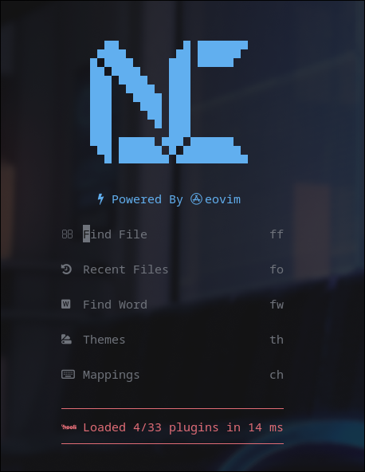
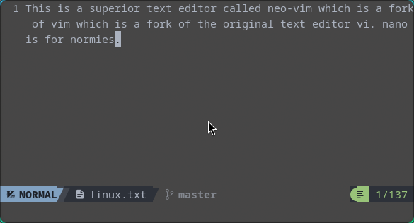

[bc]at
Command: bat/cat
Interpretation: concatenate files and print on the standard output
Output:
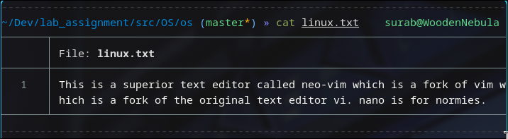

>
Command: command > file
Interpretation: redirects the input from the command or stdin to the supplied file
Output:
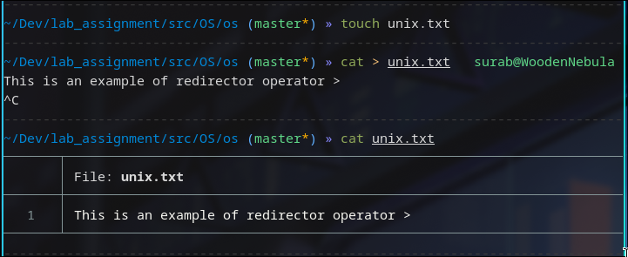

touch file1 file2 ...
Interpretation: touches multiple supplied files
Output:
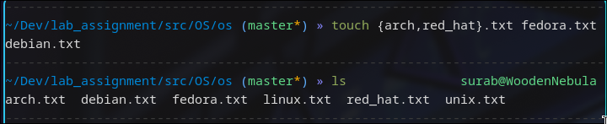

cp
Command: cp <source> <dest>
Interpretation: copies content from source to destination
Output:
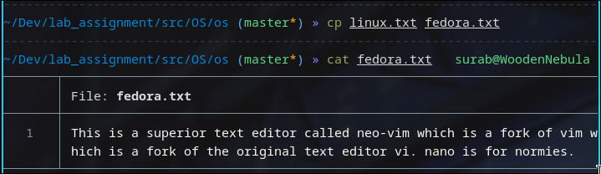

cd ..
Interpretation: goes up a directory in current dir-tree
Output:
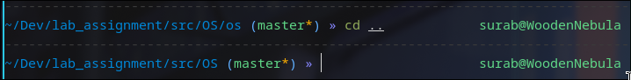

pwd
Interpretation: prints current working directory
Output:
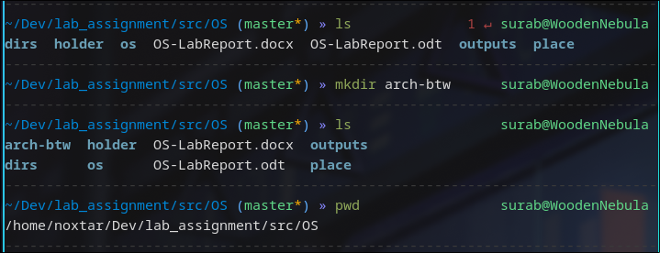

cp <file_src> <file_dest>
Interpretation: Copies file from provided source to destination
Output:
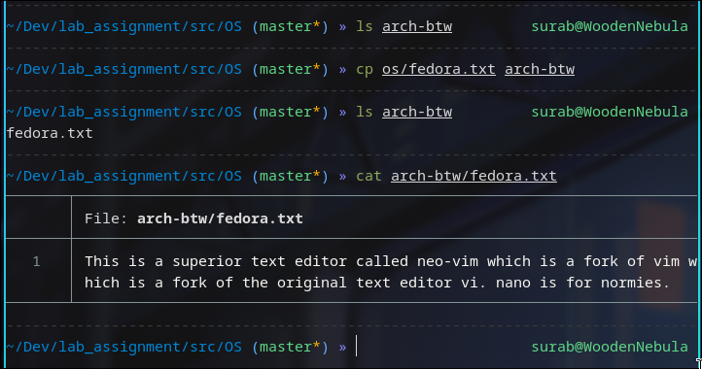

mv
Interpretation: moves file from source to destination
Output:
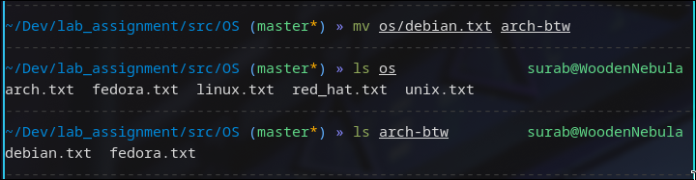

rm
Command: rm <file1> <file2> ...
Interpretation: removes file at provided paths, wildcards can be used to pattern match as well for removing multiple files
Output:
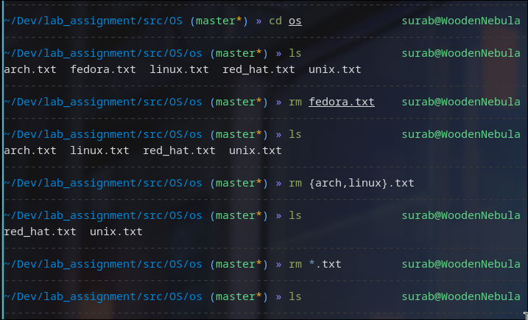

rmdir
Command: rmdir <dir>
Interpretation: removes empty directory at supplied directory
Output:
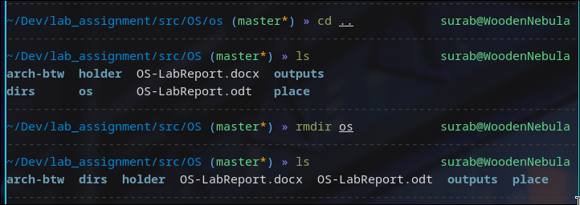

rm -rf
Interpretation: remove supplied directory recursively and forcefully
Output:
