Data Engineering Take-Home Assessment

Overview
Thanks for your interest in the Manager, Data Architect role. This take-home is designed to give us a realistic view of how you approach building a data pipeline, and to give you a sense of the kind of work you'd be doing here.
Time expectation: 4–6 hours of focused work. Please don't spend more than that — we'd rather see thoughtful scoping than a perfect-but-massive solution.
Deadline: One week from receipt. If you need more time, just let us know.
Tools: Use whatever you'd reach for on the job. Python, SQL, dbt, DuckDB, Pandas, Polars, Spark, BigQuery sandbox, Snowflake free tier — all fair game. We care about your reasoning, not your tool choice.

The Scenario
You've just joined the analytics engineering team at a media agency. The client is a national retailer running paid media across multiple platforms. The marketing team wants a unified view of campaign performance so they can answer questions like “what's our blended CPA across channels?” and “which campaigns are driving in-store visits?”
You've been given three raw data extracts (described below). Your job is to build a pipeline that ingests this data, models it sensibly, loads it into a queryable destination, and answers a few business questions.

The Data
You'll find these files in the attached data folder:

1. meta_ads_daily.csv
Daily campaign-level performance from Meta Ads Manager. Columns include:
- date, campaign_id, campaign_name, adset_id, ad_id
- impressions, clicks, spend_usd, conversions, conversion_value_usd
- objective, placement
Known issues: Some rows have spend_usd reported in local currency rather than USD (flagged inconsistently). Campaign names occasionally change mid-flight. Timestamps are in PST.

2. google_ads_daily.json
Daily campaign-level performance from Google Ads, exported as newline-delimited JSON. Schema overlaps with Meta but uses different field names (cost_micros, campaign.id, etc.) and nests some fields.
Known issues: cost_micros is in micros (divide by 1,000,000). Some campaigns appear twice on the same day due to an export bug — you'll need to decide how to handle this. Timestamps are in UTC.

3. store_visits.csv
A separate file from a foot traffic measurement partner. Daily store visits attributed to digital ad exposure, broken out by DMA.
- date, dma_code, dma_name, attributed_visits, attribution_window_days
Known issues: DMA codes don't directly map to campaign-level data — you'll need to think about how (or whether) to join this in. Some dates are missing entirely (assume zero, or interpolate, or flag — your call).

4. campaign_metadata.csv
A reference file mapping campaign_id (from either platform) to business attributes: brand, product_line, region, campaign_start_date, campaign_end_date.

What We'd Like You to Build

1. An ingestion + transformation pipeline
Ingest the raw files, clean them, and produce a unified model. We'd expect to see:
- A clear separation between raw, staged, and modeled layers (whether that's dbt models, Python modules, or just well-organized scripts)
- Handling of the data quality issues called out above (and any others you find)
- Some form of incremental-load logic, or a written explanation of how you'd handle it in production

2. A data model
Design the schema you'd want analysts to query. Star schema, OBT, something else — your call, but be ready to justify it. Document the grain of each table.

3. A queryable output
Load the modeled data somewhere we can run SQL against it. DuckDB file, SQLite, BigQuery sandbox, Snowflake trial — all fine.

4. SQL queries answering these questions
- What was the blended CPA (cost per conversion) by brand and month, across both platforms?
See cell 7
  - 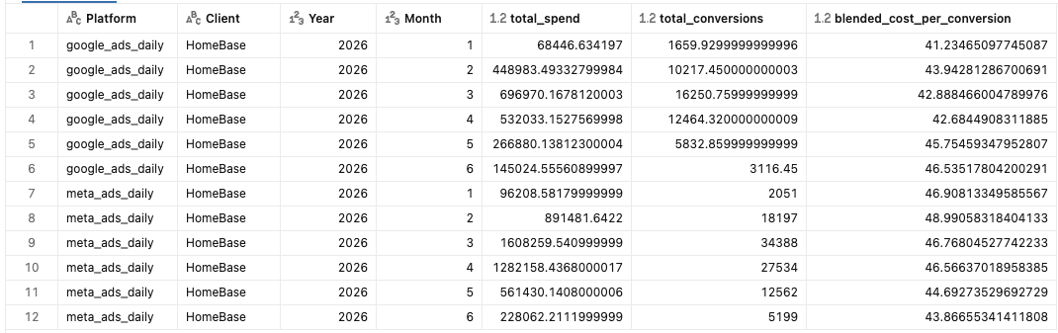
- Which campaigns had the highest week-over-week spend growth in the most recent 4 weeks of data? Show the top 10.
Recent 4 weeks only trace to 2026-05-23 which only contains (1033,1283,1203,1173) see cell 9
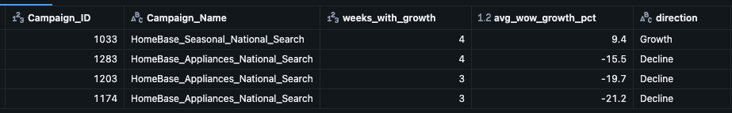

- For campaigns that ran in DMAs with store visit data, what's the relationship between weekly spend and attributed store visits? (A summary table is fine — no need to build a stats model.)
Strongly recommend to run this in Python for intuitive graph whereas SQL are messy and highly clustered see detail in cell 12
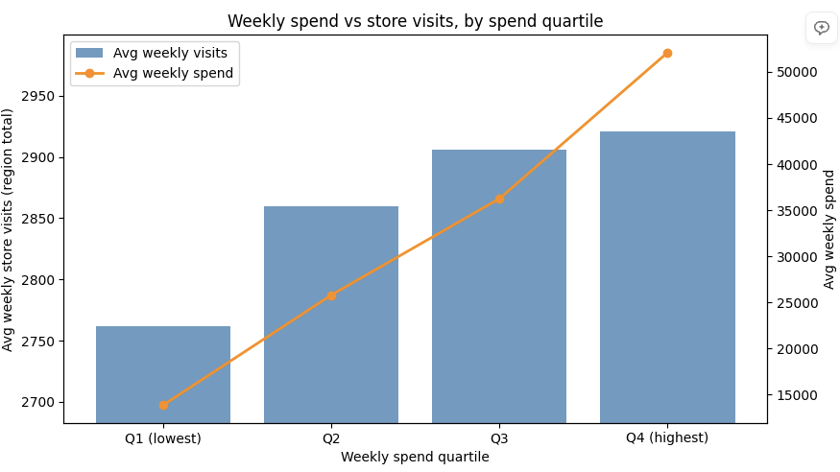
Positive correlation.
- Flag any campaigns where reported spend exceeded the campaign's stated budget (you'll need to handle the case where budget isn't in the metadata file — explain your approach).
Following campaign_id are exceeding the budget:
1174,1283,1090,1203,1274,1033,1051,1082,1241,1267,1064,1107,1023,1222,1184,1007,1120,1293,1072,1139,1308 with detail info in the notebook automapping_Staging Cell 14
null handling are explained in bullet point 7 in Readme.md

5. A README
Walk us through:
- How to run your pipeline end-to-end
- The data model and grain of each table
- Key decisions and tradeoffs you made (especially around the data quality issues)
- What you'd do differently with more time
- How you'd productionize this (orchestration, monitoring, testing, alerting)

How We'll Evaluate
We'll score your submission on:
Dimension | What we're looking for
Correctness | Queries return sensible answers; data quality issues are handled
Data modeling | Clear grain, sensible joins, model serves the questions being asked
Code quality | Readable, organized, reasonable use of functions/modules, sane naming
Edge case handling | You noticed the messy bits and made deliberate decisions about them
Communication | The README explains your thinking; we could hand this to a teammate
Production-mindedness | You've thought about how this would actually run on a schedule

We're not looking for a perfect solution. We're looking for the kind of thinking we'd want on the team — pragmatic, well-documented, and honest about tradeoffs.

Ground Rules
- Use AI tools however you normally would. Just be ready to walk through your code and decisions in a follow-up conversation.
- Don't over-engineer. A clean DuckDB + Python solution that nails the fundamentals beats a half-finished Airflow + dbt + Snowflake setup.
- Document assumptions. When the data is ambiguous, pick an approach and note why.
- Ask questions if you're stuck on the prompt. Real projects have ambiguity, but we'd rather clarify than have you guess wrong on something fundamental.

Submission
Send us a Git repo (GitHub, GitLab, whatever) or a zip file with:
- Your code
- The output database file (or instructions to regenerate it)
- Your README
- Anything else you think we should see
We'll review and get back to you within a week. If we need more information on the assessment submission, we’ll schedule additional review call.
Good luck — we're looking forward to seeing what you build.

