Luke Nasby

ENGR 29700  
Hw9

**Part 1:**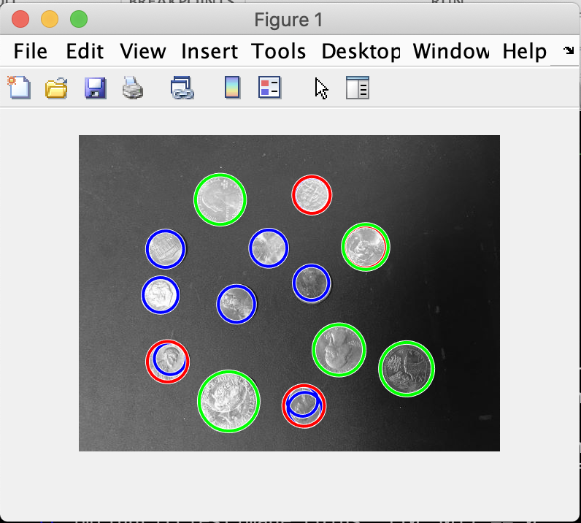

**Part 2:**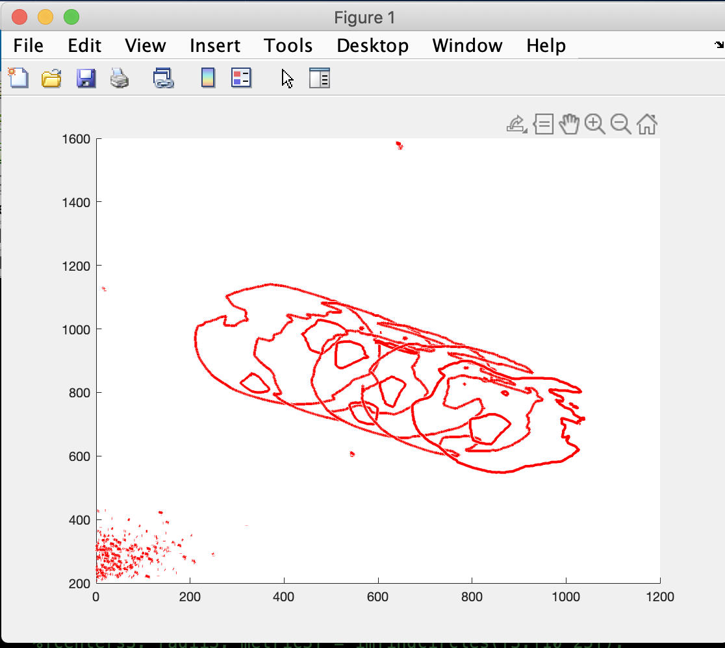

**Essay:**

The lower range of the radii parameters is usually more important since if it is too small, it will find and select an extremely large amount of pixels as opposed to the selection you were hoping for, whereas having a too large radii will simply detect nothing at all usually.

The video file object has things like duration and frame rate public (see image below), but the actual frames can only be read by class functions (video.read() etc.) Below is the image of clearly labeled statistics about a video file.