CSVimp Import Utility Overview and Usage

Table of Contents
Introductions 1
PostgreSQL Tools for the xTuple Databases 1
Relations is the xTuple Databases 2
xTuple Tables and API Views 2
Tables 2
API Views 4
Data Section 4
Map Editor 5
Map Types 5
Pre and Post Processing 5
Field Mappings 6
Import Section 6
Sample Usage 7

Introductions

CSVimp is a tool designed to import Comma Separated Value (CSV) files into the database for the xTuple Applications (PostBooks and OpenMFG). The tool consists of three primary functional areas:

Data Section: This section is the main window and shows your currently loaded CSV file
Map Editor: This section can be reached from the menu item Map | Edit.
Import Section: This section can be reached from the menu Import | Start.

These functional areas are covered in separate sections below.

PostgreSQL Tools for the xTuple Databases

Before detailing CSVimp’s functional areas, we wanted to offer a few tips that may prove useful as you navigate your xTuple Applications Database.

There are several useful tools you can use to explore and work with the xTuple Database schema:

- PgAdmin (http://www.pgadmin.org)
  - A powerful administration and development platform for the PostgreSQL database, free for any use. The application runs under Linux, xBSD, Mac, and Windows.
  - Designed to answer the needs of all users, from writing simple SQL queries to developing complex databases. The graphical interface supports all PostgreSQL features and makes administration easy. The application also includes a query builder, an SQL editor, a server-side code editor and much more.
  - pgAdmin III is released with an installer and does not require any additional driver to communicate with the database server.

- PostgreSQL Autodoc (http://www.rbt.ca/autodoc/)
  - A utility which will run through PostgreSQL system tables and generate output which describes the database. The following output formats are available: HTML, Dot, Dia, and DocBook XML.

In addition to these tools, you can also check for additional resources in the forums section of the xtuple.org community website.

Relations in the xTuple Databases
The xTuple Database schema has well over one hundred relations. Despite the shortness of their names, the relations are named to reflect essential meaning. All the fields of a table follow the format <table_name>_<field_name>. For example, the table cust has fields named: cust_name, cust_number, cust_state, etc. This naming convention becomes important when you are attempting to deduce relations. It is also important to know that every table has an id—for example, the field cust_id in the cust table. These id’s are always the primary keys. And in almost all cases, the id is the value used for references.
When a table has a reference to another table, the field will be named <table_name>_<referenced_field_name>. For example, the cust table references the custtype_id field in the custtype table. It follows, then, that the name of the reference field on the cust table is cust_custtype_id. There are two exceptions to this rule. The first is when a table references another table multiple times—as in the case of the table salesaccnt, which references the accnt_id several times. In this latter example, additional descriptive words are added (e.g., salesaccnt_credit_accnt_id). The second exception is when there is a business logic or conditional case that would require a field to reference more than one table—depending on the circumstances. The likelihood is small that you will encounter problems arising from scenarios like this during a conversion process.

xTuple Tables and API Views

CSVimp can import data into xTuple tables and Application Programmer Interface (API) Views. API Views are the cornerstone of the xTuple API and an import into a view has the advantage of executing xTuple application logic thus preserving data integrity and in some cases, inserts into multiple underlying xTuple tables simultaneously. Please see the xTuple API White Paper, available in the downloads area of the xtuple.org community website, for more details on the API.

Tables
Of the more than 200 tables in the xTuple Applications, the most significant tables you will want to look at are the following:
Name Description
accnt G/L Account Master
addr CRM Address Master
aropen Accounts Receivable Open Items
apopen Accounts Payable Open Items
arapply Accounts Receivable Applied
bomhead Bill Of Material Header
bomitem Bill of Material Item
boohead Bill Of Operations Master
booitem Bill Of Operations Item Master
crmacct CRM Account Master
cohist Sales/Customer Order History
custinfo Customer Master Information
salesrep Sales Representative Information
invhist Inventory History
item Item Master Information
itemsite Item Site Master
salesrep Sales Rep Master
vendinfo Vendor Master
The table list above is by no means an exhaustive list. However, it should give you a good basis for knowing which tables you will want to examine more closely.
Below is a list of tables that define groupings of customers, vendors, and items. This list forms a partial list of relational dependencies that must be considered before importing data into xTuple:

- customer types (custtype)
- vendor types (vendtype)
- planner codes (plancode)
- class codes (classcode)
- product categories (prodcat)
- sales reps (salesrep)
- warehouses (whsinfo).
Keeping in mind that not all references are integral to a successful import, some references are necessary. As a general rule, we recommend populating all references with appropriate information. However, be sure to take particular care to populate the following:
- custinfo:
- cust_custtype_id
- cust_salesrep_id
- vendinfo:
- vend_vendtype_id
- item:
- item_classcode_id
- item_prodcat_id
- itemsite:
- itemsite_item_id
- itemsite_warehous_id
- itemsite_plancode_id
- itemsite_costcat_id

API Views
All data records and business logic for the xTuple Applications are stored in a schema called "public." Schemas provide a way to logically separate database objects from one another while still allowing them reside in the same database and interact with one another. The business logic is stored in database objects called Procedures (in pgAdmin these are listed under the Functions object) and the physical data is stored in Table objects. When CSVimp or any other application performs a SQL SELECT, INSERT, UPDATE, DELETE or other command on a View, it executes the logic contained in the View itself and utilizes database procedures on one of more physical tables. This means that utilizing a View can result in data manipulation across multiple tables while preserving referential integrity through application logic. Note that API Views are stored in a separate schema called "api". There are Views in the public schema but these are simply logical representations of physical data and do not implement the application logic contained in and executed by the API Views.

Below is a list of current API Views:

API View Name

custchar
custcomment
custcreditcard
customer
custshipto
custtax
quote
quotecomment
quoteline
quotelinechar
quotelinecomment
salesline
saleslinechar
saleslinecomment
salesorder
salesordercomment

Later we will see an example of a CSVimp Import that leverages an API View.

Data Section

The Data section of CSVimp is the area where you load the CSV files you want to import into your xTuple Database.

You can load a CSV file from the menu File | Open CSV. Additionally, if the first line of the CSV file is a header line, you can check the box “Treat first row as header information” option located at the bottom of the screen.

Map Editor

Maps are used to import CSV files. A map defines the relationship between the columns of a specific CSV file data set and the fields of a single table or API view located within a database. Maps are stored as a collection called an atlas. In order to import data from more than one CSV file and/or into more than one table, you will need to create multiple maps. Maps are saved in an XML file format.

The creation of maps requires both an understanding of the data in a CSV file and the data as it should be stored in the database. When you first create a map, you will be prompted to provide a name for the map. This name should be brief yet descriptive. Once you have entered a map name, you will be prompted to identify the database table or API View the map is intended for. Once you have selected the table or view, your new map will be selected and you will be presented with the map information.

Map Types
There are three types of maps, and each one is handled slightly differently. Each map can have a description, which should give any detailed information about the map.

Import Maps: Inserts the data into the database as simple inserts.

Update Maps: This option exists but the functionality has not been fully developed. The intention is that it will update any existing records on the database matching records to those fields marked as Key Fields.

Append Maps: This option exists but the functionality has not been fully developed. The intention is that it will insert records into the database when the fields marked as Key Fields do not match an existing record.

Pre and Post Processing
Maps also contain fields where SQL statements can be entered. You will find fields where pre-SQL and post-SQL statements may be entered—executed before and after the import respectively. Any form of SQL may be entered into these fields. The SQL enables you to perform any additional processing that may be required. In addition, the pre-SQL field has an option to “Continue On Errors”. By default, if an error is detected when the pre-SQL is executed, the import will be terminated. If the “Continue On Errors” option is checked, then the import will continue even if an error is detected.

Field Mappings
The Field Mappings area is where you specify your actual map. Each row represents a single field on the destination table or API view you are importing into.

Key Field: This options specifies if this field should be treated as a key field for the purpose of Update and Append Maps (not implemented).
Field: Is the name of the field on the destination table for the database.
Type: Is the data type for the field.
Required: Indicates if this field is required on the database schema. Sometimes the default value on these fields are sufficient to meet the database requirements while other times they are not
Use Value: These options indicate what value should be used for this field:

Default: The default value according to the database schema is to be used
Use Column: The column specified in the Column # field is to be used
Use Empty String: An empty string is to be used for this field
Use Alternate Value: The value from the Alt. Value is to be used
Use Null: Uses a NULL value

Column #: The column # specified is to be used from the CVS file
If Col. Null: If the value read from Column # results as a NULL value then you can provide additional processing according to the selected action:
Nothing: Do nothing – use the NULL value
Use Default: Use the default value according to the database schema
Use Empty String: Use an empty string
Use Alternate Value: Use the value specified in Alt. Value
Use Alternate Column: Uses the data in the column from the CSV data file specified in Alt. Column #

Alt. Column #: The column # specified is to be used from the CVS file if the first column was NULL and the If Col. Null action was Use Alt. Column.
Alt. If Null: If the value read from the Alt. Column # results as a NULL value then you can provide additional processing according the selected action:
Nothing: Do nothing – use the NULL value
Use Default: Use the default value according to the database schema
Use Empty String: Use an empty string
Use Alternate Value: Use the value specified in Alt. Value

Alt. Value: This is any text you want to be passed to the field if the options UseAlternateValue is specified

Import Section

Once you have loaded your CSV file and also loaded/created the appropriate map, you are ready to start the import process. When you start an import, (Import | Start) you will be asked to select the map you want to use. The import will start once you have selected the map. A log window can be viewed from Import | View Log. This log window will show any log messages generated from imports during the current session.

Sample Usage
Next we wail look at screen shots that depict the importation of Chart of Account data extracted from QuickBooks 2007 Professional into a CSV file and imported into an xTuple business application with CSVimp. The Map, an XML file, and th CSV source file are available on SourceForge in the CSVimp package under the PostBooks project (http://sf.net/projects/postbooks).

When you start the CSVimp application you will see the Log In screen. The OPTIONS button displays the Login Options dialog and it is here that you reference the IP address of server name for your Postgres server, the name of the database into which you want to import, and the port to which Postgres is set to listen (unless changed in the Postgres configuration file, this will be 5432).

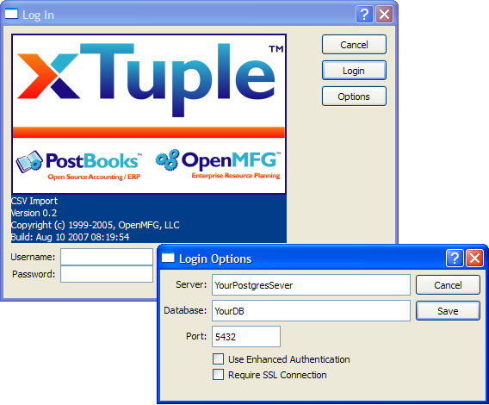
If you are using CSVimp in conjunction with an xTuple Application, you should use a fully privileged user such as 'mfgadmin'.

The screen below shows the main CSVimp screen called CSV Tool. The source CSV file has been opened using File | Open CSV. Note that the “Treat first row as header information” has been checked because the first row of the CSV file contains column heading descriptions.

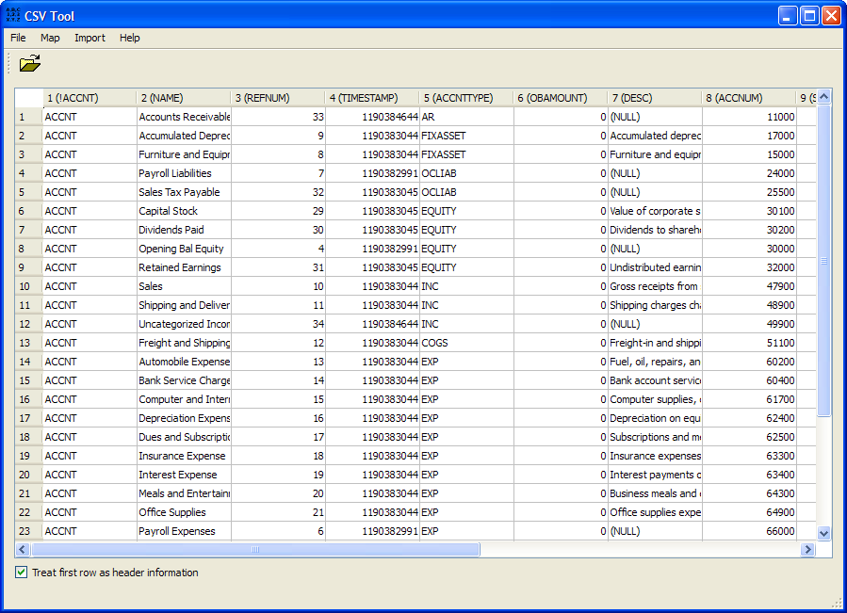

Next, the creation of the Map is initiated. This is done with the option Map | Edit and then clicking the ADD button and providing a name (shown below). If you are working with an existing map such as one you created previously or the example provided on SourceForge, simply click File | Open and locate the mapping file.
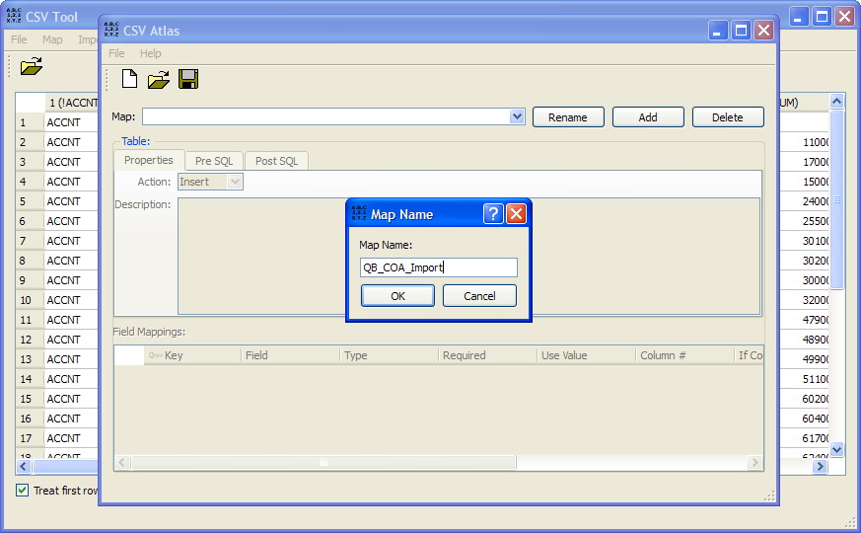

If you are creating a new Map, you will be prompted immediately with the Select Table dialog (see below). Note that API views are prefixed with “api.” because unlike tables which reside in the public schema, API Views are their own “api” schema.

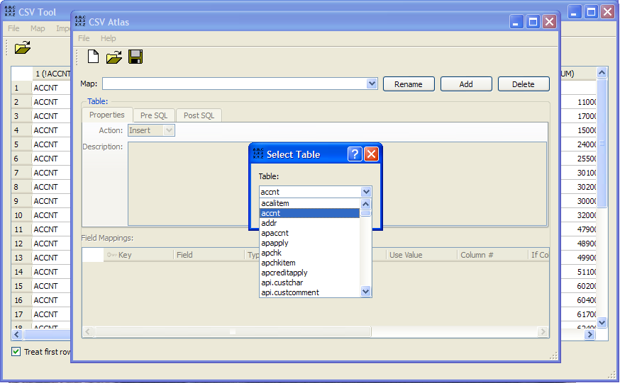

Next we are presented with the CSV Atlas screen (see below). Currently the only action that functions is “Insert.” Below it is a field for providing a Description for your map.

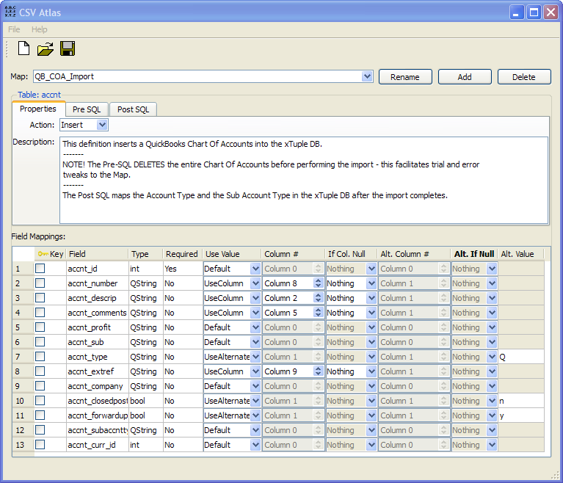

We may optionally click on the Pre SQL tab and enter SQL that is performed before the insert is executed. In the example shown, a technique is employed that is common when importing into an empty DB and trial and error is expected. The line (DELETE FROM accnt;) deletes all rows in the table before the insert. So, if our previous import did not provide the desired results, this SQL statement removes those result before the next import is executed.

NOTE: If you are using the example map provided and you are importing into a DB with data that you want to keep, remove this Pre SQL statement!

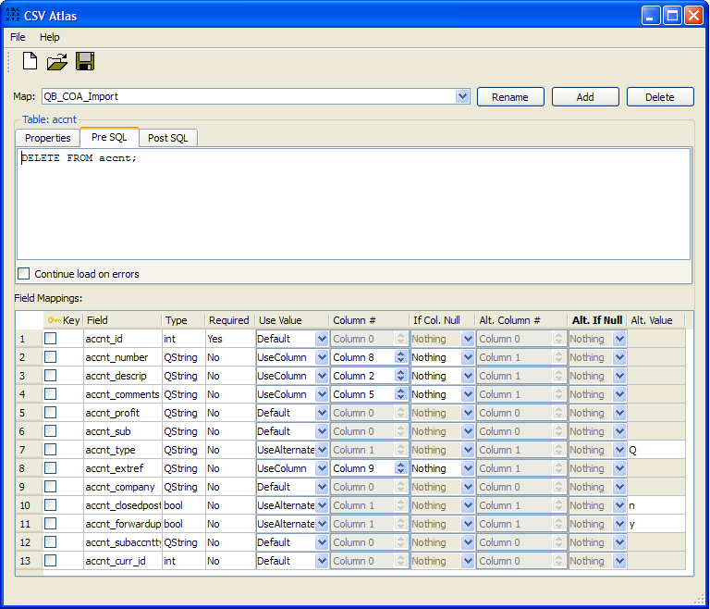

The Post SQL tab enables use to define SQL that is executed after the CSV insert is performed. In this example, the Quick Books account type was stored in the xTuple Chart of Accounts Comment field during the import. Then, after the import finishes, this SQL updates the newly imported Accounts with the proper xTuple Subaccount Type based on the value found in the Comments field. This SQL also sets each Account to the proper Account type based on the value in the Comments field.

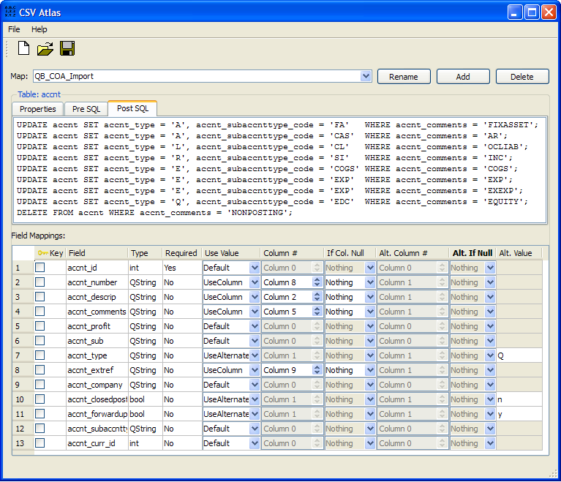
In the Field Mappings section of the screen we define the relationship between columns in the xTuple DB table accnt and columns in our CSV import file. This example also uses the UseAlternateValue option. For example, all imported accounts were given the value Q (equity) for accnt_type. Then, the Post SQL looked at the value that was placed in the accnt_comments column and updated each account to the correct xTuple account type.

We initiate an import with Import | Start found on the CSV Tool screen. If errors are encountered we see a Log screen immediately. We can always call up this screen with Import | View Log. If there are no errors we receive the message “Your import was completed successfully.”

Below we see the xTuple Chart of Accounts screen and the details for a specific account displayed in the Account Number screen.

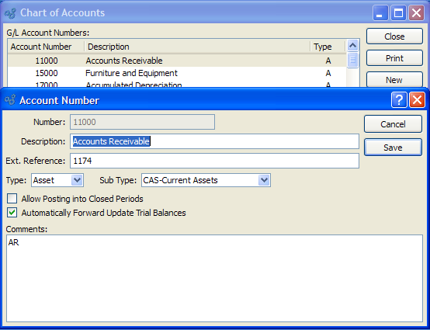

This data was originally exported from QuickBooks into a CSV file. The CSVimp tool was then used to define a map the relates the columns of the CSV file to the columns in the xTuple application table accnt along with Pre SQL and Post SQL. The result is a fully defined and usable Chart of Accounts in the xTuple application.

