Mustafa Abdi
Maabdi@uw.edu

Blood anomaly detection: Identifying abnormal blood cells to verify diagnosis

Abstract:
In medical settings, where precise detection of abnormal cells is essential for disease diagnosis, blood cell data analysis is crucial. However, it can be difficult and time-consuming to differentiate between normal and abnormal cells using only visual inspection. Because of this, doctors might have trouble reliably recognizing abnormal cells which could result in delayed or incorrect diagnoses. This project aims to determine how different blood cell characteristics such as cell diameter, nucleus area, chromatin density, cytoplasm ratio, circularity, and granularity affect the ability to identify abnormal cells. The goal of this project is to identify the factors that are most important in differentiating between normal and abnormal cells by looking at patterns and relationships within these features.

Data Dictionary:
The dataset and variables used in this project are from Kaggle, a blood cell anomaly detection dataset. It came with its own reference table that explains
• anomaly_label (Categorical): Indicates whether the blood cell is normal (0) or abnormal (1). This is the target variable used for prediction.
• cell_type (Categorical): The specific type of blood cell (e.g., Neutrophil, Lymphocyte, Blast Cell), each associated with different biological functions and clinical conditions.
• disease_category (Categorical): The classification of the condition associated with the cell (e.g., Normal_WBC, Leukemia, Anemia, Infection, Artefact).
• cell_diameter_um (Numerical): The diameter of the blood cell measured in micrometers.
• nucleus_area_pct (Numerical): The percentage of the total cell area occupied by the nucleus.
• chromatin_density (Numerical): A measure of how dense the chromatin structure is within the nucleus.
• cytoplasm_ratio (Numerical): The proportion of cytoplasm relative to the total cell size.
• circularity (Numerical): A measure of how closely the shape of the cell resembles a perfect circle.
• granularity_score (Numerical): A measurement of the texture or granularity of the cell, often associated with infection or abnormality.
• lobularity_score (Numerical) A measure of the lobed structure of the nucleus, which can indicate certain conditions.
• membrane_smoothness (Numerical) A measure of the smoothness or irregularity of the cell membrane.
Data Understanding:
Univariate properties Table
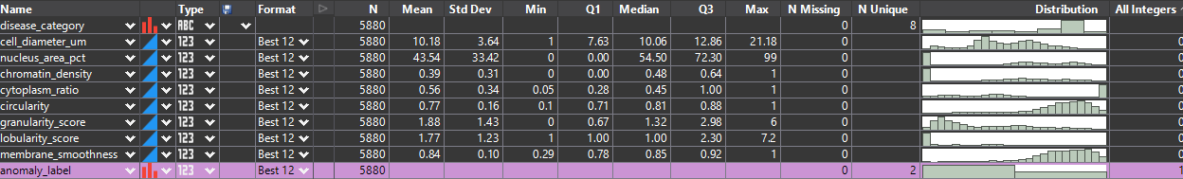
Feature | Var Type | Data Type | Count | Missing | % | Unique | Min | Q1 | Med | Q3 | Max | Mean | SD | Skew | Kurt
Anomaly label | Label | Categorical | 5880 | 0 | 0 | 2 | - | - | - | - | - | - | - | - | -
Disease category | Feature | Categorical | 5880 | 0 | 0 | 8 | - | - | - | - | - | - | - | - | -
Cell diameter um | Feature | Continuous | 5880 | 0 | 0 |  | 1.0 | 7.63 | 10.06 | 12.86 | 21.18 | 10.18 | 3.64 | -0.09 | -0.36
Nucleus area pct | Feature | Continuous | 5880 | 0 | 0 |  | 0 | 0 | 54.5 | 72.3 | 99 | 43.54 | 33.42 | -0.31 | -1.49
Chromatin density | Feature | Continuous | 5880 | 0 | 0 |  | 0 | 0 | 0.48 | 0.64 | 1 | 0.39 | 0.31 | -0.15 | -1.44
Cytoplasm ratio | Feature | Continuous | 5880 | 0 | 0 |  | 0.05 | 0.28 | 0.45 | 1 | 1 | 0.56 | 0.34 | 0.03 | -1.51
circularity | Feature | Continuous | 5880 | 0 | 0 |  | 0.10 | 0.71 | 0.81 | 0.88 | 1 | 0.77 | 0.16 | -1.38 | 1.89
Granularity score | Feature | Continuous | 5880 | 0 | 0 |  | 0 | 0.67 | 1.32 | 2.98 | 6 | 1.88 | 1.43 | 0.76 | -0.54
Lobularity score | Feature | Continuous | 5880 | 0 | 0 |  | 1 | 1 | 1 | 2.3 | 7.2 | 1.77 | 1.23 | 1.63 | 2.00
Membrane smoothness | Feature | Continuous | 5880 | 0 | 0 |  | 0.29 | 0.75 | 0.85 | 0.90 | 1 | 0.84 | 0.10 | -0.92 | 1.55

Histogram for Numeric variables:

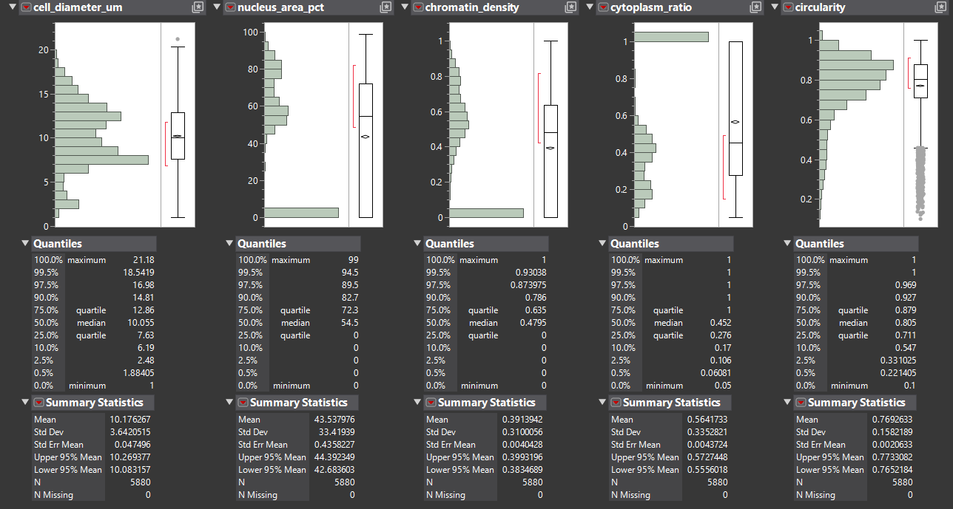
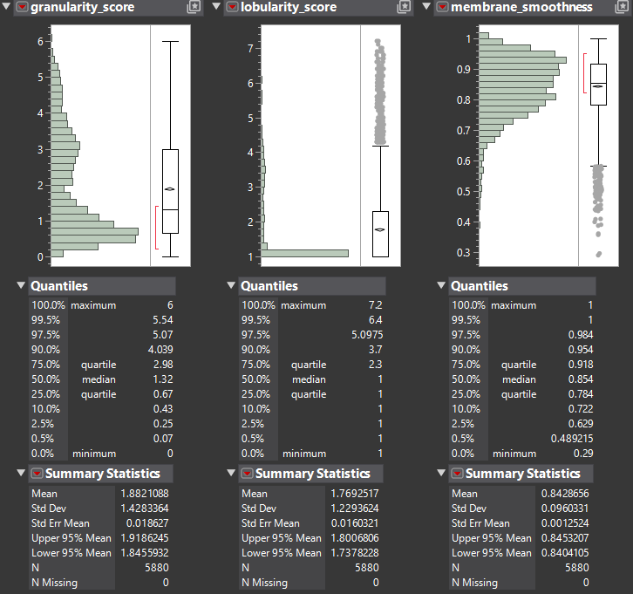
Correlation Matrix
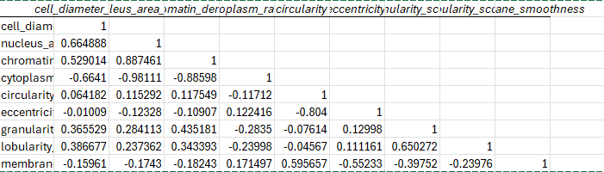
A strong positive relationship between nucleus_area_pct and chromatin_density.
The strongest correlation observed is between nucleus_area_pct and cytoplasm_ratio (r ~ -0.98), indicating a very strong inverse relationship between these variables.

Bivariate Analysis Summary Table
Feature | Analysis | Effect size | P-value
cell_diameter_um | F-stat | 6.98 | 0.0082
nucleus_area_pct | F-stat | 11.75 | 0.0006
chromatin_density | F-stat | 310.53 | <0.0001
circularity | F-stat | 1035.48 | <0.0001
granularity_score | F-stat | 452.33 | <0.0001
lobularity_score | F-stat | 35.61 | <0.0001
membrane_smoothness | F-stat | 122.21 | <0.0001

Bivariate Analysis:
chromatin_density
H#: Chromatin density has a relationship with anomaly_label
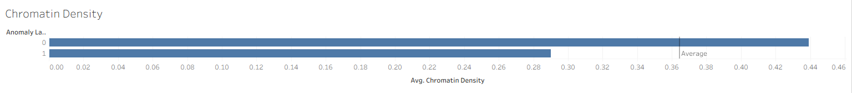
ANOVA (F-test)
C2N
F = 310.53
p < 0.0001
R-squared = 0.05
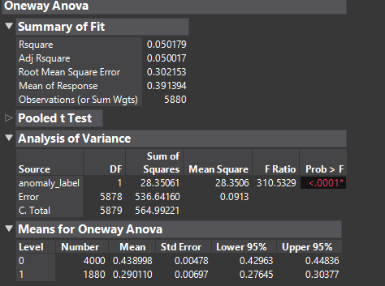
Summary
Chromatin density shows a strong and statistically significant relationship with anomaly_label.

Circularity
H#: There is a significant difference in circularity between normal cells and anomaly cells
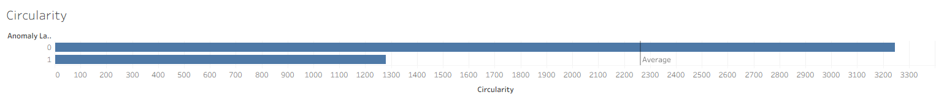
ANOVA (F-test)
C2N
F = 1035.48
p < 0.0001
R-squared = 0.15

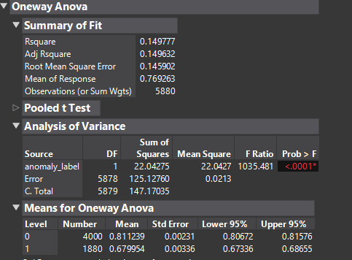
Summary
Circularity has the strongest relationship with anomaly_label among the features analyzed. It is the most useful single predictor of abnormal cells.
Granularity_score
H#: There is a significant difference in granularity score between normal and anomaly cells

ANOVA (F-test)
C2N
F = 452.33
p < 0.0001
R-squared = 0.07

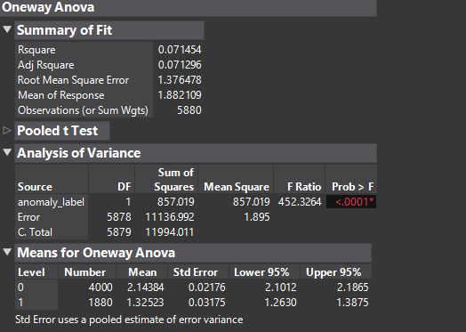
Summary
Granularity scores show a statistically significant difference between the cells.
Lobularity_score
H#: There is a significant difference in lobularity score between normal and abnormal cells.
ANOVA (F-test)
C2N
F = 35.67
p < 0.0001
R-squared = 0.01
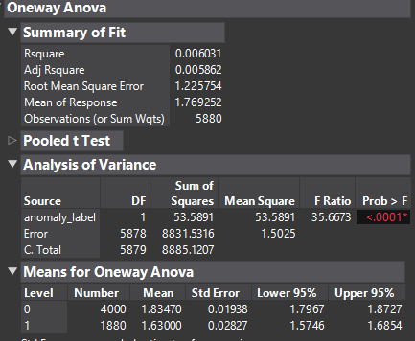
Summary
Lobularity score shows a statistically significant difference between groups

Membrane_smoothness
H#: There is a significant difference in membrane smoothness between normal and abnormal cells
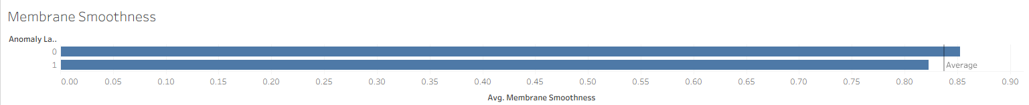
ANOVA (F-test)
C2N
F = 122.21
p < 0.0001
R-squared = 0.02
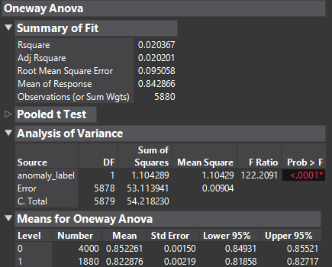
Summary
Membrane smoothness shows a statistically significant difference between normal and anormal cells.

Data preparation:
No missing Data
No outliers in Data
Transformed anomaly label as categorical. 0 or 1 represents yes/no not actual values
Looked for skewness
70/30 training/validation split

Modeling:

Model Iteration | Features | Algorithm | Accuracy | AUC
1 | cell_diameter_um, nucleus_area_pct, chromatin_density, Cytoplasm_ratio,  Circularity, granularity_score,  lobularity_score, membrane_smoothness  (All features) | Logistic Regression | 0.85 | 0.829
2 | nucleus_area_pct, chromatin_density,  Cytoplasm_ratio, Circularity,  granularity_score, lobularity_score,  (removed lowest) | Logistic Regression | 0.86 | 0.827
3 | chromatin_density, Circularity, granularity_score, lobularity_score,  (top four) | Logistic Regression | 0.80 | 0.762
4 | cell_diameter_um, nucleus_area_pct, chromatin_density, Cytoplasm_ratio,  Circularity, granularity_score,  lobularity_score, membrane_smoothness  (All features) | Decision Tree | N/A | 0.816
5 | cell_diameter_um, nucleus_area_pct, chromatin_density, Cytoplasm_ratio,  Circularity, granularity_score,  lobularity_score, membrane_smoothness  (All features) | Neural | 0.93 | N/A

Best Model: Iteration 1
Based on validation AUC, logistic regression using all features was selected as the best-performing model. It had the highest AUC.
The neural network achieved the highest accuracy (~93%). But the AUC was not available, making it difficult to compare with other models.
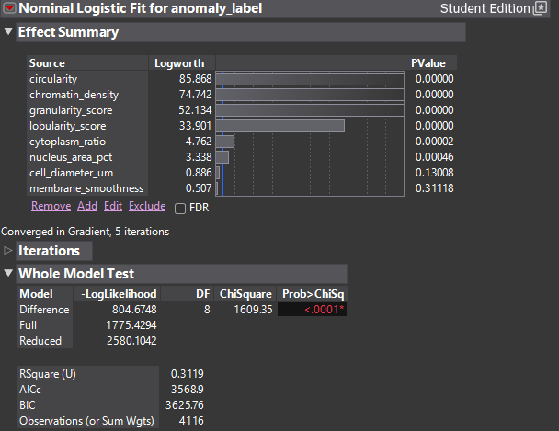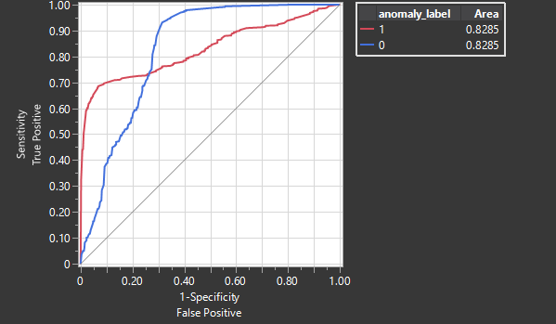
Used the model to create a prediction formula and applied a new row of fictitious data to estimate the probability of a cell being abnormal.

Findings:
- Key Predictors of Cell Anomalies:
The analysis showed that circularity, chromatin density, granularity score, and lobularity score had the largest impact on predicting abnormal cells. They all have a p < .00001. This shows that cells that are less circular and more granular are likely to be abnormal

- Significant predictior
Cytoplasm ratio and nucleus area percentage also contributed to model performance. These variables are not key predictors individually. They improved overall classification accuracy when included alongside the primary features. This can be seen as the model got slightly worse when they were removed (iteration 2)

- Not significant
Membrane smoothness was not statistically significant and was removed in reduced models. cell diameter showed only a weak effect compared to other predictors. These features show that not all features can impact the finding of abnormal cells.

- Best Model and model simplification
The full logistic regression model achieved the highest AUC (0.829), indicating the best classification performance. Using only the top features reduced AUC (0.762), showing that too much simplification harms accuracy. The nueral model had a high accuracy but no AUC available. This made it dificult to compare it to the other models.

Comments:
Tableau link
https://public.tableau.com/app/profile/mustafa.abdi/viz/FinalProjectmaabdi/Dashboard1?publish=yes
Tableau explanation:
Bar Chart: Distribution of Normal vs Abnormal Cells
This visualization shows the overall balance between normal and abnormal cells in the dataset.
Use:
Helps identify whether the dataset is imbalanced and gives context for further analysis of anomalies.

Histogram: Granularity Distribution by Cell Type
This shows how granularity values are distributed across normal and abnormal cells, helping identify differences in texture.
Use:
Useful for identifying whether granularity is a distinguishing feature between normal and abnormal cells, which can support classification models.

Scatter Plot: Chromatin Density vs Circularity
This visualization explores the relationship between two key features and shows how normal and abnormal cells are distributed in feature space.
Use:
Helps detect patterns or clustering that may separate abnormal cells from normal ones, which is useful for predictive modeling.

Bar Chart: Average Circularity by Cell Type
This summarizes the difference in average circularity between normal and abnormal cells.
Use:
Helps determine whether circularity is a strong indicator of abnormality and supports feature importance analysis.

Conclusion:
Circularity, chromatin density, and granularity are key indicators of cell structure and play an important role in distinguishing normal and abnormal cells. The dashboard reveals that circularity and chromatin density show clear differences between the two groups, suggesting they are strong predictors of abnormality.

