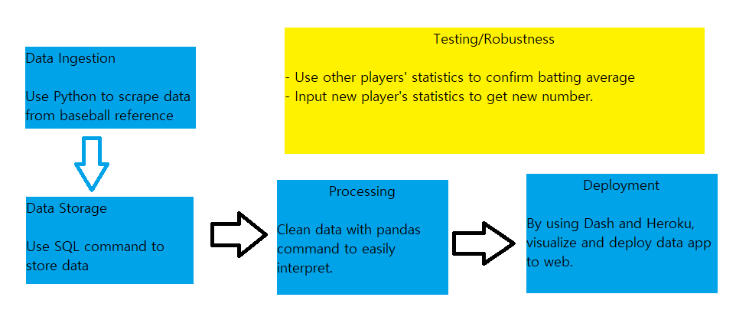

I am currently finished first box which is data digestion.

I will start working on data storage and further process next week.