ArchiMetal
9 Oct 2025 00:49:05

 | Purpose
This Case Study demonstrates the value of the ArchiMate 2.1 modeling language for planning and expressing complex business transformation.
The Case Study is about a fictitious manufacturer named ArchiMetal. Through high-level architecture modeling, the ArchiMate language illuminates the coherence between an organization, and its processes, applications, and infrastructure. This Case Study presents examples of ArchiMate models that can be elaborated as necessary for analysis, communication, decision support, and implementation.
 | ArchiMetal | 2 | / 236
 | Views
 | 01-1. Summary functional enterprise-control model
 | No viewpoint
 | 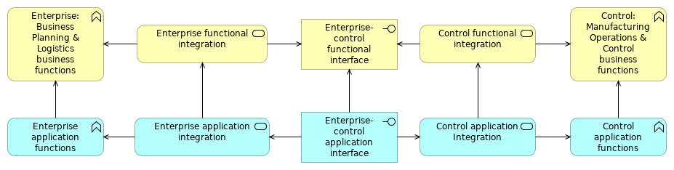
 | Elements
 | Element | Type
 | Control application functions | Application Function
 | Control application Integration | Application Service
 | Control functional integration | Business Service
 | Control: Manufacturing Operations & Control business functions | Business Function
 | Enterprise application functions | Application Function
 | Enterprise application integration | Application Service
 | Enterprise functional integration | Business Service
 | Enterprise-control application interface | Application Interface
 | Enterprise-control functional interface | Business Interface
 | Enterprise: Business Planning & Logistics business functions | Business Function
 | ArchiMetal |  | 3 | / 236
 | 01-2. Enterprise functions
 | No viewpoint
 | 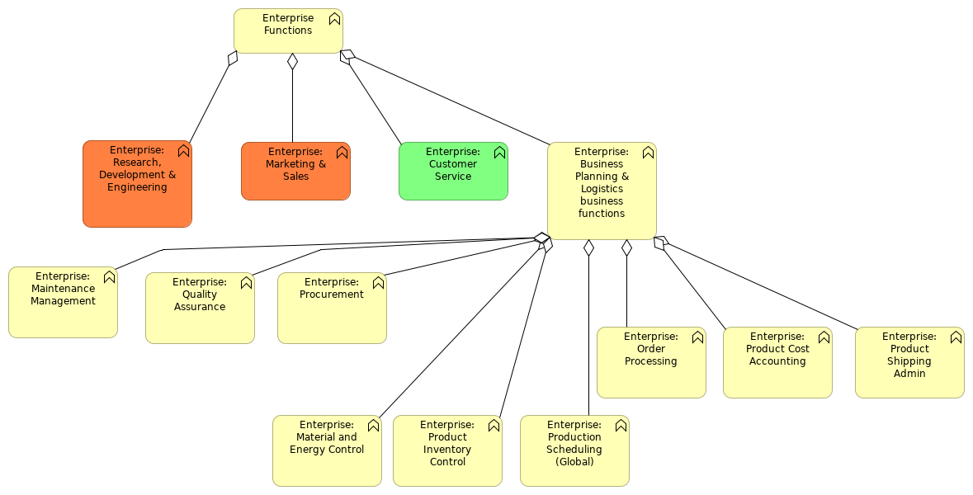
 | Elements
 | Element | Type
 | Enterprise Functions | Business Function
 | Enterprise: Business Planning & Logistics business functions | Business Function
 | Enterprise: Customer Service | Business Function
 | Enterprise: Maintenance Management | Business Function
 | Enterprise: Marketing & Sales | Business Function
 | Enterprise: Material and Energy Control | Business Function
 | Enterprise: Order Processing | Business Function
 | Enterprise: Procurement | Business Function
 | Enterprise: Product Cost Accounting | Business Function
 | Enterprise: Product Inventory Control | Business Function
 | Enterprise: Product Shipping Admin | Business Function
 | Enterprise: Production Scheduling (Global) | Business Function
 | Enterprise: Quality Assurance | Business Function
 | Enterprise: Research, Development & Engineering | Business Function
 | ArchiMetal |  | 4 | / 236
 | 01-3. Control functions
 | No viewpoint
 | 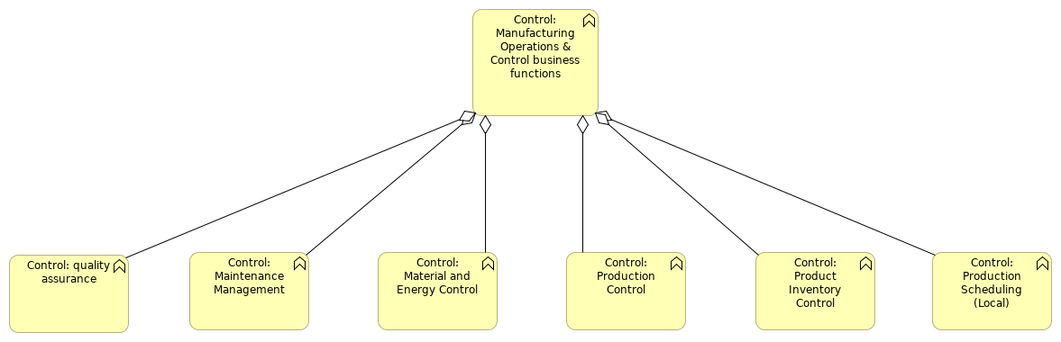
 | Elements
 | Element | Type
 | Control: Maintenance Management | Business Function
 | Control: Manufacturing Operations & Control business functions | Business Function
 | Control: Material and Energy Control | Business Function
 | Control: Product Inventory Control | Business Function
 | Control: Production Control | Business Function
 | Control: Production Scheduling (Local) | Business Function
 | Control: quality assurance | Business Function
 | ArchiMetal |  | 5 | / 236
 | 01. Functional enterprise-control model
 | No viewpoint
 | 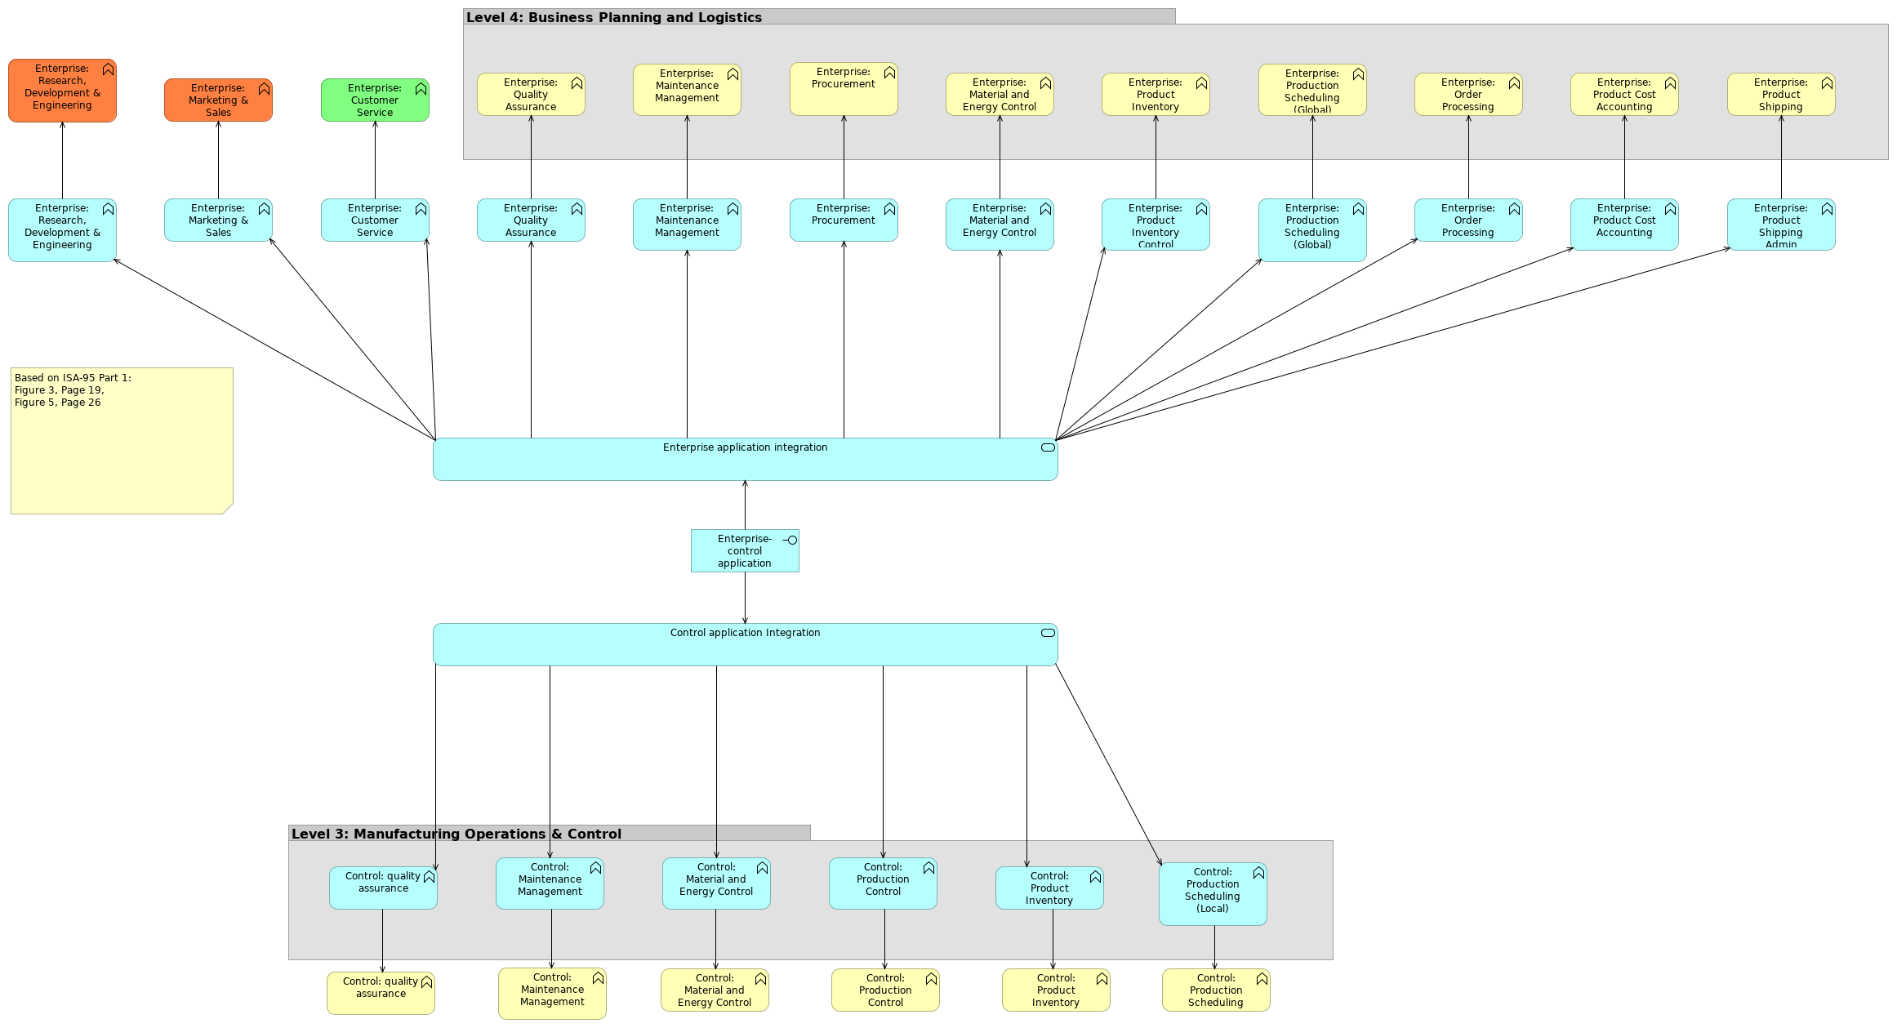
 | Elements
 | Element | Type
 | Control application Integration | Application Service
 | Control: Maintenance Management | Business Function
 | Control: Maintenance Management | Application Function
 | Control: Material and Energy Control | Business Function
 | Control: Material and Energy Control | Application Function
 | Control: Product Inventory Control | Business Function
 | Control: Product Inventory Control | Application Function
 | Control: Production Control | Business Function
 | Control: Production Control | Application Function
 | Control: Production Scheduling (Local) | Business Function
 | Control: Production Scheduling (Local) | Application Function
 | Control: quality assurance | Business Function
 | Control: quality assurance | Application Function
 | Enterprise application integration | Application Service
 | Enterprise-control application interface | Application Interface
 | Enterprise: Customer Service | Application Function
 | Enterprise: Customer Service | Business Function
 | Enterprise: Maintenance Management | Application Function
 | Enterprise: Maintenance Management | Business Function
 | Enterprise: Marketing & Sales | Application Function
 | Enterprise: Marketing & Sales | Business Function
 | Enterprise: Material and Energy Control | Application Function
 | ArchiMetal |  | 6 | / 236
 | Element | Type
 | Enterprise: Material and Energy Control | Business Function
 | Enterprise: Order Processing | Application Function
 | Enterprise: Order Processing | Business Function
 | Enterprise: Procurement | Application Function
 | Enterprise: Procurement | Business Function
 | Enterprise: Product Cost Accounting | Application Function
 | Enterprise: Product Cost Accounting | Business Function
 | Enterprise: Product Inventory Control | Application Function
 | Enterprise: Product Inventory Control | Business Function
 | Enterprise: Product Shipping Admin | Application Function
 | Enterprise: Product Shipping Admin | Business Function
 | Enterprise: Production Scheduling (Global) | Application Function
 | Enterprise: Production Scheduling (Global) | Business Function
 | Enterprise: Quality Assurance | Application Function
 | Enterprise: Quality Assurance | Business Function
 | Enterprise: Research, Development & Engineering | Application Function
 | Enterprise: Research, Development & Engineering | Business Function
 | ArchiMetal |  | 7 | / 236
 | 01. Stakeholder
 | No viewpoint
 | 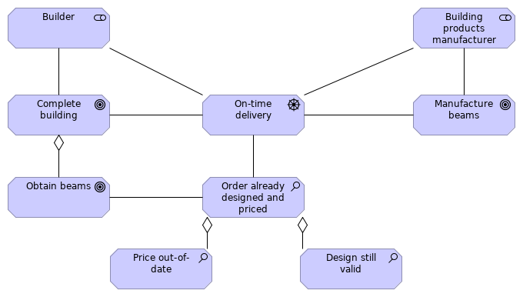
 | Elements
 | Element | Type
 | Builder | Stakeholder
 | Building products manufacturer | Stakeholder
 | Complete building | Goal
 | Design still valid | Assessment
 | Manufacture beams | Goal
 | Obtain beams | Goal
 | On-time delivery | Driver
 | Order already designed and priced | Assessment
 | Price out-of-date | Assessment
 | ArchiMetal |  | 8 | / 236
 | 02. Activity model of production operations management
 | No viewpoint
 | 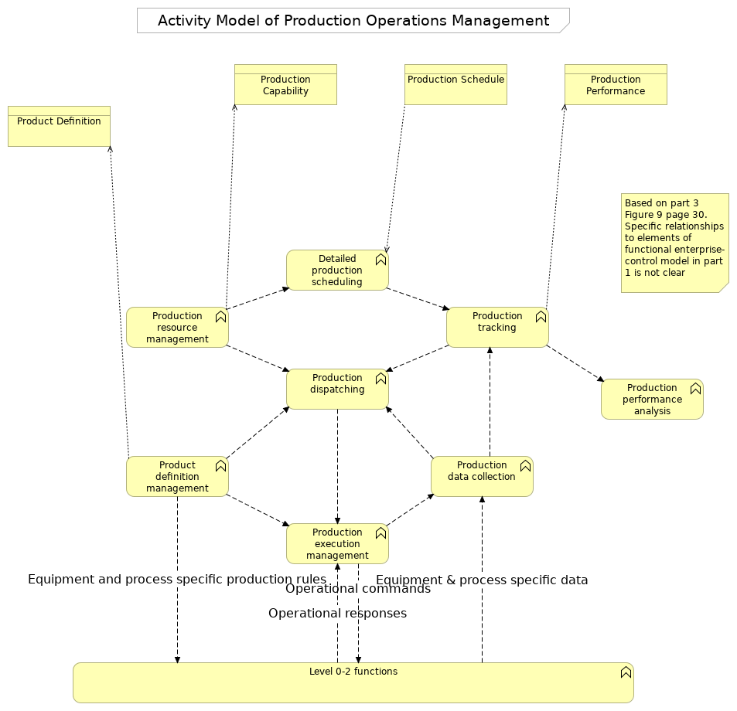
 | Elements
 | Element | Type
 | Detailed production scheduling | Business Function
 | Level 0-2 functions | Business Function
 | Product Definition | Business Object
 | Product definition management | Business Function
 | Production Capability | Business Object
 | Production data collection | Business Function
 | Production dispatching | Business Function
 | Production execution management | Business Function
 | ArchiMetal |  | 9 | / 236
 | Element | Type
 | Production Performance | Business Object
 | Production performance analysis | Business Function
 | Production resource management | Business Function
 | Production Schedule | Business Object
 | Production tracking | Business Function
 | ArchiMetal |  | 10 | / 236
 | 02. Order-to-contract
 | No viewpoint
 | 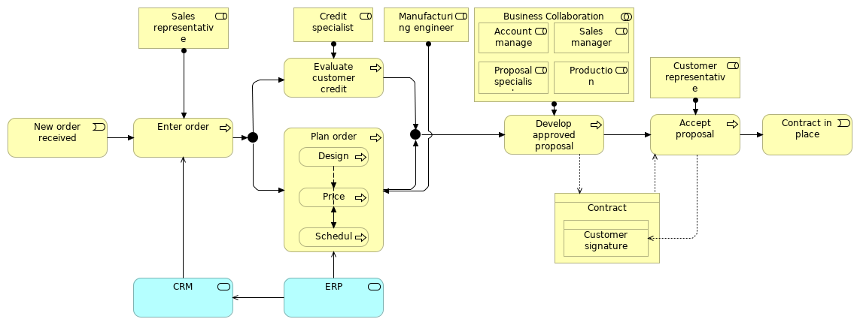
 | Elements
 | Element | Type
 | Accept proposal | Business Process
 | Account manager | Business Role
 | Business Collaboration | Business Collaboration
 | Contract | Business Object
 | Contract in place | Business Event
 | Credit specialist | Business Role
 | CRM | Application Service
 | Customer representative | Business Role
 | Customer signature | Business Object
 | Design | Business Process
 | Develop approved proposal | Business Process
 | Enter order | Business Process
 | ERP | Application Service
 | Evaluate customer credit | Business Process
 | Manufacturing engineer | Business Role
 | New order received | Business Event
 | Plan order | Business Process
 | Price | Business Process
 | Production manager | Business Role
 | Proposal specialist | Business Role
 | Sales manager | Business Role
 | Sales representative | Business Role
 | Schedule | Business Process
 | ArchiMetal |  | 11 | / 236
 | 03. CRM functional model
 | No viewpoint
 | 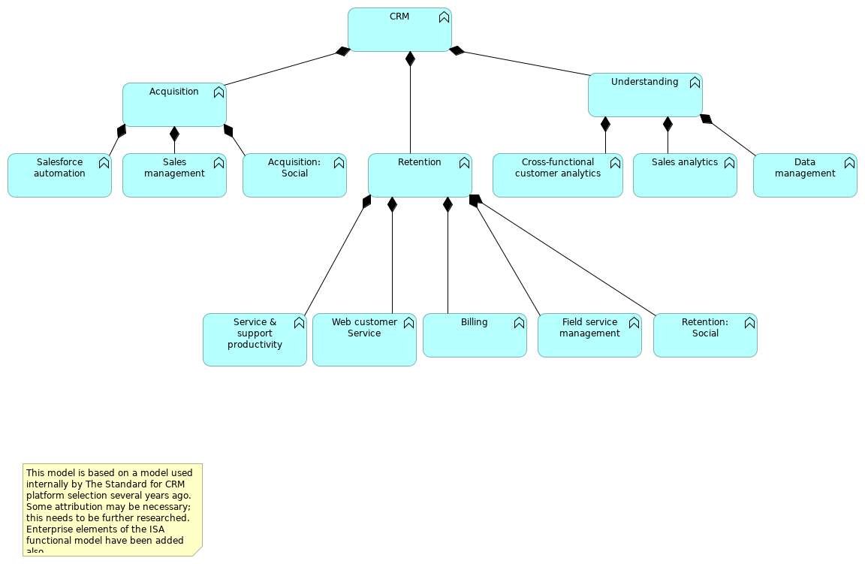
 | Elements
 | Element | Type
 | Acquisition | Application Function
 | Acquisition: Social | Application Function
 | Billing | Application Function
 | CRM | Application Function
 | Cross-functional customer analytics | Application Function
 | Data management | Application Function
 | Field service management | Application Function
 | Retention | Application Function
 | Retention: Social | Application Function
 | Sales analytics | Application Function
 | Sales management | Application Function
 | Salesforce automation | Application Function
 | Service & support productivity | Application Function
 | Understanding | Application Function
 | Web customer Service | Application Function
 | ArchiMetal |  | 12 | / 236
 | 03. Order fulfillment
 | No viewpoint
 | 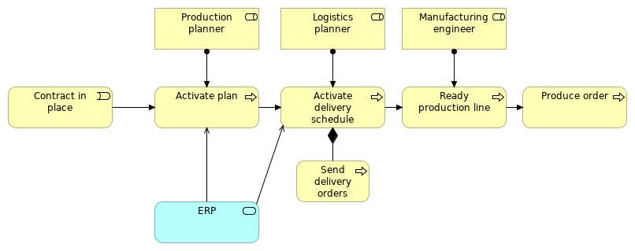
 | Elements
 | Element | Type
 | Activate delivery schedule | Business Process
 | Activate plan | Business Process
 | Contract in place | Business Event
 | ERP | Application Service
 | Logistics planner | Business Role
 | Manufacturing engineer | Business Role
 | Produce order | Business Process
 | Production planner | Business Role
 | Ready production line | Business Process
 | Send delivery orders | Business Process
 | ArchiMetal |  | 13 | / 236
 | 04. Change in production schedule
 | No viewpoint
 | 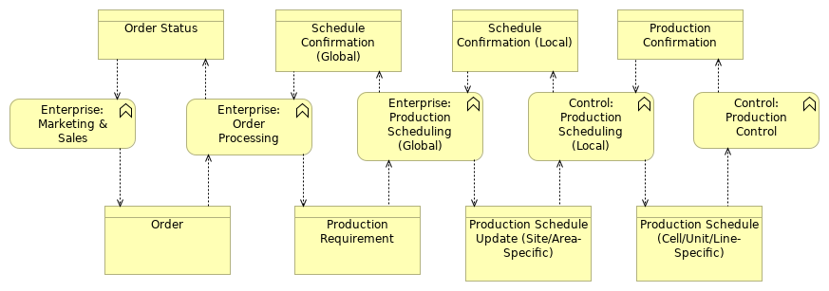
 | Elements
 | Element | Type
 | Control: Production Control | Business Function
 | Control: Production Scheduling (Local) | Business Function
 | Enterprise: Marketing & Sales | Business Function
 | Enterprise: Order Processing | Business Function
 | Enterprise: Production Scheduling (Global) | Business Function
 | Order | Business Object
 | Order Status | Business Object
 | Production Confirmation | Business Object
 | Production Requirement | Business Object
 | Production Schedule (Cell/Unit/Line-Specific) | Business Object
 | Production Schedule Update (Site/Area-Specific) | Business Object
 | Schedule Confirmation (Global) | Business Object
 | Schedule Confirmation (Local) | Business Object
 | ArchiMetal |  | 14 | / 236
 | 04. Enterprise business function usage of CRM application functions
 | No viewpoint
 | 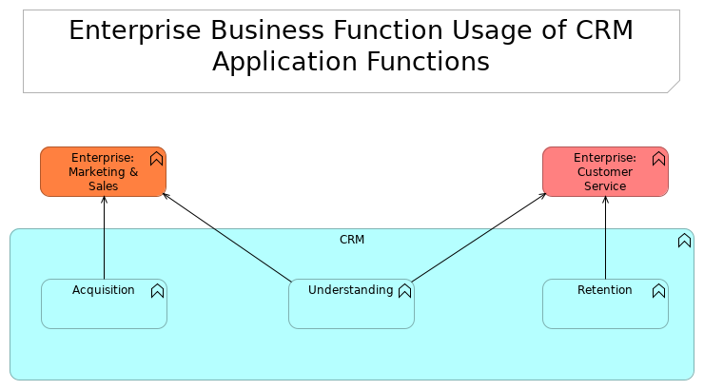
 | Elements
 | Element | Type
 | Acquisition | Application Function
 | CRM | Application Function
 | Enterprise: Customer Service | Business Function
 | Enterprise: Marketing & Sales | Business Function
 | Retention | Application Function
 | Understanding | Application Function
 | ArchiMetal |  | 15 | / 236
 | 05. Equipment hierarchy
 | No viewpoint
 | 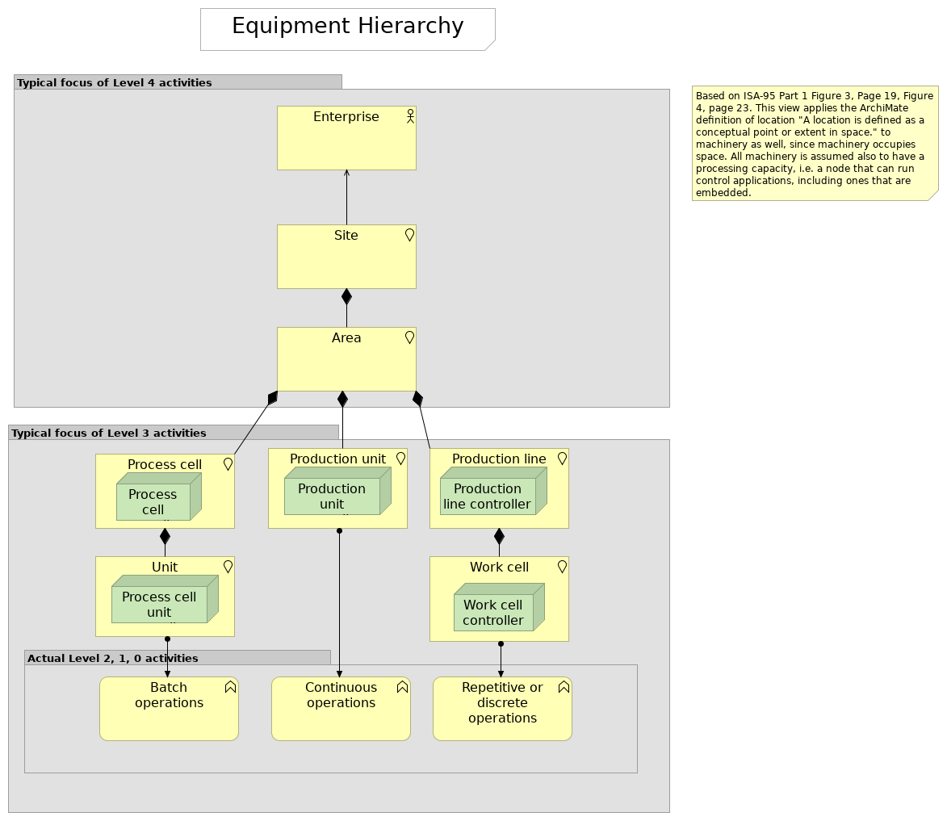
 | Elements
 | Element | Type
 | Area | Location
 | Batch operations | Business Function
 | Continuous operations | Business Function
 | Enterprise | Business Actor
 | Process cell | Location
 | Process cell controller | Node
 | Process cell unit controller | Node
 | Production line | Location
 | Production line controller | Node
 | Production unit | Location
 | Production unit controller | Node
 | Repetitive or discrete operations | Business Function
 | ArchiMetal |  | 16 | / 236
 | Element | Type
 | Site | Location
 | Unit | Location
 | Work cell | Location
 | Work cell controller | Node
 | ArchiMetal |  | 17 | / 236
 | 05. ISA-95 messages exchanged
 | No viewpoint
 | 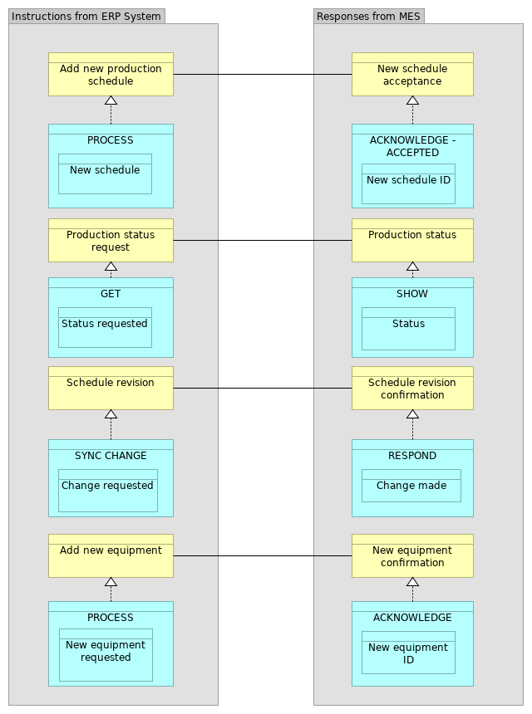
 | ArchiMetal | 18 | / 236
 | Elements
 | Element | Type
 | ACKNOWLEDGE | Data Object
 | ACKNOWLEDGE - ACCEPTED | Data Object
 | Add new equipment | Business Object
 | Add new production schedule | Business Object
 | Change made | Data Object
 | Change requested | Data Object
 | GET | Data Object
 | New equipment confirmation | Business Object
 | New equipment ID | Data Object
 | New equipment requested | Data Object
 | New schedule | Data Object
 | New schedule acceptance | Business Object
 | New schedule ID | Data Object
 | PROCESS | Data Object
 | PROCESS | Data Object
 | Production status | Business Object
 | Production status request | Business Object
 | RESPOND | Data Object
 | Schedule revision | Business Object
 | Schedule revision confirmation | Business Object
 | SHOW | Data Object
 | Status | Data Object
 | Status requested | Data Object
 | SYNC CHANGE | Data Object
 | ArchiMetal |  | 19 | / 236
 | 06. Message verbs by transaction models
 | No viewpoint
 | 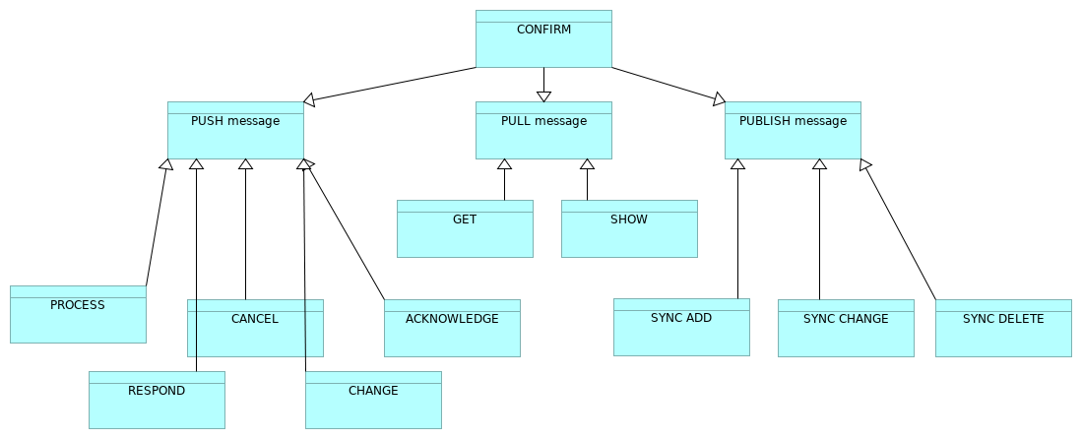
 | Elements
 | Element | Type
 | ACKNOWLEDGE | Data Object
 | CANCEL | Data Object
 | CHANGE | Data Object
 | CONFIRM | Data Object
 | GET | Data Object
 | PROCESS | Data Object
 | PUBLISH message | Data Object
 | PULL message | Data Object
 | PUSH message | Data Object
 | RESPOND | Data Object
 | SHOW | Data Object
 | SYNC ADD | Data Object
 | SYNC CHANGE | Data Object
 | SYNC DELETE | Data Object
 | ArchiMetal |  | 20 | / 236
 | 07. Object model summary
 | No viewpoint
 | 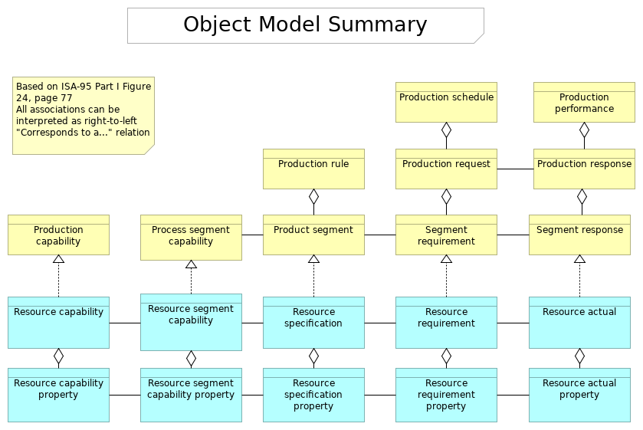
 | Elements
 | Element | Type
 | Process segment capability | Business Object
 | Product segment | Business Object
 | Production capability | Business Object
 | Production performance | Business Object
 | Production request | Business Object
 | Production response | Business Object
 | Production rule | Business Object
 | Production schedule | Business Object
 | Resource actual | Data Object
 | Resource actual property | Data Object
 | Resource capability | Data Object
 | Resource capability property | Data Object
 | Resource requirement | Data Object
 | Resource requirement property | Data Object
 | Resource segment capability | Data Object
 | Resource segment capability property | Data Object
 | Resource specification | Data Object
 | Resource specification property | Data Object
 | ArchiMetal |  | 21 | / 236
 | Element | Type
 | Segment requirement | Business Object
 | Segment response | Business Object
 | ArchiMetal |  | 22 | / 236
 | 08. ArchiMate generic example
 | No viewpoint
 | 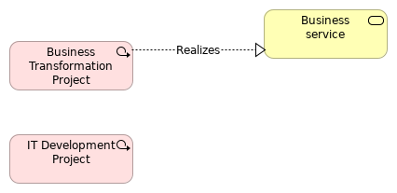
 | Elements
 | Element | Type
 | Business service | Business Service
 | Business Transformation Project | Work Package
 | IT Development Project | Work Package
 | ArchiMetal |  | 23 |  | / 236
 | Actor cooperation view for Enterprise-control application interface
 | No viewpoint
 | 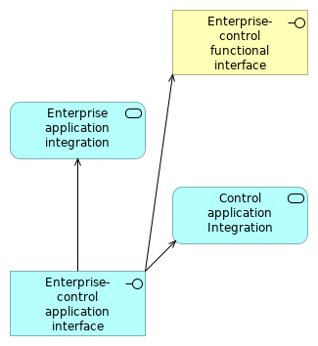
 | Elements
 | Element | Type
 | Control application Integration | Application Service
 | Enterprise application integration | Application Service
 | Enterprise-control application interface | Application Interface
 | Enterprise-control functional interface | Business Interface
 | ArchiMetal |  |  | 24 | / 236
 | Actor cooperation view for Enterprise-control functional interface
 | No viewpoint
 | 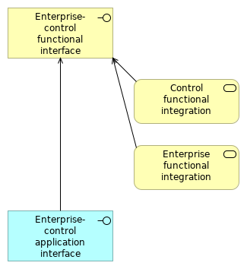
 | Elements
 | Element | Type
 | Control functional integration | Business Service
 | Enterprise functional integration | Business Service
 | Enterprise-control application interface | Application Interface
 | Enterprise-control functional interface | Business Interface
 | ArchiMetal |  |  | 25 | / 236
 | Application architecture
 | No viewpoint
 | 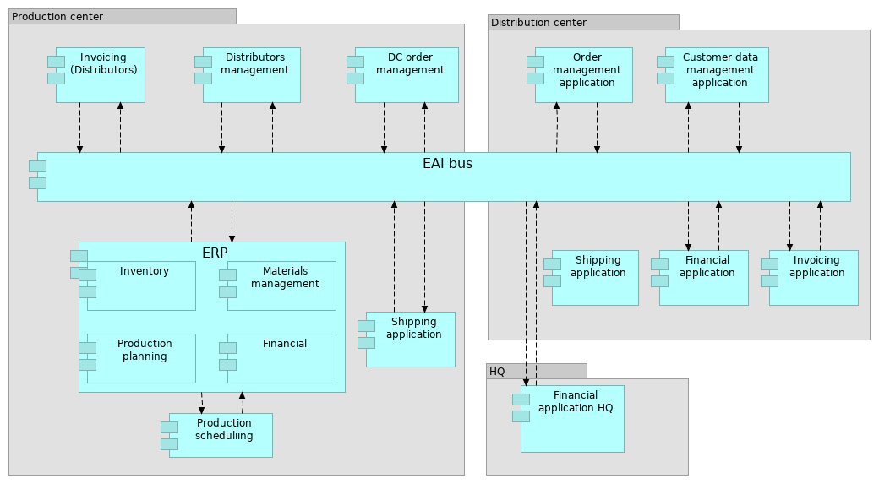
 | Elements
 | Element | Type
 | Customer data management application | Application Component
 | DC order management | Application Component
 | Distributors management | Application Component
 | EAI bus | Application Component
 | ERP | Application Component
 | Financial | Application Component
 | Financial application | Application Component
 | Financial application HQ | Application Component
 | Inventory | Application Component
 | Invoicing (Distributors) | Application Component
 | Invoicing application | Application Component
 | Materials management | Application Component
 | Order management application | Application Component
 | Production planning | Application Component
 | Production scheduliing | Application Component
 | Shipping application | Application Component
 | ArchiMetal |  | 26 | / 236
 | Application architecture_new_1
 | No viewpoint
 | 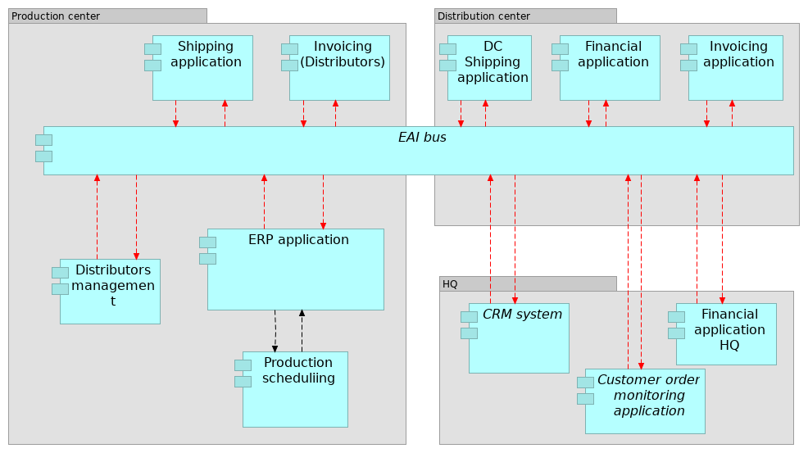
 | Elements
 | Element | Type
 | CRM system | Application Component
 | Customer order monitoring application | Application Component
 | DC Shipping application | Application Component
 | Distributors management | Application Component
 | EAI bus | Application Component
 | ERP application | Application Component
 | Financial application | Application Component
 | Financial application HQ | Application Component
 | Invoicing (Distributors) | Application Component
 | Invoicing application | Application Component
 | Production scheduliing | Application Component
 | Shipping application | Application Component
 | ArchiMetal |  | 27 | / 236
 | Architecture vision
 | No viewpoint
 | 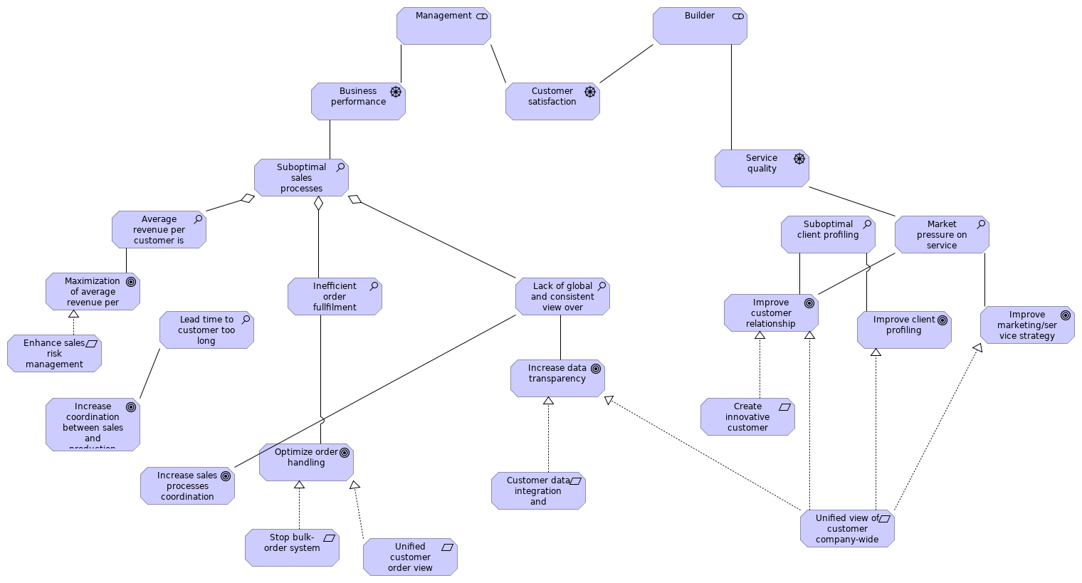
 | Elements
 | Element | Type
 | Average revenue per customer is too low | Assessment
 | Builder | Stakeholder
 | Business performance | Driver
 | Create innovative customer services | Requirement
 | Customer data integration and standardisation | Requirement
 | Customer satisfaction | Driver
 | Enhance sales risk management | Requirement
 | Improve client profiling | Goal
 | Improve customer relationship management | Goal
 | Improve marketing/service strategy | Goal
 | Increase coordination between sales and production processes | Goal
 | Increase data transparency | Goal
 | Increase sales processes coordination | Goal
 | Inefficient order fullfilment | Assessment
 | Lack of global and consistent view over customer | Assessment
 | Lead time to customer too long | Assessment
 | Management | Stakeholder
 | Market pressure on service innovation | Assessment
 | Maximization of average revenue per customer | Goal
 | Optimize order handling | Goal
 | Service quality | Driver
 | ArchiMetal |  | 28 | / 236
 | Element | Type
 | Stop bulk-order system | Requirement
 | Suboptimal client profiling | Assessment
 | Suboptimal sales processes | Assessment
 | Unified customer order view company-wide | Requirement
 | Unified view of customer company-wide | Requirement
 | ArchiMetal |  | 29 | / 236
 | As-is Application Architecture
 | No viewpoint
 | 
 | ArchiMetal |  | 30 | / 236
 | As-is Business Architecture
 | No viewpoint
 | ArchiMetal |  | 31 | / 236
 | As-is Technology Architecture
 | No viewpoint
 | ArchiMetal |  | 32 | / 236
 | Background and use of standards/reference models
 | No viewpoint
 | ArchiMetal |  | 33 | / 236
 | Business functions
 | No viewpoint
 | 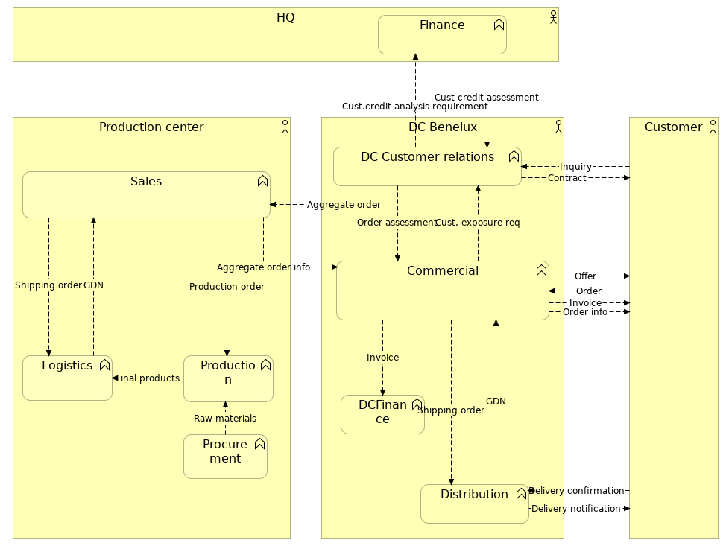
 | Elements
 | Element | Type
 | Commercial | Business Function
 | Customer | Business Actor
 | DC Benelux | Business Actor
 | DC Customer relations | Business Function
 | DCFinance | Business Function
 | Distribution | Business Function
 | Finance | Business Function
 | HQ | Business Actor
 | Logistics | Business Function
 | Procurement | Business Function
 | Production | Business Function
 | Production center | Business Actor
 | Sales | Business Function
 | ArchiMetal |  | 34 | / 236
 | ArchiMetal | 35 | / 236
 | Business functions_new
 | No viewpoint
 | 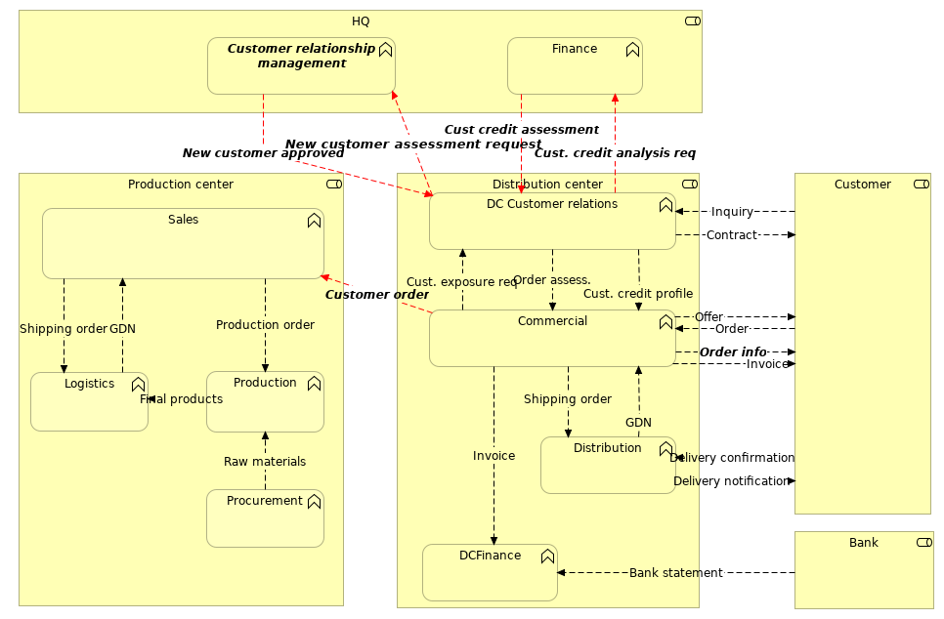
 | Elements
 | Element | Type
 | Bank | Business Role
 | Commercial | Business Function
 | Customer | Business Role
 | Customer relationship management | Business Function
 | DC Customer relations | Business Function
 | DCFinance | Business Function
 | Distribution | Business Function
 | Distribution center | Business Role
 | Finance | Business Function
 | HQ | Business Role
 | Logistics | Business Function
 | Procurement | Business Function
 | Production | Business Function
 | Production center | Business Role
 | Sales | Business Function
 | ArchiMetal |  | 36 | / 236
 | Business performance - solutions
 | No viewpoint
 | 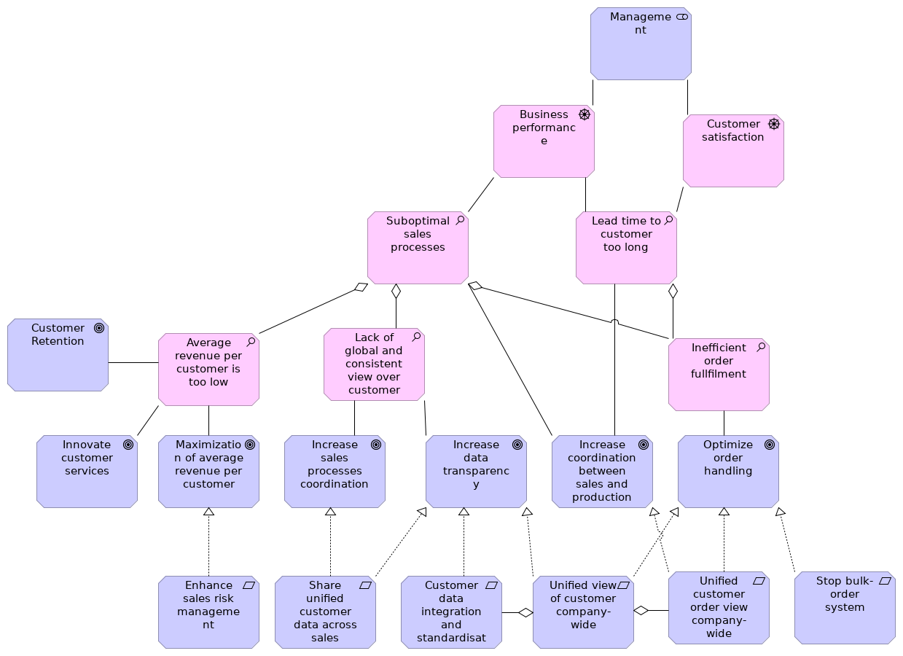
 | Elements
 | Element | Type
 | Average revenue per customer is too low | Assessment
 | Business performance | Driver
 | Customer data integration and standardisation | Requirement
 | Customer Retention | Goal
 | Customer satisfaction | Driver
 | Enhance sales risk management | Requirement
 | Increase coordination between sales and production processes | Goal
 | Increase data transparency | Goal
 | Increase sales processes coordination | Goal
 | Inefficient order fullfilment | Assessment
 | Innovate customer services | Goal
 | Lack of global and consistent view over customer | Assessment
 | Lead time to customer too long | Assessment
 | Management | Stakeholder
 | Maximization of average revenue per customer | Goal
 | ArchiMetal |  | 37 | / 236
 | Element | Type
 | Optimize order handling | Goal
 | Share unified customer data across sales processes | Requirement
 | Stop bulk-order system | Requirement
 | Suboptimal sales processes | Assessment
 | Unified customer order view company-wide | Requirement
 | Unified view of customer company-wide | Requirement
 | ArchiMetal |  | 38 | / 236
 | Compare Approaches
 | No viewpoint
 | 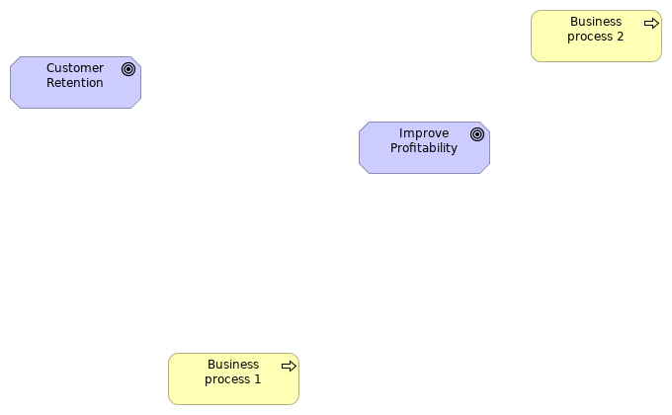
 | Elements
 | Element | Type
 | Business process 1 | Business Process
 | Business process 2 | Business Process
 | Customer Retention | Goal
 | Improve Profitability | Goal
 | ArchiMetal |  | 39 | / 236
 | Contracting
 | No viewpoint
 | 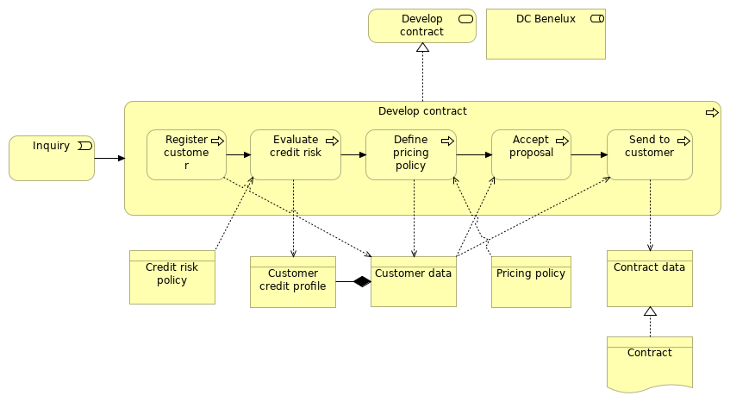
 | Elements
 | Element | Type
 | Accept proposal | Business Process
 | Contract | Representation
 | Contract data | Business Object
 | Credit risk policy | Business Object
 | Customer credit profile | Business Object
 | Customer data | Business Object
 | DC Benelux | Business Role
 | Define pricing policy | Business Process
 | Develop contract | Business Process
 | Develop contract service | Business Service
 | Evaluate credit risk | Business Process
 | Inquiry | Business Event
 | Pricing policy | Business Object
 | Register customer | Business Process
 | Send to customer | Business Process
 | ArchiMetal |  | 40 | / 236
 | Contracting_IT
 | No viewpoint
 | 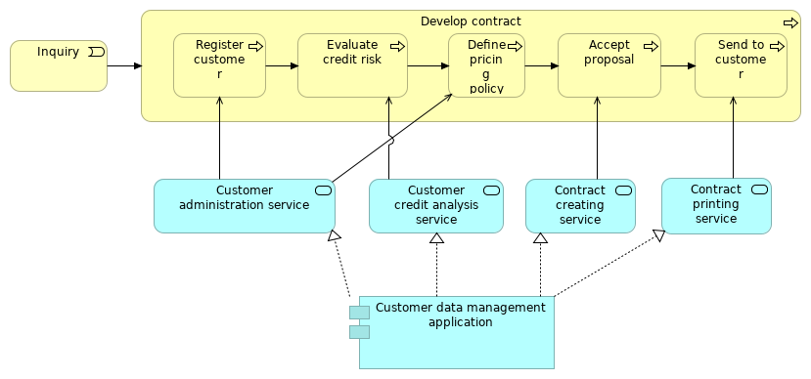
 | Elements
 | Element | Type
 | Accept proposal | Business Process
 | Contract creating service | Application Service
 | Contract printing service | Application Service
 | Customer administration service | Application Service
 | Customer credit analysis service | Application Service
 | Customer data management application | Application Component
 | Define pricing policy | Business Process
 | Develop contract | Business Process
 | Evaluate credit risk | Business Process
 | Inquiry | Business Event
 | Register customer | Business Process
 | Send to customer | Business Process
 | ArchiMetal |  | 41 | / 236
 | Contracting_new
 | No viewpoint
 | 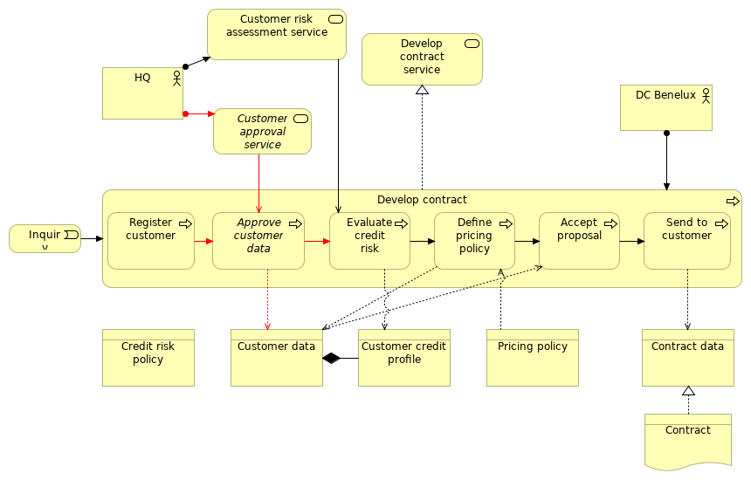
 | Elements
 | Element | Type
 | Accept proposal | Business Process
 | Approve customer data | Business Process
 | Contract | Representation
 | Contract data | Business Object
 | Credit risk policy | Business Object
 | Customer approval service | Business Service
 | Customer credit profile | Business Object
 | Customer data | Business Object
 | Customer risk assessment service | Business Service
 | DC Benelux | Business Actor
 | Define pricing policy | Business Process
 | Develop contract | Business Process
 | Develop contract service | Business Service
 | Evaluate credit risk | Business Process
 | HQ | Business Actor
 | Inquiry | Business Event
 | Pricing policy | Business Object
 | Register customer | Business Process
 | Send to customer | Business Process
 | ArchiMetal |  | 42 | / 236
 | ArchiMetal | 43 | / 236
 | Contracting_new_IT
 | No viewpoint
 | 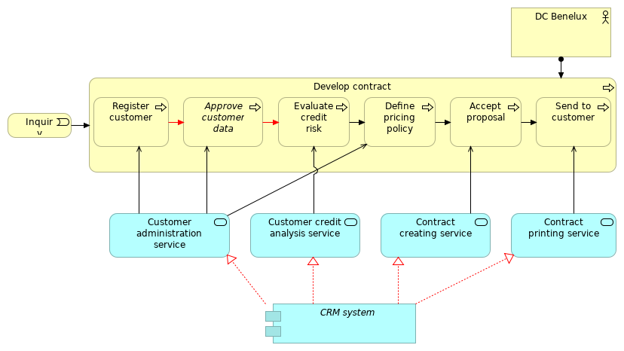
 | Elements
 | Element | Type
 | Accept proposal | Business Process
 | Approve customer data | Business Process
 | Contract creating service | Application Service
 | Contract printing service | Application Service
 | CRM system | Application Component
 | Customer administration service | Application Service
 | Customer credit analysis service | Application Service
 | DC Benelux | Business Actor
 | Define pricing policy | Business Process
 | Develop contract | Business Process
 | Evaluate credit risk | Business Process
 | Inquiry | Business Event
 | Register customer | Business Process
 | Send to customer | Business Process
 | ArchiMetal |  | 44 | / 236
 | CRM behavior_new_1
 | No viewpoint
 | 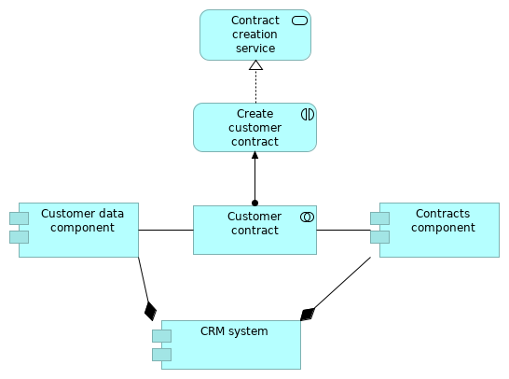
 | Elements
 | Element | Type
 | Contract creation service | Application Service
 | Contracts component | Application Component
 | Create customer contract | Application Interaction
 | CRM system | Application Component
 | Customer contract | Application Collaboration
 | Customer data component | Application Component
 | ArchiMetal |  | 45 | / 236
 | CRM behavior_new_2
 | No viewpoint
 | 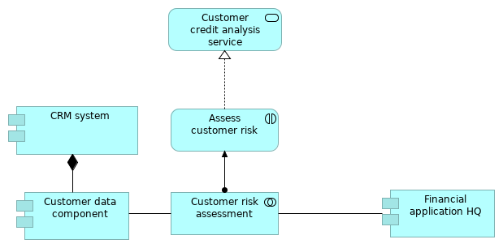
 | Elements
 | Element | Type
 | Assess customer risk | Application Interaction
 | CRM system | Application Component
 | Customer credit analysis service | Application Service
 | Customer data component | Application Component
 | Customer risk assessment | Application Collaboration
 | Financial application HQ | Application Component
 | ArchiMetal |  | 46 | / 236
 | CRM behavior_new_3
 | No viewpoint
 | 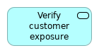
 | Elements
 | Element |  | Type
 | Verify customer exposure service |  | Application Service
 | ArchiMetal |  |  | 47 | / 236
 | CRM behavior_new_4
 | No viewpoint
 | 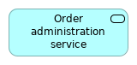
 | Elements
 | Element |  | Type
 | Order administration service |  | Application Service
 | ArchiMetal |  |  | 48 | / 236
 | CRM implementation and migration
 | No viewpoint
 | 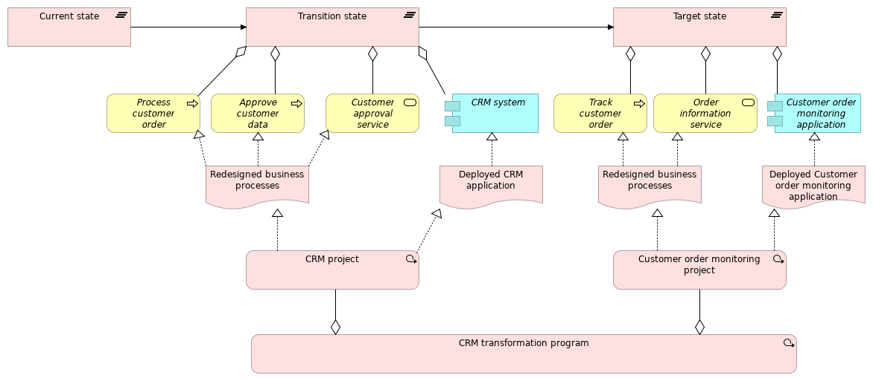
 | Elements
 | Element | Type
 | Approve customer data | Business Process
 | CRM project | Work Package
 | CRM system | Application Component
 | CRM transformation program | Work Package
 | Current state | Plateau
 | Customer approval service | Business Service
 | Customer order monitoring application | Application Component
 | Customer order monitoring project | Work Package
 | Deployed CRM application | Deliverable
 | Deployed Customer order monitoring application | Deliverable
 | Order information service | Business Service
 | Process customer order | Business Process
 | Redesigned business processes | Deliverable
 | Redesigned business processes | Deliverable
 | Target state | Plateau
 | Track customer order | Business Process
 | Transition state | Plateau
 | ArchiMetal |  | 49 | / 236
 | CRM structure_new
 | No viewpoint
 | 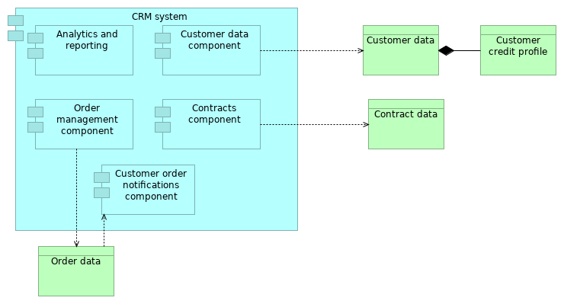
 | Elements
 | Element | Type
 | Analytics and reporting | Application Component
 | Contract data | Business Object
 | Contracts component | Application Component
 | CRM system | Application Component
 | Customer credit profile | Business Object
 | Customer data | Business Object
 | Customer data component | Application Component
 | Customer order notifications component | Application Component
 | Order data | Business Object
 | Order management component | Application Component
 | ArchiMetal |  | 50 | / 236
 | Cust. services
 | No viewpoint
 | 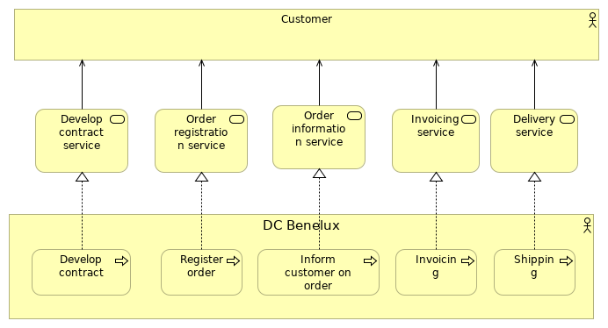
 | Elements
 | Element | Type
 | Customer | Business Actor
 | DC Benelux | Business Actor
 | Delivery service | Business Service
 | Develop contract | Business Process
 | Develop contract service | Business Service
 | Inform customer on order | Business Process
 | Invoicing | Business Process
 | Invoicing service | Business Service
 | Order information service | Business Service
 | Order registration service | Business Service
 | Register order | Business Process
 | Shipping | Business Process
 | ArchiMetal |  | 51 | / 236
 | Cust. services_new
 | No viewpoint
 | 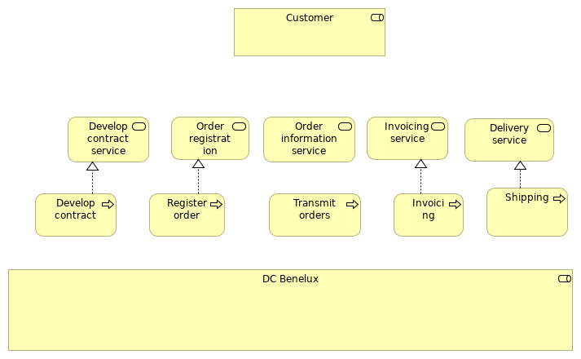
 | Elements
 | Element | Type
 | Customer | Business Role
 | DC Benelux | Business Role
 | Delivery service | Business Service
 | Develop contract | Business Process
 | Develop contract service | Business Service
 | Invoicing | Business Process
 | Invoicing service | Business Service
 | Order information service | Business Service
 | Order registration service | Business Service
 | Register order | Business Process
 | Shipping | Business Process
 | Transmit orders | Business Process
 | ArchiMetal |  | 52 | / 236
 | Cust. services_new
 | No viewpoint
 | 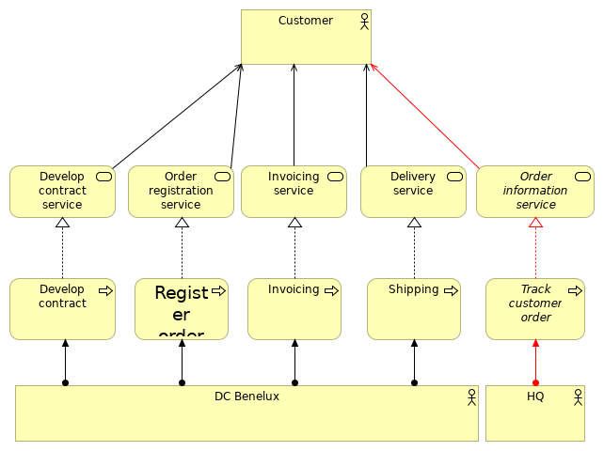
 | Elements
 | Element | Type
 | Customer | Business Actor
 | DC Benelux | Business Actor
 | Delivery service | Business Service
 | Develop contract | Business Process
 | Develop contract service | Business Service
 | HQ | Business Actor
 | Invoicing | Business Process
 | Invoicing service | Business Service
 | Order information service | Business Service
 | Order registration service | Business Service
 | Register order | Business Process
 | Shipping | Business Process
 | Track customer order | Business Process
 | ArchiMetal |  | 53 | / 236
 | ArchiMetal | 54 | / 236
 | Customer satisfaction focus - solutions
 | No viewpoint
 | 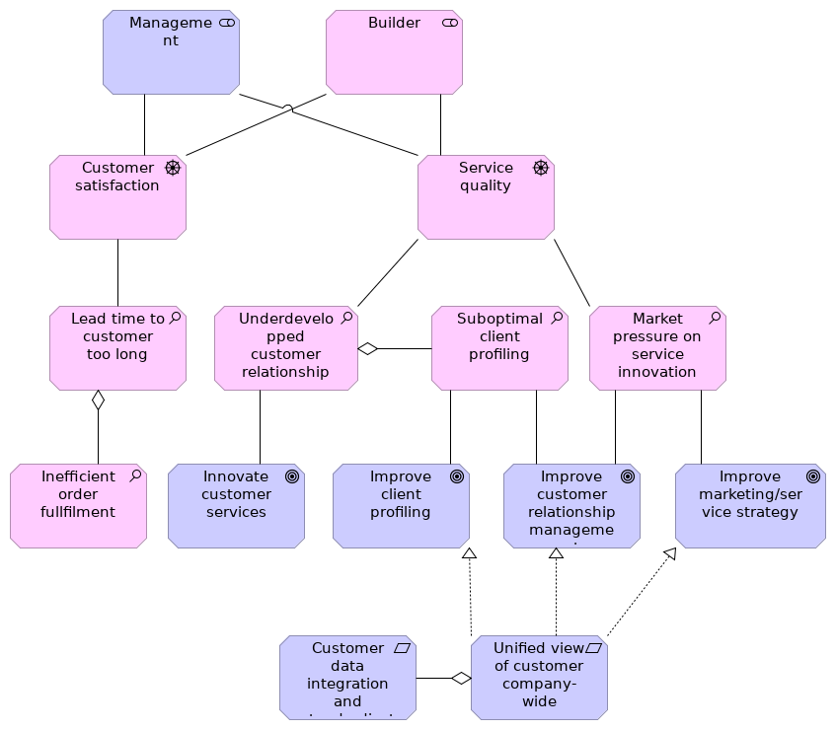
 | Elements
 | Element | Type
 | Builder | Stakeholder
 | Customer data integration and standardisation | Requirement
 | Customer satisfaction | Driver
 | Improve client profiling | Goal
 | Improve customer relationship management | Goal
 | Improve marketing/service strategy | Goal
 | Inefficient order fullfilment | Assessment
 | Innovate customer services | Goal
 | Lead time to customer too long | Assessment
 | Management | Stakeholder
 | Market pressure on service innovation | Assessment
 | ArchiMetal |  | 55 | / 236
 | Element | Type
 | Service quality | Driver
 | Suboptimal client profiling | Assessment
 | Underdevelopped customer relationship | Assessment
 | Unified view of customer company-wide | Requirement
 | ArchiMetal |  | 56 | / 236
 | Evaluate credit risk
 | No viewpoint
 | 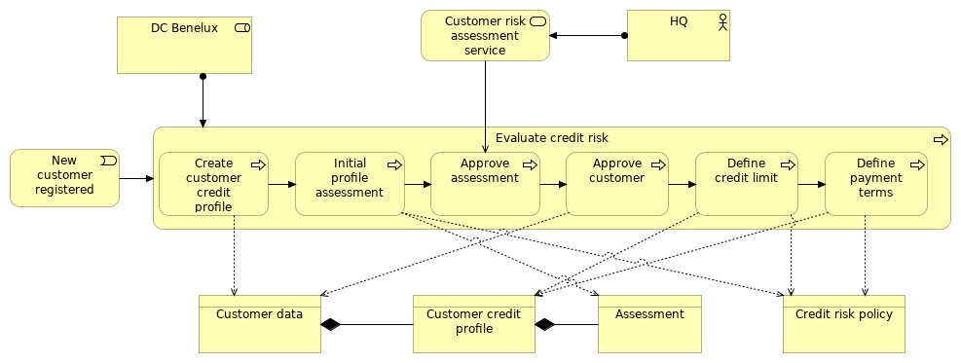
 | Elements
 | Element | Type
 | Approve assessment | Business Process
 | Approve customer | Business Process
 | Assessment | Business Object
 | Create customer credit profile | Business Process
 | Credit risk policy | Business Object
 | Customer credit profile | Business Object
 | Customer data | Business Object
 | Customer risk assessment service | Business Service
 | DC Benelux | Business Role
 | Define credit limit | Business Process
 | Define payment terms | Business Process
 | Evaluate credit risk | Business Process
 | HQ | Business Actor
 | Initial profile assessment | Business Process
 | New customer registered | Business Event
 | ArchiMetal |  | 57 | / 236
 | Evaluate credit risk_new
 | No viewpoint
 | 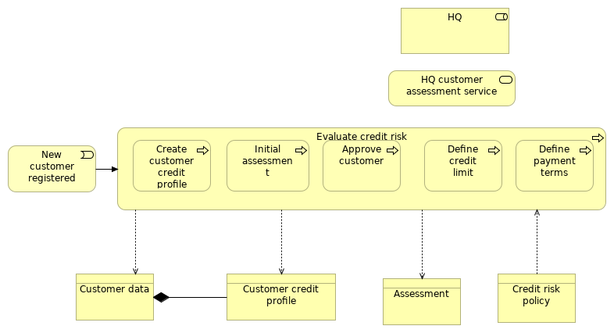
 | Elements
 | Element | Type
 | Approve customer | Business Process
 | Assessment | Business Object
 | Create customer credit profile | Business Process
 | Credit risk policy | Business Object
 | Customer credit profile | Business Object
 | Customer data | Business Object
 | Define credit limit | Business Process
 | Define payment terms | Business Process
 | Evaluate credit risk | Business Process
 | HQ | Business Role
 | HQ customer assessment service | Business Service
 | Initial assessment | Business Process
 | New customer registered | Business Event
 | ArchiMetal |  | 58 | / 236
 | Functional enterprise-control model
 | No viewpoint
 | 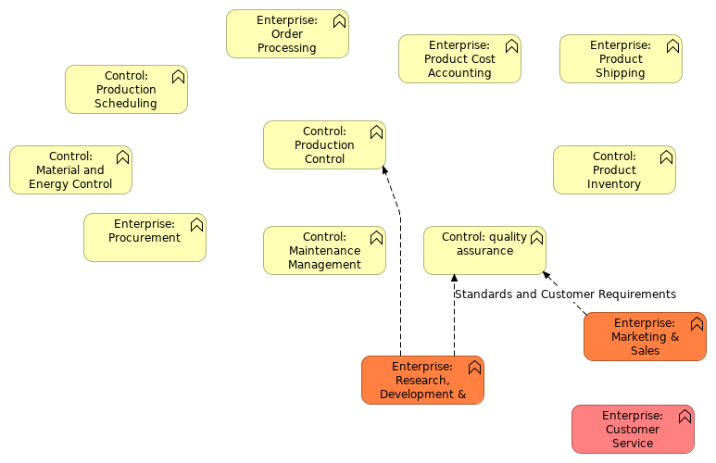
 | Elements
 | Element | Type
 | Control: Maintenance Management | Business Function
 | Control: Material and Energy Control | Business Function
 | Control: Product Inventory Control | Business Function
 | Control: Production Control | Business Function
 | Control: Production Scheduling (Local) | Business Function
 | Control: quality assurance | Business Function
 | Enterprise: Customer Service | Business Function
 | Enterprise: Marketing & Sales | Business Function
 | Enterprise: Order Processing | Business Function
 | Enterprise: Procurement | Business Function
 | Enterprise: Product Cost Accounting | Business Function
 | Enterprise: Product Shipping Admin | Business Function
 | Enterprise: Research, Development & Engineering | Business Function
 | ArchiMetal |  | 59 | / 236
 | Gap analysis and roadmaps
 | No viewpoint
 | 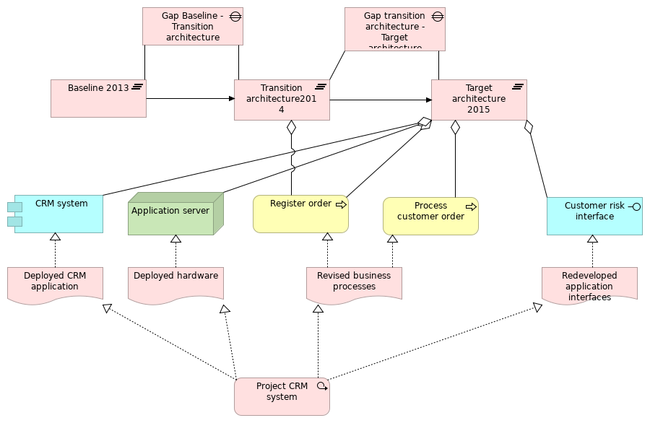
 | Elements
 | Element | Type
 | Application server | Node
 | Baseline 2013 | Plateau
 | CRM system | Application Component
 | Customer risk interface | Application Interface
 | Deployed CRM application | Deliverable
 | Deployed hardware | Deliverable
 | Gap Baseline - Transition architecture | Gap
 | Gap transition architecture - Target architecture | Gap
 | Process customer order | Business Process
 | Project CRM system | Work Package
 | Redeveloped application interfaces | Deliverable
 | Register order | Business Process
 | Revised business processes | Deliverable
 | Target architecture 2015 | Plateau
 | Transition architecture2014 | Plateau
 | ArchiMetal |  | 60 | / 236
 | Generic ArchiMate example
 | No viewpoint
 | 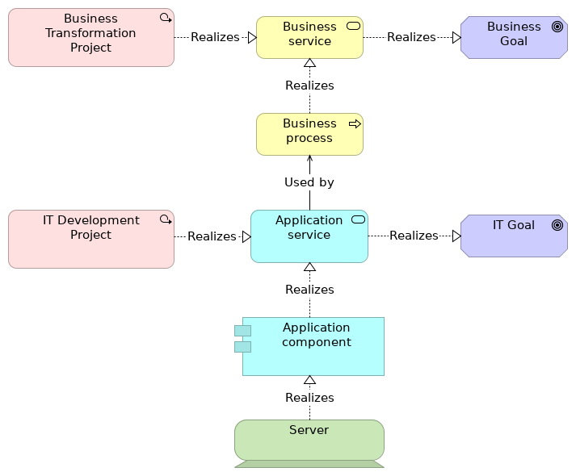
 | Elements
 | Element | Type
 | Application component | Application Component
 | Application service | Application Service
 | Business Goal | Goal
 | Business process | Business Process
 | Business service | Business Service
 | Business Transformation Project | Work Package
 | IT Development Project | Work Package
 | IT Goal | Goal
 | Server | Device
 | ArchiMetal |  | 61 | / 236
 | Inform customer
 | No viewpoint
 | 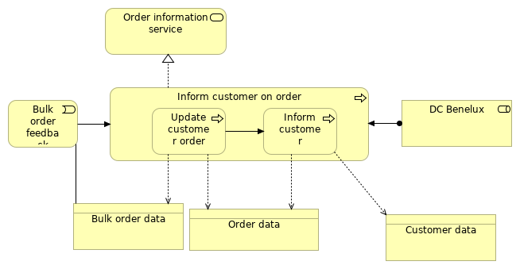
 | Elements
 | Element | Type
 | Bulk order data | Business Object
 | Bulk order feedback | Business Event
 | Customer data | Business Object
 | DC Benelux | Business Role
 | Inform customer | Business Process
 | Inform customer on order | Business Process
 | Order data | Business Object
 | Order information service | Business Service
 | Update customer order | Business Process
 | ArchiMetal |  | 62 | / 236
 | Infrastructure view
 | No viewpoint
 | 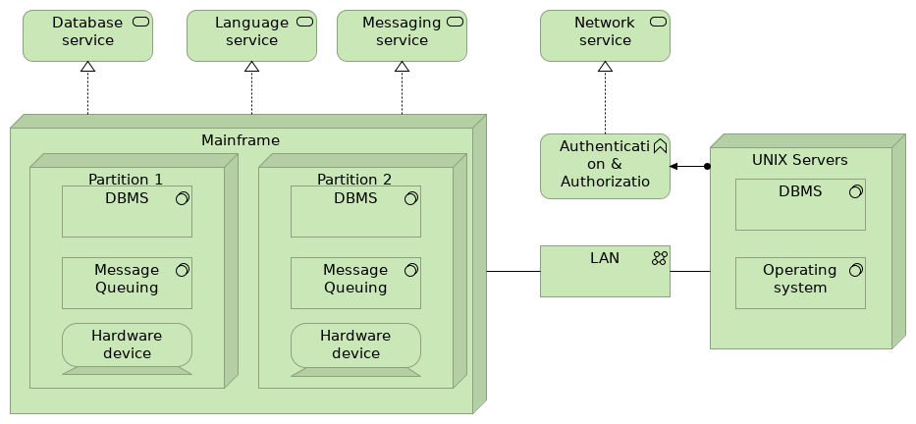
 | Elements
 | Element | Type
 | Authentication & Authorization | Technology Function
 | Database service | Technology Service
 | DBMS | System Software
 | Hardware device | Device
 | LAN | Communication Network
 | Language service | Technology Service
 | Mainframe | Node
 | Message Queuing | System Software
 | Messaging service | Technology Service
 | Network service | Technology Service
 | Operating system | System Software
 | Partition 1 | Node
 | Partition 2 | Node
 | UNIX Servers | Node
 | ArchiMetal |  | 63 | / 236
 | Landscape view
 | No viewpoint
 | 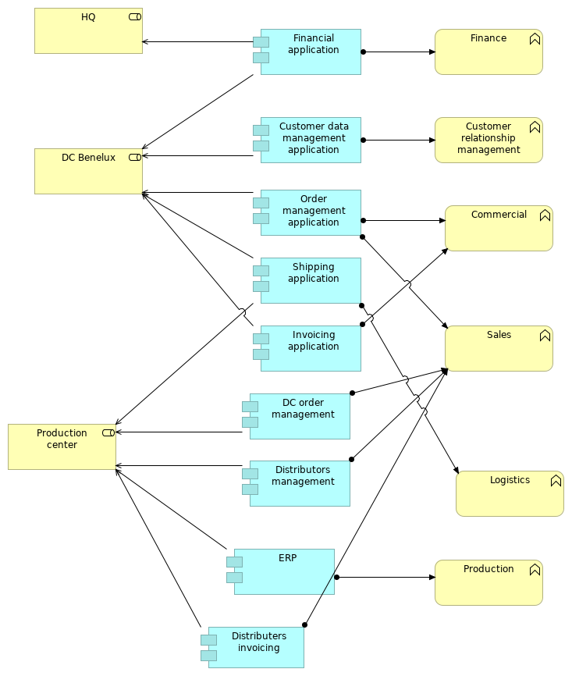
 | ArchiMetal | 64 | / 236
 | Elements
 | Element | Type
 | Commercial | Business Function
 | Customer data management application | Application Component
 | Customer relationship management | Business Function
 | DC Benelux | Business Role
 | DC order management | Application Component
 | Distributers invoicing | Application Component
 | Distributors management | Application Component
 | ERP | Application Component
 | Finance | Business Function
 | Financial application | Application Component
 | HQ | Business Role
 | Invoicing application | Application Component
 | Logistics | Business Function
 | Order management application | Application Component
 | Production | Business Function
 | Production center | Business Role
 | Sales | Business Function
 | Shipping application | Application Component
 | ArchiMetal |  | 65 | / 236
 | Layered view
 | No viewpoint
 | ArchiMetal | 66 | / 236
 | 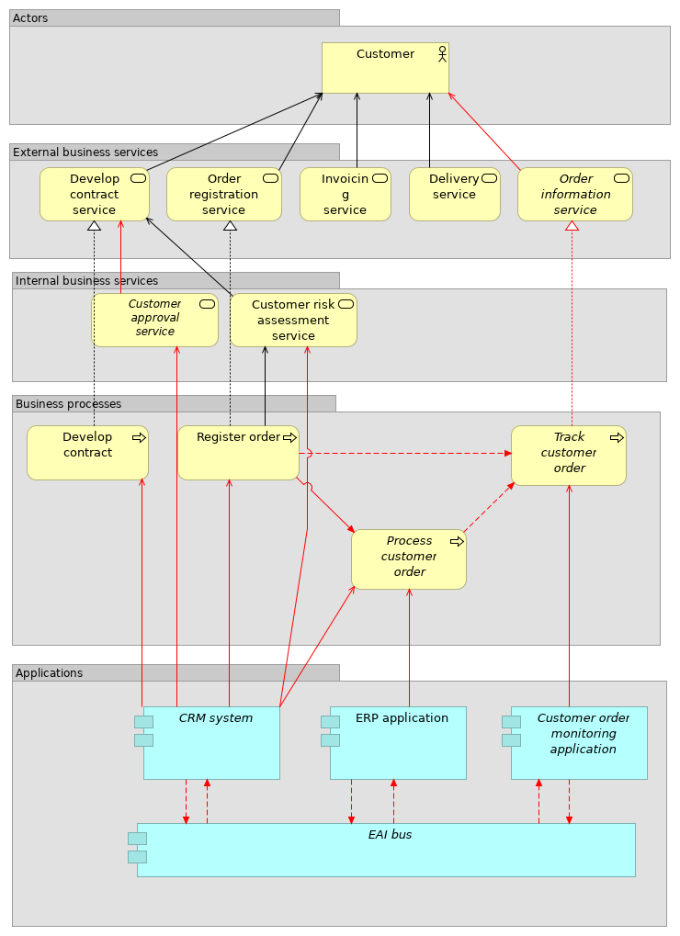
 | ArchiMetal | 67 | / 236
 | Elements
 | Element | Type
 | CRM system | Application Component
 | Customer | Business Actor
 | Customer approval service | Business Service
 | Customer order monitoring application | Application Component
 | Customer risk assessment service | Business Service
 | Delivery service | Business Service
 | Develop contract | Business Process
 | Develop contract service | Business Service
 | EAI bus | Application Component
 | ERP application | Application Component
 | Invoicing service | Business Service
 | Order information service | Business Service
 | Order registration service | Business Service
 | Process customer order | Business Process
 | Register order | Business Process
 | Track customer order | Business Process
 | ArchiMetal |  | 68 | / 236
 | Motivation - business performance focus
 | No viewpoint
 | 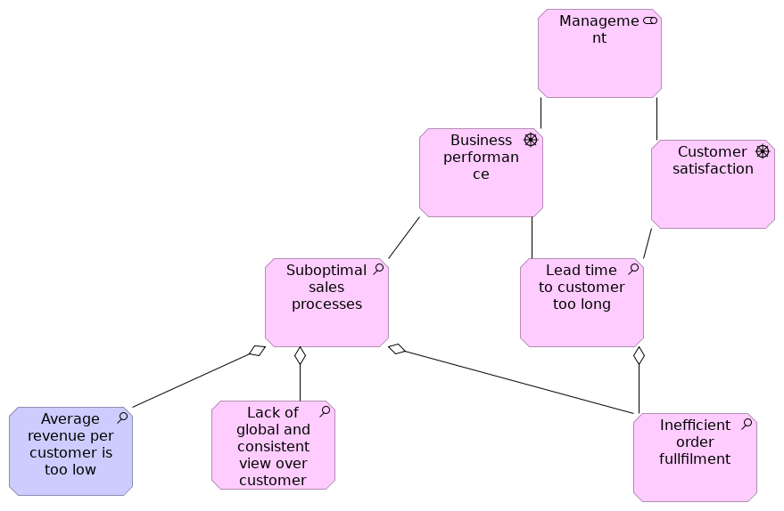
 | Elements
 | Element | Type
 | Average revenue per customer is too low | Assessment
 | Business performance | Driver
 | Customer satisfaction | Driver
 | Inefficient order fullfilment | Assessment
 | Lack of global and consistent view over customer | Assessment
 | Lead time to customer too long | Assessment
 | Management | Stakeholder
 | Suboptimal sales processes | Assessment
 | ArchiMetal |  | 69 | / 236
 | Motivation - Customer satisfaction focus
 | No viewpoint
 | 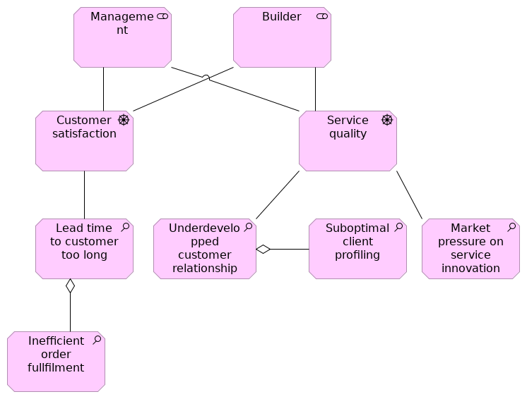
 | Elements
 | Element | Type
 | Builder | Stakeholder
 | Customer satisfaction | Driver
 | Inefficient order fullfilment | Assessment
 | Lead time to customer too long | Assessment
 | Management | Stakeholder
 | Market pressure on service innovation | Assessment
 | Service quality | Driver
 | Suboptimal client profiling | Assessment
 | Underdevelopped customer relationship | Assessment
 | ArchiMetal |  | 70 | / 236
 | New Order Message Flow
 | No viewpoint
 | 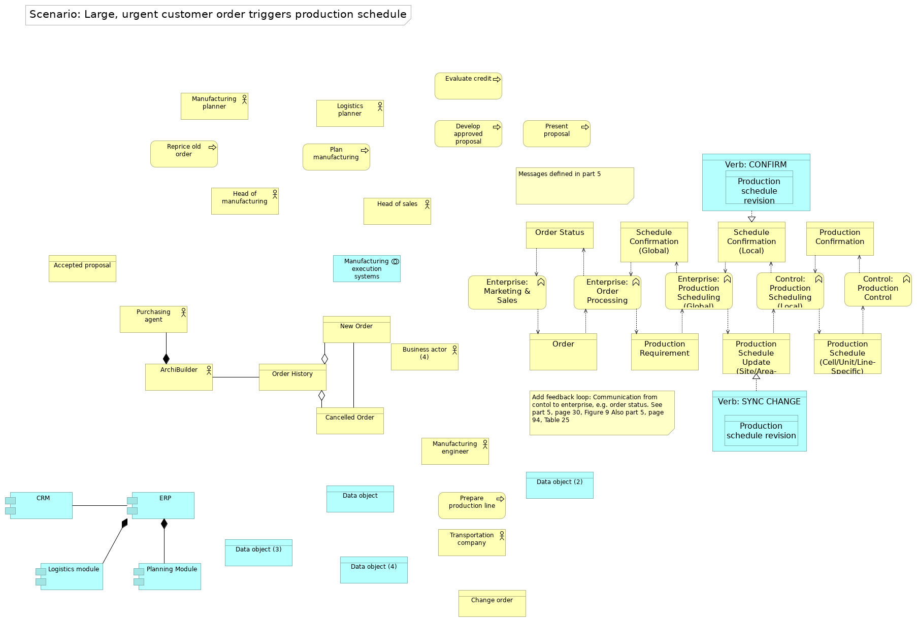
 | Elements
 | Element | Type
 | Accepted proposal | Business Object
 | ArchiBuilder | Business Actor
 | Business actor (4) | Business Actor
 | Cancelled Order | Business Object
 | Change order | Business Object
 | Control: Production Control | Business Function
 | Control: Production Scheduling (Local) | Business Function
 | CRM | Application Component
 | Data object | Data Object
 | Data object (2) | Data Object
 | Data object (3) | Data Object
 | Data object (4) | Data Object
 | Develop approved proposal | Business Process
 | Enterprise: Marketing & Sales | Business Function
 | Enterprise: Order Processing | Business Function
 | Enterprise: Production Scheduling (Global) | Business Function
 | ERP | Application Component
 | Evaluate credit | Business Process
 | ArchiMetal |  | 71 | / 236
 | Element | Type
 | Head of manufacturing | Business Actor
 | Head of sales | Business Actor
 | Logistics module | Application Component
 | Logistics planner | Business Actor
 | Manufacturing engineer | Business Actor
 | Manufacturing execution systems | Application Collaboration
 | Manufacturing planner | Business Actor
 | New Order | Business Object
 | Order | Business Object
 | Order History | Business Object
 | Order Status | Business Object
 | Plan manufacturing | Business Process
 | Planning Module | Application Component
 | Prepare production line | Business Process
 | Present proposal | Business Process
 | Production Confirmation | Business Object
 | Production Requirement | Business Object
 | Production Schedule (Cell/Unit/Line-Specific) | Business Object
 | Production schedule revision | Data Object
 | Production schedule revision confirmation | Data Object
 | Production Schedule Update (Site/Area-Specific) | Business Object
 | Purchasing agent | Business Actor
 | Reprice old order | Business Process
 | Schedule Confirmation (Global) | Business Object
 | Schedule Confirmation (Local) | Business Object
 | Transportation company | Business Actor
 | Verb: CONFIRM | Data Object
 | Verb: SYNC CHANGE | Data Object
 | ArchiMetal |  | 72 | / 236
 | Org. structure_new
 | No viewpoint
 | 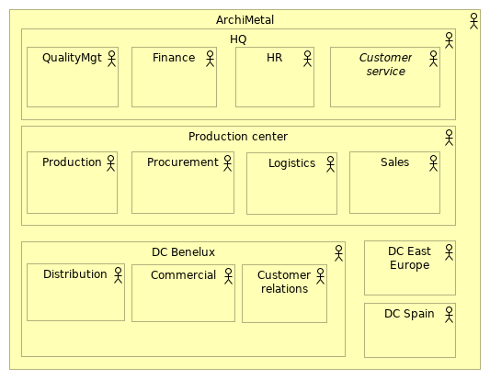
 | Elements
 | Element | Type
 | ArchiMetal | Business Actor
 | Commercial | Business Actor
 | Customer relations | Business Actor
 | Customer service | Business Actor
 | DC Benelux | Business Actor
 | DC East Europe | Business Actor
 | DC Spain | Business Actor
 | Distribution | Business Actor
 | Finance | Business Actor
 | HQ | Business Actor
 | HR | Business Actor
 | Logistics | Business Actor
 | Procurement | Business Actor
 | Production | Business Actor
 | Production center | Business Actor
 | ArchiMetal |  | 73 | / 236
 | Element | Type
 | QualityMgt | Business Actor
 | Sales | Business Actor
 | ArchiMetal |  | 74 | / 236
 | Organisation dpts
 | No viewpoint
 | 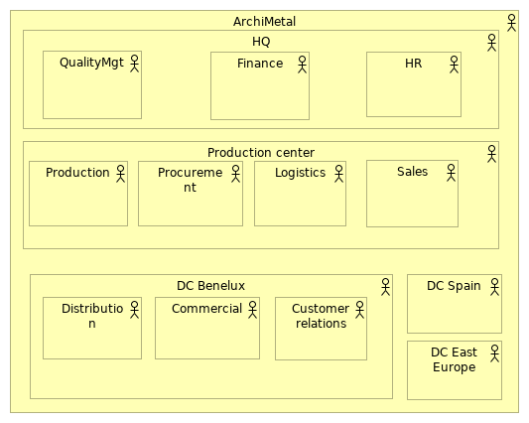
 | Elements
 | Element | Type
 | ArchiMetal | Business Actor
 | Commercial | Business Actor
 | Customer relations | Business Actor
 | DC Benelux | Business Actor
 | DC East Europe | Business Actor
 | DC Spain | Business Actor
 | Distribution | Business Actor
 | Finance | Business Actor
 | HQ | Business Actor
 | HR | Business Actor
 | Logistics | Business Actor
 | Procurement | Business Actor
 | Production | Business Actor
 | Production center | Business Actor
 | ArchiMetal |  | 75 | / 236
 | Element | Type
 | QualityMgt | Business Actor
 | Sales | Business Actor
 | ArchiMetal |  | 76 | / 236
 | Paper overview
 | No viewpoint
 | 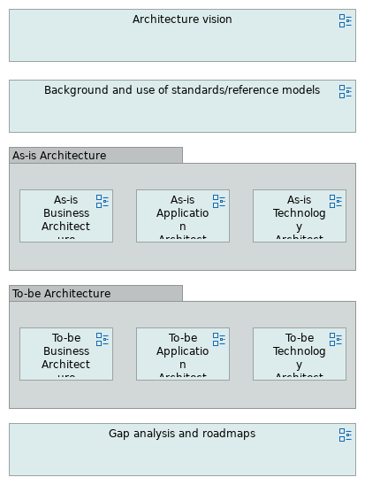
 | ArchiMetal | 77 |  | / 236
 | Process customer order_new
 | No viewpoint
 | 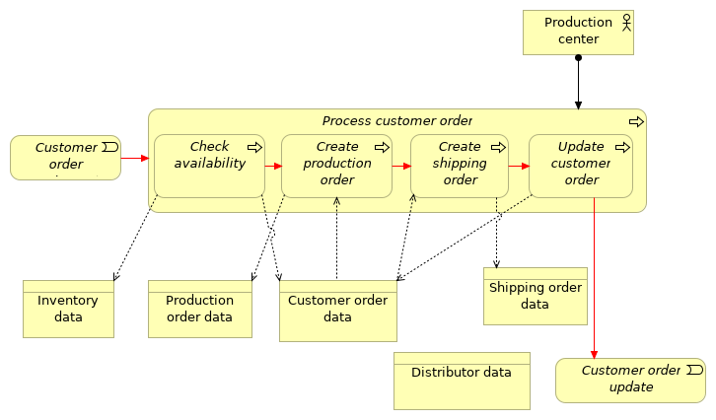
 | Elements
 | Element | Type
 | Check availability | Business Process
 | Create production order | Business Process
 | Create shipping order | Business Process
 | Customer order data | Business Object
 | Customer order registered | Business Event
 | Customer order update | Business Event
 | Distributor data | Business Object
 | Inventory data | Business Object
 | Process customer order | Business Process
 | Production center | Business Actor
 | Production order data | Business Object
 | Shipping order data | Business Object
 | Update customer order | Business Process
 | ArchiMetal |  | 78 | / 236
 | Process customer order_new_IT
 | No viewpoint
 | 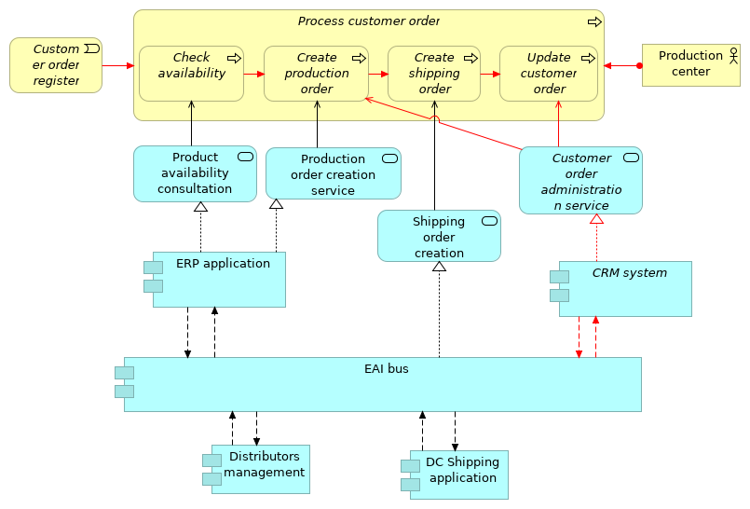
 | Elements
 | Element | Type
 | Check availability | Business Process
 | Create production order | Business Process
 | Create shipping order | Business Process
 | CRM system | Application Component
 | Customer order administration service | Application Service
 | Customer order registered | Business Event
 | DC Shipping application | Application Component
 | Distributors management | Application Component
 | EAI bus | Application Component
 | ERP application | Application Component
 | Process customer order | Business Process
 | Product availability consultation | Application Service
 | Production center | Business Actor
 | Production order creation service | Application Service
 | Shipping order creation service | Application Service
 | Update customer order | Business Process
 | ArchiMetal |  | 79 | / 236
 | ArchiMetal | 80 | / 236
 | Process DC orders
 | No viewpoint
 | 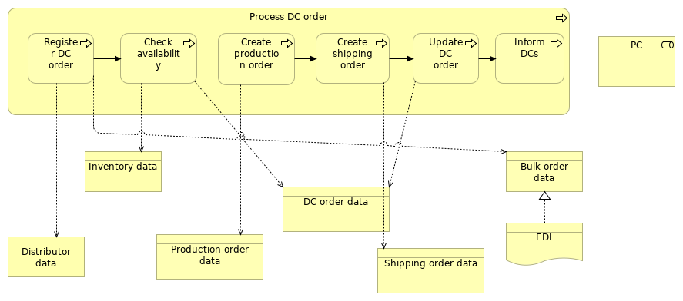
 | Elements
 | Element | Type
 | Bulk order data | Business Object
 | Check availability | Business Process
 | Create production order | Business Process
 | Create shipping order | Business Process
 | DC order data | Business Object
 | Distributor data | Business Object
 | EDI | Representation
 | Inform DCs | Business Process
 | Inventory data | Business Object
 | PC | Business Role
 | Process DC order | Business Process
 | Production order data | Business Object
 | Register DC order | Business Process
 | Shipping order data | Business Object
 | Update DC order | Business Process
 | ArchiMetal |  | 81 | / 236
 | Process DCorders_IT
 | No viewpoint
 | 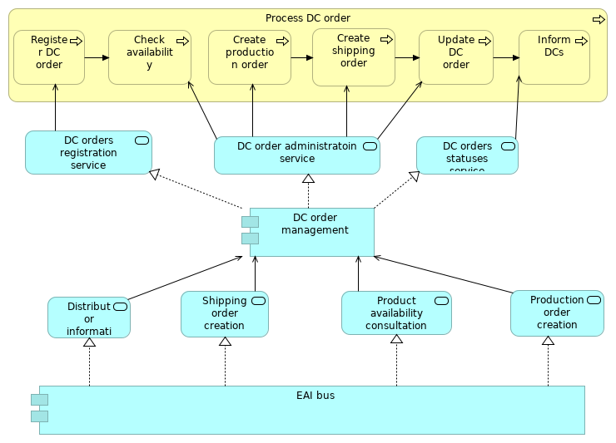
 | Elements
 | Element | Type
 | Check availability | Business Process
 | Create production order | Business Process
 | Create shipping order | Business Process
 | DC order administratoin service | Application Service
 | DC order management | Application Component
 | DC orders registration service | Application Service
 | DC orders statuses service | Application Service
 | Distributor information service | Application Service
 | EAI bus | Application Component
 | Inform DCs | Business Process
 | Process DC order | Business Process
 | Product availability consultation | Application Service
 | Production order creation service | Application Service
 | Register DC order | Business Process
 | Shipping order creation service | Application Service
 | Update DC order | Business Process
 | ArchiMetal |  | 82 | / 236
 | ArchiMetal | 83 | / 236
 | Processes interdependencies
 | No viewpoint
 | 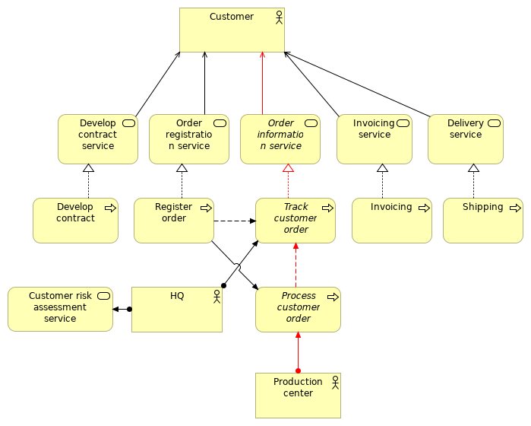
 | Elements
 | Element | Type
 | Customer | Business Actor
 | Customer risk assessment service | Business Service
 | Delivery service | Business Service
 | Develop contract | Business Process
 | Develop contract service | Business Service
 | HQ | Business Actor
 | Invoicing | Business Process
 | Invoicing service | Business Service
 | Order information service | Business Service
 | Order registration service | Business Service
 | Process customer order | Business Process
 | Production center | Business Actor
 | Register order | Business Process
 | Shipping | Business Process
 | ArchiMetal |  | 84 | / 236
 | Element | Type
 | Track customer order | Business Process
 | ArchiMetal |  | 85 | / 236
 | Processes interdependencies
 | No viewpoint
 | 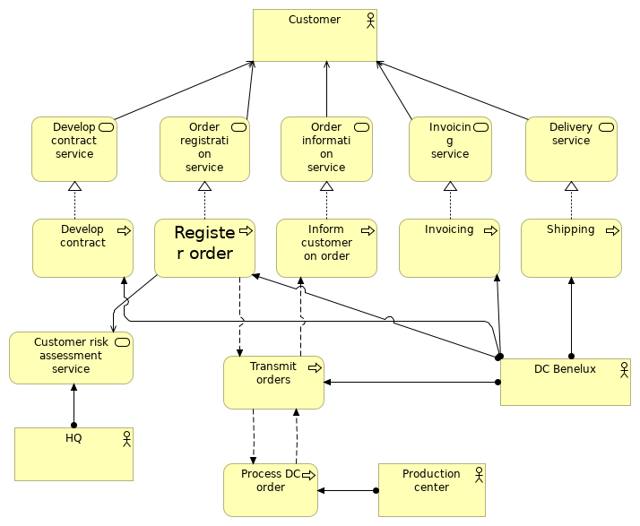
 | Elements
 | Element | Type
 | Customer | Business Actor
 | Customer risk assessment service | Business Service
 | DC Benelux | Business Actor
 | Delivery service | Business Service
 | Develop contract | Business Process
 | Develop contract service | Business Service
 | HQ | Business Actor
 | Inform customer on order | Business Process
 | Invoicing | Business Process
 | Invoicing service | Business Service
 | Order information service | Business Service
 | Order registration service | Business Service
 | Process DC order | Business Process
 | ArchiMetal |  | 86 | / 236
 | Element | Type
 | Production center | Business Actor
 | Register order | Business Process
 | Shipping | Business Process
 | Transmit orders | Business Process
 | ArchiMetal |  | 87 | / 236
 | Register order
 | No viewpoint
 | 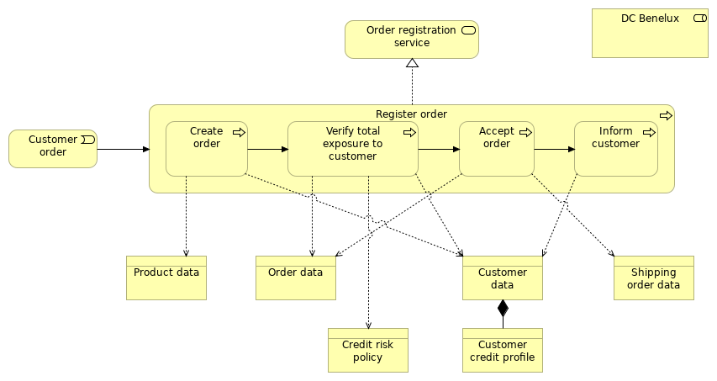
 | Elements
 | Element | Type
 | Accept order | Business Process
 | Create order | Business Process
 | Credit risk policy | Business Object
 | Customer credit profile | Business Object
 | Customer data | Business Object
 | Customer order | Business Event
 | DC Benelux | Business Role
 | Inform customer | Business Process
 | Order data | Business Object
 | Order registration service | Business Service
 | Product data | Business Object
 | Register order | Business Process
 | Shipping order data | Business Object
 | Verify total exposure to customer | Business Process
 | ArchiMetal |  | 88 | / 236
 | Register order_IT
 | No viewpoint
 | 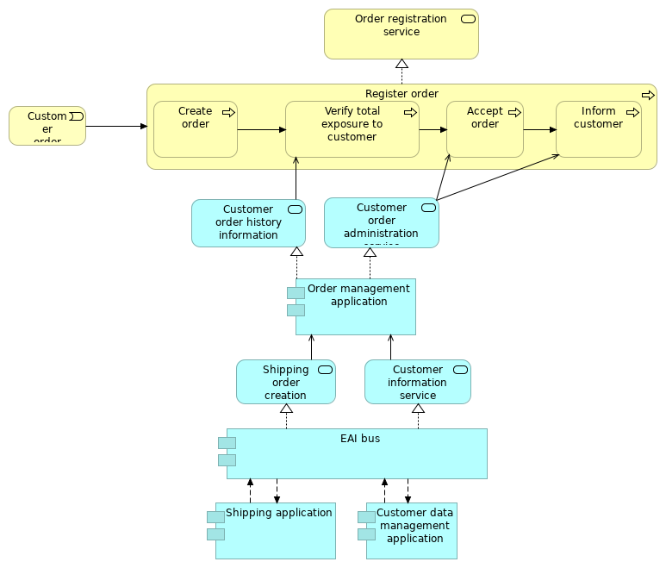
 | Elements
 | Element | Type
 | Accept order | Business Process
 | Create order | Business Process
 | Customer data management application | Application Component
 | Customer information service | Application Service
 | Customer order | Business Event
 | Customer order administration service | Application Service
 | Customer order history information service | Application Service
 | EAI bus | Application Component
 | Inform customer | Business Process
 | Order management application | Application Component
 | Order registration service | Business Service
 | Register order | Business Process
 | ArchiMetal |  | 89 | / 236
 | Element | Type
 | Shipping application | Application Component
 | Shipping order creation service | Application Service
 | Verify total exposure to customer | Business Process
 | ArchiMetal |  | 90 | / 236
 | Register order_new
 | No viewpoint
 | 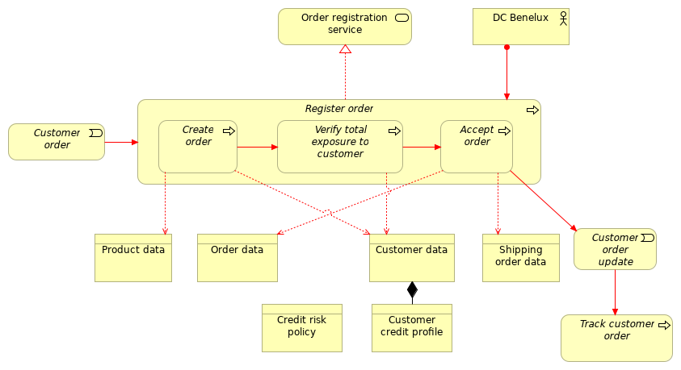
 | Elements
 | Element | Type
 | Accept order | Business Process
 | Create order | Business Process
 | Credit risk policy | Business Object
 | Customer credit profile | Business Object
 | Customer data | Business Object
 | Customer order | Business Event
 | Customer order update | Business Event
 | DC Benelux | Business Actor
 | Order data | Business Object
 | Order registration service | Business Service
 | Product data | Business Object
 | Register order | Business Process
 | Shipping order data | Business Object
 | Track customer order | Business Process
 | Verify total exposure to customer | Business Process
 | ArchiMetal |  | 91 | / 236
 | Register order_new_IT
 | No viewpoint
 | 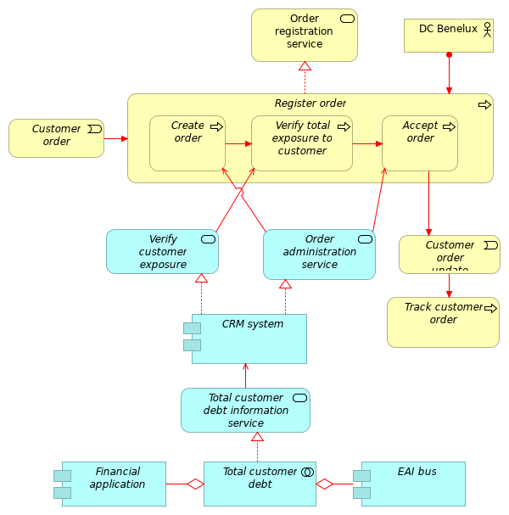
 | Elements
 | Element | Type
 | Accept order | Business Process
 | Create order | Business Process
 | CRM system | Application Component
 | Customer order | Business Event
 | Customer order update | Business Event
 | DC Benelux | Business Actor
 | EAI bus | Application Component
 | ArchiMetal |  | 92 | / 236
 | Element | Type
 | Financial application | Application Component
 | Order administration service | Application Service
 | Order registration service | Business Service
 | Register order | Business Process
 | Total customer debt | Application Collaboration
 | Total customer debt information service | Application Service
 | Track customer order | Business Process
 | Verify customer exposure service | Application Service
 | Verify total exposure to customer | Business Process
 | ArchiMetal |  | 93 | / 236
 | To-be Application Architecture
 | No viewpoint
 | ArchiMetal |  | 94 | / 236
 | To-be Business Architecture
 | No viewpoint
 | ArchiMetal |  | 95 | / 236
 | To-be Technology Architecture
 | No viewpoint
 | ArchiMetal |  | 96 | / 236
 | Total view for Process cell controller
 | No viewpoint
 | 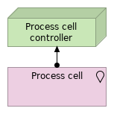
 | Elements
 | Element |  | Type
 | Process cell |  | Location
 | Process cell controller |  | Node
 | ArchiMetal |  |  | 97 | / 236
 | Total view for Production line controller
 | No viewpoint
 | 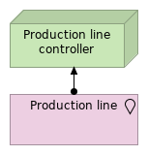
 | Elements
 | Element |  | Type
 | Production line |  | Location
 | Production line controller |  | Node
 | ArchiMetal |  |  | 98 | / 236
 | Track customer order_new_IT
 | No viewpoint
 | 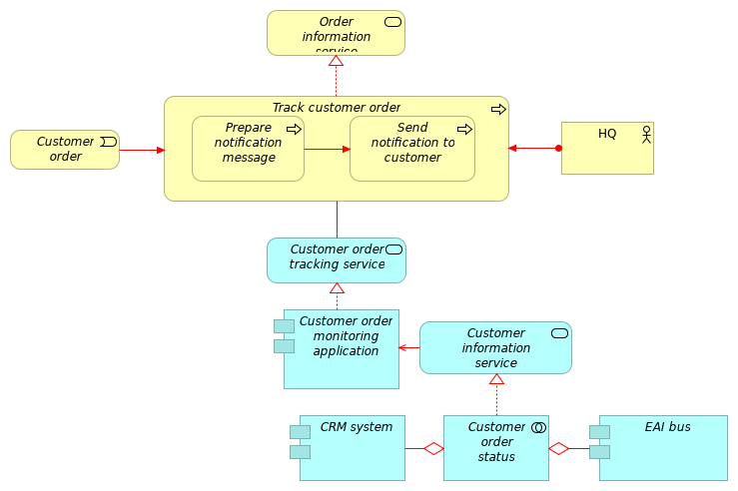
 | Elements
 | Element | Type
 | CRM system | Application Component
 | Customer information service | Application Service
 | Customer order monitoring application | Application Component
 | Customer order status | Application Collaboration
 | Customer order tracking service | Application Service
 | Customer order update | Business Event
 | EAI bus | Application Component
 | HQ | Business Actor
 | Order information service | Business Service
 | Prepare notification message | Business Process
 | Send notification to customer | Business Process
 | Track customer order | Business Process
 | ArchiMetal |  | 99 | / 236
 | Transmit orders to PC
 | No viewpoint
 | 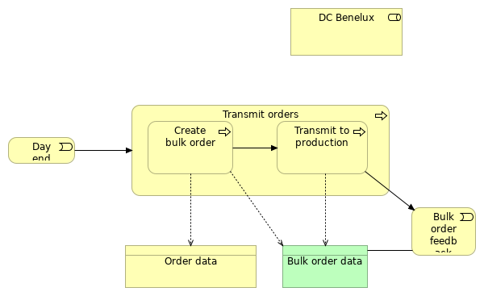
 | Elements
 | Element | Type
 | Bulk order data | Business Object
 | Bulk order feedback | Business Event
 | Create bulk order | Business Process
 | Day end | Business Event
 | DC Benelux | Business Role
 | Order data | Business Object
 | Transmit orders | Business Process
 | Transmit to production | Business Process
 | ArchiMetal |  | 100 | / 236
 | Transmit orders_IT_all
 | No viewpoint
 | 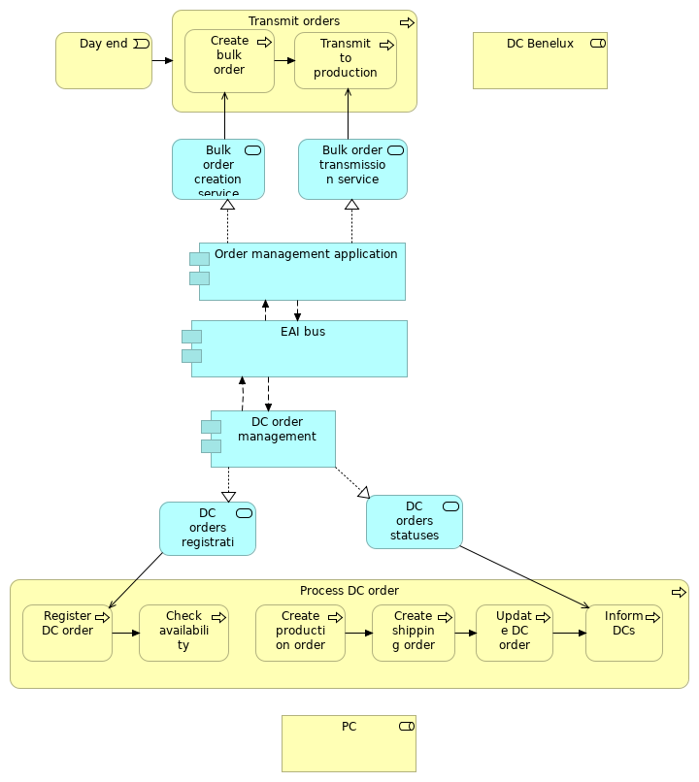
 | ArchiMetal | 101 | / 236
 | Elements
 | Element | Type
 | Bulk order creation service | Application Service
 | Bulk order transmission service | Application Service
 | Check availability | Business Process
 | Create bulk order | Business Process
 | Create production order | Business Process
 | Create shipping order | Business Process
 | Day end | Business Event
 | DC Benelux | Business Role
 | DC order management | Application Component
 | DC orders registration service | Application Service
 | DC orders statuses service | Application Service
 | EAI bus | Application Component
 | Inform DCs | Business Process
 | Order management application | Application Component
 | PC | Business Role
 | Process DC order | Business Process
 | Register DC order | Business Process
 | Transmit orders | Business Process
 | Transmit to production | Business Process
 | Update DC order | Business Process
 | ArchiMetal |  | 102 | / 236
 | Verify total exposure
 | No viewpoint
 | 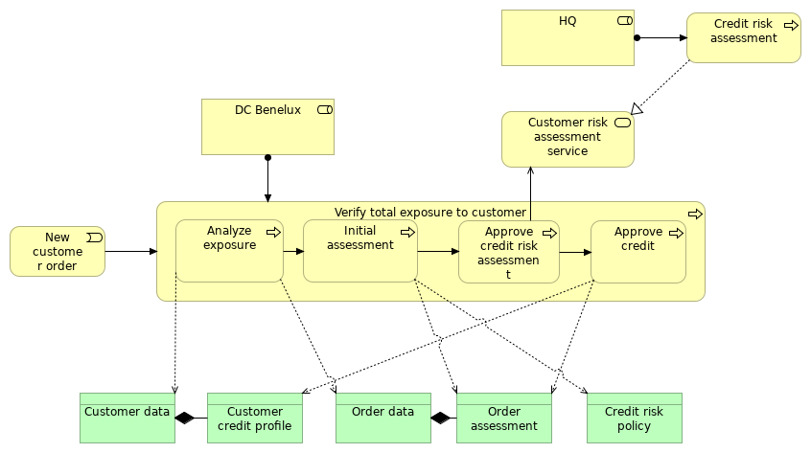
 | Elements
 | Element | Type
 | Analyze exposure | Business Process
 | Approve credit | Business Process
 | Approve credit risk assessment | Business Process
 | Credit risk assessment | Business Process
 | Credit risk policy | Business Object
 | Customer credit profile | Business Object
 | Customer data | Business Object
 | Customer risk assessment service | Business Service
 | DC Benelux | Business Role
 | HQ | Business Role
 | Initial assessment | Business Process
 | New customer order | Business Event
 | Order assessment | Business Object
 | Order data | Business Object
 | Verify total exposure to customer | Business Process
 | ArchiMetal |  | 103 | / 236
 | Vision
 | No viewpoint
 | 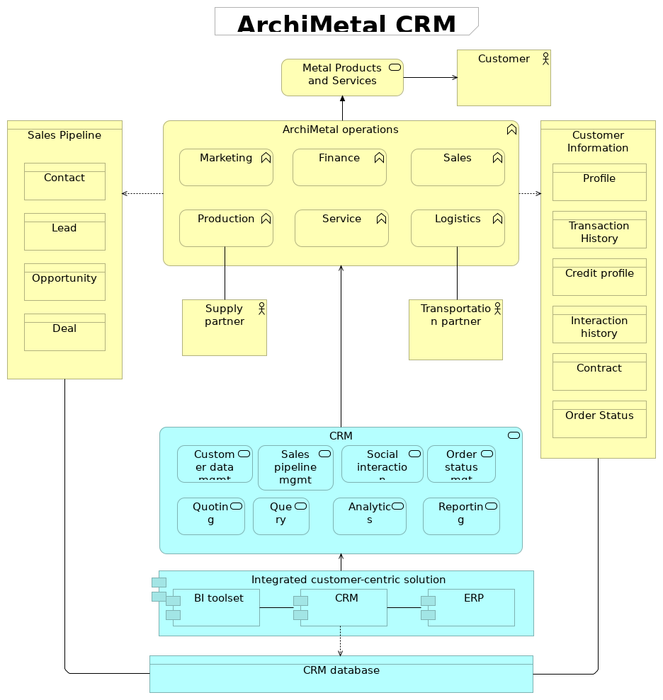
 | Elements
 | Element | Type
 | Analytics | Application Service
 | ArchiMetal operations | Business Function
 | BI toolset | Application Component
 | Contact | Business Object
 | Contract | Business Object
 | ArchiMetal |  | 104 | / 236
 | Element | Type
 | Credit profile | Business Object
 | CRM | Application Service
 | CRM | Application Component
 | CRM database | Data Object
 | Customer | Business Actor
 | Customer data mgmt | Application Service
 | Customer Information | Business Object
 | Deal | Business Object
 | ERP | Application Component
 | Finance | Business Function
 | Integrated customer-centric solution | Application Component
 | Interaction history | Business Object
 | Lead | Business Object
 | Logistics | Business Function
 | Marketing | Business Function
 | Metal Products and Services | Business Service
 | Opportunity | Business Object
 | Order Status | Business Object
 | Order status mgt | Application Service
 | Production | Business Function
 | Profile | Business Object
 | Query | Application Service
 | Quoting | Application Service
 | Reporting | Application Service
 | Sales | Business Function
 | Sales Pipeline | Business Object
 | Sales pipeline mgmt | Application Service
 | Service | Business Function
 | Social interaction | Application Service
 | Supply partner | Business Actor
 | Transaction History | Business Object
 | Transportation partner | Business Actor
 | ArchiMetal |  | 105 | / 236
 | Business Layer
 | Accept order
 | Type | Business Process
 | Accept proposal
 | Type | Business Process
 | Accepted proposal
 | Type | Business Object
 | Account manager
 | Type | Business Role
 | Activate delivery schedule
 | Type | Business Process
 | Activate plan
 | Type | Business Process
 | Add new equipment
 | Type | Business Object
 | Add new production schedule
 | Type | Business Object
 | Analyze
 | Type | Business Process
 | Analyze exposure
 | Type | Business Process
 | Approve
 | Type | Business Process
 | Approve assessment
 | Type | Business Process
 | Approve credit
 | Type | Business Process
 | Approve credit risk assessment
 | Type | Business Process
 | ArchiMetal |  | 106 | / 236
 | Approve customer
 | Type | Business Process
 | Approve customer data
 | Type | Business Process
 | ArchiBuilder
 | Type | Business Actor
 | ArchiMetal
 | Type | Business Actor
 | ArchiMetal operations
 | Type | Business Function
 | Ask for customer risk assessment
 | Type | Business Process
 | Ask for order risk assessment
 | Type | Business Process
 | Assessment
 | Type | Business Object
 | Bank
 | Type | Business Role
 | Batch operations
 | Type | Business Function
 | Bulk order data
 | Type | Business Object
 | Bulk order feedback
 | Type | Business Event
 | Business actor
 | Type | Business Actor
 | Business actor (4)
 | Type | Business Actor
 | ArchiMetal |  | 107 | / 236
 | Business Collaboration
 | Type | Business Collaboration
 | Business function
 | Type | Business Function
 | Business function
 | Type | Business Function
 | Business function (2)
 | Type | Business Function
 | Business function (2)
 | Type | Business Function
 | Business function (3)
 | Type | Business Function
 | Business function (4)
 | Type | Business Function
 | Business function (5)
 | Type | Business Function
 | Business intelligence analysi
 | Type | Business Actor
 | Business Object
 | Type | Business Object
 | Business object
 | Type | Business Object
 | Business object (2)
 | Type | Business Object
 | Business object (3)
 | Type | Business Object
 | Business object (4)
 | Type | Business Object
 | ArchiMetal |  | 108 | / 236
 | Business object (5)
 | Type | Business Object
 | Business object (6)
 | Type | Business Object
 | Business object (7)
 | Type | Business Object
 | Business process
 | Type | Business Process
 | Business process (2)
 | Type | Business Process
 | Business process (3)
 | Type | Business Process
 | Business process 1
 | Type | Business Process
 | Business process 2
 | Type | Business Process
 | Business role (3)
 | Type | Business Role
 | Business role (4)
 | Type | Business Role
 | Business service
 | Type | Business Service
 | Business service (2)
 | Type | Business Service
 | Cancelled Order
 | Type | Business Object
 | Change order
 | Type | Business Object
 | ArchiMetal |  | 109 | / 236
 | Check availability
 | Type | Business Process
 | Commercial
 | Type | Business Actor
 | Commercial
 | Type | Business Function
 | Complete
 | Type | Business Process
 | Contact
 | Type | Business Actor
 | Contact
 | Type | Business Object
 | Contact center agent
 | Type | Business Actor
 | Continuous operations
 | Type | Business Function
 | Contract
 | Type | Business Object
 | Contract
 | Type | Representation
 | Contract data
 | Type | Business Object
 | Contract in place
 | Type | Business Event
 | Control functional integration
 | Type | Business Service
 | Control: Maintenance Management
 | Type | Business Function
 | ArchiMetal |  | 110 | / 236
 | Control: Manufacturing Operations & Control business functions
 | Type | Business Function
 | Control: Material and Energy Control
 | Type | Business Function
 | Control: Product Inventory Control
 | Type | Business Function
 | Control: Production Control
 | Type | Business Function
 | Control: Production Scheduling (Local)
 | Type | Business Function
 | Control: quality assurance
 | Type | Business Function
 | Create bulk order
 | Type | Business Process
 | Create customer credit profile
 | Type | Business Process
 | Create order
 | Type | Business Process
 | Create production order
 | Type | Business Process
 | Create shipping order
 | Type | Business Process
 | Credit
 | Type | Business Actor
 | Credit
 | Type | Business Function
 | Credit profile
 | Type | Business Object
 | ArchiMetal |  | 111 | / 236
 | Credit risk assessment
 | Type | Business Process
 | Credit risk policy
 | Type | Business Object
 | Credit specialist
 | Type | Business Role
 | Customer
 | Type | Business Object
 | Customer
 | Type | Business Role
 | Customer
 | Type | Business Actor
 | Customer approval service
 | Type | Business Service
 | Customer Contact
 | Type | Business Actor
 | Customer credit profile
 | Type | Business Object
 | Customer data
 | Type | Business Object
 | Customer Information
 | Type | Business Object
 | Customer order
 | Type | Business Event
 | Customer order data
 | Type | Business Object
 | Customer order registered
 | Type | Business Event
 | ArchiMetal |  | 112 | / 236
 | Customer order update
 | Type | Business Event
 | Customer relations
 | Type | Business Actor
 | Customer relationship management
 | Type | Business Function
 | Customer representative
 | Type | Business Role
 | Customer risk assessment service
 | Type | Business Service
 | Customer service
 | Type | Business Actor
 | Customer signature
 | Type | Business Object
 | Day end
 | Type | Business Event
 | DC Benelux
 | Type | Business Role
 | DC Benelux
 | Type | Business Actor
 | DC Customer relations
 | Type | Business Function
 | DC East Europe
 | Type | Business Actor
 | DC order data
 | Type | Business Object
 | DC Spain
 | Type | Business Actor
 | ArchiMetal |  | 113 | / 236
 | DCFinance
 | Type | Business Function
 | Deal
 | Type | Business Object
 | Define credit limit
 | Type | Business Process
 | Define payment terms
 | Type | Business Process
 | Define pricing policy
 | Type | Business Process
 | Delivery service
 | Type | Business Service
 | Design
 | Type | Business Process
 | Detailed production scheduling
 | Type | Business Function
 | Develop approved proposal
 | Type | Business Process
 | Develop contract
 | Type | Business Process
 | Develop contract service
 | Type | Business Service
 | Distribution
 | Type | Business Actor
 | Distribution
 | Type | Business Function
 | Distribution center
 | Type | Business Role
 | ArchiMetal |  | 114 | / 236
 | Distributor data
 | Type | Business Object
 | EDI
 | Type | Representation
 | Enter order
 | Type | Business Process
 | Enterprise
 | Type | Business Actor
 | Enterprise functional integration
 | Type | Business Service
 | Enterprise Functions
 | Type | Business Function
 | Enterprise-control functional interface
 | Type | Business Interface
 | Enterprise: Business Planning & Logistics business functions
 | Type | Business Function
 | Enterprise: Customer Service
 | Type | Business Function
 | Enterprise: Maintenance Management
 | Type | Business Function
 | Enterprise: Marketing & Sales
 | Type | Business Function
 | Enterprise: Material and Energy Control
 | Type | Business Function
 | Enterprise: Order Processing
 | Type | Business Function
 | Enterprise: Procurement
 | Type | Business Function
 | ArchiMetal |  | 115 | / 236
 | Enterprise: Product Cost Accounting
 | Type | Business Function
 | Enterprise: Product Inventory Control
 | Type | Business Function
 | Enterprise: Product Shipping Admin
 | Type | Business Function
 | Enterprise: Production Scheduling (Global)
 | Type | Business Function
 | Enterprise: Quality Assurance
 | Type | Business Function
 | Enterprise: Research, Development & Engineering
 | Type | Business Function
 | Evaluate credit
 | Type | Business Process
 | Evaluate credit risk
 | Type | Business Process
 | Evaluate customer credit
 | Type | Business Process
 | Finance
 | Type | Business Function
 | Finance
 | Type | Business Actor
 | Head of manufacturing
 | Type | Business Actor
 | Head of sales
 | Type | Business Actor
 | HQ
 | Type | Business Role
 | ArchiMetal |  | 116 | / 236
 | HQ
 | Type | Business Actor
 | HQ customer assessment service
 | Type | Business Service
 | HR
 | Type | Business Actor
 | Inform customer
 | Type | Business Process
 | Inform customer
 | Type | Business Process
 | Inform customer on order
 | Type | Business Process
 | Inform DCs
 | Type | Business Process
 | Initial assessment
 | Type | Business Process
 | Initial profile assessment
 | Type | Business Process
 | Inquiry
 | Type | Business Event
 | Interaction history
 | Type | Business Object
 | Inventory data
 | Type | Business Object
 | Invoicing
 | Type | Business Process
 | Invoicing service
 | Type | Business Service
 | ArchiMetal |  | 117 | / 236
 | Lead
 | Type | Business Object
 | Lead
 | Type | Business Actor
 | Level 0-2 functions
 | Type | Business Function
 | Logistics
 | Type | Business Actor
 | Logistics
 | Type | Business Function
 | Logistics Partner
 | Type | Business Actor
 | Logistics planner
 | Type | Business Role
 | Logistics planner
 | Type | Business Actor
 | Manufacturing engineer
 | Type | Business Actor
 | Manufacturing engineer
 | Type | Business Role
 | Manufacturing planner
 | Type | Business Actor
 | Marketing
 | Type | Business Actor
 | Marketing
 | Type | Business Function
 | Metal Products and Services
 | Type | Business Service
 | ArchiMetal |  | 118 | / 236
 | New customer order
 | Type | Business Event
 | New customer registered
 | Type | Business Event
 | New equipment confirmation
 | Type | Business Object
 | New Order
 | Type | Business Object
 | New order received
 | Type | Business Event
 | New schedule acceptance
 | Type | Business Object
 | Opportunity
 | Type | Business Actor
 | Opportunity
 | Type | Business Object
 | Order
 | Type | Business Object
 | Order assessment
 | Type | Business Object
 | Order data
 | Type | Business Object
 | Order History
 | Type | Business Object
 | Order information service
 | Type | Business Service
 | Order registration service
 | Type | Business Service
 | ArchiMetal |  | 119 | / 236
 | Order Status
 | Type | Business Object
 | PC
 | Type | Business Role
 | Plan manufacturing
 | Type | Business Process
 | Plan order
 | Type | Business Process
 | Prepare notification message
 | Type | Business Process
 | Prepare production line
 | Type | Business Process
 | Present proposal
 | Type | Business Process
 | Price
 | Type | Business Process
 | Pricing policy
 | Type | Business Object
 | Process customer order
 | Type | Business Process
 | Process DC order
 | Type | Business Process
 | Process segment capability
 | Type | Business Object
 | Procurement
 | Type | Business Actor
 | Procurement
 | Type | Business Function
 | ArchiMetal |  | 120 | / 236
 | Produce order
 | Type | Business Process
 | Product data
 | Type | Business Object
 | Product Definition
 | Type | Business Object
 | Product definition management
 | Type | Business Function
 | Product segment
 | Type | Business Object
 | Production
 | Type | Business Function
 | Production
 | Type | Business Actor
 | Production
 | Type | Business Function
 | Production Capability
 | Type | Business Object
 | Production capability
 | Type | Business Object
 | Production center
 | Type | Business Role
 | Production center
 | Type | Business Actor
 | Production Confirmation
 | Type | Business Object
 | Production data collection
 | Type | Business Function
 | ArchiMetal |  | 121 | / 236
 | Production dispatching
 | Type | Business Function
 | Production execution management
 | Type | Business Function
 | Production manager
 | Type | Business Role
 | Production order data
 | Type | Business Object
 | Production performance
 | Type | Business Object
 | Production Performance
 | Type | Business Object
 | Production performance analysis
 | Type | Business Function
 | Production planner
 | Type | Business Role
 | Production request
 | Type | Business Object
 | Production Requirement
 | Type | Business Object
 | Production resource management
 | Type | Business Function
 | Production response
 | Type | Business Object
 | Production rule
 | Type | Business Object
 | Production Schedule
 | Type | Business Object
 | ArchiMetal |  | 122 | / 236
 | Production schedule
 | Type | Business Object
 | Production Schedule (Cell/Unit/Line-Specific)
 | Type | Business Object
 | Production Schedule Update (Site/Area-Specific)
 | Type | Business Object
 | Production status
 | Type | Business Object
 | Production status request
 | Type | Business Object
 | Production tracking
 | Type | Business Function
 | Profile
 | Type | Business Object
 | Proposal specialist
 | Type | Business Role
 | Purchasing agent
 | Type | Business Actor
 | QualityMgt
 | Type | Business Actor
 | Ready production line
 | Type | Business Process
 | Receive
 | Type | Business Process
 | Register customer
 | Type | Business Process
 | Register DC order
 | Type | Business Process
 | ArchiMetal |  | 123 | / 236
 | Register order
 | Type | Business Process
 | Repetitive or discrete operations
 | Type | Business Function
 | Reprice old order
 | Type | Business Process
 | Sales
 | Type | Business Function
 | Sales
 | Type | Business Actor
 | Sales manager
 | Type | Business Actor
 | Sales manager
 | Type | Business Role
 | Sales Pipeline
 | Type | Business Object
 | Sales professional
 | Type | Business Actor
 | Sales representative
 | Type | Business Role
 | Schedule
 | Type | Business Process
 | Schedule Confirmation (Global)
 | Type | Business Object
 | Schedule Confirmation (Local)
 | Type | Business Object
 | Schedule revision
 | Type | Business Object
 | ArchiMetal |  | 124 | / 236
 | Schedule revision confirmation
 | Type | Business Object
 | Segment requirement
 | Type | Business Object
 | Segment response
 | Type | Business Object
 | Send delivery orders
 | Type | Business Process
 | Send notification to customer
 | Type | Business Process
 | Send to customer
 | Type | Business Process
 | Service
 | Type | Business Function
 | Service professional
 | Type | Business Actor
 | Shipping
 | Type | Business Process
 | Shipping order data
 | Type | Business Object
 | Supplier
 | Type | Business Actor
 | Supply partner
 | Type | Business Actor
 | Track customer order
 | Type | Business Process
 | Transaction History
 | Type | Business Object
 | ArchiMetal |  | 125 | / 236
 | Transmit orders
 | Type | Business Process
 | Transmit to production
 | Type | Business Process
 | Transportation company
 | Type | Business Actor
 | Transportation partner
 | Type | Business Actor
 | Update customer order
 | Type | Business Process
 | Update DC order
 | Type | Business Process
 | Verify total exposure to customer
 | Type | Business Process
 | Warehousing
 | Type | Business Function
 | ArchiMetal |  | 126 | / 236
 | Application Layer
 | ACKNOWLEDGE
 | Type | Data Object
 | ACKNOWLEDGE
 | Type | Data Object
 | ACKNOWLEDGE - ACCEPTED
 | Type | Data Object
 | Acquisition
 | Type | Application Function
 | Acquisition: Social
 | Type | Application Function
 | Analytics
 | Type | Application Service
 | Analytics and reporting
 | Type | Application Component
 | Application component
 | Type | Application Component
 | Application component (2)
 | Type | Application Component
 | Application component (3)
 | Type | Application Component
 | Application component (4)
 | Type | Application Component
 | Application service
 | Type | Application Service
 | Application service (2)
 | Type | Application Service
 | Application service (3)
 | Type | Application Service
 | ArchiMetal |  | 127 | / 236
 | Assess customer risk
 | Type | Application Interaction
 | BI toolset
 | Type | Application Component
 | Billing
 | Type | Application Function
 | Bulk order creation service
 | Type | Application Service
 | Bulk order transmission service
 | Type | Application Service
 | CANCEL
 | Type | Data Object
 | CHANGE
 | Type | Data Object
 | Change made
 | Type | Data Object
 | Change requested
 | Type | Data Object
 | CONFIRM
 | Type | Data Object
 | Contract creating service
 | Type | Application Service
 | Contract creation service
 | Type | Application Service
 | Contract printing service
 | Type | Application Service
 | Contracts component
 | Type | Application Component
 | ArchiMetal |  | 128 | / 236
 | Control application functions
 | Type | Application Function
 | Control application Integration
 | Type | Application Service
 | Control: Maintenance Management
 | Type | Application Function
 | Control: Material and Energy Control
 | Type | Application Function
 | Control: Product Inventory Control
 | Type | Application Function
 | Control: Production Control
 | Type | Application Function
 | Control: Production Scheduling (Local)
 | Type | Application Function
 | Control: quality assurance
 | Type | Application Function
 | Create customer contract
 | Type | Application Interaction
 | CRM
 | Type | Application Function
 | CRM
 | Type | Application Component
 | CRM
 | Type | Application Service
 | CRM database
 | Type | Data Object
 | CRM system
 | Type | Application Component
 | ArchiMetal |  | 129 | / 236
 | Cross-functional customer analytics
 | Type |  | Application Function
 | Customer administration service
 | Type |  | Application Service
 | Customer contract
 | Type |  | Application Collaboration
 | Customer credit analysis service
 | Type |  | Application Service
 | Customer data component
 | Type |  | Application Component
 | Customer data management application
 | Type |  | Application Component
 |  | Customer data management application
 | Customer data mgmt
 | Type |  | Application Service
 | Customer information service
 | Type |  | Application Service
 | Customer order administration service
 | Type |  | Application Service
 | Customer order history information service
 | Type |  | Application Service
 | Customer order monitoring application
 | Type |  | Application Component
 | Customer order notifications component
 | Type |  | Application Component
 | Customer order status
 | Type |  | Application Collaboration
 | Customer order tracking service
 | Type |  | Application Service
 | ArchiMetal |  |  | 130 | / 236
 | Customer risk assessment
 | Type |  | Application Collaboration
 | Customer risk interface
 | Type |  | Application Interface
 | Data management
 | Type |  | Application Function
 | Data object
 | Type |  | Data Object
 | Data object (10)
 | Type |  | Data Object
 | Data object (2)
 | Type |  | Data Object
 | Data object (3)
 | Type |  | Data Object
 | Data object (4)
 | Type |  | Data Object
 | Data object (5)
 | Type |  | Data Object
 | Data object (7)
 | Type |  | Data Object
 | Data object (8)
 | Type |  | Data Object
 | Data object (9)
 | Type |  | Data Object
 | DC order administratoin service
 | Type |  | Application Service
 | DC order management
 | Type |  | Application Component
 |  | DC order management
 | ArchiMetal |  |  | 131 | / 236
 | DC orders registration service
 | Type |  | Application Service
 | DC orders statuses service
 | Type |  | Application Service
 | DC Shipping application
 | Type |  | Application Component
 | Deployment
 | Type |  | Application Function
 | Distributers invoicing
 | Type |  | Application Component
 |  | Distributers invoicing
 | Distributor information service
 | Type |  | Application Service
 | Distributors management
 | Type |  | Application Component
 |  | Distributors management
 | EAI bus
 | Type |  | Application Component
 | Enterprise application functions
 | Type |  | Application Function
 | Enterprise application integration
 | Type |  | Application Service
 | Enterprise-control application interface
 | Type |  | Application Interface
 | Enterprise: Customer Service
 | Type |  | Application Function
 | Enterprise: Maintenance Management
 | Type |  | Application Function
 | ArchiMetal |  |  | 132 | / 236
 | Enterprise: Marketing & Sales
 | Type |  | Application Function
 | Enterprise: Material and Energy Control
 | Type |  | Application Function
 | Enterprise: Order Processing
 | Type |  | Application Function
 | Enterprise: Procurement
 | Type |  | Application Function
 | Enterprise: Product Cost Accounting
 | Type |  | Application Function
 | Enterprise: Product Inventory Control
 | Type |  | Application Function
 | Enterprise: Product Shipping Admin
 | Type |  | Application Function
 | Enterprise: Production Scheduling (Global)
 | Type |  | Application Function
 | Enterprise: Quality Assurance
 | Type |  | Application Function
 | Enterprise: Research, Development & Engineering
 | Type |  | Application Function
 | ERP
 | Type |  | Application Component
 |  | ERP
 | ERP
 | Type |  | Application Service
 | ERP application
 | Type |  | Application Component
 | Field service management
 | Type |  | Application Function
 | ArchiMetal |  |  | 133 | / 236
 | Final warehouse
 | Type |  | Application Component
 | Financial
 | Type |  | Application Component
 | Financial application
 | Type |  | Application Component
 |  | Financial application
 | Financial application
 | Type |  | Application Component
 | Financial application HQ
 | Type |  | Application Component
 | Foundational
 | Type |  | Application Function
 | GET
 | Type |  | Data Object
 | Infrastructure
 | Type |  | Application Function
 | Integrated customer-centric solution
 | Type |  | Application Component
 | Inventory
 | Type |  | Application Component
 | Invoicing (Distributors)
 | Type |  | Application Component
 | Invoicing application
 | Type |  | Application Component
 |  | Invoicing application
 | Logistics module
 | Type |  | Application Component
 | ArchiMetal |  |  | 134 | / 236
 | Manufacturing execution systems
 | Type |  | Application Collaboration
 | Materials management
 | Type |  | Application Component
 | New equipment ID
 | Type |  | Data Object
 | New equipment requested
 | Type |  | Data Object
 | New schedule
 | Type |  | Data Object
 | New schedule ID
 | Type |  | Data Object
 | Order administration service
 | Type |  | Application Service
 | Order management application
 | Type |  | Application Component
 |  | Order management application
 | Order management component
 | Type |  | Application Component
 | Order status mgt
 | Type |  | Application Service
 | Planning Module
 | Type |  | Application Component
 | PROCESS
 | Type |  | Data Object
 | PROCESS
 | Type |  | Data Object
 | Product availability consultation
 | Type |  | Application Service
 | ArchiMetal |  |  | 135 | / 236
 | Production order creation service
 | Type | Application Service
 | Production planning
 | Type | Application Component
 | Production schedule revision
 | Type | Data Object
 | Production schedule revision confirmation
 | Type | Data Object
 | Production scheduliing
 | Type | Application Component
 | PUBLISH message
 | Type | Data Object
 | PULL message
 | Type | Data Object
 | PUSH message
 | Type | Data Object
 | Query
 | Type | Application Service
 | Quoting
 | Type | Application Service
 | Reporting
 | Type | Application Service
 | Resource actual
 | Type | Data Object
 | Resource actual property
 | Type | Data Object
 | Resource capability
 | Type | Data Object
 | ArchiMetal |  | 136 | / 236
 | Resource capability property
 | Type | Data Object
 | Resource requirement
 | Type | Data Object
 | Resource requirement property
 | Type | Data Object
 | Resource segment capability
 | Type | Data Object
 | Resource segment capability property
 | Type | Data Object
 | Resource specification
 | Type | Data Object
 | Resource specification property
 | Type | Data Object
 | RESPOND
 | Type | Data Object
 | Retention
 | Type | Application Function
 | Retention: Social
 | Type | Application Function
 | Sales analytics
 | Type | Application Function
 | Sales management
 | Type | Application Function
 | Sales pipeline mgmt
 | Type | Application Service
 | Salesforce automation
 | Type | Application Function
 | ArchiMetal |  | 137 | / 236
 | Service & support productivity
 | Type |  | Application Function
 | Shipping application
 | Type |  | Application Component
 |  | Shipping application
 | Shipping order creation service
 | Type |  | Application Service
 | SHOW
 | Type |  | Data Object
 | Social interaction
 | Type |  | Application Service
 | Status
 | Type |  | Data Object
 | Status requested
 | Type |  | Data Object
 | SYNC ADD
 | Type |  | Data Object
 | SYNC CHANGE
 | Type |  | Data Object
 | SYNC DELETE
 | Type |  | Data Object
 | Total customer debt
 | Type |  | Application Collaboration
 | Total customer debt information service
 | Type |  | Application Service
 | Understanding
 | Type |  | Application Function
 | Verb: CONFIRM
 | Type |  | Data Object
 | ArchiMetal |  |  | 138 | / 236
 | Verb: SYNC CHANGE
 | Type | Data Object
 | Verify customer exposure service
 | Type | Application Service
 | Web customer Service
 | Type | Application Function
 | ArchiMetal |  | 139 | / 236
 | Technology & Physical Layer
 | AIX
 | Type | System Software
 | Application server
 | Type | Node
 | Authentication & Authorization
 | Type | Technology Function
 | Database service
 | Type | Technology Service
 | DBMS
 | Type | System Software
 | Hardware
 | Type | Device
 | Hardware device
 | Type | Device
 | LAN
 | Type | Communication Network
 | Language service
 | Type | Technology Service
 | Mainframe
 | Type | Node
 | Message Queuing
 | Type | System Software
 | Messaging service
 | Type | Technology Service
 | Network service
 | Type | Technology Service
 | Operating system
 | Type | System Software
 | ArchiMetal |  | 140 | / 236
 | Partition 1
 | Type | Node
 | Partition 2
 | Type | Node
 | Process cell controller
 | Type | Node
 | Process cell unit controller
 | Type | Node
 | Production line controller
 | Type | Node
 | Production unit controller
 | Type | Node
 | Server
 | Type | Device
 | UNIX Servers
 | Type | Node
 | Work cell controller
 | Type | Node
 | ArchiMetal |  | 141 | / 236
 | Motivation
 | Assessment
 | Type | Assessment
 | Average revenue per customer is too low
 | Type | Assessment
 | Builder
 | Type | Stakeholder
 | Building products manufacturer
 | Type | Stakeholder
 | Business Goal
 | Type | Goal
 | Business performance
 | Type | Driver
 | Complete and correct order fullfilment
 | Type | Driver
 | Complete building
 | Type | Goal
 | Create innovative customer services
 | Type | Requirement
 | Customer data integration and standardisation
 | Type | Requirement
 | Customer Retention
 | Type | Goal
 | Customer satisfaction
 | Type | Driver
 | Design still valid
 | Type | Assessment
 | Enhance sales risk management
 | Type | Requirement
 | ArchiMetal |  | 142 | / 236
 | Improve client profiling
 | Type | Goal
 | Improve customer relationship management
 | Type | Goal
 | Improve marketing/service strategy
 | Type | Goal
 | Improve Profitability
 | Type | Goal
 | Increase coordination between sales and production processes
 | Type | Goal
 | Increase data transparency
 | Type | Goal
 | Increase sales processes coordination
 | Type | Goal
 | Inefficient order fullfilment
 | Type | Assessment
 | Innovate customer services
 | Type | Goal
 | IT Goal
 | Type | Goal
 | Lack of global and consistent view over customer
 | Type | Assessment
 | Lead time to customer too long
 | Type | Assessment
 | Management
 | Type | Stakeholder
 | Manufacture beams
 | Type | Goal
 | ArchiMetal |  | 143 | / 236
 | Market pressure on service innovation
 | Type | Assessment
 | Maximization of average revenue per customer
 | Type | Goal
 | No sales forecasing and customer history analysis possible
 | Type | Assessment
 | Obtain beams
 | Type | Goal
 | On-time delivery
 | Type | Driver
 | Optimize order handling
 | Type | Goal
 | Optimize processes
 | Type | Goal
 | Order already designed and priced
 | Type | Assessment
 | Price out-of-date
 | Type | Assessment
 | Service quality
 | Type | Driver
 | Share unified customer data across sales processes
 | Type | Requirement
 | Stakeholder
 | Type | Stakeholder
 | Stop bulk-order system
 | Type | Requirement
 | Suboptimal client profiling
 | Type | Assessment
 | ArchiMetal |  | 144 | / 236
 | Suboptimal sales processes
 | Type | Assessment
 | Timely order fulfilment
 | Type | Driver
 | Too many late order fullfilments
 | Type | Assessment
 | Underdevelopped customer relationship
 | Type | Assessment
 | Unified customer order view company-wide
 | Type | Requirement
 | Unified view of customer company-wide
 | Type | Requirement
 | ArchiMetal |  | 145 | / 236
 | Implementation and Migration
 | Baseline 2013
 | Type | Plateau
 | Business project
 | Type | Work Package
 | Business Transformation Project
 | Type | Work Package
 | CRM project
 | Type | Work Package
 | CRM transformation
 | Type | Work Package
 | CRM transformation program
 | Type | Work Package
 | Current state
 | Type | Plateau
 | Customer order monitoring project
 | Type | Work Package
 | Deployed CRM application
 | Type | Deliverable
 | Deployed Customer order monitoring application
 | Type | Deliverable
 | Deployed hardware
 | Type | Deliverable
 | Gap Baseline - Transition architecture
 | Type | Gap
 | Gap transition architecture - Target architecture
 | Type | Gap
 | IT Development Project
 | Type | Work Package
 | ArchiMetal |  | 146 | / 236
 | Project CRM system
 | Type | Work Package
 | Redesigned business processes
 | Type | Deliverable
 | Redesigned business processes
 | Type | Deliverable
 | Redeveloped application interfaces
 | Type | Deliverable
 | Revised business processes
 | Type | Deliverable
 | Target architecture 2015
 | Type | Plateau
 | Target state
 | Type | Plateau
 | Transition architecture2014
 | Type | Plateau
 | Transition state
 | Type | Plateau
 | Work package
 | Type | Work Package
 | Work package (2)
 | Type | Work Package
 | ArchiMetal |  | 147 | / 236
 | Other
 | Area
 | Type | Location
 | Junction
 | Type | Junction
 | Junction
 | Type | Junction
 | Process cell
 | Type | Location
 | Production line
 | Type | Location
 | Production unit
 | Type | Location
 | Site
 | Type | Location
 | Unit
 | Type | Location
 | Work cell
 | Type | Location
 | ArchiMetal |  | 148 | / 236
 | Relations
 | Association relation
 | Type | Association relation
 | Source | LAN
 | Target | Mainframe
 | Association relation
 | Type | Association relation
 | Source | LAN
 | Target | UNIX Servers
 | Serving relation
 | Type | Serving relation
 | Source | Integrated customer-centric solution
 | Target | CRM
 | Realization relation
 | Type | Realization relation
 | Source | Customer order monitoring project
 | Target | Redesigned business processes
 | Association relation
 | Type | Association relation
 | Source | Gap Baseline - Transition architecture
 | Target | Transition architecture2014
 | Realization relation
 | Type | Realization relation
 | Source | Project CRM system
 | Target | Deployed CRM application
 | Aggregation relation
 | Type | Aggregation relation
 | Source | Target architecture 2015
 | Target | Register order
 | Realization relation
 | Type | Realization relation
 | Source | Deployed hardware
 | Target | Application server
 | Realization relation
 | Type | Realization relation
 | ArchiMetal |  | 149 | / 236
 | Source | Redeveloped application interfaces
 | Target | Customer risk interface
 | Aggregation relation
 | Type | Aggregation relation
 | Source | Target architecture 2015
 | Target | Customer risk interface
 | Aggregation relation
 | Type | Aggregation relation
 | Source | Transition state
 | Target | CRM system
 | Realization relation
 | Type | Realization relation
 | Source | CRM project
 | Target | Redesigned business processes
 | Aggregation relation
 | Type | Aggregation relation
 | Source | Target architecture 2015
 | Target | CRM system
 | Triggering relation
 | Type | Triggering relation
 | Source | Baseline 2013
 | Target | Transition architecture2014
 | Aggregation relation
 | Type | Aggregation relation
 | Source | Target state
 | Target | Customer order monitoring application
 | Realization relation
 | Type | Realization relation
 | Source | Revised business processes
 | Target | Process customer order
 | Realization relation
 | Type | Realization relation
 | Source | Redesigned business processes
 | Target | Order information service
 | ArchiMetal |  | 150 | / 236
 | Realization relation
 | Type | Realization relation
 | Source | CRM project
 | Target | Deployed CRM application
 | Realization relation
 | Type | Realization relation
 | Source | Deployed Customer order monitoring application
 | Target | Customer order monitoring application
 | Aggregation relation
 | Type | Aggregation relation
 | Source | Target architecture 2015
 | Target | Application server
 | Realization relation
 | Type | Realization relation
 | Source | Project CRM system
 | Target | Redeveloped application interfaces
 | Aggregation relation
 | Type | Aggregation relation
 | Source | Transition state
 | Target | Customer approval service
 | Realization relation
 | Type | Realization relation
 | Source | Deployed CRM application
 | Target | CRM system
 | Realization relation
 | Type | Realization relation
 | Source | Customer order monitoring project
 | Target | Deployed Customer order monitoring application
 | Realization relation
 | Type | Realization relation
 | Source | Project CRM system
 | Target | Revised business processes
 | Aggregation relation
 | Type | Aggregation relation
 | Source | CRM transformation
 | Target | Business project
 | ArchiMetal |  | 151 | / 236
 | Aggregation relation
 | Type | Aggregation relation
 | Source | Target state
 | Target | Track customer order
 | Realization relation
 | Type | Realization relation
 | Source | Project CRM system
 | Target | Deployed hardware
 | Realization relation
 | Type | Realization relation
 | Source | Redesigned business processes
 | Target | Customer approval service
 | Aggregation relation
 | Type | Aggregation relation
 | Source | Transition state
 | Target | Process customer order
 | Aggregation relation
 | Type | Aggregation relation
 | Source | CRM transformation
 | Target | Project CRM system
 | Realization relation
 | Type | Realization relation
 | Source | Redesigned business processes
 | Target | Track customer order
 | Realization relation
 | Type | Realization relation
 | Source | Revised business processes
 | Target | Register order
 | Triggering relation
 | Type | Triggering relation
 | Source | Current state
 | Target | Transition state
 | Triggering relation
 | Type | Triggering relation
 | ArchiMetal |  | 152 | / 236
 | Source | Transition architecture2014
 | Target | Target architecture 2015
 | Aggregation relation
 | Type | Aggregation relation
 | Source | Target architecture 2015
 | Target | Process customer order
 | Association relation
 | Type | Association relation
 | Source | Gap transition architecture - Target architecture
 | Target | Target architecture 2015
 | Aggregation relation
 | Type | Aggregation relation
 | Source | Transition architecture2014
 | Target | Register order
 | Association relation
 | Type | Association relation
 | Source | Transition architecture2014
 | Target | Gap transition architecture - Target architecture
 | Realization relation
 | Type | Realization relation
 | Source | Redesigned business processes
 | Target | Process customer order
 | Association relation
 | Type | Association relation
 | Source | Baseline 2013
 | Target | Gap Baseline - Transition architecture
 | Aggregation relation
 | Type | Aggregation relation
 | Source | Transition state
 | Target | Approve customer data
 | Aggregation relation
 | Type | Aggregation relation
 | Source | CRM transformation program
 | Target | Customer order monitoring project
 | ArchiMetal |  | 153 | / 236
 | Realization relation
 | Type | Realization relation
 | Source | Redesigned business processes
 | Target | Approve customer data
 | Aggregation relation
 | Type | Aggregation relation
 | Source | Target state
 | Target | Order information service
 | Aggregation relation
 | Type | Aggregation relation
 | Source | CRM transformation program
 | Target | CRM project
 | Triggering relation
 | Type | Triggering relation
 | Source | Transition state
 | Target | Target state
 | Association relation
 | Type | Association relation
 | Source | Average revenue per customer is too low
 | Target | Innovate customer services
 | Realization relation
 | Type | Realization relation
 | Source | Customer data integration and standardisation
 | Target | Increase data transparency
 | Association relation
 | Type | Association relation
 | Source | Building products manufacturer
 | Target | Manufacture beams
 | Realization relation
 | Type | Realization relation
 | Source | Share unified customer data across sales processes
 | Target | Increase data transparency
 | Association relation
 | Type | Association relation
 | Source | Average revenue per customer is too low
 | Target | Customer Retention
 | ArchiMetal |  | 154 | / 236
 | Association relation
 | Type | Association relation
 | Source | On-time delivery
 | Target | Order already designed and priced
 | Association relation
 | Type | Association relation
 | Source | Timely order fulfilment
 | Target | Too many late order fullfilments
 | Association relation
 | Type | Association relation
 | Source | Service quality
 | Target | Underdevelopped customer relationship
 | Association relation
 | Type | Association relation
 | Source | Lack of global and consistent view over customer
 | Target | Increase data transparency
 | Realization relation
 | Type | Realization relation
 | Source | Unified view of customer company-wide
 | Target | Improve marketing/service strategy
 | Association relation
 | Type | Association relation
 | Source | Management
 | Target | Customer satisfaction
 | Association relation
 | Type | Association relation
 | Source | Management
 | Target | Business performance
 | Aggregation relation
 | Type | Aggregation relation
 | Source | Customer satisfaction
 | Target | Complete and correct order fullfilment
 | Aggregation relation
 | Type | Aggregation relation
 | ArchiMetal |  | 155 | / 236
 | Source | Underdevelopped customer relationship
 | Target | Suboptimal client profiling
 | Association relation
 | Type | Association relation
 | Source | Suboptimal sales processes
 | Target | Business performance
 | Aggregation relation
 | Type | Aggregation relation
 | Source | Suboptimal sales processes
 | Target | Lack of global and consistent view over customer
 | Association relation
 | Type | Association relation
 | Source | Improve customer relationship management
 | Target | Market pressure on service innovation
 | Association relation
 | Type | Association relation
 | Source | Management
 | Target | Service quality
 | Association relation
 | Type | Association relation
 | Source | Innovate customer services
 | Target | Underdevelopped customer relationship
 | Realization relation
 | Type | Realization relation
 | Source | Enhance sales risk management
 | Target | Maximization of average revenue per customer
 | Association relation
 | Type | Association relation
 | Source | Lead time to customer too long
 | Target | Increase coordination between sales and production processes
 | Realization relation
 | Type | Realization relation
 | Source | Unified view of customer company-wide
 | Target | Improve client profiling
 | ArchiMetal |  | 156 | / 236
 | Association relation
 | Type | Association relation
 | Source | Complete building
 | Target | On-time delivery
 | Aggregation relation
 | Type | Aggregation relation
 | Source | Order already designed and priced
 | Target | Design still valid
 | Association relation
 | Type | Association relation
 | Source | Builder
 | Target | On-time delivery
 | Realization relation
 | Type | Realization relation
 | Source | Unified view of customer company-wide
 | Target | Improve customer relationship management
 | Association relation
 | Type | Association relation
 | Source | Service quality
 | Target | Market pressure on service innovation
 | Association relation
 | Type | Association relation
 | Source | Suboptimal sales processes
 | Target | Optimize processes
 | Association relation
 | Type | Association relation
 | Source | Too many late order fullfilments
 | Target | Optimize order handling
 | Association relation
 | Type | Association relation
 | Source | Suboptimal client profiling
 | Target | Improve customer relationship management
 | Aggregation relation
 | Type | Aggregation relation
 | Source | Unified view of customer company-wide
 | Target | Unified customer order view company-wide
 | ArchiMetal |  | 157 | / 236
 | Aggregation relation
 | Type | Aggregation relation
 | Source | Suboptimal sales processes
 | Target | Inefficient order fullfilment
 | Association relation
 | Type | Association relation
 | Source | Service quality
 | Target | Builder
 | Realization relation
 | Type | Realization relation
 | Source | Unified customer order view company-wide
 | Target | Optimize order handling
 | Realization relation
 | Type | Realization relation
 | Source | Share unified customer data across sales processes
 | Target | Increase sales processes coordination
 | Aggregation relation
 | Type | Aggregation relation
 | Source | Unified view of customer company-wide
 | Target | Customer data integration and standardisation
 | Association relation
 | Type | Association relation
 | Source | Manufacture beams
 | Target | On-time delivery
 | Realization relation
 | Type | Realization relation
 | Source | Unified view of customer company-wide
 | Target | Optimize order handling
 | Association relation
 | Type | Association relation
 | Source | Suboptimal client profiling
 | Target | Improve client profiling
 | Association relation
 | Type | Association relation
 | ArchiMetal |  | 158 | / 236
 | Source | Customer satisfaction
 | Target | Builder
 | Association relation
 | Type | Association relation
 | Source | Design still valid
 | Target | On-time delivery
 | Association relation
 | Type | Association relation
 | Source | Business performance
 | Target | Lead time to customer too long
 | Association relation
 | Type | Association relation
 | Source | Customer satisfaction
 | Target | Lead time to customer too long
 | Association relation
 | Type | Association relation
 | Source | Building products manufacturer
 | Target | On-time delivery
 | Aggregation relation
 | Type | Aggregation relation
 | Source | Suboptimal sales processes
 | Target | Average revenue per customer is too low
 | Association relation
 | Type | Association relation
 | Source | Obtain beams
 | Target | Order already designed and priced
 | Realization relation
 | Type | Realization relation
 | Source | Unified customer order view company-wide
 | Target | Increase coordination between sales and production processes
 | Aggregation relation
 | Type | Aggregation relation
 | Source | Complete building
 | Target | Obtain beams
 | ArchiMetal |  | 159 | / 236
 | Association relation
 | Type | Association relation
 | Source | Average revenue per customer is too low
 | Target | Maximization of average revenue per customer
 | Aggregation relation
 | Type | Aggregation relation
 | Source | Customer satisfaction
 | Target | Timely order fulfilment
 | Association relation
 | Type | Association relation
 | Source | Optimize order handling
 | Target | Inefficient order fullfilment
 | Association relation
 | Type | Association relation
 | Source | Suboptimal sales processes
 | Target | Increase coordination between sales and production processes
 | Realization relation
 | Type | Realization relation
 | Source | Unified view of customer company-wide
 | Target | Increase data transparency
 | Association relation
 | Type | Association relation
 | Source | Increase sales processes coordination
 | Target | Lack of global and consistent view over customer
 | Realization relation
 | Type | Realization relation
 | Source | Stop bulk-order system
 | Target | Optimize order handling
 | Aggregation relation
 | Type | Aggregation relation
 | Source | Order already designed and priced
 | Target | Price out-of-date
 | Association relation
 | Type | Association relation
 | Source | Market pressure on service innovation
 | Target | Improve marketing/service strategy
 | ArchiMetal |  | 160 | / 236
 | Realization relation
 | Type | Realization relation
 | Source | Create innovative customer services
 | Target | Improve customer relationship management
 | Association relation
 | Type | Association relation
 | Source | Builder
 | Target | Complete building
 | Aggregation relation
 | Type | Aggregation relation
 | Source | Lead time to customer too long
 | Target | Inefficient order fullfilment
 | Triggering relation
 | Type | Triggering relation
 | Source | Contract in place
 | Target | Activate plan
 | Triggering relation
 | Type | Triggering relation
 | Source | New customer registered
 | Target | Evaluate credit risk
 | Assignment relation
 | Type | Assignment relation
 | Source | Manufacturing engineer
 | Target | Ready production line
 | Specialization relation
 | Type | Specialization relation
 | Source | Control: Maintenance Management
 | Target | Control: Manufacturing Operations & Control business functions
 | Access relation
 | Type | Access relation
 | Source | Define payment terms
 | Target | Customer credit profile
 | Realization relation
 | Type | Realization relation
 | ArchiMetal |  | 161 | / 236
 | Source | Invoicing
 | Target | Invoicing service
 | Flow relation
 | Type | Flow relation
 | Source | Schedule
 | Target | Price
 | Triggering relation
 | Type | Triggering relation
 | Source | Accept order
 | Target | Customer order update
 | Access relation
 | Type | Access relation
 | Source | Inform customer
 | Target | Customer data
 | Access relation
 | Type | Access relation
 | Source | Initial assessment
 | Target | Credit risk policy
 | Serving relation
 | Type | Serving relation
 | Source | Customer risk assessment service
 | Target | Evaluate credit risk
 | Realization relation
 | Type | Realization relation
 | Source | EDI
 | Target | Bulk order data
 | Aggregation relation
 | Type | Aggregation relation
 | Source | Enterprise: Business Planning & Logistics business functions
 | Target | Enterprise: Product Inventory Control
 | Triggering relation
 | Type | Triggering relation
 | Source | Activate delivery schedule
 | Target | Ready production line
 | ArchiMetal |  | 162 | / 236
 | Access relation
 | Type | Access relation
 | Source | Enterprise: Marketing & Sales
 | Target | Order
 | Realization relation
 | Type | Realization relation
 | Source | Develop contract
 | Target | Develop contract service
 | Triggering relation
 | Type | Triggering relation
 | Source | Junction
 | Target | Plan order
 | Access relation
 | Type | Access relation
 | Source | Analyze exposure
 | Target | Order data
 | Access relation
 | Type | Access relation
 | Source | Evaluate credit risk
 | Target | Customer data
 | Access relation
 | Type | Access relation
 | Source | Control: Production Scheduling (Local)
 | Target | Production Confirmation
 | Aggregation relation
 | Type | Aggregation relation
 | Source | Order History
 | Target | Cancelled Order
 | Triggering relation
 | Type | Triggering relation
 | Source | Analyze exposure
 | Target | Initial assessment
 | Access relation
 | Type | Access relation
 | Source | Register DC order
 | Target | Bulk order data
 | ArchiMetal |  | 163 | / 236
 | Access relation
 | Type | Access relation
 | Source | Enterprise: Order Processing
 | Target | Schedule Confirmation (Global)
 | Triggering relation
 | Type | Triggering relation
 | Source | New order received
 | Target | Enter order
 | Flow relation
 | Type | Flow relation
 | Source | Enterprise: Research, Development & Engineering
 | Target | Control: Production Control
 | Flow relation
 | Type | Flow relation
 | Source | Product definition management
 | Target | Production dispatching
 | Access relation
 | Type | Access relation
 | Source | Approve credit
 | Target | Order assessment
 | Specialization relation
 | Type | Specialization relation
 | Source | Enterprise: Product Inventory Control
 | Target | Enterprise: Business Planning & Logistics business functions
 | Triggering relation
 | Type | Triggering relation
 | Source | Update customer order
 | Target | Inform customer
 | Triggering relation
 | Type | Triggering relation
 | Source | Activate plan
 | Target | Activate delivery schedule
 | Assignment relation
 | Type | Assignment relation
 | ArchiMetal |  | 164 | / 236
 | Source | Production unit
 | Target | Continuous operations
 | Specialization relation
 | Type | Specialization relation
 | Source | Enterprise: Maintenance Management
 | Target | Enterprise: Business Planning & Logistics business functions
 | Access relation
 | Type | Access relation
 | Source | Accept proposal
 | Target | Contract
 | Assignment relation
 | Type | Assignment relation
 | Source | DC Benelux
 | Target | Register order
 | Triggering relation
 | Type | Triggering relation
 | Source | Register DC order
 | Target | Check availability
 | Access relation
 | Type | Access relation
 | Source | Create order
 | Target | Product data
 | Aggregation relation
 | Type | Aggregation relation
 | Source | Customer Information
 | Target | Interaction history
 | Realization relation
 | Type | Realization relation
 | Source | Register order
 | Target | Order registration service
 | Access relation
 | Type | Access relation
 | Source | Enterprise: Marketing & Sales
 | Target | Order Status
 | ArchiMetal |  | 165 | / 236
 | Access relation
 | Type | Access relation
 | Source | Send to customer
 | Target | Customer data
 | Assignment relation
 | Type | Assignment relation
 | Source | Production line
 | Target | Production line controller
 | Association relation
 | Type | Association relation
 | Source | Logistics
 | Target | Transportation partner
 | Association relation
 | Type | Association relation
 | Source | Schedule revision
 | Target | Schedule revision confirmation
 | Specialization relation
 | Type | Specialization relation
 | Source | Control: quality assurance
 | Target | Control: Manufacturing Operations & Control business functions
 | Access relation
 | Type | Access relation
 | Source | Enterprise: Order Processing
 | Target | Production Requirement
 | Access relation
 | Type | Access relation
 | Source | Update customer order
 | Target | Order data
 | Triggering relation
 | Type | Triggering relation
 | Source | Junction
 | Target | Evaluate customer credit
 | Composition relation
 | Type | Composition relation
 | Source | Customer credit profile
 | Target | Assessment
 | ArchiMetal |  | 166 | / 236
 | Assignment relation
 | Type | Assignment relation
 | Source | DC Benelux
 | Target | Develop contract
 | Triggering relation
 | Type | Triggering relation
 | Source | Create shipping order
 | Target | Update customer order
 | Aggregation relation
 | Type | Aggregation relation
 | Source | Enterprise Functions
 | Target | Enterprise: Customer Service
 | Composition relation
 | Type | Composition relation
 | Source | Customer data
 | Target | Customer credit profile
 | Access relation
 | Type | Access relation
 | Source | Create bulk order
 | Target | Bulk order data
 | Access relation
 | Type | Access relation
 | Source | Create shipping order
 | Target | Customer order data
 | Composition relation
 | Type | Composition relation
 | Source | Area
 | Target | Production line
 | Assignment relation
 | Type | Assignment relation
 | Source | Business Collaboration
 | Target | Develop approved proposal
 | Assignment relation
 | Type | Assignment relation
 | ArchiMetal |  | 167 | / 236
 | Source | DC Benelux
 | Target | Shipping
 | Triggering relation
 | Type | Triggering relation
 | Source | Check availability
 | Target | Create production order
 | Triggering relation
 | Type | Triggering relation
 | Source | Approve customer
 | Target | Define credit limit
 | Triggering relation
 | Type | Triggering relation
 | Source | Customer order
 | Target | Register order
 | Assignment relation
 | Type | Assignment relation
 | Source | Logistics planner
 | Target | Activate delivery schedule
 | Assignment relation
 | Type | Assignment relation
 | Source | Production planner
 | Target | Activate plan
 | Flow relation
 | Type | Flow relation
 | Source | Register order
 | Target | Track customer order
 | Access relation
 | Type | Access relation
 | Source | Approve credit
 | Target | Customer credit profile
 | Flow relation
 | Type | Flow relation
 | Source | Production data collection
 | Target | Production dispatching
 | ArchiMetal |  | 168 | / 236
 | Triggering relation
 | Type | Triggering relation
 | Source | Evaluate customer credit
 | Target | Junction
 | Aggregation relation
 | Type | Aggregation relation
 | Source | Control: Manufacturing Operations & Control business functions
 | Target | Control: Product Inventory Control
 | Triggering relation
 | Type | Triggering relation
 | Source | Accept proposal
 | Target | Contract in place
 | Access relation
 | Type | Access relation
 | Source | Marketing
 | Target | Customer Information
 | Triggering relation
 | Type | Triggering relation
 | Source | Verify total exposure to customer
 | Target | Accept order
 | Assignment relation
 | Type | Assignment relation
 | Source | DC Benelux
 | Target | Invoicing
 | Assignment relation
 | Type | Assignment relation
 | Source | HQ
 | Target | Track customer order
 | Assignment relation
 | Type | Assignment relation
 | Source | DC Benelux
 | Target | Verify total exposure to customer
 | Access relation
 | Type | Access relation
 | Source | Enterprise: Production Scheduling (Global)
 | Target | Schedule Confirmation (Global)
 | ArchiMetal |  | 169 | / 236
 | Flow relation
 | Type | Flow relation
 | Source | Production resource management
 | Target | Production dispatching
 | Serving relation
 | Type | Serving relation
 | Source | Control functional integration
 | Target | Enterprise-control functional interface
 | Access relation
 | Type | Access relation
 | Source | Inform customer
 | Target | Customer data
 | Access relation
 | Type | Access relation
 | Source | Enterprise: Production Scheduling (Global)
 | Target | Production Requirement
 | Triggering relation
 | Type | Triggering relation
 | Source | Approve credit risk assessment
 | Target | Approve credit
 | Access relation
 | Type | Access relation
 | Source | Production
 | Target | Customer Information
 | Access relation
 | Type | Access relation
 | Source | Production
 | Target | Sales Pipeline
 | Association relation
 | Type | Association relation
 | Source | Add new equipment
 | Target | New equipment confirmation
 | Access relation
 | Type | Access relation
 | ArchiMetal |  | 170 | / 236
 | Source | Approve customer
 | Target | Customer data
 | Realization relation
 | Type | Realization relation
 | Source | Shipping
 | Target | Delivery service
 | Access relation
 | Type | Access relation
 | Source | Analyze exposure
 | Target | Customer data
 | Assignment relation
 | Type | Assignment relation
 | Source | ArchiMetal
 | Target | Develop contract
 | Triggering relation
 | Type | Triggering relation
 | Source | Approve customer data
 | Target | Evaluate credit risk
 | Specialization relation
 | Type | Specialization relation
 | Source | Control: Production Scheduling (Local)
 | Target | Control: Manufacturing Operations & Control business functions
 | Access relation
 | Type | Access relation
 | Source | Update customer order
 | Target | Customer order data
 | Access relation
 | Type | Access relation
 | Source | Accept order
 | Target | Shipping order data
 | Realization relation
 | Type | Realization relation
 | Source | Contract
 | Target | Contract data
 | ArchiMetal |  | 171 | / 236
 | Access relation
 | Type | Access relation
 | Source | Create customer credit profile
 | Target | Customer data
 | Triggering relation
 | Type | Triggering relation
 | Source | Create production order
 | Target | Create shipping order
 | Flow relation
 | Type | Flow relation
 | Source | Control: quality assurance
 | Target | Control: Production Control
 | Aggregation relation
 | Type | Aggregation relation
 | Source | Production request
 | Target | Segment requirement
 | Access relation
 | Type | Access relation
 | Source | Approve customer data
 | Target | Customer data
 | Flow relation
 | Type | Flow relation
 | Source | Design
 | Target | Price
 | Access relation
 | Type | Access relation
 | Source | Define pricing policy
 | Target | Customer data
 | Access relation
 | Type | Access relation
 | Source | Service
 | Target | Customer Information
 | Serving relation
 | Type | Serving relation
 | Source | Enterprise functional integration
 | Target | Enterprise: Business Planning & Logistics business functions
 | ArchiMetal |  | 172 | / 236
 | Flow relation
 | Type | Flow relation
 | Source | Production dispatching
 | Target | Production execution management
 | Aggregation relation
 | Type | Aggregation relation
 | Source | Enterprise: Business Planning & Logistics business functions
 | Target | Enterprise: Maintenance Management
 | Specialization relation
 | Type | Specialization relation
 | Source | Control: Product Inventory Control
 | Target | Control: Manufacturing Operations & Control business functions
 | Triggering relation
 | Type | Triggering relation
 | Source | Enter order
 | Target | Junction
 | Access relation
 | Type | Access relation
 | Source | Develop approved proposal
 | Target | Contract
 | Association relation
 | Type | Association relation
 | Source | Contact
 | Target | Sales Pipeline
 | Access relation
 | Type | Access relation
 | Source | Verify total exposure to customer
 | Target | Customer data
 | Composition relation
 | Type | Composition relation
 | Source | ArchiMetal operations
 | Target | Business function
 | Association relation
 | Type | Association relation
 | ArchiMetal |  | 173 | / 236
 | Source | Track customer order
 | Target | Customer order tracking service
 | Serving relation
 | Type | Serving relation
 | Source | Delivery service
 | Target | Customer
 | Specialization relation
 | Type | Specialization relation
 | Source | Enterprise: Order Processing
 | Target | Enterprise: Business Planning & Logistics business functions
 | Aggregation relation
 | Type | Aggregation relation
 | Source | Enterprise: Business Planning & Logistics business functions
 | Target | Enterprise: Product Shipping Admin
 | Access relation
 | Type | Access relation
 | Source | Logistics
 | Target | Sales Pipeline
 | Assignment relation
 | Type | Assignment relation
 | Source | Production unit
 | Target | Production unit controller
 | Flow relation
 | Type | Flow relation
 | Source | Enterprise: Research, Development & Engineering
 | Target | Control: quality assurance
 | Access relation
 | Type | Access relation
 | Source | Marketing
 | Target | Sales Pipeline
 | Aggregation relation
 | Type | Aggregation relation
 | Source | Enterprise Functions
 | Target | Enterprise: Business Planning & Logistics business functions
 | ArchiMetal |  | 174 | / 236
 | Association relation
 | Type | Association relation
 | Source | Bulk order feedback
 | Target | Bulk order data
 | Access relation
 | Type | Access relation
 | Source | Define pricing policy
 | Target | Pricing policy
 | Association relation
 | Type | Association relation
 | Source | Segment requirement
 | Target | Product segment
 | Access relation
 | Type | Access relation
 | Source | ArchiMetal operations
 | Target | Customer Information
 | Access relation
 | Type | Access relation
 | Source | Enterprise: Production Scheduling (Global)
 | Target | Production Schedule Update (Site/Area-Specific)
 | Association relation
 | Type | Association relation
 | Source | Production response
 | Target | Production request
 | Triggering relation
 | Type | Triggering relation
 | Source | Create shipping order
 | Target | Update DC order
 | Access relation
 | Type | Access relation
 | Source | Sales
 | Target | Sales Pipeline
 | Composition relation
 | Type | Composition relation
 | Source | Process cell
 | Target | Unit
 | ArchiMetal |  | 175 | / 236
 | Access relation
 | Type | Access relation
 | Source | Control: Production Control
 | Target | Production Schedule (Cell/Unit/Line-Specific)
 | Serving relation
 | Type | Serving relation
 | Source | Control functional integration
 | Target | Control: Manufacturing Operations & Control business functions
 | Triggering relation
 | Type | Triggering relation
 | Source | Customer order registered
 | Target | Process customer order
 | Access relation
 | Type | Access relation
 | Source | Inform customer
 | Target | Order data
 | Specialization relation
 | Type | Specialization relation
 | Source | Control: Production Control
 | Target | Control: Manufacturing Operations & Control business functions
 | Triggering relation
 | Type | Triggering relation
 | Source | Initial profile assessment
 | Target | Approve assessment
 | Access relation
 | Type | Access relation
 | Source | Define credit limit
 | Target | Credit risk policy
 | Access relation
 | Type | Access relation
 | Source | Detailed production scheduling
 | Target | Production Schedule
 | Aggregation relation
 | Type | Aggregation relation
 | ArchiMetal |  | 176 | / 236
 | Source | Enterprise: Business Planning & Logistics business functions
 | Target | Enterprise: Material and Energy Control
 | Realization relation
 | Type | Realization relation
 | Source | ArchiMetal operations
 | Target | Metal Products and Services
 | Access relation
 | Type | Access relation
 | Source | Update customer order
 | Target | Bulk order data
 | Triggering relation
 | Type | Triggering relation
 | Source | Prepare notification message
 | Target | Send notification to customer
 | Access relation
 | Type | Access relation
 | Source | Control: Production Control
 | Target | Production Confirmation
 | Flow relation
 | Type | Flow relation
 | Source | Product definition management
 | Target | Production execution management
 | Access relation
 | Type | Access relation
 | Source | Check availability
 | Target | DC order data
 | Assignment relation
 | Type | Assignment relation
 | Source | Customer representative
 | Target | Accept proposal
 | Association relation
 | Type | Association relation
 | Source | Lead
 | Target | Sales Pipeline
 | ArchiMetal |  | 177 | / 236
 | Access relation
 | Type | Access relation
 | Source | Send to customer
 | Target | Contract data
 | Access relation
 | Type | Access relation
 | Source | Define credit limit
 | Target | Customer credit profile
 | Triggering relation
 | Type | Triggering relation
 | Source | Inquiry
 | Target | Develop contract
 | Composition relation
 | Type | Composition relation
 | Source | New schedule acceptance
 | Target | Production status request
 | Flow relation
 | Type | Flow relation
 | Source | Process DC order
 | Target | Transmit orders
 | Association relation
 | Type | Association relation
 | Source | New Order
 | Target | Cancelled Order
 | Aggregation relation
 | Type | Aggregation relation
 | Source | Enterprise: Business Planning & Logistics business functions
 | Target | Enterprise: Order Processing
 | Triggering relation
 | Type | Triggering relation
 | Source | Register order
 | Target | Process customer order
 | Assignment relation
 | Type | Assignment relation
 | Source | Process cell
 | Target | Process cell controller
 | ArchiMetal |  | 178 | / 236
 | Access relation
 | Type | Access relation
 | Source | Service
 | Target | Sales Pipeline
 | Access relation
 | Type | Access relation
 | Source | Sales
 | Target | Customer Information
 | Specialization relation
 | Type | Specialization relation
 | Source | Enterprise: Production Scheduling (Global)
 | Target | Enterprise: Business Planning & Logistics business functions
 | Triggering relation
 | Type | Triggering relation
 | Source | New customer order
 | Target | Verify total exposure to customer
 | Composition relation
 | Type | Composition relation
 | Source | Area
 | Target | Production unit
 | Assignment relation
 | Type | Assignment relation
 | Source | Credit specialist
 | Target | Evaluate customer credit
 | Access relation
 | Type | Access relation
 | Source | Accept proposal
 | Target | Customer data
 | Assignment relation
 | Type | Assignment relation
 | Source | HQ
 | Target | Customer risk assessment service
 | Association relation
 | Type | Association relation
 | ArchiMetal |  | 179 | / 236
 | Source | Production status request
 | Target | Production status
 | Access relation
 | Type | Access relation
 | Source | Create shipping order
 | Target | Shipping order data
 | Serving relation
 | Type | Serving relation
 | Source | Site
 | Target | Enterprise
 | Composition relation
 | Type | Composition relation
 | Source | ArchiMetal operations
 | Target | Business function (2)
 | Access relation
 | Type | Access relation
 | Source | Control: Production Scheduling (Local)
 | Target | Production Schedule (Cell/Unit/Line-Specific)
 | Flow relation
 | Type | Flow relation
 | Source | Register order
 | Target | Transmit orders
 | Triggering relation
 | Type | Triggering relation
 | Source | Register customer
 | Target | Evaluate credit risk
 | Aggregation relation
 | Type | Aggregation relation
 | Source | Control: Manufacturing Operations & Control business functions
 | Target | Control: Production Scheduling (Local)
 | Access relation
 | Type | Access relation
 | Source | Finance
 | Target | Sales Pipeline
 | ArchiMetal |  | 180 | / 236
 | Access relation
 | Type | Access relation
 | Source | Update DC order
 | Target | DC order data
 | Association relation
 | Type | Association relation
 | Source | Track customer order
 | Target | Customer order tracking service
 | Composition relation
 | Type | Composition relation
 | Source | Activate delivery schedule
 | Target | Send delivery orders
 | Triggering relation
 | Type | Triggering relation
 | Source | Bulk order feedback
 | Target | Inform customer on order
 | Access relation
 | Type | Access relation
 | Source | Production tracking
 | Target | Production Performance
 | Triggering relation
 | Type | Triggering relation
 | Source | Define pricing policy
 | Target | Accept proposal
 | Serving relation
 | Type | Serving relation
 | Source | Order registration service
 | Target | Customer
 | Triggering relation
 | Type | Triggering relation
 | Source | Create order
 | Target | Verify total exposure to customer
 | Serving relation
 | Type | Serving relation
 | Source | Approve credit risk assessment
 | Target | Customer risk assessment service
 | ArchiMetal |  | 181 | / 236
 | Association relation
 | Type | Association relation
 | Source | Production Schedule Update (Site/Area-Specific)
 | Target | Schedule Confirmation (Local)
 | Serving relation
 | Type | Serving relation
 | Source | Invoicing service
 | Target | Customer
 | Access relation
 | Type | Access relation
 | Source | Enterprise: Order Processing
 | Target | Order
 | Flow relation
 | Type | Flow relation
 | Source | Transmit orders
 | Target | Process DC order
 | Access relation
 | Type | Access relation
 | Source | Create order
 | Target | Customer data
 | Triggering relation
 | Type | Triggering relation
 | Source | Approve assessment
 | Target | Approve customer
 | Access relation
 | Type | Access relation
 | Source | Accept order
 | Target | Order data
 | Triggering relation
 | Type | Triggering relation
 | Source | Customer order update
 | Target | Track customer order
 | Specialization relation
 | Type | Specialization relation
 | ArchiMetal |  | 182 | / 236
 | Source | Enterprise: Procurement
 | Target | Enterprise: Business Planning & Logistics business functions
 | Specialization relation
 | Type | Specialization relation
 | Source | Enterprise: Product Cost Accounting
 | Target | Enterprise: Business Planning & Logistics business functions
 | Aggregation relation
 | Type | Aggregation relation
 | Source | Order History
 | Target | New Order
 | Serving relation
 | Type | Serving relation
 | Source | Register order
 | Target | Customer risk assessment service
 | Serving relation
 | Type | Serving relation
 | Source | Metal Products and Services
 | Target | Customer
 | Serving relation
 | Type | Serving relation
 | Source | Control: Product Inventory Control
 | Target | Control: Production Scheduling (Local)
 | Triggering relation
 | Type | Triggering relation
 | Source | Create bulk order
 | Target | Transmit to production
 | Aggregation relation
 | Type | Aggregation relation
 | Source | Enterprise Functions
 | Target | Enterprise: Research, Development & Engineering
 | Serving relation
 | Type | Serving relation
 | Source | Customer approval service
 | Target | Develop contract service
 | ArchiMetal |  | 183 | / 236
 | Aggregation relation
 | Type | Aggregation relation
 | Source | Production response
 | Target | Segment response
 | Triggering relation
 | Type | Triggering relation
 | Source | Define credit limit
 | Target | Define payment terms
 | Access relation
 | Type | Access relation
 | Source | Initial profile assessment
 | Target | Credit risk policy
 | Serving relation
 | Type | Serving relation
 | Source | Customer risk assessment service
 | Target | Approve assessment
 | Specialization relation
 | Type | Specialization relation
 | Source | Control: Material and Energy Control
 | Target | Control: Manufacturing Operations & Control business functions
 | Association relation
 | Type | Association relation
 | Source | Product segment
 | Target | Process segment capability
 | Composition relation
 | Type | Composition relation
 | Source | Production line
 | Target | Work cell
 | Aggregation relation
 | Type | Aggregation relation
 | Source | Production rule
 | Target | Product segment
 | Access relation
 | Type | Access relation
 | Source | Production resource management
 | Target | Production Capability
 | ArchiMetal |  | 184 | / 236
 | Flow relation
 | Type | Flow relation
 | Source | Production execution management
 | Target | Production data collection
 | Triggering relation
 | Type | Triggering relation
 | Source | Day end
 | Target | Transmit orders
 | Access relation
 | Type | Access relation
 | Source | Enterprise: Order Processing
 | Target | Order Status
 | Aggregation relation
 | Type | Aggregation relation
 | Source | Production performance
 | Target | Production response
 | Access relation
 | Type | Access relation
 | Source | Initial assessment
 | Target | Order assessment
 | Triggering relation
 | Type | Triggering relation
 | Source | Accept order
 | Target | Inform customer
 | Flow relation
 | Type | Flow relation
 | Source | Design
 | Target | Schedule
 | Access relation
 | Type | Access relation
 | Source | Register DC order
 | Target | Distributor data
 | Access relation
 | Type | Access relation
 | ArchiMetal |  | 185 | / 236
 | Source | Control: Production Scheduling (Local)
 | Target | Production Schedule Update (Site/Area-Specific)
 | Flow relation
 | Type | Flow relation
 | Source | Detailed production scheduling
 | Target | Production tracking
 | Aggregation relation
 | Type | Aggregation relation
 | Source | Enterprise: Business Planning & Logistics business functions
 | Target | Enterprise: Production Scheduling (Global)
 | Triggering relation
 | Type | Triggering relation
 | Source | Initial assessment
 | Target | Approve credit risk assessment
 | Serving relation
 | Type | Serving relation
 | Source | Develop contract service
 | Target | Customer
 | Access relation
 | Type | Access relation
 | Source | Evaluate credit risk
 | Target | Assessment
 | Assignment relation
 | Type | Assignment relation
 | Source | HQ
 | Target | Credit risk assessment
 | Access relation
 | Type | Access relation
 | Source | Finance
 | Target | Customer Information
 | Assignment relation
 | Type | Assignment relation
 | Source | Sales representative
 | Target | Enter order
 | ArchiMetal |  | 186 | / 236
 | Access relation
 | Type | Access relation
 | Source | Transmit to production
 | Target | Bulk order data
 | Composition relation
 | Type | Composition relation
 | Source | Order data
 | Target | Order assessment
 | Assignment relation
 | Type | Assignment relation
 | Source | DC Benelux
 | Target | Inform customer on order
 | Realization relation
 | Type | Realization relation
 | Source | Credit risk assessment
 | Target | Customer risk assessment service
 | Triggering relation
 | Type | Triggering relation
 | Source | Develop approved proposal
 | Target | Accept proposal
 | Association relation
 | Type | Association relation
 | Source | Customer
 | Target | Sales Pipeline
 | Triggering relation
 | Type | Triggering relation
 | Source | Accept proposal
 | Target | Send to customer
 | Aggregation relation
 | Type | Aggregation relation
 | Source | Enterprise: Business Planning & Logistics business functions
 | Target | Enterprise: Product Cost Accounting
 | Composition relation
 | Type | Composition relation
 | Source | ArchiBuilder
 | Target | Purchasing agent
 | ArchiMetal |  | 187 | / 236
 | Access relation
 | Type | Access relation
 | Source | Define payment terms
 | Target | Credit risk policy
 | Access relation
 | Type | Access relation
 | Source | Check availability
 | Target | Customer order data
 | Access relation
 | Type | Access relation
 | Source | Register customer
 | Target | Customer data
 | Access relation
 | Type | Access relation
 | Source | Enterprise: Production Scheduling (Global)
 | Target | Schedule Confirmation (Local)
 | Flow relation
 | Type | Flow relation
 | Source | Transmit orders
 | Target | Inform customer on order
 | Realization relation
 | Type | Realization relation
 | Source | Track customer order
 | Target | Order information service
 | Access relation
 | Type | Access relation
 | Source | Initial profile assessment
 | Target | Assessment
 | Aggregation relation
 | Type | Aggregation relation
 | Source | Control: Manufacturing Operations & Control business functions
 | Target | Control: quality assurance
 | Access relation
 | Type | Access relation
 | ArchiMetal |  | 188 | / 236
 | Source | Evaluate credit risk
 | Target | Credit risk policy
 | Triggering relation
 | Type | Triggering relation
 | Source | Junction
 | Target | Develop approved proposal
 | Assignment relation
 | Type | Assignment relation
 | Source | Work cell
 | Target | Repetitive or discrete operations
 | Realization relation
 | Type | Realization relation
 | Source | Inform customer on order
 | Target | Order information service
 | Serving relation
 | Type | Serving relation
 | Source | Customer risk assessment service
 | Target | Develop contract service
 | Triggering relation
 | Type | Triggering relation
 | Source | Update customer order
 | Target | Customer order update
 | Assignment relation
 | Type | Assignment relation
 | Source | DC Benelux
 | Target | Transmit orders
 | Aggregation relation
 | Type | Aggregation relation
 | Source | Enterprise: Business Planning & Logistics business functions
 | Target | Enterprise: Quality Assurance
 | Aggregation relation
 | Type | Aggregation relation
 | Source | Enterprise Functions
 | Target | Enterprise: Marketing & Sales
 | ArchiMetal |  | 189 | / 236
 | Assignment relation
 | Type | Assignment relation
 | Source | Work cell
 | Target | Work cell controller
 | Association relation
 | Type | Association relation
 | Source | ArchiBuilder
 | Target | Order History
 | Aggregation relation
 | Type | Aggregation relation
 | Source | Control: Manufacturing Operations & Control business functions
 | Target | Control: Maintenance Management
 | Access relation
 | Type | Access relation
 | Source | Create bulk order
 | Target | Order data
 | Serving relation
 | Type | Serving relation
 | Source | Customer approval service
 | Target | Approve customer data
 | Composition relation
 | Type | Composition relation
 | Source | Site
 | Target | Area
 | Association relation
 | Type | Association relation
 | Source | Segment response
 | Target | Segment requirement
 | Triggering relation
 | Type | Triggering relation
 | Source | Plan order
 | Target | Junction
 | Association relation
 | Type | Association relation
 | Source | Production
 | Target | Supply partner
 | ArchiMetal |  | 190 | / 236
 | Flow relation
 | Type | Flow relation
 | Source | Production resource management
 | Target | Detailed production scheduling
 | Triggering relation
 | Type | Triggering relation
 | Source | Ready production line
 | Target | Produce order
 | Access relation
 | Type | Access relation
 | Source | Product definition management
 | Target | Product Definition
 | Association relation
 | Type | Association relation
 | Source | Opportunity
 | Target | Sales Pipeline
 | Assignment relation
 | Type | Assignment relation
 | Source | Production center
 | Target | Process customer order
 | Assignment relation
 | Type | Assignment relation
 | Source | HQ
 | Target | Customer approval service
 | Flow relation
 | Type | Flow relation
 | Source | Production data collection
 | Target | Production tracking
 | Access relation
 | Type | Access relation
 | Source | Evaluate credit risk
 | Target | Customer credit profile
 | Access relation
 | Type | Access relation
 | ArchiMetal |  | 191 | / 236
 | Source | Create production order
 | Target | Production order data
 | Aggregation relation
 | Type | Aggregation relation
 | Source | Production schedule
 | Target | Production request
 | Assignment relation
 | Type | Assignment relation
 | Source | Production center
 | Target | Process DC order
 | Assignment relation
 | Type | Assignment relation
 | Source | Unit
 | Target | Batch operations
 | Serving relation
 | Type | Serving relation
 | Source | Order information service
 | Target | Customer
 | Access relation
 | Type | Access relation
 | Source | Verify total exposure to customer
 | Target | Credit risk policy
 | Triggering relation
 | Type | Triggering relation
 | Source | Transmit to production
 | Target | Bulk order feedback
 | Aggregation relation
 | Type | Aggregation relation
 | Source | Control: Manufacturing Operations & Control business functions
 | Target | Control: Material and Energy Control
 | Assignment relation
 | Type | Assignment relation
 | Source | Manufacturing engineer
 | Target | Plan order
 | ArchiMetal |  | 192 | / 236
 | Triggering relation
 | Type | Triggering relation
 | Source | Evaluate credit risk
 | Target | Define pricing policy
 | Assignment relation
 | Type | Assignment relation
 | Source | Unit
 | Target | Process cell unit controller
 | Triggering relation
 | Type | Triggering relation
 | Source | ArchiMetal operations
 | Target | Metal Products and Services
 | Triggering relation
 | Type | Triggering relation
 | Source | Create customer credit profile
 | Target | Initial profile assessment
 | Access relation
 | Type | Access relation
 | Source | Verify total exposure to customer
 | Target | Order data
 | Access relation
 | Type | Access relation
 | Source | ArchiMetal operations
 | Target | Sales Pipeline
 | Serving relation
 | Type | Serving relation
 | Source | Enterprise functional integration
 | Target | Enterprise-control functional interface
 | Flow relation
 | Type | Flow relation
 | Source | Production tracking
 | Target | Production performance analysis
 | Association relation
 | Type | Association relation
 | Source | Add new production schedule
 | Target | New schedule acceptance
 | ArchiMetal |  | 193 | / 236
 | Assignment relation
 | Type | Assignment relation
 | Source | DC Benelux
 | Target | Evaluate credit risk
 | Access relation
 | Type | Access relation
 | Source | Control: Production Scheduling (Local)
 | Target | Schedule Confirmation (Local)
 | Specialization relation
 | Type | Specialization relation
 | Source | Enterprise: Material and Energy Control
 | Target | Enterprise: Business Planning & Logistics business functions
 | Access relation
 | Type | Access relation
 | Source | Check availability
 | Target | Inventory data
 | Composition relation
 | Type | Composition relation
 | Source | Area
 | Target | Process cell
 | Triggering relation
 | Type | Triggering relation
 | Source | Update DC order
 | Target | Inform DCs
 | Flow relation
 | Type | Flow relation
 | Source | Production tracking
 | Target | Production dispatching
 | Aggregation relation
 | Type | Aggregation relation
 | Source | Control: Manufacturing Operations & Control business functions
 | Target | Control: Production Control
 | Triggering relation
 | Type | Triggering relation
 | ArchiMetal |  | 194 | / 236
 | Source | Register customer
 | Target | Approve customer data
 | Flow relation
 | Type | Flow relation
 | Source | Process customer order
 | Target | Track customer order
 | Access relation
 | Type | Access relation
 | Source | Accept proposal
 | Target | Customer signature
 | Aggregation relation
 | Type | Aggregation relation
 | Source | Enterprise: Business Planning & Logistics business functions
 | Target | Enterprise: Procurement
 | Specialization relation
 | Type | Specialization relation
 | Source | Enterprise: Quality Assurance
 | Target | Enterprise: Business Planning & Logistics business functions
 | Access relation
 | Type | Access relation
 | Source | Create production order
 | Target | Customer order data
 | Access relation
 | Type | Access relation
 | Source | Logistics
 | Target | Customer Information
 | Realization relation
 | Type | Realization relation
 | Source | DC order management
 | Target | DC orders registration service
 | Realization relation
 | Type | Realization relation
 | Source | Verb: SYNC CHANGE
 | Target | Production Schedule Update (Site/Area-Specific)
 | ArchiMetal |  | 195 | / 236
 | Flow relation
 | Type | Flow relation
 | Source | EAI bus
 | Target | Invoicing (Distributors)
 | Realization relation
 | Type | Realization relation
 | Source | EAI bus
 | Target | Total customer debt information service
 | Flow relation
 | Type | Flow relation
 | Source | Financial application HQ
 | Target | EAI bus
 | Flow relation
 | Type | Flow relation
 | Source | EAI bus
 | Target | Financial application HQ
 | Serving relation
 | Type | Serving relation
 | Source | Enterprise application integration
 | Target | Enterprise functional integration
 | Specialization relation
 | Type | Specialization relation
 | Source | PROCESS
 | Target | PUSH message
 | Serving relation
 | Type | Serving relation
 | Source | Customer information service
 | Target | Order management application
 | Association relation
 | Type | Association relation
 | Source | CRM database
 | Target | Customer Information
 | Serving relation
 | Type | Serving relation
 | Source | Control: Material and Energy Control
 | Target | Control: Material and Energy Control
 | ArchiMetal |  | 196 | / 236
 | Realization relation
 | Type | Realization relation
 | Source | Verb: CONFIRM
 | Target | Schedule Confirmation (Local)
 | Composition relation
 | Type | Composition relation
 | Source | CRM system
 | Target | Contracts component
 | Realization relation
 | Type | Realization relation
 | Source | Customer order monitoring application
 | Target | Customer order tracking service
 | Realization relation
 | Type | Realization relation
 | Source | CRM system
 | Target | Customer order administration service
 | Access relation
 | Type | Access relation
 | Source | Customer data component
 | Target | Customer data
 | Serving relation
 | Type | Serving relation
 | Source | Distributers invoicing
 | Target | Production center
 | Association relation
 | Type | Association relation
 | Source | Contracts component
 | Target | Customer contract
 | Serving relation
 | Type | Serving relation
 | Source | Control application Integration
 | Target | Control: Maintenance Management
 | Serving relation
 | Type | Serving relation
 | ArchiMetal |  | 197 | / 236
 | Source | Customer order history information service
 | Target | Verify total exposure to customer
 | Assignment relation
 | Type | Assignment relation
 | Source | Shipping application
 | Target | Logistics
 | Composition relation
 | Type | Composition relation
 | Source | Understanding
 | Target | Cross-functional customer analytics
 | Specialization relation
 | Type | Specialization relation
 | Source | SYNC ADD
 | Target | PUBLISH message
 | Composition relation
 | Type | Composition relation
 | Source | Verb: CONFIRM
 | Target | Production schedule revision confirmation
 | Serving relation
 | Type | Serving relation
 | Source | Production order creation service
 | Target | DC order management
 | Serving relation
 | Type | Serving relation
 | Source | CRM
 | Target | Enter order
 | Serving relation
 | Type | Serving relation
 | Source | Enterprise application integration
 | Target | Enterprise: Product Cost Accounting
 | Serving relation
 | Type | Serving relation
 | Source | DC order management
 | Target | Production center
 | ArchiMetal |  | 198 | / 236
 | Realization relation
 | Type | Realization relation
 | Source | ACKNOWLEDGE
 | Target | New equipment confirmation
 | Serving relation
 | Type | Serving relation
 | Source | Enterprise: Procurement
 | Target | Enterprise: Procurement
 | Realization relation
 | Type | Realization relation
 | Source | Data object (7)
 | Target | Production status request
 | Access relation
 | Type | Access relation
 | Source | Customer order notifications component
 | Target | Order data
 | Assignment relation
 | Type | Assignment relation
 | Source | Customer contract
 | Target | Create customer contract
 | Realization relation
 | Type | Realization relation
 | Source | CRM system
 | Target | Contract printing service
 | Association relation
 | Type | Association relation
 | Source | Customer data component
 | Target | Customer risk assessment
 | Composition relation
 | Type | Composition relation
 | Source | Acquisition
 | Target | Salesforce automation
 | Realization relation
 | Type | Realization relation
 | Source | ACKNOWLEDGE - ACCEPTED
 | Target | New schedule acceptance
 | ArchiMetal |  | 199 | / 236
 | Serving relation
 | Type | Serving relation
 | Source | Control: Maintenance Management
 | Target | Control: Maintenance Management
 | Serving relation
 | Type | Serving relation
 | Source | Enterprise-control application interface
 | Target | Control application Integration
 | Serving relation
 | Type | Serving relation
 | Source | Enterprise: Production Scheduling (Global)
 | Target | Enterprise: Production Scheduling (Global)
 | Realization relation
 | Type | Realization relation
 | Source | Customer data management application
 | Target | Customer credit analysis service
 | Flow relation
 | Type | Flow relation
 | Source | EAI bus
 | Target | ERP
 | Composition relation
 | Type | Composition relation
 | Source | ERP
 | Target | Logistics module
 | Serving relation
 | Type | Serving relation
 | Source | Enterprise-control application interface
 | Target | Enterprise application integration
 | Assignment relation
 | Type | Assignment relation
 | Source | Order management application
 | Target | Sales
 | Realization relation
 | Type | Realization relation
 | ArchiMetal |  | 200 | / 236
 | Source | RESPOND
 | Target | Schedule revision confirmation
 | Association relation
 | Type | Association relation
 | Source | Resource segment capability property
 | Target | Resource capability property
 | Realization relation
 | Type | Realization relation
 | Source | SYNC CHANGE
 | Target | Schedule revision
 | Serving relation
 | Type | Serving relation
 | Source | Customer order administration service
 | Target | Create production order
 | Serving relation
 | Type | Serving relation
 | Source | Shipping order creation service
 | Target | Order management application
 | Serving relation
 | Type | Serving relation
 | Source | Enterprise: Customer Service
 | Target | Enterprise: Customer Service
 | Realization relation
 | Type | Realization relation
 | Source | EAI bus
 | Target | Customer information service
 | Serving relation
 | Type | Serving relation
 | Source | Control application Integration
 | Target | Control: Product Inventory Control
 | Access relation
 | Type | Access relation
 | Source | Order management component
 | Target | Order data
 | ArchiMetal |  | 201 | / 236
 | Specialization relation
 | Type | Specialization relation
 | Source | CONFIRM
 | Target | PUBLISH message
 | Serving relation
 | Type | Serving relation
 | Source | Order management application
 | Target | DC Benelux
 | Serving relation
 | Type | Serving relation
 | Source | Enterprise: Product Shipping Admin
 | Target | Enterprise: Product Shipping Admin
 | Flow relation
 | Type | Flow relation
 | Source | Production scheduliing
 | Target | ERP application
 | Serving relation
 | Type | Serving relation
 | Source | CRM system
 | Target | Customer approval service
 | Assignment relation
 | Type | Assignment relation
 | Source | Customer data management application
 | Target | Customer relationship management
 | Composition relation
 | Type | Composition relation
 | Source | CRM
 | Target | Acquisition
 | Realization relation
 | Type | Realization relation
 | Source | SHOW
 | Target | Production status
 | Flow relation
 | Type | Flow relation
 | Source | EAI bus
 | Target | Distributors management
 | ArchiMetal |  | 202 | / 236
 | Serving relation
 | Type | Serving relation
 | Source | Control application Integration
 | Target | Control: Material and Energy Control
 | Flow relation
 | Type | Flow relation
 | Source | Invoicing application
 | Target | EAI bus
 | Serving relation
 | Type | Serving relation
 | Source | CRM system
 | Target | Customer risk assessment service
 | Serving relation
 | Type | Serving relation
 | Source | Understanding
 | Target | Enterprise: Customer Service
 | Flow relation
 | Type | Flow relation
 | Source | EAI bus
 | Target | CRM system
 | Flow relation
 | Type | Flow relation
 | Source | EAI bus
 | Target | DC order management
 | Aggregation relation
 | Type | Aggregation relation
 | Source | Customer order status
 | Target | EAI bus
 | Composition relation
 | Type | Composition relation
 | Source | Understanding
 | Target | Data management
 | Serving relation
 | Type | Serving relation
 | ArchiMetal |  | 203 | / 236
 | Source | Control application Integration
 | Target | Control: quality assurance
 | Realization relation
 | Type | Realization relation
 | Source | DC order management
 | Target | DC orders statuses service
 | Association relation
 | Type | Association relation
 | Source | Resource actual property
 | Target | Resource requirement property
 | Serving relation
 | Type | Serving relation
 | Source | Retention
 | Target | Enterprise: Customer Service
 | Flow relation
 | Type | Flow relation
 | Source | EAI bus
 | Target | DC Shipping application
 | Association relation
 | Type | Association relation
 | Source | Resource specification property
 | Target | Resource segment capability property
 | Association relation
 | Type | Association relation
 | Source | Customer risk assessment
 | Target | Financial application HQ
 | Serving relation
 | Type | Serving relation
 | Source | Distributor information service
 | Target | DC order management
 | Association relation
 | Type | Association relation
 | Source | Resource actual
 | Target | Resource requirement
 | ArchiMetal |  | 204 | / 236
 | Serving relation
 | Type | Serving relation
 | Source | Shipping order creation service
 | Target | DC order management
 | Serving relation
 | Type | Serving relation
 | Source | Financial application
 | Target | DC Benelux
 | Flow relation
 | Type | Flow relation
 | Source | ERP application
 | Target | EAI bus
 | Flow relation
 | Type | Flow relation
 | Source | Shipping application
 | Target | EAI bus
 | Realization relation
 | Type | Realization relation
 | Source | ERP application
 | Target | Production order creation service
 | Realization relation
 | Type | Realization relation
 | Source | Customer data management application
 | Target | Customer administration service
 | Serving relation
 | Type | Serving relation
 | Source | Enterprise application integration
 | Target | Enterprise: Marketing & Sales
 | Serving relation
 | Type | Serving relation
 | Source | Shipping application
 | Target | Production center
 | Aggregation relation
 | Type | Aggregation relation
 | Source | Resource actual
 | Target | Resource actual property
 | ArchiMetal |  | 205 | / 236
 | Composition relation
 | Type | Composition relation
 | Source | Infrastructure
 | Target | Deployment
 | Serving relation
 | Type | Serving relation
 | Source | Distributors management
 | Target | Production center
 | Association relation
 | Type | Association relation
 | Source | CRM database
 | Target | Sales Pipeline
 | Specialization relation
 | Type | Specialization relation
 | Source | ACKNOWLEDGE
 | Target | PUSH message
 | Realization relation
 | Type | Realization relation
 | Source | Customer order status
 | Target | Customer information service
 | Serving relation
 | Type | Serving relation
 | Source | Enterprise application integration
 | Target | Enterprise: Customer Service
 | Realization relation
 | Type | Realization relation
 | Source | Integrated customer-centric solution
 | Target | CRM
 | Serving relation
 | Type | Serving relation
 | Source | Bulk order creation service
 | Target | Create bulk order
 | Access relation
 | Type | Access relation
 | ArchiMetal |  | 206 | / 236
 | Source | CRM
 | Target | CRM database
 | Serving relation
 | Type | Serving relation
 | Source | DC order administratoin service
 | Target | Check availability
 | Serving relation
 | Type | Serving relation
 | Source | DC order administratoin service
 | Target | Create shipping order
 | Composition relation
 | Type | Composition relation
 | Source | CRM
 | Target | Understanding
 | Serving relation
 | Type | Serving relation
 | Source | Shipping application
 | Target | DC Benelux
 | Association relation
 | Type | Association relation
 | Source | CRM
 | Target | ERP
 | Realization relation
 | Type | Realization relation
 | Source | EAI bus
 | Target | Distributor information service
 | Realization relation
 | Type | Realization relation
 | Source | EAI bus
 | Target | Product availability consultation
 | Serving relation
 | Type | Serving relation
 | Source | Customer credit analysis service
 | Target | Evaluate credit risk
 | ArchiMetal |  | 207 | / 236
 | Serving relation
 | Type | Serving relation
 | Source | Enterprise: Marketing & Sales
 | Target | Enterprise: Marketing & Sales
 | Flow relation
 | Type | Flow relation
 | Source | Order management application
 | Target | EAI bus
 | Serving relation
 | Type | Serving relation
 | Source | Bulk order transmission service
 | Target | Transmit to production
 | Serving relation
 | Type | Serving relation
 | Source | Customer order administration service
 | Target | Accept order
 | Assignment relation
 | Type | Assignment relation
 | Source | ERP
 | Target | Production
 | Realization relation
 | Type | Realization relation
 | Source | Order management application
 | Target | Customer order history information service
 | Assignment relation
 | Type | Assignment relation
 | Source | Distributers invoicing
 | Target | Sales
 | Serving relation
 | Type | Serving relation
 | Source | Control: quality assurance
 | Target | Control: quality assurance
 | Serving relation
 | Type | Serving relation
 | Source | Enterprise application integration
 | Target | Enterprise: Procurement
 | ArchiMetal |  | 208 | / 236
 | Flow relation
 | Type | Flow relation
 | Source | Customer data management application
 | Target | EAI bus
 | Composition relation
 | Type | Composition relation
 | Source | Retention
 | Target | Service & support productivity
 | Realization relation
 | Type | Realization relation
 | Source | Resource actual
 | Target | Segment response
 | Association relation
 | Type | Association relation
 | Source | Resource requirement
 | Target | Resource specification
 | Realization relation
 | Type | Realization relation
 | Source | Resource specification
 | Target | Product segment
 | Serving relation
 | Type | Serving relation
 | Source | Order administration service
 | Target | Accept order
 | Composition relation
 | Type | Composition relation
 | Source | Retention
 | Target | Web customer Service
 | Realization relation
 | Type | Realization relation
 | Source | Resource segment capability
 | Target | Process segment capability
 | Assignment relation
 | Type | Assignment relation
 | ArchiMetal |  | 209 | / 236
 | Source | Order management application
 | Target | Commercial
 | Serving relation
 | Type | Serving relation
 | Source | Enterprise application integration
 | Target | Enterprise: Maintenance Management
 | Serving relation
 | Type | Serving relation
 | Source | Enterprise application integration
 | Target | Enterprise: Product Shipping Admin
 | Flow relation
 | Type | Flow relation
 | Source | ERP application
 | Target | EAI bus
 | Serving relation
 | Type | Serving relation
 | Source | Enterprise application integration
 | Target | Enterprise: Production Scheduling (Global)
 | Serving relation
 | Type | Serving relation
 | Source | Control: Product Inventory Control
 | Target | Control: Product Inventory Control
 | Flow relation
 | Type | Flow relation
 | Source | DC Shipping application
 | Target | EAI bus
 | Realization relation
 | Type | Realization relation
 | Source | EAI bus
 | Target | Production order creation service
 | Flow relation
 | Type | Flow relation
 | Source | CRM system
 | Target | EAI bus
 | ArchiMetal |  | 210 | / 236
 | Aggregation relation
 | Type | Aggregation relation
 | Source | Resource specification
 | Target | Resource specification property
 | Serving relation
 | Type | Serving relation
 | Source | DC orders registration service
 | Target | Register DC order
 | Serving relation
 | Type | Serving relation
 | Source | Contract printing service
 | Target | Send to customer
 | Composition relation
 | Type | Composition relation
 | Source | Verb: SYNC CHANGE
 | Target | Production schedule revision
 | Specialization relation
 | Type | Specialization relation
 | Source | GET
 | Target | PULL message
 | Assignment relation
 | Type | Assignment relation
 | Source | Invoicing application
 | Target | Commercial
 | Serving relation
 | Type | Serving relation
 | Source | CRM
 | Target | ArchiMetal operations
 | Serving relation
 | Type | Serving relation
 | Source | Invoicing application
 | Target | DC Benelux
 | Flow relation
 | Type | Flow relation
 | Source | EAI bus
 | Target | Financial application
 | ArchiMetal |  | 211 | / 236
 | Realization relation
 | Type | Realization relation
 | Source | Data object (5)
 | Target | Add new production schedule
 | Serving relation
 | Type | Serving relation
 | Source | Enterprise application integration
 | Target | Enterprise application functions
 | Realization relation
 | Type | Realization relation
 | Source | ERP application
 | Target | Product availability consultation
 | Realization relation
 | Type | Realization relation
 | Source | CRM system
 | Target | Customer credit analysis service
 | Realization relation
 | Type | Realization relation
 | Source | Resource capability
 | Target | Production capability
 | Composition relation
 | Type | Composition relation
 | Source | Retention
 | Target | Retention: Social
 | Composition relation
 | Type | Composition relation
 | Source | Acquisition
 | Target | Acquisition: Social
 | Realization relation
 | Type | Realization relation
 | Source | CRM system
 | Target | Customer administration service
 | Serving relation
 | Type | Serving relation
 | ArchiMetal |  | 212 | / 236
 | Source | Customer administration service
 | Target | Define pricing policy
 | Association relation
 | Type | Association relation
 | Source | Resource segment capability
 | Target | Resource capability
 | Composition relation
 | Type | Composition relation
 | Source | CRM
 | Target | Retention
 | Serving relation
 | Type | Serving relation
 | Source | Enterprise application integration
 | Target | Enterprise: Order Processing
 | Serving relation
 | Type | Serving relation
 | Source | Enterprise application integration
 | Target | Enterprise: Material and Energy Control
 | Composition relation
 | Type | Composition relation
 | Source | CRM system
 | Target | Customer data component
 | Composition relation
 | Type | Composition relation
 | Source | Retention
 | Target | Field service management
 | Flow relation
 | Type | Flow relation
 | Source | EAI bus
 | Target | Order management application
 | Realization relation
 | Type | Realization relation
 | Source | PROCESS
 | Target | Add new equipment
 | ArchiMetal |  | 213 | / 236
 | Flow relation
 | Type | Flow relation
 | Source | EAI bus
 | Target | Shipping application
 | Serving relation
 | Type | Serving relation
 | Source | DC order administratoin service
 | Target | Update DC order
 | Specialization relation
 | Type | Specialization relation
 | Source | CONFIRM
 | Target | PULL message
 | Composition relation
 | Type | Composition relation
 | Source | Infrastructure
 | Target | Foundational
 | Serving relation
 | Type | Serving relation
 | Source | ERP
 | Target | Plan order
 | Serving relation
 | Type | Serving relation
 | Source | Enterprise: Maintenance Management
 | Target | Enterprise: Maintenance Management
 | Realization relation
 | Type | Realization relation
 | Source | Order management application
 | Target | Bulk order creation service
 | Realization relation
 | Type | Realization relation
 | Source | Create customer contract
 | Target | Contract creation service
 | Association relation
 | Type | Association relation
 | Source | Resource requirement property
 | Target | Resource specification property
 | ArchiMetal |  | 214 | / 236
 | Serving relation
 | Type | Serving relation
 | Source | Enterprise: Quality Assurance
 | Target | Enterprise: Quality Assurance
 | Serving relation
 | Type | Serving relation
 | Source | DC orders statuses service
 | Target | Inform DCs
 | Serving relation
 | Type | Serving relation
 | Source | Enterprise: Product Inventory Control
 | Target | Enterprise: Product Inventory Control
 | Composition relation
 | Type | Composition relation
 | Source | ERP
 | Target | Planning Module
 | Serving relation
 | Type | Serving relation
 | Source | Enterprise application integration
 | Target | Enterprise: Product Inventory Control
 | Serving relation
 | Type | Serving relation
 | Source | Order administration service
 | Target | Create order
 | Association relation
 | Type | Association relation
 | Source | Resource specification
 | Target | Resource segment capability
 | Serving relation
 | Type | Serving relation
 | Source | Enterprise: Order Processing
 | Target | Enterprise: Order Processing
 | Specialization relation
 | Type | Specialization relation
 | ArchiMetal |  | 215 | / 236
 | Source | RESPOND
 | Target | PUSH message
 | Serving relation
 | Type | Serving relation
 | Source | Customer order administration service
 | Target | Update customer order
 | Serving relation
 | Type | Serving relation
 | Source | ERP
 | Target | Production center
 | Serving relation
 | Type | Serving relation
 | Source | Control: Production Control
 | Target | Control: Production Control
 | Aggregation relation
 | Type | Aggregation relation
 | Source | Customer order status
 | Target | CRM system
 | Flow relation
 | Type | Flow relation
 | Source | EAI bus
 | Target | Financial application
 | Assignment relation
 | Type | Assignment relation
 | Source | DC order management
 | Target | Sales
 | Composition relation
 | Type | Composition relation
 | Source | Acquisition
 | Target | Sales management
 | Access relation
 | Type | Access relation
 | Source | Contracts component
 | Target | Contract data
 | ArchiMetal |  | 216 | / 236
 | Specialization relation
 | Type | Specialization relation
 | Source | SYNC DELETE
 | Target | PUBLISH message
 | Specialization relation
 | Type | Specialization relation
 | Source | CANCEL
 | Target | PUSH message
 | Serving relation
 | Type | Serving relation
 | Source | ERP
 | Target | Activate delivery schedule
 | Assignment relation
 | Type | Assignment relation
 | Source | Distributors management
 | Target | Sales
 | Serving relation
 | Type | Serving relation
 | Source | Understanding
 | Target | Enterprise: Marketing & Sales
 | Serving relation
 | Type | Serving relation
 | Source | ERP
 | Target | CRM
 | Serving relation
 | Type | Serving relation
 | Source | Control application functions
 | Target | Control: Manufacturing Operations & Control business functions
 | Serving relation
 | Type | Serving relation
 | Source | Control application Integration
 | Target | Control functional integration
 | Flow relation
 | Type | Flow relation
 | Source | Production scheduliing
 | Target | ERP
 | ArchiMetal |  | 217 | / 236
 | Aggregation relation
 | Type | Aggregation relation
 | Source | Total customer debt
 | Target | Financial application
 | Flow relation
 | Type | Flow relation
 | Source | EAI bus
 | Target | ERP application
 | Serving relation
 | Type | Serving relation
 | Source | Product availability consultation
 | Target | DC order management
 | Serving relation
 | Type | Serving relation
 | Source | Enterprise application integration
 | Target | Enterprise: Quality Assurance
 | Serving relation
 | Type | Serving relation
 | Source | Customer order administration service
 | Target | Inform customer
 | Serving relation
 | Type | Serving relation
 | Source | ERP
 | Target | Activate plan
 | Serving relation
 | Type | Serving relation
 | Source | Customer administration service
 | Target | Approve customer data
 | Association relation
 | Type | Association relation
 | Source | CRM
 | Target | BI toolset
 | Flow relation
 | Type | Flow relation
 | ArchiMetal |  | 218 | / 236
 | Source | CRM system
 | Target | EAI bus
 | Composition relation
 | Type | Composition relation
 | Source | Retention
 | Target | Billing
 | Serving relation
 | Type | Serving relation
 | Source | Acquisition
 | Target | Enterprise: Marketing & Sales
 | Serving relation
 | Type | Serving relation
 | Source | CRM system
 | Target | Register order
 | Aggregation relation
 | Type | Aggregation relation
 | Source | Resource requirement
 | Target | Resource requirement property
 | Realization relation
 | Type | Realization relation
 | Source | Order management application
 | Target | Bulk order transmission service
 | Realization relation
 | Type | Realization relation
 | Source | CRM system
 | Target | Order administration service
 | Assignment relation
 | Type | Assignment relation
 | Source | Financial application
 | Target | Finance
 | Serving relation
 | Type | Serving relation
 | Source | Infrastructure
 | Target | Enterprise: Marketing & Sales
 | ArchiMetal |  | 219 | / 236
 | Specialization relation
 | Type | Specialization relation
 | Source | SYNC CHANGE
 | Target | PUBLISH message
 | Serving relation
 | Type | Serving relation
 | Source | Shipping order creation service
 | Target | Create shipping order
 | Flow relation
 | Type | Flow relation
 | Source | Financial application
 | Target | EAI bus
 | Serving relation
 | Type | Serving relation
 | Source | Enterprise: Product Cost Accounting
 | Target | Enterprise: Product Cost Accounting
 | Serving relation
 | Type | Serving relation
 | Source | Customer administration service
 | Target | Register customer
 | Realization relation
 | Type | Realization relation
 | Source | Assess customer risk
 | Target | Customer credit analysis service
 | Flow relation
 | Type | Flow relation
 | Source | Customer order monitoring application
 | Target | EAI bus
 | Serving relation
 | Type | Serving relation
 | Source | ERP application
 | Target | Process customer order
 | Specialization relation
 | Type | Specialization relation
 | Source | CHANGE
 | Target | PUSH message
 | ArchiMetal |  | 220 | / 236
 | Flow relation
 | Type | Flow relation
 | Source | EAI bus
 | Target | Customer order monitoring application
 | Serving relation
 | Type | Serving relation
 | Source | Control application Integration
 | Target | Control: Production Control
 | Realization relation
 | Type | Realization relation
 | Source | CRM system
 | Target | Verify customer exposure service
 | Realization relation
 | Type | Realization relation
 | Source | Total customer debt
 | Target | Total customer debt information service
 | Specialization relation
 | Type | Specialization relation
 | Source | SHOW
 | Target | PULL message
 | Flow relation
 | Type | Flow relation
 | Source | ERP
 | Target | Production scheduliing
 | Serving relation
 | Type | Serving relation
 | Source | Enterprise-control application interface
 | Target | Enterprise-control functional interface
 | Serving relation
 | Type | Serving relation
 | Source | Customer order monitoring application
 | Target | Track customer order
 | Serving relation
 | Type | Serving relation
 | ArchiMetal |  | 221 | / 236
 | Source | DC order administratoin service
 | Target | Create production order
 | Composition relation
 | Type | Composition relation
 | Source | CRM
 | Target | Infrastructure
 | Serving relation
 | Type | Serving relation
 | Source | Enterprise application functions
 | Target | Enterprise: Business Planning & Logistics business functions
 | Flow relation
 | Type | Flow relation
 | Source | ERP
 | Target | EAI bus
 | Aggregation relation
 | Type | Aggregation relation
 | Source | Resource capability
 | Target | Resource capability property
 | Flow relation
 | Type | Flow relation
 | Source | DC order management
 | Target | EAI bus
 | Realization relation
 | Type | Realization relation
 | Source | Data object (10)
 | Target | Schedule revision confirmation
 | Realization relation
 | Type | Realization relation
 | Source | CRM system
 | Target | Contract creating service
 | Serving relation
 | Type | Serving relation
 | Source | Enterprise application integration
 | Target | Enterprise: Research, Development & Engineering
 | ArchiMetal |  | 222 | / 236
 | Association relation
 | Type | Association relation
 | Source | Customer data component
 | Target | Customer contract
 | Flow relation
 | Type | Flow relation
 | Source | ERP application
 | Target | Production scheduliing
 | Serving relation
 | Type | Serving relation
 | Source | Infrastructure
 | Target | Enterprise: Customer Service
 | Serving relation
 | Type | Serving relation
 | Source | Customer data management application
 | Target | DC Benelux
 | Flow relation
 | Type | Flow relation
 | Source | EAI bus
 | Target | Invoicing application
 | Serving relation
 | Type | Serving relation
 | Source | Enterprise: Research, Development & Engineering
 | Target | Enterprise: Research, Development & Engineering
 | Serving relation
 | Type | Serving relation
 | Source | Contract creating service
 | Target | Accept proposal
 | Realization relation
 | Type | Realization relation
 | Source | Resource requirement
 | Target | Segment requirement
 | Flow relation
 | Type | Flow relation
 | Source | Financial application
 | Target | EAI bus
 | ArchiMetal |  | 223 | / 236
 | Aggregation relation
 | Type | Aggregation relation
 | Source | Resource segment capability
 | Target | Resource segment capability property
 | Realization relation
 | Type | Realization relation
 | Source | Customer data management application
 | Target | Contract creating service
 | Serving relation
 | Type | Serving relation
 | Source | Enterprise: Material and Energy Control
 | Target | Enterprise: Material and Energy Control
 | Specialization relation
 | Type | Specialization relation
 | Source | CONFIRM
 | Target | PUSH message
 | Serving relation
 | Type | Serving relation
 | Source | CRM system
 | Target | Develop contract
 | Realization relation
 | Type | Realization relation
 | Source | Data object (9)
 | Target | Schedule revision
 | Serving relation
 | Type | Serving relation
 | Source | Verify customer exposure service
 | Target | Verify total exposure to customer
 | Serving relation
 | Type | Serving relation
 | Source | Control application Integration
 | Target | Control application functions
 | Serving relation
 | Type | Serving relation
 | ArchiMetal |  | 224 | / 236
 | Source | Customer information service
 | Target | Customer order monitoring application
 | Realization relation
 | Type | Realization relation
 | Source | Order management application
 | Target | Customer order administration service
 | Flow relation
 | Type | Flow relation
 | Source | Invoicing (Distributors)
 | Target | EAI bus
 | Serving relation
 | Type | Serving relation
 | Source | Control application Integration
 | Target | Control: Production Scheduling (Local)
 | Serving relation
 | Type | Serving relation
 | Source | Production order creation service
 | Target | Create production order
 | Flow relation
 | Type | Flow relation
 | Source | EAI bus
 | Target | Customer data management application
 | Realization relation
 | Type | Realization relation
 | Source | DC order management
 | Target | DC order administratoin service
 | Realization relation
 | Type | Realization relation
 | Source | Data object (8)
 | Target | Production status
 | Assignment relation
 | Type | Assignment relation
 | Source | Customer risk assessment
 | Target | Assess customer risk
 | ArchiMetal |  | 225 | / 236
 | Realization relation
 | Type | Realization relation
 | Source | EAI bus
 | Target | Shipping order creation service
 | Serving relation
 | Type | Serving relation
 | Source | Total customer debt information service
 | Target | CRM system
 | Serving relation
 | Type | Serving relation
 | Source | Control: Production Scheduling (Local)
 | Target | Control: Production Scheduling (Local)
 | Realization relation
 | Type | Realization relation
 | Source | Customer data management application
 | Target | Contract printing service
 | Realization relation
 | Type | Realization relation
 | Source | GET
 | Target | Production status request
 | Serving relation
 | Type | Serving relation
 | Source | Product availability consultation
 | Target | Check availability
 | Composition relation
 | Type | Composition relation
 | Source | Understanding
 | Target | Sales analytics
 | Flow relation
 | Type | Flow relation
 | Source | Distributors management
 | Target | EAI bus
 | Aggregation relation
 | Type | Aggregation relation
 | Source | Total customer debt
 | Target | EAI bus
 | ArchiMetal |  | 226 | / 236
 | Realization relation
 | Type | Realization relation
 | Source | PROCESS
 | Target | Add new production schedule
 | Serving relation
 | Type | Serving relation
 | Source | Financial application
 | Target | HQ
 | Serving relation
 | Type | Serving relation
 | Source | CRM system
 | Target | Process customer order
 | Composition relation
 | Type | Composition relation
 | Source | UNIX Servers
 | Target | AIX
 | Composition relation
 | Type | Composition relation
 | Source | Partition 1
 | Target | DBMS
 | Composition relation
 | Type | Composition relation
 | Source | Partition 1
 | Target | Message Queuing
 | Assignment relation
 | Type | Assignment relation
 | Source | UNIX Servers
 | Target | Authentication & Authorization
 | Realization relation
 | Type | Realization relation
 | Source | Mainframe
 | Target | Messaging service
 | Composition relation
 | Type | Composition relation
 | ArchiMetal |  | 227 | / 236
 | Source | Partition 1
 | Target | Hardware
 | Realization relation
 | Type | Realization relation
 | Source | Mainframe
 | Target | Database service
 | Composition relation
 | Type | Composition relation
 | Source | Partition 2
 | Target | Message Queuing
 | Composition relation
 | Type | Composition relation
 | Source | Partition 2
 | Target | DBMS
 | Realization relation
 | Type | Realization relation
 | Source | Authentication & Authorization
 | Target | Network service
 | Realization relation
 | Type | Realization relation
 | Source | Mainframe
 | Target | Language service
 | Composition relation
 | Type | Composition relation
 | Source | Mainframe
 | Target | Partition 2
 | Composition relation
 | Type | Composition relation
 | Source | Partition 2
 | Target | Hardware device
 | Composition relation
 | Type | Composition relation
 | Source | UNIX Servers
 | Target | Operating system
 | ArchiMetal |  | 228 | / 236
 | Composition relation
 | Type | Composition relation
 | Source | Mainframe
 | Target | Partition 1
 | Aggregate order
 | Type | Flow relation
 | Source | Commercial
 | Target | Sales
 | Aggregate order info
 | Type | Flow relation
 | Source | Sales
 | Target | Commercial
 | Bank statement
 | Type | Flow relation
 | Source | Bank
 | Target | DCFinance
 | Contract
 | Type | Flow relation
 | Source | DC Customer relations
 | Target | Customer
 | Contract
 | Type | Flow relation
 | Source | DC Customer relations
 | Target | Customer
 | Cust credit assessment
 | Type | Flow relation
 | Source | Finance
 | Target | DC Customer relations
 | Cust credit assessment
 | Type | Flow relation
 | Source | Finance
 | Target | DC Customer relations
 | Cust. credit analysis req
 | Type | Flow relation
 | Source | DC Customer relations
 | Target | Finance
 | ArchiMetal |  | 229 | / 236
 | Cust. credit profile
 | Type | Flow relation
 | Source | DC Customer relations
 | Target | Commercial
 | Cust. exposure req
 | Type | Flow relation
 | Source | Commercial
 | Target | DC Customer relations
 | Cust. exposure req
 | Type | Flow relation
 | Source | Commercial
 | Target | DC Customer relations
 | Cust.credit analysis requirement
 | Type | Flow relation
 | Source | DC Customer relations
 | Target | Finance
 | Customer order
 | Type | Flow relation
 | Source | Commercial
 | Target | Sales
 | Delivery confirmation
 | Type | Flow relation
 | Source | Customer
 | Target | Distribution
 | Delivery confirmation
 | Type | Flow relation
 | Source | Customer
 | Target | Distribution
 | Delivery notification
 | Type | Flow relation
 | Source | Distribution
 | Target | Customer
 | Delivery notification
 | Type | Flow relation
 | ArchiMetal |  | 230 | / 236
 | Source | Distribution
 | Target | Customer
 | Equipment & process specific data
 | Type | Flow relation
 | Source | Level 0-2 functions
 | Target | Production data collection
 | Equipment and process specific production rules
 | Type | Flow relation
 | Source | Product definition management
 | Target | Level 0-2 functions
 | Final products
 | Type | Flow relation
 | Source | Production
 | Target | Logistics
 | Final products
 | Type | Flow relation
 | Source | Production
 | Target | Logistics
 | Final products
 | Type | Flow relation
 | Source | Warehousing
 | Target | Logistics
 | Final products
 | Type | Flow relation
 | Source | Warehousing
 | Target | Logistics
 | GDN
 | Type | Flow relation
 | Source | Logistics
 | Target | Sales
 | GDN
 | Type | Flow relation
 | Source | Distribution
 | Target | Commercial
 | ArchiMetal |  | 231 | / 236
 | GDN
 | Type | Flow relation
 | Source | Distribution
 | Target | Commercial
 | GDN
 | Type | Flow relation
 | Source | Logistics
 | Target | Warehousing
 | GDN
 | Type | Flow relation
 | Source | Logistics
 | Target | Warehousing
 | GDN
 | Type | Flow relation
 | Source | Logistics
 | Target | Sales
 | Inquiry
 | Type | Flow relation
 | Source | Customer
 | Target | DC Customer relations
 | Inquiry
 | Type | Flow relation
 | Source | Customer
 | Target | DC Customer relations
 | Invoice
 | Type | Flow relation
 | Source | Commercial
 | Target | Customer
 | Invoice
 | Type | Flow relation
 | Source | Commercial
 | Target | DCFinance
 | Invoice
 | Type | Flow relation
 | Source | Commercial
 | Target | Customer
 | ArchiMetal |  | 232 | / 236
 | Invoice
 | Type | Flow relation
 | Source | Commercial
 | Target | DCFinance
 | New customer approved
 | Type | Flow relation
 | Source | Customer relationship management
 | Target | DC Customer relations
 | New customer assessment request
 | Type | Flow relation
 | Source | DC Customer relations
 | Target | Customer relationship management
 | Offer
 | Type | Flow relation
 | Source | Commercial
 | Target | Customer
 | Offer
 | Type | Flow relation
 | Source | Commercial
 | Target | Customer
 | Operational commands
 | Type | Flow relation
 | Source | Production execution management
 | Target | Level 0-2 functions
 | Operational responses
 | Type | Flow relation
 | Source | Level 0-2 functions
 | Target | Production execution management
 | Order
 | Type | Flow relation
 | Source | Customer
 | Target | Commercial
 | Order
 | Type | Flow relation
 | ArchiMetal |  | 233 | / 236
 | Source | Customer
 | Target | Commercial
 | Order assess.
 | Type | Flow relation
 | Source | DC Customer relations
 | Target | Commercial
 | Order assessment
 | Type | Flow relation
 | Source | DC Customer relations
 | Target | Commercial
 | Order info
 | Type | Flow relation
 | Source | Commercial
 | Target | Customer
 | Order info
 | Type | Flow relation
 | Source | Commercial
 | Target | Customer
 | Production order
 | Type | Flow relation
 | Source | Sales
 | Target | Production
 | Production order
 | Type | Flow relation
 | Source | Sales
 | Target | Production
 | Raw materials
 | Type | Flow relation
 | Source | Logistics
 | Target | Production
 | Raw materials
 | Type | Flow relation
 | Source | Warehousing
 | Target | Production
 | ArchiMetal |  | 234 | / 236
 | Raw materials
 | Type | Flow relation
 | Source | Procurement
 | Target | Production
 | Raw materials
 | Type | Flow relation
 | Source | Procurement
 | Target | Production
 | Realizes
 | Type | Realization relation
 | Source | Business Transformation Project
 | Target | Business service
 | Realizes
 | Type | Realization relation
 | Source | IT Development Project
 | Target | Application service
 | Realizes
 | Type | Realization relation
 | Source | Business service
 | Target | Business Goal
 | Realizes
 | Type | Realization relation
 | Source | Business process
 | Target | Business service
 | Realizes
 | Type | Realization relation
 | Source | Application service
 | Target | IT Goal
 | Realizes
 | Type | Realization relation
 | Source | Application component
 | Target | Application service
 | Realizes
 | Type | Realization relation
 | Source | Server
 | Target | Application component
 | ArchiMetal |  | 235 | / 236
 | Shipping order
 | Type | Flow relation
 | Source | Sales
 | Target | Logistics
 | Shipping order
 | Type | Flow relation
 | Source | Commercial
 | Target | Distribution
 | Shipping order
 | Type | Flow relation
 | Source | Commercial
 | Target | Distribution
 | Shipping order
 | Type | Flow relation
 | Source | Sales
 | Target | Logistics
 | Standards and Customer Requirements
 | Type | Flow relation
 | Source | Enterprise: Marketing & Sales
 | Target | Control: quality assurance
 | Used by
 | Type | Serving relation
 | Source | Application service
 | Target | Business process
 | ArchiMetal |  | 236 | / 236

