NEXORA
AI-Powered Business Operations Platform
Project Review Document — Current Status, Technology Stack & Roadmap
Prepared for the Project Review Panel
August 2026

1. Executive Summary
Nexora is an AI-powered Business Operations Platform that unifies procurement, inventory management, manufacturing planning, supplier management, and business intelligence into a single system. Rather than simply recording transactions like a traditional inventory tool, Nexora continuously analyzes business data, explains what it finds in plain language, and recommends actions — while always leaving critical decisions to the human user.
The platform is deliberately industry-independent: it understands a business through its Products, Bill of Materials, Raw Materials, Suppliers, and Inventory rather than assuming a fixed company type, so the same system works for a bakery, a furniture manufacturer, or an electronics assembler without code changes.

Current status at a glance
- A fully functional frontend application covering all 19 planned business modules, built on a realistic, internally consistent data layer.
- An independently running AI microservice providing (a) a conversational AI assistant powered by Groq, and (b) genuine machine-learning demand forecasting using trained and validated XGBoost and Random Forest models.
- Not yet built: the persistent application backend (Spring Boot + MySQL), real user authentication, and external system integrations (billing, vendor portal). These are the next development phase.

Why this matters for the review
The frontend and AI layers were engineered with clear integration seams (a consistent service-layer pattern) specifically so that connecting the real backend later is a targeted swap of a few files, not a rewrite. This is explained in Section 4.

2. Project Objectives
Nexora was designed around the following core objectives:
- Unify procurement, inventory, manufacturing planning, and supplier management into one platform instead of several disconnected tools.
- Use AI to continuously analyze operational data, explain the reasoning behind every recommendation, and suggest actions — never to execute critical business actions on its own.
- Remain industry-independent — recommendations are derived from a business's own product/material/supplier graph, not from hardcoded assumptions about what kind of company it is.
- Reduce operational costs by preventing stock shortages and overstocking through better procurement timing and quantity decisions.
- Present the full state of the business on one home screen (the “AI Command Center”) instead of requiring users to hunt through many menus.
- Scale from a small business with a handful of products to an enterprise with complex multi-warehouse operations, without redesigning the application.

3. Technology Stack
The table below lists every technology actually used in the current build, and clearly marks the two components that are planned but not yet implemented.
Layer | Technology | Purpose
Frontend | React 19, TypeScript, Vite | Core UI framework, type safety, fast build tooling
Frontend | Tailwind CSS, Framer Motion | Design system, styling, animation and 3D micro-interactions
Frontend | TanStack Query | Server-state management, caching and data fetching
Frontend | Recharts | Charts, graphs and data visualization
Frontend | React Three Fiber + Drei | Optional 3D visual elements (hero scenes, card effects)
AI / ML Service | Python 3.12, FastAPI | Standalone backend web service framework
AI / ML Service | Groq (LLM API) | Conversational AI assistant, natural-language explanations
AI / ML Service | scikit-learn, XGBoost | Machine-learning demand forecasting models
AI / ML Service | pandas, NumPy | Data processing and feature engineering
AI / ML Service | joblib, Uvicorn | Trained-model persistence; ASGI application server
Planned Backend | Spring Boot (Java) | Application backend, REST APIs, business logic — not yet built
Planned Backend | MySQL | Relational database for persistent storage — not yet built
Tooling | npm, TypeScript (strict mode) | Dependency management and compile-time type safety

4. System Architecture
Nexora is built as three independent pieces that communicate over HTTP. The frontend and the AI/ML service are both complete and actually running today; the application backend is planned for the next phase.
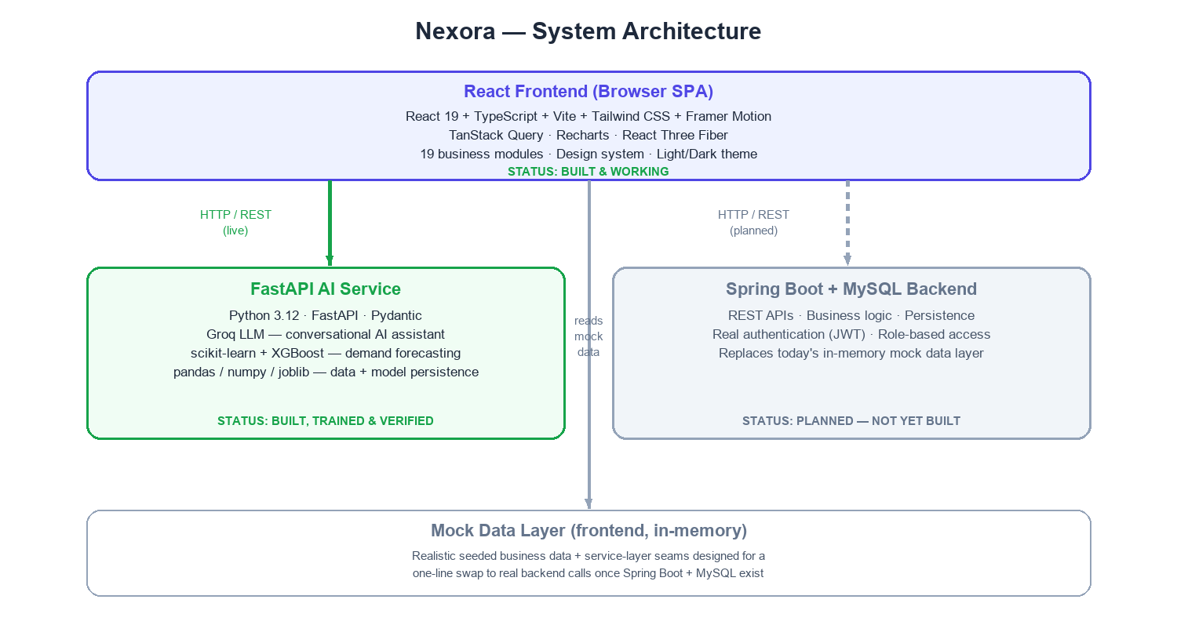

Why a mock data layer, and why it is not a shortcut
Until the Spring Boot + MySQL backend exists, the frontend runs against a structured, realistic mock data layer (seeded sample data for a fictional Indian food & beverage manufacturer). Every feature accesses this data through the same service-layer interface pattern a real backend API would use — the same function signatures, pagination, filtering and sorting contracts. This means replacing the mock layer with real API calls later is a matter of changing what happens inside a handful of service files, not restructuring the application.
The AI/ML service is not mocked — it is a real, separately running Python service. The frontend calls it exactly the way it will call the future Spring Boot backend, over a REST API, which is why it was built and connected first.

5. Completed Modules
All 19 modules originally scoped for this phase are implemented and functioning end-to-end against the data layer described in Section 4.
# | Module | What it does
1 | Login / Account | Sign-in, password reset, editable profile and settings (theme, language, notifications)
2 | AI Command Center | Home dashboard: business health score, priorities, alerts, revenue trends, quick actions, AI recommendations and an embedded AI chat panel
3 | Products | Full product catalog: create, edit, delete, search, filter, categories
4 | Raw Materials | Material catalog with units, categories, perishability and supplier linkage
5 | Bill of Materials (BOM) | Define materials required per product, with a live cost calculator and material-requirement preview
6 | Inventory | Stock dashboard, low-stock alerts, 90-day trend charts, warehouse breakdown, movement history
7 | Warehouse | Warehouse list and detail views with capacity, location and manager information
8 | Procurement | Purchase order lifecycle from AI recommendation through supplier selection, approval and status tracking
9 | Vendors | Supplier profiles, ratings, performance analytics, lead times and order history
10 | Reports | Business, Inventory, Procurement, Forecast and Supplier reports with charts and CSV export
11 | Business Calendar | Government, company and supplier holidays plus maintenance schedules
12 | AI Health Check | Overall and category-level (inventory, supplier, procurement, forecast, market) health scoring with AI narrative
13 | AI Chatbot | Floating conversational assistant available on every screen, powered by Groq
14 | AI Setup Wizard | 12-step guided onboarding for a new business (company, warehouses, products, materials, suppliers, calendar, etc.)
15 | AI Action Center | Queue of AI-recommended actions requiring explicit human approval before anything happens
16 | Market Intelligence | Commodity, fuel, currency and supply-chain risk monitoring, filtered to only what affects this business
17 | Notifications | Prioritized alert center with read/unread tracking
18 | User Preferences | Theme, language and appearance settings
19 | Help Center | FAQs, guided tutorials, and an AI-powered help panel

6. Artificial Intelligence & Machine Learning Capabilities
Nexora's AI layer is composed of four distinct pieces, each doing a genuinely different job:

6.1 Recommendation Engine (rule-based, deterministic)
Reads the real relationships between Products, Bill of Materials, Raw Materials, Inventory and Suppliers to generate reorder and safety-stock recommendations. Every recommendation includes a plain-English reason, a confidence score, the business impact, the risks of ignoring it, and a suggested action — this is genuine computed logic over real data relationships, not random or canned text.

6.2 Business Health Engine
Scores the business across inventory, supplier, procurement, forecast and market-risk categories, and produces an AI-written narrative summary explaining what is driving the overall score.

6.3 Conversational AI Assistant (Groq)
A floating chat assistant available throughout the application, powered by the Groq LLM API through the dedicated FastAPI service (the frontend never calls Groq directly). It explains screens, answers questions about inventory and procurement, and helps with onboarding — but by design it never executes a business action itself; every consequential action still requires explicit user approval in the AI Action Center.

6.4 Demand Forecasting (XGBoost + Random Forest)
This is real, trained machine learning, not a placeholder. Because no real historical sales data exists yet for this project, the service deterministically generates about two years of synthetic daily sales history per product category (capturing trend, weekly seasonality and festive-season demand spikes) and trains on that — every forecast response says so explicitly, so nothing is presented as real data that isn't.
- Both an XGBoost Regressor and a Random Forest Regressor are trained per product category on a time-based train/validation split (not a random shuffle, since this is time-series data).
- The model with the lower validation error is automatically selected per category — in practice, each algorithm wins on different categories, confirming the comparison is real.
- Forecasts are served for daily, weekly, monthly and quarterly horizons, scaled to each specific product's actual usage level.
- If a model isn't ready or the service is unreachable, the application degrades gracefully to a simple projection instead of showing an error — verified by deliberately stopping the service during testing.

6.5 Company-Independence Filter (Market Intelligence)
A differentiating design principle: global market events (commodity price changes, currency movements, supply-chain disruptions) only generate a recommendation if they affect a raw material this specific business actually uses. A steel price shortage is not shown to a business that does not use steel. This is what keeps Nexora industry-independent — the same logic works for any type of manufacturer without modification.

7. What Remains To Be Done
The following items are explicitly out of scope for the current phase and are planned for the next phase of development.
Area | What remains
Application backend | Spring Boot REST API layer — controllers, services, repositories and entities
Database | MySQL schema design and persistence (all data currently lives in memory and resets each session)
Authentication | Real user authentication and role-based authorization (JWT). The current login accepts any credentials, by design, for demo purposes
Billing integration | Real connection to external billing systems via API, CSV import or webhook (currently UI-only)
Vendor portal | A supplier-facing login where vendors confirm deliveries and update order status directly
Notifications | Real push/email/SMS delivery (Notification Center currently reflects mocked events)
Reporting | PDF report generation (CSV export already works; PDF is a labeled “coming soon” placeholder)
Forecasting data | Swapping in real historical sales data once the business has accumulated some — the models themselves are already real and trained
Non-functional | Load testing, security hardening, CI/CD deployment pipeline

8. Testing & Verification Performed
- TypeScript strict-mode compilation passes with zero errors across the entire frontend codebase.
- Production build verified to complete successfully.
- The AI/ML service was booted from a clean state and confirmed to train all category forecasting models in under five seconds.
- Forecast prediction endpoints were tested for daily, weekly and monthly granularities, including an unknown-category fallback.
- Resilience was deliberately tested: a corrupted model file was injected and confirmed to retrain in isolation without affecting other categories or crashing the service; the AI service was stopped entirely while the frontend was open, and the Forecast Report was confirmed to degrade gracefully rather than error out, then recover cleanly on restart.
- Every one of the 19 modules was manually exercised end-to-end in the browser, including the full reorder-recommendation → purchase-order-creation → approval workflow and the market-intelligence relevance filter.

9. Anticipated Panel Questions & Suggested Answers
A quick-reference list of questions this kind of project commonly draws, with concise suggested answers.
Q1. Why is all the data mocked/synthetic instead of real?
Because the persistent backend and database are the next phase, not this one. The mock data is deliberately realistic and internally consistent (products link to real BOMs, inventory, and suppliers) so every screen and every AI recommendation behaves exactly as it will once real data replaces it. This is a standard, deliberate staging strategy — build and validate the full application experience first, then connect persistence.
Q2. Is the AI actually intelligent, or just if-else rules dressed up?
Both, honestly, by design. The recommendation engine and health scoring are deterministic rule-based logic — that is intentional, because those decisions must be explainable and auditable, not a black box. The conversational assistant and the demand forecasting, however, are genuine machine learning / LLM components: Groq for natural language, and trained-and-validated XGBoost/Random Forest models for forecasting.
Q3. Why Groq instead of OpenAI or another LLM provider?
Groq offers very low-latency inference, which matters for a chat assistant embedded throughout a business application. The integration is also abstracted behind Nexora's own service interface, so the underlying provider could be swapped later without changing any frontend code.
Q4. Why train both XGBoost and Random Forest instead of picking one?
To make an evidence-based choice instead of an assumption. Both are trained per product category and compared on held-out validation error; in practice each algorithm wins on different categories, which is itself useful confirmation that the comparison is meaningful rather than cosmetic.
Q5. What happens if the AI service goes down?
The frontend is built to fail soft everywhere it depends on the AI service. Chat, health-check summaries and demand forecasts all fall back to a simpler, clearly-labeled degraded response instead of showing an error — this was explicitly tested by stopping the service while the application was in use.
Q6. Is this production-ready today?
The frontend experience and the AI layer are. The application is not production-ready as a whole because it has no persistent database or real authentication yet — those are the explicitly scoped next phase.
Q7. How would a real backend be connected later?
Every frontend feature already talks to a service-layer interface with the same shape a real REST API would have (pagination, filtering, sorting, promises). Connecting Spring Boot means implementing those same endpoints and changing what a handful of service files call — not restructuring the application.
Q8. Does the AI ever take actions on its own?
No, by design. Every module that recommends an action (reordering stock, approving a purchase order) requires explicit human confirmation through the AI Action Center. The AI prepares and explains; the user decides.
Q9. How does the platform stay industry-independent?
It never reasons from a hardcoded company type. All recommendations and market-relevance filtering are derived purely from a business's own Products → BOM → Raw Materials → Suppliers graph, so the same logic applies whether the business makes food, furniture or electronics.
Q10. What was the biggest engineering challenge?
Keeping the mock-data phase and the eventual real-backend phase cleanly separated — building a frontend that looks and behaves like a finished product today, while making sure every data access point is structured so the swap to a real backend later is mechanical rather than a rewrite.

10. Conclusion
Nexora has completed its frontend-and-AI development phase: a fully working application covering all 19 planned business modules, a genuine AI recommendation and health-scoring layer, a live conversational assistant, and trained, validated machine-learning demand forecasting — all verified end-to-end, including deliberate failure-mode testing.
The remaining work — the Spring Boot backend, MySQL persistence, real authentication, and external integrations — is a well-defined next phase. The current architecture was built specifically to make that phase a targeted integration effort rather than a rewrite, which is the central engineering decision behind this milestone.

