* We have done MVC (Model View Controller) for this project.
* We have index.html, money.jpg, mvc.js, style.css, unit tests.html and README file for this project.
* We made index.html file for our web page.
* We have MVC.js file where we have Controller, Model and View functions.
* Money.jpg is a picture for web page.
* Style.css file has code for design the web page.
* We made unit test file for all the unit test.

For our web page,

1. This is screenshot how our web page look like for index.html file

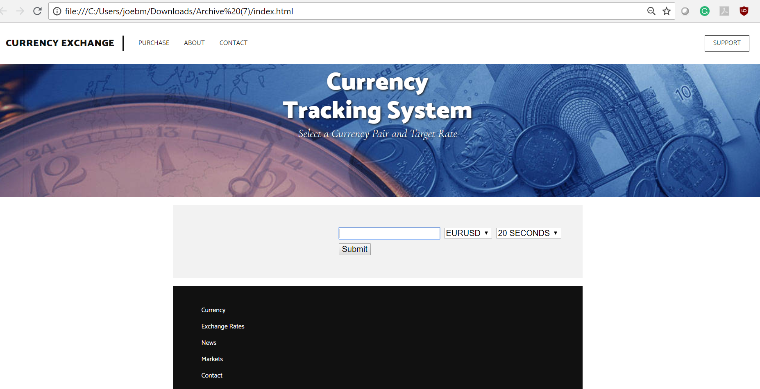

In this we have

--> **Input Box** where user can type the target price. If user type anything besides numbers, then there is an alert message box where it says "please enter a number greater than 0”.

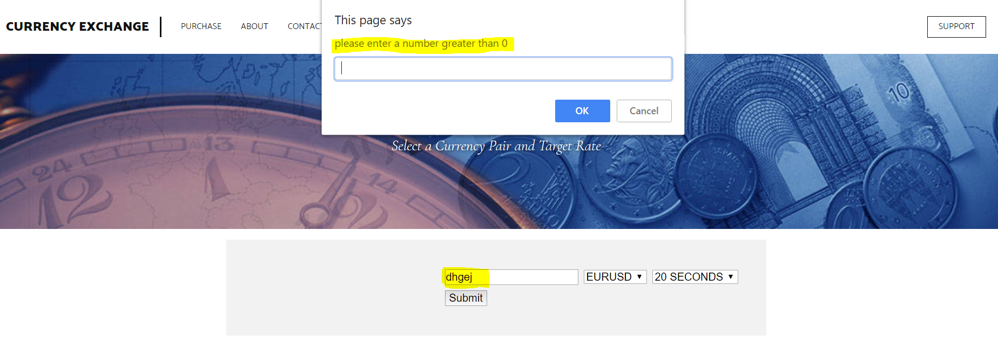

--> Next to input box we have **currency pair**, where user can select currency pair value from the drop-down list.

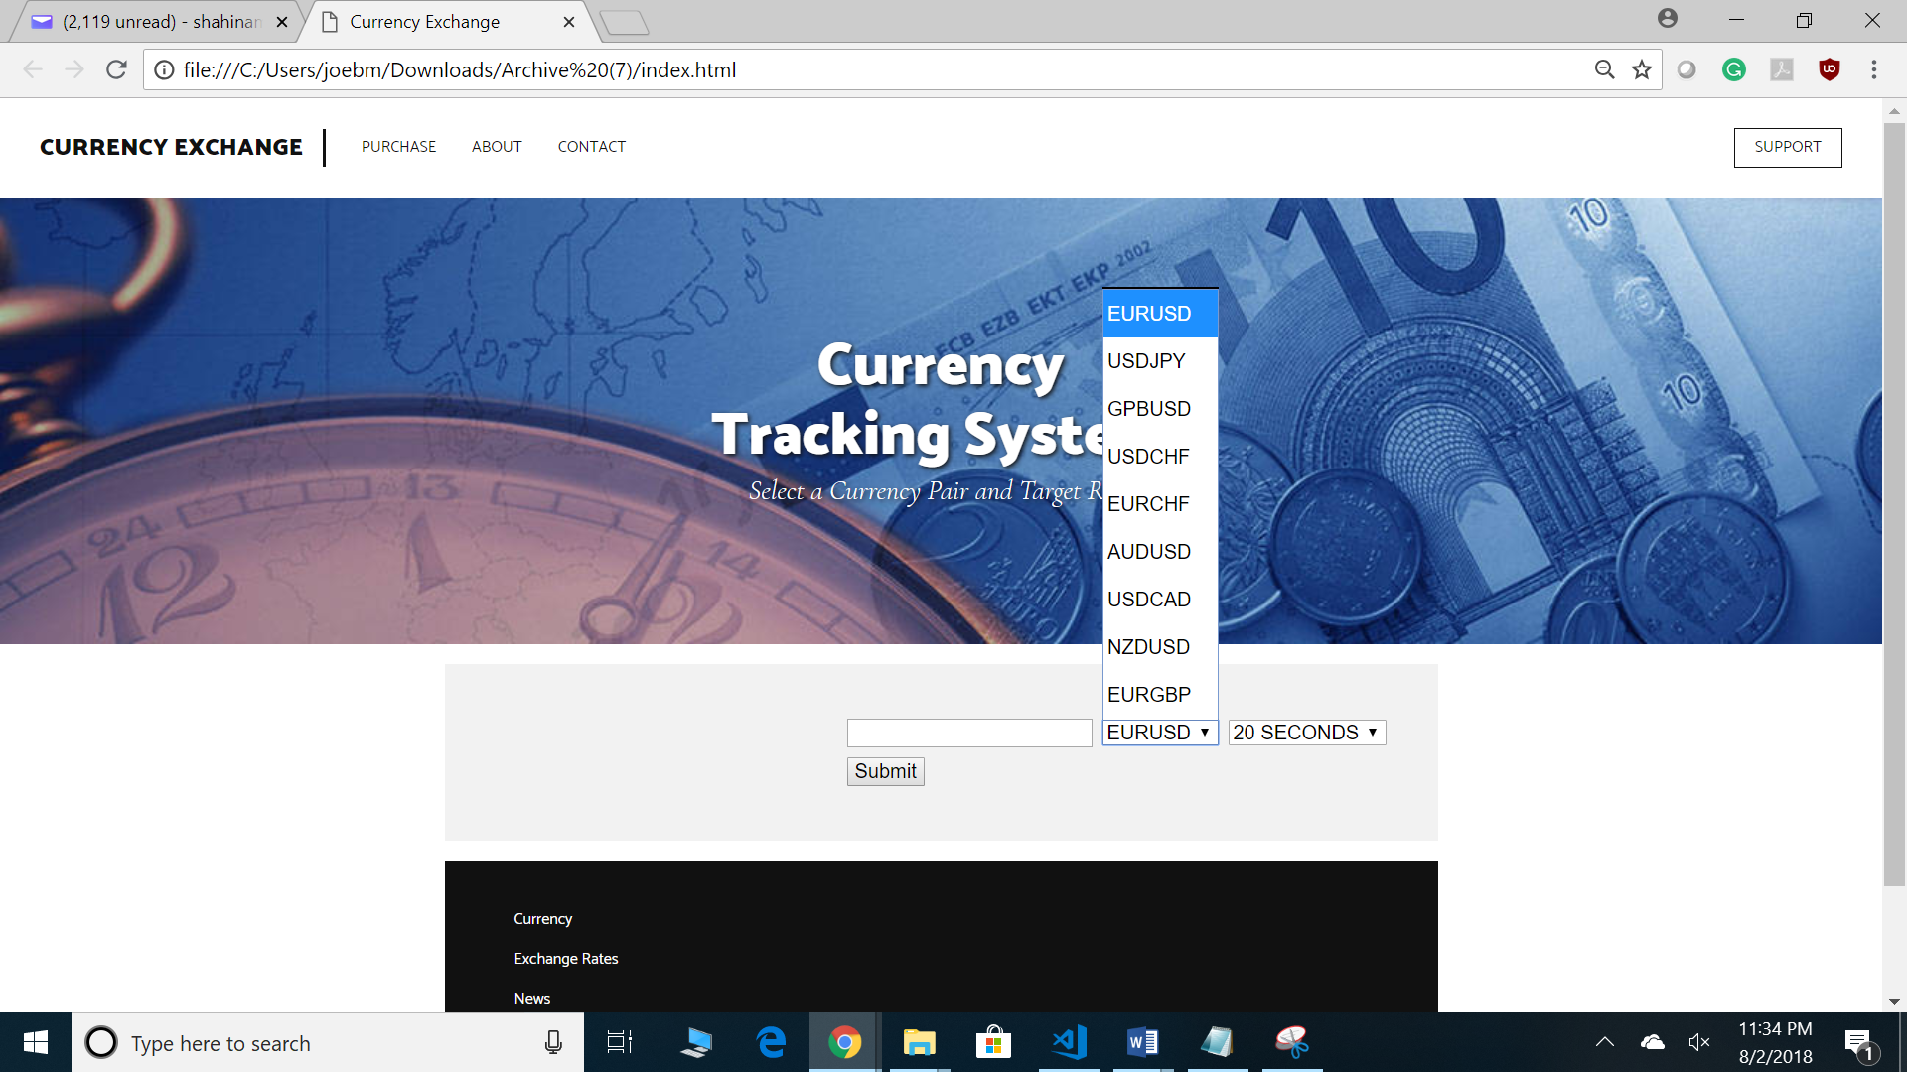

--> Next to currency pair, we have **user. Frequency**, from where user can select from "20 seconds up to 1 minutes" from alert notification.

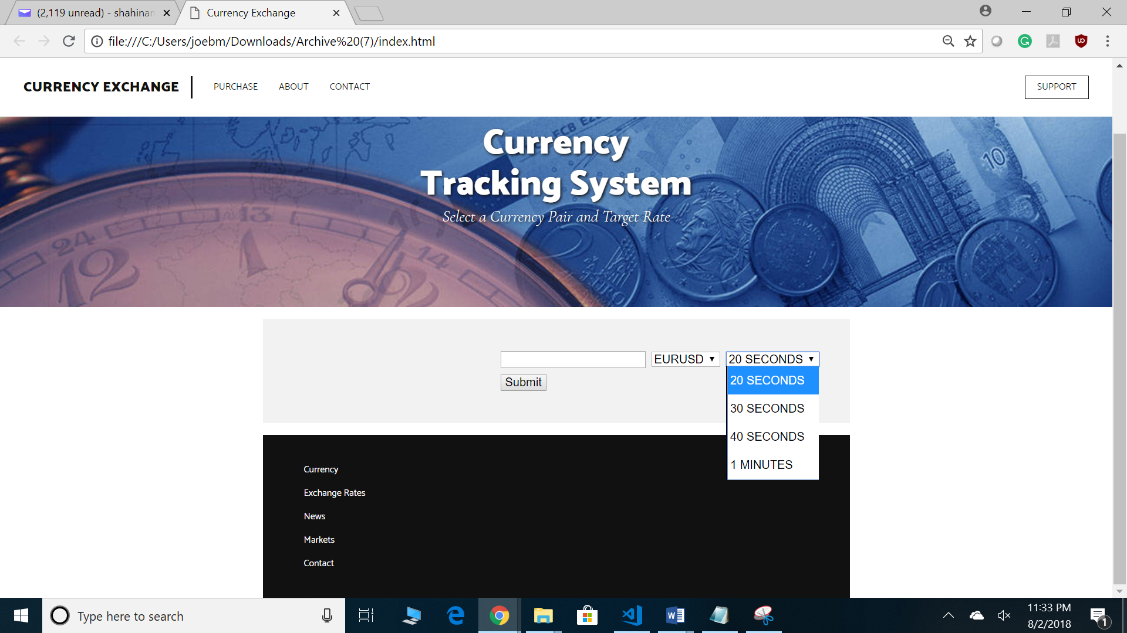

--> when a user put a target price in the input box, if that target price match with the market price then it will notify the user with pop up message box saying that price is "Matched", if it doesn’t match then no alert.

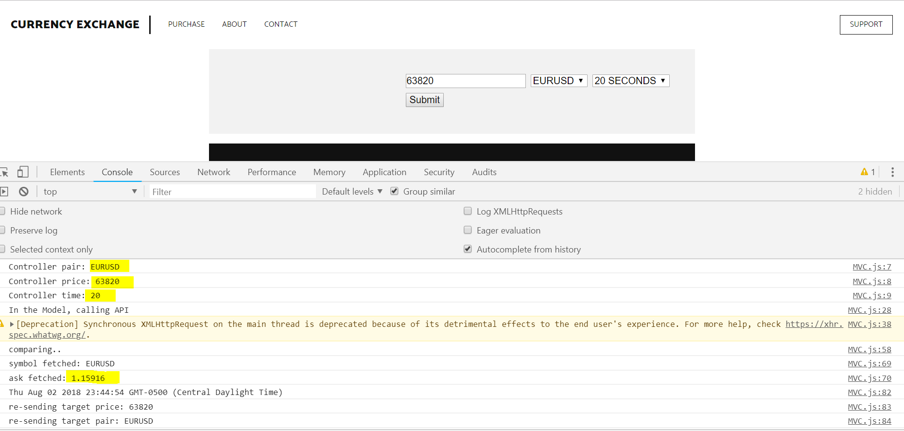

Market price is different so no alert

User select pair, input price and time

--> Once price is matched its going to notify the user.

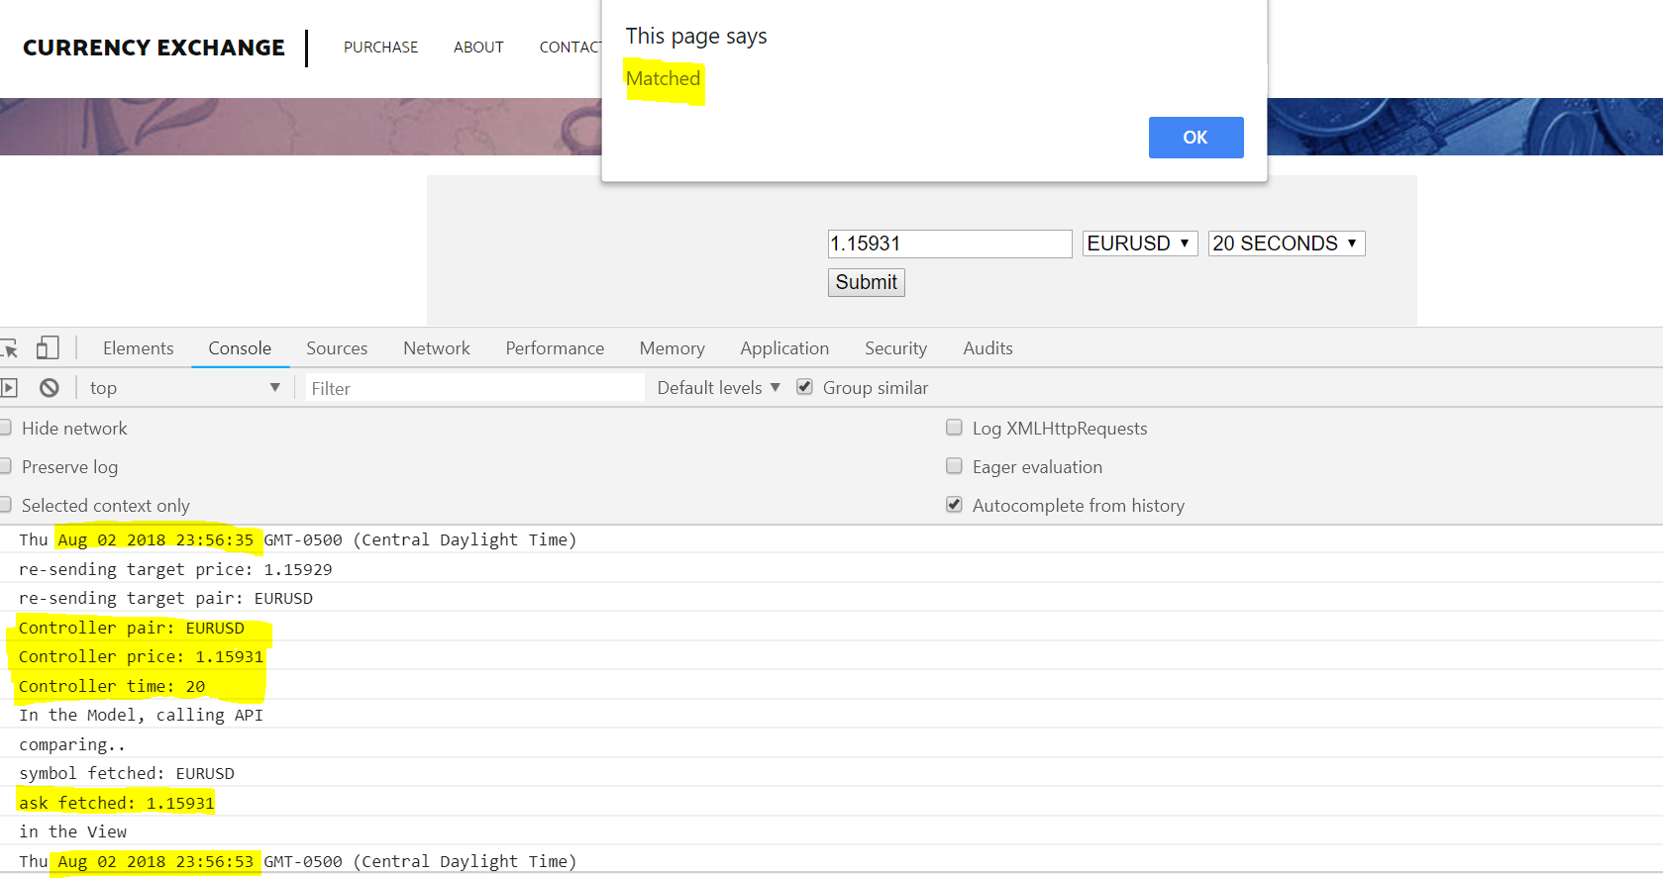

User input price is that matched with market price

Market price

Timing different for 20 seconds

Second example: -

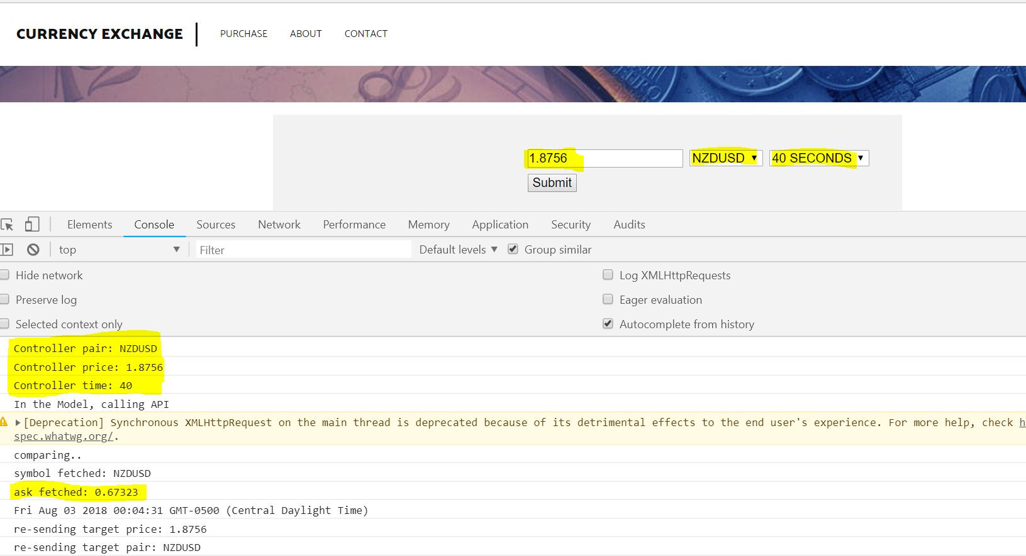

Market price is different so no alert

User input pair, price and time

Price Matched!

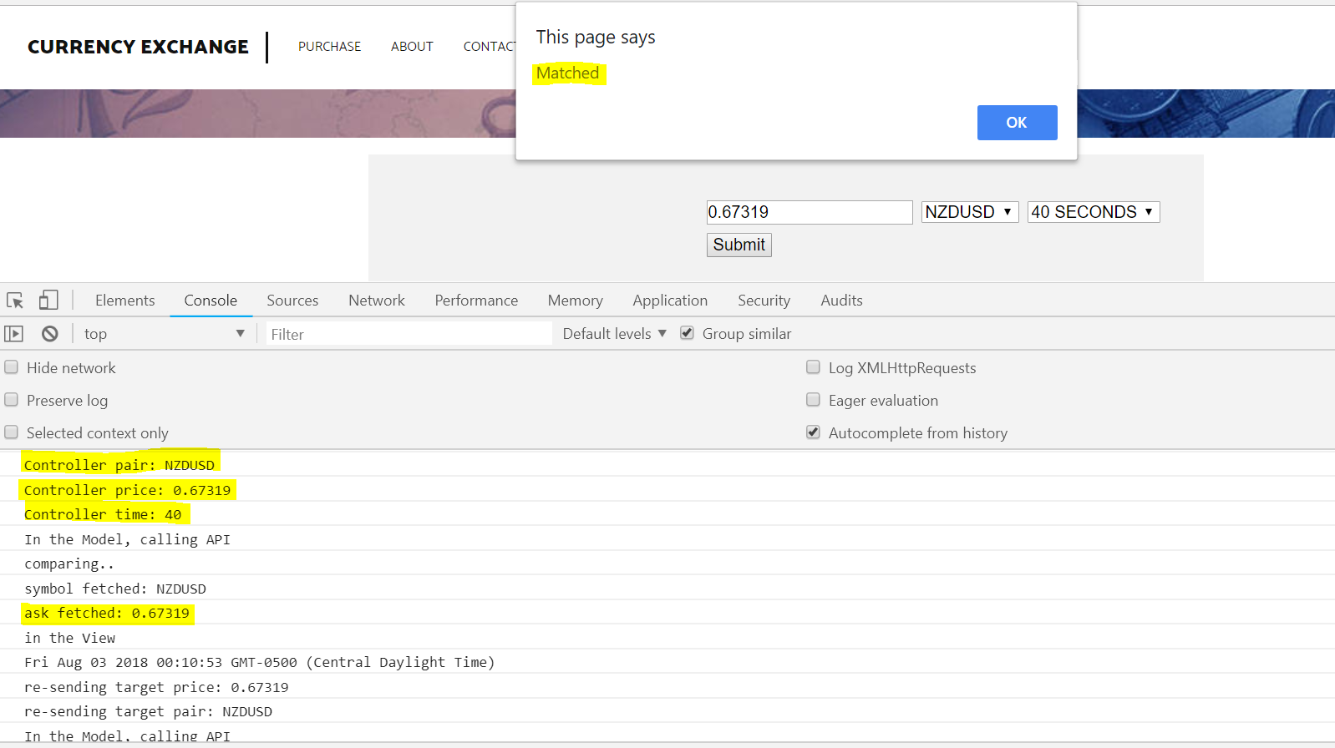

Market price

User input is matched with the market price