Registerable Intellectual Property

# Patentable inventions

1. Workmatec Marketplace
   1. Create Apps
   2. Share Apps
   3. Publish Apps in Marketplace
   4. Get Feedback, Improve
   5. Go Earn

How it is different from other marketplaces?

1. Complete online development platform
2. Mobile development
3. Online collaborative development

# Trade marks

Workmatec registered trade mark may be any one of the following:

1. WMT or WorkMaTec or Workmatec (Product Name)
2. Workmatec.com (site)
3. Work Less, Do More (Phrase/ Tagline)
4. Workmatec (Logo)
5. Workmatec Engine
6. Workmatec Cloud Environment (SaaS)
7. Workmatec Intelligent Chat
8. Workmatec Analytics
9. Workmatec Steps
10. Workmatec Apps
11. Workmatec Test Drive
12. Workmatec Business Rules
13. Workmatec Forms
14. Workmatec Documents

Non-Registerable Intellectual Property

# Copyrights

1. Product Architecture
2. Source code
3. Database Storage Structure
4. Cloud Storage
5. Business Algorithms and Logics

# Confidential Information

1. Encryption Keys

# Intellectual Capital

1. Human Capital (also confidential)
   1. Professional Competencies
   2. Work Experiences
   3. Motivation and Behavior
2. Structural Capital
   1. Quality Control System, Procedures, Manuals
   2. Brand
   3. Training Programs
   4. Customers

Functional Description

# Workmatec

Workmatec supplies a platform for organizing team communication, apps, data management and analysis in workspaces. Users can also select business apps from an online Marketplace or build their own according to needs.

# Workmatec Engine

Workmatec Engine is the central module of the Workmatec that provides an integration framework to all Workmatec modules and API. Following are some key responsibilities of Workmatec Engine:

* Governs the flow of a process at run time from one step or user to another as per action or defined rules.
* Generates notification and reminders
* Performs housekeeping
* Modules Integration
* Database Interaction

# Workmatec Tasks

Workmatec Tasks are the basic unit of action in Workmatec. User can follow tasks, assign them to him/herself or others add notes, attach form, define business rules or comment on them.

# Task Feeds

Task Feeds is view of all the tasks that are [assigned](https://asana.com/guide/help/tasks/basics#gl-assigning-tasks) to user or followed by user in a given Workspace. For many users, Tasks Feeds is their first stop in Workmatec. Users can view latest tasks, add comment, complete tasks, attach file, open form, view reminders etc from Task Feeds page.

# Workmatec Intelligent Chat

Workmatec Intelligent Chat is a framework which offers individual or group messaging. It also works as a [personal assistant](http://en.wikipedia.org/wiki/Personal_assistant). Workmatec provides a [normal chat interface and by using hash tags](http://en.wikipedia.org/wiki/Natural_language_user_interface) (#remindme, #meeting, #createtask etc) enables users to execute commands. All content inside Workmatec Chat is searchable from one search box.

# Rule Engine

Rule Engine is a Workmatec framework that enables the execution and maintenance of workflows. It provides interaction and communication between data/process activities/users spread across one or more apps as per the defined rules and business logic.

# Form Engine

By adding a Form to an app, user can get data into Workmatec from an external source, such as public website or from the team members etc. Forms can be used for many different purposes. Some common examples are; Leave request form, Recruitment from, Sales Lead etc. Workmatec Form Engine manipulates all the form data, maintain data accessibility, security and its availability for reports and analysis.

# Workmatec App

A Workmatec App is a pre-defined application which may include Forms, Steps, Business Rules, Recipients, Groups, etc. Workmatec apps are normally defined to fulfil any business need or requirement like Daily Attendance, Recruitment of employees, Sales Lead etc. Workmatec Marketplace contains several predefined apps. Workmatec also allows to create new apps.

# Workmatec Steps

Workmatec Steps are division of an app into steps based on activity, user roles or business requirement etc. Workmatec enables the visibility and control of data form fields at step level.

# Workmatec Documents

Workmatec Documents is system used to track, manage and store documents. It is capable of keeping a record of the various versions created and modified by different users. It also provides search capabilities with-in documents.

# Workmatec Workspace

A Workspace, like an Organization, is a collection of people and the apps they work on together.

# Contacts

Contacts are people in a user’s Workspace: like teammates, employees, families, friends or business contacts. Workmatec allows each user to start own workspace.

# Groups

Workmatec Group are collection of individual contacts or groups. These groups can be used in apps, tasks and chat.

# Workmatec Analytics

Workmatec Analytics is a built-in components that tracks activities perform within user workspace. User can analyze the progress and performance of workspace members. It highlights areas or tasks that need attentions. Analysis can be based on defined or customized period for individuals, groups, department or whole workspace.

# Workmatec Marketplace

Workmatec Marketplace is accessible via the link in menu of all Workmatec account. There are several of pre-made apps that are readily available in Workmatec Marketplace. Users can select business apps from Marketplace according to their needs.

# CAD (Community-based App Development)

Using Workmatec, community developers can get set of development tools that allow developers to design, develop, and deploy apps across the workspace/ organization, then scale and evolve those apps as needed, anytime and anywhere. Workmatec revolutionize the application development process, enabling you to build and run applications efficiently by optimizing an application’s lifecycle from development to operations and evolution.

These developed applications can become part of Workmatec Marketplace through a WMT CAD (Workmatec Community-based App Development) process.

# Test Drive

Workmatec Test Drive allows users to test apps from Marketplace before installation on workspace. Test Drive allows users to interact with application forms, workflow, business rules and reports.

# Workmatec API

The Workmatec REST API lets developers to integrate with Workmatec components using simple HTTP methods, in either XML or JSON formats. This makes an ideal API for developing custom applications or external clients. Following benefits of using the REST API in integrations:

* Universal access: Use standard HTTP method call-outs, available on every language and platform, to make requests and retrieve information from Force.com.
* Standards-based security: Utilize the OAuth 2.0 protocol for authenticating REST calls.
* Data model: Gain access to the same data model and standard objects as those in SOAP-based Web services.
* Flexible formats: Serialize data in either the XML or JSON format.

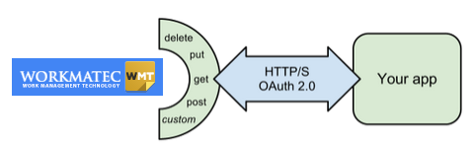

# JSON

JSON or JavaScript Object Notation, is an open standard format that uses human-readable text to transmit data objects consisting of attribute–value pairs. It is used primarily to transmit data between a server and web application, as an alternative to XML. JSON is a language-independent data format. Code for parsing and generating JSON data is readily available in many programming languages.

# Encryption

Workmatec uses secure socket layer (SSL) technology to encrypt the transmission of data to our servers, which helps protect data.

Advanced Encryption Standard (AES256) is being used in Workmatec to encrypt user data. The Advanced Encryption Standard or AES is a symmetric block cipher is also used by the U.S. government to protect classified information.

# Key Storage

Secure key management is essential to protecting data in the cloud. Workmatec uses Azure Key Vaults to safeguard encryption keys. With Azure Key Vault, Workmatec stores encrypt keys and small secrets like passwords using Hardware Security Modules (HSMs). Keys in HSMs certified to FIPS 140-2 level 2 standards so that your keys stay within the HSM boundary.

# Workmatec SaaS model

Workmatec uses Software as a Service (SaaS) for service distribution model. In SaaS, applications are hosted by a vendor or service provider and made available to customers over a network, typically the Internet.

Benefits of the Workmatec SaaS model include:

* Easier administration
* Automatic updates and [patch management](http://searchenterprisedesktop.techtarget.com/definition/patch-management)
* Compatibility: All users will have the same version of software.
* Easier [collaboration](http://whatis.techtarget.com/definition/collaboration), for the same reason
* Global accessibility

*Note: The traditional model of software distribution, in which software is purchased for and installed on personal computers, is sometimes referred to as software as a product.*

Technical Detail

# Technical Overview

|  |  |
| --- | --- |
| Workmatec Service Category | Software as a Service (SaaS) |
| Development Tool | Microsoft Visual Studio 2013  Microsoft Visual Studio Online |
| Development Languages | Node JS  Angular JS  JavaScript |
| Third Party Libraries | amCharts  jQuery  jQueryMobile |
| Database | Microsoft SQL Server 2012  Microsoft SQL Server Azure  Microsoft DocumentDB |
| Cloud Environment | Microsoft Azure |
| Source Control | Microsoft SourceSafe  Microsoft Team Foundation Server |
| Encryption Key Storage | Azure Key Vault |
| SSL Encryption | 256-bit (GeoTrust) |
| Domain | [www.workmatec.com](http://www.workmatec.com) |
| Public IP Address | - |
| Notification Service | SendGrid |

# Workmatec Components

|  |  |
| --- | --- |
| Front End | Web/ Desktop Application |
|  | Android App |
| Back End | Microsoft SQL Server 2012 |
|  | Microsoft SQL Server Azure |
|  | DocumentDB |
|  | SQL Lite (Android) |
| Modules | Workmatec Engine |
|  | Tasks |
|  | Feed |
|  | Chat |
|  | Activities |
|  | Rules |
|  | Forms |
|  | Documents |
|  | Test Engine |
|  | Reports |
|  | Analytics |
|  | Contacts and Groups |
| API Components | Workmatec API |
| Marketplace Categories | Administration |
|  | Customer Relationship Management |
|  | Human Resource |
|  | Accounts and Finance |

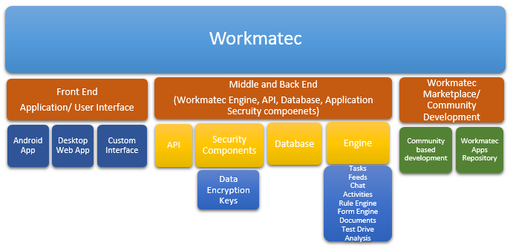

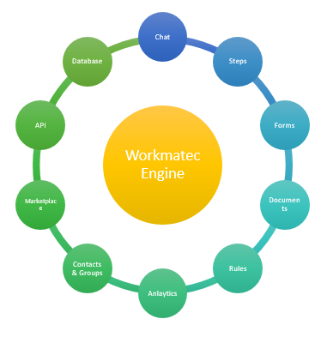

# BizSpark Program:

BizSpark join date: 11/10/2014

MSDN subscription ID: 1400576408

Microsoft account: [workmatec@outlook.com](mailto:workmatec@outlook.com)

Duration: 3 years

# Cloud Items

|  |  |  |
| --- | --- | --- |
| **Cloud Items** | **Type** | **Size/ Specification** |
| Workamatec Application | Virtual Machine | 3 instance |
| Staging Application | Virtual Machine | 1 instance |
| SQL Database (S2) | Database | 2 Database |
| DocumentDB | NoSQL Database | 8 Capacity Units (24 Collections) |
| Block Blobs | Storage | 100 GB |
| Page Blobs and Disks | Storage | 100 GB |
| Tables and Queues | Storage | 50 GB |
| Files | Storage | 1000 GB |
| Storage Transactions | Storage | 10 Millions |
| Backup | Backup | 100 GB |
| Search | Search Units | 2 Search Unit |
| Workmatec API Unit | Cloud API | 1 API Unit |
| Support | Support | Technical Only |
| Visual Studio Online/ TFVC | Cloud Developing Environment and Source Control | 5 Users |
| SendGrid | App Serice | 25000 emails / day |

*Currently all WMT applications and databases are deployed at US East 2 location of Microsoft Azure due to maximum availability of features, cost and services at the moment.*

# VM Instance Specification

* Hosting Plan: Standard
* Instance Size: Medium (2 Core 4 GB)
* Instance: Min 1 - Max 3
* Target CPU (For Auto Scaling): 60 – 80 %

# Database Specification

* Service Tier: Standard
* Performance Level: S2 (50 DTU)
* Max Size: 1GB

*Workmatec site is currently configured as Auto Scalable mode. It scale up or down automatically depends upon CPU usage.*

# Workmatec application architecture

Workmatec software architecture is based on MVC. MVC is the separation of model, view and controller. This separation of responsibilities allows flexibility of application down the road. Following are key areas where flexibility is available:

**Efficient modularity:** This allows any of the Workmatec components to be swapped in and out as the business user or programmer desires.

**Multiple views:** Workmatec application can display the state of the model in a variety of ways, and create/design them in a scalable, modular way.

**Ease of growth:** Controllers and views can grow as the model grows; and older versions of the views and controllers can still be used.

**Clarity of design:** The public methods in the Workmatec model stand as an API for all the commands available to manipulate its data and state.

# Workmatec backend database

Workmatec uses NoSQL database at backend. NoSQL databases are highly optimized for retrieval and appending operations. Key advantages of using NoSQL database are:

* Non-relational and schema-less data model
* Low latency and high performance
* Highly scalable

# Scalability options

Workmatec's Application design is tightly integrated with Microsoft Azure for best performance. Azure offers secure and flexible development, deployment and scaling options for any sized Web application.

Deployed Workmatec application, service and database can be scaled in terms of:

* Website Size
* CPU Processor Size/Cores
* Bandwidth (input and output bandwidth)
* Memory (RAM)
* Database Performance

Auto-Scale is configured in Azure to auto selection of the preferred model suitable for deployed application.

# Performance Testing

Workmatec application tested for both **Load** and **Consistency**. Two different scenarios executed for performance testing using Apache jMeter tool.

1. In scenario A, 250 thread (user connections) were made within a second and repeated for 100 times. Total of 25000 user connections were successfully processed within 30 minutes. Each user performed six operations in single connection including Connect, Login, Task Feeds, Inbox, My Apps and Logout. This scenario helps to check capability of **load capacity of application**.
2. In scenario B, 25 threads (user connections) were made within a second and repeated for 10,000 times. Total of 250,000 user connections were successfully processed within 6 hours. Each user performed six operations in single connection including Connect, Login, Task Feeds, Inbox, My Apps and Logout. This scenario helps to check the **consistency of the application**.

During testing of both of the above scenarios, Web Application and database were monitored closely. CPU was observed as working normally and no HTTP error generated from the web application. Database also processed all of the requests successfully and used up to 98.7% of allocated capacity.

# Business Layers

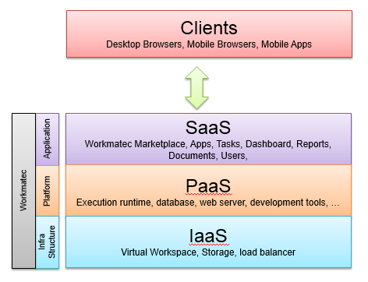

# CAD (Community-based App Development)

# 

# Workmatec Service Delivery and Security Model



# SWOT Analysis

|  |  |  |
| --- | --- | --- |
| **Internal** | **Strengths** | **Weaknesses** |
| * Less need of in-house IT * High availability anywhere * Low activation cost * Fast implementation * Low risk of purchasing * Easy upgrades * Possible better technical security * A wide range of potential customers * Low costs for individual customer * Simpler version management * Simple development process * Quick selling | * Less control * Non- tailored application * High dependency on the service provider * Standardized contracts * No offline usage * Flow of income * High costs with bringing of customers * Weaker locking of the customer |
| **External** | **Opportunities** | **Threats** |
| * More options * More focus on the core business * Cost savings * Low risk testing * Self-service model * High cost-value ratio * Scalable business model * Possibilities of internal viral-effect * Quick entry to global markets * Possibility to start with minimal risks * Cost saving in development * Faster feedback-cycle * Active use of user communities | * Integrations to existing systems * Trust in provider and security * Legal restrictions * Changes in the service or availability * Lack of local support * Customers fears regarding data security * Quick coping of service * Customer value diminishes * Moving into unknown territories * Differences in the development |

# Marketplace Apps

