|  |  |  |
| --- | --- | --- |
| GO ASSESS Collateral | January 1  2013 | |
| GO ASSESS Features and Benefits Matrix version 1.0 | |  |

Contents

Introduction 4

Essential Features 4

Create Electronic Assessments Easily 4

The Challenge 4

The Solution 5

Drastically Reduce Assessment Feedback Incorporation Times 5

The Challenge 5

The Solution 6

Collecting Assessment Data 6

The Challenge 6

The Solution 6

Data Cleaning and Validation 6

The Challenge 7

The Solution 7

Actionable Insights and Decision Making Support 7

The Challenge 7

The Solution 7

Exporting Assessment Data 8

The Challenge 8

The Solution 8

GO ASSESS Features 9

Create Assessments with Simple Drag and Drop 9

Templates and Reuse Questions from Past Assessments 9

Invite Contributors to Give Feedback 9

Time-barred Collaboration 9

Approval Process for Assessments 10

Use Mobile Phones to Collect Data 10

Support for Manual Data Entry 10

Clean and Validate Your Assessment Data 10

Approve Assessment Data Release 10

Rich Reports and Assessment Data Analysis 10

Export Your Data 11

GO ASSESS Feature Matrix 12

# Introduction

GO ASSESS is an easy-to-use assessment tool builder geared towards the specific needs of the public and private sector.

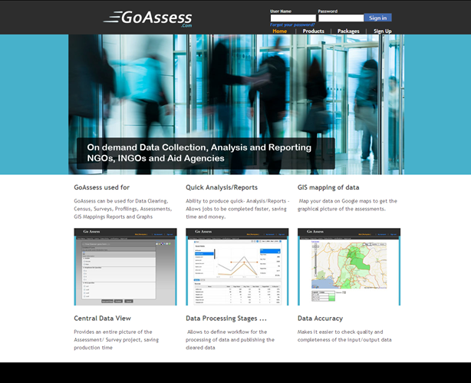Using GO ASSESS, you can use a simple drag-and-drop process to create assessments and collaborate on your draft assessments with your colleagues to gather and incorporate their feedback. GO ASSESS reduces the time and effort it takes to build effective, thorough assessments by as much as 80%.

Not only can you create and finalize assessments quickly – GO ASSESS also assists you in gathering data through traditional paper as well as mobile phones and PCs. The gathered data can then be cleaned and validated to ensure data integrity and validity – all through the processes utilized by GO ASSESS.

Once the gathered data is cleaned and validated, GO ASSESS uses it to provide program managers with actionable insights and decision-making support – as well as allowing the export of data into SPSS as well as Microsoft Excel.

GO ASSESS thus helps you manage the assessment process from start to finish – greatly reducing the time and cost involved in traditional, manual assessment approaches.

# Essential Features

## Create Electronic Assessments Easily

### The Challenge

One of the challenges involved in the assessment process is the reliance on paper-based questionnaires and documentation. Creating assessments on paper is time consuming and it is hard to improve and evolve assessment drafts.

### The Solution

Using GO ASSESS, you use a simple and intuitive web browser interface to quickly and effortlessly create assessments. You can drag-and-drop questions onto you assessment without the need for any specialist support. A process that takes less than 2 minutes to master – the drag-and-drop approach to making assessments automatically creates a database of assessment questions that can range from simple to highly complex.

Answers to questions in a GO ASSESS managed assessment can vary from simple textual answers to answers using images, multi-choice answers and a lot more. A rich set of question types comes ready-made with GO ASSESS, so you can easily create an assessment that matches field requirements and needs.

## Drastically Reduce Assessment Feedback Incorporation Times

### The Challenge

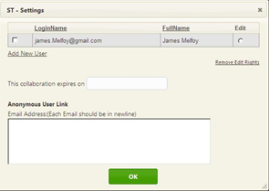Another significant and time consuming activity involved in the assessment process is the incorporation of feedback from your colleagues and partners. Your partners and collaborators would typically approach an assessment from their own vantage points and often will prefer to include questions and that data they consider the most relevant.

In an assessment process based on paper – it takes a long time to tweak and improve assessments, especially when collaborators on an assessment are geographically dispersed. It is also difficult for assessment collaborators to give feedback and helpful suggestions to improve a paper-based assessment draft. The draft may soon become tedious to manage.

### The Solution

GO ASSESS solves these problems by allowing your assessment partners and collaborators to join you right on the assessment draft in GO ASSESS and give feedback in one central location: The assessment draft itself. You can easily share your draft assessment link with your assessment collaborators who can provide suggestions and feedback against each question you’ve drafted. By bringing all parties to the same virtual table, you can finalize an assessment draft in hours instead of weeks!

## Collecting Assessment Data

### The Challenge

In the assessment process, gathering field data in risky, politically charged or disaster-struck environments is a crucial and risky endeavor. Traditional methods of data collection using basic paper-based forms is both error-prone and time consuming in such high-pressure, high-risk environments. In-efficient data gathering processes can reduce the quality, quantity and integrity of the data collected and thus under-mine the very assessment itself.

### The Solution

GO ASSESS offers fast, efficient data gathering using smart phones. The GO ASSESS mobile component sits on an agent’s mobile phone and gives her the ability to collect data quickly and efficiently – thus reducing the time and cost involved in data gathering – as well as improving the integrity and accuracy of the data collected.

Where using smart phones to collect assessment data is not feasible, GO ASSESS also supports gathering assessment data through traditional paper-based forms. The agents can collect data in the field and the data can be entered into the GO ASSESS system through a traditional PC.

Data Cleaning and Validation

### **The Challenge**

With traditional assessments, it is always a challenge to ensure high data integrity and validity. Do the data realistically mirror the situation on the ground? Was the assessment carried out diligently and professionally? Essentially – can we trust this data? Traditional approaches to data cleaning and validation involve ad hoc processes to use a battery of tests to verify the data. These tests may include follow-up with the population being assessed using call centers or through field agents. Data validation processes managed this way, are fragmented, slow and error-prone in themselves which can reduce the efficacy of the assessment besides incurring delays.

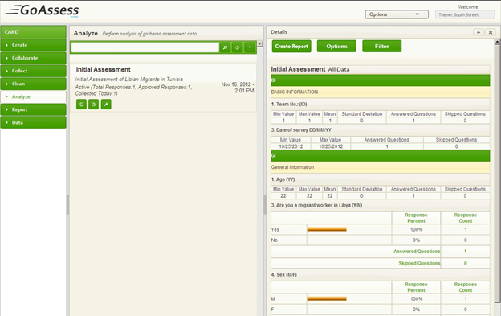

### The Solution

GO ASSESS supports integrated data cleaning, validation and integrity verification processes that streamline the process of validating field data. Using GO ASSESS, you can not only reduce the time and effort involved in data validation but improve the workflow of these processes to ensure high data integrity.

## **Actionable Insights and Decision Making Support**

### The Challenge

With any assessment, the point is not merely to collect data. Any data set needs to be analyzed in order to come up with practical, actionable insight into the situation on the ground. With traditional assessments, using the gathered data to inform decisions and form effective policies is always a daunting challenge in itself.

### The Solution

GO ASSESS offers rich reporting and analysis tools to help you accomplish this task. With its rich visualization of data points using geographical and political maps, you can quickly identify areas most in need of immediate assistance as well as use the data to gain insight into the specific problems being faced by the affected populations.

## Exporting Assessment Data

### The Challenge

With any data-set, various organizations may have their own preferred data analysis tools and processes in place. Taking in raw data from a traditional assessment and using it with a multitude of reporting and decision making systems is a time consuming activity that requires manual work and effort.

### The Solution

To address this need GO ASSESS allows easy export of assessment data to SPSS as well as a spreadsheet. Support for spreadsheets means that the data can be quickly imported into external systems with only minimal tweaking required.

# GO ASSESS Features

## G:\AIMS Screen Shots - Copy\Rules.pngCreate Assessments with Simple Drag and Drop

The GO ASSESS drag-and-drop interface makes it easy to create new assessments in quick time. No specialist help needed! While creating an assessment, you can drag entire questions onto the page to become part of the assessment. You can also divide related sets of questions into their own sections for improved readability.

## Templates and Reuse Questions from Past Assessments

GO ASSESS lets you optionally use questions from templates and past assessments to quickly build a relevant and effective assessment. To use questions from past assessments conducted by your own organization as well as other organizations, simply add an existing question using an intuitive user interface for finding relevant questions.

Invite Contributors to Give Feedback

You can invite your partners and collaborators to any assessment created in GO ASSESS. You can use the collaboration feature to gather feedback on your assessments from your assessment partners.

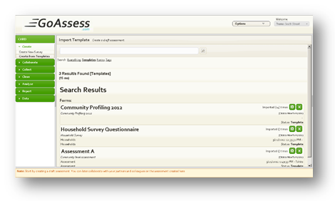 To enable collaboration with partners, you simply send a web link of your assessment. Your assessment partners can then view the draft assessment and give their feedback on each question contained in the assessment. This allows you to quickly finalize an assessment draft without having to manually gather feedback from each assessment partner.

## Time-barred Collaboration

In GO ASSESS, all collaboration on assessment drafts can be time-limited. You simply decide how long you want a given assessment to be open for discussion and feedback. Your assessment partners are automatically notified about the time-barred nature of the assessment draft and are thus encouraged and urged to participate in the process of drafting an assessment on high priority.

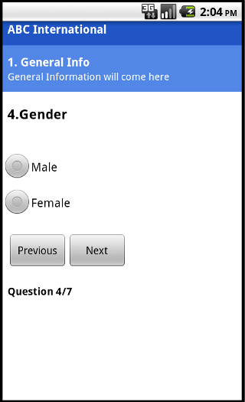Approval Process for Assessments

After an assessment draft has been finalized, you can request the Assessment Program Manager to approve an assessment. Approving an assessment allows field agents to start gathering data on an assessment using mobile phones, paper-based forms and PCs.

## Use Mobile Phones to Collect Data

Once an assessment has been approved in GO ASSESS, agents in the field can use mobile phones to gather assessment data. Using mobile phones to gather is both faster and less error-prone – especially in high sensitivity areas and populations. Data gathered in the field can then be imported into the GO ASSESS system by means of a PC or through internet connectivity.

## Support for Manual Data Entry

Where conducting mobile phone based assessments is not an option, GO ASSESS also supports gathering assessment data using traditional paper-based assessments. You can subsequently enter the data into the GO ASSESS by using convenient browser-based pages for inputting data.

## Clean and Validate Your Assessment Data

GO ASSESS allows you to efficiently manage data cleaning and validation processes related to your assessment. Using the GO ASSESS workflows for running data integrity checks through call-centers and on-site agents and managers – you can quickly run a smooth data validation to ensure high data integrity.

## Approve Assessment Data Release

You can explicitly approve release of data gathered during an assessment. This ensures that data from an assessment is only made available for further use after you’re fully satisfied with the quality and integrity of the data.

## Rich Reports and Assessment Data Analysis

GO ASSESS offers rich reporting capabilities to help you visualize the data and make informed decisions based on the data. Reporting capabilities in GO ASSESS include the ability to view data in the backdrop of geographical and political maps of the area where the assessment is being conducted.

Besides visual reports and graphs, GoAsssess also lets you analyze the assessment data on a per question basis to identify immediate and current needs as well as weigh tactical priorities. The primary goal of reporting and analysis functionality in GO ASSESS is to help you formulate intelligent work plans for the target areas where the assessment was conducted.

## Export Your Data

With GO ASSESS, you can also export your assessment data to external systems for further analysis. GO ASSESS already supports exporting assessment data to IBM SPSS as well as spreadsheet programs such as Microsoft Excel and OpenOffice.

# GO ASSESS Feature Matrix

|  |
| --- |
| ***Create Assessments*** |
| *Simply drag-and-drop questions to create assessments* |
| *WYSIWYG support for creating assessments* |
| *Include images in your questions and answers* |
| *Re-use past assessments and questions from past assessments* |
| ***Collaborate on Assessment Drafts*** |
| *Collaborate and discuss with partners on each question in the draft assessment* |
| *Set limits for how long a draft assessment is open for feedback from partners* |
| *Send collaboration requests through email* |
| ***Request Approvals for Assessments*** |
| *Assessment approval dashboard for program managers* |
| *Approval request notifications through email* |
| ***Collect Assessment Data*** |
| *Collect assessment data through mobile phones* |
| *Collect assessment data using paper-based assessments* |
| *Collect assessment data through PC and web browser* |
| ***Clean and Validate Assessment Data*** |
| *GO ASSESS automatically cleans assessment data using its rules engine* |
| *Validate assessment data through on-site agents* |
| *Validate data through call centers* |
| ***Report Assessment Data*** |
| *Dashboard to report assessment data* |
| *Email notifications for the release of assessment report* |
| ***Analyze and Decision Support*** |
| *Visualize assessment data through graphs and charts* |
| *Visualize assessment data imposed on geographical and political maps* |
| ***Export Assessment Data*** |
| *Data in IBM SPSS format* |
| *Export assessment data to Spreadsheet programs (such as MS Office and OpenOffice)* |