|  |
| --- |
| **GOASSESS User Manual** |
| GoAssess.im4hc.com |
|  |
| GOASSESS enhance organizational working efficiency in collaborative environment. This document is to facilitate you to use GOASSESS easily. GOASSESS is an easy-to-use assessment tool builder geared towards the specific needs of the humanitarian sector. |
|  |
| **GOASSESS powered by CARD©** |
| **9/18/2012** |
|  |

Table of Contents

1. Getting Started/Start with GoAssess 6

i. How to get GoAssess account 6

ii. GoAssess Account Types 6

1. Basic 6

2. Professional 6

3. Enterprise 6

iii. Payment Methods 6

2. Create an Assessment 6

i. Create a new Assessment 7

1. Where to begin 7

2. How to Add Questions 7

3. How Section Works 8

4. Preview Assessment 9

5. Print Assessment 10

ii. Create Assessment from Templates 10

1. Search a Template from GoAssess collection 11

2. How to Import a Template 11

3. How to edit template 12

4. Delete a template 12

iii. Question types and Properties 12

1. Question Types and properties 12

2. Properties 15

3. Delete Question 16

4. Duplicate [copy] Question 16

5. Edit Question 16

6. Comment a Question 17

7. Mark Question as Required Field 17

iv. Section types and their features 17

1. Section Types 17

2. Properties 18

v. Form (Assessment) Properties 19

1. Assessment Theme 19

2. Question numbering 19

3. Option Style (Only for radio button and check box) 20

4. Form Image (Banner) 20

5. Welcome Message 20

6. Close Message 20

7. Survey Identifier 21

vi. Search and Import Questions and Sections 21

1. Search & Import Question from GoAssess collection 21

2. Search & Import Section from GoAssess collection 21

3. Search Assessment by Tags 22

vii. Tag Your Question, Sections and Assessments 22

1. Tag Question 23

2. Tag Section 23

3. Tag Assessment (form) 24

viii. Apply Rules and Logics 24

1. How to apply Rules and Logic 24

ix. Mark your Assessment a Template 25

1. How to Mark Assessment a Template 26

x. Save the Assessment 26

2. How to Save Assessment 26

xi. Edit Saved Assessment 26

3. Collaborate with Members 27

i. Simple and advanced Search Draft Assessment 27

ii. Share Assessment within Organization 28

iii. Share Assessment with anonymous user 28

iv. Share Assessment inter Organizations 28

v. Add more users for Collaboration 28

vi. Assign Edit Rights to a user 29

vii. Add Comments on shared Draft Assessment 29

viii. View other members/users Comments on shared Assessment 29

ix. Edit Draft Assessment 29

x. Preview &Print Draft Assessment 29

xi. Duplicate Draft Assessment 30

xii. Delete Draft Assessment 30

xiii. Publish a Draft Assessment 30

4. Collect Responses 30

i. How to Publish an Assessment 31

ii. Simple and Advanced Search Published Assessment 31

iii. Support for Manual Data Entry 32

iv. Collect Responses online 32

v. Create Duplicate of Published Assessment 33

vi. Allow Specific users to collect response 34

vii. Allow specific users for Data Cleaning 35

viii. Allow Smart phone Collection 35

ix. Add more users for data Collection from Collect 35

x. Send Assessment to anonymous user to collect response 36

xi. Attach Assessment web link on your website 36

xii. Delete Assessment 37

5. Collect via Smart Phones (Android) 37

i. Download and install GoAssess 37

ii. Get from Server 37

iii. Start survey 37

iv. Send to Server 37

6. Data Cleaning 38

i. Search assessment for Cleaning 39

ii. Verify Response 40

iii. Approve Response 41

7. Analyze results 42

i. Search an Assessment Report Analysis 42

ii. Report Summary 43

1. Summary Report Options 44

2. Report Summary Filter 44

3. Create Custom Report 46

iii. Detailed Analysis Report 47

1. Apply Filters 47

2. Summarized by: Count, Sum, Average, Count Percentage, Sum Percentage 48

3. Create Custom Reports 48

iv. Share Reports with Users 49

v. Share Reports with anonymous Users 50

vi. Attach Web-Link of Analysis Report on web site 50

vii. Add more users for Assessment result analysis 50

8. Reports 51

i. Search an Assessment Report 51

ii. Refresh Reports Page 51

iii. Share Report with user of the organization 51

iv. Share Report with anonymous user 51

v. Add more users for Assessment Reports 52

vi. Edit Report 52

vii. Delete Reports 52

9. Export Data 53

i. Export all responses of Assessment to MS Excel Sheet 53

10. Manage Users 54

i. Create user/Add User 54

ii. Assign Tasks 55

iii. Edit User Tasks 55

iv. View User Profile 56

v. Delete User 56

vi. Manage Groups 57

11. My Profile 58

i. How to create profile 58

ii. Update Profile 58

12. Other Options 59

i. Resize 59

ii. Remove Theme 59

iii. Change Password 59

iv. Help 59

v. Sign-Out 59

13. Apply a Theme 60

14. Conclusion 60

# Getting Started/Start with GoAssess

## How to get GoAssess account

Go to [www.Goassess.com](http://www.Goassess.com) Press Sign-Up and *Provide following information to get GoAssess account*

* Name
* company name
* Valid Email address
* Telephone number
* Select account type
* Select country
* Enter city name
* Select type of the organization
* Enter two words
* Press submit button

An email will generated on the email address. Mail will contain user name, password and a link. Link is used to activate GoAssess account.

## GoAssess Account Types

### Basic

### Professional

### Enterprise

## Payment Methods

# Create an Assessment

Using GoAssess, use a simple and intuitive web browser interface to quickly and effortlessly create assessments. Drag-and-drop questions onto assessment without the need for any specialist support. A process that takes less than 2 minutes to master – the drag-and-drop approach to making assessments automatically creates a database of assessment questions that can range from simple to highly complex.

GoAssess managed assessment can vary from simple textual answers to answers using images, multi-choice answers and a lot more. A rich set of question types comes ready-made with GoAssess, so you can easily create an assessment that matches field requirements and needs.

## Create a new Assessment

User can create an assessment via two methods first is to create a new assessment and other is to create Assessment by using GoAssess template.

### Where to begin

*Follow these steps to start creating a new assessment with GoAssess.*

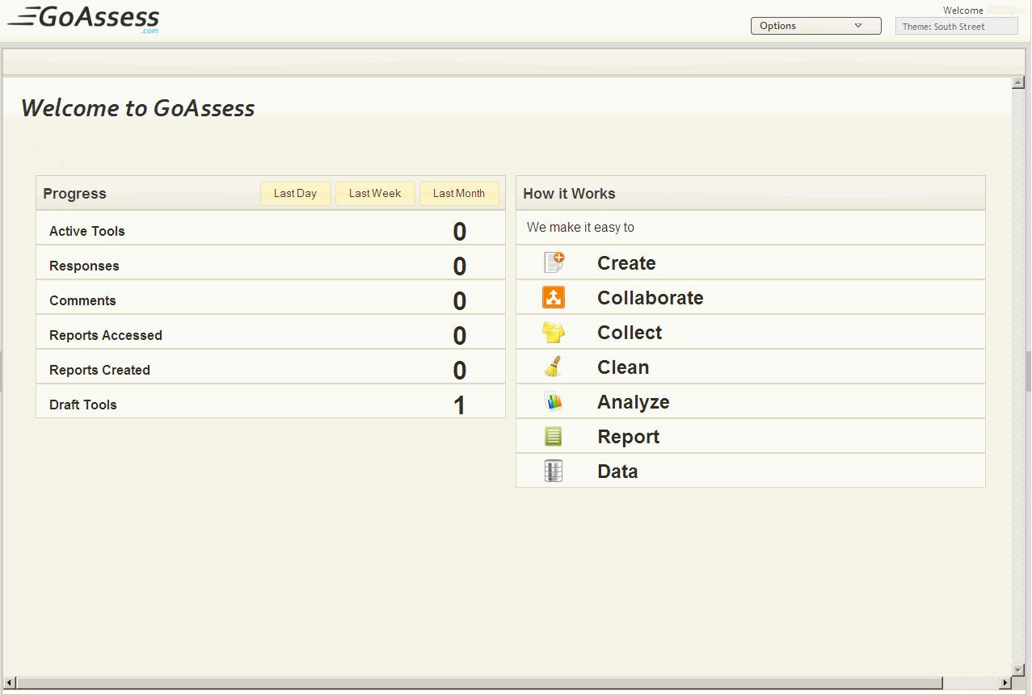

* Click create
* Select Create New Assessment

### How to Add Questions

*Follow these steps to add Questions to an assessment*

* Click Standard Tools
* Drag and drop Question
* Click Question’s Default Statement to Edit it, after editing it press enter to save the question

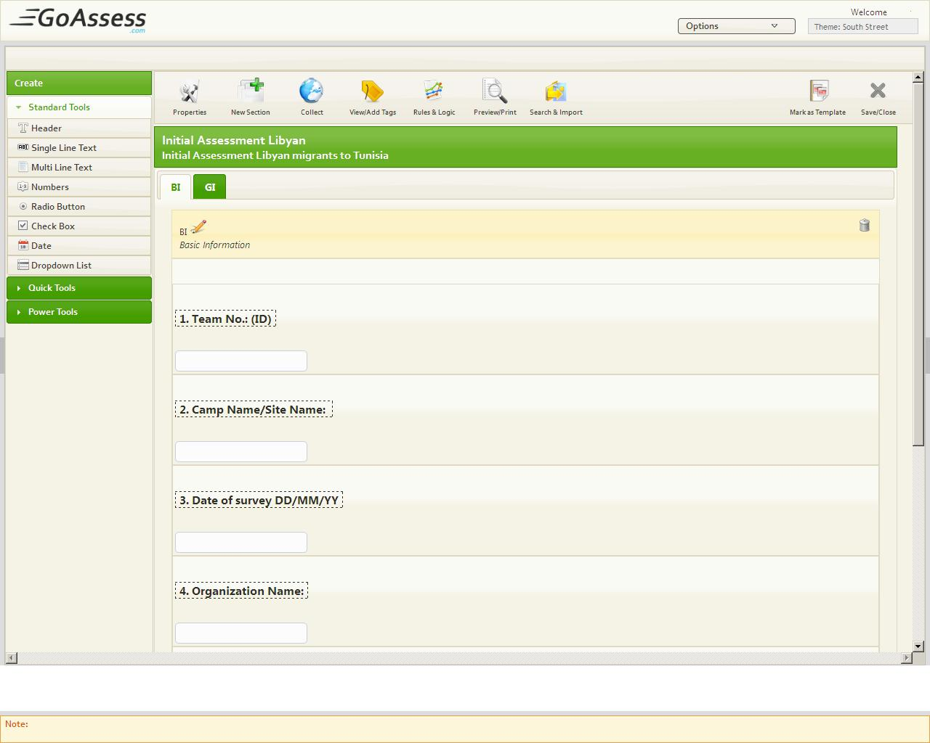

### How Section Works

*Follow these steps to add Section to an assessment*

* Click Create New assessment
* Click *“Add New Section”* at top Left corner of form builder, Type Section name and its description and press Save, and for existing section click At edit button near to the name of Section*(Default section), enter* section name and description and press Save

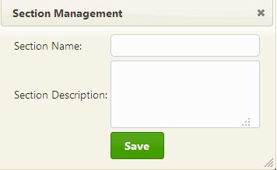

### Preview Assessment

*Follow these steps to Preview an assessment*

* Click “Print Preview” button at the top of the form builder



### Print Assessment

*Follow these steps to print an assessment*

* Once Assessment is completed take preview of it and press Print button to take printed copy.

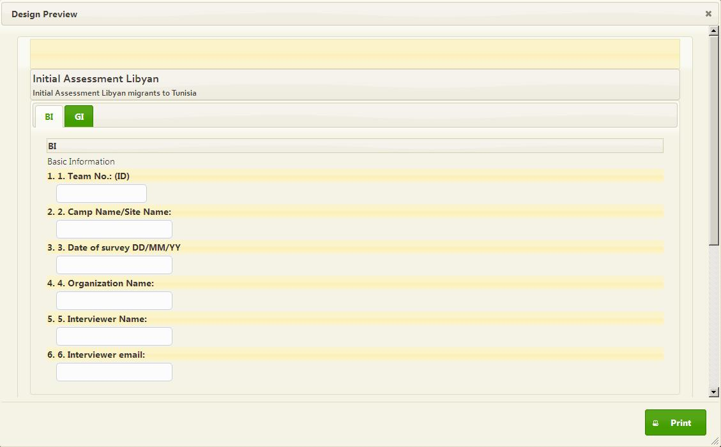

## Create Assessment from Templates

User can create an Assessment by using GoAssess templates according to requirement

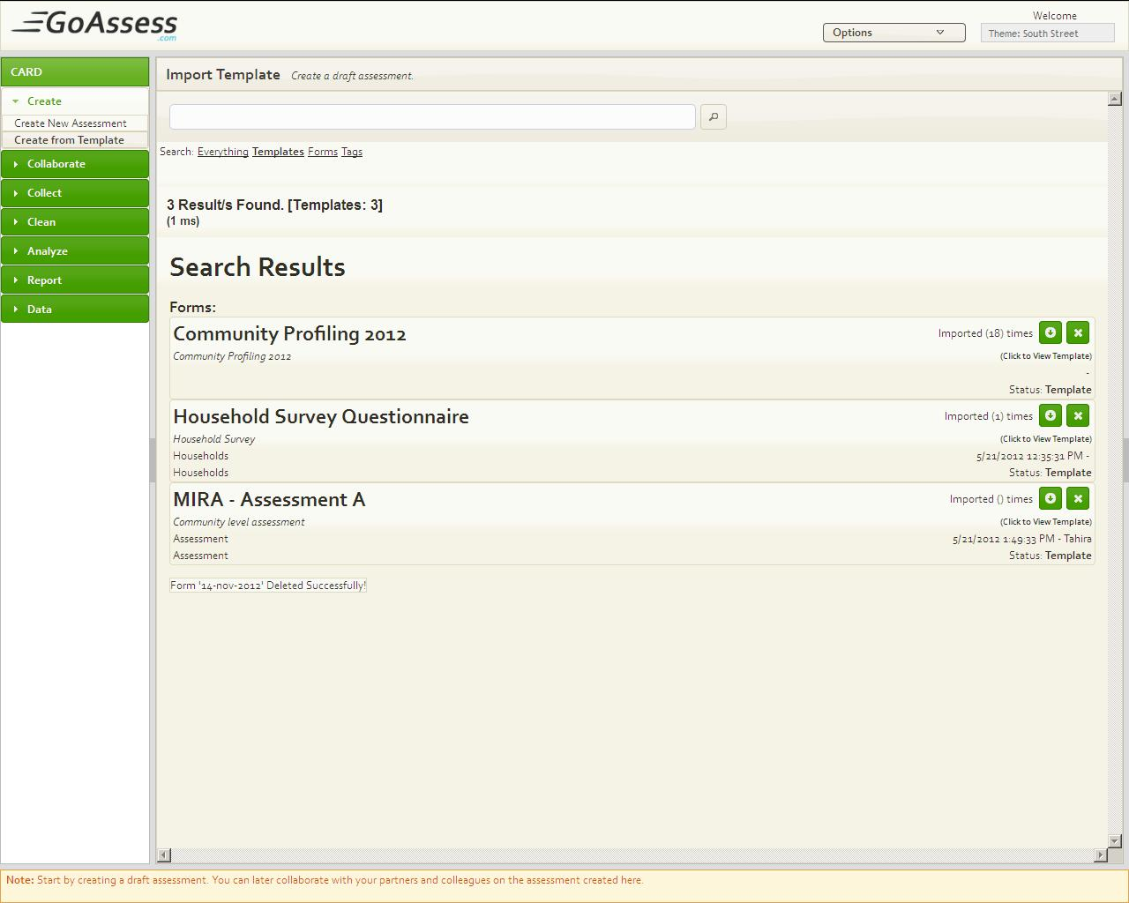

### Search a Template from GoAssess collection

*Follow these steps to search an assessment from GoAssess Templates collection*

* Click Create from Template
* Click Template from everything, Templates, Forms and Tags at the top of the templates page.
* Type the name of the assessment in the search Bar and press Enter
* Click At the name of the assessment to preview it

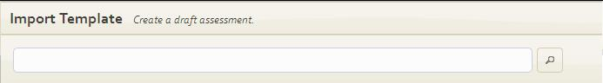

### How to Import a Template

*Follow these steps to Import a Template*

* Click Create from ‘Template’
* Click Template from everything, templates, forms and tags at the top of the templates page.
* Type the Name of the assessment in the search Bar and press Enter
* Click At the name of the assessment to preview it
* Click Import button at the right side of the Template Name to Import it

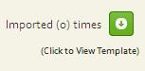

### How to edit template

*Follow these steps to Edit Template*

* Once you Import a Template it will be opened in the Form builder you can Add, edit or delete Questions and also can Add, edit or delete Sections or change Question properties.

### Delete a template

*Follow these steps to Delete a Template*

* Search a Template by using the above mentioned method
* Press Delete (Cross) button at right side of the template name

D:\Tahira downloads\14-11-2012\delete button.jpg

## Question types and Properties

GoAssess categorize Questions [tools] into three groups Standard Tools, Quick Tools and Power Tools. GoAssess user has right to add, update and delete questions from any of the above mentioned groups to his/her assessment, can also change question properties.

### Question Types and properties

*Following are the Questions in the Standard Tools*

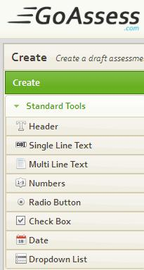

* **Header**: To Make a note
* **Single Line Text** : To take one line text response
* **Multi Line Text**: To take paragraph
* **Number:** To take numerical value
* **Radio Button:** Select only One Option
* **Check Box:** Select Multiple options
* **Date:** Calendar Tool
* **Drop Down List:** Select One option From list of Options

*Following are the Question Types in the Quick Tools*

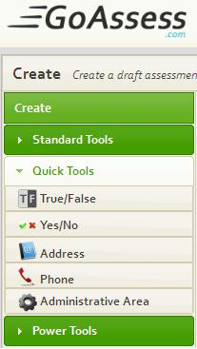

* **True/False**: Take only True or False
* **Yes/No**: Take only Yes or No
* **Address**: To take complete address of respondent
* **Phone**: To take complete phone number
* **Administrative Area**: Takes Area in the country to be administered

*Following are the Questions in the Power Tools*

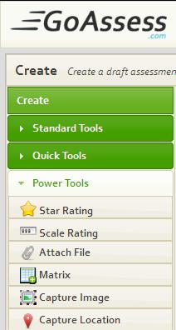

* **Star Rating**: Scale the quality
* **Scale Rating**: Scale the Quality
* **Attach File**: To attach a file
* **Matrix:** Take two dimensional response
* **Capture Image**: Capture Images
* **Capture Location**: Capture Location Geographically

### Properties

*Following are the Questions Properties in the Standard Tools. Click Edit button D:\Tahira downloads\14-11-2012\Edit button.jpgto apply different properties.*

* **Header:** *Font size*, user can select different font size for every header
* **Single Line Text:**  For a single line type question GoAssess user has facility to fix the *maximum length* of the response, and also can fix the *Data Type* fromAlphabets-only and alpha-numeric,user can set the *default value* for *it* and also can set the *Help Text.*
* **Multi Line Text:** Maximum Length, Data Type, Default Value, Help Text
* **Number:** Minimum Length, Maximum Length, Default Value and Help Text
* **Radio Button:** Enable Other Text Field, Help Text
* **Check Box:** Enable Other Text Field, Maximum number of options selection and Help Text
* **Date:** Date Format, Default Value and Help Text
* **Drop Down List:** Options

*Following are the Questions in the Power Tools*

* **Star Rating:** Interval, Default Value, Help Text
* **Scale Rating:** Interval Left text Right Text, starting value and Help text
* **Attach File:** Maximum File size, Help text
* **Matrix:** Help text
* **Capture Location:** Auto (Only for smart phones),Manual (Default), Google Maps and Help Text

### Delete Question

*Follow these steps to Delete a Questions.*

* Start an Assessment
* Add a question
* At most right side of the question there is a delete(Cross) button
* Press cross button D:\Tahira downloads\14-11-2012\question.delete button.jpg

### Duplicate [copy] Question

*Follow these steps to Duplicate a Questions.*

* Start an Assessment
* Add a question
* At right side of the question there is a duplicate(Copy) button
* Press ***Copy*** button D:\Tahira downloads\14-11-2012\Copy button.jpg

### Edit Question

*Follow these steps to Edit a Questions (Not applicable for Quick Tools and Capture Image)*

* Start an Assessment
* Add a question
* At right side of the question there is a Edit button
* Press ***Edit*** buttonD:\Tahira downloads\14-11-2012\Edit button.jpg
* Select Properties
* Press Save button

### Comment a Question

Assessment creator can add comment to every question at Assessment creation time to convey some message to collaborators about that question to take their response.

Respondents can also add comments in response, in collaboration phase. According to the given rights to them by admin(Assessment creator/ Assessment owner).

*Follow these steps to Comment a Questions*

* Start an Assessment
* Add a question
* At right side of the question there is a Comment button
* Press ***Comment*** buttonD:\Tahira downloads\14-11-2012\Comment button.jpg
* Add a comment
* Press *Post*

### Mark Question as Required Field

Assessment owner can force end-user or respondent to answer some necessary questions by using required field feature.

*Follow these steps to Mark a Question as required field (not applicable for Matrix Question and header)*

* Start an Assessment
* Drag and drop a question on Assessment
* At right side of the question there is a Required field (Star) buttonD:\Tahira downloads\14-11-2012\required field button.jpg
* Press *Required field* button

## Section types and their features

User has facility to divide an Assessment into multiple parts/sections to take different type of information in separate parts/sections and also to perform analysis on information.

### Section Types

*Following are the Section types*

* **Default Section:** GoAssess By Default add a default section to a new Assessment for ease of use, you can edit its name and description. Add Questions to it update them or delete them according to requirement.
* **Matrix Section:** A Matrix section gathers multiple records for single response. Matrix section could not be First section.

**For Example:** In a Flood related Assessment in first section you are taking the General information about their (family) current condition. In other section you want to gather information about each and every member of the family, Each family may have different number of family members so that create a Matrix section for gathering multiple records for a single response.

### Properties

*Following are the Section Properties*

* ***Edit Section name*** and Description for existing section click At edit button D:\Tahira downloads\14-11-2012\Edit button.jpg near to the name of Section*(Default section),enter* section name and description and press Save
* ***Delete Section***

*Follow these steps to Delete a Section*

1. Press Delete Button at the right side of the section nameD:\Tahira downloads\14-11-2012\Delete Section button.jpg

* ***Make Section A Matrix***

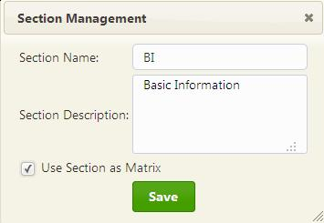

*Follow these steps to make any section, Matrix Section*

* Press Section Edit Button
* Check Mark the Option “Use Section as Matrix”, note that first Section could not be a Matrix Section
* Press save button

## Form (Assessment) Properties

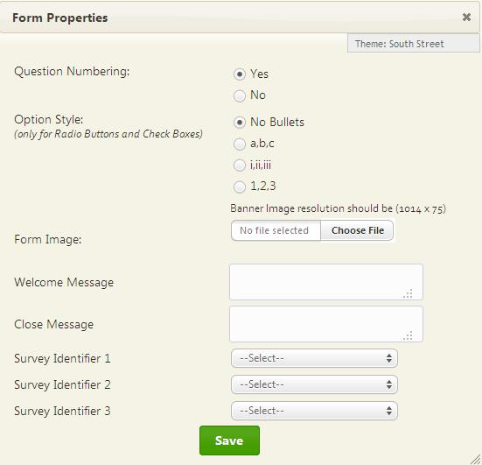

### Assessment Theme

User can apply theme of his own choice to his/her Assessment.

Follow these steps to apply Theme to Assessment

* Click Create
* Select Create New Assessment
* Click Form Properties
* Select any Theme as “South Street” is selected in the above image.
* Press Save

### Question numbering

GoAssess user can apply numbering to questions of assessment and also can disable it.

*To disable Question numbering Follow these steps*

* Click Create
* Select Create New Assessment
* Click Form Properties
* Select No From Question Numbering
* Press Save

### Option Style (Only for radio button and check box)

GoAssess facilitates you to choose option style of your choice

*Follow these steps to change option style (only for radio button and check boxes)*

* Click Create
* Select Create New Assessment
* Click Form Properties
* Select one style from **Option Style** Drop Down
* Press OK

### Form Image (Banner)

There is facility in GoAssess to Add Banner to assessment.

*Follow these steps to Apply Banner to Assessment*

* Click Create
* Select Create New Assessment
* Click Form Properties
* Select Banner Image From Computer
* Press OK

### Welcome Message

User can write his/her own type welcome message to collector at start of each response

*Follow these steps to convey a Welcome message*

* Click Create
* Select Create New Assessment
* Click Form Properties
* Enter Welcome Message in Welcome Message Box
* Press OK

### Close Message

User can write his/her own type Close message to collector at End of each response

*Follow these steps to convey a Closing message*

* Click Create
* Select Create New Assessment
* Click Form Properties
* Enter Close Message in Close Message Box
* Press OK

### Survey Identifier

Survey Identifier is to represent a response/case uniquely. For **example** an assessment has personal information name, CNIC, age, gender, education. Every person has the unique CNIC number, so you may choose CNIC as assessment Identifier to uniquely identify each response.

GoAssess allow you to select 1-3 identifiers here note that it is not necessary to choose identifier for every assessment. It depends on your requirement that you need identifier in assessment or not.

## Search and Import Questions and Sections

User can Search and import Questions and section From GoAssess collection. It has questions and sections bank.

User can easily search and preview sections and questions, if the question or a section is suitable then can import it.

After importing a section user can also edit it can add more question to it, can change its question’s statements and can also delete existing question, can change section’s name too, it’s all depends upon the user requirement.

For question import, user can edit it also, for example can change its statement and if the question is a check box or a radio button then also user can add more options to it and also can remove/delete some existing options.

### Search & Import Question from GoAssess collection

*Follow these steps to Import Questions from GoAssess Collection*

* Start an Assessment
* Click on Search and import
* Select Questions
* Click on the name of the Assessment section to preview it
* Press Import to import Question D:\Tahira downloads\14-11-2012\Import button.jpg

### Search & Import Section from GoAssess collection

*Follow these steps to Import Section from GoAssess Collection*

* Start an Assessment
* Click on Search and import
* Select Sections
* Click on the name of the Assessment section to preview it
* Press Import to import the Complete section D:\Tahira downloads\14-11-2012\Import button.jpg

### Search Assessment by Tags

*Follow these steps to search assessment by tag in assessment from scratch*

1. Click Create
2. Click a new ‘Create’
3. Click search and import
4. Click tags
5. Enter tag in search bar

*Follow these steps to search assessment by tag in assessment from template*

1. Click Create
2. Click create from template
3. Select tag
4. Enter assessment tag in the search bar

## Tag Your Question, Sections and Assessments

User can tag sections and questions and Assessment. Tags help you out to search a question/section/form by its tag or can search multiple questions with one common tag. User can add same tag to multiple questions.

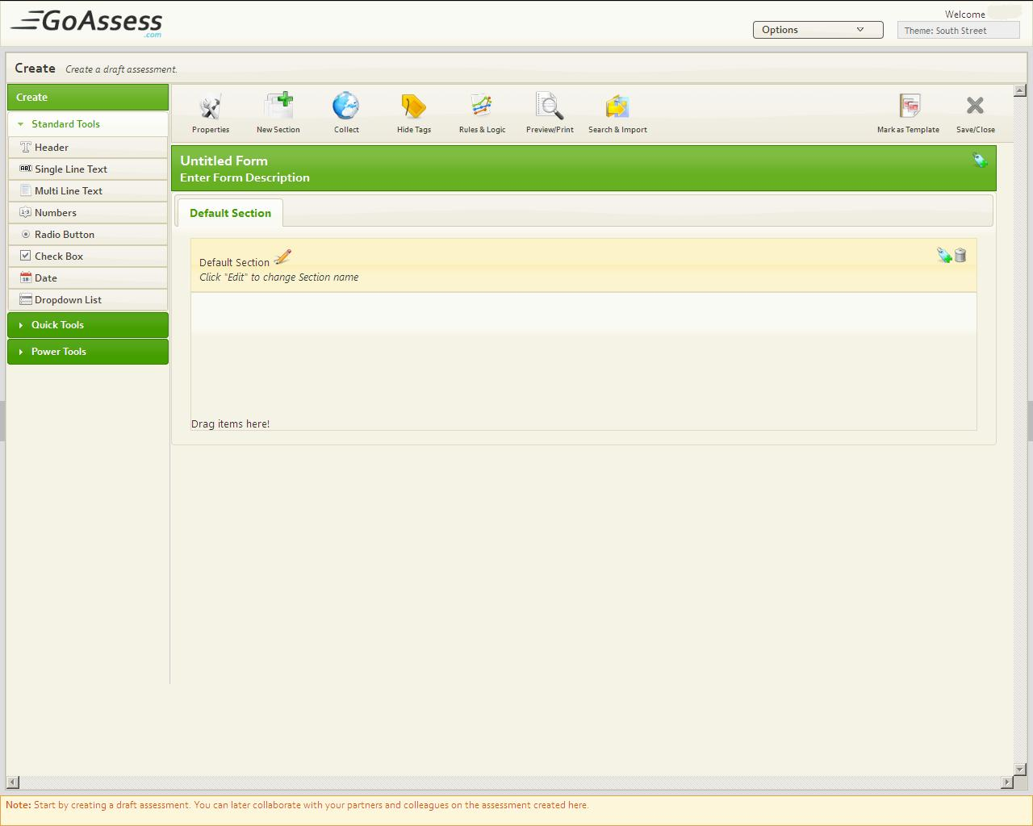

### Tag Question

*Follow these steps to Tag a Question of Assessment*

* Start a new Assessment
* Drag and drop a Question
* Press View/Add Tags
* Click on blue Book Mark Icon on the left side of the QuestionD:\Tahira downloads\14-11-2012\tag.jpg
* Add Tag
* Press Submit Query

### Tag Section

*Follow these steps to Tag a Section of Assessment*

* Start a new Assessment
* Press View/Add Tags
* Click tag icon on the left side of the Section NameD:\Tahira downloads\14-11-2012\tag.jpg
* Add Tag
* Press Submit Query

### Tag Assessment (form)

*Follow these steps to Tag an Assessment*

* Start a new Assessment
* Press View/Add Tags
* Click on tag at the left side of the Assessment NameD:\Tahira downloads\14-11-2012\tag.jpg
* Add Tag
* Press Submit Query

## Apply Rules and Logics

Rules and logic could be used when there are different paths according to end-user’s input in the previous Question. **For Example** for a Question A of yes/no type rules and logic could be applied as, if yes go to the question C if no go to the question D.

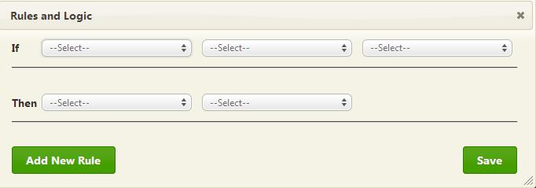

### How to apply Rules and Logic

*Follow these steps to Apply Rules and Logics on Assessment*

* Start an Assessment
* Drag and drop Two Question
* Click Rules and Logic
* Select one question from if drop down
* Select Condition
* Select value
* Select Jump From Then Drop Down
* Select other Question to jump on
* Press Add new Rule
* Press Save

## Mark your Assessment a Template

GoAssess lets you optionally use questions from templates and past assessments to quickly build a relevant and effective assessment. To use questions from past assessments conducted by your own organization as well as other Organizations, simply add an existing question using an intuitive user interface for finding relevant questions.

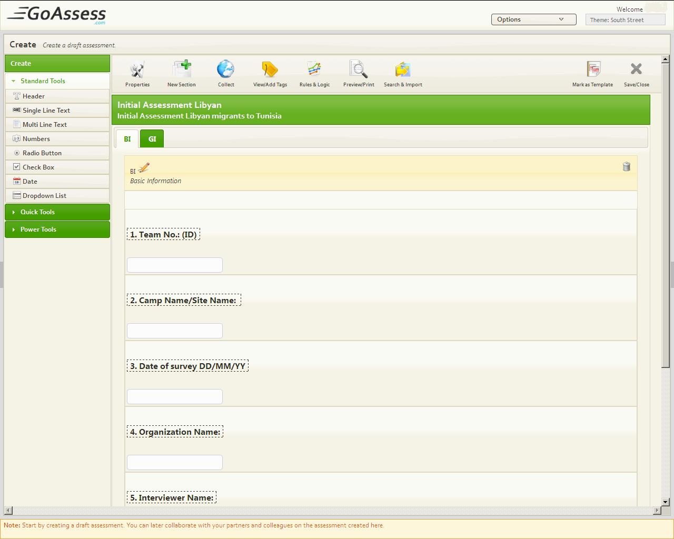

### How to Mark Assessment a Template

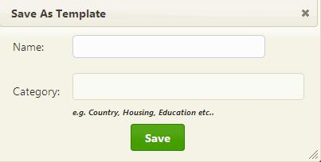

*Follow these steps to Mark Assessment as Template*

* Start an Assessment
* Drag and drop Questions
* Click Mark As Template
* Enter its Name
* Enter its Category
* Press Save

## Save the Assessment

Assessment could be saved for further collaboration, for more enhancements and also for more work.

### How to Save Assessment

*Follow these steps to Save Assessment*

* Start an Assessment
* Drag and drop Questions
* Click Save/Close
* Enter its Name
* Click Save/Close
* Press Save or Discard if you don’t want to save it.

## Edit Saved Assessment

*Once an assessment is saved follow these steps to edit saved assessment*

* Select Collaborate
* Select Assessment to view it
* Click Edit(Pencil) button below to Assessment name
* Edit Assessment by adding, Deleting, updating Questions and Sections etc.
* Click Save/Close to save Assessment again.
* Press Save to save or Discard to discard.

# Collaborate with Members

GoAssess solved problems by allowing assessment partners and collaborators to join you right on the assessment draft in GoAssess and give feedback in one central location: The assessment draft itself. You can easily share draft assessment link with assessment collaborators who can provide suggestions and feedback against each question you’ve drafted. By bringing all parties to the same virtual table, you can finalize an assessment draft in hours instead of weeks!

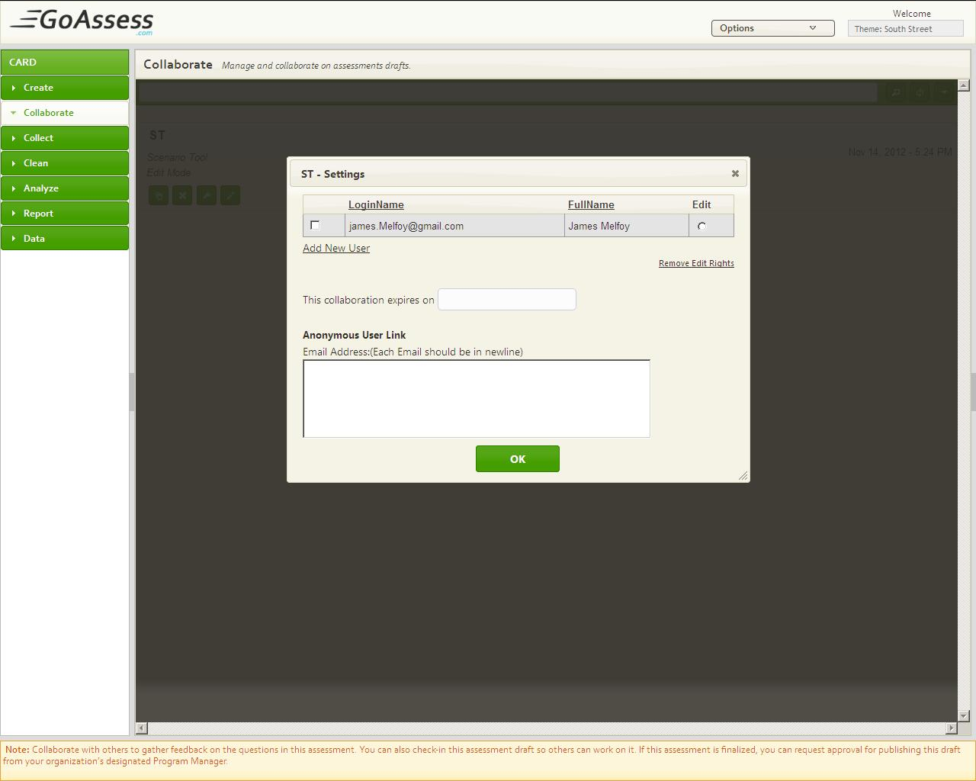

## Simple and advanced Search Draft Assessment

*Follow these steps to search a draft assessment*

1. Click ‘Collaborate’
2. Enter the name of the assessment in the search bar
3. Press enter

*Follow these steps to search advance a draft assessment*

1. Click ‘Collaborate’
2. Click advance search button D:\Tahira downloads\20-11-12\adv.search button.jpg
3. Click one button from Title, Update Date, status, Asc, Dsc to sort Assessments list.

## Share Assessment within Organization

*Once Assessment is saved follow these steps to share saved assessment with users (within organization)*

* Select Collaborate
* Click settings of assessmentD:\Tahira downloads\14-11-2012\settings button.jpg
* Check the users to collaborate
* Press OK button

## Share Assessment with anonymous user

*Follow these steps to share saved Assessment with Anonymous users (within organization)*

* Select Collaborate
* Click Settings of Assessment
* Enter valid email address of anonymous user(who is not GoAssess user)
* Press OK

## Share Assessment inter Organizations

You can invite your partners and collaborators to any assessment created in GoAssess. You can use the collaboration feature to gather feedback on your assessments from your assessment partners.

To enable collaboration with partners, you simply send a web link to your assessment. Your assessment partners can then view the draft assessment and give their feedback on each question contained in the assessment. This allows you to quickly finalize an assessment draft without having to manually gather feedback from each assessment partner.

## Add more users for Collaboration

*Follow these steps to Add new user to collaborate with you*

* Select Collaborate
* Click Settings of Assessment
* Click Add New user
* Click Add or create new user
* Click Add new user from new window
* Press Add

## Assign Edit Rights to a user

*Follow these steps to allow edit rights to user (within organization)*

* Select Collaborate
* Click Settings of Assessment
* Select one user by selecting radio button at the right side of user name
* Press OK button

## Add Comments on shared Draft Assessment

*Follow these steps to add comments on shared assessment*

* Select Collaborate
* Click at the name of assessment, in third pane assessment will be displayed
* Click Expand(aero) Button From Third pane D:\Tahira downloads\14-11-2012\expand button.jpg
* Click Comment ButtonD:\Tahira downloads\14-11-2012\Comment button.jpg
* Add Comment
* Press POST button to post it

## View other members/users Comments on shared Assessment

*Follow these steps to add comments on shared Assessment*

* Select Collaborate
* Click at the name of Assessment, it will be displayed in third pane
* Click Expand(aero) Button From Third pane [placed at top]
* Click Comment Button

## Edit Draft Assessment

*Once Assessment is saved, follow these steps to Edit saved assessment*

* Select Collaborate
* Select assessment to view it
* Click Edit(Pencil) button below to Assessment nameD:\Tahira downloads\14-11-2012\Edit button.jpg
* Edit Assessment by adding, Deleting, updating Questions and Sections etc.
* Click Save/Close to save Assessment again.
* Press Discard to discard.

## Preview &Print Draft Assessment

*Follow these steps to Preview and Print Draft Assessment*

* Select Collaborate
* Click at the name of Assessment, it will be displayed in third pane
* Click Expand(aero) Button From Third pane [placed at top]
* Click Print page ButtonD:\Tahira downloads\14-11-2012\Print button.jpg

## Duplicate Draft Assessment

*Follow these steps to Duplicate draft assessment*

* Select Collaborate
* Click Duplicate button Below to the assessment nameD:\Tahira downloads\14-11-2012\Duplicate button.jpg
* Enter New name
* Press OK

## Delete Draft Assessment

*Follow these steps to Delete draft assessment*

* Select Collaborate
* Click Delete(Cross) button Below to the assessment nameD:\Tahira downloads\14-11-2012\delete.jpg
* Press Delete

## Publish a Draft Assessment

*Follow these steps to Publish draft assessment*

* Select Collaborate
* Click Edit Button which is available below to the name of the assessment
* Press Collect (Globe) ButtonD:\Tahira downloads\14-11-2012\Publish button.jpg
* Enter/Select Expiry Date
* Press OK

# Collect Responses

GoAssess offers fast, efficient data gathering using smart phones. The GoAssess mobile component sits on an agent’s mobile phone and gives her the ability to collect data quickly and efficiently – thus reducing the time and cost involved in data gathering – as well as improving the integrity and accuracy of the data collected.

Where using smart phones to collect assessment data is not feasible, GoAssess also supports gathering assessment data through traditional paper-based forms. The agents can collect data in the field and the data can be entered into the GoAssess system through a traditional PC.

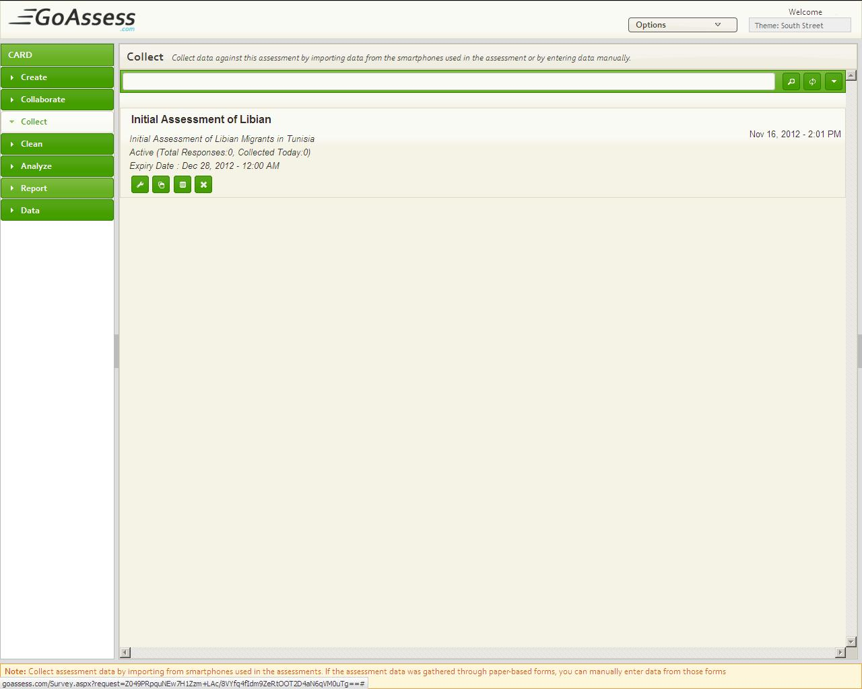

## How to Publish an Assessment

*Follow these steps to Publish assessment*

* Start an assessment
* Create an assessment/Add Questions and Section
* Press Collect Button
* Enter Expiry Date
* Press OK

## Simple and Advanced Search Published Assessment

*Follow these steps to search a published assessment*

1. Click ‘Collect’
2. Enter the name of the assessment in the search bar
3. Press enter

*Follow these steps to search advance a draft assessment*

1. Click ‘Collect’
2. Click advance search button D:\Tahira downloads\20-11-12\adv.search button.jpg
3. Click one button from Title, Update Date, status, Asc, Dsc to sort Assessments list

## Support for Manual Data Entry

Where conducting mobile phone based assessments is not an option, GoAssess also supports gathering assessment data using traditional paper-based assessments. You can subsequently enter the data into the GoAssess by using convenient browser-based pages for inputting data.

## Collect Responses online

*Once Assessment is published follow these steps to Collect response online*

* Create an Assessment
* Select Collect
* Click at the name of the assessment
* Add response
* Press ‘Save and Close’ , press ‘Save and Add new Record’ to add more responses

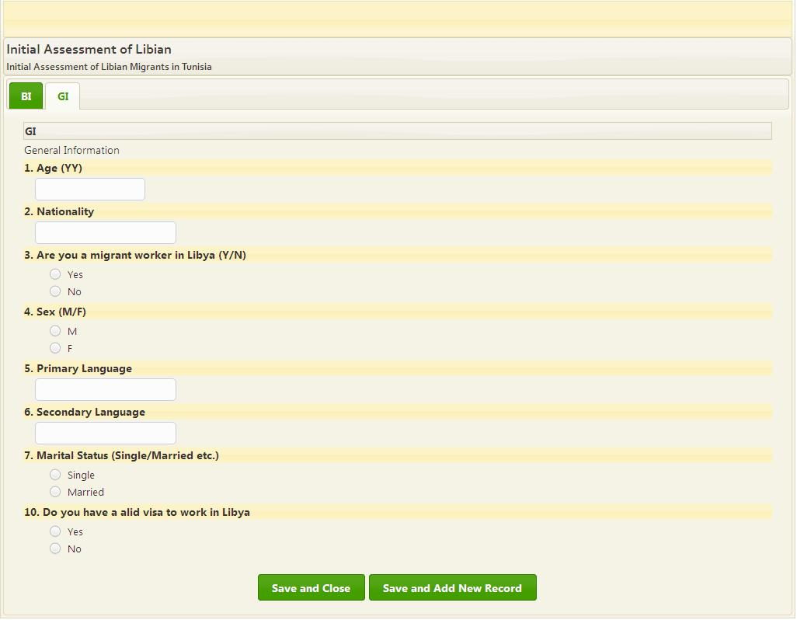

## Create Duplicate of Published Assessment

*Follow these steps to Duplicate published assessment*

* Select Create
* Click Duplicate button below to the assessment nameD:\Tahira downloads\14-11-2012\Duplicate button.jpg
* Enter New name
* Press OK

## Allow Specific users to collect response

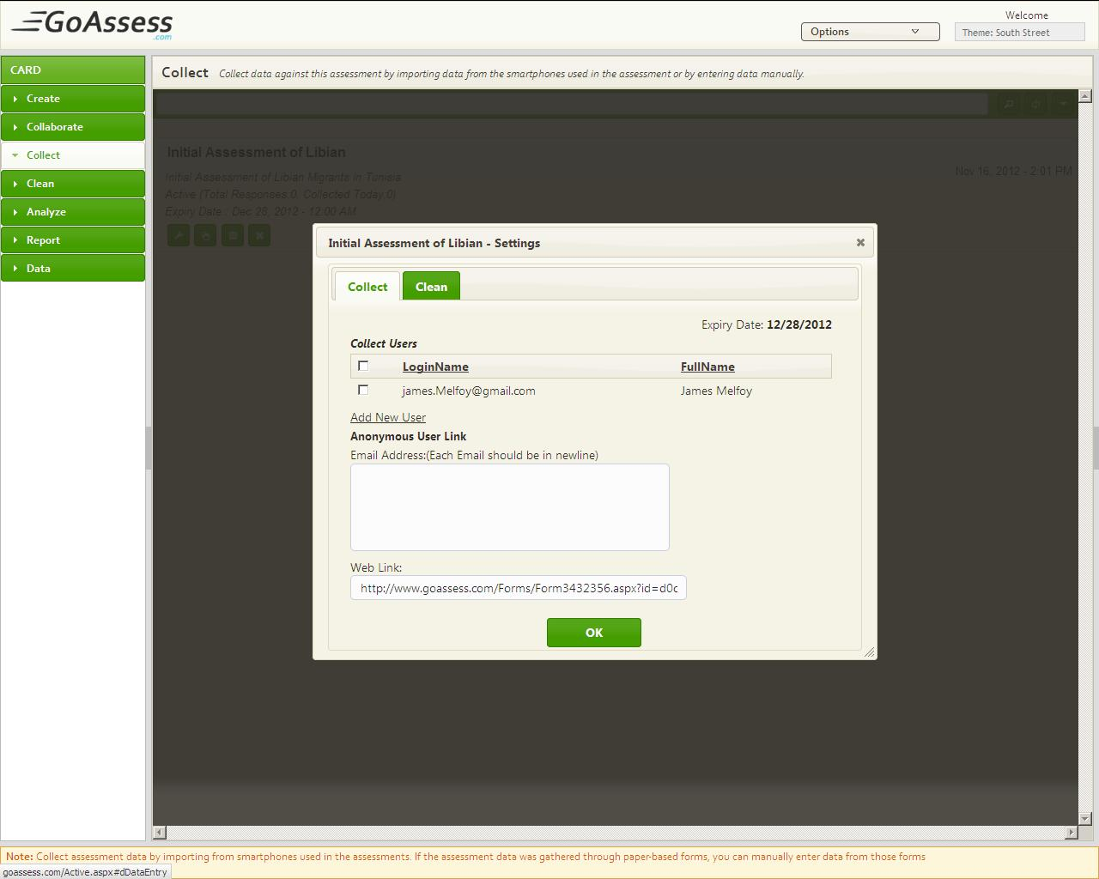

*Once Assessment is published, Follow these steps to Share assessment with users (within organization)*

* Select Collect
* Click Settings of particular Assessment
* Check the Users to Collect if there is not user in the list press Add New User
* Add new user
* Check the user for Assessment collection
* Press OK button

## Allow specific users for Data Cleaning

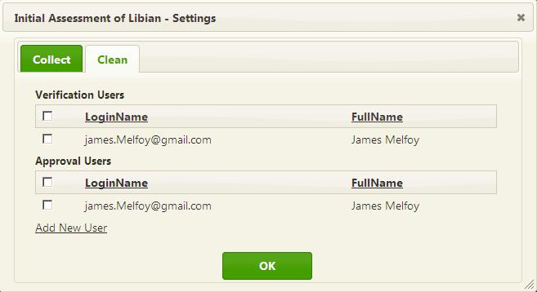

*Once assessment is published follow these steps to Share assessment with users (within organization)*

* Select Collect
* Click Settings of Assessment
* Select ***Clean*** tab
* Check Users for Data cleaning
* Press OK

## Allow Smart phone Collection

*Once assessment is published follow these steps to Share assessment with users (within organization)*

* Select Collect
* Click ***smart phone*** button available below to the assessment name
* Click Settings
* Check Users for collection
* Press OK

## Add more users for data Collection from Collect

*Follow these steps to add New User to GoAssess directory*

* Select Collect
* Click Settings of Particular Assessment
* Click add new user
* Press Create or Add New User
* Enter Email Id of user to search user in GoAssess directory
* Press Not in Directory? Add New User
* Enter Full User Name
* Enter User Valid Email ID
* Press Add
* Click Add/view roles
* Check Collect From List
* Press Close of list
* Check user name from settings of the assessment

## Send Assessment to anonymous user to collect response

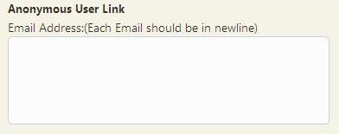

*Follow these steps to send assessment to anonymous user to collect response*

* Select Collect
* Click Settings of particular assessment
* Enter Email address of Anonymous user
* Press OK

## Attach Assessment web link on your website

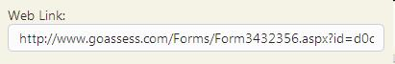

*Follow these steps to Attach assessment Web-Link to a website*

* Select Collect
* Click Settings of particular Assessment
* Copy web-Link and attach it to website
* Press OK

## Delete Assessment

*Follow these steps to Delete an assessment*

* Select Collect
* Click Delete Button
* Press Delete for Dialogue box

# Collect via Smart Phones (Android)

Once an assessment has been approved in GoAssess, agents in the field can use mobile phones to gather assessment data. Using mobile phones to gather is both faster and less error-prone – especially in high sensitivity areas and populations. Data gathered in the field can then be imported into the GoAssess system by means of a PC.

## Download and install GoAssess

*Follow these steps to download and install GoAssess on smart phone*

1. Go to GoAssess website [www.Goassess.com](http://www.Goassess.com) from your Mobile phone
2. Click and download [GoAssess Android Application](http://aims.im4hc.com/Files/AIMS.apk)
3. Install Application

## Get from Server

*Follow these steps to ‘Get Assessment from server’*

1. Click Collect
2. Login with valid user name and password
3. Click Get from server

## Start survey

*Follow these steps to ‘Start survey’*

1. Click Collect
2. Login with valid user name and password
3. Click Get from server
4. Click Start survey
5. Click the Assessment name
6. Press Next for next Question
7. Press Previous to view/edit previous
8. Press ‘Add another record’ to enter multiple responses
9. Press finish to finish

## Send to Server

*Follow these steps to ‘Send to server’*

1. Click Collect
2. Login with valid user name and password
3. Click Get from server
4. Click Start survey
5. Click the Assessment name
6. Press Next for next Question
7. Press Previous to view/edit previous
8. Press ‘Add another record’ to enter multiple responses
9. Click ‘Send to server’
10. Select sync all

# Data Cleaning

GoAssess supports integrated data cleaning, validation and integrity verification processes that streamline the process of validating field data. Using GoAssess, you can not only reduce the time and effort involved in data validation but improve the workflow of these processes to ensure high data integrity.

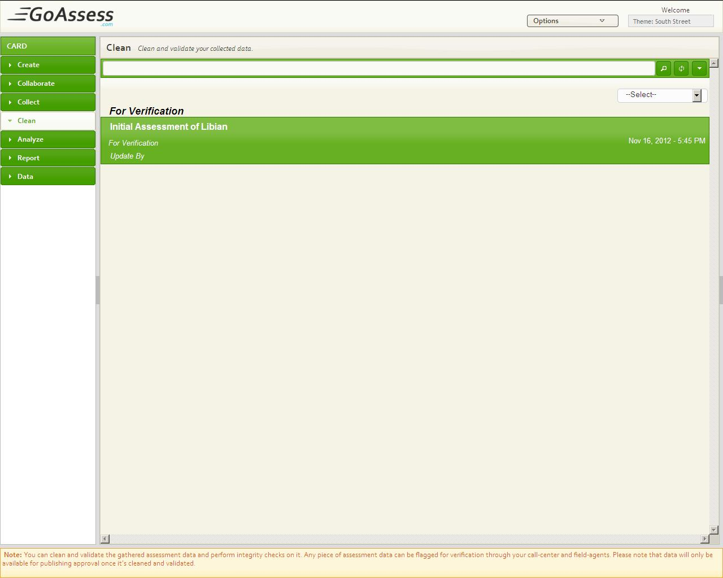

## Search assessment for Cleaning

*Follow these steps to search assessment for Cleaning*

* Select Clean
* Enter name of Assessment in Search Bar and Press Enter

AND

* Select ***For Approval*** from Select drop down list to search Assessments responses for Approval, by -Default it search responses for verification.

*Follow these steps to Advance search assessment for Cleaning*

* Create an Assessment
* Add Response for it
* Select Clean
* Press advance search button at most right side of the search Bar
* Press ***Title*** to sort Assessments in alphabetical order
* To sort Assessments by Create Date press ***Create Date***

## Verify Response

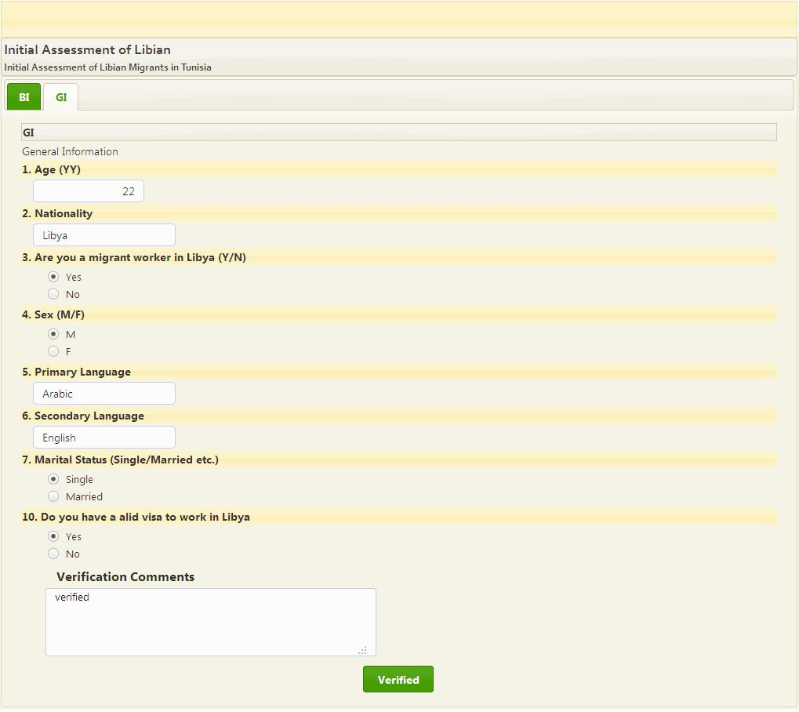

*Follow these steps to Verify Responses*

* Create an Assessment
* Publish it
* Collect response for it
* Select Clean
* Click Assessment name
* Write Comment
* Press ***Verified*** if response is fine otherwise close the Tab

## Approve Response

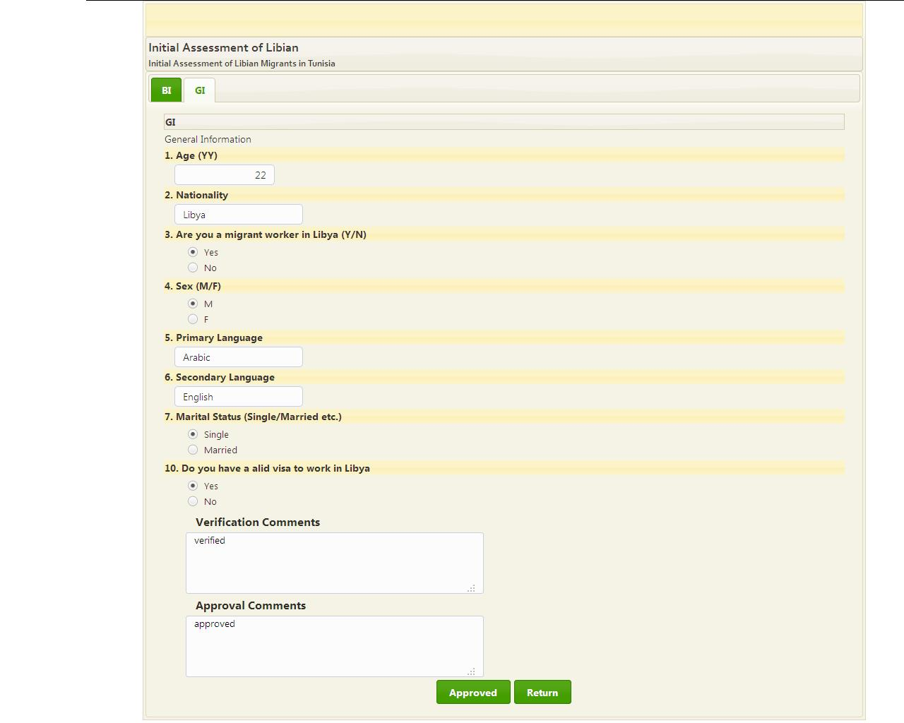

*Follow these steps to Approve a Responses*

* Create an Assessment
* Publish it
* Collect response for it
* Select Clean
* Select ***For Approval*** From –Select—Drop Down
* Click Assessment name
* Write Comment
* Press ***Approved*** if response is fine otherwise Press ***Return***

# Analyze results

GoAssess offers rich reporting and analysis tools to help you accomplish this task. With its rich visualization of data points using geographical and political maps, you can quickly identify areas most in need of immediate assistance as well as use the data to gain insight into the specific problems being faced by the affected populations.

The primary goal of reporting and analysis functionality in GoAssess is to help you formulate intelligent work plans for the target areas where the assessment was conducted.

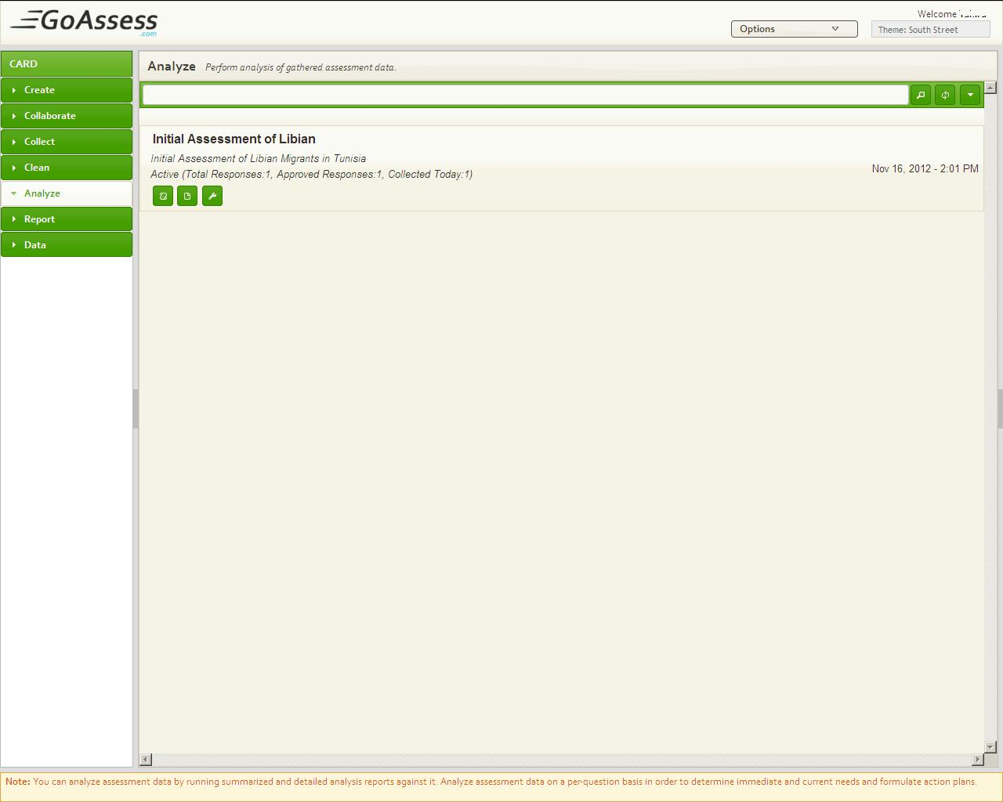

## Search an Assessment Report Analysis

*Follow these steps to search an assessment report*

1. Click ‘Analyze’
2. Enter the name of the assessment in the search bar
3. Press enter

*Follow these steps to search advance an assessment report*

1. Click ‘Analyze’
2. Click advance search button D:\Tahira downloads\20-11-12\adv.search button.jpg
3. Click one button from Title, Update Date, status, Asc, Dsc to sort Assessments list

## Report Summary

GoAssess supports integrated data cleaning, validation and integrity verification processes that streamline the process of validating field data. Using GoAssess, you can not only reduce the time and effort involved in data validation but improve the workflow of these processes to ensure high data integrity.

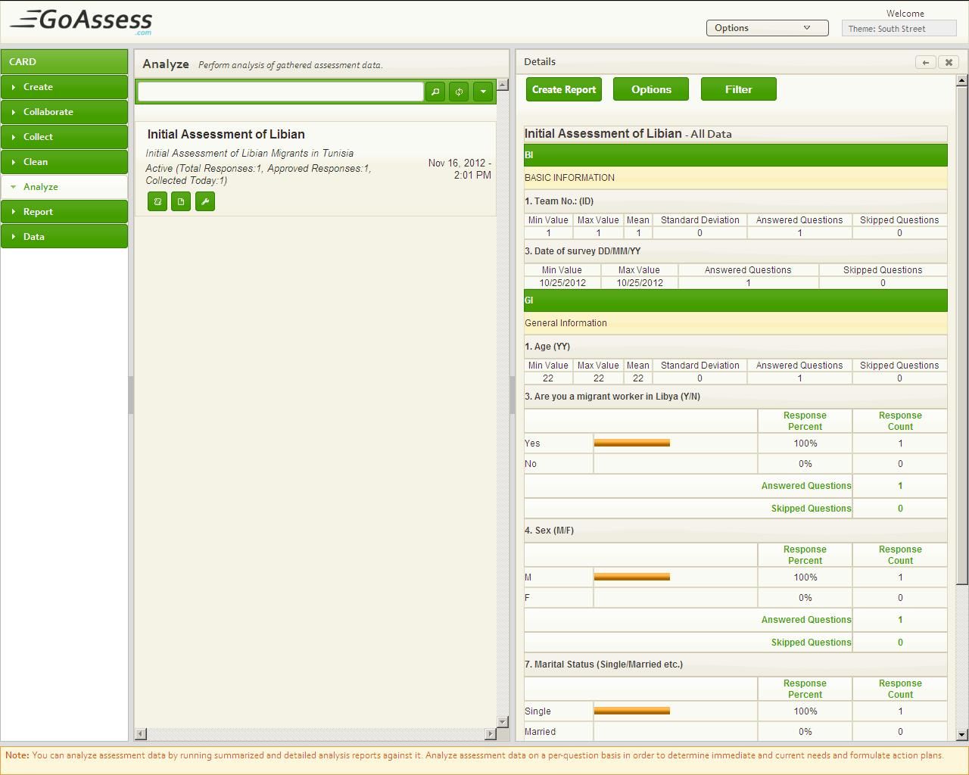

*Follow these steps to View Report Summary*

* Create an Assessment
* Publish it
* Collect response for it
* Select Analyze
* Click Assessment name
* Expand Third Pane

### Summary Report Options

GoAssess facilitates Assessment owner to show user as much data that he/she want, it could be either only cleaned data or all data, if the owner Select Cleaned Data, then All users of organization [those have rights of Report summary] will view All cleaned data Summary Report. By-Default it shows all data in Summary Report.

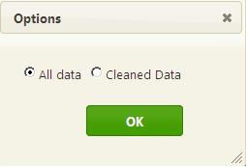

*Follow these steps to View Only Cleaned Data in Summary Report*

* Create an Assessment
* Publish it
* Collect response for it
* Select Analyze
* Click Summary Report Below to the Assessment Name
* Click ***Options***
* Select Cleaned Data
* Press OK

### Report Summary Filter

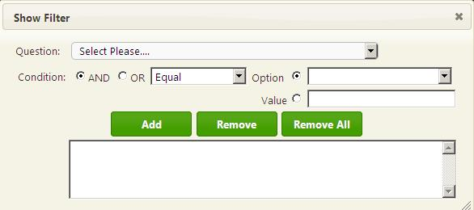

*Follow these steps to Apply Filter on GoAssess Summary Report*

* Create an Assessment
* Publish it
* Collect response for it
* Select Analyze
* Click Summary Report below to the assessment name
* Expand report
* Click ***Filter***
* Select a ***Question*** From question drop-down
* Select One From “AND” or ”OR”
* Select condition from Equal to, less than, greater than etc
* Select ***Option*** if the selected question was check box, radio button or drop down list Otherwise Select ***Value***
* Enter ***Value*** if you Select value
* Press Add

### Create Custom Report

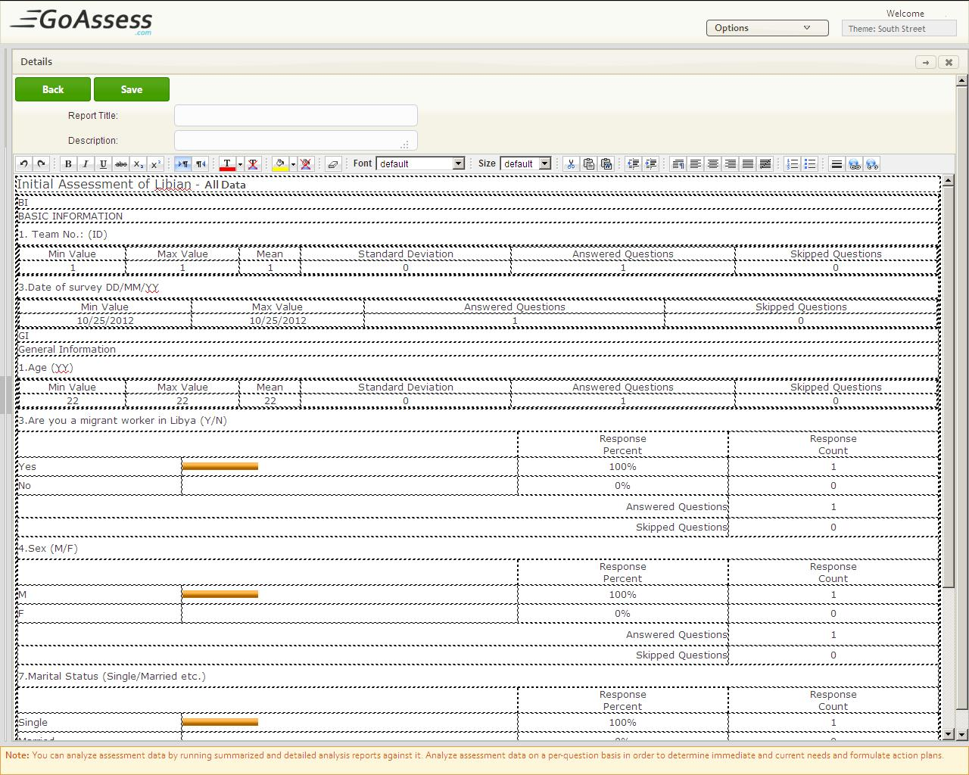

*Follow these steps to create custom Report from summary Report*

* Create an Assessment
* Publish it
* Collect response for it
* Select Analyze
* Click Summary Report below to the assessment name
* Expand report
* Click ***Create Report***
* Enter Title & Description
* Edit Report If needed by just click and type
* Press ***Save*** otherwise Press ***Back***

## Detailed Analysis Report

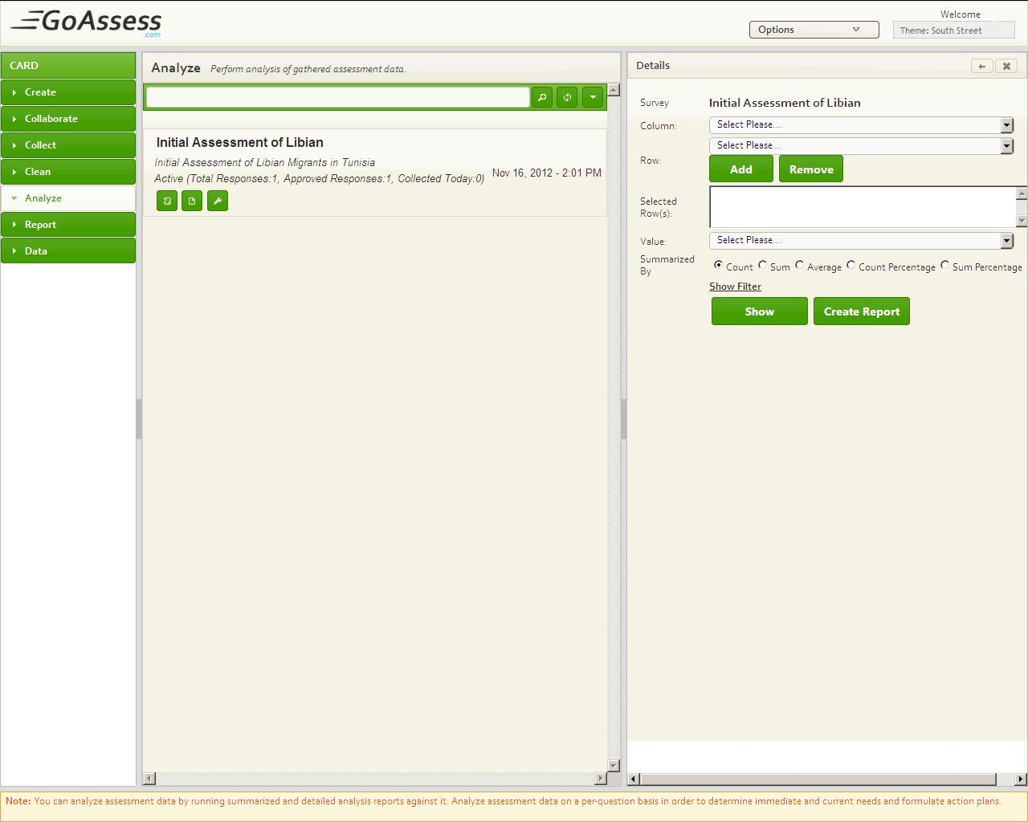

*Follow these steps to View Detailed Analysis Report*

* Create an Assessment
* Publish it
* Collect response for it
* Select Analyze
* Click ***Detailed analysis Report***
* Expand Third Pane

### Apply Filters

*Follow these steps to apply filter on Detailed Analysis Report*

* Create an Assessment
* Publish it
* Collect response for it
* Select Analyze
* Click ***Detailed analysis Report***
* Expand Third Pane
* Select question From ***Column*** Drop down
* Select question From ***Row*** Drop down
* Press Add
* Press Remove to remove added row and column
* Select question From ***Value*** Drop down
* Press Show

### Summarized by: Count, Sum, Average, Count Percentage, Sum Percentage

*Follow these steps to Apply filter on Detailed Analysis Report*

* Create an Assessment with number field
* Publish it
* Collect response for it
* Select Analyze
* Click ***Detailed analysis Report***
* Expand Third Pane
* Select question From ***Column*** Drop down
* Select question From ***Row*** Drop down
* Press Add
* Press Remove to remove added row and column
* Select question From ***Value*** Drop down
* Select Count, SUM, Average, Percentage OR Sum Percentage
* Press ***Show***

### Create Custom Reports

*Follow these steps to Apply filter on Detailed Analysis Report*

* Create an Assessment
* Publish it
* Collect response for it
* Select Analyze
* Click ***Detailed analysis Report***
* Expand Third Pane
* Select Question From ***Column*** Drop down
* Select Question From ***Row*** Drop down
* Press Add
* Press Remove to remove added row and column
* Select Question From ***Value*** Drop down
* Press ***Show***
* Press Create Report
* Enter Report Title
* Enter Description(optional)
* Enter Header(optional)
* Enter Footer(optional)
* Press ***View*** to preview Custom Report
* Press ***Save*** To save Report in Reports

## Share Reports with Users

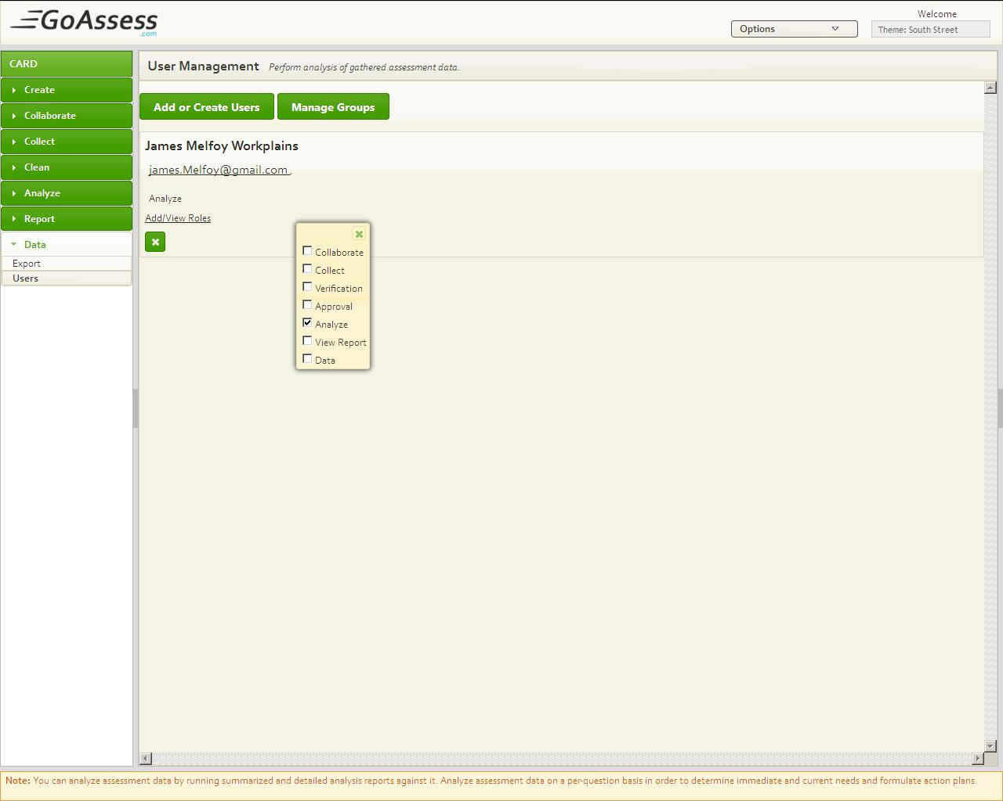

*Follow these steps to Share Reports with Users*

* Create an Assessment
* Publish it
* Collect response for it
* Select Analyze
* Click ***Settings*** *of the particular Assessment*
* Check names of the users
* Press OK

## Share Reports with anonymous Users

*Follow these steps to Share Reports with Anonymous User*

* Create an Assessment
* Publish it
* Collect response for it
* Select Analyze
* Click ***Settings*** *of the particular Assessment*
* Enter Valid E-Mail Id of anonymous user
* Press OK

## Attach Web-Link of Analysis Report on web site

*Follow these steps to Attach report web-link to a Website*

* Create an Assessment
* Publish it
* Collect response for it
* Select Analyze
* Click ***Settings*** *of the particular Assessment*
* Copy the Web-Link and attach it to web-site
* Press OK

## Add more users for Assessment result analysis

*Follow these steps to add more users to share Reports with them*

* Create an Assessment
* Publish it
* Collect response for it
* Select Analyze
* Click ***Settings***
* Click Add New User
* Press Add or Create New User
* Press Not in Directory? Add New User
* Enter Full name of the user
* Enter valid Email Address(Login)
* Press Add
* Check the user name from Assessment analyze settings of the particular Assessment

# Reports

## Search an Assessment Report

*Follow these steps to Search an Assessment Custom Report*

* Create an Assessment
* Publish it
* Collect response for it
* Select Reports
* Enter name of the Report in search Bar
* Press Enter

*Follow these steps to search an assessment Custom Report by title and Creating Date*

* Create an Assessment
* Publish it
* Collect response for it
* Select Reports
* Click Advance Search button placed at right side of the search bar
* Press Title

Reports will be sort in alphabetical order in response

OR

* Press Create Date

Reports will be sort By Creation Date in response

## Refresh Reports Page

## Share Report with user of the organization

*Follow these steps to Share reports with users*

* Create an Assessment
* Publish it
* Collect response for it
* Select Reports
* Click ***Settings*** *of the particular Assessment*
* Check names of the users
* Press OK

## Share Report with anonymous user

*Follow these steps to Share Reports with Anonymous User*

* Create an Assessment
* Publish it
* Collect response for it
* Select Reports
* Click ***Settings*** *of the particular Assessment*
* Enter Valid E-Mail Id of anonymous user in anonymous user box
* Press OK

## Add more users for Assessment Reports

*Follow these steps to add more new users to view reports*

* Create an Assessment
* Publish it
* Collect response for it
* Select Reports
* Click ***Settings*** *of the particular Assessment*
* Click Add New User
* Press Add or Create New User
* Press Not in Directory? Add New User
* Enter Full name of the User
* Enter Valid Email Address(Login)
* Press Add
* Select Data and then select users
* Click add/view Rules for the user
* Check Reports
* Select reports again
* Click Settings, newly added user will be there to assign reports to him/her

## Edit Report

*Follow these steps to Edit Custom report*

* Create an Assessment
* Publish it
* Collect response for it
* Select Reports
* Click Edit button below to the report name
* Edit Report
* Press Save

## Delete Reports

*Follow these steps to Delete Custom report*

* Create an Assessment
* Publish it
* Collect response for it
* Select Reports
* Click Delete Button
* Press Delete

# Export Data

To address this need GoAssess allows easy export of assessment data to SPSS as well as a spreadsheet. Support for spreadsheets means that the data can be quickly imported into external systems with only minimal tweaking required.

## Export all responses of Assessment to MS Excel Sheet

*Follow these steps to Export Data of assessment*

* Create an Assessment
* Publish it
* Collect responses for it
* Select Data
* Select Export
* Click at the name of Assessment, to export
* Click Export in MS Excel

# Manage Users

## Create user/Add User

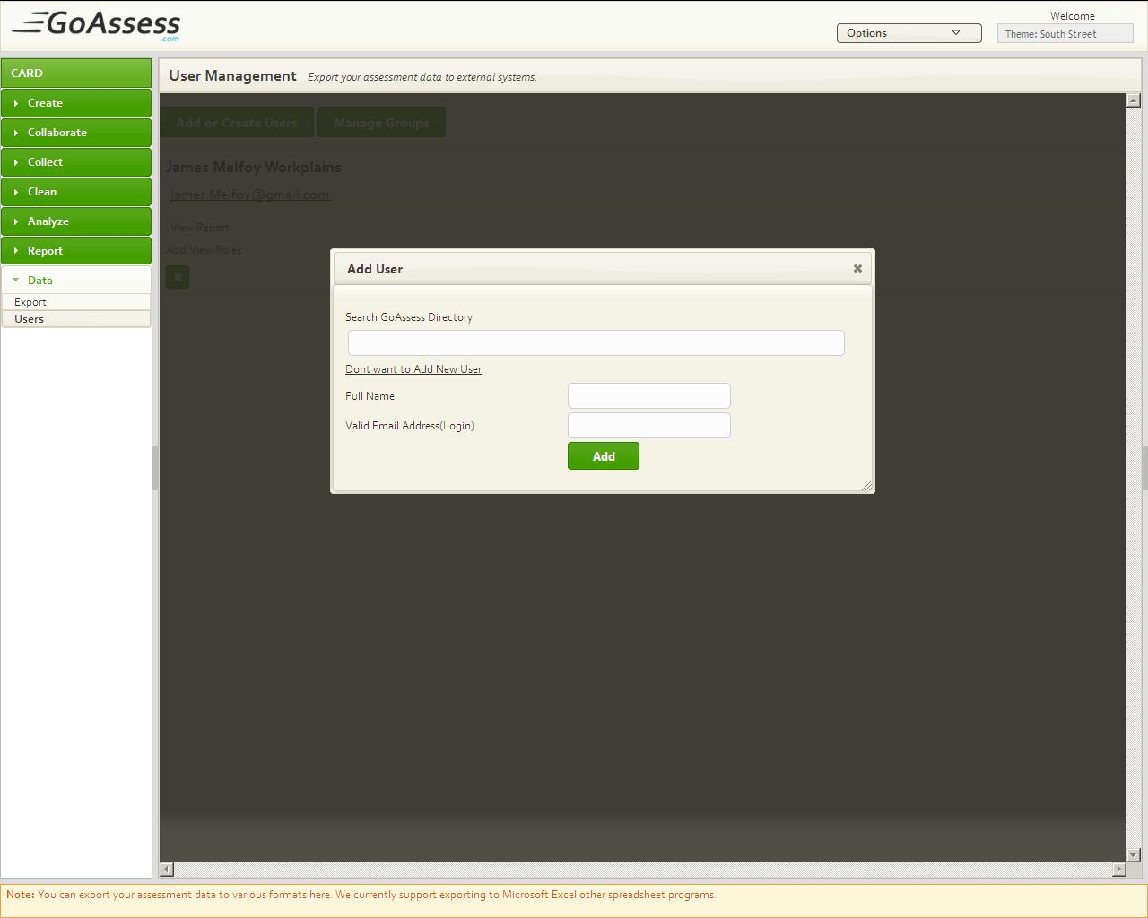

*Follow these steps to Export Data of Assessment*

* After Log-in select Data
* Select Users
* Press Add or Create New User
* Press Not in Directory? Add New User
* Enter Full name of the User
* Enter Valid Email Address(Login)
* Press Add

## Assign Tasks

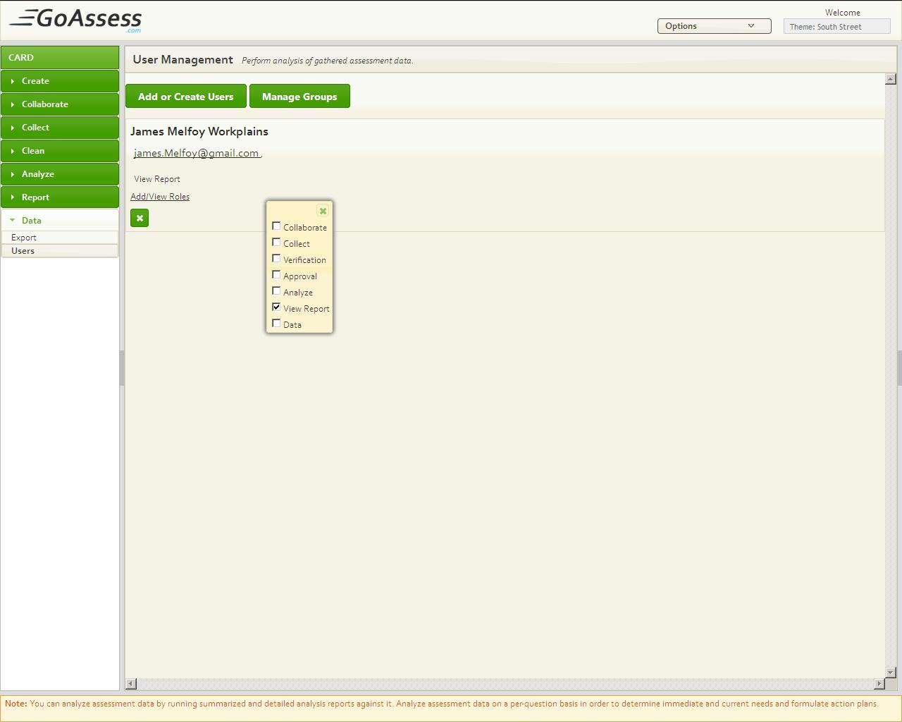

*Follow these steps to assign Tasks to Use*

* After Log-in select Data
* Select Users
* Press Add or Create New User
* Press Not in Directory? Add New User
* Enter Full name of the User
* Enter Valid Email Address(Login)
* Press Add
* Press add / view roles
* Check rules to assign to this user

## Edit User Tasks

*Follow these steps to Edit Assigned Tasks*

* Select Users
* Press add / view roles below to the user name
* Check or uncheck roles assigned to the user
* Close the tasks list

## View User Profile

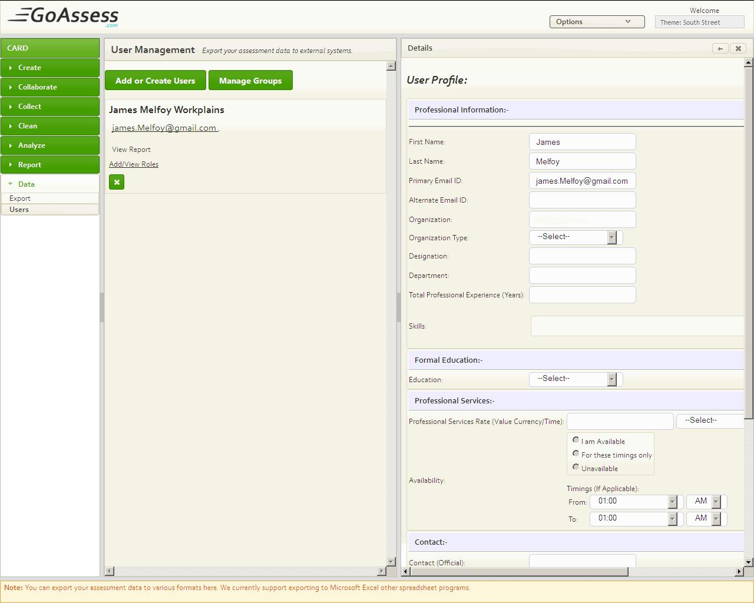

*Follow these steps to View User Profile*

* Select Users
* Click at the name of the user

User profile will be opened in third pane

## Delete User

*Follow these steps to Delete user*

* Select Users
* Click at Delete (cross) button
* Press Delete

## Manage Groups

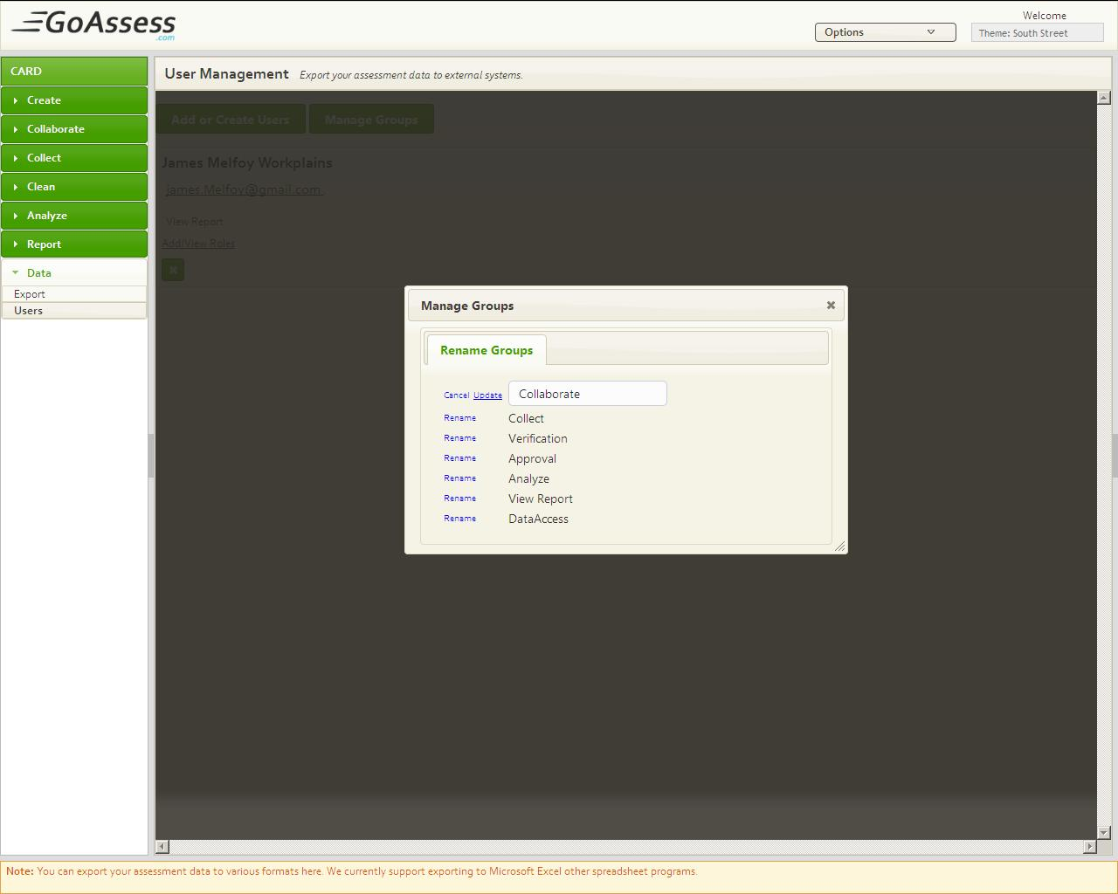

*Follow these steps to Manage user*

* Select Users
* Click Manage Groups
* In Front of each Task name there is “Rename” button Press **Rename**
* Enter New name
* Press Update

OR

* Press **Cancel** to stop Update

# My Profile

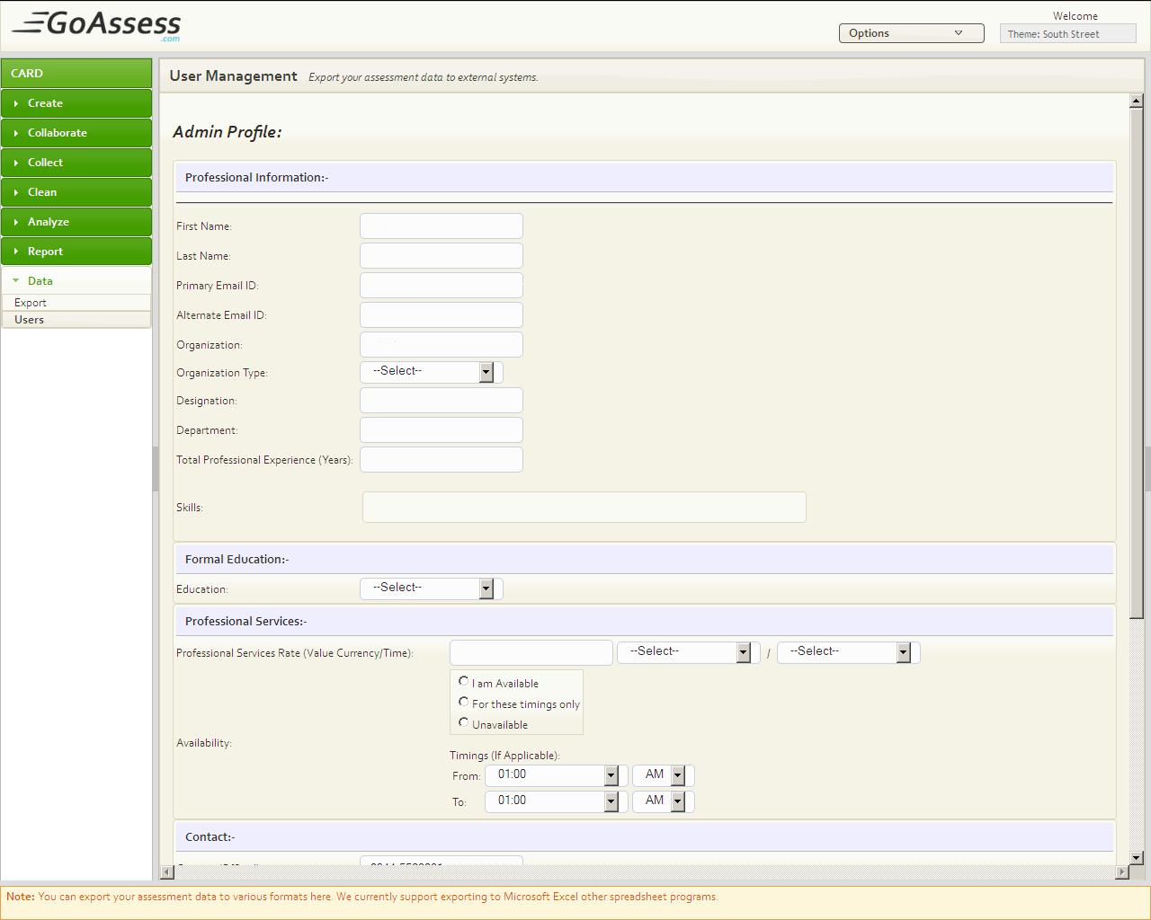

## How to create profile

*Follow these steps to Create Profile*

* Log-in with valid user name and password
* There is an **Options** Drop Down at Top hover your mouse over **Options**
* Select My Profile
* Fill all field
* Press Update Profile

## Update Profile

*Follow these steps to Update Profile*

* Log-in with valid user name and password
* There is an **Options** Drop Down at Top hover your mouse over **Options**
* Select My Profile
* Update required field
* Press Update Profile

# Other Options

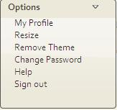

## Resize

## Remove Theme

*Follow these steps to Remove a Theme*

* Log-in with valid user name and password
* There is an **Options** Drop Down at Top hover your mouse over **Options**
* Select Remove Theme

## Change Password

*Follow these steps to your Change Password*

* Log-in with valid user name and password
* There is an **Options** Drop Down at Top hover your mouse over **Options**
* Select Change Password
* Enter Old Password
* Enter New Password
* Enter again New password to Confirm it
* Press **Update**

## Help

## Sign-Out

*Follow these steps to sign-out*

* Log-in with valid user name and password
* There is an **Options** Drop Down at Top hover your mouse over **Options**
* Select Sign-Out

# Apply a Theme

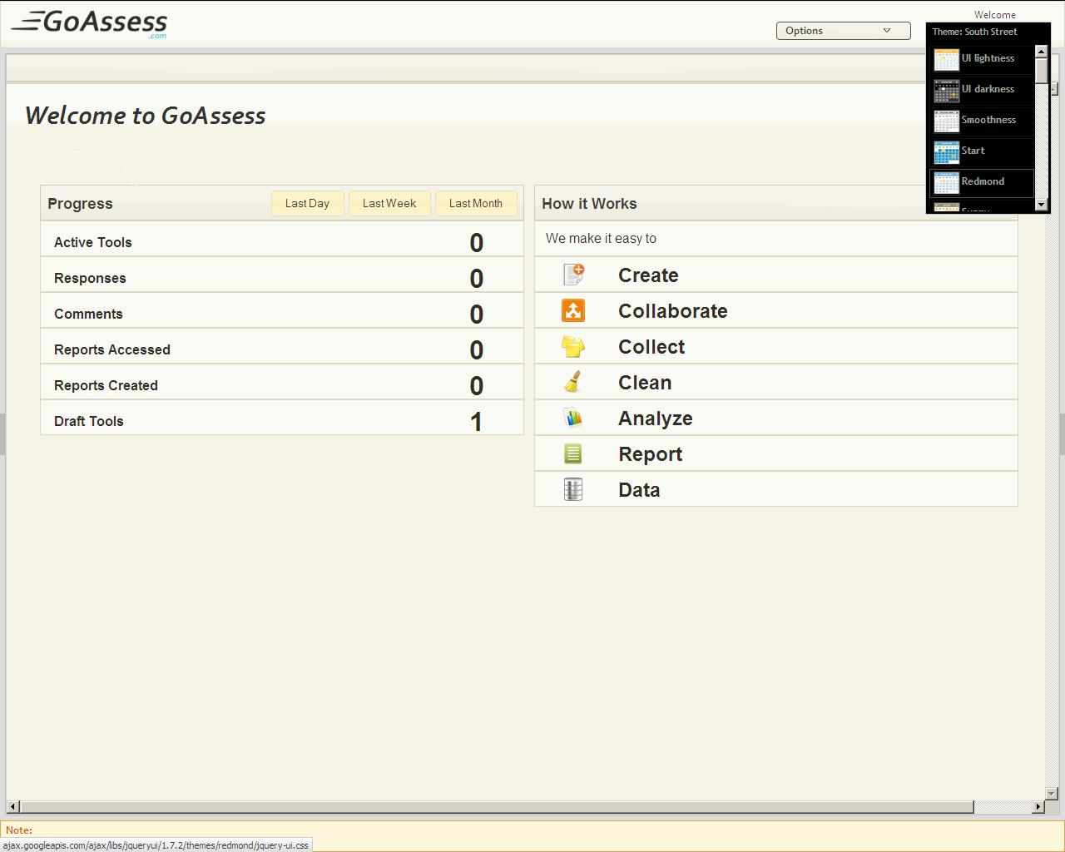

GoAssess provides you a list of Themes you can apply a theme of your choice

*Follow these steps to Apply Theme*

* Log-in with valid user name and password
* There is Themes Drop Down next to the Options Drop down
* Select a Theme

# Conclusion