**Workmatec**

1. **Registration**

These are the steps to be performed in order to become the member of workmatec.

* 1. **Signup**

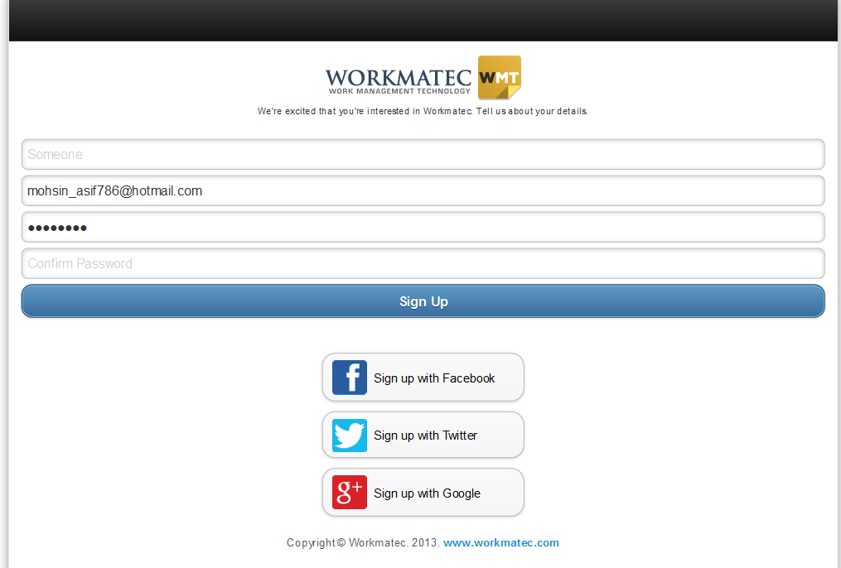

1. Name: This would take the input of any name.
2. Email: This would take the email address as input.
3. Password: This would take the password as input and password can be any specific characters and numbers or symbols.
4. Confirm Password: This take the password as input and password can be any specific characters and numbers or symbols.
5. Signup Button: On click of this button a user created for workmatec.
6. Signup with Facebook: Users can also signup by using an already existed Facebook account.
7. Signup with Twitter: Users can also signup by using an already existed Twitter account.
8. Signup with Google: Users can also signup by using an already existed Gmail account.
   1. **Forgot you password**

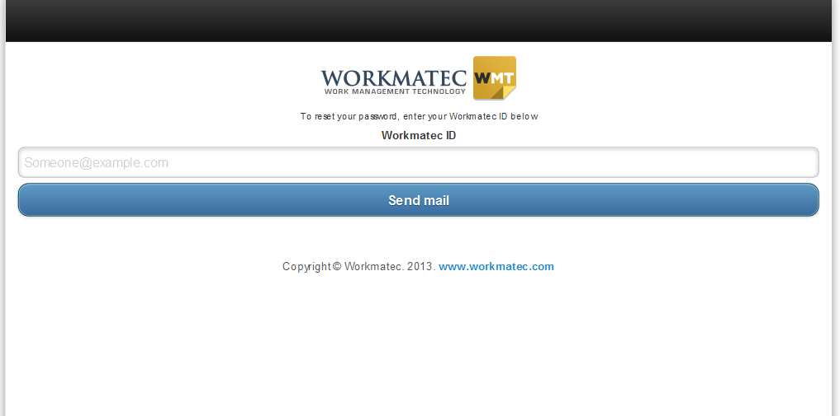

* + 1. Workmate ID: This will take the email as input on which it sends the account details.
    2. Send Mail Button: On click of this button an email of user account details will be sent to the workmatec id.
  1. **Login**

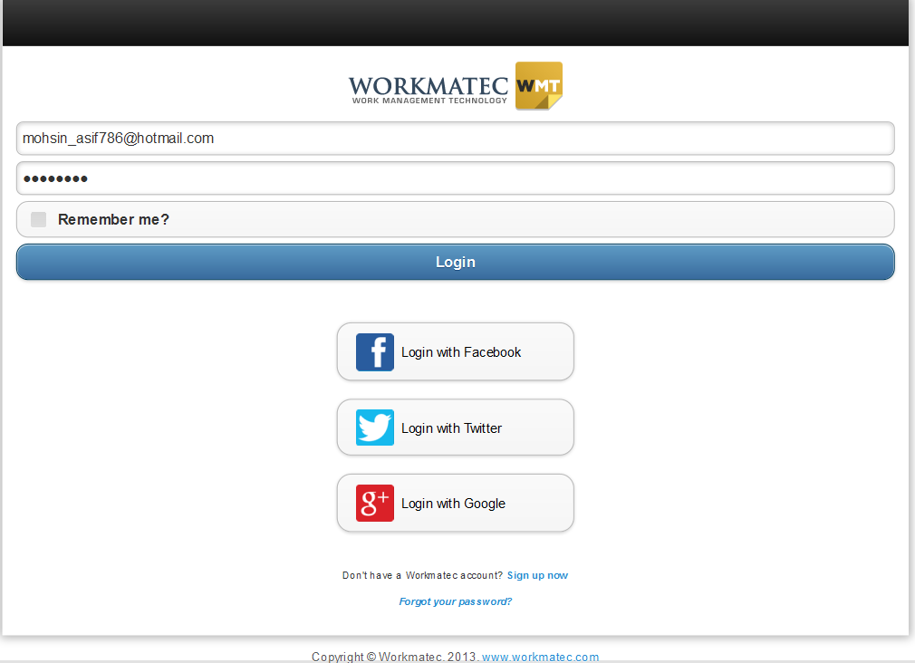

* + 1. Workmate ID: This will take the email or name as input as login detail. This is a mandatory field.
    2. Password: This will take the password as input. This is a mandatory field.
    3. Remember me: This option is used to remember the username and password.
    4. Login Button: On click of this button the browser will remember the last entered username and password.
    5. Login with Facebook: A user can login the workmatec by using its existing Facebook Id.
    6. Login with Twitter: A user can login the workmatec by using its existing Twitter Id.
    7. Login with Google: A user can login the workmatec by using its existing Gmail Id.

1. **Dashboard**

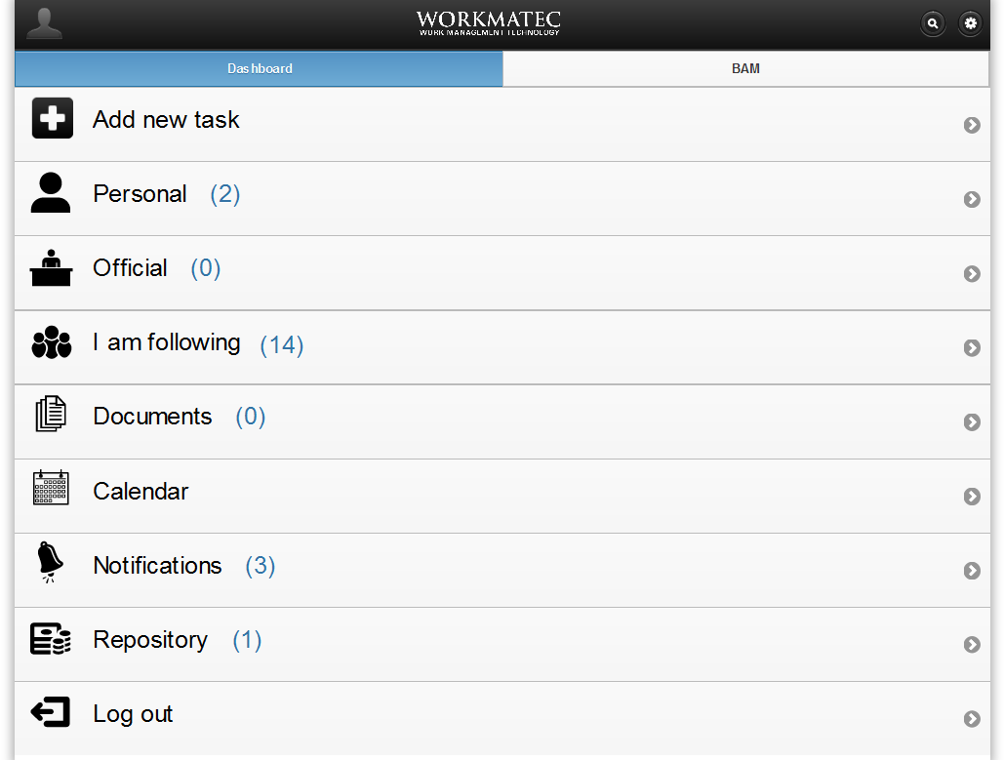

Description of module: The dashboard is the page appeared after the user gives its “Username” and “Password” and clicks the login button.

Parent Module ID:

**2.1 Add New Task**

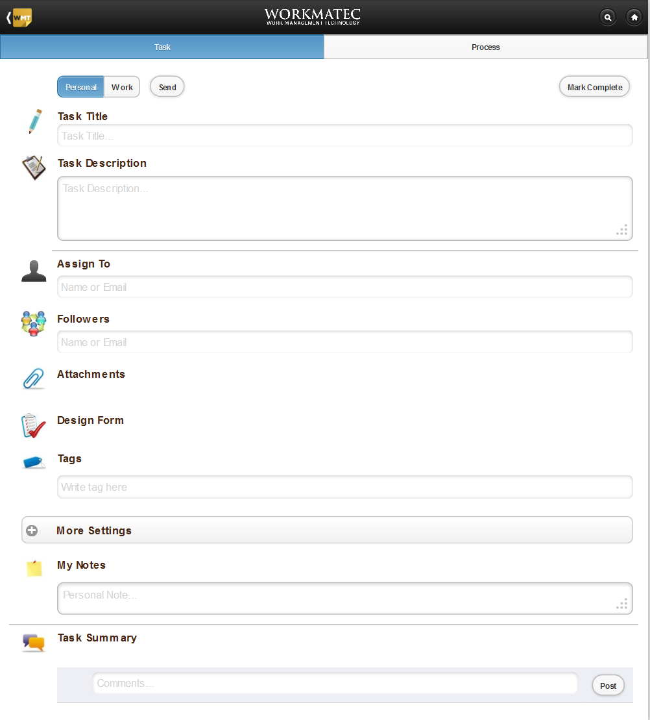

ID: WM1-F1

Parent Module ID: WM1

Purpose / Description:

* Inputs:

Personal / Work: It selects the task type.

Send Task Button: It will send the task. The task will go to Repository.

Mark Complete: It will mark the complete task.

Task Title: The task title will be the name of the task. This is a required field.

Task Description: The task description is the small detail about the task. This is a required field.

Assign To: This field takes the Name or Email as input. This is a required field.

Followers: This field takes the Name or Email as input.

Attachments: This field takes the file input as attachment of any data type.

Design Form: Attach a new form with task.

Tags: This field should contain the related text keywords input.

This Task is required by: This will set the Date and Time.

Remind Me: This will set the reminder for “Everyday,” “Before 1 Day”, “Before 1 Hour”.

Generate Late Notification: This will generate late notifications “Everyday” or “One time”.

Repeat This Task: This will repeat the task “Never”, “Every assigned day”, “Every assigned Week”, “Every assigned Month”, “Every assigned Year”.

My Notes: Write the notes in the text form it can be any personal note.

Task Summary: Summary of the task which contains the every step performed in creation of the task.

* Processing:
* Output: Generate a task.
  + 1. **Task**
    2. **Design Form**

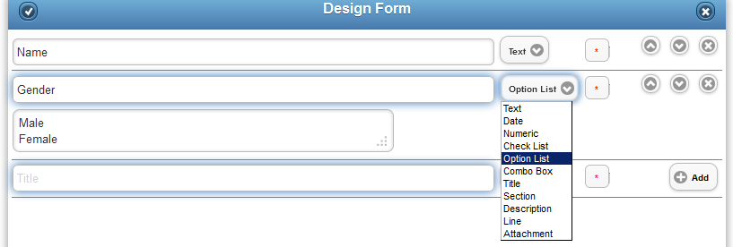

ID: WM1-F2

Parent Module ID: WM1

Purpose / Description:

* Inputs:

1. Data Field: This filed takes the input as data field name or description in text form.
2. Data Field Type: List of data types.
3. Required Field: Is this field required or not.
4. Add Button: Add field in the form.

* Processing:
* Output: A user data entry form.
  + 1. **Process** 
       1. **Activities**

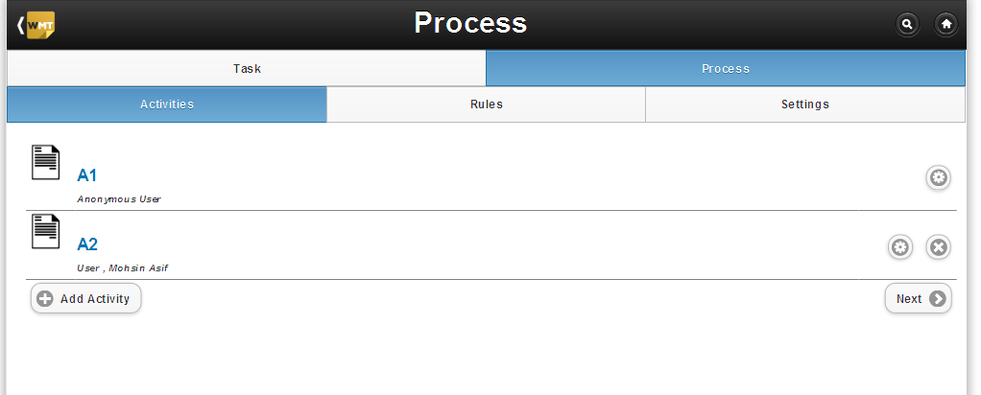

Purpose / Description:

* Inputs:

1. Add Activity: This adds the new activity.

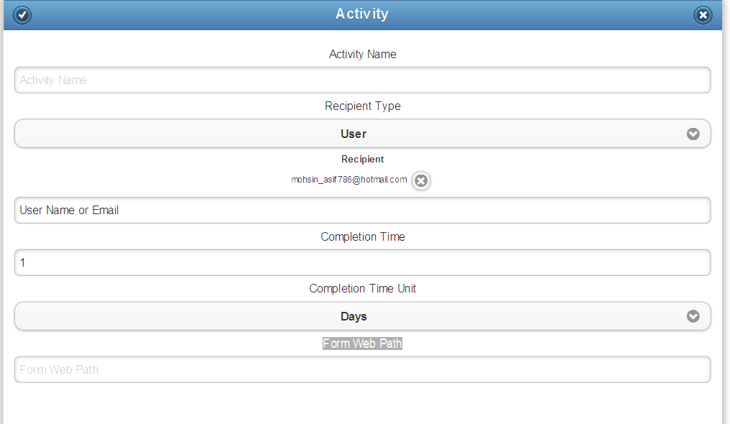

Activity Name: This will get the activity name as input.

Recipient Type Drop Down: This will define the recipient type of the activity.

Recipient: This will take the user name or email as input.

Completion Time: This will take the numeric value of completion time.

Completion Time Unit Drop Down: This will define the unit of the completion time. The completion time unit can be in “Days”, “Hours”, and “Minutes.”

Form Web Path: This text field will take the form web path as the input.

Save Button: This button will save the new activity.

Cancel Button: This button will cancel the new activity.

1. Edit Activity: This will transfer to edit activity form.

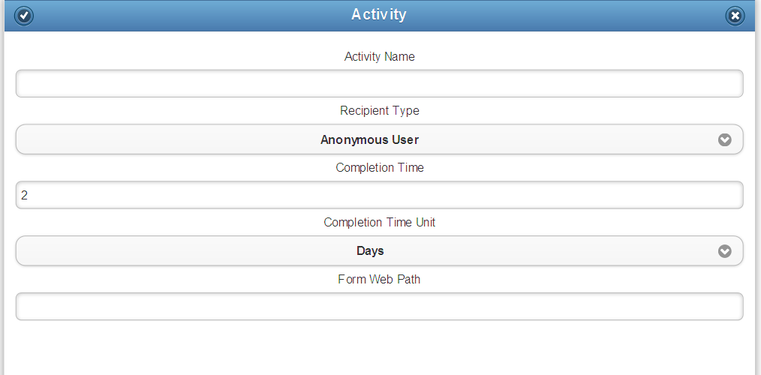

Activity Name: This text filed will get the activity name as input it will be any name.

Recipient Drop Down: This will define the recipient type of the activity.

Completion Time: This will take the numeric value of completion time.

Completion Time Unit Drop Down: This will define the unit of the completion time. The completion time unit can be in “Days”, “Hours”, and “Minutes.”

Form Web Path: This text field will take the form web path as the input.

Save Button: This button will save the edited activity.

Cancel Button: This button will cancel the edited activity.

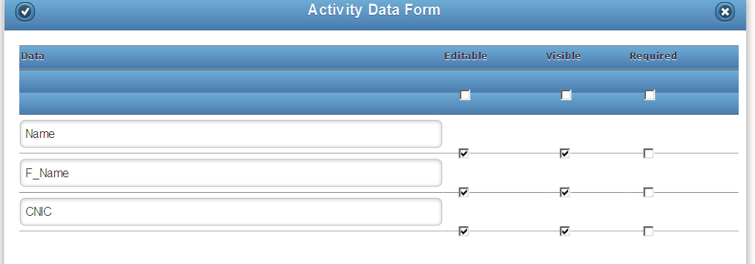

1. Activity Data Form:

Editable Check Box: This will set the form fields to be editable or not.

Visible Check Box: This will set the form fields to be visible or not.

Required Check Box: This will set the form fields which are required or not.

Save Button: This will save the activity data form.

Cancel Button: This will cancel the activity data form.

1. Next Button: This will transfer to the next functionality of settings.

* Processing:
* Output: A complete activity will be created.
  + - 1. **Rules**

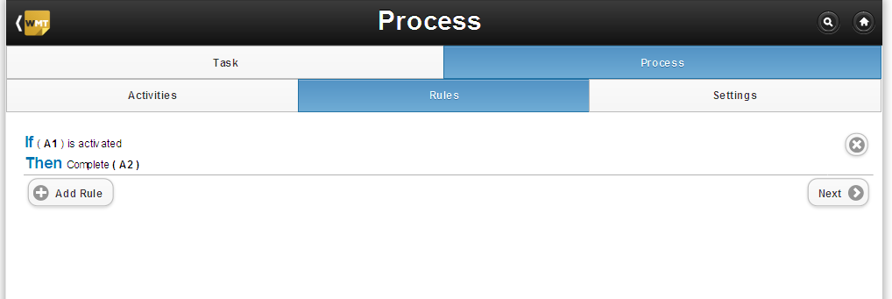

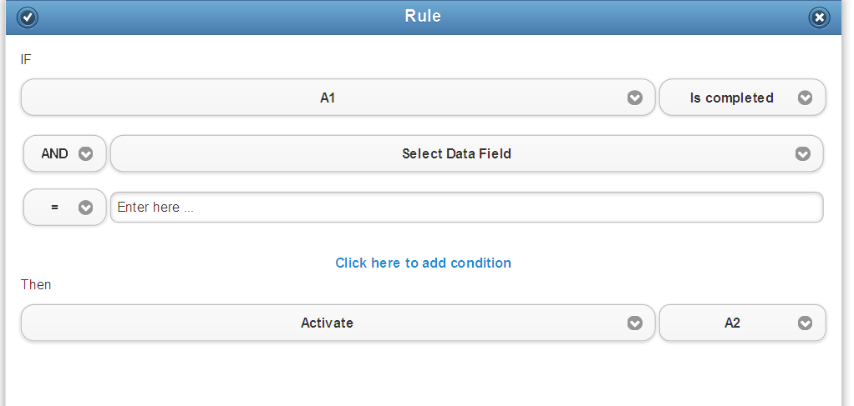

* Inputs:

1. Rule: Different rules can be defined in this section and can be assigned to multiple activities.

* Processing:
* Output: A complete rule will be created.
  + - 1. **Settings**
* Inputs:

1. Simulate: This will goes to the simulate form and simulate the activities or rules.

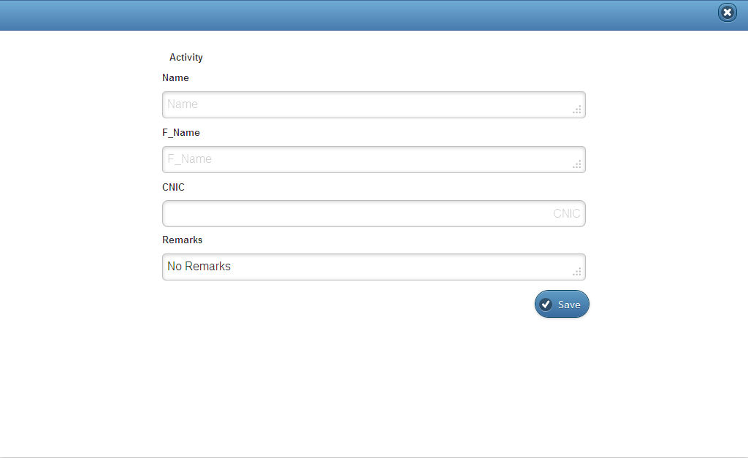

1. Publish: This will publish the activities and rules.

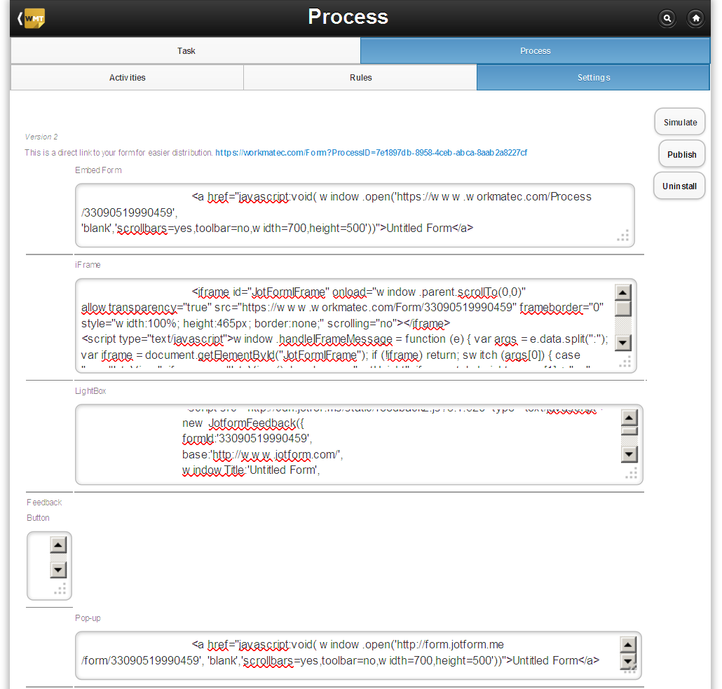

1. Delete: This will delete the activities and rules.

* Processing:
* Output: A complete management of rules and activities.
  1. **Personal**

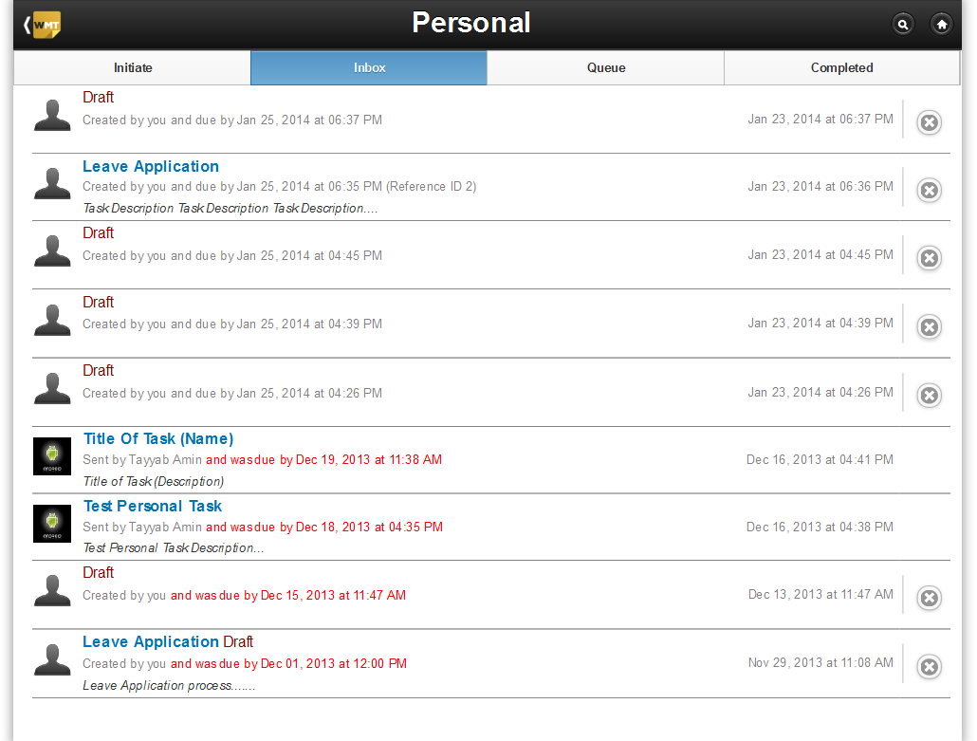

ID: WM1-F1

Parent Module ID: WM1

Purpose / Description:

* + 1. Initiate: This will show the list of personal initiated tasks.
    2. Inbox: This will show the draft list of personal tasks.
    3. Queue: This will show the queue list of personal tasks.
    4. Completed: This will show the list of completed personal tasks.
  1. **Official**

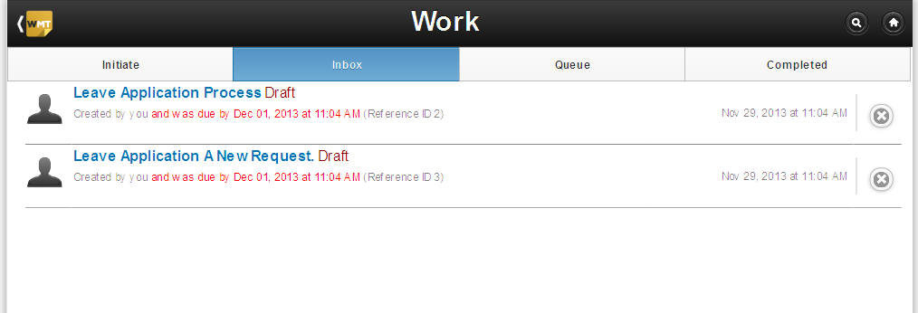

ID: WM1-F1

Parent Module ID: WM1

Purpose / Description:

* + 1. Initiate: This will show the list of official initiated tasks.
    2. Inbox: This will show the draft list of official tasks.
    3. Queue: This will show the queue list of official tasks.
    4. Completed: This will show the list of completed official tasks.
  1. **I am following**

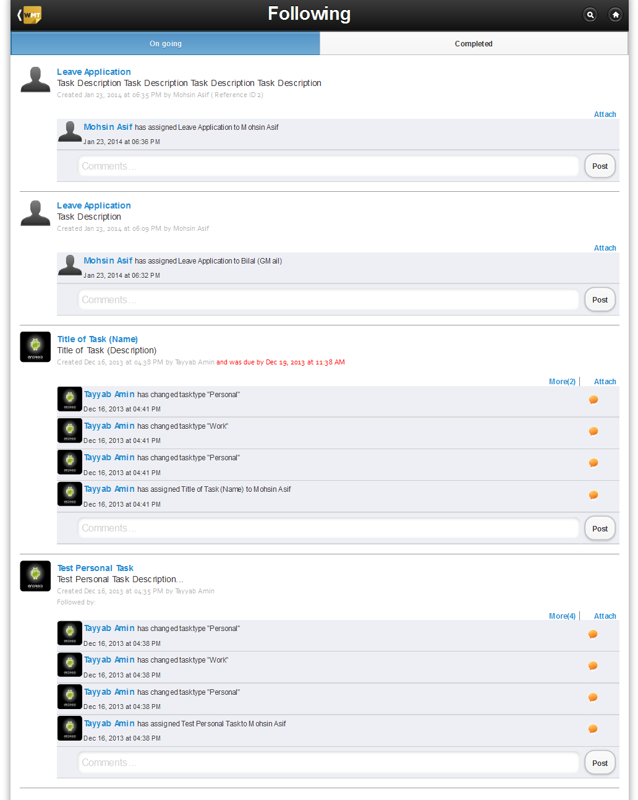

ID: WM1-F2

Parent Module ID: WM1

Purpose / Description:

* + 1. On Going: This will show the list of on-going tasks by different users.
    2. Completed: This will show the list of completed tasks by different users.
  1. **Documents**

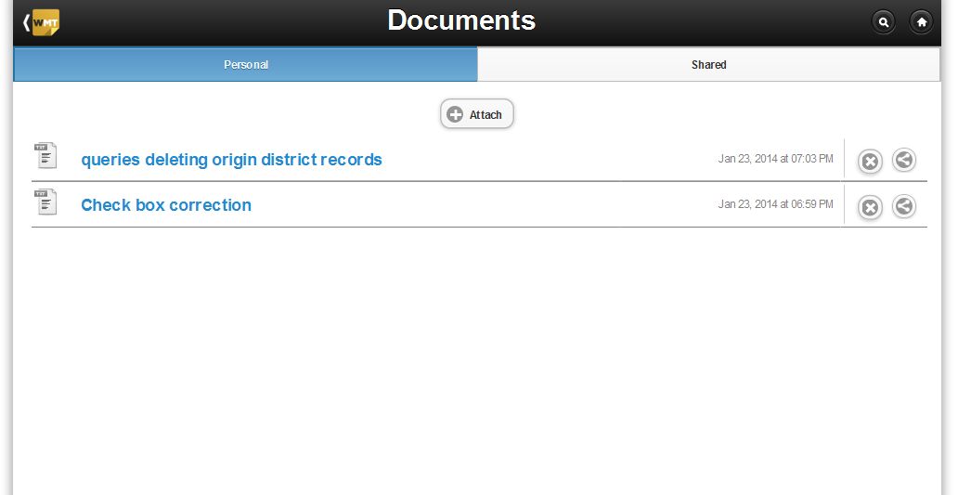

ID: WM1-F2

Parent Module ID: WM1

Purpose / Description:

* + 1. Personal: This will gives the option to attach any personal document. In this section you can view, delete and share documents.

View: The uploaded document will be viewed from this link.

Delete: The uploaded document will be deleted from this button.

Share: The uploaded document will be shared from this button.

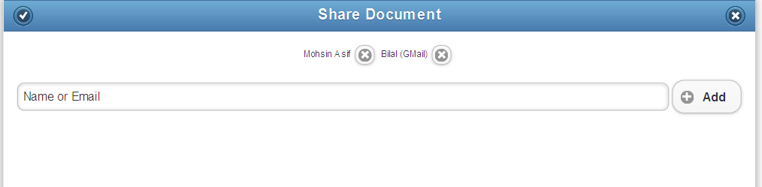

Save Button: This button will save the shared document form.

Cancel Button: This button will cancel the shared document form.

* + 1. Shared: This will show the list of share documents. Shared documents will be viewed and deleted from this section.

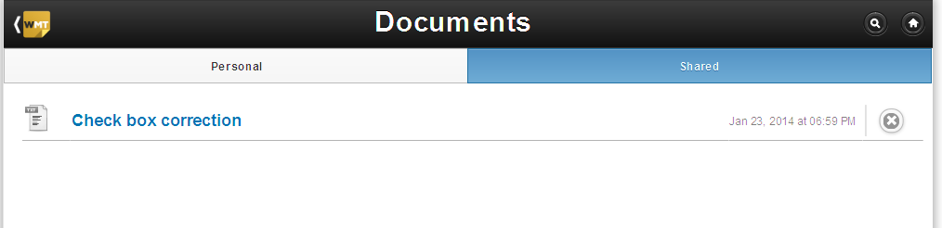

* 1. **Calendar**

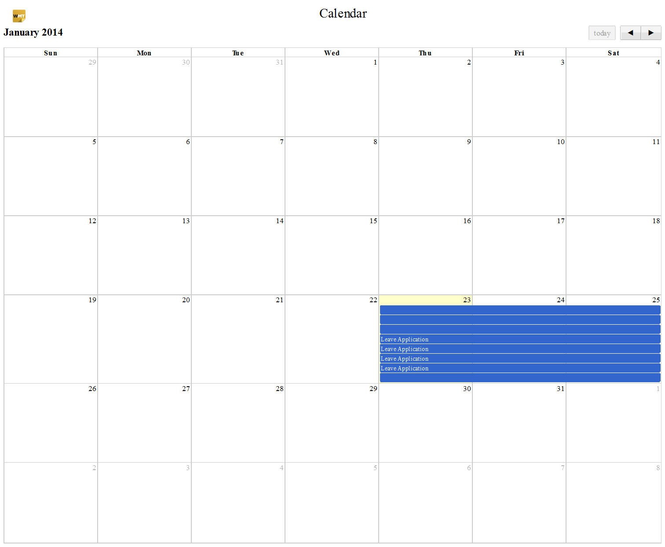

ID: WM1-F2

Parent Module ID: WM1

Purpose / Description: The Calendar shows the graphical view of different events set on the calendar.

* 1. **Notifications**

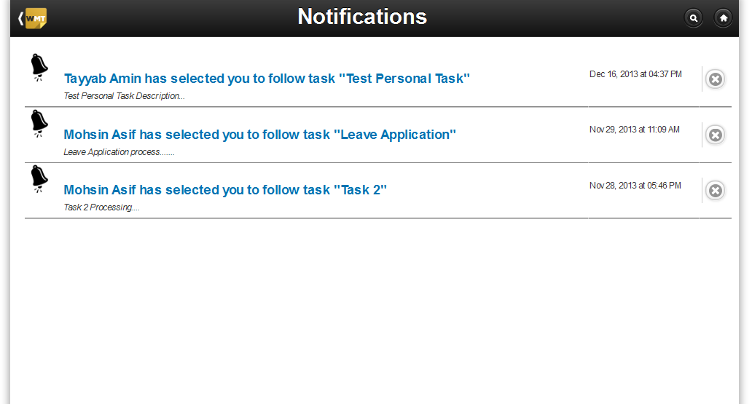

ID: WM1-F2

Parent Module ID: WM1

Purpose / Description: This section will show the notifications by different users. The notifications can be deleted from here.

* 1. **Repository**

# C:\Users\Administrator\Desktop\Workmatec Pics\repository.png

ID: WM1-F2

Parent Module ID: WM1

Purpose / Description:

* + 1. Personal: This will show the list of personal tasks. These personal tasks can be shared with the other user.
    2. Shared: This will show the list of shared personal tasks.
    3. Data Entry: This section contains the “Data Entry Form”, “Create Form”, “Edit Form”, “View Form” and “Share Form” functionality.
       1. Create Data Entry Form:

Form Title: This text field will take the text title as input.

Form Description: This text field will take the text as description.

Save Button: On click of this button the data entry form will be created.

Close Button: On Click of this button the data entry form will be cancelled.

* + - 1. Edit Data Entry Form:

Form Title: This text field will get the text title as input.

Form Description: This text field will get the text description as input.

Text Field: This will get the text as input.

Filed Type Drop down: This will define the type of the text field value.

Mandatory Button: This button will set that the field is mandatory or optional.

Add Button: This button will add the form fields.

* + - 1. View Data Entry Form: The data entry form created will be viewed by using this functionality.
      2. Share Data Entry Form:

Share With: This will share the process with the name or email address entered in the below box.

Create a copy: This will create the copy of this process.

Text Filed: This field will take the text or email as input.

Save Button: This button will save the share process.

Cancel Button: This button will cancel the share process.

* 1. **Log Out**

Purpose / Description: This will logout the user and after that shows the login page.

1. **<<Module Name 2>>**

ID: WM2

Description of module: <<Write here basic working of module>>

Parent Module ID: <<Dependency if any – write ID of its parent module>>

* 1. **<<Functionality 1>>**

ID: WM2-F1

Parent Module ID: <<Dependency if any – write ID of its parent module>>

Purpose / Description: <<Inputs 🡪 Processing 🡪 Output>>

* 1. **<< Functionality 2>>**

ID: WM2-F2

Parent Module ID: <<Dependency if any – write ID of its parent module>>

Purpose / Description: <<Inputs 🡪 Processing 🡪 Output>>