**ATTENDANCE**

Version: 1.0

**WorkmatecLogo.png**

**Workplains (Pvt.) Ltd**

Phone: ***********

E-mail: [info@workplains.com](mailto:info@workplains.com)

Web: <http://www.workplains.com>

**TABLE OF CONTENTS**

**1.** **Purpose** 2

**2.** **Process Description** 2

**3.** **Process Flow** 3

1. **Purpose**

Purpose of this process is to record employee’s daily attendance.

1. **Process Description**
2. Before start of work, select process of Attendance from the Apps tab:

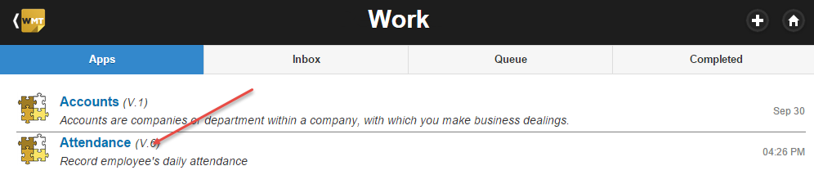

1. This will initiate the attendance process of the employee. Here employee will enter its check-in date and time and submit the form.

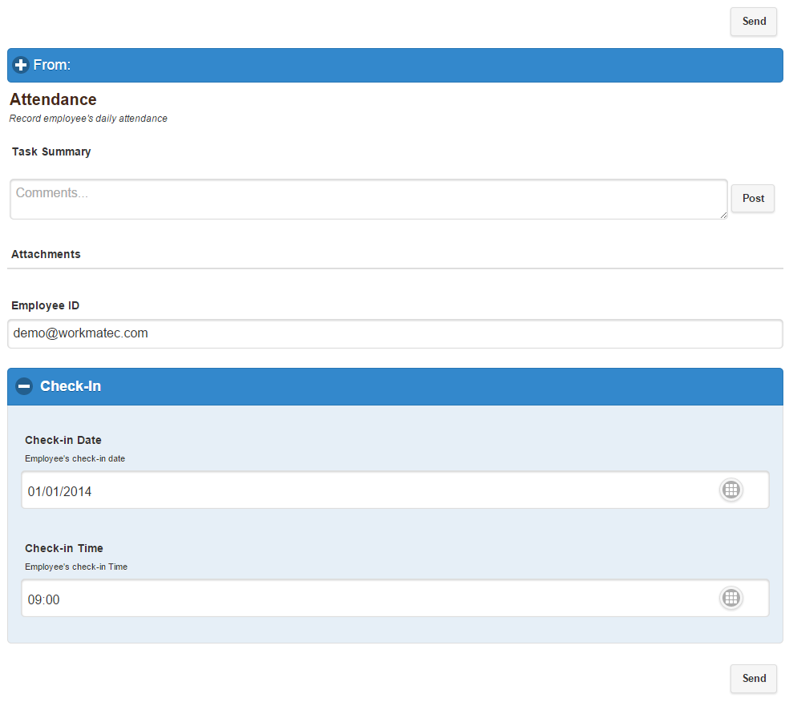

1. After close of work employee will open its task from Inbox tab.

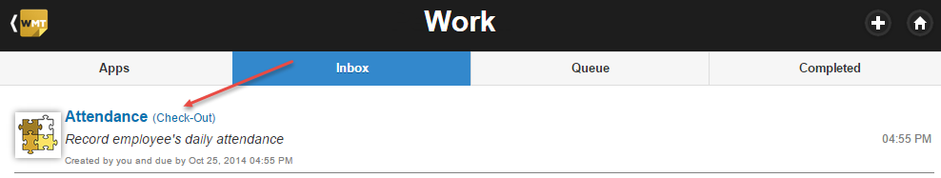

1. Here employee will enter its check-out date and time and submit the form. This step will complete the attendance process for the day.

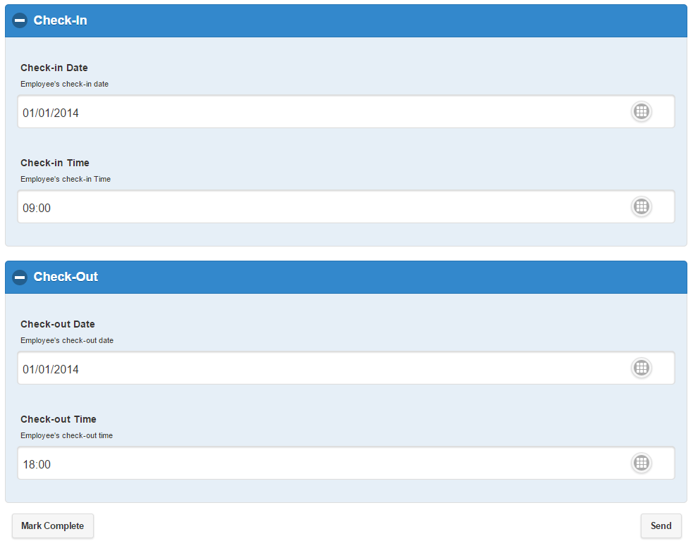

1. **Process Flow**

