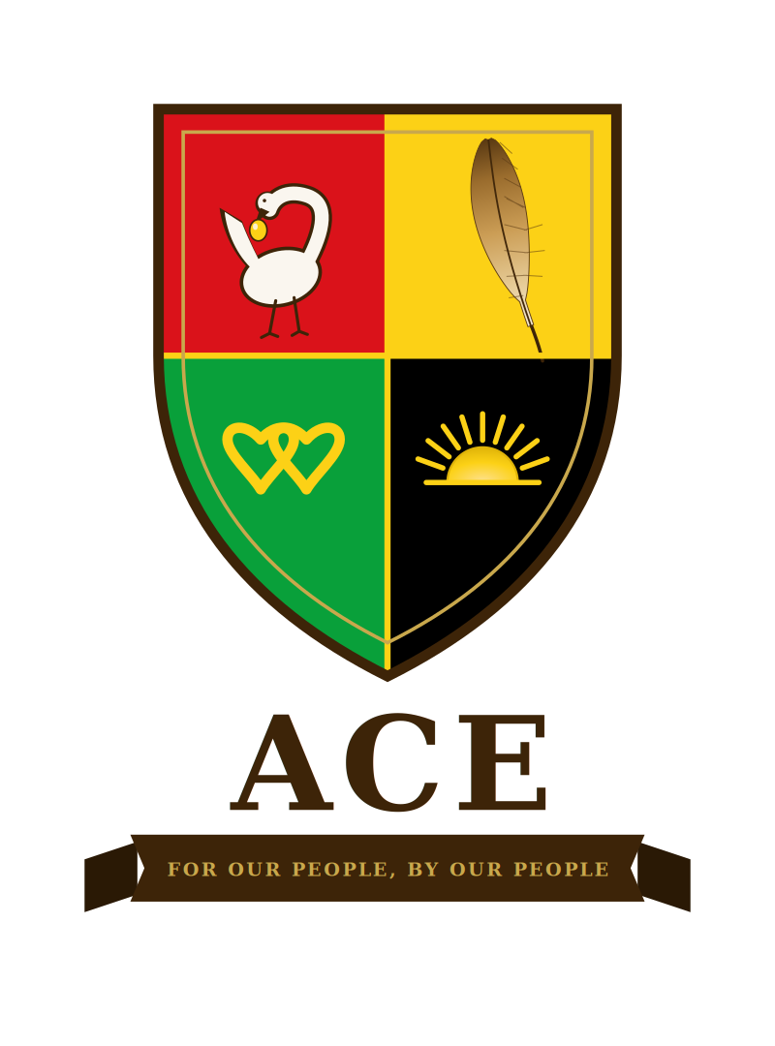

Executive Summary
Alliance for Collective Empowerment and Development
v1.8 - June 2026

Léandre Poplus, Founder
For Our People, By Our People.

ALLIANCE FOR COLLECTIVE EMPOWERMENT

ACE
EXECUTIVE SUMMARY

“We are not asking for a seat at the table. We are building our own.”

Léandre Poplus, Founder

WHY ACE EXISTS
The idea for the Alliance for Collective Empowerment and Development began with a simple observation: two communities, dispossessed by the same government, each hold exactly what the other lacks.
Native American nations hold sovereign land, territory protected by federal law, outside state taxation, outside municipal zoning, outside many of the legal mechanisms that have historically been used to destroy Black and Native institutions the moment they became powerful enough to matter. What they have lacked is the capital, the population density, and the financial infrastructure to convert that land into a self-sustaining economy.
Black Americans hold $1.6 trillion in annual spending power, a growing professional and entrepreneurial class, and generations of scholarship, institution-building, and cultural production forged under conditions designed to make all of it impossible. What they have lacked is land, sovereign, protected, unchallengeable ground on which to build without asking permission and without fear of what has always come next.
This is not about one community being superior to the other. That framing would simply replicate the logic both communities are trying to escape. This is about two communities honestly naming their own gaps and recognizing that the right partner does not fill your weakness with their strength, they bring a weakness of a different kind, and together you eliminate both.
A box of nails and a stack of timber. Each one formidable on its own terms. Neither one a building. Together, something neither could become alone.

Weakness
Each community lacks what the other holds. Land without capital cannot develop. Capital without land cannot root. This is the gap ACE is built to close.

Strength
The combination is not additive. It is exponential. Sovereign land plus community capital plus population equals the legal, territorial, and economic foundation for an independent, self-governing civilization. No external institution needs to grant it. No political climate can revoke it.

Opportunity
The joining of these two communities creates something the United States has never seen and has never had to contend with: a legally protected, economically self-sustaining, culturally sovereign civilization built by the two peoples this country has spent the most effort trying to erase. The opportunity is not just survival. It is the construction of something permanent.

Threat
The threat is twofold and must be named plainly. The first threat is inaction. For over 400 years, Black Americans have faced a sustained and documented campaign of extermination, not metaphorical, but literal: the destruction of Reconstruction, the massacre of Greenwood, the dismantling of every Black institution that grew powerful enough to threaten the status quo. Native Americans have faced the same campaign across 250 years: genocide, forced removal, the criminalization of language, the systematic theft of land. The threat of doing nothing is not stagnation. It is continuation of what has already been done. The second threat is attempting this and failing, which is why ACE has been designed with its predecessors specifically in mind, and why every legal protection, every sovereignty clause, and every gap-proofing provision in this framework exists.
ACE is the answer to both threats. Not a movement. Not a petition. A civilization, built by the people it is built for, on ground no one can take.

Léandre Poplus, Founder

THE VISION
The Alliance for Collective Empowerment (ACE) is a 25-year initiative to establish a network of self- governing, self-sustaining cities for Black and Native American communities on tribal land across the United States protected by tribal sovereignty law, funded by community capital, and governed by a constitutional framework designed to last generations.
ACE is not a program. It is not a nonprofit initiative. It is not a political campaign. It is the architectural blueprint for an independent civilization with its own cities, schools, hospitals, economy, and governing constitution built by two of the most historically dispossessed peoples in American history, for themselves, on their own terms.
ACE has been designed with its predecessors in mind. The destruction of the Freedmen’s Bureau, the 1921 Tulsa Race Massacre of the Greenwood District, the dismantling of Five Civilized Tribes’ pre- statehood governments, and the FBI’s COINTELPRO program all form a documented pattern of resistance to Black and Native self-governance at its moment of greatest success. Every legal protection, constitutional provision, and sovereignty clause in this Act exists because ACE has studied that history and built accordingly.

THE STRATEGIC LOGIC

Native Americans hold tribal sovereign land territory not subject to standard U.S. municipal law, state taxation, or federal zoning. This is the legal and territorial foundation no other community in America can offer.
Black Americans hold $1.6 trillion in annual spending power the investment capital, consumer base, and labor force that turns sovereign land into a functioning economy.
Together: sovereign land + capital + population = an independent, self-governing civilization. Neither community can build this alone. Both can build it together.

THE SCALE

Target population  32 million  Black Americans (planning figure) Pioneer population target  300,000  Phase 3 milestone - proof of concept Phase 1 land commitment  150,000 acres  Released in 25,000-acre milestone increments | Long-range land footprint  24M acres  National network @ 0.75 acres/resident Development horizon  25 years  Four phases  City network target  10+ cities  Across 5 regions, multiple tribal partners

THE TRIBAL PARTNERSHIP
ACE’s legal foundation is tribal sovereignty the most durable legal protection available on American soil, having survived 200 years of federal attempts to dismantle it. ACE enters 70-to-99-year land leases with federally recognized tribal nations under the HEARTH Act of 2012, operating as a Tribally Chartered Entity that extends sovereign immunity to all ACE community operations.
Priority tribal targets: The Navajo Nation (17.5M acres across Arizona, New Mexico, and Utah) is the primary scale partner. Secondary targets include the Cheyenne River, Pine Ridge, Standing Rock, and Wind River reservations for their land scale and sovereignty strength; and the Cherokee, Seminole, Muscogee, and Lumbee nations for their documented historical relationships with Black Americans.
The Tribal Partnership Agreement includes a political transition protection clause: ACE agreements survive changes in tribal leadership and bind all successor governments, with a mandatory 60-day consultation period before any amendment proceedings may begin. ACE retains tribal sovereignty counsel on 24-hour retainer for this specific contingency.
Native agricultural sovereignty: The ACE Agricultural Cooperative assigns not less than 51% equity to the Tribal Partner, recognizing tribal nations as the senior agricultural partners whose generational land knowledge is the foundation of ACE food production. The ACE Farming Academy trains Black farmers under tribal agricultural faculty.

THE CONTINGENCY LAND CLAIM
ACE pursues tribal partnership as its primary and preferred path to land and territory. ACE also pursues, simultaneously and without dependency on any single party, a second and parallel path: a claim to ten million acres of land already held by the United States as public land under the Bureau of Land Management, distributed as one million acres each across ten states. This is land the federal government already holds and administers, not land that must be purchased, condemned, or taken from any private party, state, or tribal nation.
The claim is grounded in Special Field Order No. 15, the January 1865 promise of land to formerly enslaved Black Americans, revoked by President Andrew Johnson within the same year. Ten million acres represents a deliberately modest, achievable fraction of that original promise, not its full restatement. The legal theory rests on a continuity doctrine drawn from the Supreme Court’s own language in Dred Scott v. Sandford, which recognized Native American tribes as a free and independent people governed by their own laws even while displacing them by force, while denying Black Americans any such standing at all. ACE does not claim present eligibility under existing federal tribal recognition law. ACE instead calls on Congress to enact new, standalone legislation, modeled on the strength of the existing tribal trust framework but created through Congress’s own independent authority, exactly as Congress has created new statutory remedies for other dispossessed peoples in the past.
This path runs alongside the tribal partnership track, never against it and never in place of it. ACE pursues both so that its mission never depends on the consent of any single party, and so that its pursuit of tribal partnership proceeds from dignity rather than necessity

THE FOUR PHASES

PHASE 1 Years 0-2 The Movement  Form ACE legal entities. Recruit Native American Co-Chair the most urgent pre-institutional act. Forge tribal partnerships. Build national grassroots awareness. Secure founding capital.  PHASE 3 Years 7-15 The City  Scale to 300,000 pioneer residents. All municipal systems operational, governance, courts, hospital, university, media, economy. | PHASE 2 Years 2-7 Territory  Execute first Tribal Partnership Agreement. Break ground. Build water, energy, roads, homes. Launch clinic, school, ACE Credit Union, agricultural cooperative.  PHASE 4 Years 15-25 Civilization  10+ ACE cities nationally. ACE University system.  $50B+ annual economy. International trade with Africa and Caribbean. 32M served.

WHAT ACE BUILDS - THE FULL SYSTEM

🏠 Housing  Lease-to-own on tribal land. ACE-CPF Housing Account builds equity automatically. Zero Homelessness Mandate.  🏫 Education  K–12 through ACE University. BIE-approved. Pan- African and Indigenous studies at every grade. Tuition-free for ACE residents.  🏥 Healthcare  Community clinic to full hospital. MediSave-funded no medical debt. Modern medicine co-equal with Indigenous and African traditional healing. Black maternal mortality eliminated by design. | 🏛️ Governance  Three-branch government. ACE Community Assembly, Executive Council, Community Court. Co-equal tribal co- governance. ACE Governing Charter as supreme law.  🛡️ Public Safety  Tiered peacekeeping. 60% of calls handled by unarmed community care responders. Restorative justice replaces incarceration as default.  🌿 Food & Energy  80% halal food establishments. Swine prohibition on all ACE land and no swine as domestic pets. 51% tribal- majority agricultural cooperative. Full energy independence.
💰 Economy  ACE owns infrastructure layer. Free enterprise above it. Majority Lending Institution network. ACE Economic Solidarity Culture builds internal dollar circulation. | 📺 Media & Culture  ACE Media Network: TV, podcast, print, streaming. ACE Culinary Archive preserves and evolves Black and Native food traditions. Community-owned narrative.

THE ACE SOCIAL CONTRACT

Every ACE resident who works and contributes is guaranteed four things by retirement age:
- A home they own, free and clear, within ACE Territory funded through the ACE Community Provident Fund Housing Account
- A retirement income sufficient to live with dignity funded through the ACE-CPF Retirement Account
- Comprehensive healthcare for themselves and their dependents, without debt funded through the ACE MediSave Program and ACE Community Shield catastrophic pool
- Free education for their children, from early childhood through university within the ACE school system

This is the promise ACE makes. Not as aspiration. As architecture.

COMMUNITY HEALTH POLICY
ACE’s food standards are grounded in public health evidence, not governance control or religious doctrine. Black Americans experience cardiovascular disease at 60% higher rates, diabetes at 77% higher rates, and hypertension at the highest rates of any demographic group all directly linked in peer- reviewed literature to diets high in processed pork and saturated fat. Native Americans experience type 2 diabetes at more than twice the national average. ACE corrects these outcomes by design on its own land.
The Nation of Islam has made this precise health argument for over 80 years. Elijah Muhammad’s foundational work identified pork consumption as a primary driver of the chronic disease burden in Black communities’ decades before the epidemiological literature confirmed it. ACE’s food policy vindicates that long-standing position and welcomes the Nation of Islam as a founding partner in the ACE Food Health Initiative.
The ACE Food Standards: 80% of food establishments halal-certified. No swine of any kind raised, kept, or produced on ACE land. No swine kept as domestic pets. Pork available only in the 20% non- halal commercial tier, sourced exclusively from tribal farmers. All ACE institutions, schools, hospital, government buildings are pork-free without exception.

FUNDING PHILOSOPHY
The U.S. government is responsible for the conditions ACE corrects. Federal grants are a supplementary instrument never the foundation. ACE is funded by its community:
- Major donor investment from high-net-worth Black and Native American individuals structured as named infrastructure commitments, not charity. Tier 0 outreach: President Barack Obama, approached as Counselor before any other contact.
- Community Investment Bonds from $500 entry point turning every community member into a co- owner
- ACE infrastructure enterprise revenue from energy, agriculture, broadband, and land leases the two- stream funding model that sustains community services without resident taxation
- ACE Economic Solidarity Culture: dollar circulation rate tracked and published quarterly; ACE Loyalty Network makes choosing ACE businesses economically advantageous in the immediate term

THE POLITICAL DEMAND
The Black American Tax Equity Initiative (BATEI) demands that Congress extend the same federal tax exemption status to Black Americans that it has already extended to Native American tribal members. Native Americans carry this exemption as a matter of citizenship in their nation, whether they live on or off their reservation. ACE demands equal application of that principle: the exemption follows the person, not the location, and applies to Black Americans operating within ACE-chartered entities wherever they reside and conduct business. The U.S. government has accepted the principle that a government responsible for the dispossession of a people owes them remedial recognition in law. It has applied that principle to tribal nations. It has not applied it to Black Americans, despite identical moral and legal logic. ACE asks for equal application of a principle already accepted.
The ACE Congressional Caucus is ACE’s independent political accountability network not a caucus within Congress but an external endorsement body that holds elected officials accountable to ACE communities and supports primary challenges when endorsed members drift. ACE forms all its own institutions. It does not partner with or channel its agenda through existing political caucuses whose institutional entrenchment has compromised their independence.

THE FUTURE IS OURS.
LET’S BUILD IT.

The full ACE Act - 20 Titles - is enclosed.
Léandre Poplus, Founder - Alliance for Collective Empowerment

