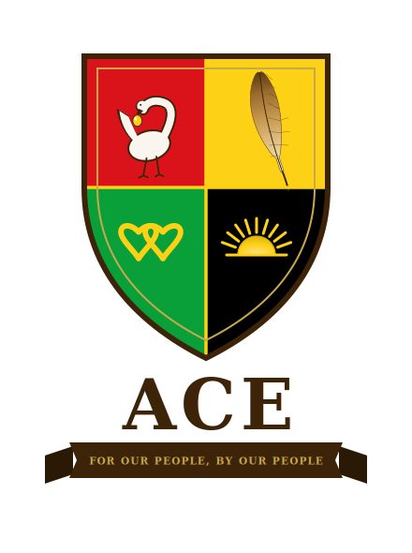

For the Builders of Black Independence
Minister Louis Farrakhan
Alliance for Collective Empowerment and Development
v2.1 - June 2026

Léandre Poplus, Founder
For Our People, By Our People.

ALLIANCE FOR COLLECTIVE EMPOWERMENT

ACE

WHY ACE EXISTS
For decades you have said that Black people in America cannot petition their way to freedom, cannot integrate their way to sovereignty, and cannot build lasting power inside institutions designed to contain them. The evidence has agreed with you every time.
What has been missing is not the vision. It is the blueprint. ACE is the blueprint. The legal architecture, the territorial foundation through tribal sovereignty, the governing constitution, the economic model. Everything you have been calling for, now architectured and ready to build. We are not asking you to become ACE. We are showing you that what you have preached is now buildable, and we believe you should be part of building it.

YOU HAVE BEEN RIGHT

As-Salamu Alaykum, Minister Farrakhan.

For generations you have taught that Black people in America must build their own economy, own their own land, govern their own communities, and stop begging a system built on our oppression to treat us fairly. You have been right. I share this vision, Minister Farrakhan, and I believe the time to build it has come. ACE introduces a legal and structural foundation, the architecture that turns decades of righteous teaching into a city our people can build, grow and live in.
The Alliance for Collective Empowerment (ACE) is that blueprint.
ACE is a 25-year initiative to establish a network of self-governing, self-sustaining cities for Black and Native American communities on tribal sovereign land; land that sits outside state jurisdiction, outside federal taxation of tribal enterprise, and outside many of the legal mechanisms that have historically been used to destroy Black economic and political institutions the moment they became powerful enough to threaten the status quo.
The tribal sovereignty partnership is not symbolic. It is a legal architecture that has survived 200 years of federal attempts to dismantle it. It is the most durable legal protection available to a Black community organization in the United States. And it is available to ACE because Black and Native Americans are natural allies; two peoples dispossessed by the same government with complementary assets: land and sovereignty on one side, capital, scholarship and population on the other.
What ACE aims to build: Cities with their own schools, their own hospitals, their own courts, their own police a peacekeeping corps accountable to the community, not to the state. Their own banks. Their own farms. Their own media. Their own constitution. Their own government. Everything your theology has called for. Architectured. Legal. Buildable.

THE ASK
We are not asking you to become ACE. We are showing you that what you have been calling for is now blueprinted and ready to build. We believe you should be part of it. THE ASK
- We are asking for your endorsement of this initiative to your community, the people who trust your voice and have been ready for this moment longer than anyone.
- We are asking for your organization’s participation as an ACE Community Ministry Partner connecting your network to ACE town halls, investment opportunities, and community development resources.
- We are asking for your introduction to others within your sphere of influence who share this vision and have the resources to invest in it.
The door is open. The proposal is enclosed. Let’s meet.

The vision you have preached for generations is now architectured.
We built it. Come see it.

The full ACE Act is enclosed. Thank you for your time.
SUPPORTING LEGAL DOCUMENTATION, AVAILABLE UPON REQUEST
The following documents have been prepared and are available to you upon request:
• ACE Sovereign Territory Act: Companion Legal Brief v1.0 - Pre-argument legal defense of ACE’s contingency land claim: ten million acres of existing federal public land across ten states, grounded in the 1865 promise of forty acres that was made and broken in the same year.
• ACE Submission to the United Nations CERD v1.0 - Formal submission to the UN Committee on the Elimination of Racial Discrimination’s active General Recommendation on reparations for chattel enslavement, filed June 2026. The international accountability track the NOI has called for.
DIRECT CONTACT
Léandre Poplus
Founder, Alliance for Collective Empowerment and Development
951-323-7942
founders@acecommunities.org

