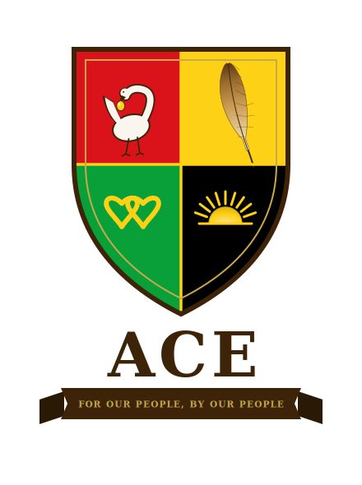

Personal & Confidential
President Barack Obama
Alliance for Collective Empowerment and Development
v2.1 - June 2026

Léandre Poplus, Founder
For Our People, By Our People.

ALLIANCE FOR COLLECTIVE EMPOWERMENT

ACE

A NOTE FROM THE FOUNDER
My name is Leandre Poplus. I built this because the conditions that produced it left me no honest alternative.
Black Americans have been in this country for over 400 years. We have fought in every war, built the economy that made this nation wealthy, and generated more than $1.6 trillion in annual spending power. We have marched, organized, litigated, legislated, and elected. And the gap between what this country owes us and what it has delivered has not closed. It has widened.
Native Americans have been on this land since before the concept of America existed. Their sovereignty was promised by treaty and dismantled by policy, repeatedly, at the moment it became most valuable. They hold millions of acres of land the federal government cannot take. They hold a legal architecture that has survived 200 years of federal attempts to dismantle it.
These two communities, dispossessed by the same government, with complementary assets, have never formally built together. ACE is what happens when they do.
This is not a protest. It is not a petition. It is a 25-year architectural plan: cities, schools, hospitals, courts, banks, farms, and a governing constitution, built on sovereign land, funded by our own people, governed by our own hands.
I built this because I believe we have been waiting for permission that was never coming. ACE is what we build when we stop waiting.

Leandre Poplus
Founder, Alliance for Collective Empowerment and Development
For Our People, By Our People.

WHY ACE EXISTS
You have seen what happens when Black institutions reach the height of their power. Greenwood. The Freedmen’s Bureau. COINTELPRO. You have also seen, from the highest office in this country, exactly how narrow the margin is between what the system permits and what it dismantles the moment it feels threatened.
ACE was built with that history specifically in mind. Every legal protection in the ACE Act exists because we studied what happened to what came before us and chose to build accordingly. The question we are bringing to you is not whether this vision is necessary. We believe you already know that it is. The question is whether the architecture is sound enough to survive what will come for it.
That is why we need your counsel, not your endorsement.

DEAR PRESIDENT OBAMA

You are the only person alive who has stood at the exact intersection where this initiative lives: the tension between operating inside American systems and carrying the full weight of what those systems have done and continue to do to Black and Native people in this country. You have navigated that tension at the highest level any person can. ACE needs that navigation now.
The Alliance for Collective Empowerment is a 25-year initiative to build a network of self-governing, self- sustaining cities for Black and Native American communities on tribal land protected by sovereign law, funded by community capital, governed by a constitutional framework we wrote ourselves.
This is not a movement without a map. The enclosed ACE Act is 22 Titles, a founding constitution, a phased 25-year development plan, a tribal engagement strategy, a healthcare system, an education system from kindergarten through medical school, a community finance model, and a formal tax equity initiative that demands Congress apply to Black Americans the same remedial principle it has already extended to tribal nations.
We are not asking for your public endorsement. We understand the complexity of your position. We are asking for something more valuable: your private assessment of whether this framework is sound, and if you believe it is your willingness to say so to the people whose support will determine whether it is built.

THE ASK
Will you help us navigate this correctly?
If you review the enclosed proposal and believe it is serious, legally grounded, and worthy of the attention of the people who have the resources and the influence to make it real a private word from you to any of them changes everything.
If you have concerns about the framework, we want to hear them before we move further. Your knowledge of what can be legally and politically defended, and what cannot, is irreplaceable.
We will follow up through the Obama Foundation within 90 days of this delivery. If you choose not to respond, we will proceed and we will not make your silence public. ACE builds what ACE builds. But we believe you should see this first.

We are not asking you to carry this. We are asking you to tell us if we are carrying it correctly.

We also recognize that decisions of this weight are rarely made alone. If Michelle reads this with you, we hope she reads it closely. She has spent her career thinking about what institutions owe the communities they were built to serve, and her perspective on what ACE is building is one we would not take lightly.
The full ACE Act is enclosed. We would welcome your time.
SUPPORTING LEGAL DOCUMENTATION, AVAILABLE UPON REQUEST
The following documents have been prepared and are available to you upon request:
• ACE Sovereign Territory Act: Companion Legal Brief v1.0 - Pre-argument legal defense of ACE’s contingency land claim across ten states of existing federal public land, grounded in the Continuity Doctrine and the Federally Recognized Indian Tribe List Act of 1994.
• ACE Submission to the United Nations CERD v1.0 - Formal civil society submission to the Committee on the Elimination of Racial Discrimination’s active General Recommendation on reparations for chattel enslavement, filed June 2026.
DIRECT CONTACT
Léandre Poplus
Founder, Alliance for Collective Empowerment and Development
951-323-7942
founders@acecommunities.org

