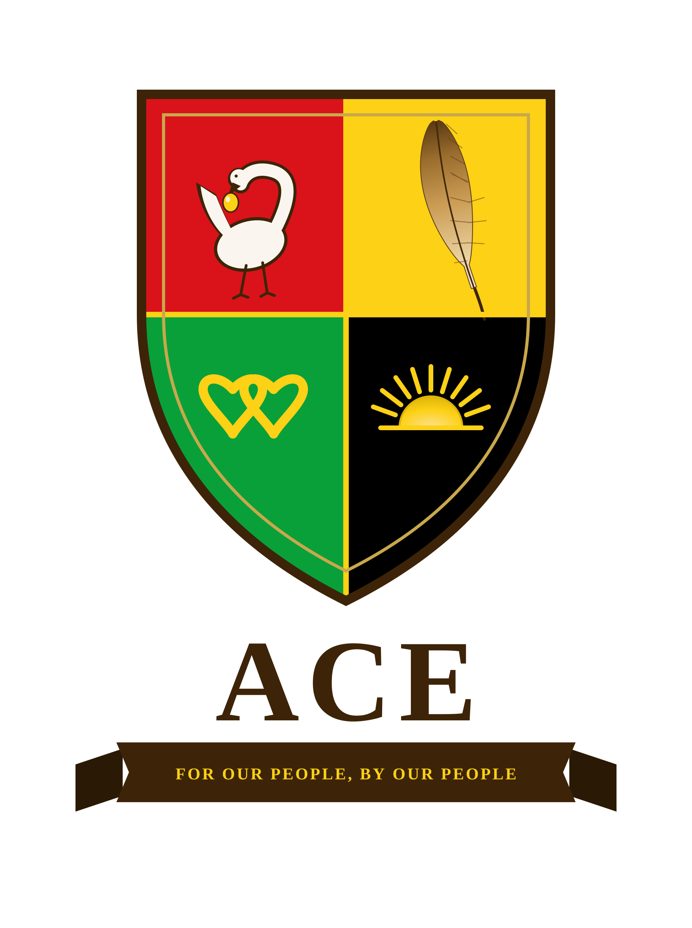
ALLIANCE FOR COLLECTIVE EMPOWERMENT AND DEVELOPMENT
A CONVERSATION WORTH STARTING
An invitation to the people who move the culture
For Our People, By Our People

A QUESTION FOR THE ROOM
Every generation of Black America has been told the same thing: keep pushing, keep marching, keep working the system, and one day it will finally work for you. Generations have given their lives to that promise. Spoiler alert, the American dream and its promises were never written to include people of color.
So here is the question almost no one asks out loud: what if the system was never broken? What if it has been working exactly as designed all along?
You cannot reform a system built to exclude you. You have to build your own.
That is the idea at the center of a growing movement called ACE, the Alliance for Collective Empowerment and Development. It is not a protest. It is not another petition. It is a serious, structured plan to build self-governing, self-sustaining communities for Black and Native American people, on sovereign land, funded by our own capital, and governed by our own hands.

WHY WE ARE COMING TO YOU
Ideas do not move because they are true. They move because the right people put them in front of the right audiences at the right moment. You have built something rare: a platform where real conversations happen, where your audience actually listens, and where a bold idea can catch fire before the gatekeepers even notice.
We are not asking you to endorse anything. We are not asking for money. We are asking for something simpler and, honestly, more powerful: a conversation. A chance to bring this idea to your audience and let them wrestle with it the way you do best.

WHAT MAKES THIS WORTH A CONVERSATION
- It reframes the entire debate. Not "how do we fix America for Black people," but "why are we still asking a system built to exclude us to include us?"
- It is not theory. There is a full framework behind it, a twenty-five-year plan, a legal architecture, a funding model, already written and ready.
- It unites two peoples with a shared history of dispossession: the land sovereignty of Native nations and the population, capital, and talent of Black America.
- It is the kind of idea your audience has never quite heard framed this way, and will not stop thinking about after they do.

THE ONLY ASK
Have a conversation with the founder. On your show, on the phone, however you prefer. Hear the full thesis directly from the source, then decide for yourself whether it is worth putting in front of your audience.
That is the entire request. No commitment beyond a conversation. The idea will do the rest.

Reform was the trap. Building is the answer.
Let's start the conversation.
Léandre Poplus, Founder
Alliance for Collective Empowerment and Development
founders@acecommunities.org · acecommunities.org
Direct line: 951-323-7942
To read the short public case, ask for The Founding Position and Reform Was the Trap.

