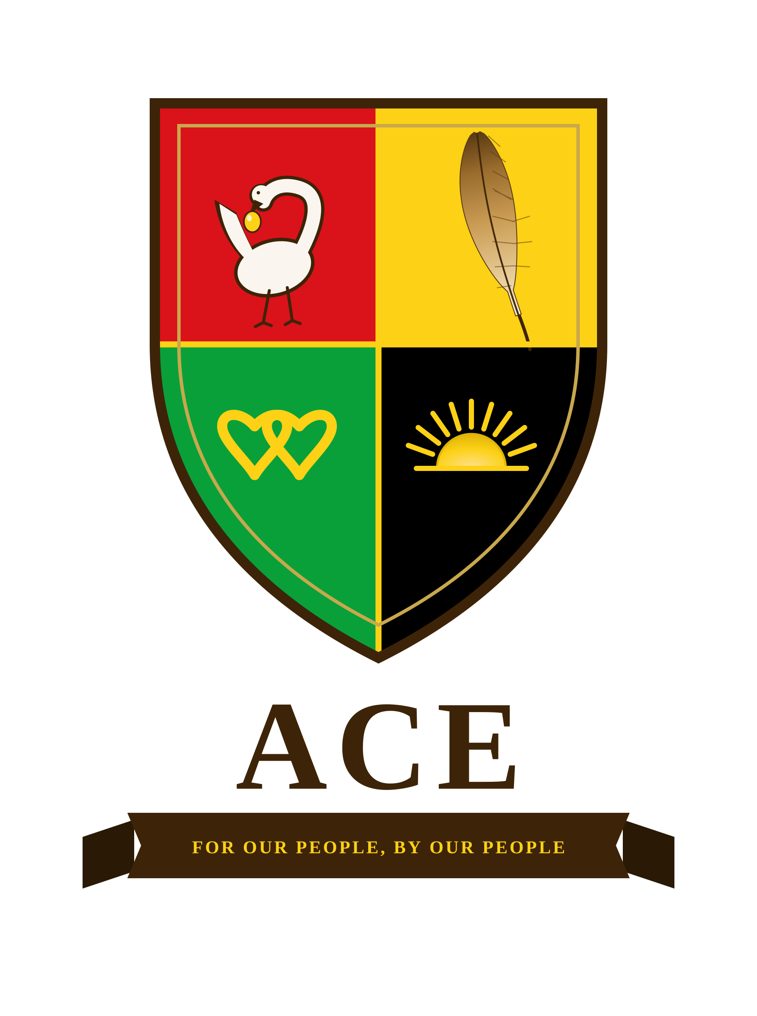
ALLIANCE FOR COLLECTIVE EMPOWERMENT AND DEVELOPMENT
AN INVITATION TO BUILD
A briefing for those with the means to build what has never been built
For Our People, By Our People

THE PREMISE
For four centuries, the wealth, labor, and talent of Black America have built institutions that were never designed to serve the people who built them. Every remedy since has asked the same system to correct itself: to legislate inclusion, to reform from within, to open a door that was engineered to stay closed. The results speak for themselves.
The Alliance for Collective Empowerment and Development begins from a different premise. If a structure was built to exclude, the answer is not to petition it. The answer is to build a new one, owned and governed by the people it serves, on ground that the old structure does not control.
This is not a request for charity. It is an invitation to build.

WHAT ACE IS
ACE is a twenty-five-year framework to establish a network of self-governing, self-sustaining communities for Black and Native American people. It unites two peoples with a shared history of dispossession and a shared claim to self-determination: the land sovereignty of Native nations, and the population, capital, and human capital of Black America.
On that foundation, ACE builds permanent institutions that answer to no one else, in housing, education, healthcare, finance, and governance, under a constitution written by the people they serve. The complete architecture already exists in detail: the legal framework, the phased plan, the governing structure, and the economic model.

WHY THIS IS DIFFERENT FROM WHAT YOU HAVE BEEN SHOWN
- It is structural, not symbolic. ACE does not seek representation inside existing institutions. It builds new ones, with real ownership and real sovereignty.
- It is capital-led, not grant-dependent. ACE is designed to be funded first by the community's own wealth and cooperative ownership. Outside capital enters as founding partnership in something historic, not as a donation to a cause.
- It is already built on paper. This is not a concept seeking a plan. The plan is written, the legal architecture is drafted, and the framework is ready for the people prepared to move first.
- It is generational. What is built here is meant to outlast everyone who builds it, the way a founding document is meant to outlast its authors.

WHY WE ARE BRINGING THIS TO YOU
The people receiving this briefing have already done what most are told is impossible: they have built enterprises, institutions, and fortunes on their own terms, often against a system designed to make that harder for them than for anyone else. You understand, better than most, what it takes to build something real from the ground up, and what it means to own it outright.
ACE is that same act of building, at the scale of a civilization. We are not asking you to fund it today. We are asking you to hear it, fully, directly, and early, before it becomes the thing everyone wishes they had been part of at the beginning.

THE ONLY ASK
A conversation with the founder. Hear the complete thesis, the full framework, and the plan, directly from the source. What follows from there is your decision to make, with the full picture in front of you.
The complete framework, including the founding Act itself, is available to those who ask. It is a substantial document, and deliberately so. This briefing exists to earn the conversation in which it is best understood.

Reform was the trap. Building is the answer.
The invitation is open.
Léandre Poplus, Founder
Alliance for Collective Empowerment and Development
founders@acecommunities.org · acecommunities.org
Direct line: 951-323-7942

