| **National University of Computer and Emerging Sciences, Lahore Campus** | | | | |
| --- | --- | --- | --- | --- |
| C:\Users\saif\AppData\Local\Microsoft\Windows\Temporary Internet Files\Content.Word\final design.jpg | **Course Name:** | **Digital Logic Design** | **Course Code:** | **EE1005** |
| **Degree Program:** | **BS-CS** | **Semester:** | **Spring 2024** |
| **Due Date:** | **26th February, 2024** | **Weight** |  |
| **Section:** | **A & B** | **Page(s):** |  |
| **Exam Type:** | **Assignment # 1** | **Total Marks:** |  |
| **Student : Name:_____________________________ Roll No.________________ Section:_______** | | | | |
| **Instruction/Notes:** | Attempt all questions. Programmable calculators are not allowed. | | | |

**Question 1:**

1. Write the equation of F
2. Implement the circuit using
   1. OR, not gates only
3. Implement the circuit using NAND gate only.
4. complete the timing diagram

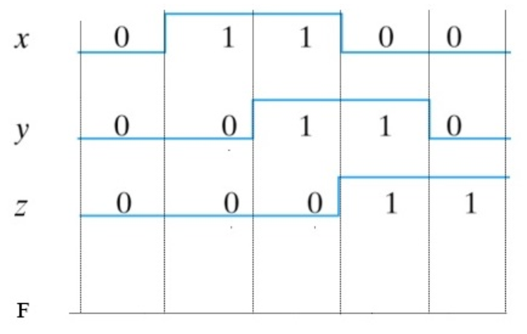

**Question 2:**

**Design a combinational circuit that performs the addition of 2 binary numbers (3 bit each).**

**Question 3:**

You are tasked with designing a combination circuit for an election with a total of 300 seats. To win the election, a two-thirds majority is required. Parties can form alliances to win the election.

There are four parties participating: A, B, C, and D. Party A holds 100 seats, Party B has 40 seats, Party C holds 135 seats, and Party D has 25 seats.

Each party possesses a switch that, when closed, indicates a 'yes' vote for all of their seats, and when opened, indicates a 'no' vote.

Your goal is to design a combinational circuit that will activate a light if the parties, either individually or in alliance, have the potential to secure the two-thirds majority required to win the election.

**Question 4:**

**Solve the following questions from the exercise of Book Morris Mano 5th edition:**

**2.14 (c)**

**2.15 (b)**

**2.17 (b)**

**2.20(c)**

**2.23 (b) (write the answer in POS and SOP forms)**

**2.26**