Image Page
A document with an embedded picture, to widen the visual gate beyond text-and-table pages: the image must render at the same size and position in both engines.
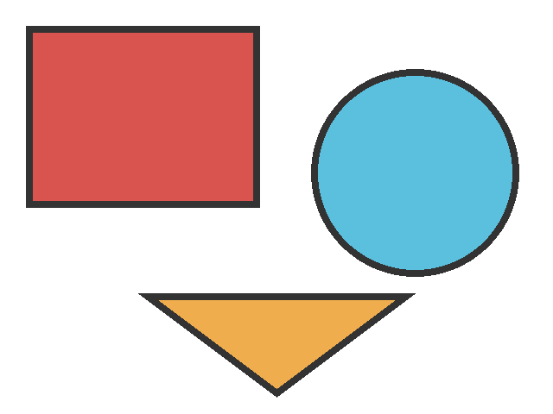
Caption: WO Image Gate — geometric test image.
A trailing paragraph after the image.

