# About World of Workflows

Welcome to World of Workflows! World of Workflows is a software solution that allows anyone to automate business processes, be those simple processes for yourself or processes that encompass your entire business.

## Overview of World of Workflows

World of Workflows is a powerful software solution designed to streamline and optimize your business processes by providing an intuitive platform for creating, managing, and automating both simple and complex workflows. We consider any process you perform with more than one step to be considered a workflow. With over 100 activities to choose from and plugins that extend this functionality, you can easily tailor workflows to suit your organization’s specific needs. By integrating a rich, dynamic, user-configurable database and an advanced task management system, World of Workflows enables you to efficiently manage your projects and tasks, collaborate with your team, and track progress in real-time.

World of Workflows comes in two key editions:

* **Personal Edition** or PE runs on your local PC and is for personal use or workflow development.
* **Business Edition** or BE runs on any of the major cloud providers or your servers and offers enhanced features such as single sign-on and rich permissions and access control.

## Key features and components of World of Workflows

* Workflow Editor, a core component of World of Workflows, offers a flexible and user-friendly interface for building and customizing workflows. Some of the key features and components include:
  + A wide range of pre-built activities that can be easily added, edited, and connected within your workflows. These activities can be extended using Plugins.
* A user-configurable database for managing data and integrating with external databases or APIs.
* A robust task management system that enables you to create, assign, and track tasks, as well as collaborate with your team members.
* Workflow templates called Solutions for quickly implementing common processes and best practices.
* Advanced features such as workflow automation with triggers, third-party application integration, and the ability to create custom activities.
* Comprehensive security and permissions settings to ensure data protection and controlled access *with Business Edition*.
* Plugins, which extend the capability of the system.
* OData access which simplifies the process of reporting and dashboarding of your data.
* Credential manager which allows you to securely connect to 3rd party APIs and systems, such as ChatGPT, Xero, Office 365 and many, many more.

Our extensible database which can be accessed from the User Interface or within workflows provides the following features:

* Extremely high performance
* Customizable tables (Types), Columns and Relationships
* Custom views to see filtered and sorted database entries.
* Flexible import
* Full Export
* Inline editing
* Sort, Filter and paging

Our detailed task system allows for the system to reach out to users and instruct them where manual tasks are required and includes the following features:

* Task Queues
* Task Details formatted with Markdown
* Update data in the database directly from a task
* Custom outcomes that branch the workflow.

## Examples of process automation with World of Workflows.

Our customers have used World of Workflows to automate several business processes. Here are some examples:

1. A media company uses World of Workflows integrated with ChatGPT to write draft articles on incoming press releases automatically.
2. A soccer club uses World of Workflows to notify coaches and managers when it is their turn to put up or take down nets on a soccer field based on the draw in an external system.
3. An independent school uses World of Workflows to manage its enrolment process.
4. A managed service provider uses World of Workflows to correctly bill customers for their telephone voice usage.
5. A sporting club uses World of Workflows to automatically generate a weekly newsletter.
6. A not-for-profit uses World of Workflows to manage its grant application process.

# Versions

This section describes the differences between the Personal Edition and the Business Edition.

## Comparison Table

**Core Features**

| Feature | Personal Edition | Business Edition |  |
| --- | --- | --- | --- |
| SQLLite Support | Yes | Yes |  |
| SQL Server Support | - | - |  |
| Azure SQL Server Support | - | - |  |
| Local Installation | Yes | Yes |  |
| Users | - | Yes |  |
| Groups | - | Yes |  |
| Single Sign On | - | Yes |  |
| Azure Active Directory | - | Yes |  |
| Tasks | Yes | Yes |  |
| Views | Yes | Yes |  |
| Data | Yes | Yes |  |
| Workflows | Yes | Yes |  |
| Workflows Testing | - | Yes |  |
| Plugins | Yes | Yes |  |
| Data Backups | Yes | Yes |  |
| Data Restore | Yes | Yes |  |
| Data Export | Yes | Yes |  |
| Data Import | Yes | Yes |  |
| Workflows Univeristy | Yes | Yes |  |
| Self Documentation | Yes | Yes |  |

**Workflow Features**

| Feature | Personal Edition | Business Edition |  |
| --- | --- | --- | --- |
| Compensation | Yes | Yes |  |
| Console | Yes | Yes |  |
| Flow Control | Yes | Yes |  |
| Data | Yes | Yes |  |
| Users | - | Yes |  |
| Email | Yes | Yes |  |
| File | Yes | Yes |  |
| HTTP | Yes | Yes |  |
| Jotform | Yes | Yes |  |
| Random Numbers | Yes | Yes |  |
| Robotic Process Automation | Yes | Yes |  |
| JavaScript Support | Yes | Yes |  |
| Liquid Support | Yes | Yes |  |
| State Machine | Yes | Yes |  |
| Tasks | Yes | Yes |  |
| Timers | Yes | Yes |  |
| Views | Yes | Yes |  |

Note in Personal Edition, the database is stored in C:\ProgramData\WorldOfWorkflows and backups are stored in C:\ProgramData\WorldOfWorkflows\Backup.

# Installation/Setup

This section contains instructions on how to install and configure World of Workflows on your machine.

## Windows Installation

1. Navigate to the [latest release](https://github.com/World-of-Workflows/WorkflowsUniversity/releases)
2. Download the Windows Version of PE for either ARM or X64 >There is an ARM version to run on ARM processors, and x64 version to run on Intel processors. The ARM versin will also run well in a VM on MacOS on an M1 or later porocessor.
3. Run the downloaded application 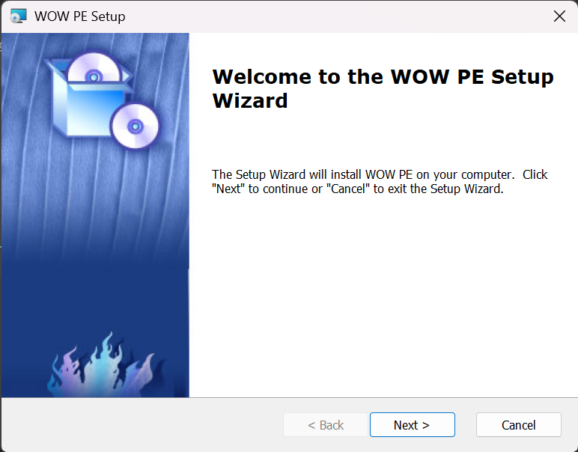
4. Click **Next >** 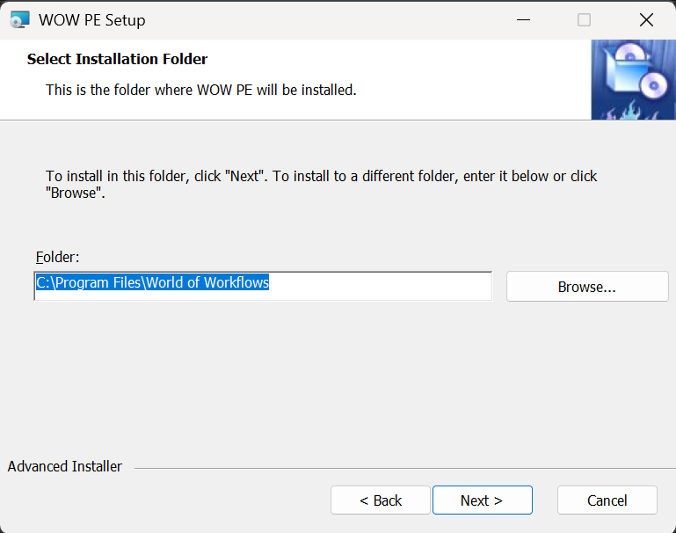
5. Accept or change the folder and click **Next >** 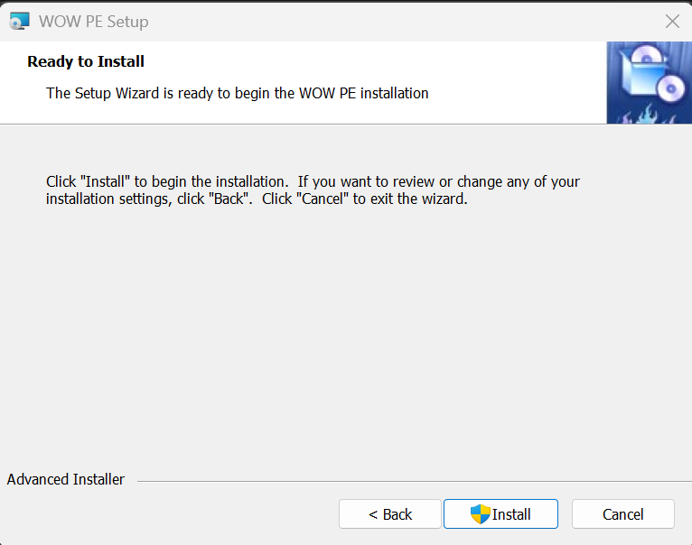
6. Click **Install** 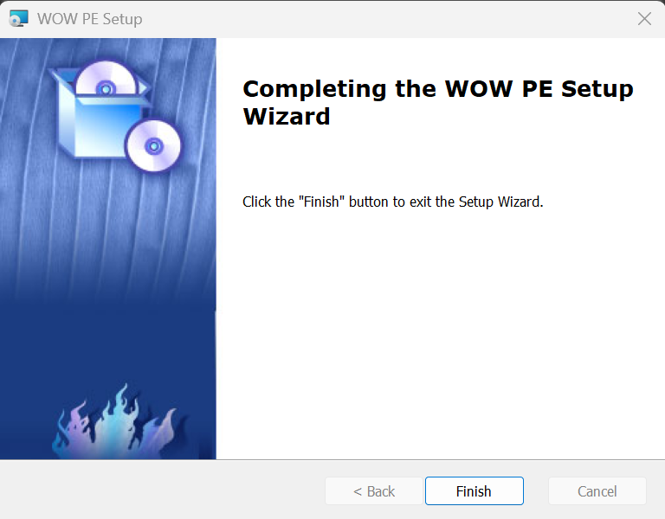
7. Click **Finish**

**World of Workflows PE (Windows Installation)** is complete

To run World of Workflows, go to <https://localhost:7063/admin>{:target=“_blank”}

## Linux Installation

1. Install dotnet 8 on your version of linux using the link [here](https://dotnet.microsoft.com/en-us/download)
2. Open a terminal window on your linux device
3. navigate to ~ bash cd ~
4. Create a new folder for World of Workflows

* mkdir WoW  
  cd WoW

1. In your browser, navigate to the [latest release folder](https://github.com/World-of-Workflows/WorkflowsUniversity/releases)
2. Right Click **WorldOfWorkflowsxPE_xxx_linux_x64.zip**
3. Download to your linux pc using a command like the one below:

* wget https://github.com/World-of-Workflows/WorkflowsUniversity/releases/download/1.7.539/WorldOfWorkflowsPE_1.7.539_linux-x64.zip

1. Extract World of Workflows using the following command

* unzip WorldOfWorkflowsPE_1.7.539_linux-x64.zip  
  rm WorldOfWorkflowsPE_1.7.539_linux-x64.zip

1. copy the files to their production location

sudo cp -r . /var/www/WorldOfWorkflows

1. Create a new Service file sudo nano /etc/systemd/system/kestrel-wow.service
2. Enter the following information

* [Unit]  
  Description=World of Workflows 1.7  
    
  [Service]  
  WorkingDirectory=/var/www/WorldofWorkflows  
  ExecStart=/var/www/WorldofWorkflows/HubOneWorkflowsApp.Server  
  Restart=always  
  # Restart service after 10 seconds if the dotnet service crashes:  
  RestartSec=10  
  KillSignal=SIGINT  
  SyslogIdentifier=world-of-workflows  
  User=root  
  Environment=ASPNETCORE_ENVIRONMENT=Production  
  Environment=DOTNET_NOLOGO=true  
    
  [Install]  
  WantedBy=multi-user.target

1. Start the service with the following command bash sudo systemctl start kestrel-wow
2. Check the service is running with bash sudo systemctl status kestrel-wow
3. You should see the following ● kestrel-wow.service - World of Workflows 1.7 Loaded: loaded (/etc/systemd/system/kestrel-wow.service; enabled; preset: disabled) Active: active (running) since Thu 2024-02-29 12:44:42 AEDT; 26min ago Main PID: 177798 (HubOneWorkflows) Tasks: 24 (limit: 48864) Memory: 342.5M CPU: 10.471s CGroup: /system.slice/kestrel-wow.service └─177798 /var/www/WorldofWorkflows/HubOneWorkflowsApp.Server
4. If the service is not running, try the following steps:
   1. Change the permissions on the executable bash sudo chmod 777 /var/www/WorldofWorkflows/HubOneWorkflowsApp.Server sudo systemctl start kestrel-wow
   2. Change the SELinux policy. *Note, Changing SEinux policies can be complex and depends on your specific setup. The step belwo sets the file to a permissive tyope to test if SELinux is the issue*
   * sudo chcon -t bin_t /var/www/WorldofWorkflows/HubOneWorkflowsApp.Server
5. Finally, to connect to World of Workflows using https, you need to trust the dotnet certificate. You do this using the following command: bash dotnet dev-certs https --trust
6. You may need to trust the certificate. To do this, follow the instructions below:
   1. Export the certificate to a file bash dotnet dev-certs https -ep ${HOME}/.aspnet/https/aspnetapp.pfx -p <password>
   2. Convert to PEM Format
   * openssl pkcs12 -in ${HOME}/.aspnet/https/aspnetapp.pfx -out ${HOME}/.aspnet/https/aspnetapp.pem -nodes -password pass:<password>
   1. Add to trusted stores
      1. Ubuntu/Debian
      * sudo cp ${HOME}/.aspnet/https/aspnetapp.pem /usr/local/share/ca-certificates/aspnetapp.crt  
        sudo update-ca-certificates
      1. Fedora/RedHat
      * sudo cp ${HOME}/.aspnet/https/aspnetapp.pem /etc/pki/ca-trust/source/anchors/  
        sudo update-ca-trust

To run World of Workflows, go to <https://localhost:7063/admin>{:target=“_blank”}

# World of Workflows Business Edition

World of Workflows Business Edition is available on the Azure Marketplace here:

[Azure Marketplace](https://azuremarketplace.microsoft.com/en-us/marketplace/apps/worldofworkflows.wowbe?tab=Overview)

## Installation Instructions

### Installing Pre-requisites

1. Navigate to the [Azure Portal](https://portal.azure.com/#home) 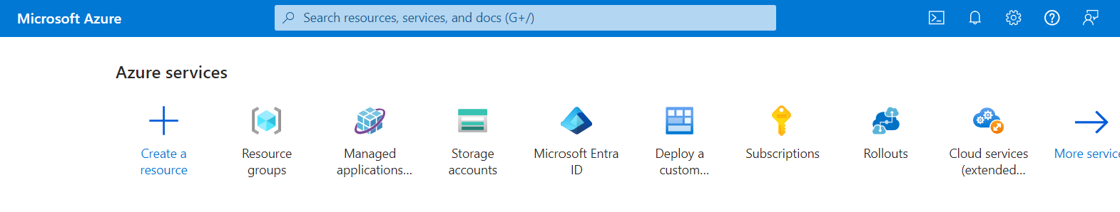
2. Click [**+ Create a resource**](https://portal.azure.com/#create/hub) 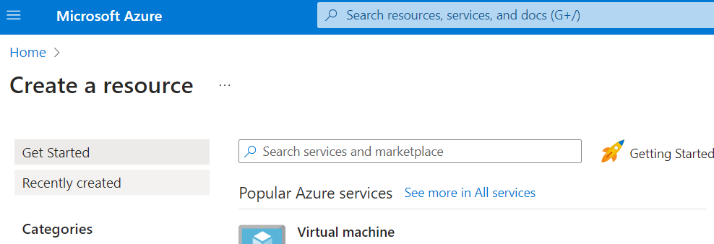
3. Search for **User Managed Identity**. 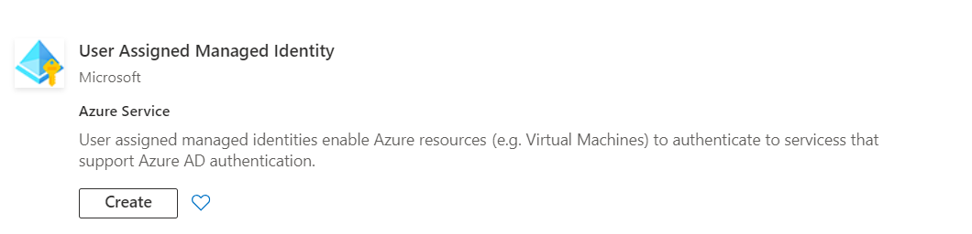
4. Under User Managed Identity, click **Create**
5. Create or choose a **Resource Group**, Set the Region to be your local region and give the Identity a name. We commonly use **WOWBEInstaller**. 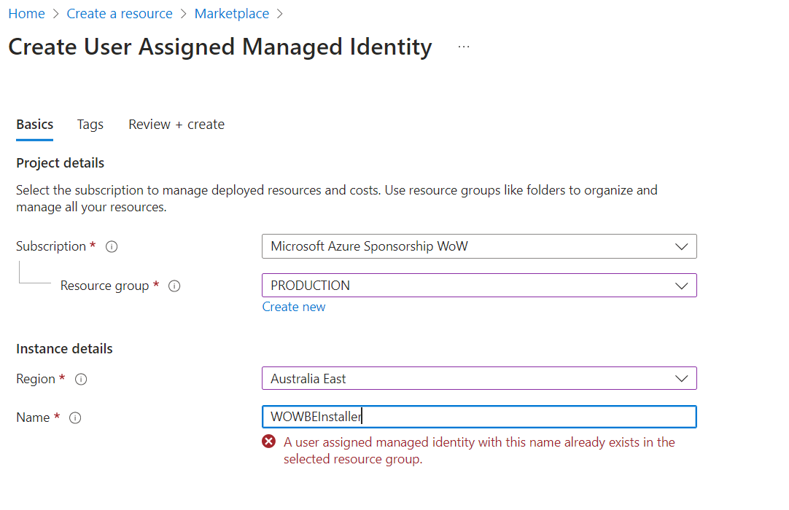
6. Click **Review + Create**
7. Give your managed Identity Permissions as follows:
   * for the subscription where you will install World of Workflows, make the managed Identity an **Owner**.
   * In Entra Id, in the directory you will install World of Workflows, make the managed Identity an **Application Administrator**

**Note:**  *The managed identity can be deleted after deployment is complete.*

### Installing World of Workflows

1. Navigate to the [Azure Portal](https://portal.azure.com/#home) 
2. Click [**+ Create a resource**](https://portal.azure.com/#create/hub) 
3. Search for **User World of Workflows** or click the link to the [Azure Marketplace](https://azuremarketplace.microsoft.com/en-us/marketplace/apps/worldofworkflows.wowbe?tab=Overview).
4. Choose your plan and click **Create**
5. Complete the form as follows:
   1. **Project Details** 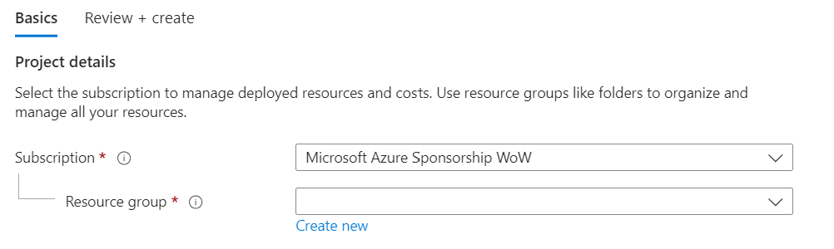
      * Enter the subscription where you would like to install world of Workflows and create a new **Resource Group** by clicking **Create new**
   2. **Instance Details** 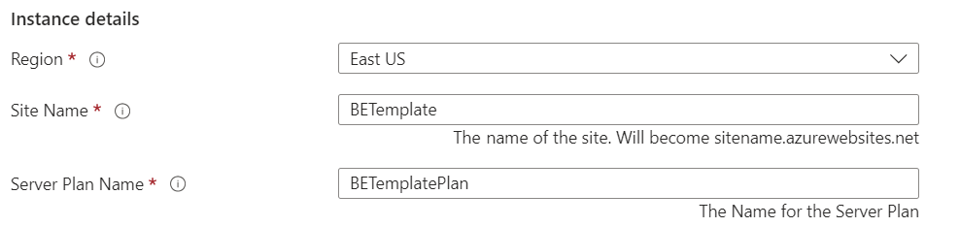
      * Choose the region where you want to install Wold of Workflows and choose a **Site Name** and **Server Plan Name**.
      * **Site Name**: This is the name of the application. It can be anything you want, must be unique and will become https://<sitename>.azurewebsites.net when deployment is complete.
      * **Server Plan Name**: This can be anything you want and is the plan the server sits under. You use this for scaling your instance up and down.
   3. **User assigned managed identity** 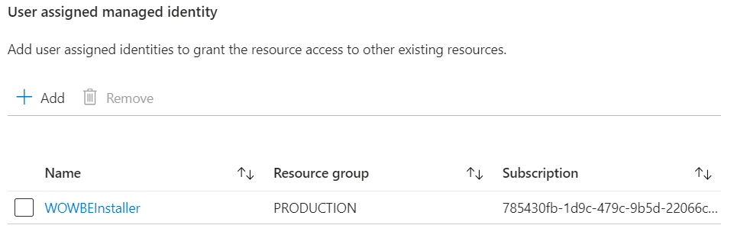
      * Choose the user assigned managed identity created in pre-requisites above. Identities need Owner Access to the subscription and Application Administrator access to Entra Id. This identity can be deleted after deployment is complete.
   4. **Single Selector** 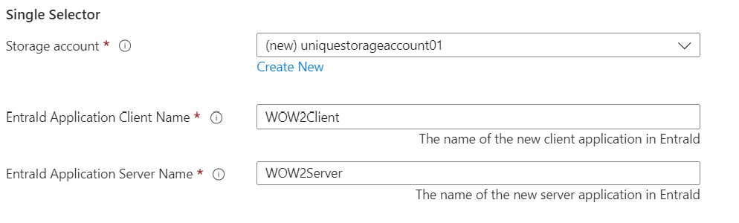
      * Create a new **storage account** for World of Workflows by clicking **Create New**. 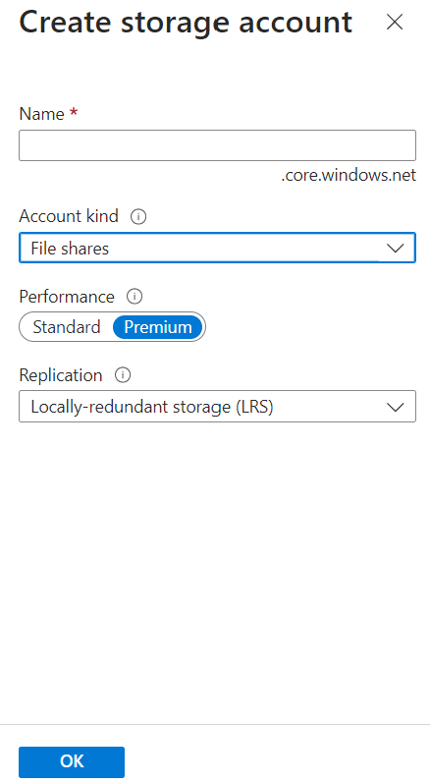
      * Ensure the storage account has a unique name and is configured for **File Shares** as the account kind. When done click **Ok**
      * Enter the name for the Client Application and Server Application in Entra Id. This will create the applications we will use to assign permissions and access the World of Workflows API from other applications.
   5. **Managed Application Details** 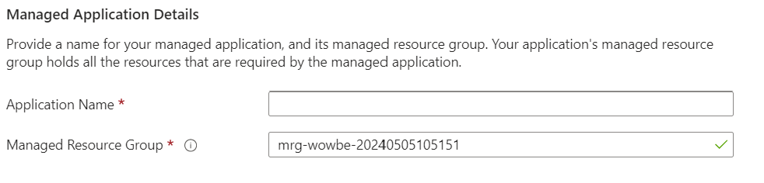
      * Enter the Application Name (for example **World of Workflows**)
      * Edit the Managed Resource Group if required .
6. Click **Review and Create**
7. Accept the Terms and Conditions and click **Create**

After about 15 minutes, navigate to https://<sitename>.azurewebsites.net

### Granting Permissions

Granting permissions in World of Workflows requires you first to configure the Server Entra Id Application and then assign permissions.

**Important:** Wait until deployment is complete before performing the tasks below.

1. **Setting up Server Application**
   1. You only need perform this once
   2. Navigate to [Azure Portal –> Entra Id –> App Registrations](https://portal.azure.com/#view/Microsoft_AAD_IAM/ActiveDirectoryMenuBlade/~/RegisteredApps)
   3. Click **All Applications**
   4. Search for the Server application configured in step iv. above.
   5. Click **API Permissions** 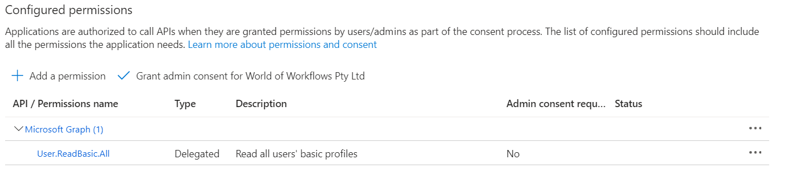
   6. Click **Add a permission**
   7. Click **Microsoft Graph**
   8. Click **Delegated Permissions**
   9. Select **email, offline_access, openid and profile**
   10. Click **Add Permissions**
   11. Click **Grant Admin Consent**
   12. Click **Yes**
2. **Granting Permissions**
   1. Navigate to [Azure Portal –> Entra Id –> Enteprrise Applications](https://portal.azure.com/#view/Microsoft_AAD_IAM/StartboardApplicationsMenuBlade/~/AppAppsPreview/menuId~/null)
   2. Click **X** next to Application type == Enteprrise Applications. 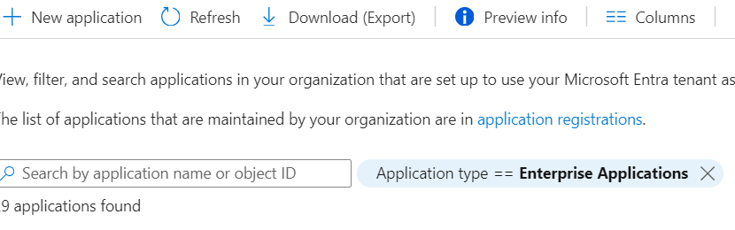
   3. Search for and select the server applcation congfigured in step iv above.
   4. Under **Manage**, choose **Users and Groups** 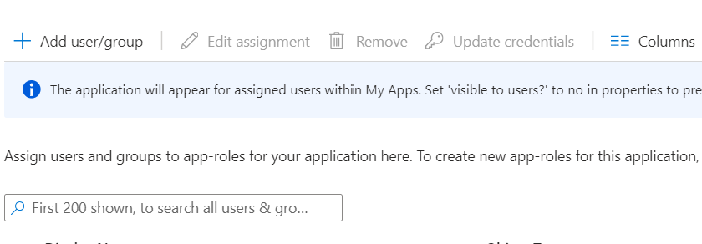
   5. Click **Add user/group** 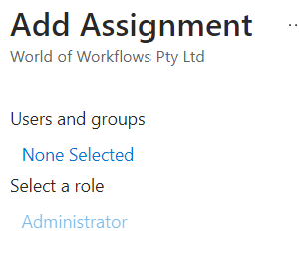
   6. Click **None Selected**
   7. Search for and select the User you want to grant permissions to 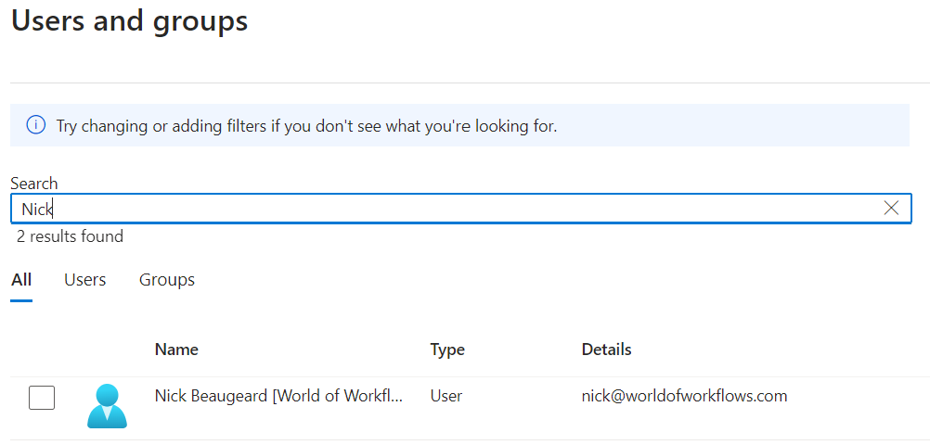
   8. Click **Select**
   9. Click **Assign**. *Administrator is the only role available in this version*

Now you can navigate to your new server and login.

# Setting up High Availability Clusters

In order to support high performance and high avaiability scenarios, World of Workflows can operate in a cluster, with multiple servers providing the interface for the customer.

Configuration is performed by installing and configuring four additional components and altering the world of workflows configuration file.

Contact your account manager or support@worldofworkflows.com for assistance setting up clusters.

# Changing Azure Directory

Authentication in World of Workflows is performed using Azure Active Directory and this ensures security both through the client application and at the server side. To Change the directory for the application is simple yet slightly involved.

In Order to change the Directory you will follow three steps:

1. Register the application in Azure AD
2. Change the configuration for the Server
3. Change the configuration for the client.

When you have registered the application in Azure AD, you should be able to complete the table below:

| Item | Variable | Value |
| --- | --- | --- |
| Client Id | {CLIENT_ID} | The Client Id of the application |
| Tenant Id | {TENANT_ID} | The Tenant Id of the application |
| Scope | {SCOPE} | The Scope of the application |
| Scope URL | {SCOPE_URL} | The Full Url of the Scope |
| Domain Name | {DOMAIN_NAME} | The Domain Name of the Tenant Directory |

## Register the application in Azure Ad

### Create a tenant

Follow the guidance in Quickstart: [Set up a tenant to create a tenant in AAD](https://learn.microsoft.com/en-us/azure/active-directory/develop/quickstart-create-new-tenant).

### Register a server API app

#### Register an AAD app for the Server API app:

1. Navigate to Azure Active Directory in the Azure portal. Select **App registrations** in the sidebar. Select the **New registration** button.
2. Provide a Name for the app (for example, World of Workflows).
3. Choose a Supported account type. You may select **Accounts in this organizational directory only (single tenant)** for this experience.
4. The app does require a Redirect URI, make this the URI of your application when running locally, e.g. https://localhost:7063. It may ask what type of application. In this case, use SPA.
5. If you’re using an unverified publisher domain, clear the Permissions > Grant admin consent to openid and offline_access permissions checkbox. If the publisher domain is verified, this checkbox isn’t present. > **Note: If the application doesn’t have a scope, azure will prompt you to create an application ID URI**
6. Select Register. Record the following information:

* Client ID (for example, 41451fa7-82d9-4673-8fa5-69eff5a761fd)
* Tenant Id (for example, e86c78e2-8bb4-4c41-aefd-918e0565a45e)
* Domain Name (for example, contoso.onmicrosoft.com): The domain is available as the Publisher domain in the Branding blade of the Azure portal for the registered app.

In Expose an API:

1. Select Add a scope.
2. Select Save and continue.
3. Provide a Scope name (for example, API.Access).
4. Provide an Admin consent display name (for example, Access API).
5. Provide an Admin consent description (for example, Allows the app to access server app API endpoints).
6. Confirm that the State is set to Enabled.
7. Select Add scope.

Record the following information:

1. Scope Url (for example, api://41451fa7-82d9-4673-8fa5-69eff5a761fd/API.Access)
2. Scope (for example, API.Access)

In Authentication > Platform configurations > Single-page application (SPA):

1. Confirm the Redirect URI of https://localhost:7063/authentication/login-callback is present. ( or the URL your application uses)
2. In the Implicit grant section, ensure that the checkboxes for Access tokens and ID tokens are not selected.
3. The remaining defaults for the app are acceptable for this experience.
4. Select the Save button.

## Change the configuration for the Server

This file, appsettings.json resides in the root folder of the application.

"AzureAd": {  
 "Instance": "https://login.microsoftonline.com/",  
 "Domain": "{DOMAIN_NAME}",  
 "TenantId": "{TENANT_ID}",  
 "ClientId": "{CLIENT_ID}",  
 "Scopes": "{SCOPE}",  
 "CallbackPath": "/signin-oidc"  
 },  
 "AuthorizationUrl": "https://login.microsoftonline.com/{TENANT_ID}}/oauth2/v2.0/authorize",  
 "TokenUrl": "https://login.microsoftonline.com/{TENANT_ID}/oauth2/v2.0/token",  
 "ApiScope": "{SCOPE_URL}",  
 "OpenIdClientId": "{CLIENT_ID}"

## Change the configuration for the client

This file, appsettings.json resides in the wwwroot folder of the published application. Make sure you also remove appsettings.json.br and appsettings.json.gz.

"AzureAdCli": {  
 "Authority": "https://login.microsoftonline.com/{TENANT_ID}}",  
 "ClientId": "{CLIENT_ID}",  
 "ValidateAuthority": true  
 }

# Authentication with Microsoft Entra ID for External users

Each person who accesses your application needs permission. 1. You can invite an **external user** in Micorosft Entra ID:

https://portal.azure.com/#view/Microsoft_AAD_UsersAndTenants/UserManagementMenuBlade/~/AllUsers

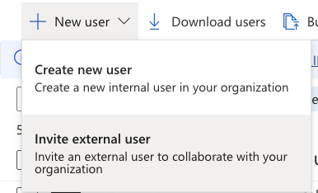

image

1. You can set up a Dynamic Group in MS Entra ID to provide access to these users:

https://portal.azure.com/#view/Microsoft_AAD_IAM/GroupsManagementMenuBlade/~/AllGroups

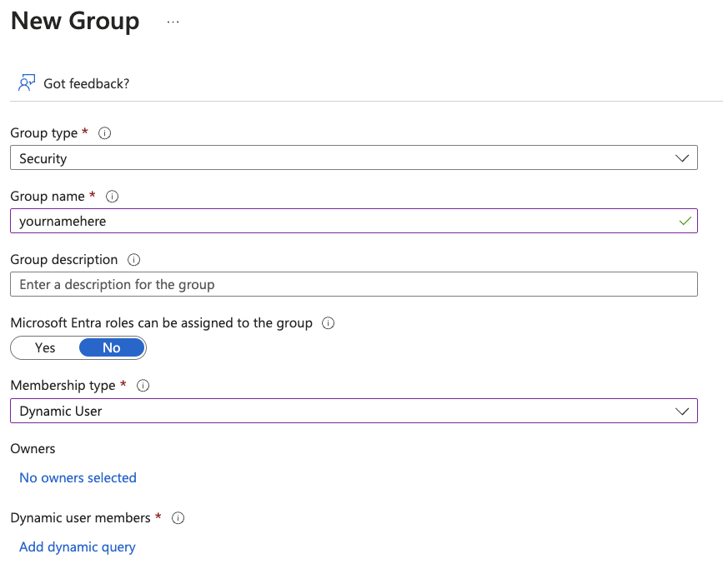

image

One way to dynamically add external users to the group is using a dynamic rule, such as this:

(user.userPrincipalName -contains "#EXT#")

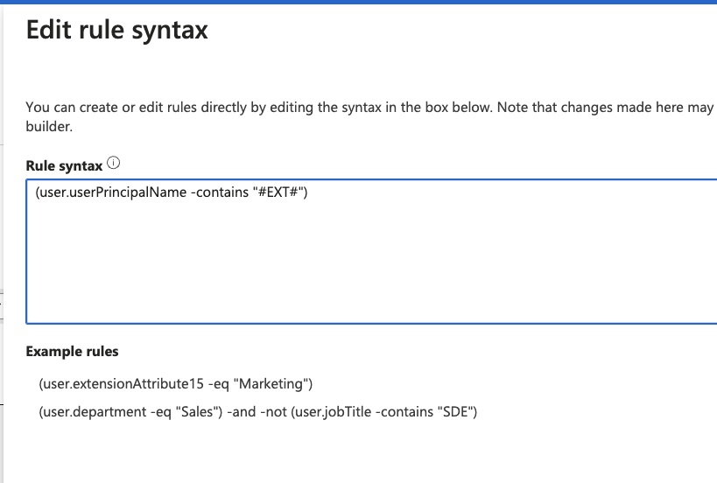

image

1. Give the group access to your application
2. Find your application name in the App registrations page

https://portal.azure.com/#view/Microsoft_AAD_IAM/ActiveDirectoryMenuBlade/~/RegisteredApps

Look in All Applications, using your ClientID 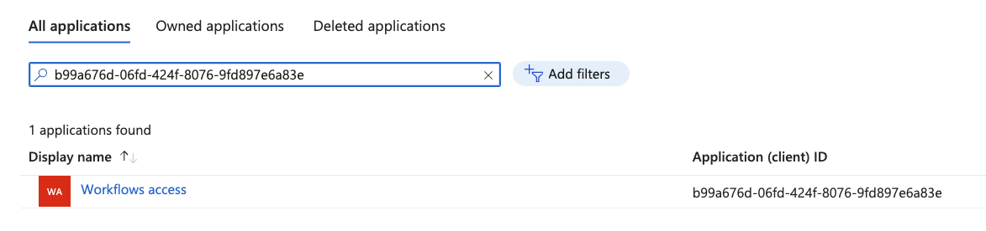

Then go to Enterprise Applications

https://portal.azure.com/#view/Microsoft_AAD_IAM/StartboardApplicationsMenuBlade/~/AppAppsPreview/menuId~/null

First, remove the ‘Enterprise Applications’ filter 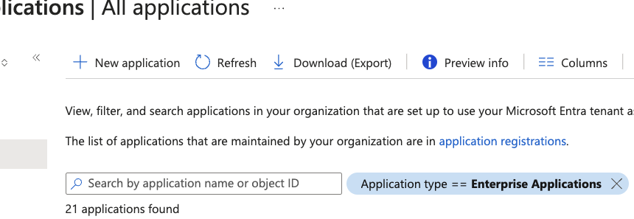 And add the group:

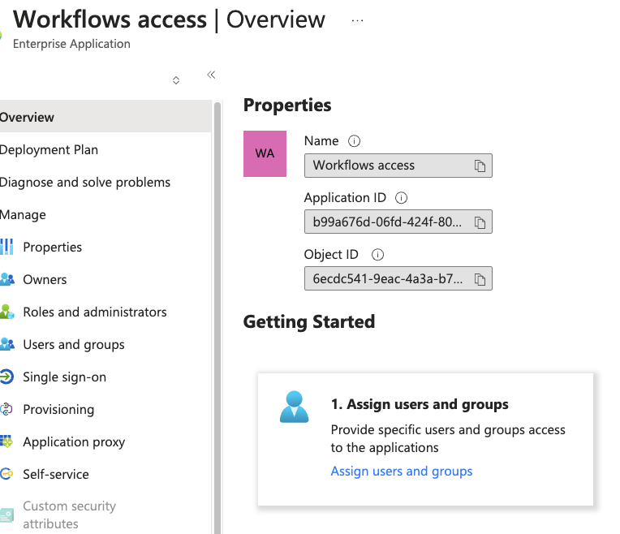

image

image

image

Click ‘None Selected’ to begin

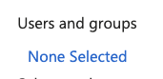

image

1. Provide cross-domain collaboration rights to the user’s domain

https://portal.azure.com/#view/Microsoft_AAD_IAM/CompanyRelationshipsMenuBlade/~/Settings

Add the domain name, or select one of the other radio buttons

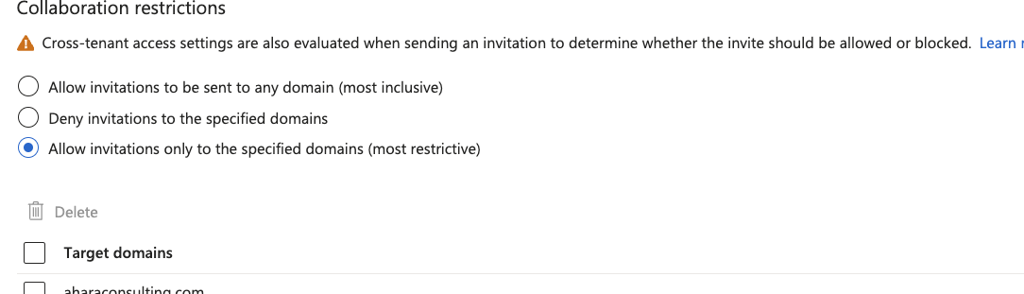

image

# Navigation

## Home Page

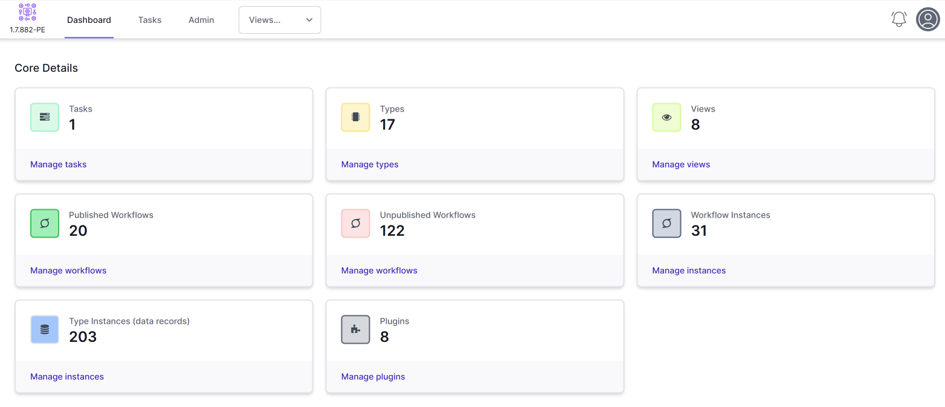

Home Page

The home page has a number of **tiles** that show various statistics of your World of Workflows installation. You can use these tiles to navigate to these icons.

The top navigation includes the **Dashboard** or home page. **Tasks** take you to the task page and Admin is the rest of the navigation.

*This will change when you add* ***views****.*

## Tasks

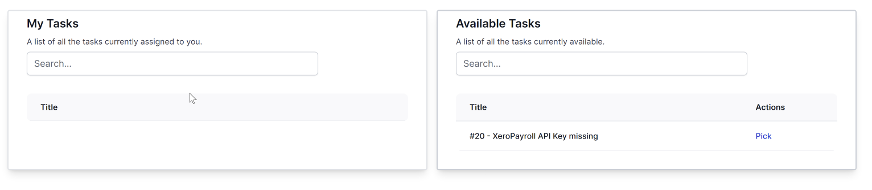

Tasks Page

The tasks page consists of two columns. The left-hand column shows tasks you have picked and are in your queue. The right-hand column shows the current available tasks to pick.

## Admin

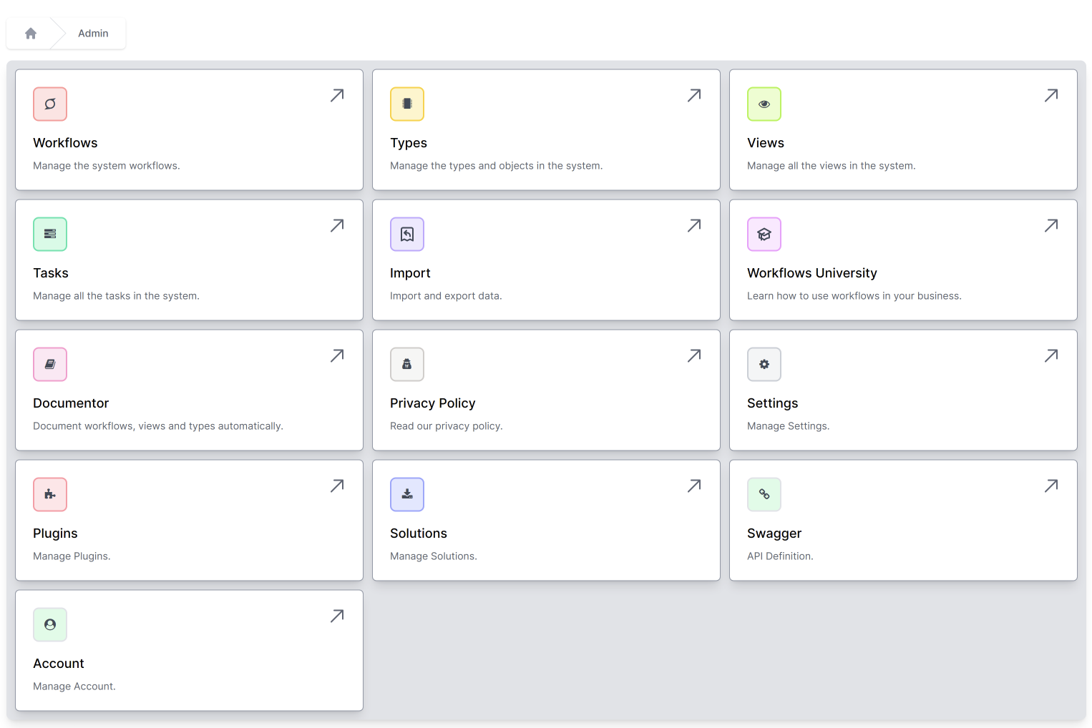

Admin Page

The admin page allows you to navigate between the various aspects of the system and manipulate data, workflows, tasks and more.

The sections of the Admin page are defined below:

### Workflows

This gives you access to the Workflows which allows you to manage all of the Workflows in the system. Workflows are ways of visually describing what your process should do and instructing World of Workflows to perform tasks that you want it to perform.

### Types

Types give you access to the inbuilt database within World of Workflows. Here you can add, retrieve and manipulate data across the system.

### Views

While Types allows you to manipulate the underlying data, **Views** allows you to choose what the users of the system see. You can choose which fields they see and apply filters. Within views, you can easily set up navigation hierarchies for end users.

### Tasks

World of Workflows has a built-in task management and queuing system that allows for tasks that not only instruct users but allow them to manipulate data in task and have multiple options for task completion. This tab gives administrators access to the entire list of tasks.

### Import

The Import system allows you to import any data from CSV using an intuitive and powerful import wizard.

### Workflows University

This site is available from within the application at any time.

### Documentor

The documentor automatically creates a document of the database, data dictionary, workflows and contents of the workflows for your records.

### Privacy Policy

This is the World of Workflows Privacy Policy

### Settings

The Settings area allows you to back up the database, restart the service and check if the service is running.

### Plugins

Plugins are small applications that extend the Workflows in World of Workflows to make it easier to work with other systems, such as Microsoft 365, Xero or OpenAI.

### Solutions

Solutions allow you to import and export your entire configuration (or part of it) for loading on another World of Workflows system.

### Swagger

This shows API Definitions as it applies to your own World of Workflows installation. The API extends as you create new Types and publish new workflows.

### Account

This shows the information on your account, license key and more.

# Getting Started / My First Workflow

In this section, we’re going to step you through getting started, creating a **Type** and **Data**, Creating a **Workflow** and working with a task.

We’re going to start with a customer service example. We’re going to configure World of Workflows with a system to manage sales leads. We’ll be able to categorize these leads and create a system for follow-up and closing them.

In addition, we’ll create several **views** so you can allow your users to easily navigate the data.

Follow the steps below to complete this exercise.

1. [Creating a data structure](./create_data_structure.html) - In this section, we create the structure for the data we are going to use. We commonly create solutions by working with data first.
2. [Adding data](./adding_data.html) - In this section we add data for lead status and add our first lead.
3. [Create Workflow](./create-workflow.html) - In this section, we create a workflow to follow up a lead with a task.
4. [Try it out](./try_it_out.html) - Try out the workflow and see the tasks you created

# Creating a data structure

We’re going to create two types:

* **Lead** contains information on the lead
* **LeadStatus** contains the status of the lead.

*Note: we use singular names by convention when creating types.*

## Creating Types

1. Navigate to Admin -> Types Types
2. Click **+** to create a New Type 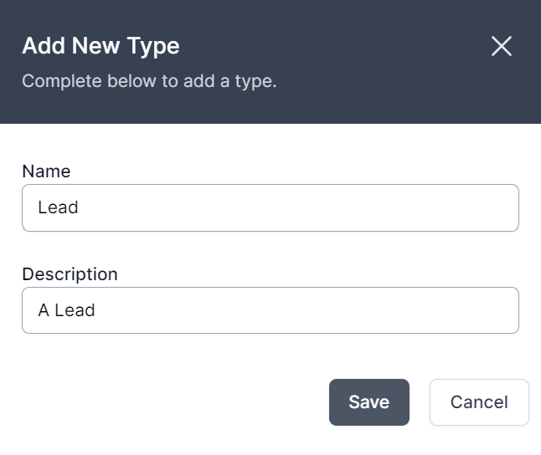
3. Enter the Name as **Lead** and the Description as **A Lead**. Click **Save**.
4. Click **+** to create another new Type
5. Enter the Name as **LeadStatus** and the Description as **Status of a Lead**
6. Types should look like the screenshot below. If not, use the delete or edit buttons to make the relevant amendments. 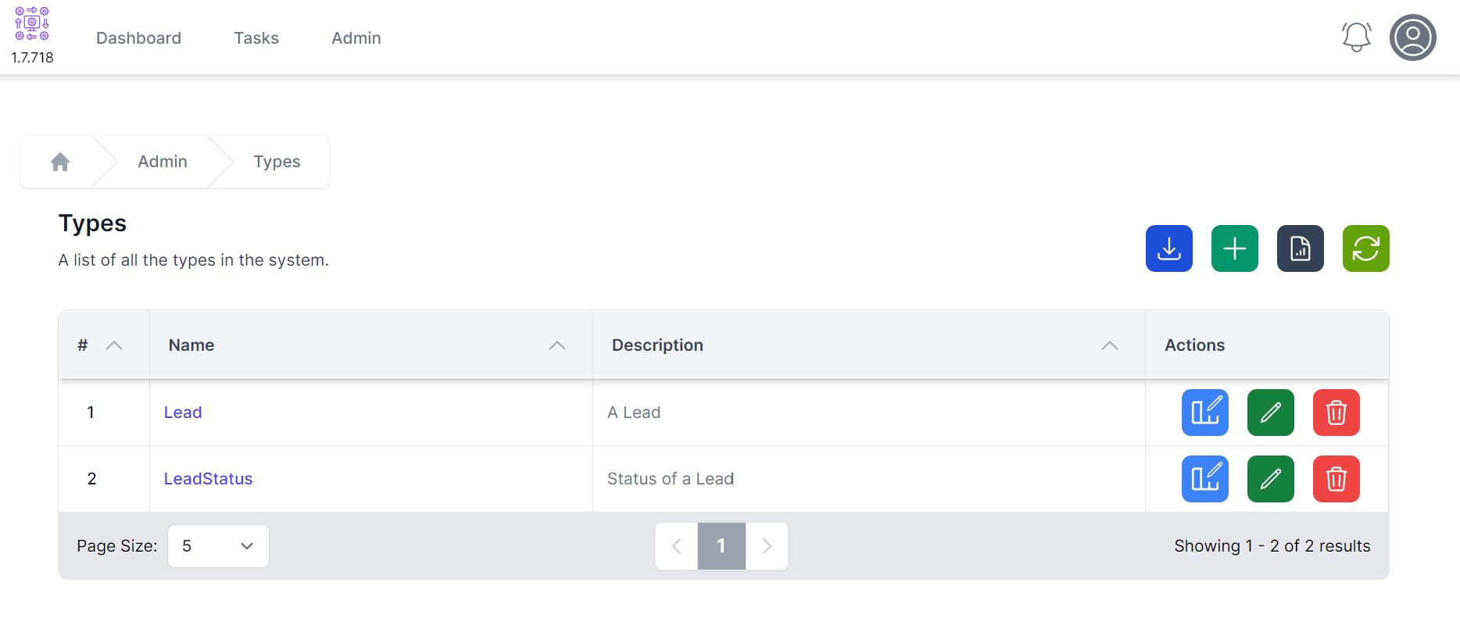

## Creating Columns

1. Click the  button next to the **Lead** Type.
2. As you can see, we have an existing column, the Title Column. *Title columns are important but you can change their name, display name, description, display order and whether they are visible.* 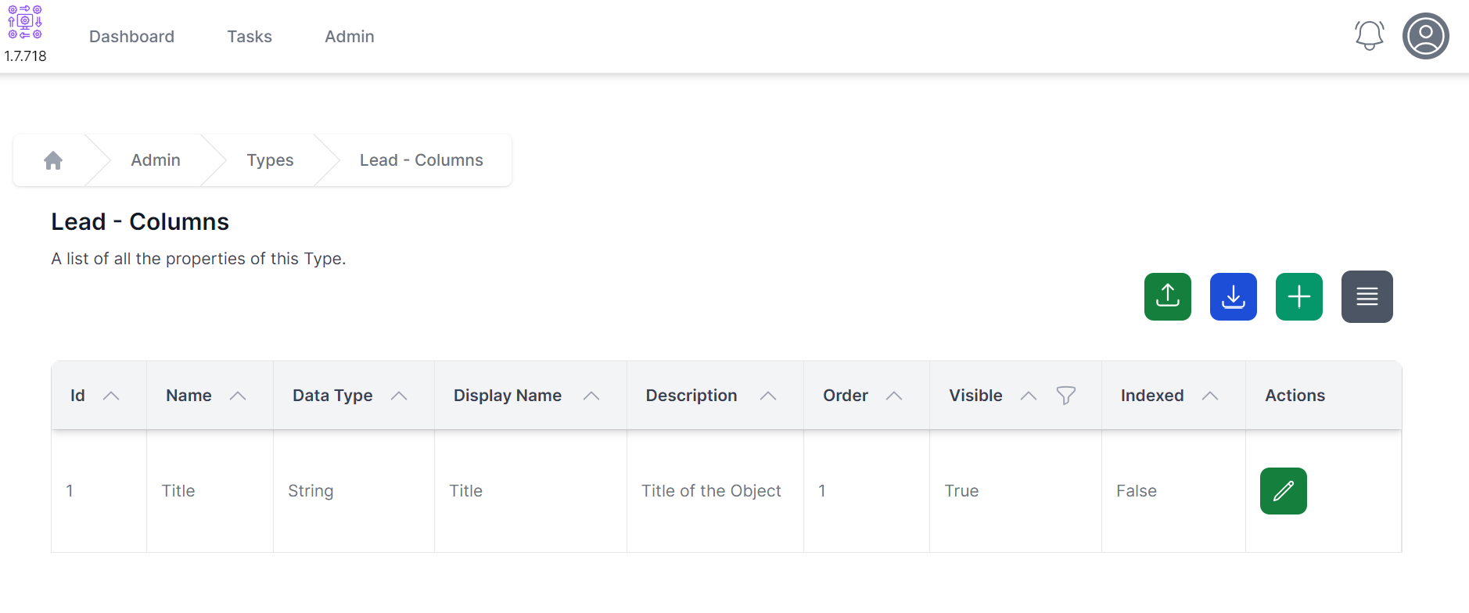
3. Click **+** to add a new Column 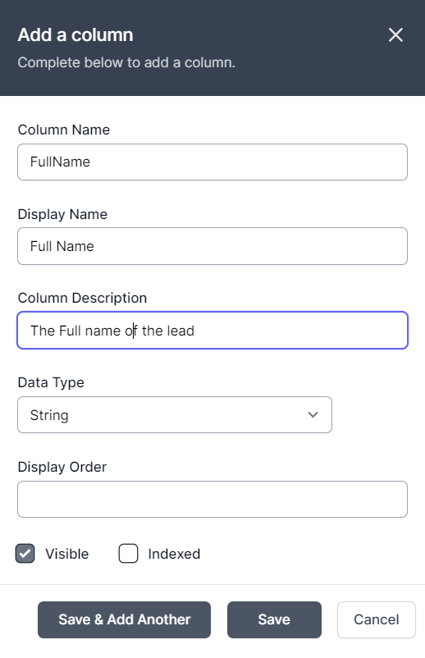
4. Enter details as follows:
   1. **Column Name:** FullName
   2. **Display Name:** Full Name
   3. **Description:** The Full name of the lead
   4. **DataType:** String
   5. **Display Order:** Leave Blank
   6. **Visible:** Checked
   7. **Indexed:** Not Checked
5. Click **Save & Add Another**
6. Enter Details as follows:
   1. **Column Name:** Email
   2. **Display Name:** Email
   3. **Description:** The Email address of the lead
   4. **DataType:** String
   5. **Display Order:** Leave Blank
   6. **Visible:** Checked
   7. **Indexed:** Not Checked
7. Click **Save & Add Another**
8. Enter Details as follows:
   1. **Column Name:** Description
   2. **Display Name:** Description
   3. **Description:** The Description of the lead
   4. **DataType:** String
   5. **Display Order:** Leave Blank
   6. **Visible:** Checked
   7. **Indexed:** Not Checked
9. Click **Save & Add Another**
10. Enter Details as follows:
    1. **Column Name:** Status
    2. **Display Name:** Status
    3. **Description:** The status of the lead
    4. **DataType:** Reference
    5. **Object Type:** LeadStatus
    6. **Display Order:** Leave Blank
    7. **Visible:** Checked
    8. **Indexed:** Not Checked
11. Click **Save**
12. Your Lead Columns should look like the screenshot below. If not, use the edit and delete buttons to fix it. 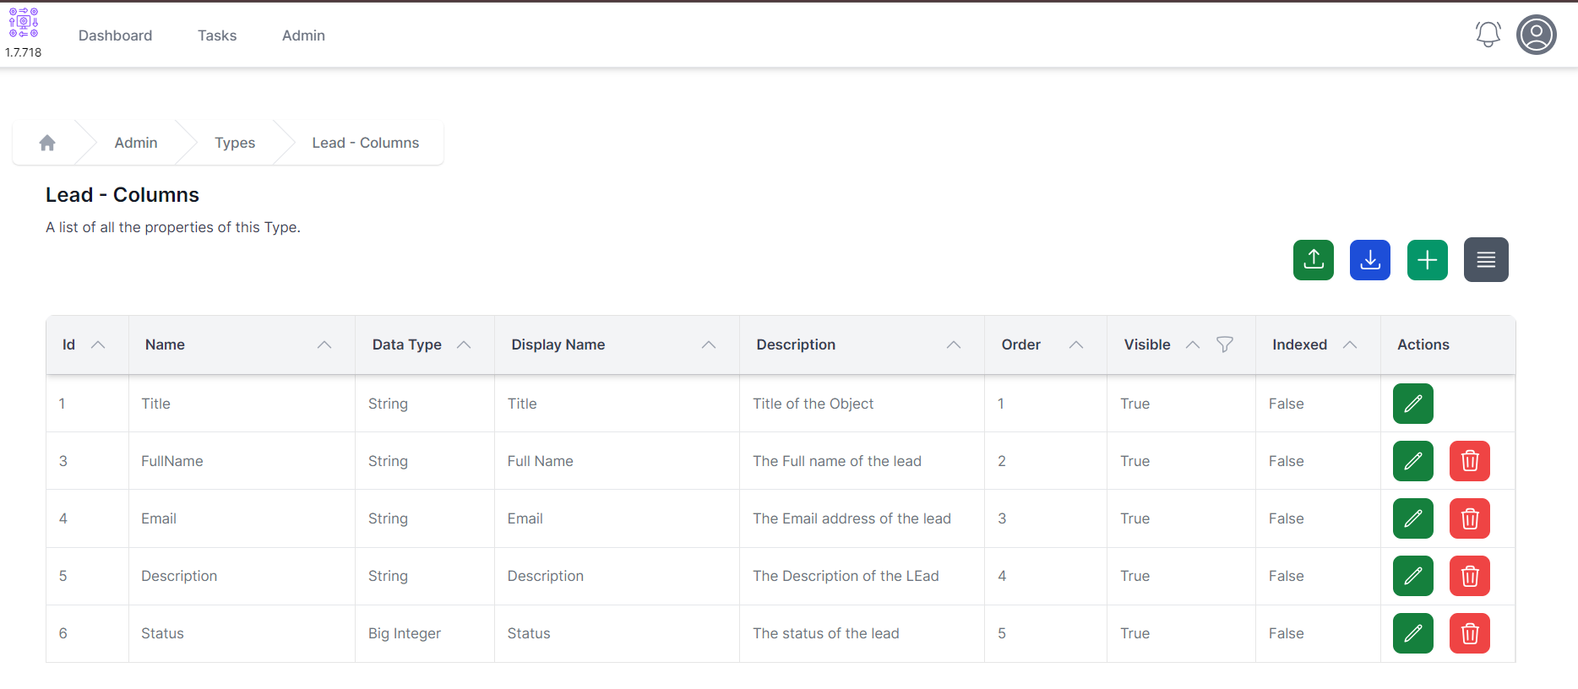

You have successfully created the data structure so can go to [**step 2, adding data**](./adding_data.html)

# Adding Data

## Status

In this section, we are going to add some lead statuses, and our first couple of leads.

1. Navigate to **Admin** -> **Types** -> **LeadStatus** 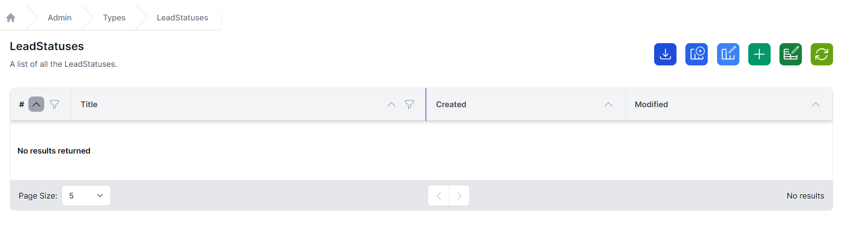
2. Click **+** to add a new Lead Status 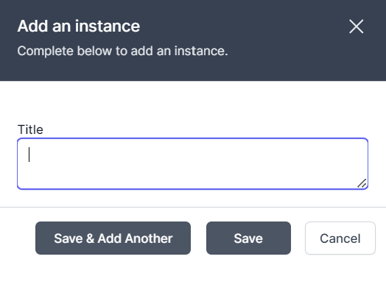
3. Add details as follows:
   1. **Title:** New
4. Click **Save & Add Another**
5. Add details as follows:
   1. **Title:** Qualified
6. Click **Save & Add Another**
7. Add details as follows:
   1. **Title:** Closed
8. Click **Save**
9. LeadStatus will look like the screen shot below. Click on the Id of items to change or delete them. 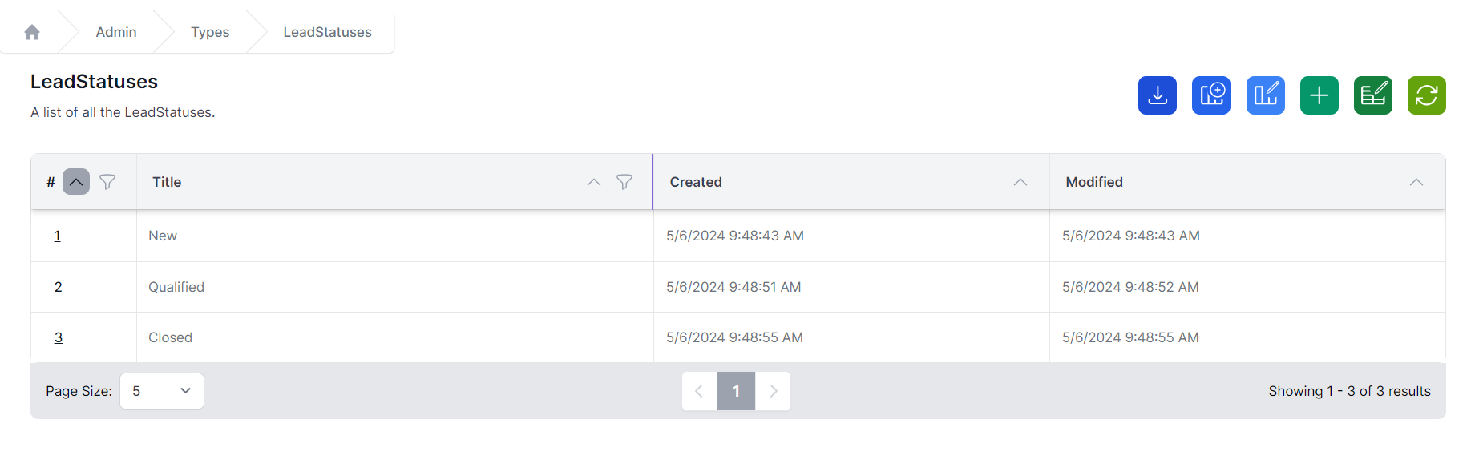

## Leads

1. Navigate to **Admin** -> **Types** -> **Lead** 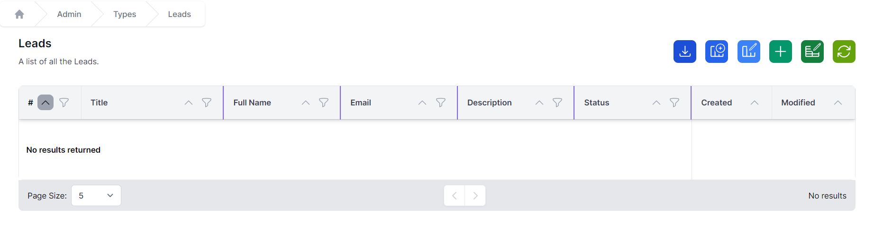
2. Click **+** to add a new Lead 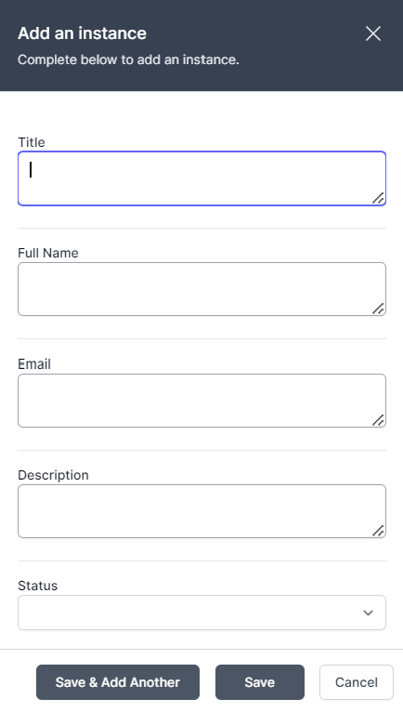
3. Add details as follows:
   1. **Title:** World of Workflows
   2. **Full Name:** Nick Beaugeard
   3. **Email:** nick@worldofworkflows.com
   4. **Description:** opportunity to sell our product to World of Workflows
   5. **Status:** New
4. Click **Save**
5. The list of leads should look like the screen shot below. *Note in this case I modified a mistake, so the modified date is greater than the created date.* 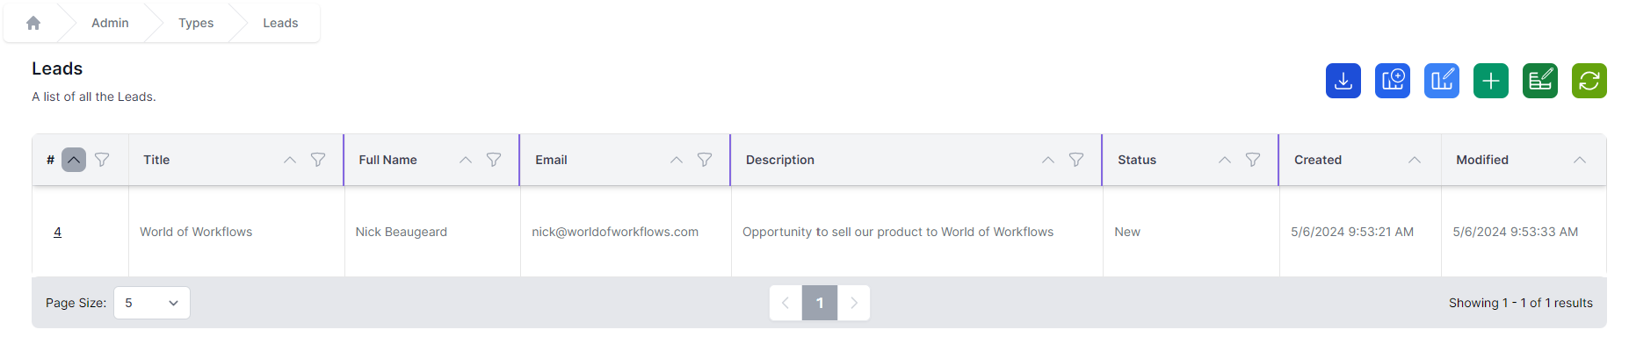

You have successfully created the data so can go to [**step 3, create workflow**](./create-workflow.html)

# Create Workflow

1. Navigate to **Admin** –> **Workflows** 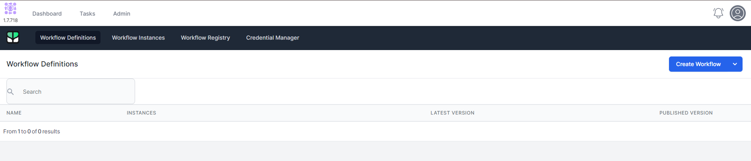
2. Click **Create Workflow** 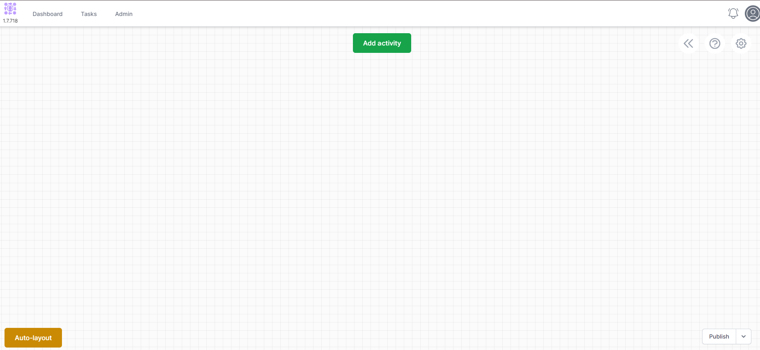
3. Click the Cog icon in the top right 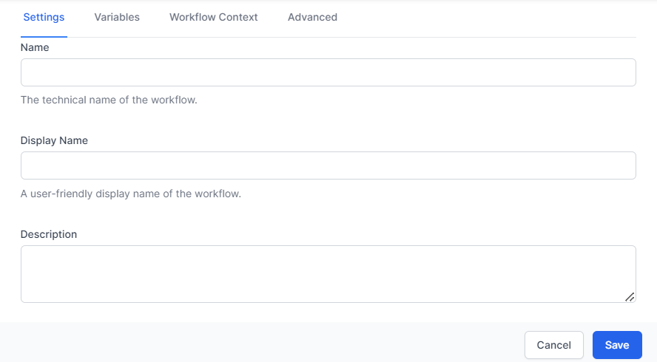
4. Make the name **Review Lead** and click **Save**
5. Click **Add Activity**
6. On the left, choose **Data** 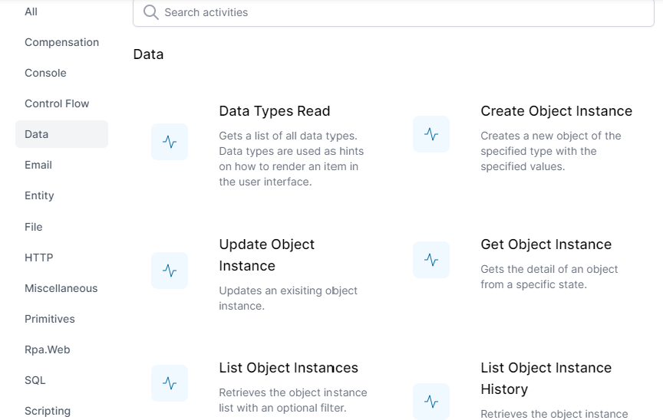
7. Scroll down and choose **Object Instance Trigger** 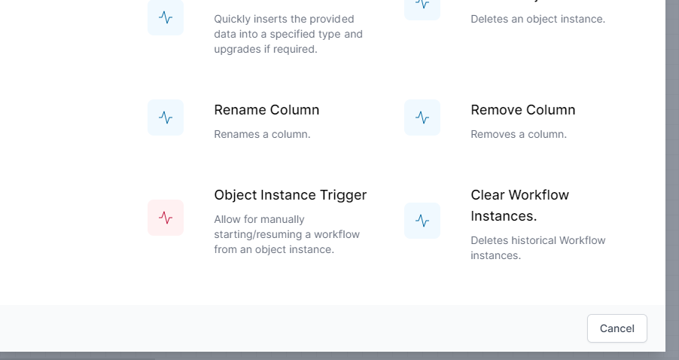
8. Drag the new activity to a position on the left 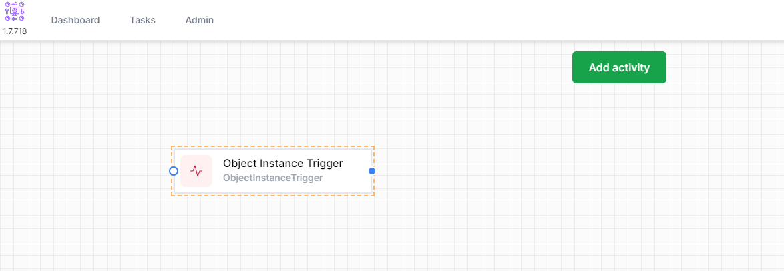
9. **Right Click** the **Object Instance Trigger** and click **Edit** 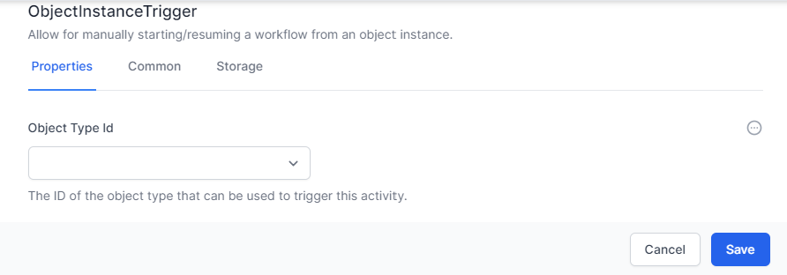
10. Select **Lead** under Object Type Id and Choose the **Common** Tab.
11. Change the **Name** to **LeadTrigger** and the Display Name to **Review Lead** 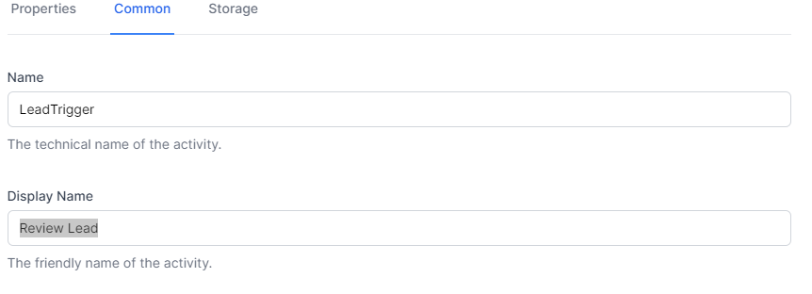
12. Click **Save**
13. Click **Add Activity**
14. On the left, choose **Tasks** and choose **Task Create**
15. Drag the **Task Create** activity to the right of the **Review Lead** Activity 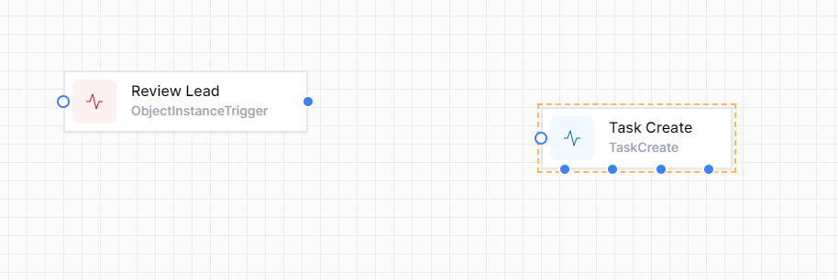
16. Now using the blue dot to the right of the **Review Lead** activity, connect it to the blue circle on the Task Create Activity. It should look like the below: 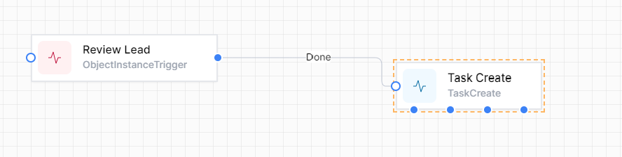
17. Right Click the **Task Create** activity and choose **Edit** 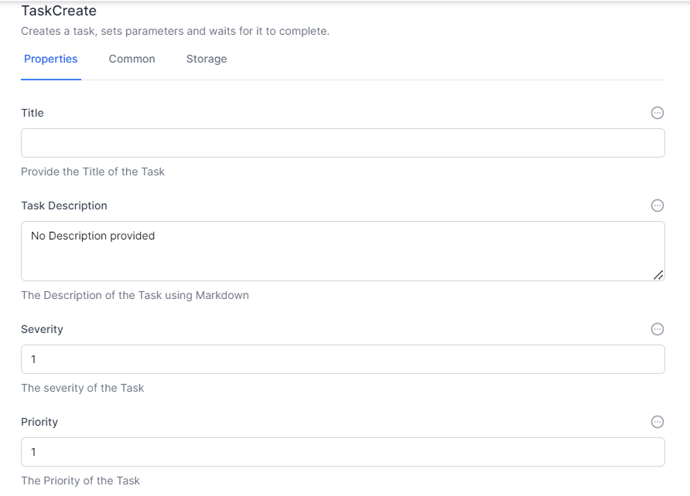
18. To the right of the Title, click Elipsis and choose **Liquid**
19. In the Title Type Review Lead #{%raw%}{{Activities.LeadTrigger.InstanceId}}{%endraw%}
20. In the description, type # Review Lead It is time to review this lead. Please review it
21. Leave the Severity, Priority and Due. 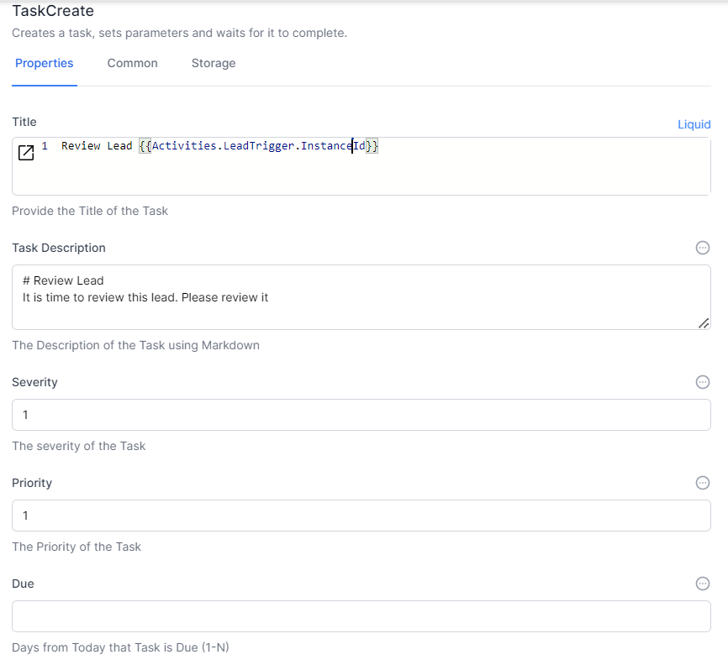
22. In the related ObjectId, click Elipsis and choose **Liquid**
23. Enter {%raw%}{Activities.LeadTrigger.ObjectId}}{%endraw%} in the Related Object Id
24. In the Data Questions Add Status for **Name** and Status for **Value**
25. In Branches, add the text “Done” and click Enter. 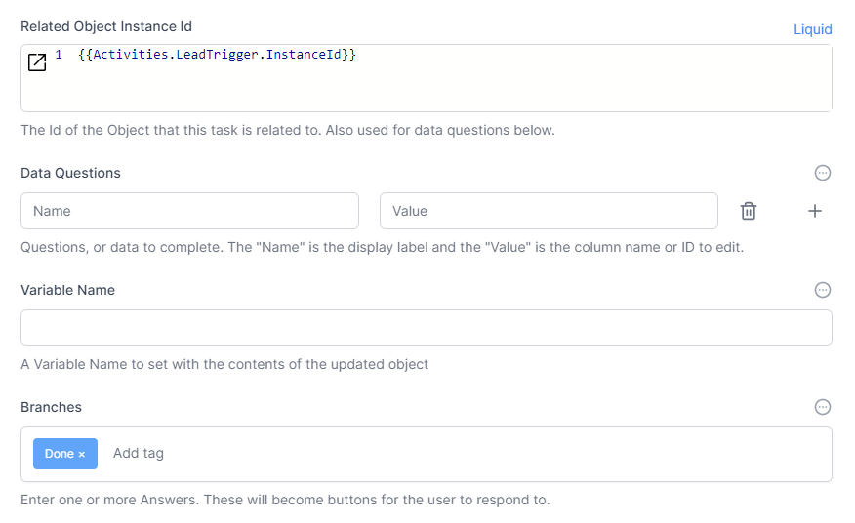
26. Click **Save**
27. Click **Publish**

**Congratulations.** You have created your first workflow. When you click the option on a lead it should create a task to update the lead. You can now [Try it out](./try_it_out.html).

**Note:** The **Liquid** system is a way of reading and writing data between activities. In World of Workflows, we support Liquid and JavaScript for this.

# Try it Out

1. Navigate to **Admin** –> **Types** –> **Lead** 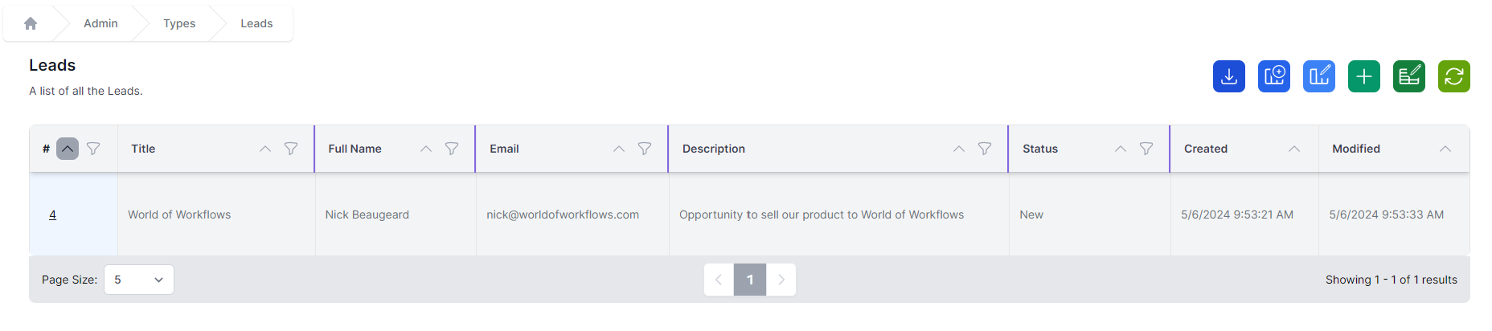
2. Click the Id for the Lead (In this case 4) 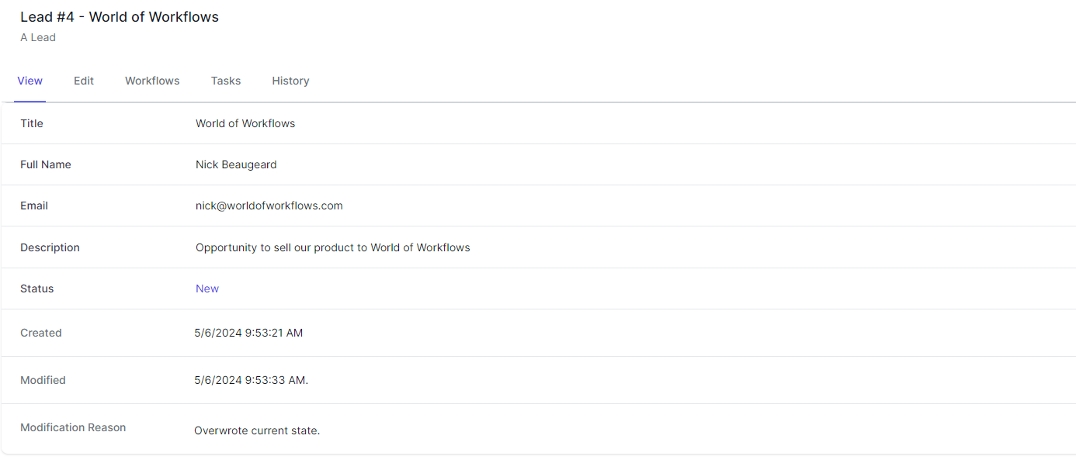
3. Click the Workflows Tab 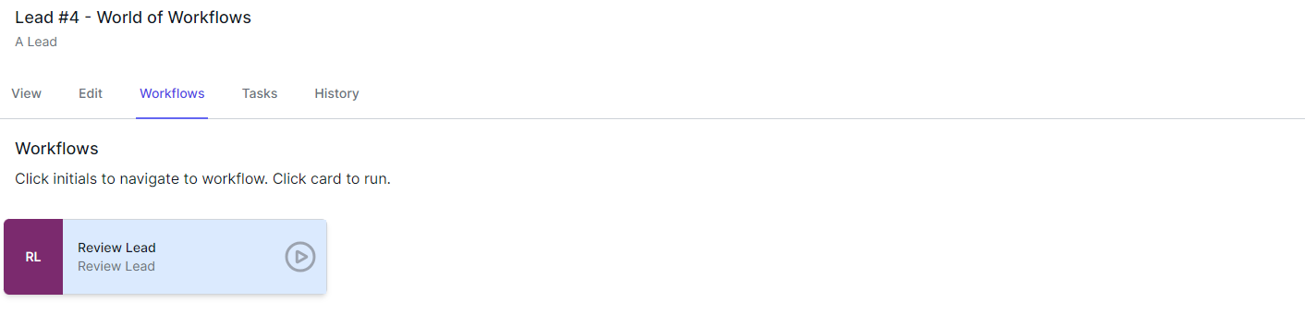
4. Click **Review Lead**
5. Navigate to **Tasks** 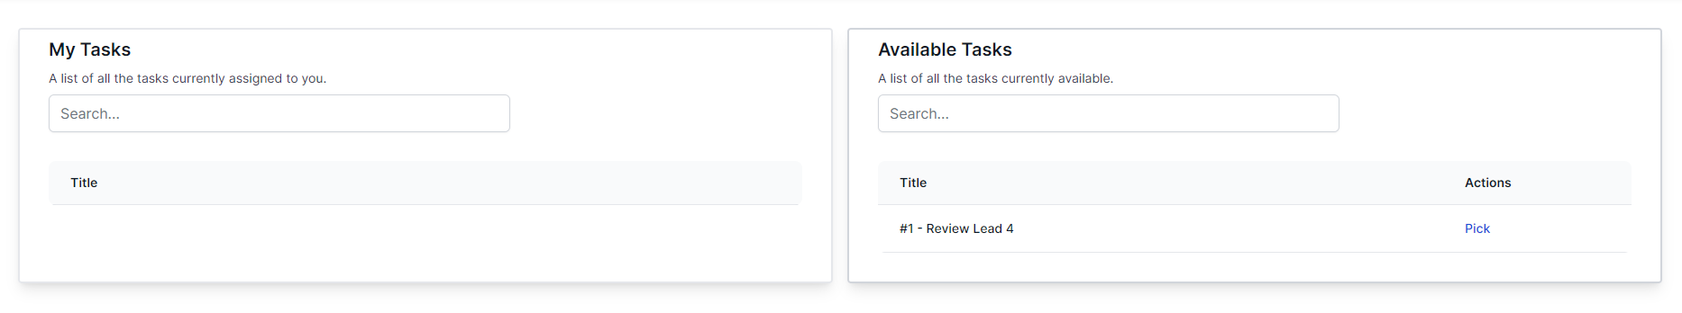
6. Click **Pick** next to the task. This moves the task from the available queue into your queue. 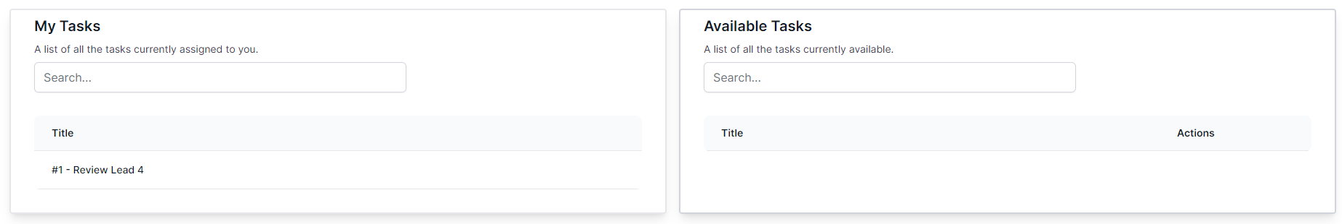
7. Click the Task in the **My Tasks** queue. 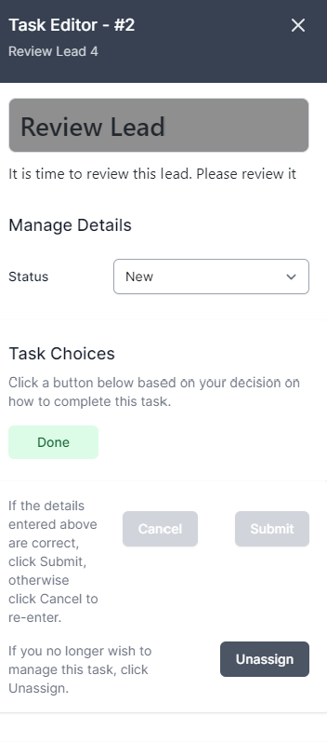
8. Here you can change the status of the lead, click **Done** and Submit to save. You can also **Unassign** the lead if you wish.

**Congratulations.** You have now completed our first getting started guide. You have created a lead management system that allows for task-based reviews of leads.