Tuftmaster End of Month Process

The end of month process is initiated by Suzie as follows:

1. Step 1, Close Invoicing
   * 1. Navigate to Tuftware2 using RDP
     2. Double Click **EndOfMonth** Tool
     3. Type Password: tufteom 4. Click the Key Icon

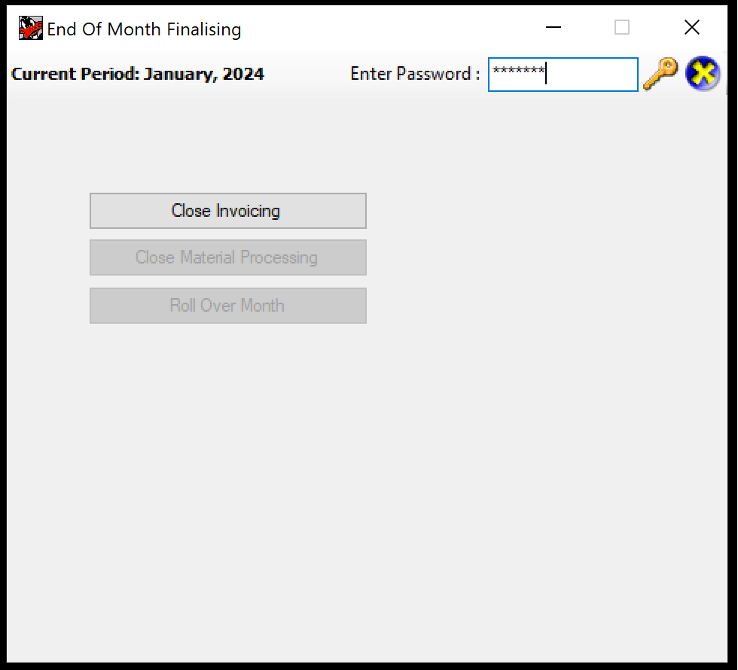

5. Click **Close Invoicing**

**Note** This can take up to 40 minutes

TELL SUZIE YOU ARE DONE AND WAIT FOR HER TO ASK YOU TO PERFOM THE ROLLOVER (USUALLY THE NEXT DAY)

Step 2, Rollover

**THIS WILL BE INITIATED BY SUZIE**

* 1. Navigate to Tuftware2 using RDP
  2. Double Click **EndOfMonth** Tool
  3. Type Password: tufteom
  4. Click the Key Icon

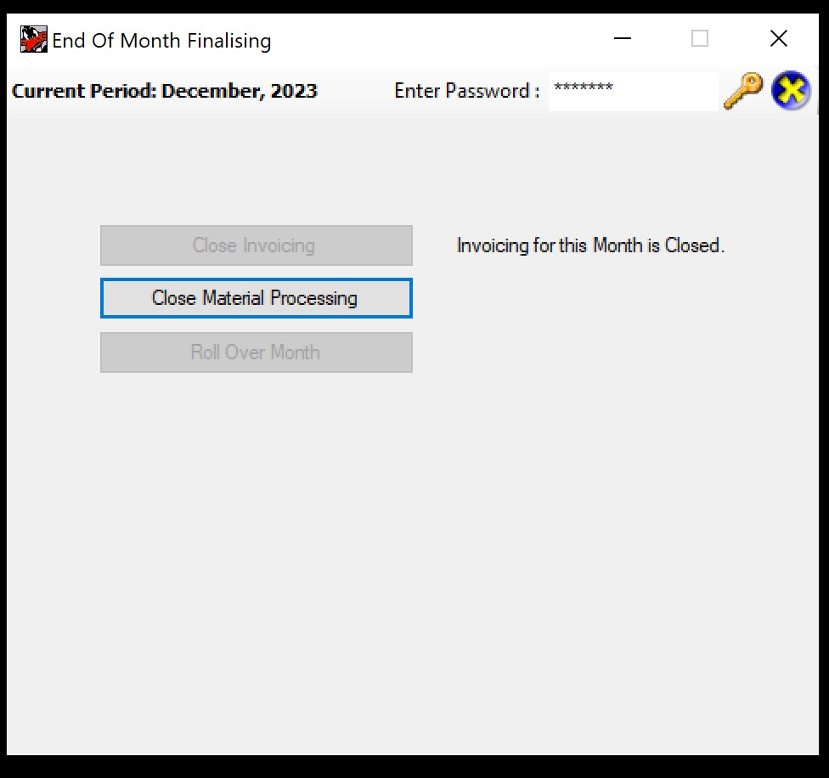

* 1. Click **Close Material processing**
  2. When the app has finished that process, click

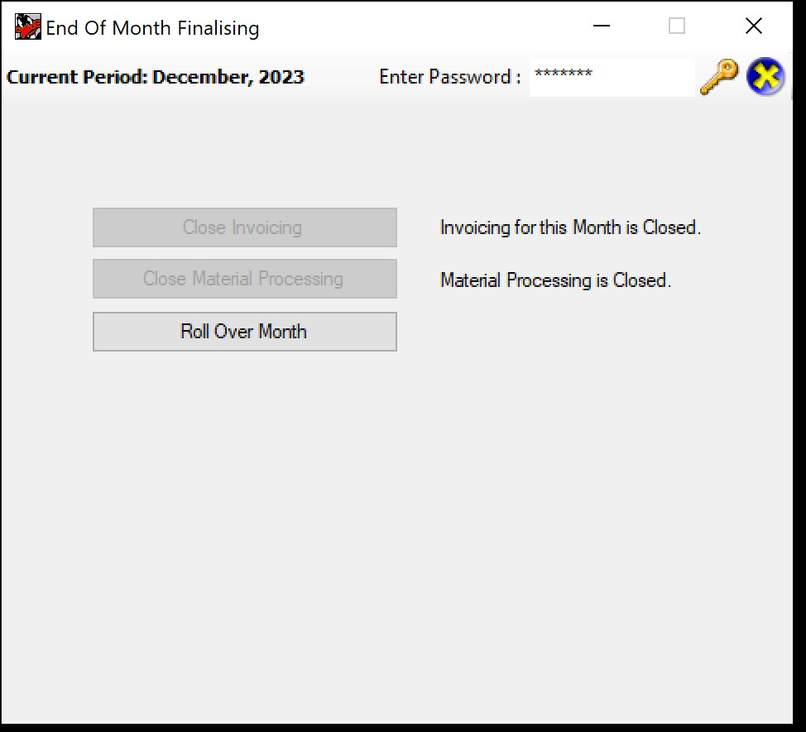

**Roll Over Month**

* 1. A Dialog saying "You have selected to Roll Over the Current Nonth. Are you SURE you want to continue? appears. Click **Yes**

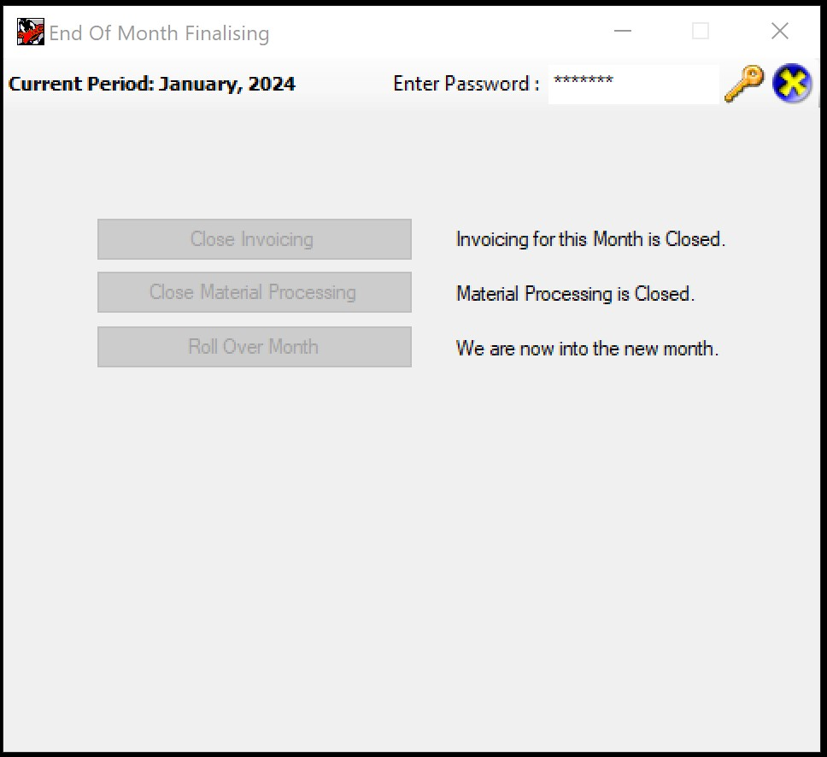

**End of Month Complete**