EMS Comparison

This document compares the performance of the predictions the EfficientIO EMS made to the actual data. For multiple projects the predictions of their different components are plotted. The current testing is done without using previous values as inputs. All current inputs are the from the weather prediction service. The models are also evaluated using shifted values. These shifted values are the measurements that were observed in previous timesteps, e.g.: the day before.
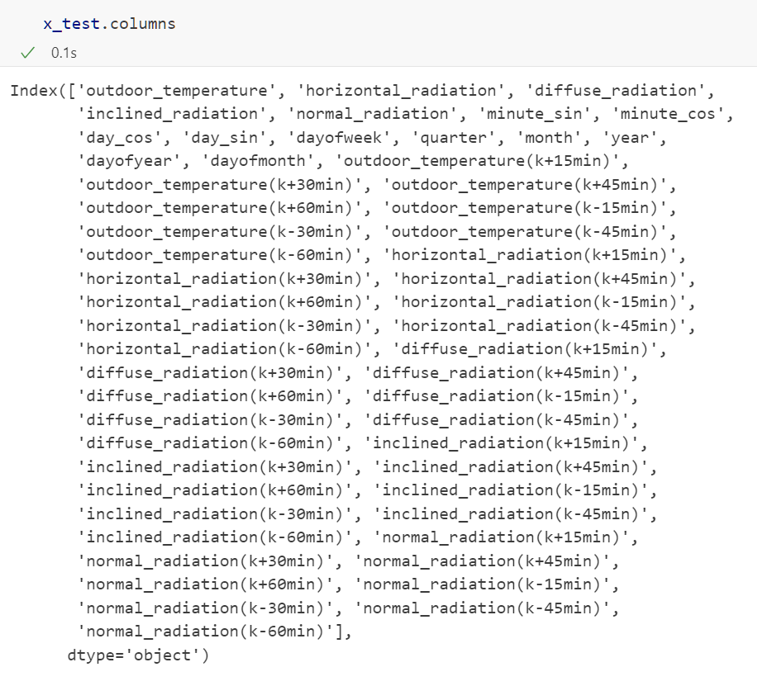
Figure 1 Screenshot of input columns without shifted columns

  - BMS-Project “Hammerschied”
The first project tested, is the project Hammerschied.
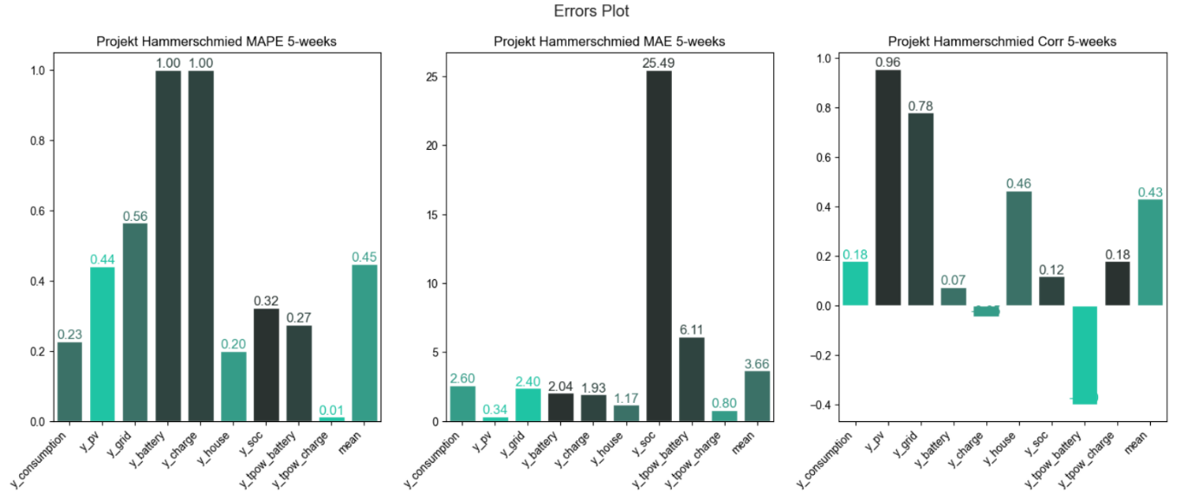
The first figure displays multiple error metrics currently used to compare model performance. Even though the mean absolute percentage error (MAPE) might be quite huge, in absolute terms the error is less than 1kWh on average for photovoltaic systems.
Figure 2 Errors of project Hammerschmied
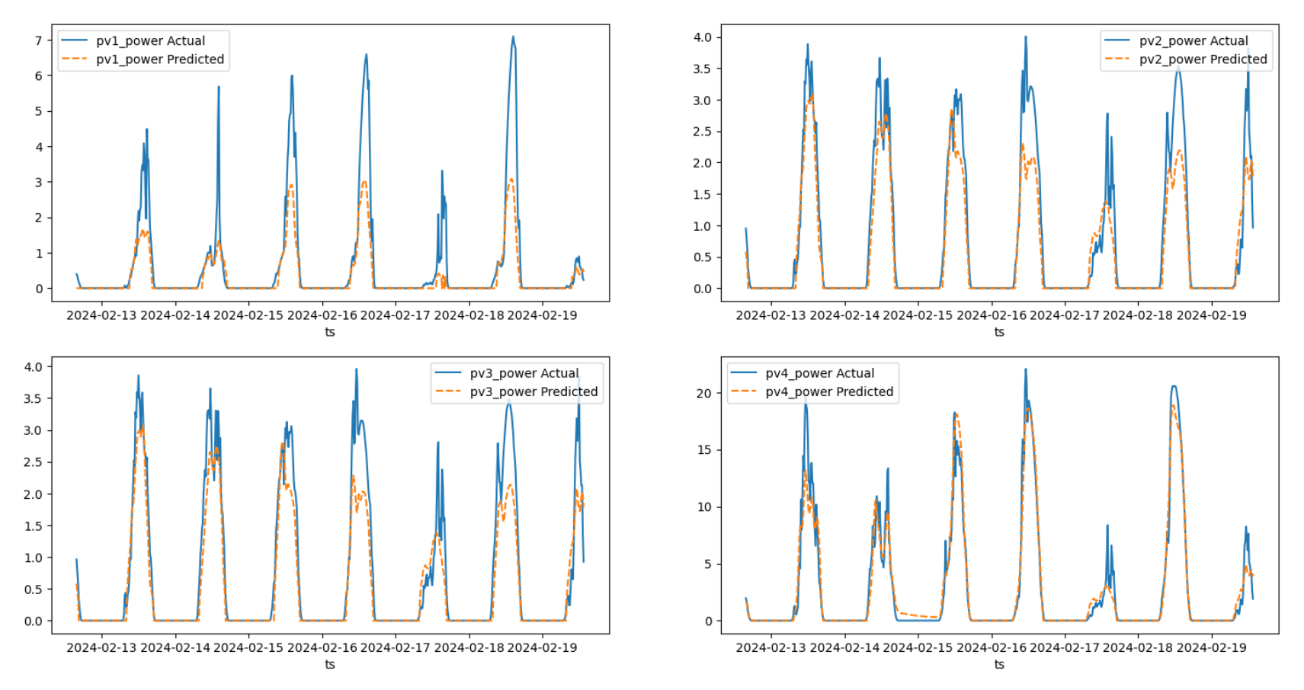
Figure 3 photovoltaic energy production predictions for the project Hammerschmied
Figure 3 shows clearly, that the EMS system learned to predict photovoltaic energy production. Still, it should be noted that that the peaks are not always predicted high enough.
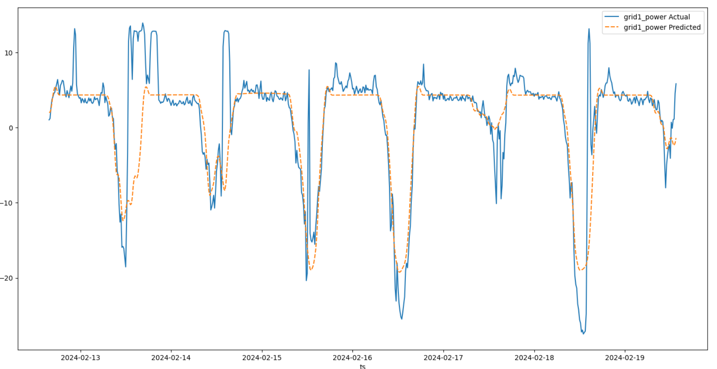
Figure 4 Grid energy usage for the project Hammerschmied
Grid energy usage shown in Figure 4, clearly needs improvements. Though grid feed in, probably stemming from photovoltaic production, is modelled quite well, usage peeks are not predicted.
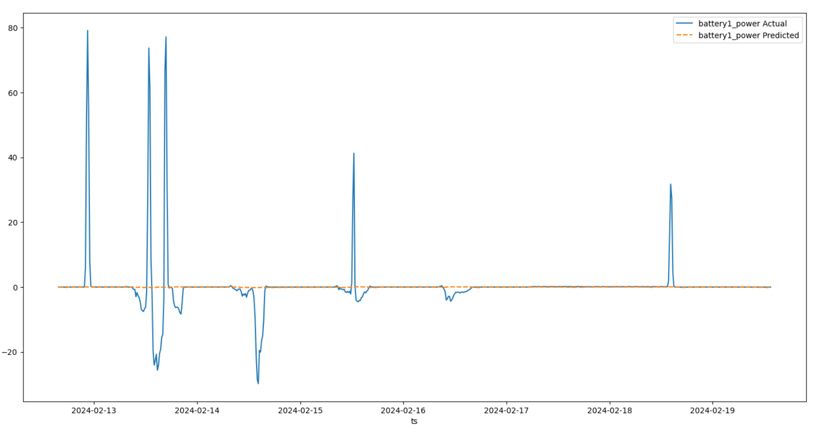
Figure 5 Battery power for the project Hammerschmiedt
The model is not well equipped to predict the battery power or state of charge, as seen in Figure 5 or Figure 6.
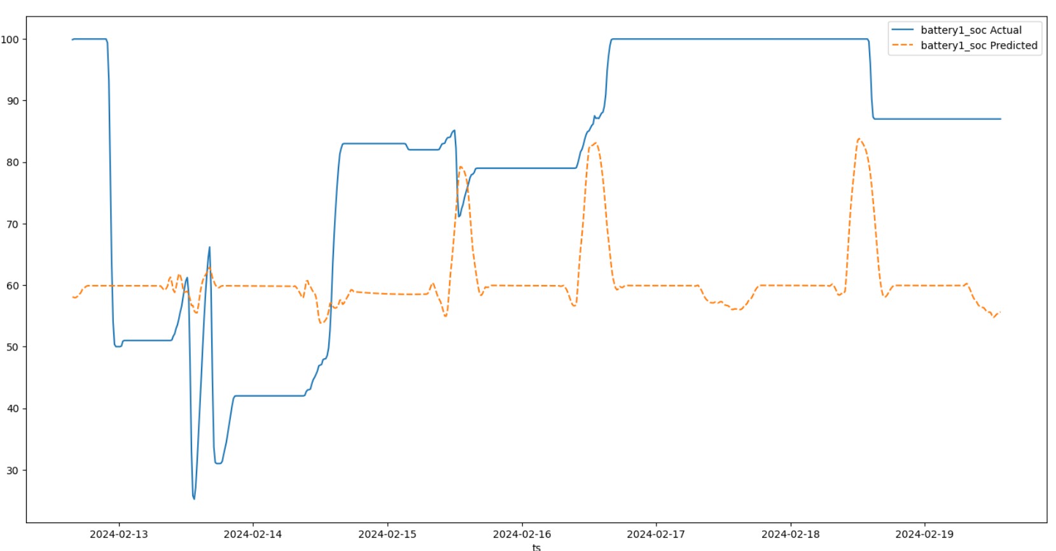
Figure 6 Battery state of charge for project Hammerschmiedt

  - BMS-Project “Katzenhofer”
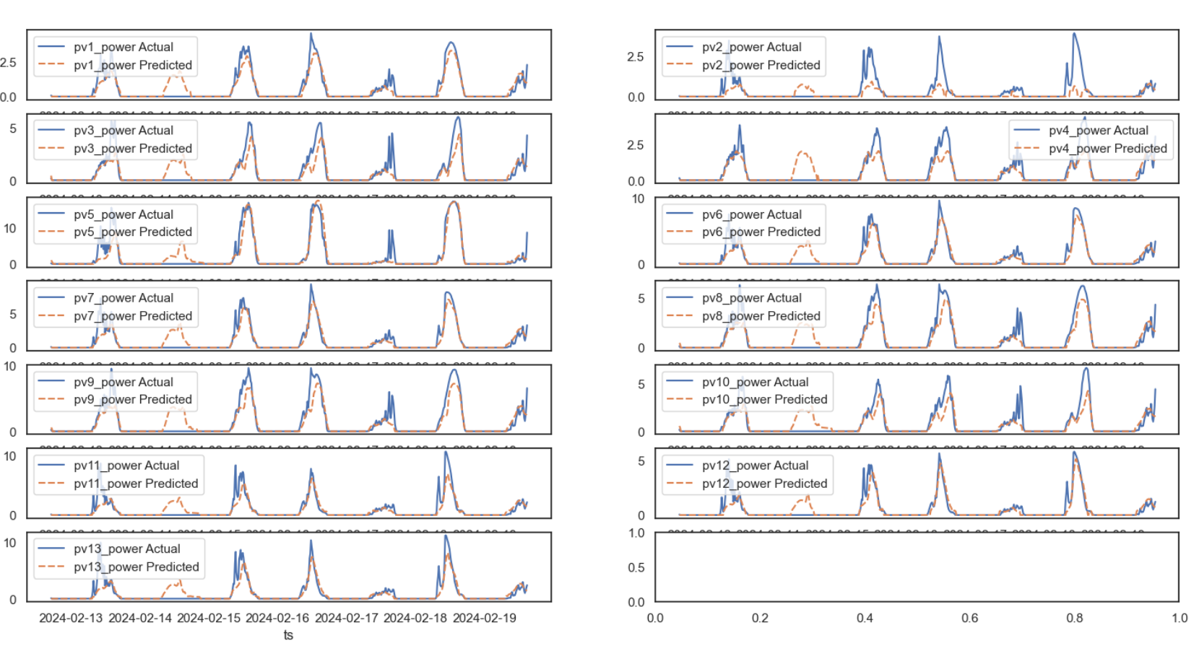
Figure 7 photovolatic energy production prediction for the project Katzenhofer

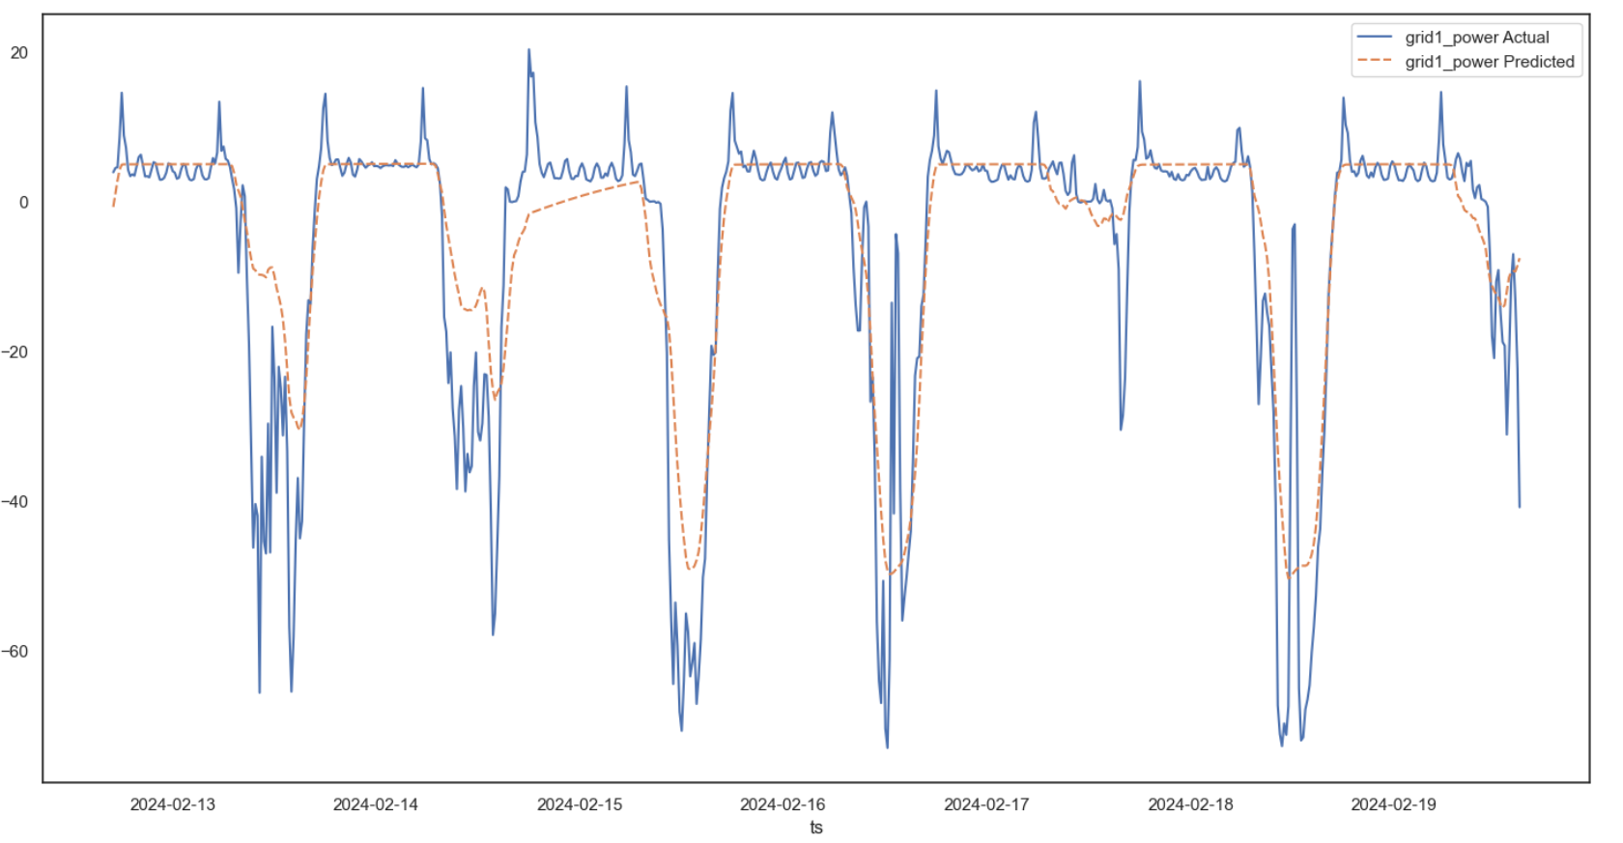
Figure 8 Grid energy usage for the project Katzenhofer

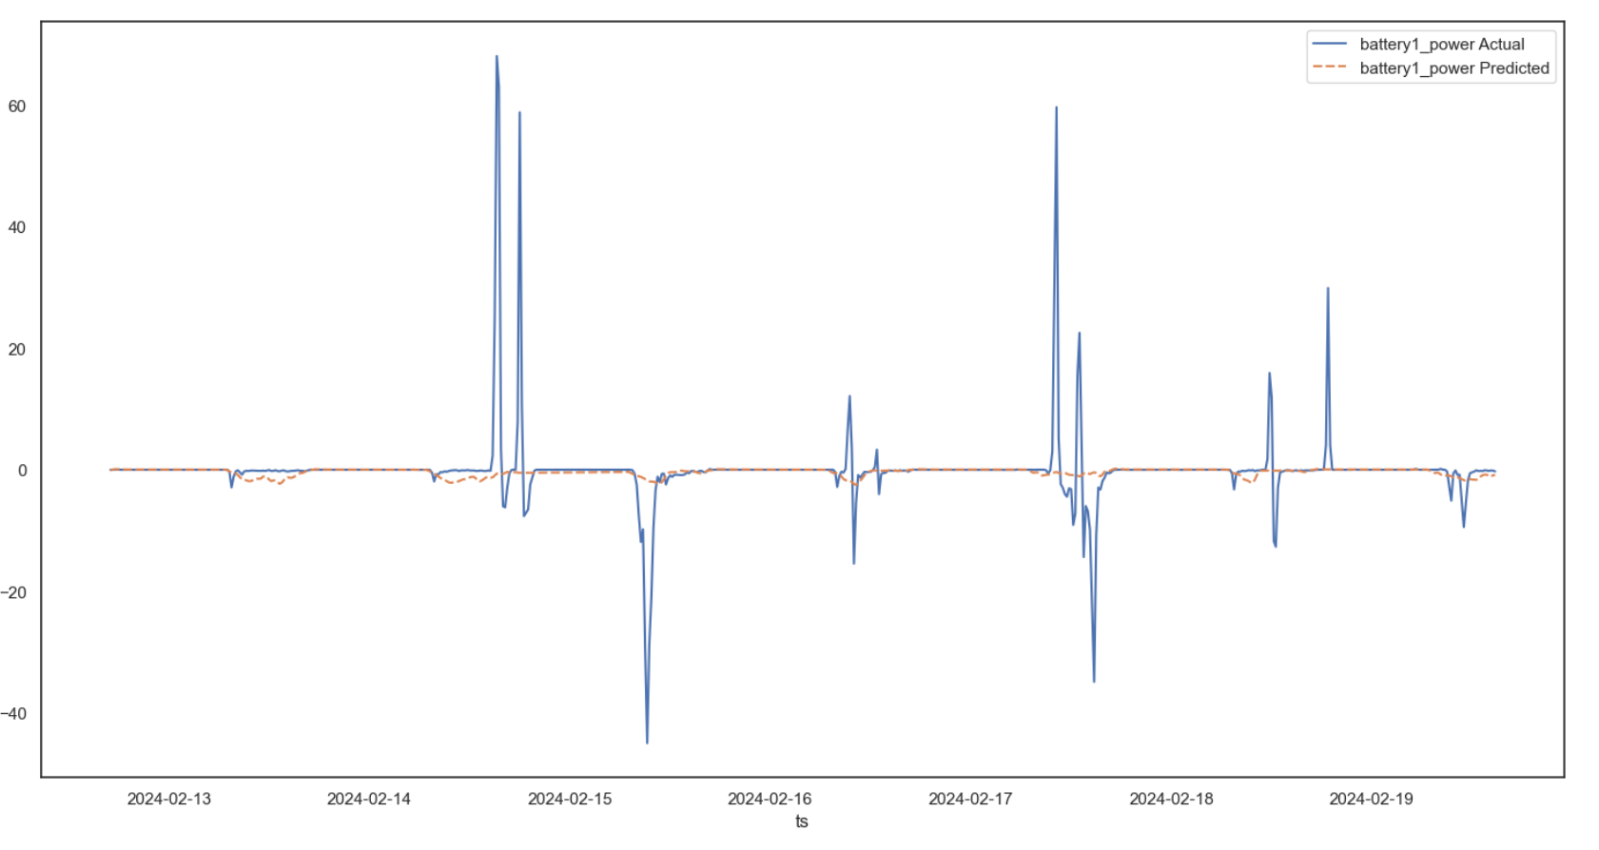
Figure 9 Battery power usage for the project Katzenhofer

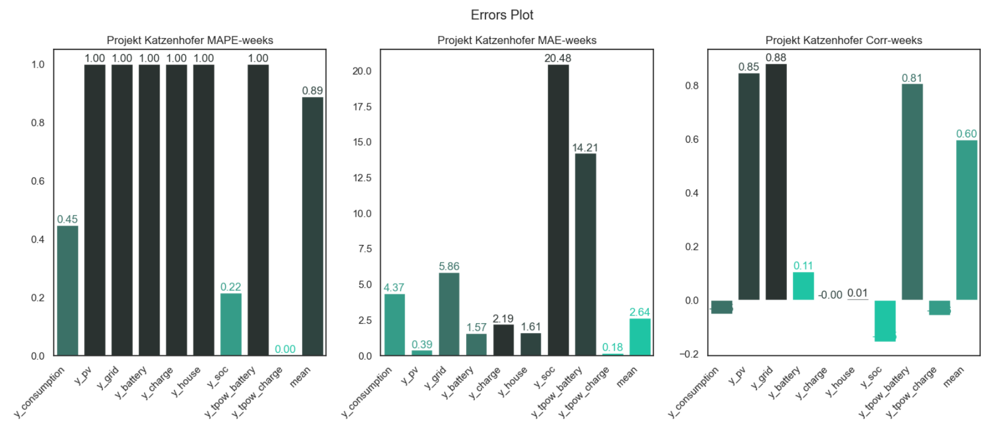
Figure 10 Metrics for the project Katzenhofer

