Leishmaniasis Country Profile Generator

User Manual

The Leishmaniasis Country Profile Generator, from now LCPG, retrieves country data from several sources for a specific year and puts it in an HTML country profile format ready to print in PDF.

Table of Contents

1. Metadata and permissions requirements 2

2. Generating a country profile 3

2.1 Configuration panel 4

2.1.1 General 4

2.2.2 Maps 5

2.2.3 Footnotes 6

2.2 Country profile 7

2.2.1 Text to update before printing 7

2.2.2 Edit elements in the CP 7

2.2.3 Footnote elements in the CP 7

2.2.4 Arrange maps and charts 8

2.2.5 Printing the CP or saving it as PDF 8

3. Source of information in country profile sections 9

3.1 Country general information section 9

3.2 Epidemiology section 11

3.3 Monthly distribution of new cases January-December section 14

3.4 Maps section 15

3.5 Control and surveillance section 16

3.6 Diagnosis section 17

3.7 Treatment and medicines and Treatment Outcome section 19

# Metadata and permissions requirements

LCPG and the user using it need metadata (and eventually) data read access to the following metadata:

|  |  |  |  |
| --- | --- | --- | --- |
| **Type** | **ID** | **Name** | **Comments** |
| program | w9hSFsNr3Vh | CL_cases_by provenance |  |
| program | NVUlJzIakuO | Footnotes for Report Generator RG_ | Needs to be assigned to the country |
| program | Jd8gnEIt8uT | Leishmaniasis endemicity | Needs to be assigned to the country |
| program | i5JSf4ffFl2 | VL_cases_by provenance |  |
| dataSet | Uc3j0vpsfSB | Cutaneous Leishmaniasis - ACL/ZCL - Detailed aggregated - Annual |  |
| dataSet | Sn0dExPzQqW | Cutaneous Leishmaniasis - ACL/ZCL - Simple aggregated - Annual |  |
| dataSet | tnek2LjfuIm | Cutaneous Leishmaniasis - Detailed aggregated - Annual |  |
| dataSet | zna8KfLMXn4 | Cutaneous Leishmaniasis - Simple aggregated - Annual |  |
| dataSet | NKWbkXyfO5F | General information | Needs to be assigned to the country |
| dataSet | p0NhuIUoeST | GHO indicators for NTDs | Needs to be assigned to the country |
| dataSet | fdBM4sWSuPR | Visceral Leishmaniasis - Detailed aggregated - Annual |  |
| dataSet | SHw2zOysJ1R | Visceral Leishmaniasis - Simple aggregated - Annual |  |
| sqlViews | mejiVo59hWs | categoryOptionCombos in DS |  |
| sqlViews | oQdIVqkVlxC | data elements in dataSet |  |
| sqlViews | IrawAndH02Y | data elements used in program |  |
| legendSet | clwSlrqvmMx | ACL Incidence |  |
| legendSet | TnU2O8YxH51 | CL Incidence |  |
| legendSet | gUOjExXros1 | VL Incidence |  |
| legendSet | TbrqpLWzLS8 | ZCL Incidence |  |
| indicatorGroup | nozEoB0uRq9 | NTD_Leish_CP_INC_charts_IG | It doesn’t need the IG itself but its indicators. |
| indicatorGroup | VvTNYst2QCW | NTD_Leish_CP_maps_IG | It doesn’t need the IG itself but its indicators. |
| indicatorGroup | KUdeVRtIK45 | NTD_Leish_CP_popAtRisk_IG | It doesn’t need the IG itself but its indicators. |
| indicatorGroup | Wp7ZgcxoAwM | NTD_LSH_EPI_NewCases_IG | It doesn’t need the IG itself but its indicators. |

# Generating a country profile

Look for the app called “Leishmaniasis Country Profile Generator” in the apps bar of the WIDP instance.

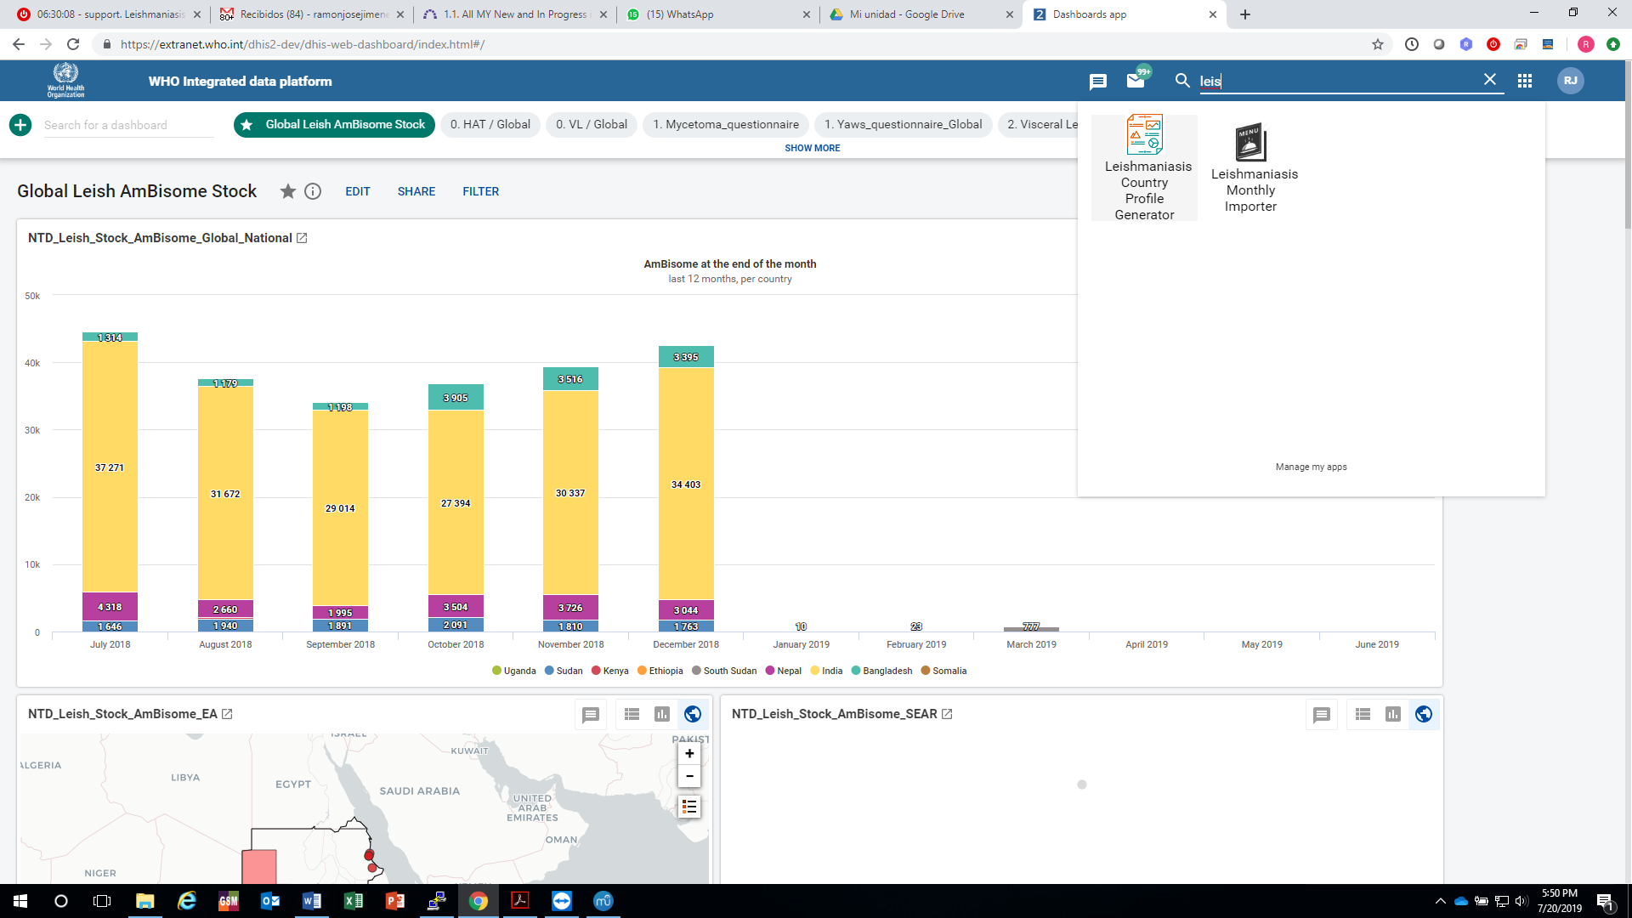

A form box like the following will appear

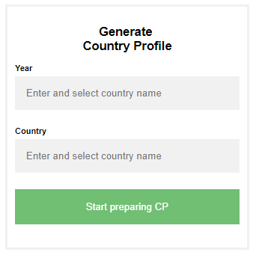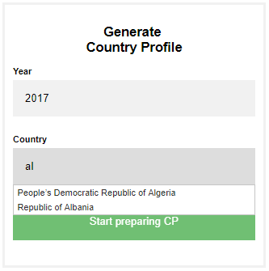

Start typing a year and a country. Once it starts appearing in the list, select it. This selection is needed, otherwise, the system won’t take in account the text you typed.

The LCPG has two main sections: The configuration panel and the country profile itself.

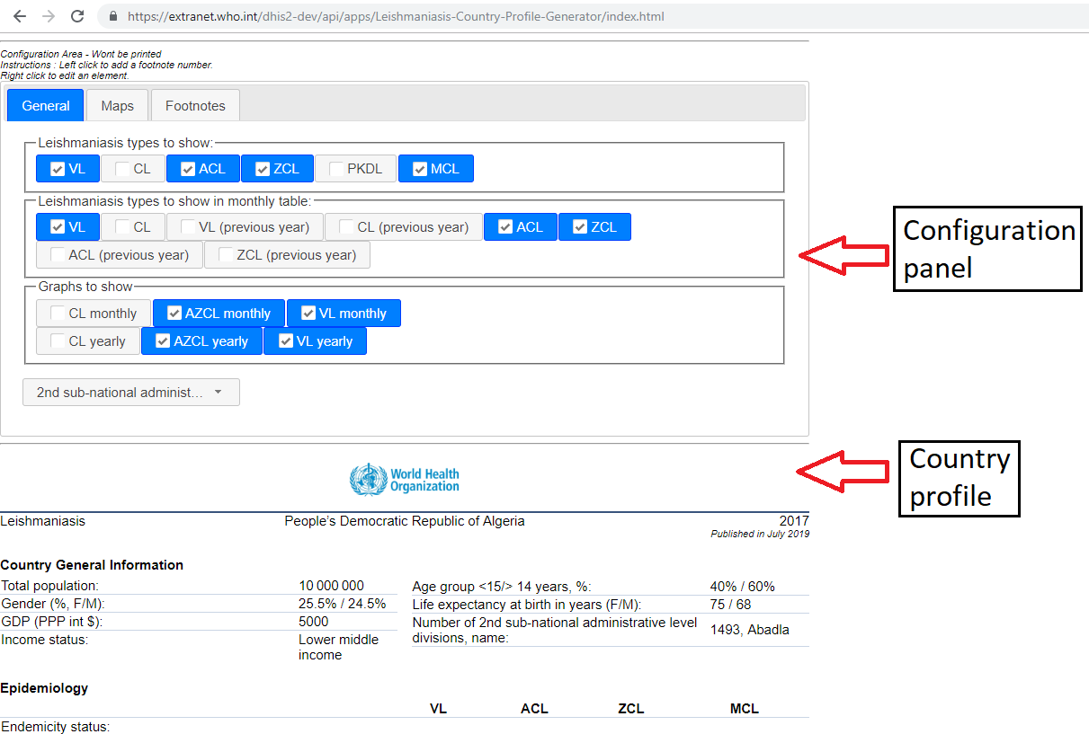

## 2.1 Configuration panel

In this panel you can configure which elements are showing in the CP and how. It has three tabs: General, to manage which types of the disease will appear in the tables, the graphs and the subnational level taken in account; maps to configure maps, legends and “notas bene”; and Footnotes, to manage which footnotes will appear in the CP.

### 2.1.1 General

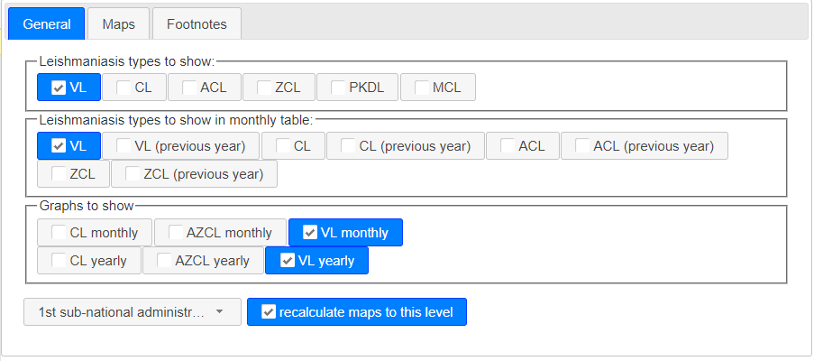

Leishmaniasis types to show are checked if, at least, one leishmaniasis dataset of this type (VL, CL or ACL/ZCL) is assigned to the country. PKDL and MCL are unchecked by default.

The behavior is the same in the monthly table checkboxes except for previous years, whose checkboxes are by default unchecked.

The graphs checkboxes follow also the same logic.

The subnational level dropdown menu is set, by default, to the first subnational level. Changing it to 2nd or 3rd subnational level will update:

* The “Number of endemic X sub-national…” row text-and-value in the Country General Information section.
* The “Number of endemic X sub-national…” row text-and-value in the Epidemiology section.
* All the maps if the “recalculate maps to this level” checkbox is checked.

### 2.2.2 Maps

As in the previous tab, the maps checkboxes follow the same logic of the previous other checkboxes.

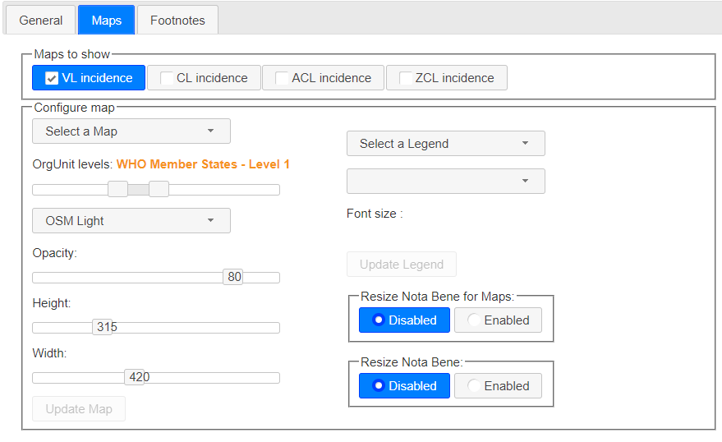

To update a map, select a map name on the dropdown. Select the deepest subnational level you want to see drawn in the map. You can select also the background layout, the opacity, the height and the width. Click “Update Map” once you finished the configuration.

You can relocate and resize the legend within the map. To do that, select a legend on the right dropdown menu. You will see appear the legend at right. You can resize it, edit the text or select the corner where it will be shown. Click “Update Legend” to apply changes.

Size of the two “Nota Bene” in the CP are locked by default. You may enable this feature to adapt the size of the box to the content or the location. Remember putting them back to “disabled” once you have finished.

### 2.2.3 Footnotes

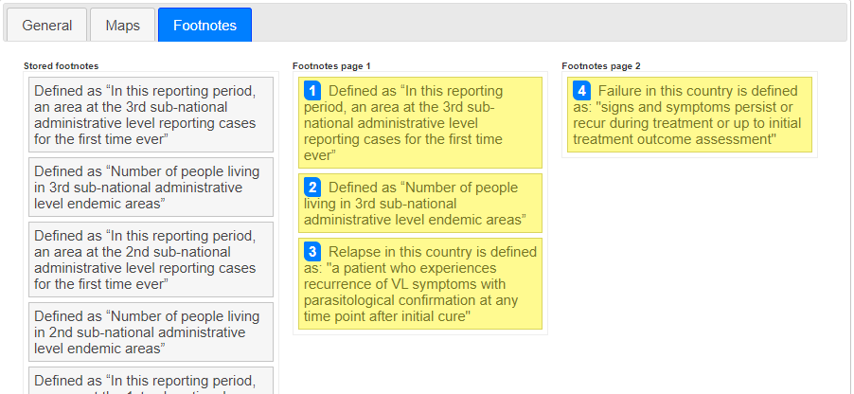

In this section you organize the footnotes stored in and got from the footnote program.

To move one footnote from one page to another or to remove from the CP, just drag and drop it in the correct box. You can reorder them within the box. The footnote index will be accordingly updated. However, the index you put in the CP text are not “linked” to these footnotes: It’s up to you to make sure the reference and the index match.

## 2.2 Country profile

### 2.2.1 Texts to update before printing

Two texts in CP are generated but must be verified before printing. Those text are highlighted in red and, as described in 2.2.2 section, can be modified and its color changed to black. The texts are:

Name of the division levels: The system, takes, as example, the first subdivision level found, but this text should be updated to its specific category name (region, district, department, upazilla… etc).

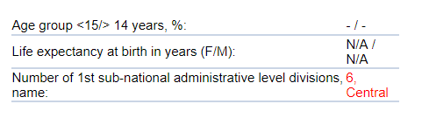

Title on maps: The text in red is automatically changed when you check or uncheck the maps, checkboxes. Just, verify the title is correct and change the color to blue.



### 2.2.2 Edit elements in the CP

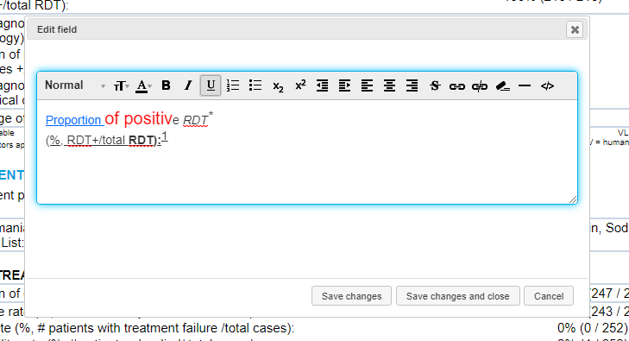

You can edit almost any text in the CP. To do that, just right click on the element and an edit field box will pop up. You can change the text, color, size, text style, add hyperlinks, etc.

### 2.2.3 Footnote elements in the CP

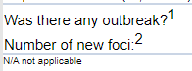You can footnote almost any element of the CP by left clicking on the element. A footnote index (1 for first clicked element) will be added to the element. The next element will be footnoted with the number “2” and so on. If you want to remove a footnote index, just left click again on it. It’s better to remove all higher footnote indexes first, to keep a logic sequence of indexes.

### 2.2.4 Arrange maps and charts

Charts and maps can be moved by clicking on them and moving the mouse to the desired location.  
In addition, maps can be zoomed in and its content moved up, down, left or right. However, they cannot be zoomed out for the instance. If you need to reset a map, just go to the maps section in the configuration zone, select the map and click on “Update map”.

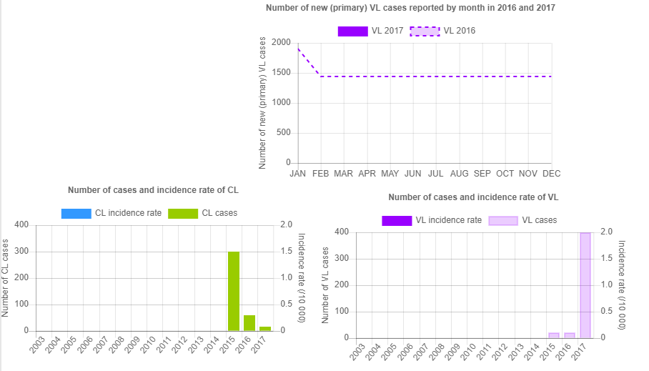 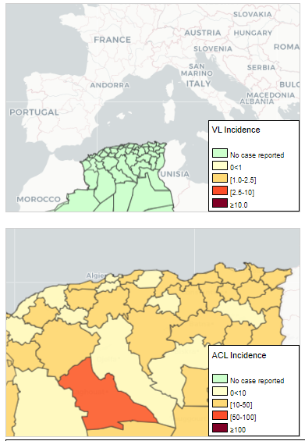

### 2.2.5 Printing the CP or saving it as PDF

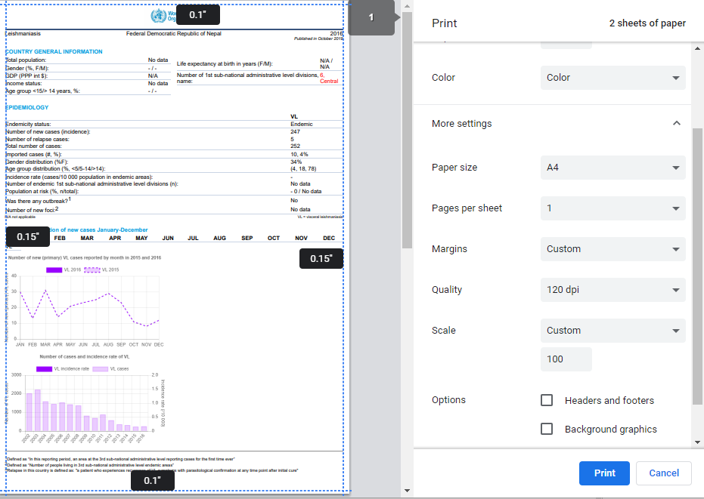In order to generate the PDF version of the CP, click ctrl+P. You can adjust the final with the parameters: paper size (A4) scale (normally 100%), margins (minimum or custom). Select your printer or the option “Save as PDF”.

# Source of information in country profile sections

## Country general information section

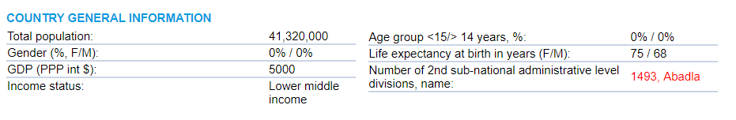

B7

B6

B5

B4

B2

B3

B1

|  |  |  |  |  |
| --- | --- | --- | --- | --- |
| **CODE** | **DataSet / Program** | **DataElement / Indicator** | **CatCombos / comments** | |
| B1 | DS_GeneralInformation | GEN_UN_WPP_Pop_Tot_1000 * 1000 | It shows “No data” if no data value found. | |
| B2 | DS_GeneralInformation | GEN_UN_WPP_Pop_Tot_AgeSex_1000  /  B1 | |  |  | | --- | --- | | name | id | | Under 5y, Female | o7NkWl5xFuS | | 5 to 9 y, Female | xodN5e1QCp6 | | 10-14yr, Female | oic7kU2uVtJ | | 15 to 19 y, Female | adEelGXyPIn | | 20 to 24 y, Female | SobJ4FGuBRA | | 25 to 29 y, Female | qdWOgC6bbBi | | 30 to 34 y, Female | IVFKF7NzjJa | | 35 to 39 y, Female | Jkrg1KI25AV | | 40 to 44 y, Female | i6rBoDsk4LE | | 45 to 49 y, Female | irBgvZTT9zq | | 50 to 54 y, Female | B2cV93OdJpI | | 55 to 59 y, Female | nJEkgZS74Tt | | 60 to 64 y, Female | RJDdLqVGxu8 | | 65 to 69 y, Female | ECle1XHoHZ2 | | 70 to 74 y, Female | Gh29gSpSYPp | | 75 to 79 y, Female | zvECz1sg3sj | | 80 to 84 y, Female | BO8BiFA6WZo | | 85 to 89 y, Female | hI8wdaiRHaS | | 90 to 94 y, Female | kH3O17Sezfp | | 95 to 99 y, Female | nHBTtdVMe7l | | 100 y and over, Female | gkeN62eQlSA | | |
| |  |  | | --- | --- | | name | id | | Under 5y, Male | gWsMlGpOSzY | | 5 to 9 y, Male | lptUC1gVg8o | | 10-14yr, Male | o8dMMqNDCtr | | 15 to 19 y, Male | xdAhLef7xG4 | | 20 to 24 y, Male | ZYAx6PjJ2ZM | | 25 to 29 y, Male | AJkBK9XBytM | | 30 to 34 y, Male | xsUkVS0PK0u | | 35 to 39 y, Male | VwZsMBUBdR1 | | 40 to 44 y, Male | XucrdYEMOE7 | | 45 to 49 y, Male | BvCWyIwIqa8 | | 50 to 54 y, Male | RwwDYedBcDl | | 55 to 59 y, Male | xaMRyDOevEu | | 60 to 64 y, Male | Ss3gp5wAYOQ | | 65 to 69 y, Male | a2dH289sMou | | 70 to 74 y, Male | C0VIpje6ADR | | 75 to 79 y, Male | MKDYDGdryXB | | 80 to 84 y, Male | BpI46BM32FB | | 85 to 89 y, Male | avCYQARWeei | | 90 to 94 y, Male | PKDfpYDkyoy | | 95 to 99 y, Male | kXo51Sydk1t | | 100 y and over, Male | ttAEJltz1yh | | |
| B3 | DS_GeneralInformation | NY.GDP.PCAP.PP.CD |  |  |
| B4 | DS_GeneralInformation | GEN_WB_IncomeGroup |  |  |
| B5 | DS_GeneralInformation | GEN_UN_WPP_Pop_Tot_AgeSex_1000 | As B2, but also those Gender Unknown.  Left: Under 5y, 5 to 9 y, 10-14yr  Right: All the others. |  |
| B6 | DS_GeneralInformation | GEN_UN_WPP_LifeExpBirth_Female  GEN_UN_WPP_LifeExpBirth_Male |  |  |
| B7 | Number of subdivisions in the orgUnitTree for the current country at the selected level. The name is the first occurrence found in the orgUnitTree. | | | |

## 3.2 Epidemiology section

C11

C12

C10

C9

C8

C7

C6

C5

C4

C2

C3

C1

See detailed descriptions on table on next page. Codes are used when possible. Names or names and UIDs otherwise.

|  |  |  |  |  |  |
| --- | --- | --- | --- | --- | --- |
| CODE | **DataSet** | **DataElement / Indicator** | **CatCombos / Comments** | | |
| C1 | GHO_NTDs | NTD_LEISHVEND  NTD_LEISHCEND  NTD_LEISHACEND  NTD_LEISHZCEND  NTD_LEISHMCEND  NTD_LEISHPKDLEND | - | It replaces the numeric code (1,3 or 5) by “Endemic”, “Previously endemic” or “Non endemic”. It shows “Error!” if other code is found. | |
| C2 | DS_VL_Detailed_Annual  DS_VL_Simple_Annual  GHO_NTDs | VL_EPI_Type | New  (default for PKDL and MCL) | It shows “No data” if no data found in the system. | |
| DS_CL_Detailed_Annual  DS_CL_Detailed_Monthly  DS_CL_Simple_Annual  GHO_NTDs | CL_EPI_Type MCL_GEN_EPID_cases |
| DS_ACL/ZCL_Detailed_Annual | ACL_EPI_Type ZCL_EPI_Type |
| DS_VL_Detailed_Annual DS_VL_Simple_Annual | PKDL_GEN_EPID_cases |
| C3 | *As C2 for each DE | VL_EPI_Type  CL_EPI_Type ACL_EPI_Type  ZCL_EPI_Type | Relapse  (N/A for PKDL and MCL) | It shows “No data” if no data found in the system. | |
| C4 | *As C2 for each DE | VL_EPI_Type CL_EPI_Type ACL_EPI_Type  ZCL_EPI_Type  PKDL_GEN_EPID_cases  MCL_GEN_EPID_cases | New  Relapse  Type unspecified  (default for PKDL and MCL) | It shows “No data” if no data found in the system. | |
| C5 | DS_VL_Simple_Annual  DS_VL_Detailed_Annual | VL_EPI_Type_Origin | New, Autochthonous  Relapse, Autochthonous  Type unspecified, Autochthonous  New, Imported  Relapse, Imported  Type unspecified, Imported  New, Origin unknown  Relapse, Origin unknown  Type unspecified, Origin unknown  LCPG shows - instead XY% if it was not able to calculate percentage. | | |
| DS_CL_Detailed_Annual  DS_CL_Detailed_Monthly  DS_CL_Simple_Annual | CL_EPI_Type_Origin |
| DS_ACL/ZCL_Detailed_Annual | ACL_EPI_Type_Origin |
| ZCL_EPI_Type_Origin |
| C6 | DS_VL_Detailed_Annual | VL_EPI_Type_Gender | name="New, Female" id="TtoYCIVcBA3"  name="New, Gender Unknown" id="FaYhAlKLX16"  name="New, Male" id="GpQZH8hC7jY"  name="Type unspecified, Female" id="wGED4K5Bs37"  name="Type unspecified, Gender Unknown" id="zkKbIIarKWM"  name="Type unspecified, Male" id="aWWYWv6buzp"  LCPG shows - instead XY% if it was not able to calculate percentage. | | |
| DS_CL_Detailed_Monthly  DS_CL_Detailed_Annual | CL_EPI_Type_Gender |
| DS_ACL/ZCL_Detailed_Annual | ACL_EPI_Type_Gender |
| ZCL_EPI_Type_Gender |
| DS_VL_Detailed_Annual | PKDL_EPID_sex | name="Female" id="V2LdgcGgFQt"  name="Gender Unknown" id="jNbFhhnUsQv"  name="Male" id="Z2hvpF7mhh7"  LCPG shows - instead XY% if it was not able to calculate percentage. | | |
| DS_CL_Detailed_Monthly  DS_CL_Simple_Annual  DS_CL_Detailed_Annual | MCL_EPID_sex |
| C7 | DS_VL_Detailed_Annual | VL_EPI_Type_Age | name="New, 15 y and over" id="DDliBAHqwGV"  name="New, 5 to 14 y" id="mTyLqDjpQ5b"  name="New, Age Unknown" id="dVuOzmU4xbI"  name="New, Under 5y" id="hKq5WASZw8q"  name="Type unspecified, 15 y and over" id="UQMTeRPY2U0"  name="Type unspecified, 5 to 14 y" id="P6R9XEaqQbz"  name="Type unspecified, Age Unknown" id="nIbrdHllMKh"  name="Type unspecified, Under 5y" id="rZwYGlqR8GG" | | |
| DS_CL_Detailed_Monthly  DS_CL_Detailed_Annual | CL_EPI_Type_Age |
| DS_ACL/ZCL_Detailed_Annual | ACL_EPI_Type_Age |
| ZCL_EPI_Type_Age |
| DS_VL_Detailed_Annual | PKDL_EPID_age | name="15 y and over" id="rN9ELJVdEpo"  name="5 to 14 y" id="moktBQGym51"  name="Age Unknown" id="gPGNI7bWhDB"  name="Under 5y" id="HDXcEOGT2s1" | | |
| DS_CL_Detailed_Monthly  DS_CL_Simple_Annual  DS_CL_Detailed_Annual | MCL_EPID_age |
| C8 | - | Value in C2 * 10000 / population at risk (numerator at C10) | If population at risk is 0, the incidence text shows N/A.  N/A for PKDL and MCL. | | |
| C9 | Leishmaniasis endemicity | DET_VL_endemicity_WHO  DET_CL_endemicity_WHO  DET_ACL_endemicity_WHO  DET_ZCL_endemicity_WHO | Gets the count of orgUnits at the selected subnational level in **CODEHERE** having “1” as value for the dataElement and year.  N/A for PKDL and MCL. | | |
| C10 | - | VL_POP_AT_RISK_I  CL_POP_AT_RISK_I  ACL_POP_AT_RISK_I  ZCL_POP_AT_RISK_I | Adds all the values at selected subnational level in **CODEHERE**. The indicator value is GEN_pop_Leish if the corresponding PI XXX_endemicity_WHO_factor1_PI equals 1. The indicator value is 0 otherwise.  LCPG shows - instead XY% if it was not able to calculate percentage.  N/A for PKDL and MCL. | | |
| DS_GeneralInformation | B1 | Total population is same value as B1 | | |
| C11 | DS_VL_Simple_Annual  DS_VL_Detailed_Annual | VL_GEN_EPID_outbreak | default | | Converts the boolean value to Yes/No text.  N/A for PKDL and MCL. |
| DS_CL_Detailed_Annual  DS_CL_Simple_Annual | CL_GEN_EPID_outbreak |
| DS_ACL/ZCL_Detailed_Annual | ACL_GEN_EPID_outbreak  ZCL_GEN_EPID_outbreak |
| C12 | DS_VL_Simple_Annual  DS_VL_Detailed_Annual | VL_GEN_EPID_new focus | default | | N/A for PKDL and MCL. |
| DS_CL_Detailed_Annual  DS_CL_Simple_Annual | CL_GEN_EPID_new focus |
| DS_ACL/ZCL_Detailed_Annual | ACL_GEN_EPID_new focus  ZCL_GEN_EPID_new focus |

## 3.3 Monthly distribution of new cases January-December section

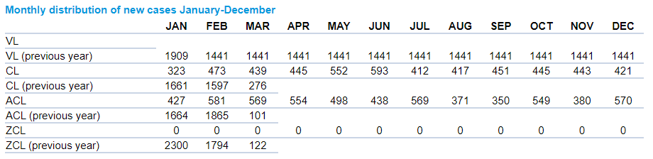

D1

D2

D4

D3

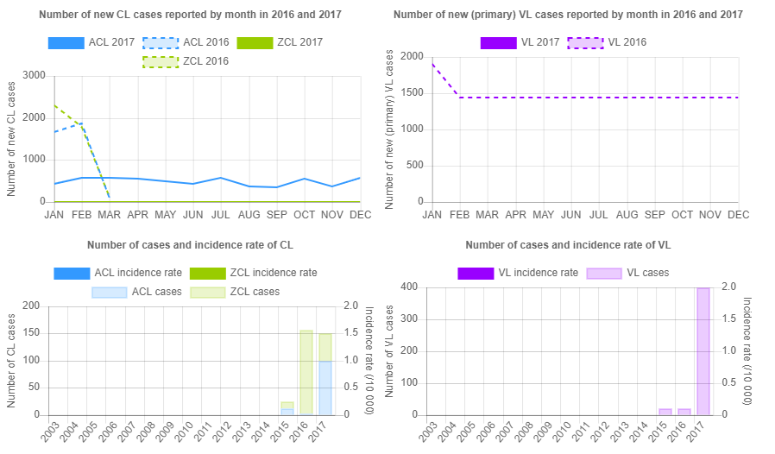

D5

D5

D4

D3

D1

|  |  |  |
| --- | --- | --- |
| CODE | **Program** | **DataElement** |
| D1 | VL_cases_by provenance | VL_cases_byProvenance_T |
| D2 | CL_cases_by provenance | CL_cases_byProvenance_T |
| D3 | ACL_cases_byProvenance_T |
| D4 | ZCL_cases_byProvenance_T |

|  |  |  |  |
| --- | --- | --- | --- |
| CODE | **DataSet** | **DataElement / Indicator** | **CatCombos / Comments** |
| D5 | Same as in C2 | VL_EPI_Type  CL_EPI_Type  ACL_EPI_Type  ZCL_EPI_Type | Same as in C2, but data is retrieved from Analytics for last 15 years instead from raw data. |

Incidence rates

|  |  |  |  |
| --- | --- | --- | --- |
| **INDICATOR** | **Numerator** | **denominator** | **Comments** |
| IA_VL_EPI_INC_PopUN_10000 | VL_cases_byProvenance_T | GEN_UN_WPP_Pop_Tot_1000 * 1000 | **indicatorType:** Per ten thousand |
| IA_CL_EPI_INC_PopUN_10000 | CL_cases_byProvenance_T |
| IA_ACL_EPI_INC_PopUN_10000 | ACL_cases_byProvenance_T |
| IA_ZCL_EPI_INC_PopUN_10000 | ZCL_cases_byProvenance_T |

## 3.4 Maps section

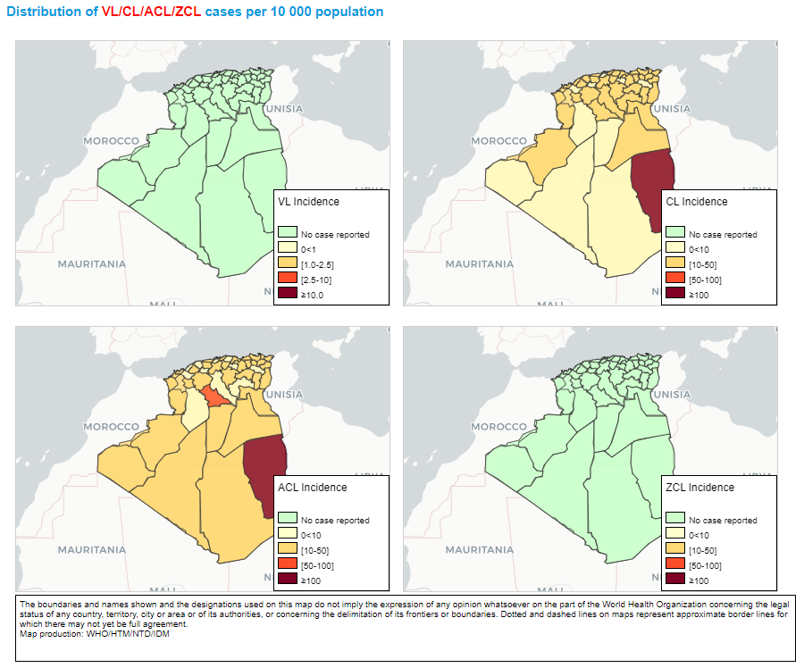

|  |  |  |  |
| --- | --- | --- | --- |
| **INDICATOR** | **Numerator** | **denominator** | **Comments** |
| VL_EPI_INC_PopData_LSH_10000 | VL_cases_byProvenance_T | GEN_pop_Leish  (In Population data dataset) | **indicatorType:** Per ten thousand |
| CL_EPI_INC_PopData_LSH_10000 | CL_cases_byProvenance_T |
| ACL_EPI_INC_PopData_LSH_10000 | ACL_cases_byProvenance_T |
| ZCL_EPI_INC_PopData_LSH_10000 | ZCL_cases_byProvenance_T |

|  |  |  |  |  |
| --- | --- | --- | --- | --- |
| **LEGENDSET name** | **Legend Name** | **startValue** | **endValue** | **Color** |
| VL_INCIDENCE_LEGEND_0_10 | No case reported | 0.0 | 0.001 | #CCFFCC |
| 0<1 | 0.001 | 1.0 | #FFFFCC |
| [1-2.5] | 1.0 | 2.5 | #FED976 |
| [2.5-10] | 2.5 | 10.0 | #FC4E2A |
| ≥10 | 10.0 | 10000.0 | #800026 |
| CL_INCIDENCE_LEGEND_0_100  ACL_INCIDENCE_LEGEND_0_100  ZCL_INCIDENCE_LEGEND_0_100 | No case reported | 0.0 | 0.001 | #CCFFCC |
| 0<10 | 0.001 | 10.0 | #FFFFCC |
| [10-50] | 10.0 | 50.0 | #FED976 |
| [50-100] | 50.0 | 100.0 | #FC4E2A |
| ≥100 | 100.0 | 10000.0 | #800026 |

## 3.5 Control and surveillance section

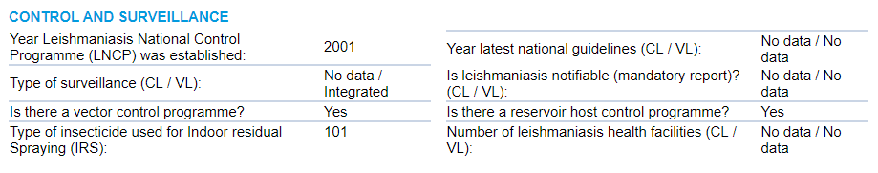

G8

G5

G7

G6

G4

G3

G2

G1

|  |  |  |  |
| --- | --- | --- | --- |
| CODE | **DataSet** | **DataElement / Indicator** | **Comments** |
| G1 | DS_VL_Detailed_Annual  DS_CL_Detailed_Annual  DS_ACL/ZCL_Detailed_Annual | Leish_GEN_LNCP_year | It shows “No data” when no entry found in the system. |
| G2 | DS_CL_Detailed_Annual | CL_GEN_Surv_Type | Converts codes into texts:  1: Vertical  2: Integrated  7: Other  8: Non-applicable  9: Unknown |
| DS_VL_Detailed_Annual | VL_GEN_Surv_Type |
| G3 | DS_CL_Detailed_Annual  DS_ACL/ZCL_Detailed_Annual  DS_VL_Detailed_Annual | Leish_GEN_VectorControl | Converts codes into texts:  1: Yes  2: No  9: Unknown |
| G4 | Leish_GEN_VectorControl_Insecticide | It shows “No data” when no entry found in the system. |
| G5 | DS_ACL/ZCL_Detailed_Annual  DS_CL_Detailed_Annual | CL_GEN_Guidelines_year | It shows “No data” when no entry found in the system. |
| VL_GEN_Guidelines_year | VL_GEN_Guidelines_year |
| G6 | DS_CL_Detailed_Annual  DS_ACL/ZCL_Detailed_Annual | CL_GEN_Surv_Notif | Converts codes into texts:  1: Yes  2: No  9: Unknown |
| DS_VL_Detailed_Annual | VL_GEN_Surv_Notif |
| G7 | DS_CL_Detailed_Annual  DS_ACL/ZCL_Detailed_Annual  DS_VL_Detailed_Annual | Leish_GEN_ReservoirControl | Converts codes into texts:  1: Yes  2: No  9: Unknown |
| G8 | DS_CL_Detailed_Annual | CL_GEN_Surv_HF | It shows “No data” when no entry found in the system. |
|  | VL_GEN_Surv_HF |

## 3.6 Diagnosis section

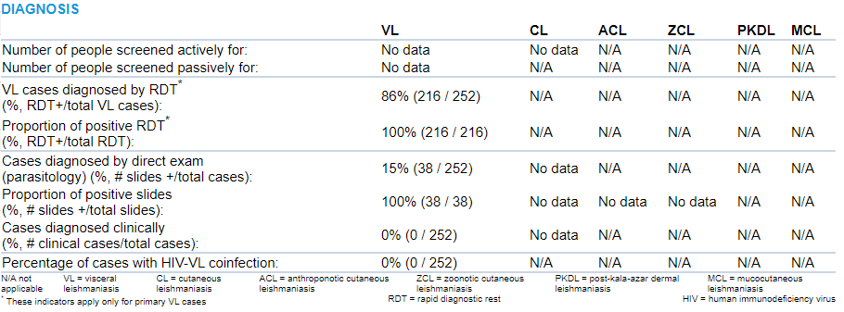

H1

H2

H3

H4

H5

H7

H6

H8

|  |  |  |  |  |
| --- | --- | --- | --- | --- |
| CODE | **DataSet** | **DataElement / Indicator** | **CatCombos / Comments** | |
| H1 | DS_VL_Detailed_Annual | VL_SCREEN_active | - | N/A for PKDL and MCL |
| DS_CL_Detailed_Monthly  DS_CL_Detailed_Annual | CL_SCREEN_active |
| DS_ACL/ZCL_Detailed_Annual | ACL_SCREEN_active  ZCL_SCREEN_active |
| H2 | DS_VL_Detailed_Annual | VL_SCREEN_passive | - | this DE is assigned to the dataset but it’s not in the form! |
| DS_CL_Detailed_Monthly  DS_CL_Detailed_Annual | CL_SCREEN_passive | - | This DE is not assigned to the dataset ! |
| DS_ACL/ZCL_Detailed_Annual | ACL_SCREEN_passive  ZCL_SCREEN_passive | - | these DE are assigned to the dataset but they are not in the form!  N/A for PKDL and MCL |
| H3 | DS_VL_Detailed_Annual | VL_Lab_RDT_results_type | name="New, Positive" id="jRcT6HVKb2t"  name="Type unspecified, Positive"  id="YXktM46YiXo" | VL_Lab_RDT_results_type  (New + Unsp.)  /  Total new and unsp. cases  N/A for CL (All types) and PKDL. |
| H4 | DS_VL_Detailed_Annual | VL_Lab_RDT_tested_type | name="New" id="psVSPLclyFj"  name="Type unspecified" id="IRW4YrOtk5q" | VL_Lab_RDT_results_type  (New + Unsp.)  /  VL_Lab_RDT_tested_type  (New + Unsp.)  N/A for CL (All types) and PKDL. |
| VL_Lab_RDT_results_type | name="New, Positive" id="jRcT6HVKb2t"  name="Type unspecified, Positive"  id="YXktM46YiXo" |
| H5 | DS_VL_Detailed_Annual | VL_Lab_parasito_tested_type | New  Relapse  Type unspecified | Direct exam diagnosed  /  Total cases (C4) |
| DS_CL_Detailed_Annual  DS_ACL/ZCL_Detailed_Monthly | CL_LAB_parasito_Suspects |
| DS_ACL/ZCL_Detailed_Annual | ACL_Lab_Parasito_Results  ZCL_Lab_Parasito_Results |
| H6 | DS_VL_Detailed_Annual | VL_LAB_parasito_result_type | name="New, Positive" id="jRcT6HVKb2t"  name="Relapse, Positive" id="QKqVJ13mGZI"  name="Type unspecified, Positive"  id="YXktM46YiXo" | Direct exam diagnosed  /  Direct exam diagnoses (numerator on H5) |
| DS_CL_Detailed_Annual  DS_ACL/ZCL_Detailed_Monthly | CL_LAB_Parasito_Results |
| DS_ACL/ZCL_Detailed_Annual | ACL_Lab_Parasito_Results  ZCL_Lab_Parasito_Results |
| H7 | DS_VL_Detailed_Annual | VL_LAB_clinical | New  Relapse  Type unspecified | Clinical cases  /  Total cases (C4) |
| DS_CL_Detailed_Annual  DS_ACL/ZCL_Detailed_Monthly | **NO DATA ELEMENT** |
| DS_ACL/ZCL_Detailed_Annual | **NO DATA ELEMENT**  **NO DATA ELEMENT** |
| H8 | DS_VL_Detailed_Annual | VL_LAB_HIVstatus_Type | name="New, Positive" id="jRcT6HVKb2t"  name="Relapse, Positive" id="QKqVJ13mGZI"  name="Type unspecified, Positive"  id="YXktM46YiXo" | VL_LAB_HIVstatus_Type (New Positive + Relapse Positive + Unsp. Positive)  /  Total cases (C4) |

## 3.7 Treatment and medicines and Treatment Outcome section

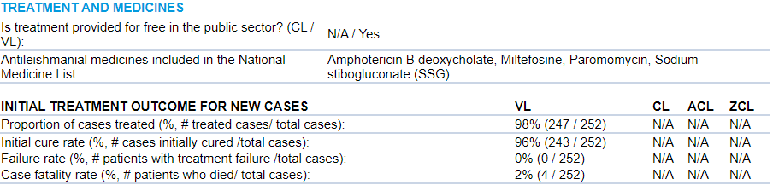

I6

I5

I4

I3

I2

I1

|  |  |  |  |
| --- | --- | --- | --- |
|  |  |  |  |
| I1 | DS_VL_Detailed_Annual | VL_GEN_TxFree | Converts codes into texts:  1: Yes  2: No  9: Unknown |
| DS_CL_Detailed_Annual  DS_ACL/ZCL_Detailed_Annual | CL_GEN_TxFree |
| I2 | DS_VL_Detailed_Annual  DS_CL_Detailed_Annual  DS_ACL/ZCL_Detailed_Annual | Leish_GEN_EML_AmphotericinB  Leish_GEN_EML_LiposomalAmp  Leish_GEN_EML_Meglumine  Leish_GEN_EML_Miltefosine  Leish_GEN_EML_Paromomycin  Leish_GEN_EML_Pentamidine  Leish_GEN_EML_SSG | LCPG retrieves ids and replaced by hardcodes names:  Amphotericin B deoxycholate  Liposomal amphotericin B  Meglumine antimoniate  Miltefosine  Paromomycin  Pentamidine  Sodium stibogluconate (SSG) |
| I3 | DS_VL_Detailed_Annual | VL_TREAT_completed | Treatment completed, New, Ambisome  Treatment completed, New, Antimonials  Treatment completed, New, Other VL drug  Treatment completed, New, SSG + Paramomycin  Treatment completed, New, VL drug unspecified  Treatment completed, Type unspecified, Ambisome  Treatment completed, Type unspecified, Antimonials  Treatment completed, Type unspecified, Other VL drug  Treatment completed, Type unspecified, SSG + Paramomycin  Treatment completed, Type unspecified, VL drug unspecified  Treatment stopped (adverse event, death...), New, Ambisome  Treatment stopped (adverse event, death...), New, Antimonials  Treatment stopped (adverse event, death...), New, Other VL drug  Treatment stopped (adverse event, death...), New, SSG + Paramomycin  Treatment stopped (adverse event, death...), New, VL drug unspecified  Treatment stopped (adverse event, death...), Type unspecified, Ambisome  Treatment stopped (adverse event, death...), Type unspecified, Antimonials  Treatment stopped (adverse event, death...), Type unspecified, Other VL drug  Treatment stopped (adverse event, death...), Type unspecified, SSG + Paramomycin  Treatment stopped (adverse event, death...), Type unspecified, VL drug unspecified  Defaulter, New, Ambisome  Defaulter, New, Antimonials  Defaulter, New, Other VL drug  Defaulter, New, SSG + Paramomycin  Defaulter, New, VL drug unspecified  Defaulter, Type unspecified, Ambisome  Defaulter, Type unspecified, Antimonials  Defaulter, Type unspecified, Other VL drug  Defaulter, Type unspecified, SSG + Paramomycin  Defaulter, Type unspecified, VL drug unspecified  Treatment completion unknown, New, Ambisome  Treatment completion unknown, New, Antimonials  Treatment completion unknown, New, Other VL drug  Treatment completion unknown, New, SSG + Paramomycin  Treatment completion unknown, New, VL drug unspecified  Treatment completion unknown, Type unspecified, Ambisome  Treatment completion unknown, Type unspecified, Antimonials  Treatment completion unknown, Type unspecified, Other VL drug  Treatment completion unknown, Type unspecified, SSG + Paramomycin  Treatment completion unknown, Type unspecified, VL drug unspecified |
| DS_CL_Detailed_Annual | CL_TREAT_completed | Treatment completed, New, Meglumine Antimoniate (glucantime)  Treatment completed, New, Other CL drug  Treatment completed, New, SSG  Treatment completed, New, Treatment Drug Unknown  Treatment completed, Type unspecified, Meglumine Antimoniate (glucantime)  Treatment completed, Type unspecified, Other CL drug  Treatment completed, Type unspecified, SSG  Treatment completed, Type unspecified, Treatment Drug Unknown  Treatment stopped (adverse event, death...), New, Meglumine Antimoniate (glucantime)  Treatment stopped (adverse event, death...), New, Other CL drug  Treatment stopped (adverse event, death...), New, SSG  Treatment stopped (adverse event, death...), New, Treatment Drug Unknown  Treatment stopped (adverse event, death...), Type unspecified, Meglumine Antimoniate (glucantime)  Treatment stopped (adverse event, death...), Type unspecified, Other CL drug  Treatment stopped (adverse event, death...), Type unspecified, SSG  Treatment stopped (adverse event, death...), Type unspecified, Treatment Drug Unknown  Defaulter, New, Meglumine Antimoniate (glucantime)  Defaulter, New, Other CL drug  Defaulter, New, SSG  Defaulter, New, Treatment Drug Unknown  Defaulter, Type unspecified, Meglumine Antimoniate (glucantime)  Defaulter, Type unspecified, Other CL drug  Defaulter, Type unspecified, SSG  Defaulter, Type unspecified, Treatment Drug Unknown  Treatment completion unknown, New, Meglumine Antimoniate (glucantime)  Treatment completion unknown, New, Other CL drug  Treatment completion unknown, New, SSG  Treatment completion unknown, New, Treatment Drug Unknown  Treatment completion unknown, Type unspecified, Meglumine Antimoniate (glucantime)  Treatment completion unknown, Type unspecified, Other CL drug  Treatment completion unknown, Type unspecified, SSG  Treatment completion unknown, Type unspecified, Treatment Drug Unknown |
| DS_ACL/ZCL_Detailed_Annual | ACL_TREAT_completed  ZCL_TREAT_completed |
| I4 | DS_VL_Detailed_Annual  DS_CL_Detailed_Monthly  DS_CL_Detailed_Annual  DS_ACL/ZCL_Detailed_Annual | VL_INIT_ITxO_Drug_Type  CL_ITxO_Tx-route  ACL_ITxO_Tx-drug  ZCL_ITxO_Tx-drug | Ambisome, New, Initial Cure  Ambisome, Type unspecified, Initial Cure  Antimonials, New, Initial Cure  Antimonials, Type unspecified, Initial Cure  Meglumine Antimoniate (glucantime), New, Initial Cure  Meglumine Antimoniate (glucantime), Type unspecified, Initial Cure  Other CL drug, New, Initial Cure  Other CL drug, Type unspecified, Initial Cure  Other VL drug, New, Initial Cure  Other VL drug, Type unspecified, Initial Cure  SSG, New, Initial Cure  SSG + Paramomycin, New, Initial Cure  SSG + Paramomycin, Type unspecified, Initial Cure  SSG, Type unspecified, Initial Cure  Treatment Drug Unknown, New, Initial Cure  Treatment Drug Unknown, Type unspecified, Initial Cure  VL drug unspecified, New, Initial Cure  VL drug unspecified, Type unspecified, Initial Cure |
| I5 | Ambisome, New, Failure  Ambisome, Type unspecified, Failure  Antimonials, New, Failure  Antimonials, Type unspecified, Failure  Meglumine Antimoniate (glucantime), New, Failure  Meglumine Antimoniate (glucantime), Type unspecified, Failure  Other CL drug, New, Failure  Other CL drug, Type unspecified, Failure  Other VL drug, New, Failure  Other VL drug, Type unspecified, Failure  SSG, New, Failure  SSG + Paramomycin, New, Failure  SSG + Paramomycin, Type unspecified, Failure  SSG, Type unspecified, Failure  Treatment Drug Unknown, New, Failure  Treatment Drug Unknown, Type unspecified, Failure  VL drug unspecified, New, FailureVL drug unspecified, Type unspecified, Failure |
| I6 | Ambisome, New, Death  Ambisome, Type unspecified, Death  Antimonials, New, Death  Antimonials, Type unspecified, Death  Meglumine Antimoniate (glucantime), New, Death  Meglumine Antimoniate (glucantime), Type unspecified, Death  Other CL drug, New, Death  Other CL drug, Type unspecified, Death  Other VL drug, New, Death  Other VL drug, Type unspecified, Death  SSG, New, Death  SSG + Paramomycin, New, Death  SSG + Paramomycin, Type unspecified, Death  SSG, Type unspecified, Death  Treatment Drug Unknown, New, Death  Treatment Drug Unknown, Type unspecified, Death  VL drug unspecified, New, DeathVL drug unspecified, Type unspecified, Death |