Leishmaniasis Country Profile Generator

User Manual

The Leishmaniasis Country Profile Generator retrieves country data from several sources for a specific year and puts it in an HTML country profile format ready to print in PDF.

# Starting the process

Look for an app called “Leishmaniasis Country Profile Generator” in the apps bar of the WIDP instance.

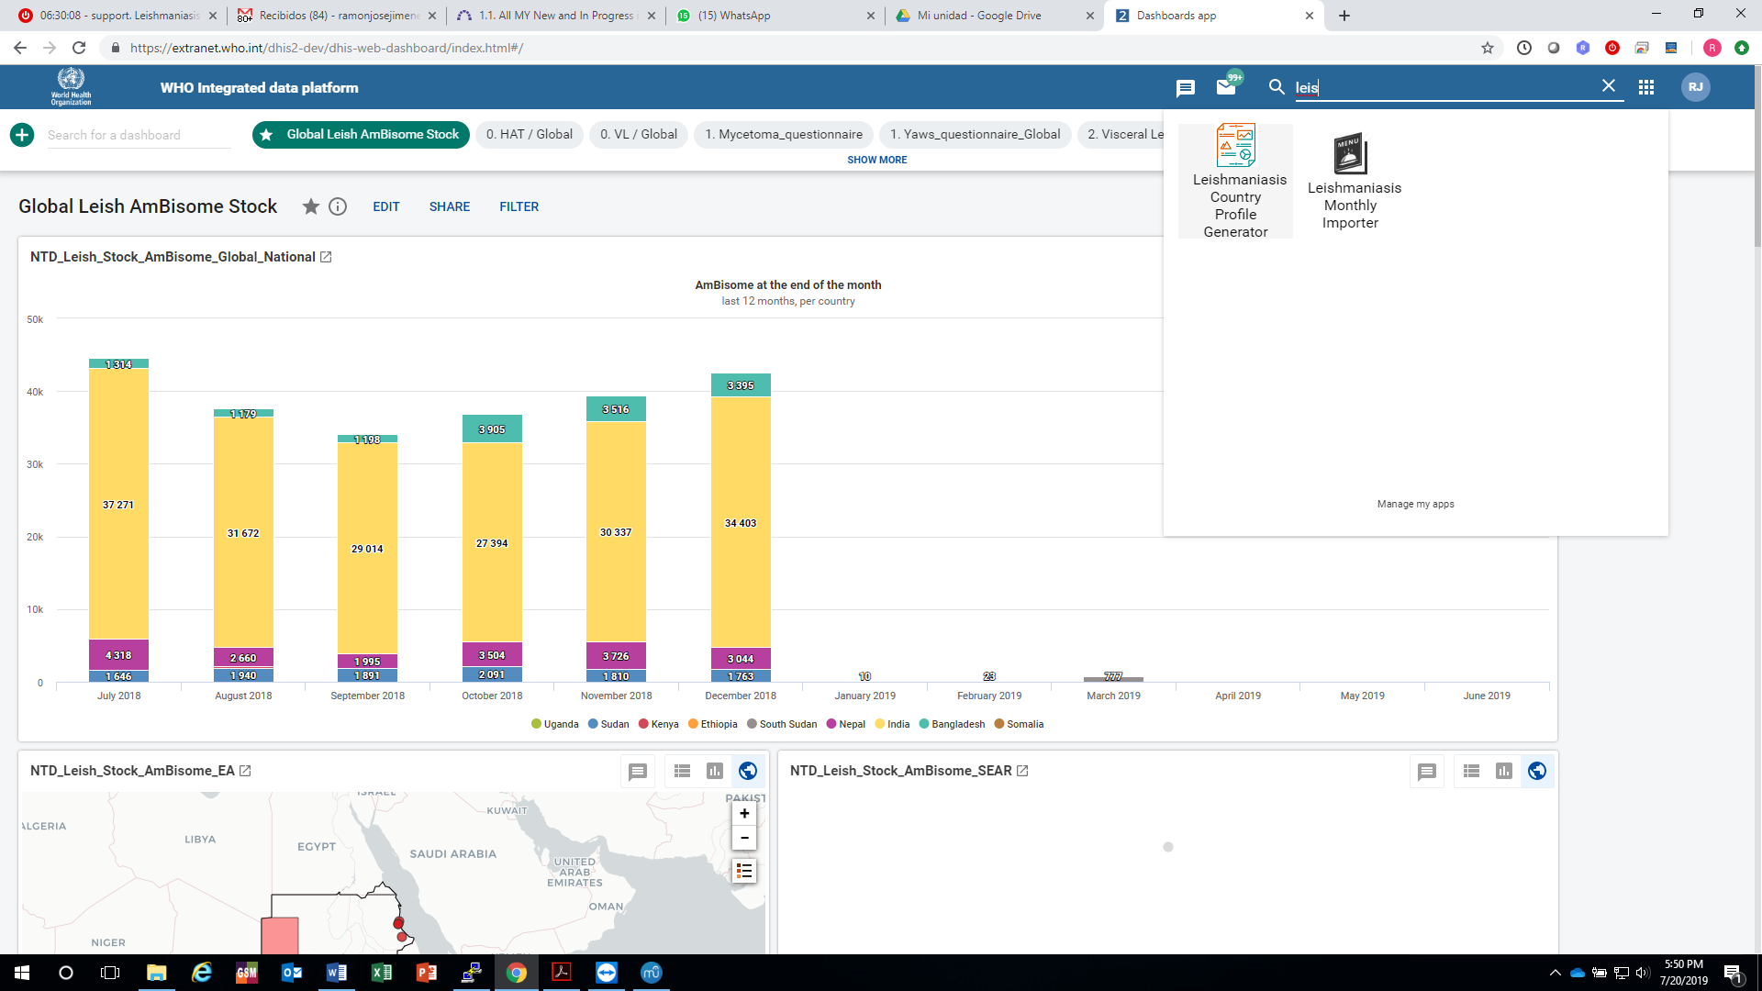

A form box like the following will appear

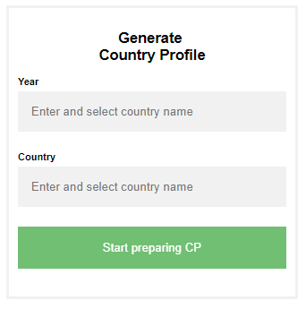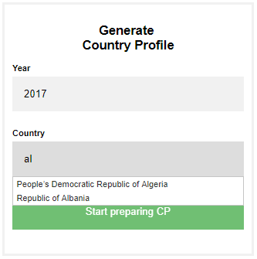

Just start typing a year and a country. Once it starts appearing in the list, select it. This selection is needed, otherwise, the system won’t take in account the text you typed.

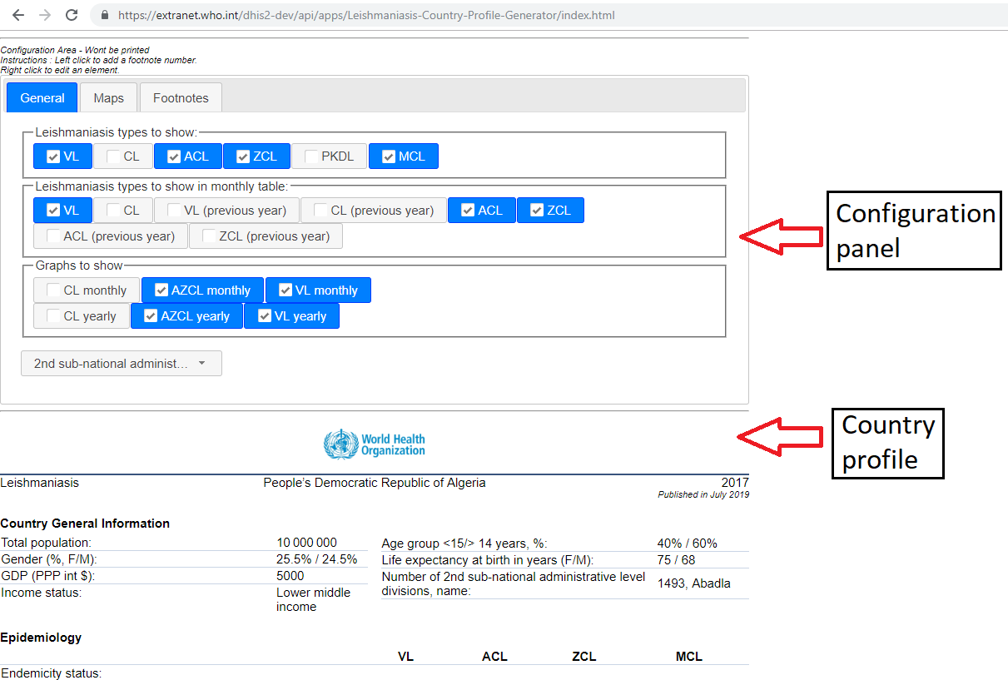

# Source of information in country profile sections

## Country general information section

## Epidemiology section

Endemicity status

It takes it from Endemicity variables in GHO dataset. It replaces the code by “Endemic”, “Previously endemic” or “Non endemic”. It puts “No data” if other code is found or not data found at all.

### Number of new cases (incidence):

Come from CL_EPI_Type, ACL_EPI_Type, ZCL_EPI_Type, MCL_GEN_EPID_cases, , PKDL_GEN_EPID_cases, VL_EPI_Type and CC New

### Number of relapse cases:

Come from CL_EPI_Type, ACL_EPI_Type, ZCL_EPI_Type, VL_EPI_Type and CC Relapse

### Total number of cases:

The App adds the number of new, relapse and (CC) “Type unspecified” cases.

### Incidence rate

New cases / pop_at_risk. If pop at risk is 0, the incidence text shows N/A.

## Monthly distribution of new cases January-December section

The cases come from the variables CL_cases_byProvenance_T, ACL_cases_byProvenance_T ZCL_cases_byProvenance_T and VL_cases_byProvenance_T in programs CL_cases_by provenance (w9hSFsNr3Vh ) and VL_cases_by provenance (i5JSf4ffFl2)

## Charts section

New cases by provenance / PopUN

## Maps section

## Control and surveillance section

### Year Leishmaniasis National Control Programme (LNCP) was established:

DataElement: Leish_GEN_LNCP_year DataSet: DS_VL_Detailed_Annual, DS_CL_Detailed_Annual, DS_ACL/ZCL_Detailed_Annual

### Type of surveillance (CL / VL):

DataElement: CL_GEN_Surv_Type, DataSets: DS_ACL/ZCL_Detailed_Annual, DS_CL_Detailed_Annual

DataElement: VL_GEN_Surv_Type, DataSets: DS_VL_Detailed_Annual

## Diagnosis section

## Treatment and medicines section

## Treatment Outcome section