RECIPE MANAGER Version 0.2013.10.31

Added specifications

- Ingredient description :

- During the ingredient description descriptors defined as ‘Other’ are no longer proposed (shown on the screen) in the pop-up Facet.
- As a result, a red/blue icon will appear next to any pre-entered recipes which contained ingredients described using one or more ‘Other’ descriptors. These specific ingredients will also be identified with a red/blue icon, meaning there is a description problem, and
- To validate the recipe, the ingredients with a red/blue icon will need to be re-described using the available list of descriptors. The icons of the ingredients and of the attached recipe will become blue (meaning no action needed).

- Shadow Management

Introduction :
Up to now the management of shadow items did not properly generate all possible combinations including all synonyms and alternative classifications couples. Moreover the deletion of shadow items was not handled properly either.
That is why the shadow recipe management has been improved. This document describes the approaches for the user in NEW, EDIT and DELETE modes.

Function « Shadow recipe management » in the “Recipe” menu of the Recipe list:

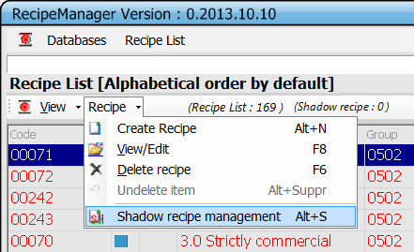

If a user selects the function « Shadow recipe management » the following pop-up appears and the user can create, modify or delete one or more shadow items.
On the top of the pop up the user can read the information relative to the main recipe. The button ‘View Ingr.’ enables to view the recipe ingredients (same approach as before).

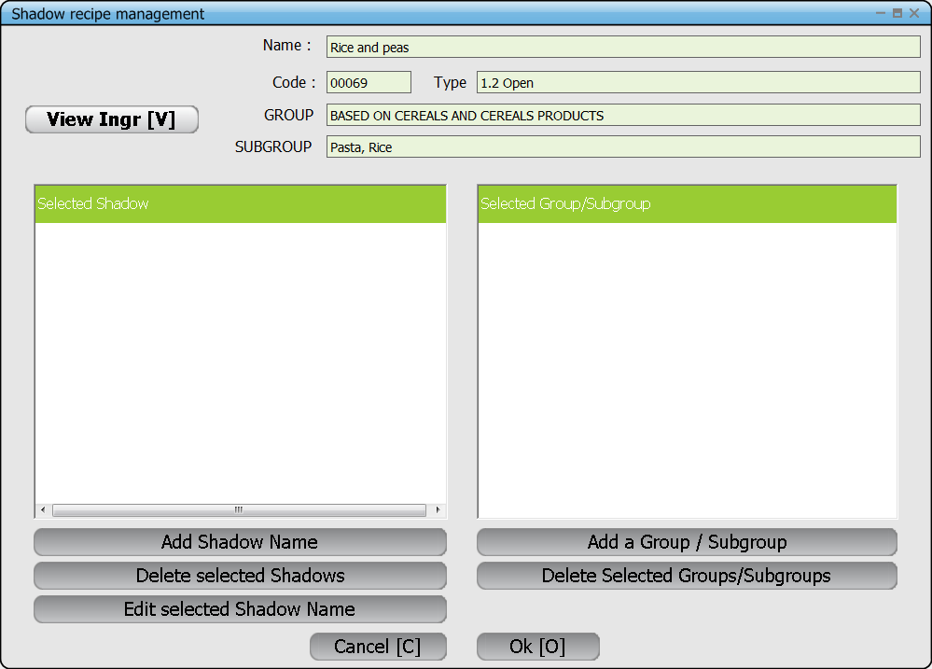

Creation of Shadow items
If no Shadow item exists for a given recipe then when the user selects the function “Shadow recipe management”, in the pop-up the two blocks « Select Shadow » and « Select Group/Subgroup » will appear empty.
Using buttons “Add », the user can create either synonyms (shadow names) or alternative classification(s) for the recipe.

Editing Shadow items
If the user selects the function “Shadow recipe management” after having selected a recipe which already has shadow items, the pop-up will list these shadow names and/or alternative group/subgroups. In the block “Selected shadow» are listed all the synonyms attached to this recipe – different from the main name. In the block « Selected Group/Subgroup » are listed all the alternative groups/sub-groups –different from the main recipe classification listed at the top of the pop up.
- Using the corresponding buttons « Add…. », the user will create either synonyms (shadow names) or alternative classifications.
- Using the corresponding buttons « Delete…. », the user can delete the selected existing synonyms (shadow names) or alternative classifications.
- Using the button « Edit selected Shadow Name», the user can modify a shadow name.

Deleting Shadow items
It is no longer possible to delete a shadow row (no active ‘delete’, nor F6) from the main recipe list. To delete one or more shadow items the user has to be on the main recipe or one of its shadow rows then select the function « Shadow recipe management”.
The pop-up appears with the two blocks containing either the shadow name(s) and/or group/subgroup. Using the buttons « Delete… », the user can delete the selected existing synonyms (shadow names) or alternative classifications.
The program will ask you to confirm before deleting.

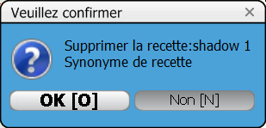

Pop-up ‘Shadow Specification’

- View ingredient:
The button ‘View Ingr.’ enables to view the recipe ingredients with their quantities and percentages ‘as consumed’ :
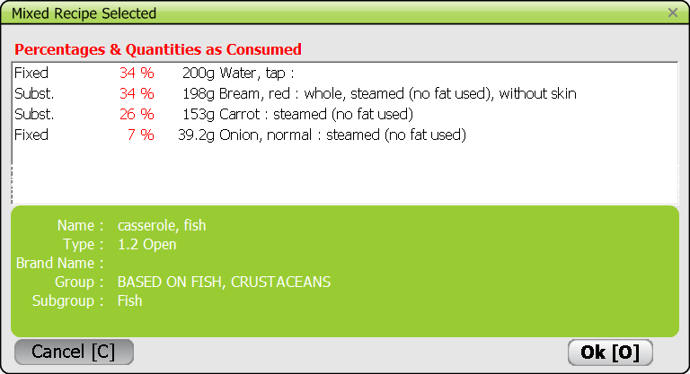

- Add Shadow Name :
By clicking on the button « Add Shadow Name », the following pop-up appears and the user can enter a shadow name. To save the new synonym, the user must choose ‘OK’. To quit without saving, choose ‘Cancel’.
The user can click on the button « Add Shadow Name » as many times as needed to enter all the synonyms. All these names are listed after saving in the left hand block « Selected Shadow ».

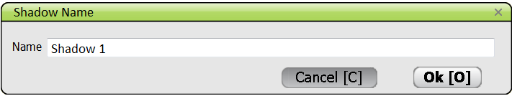
After saving, the new shadow name is listed in the block « Selected Shadow ». Each name is preceded by a tick box which enables to select it for editing.

- Add a Group/subgroup :
By clicking on the button « Add a group/subgroup », the following pop-up appears and the user can select an alternative group/sub-group. To save the new classification, the user must double-click. To quit without saving, press “escape” or click on X in the top right corner.
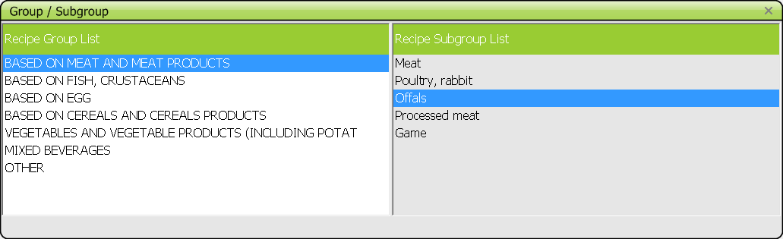

- Delete selected Shadows :
The user selects one or more synonyms to be deleted by ticking the boxes in front of those items. Then by clicking on the button “Delete selected Shadows”, a pop up asks to confirm the deletion:
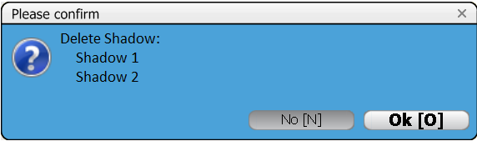
If the user answers « OK » then the selected shadow item(s) is/are deleted.
If the user answers “NO », the pop up ‘Shadow Specification’ is prompted back without changes.

- Delete selected Groups/subgroups :
The user selects one or more alternative group/sub-groups to be deleted by ticking the boxes in front of those items. Then by clicking on the button « Delete selected groups/subgroups”, a pop up asks to confirm the deletion:
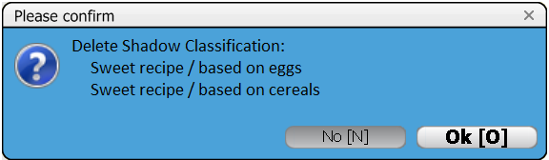
If the user answers « OK » then the selected alternative group/sub-group(s) is/are deleted.
If the user answers “NO », the pop up ‘Shadow Specification’ is prompted back without changes.

- Edit seleted Shadow Name :
The user selects one or more synonyms to be edited/modified by ticking the boxes in front of those items. Then by clicking on the button “Edit selected Shadow Name”, the following pop-up appears with the existing name to be modified. The user can modify the shadow name and save it by pressing “OK”. By pressing “Cancel” no modifications will take place.

After saving, the modified shadow name is listed in the block « select Shadow ».

- Final OK or Cancel (all) :
Once the shadow item handling is finished for a recipe, to confirm the changes, the user has to leave the pop-up “Shadow recipe management” by saving with “OK”.
By clicking on the “Cancel” button, the changes you made to either shadow names or groups will not be saved in main recipe screen even though you saved them in the pop up: no changes will be taken into account AT ALL and the names will be as before you selected the function!
Cancel button : If the user chooses « Cancel », nothing at all is modified for that recipe and the screen Recipe list is shown.
OK button : If the user chooses “OK » then :
- All previous shadow items of that recipe are deleted from the list
- All the shadows items are newly created as defined in the pop-up “Shadow recipe management” by taking into account all possible combinations. See rules below.
- The Recipe list screen is shown with the new shadow items.

- Rules to create all shadow items attached to a main recipe :
For example, for a given main recipe called « Main recipe (new) » classified in 08 02 « Sweet recipe / based on fruits » different shadow items will be created with the same recipe code as the main recipe.

- Case of 1 new shadow name – no alternative classification :
  - One shadow item is created with the new name

- Case of several new shadow names – no alternative classification:
  - One shadow item (row) is created for each new name (2 new names => 2 Shadow items)
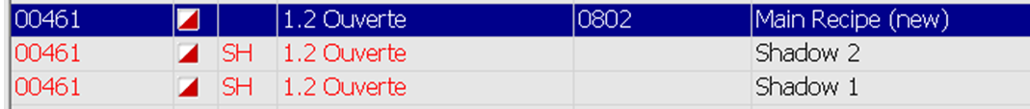

- Case of no new shadow name and 1 alternative classification :
  - One shadow item (row) is created with the same name as the main recipe but having the alternative classification :

- Case of no new shadow name and several alternative classifications:
  - One shadow item (row) is created for each new classification of a recipe having the same name as the main recipe (2 alternative classifications => 2 Shadow items) :
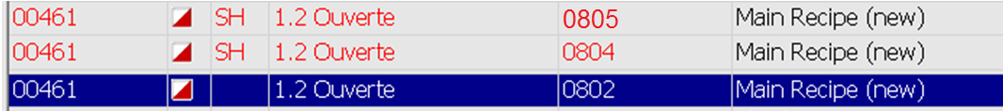

- Case of several shadow names and several alternative classifications:
  - All possible combinations of names (including the main recipe name) and alternative classifications (including that of the main recipe) are created.
For example, if the pop-up “Shadow Specification” looks like this :
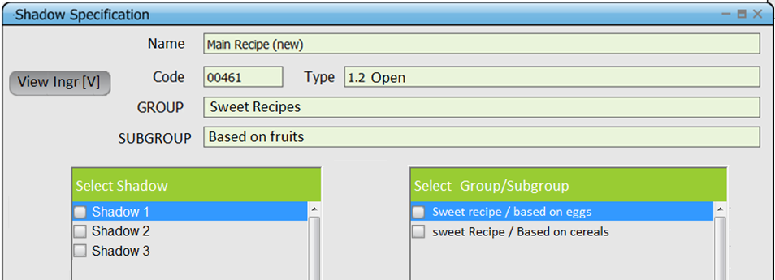

Then 11 Shadows items are created :
    - 3 with the existing classification (1 per shadow name)
    - 4 for the classification 0801 (for the 3 shadow names + the main recipe name)
    - 4 for the classification 0804 (for the 3 shadow names + the main recipe name)
At the end, the Recipe list screen shows:
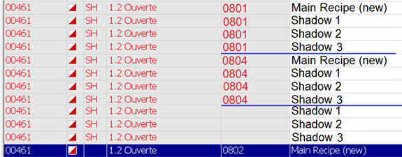

- Particular case : no shadow name and no alternative classification :
If after the management of the recipe shadows, the two blocks of the pop-up « Shadow recipe management » are empty when the user selects “OK” then
  - If there was no shadow item for that recipe, the Recipe list screen is shown;
  - If there was at least one shadow item for that recipe then a pop-up ask to confirm the deletion of existing shadow items (without creating new ones) :
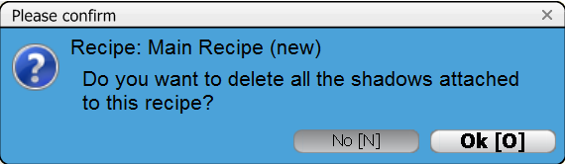
    - If the user answers « YES », all the existing shadow items are deleted and the Recipe list screen is shown
    - If the user answers “NO », all the existing shadow items are kept and the Recipe list screen is shown containing the shadow items.

