

General Functional Specification
For e-SMP

dttanh

Version: 02b

Revision History
Date | Version | Description | Author
30/08/2011 | 01a | Create new | ITeal
29/11/2011 | 01b | Update with the Proposal (SC, Language...) | ITeal
05/12/2011 | 001 | Official SFG → To be delivered | ITeal
24/12/2011 | 02a | Update with CIRC’s comment:  Replace “Reuse Data”  Remove some unecessrary items  Remove some parts that are discussing at detail level  Answer CIRC’s question | ITeal
31/01/2012 | 02b | Answer CIRC’s question  Copy from SRS-EMP-IM-01 | ITeal

Table of Contents
Revision History 2
Table of Contents 3
List of Tables 8
List of Figures 9
List of Figures 9
1. PROJECT DOCUMENT 10
1.1 SPECIFICATION 10
1.2 OTHER REFERENCE 10
2. Abbreviations 11
3. Introduction 12
4. System Overview 13
4.1 Modules 13
4.2 Database Structure 14
5. General Requirement 16
5.1 Online Help 16
5.1.1 Search 16
5.1.2 Search Criteria 16
5.1.3 Search results 17
5.2 Multi-Language 19
5.2.1 EMP’s interfaces 19
5.2.2 Translation of Maintenance & Setting Data 20
5.2.2.1 Translation of Library Data 20
5.2.2.2 Translation of Project Data and Country Data 21
5.2.2.3 GUI of Epicsoft Application 22
5.2.2.4 International Labels 22
5.2.2.5 Mass Translation 23
5.2.3 Control of translations 23
5.3 Alerts 23
6. Security & Communication 25
6.1 User & Right Management 25
6.1.1 User Management 25
6.1.2 Right Management 27
6.1.2.1 Role 27
6.1.2.2 Right 28
6.1.2.3 Object 29
6.1.2.4 Function 30
6.1.2.5 Perimeter 31
6.1.3 User Authentication 32
6.1.4 Import / Export Users 35
6.2 Administration of Project, Country, Region 35
6.2.1 Country Administration 35
6.2.2 Region Administration 36
6.2.3 Project Administration 36
6.2.4 Setting data 38
6.2.4.1 Language 38
6.2.4.2 Institute 38
6.2.4.3 Type of study 39
6.2.4.4 Age group 39
6.2.4.5 Translation EMP 40
7. Interview Manager 41
7.1 INTRODUCTION 41
7.2 Import Setting 42
7.2.1 IMapp is installed with MSApp at IARC 42
7.2.2 IMapp is installed in decentralized mode 42
7.3 Upload Interview 42
7.4 Folder Management 44
7.5 Import Interviews 45
7.5.1 Import 1 Interview File 45
7.5.2 Batch Import of Interviews 46
7.5.3 Management for Archive Files 46
7.6 NOTES Processing 47
7.6.1 General 47
7.6.2 NOTES Concept 47
7.6.2.1 Notes attached to an Item 47
7.6.2.2 Note Status 48
7.6.3 Notes Selection 49
7.6.4 Display the Notes List 49
7.6.5 Update Notes 50
7.7 Filter & Export Inverviews 50
7.7.1 Filter the interviews 50
7.7.2 Display the Interview List - Export 51
7.7.3 Obsoleted Interviews 51
7.8 Subject management 52
7.9 Multi-Language 53
7.10 Installation of Interview Manager in decentralized Mode 53
8. Maintenance & Setting 54
8.1 Core Function 54
8.1.1 Maintenance & Setting Data 54
8.1.2 Core Business 55
8.1.2.1 Project IARC Library 56
8.1.2.2 Other Project 56
8.1.2.3 Interface 56
8.1.2.3.1 FUF (Food Update Form) 56
8.1.2.3.2 RUF (Recipe Update Form) 57
8.2 Collaborative Work 57
8.2.1 Traceability Information 57
8.2.1.1 Traceability attached to 1 record 57
8.2.1.2 Status – State – Action - Level 58
8.2.1.2.1 State of 1 record 58
8.2.1.2.2 Status of 1 Record 59
8.2.1.3 Comment 62
8.2.1.4 Last Validated Values 63
8.2.1.5 Other trace information 63
8.2.1.6 Business Rules for Traceability Information 64
8.2.1.6.1 Displaying record in grid 64
8.2.1.6.2 Other rules 64
8.2.1.7 Filter and display the traceability information 64
8.2.2 Traceability Information for Translation 65
8.2.3 Communication 66
8.2.3.1 Message Definition 66
8.2.3.2 Message Rules 66
8.2.3.3 Visualization 67
8.2.3.3.1 Communication button 67
8.2.3.3.2 Create Message 68
8.2.3.3.3 Create Comment 68
8.3 Versioning & Export 69
8.3.1 Versioning 69
8.3.2 Exporting - Create new version in MSApp 72
8.4 Control 72
8.5 Photo Handling 73
8.6 Reuse Data 73
8.6.1 Generalities 73
8.6.2 Total Import 73
8.6.3 Table Import 75
8.6.3.1 Project data Import 75
8.6.3.2 Project/Country data Import 76
8.6.4 Unit Import 80
8.6.4.1 Project data: 80
8.6.4.2 Project/country data: 81
8.6.4.3 CSV-file Import 82
8.7 Access to Import Function 82
9. DATA 83
IARC: I move all the annex 3 to here point 9. The annexes are now in point 10. 83
9.1.1 Library 83
9.1.1.1 Setting 83
9.1.1.2 Classification 84
9.1.1.3 Description 85
9.1.1.3.1 Facettes 85
9.1.1.3.2 Descripteurs 86
9.1.1.4 Quantification par images 88
9.1.1.4.1 Photos de HHM 88
9.1.1.4.2 Série photos (EPIC-soft picture book) 88
9.1.1.4.3 Photos de Shape (Surface) 89
9.1.1.4.4 Photos de Thickness (Épaisseur) 89
9.1.1.4.5 Probing par groupe/sous-groupe 89
9.1.2 Données Projet 90
9.1.2.1 Setting 90
9.1.2.2 Quantification par photo 90
9.1.2.2.1 Food 90
1) Classification : 90
2) Description 90
3) Quantification by classification 91
4) Probing by group 91
9.1.2.2.2 Recipe 91
1) Classification : 91
2) Description 91
3) Quantification by classification 92
4) Probing by group 92
9.1.2.2.3 Suppléments 92
1) Classification 92
2) Description (facettes/descripteur) 93
9.1.3 Données Pays 93
9.1.3.1 Setting 93
9.1.3.2 Common data 93
9.1.3.2.1 Classification 93
9.1.3.2.2 FaceByGroup 93
(ii) Food 93
1) Liste des aliments et shadow et Brand name 93
2) Description et probing 94
3) Quantification 94
4) Coefficients & % 95
5) Valeurs nutritionnelles 96
(iii) Recipe 97
1) Liste des recettes et shadow et Brand name 97
2) Ingrédients 98
3) Description et probing 100
4) Quantification 101
5) Coefficients & % 101
6) Valeurs nutritionnelles 102
(iv) Supplément 102
1) Liste 102
2) Description 102
9.1.4 Synthèse des données 102
9.1.4.1 Setting 102
9.1.4.2 Classification 103
9.1.4.3 Description 103
9.1.4.4 Quantification par photos 104
9.1.4.5 Quantification par std portion/std unit 104
9.1.4.6 Quantification par groupe 104
9.1.4.7 Quantification par individuelle 105
9.1.4.8 Probing 105
9.1.4.9 Coefficient / valeurs maximales 105
9.1.4.10 Nutriments 106
9.1.5 Gestion du facet-string 106
9.1.5.1 Description 106
9.1.5.2 Implémentation en BDD sur EMP 106
9.1.5.3 Principes ergonomiques sur EMP 107
9.2 Processus métier 109
9.2.1 Introduction 109
9.2.2 Initialisation des données Library 109
9.2.3 New Project 109
9.2.3.1 New project : Administration : 109
9.2.3.2 New project : Création des données : 109
9.2.4 New Country 112
9.2.4.1 New country : Administration : 112
9.2.4.2 New country : Création des données : 112
9.2.5 IMPORT des données pays : 113
9.2.6 New country : Mise à jour données pays 115
9.2.7 FUF 116
9.2.8 RUF 117
9.2.9 Suppression des données pays 117
9.2.10 Export vers Epic Soft 118
10. Annex 1: Subject management 119
10.1 Annex 3 - “Note management” & “View/Export interview” screens: 121
10.2 Annex 4 – MS Data Organization & Importation 126
10.2.1 Library data organization 126
10.2.2 Project data organization 127
10.2.3 Project/Country data organization 127

List of Tables
Table 1. System Alert 24
Table 2. User Information 26
Table 3. Possible rights for each function 29
Table 4. Perimeter on Project / Country 32
Table 5. Country's Information 35
Table 6. Region's Information 36
Table 7. Project's Information 37
Table 8. Laguange’s information 38
Translations are needed for the Name. 38
Table 9. Institue’s information 39
No Translations needed. 39
Table 10. Type of Study’s information 39
Translations are needed for the Label. 39
Table 11. Age group’s information 39
Translations are needed for the Label. 39
Table 12. Possible Note types in IMApp 48
Table 13. Note Status 49
Table 14. Note: 59
Table 15. Possible impacts on version changes 70

List of Figures
Figure 1. EMP's Modules 13
Figure 2. EMP Database structure 14
Figure 3. EMP deployment on centralized mode (IARC) or decentralized mode 15
Figure 4. An example of search page 17
Figure 5. Actions on Grid 18
Figure 6. Fiche Screen 19
Figure 7. Excel format for language files exported by language management 20
Figure 8. Example of International Labels 22
Figure 9. Function definition 31
Figure 10. Interview Manager 41
Figure 11. Import Interviews from Epicsoft Application 42
Figure 12. Maintenance & Setting Data Preparation 55
Figure 13. Creation of 1 record from level N-1 to level N 60
Figure 14. Modification of data from level N-1 to level N 61
Figure 15. Suppression of validated data from level N-1 to N 62
Figure 16. Screen with communication button 67
Figure 17. Communication Rule – New Message 68
Figure 18. Add comment on data 69

- PROJECT DOCUMENT
  - SPECIFICATION
No | Document | Description
1 | RM4_SFG_IARC_EMP_V1.0.doc | SFG
2
  - OTHER REFERENCE
No | Deliverables | Description
1 | General_concepts_apr2010_cr.xls
2 | Preparation ES version-v7.ppt
3 | IARC-EMP_SFD_Lot2_V0.3_UK.ppt
4 | EMP-Multi-languages-01b.doc
5 | EMP-Proposal-Collaborative-Work 02a.doc
6 | EMP-Proposal-Reuse Data - 01b.doc
7 | SRS-EMP-SC-01b.doc
 | RM4_SFG_IARC_EMP_V1.0.doc | SFG prepared by SQLI
- Abbreviations
Abbreviation | Description | Note
Itv | Interview
MSApp | Maintenance & Setting Application
SCApp | Security & Communication Application
IMApp | Interview Manager Application
HMI | Human Machine Interface
SFG2 | This document is addition feature for existing SFG → called SFG2

- Introduction
This document (SFG2) contains additional features for the existing SFG of Scope 1. In principle, the SFG doesn’t belong to Scope 2 because in Scope2 we only implement the features that defined in SCOPE 1.
Module | Item | SFG | SFD | Implementation
SC | User & Role Management | Scope 1  (Review in Scope 2) | Scope 1  (Review in Scope 2) | Scope 1  (Review in Scope 2)
 | Communication  (Send Alert) | Scope 2 | Scope 2 | Scope 2
Interview Manager | All | Scope 1 | Scope 1 | Scope 1
Maintenance & Setting | All | Scope 1 | Scope 2 | Scope 2

IARC: it will be good to add the definition/content of scope 1 and scope 2 before these remarks.
ITeal: done
Howerver, some features defined in Scope 1 are still needed to be considered and updated so we continue the SFG in Scope 1 by an additional document called SFG2.

The following features will be defined in Scope 2:
Collaborative Work
Reuse Data (Import data from other projects)
Versionning & Export
User & Role Management

The other features aren’t necessary to re-define in general aspect.

All the functionalities in SFG and SFG2 will be continued to develop in the forthcoming phase by different documents (SFD, MCD, Architecture, Interfaces).

In addition, the interfaces, icons, graphics which are present in this document is used for illustration Purpose only. These will be continued to consider and discuss in the next step of Project (SFD).
- System Overview
  - Modules
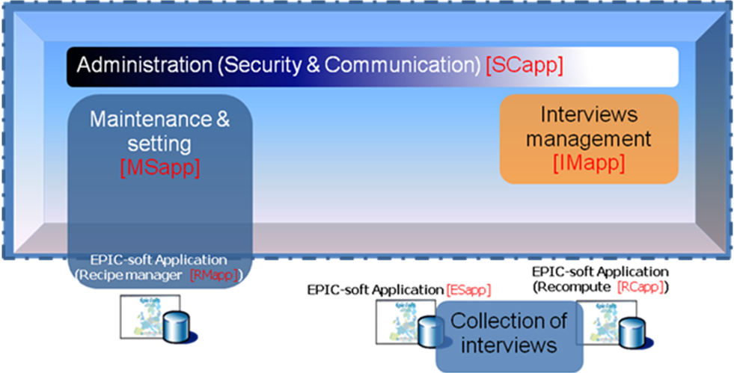
- EMP's Modules
EMP includes the following modules:
- SCapp : Security & Communication
User & Role management (user’s rights)
Project management (including country, center… management)
Communication: Send Alert to user
On line help and guidelines
- MSapp : Maintenance & Setting
Preparation of maintenance/parameter data and setting
- RMapp : Recipe Manager
Setting recipe ingredients
- ESapp : EPIC-soft Application and Data entry application
Collection of interviews or records
- IMapp : Interviews Management
Consolidation of interviews, note update and exports
Recalculation of interviews data with new settings
Note: Module in Yellow highlight aren't include in this project
A part Roles and actors is missing.
[ITeal]: What do you mean by “Roles & Actors”? IARC: user’s rights in SCapp. I specified it in User’s & role point
  - Database Structure
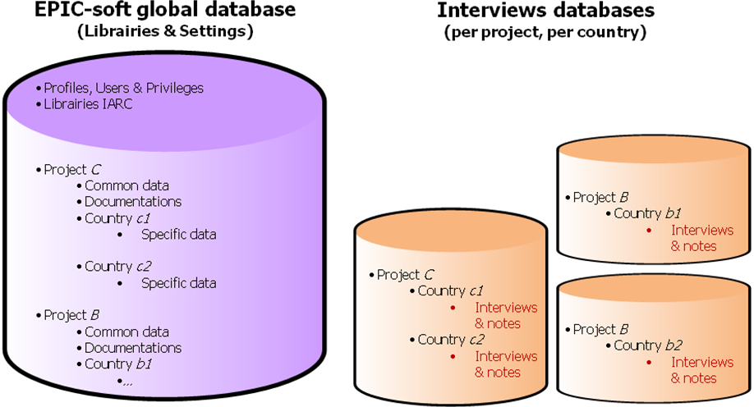
- EMP Database structure
EMP data are grouped into 3 sets as following:
Maintenance & Setting Data (purple background)
Interview Data (Orange background): They will be aggregated and consolidated by project and country. The IMApp will install the databases in centralized mode (IARC) or decentralized way (at the project or country level).
Project & user data

Database server

Application server

IMapp
SCapp
Database server

Application server

IMapp
MSapp
SCapp
EPIC-soft Application
Database server

Application server

IMapp
SCapp
Main site IARC & countries hosted by IARC
Local site for country 1
Local site for countries 2, 3, ...
EPIC-soft Application
EPIC-soft Application
EPIC-soft Application
EPIC-soft Application
EPIC-soft Application
- EMP deployment on centralized mode (IARC) or decentralized mode
- General Requirement
  - Online Help
Refer to “RM4_SFG_IARC_EMP_V1.0.doc” part “3.2 AIDE EN LIGNE”.
CC: In this document some specifications are missing specialy the fact that :
the help button (?) can be available one or several time in the same screen
a doc-file is attached to each help button
and not only 1 help button and 1 doc-file for all the application MSapp.
[Iteal]: Please describe your need on “Online Help” →but I propose to do it with lower priority (help can be done later)
IARC: OK
    - Search
    - Search Criteria
To provide an easy way to access to records in the database, EMP implements the search screens that help users to find exactly what they are looking for.
The search function allows users to filter by criteria:
The values of item: code, label …
The Traceability information (see in EMP-Proposal-Collaborative-Work 02a.doc)
The type of control using for the criteria will be based on the type of data and the context specified, for example:
Free text input for numerical or text value
Checkbox for Boolean or multi-choice values
Dropdown list for a list of options
Search also can be performed without any criteria; in this case the search function will return all records in database.
Explicit and Implicit search:
For the criteria of type string, normally we search all exact match for the particular text entered. This is called “Explicit search”.
In other cases, users also want to search based on a part of the chain. This will be called “Implicit search” and be done by using % (ex: %fish% → search for everything which contains “fish” text).
If the user selects several search criteria, the conditions are cumulative; the “and” is used between the selected criteria. (e.g. status= “on process” and action= “create”).
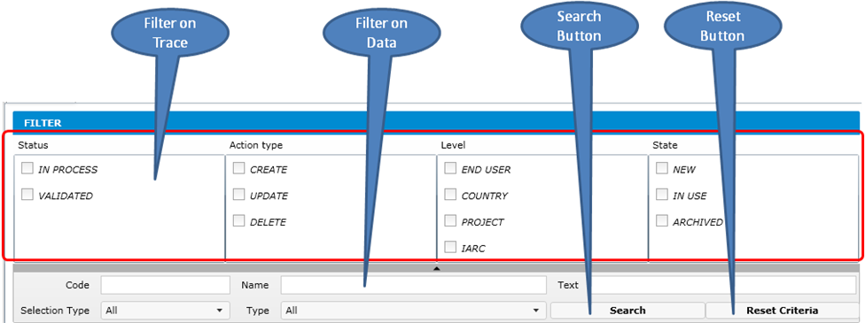
- An example of search page
CC: the search and reset buttons are not enough visible. The use of 6 buttons for the traceability variables is too limited. Effectively, the traceability variables represent more then the status variables we have also: Action, level, users, state, date… and users should also have the possibility to search on these fields.

[ITeal]: Update figure → detail on Interface will be discussed on “GUI Design” part. IARC: OK
    - Search results
The results are displayed as an ordered list (the columns priority used for the sort, will be screen specific).
A pager at the end of search page provides access to the next or previous pages, when the list is too large. The number of items per page will be decided for each screen.
A default sort is proposed by screen but the user can always sort data in the list by clicking on the header of each column.
The status / state of rows in the list can be indicated using colors.
The list items can be selected individually or globally. A list of actions will be available based on this selection. When no item is selected the only possible action is to create a new record.
It may also have a horizontal scroll bar in case the column list is too large. In this case we could have fixed columns on the screen that does not move with the movement of the lift (e.g. fixed and variable food name on standard mobile units).
At the bottom of each Grid, there’ll have an action bar, action on this bar will be considered for the selected row item on grid (e.g., delete, comment…)
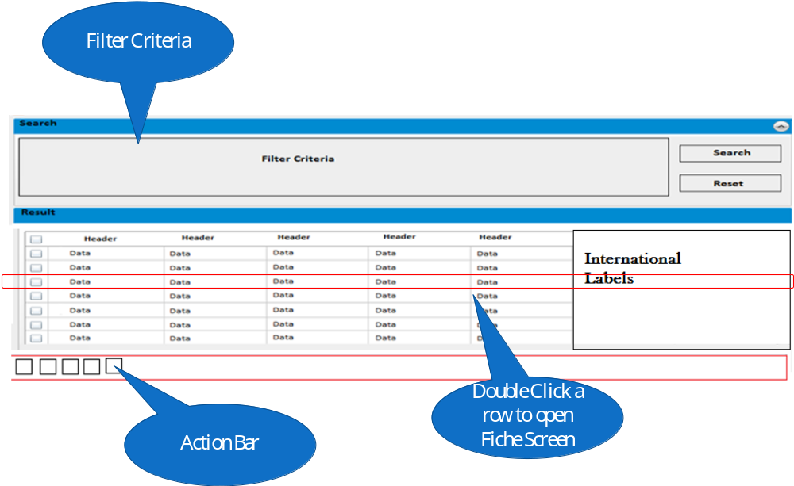
- Actions on Grid
The search result will be displayed in one of two modes “List”, user can double click on each row to open the corresponding Fiche screen:
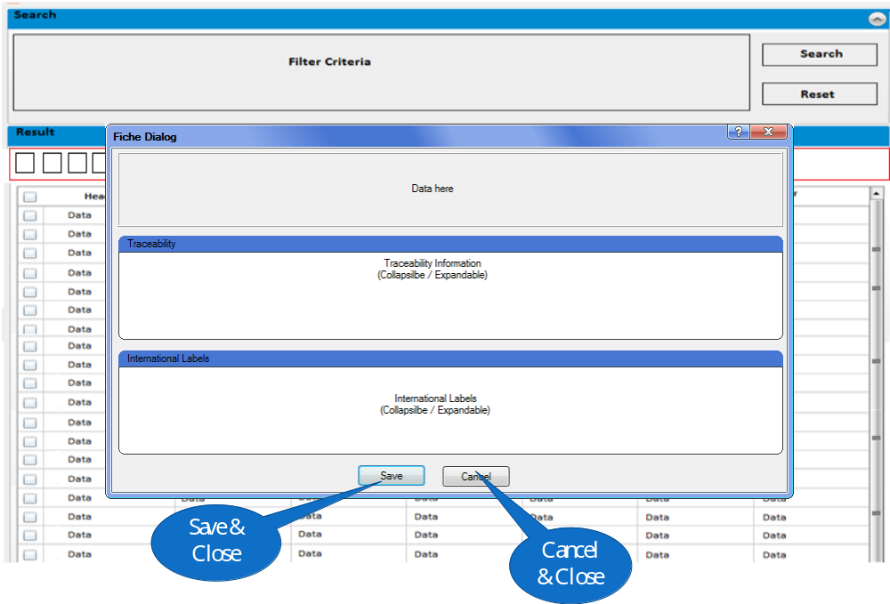
- Fiche Screen
  - Multi-Language
This part is copy from “EMP-Multi-languages-01b_Gwh_CC.doc” which has been discussed with CIRC
In order to establish a global utilization (~30 languages), EMP (menu, screens) and its generated databases (including the EPICTEXT which is used in the EPIC-soft application) are translated into multiple languages. It's necessary to manage 2 different aspects:
HMI: texts displayed in interface of EMP.
Maintenance & Setting Data.
The 2 aspects must be managed independently.
    - EMP’s interfaces
The elements of the EMP must be translated into different languages, 1 language is available to select if it's defined and set active in the language management.
User can select the language of EMP Interface in the top of screen. English will be used for the missing labels in selected language (if has).
Each user will have an attached language that will be used after logging into the EMP; the attached user language will be set by 2 ways:
When creating user, the administrator can set the language attached to the created user
After logging into the system, user can change the attached language in user information.
The language used in EMP’s interface and the language of the data are independent. Users can select different languages for each aspect at the same time. It means that they can choose English for EMP’s interface and French for Maintenance & Setting's data.
The administrator of the system (IARC) can define new language for EMP by:
- Define new language in the language management with the following information:
Culture Code
Name (in multiple languages)
Active: indicate that this language is available to use or not
- Defining all labels for the new language:
Use the export function to export all labels to an excel file (pre-defined format). User can choose the language to export and EMP will recommend exporting the languages which aren't complete. English always be selected and user cannot un-select it (use as source to compare). There will have a specific screen to manage the Import / Export of Language.
- Excel format for language files exported by language management
Define all labels in the new language.
Import the excel file into EMP system. EMP will have mechanism to analyze the excel file, detect the imported language and update for all its labels. If there're missing labels for a specific language → EMP will display a warning.
- EMP will verify the imported file, if all texts have not be translated into new language → the system will display a warning that "All labels aren't translate into new language, the English will be used for missing label."
    - Translation of Maintenance & Setting Data
This part has been discussed with CIRC but an additional feature needs to be integrated according to the discussion recently on the “Traceability on Translation” → This will be continued on SFD.
      - Translation of Library Data
- The IARC library will be provided in English and can be translated into other languages during the integration of new countries / projects (on demand).
- When creating a new project, the library data needs to be available in all languages of this project, there are 2 cases:
If the new project includes 1 new language (no translation of library data before), the library data needs to be translated into this language. The translation will be validated by IARC. After this validation, the translation shouldn't be changed by user. CC: no, a label can be translated and then this translation can be modified later on (e.g. giving more precision, spelling mistake…) and high level (e.g. IARC) will validate all the translations done and re-done.
If the new project includes a specific language, if library data are already translated in this specific language (done by a previous project/country), → this translation of library will be reused completely.
[Dtta]: After validation, the library data can be exported to Epicsoft database, if one user can change this, it might cause the incoherence. → What do you think in this case?
Gwh: incoherence relating to what? I’m not sure I understand the problem.
CC: the changes will always been validated by IARC so information can always be “in process”.
→ CC & Gwh: will discussed more at CIRC side
Note: If all the data are not translated and validated, the export is not possible. The data export cannot be discussed here. See traceability variables for translation
- User can do the translation of library data in 2 ways:
Translate in the interface: the data will be in the selected language (Project – Country – Language); the user can also input the data labels in the different languages. Translation row by row (e.g. when adding a record in the list, the user can enter all the needed translations for this item – use case: data update)
Using mass translation as in 5.2.2.5 (e.g. use case: creation of new database – the user can prepare a list in the main country language then translate the entire list in English and validate all record translations)
      - Translation of Project Data and Country Data
- The project common data must be in English and translated into the languages of all its attached countries.
The country data will be in language(s) of this country (multiple languages for 1 country is possible) and must be translated into English (for the controls of project coordinator).
The EPIC-soft database will be exportable only if the project and country data have been validated in all the languages of all countries (languages and countries in the selection of user to export) by control of translations: data, labels, “short” labels, comments. CC: The EPIC-Soft database is project/country and language specific, so to export an Epicsoft database, the user will have to select a project/country & 1 language. This selected language has to be validated (see traceability for translation).
- User can do the translation of Project / Country data in 2 ways:
Translate in the interface: the data will be in the selected language (Project – Country – Language); use can also input the data labels in the different languages. Translation row by row (e.g. when adding a record in the list, the user can enter all the needed translations for this item – use case: data update)
Using mass translation as in 5.2.2.5. (e.g. use case: creation of new database – the user can prepare a list in the main country language then translate all the list in English and validate all record translations)
      - GUI of Epicsoft Application
The GUI (menus, screens) of EPIC-soft application (table EPICTEXT) will be managed on the EMP as Library data,
EMP will have an interface to manage the EPICTEXT like other library data, in this screen will also have functions to import / export EPICTEXT from / to excel file.
      - International Labels
International labels are the translations of EMP data into different languages.
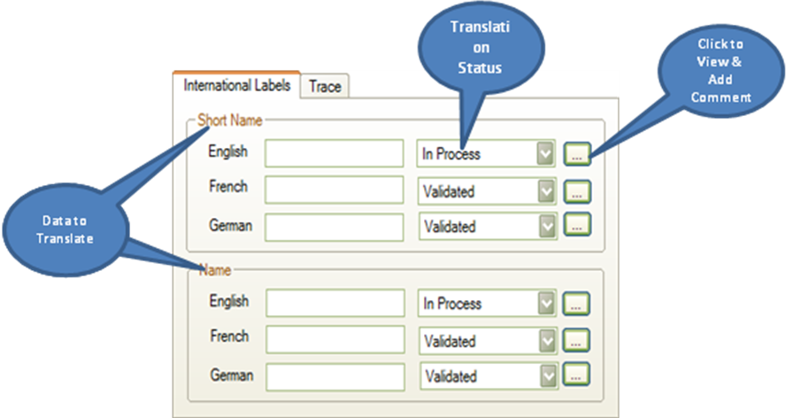
- Example of International Labels
In the left part of the screen, data are displayed in the selected language by user (Project – Country – Language).
CC: The traceability variables for translation are missing in this screen. They need to be displayed in the right part of the screen. In this “International Name” part, all the available languages for the displayed Library, Project or Project/Country data are displayed including the language selected with the perimeter. We need to display all the languages in this part because they have attached traceability variables.
[ITeal]: I update the figure as an example, the integration of International Labels will be discuss of GUI Design:Display in Grid or not
Display in Fiche IARC : Ok
The international labels include:
Library data: the data have to be translated with all active languages (language management).
For project data: the data have to be translated with the languages defined for this project and attached project/country.
For country data: the data have to be translated with the language (s) defined for this project/country.
If the user selects a project/country and a language for with the translation is not completed, in the left part of the screen, the name/label fields will be empty. → (To be validated on CIRC's side)
When editing data, EMP will have mechanism to detect change on "International Labels" to decide what will be saved to data base (note for dev).
      - Mass Translation
Sometime, we need to do the mass translation for an object (by a dietician or nutritionist who is familiar with EPIC-Soft).
The Mass Translation button will be available at the bottom – left of each screen in the action bar. User clicks on this button to open the mass translation dialog.
The detail of mass translation dialog will be discussed in GUI Design part. IARC : Ok
    - Control of translations
A control function of the translations is needed to ensure that all data is translated and usable. This control should be integrated in the consistency checks of the data which must be done before exporting an EPIC-soft database.
However, user still be able to select the control of translation in the menu of EMP, EMP will do the control of translation for the active screen that opened currently.
See the part 8.4 for more detail.
CC: For controls, the traceability variables are also important (e.g. all records have to be “validated” before the export).
For control, we can also add the business rule like “Identical translated labels not possible for 2 different records” (e.g. true for the food/recipe lists…)
  - Alerts
CC: perhaps you can cumulate this part “alert” with the “communication” one (poit 8.2.5) because alert are also communication.
[ITeal]: Part 8 is for Maintenance & Setting, and the Alerts is for all modules → so we think it’s beter to put the Alerts here. IARC : Ok
In some special cases, the system can create the Alert and send to users to notify them. The Alert will be similar to the Message but it’s created by the system automatically.
The format of Alert will be pre-defined.
The system should create Alert in the following cases:
Situation to send Alert | Receivers | Data
User creation | Created User | Login & Password
User Data Change:  - Password  - Role / Permissions / Perimeter | Changed User | Notify the user that the data has been changed
A new version of Epicsoft has been exported | User at the same scope  Project Coordinator  Country Coordinator | Information Message  CC: not sure that it is automatic, because sometime the national coordinator can generate a Epicsoft DB version only his own check.
Interview has been uploaded | Project Coordinator  Country Coordinator  Local Coordinator  Interviewer who did the upload | Information Message  CC: 1 message per set of interview?  [Iteal]: 1 message for each upload time (may be one or more sets of interviews)
Interview has been exported to ESApp | Project Coordinator  Country Coordinator  Local Coordinator  Interviewer(s) who will do the update | Information Message
To be continued if has
- System Alert
- Security & Communication
Refer to “SRS-EMP-SC-01b.doc” which has been discussed with CIRC
  - User & Right Management
    - User Management
The SCApp allows creating and managing the following information for each user:
Information | Description | Data Type | Create | Update | On Grid | Search | Mandatory
Title | Mr., Mrs., Ms… | Text | Yes | Yes | No | No
First Name |  | Text | Yes | Yes | Yes | Yes | Yes
Family Name |  | Text | Yes | Yes | Yes | Yes | Yes
Login |  | Text | Yes | Yes | No | Yes | Yes
Password & Password repeat |  | Text | Yes | Yes | No | No | Yes
Email |  | Text | Yes | Yes | Yes | Yes | Yes
Phone |  | Text | Yes | Yes | No | No
Mobile |  | Text | Yes | Yes | No | No
Fonction | Same as “User Background”. The user has to select the background from a list so he cannot create or update a background in this screen. | List | No | No | Yes | Yes
Country |  | List | No | No | No | Yes | Yes
Institute |  | List | No | No | Yes | Yes | Yes
Starting Date |  | Date | Yes | Yes | No | No
End Date |  | Date | Yes | Yes | No | No
Default Language | Language displayed by default on EMP | List | No | No | No | No | Yes
Active |  | Boolean | Yes | Yes | Yes | Yes
Comment | Other description on this user | Text | Yes | Yes | No | No
Project | 1 Favorite project or project/country | List | No | No | No | Yes
Role |  | List | Yes | Yes | No | Yes
- User Information
An user can be attached to:
The administration
The library
one or several project,
one or several project/country
With different roles and functions
In the above table:
Create Column indicates that the information can be input at creation or not
Update Column indicates that the information can be modified or not
CC: these 2 points are not clear for us; if the columns are available, that it is abvious that we can create or modified them? When the column value is come from a list, we cannot create/modify it but we just can select it. Can you specify what you espect?
[ITeal]:
- Yes, That’s it, but you can set column as read-only (based on business, for example: the code of “In Use” record)
If the value comes from a list we have “Combo box” columns, where user can select like in a combo box. IARC : OK, It will be specified in the detailed specification document.
On Grid Column indicates that the information is displayed on the grid of user list or not.
Search Column indicates that the information can be used as criteria to search user or not.
Mandatory column for fields that need to be imperatively filled.
SCApp will implement 1 interface allowing the administrator to search users and display result in a users list. In this interface, the administrator can:
Search users
Create a new user
View detailed information on a user
Modify information of user
Delete User
Create/Delete link between user and perimeters
Export User list to excel files: User can select multiple users or all displayed users to export. If no user selected in the first “action column”, then all the displayed users are exported. The attached project(s)/country (ies) are also exported. The format of excel file will be pre-defined.
Export all user information to xml files that uses for Interview manager in decentralized mode (To be specified in "Proposal for Import / Export data"). CC: for decentralized mode, it is not only the user list that needs to be exported and imported in IMapp (e.g. project, country, FCO list, food list…). So we can image 1 xml-file containing all the needed parameters/tables.
After the display of the user list in the first screen, the “user detail interface” will includes 2 tabs:
  - 1 Tab for administration information (Table 2)
  - 1 Tab for Permission for link with different project and/or project/country
When we create a new user, we will need to fill all administration/general information first and then go to the second tab to attach one or several perimeters (project, project/country) with attached permissions.
    - Right Management
This function is used to manage the possible actions that one user can do on EMP system and depending on the attached project. To manage rights of user, we define the following dimensions:
      - Role
The following roles are defined in EMP:
- International principal Administrator/Coordinator (IARC):
As the owner of the EMP, IARC is in charge of the overall methodological application (EPIC-soft program and its related tools, guidelines and infrastructure) and the maintenance of the main site and infrastructure, with direct contact with the project administrator/coordinator and possibly with the national administrator/coordinators;
- International project Administrator/Coordinator
In charge of the coordination of a specific project, the international coordinator will also be in charge of the maintenance of the common EPIC-soft databases specific to its project through interface tools available on the IARC main site.
- National administrator/coordinator
In charge of the coordination of the field work performed at the national level by the end-users and responsible of the national collected data, they will also be in charge of preparing and upgrading the country-specific databases through procedures proposed by the international principal and project administrators/coordinators;
- Intermediate local coordinators
Depending on the study design and project-specific logistics, other lower levels of administration (e.g. at the region or centre level) may exist. They will be involved in the direct supervision of the end-users and might be involved in maintenance and interview data related tasks delegated by the “National administrator/coordinator”;
- End-users
In charge of collecting and saving the 24-HDR interviews and transferring them and their related “notes” (note files) to the upper coordinators according to project-specific procedures and tools;
- Guest
A level of guest may exist to allow the user to only view and not modify data from a different perimeter (e.g. other project data). This role will be used in order to help in the preparation of its own database.
Roles are predefined by the system; administrator can not add / remove / modify the roles. CC: what do you mean? [ITeal]: There’re 6 roles, you can not use any functions of EMP to add more roles, remove a roles or modify these 6 roles. IARC: Ok
      - Right
Right is the possible action that user can do in EMP.
The possible actions are depending on the specific module, an action can be available on a module but not available in another one.
Rights are predefined by the system; administrator can not add / remove / modify the right.
The following Table defines the possible Rights on each module:
Right | Description | Key | Security & Communication | Maintenance & Setting | Interview Manager
View (Read) |  | R | x | x | x
Add |  | A | x | x | x
Modify |  | M | x | x | x
Delete |  | D | x | x | x
Export | e.g. : ES Database, ITV | E | x | x | x
Import | - Copy data from other projects, countries  - Import Library from existing backup file | C |  | x
Upload | e.g. interview data | U |  | x | x
Import | E.g. interview data, food list… | I |  |  | x
Empty Trash |  | T |  | x
- Possible rights for each function
→ To be confirmed by CIRC all the possible rights (do it later)
      - Object
Object is the data on which the action acts. When defining the actions, we must specify the data/object which the actions affect such as: Add "user", Validate "Food", Upload "Interview…"
The Possible objects in EMP will be:
- For SCApp:
User
Help
Project
Country (Administration Information)
Region
Setting…
- For Interview Manager:
Note
Interview (view)
Folder
Subject
Import parameters
- For Maintenance & Setting:
Setting
Library data
  - Classification (Food / Recipe)
  - List of facets
  - List of facets/descriptors etc…
Project data
  - Classification (Food / Recipe)
  - List of facets
  - List of descriptors
  - List of facet/descriptors per group/subgroup etc…
Country data: Food
  - Food list
  - Food Shadow list
  - Food Brand name list…
Country data: Recipe
  - Recipe list
  - Recipe Shadow list
  - Recipe Brand name list…
Country data: Supplement
  - Supplement list…
Each pair (Action or right, Object) is called "Permission".
Objects are predefined by the system; administrator can not add / remove / modify the objects.
→ To be confirmed by CIRC all the possible rights (do it later – same with Right)
CC: after discussion with Jean-Paul, it means that the object is not a screen but an element on which rights are applied (e.g. for interview manager, we can see interview as an object (we can import, view interview…) so this list is perhaps no more relevant, what do you think?
[ITeal]: Object is screen is good for us. But it’ll be hard for you to define a function because we’ll have about more than 100 screens in EMP.
We should consider each Object is the group of screen such as:Food includes:
Food List
Coefficient
Standard Portion
Standard Unit
….
This will help you to be easier to define function. IARC: Ok

      - Function
A role can have one or several attached functions. Function is 1 set of permissions that the administrator can define as common usage for all projects. Example: for the role “local coordinator” we can have the functions “data collection” or “data collection and management” for IMapp. Each function includes the following information:
Role: The role that this function belongs to, 1 function can only belong to 1 role and 2 different roles can include 2 different functions with the same name.
Function Name: Default, Data Manager, User Manager…
Set of Permissions
The following figure shows 1 example of a function:
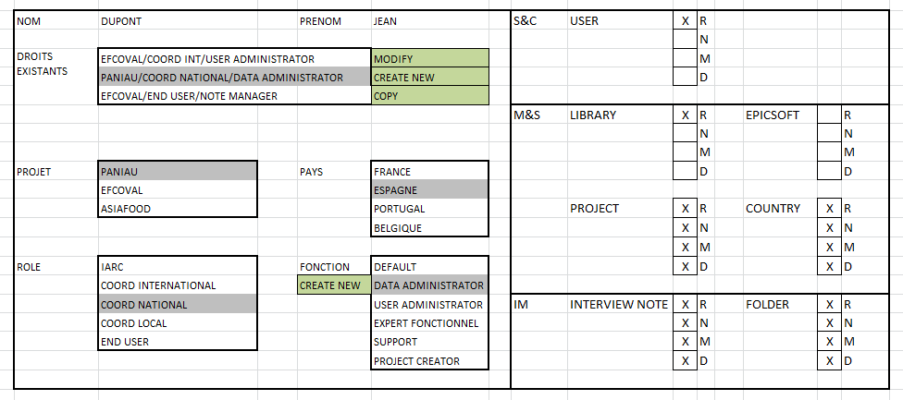
- Function definition
The Administrator can:
Create new Function
Modify Function (Add / remove permissions)
Delete Empty Function (no relation)
Duplicate a function
Each Role will have 1 built-in Function called "Default" that pre-defines all permissions for 1 Principal Administrator / Coordinator (IARC), 1 International Project Administrator / Coordinator, 1 National Administrator / Coordinator, 1 Intermediate Local Coordinators and 1 End-Users.
→ Need to define 6 "Default" functions for 6 Roles → to be completed after finishing the list of "Rights" and "Objects" (by CIRC).
CC: For each role, at least 1 function need to be defined why do you want a default one? Not necessary to have a notion of default for me??
[Iteal]: The default one is the one that propose to add for one user when they’re at certain role → but we can select other item than the default one. IARC: Ok

      - Perimeter
Perimeter defines the "Area" that the Function affects; we separate 3 Levels of perimeters:
- Library & 1 data language
- Project/sub-project & 1 data language
- Project/sub-project & 1 country & 1 data language

CC: We do not need to select 1 project-sub-project and several countries because a data is attached to the library or to a project-sub-project or to a project/subproject and 1 country.
When we define a project/sub-project, we can attach different countries and for each country, one or several languages can be attached.
Dtta: To be discussed
→ We will do later when we decide to use “Sub project”
- Project / Country Level: We can select:
Project Level with all available countries
Project Level only (no country)
Project Level with 1 or several countries
Country level only (one or several or all)
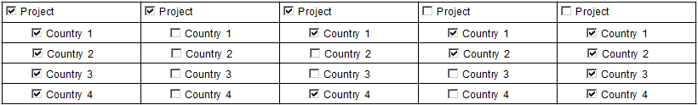
- Perimeter on Project / Country
CC: In reality the perimeter can be:
Administration (to see administration data)
the library (to see the library data)
a project (to see the project data)
a project and an attached country (to see a project/country data)
The language is not in the perimeter, it is attached to the selected perimeter and it is just a way to see the data of the selected perimeter.

IARC: See also the document called “Perimeter and visibility and guest role-01b.doc”.

    - User Authentication
User will use his login / password to log into the EMP. Each user can have one or several Profiles.
Each Profile includes:
1 Perimeter
1 Role
1 or several Function(s). If case of several functions, the permissions are cumulated.
The following tables show 1 example on the profiles of user:
General table:
User
Profile | Area (perimeter)
Profile |  | Role
Profile |  |  | Function
Profile |  |  |  | Permission(object/rights)
Profile |  |  |  | Permission(object/rights)
Profile |  |  |  | Etc…
At Library level:
Profile 1 | Library data
Profile 1 |  | Country Coordinator
Profile 1 |  |  | Low level
Profile 1 |  |  |  | Classification / View & Request
Profile 1 |  |  |  | Facet list / View & Request
Profile 1 |  |  |  | Descriptor list / View & Request
Profile 1 |  |  |  | Etc…
At Project level:
Profile 2 | EPIC (project data)
Profile 2 |  | Country Coordinator
Profile 2 |  |  | Low level
Profile 2 |  |  |  | Classification / View & Request
Profile 2 |  |  |  | Facet list / View & Request
Profile 2 |  |  |  | Descriptor list / View & Request
Profile 2 |  |  |  | Etc…
At Country level:
Profile 3 | EPIC-France (Country specific data)
Profile 3 |  | Country Coordinator
Profile 3 |  |  | High level
Profile 3 |  |  |  | Food list / View, Create, Modify, Delete, Export, Import
Profile 3 |  |  |  | Facet per foods / View, Create, Modify, Delete, Export, Import
Profile 3 |  |  |  | Quantification per foods / View, Create, Modify, Delete, Export, Import
Profile 3 |  |  |  | Etc…
At Country level for another project:
Profile 3? or 4 | EFCOVAL-France (Country specific data)
Profile 3? or 4 |  | Guest
Profile 3? or 4 |  |  | Low Level
Profile 3? or 4 |  |  |  | Food list / View
Profile 3? or 4 |  |  |  | Facet per foods / View
Profile 3? or 4 |  |  |  | Quantification per foods / View
Profile 3? or 4 |  |  |  | Etc…
Note: Within a perimeter, the role / function that 1 user can assign to another one can be the same or a less role / function as its own role/function. For example:
1 user who has the functions Data Manager & User Manager in Project A can assign to others Data Manager, User Manager or both. He cannot assign others INTERVIEW MANAGER in project A.
1 user with only perimeter in Project A/ Country B cannot assign others any role / function in other Project / Country.
CC: example not clear!
    - Import / Export Users
Export User list to excel files: User can select multiple users or all displayed users to export. The format of excel file will be pre-defined.
Import / Export all user information from / to xml files that uses for Interview manager in decentralized mode.
CC: point already mentioned in point 6.1.1. For decentralized mode, it is not only the user list that needs to be exported and imported in IMapp (e.g. project, country, FCO list, food list…). So we can image 1 xml-file containing all the needed parameters/tables.
  - Administration of Project, Country, Region
The Epicsoft Project and Country data will be managed in MSapp but their definitions are managed in SCApp.
    - Country Administration
The SCapp allows managing the country including:
Search countries
Create new country
Modify country
Delete country (hasn't been used/attached to a project)
The following table lists all information of country and their usage. The translation of country name has to be available.
Information | Description | Data Type | Create | Update | On Grid | Search | Man datory
Code | The Region Code, it must be unique | Text | Yes | Yes | Yes | Yes | Yes
Name | The Region Name (multi languages) | Text | Yes | Yes | Yes | Yes | Yes
Comment | Free description on this country | Text | Yes | Yes | Yes | No
- Country's Information
Note:
Country has to exist before creating Project, Region
On the Grid, the sort is done on the Country name (in the selected language) & Country code
    - Region Administration
The SCapp allows managing the regions including:
Search Regions
Create new Region
Modify Region
Delete Region (hasn't been used/attached to a project)
The following table lists all information of region and their usage:
Information | Description | Data Type | Create | Update | On Grid | Search | Man datory
Code | The Region Code, it must be unique | Text | Yes | Yes | Yes | Yes | Yes
Name | The Region Name (multi languages) | Text | Yes | Yes | Yes | Yes | Yes
Country | The country that this region belongs to | List | Yes | Yes | Yes | Yes | Yes
Comment | Free description on this region | Text | Yes | Yes | No | No
- Region's Information
The translation of region name has to be available.
Note: When we click on the column titles, the sort is defined as below:
click on Country name title: sort done on the Country name & Region name & Region code
click on Region name title: sort done on the Region name & Country name & Region code
click on Region code title: sort done on the Region code & Country name & Region name
    - Project Administration
The SCapp allows managing the Project including:
Search projects
Create new project
Modify project
Delete empty project (hasn't been used)
The following table lists all information of sub-project and their usage:
Information | Description | Data Type | Create | Update | On Grid | Search | Mandatory
Code | Is it the code ? | Text | Yes | Yes | Yes | Yes | Yes
Name |  | Text | Yes | Yes | Yes | Yes | Yes
Parent Project | Use for Sub-Project: The project that this sub-project belongs to | List | Yes | Yes | No | No
Coordinating institute |  | List | Yes | Yes | Yes | Yes | Yes
Type of Study |  | List – Multi Select | Yes | Yes | Yes | Yes | Yes
Target Population |  | List – Multi Select | Yes | Yes | Yes | Yes | Yes
Geographical Level |  | Text | yes | Yes | Yes | Yes | Yes
Starting Date |  | Date | Yes | Yes | Yes | Yes
End Date |  | Date | Yes | Yes | Yes | Yes
Active |  | Boolean | Yes | Yes | Yes | Yes
Study objective |  | Text | Yes | Yes | No | No
Study design/population |  | Text | Yes | Yes | No | No
Dietary method |  | Text | Yes | Yes | No | No
Other comments |  | Text | Yes | Yes | No | No
Countries Included | (*) | List | Yes | Yes | No | No | Yes
Validation Role | Role(s) to validate & export the data (Epicsoft DB) | List | Yes | Yes | No | No | Yes
- Project's Information
(*) The link between Project and Country is not enough. We have to define the following links:
Project and attached Countries.
For each selected Country, an attached institute within this project
For each selected Country, one or several attached languages within this project
For each selected Country, one or several attached Region within this project
For each selected Region, an attached institute for this Country & Project
On the Grid, the sort is done on the Parent Project short name & project nameCC the following setting screen of “Administration” is missing:
    - Setting data
      - Language
The SCapp allows managing the languages including:
Search Languages
Create new Language
Modify Language
Delete Language (hasn't been used)
Information | Description | Data Type | Create | Update | On Grid | Search | Mandatory
Culture Code |  | List | Yes | Yes | Yes | Yes | Yes
Name |  | Text | Yes | Yes | Yes | Yes | Yes
Active | Indicate that this language is available to use or not | Boolean | Yes | Yes | Yes | Yes | Yes
- Laguange’s information
Translations are needed for the Name.
      - Institute
The SCapp allows managing the institues including:
Search institues
Create new institue
Modify institue
Delete institue (hasn't been used)
Information | Description | Data Type | Create | Update | On Grid | Search | Mandatory
Name |  | Text | Yes | Yes | Yes | Yes | Yes
Town |  | Text | Yes | Yes | Yes | Yes | Yes
Country |  | List | Yes | Yes | Yes | Yes | Yes
Address |  | Text | Yes | Yes | Yes | Yes | Yes
Phone |  | Number | Yes | Yes | Yes | Yes | Yes
Active |  | Boolean | Yes | Yes | Yes | Yes | Yes
Description |  | Text | Yes | Yes | No | No | No
- Institue’s information
No Translations needed.

      - Type of study
The SCapp allows managing the Type of Studies including:
- Search Type of Studies
- Create new Type of Study
- Modify Type of Study
- Delete Type of Study (hasn't been used)

Information | Description | Data Type | Create | Update | On Grid | Search | Mandatory
Label |  | Text | Yes | Yes | Yes | Yes | Yes
- Type of Study’s information
Translations are needed for the Label.
      - Age group
The SCapp allows managing the Agegroups including:
- Search Agegroups
- Create new Agegroup
- Modify Agegroups
- Delete Agegroup (hasn't been used)
Information | Description | Data Type | Create | Update | On Grid | Search | Mandatory
Label |  | Text | Yes | Yes | Yes | Yes | Yes
- Age group’s information
Translations are needed for the Label.

      - Translation EMP
EMP will implement a screen allowing user to Import / Export the labels for EMP Interfaces for all available languages.
The details are in 5.2.1
IARC: The generated file is a csv-file with ‘|’ as delimiter (asked by our task force).
- Interview Manager
Refer to “SRS-EMP-IM-01.doc” which has been confirmed with CIRC.
  - INTRODUCTION
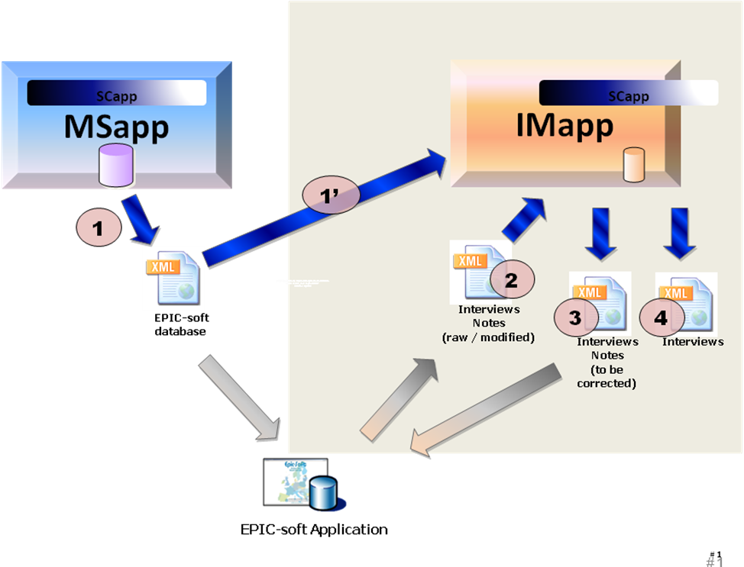
- Interview Manager
The objective of this module is to gather the interviews from Epicsoft Application, to process the notes and status attached to these interviews and to send the interviews to EPIC-Soft application for update. It contains the following business:
- Import the EPIC-soft database (xml) file (generated by MSApp) (1')
- Upload interviews on the platform (end-user task)
- Import the Interviews (xml) and notes from Epicsoft Application: (2)
Original Interviews and Notes OR
Modified Interviews and Notes: Epicsoft Application received interviews and notes from IMApp for correction and then, the updated interviews are sent again to IMApp.
- Manage the subject information (ex: problem of subject code, birth date and sex, predefined list of subject to be interviewed)
- Manage the Notes attached to the interviews
- Re-compute the interviews (Not include in this scope)
- Export Interviews (xml) that need correction from Epicsoft Application (3).
- Export Interview: used for external purposes such as statistic…

Note:
Several iterations of flow 2 & 3 are possible; this will be finished until no more correction is needed for interviews and notes. For each new iteration, IMApp stores a new occurrence of Interview (new version) in the database.

In addition, the Interview Manager will include the following services:
- Manage versions of Interviews (in iterations)
- Handle error during import; correct the errors on Subject information (Code, sex, birth date…).
- Manage the Subject Code to be interviewed.
  - Import Setting
    - IMapp is installed with MSApp at IARC
IMApp can use the data from MSApp directly, no need to import anything.
    - IMapp is installed in decentralized mode
- Used for Upload, Import Interview:
Identification of setting: Project – Version – Country – Used Language and an Identification of the interview version.
- Use for Recompute: TBD

The imported setting will replace the existing setting in IMApp. The imported setting is an upgraded version.
Note: We can import data of one project/sub-project/country with 2-3 different languages (ex: Belgium).
  - Upload Interview
This part will describe the flow that the end-user uploads his interviews into EMP systems and how the uploaded files are stored in EMP.
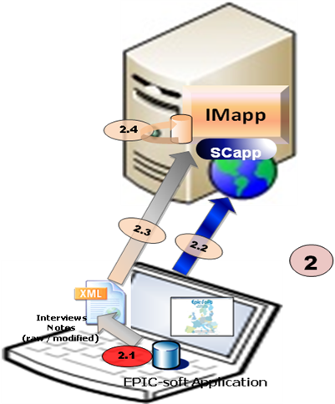
- Import Interviews from Epicsoft Application
- (2.1): The end user exports interviews with attached notes from Epicsoft Application (files are in a certain directory of his PC), the exported interviews files will be grouped in an xml file (provide a file name containing the date, time and version)
- (2.2): The end user connects to EMP, the module SCApp authenticates him and assign the access rights to selected project / sub-project (*) / country / data language.
CC: we decide to call it sub-project instead of version.
- (2.3): The end user uploads the archive to the server:
IMApp display a file selection that asks the user to select the files he wants to upload (the supported file will be *.xml, *.rar, *.zip or all three types). The user can select 1 or multiple files at once.
IMapp checks if the data are consistent with the rights of the end user (user must have rights on the projects / sub-project / countries the data belongs to).
IMapp inform the Coordinator by the communication means of SCApp (TBD) to alert that interviews have been uploaded.
IMapp display a message that let the end user confirm the upload of the file, this message should also inform the end user that this loaded interview dataset has also to be saved in a dedicated folder on her/his PC + on other support (backup). Such as (this message is defined in database, we can change this later if needed, it's multi-languages also):
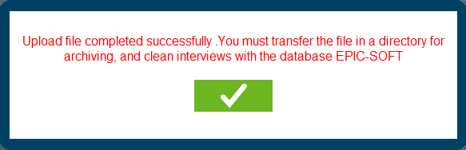
- Note:
IMApp will implement an interface to manages the uploaded files with status and logs (xml only, for zip, rar files → we'll get all xml from the zip, rar to manage).
Xml-file name: to the name given by the end-user, the date and hour of the upload have to be added or this information kept by another mean
- Check the consistency of the xml file:
1. Check File format (xml)
In the File selection Dialog: User can select xml, zip, rar only
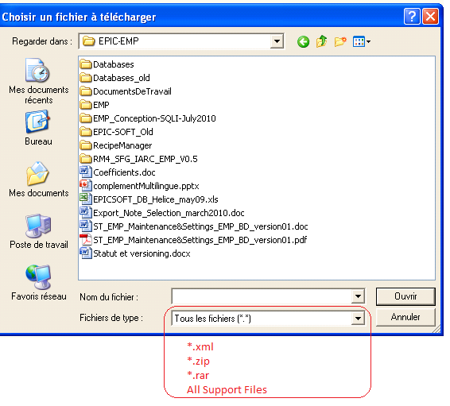
In the case of zip or rar file: Check the contents
→ If all is xml file → OK
→ If there's other file (not xml) → this file is uploaded, the non-xml files are ignored and a warning like this is displayed "The zip (rar) contains files that isn't in xml format, these files will be ignored".

2. Check xml file
Check that xml file is in correct format (xsd schema)
Decode xml file & Check the corresponding of project-sub-project-country-language in xml file with the project-sub-project-country-language as selection of user.
→ If the check failed → Display error message and the file can not be imported.
3. User can delete uploaded file (successfully uploaded): Maybe he (she) want to replace it by a newer file.
  - Folder Management
IMApp will use folders to classify the interview. The folders will be managed as following:
The user will be able to create folders (1 level directory only),
A folder is attached to 1 Project–Version–Country and be managed virtually in database (not in hard-disk).
It's not possible to have 2 folders with the same name inside 1 Project–sub-Project–Country.
1 Interview can be stored in 1 folder only.
It's possible to rename the folder, remove empty folder or move interview(s) from 1 folder to another.
IMApp will have a simple interface to see the folder list where the user can select a folder to display all its interviews.
CC: In this screen, we will need a search facility and a function to select several interviews in order to move them in another folder.
  - Import Interviews
After uploading into IMApp by end-users, the interviews have to be stored in the database of IMApp. The Coordinator will have to:
Select a Project-sub-project / country / language when he/she logs in,
Select one or several uploaded files,
Import them into the database of IMApp.
In the IMApp, only interviews files from 1 project-version-country-language can be imported at once. The coordinator can select one or several files to consolidate at the same time.

IMApp must provide a simple interface allowing the user to select interviews files to import. Before that, the user must specify the project- sub-project-country-language, he's working in.

Controls:
Checks on interviews specificities
Checks on subject information
    - Import 1 Interview File
When importing 1 xml file, the IMApp will decode the xml file and process the import interview by interview:
- (1): Check the Identification of the Interview by: Project + Sub-project + Country + data Language + Center + Subject + Recalled Date.
- (2): Check existence of Interview in database:
If the Interview is available in database (same values for all these fields):
→If Flag of Interview = "Not Exported" → System will generate 1 error message to inform the user that the interview already exist in IMApp without having been exported first and abort the importation.
→If Flag of Interview = "Exported": System will increase the version number of the interview being imported by 1, store the interview with this new version number and update the Flag of this interview to "Not Exported" to enable the use of this interview (export, edition).
If the Interview isn't present in database: Store the interview with the initial version number (V0) and set flag to "Not exported".
- (3): Control the Subject: Check if the imported subject code exists:
IF YES (Subject code exists)
→ IF information on sex & birth date is identical THEN link the interview to this subject
→ IF information on sex & birth date is different THEN display a warning (*) and create a new subject with a temporary subject code
(*) If Warning: the problems are written in a log file, and the process continues with the Subject creation indicating ‘temporary subject code’. The coordinator should change it later with the appropriate subject function.
IF NO (subject code does not exists) → OK : creation of the subject

Notes: To manage the subject list, 3 solutions are possible for the coordinator:
A predefined list with all subject information can be entered in IMapp so the controls on code+sex+birth date can be done efficiently
The subject list is not pre-entered, so the list is generated automatically during the recall import (flagged as new subject). Remark: the controls on code+sex+birth date will be performed only in case of import of several recalls for the same subject.
A predefined list of incomplete subject information (e.g. code only; or code + sex) can be entered in IMapp so only the control on the available information can be done. Then the missing information (sex and/or birth date) are imported.
- (4) Interview data import
At the end of the interview loading, a last check is performed on the level of the interview data coherence with the imported parameters (e.g. whether the food consumption occasion (FCO) code exists in the list of imported parameters)
In case of data incoherence, an error message like ‘parameters incoherence’ will appear (including the details about the incoherence problem)? The incoherent parameter (e.g. FCO) will be flagged.

NOTE:
- If an error occurred during the import of a set of interviews (xml-file), the problem is noticed in a log-file and all the interviews of this set are not imported.
- Error file will be managed in a list, Coordinator can:
View log of each file
Delete file
Download file
    - Batch Import of Interviews
In the Import screen, the coordinator can select one or multiple files to be imported. In the case of multiple files, the IMApp will do as the following:
Do the importation file by file as in 7.5.1
If error occurs on 1 xml file, this file will be ignored (save log) and the IMApp will go to next file.
After importation of all archives, IMApp will display the summary that contains the log for all importations: success or error, cause of error…
    - Management for Archive Files
IMApp must implement a mechanism for managing the xml files (xml) on the server. Xml files can have the states as following:
"Uploaded": Indicate that the xml has been uploaded by an end-user → the coordinator can import archive in this state.
"Imported": Indicates that the file has been imported successfully by the coordinator. Imported files will be removed automatically after the import has been done without problem.
"Error": Indicate that there were errors during the import of this file. In this case a function has to be implemented to allow the coordinator to see a log of the import attached to this “error file”.
- End user can do the following actions on archive file:
Delete his "Uploaded file"
- The coordinator can do the action like end-user and:
Delete the imported file.
Delete the Error file (The import is not possible even if the setting is up to date.)
Delete the "Uploaded" File
- Note:
For the "Uploaded File": User can upload another file with the same name, in this case the system will ask the user to confirm to overwrite of the existing file.
For the "Error file": User can not delete or replace this file, if the user upload another xml file with the same name → IMApp will add a number to the file name and inform user about it by a message.
Coordinator can see the log of import of "error file"; he (she) can remove it and require the end-user to re-upload a new file.
  - NOTES Processing
    - General
NOTES processing will implement the following functions:
View & Filter Notes
Update notes’ status & comment manually
Function for Recompute Module (TBD)
    - NOTES Concept
      - Notes attached to an Item
Notes are data available in interviews database. A note is always attached to an item that involves:
- General Notes attached directly to a Subject
- Specific Notes attached to a:
FCO (Meal)
Quick list item (QLI)
Food/fat
Recipe
Ingredient
Supplement
"Note Type" indicates which item the note is attached to and the reason the note was created. This field is stored in the database but can not be used to filter & view the notes.

The following tables will show the possible notes in IMApp:
ITEM | NOTE TYPE | TYPE  CODE | Comments | Manual vs Auto
Subject | General | G |  | Manual
Subject | Special diet | G_DT | Note for “Other” field for special diet | Automatic
Subject | Special day | G_DY | Note for “Other” field for special day | Automatic
FCO | Specific | SPE |  | Manual
QLI | Specific | SPE |  | Manual
QLI | Empty | EMP | If a Note already exists, the type code is not changed. | Automatic
FOOD | New food | NEW_F | Message “New food” writes | Automatic
FOOD | Specific | SPE | If a Note already exists, the type code is not changed. | Manual
FOOD | Unknown quantity | UNK | Message “Unknown quantity” writes.  If a Note already exists, the type code is not changed. | Automatic
FOOD | Null quantity | NULL | Message “Null quantity” writes.  If a Note already exists, the type code is not changed. | Automatic
FOOD | Overflow quantity | OVER | Message “Overflow quantity” writes.  If a Note already exists, the type code is not changed. | Automatic
RECIPE | New recipe | NEW_R | Message “New recipe” writes | Automatic
RECIPE | Commercial recipe | COM | Message “Commercial recipe” writes | Automatic
RECIPE | Open unknown recipe | I_ADD | Message “Open recipe: added ingredient” | Automatic
RECIPE | Open unknown recipe | I_DEL | Message “Open recipe: deleted ingredient”
RECIPE | Specific | SPE | If a Note already exists, the type code is not changed. | Manual
RECIPE | Unknown quantity | UNK | Message “Unknown quantity” writes.  If a Note already exists, the type code is not changed. | Automatic
RECIPE | Null quantity | NULL | Message “Null quantity” writes.  If a Note already exists, the type code is not changed. | Automatic
RECIPE | Overflow quantity | OVER | Message “Overflow quantity” writes.  If a Note already exists, the type code is not changed. | Automatic
INGREDIENT | New food | NEW_F | Message “New food” writes | Automatic
INGREDIENT | Specific | SPE | If a Note already exists the type code is not changed. | Manual
INGREDIENT | Unknown quantity | UNK | Message “Unknown quantity” writes.  If a Note already exists, the type code is not changed. | Automatic
INGREDIENT | Null quantity | NULL | Message “Null quantity” writes.  If a Note already exists, the type code is not changed. | Automatic
SUPPLEMENT | Specific | SPE |  | Manual
SUPPLEMENT | Null quantity | NULL | Message “Null quantity” writes.  If a Note already exists, the type code is not changed. | Automatic
 | Specific | F_xx | XX for the supplement facet number. See Table DS_Facet.  Examples :  F_01= other source, F_03= other place, F04=other packing | Automatic
- Possible Note types in IMApp
      - Note Status
A Status is attached to each note. It will be used to indicate the current state of the note and the actions to do on the item. Each status will have an attribute attached called S_Hide indicating if the note in this status must or mustn't be displayed.
The note’s status is project dependant except for the modality “New” (coded 00) that is automatically attributed at the note creation by ESapp.
Example of note status list:
Value | Description | S_Hide
00 | New (mandatory) | No hide
01 | Ongoing | No hide
02 | No action needed/Ignore | Hide
03 | Action approved by coordinator | No hide
99 | Action done | Hide
- Note Status
By default IMApp will not display Notes with status "Hide".
The Note’s status value will be specific for each project and has to be imported from MSApp.
    - Notes Selection
IMApp will display all notes of Project – Sub-project – Country – Language (selected by user) in a grid. User can do the filter by clicking on the header of each column (like excel 2007 and later).
The following data of interview will be displayed in the grid and can be filtered by (Q&A EMP-2313):
Folder
Region
Interviewer Code
Recall Date
Subject Code (or subject code can merge country+region+subject code)
Subject Sex
Birth Date
Sp. day
Sp. diet
Type of record (e.g. food, recipe, fat…)
Food / Recipe name or FCO name (that means value of “Name” column but when this column is empty then value of “Text” column)
Classification (Group/Sub Group/Sub-sub Group)
FacetString
QM Method
QM Code
Consumed quantity

Note from EMP-2188:
On screen, if the user selects a note type or a note status (e.g. status note='to be updated'), the displayed lines are only those that answer to the criteria (e.g. only records with note status='to be updated").
For export, even if on screen only some lines are displayed (and not the complete interview), the export file should contain all the interview records (e.g. all the interviews containing at least one note status='to be validated").
    - Display the Notes List
The Filter will be done with the latest versions of interviews. The filter result will be display in 1 note list (mode List). The information in the list must be enough to identify one note.
User can double click on each row to open 1 interface that contain all information of the note (read-only), user can also modify some information on it (note status and comment).

It's possible to open the interface to the interviews associated with 1 note.
In this screen we can see the items with attached notes. For the user, it can be interesting to have a function that allows seeing all the interview records attached to this note.
    - Update Notes
Only Notes attached to the latest version of an interview can be modified.
In IMApp, the following information can be modified:
Comment: free text
Status: The status of note can only be updated by user manually (no automatic update by IMApp)
These informations can be modified in the following ways:
In the Note List: User can select one or several notes to be updated, then input status and comment (once for all selected items) and click on a button to update for all. The comment of all the selected notes will be replaced by this new one.
In the "Note details" interface: user can update the comment and status of one selected note.
  - Filter & Export Inverviews
    - Filter the interviews
IMApp will display all interviews of Project – Sub-project – Country – Language (selected by user) in a grid. User can do the filter by clicking on the header of each column (like excel 2007 and later).
The following data of interview will be displayed in the grid and can be filtered (Q&A EMP-2313):
Folder
Region
Interviewer Code
Recall Date
Subject Code (or subject code can merge country+region+subject code)
Subject Sex
Birth Date
Sp. day
Sp. diet
Type of record (e.g. food, recipe, fat…)
Food / Recipe name or FCO name (that means value of “Name” column but when this column is empty then value of “Text” column)
Classification (Group/Sub Group/Sub-sub Group)
FacetString
QM Method
QM Code

Note:
The Filter will be done with the latest versions of interviews.
IM can display "Exported" and "Not Exported" interview separated by background color of grid.
User can see the Information of "Exported" Interview but can not make any modification
CC: In fact by default only the non-exported intervews will be displayed. We can image a button to change this option and to display only exported interviews (or both??). We can also just propose a button to export the list of “exported interviews”, list of subject code + recall data + general information). I am not sure that this column is necessary. To be discussed

There’ll have a check button "Display Exported Interview" in the top of screen, user can click on this to display the exported interview or not
Note from EMP-2188:
On screen, if the user selects a note type or a note status (e.g. status note='to be updated'), the displayed lines are only those that answer to the criteria (e.g. only records with note status='to be updated").
For export, even if on screen only some lines are displayed (and not the complete interview), the export file should contain all the interview records (e.g. all the interviews containing at least one note status='to be validated").
    - Display the Interview List - Export
The filter result will be displayed in 1 Interview list (List mode). The information in the list must be enough to identify one interview.
User can select one or multiple interviews and do the following actions:
- Export to Epicsoft Application: in xml format
- In this case, the selected interviews are exported in xml-file and flagged as “exported” in IMapp. The user cannot update or re-export these interviews from IMapp. The system will notify (by the communication means of SCApp) the selected end-user about this exportation (specified by the coordinator). The generated xml-file has to be stored on a dedicated folder.
- After having received the notification, the end-user has to connect to the platform and according to their user rights can select the xml-file and download it to her/his PC.
- The exported xml file will be displayed in a list, user can select to download it. Once all interviews of 1 xml file are imported again → the corresponding xml file will be deleted automatically by the system.
- Export to External File (CSV, xml): User can choose between the 2 export types:
- Complete: all information of selected interviews will be exported.
- Simplify: Certain data will be exported (TBC in SDD)
- In this case, the flag/indicator for export is not activated / modified.
    - Obsoleted Interviews
IMApp will include 1 interface to manage all obsolete interviews that:
Display all earlier versions (do not display if interview has only 1 version)
Each interview will be displayed in each row
Filters: display the following information:
Folder
Region
Interviewer code
Recall date
Subject code
Gender
Birthdate
Special diet
Special day
Interview Version
Version Date
Actions:
Delete: not for first version, user can delete 1 or multiple records
Restore: 1 or multiple records, after restoring → all later versions of restored version will be removed (For example: If 1 interview has 10 version from 1 to 10, if we restore to version 5, the versions from 6 to 10 will be removed)
View Interview: User can double click on each row to open a « fiche screen » that contains all items of it.
Selection Behavior: Quite the same with Gmail when « Select All »
  - Subject management
This function includes:
- Filter the Subject by:
Code (region – ID code)
Temporary
Sex
Birth Date
Name (optional)
Surname (optional)
Recall date
- Display the subject found by filter in a grid with:
Code (region – ID code)
Temporary
Sex
Birth Date
Height
Name (optional)
Surname (optional)
Recall date (we can have several recall date per subjects)
Interviewer code
Interview number
- Modify the Subject's information: Code, Temporary, Name, Surname, Sex, and Birth Date, and Height.
- In case of update of a subject code:
Check that the new code is not already affected
→ If not then the update is done on all the interviews attached to this subject (also all the interviews’ versions)
→ If yes then
+ If the recall date doesn’t already exist for this new subject code then change the subject code
+ If the recall date already exist for this new subject code then the change is not possible.
- In case of update of a subject recall date:
Check that the new recall date doesn’t already exist for this subject
→If not then the update is done on all the interviews attached to this subject (also all the interviews’ versions)
→If yes then the change is not possible.
- In case of update of a subject sex, birth date, name, family name… the update is done with control.
See the the Error: Reference source not found for the Control of Subject's information.
  - Multi-Language
In EMP, 1 country can have more than 1 language such as Belgium (French, German…), the end-user can select different language to download the Epicsoft Database and the interviews made by them will be in the language that they selected to download. So in this case the interviews in 1 country can be in different languages.
CC: in fact, ESapp is running with an Epicsoft database defined for 1 project, 1 country and 1 language. So in case several languages are available for 1 country, the coordinator will have to export several Epicsoft databases for the same country; 1 per language.
When an user connects to the EMP, they select Project – sub-project – Country – Language and then filter the interviews / notes, the interviews / notes will be displayed to him (her) in the same language as when they were made (no translation even if they're in different languages).

Note:
MSApp Database contains the translation for all data of Epicsoft Database; we can translate the data in different languages by using the code (Food, Recipe, supplement…) except for the Note comments that cannot be translated because it is open text.
  - Installation of Interview Manager in decentralized Mode
EMP will implement the 3 modules: SCApp, MSapp and IMapp independently. [Gwh: MSApp and IMApp are independent regarding each other but they both depend on SCApp] In decentralized mode we need to have 2 modules, SCApp and Imapp, deployed on a local server. There is no synchronization directly between CIRC's server and any local server. To operate in decentralized mode, the SCApp and IMApp will need some data:
Identification of Project, Country, User data (information + roles): can be imported from xml file and screens need to be developed to enter these informations (administration SCapp)
Data used for Recompute (TBD – may be all MSApp database)
We can export this information from CIRC’s servers and import it to the local server.
See point 7.9 of SFG that gives more details on this part.
- Maintenance & Setting
Maintenance & Setting allows user to prepare Epicsoft database for using in Epicsoft application. The users (with enough privilege) will use specific screens to create / update / delete the Library (IARC) data, Project Common Data and Country Specific Data.
After the preparation, the user can export the Epicsoft database and use in Epicsoft application.
The MSApp has the following functions:
Management of all about 70 tables of Epicsoft Database including: View / Insert / Update / Delete Record (called Core Function).
Reuse Data: Import data from other project / countries
Photo Handling: Some data in MS database includes image that requires the special management
Collaborative Work: how people work with each other on EMP.
Control: Check the coherence of MS database before exporting.
Versioning and Export: Export Epicsoft Database and manage its versions.
  - Core Function
    - Maintenance & Setting Data
Refer to “DATA” for the details on data on Maintenance & Setting.
    - Core Business
IARC Libary
Project – P1
New Project
Project Pn
Library Data
Project Common Data
Country Specific Data
Inherit
Order when preparing data
Inherit Library Data
Reuse Country Data from other project
Reuse Country Data from Same Project
Reuse Project Data from other project
- Maintenance & Setting Data Preparation
Note: Some special Library Data will be managed in Library Level without copying to any Project; The Project will get them at the time of exporting such as:
Countries
Centers (called Region now)
Days
Months
EpicTexts
...
      - Project IARC Library
The initialization of IARC Library will be executed once when the EMP system is built up. The Library can be initialized in 2 ways:
Import from Existing Epicsoft Database: The Epicsoft Database contains Library Data, Project Data and Country Data. This importation will be done manually by copying table by table or using a special SQL script.
Prepare manually using Interface of Core Function. CC: what do you mean by “Core function”? Is it for import of csv-files?
[ITeal]: “Core Function” means all screens of Maintenance & Setting to manage about 70 tables that corresponding with Epicsoft Database. The other functions will be: Collaborative Work, Reuse Data, and Control…
With this understand → The Import csv isn’t Core Funtion. But it’s in Import function. IARC: For us we do not see it in the same way. In all screens a function will allows to export the selected data in csv-file. The import of the csv-file is only plan for some lists (e.g. food list). So for us the export in csv-file function is a core one because in all screens.
[Iteal]: OK
      - Other Project
The Project data will be initialized in the following ways:
- Project Common Data
Inherit from IARC Library
Reuse from other projects
Prepare manually using Interface of Core Function
- Country Data
Inherit from IARC Library
Reuse from the same country of other project
Reuse from the other country of other project
Reuse from the other country of current project
Prepare manually using Interface of Core Function
Import Food List, Recipe List, and Supplement List from csv files.
      - Interface
All screens of Core will be accessible via Menu.
        - FUF (Food Update Form)
This is one special screen that helps user to view all data related to Food:
Summary information of food
General: name, status, shadow, generic food, Food supplement type or not.
Description: description of food
Quantification: methods of quantification of the food
Coefficients and% density, FSS, compared with or without waste, compared raw / cooked, CDF, FLO, maximum values
Nutrients: composition of the food nutrients (water, protein, carbohydrates, fats, alcohol, etc.)…
FUF will be organized in 1 page with Panels, each panel will contain 1 of the above information and it’s collapsible / expandable.
There’ll have buttons in FUF to open all the above links.
There's possibility to duplicate 1 existing food then modify its related information.
CC: A not so easy point: How do you plan to do for traceability variables that are not attached to a fuf but for each field of the FUF?
[ITeal]: Duplicate all items linked to food:
Food in Food List + Trace
Quantifiacation by Food + Trace
Standard Portion + Trace…
…..
It’s not detail level in SFG → I propose to stop as here → to be discussed in detail if needed.
IARC: OK
        - RUF (Recipe Update Form)
This screen has the same purpose with FUF but it's specified for Recipe with in addition, a notion of recipe ingredients.
  - Collaborative Work
    - Traceability Information
This part is copied from EMP-Proposal-Collaborative-Work 02a.doc (discussed with CIRC):
      - Traceability attached to 1 record
Traceability is the managed information attached to each data row in MS. In MS, we define the following traceability information:
- Information to be filled by User:
Status: "IN PROCESS" / "TO BE REVIEWED" / “TO BE APPROVED” / "VALIDATED" is the exchanged information between users at different level (Creator & Validator of data).
Comment: free comment by user for each records or a set of records
Alert: manual alert by user (sent email)
- Information filled automatically by the system :
User Level: Guest / End-user / Local /National – Country / International – Project / IARC.
Action: Create / Update / Delete. This action moves from a modality to another one with conditions (e.g. moved from “create” to “update” only if the record has been validated by the upper level else stay in “create”)
Identification: Login (e.g. CCasagrande)
Timestamp: YYYY/MM/DD HH:MM:SS: Last Modified Time.
Database State: New / In used / Archived
Alert: Possibility to automatically send an alert in special cases (to be defined.)
- Variable saved automatically by the system:
Archive: The previous values of the validated or “to be approved” record will be stored in a specific variable called archive (e.g. a record is validated by a National coordinator then updated and “to be approved” by the local coordinator, the national validated record values will be stored in the archive variable).
To be confirmed by CIRC: In my opinion, we should keep the last validated record that can be exported.
      - Status – State – Action - Level
        - State of 1 record
There're 3 different states of 1 record:
- NEW: This state is assigned automatically when the record is just created. This state indicates that data hasn’t been exported to Epicsoft Database.
- IN USE: This state indicates that the record has been exported in the Epicsoft Database. At the time of Exporting, the system will ask for confirmation of user if this exporting is just a temporary Epicsoft Database (for test) or is for the fieldwork:
If it’s a test → the records in NEW state will remain in NEW
If it’s not → the records in NEW state will change to IN USE state.
The state of record in “IN USE” or ARCHIVED state will not be changed due to the export.
- ARCHIVED (Archived, Obsolete): This state indicates that this record is deleted logically; it is updated automatically when the superior validates the deletion of data if the previous state is "IN USE".
Action / precision | Initial State | Change | Final State
Create a new Record | - | Automatic | NEW
Delete the record physically | NEW | Automatic | -
Export the record in database EPICSOFT | NEW | Manual | IN USE
Delete the record logically | IN USE | Automatic | ARCHIVED
- Note:
It should be possible to change an item with:state=archivated by state=in used using a button “Undelete”
[Iteal]: OK
        - Status of 1 Record
The EMP must allow users at all levels to filter data based on their status. Only the data with status = "VALIDATED" can be included in the Epicsoft Database exported by MSapp. Before exporting Epicsoft Database, EMP must check if the data is coherent and exportable (1 data can be exported if it and all its dependencies are validated) using predefined controls.
There’re 5 different states for each record:
- “IN PROCESS” (Under development): This is the default status of record and it's updated automatically at:
Creation of 1 record by User Interface or by Importing.
Request to modify or delete record by UI (not yet validated or “to be approved”).
When the Validator doesn't validate (or approve”) the update of record (add, modify or delete) because the value is not correct or the action isn't validated, the status of this record will be automatically be set to "To be reviewed"
- “TO BE APPROVED” or “VALIDATED” (Ready / validated at certain level): Indicate that data has been accepted at certain level and need “to be approved” by a supervisor who can then “validate” the data or return it with the status “to be reviewed”. The status “validated” closes a loop of discussion. When an item is “validated” or “to be validated”, the record values is automatically archived. A validated item can be exported to Epicsoft Database.
- “TO BE REVIEWED”: indicates that the action wasn’t validated by the user and need to be reviewed by a lower level.
The following figures will the status transition of 1 record at level N:
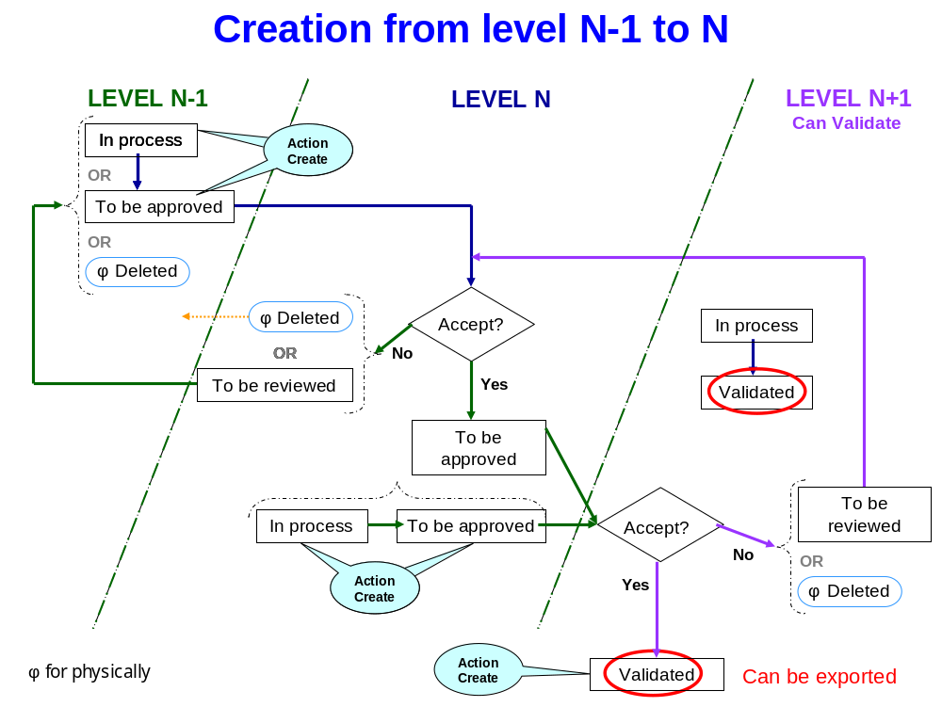
- Creation of 1 record from level N-1 to level N
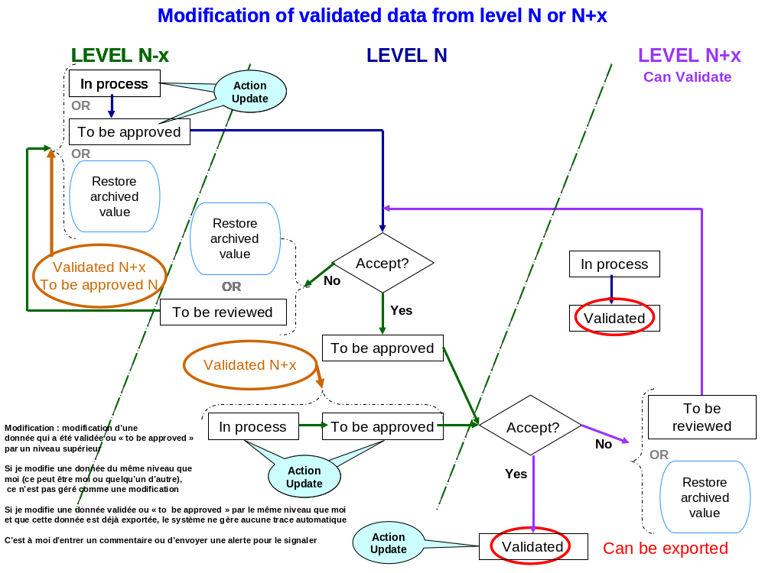
- Modification of data from level N-1 to level N
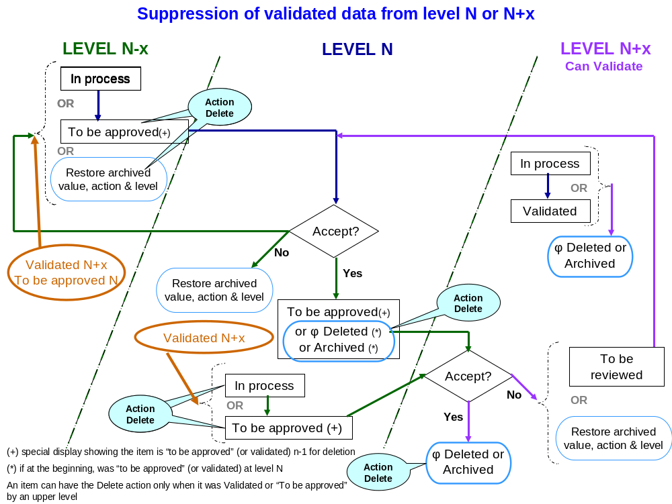
- Suppression of validated data from level N-1 to N
Note: We have now 2 main cases:
when an item is “in used”, it can be physically deleted and the delete procedure follows the same rules as for an “modified” or “created” item except that at the end (validation level) the item is archivated.
When an item is not “in used” but “new”, the level that creates the item or an upper lever can physically delete it.
      - Comment
Same with the status, level, action and state, comment is attached to each data row in MS, the purposes of comments are:
Add more information, description for the data
Validator can explain why he (she) validates or rejects the record.
Automatic comment by EMP to trace the history of modification. IARC: can you explain the difference between this comment and the “last validated values”? It not clear for us?
[Iteal]: With your new decision of only an allocated space --> we don't need this anymore.
There’re possible multiple comments for each row of data, the system displays the last comment on data by default, but user will be able to view the history of comment.
For performance reason, we shouldn’t keep all history of comments in database; we should keep a certain number of latest comments (configurable). IARC: after internal discussion, the comment will be an allocated space where users can add/delete/modify the information. We will not keep history of comment. We decide to simplify the comment approach.\
[Iteal]: Ok, remove next part due to this
      - Last Validated Values
The system can remember the last validated or “to be approved” values (can be exported) for each record (data, status, state…). The last validated values will be used for:
Compare between the last validated values with the current values (Validator or reviewer might need to see in order to accept or reject)
Revert data to last validated values at any time if needed
The values are archived in these cases:
The first time a record is “to be approved”
When a record is “to be approved” or “validated” by an upper level than the one available in the archive.
IARC:
Note: the status of a validated record can changed (e.g. by “to be approved”). When the list including this record, is proposed in another screen, for this record, it is the validated values that need to be displayed and not the “to be approved” one. Example a special day record called “AA” move from “validated” to “to be approved” at the library level. At the project level, when a user displays the proposed library list of special day (Menu project: special day screen), the validated records are displayed but also the records that are previously validated as the “AA” one. We can perhaps develop this point in the detailed specification.
Iteal: ok
      - Other trace information
The system also traces the following information:
Identification (login): last modified user. IARC: it will be good to store also the perimeter selected by the user to have a complete Identification on who did the modification because a user can have several projects attached (e.g. if I change a record in the project EPIC, the identification will be “EPIC/ccasagrande”).
[Iteal]: OK
Timestamp: last updated time

      - Business Rules for Traceability Information
        - Displaying record in grid
At each level (N), user can work with data from different levels (higher or lower) as following:
- Work to do (displayed in Green)
Validated at level N-1
In Process at level N
To be reviewed at level N+1
- Work could be done (Displayed in Orange)
Validated at level N-2…. N-x
To be reviewed N+2.. N+x
In Process <> Level N and State <> New
- Work Done (displayed in Green)
Validated ant N, N+1... N+x
To be reviewed at N
- Deleted Record (displayed stroke and in Grey)
- Other records (displayed in grey)
In process<>N and State=New
To be reviewed N-1, N-2… N-x
        - Other rules
With User at Level N, record state = New:
Validated or in process N or N-1, N-2, N-x → Physical delete possible
Validated or in process N+1, N+2, N+x → Physical delete NOT possible
IARC: Note: in the list, the archivated records are not displayed by default.
[Iteal]: OK
      - Filter and display the traceability information
It is necessary to filter and view the traceability data:
Status: IN PROCESS, TO BE REVIEWED, TO BE APPROVED, VALIDATED
Actions: CREATE / UPDATE / DELETE.
State: NEW / IN USE / ARCHIVED
Level: END USER / LOCAL / COUNTRY / PROJECT / IARC
Period of modification (from… since….)
Identification
[Iteal]: OK
    - Traceability Information for Translation
For data that need translation (e.g. food list), the translation in another language can be done:
- Using a Mass translation:
Once a list is ready in a language, all the reported records can be translated in another language.
This approach will be used when the translation of an already existing list has to be done in a new languages (e.g. when a new country is added in the platform, all the library data will have to be translated) or when a list is ready in the main language and has to be translated in all the languages available for a country (e.g. food list in English and Spanish, or food list for Switzerland with 3 different languages + English).
In the attached screen, a function/button (e.g. translation) allows to select 2 languages (from predefined list – attached to according to the project/country), the main one and the one for translation. Then, a screen is displayed with the list available in the 2 different languages. Added columns related to translation traceability are also available. See below.
The user can then translate and validate the translation done record by record. Some functions can allow updating the traceability variables for several records in the same time.
- Using a translation record by record:
A record is added in the list, the user can:
+ validate it
+ Enter the needed translations and validate each translation.
In this case, the user has to specify 2 different status variables, the one for the record (“in process” by default) and the other for the translation (“to be approved/validated” by default).
- Traceability variables attached to translation are:
Translation Status: "IN PROCESS" / "TO BE REVIEWED" / "TO BE APPROVED” / “VALIDATED" is the exchanged information between users at different level. The default value is “validated” (or “to be approved” according to the user level) and not “in process” as it is for record status (e.g. if a record is translated, the translation status=’validated’ or “to be approved”)
User Level: End-user / Local / National / International / IARC. Automatically attributed.
Comment: free comment given by the user for each records or a set of records
Alert: manual alert by user (sent email)
- Special Rules:
Data can be exported in Epicsoft database for a country & language, only if all the record status are “validated” and all translation status for the selected language are also “validated”.
    - Communication
The purpose of this part is to define the mechanism that helps users communicate with each other in EMP.
There’re 2 types of messages in EMP:
Simple Message: message edited by user and send to others (email)
Alert: Send automatically by the application.
      - Message Definition
Each Message will include:
- Type:
Simple message
Alert
- Destination:
To: Single or Multiple
CC: None, Single or Multiple
- Content: The content can be edited manually by user or automatically by application. Content will include:
Subject
Body
Attachment
      - Message Rules
The message will be prepared in MSapp (automatic or manual) and send to email of users (defined in the User Information).
There’s no management of Internal Message
In the email, it’s possible to add the link to the application / screens / data. User who received the e-mail can click on this link to open the related screen / data in EMP.
It’s necessary to limit number of records attached to a link in email because to open the link in application we pass data to application by URL (max length of URL is about 2000 characters).
CC: is it possible to link directly with a screen (table) rather than record(s) ?
[Iteal]: Yes → the link to screen is simpler than link to records IARC: perfect.
After click on the link, if the user name & password aren’t remembered → user must input them. In the case of they are remembered → we go directly to the screen.
After sending 1 message, the system will create 1 comment from this message and attach to the corresponding records (but with the type = Message or Alert). User will be able to see this comment when seeing the record.
CC: we are not sure to store the e-mail attached to the record because:
We can see the sent message but not the answer
The e-mail will be stored twice, in the e-mail box and in the application..
How to store several e-mail to 1 record? That can increase the database size.
Everybody can then see the messages
[Iteal]: Yes, it’ll increase database size and more complicated → so I propose to not create comment for email if you don’t really need this on you business
IARC: We prefer not to store automatically all the sent e-mail in the traceability comment field. The user will have to ask for this specially when the e-mail is related to several records.

[Iteal]: OK
      - Visualization
        - Communication button
The communication button will be available in each screen (red button at bottom-right corner)
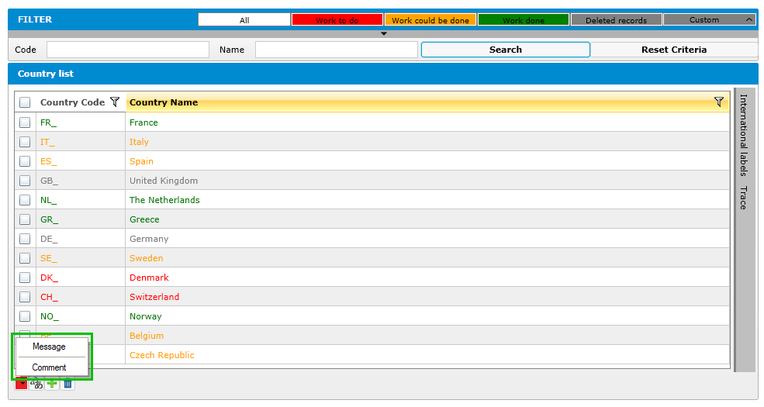
- Screen with communication button
When users click on the Communication button, a popup will be displayed, they can choose to:
Create new message
Create comment
CC: can you specify? Comment for several records, isn’t it? Comment can be attached to records but also to translation…
[ITeal]: Comment for records in this case IARC: OK
        - Create Message
In EMP, user can send the message to others, the process of sending message will be as following:
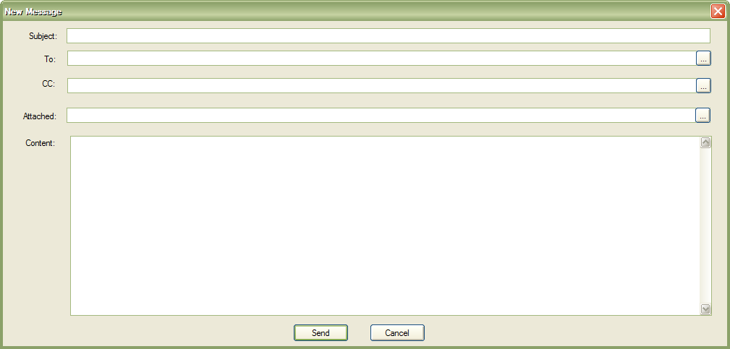
- Communication Rule – New Message
The Receivers: should be in the same project, Country or CIRC (there’ll have a configuration screen to configure the receivers that one user can choose when creating new message)
To: one or multiple (predefined list proposed and can also type an adress)
CC: None, one or multiple (predefined list proposed and can also type an adress)
After clicking on the Send Button, EMP will send the email to the selected destination (to & CC).
System will add automatically the link at the end of the content before sending the message; the receiver can click on the link to open the corresponding screen / data.
CC: how the user can specify the links?
[ITeal]: The link is created by the system; receivers can click in this to open application if they have right. IARC: OK

        - Create Comment
EMP will offer the users the possibility to add comment on data, users need to click on communication button and then "Comment" (the comment is only enabled if there's at least one selected rows in grid)
The following dialog will be displayed to user:
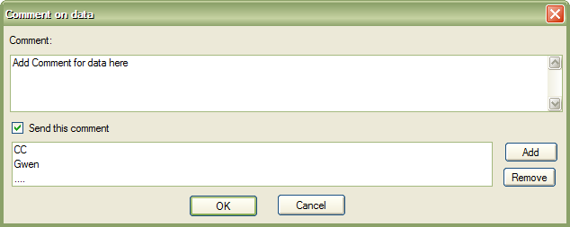
- Add comment on data
In this screen, users can write a comment to be attached to the selected data; it is possible to notify this comment to another user by checking the "Send this comment” and select the receivers of this comment. By default, the comment will not be sent.
If the comment hasn’t the destination → system will add this comment on each selected row same as comment in traceability
If the comment has the destination → system will send the email with the comment to the receivers.
System will add the link to the end of the content automatically before sending the message; the receiver can click on the link to open the corresponding screen / data.
IARC: We keep this option; possibility to add a comment to one and several records and to send this comment to parteners.
[Iteal]: OK
  - Versioning & Export
    - Versioning
The data of MSApp are organized in different levels: Library Data, Project Common Data and Country Specific Data. MSApp allow to prepare / update all these data and to export the Epicsoft database which will be used by RMapp, ESapp, IMapp and RCapp.
During operation of EMP, the exporting of Epicsoft Database can be done multiple times following the additions, updates and archives of data. The exported Epicsoft Data can be used by:
- Epicsoft Application:
Do the new interview
Edit the interview which has been made before
- Interview Manager (ReCompute)
Depending of the type of data, type of modification made, there might have some impact on the interviews which have been made before. The impact can be important especially when modifications have been done on project data that can change a lot the Epicsoft database contain.
The following table shows all the cases of modification and the possible impacts:
 | Differences between version of Epicsoft DB in V_{n} and V_{n+1} (changes in project / countries data) | ESapp | ESapp | RCApp
 |  | New  Interviews done with Epicsoft DB Vn+1 | Edit with a Epicsoft DB Vn+1 of interviews done with Epicsoft DB Vn | Run with Epicsoft DB Vn+1 on interviews done with Epicsoft DB Vn
Project Data
Setting | - Add | OK | OK | OK
Setting | - Modify | OK | OK | OK
Setting | - Delete / Archive | OK | (²) | (²)
List items (classif, facets/descriptors, photos…) | - Add | OK | OK | OK
List items (classif, facets/descriptors, photos…) | - Modify | OK | OK | OK
List items (classif, facets/descriptors, photos…) | - Delete / Archive | OK | (³) | (³)
Link tables (fdfacet, fdquant, fdprobing, rcpfacet….) | - Add | OK | (⁴) | (⁴)
Link tables (fdfacet, fdquant, fdprobing, rcpfacet….) | - Modify | OK | (⁴) | (⁴)
Link tables (fdfacet, fdquant, fdprobing, rcpfacet….) | - Delete / Archive | OK | (⁴) | (⁴)
Country Data
All Countries Data | - Add | OK | OK | OK
All Countries Data | - Modify | OK | OK | OK
All Countries Data | - Delete / Archive | OK | OK(¹) | OK
- Possible impacts on version changes
(1): An archived item (food, recipe) is still able to be used in mode "Edit Interview" but isn't able to be used in mode "New Interview" (The MS will export the Epicsoft Database including the state of all records → the ESApp must check the state to satisfy this rule).
IARC: Another way to do is to have 2 types of epicsoft database exports:
Without archivated items to do the data collection (new interviews)
With archivated items to do data cleaning using ESapp or IMapp (to edit interviews)
Using this approach, it is not necessary to export the state of each record in the Epicsoft database. For the moment, the state variable is not used in EPIC-Soft application.
We can perhaps discussed this point (export database) in the detailed specifications.
[Iteal]: OK
(2): If one item in "FCO" and "Place of Consumption" is deleted (in Library, there's no archived), so the Epicsoft Application can have problems to edit the related item. RCapp will generate an error message.
IARC: Also in library, data can be archivated. For example, an item is used at a project level and then the library coordinatorcan decide to delete it. In this case, the item cannot be deleted (because already selected) so the application has to archivate it. For the Epicsoft database export, we can ask to the user if (s)he needs archived items or not and the export program can prepare the database in this sens.
We can perhaps discussed this point (export database) in the detailed specifications.
[Iteal]: OK
(3): If the classification of foods and recipes (group, subgroup) has been deleted / archived, in the new version these foods, recipes have been re-classified. The quantification and description attached to this item are also modified by cascade effect:
As result, ESAPP cannot edit these items with the methods used during the creation of this interview but will use the new rules.
RCApp signals that these items were reclassified and their descriptions and / or quantification don't go with the new classification rules.

(4): if a link table (e.g. fadebygroup, fdqmdetail…) has been modified (deleted, changed), it will have effects on the entered foods & recipes which cascade effects:
ESApp cannot edit these items with the methods used during the creation of this interview but will use the new rules.
RCApp signals that these items don't go with their new description and / or quantification.
To manage the coherences between the different applications: ESApp (new interviews, edit interviews), ReCompute interviews (IMapp) using the different Epicsoft Database, we'll use the version of each Epicsoft Database which has been exported from MSApp.
The version number is a number for each Project/country managed by MSApp; this version number will be increased automatically each time a new Epicsoft Database is exported. Editing an interview, ESapp will have to check that the epicsoft database version used is greater or equal to the release stored in the interview. IMapp will have to do the same control…

    - Exporting - Create new version in MSApp
- EMP will add version number for all Epicsoft Database exported by MSApp. The information attached to each version includes:
Project (Current Project)
Country (current country)
Language to export.
Exported Date (Automatic by MSApp) CC: the exported date is enough, why a code + date?? That can be redundant.
[ITeal]: Which is code in your question? Do you mean “Version name”? I explain why we need version name bellow.
IARC: sorry, I will ask in another way my question. Is it necessary to have a Version number + an Exported date? Perhaps the date can be anough? ESapp, Recompute will use the date to compare the Epicsoft and Interview database version.
[Iteal]: OK, I think date is enough
Version Name: beside the number, the coordinator might need to define the version name such as: Epic 2010, Final Version… → That'll help us a clearer understanding on the exported version.
- Only the validated data with validated translation can be exported.
- In each project, we must define which roles will have Validation Right.
- Before exporting, System will do the Control on all data that will be exported and if all the blocked controls are OK, all validated data will be exported.
- Export updated database for EPIC-Soft application
The export can be done for the data collection (new interviews) so the archivated items will not exported.
The export can be done for the data cleaning (to edit interviews) so the archivated items will be exported.
- Export updated MS Database for interview manager:
In Centralized Mode: The MS Database and IM Database will be at the same server, we can update the MS Database for IM directly without needing of Export / Import
In Decentralized Mode:
The MS will export MS Database (for selected countries) into xml file that will be used to import into the IM Module in decentralized mode.
Export User's Information & Permissions: to be imported into IM in decentralized mode.
  - Control
The control will check for the following:
Coherence of MS Data
Translation of Data
Epicsoft Database is exportable only if the blocked Controls are Ok.
IARC: We can image to have in the control list some less important as warning. We will see in the detailed specifications.
[Iteal]: OK
Control is the function that will be use to check the validation and completion of MS Data. We can use them in different situations::
Total Control: All the controls are run on all the data attached to a selected project/country. The total control will be automatically done before Exporting Epicsoft Database or when user needs. The total control function will be accessible via Menu.
Partial Control: controls are run by set of data. We can have controls on :
  - a selected project (only project tables)
  - a selected country and on food part (food project/country tables)
  - a selected country and on recipe part (recipe project/country tables)
  - a selected country and on supplement part (supplement project/country tables)
Unit Control: Control for each Interface, while preparing MS Data, users can do the control in each screen to verify their data.
IARC: can you give us a example of unit control? In a screen, we already have business rules that are automatically applied, do you see other controls? IARC: Yes completeness.
[Iteal]: Such as "Check the translation for 1 table"
Note: Refer to RM4_SFG_IARC_EMP_V1.0.doc – Part "10 - ANNEXE 2 – CONTROLES" for all rules for Control
Also available in Annex 5 in this document.
  - Photo Handling
Refer to “Photo management-01d.doc” for the definition of photo handling.
  - Reuse Data
    - Generalities
When preparing data for 1 Project / Country, user can reuse data from other projects / countries by using the import functions of MSApp including:
Total Import
Table Import
Unitary Import (per record)
Automatic Import
Import of csv-files
Note: whatever the type of import, the translations of the imported data have also to be imported.
    - Total Import
The total import will be used to import Project Data and its attached Country Data. The User can decide to import.
the project + a selected project/country data
or the project data + several selected country data
or a selected country data only
[dtta]: if “selected country data only” → the project data must be available before we can import country data → Is this?
CC: yes, it is the following case:
a project with several attached country
a new version of this project is created
Country 1 is ready to start with this new project version but not the other one so we will do a total import for this project/country
A second Country is ready to start with this new project version so we will copy only its country data and not the project data because already updated by the country 1.
Etc… for other attached countries.

Note:
  - The total import is used especially for projects that are the continuity of an already existing one (e.g. PANEU 2012 will be the continuity of PANEU 2011).
  - At the new project creation, the IARC user will have to indicate that this new created project is closely attached to a given old one (e.g. PANEU 2012 is attached to PANEU 2011).
  - In this case, for the New project and for all the copied records, the items’ State variable value will not be changed (=“In use”). The items/records will not be deleted but archived. The item codes are also kept as they are (e.g. food code, standard unit code…).
  - The total import can be done after the project creation, in the project screen where the following questions are asked to the user “closely link project?” and if the answer is Yes the question “To which project?” is also asked. Then a total import button can be available.
In the Total Import, the current project & project/Country tables must be empty. In case it is not empty, the system will display a warning and if the user answers OK (and not Cancel), all the tables of this project/country will be cleared before doing the import.
Traceability variables:
status = in process
level=null (or imported)
[dtta]: In my opinion:
- We can import the “Validated Records” only → is this?
- After import record from a project / Country → do we need to change “State” of source (from New to In Use)?
CC: No, we create a new project version when the previous one is nearly finalized so we prefer to copy all the data in the state they are that means also the “in process/to be approved/to be reviewed/validated” status have to be copied and the state values don’t have to be modified too. It is a data copy to another project/country keeping the same data state.
    - Table Import
In MSapp, we have several tables organized per type of data. We have library data, project data and project/country data. Only project and project/country data can be imported.
      - Project data Import
See Annex 4 – MS Data Organization & Importation
For some project tables the import can be done from the library or from another project:
All the setting tables attached to the project (e.g. special day/diet, probing list…)
Food tables attached to the project: Classification, facets & descriptors
Recipe tables attached to the project: Classifications, Facets & descriptors
Supplement tables attached to the project: Classifications, Facets & descriptors

For other project tables, the import can only be done from another project.
Food tables attached to the project:
    - Facets/descriptors by group/subgroup (Fadebygroup, table=Groupfac)
    - Facet rules
    - Quantification by group/subgroup
    - Probing by group/subgroup
Recipe tables attached to the project:
    - Facets/descriptors by group/subgroup (table=R_Groupfac)
    - Facet rules
    - Quantification by group/subgroup
    - Probing by group/subgroup

The import of project data has to follow a certain order described here:
- The classification, the facet/descriptor before the “Facets/descriptors by group/subgroup” and then the Facet rules.
- Followed by the photo and shape lists and the “Quantification by group/subgroup”
- Followed by the probing list and the “Probing by group/subgroup”
- Followed by the other setting data

Opening the import screen, the user can decide to:
- Import data table per table from other projects (or from the Library)
Example:
    - For the PANEU special day table, the import can be done using the Library special day table or the EFCOVAL special day list or EPIC special day table,
    - For PANEU probing list table, the import can be done using a different project’s table such as EPIC….
- Import data of a select group of tables from other projects (or from the Library).
Example:
    - For the PANEU setting table, the import can be done using the Library setting data
    - For the PANEU Classification (foods/recipe/supplement), the import can be done using the EPIC classification data
    - For the PANEU “Facets/descriptors by group/subgroup”, “facet rules”… (foods/recipe/supplement), the import can be done using the EFCOVAL data
    - etc…

During the import some controls have to be done:
The current project table must be empty before the import.
In case of the project table selected for import is not empty and the attached country tables are empty, the system will display a warning and if the user answers OK (& not Cancel), the project table will be cleared before doing the import (use case = Epicsoft database creation).
In case the project table is not empty and the attached country tables are also not empty too, the system will display a warning saying that the import is not possible because data are present in an attached country (use case = Epicsoft database update at project level). As it is not possible to do a table project import in this case, we can also decide to inactive the import table button.
Controls of coherence between data have to be done (e.g. problem if a facet is available in the Groupfac table but not in the facet list). In case of problem, the non-imported records are stored in a log-file, log-file organized by table.

Notes:
For the “Facets/descriptors by group/subgroup” tables for foods and for recipes, once they are ready (all records validated), their data can be copied at the country level and the national coordinator can change the descriptors order (columns order_fac et order_desc), “not-in-the-name” and default columns.
In the same way, the classification sub-sub-group for food et sub-group for recipes can be modified at the country level

Traceability variables:
status = in process
level=null (or imported)
      - Project/Country data Import

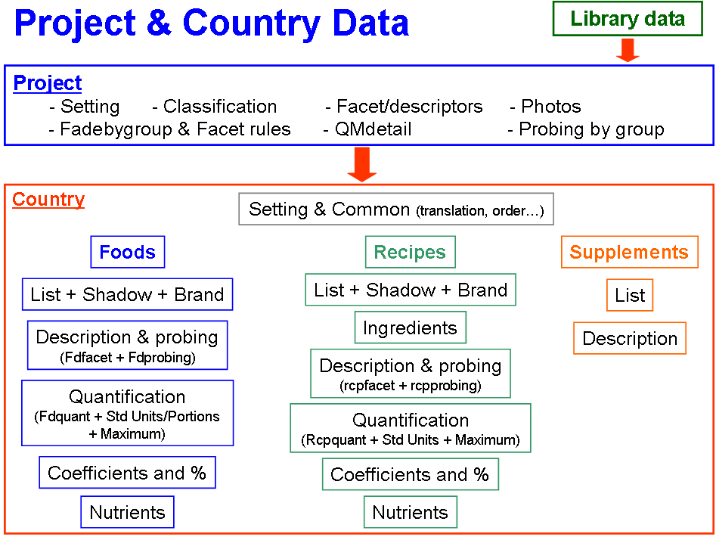

See the Project/country table organization in ANNEX 3

The country tables are different:
- Some are totally independent
- Some are built according to rules decided at the project level.
- Some are linked with other country tables

A - The independent country tables can be imported alone from another project, project/country or Library. These tables are:
- Setting tables: Source
  - Check-list by FCO From Project/country
  - Interviewer list From Project/country
- Common tables:
  - Photo (including photo series, shapes, HHM, thickness) From Library or project or project/country
  - Food Classifications for sub-sub-group From Library or Project
  - Food Facets/descriptors by group/subgroup (Groupfac) Project
  - Recipe Classifications for sub-group From Library or Project
  - Recipe Facets/descriptors by group/subgroup (R_Groupfac) From Project
  - Supplement Classifications From Library or Project/country
- Food Brand name list From Project/country
- % of fat left over in the dish From Project/Country
- Recipe Brand name list From Project/country
- Supplement List From Project/country

B - The country tables that are built according to others cannot be imported because they directly depend on the project rules (e.g. facets by foods). These tables are:

- Food tables:
  - Food description (Foodfaex table) Generated
Never imported but prepared according to the food list and to “Food Facets/descriptors by group/subgroup” (groupfac table)
  - Food quantification (QM_foods table) Generated
Never imported but prepared according to the food list and to “Food Quantification by group/subgroup” (qm_group table)
  - Food probing Generated
Never imported but prepared according to the food list and to “Food Probing by group/subgroup” (pqpath table)
- Recipe tables:
  - Recipe description (R_rcpfaex table) Generated
Never imported but prepared according to the recipe list and to “recipe Facets/descriptors by group/subgroup” (r_groupfac table).
  - Recipe quantification (QM_recip table) Generated
Never imported but prepared according to the recipe list and to “recipe Quantification by group/subgroup” (qm_rclas table)
  - Recipe probing Generated
Never imported but prepared according to the food list and to “recipe Probing by group/subgroup” (Rpqpath table)
- Supplements tables:
  - Supplement description Generated
Never imported but prepared according to the supplement list and to the facet list with the specific order.

C - Linked country tables that can be imported and all the attached tables are automatically imported at the same time

- Food and shadow list Project/country
The following tables are automatically imported at the same time:
    - Standard unit
    - Standard portion
    - Maximum
    - Coefficients: Density, Rawcooked & Edible
    - Percentages: Fats during cooking, Fats/sauces/sweeteners added
    - Nutrient values
- Recipe and shadow list Project/country
The following tables are automatically imported at the same time:
    - attached ingredients and related information
    - Standard unit
    - Maximum
    - Coefficients: Density
    - Percentages: Fats/sauces/sweeteners added
    - Nutrient values

Note: The food, recipe or supplement codes of the sources (codes project/country/item) are kept to have a trace of where they come from (e.g. for a food, the project/country/foodnum are kept)
Even if the main table is not empty (e.g. food list), the import can be done combining the new list with the previous one and the same rule applies to the attached tables (e.g. std unit, maximum…)

D - Linked country tables that cannot be imported because the link with the main table (food or recipe list) is not kept.

- Foods
The following tables cannot be imported alone:
    - Standard unit
    - Standard portion
    - Maximum
    - Coefficients: Density, Rawcooked & Edible
    - Percentages: Fats during cooking, Fats/sauces/sweeteners added & % of fat left over
    - Nutrient values
- Recipes
The following tables cannot be imported alone:
    - Ingredient
    - Standard unit
    - Maximum
    - Coefficients: Density
    - Percentages: Fats/sauces/sweeteners added
    - Nutrient values

Note: In this case, the user will have to use the unitary import item by item.

E - During the import some controls have to be done:

Case A:
The current project/country table must be empty before the import.
In case it is not empty, the system will display a warning and if the user answers OK (& not Cancel), the current project/country table is cleared before doing the import.

Case B: No controls during the generation because done by the application
Case C:
Even if the main table is not empty (e.g. food list), the import can be done, combining the new list and the previous one and the same rule with the attached tables (e.g. std unit, maximum…)
Some controls of coherence have to be done such as the food name must not already exist in the same language (management rules).
Case D: no import so no control

Traceability variables:
Status = in process
Level=null (or imported)
    - Unit Import
The Unit Import is the importation at record level, in one screen user can opt to import one or several records from the same table of other Project / Country.
As for table import, we need to distinguish different situations depending on the type of data.
      - Project data:
For some project tables, the import of records from other project data is not possible: the user has to select a record directly from the library (e.g. facet has to be selected in the Library facet list). These tables are:
Setting tables : Special diet, special day, place of consumption, probing list, photo list, FCO list, nutrient list, ,
Foods: facets, descriptors, classification (at the group/subgroup level)
Recipes: facets, descriptors, classification (at the group level)
Supplements: Classification, facets and descriptors

For some tables, the import record from other projects can be done. These tables are:
Setting tables : Note Status list
Recipes: classification (at the subgroup level)
Supplements: Classification

      - Project/country data:
Depending on the country tables, we will have different types of record imports.
Case Country 1 - It can be unitary: one or several records from one source table are imported into one target table.
Case Country 2 - It can be unitary with linked records: when the user selects one or several records in a target table, these records + the linked records from other tables are imported in the corresponding target tables (e.g. if a food is selected, this food is imported but also the attached standard units, portions, maximum values, coefficients…).
[dtta]: In this part, you talk about 2 cases: 1 & 2. But the below paragraph they’re case A & case B. Do you confirm that: “Case Country 1” is case A & “Case Country 2” is case B?
CC: sorry if it is not clear. No these cases are not linked to Case A or B defined previously. They are different situations because it is a “unitary import”. I changed the following sentence and I hope that it is clearer to you.

The Project/country tables are all in case 1 except for the following ones that are in case 2:
- Foods:
  - Food list : if a food list record is selected for import, the linked records of the following tables are also imported:
    - Standard units
    - Standard portion
    - Maximum
    - Coefficients: Density, Rawcooked, Edible
    - Percentages: Fats during cooking, Fats/sauces/sweeteners added
    - Nutrient values
- Recipes:
  - Recipe list : if a recipe list record is selected for import, the linked records of the following tables are also imported:
    - Ingredients
    - Standard units
    - Maximum
    - Coefficient: Density
    - Percentage: Fats/sauces/sweeteners added
    - Nutrient values

Rule for Unit Import:
  - The Destination Table(s) doesn’t need to be empty; the importation can be done several times. However, one record which has been imported cannot be imported a second time.
  - When an item is selected for import, it can be necessary to ask the user to which main item it has to be attached (e.g. if a standard unit is selected, it is necessary to ask to the user to which food this std unit needs to be attached). It can be possible to select several records and to attach them to one food/recipe item (e.g. 5 density coefficients for 1 food).
  - When a food or recipe item (main ones) is selected, it is necessary to ask a confirmation to the user on the group/subgroup/sub-subgroup attributed (source classification can be different from the target one).
  - Check the coherences between new imported data and the existing data in the current project / country.
Traceability variables:
status = in process
level=null (or imported)
      - CSV-file Import
The Import using csv-files can be used for specific data such as:
Food list
Recipe list
Supplement list
Food Brand name list
Recipe Brand name list
Interviewer list
[dtta]: Do you have format of csv files? Are they defined by us (ITeal) with all columns in each table?
CC: Yes we are waiting for your propositions (depending of the table) and then we can discuss. It is detailed specification part.
  - Access to Import Function
CC: if fact, we do not need this import page nether the import in the menu because:
For table import, an import button has to be available at the bottom of each screens (when relevant)
For unitary import an “unitary import” button has to be available at the bottom of each screens (when relevant)
For Total import, it is at the project screen level (in administration), that we will need a special pop-up (screen) that allows to import
  - the project + a selected project/country data
  - or the project data + several selected country data
  - or a selected country data only
- DATA
IARC: I move all the annex 3 to here point 9. The annexes are now in point 10.
    - Library
La bibliothèque du CIRC (ou Library IARC), constitue la référence des données de paramétrage à destination de EPIC-Soft application. Elles sont les listes exhaustives provenant de la capitalisation de différents projets. Elles représentent les données nécessaires pour lancer de nouveaux projets. Elles sont fournies pour tous les utilisateurs en mode de vue et sont mises à jour par le CIRC. Certaines données ne sont pas modifiables au sein des projets, d’autres sont des propositions qui servent à initialiser les projets, et qui peuvent y êtres modifiées, complétées.
Toutes les traductions disponibles de ces données peuvent être fournies.

Leur description est dans les sous-paragraphes suivants.
      - Setting
Ces données définissent les paramètres qui peuvent être utilisés par tous les projets.
Certaines sont des propositions (comme par exemple la liste ‘jours spéciaux’) et certaines sont directement utilisées (sans modification) par les coordinateurs du projet (ex : Recipe pathway).
La liste des données de setting est :
- Liste des Pays et des Centres,
- Liste des jours de la semaine,
- Liste des mois,
- Liste des repas (FCO : Food Consumption Occasions),
- lieux de consommation,
- Check-list pour FCO,
- Liste des jours spéciaux,
- liste des régimes alimentaires spéciaux,
- liste de questions (probing),
- les contrôles sur les valeurs anthropométriques,
- substitution des ingrédients (substit table)
- Contrôles sur les descripteurs des ingrédients fixes (descsubs table)
- liste des nutriments (énergie, macronutriments et eau sont obligatoires), les attributs sont les suivants :
- code (style EUROFIR)
- nom (label)
- Unité : mlg, gr, Kcal, etc.,
- Obligatoire ? (o/n),
- visible ? (o/n),
- commentaire
- contrôles sur les valeurs nutritionnelles (Nutlimit)
- Incompatibilités entre descripteurs
- règles générales d’accès sur les recettes (recipe pathway)
- IHM (menus, écrans) d’Epic-soft application (EPICTEXT), la traduction se fait par les pays (fonction import-export, avec anglais en langue de référence).

Il existe aussi des données setting spécifiques aux projets :
- Paramétrage de l’application EPIC-soft (e.g. heures demandées avec ou sans minutes…)
- Statuts appliqués aux notes : liste des modalités possibles

Il existe aussi des données setting spécifiques aux pays :
- Liste des interviewers

      - Classification
La classification consiste à organiser :
- D’une part les types de données qui sont à gérer : aliments, recettes et suppléments
- Et d’autre part à établir des groupes pour chaque type (ex. groupe des pommes de terre, groupe des matières grasses, etc.).

Cette classification s’applique pour les aliments, les recettes et parfois pour les suppléments (dépendant des besoins des projets/pays).

Pour faciliter leur gestion, il est également souhaitable de pouvoir classer les photos (séries de photos), les formes (shape), les HHM et les photos liées aux épaisseurs. Cette classification sera indépendante des classifications définies pour les interviews.

La classification est au maximum définie sur 3 niveaux :
- Niveau 1 : groupe
- Niveau 2 : sous-groupe attaché à un groupe
- Niveau 3 : sous-sous-groupe attaché à un sous-groupe

Les projets héritent des classifications définies dans les library du CIRC, des modifications sont possibles :

- Aliments :
  - Groupes et Sous-groupes: non modifiables au niveau projet.
  - Sous-sous-groupes certains peuvent être ajoutés/modifiés au niveau projets. Un indicateur au niveau du sous-groupe permettra d’identifier lesquels sont modifiables.
  - Certains groupes sont identifiés comme appartenant à FAT, FSS et FLO.

- Recettes :
  - Groupe : non modifiable au niveau projet.
  - Sous-groupes sont tous modifiables au niveau pays.

- Suppléments
  - La classification des suppléments n’est pas obligatoire. Une ou plusieurs classifications seront proposées au niveau de la Library. Ce n’est qu’au niveau projet ou même pays que cette classification sera décidée. Elle peut même être complètement différente de celle proposée au niveau Library.
- Photos : Définie uniquement au niveau Library.

Le modèle doit permettre une évolution vers plusieurs classifications de même type (plusieurs classifications food, plusieurs classifications recettes, etc.).
      - Description
La description des aliments, recettes et des suppléments se fait, avec :
- Des facettes (facets) : liste de questions
- Des descripteurs (descriptors) associés à une facette : liste de réponses possibles

Exemples :
- Facette : « physical state »
  - Descripteurs : « liquid », « powdered », « pureed », « cube » etc.

- Facette : « cooking method »
  - Descripteurs : « barbecued », « boiled », « fried », etc.

Une liste des facettes / descripteurs existe pour chaque type d'élément (aliment et recette et supplément). Ces listes sont indépendantes les unes des autres.

Une version initiale de ces listes est fournie dans la bibliothèque IARC.

Les projet/pays ne peuvent ajouter de facettes/descripteurs à leur niveau. Une fonction permet de demander au CIRC d’ajouter de nouveaux éléments (facette et/ou descripteur) dans la Library. Cette demande suivra un processus de validation tel qu’il est defini au §.
        - Facettes
La facette est identifiée par son code, elle a un nom (label).
Il existe des facettes pour les foods, pour les recettes et pour les suppléments bien distinctes.

- FOODS :

3 types de facettes pour les foods :
- Type = 0 => standard --> descripteurs dans la liste des descripteurs (DESCRIPTOR)
- Type = 1 => brand --> descripteurs dans la liste –ouverte- des marques (BRAND)
Type = 2 => fat/liquid --> descripteurs dans la liste des aliments (FOOD).

Pour les facettes dont les descripteurs sont disponibles dans la table des aliments (Type = 2), il est nécessaire de définir les groupes / sous-groupes / sous-sous-groupes de foods, qui permettront d’afficher une liste d’aliments réduite et sélectionnée.

2 types de sélection
- Mono-sélection de descripteur
- Multi-sélection de descripteur

Note technique :
Les facettes : « physical state », « « cooking method », « brand name » sont particulières. Pour pouvoir assurer les contraintes et contrôles qui leur sont attachés, il est nécessaire que l’application puisse les ‘reconnaitre’. Elles seront donc identifiées de façon particulière. Le paramétrage de l’identification des ces facettes particulières sera très stable, (physical state → code = 02, cooking method → code = 03), de ce fait, il sera fait hors IHM directement en base, ou dans un fichier de propriétés de l’application.

- RECIPES :

2 types de facettes pour les Recettes :
- Type = 0 => standard --> descripteurs dans la liste des descripteurs (DESCRIPTOR)
- Type = 1 => brand --> descripteurs dans la liste des marques (BRAND)

2 types de sélection
- Mono-sélection de descripteur
- Multi-sélection de descripteur

Certaines facettes sont à identifier de façon particulière (idem foods). Cette identification est nécessaire pour identifier les facettes obligatoires dans tout projet et pour pouvoir effectuer certains contrôles de cohérence sur les données, il s’agit de la facette « known/unknown » et de la facette « Recipe production ».

- SUPPLEMENTS :

2 types de sélection
- Mono-sélection de descripteur
- Multi-sélection de descripteur

La facette « physical state » doit être identifie de façon particulière (idem foods) car elle est obligatoire pour la « quantification » des suppléments.

Les facettes attachées aux suppléments doivent être ordonnées/organisées afin de prédéfinir un ordre d’affichage qui sera suivi au niveau projet. Leur gestion est plus simple que pour les foods (voir 6.2.2.3.2) et recipes (voir 6.2.2.4.2).

        - Descripteurs

Le descripteur ‘standard’ est identifié par son code, il a un nom (label) et est attaché à une facette.
Une facette (question) a plusieurs descripteurs attachés (réponses possibles).
Comme pour les facettes, il existe des descripteurs propres aux foods, aux recettes et aux suppléments.

- Foods :

Pour les descripteurs associés à la facette ‘cooking method’, il faut pouvoir identifier 1/ celui qui correspond à une réponse ‘cru’, 2/ ceux qui correspondent à une réponse ‘cuit avec MG’. La question ‘matière grasse pendant la cuisson ?' sera alors proposée par le ESApp, 3/ ceux qui correspondent à une réponse ‘cuit en friture profonde’ et 4/ les autres.
- 1=Raw descriptor
- 2=Descriptors to ask the question “fat used during cooking” for food only
- 3=Descriptors “deep fried” to ask the question “fat used during cooking” for food & ingredients
- 0=Other descriptors without consequences ESapp algorithms

Définition des groupes de descripteurs pour gérer les coefficients RAWCOOK et PCTFAT plus facilement pour l’utilisateur.
La liste des groupes est :
- Pour RAWCOOK :
  - BO : ‘boiled’,
  - BA : ‘baked’,
  - RO : ‘Roasted’,
  - FR : ‘Fried’,
  - RA : ‘Raw’,

- Pour PCTFAT :
  - ‘very fatty’,
  - ‘Fatty’,
  - ‘Low fat’
  - ‘No fat’

Pour les facettes définies avec « multi-selection » de descripteurs, certains descripteurs ne tolèrent pas d’être sélectionnés avec d’autres. Il est donc nécessaire d’identifier ces descripteurs pour empêcher la multi-sélection dans ESapp.
- 1= mono descripteur (alone descriptor)
- 0=multi-descripteurs (not alone descriptor)

Pour la facette « brand », les descripteurs sont définis comme une liste de valeurs textuelles faisant référence à des marques. Pour certain pays multilingues comme la Belgique, les marques seront en plusieurs ‘langues’.

- Recipe:

Pour les descripteurs associés à la facette ‘recipe production’, il faut pouvoir identifier 1/ les descripteurs qui correspondent à une recette faite à la maison ’homemade’ et 2/ les descripteurs qui correspondent à une recette ’commerciale’
- 1=homemade
- 0=commercial

Pour les facettes définies avec « multi-sélection » de descripteurs, certains descripteurs ne tolèrent pas d’être sélectionnés avec d’autres. Il est donc nécessaire d’identifié ces descripteurs pour empêcher la multi-sélection dans ESapp.
- 1= mono descripteur (alone descriptor)
- 0=multi-descripteurs (not alone descriptor)

Pour les recettes, il existe aussi une facette « brand », avec des descripteurs définis comme une liste ouverte de valeurs textuelles faisant référence à des marques.

- Supplements:

Pour chaque facette, il est nécessaire (mais pas obligatoire) de définir un descripteur ‘défaut’ sur lequel le curseur se positionnera dans la fenêtre facette/descripteur d’ESapp.
- 1=default
- 0=other (not default)

Seulement pour la facette utilisée pour la quantification (physical state), il est necessaire de savoir si le descripteur permet ou pas de proposer la méthode HHM dans MSapp
- 1=la méthode HHM est proposée,
- 0=la méthode HHM n’est pas proposée.

Une variable permet d’identifier le descripteur « Other » des autres (1=other, 0=not other) et pour lequel ESapp suit une procédure différente.

Une variable permet de donner un ordre d’affiche des descripteurs d’une même facette (1=premier, 2=second…)
      - Quantification par images
Pour évaluer la quantité des aliments (ou recettes) prise lors des repas, les éléments suivants sont gérés :
- HHM (unité de mesure ménagère standard),
- Séries de Photos,
- Shape,
- Thickness (certaines (pas toutes) épaisseurs ont une photo).

Ces données sont gérées au niveau Library, elles sont proposées aux projets et aux pays qui peuvent particulariser leur utilisation.

Toutes les photos :
- sont liées à une classification indépendante de celles utilisées dans EPIC-soft (groupe, sous-groupe, sous-sous-groupe). Cette notion permet rechercher, d’ordonner la liste de photos, elle est interne à maintenance et setting, ne sera pas exportée vers EPIC-SOFT application.
- En plus du commentaire nécessaire à EPIC SOFT pour Shape, HHM, Thickness, un commentaire ‘libre’ interne à EMP est à gérer.
        - Photos de HHM
Les HHM sont des unités de mesure ménagère standard, telles que les verres, les cuillères, les bols, etc.

Elles sont définies par :
- Un code de HHM (unique par pays),
- Un nom (label),
- Le volume en ml
- L’ordre de présentation à l’écran lors de l’interview,
- Des côtes :
  - Diamètre,
  - Hauteur totale,
  - Hauteur du récipient, (seulement pour les verres à pied)
- Une photo,
- Un commentaire libre, permettant de préciser son utilisation,
- Fraction : pour répondre au besoin d’utiliser une HHM ‘non pleine’, (par exemple un demi-verre), il est nécessaire de pouvoir définir des fractions sur les HHM. Il est important que les fractions puissent être présentées sur Epic-Soft en écriture arithmétique,( ex ½).

Les HHM sont gérées par le CIRC, elles ne sont pas modifiables par les projets, chaque pays/projet peut choisir celles qu’il veut utiliser.
        - Série photos (EPIC-soft picture book)
Le sujet visualise le plat sur la photo, il peut ainsi répondre avec plus de précision sur la quantité prise lors du repas.

Les photos sont regroupées en séries. Une série de photos concerne le même aliment, ou la même recette, sur les différentes photos de la série, seule la quantité change. Une série est définie par :
- Un code de la série (unique),
- Un attribut permettant de définir si la quantité est avec ou sans déchets,
- Un attribut permettant de définir s’il s’agit d’une quantité est en cru ou cuit,
- Une unité de mesure valable pour toutes les photos de la série, (G = grammes, V = ml (volume),
- Une photo (de type planche contact) de toutes les photos de la série.

Chaque photo de la série est définie par :
- le code de la photo (unique),
- La quantité (en g ou ml) de l’aliment / recette correspondant à la photo dans la série.

Les photos et les séries photos sont gérées par le CIRC, elles ne sont pas modifiables par les projets.

        - Photos de Shape (Surface)

Les ‘Shape’ sont des formes standards, (exemple forme d’une tranche de pain), permettant d’évaluer une surface.
Les caractéristiques de ‘shape’ sont :
- Un code (unique)
- Valeur de la surface (en cm2),
- Un commentaire libre, permettant de préciser son utilisation,
- Une photo représentative.

Les formes sont gérées par le CIRC, elles ne sont pas modifiables par les projets.
        - Photos de Thickness (Épaisseur)
Les ‘Thickness’ sont des épaisseurs ‘standard’, (exemple épaisseur d’une tranche de pain), permettant d’évaluer une quantité. Pour quantifier les aliments étalés sur du pain, des crêpes…, des photos sont disponibles.

Les caractéristiques de ‘Thickness’ sont :
- Un code (unique)
- Valeur de l’épaisseur (en cm),
- Un commentaire libre, permettant de préciser son utilisation,
- Une photo représentative éventuellement (e.g. P058),

Les ‘Thickness’ sont rattachées à un ou plusieurs groupes alimentaires de food et/ou de recipe.

Les photos des épaisseurs sont gérées par le CIRC, elles ne sont pas modifiables par les projets.
        - Probing par groupe/sous-groupe
Au niveau de la Library pour chaque groupe/sous-groupe/sous-sous-groupe food et recette on propose une liste de probing. Certains probings sont obligatoires car liés aux pourcentages fat, sauce, sweetener (FSS).
    - Données Projet
      - Setting
La liste des données de setting héritées de la Library et modifiables au niveau projet sont :
- Liste des repas (FCO : Food Consumption Occasions),
- lieux de consommation,
- Liste des jours spéciaux,
- liste des régimes alimentaires spéciaux,
- liste de questions (probing),
- les contrôles sur les valeurs anthropométriques,

Setting spécifiques aux projets :
- Paramétrage de l’application EPIC-soft, ~10 paramètres, (e.g. heures demandées avec ou sans minutes, liste des fractions utilisables, …)
- Statuts appliqués aux notes pour interview manager : liste des modalités possibles

      - Quantification par photo
La quantification par photo est héritée de la Library, elle est proposée au projet qui peut choisir le sous-ensemble qu’il souhaite utiliser. Cela inclut les séries photos (picture book), les HHM, les shapes et les épaisseurs.
        - Food

Classification :
Les projets héritent des classifications définies dans les library du CIRC, des modifications sont possibles :
  - Groupes et Sous-groupes: non modifiables au niveau projet.
  - Sous-sous-groupes certains peuvent être ajoutés/modifiés au niveau projets. Un indicateur au niveau du sous-groupe permettra d’identifier lesquels sont modifiables.

Description
- facettes/descripteur (food) :
  - Le projet particularise ses listes de facettes/descripteurs en sélectionnant les items qu’il souhaite utiliser. Les items (facettes/descripteurs) sélectionnés au niveau projet sont des sous ensembles d’items proposés dans la Library.
  - Les listes des facettes/descripteurs sélectionnés au niveau projet sont utilisées par tous les pays attachés à ce projet.
  - La facette 02 (physical state) et 03 (cooking method) sont obligatoires.

- FadeByGroup (food) :
Il s’agit de définir quels sont les facettes et descripteurs utilisables par groupe alimentaire, voire sous-groupe ou sous-sous-groupe, au niveau du projet sous condition de règles de gestion (e.g. facettes 02, 03 obligatoires…).

Prévoir la gestion d’un commentaire interne EMP.

Le FadeByGroup n’est pas dans la Library, il sera hérité d’un projet et adapte au nouveau projet.

- facetRule (food) :

Il s’agit de définir des règles d’affichage des facettes, en fonction des descripteurs déjà sélectionnés et cela par groupe alimentaire, voire sous-groupe ou sous-sous-groupe, au niveau du projet sous condition de règles de gestion et très fortement lié avec le fadebygroug.

Prévoir la gestion d’un commentaire interne EMP.

Le FacetRule n’est pas dans la Library, il sera hérité d’un projet et adapte au nouveau projet.

Quantification by classification
La « quantification by classification » permet de définir quelles méthodes de quantification peuvent être utilisées sur les groupes, sous-groupes ou sous-sous-groupes.

Les méthodes de quantification qui y sont listées sont :
- P : photo
- H : HHM
- A : Shape
- U : standard Unit
- S : standard portion

Pour les aliments, il peut être nécessaire de spécifier si cette méthode de quantification s’applique
- pour un aliment : cru, cuit ou pour les 2.
- pour quels descripteurs de la facette « Physical state », (Ex. : pour un même aliment la méthode de quantification peut être différente si le produit est en poudre ou liquide),
- Pour photos et shape quelle est la méthode de quantification, (ex. P001), la sélection se fera par désignation de la photo dans la bibliothèque du projet,
De plus, un champ commentaire (pour EPIC Soft) est disponible et obligatoire.

La quantification par groupe est définie au niveau projet puis adaptée au niveau de chaque aliment par chaque pays.

Probing by group
«Probing by group » est hérité de la Library, elle est proposée au projet qui peut tout modifier, à l’exception des probings obligatoires.
        - Recipe

Classification :
Les projets héritent des classifications définies dans les library du CIRC, des modifications sont possibles :
  - Groupes: non modifiables au niveau projet.
  - Sous-groupes peuvent être ajoutés/modifiés au niveau projets.

Description
- facettes/descripteur (recipe) :
  - Le projet particularise ses listes de facettes/descripteurs en sélectionnant les items qu’il souhaite utiliser. Les items (facettes/descripteurs) sélectionnés au niveau projet sont des sous ensembles d’items proposés dans la Library.
  - Les listes des facettes/descripteurs sélectionnées au niveau projet sont utilisées par tous les pays attachés à ce projet.
  - Les facettes : 00 (Known/unknown) et 01 (recipe production) sont obligatoires.

- FadeByGroup (recipe) :
Il s’agit de définir quels sont les facettes et descripteurs utilisables par groupe alimentaire, voire sous-groupe, au niveau du projet.

Prévoir la gestion d’un commentaire interne EMP.

Le FadeByGroup n’est pas dans la Library, il sera hérité d’un projet et adapte au nouveau projet.

- facetRule (food) :

Il s’agit de définir des règles d’affichage des facettes, en fonction des descripteurs déjà sélectionnés et cela par groupe alimentaire, voire sous-groupe, au niveau du projet.

Prévoir la gestion d’un commentaire interne EMP.

Le FaectRule n’est pas dans la Library, il sera hérité d’un projet et adapte au nouveau projet.

Quantification by classification
La « quantification by classification » permet de définir quelles méthodes de quantification peuvent être utilisées sur les groupes.

Les méthodes de quantification qui y sont listées sont :
- P : photo
- H : HHM
- A : Shape
- U : standard Unit

Attributs à gérer :
- Pour photos et shape définir la méthode de quantification, (ex. P001), la sélection se fera par désignation de la photo dans la bibliothèque du projet,
- Un champ commentaire (pour EPIC Soft).

La quantification par groupe est définie au niveau projet puis adaptée au niveau de chaque aliment par chaque pays.

Probing by group
«Probing by group » est hérité de la Library, elle est proposée au projet qui peut tout modifier, à l’exception des probings obligatoires.
        - Suppléments

Classification

La classification des suppléments n’est pas obligatoire. Une ou plusieurs classifications seront proposées au niveau de la Library. Ce n’est qu’au niveau projet ou même pays que cette classification sera décidée. Elle peut même être complètement différente de celle proposée au niveau Library.

Description (facettes/descripteur)
Le projet particularise ces listes de facettes/descripteurs en sélectionnant les items qu’il souhaite utiliser. Les items (facettes/descripteurs) sélectionnés au niveau projet sont des sous ensembles d’items proposés dans la Library.

Les facettes : 99 (physical state) est obligatoire.
    - Données Pays
      - Setting
Setting spécifiques aux pays :
- Liste des interviewers
- Check-list pour FCO
      - Common data
        - Classification
Les modifications au niveau pays sont :
- Food : uniquement les sous-sous-groupes,
- recipe : uniquement les sous-groupes,
- supplément : tout, voire ne pas en garder.
        - FaceByGroup
Pour food et recipe, fixer au niveau pays :
- L’ordre d’affichage des descripteurs
- le descripteur à utiliser ‘par défaut’ (non obligatoire)
- Les descripteurs dont les noms ne seront pas affichés à l’écran d’ESapp (not in the name).

Food
La ‘food liste’ est la liste des aliments d’un pays qui sera utilisée lors des interviews.

Liste des aliments et shadow et Brand name
- Liste des aliments et shadow) : un aliment est caractérisé par :
- Un lien avec la classification,
- Un code (la gestion du code est propre à chaque projet/pays),
- Un type d’aliment :
  - CO --> aliment commun,
  - SH --> aliment synonyme (Shadow),
  - GI --> Aliment générique, (gestion d’un flag + extension du nom spécifique).
- Aliment associé à la notion de supplément ou pas.

La liste des aliments sera traduite.
- Les SH doivent êtres saisis après l'aliment principal de type GI ou CO auquel ils sont rattachés. Ils ont le même code que l'aliment non SH auquel ils sont rattachés. Pour les ‘shadows’ il n’y a pas de nécessité de traduction car ils sont propre à une langue.

- Les marques sont associées à la classification (groupe/sous-groupe/sous-sous-groupe), sous condition que la facette ‘BrandName’ (12) soit disponible, pour le groupe/sous-groupe/sous-sous-groupe de l’aliment dans l’association facet par groupe (fabygroup) du pays.

Les marques d’un même pays n’ont pas besoin d’être traduites sauf cas de pays multilingues. Nom NL Nom FR
Aldi huismerk n.s. Aldi marque du magasin n.s.
Aldi, All Seasons Aldi, All Seasons
Aldi. ander huismerk Aldi. autre marque du magasin
Bofrost Bofrost

Description et probing
- Facet by food
La description d’un food se fait en fonction des facettes définies pour son groupe (sous-groupe ou sous-sous-groupe), dans le FadeByGroup. Au niveau pays on peut prendre tout, un sous-ensemble ou rien.
A noter que certaines facettes sont obligatoires.

- Probing by food
Le choix des probing d’un food se fait en fonction des probings définies pour son groupe (sous-groupe ou sous-sous-groupe), dans le ProbingByGroup projet. Au niveau pays on peut tout prendre, un sous-ensemble ou rien. Attention contrôler que certains probing sont présent, car ils sont en lien vers les FSS.

Quantification
- Quantification by food :
La quantification d’un food est un sous-ensemble des méthodes de quantification définies pour son groupe (sous-groupe ou sous-sous-groupe), dans le QuantifByGroup projet. Sont repris la méthode, et le code de la méthode pour photo et shape.

- Std unit :
Pour les foods avec méthode de quantification = ‘U’ (définies dans Quantification by food), il sera nécessaire de définir une ou plusieurs ‘Std unit’, avec :
  - Un code identifiant unique,
  - Une quantité/volume (défini en fonction de l’unité)
  - L’unité (g : gramme, v : volume),
  - Un commentaire (à exporter vers EPIC-Soft).
  - Un champ ‘edib’ (quantité avec ou sans déchet),
  - Un champ cru/cuit, (quantité en cru/cuit),
  - Ordre d’affichage des ‘Std unit’ (par food),

- Std portion :
Pour les foods avec méthode de quantification = ‘S’ (définies dans Quantification by food) ), il sera nécessaire de définir une ou plusieurs ‘Std portion’, avec :
  - Un code identifiant unique par food,
  - Une quantité/volume (défini en fonction de l’unité)
  - L’unité (g : gramme, v : volume),
  - Un commentaire (à exporter vers EPIC-Soft).
  - Un champ ‘edib’ (quantité avec ou sans déchet),
  - Un champ cru/cuit, (quantité en cru/cuit),
  - Ordre d’affichage des ‘Std portion’ (par food),

- Maximum :
Pour chaque food ou au niveau groupe/sous-groupe/sous-sous-groupe on identifie une ou plusieurs valeurs maximales qui dépend d’un ‘facet-string’. Le ‘facet-string’ donne la description de l’aliment : série de couples facettes/descripteur . Le facet-string peut être nul, dans ce cas, c’est le maximum par défaut. Un seul défaut par food. Il faut également gérer une priorité de lecture des quantités max.

Coefficients & %

Une description des coefficients utilisés sur EPIC-Soft est donnée en annexe au §

Liste des coefficients :
  - Densité (obligatoire),
  - cru/cuit.
  - edible : avec ou sans déchet,
La liste des % :
  - « fat during cooking » (FDC),
  - « fat/sauce/sweetener added » (FSS)
  - « fat left over in the dish » (FLO).

- Densité :
Pour chaque aliment on a un ou plusieurs coefficients de densité qui dépend de :
- Edib : avec ou sans déchet ou dans les deux cas,
- sur un aliment cru, cuit ou dans les deux cas,
- de sa description (facet-string)
lecture des coefficients suivant un ordre de priorité attaché.

- Cru /cuit :
- Pour certains aliments on a un ou plusieurs coefficients cru/cuit. La condition pour que l’aliment ait un coefficient cru/cuit est que la facette 03 (cooking method) soit dans sa description. La valeur du coefficient est attachée à une description (facet-string), une priorité attachée.
Regroupement des descripteurs pour faciliter la saisie par l’utilisateur.

- edible : avec ou sans déchet
- Pour certains food groupes, plusieurs coefficients sont obligatoirement à renseigner, pour d’autres, il n’y a en a pas besoin, pour d’autres encore c’est suivant les habitudes locales. La valeur du coefficient est attachée à une description (facet-string), une priorité attachée.
On sait que le coef. ‘edible’ n’est pas à définir pour certains groupes alimentaires. Faut-il le définir quelque part ? → oui, par exemple, on en veut pas voir les groupes des liquides dans l’écran de mise à jour des coefficient Edib
→ pour les groupes ou le coefficient Edib est possible, tous les foods doivent être renseignés avec au moins un défaut (=1)

Pour chaque coefficient il faut pouvoir définir :
- dans quel ordre les séquences de facettes / descripteurs seront évaluées,
- une valeur de défaut du coefficient (la priorité la + faible), qui sera utilisée lorsqu’aucune séquence ne sera satisfaite.

- « fat during cooking (FDC) :
Uniquement si la facette ‘cooking method’ existe, pour le food (ou groupe groupe/sous-groupe/sous-sous-groupe).
Pour chaque pourcentage « fat during cooking » (matière grasse utilisée lors de la cuisson), la valeur du pourcentage dépend :
- D'une description de la facette ‘cooking method’, couple facette/descripteur.
- D’une classification (groupe/sous-groupe/sous-sous-groupe) de food ou d’un food
- D’une classification (groupe/sous-groupe/sous-sous-groupe) de FAT ou d’un F AT (optionnel), identifié comme tel dans la classification.
Regroupement des descripteurs pour faciliter la saisie par l’utilisateur.

- « fat/sauce/sweetener added » (FSS):
Pour chaque coefficient « fat/sauce/sweetener added » (matière grasse/sauces et sucreries ajoutées après), la valeur du pourcentage dépend :
- D’une classification (groupe/sous-groupe/sous-sous-groupe) de food ou d’un directement d’un food
- D’une classification (groupe/sous-groupe/sous-sous-groupe) de FSS ou directement un FSS (optionnel), identifié comme tel dans sa classification.

- « fat left over in the dish » (FLO) :
Pour chaque pourcentage « fat left over in the dish » (FLO)» (matière grasse/sauces laissées dans le plat), la valeur du pourcentage dépend :
- D’une classification (groupe/sous-groupe/sous-sous-groupe) de FLO identifié comme tel dans la classification.

Valeurs nutritionnelles

Il s’agit de définir, au niveau pays, pour chaque aliment, une association avec une liste de nutriments, sous la forme d’un tableau croisé.
L’association dépend :
- D’un food (ou group/sous-groupe/ sous-sous-groupe),
- D’une description (facet string),
- D’une marque (optionnelle),
- Fat / liquide attachés (voir ci-dessous).

Certains aliments (dit ‘complexes’) ont des types FAT (ou des types de liquides), attachés. Exemple un gâteau peut être au beurre ou à la margarine (les nutriments sont différents si on a les acides gras comme nutriments).

Il faut également pouvoir enregistrer un commentaire au niveau de l’association.

Tables actuelles :
- items_def (liste des foods),
- Inter_values (association entre le code food et code nutriment),

Exemple pour quelques aliments :

 | Macronutriments en g pour 100 g d'aliment
 | Eau |  | Protéines |  | Glucides |  | Lipides |  | Alcool
 | Val | commentaire | Val | commentaire | Val | commentaire | Val | commentaire | Val | commentaire
Beurre | 15,5 | commentaire 1 | 0,7 | commentaire 10 | 0,5 | commentaire 20 | 83 | commentaire 30 | 0
Fromage Reblochon | 50,3 | commentaire 2 | 19,7 | commentaire 11 |  |  | 25,6 | commentaire 31 | 0
Lait de chèvre | 87,5 | commentaire 3 | 3,4 | commentaire 12 | 4,4 | commentaire 22 | 3,8 | commentaire 32 | 0
Champignons de Paris | 92 | commentaire 4 | 2,3 | commentaire 13 | 0,5 | commentaire 23 | 0,5 | commentaire 33 | 0
…

A noter que le commentaire peut être facultatif, et qu’il y aura potentiellement d’autres informations à stocker (énergie).

Du point de vue de EMP le chargement de ces tables sera fait par import (évolution à terme vers un module de gestion des nutriments à partir des interviews déjà faites et des tables de composition existante).

Recipe
La ‘recipe list’ est la liste des recettes d’un pays qui sera utilisée lors des interviews.

Liste des recettes et shadow et Brand name
- Liste des recettes et shadow : une recette est caractérisée par :
- Un lien avec la classification,
- Un code (la gestion du code est propre à chaque projet/pays),
- Un type de recette :
  - CO --> common recipe,
traduit
  - SH --> recette synonyme (Shadow). Les SH doivent êtres saisis après la recette principale de type CO à la quelle elles sont rattachées. Elles ont le même code que la recette non SH à la quelle elles sont rattachées. Pour les ‘shadows’ il n’y a pas de nécessité de traduction car elles sont propres à une langue.

  - Caractéristique de la recette, qui définie plus précisément la recette :
    - 1.2=Open
    - 1.3=Open with brand
    - 2.1=Closed
    - 2.2=Closed with brand
    - 3.0=Commercial
Les recettes commerciales (1.3, 2.2, 3.0) sont rattachées à une marque.

Les marques sont associées à la classification (groupe/sous-groupe), sous condition que la facette ‘BrandName’ (02) soit disponible, pour le groupe/sous-groupe de la recette dans l’association facet par groupe (fabygroup) du pays. Les marques d’un même pays n’ont pas besoin d’êtres traduites sauf cas multilingue.

Ingrédients
Les ingrédients de recettes seront saisis/modifiés en utilisant le module « recipe manager ».

Un liste des recettes pourra être saisie sur EMP (module Maintenance et Setting), cf. § précédent, puis exportée vers le module « recipe manager » (RMapp), les ingrédients y seront saisis, puis les recettes réimportées vers le module Maintenance et Setting de EMP (MSapp).

Le format du fichier d’import/export vers et depuis RMapp, sera le même que celui d’export vers EPIC-Soft Application.

Dans le sens MSapp vers RMapp :
  - Le fichier d’export contient
    - une liste des recettes avec pour certaines des ingrédients
    - l’ensemble du paramétrage, les données de paramétrage vont permettre la saisie des ingrédients de recette sur RMapp,
  - Au moment de l’import les données résiduelles sur la base RMapp sont supprimées,
  - Avec RMapp il est possible de :
    - Créer de nouvelles recettes
    - De modifier, créer ou supprimer les ingrédients de toutes les recettes.
  - Au moment de l’export RMapp doit avec les contrôles adéquats, s’assurer que les données exportées sont cohérentes.

Dans le sens RMapp vers MSapp :
Lors de l’import de recettes surs MSapp les principales règles de gestion sont les suivantes :
  - Si la recette a un identifiant cela signifie qu’elle a été créé sur MSapp, dans ce cas les ingrédients de la recette sont remplacés par ceux qui sont dans le fichier d’import.
  - Si la recette n’a pas d’identifiant, cela signifie qu’elle a été créé avec le recipe manager, la recette est donc créé avec ses ingrédients dans MSapp. L’identifiant de la recette est donnée par MSapp.
  - Lors de l’import d’une recette, si l’import se passe sans erreur la recette est enregistrée avec le statut « validated », sinon la recette est enregistrée avec le statut « in process »
  - Dans le cas où lors de l’import un food référencé comme ingrédient de la recette est absent de la base MSapp, la recette est importé sans cet ingrédient, le statut de la recette est « in process », le commentaire de la recette est mise à jour avec ‘ingrédient xxx non importé’.

  - Note technique : une transaction en base de données par recette.

Les tables actuelles :
MIXEDING (descriptions et quantification des ingredients, qui sont des foods ou des sous-recettes) :
- MIXEDING R_IDNUM TEXT (5, ) Recipe ID number the ingredient belong to
- MIXEDING TYPE_IT INT(1) Type of item: 1 for food, 2 for recipe
- MIXEDING IDNUM TEXT (5, ) Ingredient Food or Recipe ID number
- MIXEDING ING_NUM DOUBLE (15, ) Sequential Number for Ingredients within a Mixed Recipe
- MIXEDING S_ING_NUM DOUBLE (15, ) Sequential Number for Ingredients within a Sub-Recipe
- MIXEDING ING_TYPE TEXT (1, ) Ingr. Substitutable(=2) or Ingr. Fixed(=1) or fat during cooking(=3) or type of fat used (=A2) or type of milk/liquid used(=A3)
- MIXEDING TYPE TEXT (2, ) Food type (GI or blank)
- MIXEDING GROUP TEXT (2, ) Ingredient food/recipe group
- MIXEDING SUBGROUP1 TEXT (2, ) Ingredient food/recipe subgroup
- MIXEDING SUBGROUP2 TEXT (2, ) Ingredient food sub-subgroup
- MIXEDING NAME TEXT (100, ) Ingredient name
- MIXEDING TEXT MEMO Description text (facet/descriptor text)
- MIXEDING FACETS_STR MEMO Facets-Descriptors codes used to describe the ingredient
- MIXEDING BRANDNAME TEXT (100, ) Ingredient brand name (if any)
- MIXEDING STATUS TEXT (1, ) =1 if ingredient described and quantified else =0
- MIXEDING ESTIM_QTY DOUBLE (15, ) Estimated quantity (before coefficient applied)
- MIXEDING Q_METHOD TEXT (1, ) Type of quantification method
- MIXEDING QM_CODE TEXT (4, ) Quantification method code
- MIXEDING NGRAMS DOUBLE (15, ) Quantity in gr/volume attached to the selected Photo, HHM, STDU
- MIXEDING PROPORT TEXT (3, ) Proportion of Photo, HHM, STDU
- MIXEDING HHMFRACT TEXT (3, ) HHM Fraction
- MIXEDING RAWCOOKED TEXT (1, ) Quantity Estimated Raw or Cooked 1 = Raw 2 = Cooked or Not applicable
- MIXEDING CONSRAWCO TEXT (1, ) Quantity Consumed Raw or Cooked 1 = Raw 2 = Cooked or Not applicable
- MIXEDING CONVER DOUBLE (15, ) Conversion factor raw->cook
- MIXEDING EDIB TEXT (1, ) Quantity as estimated: 1=without un-edible part & 2=with un-edible part
- MIXEDING EDIB_CSTE DOUBLE (15, ) Conversion factor for edible part
- MIXEDING DENSITY DOUBLE (15, ) Density Coefficient only for HHM
- MIXEDING FATL_PCT DOUBLE (15, ) Fat Left-Over Percentage
- MIXEDING FATLEFTO BIT (1, ) Fat Left-Over Code (F=False, T=True)
- MIXEDING PCT_CONS DOUBLE (15, ) Percentage/Proportion as Consumed for Recipe Ingredients
- MIXEDING PCT_ESTIM DOUBLE (15, ) Percentage/Proportion as Estimated for Recipe Ingredients
- MIXEDING CONS_QTY DOUBLE (15, ) Final quantity in g (with coefficient applied)
- MIXEDING Q_UNIT TEXT (1, ) Unit of selected quantity for method Photo, std U, std P (G=gram, V=volum)
- MIXEDING POUND DOUBLE (15, ) Consumed quantity in pound
- MIXEDING OUNCE DOUBLE (15, ) Consumed quantity in ounce
- MIXEDING QUART DOUBLE (15, ) Consumed quantity in quart
- MIXEDING PINT DOUBLE (15, ) Consumed quantity in pint
- MIXEDING FLOUNCE DOUBLE (15, ) Consumed quantity in flounce
- MIXEDING RAW_Q DOUBLE (15, ) Raw quantity without inedible (sans dechet)

MIXEDING_QT (quantité que pour les photos et les shape) :

MIXEDING_QT R_IDNUM TEXT (5, ) Recipe ID number the ingredient belong to
MIXEDING_QT IDNUM TEXT (5, ) Ingredient Food or Recipe ID number
MIXEDING_QT TYPE_IT INT(1) Type of Item: 1 for food, 2 for recipe
MIXEDING_QT ING_NUM DOUBLE (15, ) Sequential Number within a Mixed Recipe for Ingr.
MIXEDING_QT S_ING_NUM DOUBLE (15, ) Sequential Number for Ingredients within a Sub-Recipe
MIXEDING_QT ORDER DOUBLE(4, ) Order of shape selection (e.g. 1)
MIXEDING_QT SH_CODE TEXT(5, ) Shape code (e.g. S001)
MIXEDING_QT SH_SURFACE DOUBLE(10,2 ) Shape surface in cm2 (e.g. 200cm2). 2 decimals
MIXEDING_QT TH_CODE TEXT(10, ) Shape: Thickness code (e.g. A or 58_1)
MIXEDING_QT TH_THICK DOUBLE(10,2 ) Thickness in mm (e.g. 40mm, 0.05 mm). 5 decimals
MIXEDING_QT PH_CODE TEXT(4, ) Photo: Number of the Selected Photo (e.g. 1 or 4)
MIXEDING_QT PH_QTY DOUBLE(10,2 ) Photo quantity
MIXEDING_QT FRACT TEXT(5, ) Shape & Photo: Fraction or unit (e.g. 3/5 or 1 or 2)

Questions :
Comment gérer la dépendance entre la description/quantification des foods que l’on retrouve dans ces tables ingrédients, dans le cas de la mise à jour, ou de la suppression.
Exemple :
- Recette : omelette au jambon
- Ingrédients :
  - Œufs : description → 0107,0311 ; quantification → 3 stdUnit (code 5),
  - Lait : description → 0102, 0201, 0802, 0701, 0408, 1199 ; quantification → 15g
  - Beurre : description →0801, quantification → 10g
  - jambon : description → 0315, 1401 ; quantification → 50g

Problématique :
Après la définition de la recette, ajustements au niveau des foods :
1er) pour les œufs suppression du code 5 pour les stdUnit,
2eme) ou, pour le lait suppression du descripteur 02 pour la facette 08.
3eme) ou, suppression de l’aliment beurre

Proposition :
- Pas de ‘blocage’ de la modification de la modification niveau food, mais une alerte du type ‘données utilisées dans les ingrédients’.
- Au niveau de la recette mettre son statut à ‘invalide’ + modifier son commentaire en précisant la nature de la modification.

Problématique équivalente à l’import de la recette depuis ‘recipe manager’ vers EMP :
Si un ingrédient n’y est plus ou si sa description/quantification a changé, que faire lors de l’import ?
Proposition : importer la recette sans cet ingrédient et mettre son statut à IN PROCESS + modifier son commentaire en précisant la nature de la modification.

Description et probing
- Facet by recipe
La description d’une recette se fait en fonction des facettes définies pour son groupe (ou sous-groupe), dans le FadeByGroup. Au niveau pays on peut prendre tout, un sous-ensemble ou rien.
A noter que certaines facettes sont obligatoires.

- Probing by recipe
Le probing d’une recette se fait en fonction des probings définies pour son groupe (ou sous-groupe), dans le ProbingByGroup. Au niveau pays on peut prendre tout, un sous-ensemble ou rien. Certains probings sont obligatoires, ils doivent donc faire partie de la liste retenue par le pays.

Quantification
- Quantification by recipe :
La quantification d’une recette est un sous-ensemble des méthodes de quantification définies pour son groupe (ou sous-groupe), dans le QuantifByGroup projet. Sont repris la méthode, et le code de la méthode pour photo (picture book) et shape.

- Std unit :
Pour les recettes avec méthode de quantification = ‘U’ (définies dans Quantification by recipe), definir une ou plusieurs ‘Std unit’, avec :
  - Un code identifiant unique,
  - Une quantité/volume (défini en fonction de l’unité)
  - L’unité (g : gramme, v : volume),
  - Un commentaire (à exporter vers EPIC-Soft).
  - Ordre d’affichage des ‘Std unit’ (par recipe),

- Maximum :
Pour chaque recipe ou au niveau groupe/sous-groupe on identifie une valeur maximale .

Coefficients & %

Une description des coefficients utilisés sur EPIC-Soft est donnée en annexe au §

La liste des coefficients :
  - Densité (obligatoire),
La liste des % :
  - « fat/sauce/sweetener added » (FSS)

- Densité :
Pour chaque recette on a un ou plusieurs coefficients de densité qui dépend de :
- de sa description (facet-string), et d’une priorité attachée.

- « fat/sauce/sweetener added » (FSS):
Pour chaque coefficient « fat/sauce/sweetener added » (matière grasse/sauces et sucreries ajoutées après), la valeur du pourcentage dépend :
- De la classification de la recette (groupe/sous-groupe) ou directement de la recette
- De la classification du FSS (groupe/sous-groupe/sous-sous-groupe) ou directement du FSS (optionnel). Le FSS est identifié comme tel dans sa classification.

Valeurs nutritionnelles

Il s’agit de définir au niveau pays, pour certaines recettes (commerciales ?), l’association avec une liste de nutriments, sous la forme d’un tableau croisé.
L’association dépend :
- D’une recette (ou group/sous-groupe),
- D’une description (facet string) (à confirmer)
- D’une marque (optionnelle),

Il faut également pouvoir enregistrer un commentaire au niveau de l’association.

Tables actuelles :
- items_def (liste des recettes),
- Inter_values (association entre le code recette et code nutriment),

Note technique :
Du point de vue de EMP le chargement de ces tables sera fait par import (évolution à terme vers un module de gestion des nutriments à partir des interviews déjà faites et des tables de composition existante).

Supplément

Liste
La liste des suppléments est caractérisée par :
- Un lien avec la classification (non obligatoire)
- Un code (la gestion du code est propre à chaque projet/pays),
- Un type de supplément :
  - CO → common supplément,
  - GI → générique

Description
Pour chaque supplément proposer la liste des facettes telle qu’elle est ordonnée dans la liste des facettes (de suppléments) projet. La facette 99 (physical state est obligatoire et est la dernière de la liste).
    - Synthèse des données
Le présent § présente sous la forme de tableaux croisés une synthèse des paragraphes précédents de descriptions des données.
L’ordre de présentation est celui déjà utilisé dans les § précédents.

La lettre ‘X’ indique que la donnée est modifiable à ce niveau, les éventuelles contraintes sont notées dans la colonne ‘Remarques’.

      - Setting

 | IARC Library | Commun  Projet | Specific  Country | Remarques
Pays & Centre | X
Jours de la semaine | X
Mois | X
Liste FCO | X | X
lieux de consommation | X | X
Check-list pour FCO | X | X | X
Jours spéciaux | X | X
Régime alimentaires spéciaux | X | X
Probing | X | X
Valeurs anthropométriques | X | X
Substitution des ingrédients | X | X
Contrôle ingrédients fixes | X
Liste des nutriments | X | X
Contrôles Nutriments | X
Incompatibilités entre descripteurs | X
Pathway des recettes | X
IHM de EPIC-SOFT application (EPICTEXT) | X | X | X | Seulement de la traduction au niveau projet/pays.
Paramètres EPIC-soft | X | X
Statuts des notes | X | X
Liste des interviewers |  |  | X

      - Classification

 |  | IARC Library | Commun  Projet | Specific  Country | Remarques
Type de données (Food, Recipe, supplément et photos) |  |  |  |  | liste non modifiable sans évolution des applications
Classification (groupe, sous-groupe, sous-sous-groupe) | Food | X | X(1) | X | Identifier les sous-sous-groupes qui peuvent êtres modifiés/ajoutés au niveau projets.  Identifier les groupes/sous-groupes/sous-sous-groupes appartenant à FAT, FSS et FLO.  (1) --> Groupes et Sous-groupes: non modifiables au niveau projet, les sous-sous-groupes identifiés comme tels sont modifiables au niveau projet.
Classification (groupe, sous-groupe, sous-sous-groupe) | Recipe | X | X(2) | X | (2) --> Sous-groupes sont tous modifiables au niveau pays
Classification (groupe, sous-groupe, sous-sous-groupe) | Supplement | X | X(3) | X | (3) --> tout est modifiable par les pays (voire pas d’utilisation de classification)
Classification (groupe, sous-groupe, sous-sous-groupe) | Photos | X |  |  | Proposition à fournir par le CIRC

      - Description

 |  | IARC Library | Commun  Projet | Specific  Country | Remarques
Facettes | Food | X(1) |  |  | (1) --> Facettes « physical state » et facette « Cooking Method » à identifier de manière particulière
Facettes | Recipe | X(2) |  |  | (2) → facette « known/unknown » et « recipe production » obligatoires
Facettes | Supplément | X(3) |  |  | (3) → facette « physical state » obligatoire  → pouvoir préciser un ordre d’affichage des facettes et des descripteurs
Descripteurs | Food | X(4) |  |  | (4) --> Particularités pour les descripteurs associés au facettes « physical state » et facette « CookingMethod »
Descripteurs | Recipe | X(5) |  |  | (5) --> identifier de façon particulière des descripteurs qui correspondent à recettes maison’ (‘home made’), et à des ‘recettes connues’ (‘known’).
Descripteurs | Supplément | X6) |  |  | (6) --> identifier de façon particulière des descripteurs qui correspondent à une quantification avec la méthode HHM
Association facettes/descripteur – groupe |  |  | X | X(7) | (7) --> Au niveau pays, il sera nécessaire de définir la liste des facettes à utiliser pour chaque aliment (sous-ensemble de la proposition définie au niveau projet pour le groupe alimentaire concerné).  Un ordre d'apparition des facettes, les descripteurs dont on ne souhaite pas voir apparaitre le nom, pour chaque facette un descripteur par défaut (non obligatoire).
      - Quantification par photos

 |  | Library | Commun | Country spécific | Remarques
 |  | CIRC | Projet | Country spécific | Remarques
HHM |  | X | X(1) | X(1) | (1) --> chaque pays/projet peut choisir celles qu’il utilise.  Pas de rajout au niveau pays/projet.
Séries de photos |  | X
Shape |  | X
Thickness |  | X
      - Quantification par std portion/std unit

 |  | Library | Commun | Country spécific | Remarques
 |  | CIRC | Projet | Country spécific | Remarques
standard portion | food | X |  | X(3) | (3) --> le lien entre la standard portion est l'aliment à faire
standard portion | recipe
standard portion | supplément
standard unit | food | X |  | X(3) | (3) --> le lien entre la standard portion est l'aliment à faire
standard unit | recipe | X |  | X(4) | (3) --> le lien entre la standard portion est la recette à faire
standard unit | supplément

      - Quantification par groupe

 |  | Library | Commun | Country spécific | Remarques
 |  | CIRC | Projet | Country spécific | Remarques
Quantification par groupe | food |  | X(2) |  | (2) --> spécificités à gérer :  - méthode de quantification s’applique pour un aliment cru, cuit ou pour les 2.  - pour quels descripteurs de la facette « Physical state ».
Quantification par groupe | recipe |  | X
Quantification par groupe | supplément

      - Quantification par individuelle

 |  | Library | Commun | Country spécific | Remarques
 |  | CIRC | Projet | Country spécific | Remarques
Quantification individuelle | food |  |  | X
Quantification individuelle | recipe |  |  | X
Quantification individuelle | supplément
      - Probing

 |  | Library | Commun | Country spécific | Remarques
 |  | CIRC | Projet | Country spécific | Remarques
Probing | food | X | X(1) | X(2) | Définition de la liste des probings au niveau librairy CIRC  (1) --> le lien entre probings et groupes  (2) --> le lien entre probings et aliments
Probing | recipe | X | X(3) | X(4) | Définition de la liste des probings au niveau librairy CIRC  (3) --> le lien entre probings et groupes  (4) --> le lien entre probings et recettes
Probing | supplément
      - Coefficient / valeurs maximales

 |  | Library | Commun | Country spécific | Remarques
 |  | CIRC | Projet | Country spécific | Remarques
coefficient | food |  | X(5) | X(6) | Sont concernés coef de :  - densité,  - « fat/sauce/sweetener added » (FSS)  - le rapport avec ou sans déchet,  - le rapport cru/cuit.  - « fat during cooking » (FDC),  - « fat left over in the dish » (FLO).  (5) --> le lien entre coef. et groupes  (6) --> le lien entre coef. et aliments
coefficient | recipe |  | X(7) | X(8) | Sont concernés coef de :  - densité,  - « fat/sauce/sweetener added » (FSS).  (7) --> le lien entre coef. et groupes  (8) --> le lien entre coef. et recettes
coefficient | supplément
Valeur maximale | food |  | X(9) | X(10) | (9) --> le lien entre valeur max. et groupes  (10) --> le lien entre valeur max. et aliments
Valeur maximale | recipe |  | X(11) | X(12) | (11) --> le lien entre valeur max. et groupes  (12) --> le lien entre valeur max. et aliments
Valeur maximale | supplément
      - Nutriments

 |  | Library | Commun | Country spécific | Remarques
 |  | CIRC | Projet | Country spécific | Remarques
Nutriments | food | X |  | X(13) | la table des nutriments est définie au niveau du CIRC  (13) --> le lien entre nutriments et aliments
Nutriments | recipe | X |  | X(14) | la table des nutriments est définie au niveau du CIRC  (14) --> le lien entre nutriments et recettes
Nutriments | supplément

    - Gestion du facet-string
      - Description
La notion de facet-string sur l’application EPIC-Soft est une chaine de caractères contenant un liste de facettes descripteurs.

Le facet-string est utilisé à divers endroits, il défini la description (enchainement de facettes descripteurs) d’un aliment /recette à laquelle se rapporte une valeur.

Exemple :
Pour le coefficient de densité (DENSITY), on peut avoir :

Food | value Density | order | description (facet-string)
33 | 0,9 | 1 | 0203,0405
33 | 0,7 | 2 | 0204
33 | 0,8 | 3

C'est-à-dire :
Pour l’aliment de code 33
- la valeur de la densité est 0,9 si sa description est facette 02 avec descripteur 03 et facette 04 avec descripteur 05
- la valeur de la densité est 0,7 si sa description est facette 02 avec descripteur 04
- la valeur de la densité est 0,8 pour les autres descriptions.

La colonne order indique l’ordre d’évaluation de la description par EPIC-SOFT
Il y a toujours une valeur par défaut, sans description, (donc pour n’importe qu’elle autre valeur de description), elle correspond à l’ordre le moins prioritaire.

      - Implémentation en BDD sur EMP
Note technique :
Sur EMP la modélisation base de données de l’exemple ci-dessus sera le suivante :

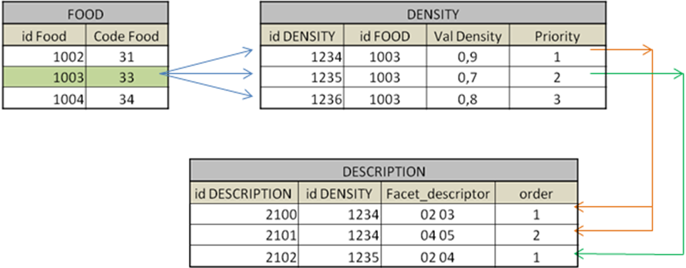

      - Principes ergonomiques sur EMP

Ci-dessous la maquette de saisie / mise à jour du coefficient Raw / Cook pour un aliment :

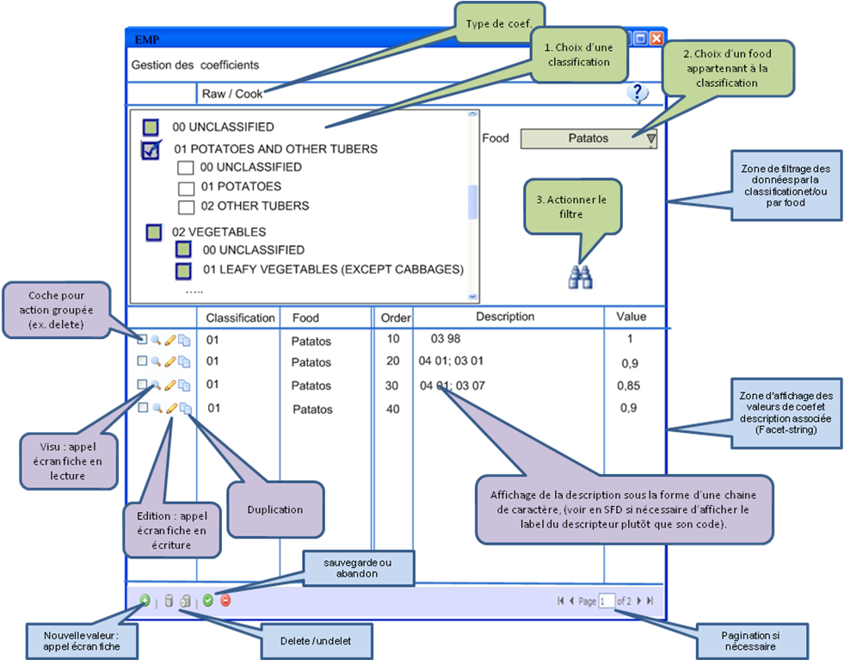

Cet écran permet de définir les valeur d’un type de coefficient, (raw/cook dans l’exemple). Il est possible de filtrer sur la classification et/ou le food.
L’ajout, la modification et la visualisation d’une ligne se fera par un écran de type fiche, (maquette présentée ci-dessous).

Lors de la sauvegarde il sera nécessaire de vérifier
- Qu’il n’y a pas pour un même food de valeur de coef. avec la même description.
- qu’il y a bien une valeur par défaut : valeur associée à aucune description et avec l’ordre d’évaluation le moins prioritaire.

Maquette de l’écran fiche :
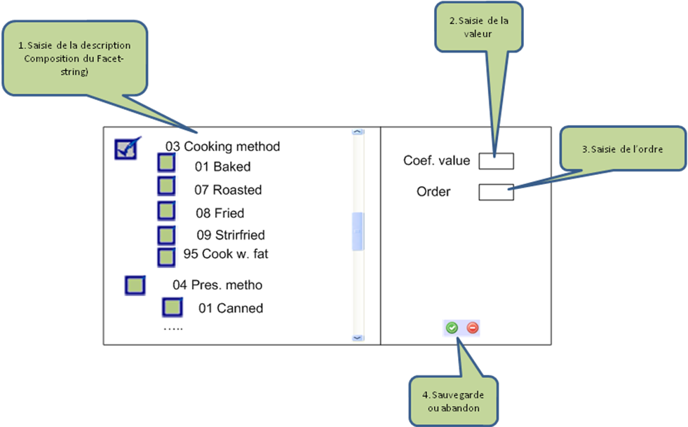

Les règles de gestions principales :
- afficher uniquement les facets disponibles pour le food et dans l’ordre,
- pour chaque facet afficher les descripteurs définis dans le Facdebygroup et dans le même ordre,
- pour certaines facet possibilité de sélectionner plusieurs descripteurs (facet multi-descripteurs).

La gestion des statuts et de commentaires n’est pas présente sur ces maquettes d’écrans, elles sont cependant à implémenter sur les coefficients :
  - Pour un food/recette donnée, la valeur du statut sera globale à l’ensemble des valeurs d’un coefficient. Exemple : lors de la modification, ajout, suppression d’une valeur du coefficient EDIB, c’est l’ensemble toutes les valeurs de EDIB qui passent au statut ‘in process’.
  - Les commentaires sont à gérer de façon individuelle sur chaque valeur de coefficient.

Remarque → pour le coefficient RAW/COOK et PCTFAT il est important de pouvoir proposer de saisir une valeur de coefficient pour un ensemble de descripteurs (regroupement). Dans l’exemple ci-dessus pour la facette ‘Cooking Method (03)’, l’utilisateur devra pouvoir saisir le groupe ‘FR : Fried’ et l’application renseigne automatique 3 lignes avec la même valeur de coef : 0,85 pour tous les descripteurs de ce groupe (Fried (08), Stirfried (09) et Deep fried (10)).Les regroupements de descripteurs ne sont pas les mêmes pour RAWCOOK et PCTFAT.

Pour les autres coefficients les principes de fonctionnement sont similaires : Edib ou PCTFAT
  - Processus métier
    - Introduction
Ce § présente l’enchainement des taches pour les processus métier ci-dessous, au sens organisationnel, en évitant les redondances par rapport aux § précédents.
    - Initialisation des données Library
L’initialisation des données Library se fera à partir des fichiers existants qui constituent la référence des données de paramétrage à destination de EPIC-Soft application. Ces données sont les listes exhaustives provenant de la capitalisation de différents projets.
Cette initialisation est un processus de reprise de données qui sera exécutée une seule fois.
Note technique :
La reprise de données se fera sans IHM, à partir de scripts SQL.
→ statut à la création = in process / CIRC / create / New

La mise à jour des données Library se fera sur MSapp. Après validation, on aura = validated / CIRC / null / in use
Il est aussi possible d’archiver des items qui, une fois testés sur le terrain, sont jugés non utilisables (e.g. facette Bio).

Les classifications pourront être chargées en utilisant la fonction d’import de données.
    - New Project
Tâches pour la création d’un nouveau projet :
      - New project : Administration :
  - Définition du projet : nom, pays participants, types populations, objectifs, commentaires, etc. (voir fiche de renseignement, à donner par le CIRC).
  - Pour chaque pays du projet : définition des informations du pays dans le contexte du projet, et définitions de la ou des langues à retenir.
  - Création d’utilisateurs et attribution des rôles/profils pour chaque utilisateur.

Dans un premier temps, ces tâches d’administration seront faites par le CIRC.
      - New project : Création des données :

Une fonction devra permettre d’initialiser globalement les données du projet. 2 solutions sont possibles :

- A partir des données Library CIRC et de données projet (voir schéma) :
  - par copie des données de Library CIRC,
  - par copie (ou par import) des données d’un projet (choisi dans la liste des projets) pour :
    - facette/descripteur par groupe (‘Fadebygroup‘), et règles sur les facettes (facet rules),
    - quantification par groupe (‘QMdetail’).
    - Probing par groupe
Il est possible de choisir les (‘Fadebygroup‘), (facet rules) d’un projet et le (‘QMdetail’) d’un projet différent (cf. 3.7.4).

- A partir d’un autre projet :
  - par copie de toutes les données d’un projet source, vers le projet destination.
  - Ou par import de l’ensemble des tables provenant d’un projet source, vers le projet destinataire. L’import sera surtout utilisé au démarrage de MSapp jusqu’à ce que MSapp soit plus fourni. CCL : non car l’import n’est pas disponible sur toutes les tables, les fonctions d’import sont listées § 3.7.5

Au moment de l’initialisation Projet on n’initialise pas les données pays : cela se fera dans un second temps.

Les items seront créés en version initiale et avec l’état « new » et Statut = in process / projet / create. Après une copie ou un import le niveau est celui de la donnée elle-même et non celui de l’utilisateur (ex : toujours projet même si le CIRC fait la copie).

Les données projet ‘common data’ sont maintenues au niveau du projet (par exemple coordinateurs internationaux) et sont validées par le CIRC. Lors de la première passe pour particulariser ces données, l’approche sera une approche ‘table par table’.

Dans un premier temps ces tâches d’initialisation seront faites par le CIRC mais pourront être déléguées dans le futur.

- Ajout de données Projet :
  - Classification (groupe/sous-groupe/sous-sous-groupe)
  - Facette/descripteur
  - photos en général (uniquement pour food et recipe)
  - Liste des repas (FCO : Food Consumption Occasions),
  - lieux de consommation,
  - Liste des jours spéciaux,
  - liste des régimes alimentaires spéciaux,
  - liste de questions (probing),
  - les contrôles sur les valeurs anthropométriques,
Pour les données ci-dessus, l’ajout pourra se faire à partir des données présentes dans la Library ou a partir d’un autre projet assez proche.
Dans l’écran, l’ajout de données se fera en utilisant une liste qui sera définie au niveau Library à l’exception des sous-sous-groupes de food, des sous-groupes de recette et de la classification des suppléments qui peuvent être générés et gérés au niveau projet. Lorsque une liste est proposée a l’écran pour sélection (ex : liste des descripteurs d’une facette), les items proposés seront uniquement ceux qui n’ont pas encore étés sélectionnés pour le projet.

2 cas existent :
- données dispo dans librairie : copie sur projet (et utilisation)
- non dispo dans librairie : visualisation de la liste Library, demande d’ajout au niveau Library/CIRC.
Une fois validée par le CIRC, le CIRC informe le(s) projet(s) que la donnée est disponible dans la Library ou refuse la demande via l’utilisation des statuts et de la traçabilité des données.

Pour les tables de liens ‘Fadebygroup‘, ‘facet rules’, ‘QMdetail’ et ‘probing by group’, l’utilisateur utilise les données définies au niveau Projet (projet proche si possible) via une copie ou un import.

L’utilisateur peut exporter ces fichiers pour mieux les visualiser et garder une trace (version papier).
L’utilisateur pourra aussi visualiser les données/fichiers d’autres projets selon les profils. Il ne sera pas possible de copier directement via l’écran des données d’un autre projet : saisie manuelle ou import pour les tables de liens.

- Mise à jour de données Projet :

La mise à jour des données projet se fait en utilisant les écrans/fonctions proposés par le module MSApp.

Les données seront mises à jour dans l’ordre, telles qu’elles sont définies au § Error: Reference source not found Approche par table.

L’ajout, la modification et la suppression des données se basent sur le processus de gestion des statuts, tel qu’ils sont définis au §

Pour les données de Setting qui ne sont gérées qu’au niveau Library (ex. liste des pays/centres, ‘recipe Pathway’…), toute modification sera automatiquement répercutée aux niveaux projets/pays.

- Suppression d’une donnée :

  - Classification (groupe/sous-groupe/sous-sous-groupe)
Rien n’est modifiable/supprimable à l’exception de certains sous-sous-groupes de foods et des sous-groupes de recettes. Pour les suppléments la classification est totalement modifiable/supprimable.
  - Facette/descripteur
tout est supprimable sous condition des règles de gestion (e.g. facettes 02, 03 obligatoires…). Pour modification voir ci-dessus Ajout de données
  - Photos en général (uniquement pour food et recipe)
  - données de setting (voir 6.2.2.),
.
  - Pour Fadebygroup‘, ‘facet rules’, ‘QMdetail’ et ‘probing by group’, tout est modifiable/supprimable sous condition des règles de gestion (e.g. facettes 02, 03 obligatoires…).

Le ‘delete’ au niveau de données projet se fera en cascade pour les données Projet mais également pour les données Pays. Un warning sera affiché. La suppression physique sera autorisée selon les droits par rapport à la fonction ‘vider la corbeille’.

Les règles sur l’état des données définies au § sont à respecter. L’état des données Projet passe à « in use » quand au moins 1 des pays attachés à ce projet a décidé de passer ses données à l’état « in use ».

    - New Country
Tâches pour la création d’un nouveau pays :
      - New country : Administration :
- Définition du pays : nom, commentaire… (voir fiche de demande)
- Rattachement au projet.
- Création des utilisateurs
- Attribution des rôles : utilisateurs – profil / pays

Dans un premier temps ces tâches d’administration seront faites par le CIRC/administrateur projet.
      - New country : Création des données :
Plusieurs solutions pour l’initialisation des données pays (voir schéma):
1) Par copie de données :
  - D’un même pays mais d’un projet différent (« country 1 » dans le schéma ci-dessous)
  - ou d’un pays différent dans le même projet ou d’un projet différent (« country 2 » dans le schéma ci-dessous)
2) Par export/import de fichiers extérieurs à l’application (e.g. Excel food list, recipe liste et supplément liste, « country 6 » dans le schéma ci-dessous, cf. § ci-dessous pour le détail des fonctions d’import.
3) Par combinaison des deux solutions précédentes « country 5 » dans le schéma ci-dessous

Dans tous les cas les fonctions d’initialisation produiront un rapport du compte rendu d’initialisation, avec les données non importées, et les raisons de l’erreur.

Pour les fonctions d’initiation, par duplication et par import, les codes food, recipe et supplements seront concernés dans le cas où le pays source et le pays destination sont les mêmes (code pays identique). Dans le cas où les pays source et destination sont différents les codes food, recipe et supplements sont régénérés.

Les items seront créés avec l’état « new » et Statut = in process / Country / create. Après une copie ou un import le niveau est celui de la donnée elle-même et non celui de l’utilisateur (ex : toujours pays même si le CIRC fait la copie).

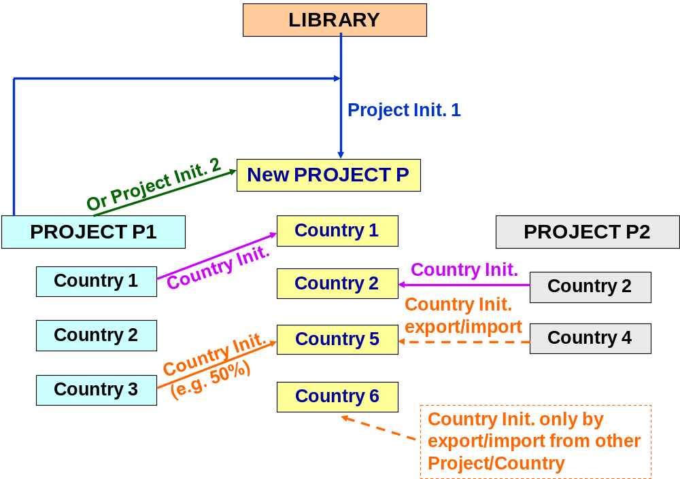
    - IMPORT des données pays :
Cas 1 : Nouveau pays – Compilation depuis différents pays (même projet ou projets différents).

L’import des données pays sera disponible pour certains scenarii (ex. création d’un nouveau pays à partir de plusieurs sources, même projet ou projets différents) et restreint à certaines tables.

- Listes :
Initialisation des listes de foods, recettes et suppléments :
  - ‘Food list’avec ‘shadow’,
  - ‘Recipe list’ avec ‘shadow’,
  - ‘Supplement list’,
  - ‘brand name’.

Export d’un ou plusieurs fichiers d’un ou plusieurs autres projet/pays. Travail sur fichier Excel. Puis initialisation par import avec rapport sur les problèmes d’import rencontrés. Chaque liste sera gérée indépendamment.

L’import complète la liste (de food, recettes ou suppléments) si l’item n’existe pas ou modifie les items s’ils existent déjà.

Si l’item est créé à partir d’un pays différent, le code (food/recette/supplément), ne sera généré - qu’au moment de la validation au plus au niveau (projet ou CIRC), ou à la création de la version EPIC-soft.

Si l’item est créé à partir des données du même pays, le code item sera conservé (même code pays).

La fonction copier/coller depuis un autre projet/pays par IHM ne sera utilisée que lorsque MSapp aura un certain nombre de projet/pays implémentés. L’utilisateur peut toujours utiliser la fonction d’export-import, et composer le/les fichiers d’import.

- Description et probing par food/recipe:
Pas de processus d’initialisation particulier, pas de fonction d’import-export. Les informations seront saisies dans les écrans, conformément aux règles de gestion définies au niveau projet.
Pour les suppléments, une description est proposée et l’utilisateur peut la modifier, (suppression des facettes non relevantes pour le supplément).

- Quantification food/recette (foodQuant/recipeQuant, StdUnit, stdPortion, maximum) :
  - - foodQuant/recipeQuant : pas de processus d’initialisation particulier, les informations seront saisies dans les écrans, conformément aux règles de gestion définies au niveau projet
  - - StdUnit, stdPortion :
Une fonction d’export/import sera proposée pour l’initialisation de ces données. Avant l’import il sera nécessaire de rapprocher manuellement dans le fichier d’import les food/recipe du projet en cours au StdUnit, stdPortion, que l’on souhaite importer.
Le processus est le suivant pour importer des standards units de foods :
- exporter StdUnit par food du pays source
- exporter la liste des foods pour lesquels des standards units sont nécessaires (du pays de travail). L’export contiendra les standards units déjà saisis + les attendus (en fonction du fdquant)
Note : pour la fonction d’export, avoir la possibilité de sélectionner les items à exporter suivant différents critères : classification, méthode de quantification… cf.3.7.2.
- mise à jour manuelle du fichier (Excel), c'est-à-dire faire les liens entre les foods du pays de travail et des standards units source en utilisant un format prédéfini.
- import de ce fichier dans le pays de travail avec rapport sur les records non chargés

- Maximum, coefficients et % (food et recipe):
Même approche que pour StdUnit, stdPortion , avec problématique supplémentaire du facet-string pour l’import (voir point 6.2).

- Nutriments (food et recipe):
Même approche que ci-dessus : export puis import.

- Ingrédients de recette :
Lorsque toutes les bases de données foods sont validées au niveau supérieur, export de la liste des recettes vers RMapp ainsi que la base de données EPIC-soft (‘food pathway’ quand on est dans le cadre de la création d’une version).
La saisie des ingrédients se fait sur RMapp (voir point 6….)
Dans le fichier d’import venant du RMapp :
  - si l’ID existe dans MSapp (avec même code recette) : on remplace la recette et ses ingrédients.
  - Si l’ID n’existe pas –recette créée sous RMapp (et code recette null) : la recette est créée sous MSapp).
  - On ne prévoit pas de supprimer une recette dans RMapp mais uniquement au niveau MSapp.

Le statut d’une recette après import dépendra des résultats du contrôle d’import:
- validated : si import OK
- in process : si problème d’import, exemple : il manque un food

1.1.5.2.2. COPIE des données pays
Cas 2 : Nouveau pays –> Adaptation de la version d’un autre pays (d’un même projet ou d’un projet différent) et
Cas 3 : pays existant –> adaptation de la version du même pays, (d’un projet différent).

La copie se fait à partir de données pays déjà existante(s) dans MSapp, par les niveaux supérieurs (CIRC/projet).

A chaque copie, un « compte rendu d’initialisation » (rapport) sera produit avec les données non importées, et les raisons des erreurs par rapport aux données Projet. Ce rapport devra être accessible et parcouru par le coordinateur pays.

A l’initialisation : Statut = in process / Country / create même si l’utilisateur est le CIRC ou le coordinateur Projet

Tous les records (données) devront être passés en revue- s’il s’agit d’un pays différent, il faudra traduire la liste d’aliments- et validés.

Toutes les tables seront copiées, y compris les tables de liens. La fonction de copie devra vérifier que les références nécessaires (données projets), existent.
Les modifications sur les tables de liens se fera via les écrans de MSapp.

S’il s’agit d’un même pays, garder de préférence les mêmes codes foods, recettes et suppléments que ceux de la version source.

    - New country : Mise à jour données pays
La mise à jour des données ‘country specific data’ se fait par l’utilisation des écrans spécifiques de l’application :
- Soit en approche table par table, en suivant une logique métier, telle qu’elle est définie dans le § d’initialisation des données pays (voir paragraphe… et schema…). Durant cette phase, on aura également besoin de réaliser des exports/imports de données (1 ou plusieurs records).
- Soit en approche transverse avec des écrans FUF (Food Update Form), et RUF (Recipe Update Form) avec possibilité d’utiliser la fonction « copy to ».
L’objectif de l’approche par FUF est de pouvoir visualiser /modifier l’ensemble des informations d’un aliment ou d’une recette avec un seul écran. Il permet de connaitre les statuts/détails des items. Tous les aliments/recettes doivent pour visualisés/modifiés via les écrans FUF/RUF.
L’accès à l’item (food ou recipe) au travers de l’écran FUF et RUF se fera respectivement depuis l’écran ‘résultat de recherche food’ et ‘résultat de recherche recipe’.

Les ingrédients de recettes seront mis à jour par le module ‘recipe manager’ et importés dans MSapp. Prévoir dans MSapp un écran de visualisation des ingrédients, écran de type liste.
    - FUF

L’écran FUF est composé de plusieurs onglets permettant de visualiser l’ensemble des données attachées au Food :
- Général : nom, statut, shadow, Aliment générique, Aliment de type supplément ou pas,
- Description : méthodes de description de l’aliment
- Quantification : méthodes de quantification de l’aliment
- Coefficients et %: densité, FSS, rapport avec ou sans déchet, rapport cru/cuit, FDC, FLO, valeurs maximales
- Nutriments : composition de l’aliment en nutriments (Eau, Protéines, Glucides, Lipides, Alcool, etc.).
- sommaire présentant de façon synthétique l’ensemble des informations ci-dessus (premier ou dernier onglet ?).

Depuis l’écran FUF il sera possible de faire un export, soit sous la forme d’un rapport ou d’un fichier structuré de type Excel.
La création d’un nouvel aliment pourra se faire par duplication d’un aliment existant, puis la modification de ce dernier se fera dans l’écran FUF.

Pendant la mise à jour d’un aliment, il est parfois nécessaire de visualiser les valeurs des aliments du même groupe alimentaire. Pour faciliter cela, l’écran FUF proposera des liens vers les écrans (approche table par table) :
- description et probing,
- Quantification : FdQuant, Std unit, std Portion, maxima,
- Coéfficients et %
- Nutriment.

Ces liens seront pré-initialisés, avec filtres sur la classification du food en cours de modification.

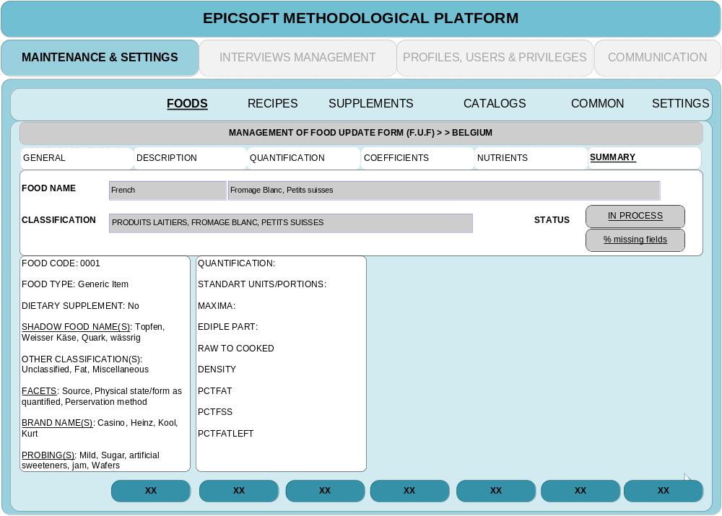

Gestion de la sauvegarde en base :
Lors de la mise à jour des données en base, le statut et les commentaires rattachés seront mis à jour de la même façon que si la donnée avait été modifiée par l’écran ‘table par table’.
L’écran de FUF permettra de visualiser les informations relatives aux commentaires et au statut.
Questions :
- Faut-il gérer une sauvegarde générale : un seul bouton ‘sauvegarder’ dans une zone commune de l’écran, accessible depuis tous les onglets → toutes les données sont sauvegardées tous les statuts et les commentaires associés sont mises à jour
- Ou faut-il gérer une sauvegarde par onglet : un bouton ‘sauvegarder’ par onglet→ les données de l’onglet sont sauvegardées, les statuts et les commentaires associés sont mises à jour. A trancher
    - RUF
Approche identique au FUF.
Pas de spécificités particulières.
Les ingrédients ne seront pas gérés dans l’écran RUF.
    - Suppression des données pays
La suppression des données pays est en cohérence avec les fonctions de mise à jour au niveau des droits.
Lors du travail sur MSapp, les liens de cohérence permettent la suppression en cascade des liens logiques, avec warning.
Attention, pour la suppression à cause de liens métiers comme ex : la suppression de facette 03 pour un food implique la suppression aussi des coefficients Rawcook et Pctfat attachés s’ils existent cela impose une RG en ‘dur’.

Le statut de la donnée supprimée passe à « validated / <niveau du user> / delete » Les statuts des données liées à celle supprimée seront aussi a « validated / <niveau du user> / delete »
Une fois la suppression validée par le coordinateur projet/CIRC (facette 03 supprimée) alors toutes les données liées (rawcook…) sont :
soit physiquement supprimées si l’Etat = « new »
Soit archivées si l’Etat = « in use »

Le ‘delete’ en cascade au niveau de donnée pays, depuis un food une recette ou un supplément sera possible. Traiter le cas particulier des food qui sont utilisés comme ingrédients de recette.

    - Export vers Epic Soft
L’export des données vers EPIC-SOFT application se fera sur des données validées. L’utilisateur aura le choix de sélectionner les différents niveaux de validation parmi : COUNTRY, PROJECT et IARC.
Seront exportables les données à l’état NEW, USED et ARCHIVATED.

L’utilisateur pourra également préciser s’il exporte les données pour un projet Pilote ou pour le module « recipe manager », dans ces 2 cas l’état des données n’évolueront pas. Dans le cas contraire (pas pour un projet Pilote et pas pour le module « recipe manager »,) les données à l’état NEW passeront à l’état IN USE.

- Annex 1: Subject management
- Display the subject information with:
Code (region – ID code)
Sex
Birth Date
Name (optional)
Surname (optional)
We can have several recalls per subject with this specific information:
Recall date ()
Interview number (1 per interview)
Height
Weight
Interviewer code (1 per interview)
Temporary flag. This flag means “records to be updated” and is set to yes when a problem of incoherence occurred during the import.
Update with flag “temporary” = 0 (no):
- If update on fields 6, 7, 8, 9, 10 – update on 1 interview -
- The update is applied to all the versions of this updated attached interview.
Special case:
- update on Recall date:
  - If the recall date already exists for this subject Then error message
  - Else update done on all attached interview versions.
- update of Interview number / height / weight / interviewer code
  - Update done on all attached interview versions.

Gwh: there’s an interrogation about updating the version 0 (first imported and considered as “original”). Can it be kept as is and never modified while still keeping the filiation link with newer versions?

- If update on fields 1, 2, 3, 4, 5 – update on 1 subject -
- The update is applied to all the interviews attached to this subject and also to all the attached interview versions.
Special cases:
- update on code (region – ID)
  - If the Region+ID already exist in the interview data Then
    - Display a summary pop-up with the information of the existing subject along with all the interviews attached to this subject and a way to compare this with the information and interviews of the subject being modified.
    - If no interviews have the same recall date for this subject then the update is possible. (Which values for the field sex & birth date if not the same?)
    - Ask for confirmation
    - If interviews with same recall date for this subject then the update is not possible → error message
Example:
Summary screen:
Region – ID – recall date
001 – 0125B – 11/02/2011
001 – 0125B – 08/03/2011
001 – 0125B – 12/05/2011

001 – 0125C – 08/03/2011
001 – 0125C – 10/04/2011

Asked change: code 001-0125C changed by 001-0125B
Before After
001 – 0125B – 11/02/2011 001 – 0125B – 11/02/2011
001 – 0125B – 08/03/2011 001 – 0125B – 08/03/2011
001 – 0125B – 12/05/2011 001 – 0125B – 12/05/2011
001 – 0125C – 08/03/2011 001 – 0125C – 08/03/2011 → problem interview already exists
001 – 0125C – 10/04/2011 001 – 0125C – 10/04/2011 → OK
➔ In this case the update is not possible so error message. The user will have to change first the recall date 08/03/2011 of the subject 001 - 0125C.

update on sex Birth Date, Name, Surname :
The update is applied to all the interviews attached to this subject and also to all the attached interviews’ versions.

Update with flag “temporary” = 1 (Yes -> loaded with problem):

This case occurs only when the subject code already exists and when the sex/and birth date of the subject is not the same as the already entered one.

In this case we have 2 possibilities:

- attach the record “temporary” to an already existed one

  - If same Id code but different birth date and/or sex:
Control on the recall date:
If date already exists for the attached subject then error message
Else
Ask to the subject the correct sex and birth date proposing between the 2 possible values (per fields) & change the flag “temporary=yes” by “no”.

  - If same id code, same birth date, same sex and same recall date
The user can change the recall date and/or the subject ID and link this record to another one.
If not the same sex and/or birth date then ask to the subject the correct sex and birth date proposing between the 2 possible values (per fields) & change the flag “temporary=yes” by “no”.

- change the subject ID by a new one (not already existing)
  - The flag “temporary=yes” is changed by “no”

  - Annex 3 - “Note management” & “View/Export interview” screens:
Added comments from Task Force:
Note screen from sqli to be adapted:
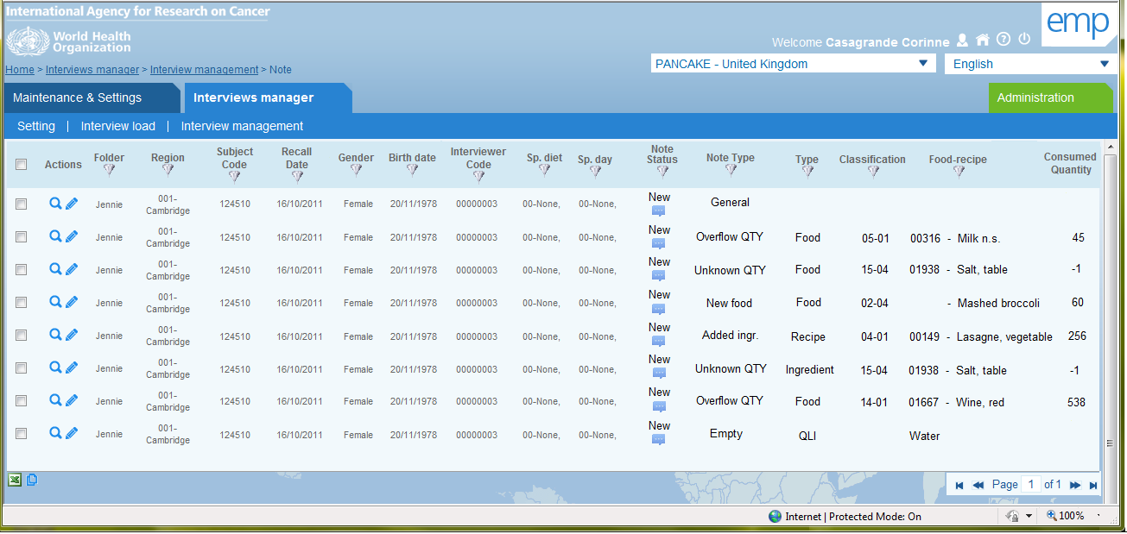
View interview screen from sqli to be adapted:
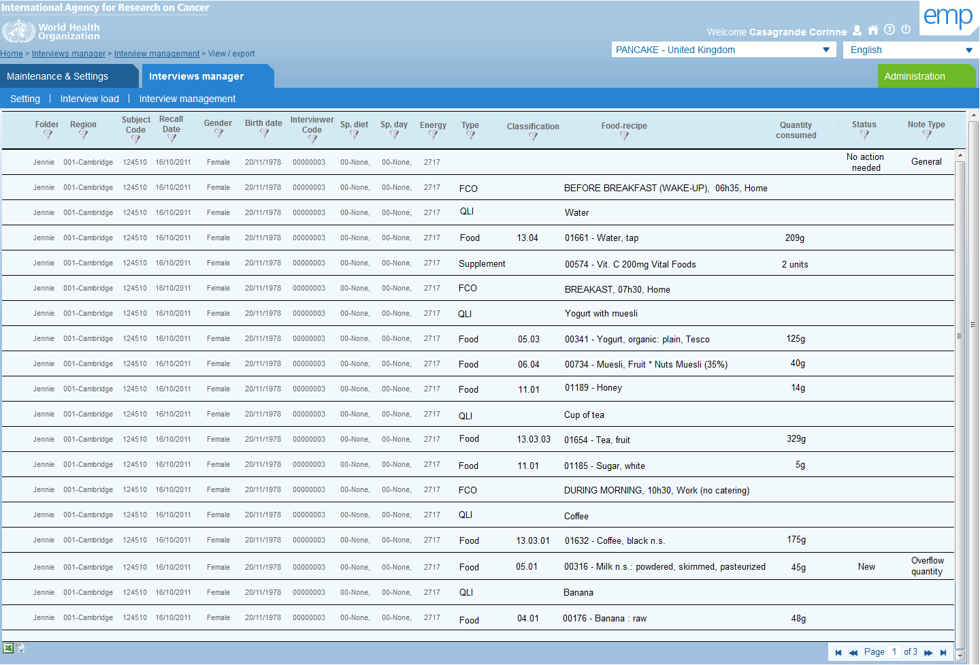
In both screens:
- Add the possibility to fold / unfold some columns on screen. The variables directly link to the recall information from Gender to Special day (data from INTGI table except the subject code & recall date) can be folded.
- The fact to see the note comment by passing the mouse on the icon is much appreciated.
- It is not necessary to display the food/recipe code; the name yes but without the code
- It is not necessary to display the special day & diet codes; the name yes but without the code.
- It is also important to see the food/recipe description as in EPIC-Soft description quantification screen → “Name followed by “:” and descriptors delimited with gomma”
(e.g. Potato n.s. : boiled, without skin)
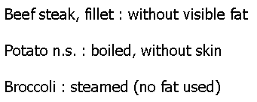
To do that, the food/recipe name is available in the filed Interv.Name and the description label in Interv.Text columns and it is necessary to combine these two fields in one with the “:” as separator.
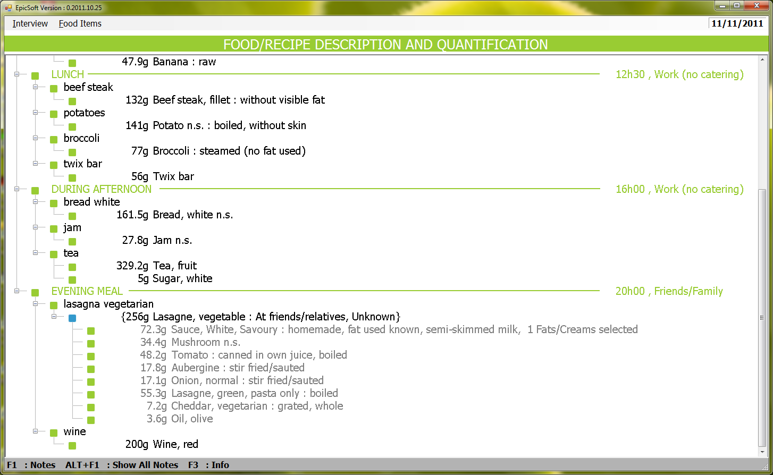

- It will be useful to have the possibility to keep the selection done using different filters and to be able to select a already done filter selection. For exemple, using the funnel I select the “female” & special day “none” & special diet “none” and classification “group 01 to 05”. Then I save this filter combinaison given a name “filter on group 01 to 05 for women”. When I re-open this screen, I can select an already existed filter combination and run it to see the result on screen.

Specialy in View/Export interview screen:
- Add the columns :
  - Food/recipe description in series of codes (Interv.Facet_str)
  - Quantification method code (Interv.q_method)
  - Quantification code (Interv.qm_code) when available
Exemple : « H H010 » or « G » or “V ” or “P P020” etc…

- For the export for data analyses, il would be useful is we can add sequential number within an interview to numbering the reported records and also to see the link between the special records;
  - Food and attached fat during cooking (Type=4 and Type=6 from Interv table)
  - Food and attached fat facet (Type=4 & Type=A2 // Type=4 & TypeA3)
  - Recipe and attached ingredients (Type=3 & Type=5)
  - Ingredients and attached fat during cooking (Type=5 and Type=7)
  - Ingredients and attached fat facet (Type=5 & Type=A2 // Type=5 & TypeA3)

Exemple of 1 interview and Line_NB variable:

Obs IDR24H FCO_CODE HOUR TYPE FOODNUM LINE_NB

24 1100200173 Breakfast 8 Food 1500 22-00
25 1100200173 Breakfast 8 Food 1504 23-00
26 1100200173 Breakfast 8 Food 0207 24-00
27 1100200173 Before Lunch 12 Food 1478 25-00
28 1100200173 Before Lunch 12 Food 0207 26-00
29 1100200173 Before Lunch 12 Food 1127 27-00
30 1100200173 Lunch 13 Food 0751 28-00
31 1100200173 Lunch 13 Food 1104 29-00
32 1100200173 Lunch 13 Food 0034 30-00
33 1100200173 Lunch 13 Food 1750 31-00
34 1100200173 Lunch 13 Food 1078 32-00
35 1100200173 Lunch 13 Food 0239 33-00
36 1100200173 Lunch 13 Food 0520 34-00
37 1100200173 Lunch 13 Food 1526 35-00
38 1100200173 After Lunch 14 Food 1481 36-00
39 1100200173 After Lunch 14 Food 1504 37-00
40 1100200173 During Afternoon 17 Food 1492 38-00
41 1100200173 Before Dinner 19 Food 1529 39-00
42 1100200173 Before Dinner 19 Food 0633 40-00
43 1100200173 Before Dinner 19 Food 0175 41-00
44 1100200173 Before Dinner 19 Food 0069 42-00
45 1100200173 Before Dinner 19 Food 1750 43-00
46 1100200173 Dinner 21 Food 0001 44-00
47 1100200173 Dinner 21 Food 1751 45-00
48 1100200173 Dinner 21 Recipe 0167 46-00
49 1100200173 Dinner 21 Ingredient 0504 46-01
50 1100200173 Dinner 21 Fat used facet 1091 46-07
51 1100200173 Dinner 21 Ingredient 1733 46-07
52 1100200173 Dinner 21 Ingredient 0045 46-08
53 1100200173 Dinner 21 Ingredient 0042 46-09
54 1100200173 Dinner 21 Ingredient 0087 46-10
55 1100200173 Dinner 21 Ingredient 0204 46-11
56 1100200173 Dinner 21 Ingredient 1017 46-12
57 1100200173 Dinner 21 Food 0753 47-00
58 1100200173 Dinner 21 Food 0944 48-00
59 1100200173 Dinner 21 Food 0341 49-00
60 1100200173 Dinner 21 Food 1585 50-00
61 1100200173 Dinner 21 Food 2108 51-00
62 1100200173 Dinner 21 Food 1526 52-00
  - Annex 4 – MS Data Organization & Importation
    - Library data organization
TABLE LIST
  - Setting tables:
    - Special diet
    - Special day
    - Place of consumption
    - Probing list
    - Check on Anthropometric values
    - Photo (including photo series, shapes, HHM, thickness)
    - FCO list
    - Nutrient list
    - Note Status list
    - Substitution limitation
    - EPIC-soft Parameters
    - Country list
    - Center list
    - Day of week list
    - Months list
    - Check list per FCO
    - Substitution limitation (SUBSTIT & DESCSUBS)
    - Improbable sequences of food descriptors
    - Recipe pathway
  - Foods:
    - Classifications
    - Facets/descriptors
  - Recipes:
    - Classifications
    - Facets/descriptors
  - Supplements:
    - Classifications
    - Facets/descriptors

    - Project data organization

TABLE LIST | POSSIBLE IMPORT  FROM OTHER:
  - Setting tables:
- Special diet | Project or Library
- Special day | Project or Library
- Place of consumption list | Project or Library
- Probing list | Project or Library
- Anthropometric values | Project or Library
- Photo (including photo series, shapes, HHM, thickness) | Project or Library
- FCO | Project or Library
- Nutrient list | Project or Library
- Note Status list | Project or Library
- Substitution limitation | Project or Library
- EPIC-soft Parameters | Project or Library
  - Foods:
- Classifications | Project or Library
- Facets/descriptors | Project or Library
- Facets/descriptors by group/subgroup (Fadebygroup, table=Groupfac) | Project
- Facet rules | Project
- Quantification by group/subgroup | Project
- Probing by group/subgroup | Project
  - Recipes:
- Classifications | Project or Library
- Facets/descriptors | Project or Library
- Facets/descriptors by group/subgroup (table=R_Groupfac) | Project
- Facet rules | Project
- Quantification by group/subgroup | Project
- Probing by group/subgroup | Project
  - Supplements:
- Classifications | Project or Library
- Facets/descriptors | Project or Library

    - Project/Country data organization

The Project/country tables are organized as follow:

TABLE LIST | POSSIBLE IMPORT  FROM OTHER:
  - Setting tables:
- Check-list by FCO | Project/country
- Interviewer list | Project/country
  - Common
- Photo (including photo series, shapes, HHM, thickness) (from library) | Library
- Food Classifications for sub-sub-group | Project
- Food Facets/descriptors by group/subgroup (table=Groupfac) | Project
- Recipe Classifications for sub-group | Project
- Recipe Facets/descriptors by group/subgroup (table=R_Groupfac) | Project
- Supplement Classifications | Project/country
  - Foods:
- Food & food shadow List | Project/country
- Food description (Foodfaex table). | Never imported but prepared according to the food list and to “Food Facets/descriptors by group/subgroup” (groupfac table)
- Food Brand name list | Project/country
- Food quantification (QM_foods table) | Never imported but prepared according to the food list and to “Food Quantification by group/subgroup” (qm_group table)
- Food probing | Never imported but prepared according to the food list and to “Food Probing by group/subgroup” (pqpath table)
- Standard unit (2) | Project/country
- Standard portion (2) | Project/country
- Maximum (2) | Project/country
    - Coefficients
- Density (2) | Project/country
- Rawcooked (2) | Project/country
- Edible (2) | Project/country
    - Percentages
- Fats during cooking (2) | Project/country
- Fats/sauces/sweeteners added (2) | Project/country
- % of fat left over (2) | Project/country
- Nutrient values (2) | Project/country

TABLE LIST | POSSIBLE IMPORT  FROM OTHER:
  - Recipes:
- Recipe & recipe shadow List | Project/country  with attached ingredient
- Recipe description (R_rcpfaex table) | Never imported but prepared according to the recipe list and to “recipe Facets/descriptors by group/subgroup” (r_groupfac table).
- Recipe Brand name list (2) | Project/country
- Recipe quantification (QM_recip table) | Never imported but prepared according to the recipe list and to “recipe Quantification by group/subgroup” (qm_rclas table)
- Recipe probing | Never imported but prepared according to the food list and to “recipe Probing by group/subgroup” (Rpqpath table)
- Standard unit (2) | Project/country
- Maximum (2) | Project/country
- Coefficients: Density (2) | Project/country
- Percentages: Fats/sauces/sweeteners added (2) | Project/country
- Nutrient values (2) | Project/country
  - Supplements:
- Supplement List (2) | Project/country
- Supplement description | Never imported but prepared according to the supplement list and to the facet list with the specific order.

  - Annex 5 – Controls
A classer en
- Contrôles de surface / intégrité
- Règles de gestions
- Contrôle qualité.
    - LIBRARY (géré par le CIRC)
      - Setting
- Days of week, months, pays, centre, FCO, POC, special day & special diet, probing list,
- Code unique
- Label unique
- Pour Special Day et Special diet vérifier que
  - les 2 modalités 00 et 99 sont présentes
  - le code 00 correspond à « None »
  - le code 99 correspond à « other »

    - Check list per FCO
- Label unique per FCO

    - Anthropometry
- Dans Ant_var, seules les modalités « HEIGHT » et « WEIGHT » sont possibles
- Valeur Null possible pour la variable Sex, pas pour les autres

    - Substitution limitation (Substit & Descsubs)
- Quand un lien est fait entre un groupe/sous-groupe et un F_Class (e.g. 1304 avec 0501, 0503…) alors doit exister les liens reciproque (e.g. 0501 avec 1304 et 0503 avec 1304)

    - Improbable sequence of food descriptor

    - Note Status list
  - Code unique
  - Label unique
  - S_hide obligatoire
  - les suivants sont obligatoires
  - code 00 correspondant à « New »
  - code 99 correspond à « Action done »
  - code 999 correspond à « deleted »

    - Nutrient list (proposal 1 list – energy, macro & water mandatory)
  - Code unique
  - Label unique
  - Les records suivants sont obligatoires (avec Ntr_display=1)
  - 1 Energy
  - 2 Proteins
  - 3 Carbohydrates
  - 4 Total fats
  - 5 Alcohol
  - 6 Water

    - Checks for nutrient values (Nutlimit) (table accessible que pour le CIRC)
  - Dans Name, on doit avoir les valeurs (protein, ch, fat, alcohol, energy et PAL)
  - Si Name=PAL alors la variable VAL doit être renseignée
  - Si Name<>PAL alors les variables MIN, MAX et UNIT doivent être renseignées.

    - Recipe pathway (table accessible que pour le CIRC)
  - Dans R_Type, on doit avoir les valeurs (1.1, 1.2, 1.3, 2.1, 2.2, 3.0, 4.1, 4.2)

      - Classification lists
    - Food classification
- Vérifier que pour tous les groupes, un sous-groupe codé 00 « undefined or mixed » existe. Au moment de la creation (e.g. d’un sous-sous-groupe), il faudra verifier que l’incrémentation est proposée automatiquement ( démarre par 00, puis 01…)
- Tout groupe doit avoir au moins 2 sous-groupes (dont 00 « undefined »)
- Vérifier que si des sous-sous groupes existent, alors qu’un sous-sous-groupe codé 00 « undefined » existe, il en faut au moins deux.
- Label unique pour des groupes
- Label unique pour des sous-groupes d’un même groupe
- Label unique pour des sous-sous-groupes d’un même sous-groupe

    - Recipe classification
- Les sous-groupes ne sont pas obligatoire mais si 1 sous-groupe existe alors verifier que :
  - pour ce groupe, un sous-groupe codé 00 « undefined » existe
  - au moins 2 sous-groupes existent (dont 00 « undefined »)
- Label unique pour des groupes
- Label unique pour des sous-groupes d’un même groupe
- Pas de sous-sous-groupe

    - Supplement classification (gérer au niveau pays)
  - Label unique pour des groupes
  - Label unique pour des sous-groupes d’un même groupe (idem pour la gestion des codes : 00, puis 01… au moins deux sous-groupes)
  - Label unique pour des sous-sous-groupes d’un même sous-groupe (idem pour la gestion des codes : 00, puis 01… au moins deux sous-sous-groupes)
  - Les sous-groupes ne sont pas obligatoires mais si 1 sous-groupe existe alors verifier que
  - pour ce groupe, un sous-groupe codé 00 « undefined » existe
  - au moins 2 sous-groupes existent (dont 00 « undefined »)
  - Les sous-sous-groupes ne sont pas obligatoires mais si 1 sous-sous-groupe existe alors verifier que
  - pour ce sous-groupe, un sous-sous-groupe codé 00 « undefined » existe
  - au moins 2 sous-sous-groupes existent (dont 00 « undefined »)

    - Traduction de l’IHM d’ESapp (EPICTEXT)
  - Lorsque l’on charge une traduction de ce fichier, vérifier que tous les « messages » existent bien et que toutes les traductions sont faites.
      - Facet/descriptor lists
    - Food facets
  - Code unique
  - Label unique
  - Facette « physical state » codée 02
  - Facette « cooking method » codée 03
  - Facette « brand name » codée 12
  - Les modalités 1 (brand), 2 (type of fat) & 3 (type of liquid) obligatoire pour la variable Facet_type. Pour les modalités 2 & 3, Facet_grp doit être renseignée.

    - Food descriptors
  - Code unique pour une facette
  - Label unique
  - Descripteur code = 00 doit exister pour chaque facette
  - Pour la facette 03 cooking method, un seul descripteur raw obligatoire (Desc_cook=1). De même Desc_cook doit avoir des valeurs 2 & 3 pour cette facette uniquement.

    - Recipe facets
  - Code unique
  - Label unique
  - Facette « known/unknown » codée 00 obligatoire
  - Facette « recipe production » codée 01 obligatoire

    - Recipe descriptors
  - Code unique pour une facette
  - Label unique
  - Descripteur code = 00 doit exister pour chaque facette
  - Pour la facette 00 « known/unknown », les descripteurs « 00 known » et « 01 unknown » sont obligatoires et figés
  - Pour la facette 01 « recipe production », la variable Rdesc_type doit avoir la modalité = 1 pour les descripteurs « homemade ».

    - Supplement facets
  - Code unique
  - Label unique
  - Facette « physical state » codée 99 obligatoire avec Dsfacet_quant=1

    - Supplement descriptors
  - Code unique pour une facette
  - Label unique
  - Descripteur code = 00 doit exister pour chaque facette.
  - Pour la facette 99 « Physical state », le champ Dsdesc_HHM doit être renseigné

      - Photos (photo series, HHM, shapes, thickness)
    - Photo
  - Code unique
  - Series PH_Qstr : les numéros (ou lettre) et les quantités des photos doivent être ascendants.

    - HHM
  - Code unique
  - Label unique
  - Fractions HHM_Qstr : les fractions doivent être stockées dans un ordre ascendant. 1 doit toujours être disponible.

    - Shapes
  - Code unique
  - Label unique

    - Thickness
  - Code unique

      - Probing by group
  - Codes Probing existent.
  - Codes groupe/sous-groupe/sous-sous-groupe existent.

    - Project common data

      - Setting

- Pour les données suivantes les contrôles sont les mêmes que dans la partie Library :
  - FCO, POC, special day & special diet, probing list,
  - Check list per FCO
  - Anthropometry
  - Substitution limitation (Substit)
  - Note Status list
  - Nutrient list

    - EPIC-soft Parameter
  - La liste des paramètres est prédéfinie et sont fixes : pas d’ajout, de modification ni de suppression possible (variable Param_Lab).
  - Les réponses possibles à chaque paramètre (variable Param_Lib) sont aussi prédéfinies voir tableau ci-dessous pour les options disponibles.

Nom du champ | Description | Remarques ou attribut particulier
noaskdateatbeginning | 1=Ne demande plus la date au démarrage,  0=Demande la confirmation de la date | Le champ peut être manquant, par défaut EpicSoft demande la date (0)
main_unit | Gestion des unités anglaises | 1= utilisation des unités anglaise  0=unités anglaises non utilisées (défaut)
nbDecimal_Height | Gestion des décimales pour la saisie de la taille d’un sujet | 0 = Pas de décimale  n = nombre de décimales pour la saisie (1…12)
nbDecimal_Weight | Gestion des décimales pour la saisie du poids d’unsujet | 0 = Pas de décimale  n = nombre de décimales pour la saisie (1…12)
fco_minutes | Activation de la gestion des minutes dans les FCO | 0 = Minutes non demandées  1 = Minutes activées
NoteStatusUpdate | Gestion du champ statut des notes  Pour le CIRC : Ce paramètre correspond plutôt à un droit utilisateur… ou le gérer ? A discuter. | 0 = Modification du statut verrouillée  1 = Modification du statut autorisée
BMRselect | Gestion du calcul de l’énergie attendue | FAO/WHO/UNU  Schofield
DietarySupplementClass | Utilisation d’une classification pour les suppléments | 0=No par défaut  1=Yes classification utilisée
FRACTION_GV | Définition des fractions à utiliser pour les méthodes poids & volumes | Fractions triées par ordre croissant et séparées par une virgule (ex : 1/6,1/3,1/2,2/3,5/6)
FRACTION_U | Définition des fractions à utiliser pour la méthode Std Unit | Fractions triées par ordre croissant et séparées par une virgule (ex : 1/4,1/3,1/2,2/3,3/4)
FRACTION_PH | Définition des fractions à utiliser pour la méthode Photos | Fractions triées par ordre croissant et séparées par une virgule (ex : 1/4,1/3,1/2,2/3,3/4)
FRACTION_W | Définition des fractions à utiliser pour la méthode « part of the whole known recipe » | Fractions triées par ordre croissant et séparées par une virgule (ex : 1/6,1/3,1/2,2/3,5/6)
FRACTION_SH | Définition des fractions à utiliser pour la méthode SHAPES | Fractions triées par ordre croissant et séparées par une virgule (ex : 1/6,1/3,1/2,2/3,5/6)
ING_PERCENT | Pourcentage ‘cut-off’ pour ingrédients de recette. Valeur entre 0 et 99 | Exemple : 25
INT_NUMBER | Variable Interview number à visualiser ou pas | 0=No par défaut  1=Yes affichée

      - Classification lists
- Pour les données suivantes les contrôles sont les mêmes que dans la partie Library :
  - Food classification
  - Recipe classification
  - Supplement classification

      - Facet/descriptor lists
- Pour les données suivantes les contrôles sont les mêmes que dans la partie Library :
    - Food facets (Facettes « physical state » codée 02 et « cooking method » codée 03 sont obligatoires)
    - Food descriptors
    - Recipe facets
    - Recipe descriptors
    - Supplement facets
    - Supplement descriptors
      - Facet/descriptor lists & facet rules by group/subgroup

    - Food and Recipe facet/descriptor by group/subgroup (fadebygroup)
    - Unicité sur codes groupe/sous-groupe/sous-sous-groupe + codes facettes/descripteurs.
    - Liste des descripteurs non utilisés (warning)
    - Liste des groupe/sous-groupe et facette utilisés qui n’ont pas de défaut (variable défaut à null pour un couple sous-groupe/facette)
    - Descripteur '00' toujours 'Not in the Name'

    - Food and Recipe facet rules
    - Unicité sur code facette + code facette/descripteur + codes groupe/sous-groupe/sous-sous-groupe

      - Photos

- Pour les données suivantes les contrôles sont les mêmes que dans la partie Library :
  - Photo
  - HHM
  - Shapes
  - Thickness
      - Quantification methods by group/subgroup

    - Food and Recipe quantification method by group/subgroup (Qmdetail)
    - Unicité sur codes groupe/sous-groupe/sous-sous-groupe + physical state + raw to cooked + quantification type + quantification méthode code
    - Si un descripteur « physical state » est sélectionné alors cette facette existe aussi dans le « fadebygroup » pour le groupe/sous-groupe défini.
    - Si raw-to-cooked est égal à 1 ou 2 alors la facette cooking method existe aussi dans le « fadebygroup » pour le groupe/sous-groupe défini.
    - Si raw-to-cooked est égal à 1 alors la facette cooking method et le descripteur « raw » existent aussi dans le « fadebygroup » pour le groupe/sous-groupe défini.

      - Probing questions by group/subgroup
- Pour ces données les contrôles sont les mêmes que dans la partie Library.
    - Project country specific data
      - Setting/Parameter

    - Traductions
  - Toutes les données disponibles au niveau du projet devront être traduites. Un contrôle permettra d’identifier les items non traduits par table/entité (ex. le label d’un groupe, le label d’un descripteur…).
  - Epictext :
    - Tout le contenu, sans exception, de la table Epictext devra aussi être complètement traduit dans la/les langues du pays.
    - Certains caractères disponibles dans le label anglais devront aussi l’être dans la traduction : &, &&, “, -, ?, !, <, >, %, :, …, [, ], a), b), c), (, ),

    - Liste des interviewers
  - Combinaison des codes interviewer + code pays + code centre est unique
  - Combinaison des codes interviewer + Nom + prénom unique

    - Liste des contrôles par FCO

    - Facettes/descripteurs par groupe/sous-groupe
  - Même contrôles que dans la partie projet
  - Variable order renseignée avec des valeurs consécutives et non identiques

      - Foods
        - Food, shadows and brand lists

    - Liste des Foods
  - Le nom doit commencer par une capitale ou “
  - Pour les items génériques (GI), dans le label anglais on doit avoir les caractères « n.s. » et les correspondants dans la traduction (e.g. « n.e. » en espagnol, « uspes. » en norvégien…)
  - Le code food doit être unique
  - Le nom du food doit être unique en anglais et dans les langues du pays. Faire aussi ce test sur les noms sans les caractères « n.s. » (ex : on ne peut pas avoir « Beurre n.s. » et « Beurre »)
  - Contrôles visuels :
    - Check that the name is really new (not a synonym),
    - Check that the local name is structured in the same way as linked foods (e.g. ‘rice flour’ will have to be renamed ‘flour, rice’ – with or without comma).
    - Check that it cannot be described using an existing food
    - Check it is properly classified → visual check

    - Liste des Shadows
  - Si un shadow est attaché à un food générique alors son label doit aussi contenir les caractères du générique (ex. n.s.).
  - Le nom du Shadow ne doit pas déjà exister dans la liste des Foods
  - Contrôles visuels :
    - Check that the shadow is a really new one,
    - Check that the local name is structured in the same way as linked foods (e.g. ‘rice flour’ will have to be renamed ‘flour, rice’ – with or without comma).
    - Check that it cannot be described using an existing food

    - Liste des Brand
  - Un groupe/sous-groupe ne peut avoir des brands que si la facette 12 « brand name » existe dans le fadebygroup pour ce groupe/sous-groupe.
  - Contrôles visuels :
    - Check that the new brand is relevant: better in the food list? To which food item it refers?
        - Food description and probing

    - Facet per food (FdFacet)
  - Tous les foods doivent être présents dans la table
  - Les facettes doivent être présentées dans le même ordre que dans le fadebygroup.
  - Vérifier que si une facette est sélectionnée et si cette dernière est liée par le « facet rule » à une seconde, alors cette seconde facette doit aussi être sélectionnée pour ce food (géré aussi de façon automatique à la construction).
  - Prévoir une liste des facettes non utilisées par group/sous-groupe (warning)
  - Prevoir une liste de foods qui n’utilisent pas les facettes 02 et 03 alors que ces facettes sont proposees au niveau fadebygroup (warning).
    - Probing questions per food (FdProbing)
  - Tous les foods doivent être présents dans la table
  - Prévoir une liste des probing questions non sélectionnées par group/sous-groupe (warning).
  - Contrôler que si pour un food, des valeurs existent dans la table « % of fats/sauces/sweeteners » alors les probing identifiées comme Fats/sauces/sweeteners (FSS=1 et codées 15, 16, 22) ont été sélectionnées pour ce food.
        - Food quantification and maximum

    - Quantification method per food (Fdquant)
  - Tous les foods doivent être présents dans la table.
  - Les méthodes de quantifications proposées pour un food sont celles définies au niveau du groupe/sous-groupe de ce food dans la table quantification par groupe/sous-groupe (FdQmdetail).
  - Si la méthode Standard Unit est sélectionnée alors une/des standards Units doivent exister dans la table des standards units pour ce food.
  - Si la méthode Standard Portion est sélectionnée alors une/des standards portions doivent exister dans la table des standards portions pour ce food.
  - Si une photo/standard unit/standard portion définie avec la variable Edib=2, a été sélectionnée pour un food alors un coefficient de déchet doit être présent dans la table EDIB pour ce food.
  - Même chose pour la variable Rawcook=1 et la table raw-cooked coefficient pour ce food.

    - Standard Unit per food (Fdstd ou M_stduts)
  - Tous les foods ayant la méthode standard unit (U) définie au niveau de sa quantification (Fdquant) doivent être présents dans la table.
  - Si plusieurs standard units sont définies pour le même food, alors pour ces standard units, le champ commentaire doit être renseigné.
  - La variable raw_cooked peut être renseignée si la facette cooking method est présente pour ce food dans sa description (Fdfacet), le défaut est 2 (règle de gestion) ;
  - Si la variable raw_cooked est =1 alors un coefficient cru-cuit doit exister pour ce food dans la table « rawcook »
  - Si la variable Edib est =2 alors un coefficient « déchet » doit exister pour ce food dans la table « Edib ».
  - Contrôles visuels :
    - Check if the chosen standard unit really fit, comment is explicit, uses the common abbreviations, includes some size/dimension for fruits and vegetables

    - Standard Portion per food (Fdstd ou M_stdpor)
  - Tous les foods ayant la méthode standard portion (S) définie au niveau de sa quantification (Fdquant) doivent être présents dans la table.
  - Si plusieurs standard portions sont définies pour le même food, alors pour ces standard portions, le champ commentaire doit être renseigné.
  - La variable raw_cooked peut être renseignée si la facette cooking method est présente pour ce food dans sa description (Fdfacet)
  - Si la variable raw_cooked est =1 alors un coefficient cru-cuit doit exister pour ce food dans la table « rawcook »
  - Si la variable Edib est =2 alors un coefficient « déchet » doit exister pour ce food dans la table « Edib »
  - Contrôles visuels :
    - Check if the chosen standard portion really fit, comment is explicit, uses the common abbreviations, includes some size/dimension for fruits and vegetables

    - Maximum per food (Fdmax)
  - Tous les foods doivent être présents dans la table.
  - Le maximum est compris dans ]0,10000]
  - Le maximum doit être supérieur à 2 fois la plus grande quantité de standard unit ou 2 fois la plus grande quantité de photo (warning).
  - Les facette/descripteurs présents dans le champ facet_string doivent être présents dans les tables « facettes par food » et « facettes/descripteurs par groupe/sous-groupe »
  - tous les groupes et sous-groupes et sous-sous-groupes doivent avoir au moins une valeur de maxima
        - Food coefficients and percentages

    - Coefficient Raw to cooked
  - Un coefficient doit exister pour tous les foods décrits avec la facette « 03 cooking method » dans FdFacet
  - Chaque descripteur de la facette ‘Cooking method’ défini dans le fadebygroup doit avoir un coefficient (géré de façon automatique)
  - Les descripteurs proposés (facet-strings) découlent des facettes attachées à chaque food dans le FdFacet et des descripteurs définis dans le Fadebygroup
  - La valeur des coefficients est dans ]0,5] → warning.

    - Coefficient Density
  - Tous les foods doivent être présents dans la table
  - La valeur des coefficients est dans ]0,5] → warning
  - Les descripteurs proposés (facet-strings) découlent des facettes attachées à chaque food dans le FdFacet et des descripteurs définis dans le Fadebygroup

    - Coefficient Edible (déchets)
  - La valeur des coefficients est dans ]0,1]
  - Les descripteurs proposés (facet-strings) découlent des facettes attachées à chaque food dans le FdFacet et des descripteurs définis dans le Fadebygroup

    - Percentages of Fats during cooking
  - La valeur des coefficients est dans ]0,1[
  - Tous les aliments décrits avec la facette « cooking method » doivent être présent dans cette table.
  - Tous les groupes/sous-groupes/sous-sous-groupes dans lesquels la facette cooking method a été choisie doivent être pris en compte/couverts.
  - Les groupes/sous-groupe de fats présents sont ceux qui ont la variable FDC=1 dans la table des food groupes/sous-groupes (géré automatiquement).

    - Percentages of Fats/sauces/sweeteners added after cooking
  - La valeur des coefficients est dans ]0,1[
  - Tous les foods doivent être présents dans la table (pas sure ??)
  - Tous les groupes/sous-groupes/sous-sous-groupes doivent être pris en compte/couverts.
  - Les groupes/sous-groupes de fats/sauces/sweeteners présents sont ceux qui ont la variable FSS=1 dans la table des food groupes/sous-groupes.
  - Si les probing identifiées comme fats/sauces/sweeteners on été attribuées a un food, alors un pourcentage doit exister pour ce food.
  - Contrôles visuels :
    - Check the values in comparison to other foods of the same group by giving the range of % of fat available for this group in PCTFSS.END.

    - Percentages of Fat left-over in the dish
  - La valeur des coefficients est dans ]0,1[
  - Les groupes/sous-groupe de fats présents sont ceux qui ont la variable FLO=1 dans la table des food groupes/sous-groupes.

        - Food nutrients
    - Définitions des items (Items_def)
  - Tous les foods doivent être présents dans la table.
  - Les descripteurs proposés (facet-strings) découlent des facettes attachées à chaque food dans le FdFacet et des descripteurs définis dans le Fadebygroup
  - Si un item a la facette 15 ou 16 (et descripteur not= 00) dans son facet_string alors cet item doit avoir des items de type fat ou liquide attachés (type=A2 et A3).
  - Tous les foods groupes/sous-groupes doivent aussi être présents dans la table.
  - Pour les groupes/sous-groupes, les descripteurs proposés dépendent des facettes/descripteurs définis dans le Fadebygroup.
  - Contrôles visuels :
    - Identify cases which may have been skipped (powdered) and ask for values

    - Valeurs nutritionnelles
  - Tout item défini dans la table Items_def doit avoir une valeur d’énergie, de macro nutriments et d’eau (nutriments avec la variable ntr_display=1).
  - Vérifier que la somme prot+cho+fat+alc+water =100 (+/- 5%) → warning
  - Vérification de la valeur energy (+/- 15%) avec le calcul suivant : energy=4*prot+4*cho+9*fat*7*alc → warning
        - FUF
    - Durant l’utilisation des FUF les règles de gestions identiques à celles utilisées pour l’approche table seront appliquées.
    - Pas de contrôles spécifiques aux FUF
      - Recipe
        - Recipe, shadows and brand lists

    - Liste des Recettes
  - Le nom doit commencer par une capitale ou “
  - Pour les items génériques (GI), dans le label anglais on doit avoir les caractères « n.s. » et les correspondants dans la traduction (e.g. « n.e. » en espagnol, « uspes. » en norvégien…)
  - Le code recette doit être unique
  - Le nom de la recette doit être unique en anglais et dans les langues du pays. Faire aussi ce test sur les noms sans les caractères « n.s. » (ex : on ne peut pas avoir « Lasagne n.s. » et « Lasagne »)

    - Liste des Shadows
  - Si un shadow est attaché à une recette générique alors son label doit aussi avoir les caractères du générique.
  - Le nom du Shadow ne doit pas déjà exister dans la liste des recettes

    - Liste des Brand
  - Un groupe/sous-groupe ne peut avoir des brands que si la facette 12 « brand name » existe dans le fadebygroup pour ce groupe/sous-groupe.

    - Liste des Ingrédients
  - Un ingrédient n’est substituable que si son groupe/sous-groupe… est défini dans la table des substitutions des foods.
  - Les ingrédients génériques doivent être substituables.
  - La description d’un ingrédient doit suivre les règles de la table Fdfacet et Fadebygroup donc sa description doit être cohérente avec ce qui est défini dans ces tables.
  - De même la description d’un ingrédient doit suivre les règles des combinaisons possibles donc suivre les règles de la table Desc_improbable.
  - Identifier les descripteurs 00 dans les descriptions (à éviter pour des problèmes possibles de quantification, même quand l’ingrédient est substituable) → warning
  - Prévoir une liste d’ingrédient qui ont été sélectionnés 2 fois ou plus dans la même recette → warning
  - Un ingrédient ne peut pas être Fixed si sa description contient les facettes 12,13,14 ou 16 à moins d’appartenir à une recette ‘strictement commerciale’
  - Un ingrédient ne peut pas être Fixed si sa description contient le descripteur 00 undefined à moins d’appartenir à une recette ‘strictement commerciale’.
  - Facet from one fat in the recipe if no deep fried Fdfacet.end present (Facetrul.db3 active) (???)
        - Recipe description and probing
    - Facet per recette (RcpFacet)
  - Toutes les recettes doivent être présentes dans la table
  - Les facettes doivent être présentées dans le même ordre que dans le fadebygroup des recettes.
  - Prévoir une liste des facettes non utilisées. → warning

    - Probing questions per food (FdProbing)
  - Tous les foods doivent être présents dans la table
  - Prévoir une liste des probing questions non selectionnées. → warning
  - Contrôles visuels : ou automatisé
    - Probings fat (15), sauce (22) and sweetener (16) should be used systematically (if relevant)
        - Recipe quantification and maximum
    - Quantification method per recipe (Rcpquant)
  - Toutes les recettes doivent être présentes dans la table.
  - Les méthodes de quantifications proposées pour une recette sont celles définies au niveau du groupe/sous-groupe de cette recette dans la table quantification par groupe/sous-groupe (RcpQmdetail).
  - Si la méthode Standard Unit est sélectionnée alors une/des standards Units doivent exister dans la table des standards units pour cette recette.
  - Contrôles visuels :
    - Check if the chosen photo really fit

    - Standard Unit per recipe (rcpstdu ou M_stduts)
  - Toutes les recettes ayant la méthode standard unit (U) définie au niveau de sa quantification (rcpquant) doivent être présents dans la table.
  - Si plusieurs standard units sont définies pour la même recette, alors, pour ces standard units, le champ commentaire doit être renseigné.
  - Contrôles visuels :
    - Check if the chosen standard unit really fit, comment is explicit, uses the common abbreviations, includes some size/dimension for e.g. pizzas, quiches

    - Maximum per recipe (Rcpmax)
  - Toutes les recettes doivent être présentes dans la table.
  - Le maximum est compris dans ]0,10000]
  - Le maximum doit être supérieur à 2 fois la plus grande quantité de standard unit ou 2 fois la plus grande quantité de photo.
        - Recipe coefficients and percentages
    - Coefficient Density
  - Toutes les recettes doivent être présentes dans la table
  - La valeur des coefficients est dans ]0,5]

    - Percentages of Fats/sauces/sweeteners added after cooking
  - La valeur des coefficients est dans ]0,1[
  - Toutes les recettes doivent être présentes dans la table (pas sure ??)
  - ar contre, il faut vérifier que tous les groupes/sous-groupes sont pris en compte/couverts.
  - Les groupes/sous-groupe de fats/sauces/sweeteners présents sont ceux qui ont la variable FSS=1 dans la table des food groupes/sous-groupes
  - Si les probings identifiées comme fats/sauces/sweeteners on été attribuées a une recette, alors un pourcentage doit exister pour ce recette.
  - Contrôles visuels : ou lien auto avec les probings
    - Check the values in comparison to other recipes of the same group by giving the range of % of fat available for this group in RCPPCTFSS.END.
        - Recipe nutrients
    - Do we really need to enter nutrient values at recipe level? In the table structure it is possible. The algorithm used by EPIC-soft needs to be tested (be careful not to double the values (from the whole recipe and from the ingredient sum).

If yes:

    - Définitions des items (Items_def)
  - Les descripteurs proposés (facet-strings) découlent des facettes attachées à chaque recette dans le RcpFacet et des descripteurs définis dans le RcpFadebygroup
  - Pour chaque groupe, les descripteurs proposés dépendent des facettes/descripteurs définis dans le RcpFadebygroup.

    - Valeurs nutritionnelles
  - Tout item défini dans la table Items_def doit avoir une valeur d’énergie, de macro nutriments et d’eau (nutriments avec la variable ntr_display=1).
  - Vérifier que la somme prot+cho+fat+alc+water =100 (+/- 5%) → warning
  - Vérification de la valeur energy (+/- 15%) avec le calcul suivant : energy=4*prot+4*cho+9*fat*7*alc → warning
        - RUF
    - Durant l’utilisation des RUF les règles de gestions identiques à celles utilisées pour l’approche table seront appliquées.
    - Pas de contrôles spécifiques aux RUF
      - Supplement
        - Supplement classification
    - Coefficient Density
  - Label unique pour des groupes
  - Label unique pour des sous-groupes d’un même groupe
  - Label unique pour des sous-sous-groupes d’un même sous-groupe
        - Supplement list
    - Liste des suppléments
  - Le nom doit commencer par une capitale ou “
  - Pour les items génériques (GI), dans le label anglais on doit avoir les caractères « n.s. » et les correspondants dans la traduction (e.g. « n.e. » en espagnol, « uspes. » en norvégien…)
  - Le code supplément doit être unique
  - Le nom du supplément doit être unique en anglais et dans les langues du pays. Faire aussi ce test sur les noms sans les caractères « n.s. » (ex : on ne peut pas avoir « Vit C n.s. » et « Vit C »)
        - Supplement description
    - Facettes par supplément
  - Tout supplément doit avoir dans sa description la facette 99 « physical state » (= respecter l’ordre défini au niveau du projet fadebygroup, voir ci-dessous)
  - Les facettes doivent être présentées dans le même ordre que dans l’ordre défini dans la table facette
  - Prévoir une liste des facettes non utilisées. → warning

  - Annex 6 – Rules on Coefficients & percentages used by EPIC-SOFT
    - DENSITY

DENSITY | ID_NUM
DENSITY | D_TYPE
DENSITY | PRIORITY
DENSITY | FACETS_STR
DENSITY | EDIB
DENSITY | RAWCOOK
DENSITY | D_FACTOR

Toujours nécessaire maintenant (méthode Volume) : plus uniquement lié aux méthodes de quantification HHM et shapes.

Chaque valeur de densité aura:
- un type food ou recette
- un ordre de priorité
- un facet-string (pas de facet string correspond au défaut, dernière priorité)
- une variable binaire EDIB as estimated liée au coefficient
- une variable binaire RAWCOOK as estimated liée au coefficient

Contrôles :
- renseigné
- sur les ordres de priorité ?

Pour aider l’utilisateur à entrer les valeurs de densité, il aura à disposition :
- le ‘help’ avec des propositions
- accès à la table densité (en liste)
N.B. : il n’y a pas de densité proposée par défaut au niveau du sous-groupe.

Exemples :

ID_NUM |  | RAWCOOK | EDIB | PRIORITY | D_FACTOR | FACETS_STR
19 | Epinards | R | E | 1 | 0.08 | 0399
19 | Epinards | C | E | 2 | 1.00
19 | Epinards | R | E | 3 | 0.08
1035 | Crevettes n.s. | C | E | 1 | 0.77
1035 | Crevettes n.s. | C | I | 2 | 0.58

Pour les fruits: distinguer 0403 0204 (sec), 0412 0204 (semi-sec), 0226 (réhydraté).
Oignon sec (0403) consommé cru (0399 ou 0398 ?), et autres 04xx, à lister en début de liste

    - EDIB

EDIBLEP | ID_NUM
EDIBLEP | PRIORITY
EDIBLEP | FACETS_STR
EDIBLEP | EPC_FACT

Chaque valeur d’EDIB (seulement food) aura:
- un ordre de priorité
- un facet-string (pas de facet string correspond au défaut, dernière priorité)

Pour aider l’utilisateur à entrer les valeurs de EDIB, il aura à disposition :
- le ‘help’ avec des propositions
- accès à la table EDIB (en liste)
- pour le sous-groupe des poissons (08 01) seront à renseigner les facet-strings
- (02-18) whole - (02-19) fillet - (02-20) slice/steak (04-01) canned et - défaut
- pour les crustacés (08 02)
- (02-22) in shell - défaut
N.B. : il n’y a pas de ‘EDIB’ proposé par défaut au niveau du sous-groupe.

Exemple:

ID_NUM |  | PRIORITY | EPC_FACT | FACETS_STR
2440 | Congre | 4 | 0.70 | 0218
2440 | Congre | 2 | 0.95 | 0219
2440 | Congre | 3 | 0.80 | 0220
2440 | Congre | 1 | 1.00 | 0401
2440 | Congre | 5 | 0.70

    - RAWCOOK

RAWCOOK | ID_NUM
RAWCOOK | PRIORITY
RAWCOOK | FACETS_STR
RAWCOOK | RC_FACTOR

Lié à la facette 03 Cooking method: ne pas renseigner sinon.

Chaque valeur de RAWCOOK (seulement food) aura:
- un ordre de priorité
- un facet-string (pas de facet string correspond au défaut, dernière priorité)

Pour aider l’utilisateur à entrer les valeurs de RAWCOOK, il aura à disposition :
- le ‘help’ avec des propositions
- accès à la table RAWCOOK (en liste)
- prévoir un regroupement des descripteurs (>30) et des labels type ‘boiled’, ‘baked’…
N.B. : il n’y a pas de ‘RAWCOOK’ proposé par défaut au niveau du sous-groupe.

Exemple:

ID_NUM |  | PRIORITY | RC_FACTOR | FACETS_STR
1 | Pomme de terre | 5 | 0.98 | BO
1 | Pomme de terre | 4 | 0.80 | BA
1 | Pomme de terre | 3 | 0.80 | RO
1 | Pomme de terre | 2 | 0.60 | FR
1 | Pomme de terre | 1 | 3.13 | 0403
1 | Pomme de terre | 6 | 0.98

Gérer les produits 0401 canned séparément (proche de 1).
Tomate, sèche, conserve à l’huile

    - PCTFAT

SPFDCOOK | FOOD_GROUP
SPFDCOOK | FOOD_SUBG1
SPFDCOOK | FOOD_SUBG2
SPFDCOOK | FOOD_IDNUM
SPFDCOOK | FAT_GROUP
SPFDCOOK | FAT_SUBG1
SPFDCOOK | FAT_SUBG2
SPFDCOOK | FAT_IDNUM
SPFDCOOK | COOK_METH
SPFDCOOK | PCT_ABSOR

Lié à la facette 03 Cooking method: ne pas renseigner sinon.

Chaque valeur de PCTFAT (seulement food) sera liée à:
- une cooking method (ou regroupement)
- un groupe correspondant à l’aliment consommé (voire sous-groupe, sous-sous-groupe, aliment)
- un groupe correspondant à la matière grasse utilisée pour la cuisson (voire sous-groupe, sous-sous-groupe, matière grasse)
Voir les champs mandatory.

Pour aider l’utilisateur à entrer les valeurs de PCTFAT, il aura à disposition :
- le ‘help’ avec des propositions
- proposition par défaut au niveau du groupe, sous-groupe…
- accès à la table PCTFAT (en liste)
- accès à la liste des matières grasses (setting)
- prévoir un regroupement des descripteurs (>30) et des labels type ‘very fatty, ‘fatty’…

Contrôles :
- champs mandatory

Exemple :

FOOD_GROUP | FOOD_SUBG1 | FOOD_SUBG2 | FOOD_IDNUM | FAT_GROUP | FAT_SUBG1 | FAT_SUBG2 | FAT_IDNUM | COOK_METH | PCT_ABSOR
01 |  |  |  | 10 |  |  |  | very | 0.12
01 |  |  |  |  |  |  | 00102 | very | 0.12
01 | 01 |  | 1 | 10 |  |  |  | very | 0.12
01 | 01 |  | 1 | 10 |  |  |  | fatty | 0.08
01 | 01 |  | 1 | 10 |  |  |  | low | 0.04

    - PCTFSS

SPFACOOK | FOOD_GROUP
SPFACOOK | FOOD_SUBG1
SPFACOOK | FOOD_SUBG2
SPFACOOK | FOOD_IDNUM
SPFACOOK | X_GROUP
SPFACOOK | X_SUBG1
SPFACOOK | X_SUBG2
SPFACOOK | X_IDNUM
SPFACOOK | PCT_ADDED

SPFACORE | RECI_GROUP
SPFACORE | RECI_SUBGR
SPFACORE | RECI_IDNUM
SPFACORE | X_GROUP
SPFACORE | X_SUBG1
SPFACORE | X_SUBG2
SPFACORE | X_IDNUM
SPFACORE | PCT_ADDED

Chaque valeur de PCTFSS (food et recipe) sera liée à:
- un groupe correspondant à l’aliment consommé (voire sous-groupe, sous-sous-groupe, aliment)
- un groupe correspondant au produit ajouté à quantifier (voire sous-groupe, sous-sous-groupe, produit)
Voir les champs mandatory.

Pour aider l’utilisateur à entrer les valeurs de PCTFSS, il aura à disposition :
- le ‘help’ avec des propositions
- proposition par défaut au niveau du groupe, sous-groupe…
- accès à la table PCTFSS (en liste)
- accès à la liste des ‘fats, sauces, sweeteners’ (setting)

Contrôles :
- champs mandatory
- lien avec les probings attachés à l’aliment FOOD_IDNUM : probing fat (07,15), sauce (22,23), or sweetener (16). Par exemple, si l’aliment yaourt est lié au probing 16, il doit y avoir un coefficient/record pour le groupe 0503 Yaourts, voire éventuellement pour un yaourt spécifique (ou plusieurs) et le groupe 11 Sucre, confiseries, voire également pour le sous-groupe 1101 Sucre, miel…ou un aliment sous 1101.

Exemple :

FOOD_GROUP | FOOD_SUBG1 | FOOD_SUBG2 | FOOD_IDNUM | X_GROUP | X_SUBG1 | X_SUBG2 | X_IDNUM | PCT_ADDED
05 | 0503 |  |  | 11 | 1101 |  |  | 0.10

    - PCTFATLEFT

FATLEFTO | GROUP
FATLEFTO | SUBGROUP1
FATLEFTO | SUBGROUP2
FATLEFTO | PCT_LEFT

N’est pas défini au niveau de l’aliment, donc n’apparait pas dans le FUF.

