Traceability

- Definitions:

The traceability data are usable to facilitate the construction and to follow the life cycle (le suivi) of the data in MSapp

For all table records, we have the following information and possible function:

- Status: "in process" / "to be reviewed" / “to be approved” / "validated". That represents the situation of the record and the exchange/communication between users. The possibility to validate is only allowed to high levels of users (e.g. IARC, Project coordinators). The minimum level necessary to validate is configurable per project.

- Comment: free comment by user for each records or a set of records

- User Level/Roles: Guest / End-user / Local /National – Country / International – Project / IARC

- Action: Create / Update / Delete represents the action done by the user on the record. The move from a modality to another one is done with conditions on status variable (e.g. moved from “create” to “update” only if the record has been validated by the upper level otherwise stay in “create”)

- Identification of the user who has done the action: Login (e.g. CCasagrande)

- Timestamp: Last action Time

- Database State: Depend on the fact that the data has been exported and potentially used to collect interviews (New / In used / Archived). This state condition if we can delete physically a record or not.

- Archive data:
A validated record can be modified and its status can change (e.g. updated by user without the “validation” right). In this case, we would like:
- to keep all the information of the “validated” record in order to restore it in case of the modification is not accepted by a higher level.
- To continue to use this “validated record” until the pending change is validated.

- Alert: possibility to sent manual alert by user (sent email) or in some special cases automatic alert can be sent

See figure in Annex 1 for the status transition of a record at different levels

- Use cases: special situations for validated records:

Statement:

- Once a record has been validated (e.g. by IARC), it is consider as finalized and it can be used.
- When it is a Library data, this data can be used by all the projects.
- When it is a Project data, it can be used in other tables within this project and also by all the countries attached to this project.
- When it is a Country data, it can be used in other tables within this country.

Problematic 1: validated records that have been modified

- A validated record is modified and its status is not changed staying equal to “validated”. This is the case for users that have the right to “validate”.
In this case, the new validated record is available for table within the same level and also for lower levels. The previous validated record is not retained / not archived. → No problem, classic update.

- A validated record can be modified and its status can change. This is the case for users that don’t have the right to “validate”.
In this case, it will be necessary to:
- Keep all the information of the “validated” record in order to restore it, in case of the modification is not accepted by a higher level.

- Continue to use this “validated record” within the same data level or for lower levels until a decision has been taken on the asked change (validated it or restore previous record).
Note: we can assume that the selection of this “validated” record within the same data level or for lower levels will always be done using pop-up approach/display.

- Iteal solution:

  - Point a.: OK by keeping all the “new record” information (that mean the non validated record e.g. ‘to be approved’) in a special column attached to the record (text/memo columns).
    - Questions:
      - is it possible to store information available in a meno column into another column with memo format too? No problem?
      - Is it easy to extract and displayed the information of a memo column into different fields on screen?

  - Pont b.: We always see the “validated record” within the same data level or for lower levels. At lower levels the user will only view the validated records. At the same data level, the user will see the validated record with a mark indicated that he will have to open the fiche to see the modified information.

- IARC solution:

  - Point a.: OK by
    - Keeping in a new record the current record information (including the asked change) and specified it as “current” one (addition of a type of record as new column).
    - Keeping the “validated” record in a record specified as “archived” one (addition of a type of record as new column).
    - Keeping a link between these 2 records (e.g. for the archived one, add the id of the “current” one)

  - Point b. OK by:
    - Displaying the “current” record when we open the screen specific to this data.
    - Displaying the “archived” and “validated” records in the pop-up for same data level or for lower levels.

    - Questions:
      - Iteal defines this approach more complex than and estimate these changes on 65 days of development. “demande de DUPLICATION des donnees que nous estimons hors perimeter est evalue a 65 jours de charges. ». Are you agreed with that ?

- See Annex 2: Request Use cases:
We can see the evolution of current records and the evolution of the “archive” record in parallel:
    - for all the data levels (library, project, country) and
    - for all asked modifications (add, delete and update)

Problematic 2: Cascade update

- - When a update has been done on a Project data, a automatic cascade update will be propagated.
  - Example 1: Facet deleted, the fadebygroup needs to be reviewed and as well as the fdfacet, idem for quantification, for probing
  - Example 2: Addition of a facet + addition of this facet/descriptors in fadebygroup validated by IARC THEN the status of Fdfacet records have to be changed to "to be approved" / "Country" (because it’s a country data). Do we have to do the same for Fdlist items, for modified group/subgroups?
  - Examples: Modification of a sub-subgroup at project level THEN Fdlist + Fdfacet + etc... have to be reviewed. How to do?

Annex 1: the status transition of a record at different levels
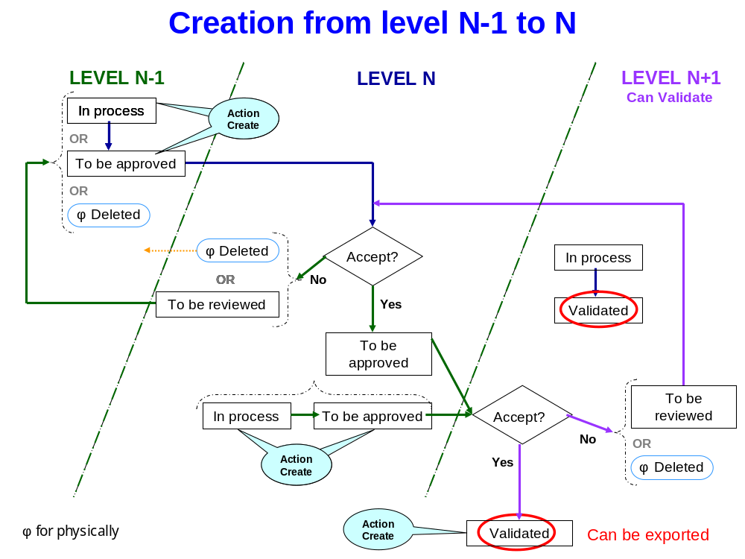
- Creation of 1 record from level N-1 to level N

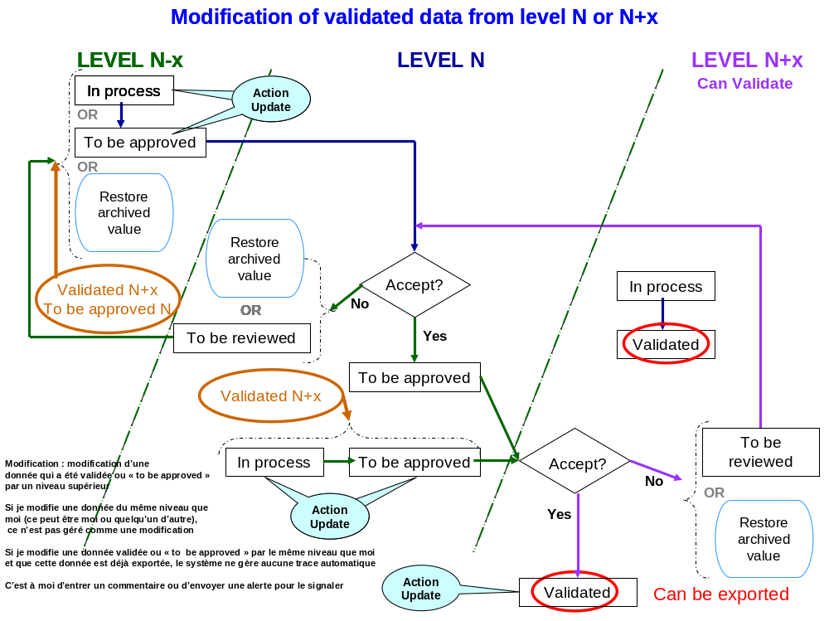
- Modification of data from level N-1 to level N
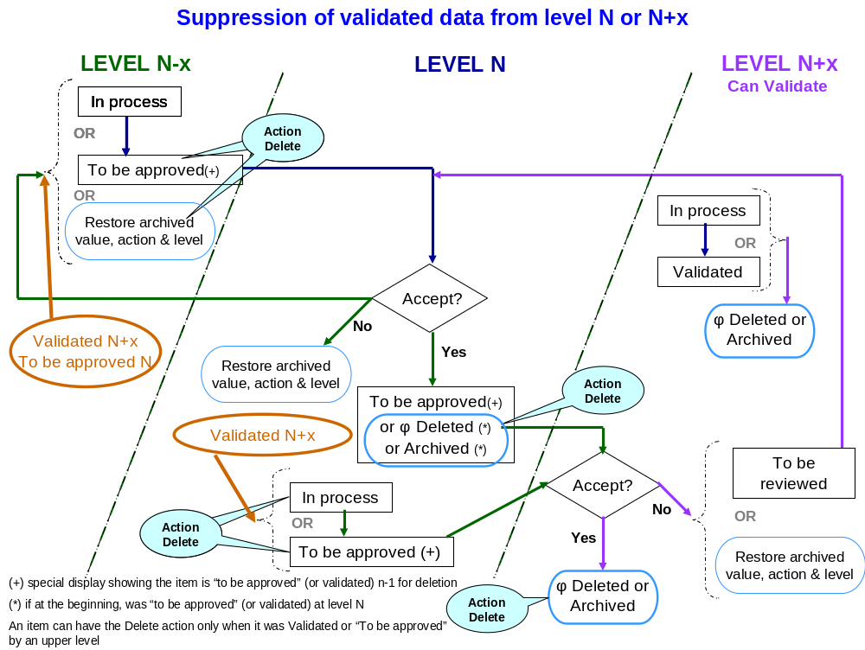
- Suppression of validated data from level N-1 to N

Annex 2: Use cases for requests

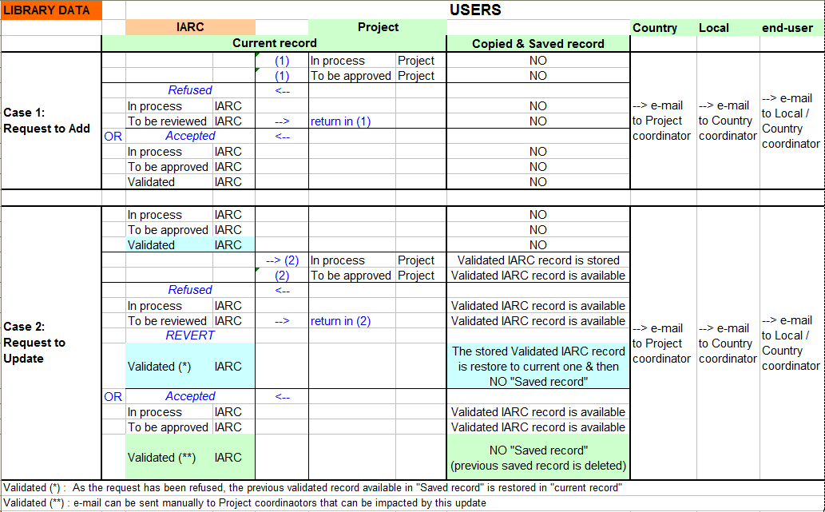

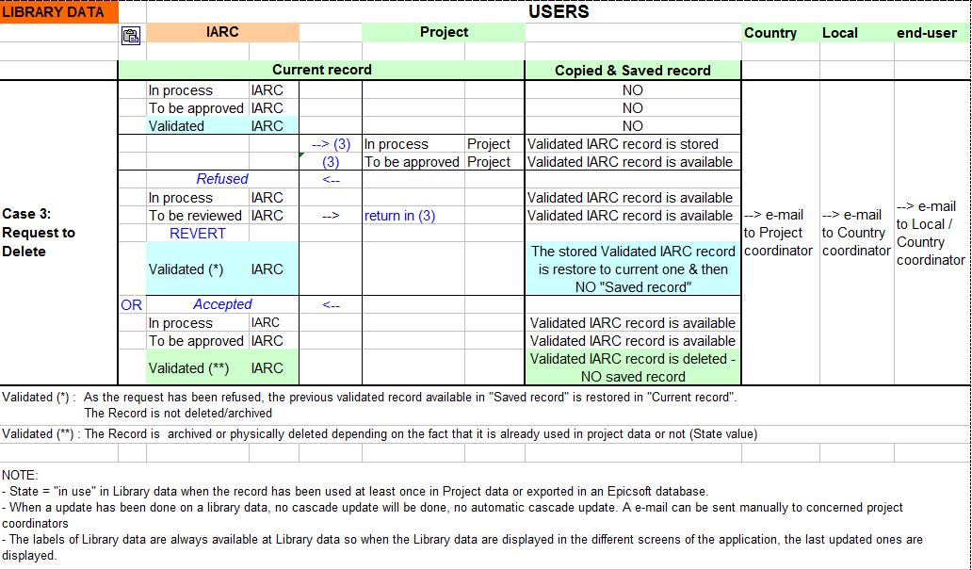

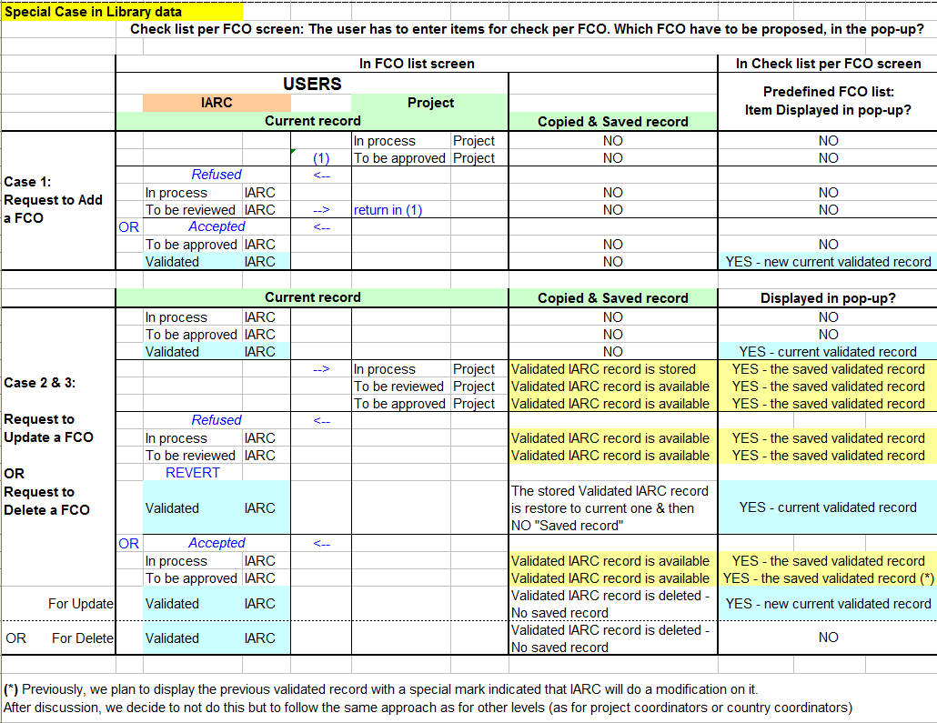

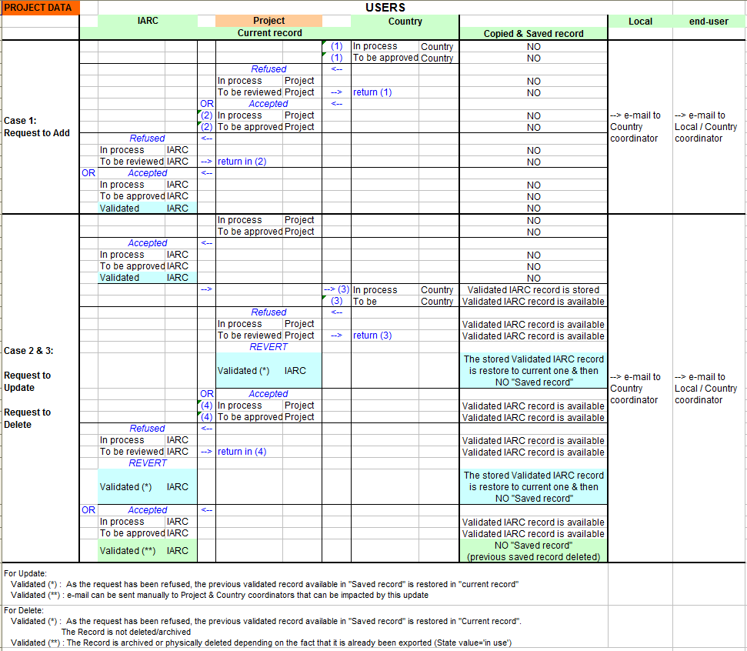

List of Links between project & Library & Country tables:

Project Setting | & Library Setting
Project groups/subgroups/sub-subgroups | & Library groups/subgroups
Project facets/descriptors | & Library facets/descriptors
Project photos (series, shapes, HHM, thickness) | & Library photos
Project photos (series, shapes, HHM, thickness) | & Country photos
Project Probings | & Library probing
Project Fadebygroup | & Project groups/subgroups/sub-subgroups
Project Fadebygroup | & Project facets/descriptors
Project Fadebygroup | & Country FdFacet (or RcpFacet)
Project Facetrul | & Project groups/subgroups/sub-subgroups
Project Facetrul | & Project facets/descriptors
Project Improbable Descriptors | & Project groups/subgroups/sub-subgroups
Project Improbable Descriptors | & Project facets/descriptors

Project Qmdetail | & Project groups/subgroups/sub-subgroups
Project Qmdetail | & Project facets/descriptors
Project Qmdetail | & Project photos
Project Qmdetail | & Country FdQuant (or RcpQuant)
Project Probing per groups/subgroups | & Project groups/subgroups/sub-subgroups
Project Probing per groups/subgroups | & Country FdProbing (or RcpProbing)

NOTE:
- State = "in use" in Project data when the record has been exported in an Epicsoft datbase.
- The labels of Project data are available at Library level (in most of the cases) so when the project data are displayed in the different screens of the application, the last updated ones are displayed.

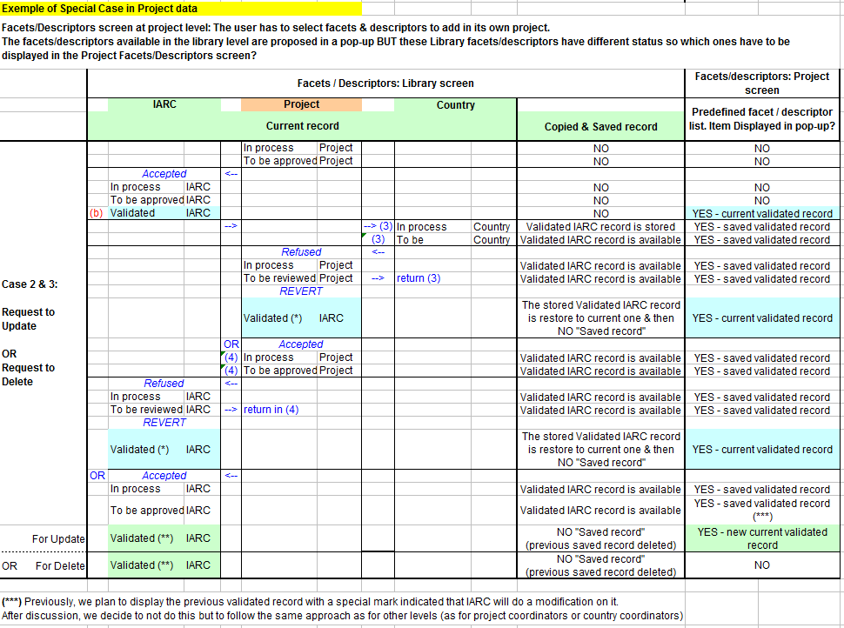

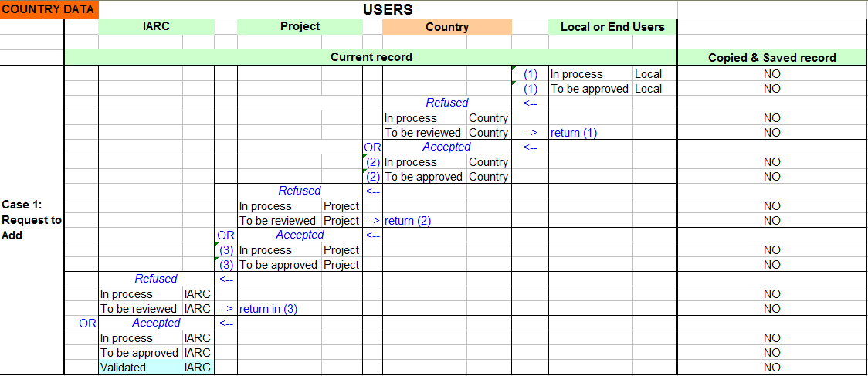

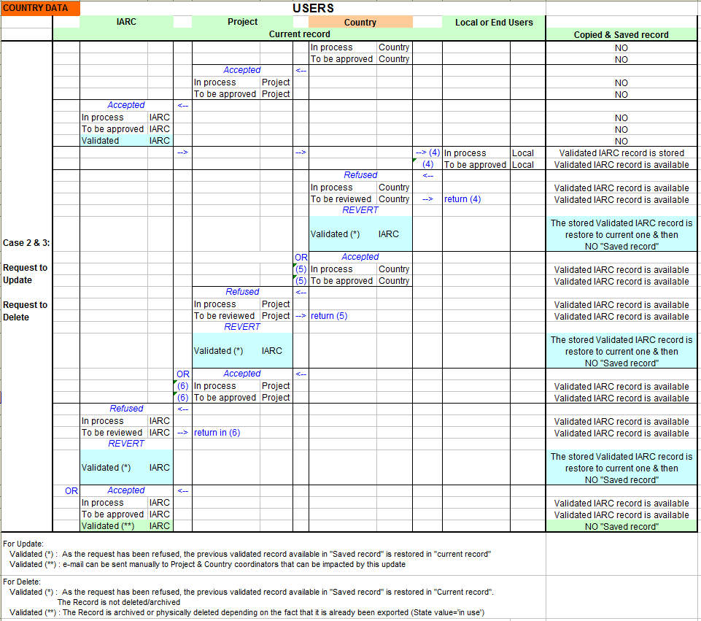

List of Links between Country tables and Country & Project tables:

Country Setting (check list per FCO) | & | Project Setting (check list per FCO)
Country Photo | & | Project Photo
Country classification | & | Project classification
Country Fadebygroup | & | Project Fadebygroup
Country Food list | & | Country Food Classification
Country food facet | & | Country Food list
Country food facet | & | Country Fadebygroup
Country food brandname | & | Country Fadebygroup
Country food quantification | & | Country Food list
Country food quantification | & | Project Food qmdetail
Country food quantification | & | Country Photo
Country food standard Unit | & | Country food list
Country food standard Unit | & | Country food quantification
Country food standard Unit | & | Country food facet
Country food standard Unit | & | Country food raw to cooked
Country food standard Unit | & | Country food Edible part
Country food standard Portion | & | Country food list
Country food standard Portion | & | Country food quantification
Country food standard Portion | & | Country food facet
Country food standard Portion | & | Country food raw to cooked
Country food standard Portion | & | Country food Edible part
Country food density | & | Country food list
Country food density | & | Country food facet
Country food density | & | Country Fadebygroup
Country food raw to cooked | & | Country food list
Country food raw to cooked | & | Country Fadebygroup
Country food raw to cooked | & | Country food facet
Country food Edible part | & | Country food list
Country food Edible part | & | Country Fadebygroup
Country food Edible part | & | Country food facet
Country % of fat during cooking | & | Country food list
Country % of fat during cooking | & | Country Fadebygroup
Country % of fat during cooking | & | Country food facet
Country % FSS after cooking | & | Country food list
Country % FSS after cooking | & | Country food facet
Country food probing | & | Country food list
Country food probing | & | Project probing per groups/subgroups
Country food probing | & | Project probing list

Country food maximum | & | Country food list
Country food maximum | & | Country food quantification
Country food maximum | & | Country food standard unit
Country food maximum | & | Country food standard portion
Country food maximum | & | Country photos
Country food maximum | & | Country Fadebygroup
Country food maximum | & | Country food facet
Country food nutrient values | & | Country food list
Country food nutrient values | & | Country Fadebygroup
Country food nutrient values | & | Country food facet
Country Recipe list | & | Country recipe Classification
Country recipe facet | & | Country recipe list
Country recipe facet | & | Country recipe Fadebygroup
Country recipe brandname | & | Country recipe Fadebygroup
Country recipe quantification | & | Country recipe list
Country recipe quantification | & | Project recipe qmdetail
Country recipe quantification | & | Country Photo
Country recipe standard Unit | & | Country recipe list
Country recipe standard Unit | & | Country recipe quantification
Country recipe density | & | Country recipe list
Country recipe density | & | Country recipe facet
Country recipe density | & | Country recipe Fadebygroup
Country % FSS after cooking | & | Country recipe Classification
Country % FSS after cooking | & | Country recipe list
Country recipe probing | & | Country recipe list
Country recipe probing | & | Project probing per receipe groups/subgroups
Country recipe probing | & | Project probing list
Country recipe maximum | & | Country recipe list
Country recipe maximum | & | Country recipe quantification
Country recipe maximum | & | Country recipe standard unit
Country recipe maximum | & | Country photos
Country recipe nutrient values | & | Country recipe list
Country recipe nutrient values | & | Country Fadebygroup
Country recipe nutrient values | & | Country recipe facet
Country Supplement list | & | Country supplement Classification
Country Supplement list | & | Country supplement facet

