Function blue cross:
When we select the function blue cross the “import” pop-up is displayed with a proposed list of selected records. Sometime this list is exhaustive (all records available in Library) as in the screen check list by FCO and sometime this list contains only the non-already selected records as in special day/diet at project level.
Do you have a reason for this discrepancy?

Function blue cross and pagination:
When the list proposed contains different pages, we can select some records in the first page, then move in a second page, select other records and when we validate our selection, only the records selected in the last page are available in the list screen. To avoid that, we can have 2 approaches:
- Before changing page a message is displayed asking if we want to save or not the selection
- The selections done in the previous pages are kept and the validation returns all the selected records.

Checklist by FCO: FCO code:
In the list we have only the code, in the pop-up available in the fiche, we can see the FCO code & name. It will be good to have the same approach everywhere by displaying the code+label also for the user, the label can be enough.
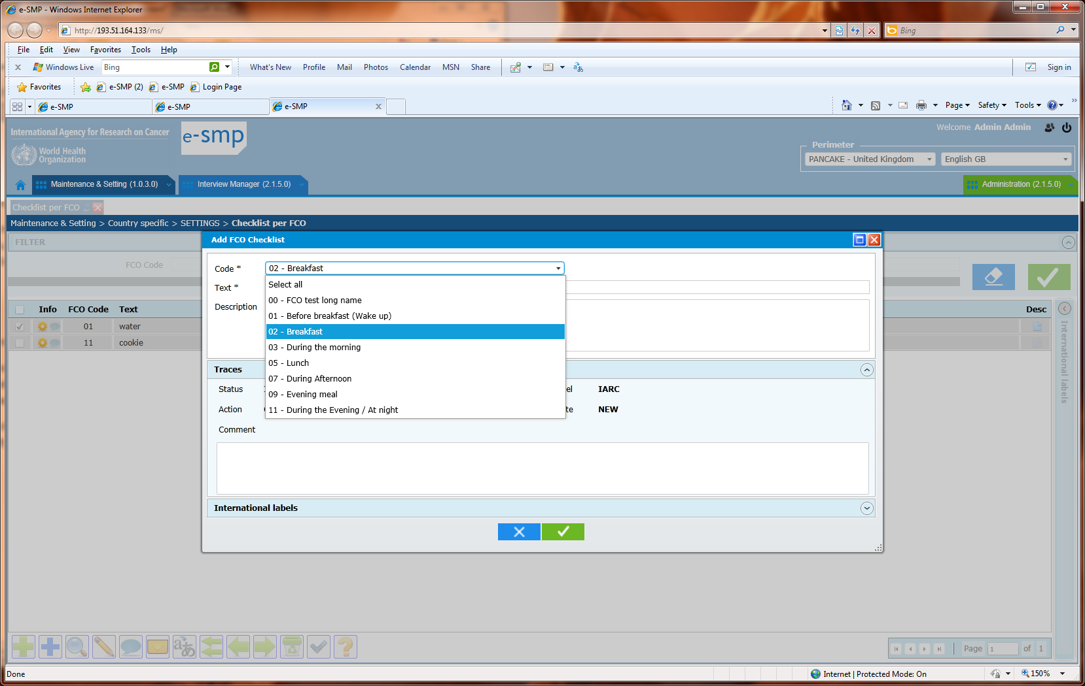

Control button:
We can select the control button  in each screen sometime some error messages are returned sometime no. Can we have specified in a document or in each check list what the control button does and can we have the list of all the possible returned messages. We need this document in order to prepare guidelines and to explain to future users how to do for each situation.
Example in checklist per FCO at country level, the button can be run but we do not have the details on which controls have been run

MASS translation - Column Sort:
We display a list in 2 languages for translation. The list is long and we have several pages. When we click on the column name we expect that the whole list is sorted on this column but, in fact, only the 20 records of the page are sorted! (e.g. check list per FCO).
Regarding an user point of view, it is the whole list that has to be sorted. The page cut-off is technically done, not logically (e.g. 20 lines) so not usable for a view point.
NOTE: We would like to have the same approach as for the blue cross function (import)

MASS translation – Status:
For the translation, we decided that the status “validated” is the default. I open the pop-up Mass translation with a list to be translated. I start the translation by entering values and doing return. By default, the cursor moves to the next line and it is fine to go faster. The status column stays empty. It is only when I click on the validated button that the all the non-filled status move to “validated”. In fact, in point of view of a user, it is better that before saying OK (green button), all the done modifications are well displayed on screen and it is not the case for the column status where the fields are empty first, and only after the OK selection, the user can see what has been saved.
So we can have another approach that is:
- The user enter a new name and when he/she select the Return:
  - if the status is empty, the field move to “validated” (Default value)
  - if the status is not empty, the field value does not changed
- Then when the OK is selected the displayed screen is the same as before.
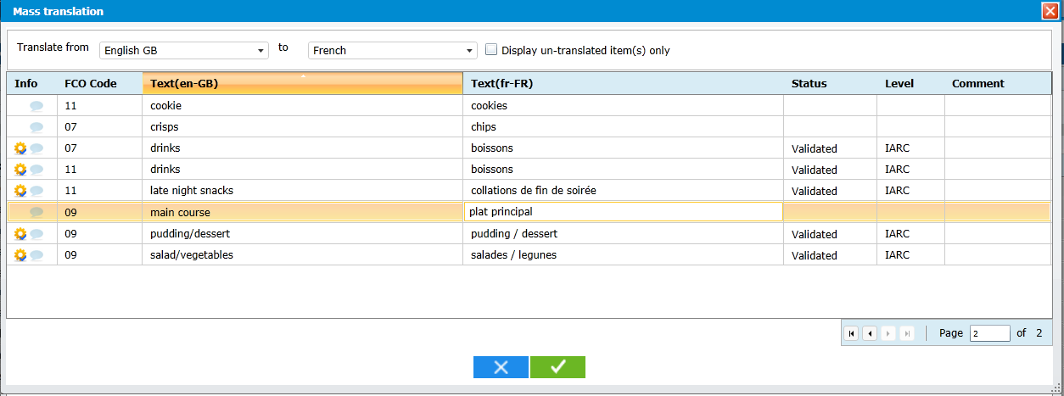

Checklist by FCO: FICHE

We want to add a text to 5 different FCO. For this action, we have to repeat 5 times the procedure (e.g. water to several FCO).
IF we add a check box in front each FCO code in the following pop-up, we can allow the user to select several FCO, to enter only 1 name, 1 status, 1 description and 1 translation and several records can be generated in the list.
