MSapp – version 0.0.1.0

Special Diet
Liste:
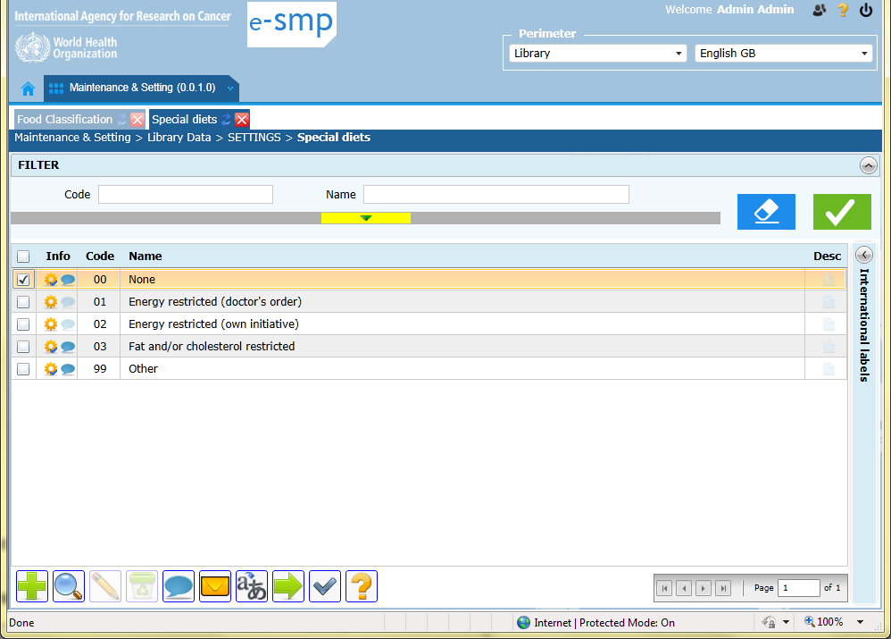

Fiche:
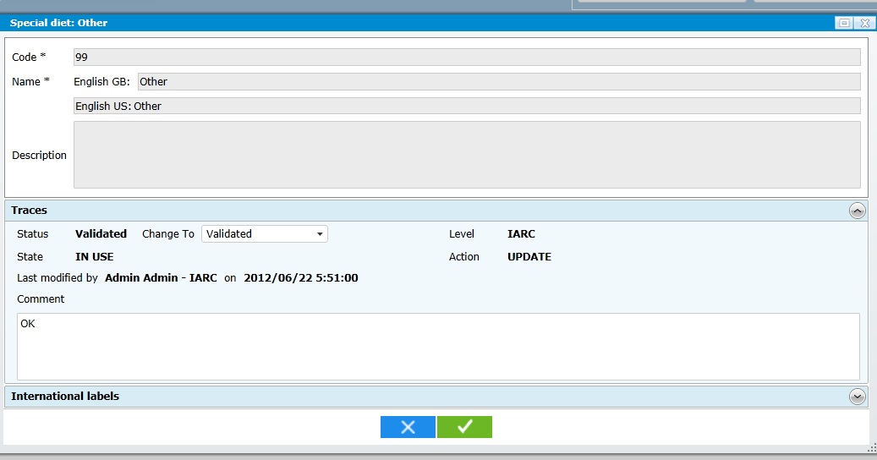
- Common remarks

  - Search:
- We cannot use the jocker character in the code field
- Trace: order of fields should be status, Level, Action type, state and last modification.
- Trace: By default all the modalities are selected and it is what we need but when we want to view only the “validated” records for example, it is necessary to click on 3 check boxes. Near each column title (e.g. status) can we have a check box to allow the user to select/unselect all the possible modalities?
- Trace: Change the label the “Ident.” per “By ”
- Trace: To help the user, we need a predefined list with the user names to fill the “ident.” Field.

  - Liste
- We have to find other icons for the status. It is difficult to see the difference between validated and to be approved.

  - Fiche
    - Trace:
- Why do we have Status Validated and “Change to”. “Status” is enough?
- The field order is Status, level then Action and at the end State
- Date display: is it in country design or always as yyy/mm/dd?
- “Show change” button: It can be better to always have it displayed but activated only when relevant.

    - Show changes
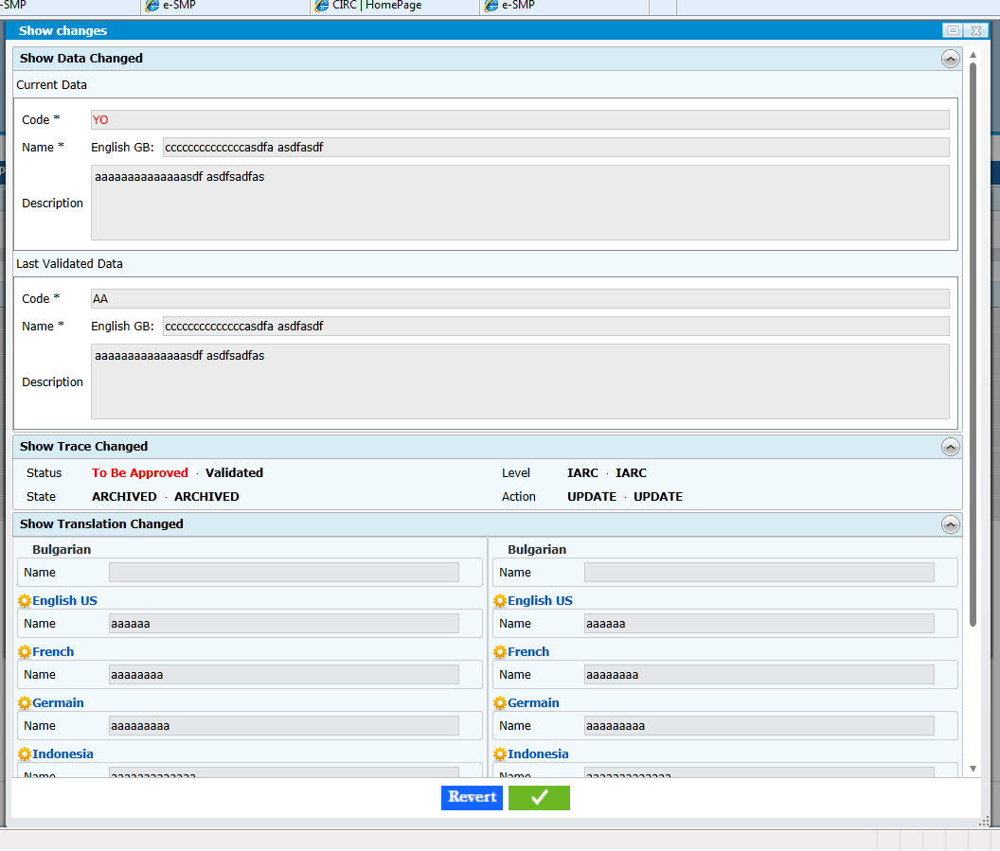
- 1. We prefer to have the part “current data” updatable
- 2. The trace part can be moved just after the “current data” and can be updatable too.
- 3. The “last validated data” does not changed and we can add 2 lines not updatable describing the previous trace values. It is not necessary to present it in a block.
- 4. To be discussed:
    - Do we have to keep the previous values of the international labels? They already have they own status and we had decided to not keep the previous values?
    - Part 2 before or after part 3?
- Using the icon, we can open or close the “last validated data”. This part is available only if previous data are available. The show changes button is no more available, replaced by this open/closed icon
- Clicking on revert button, the previous values are automatically copied in the “current changed part”.

IARC Proposal
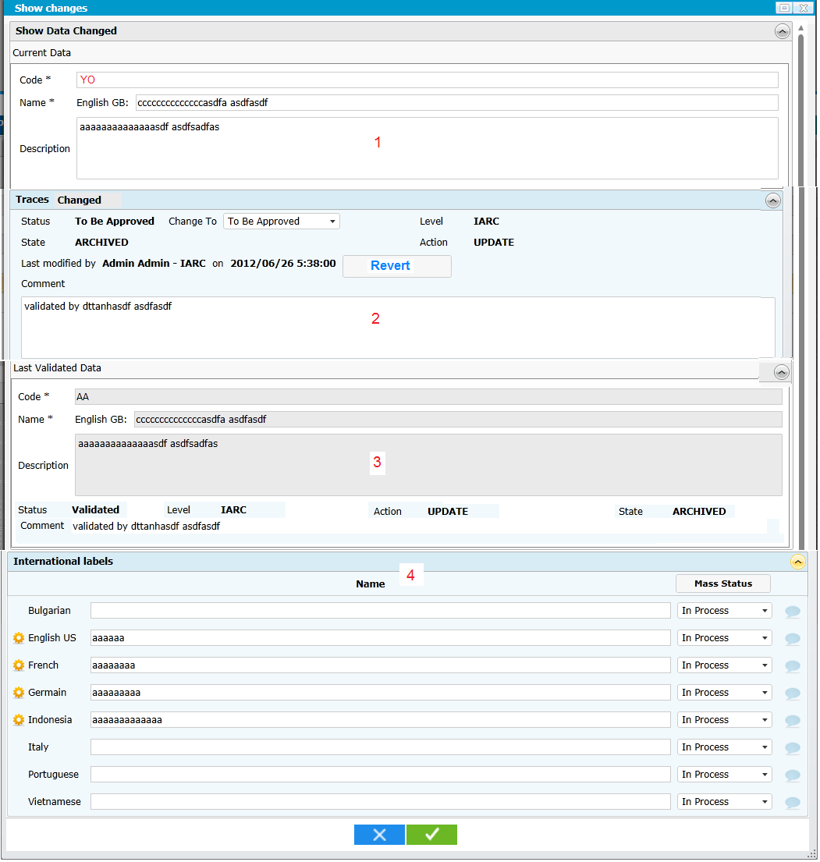

    - International label
- In this screen, we can translate an item on 2 different lines (using the return). Can you block this action? This will display special characters in part left “international label”

- Library specific remarks
  - Search
  - Liste
  - Fiche

- Project specific remarks
  - Search
  - Liste
  - Fiche

- Export
  - Can we change the column order in the export? For the record trace, we prefer to have this order:
Status & Level & Action & State & Last Modified & User & Login
  - Do we really need the login?
  - Instead of the code language, can we have the language (e.g. instead of “Name(bg-BG)” we can have “Name(Bulgarian)“?

- Mass translation
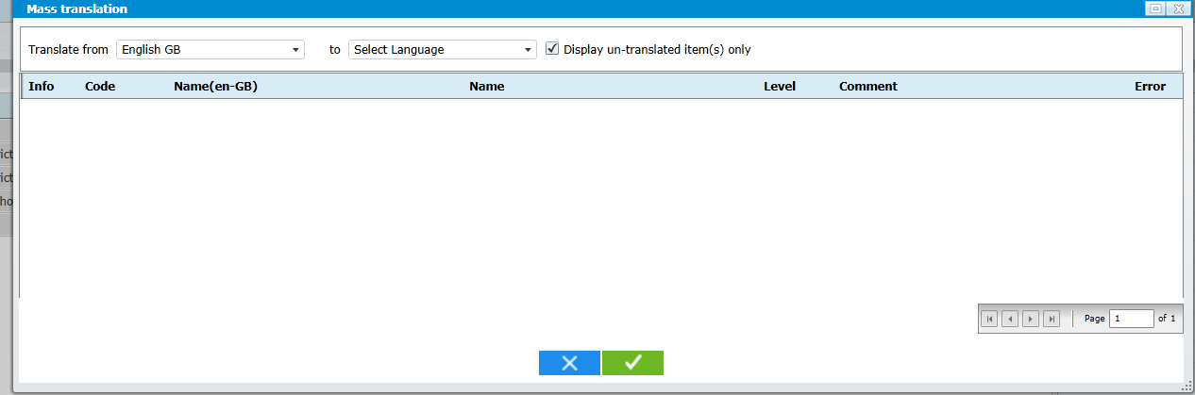
  - What is the error column?
  - In “translate from” field, it should not possible to select a language that not have all items already available and validated. It is for this reason that translation has always to be done from GB to another language by not proposing language in “translate from” field.
  - No more comment because it is not possible to view how to fill.

- Tables remarks

