MSapp – version 0.0.1.0

Food classification

- Common remarks

  - Search

    - Main fields:
      - Code: How a user can search for all subgroups of group 01? Can we enter “01%”? Because we don’t when to see all the groups or subgroups or sub-subgroups with code “01”, as it is here. In the same order, can we enter “%01”, sub-subgroup 01?
    - Trace fields:
      - Can you order the fields as followed: Status + Level + Action + State + Last modification.
      - Label: change the “Ident.” per “By ”
      - To help the user, we need a predefined list with the user names to fill the “ident.” Field.

  - Liste

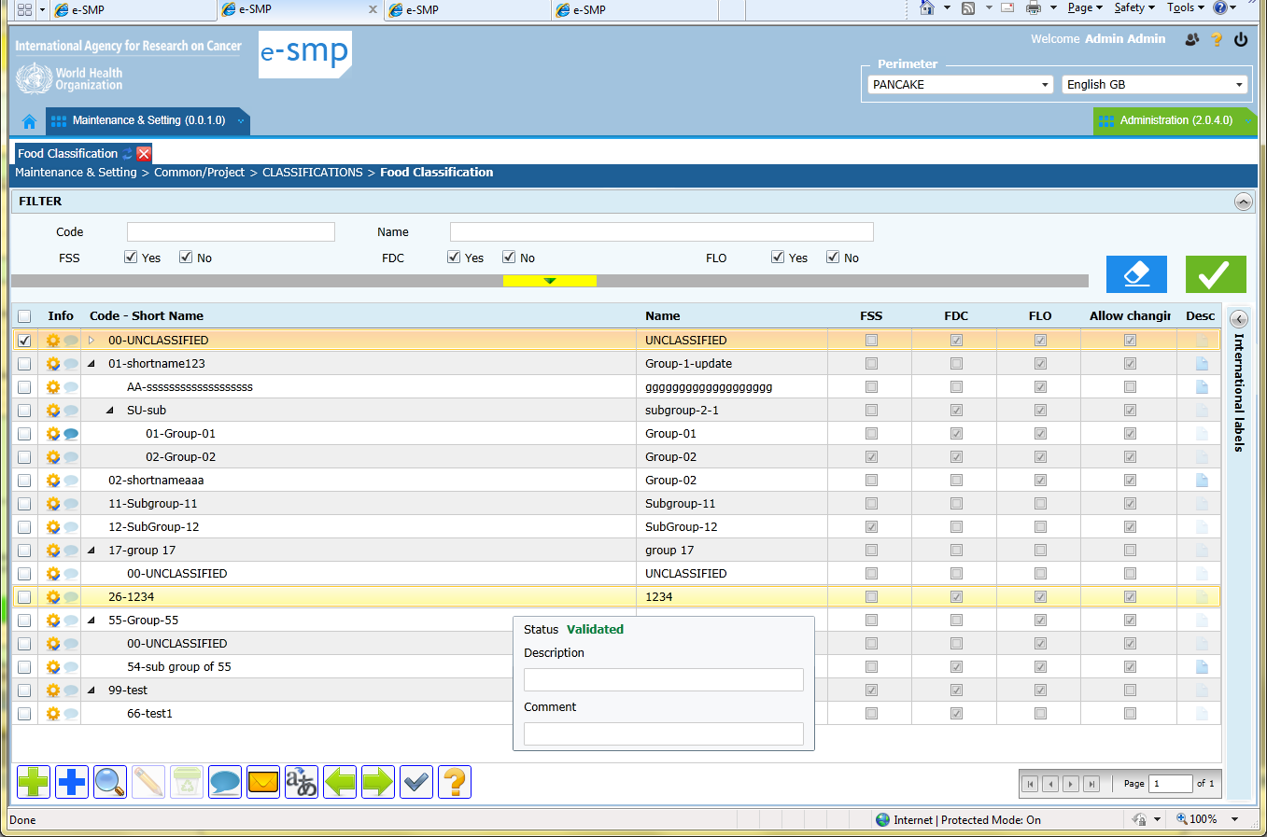

    - To be discussed: Are you agreed with this design, with the arrows use?
Inconvenient: the result of the search not displayed only the selected records but also the attached main records (e.g. if search on name “Unclassified”, all the groups with be displayed with a arrow in front of. The user will have to click on this icon to open the group and view the subgroups (and do the same for sub-sub-group)
Advantage: We can see that it is a “tree approach” with group, subgroup, sub-subgroup levels.

    - The arrow icon showing that sub-groups or sub-sub-groups exist, is too small and not enough visible. For example we can have: black if not open & in white if open, increase the size… The default can be all open…

    - We appreciate to have the possibility to change manually the width of the column using the mouse.

    - Can we have the same approach as in IMapp for the cell contain by truncating the label if too long?

    - Tooltip on record status: the description should be after the comment or before the status because comment is linked to status but not description that is link to the record content.

    - To be discussed: The tooltip with the record status is always displayed whatever the place of the mouse, it’s following the mouse! Do we have to keep the information comment and description in the same tooltip or not?
If yes, the column desc can be deleted.
If no we can have 2 tooltips, one for status and comment and another one for description available with icon on Desc column.

    - Buttons:
      - Mass translation:
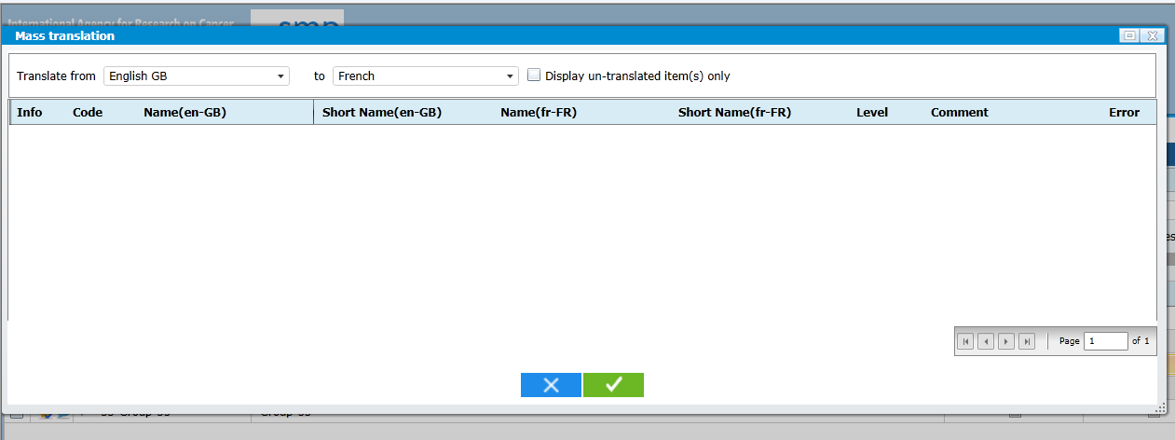
- What is the column Error?
- Button mass status is not here?
- When there are 2 labels to be translated, perhaps it can be better to order the columns as Name(en-GB), Name(fr-FR), Short Name(en-GB), Short Name(fr-FR)
- Button “Mass Status” is missing.
- Change button tooltip label “detail” by “View”
- Change button tooltip label “comment” by “change several status & comment”
- Export: a file name should be given automatically and the user can modified it is necessary (e.g. Food_Classification_20120615.csv)
- Export classification:
  - In the export all the records available on screen have to be exported (search result) but not only the selected one with the checkbox.
  - For subgroup, the attached group code needs to be exported and attached to the subgroup code
  - For sub-subgroup, the attached group and sub-group codes need to be exported and attached to the sub-subgroup code. We are working with code “01 01” for a subgroup or 02 01 01 for a sub-sub-group.

      - To be discussed:
- we have 3 buttons to do nearly the same action:
  - Green +: to add a new record manually
  - Blue + : to select and copy record from Library
  - Import (green left arrow): to select and copy record from another Project
Do we really need 3 buttons (import and blue + is the same action/window just from different sources)?
Do we need to guide the user work by presenting the library data first, then if the proposal is not what is needed, (s)he can view & select from other projects then if not relevant too, (s)he can enter a new record ?
Different use cases: a) for project data (classification, setting, photo, facets/descriptors…), b) for Country data (food, coefficients, percentages…)

  - Fiche

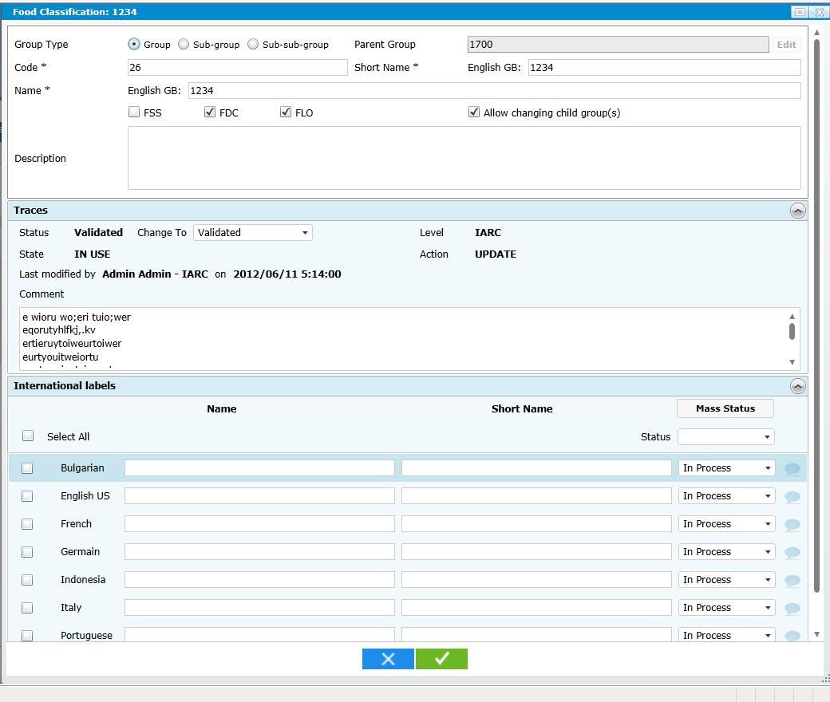
    - Group type: Why do we have this field as we already have the Parent group?
    - Presentation: can we organise in order to have:
- Parent (null OR group code and short name OR group code + subgroup code + subgroup short name)
- Code Name (English GB)
- Short name (English GB)
- FSS FDC FLO Allow…
- OR instead of Parent in code field we can have directly the group + subgroup + sub-subgroup code as in Epicsoft where the 3 codes are stored.
    - Parent group pop-up: Why do we have a clear button?

    - Trace:
- Why do we have Status Validated and “Change to”. Change to is enough?
- The field order is Status, level then Action and at the end State
- Date display: is it in country design or always as yyy/mm/dd?
- “Show change” button: It can be better to always have it displayed but activated only when relevant.

    - Translation:
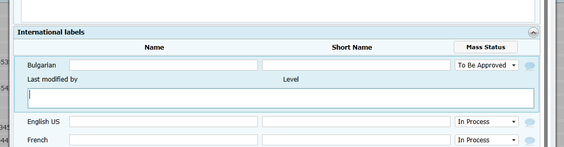
- Label Name and Short Name can be at the same level as “Select all”
- Do we really need the Mass status button? The status field at the top can be always available (rename as “change selected status”).
- As it is now, It is not possible to change several status and comments in the same time.
- So can we have a button that open a pop-up with status and comment field to be attributed to several translations (same approach as for button mass translation)?
- “Comment” label is missing.
- Values for Last modified and Level are missing
- It is not obvious that we have to click on the icon “balloon” to see the comment. In fiche screen it is a tooltip attached to this icon. Do you have an idea on how to present it as a button?

- Library specific remarks
  - Search
  - Liste
  - Fiche
- Project specific remarks
  - Search
  - Liste
  - Fiche
- Country specific remarks
  - Search
  - Liste
  - Fiche

- Tables remarks

  - MS_CLASSIFICATION
    - This table is only related to Food classification. Do you plan to have a header table, that defines the type and name of classification? For example: “Epicsoft classification 2012”, type=“Food” OR “Epicsoft classification 2012”, type=“Recipe”, OR “Supplement Classification for France 2012”, type=“Supplement”, OR Supplement Classification for France 2013” , type=“Supplement”
This header table is important a) for the supplement classification; we can have several ones in the library, but also for the evolution of the application. In the future we will have several foods classifications…

