MSapp – version 1.0.1.0

FOOD CLASSIFICATIONS

LISTE:

- Question: how many records can be displayed in 1 page?

- Display time: after having entered more than 50 records in screen, the time to display the data in list became slow.

- Sort order: I add a sub-subgroup coded 050102. When the list it is displayed this group is before the 050101 sub-subgroup. This list has to be sort by group/subgroup/sub-subgroup even after an Add.
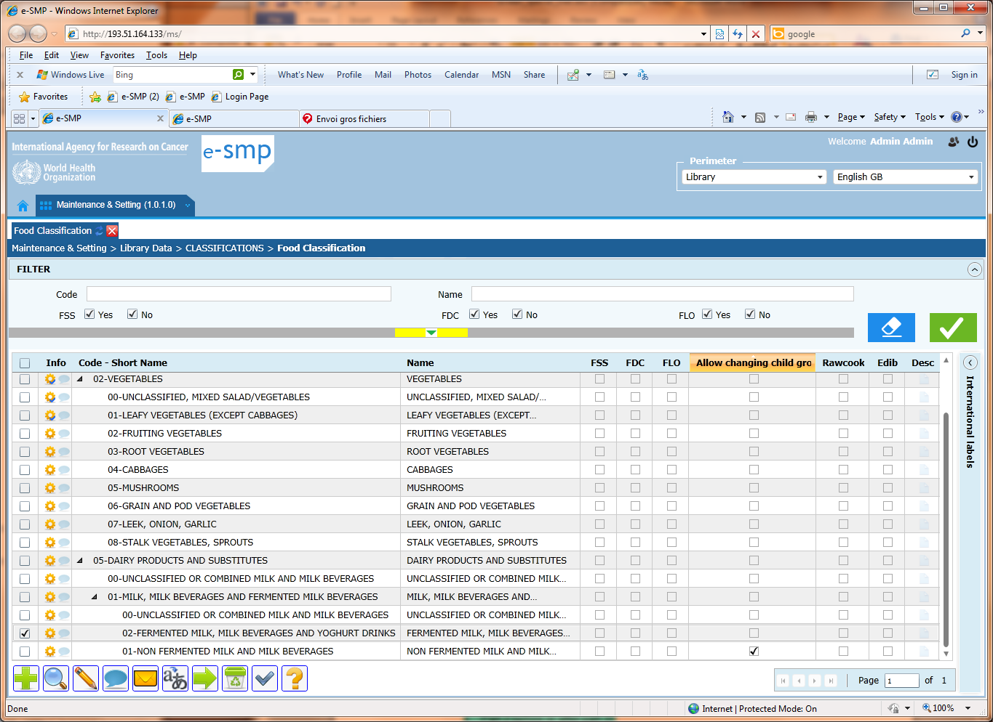

- Fold/unfold option: Is it possible to have a function somewhere that allows folding / unfolding the list?

- Folded-unfolded display: I fold all displayed groups keeping the last one unfolded (see screen below). Then I add a subgroup to this last group. When I come back to the list, all the groups/subgroups are unfolded. My previous selection is not kept.
List before the add:
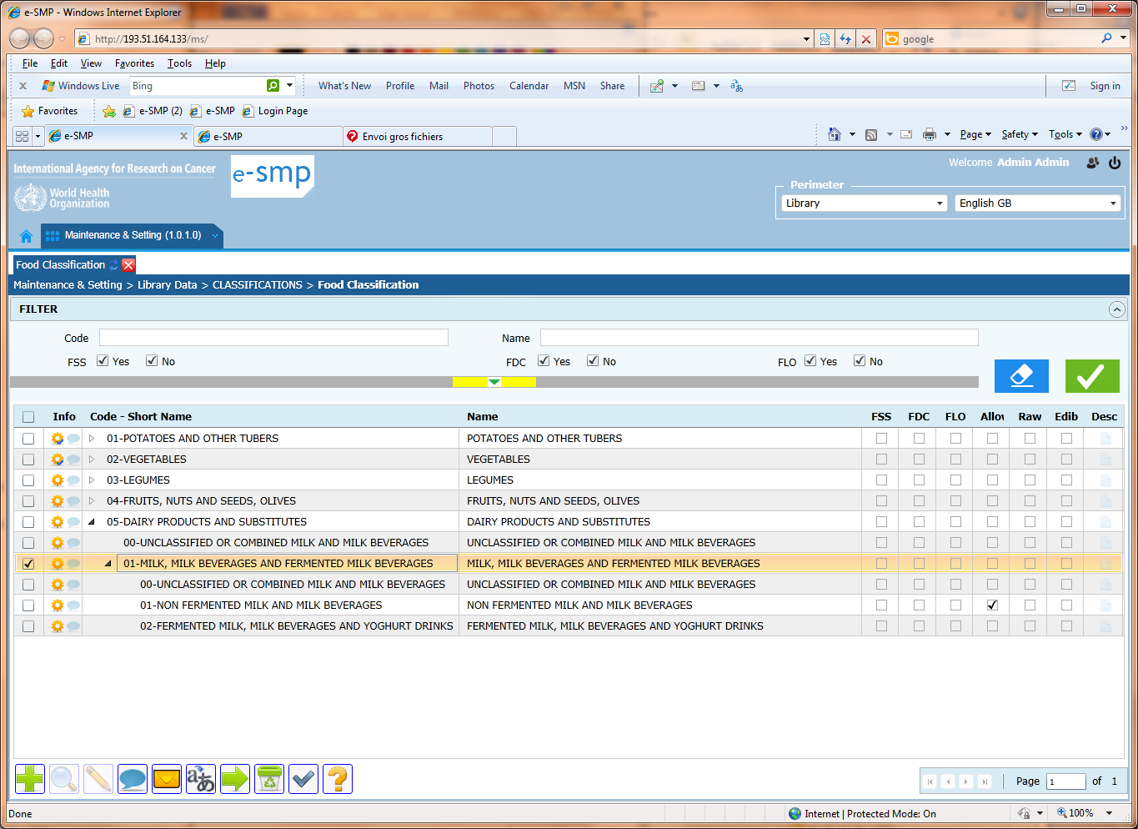
List after Add:
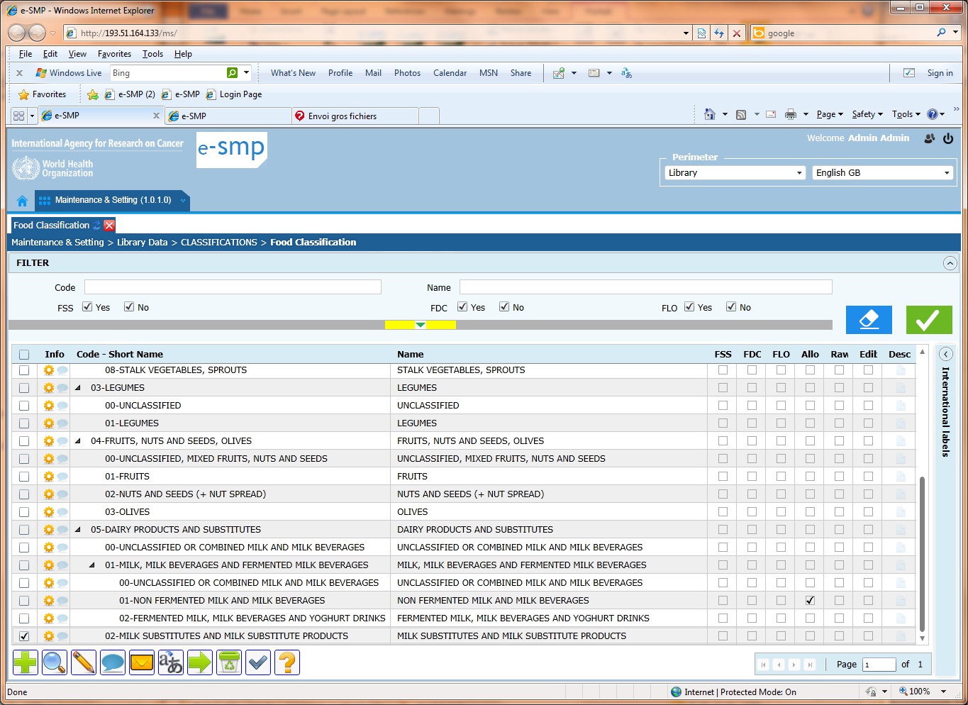

- Group code display: When a group contains more than 18-22 attached sub-groups, sub-subgroups, the group is no more displayed on screen and the user can be lost or has to go up/down to have a perfect view. To avoid this situation, it can be interesting to display all the codes in front of the labels, that means for example “05 08 01 ICE CREAM (MILK BASED)”. Is it possible?

- The tooltip “Status” is not always well displayed. See in my example, I point the mouse on the blank arrow to open the sub-subgroup and as the tooltip is displayed it is not easy to select the arrow. Can you display the tooltip more in the right/left part of the mouse, especially when the mouse is in the left or right part of the screen?
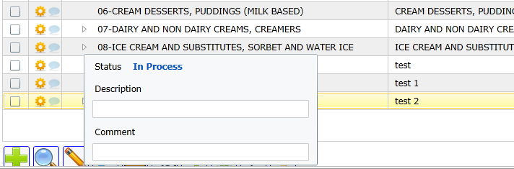

FICHE:

- Presentation: Before
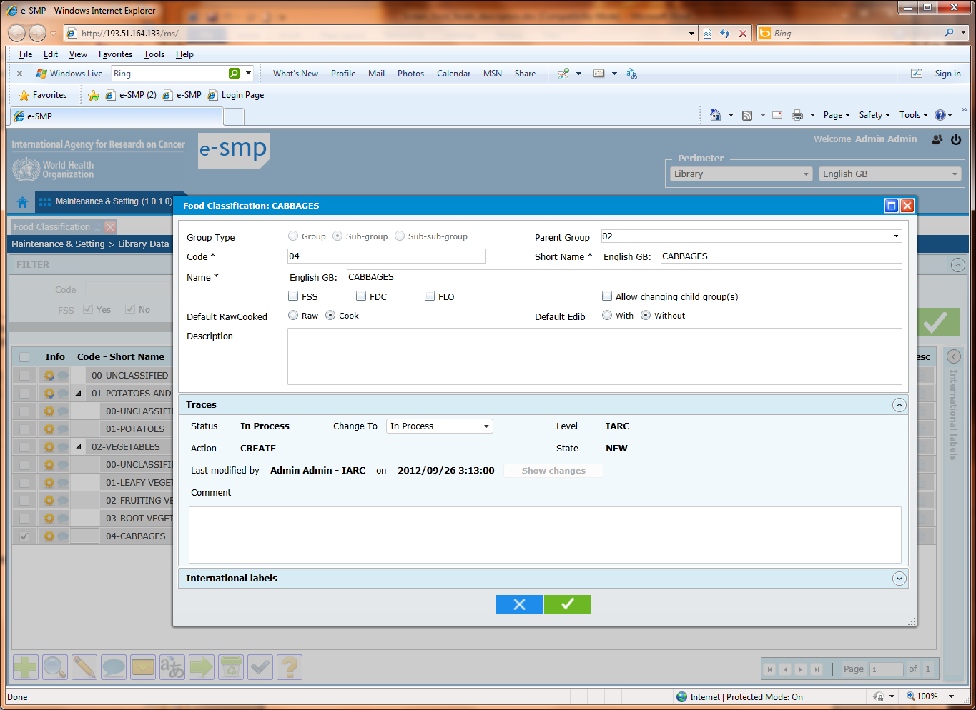
After:
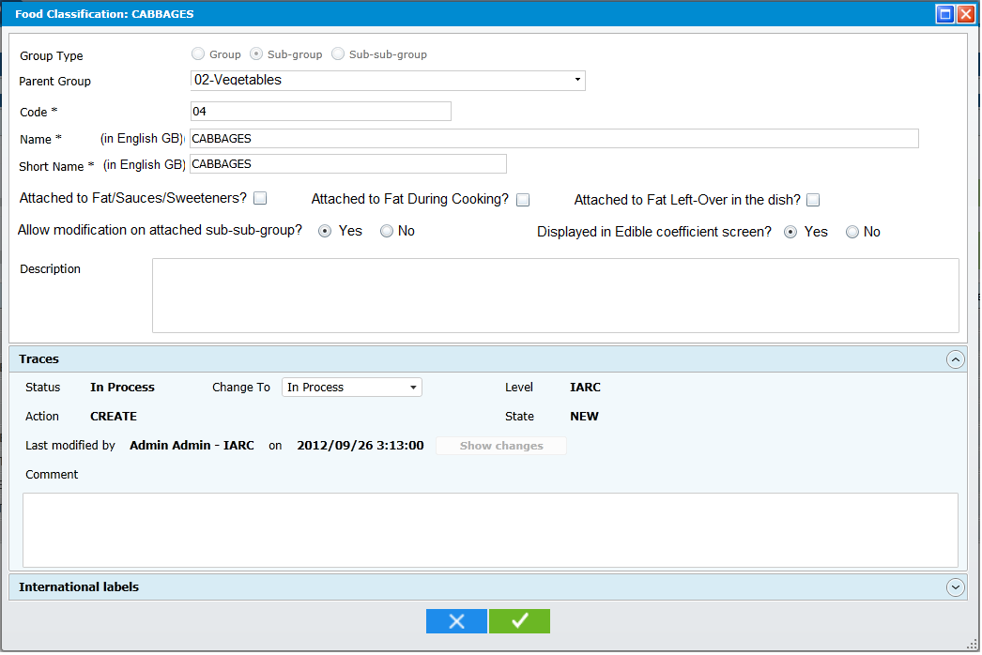
- The ‘Group type’ field is not necessary. Effectively, in the proposed ‘Parent group’ field, we can propose the list of available groups and subgroups with radio button in front of all. If the user select a group, the entered Code will be a sub-group, if he/she selects a sub-group, the entered code will be a sub-subgroup. If he/she lets the ‘Parent group’ empty, it is a group.
To avoid mistake, once the ‘Parent group’ and Code is entered, a message can be displayed after the Code field saying if the entered value is a group, a subgroup or a sub-sub-group.
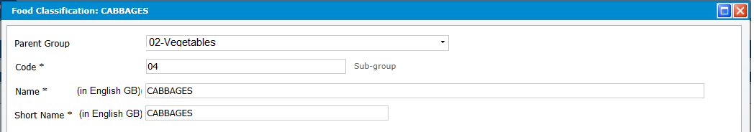

- Parent group: add the group/subgroup Name
- Put the short Name after the Name
- Ask question for changing child group. Default is Yes
- Change labels of FSS, FDC and FLO
- Change question on EDIB.
- What is the question on Rawcook?
- The question on modification on attached sub-sub-group has to be active/displayed only when we are at the sub-group level (never at group or sub-subgroup levels)

- Pop-up ‘Parent group’: I have created the group 05 with several sub-groups attached. After the sub-group 07-Dairy, I want to create a sub-sub-group. I select the radio button Sub-subgroup and then I open the ‘Parent group’ list. In the proposed list I can just select the subgroups 0500 & 0501 but not the other subgroups attached to this group, why? All the subgroups have to be selected (radio button available).
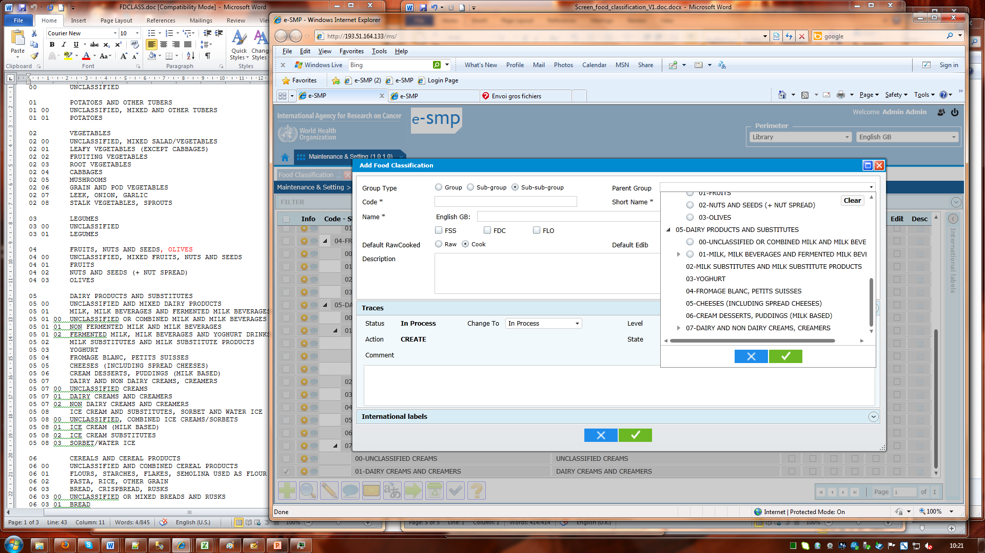

- Short name: only on 20 characters (not 100)

FUNCTIONS:
- ADD a group: I add a group (e.g. 02 Vegetable. Automatically an attached subgroup “02 00 – unclassified” is created. When I open the fiche of this subgroup 0100, there is no parent attached and when I click on this field, I don’t have the possibility to select the last created group (coded 02)? This problem occurs at sub-group level each time we have only 1 subgroup within a group and we edit it.
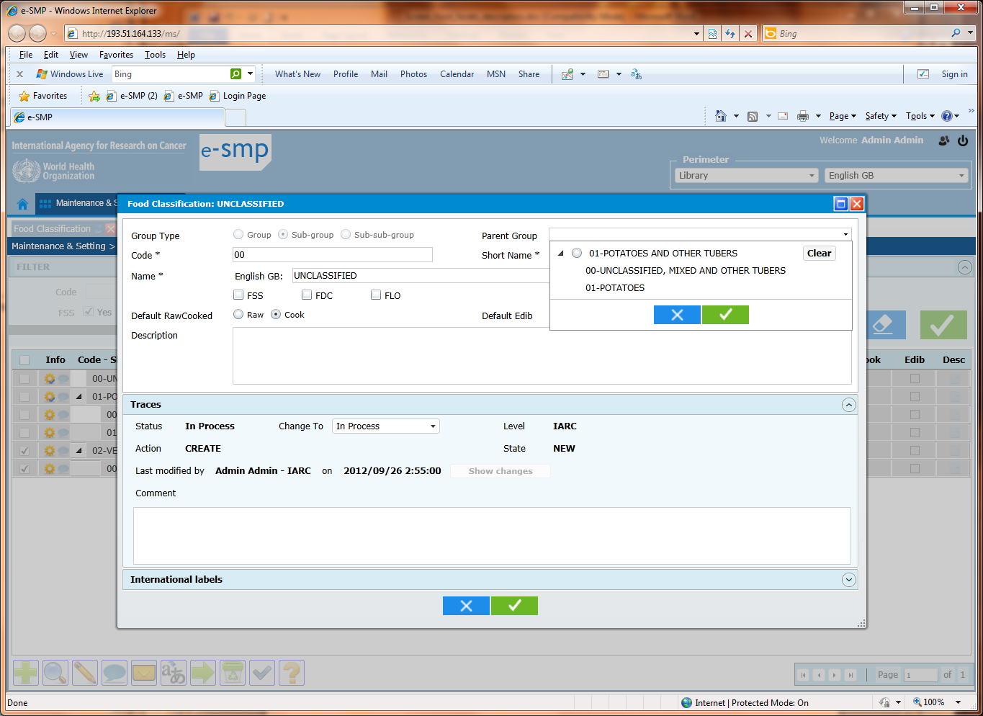

- Add Default: On the list:
- If my cursor is on a group, then the fiche is opened with Sub-group button activated and the focussed group code + name is displayed in parent group
- If my cursor is on a subgroup, then the fiche is opened with Sub-subgroup button activated and the focussed sub-group code + name is displayed in parent group
- If my cursor is on a sub-subgroup, then the fiche is opened with sub-subgroup button activated and the focussed sub-group code + name is displayed in parent group field

- Delete:
- I select some subgroups and then I select the delete function. A pop-up is displayed asking if we confirm or not the delete.
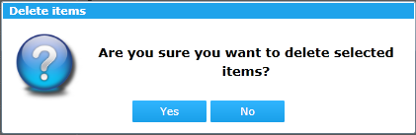
After having selected the Yes button, the pop-up with the delete summary is displayed.
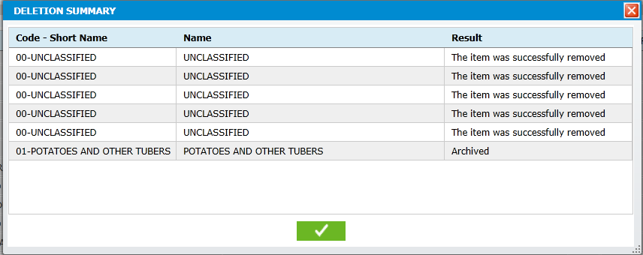
- In this delete summary pop-up, can you add all the codes; group/subgroup/sub-subgroup?
- For delete, we propose another approach:
  - Instead of displaying a warning message “are you sure…?” we replace this pop-up by the “deletion summary” one adding the message “Are you sure…?” + the 2 buttons Yes/No.
  - In the result column the message changes by using the future (not the past)
  - If the answer is Yes, all selected records are deleted or archived.
  - If the answer is No, return in List
With this approach, only 1 pop-up is displayed (not 2) and the user can see what will be deleted and can select the answer (Yes/No) knowing perfectly what will be deleted/archived.

- Export: In the export file, we cannot distinguish what is a group, a subgroup or a sub-subgroup. We cannot have a notion of attached to. In the code column you can put the group + subgroup + sub-subgroup code as below:
Code Name
01 POTATOES AND OTHER TUBERS
01 00 UNCLASSIFIED, MIXED AND OTHER TUBERS
01 01 POTATOES
02 VEGETABLES
02 00 UNCLASSIFIED, MIXED SALAD/VEGETABLES
02 01 LEAFY VEGETABLES (EXCEPT CABBAGES)
02 02 FRUITING VEGETABLES
02 03 ROOT VEGETABLES

- Mass translation:
  - Status: it is really onerous in time, to have to select a status in each line. We have to do 3 chicks with the mouse to have the list of available status and then 1 to select it. Can you propose another way to do? For example a button that gives the same status to different lines.
  - Status default: We can also attribute automatically a default status, the most high for the user (e.g. for Admin, it is Validated, for country collaborator, To be approved)
  - Status: A status can only be attributed if a translation has been done (no empty field). This case should not be possible:
  - Column order: we cannot sort the list by clicking on the column name and it can be interesting to have it when labels are similar.
  - Name & short Name: In these 2 field, I can enter a label, a enter and a label. Enter cannot be selected as in this example:
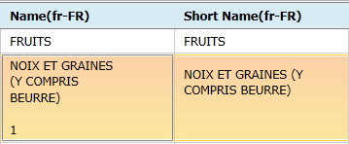
  - I enter a translated name in page 2. I pass to page 1 (without clicking on ok green button), then I select the ok/green button. I move to the page 2 but the previously entered name is not available!
Perhaps, the best way to do to include all the possible cases (moving from page 1 to 5 then to 10…) it is that when the user select a page (option), a question is asked to know if he/she wants to save the work done. This question appears only when modification has been done on the current page.

Blue + (add): when 2 subgroups are validated but not the attached group, we have this special situation. If the user selects the 2 subgroups for import in project list, a message blocks her/him.
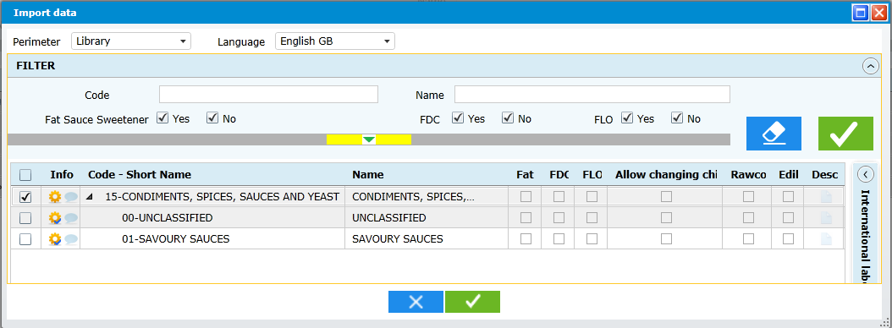

DATABASE:
- MS_Classification:
  - Can you explain the definition and the use of columns IDSource and ImportType?
  - What is the use of columns DefaultEdib and DefaultRawCook? In which case do we need them? Can you explain?
- MS_Classification _L10N
  - Short_name: 20 characters only (not 100)
  - What is the use/necessity of IdL10N column?
  - You keep the ID_Group and ID_Subgroup in this table too. Perhaps, for a question of performance, it can be better to keep directly the Code and LongCode? What do you think?

