MSapp – version 0.0.1.0

Food Facets/Descriptors

- Common remarks

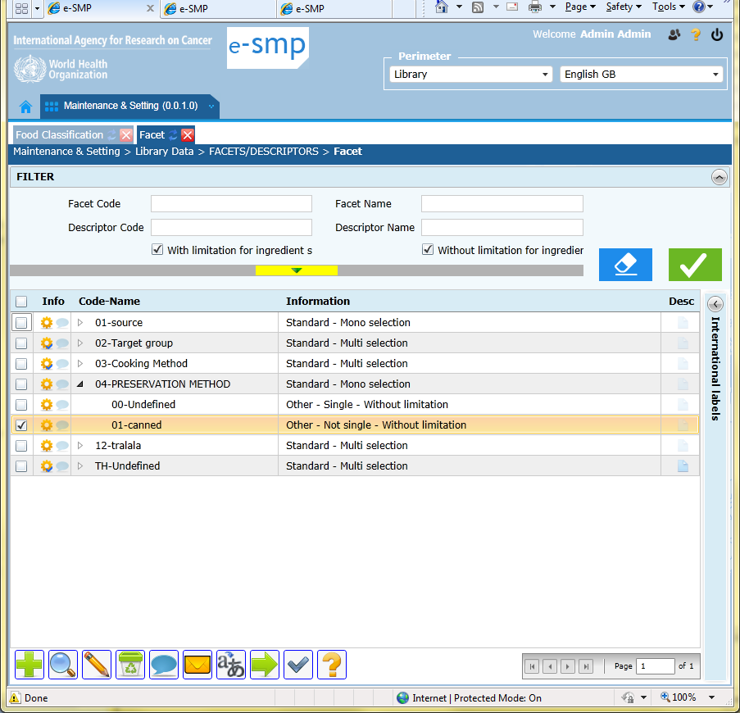
  - Search
    - Main fields:
      - Facet and descriptor Codes: the size of these 2 fields is too long. Code is on 2 characters only.
      - The default of “with/without limitation for ingredient substitution” is without. Change the design by “Descriptor blocking the ingredient substitution Y/N?”. Both answer Yes & No selected. For information in the fiche, Default is No.
      - When we search on descriptors (e.g.0% in descr. code), the result is not displayed because descriptors are not open…It is not user friendly.
      - Missing fields: facet_type_s and Descr_single

  - Trace fields: The tooltip to display the description field is too small in this screen. Can you increase it? Effectively, the description is very important and big in this screen .

  - Liste
    - The default has to be all opened; displayed facets and descriptors view on screen.
    - The facet order is not displayed in the fiche, so it is not possible to attribute an order to new facet…. How to do?
    - Can you explain what are available in Information column
    - Facet: facet_group is missing

    - Buttons:
      - ADD (green +) : In this screen, the user can add a facet or a descriptor using the same button depending on what is selected on screen. If no record selected then add facet else add descriptor…
      - EXPORT:
- Only facets are exported. Descriptor list is needed too.
- For facets, facet_type, facet_type_s and facet_grp columns are missing

  - Fiche: Descriptor

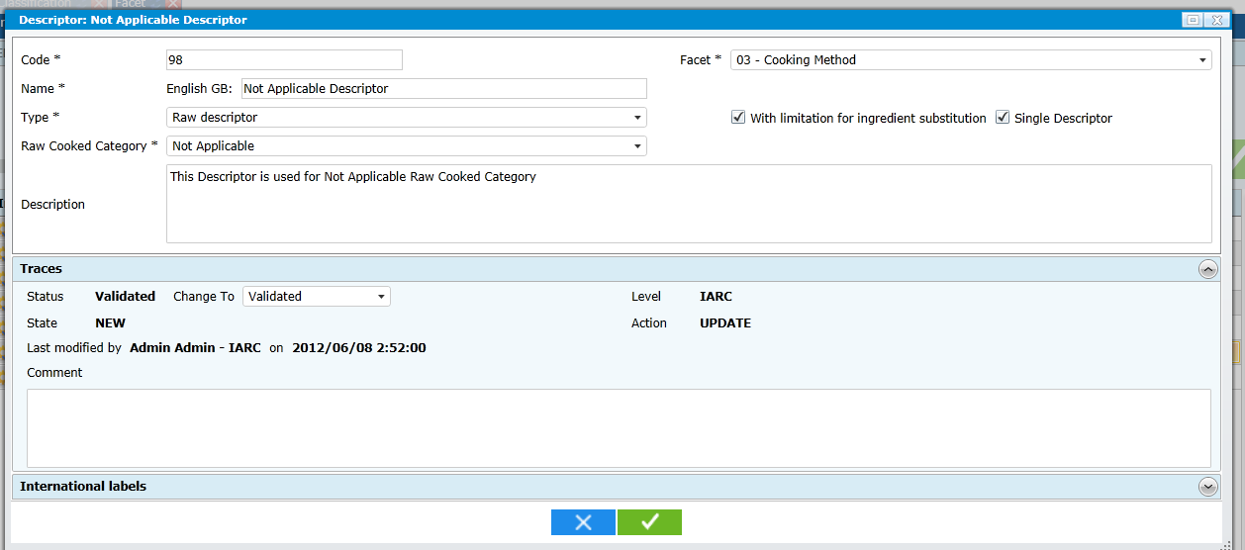

    - I will prefer to have the facet at the top of the pop-up, then the descriptor code + name at line 2 followed by the other questions asked when it is relevant.
    - The Description field should be bigger in this screen because its contain is important.
    - The field “Name in perimeter” is missing.
    - Raw cooked category should be activated only if facet 03 cooking method is selected.
    - Limitation for ingredient substitution; see in Search point and change the question by “Is it a descriptor that blocks the ingredient substitution (Y/N)?” (if Yes then Descsubs record management, Else nothing, Default=0 no)
    - Type field: we cannot view the different answers? In fact, it is a question “Is it an exclusive descriptor?” with answer No/Yes. This question is asked only if the attached facet is with “multi-selection”.
    - For facet cooking method 03, we have 2 other questions:
- “Is it the raw descriptor (y/n)?” ((Descface.Descr_single, 0=no, 1=yes raw, default=0)
- “Is it the descriptor linked to “fat used during cooking” (y/n)? (Descface.Desc_cook, 2=yes, 0=no, default=0)
If answer to a. is Yes, then the question b. is not asked else question b. asked.
If a. answer is Yes then Type=1
If a. answer is No and b. answer is Yes then Type=2
If a. answer is No and b. answer is No (default values), then Type=0
Summary on asked questions:
- Is it an exclusive descriptor (Y/N)?
- Is it the raw descriptor (Y/N)?”
- Is it the descriptor linked to “fat used during cooking” (Y/N)?
- Is it a descriptor that blocks the ingredient substitution (Y/N)?

  - Fiche: Facet
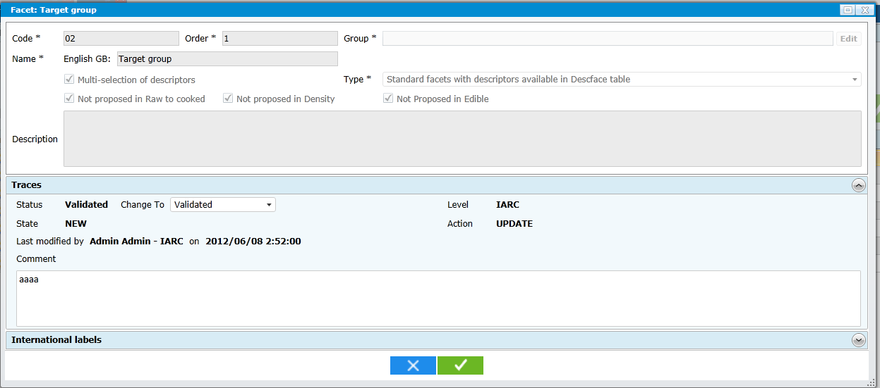

    - How do you plan to display the group field when several groups/subgroups are selected?

    - Pop-up Design proposal (for group field:
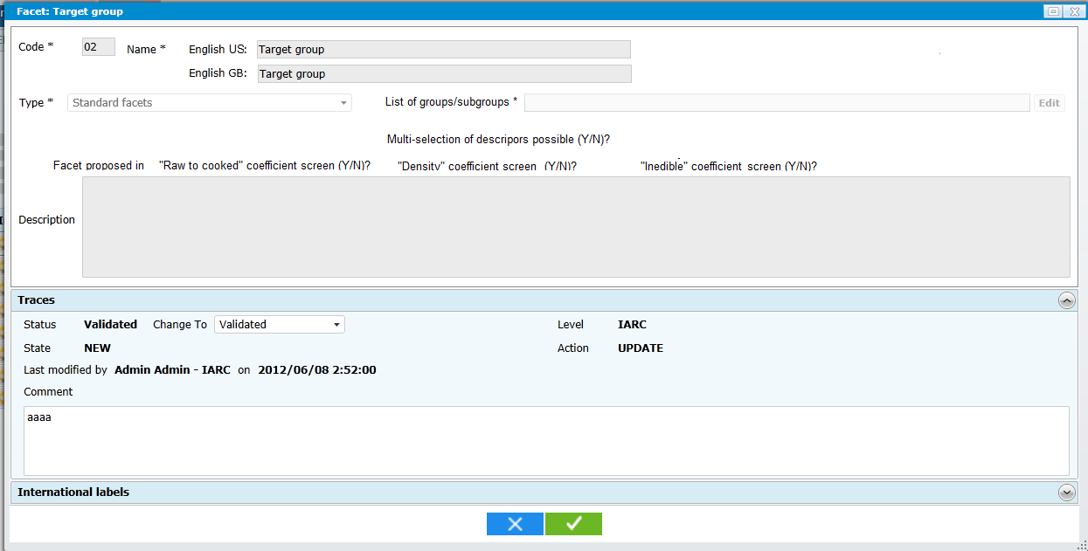

- Type modalities are:
  - Standard facet (Facets.Facet_type :=0 if selected / default)
  - Brand name (Facets.Facet_type :=1 if selected)
  - Attached to food list (Facets.Facet_type :=2 if selected)
- IF Type=2 then the question of Group is displayed
- Field “Multi-selection of descriptor possible (Y/N)? this question is asked only if type=1. For the 2 other type modalities is always no for brand name and always yes for “attached to food”
- What do you propose for the “list of groups/subgroups”

- Tables remarks

- Library specific remarks
  - Search
  - Liste
  - Fiche Facet: The questions “if the selected facet should be or not displayed in the 3 different coefficients” is only available at Library level. At project level, these 3 questions are not asked and displayed.

- Project specific remarks
  - Search
    - The search on the question with/without limitation is not necessary at Project level
  - Liste
    - In information column, the 4 question answers (see point 1.3) are not displayed at Project level
  - Fiche descriptor
    - The questions 1-, 2-, 3- & 4- (see point 1.3) are not displayed when we are at Project level

