MSapp – version 0.0.1.0

Food Fadebygroup

- Common remarks

  - Classification:
    - It is not possible to adapt manually the size of the column “classification”.
    - The arrows are not enough visible. Use the same colour in all screens (e.g. blank if not opened and white if opened)
    - Why do we need a button Select classification and we cannot have a checkbox in front of each group/subgroup/sub-sub-group, as in the pop-up attached to this button? In this case, we will also need a checkbox to select/unselect all the group/subgroup.
    - Possibility to select different groups and to display in the list the result of this selection + addition of column classification in the list.

  - Search
    - Main fields:
      - Facet-descriptor: We cannot use the joker character in this search and it can be useful regarding the number of facets and descriptors (e.g. 03% or %00%...).
      - Edit pop-up: The search can only be done within a group/subgroup already selected. Is it correct? So we cannot display all the group/subgroup where the facet 03 has been selected for example. This approach is not exactly what we need. See point 1.1.4. Possibility to select some groups/subgroups or all of them or none in the classification part (left)
      - In the pop-up facet/descriptor (edit button), it is not possible to select a facet. A checkbox in from of the facet line can be added to select the facet and all its attached descriptors.
      - The filter on facet-descriptor needs to be applied on the selected groups/subgroups or on all (all if no group/subgroup selected OR if all groups/subgroups selected)
      - The filter has to be done on facet level (whatever the descriptors) by adding a checkbox at facet level in the following pop-up
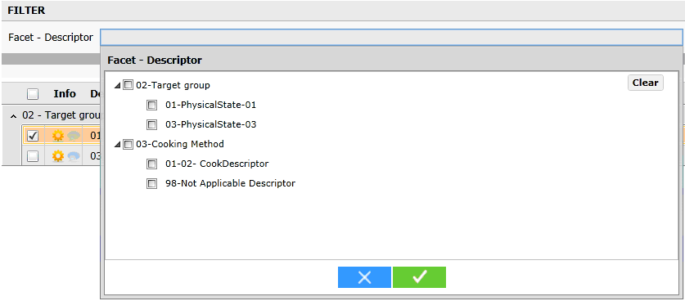

    - Trace fields:

  - Liste
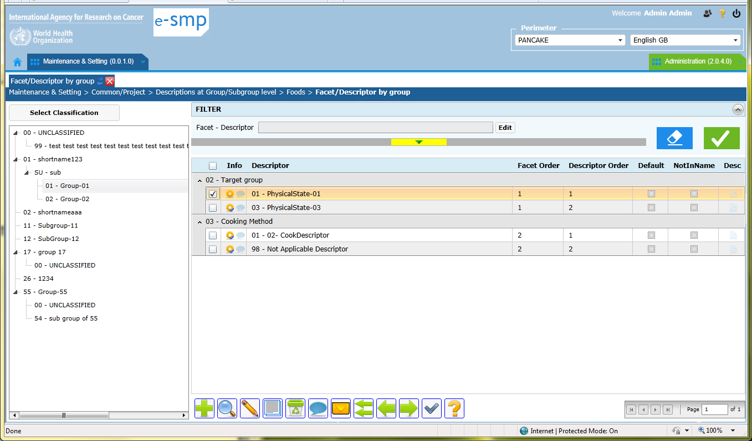
    - A column group/subgroup needs to be added. See point 1.1.3.
    - In the classification part, the groups/subgroups/sub-subgroups with facets attached need to be highlighted (the other groups/subgroups can be in grey).
    - Column order: facet/descriptor, default, not in the name, descriptor order.
    - We can have only 1 column order with at the facet line the facet order and at the descriptor line, the descriptor order.

    - Buttons:
      - Add (green cross): It is frustrating to add only one descriptor with the Edit button. We open the facets/descriptors pop-up with all and we can only select one! Regarding the number of descriptors selected per group/subgroup in this table (e.g. can be more than 100 descriptors for 1 subgroup), it will take to much time for the user, to select the needed descriptors following this approach.
Can you add the possibility to select several descriptors in the same time and giving the same status… trace variables to all of them? See fiche

  - Fiche
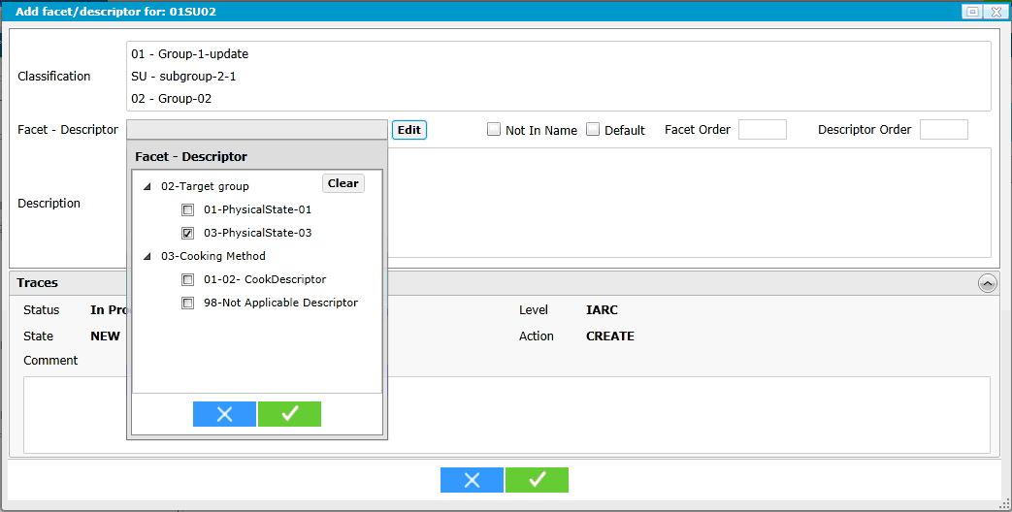
    - Business rules: if we have records attached to a group, it is not possible too have records attached to this group, subgroups and sub-sub-groups excepted doing a cut and paste
    - Using Edit button, several records can be selected
    - Using Add button the displayed fiche allows to add several descriptors in the same time using the fiche edit button
    - Adding the possibility to attribute the same status and/or comment to all the selected descriptors or only to one
    - Proposal: Edit button at the top of the fiche: “Facet-Descriptor” pop-up

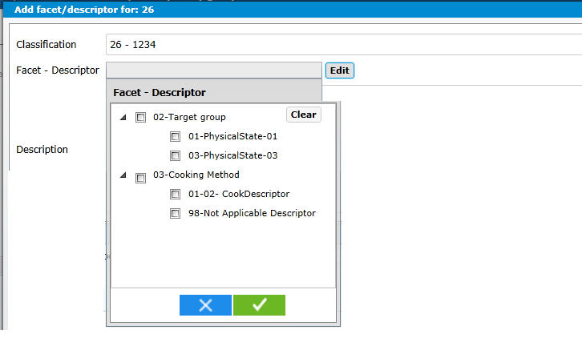

    - Proposal of Complete fiche

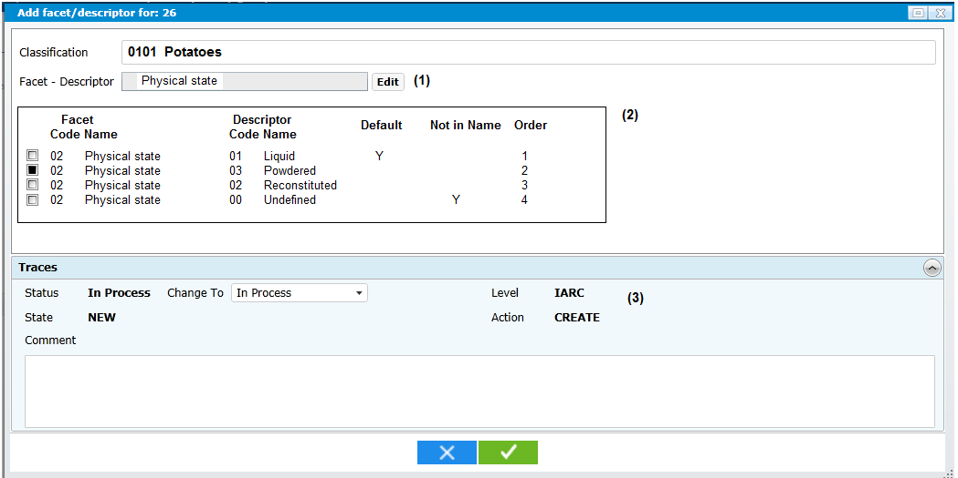
- If 1 facet is selected then facet name is displayed
- The fields Default, Not in Name and Order can be updated directly in the grid
- The displayed trace field values are the one where the cursor is focused on. If several line are selected, only status and comment can be viewed and updatable.

- Project specific remarks
  - Search
  - Liste
  - Fiche

- Country specific remarks
  - At country level, only the fields “default”, “not in the Name” and Order can be modified.

- Tables remarks

