Test MSapp version 0.0.2.0

- Special diet screen:

  - Search: the joker character is not allowed in Code field. I have to type the correct code value to do a search on a code!

  - Liste
    - Info Tooltip: Can you move the comment before the description? The comment is attached to the status, the description to the whole record. To be done in all screens
    - Can you check how the activation or not of the check boxes. For example: I select 3 items:
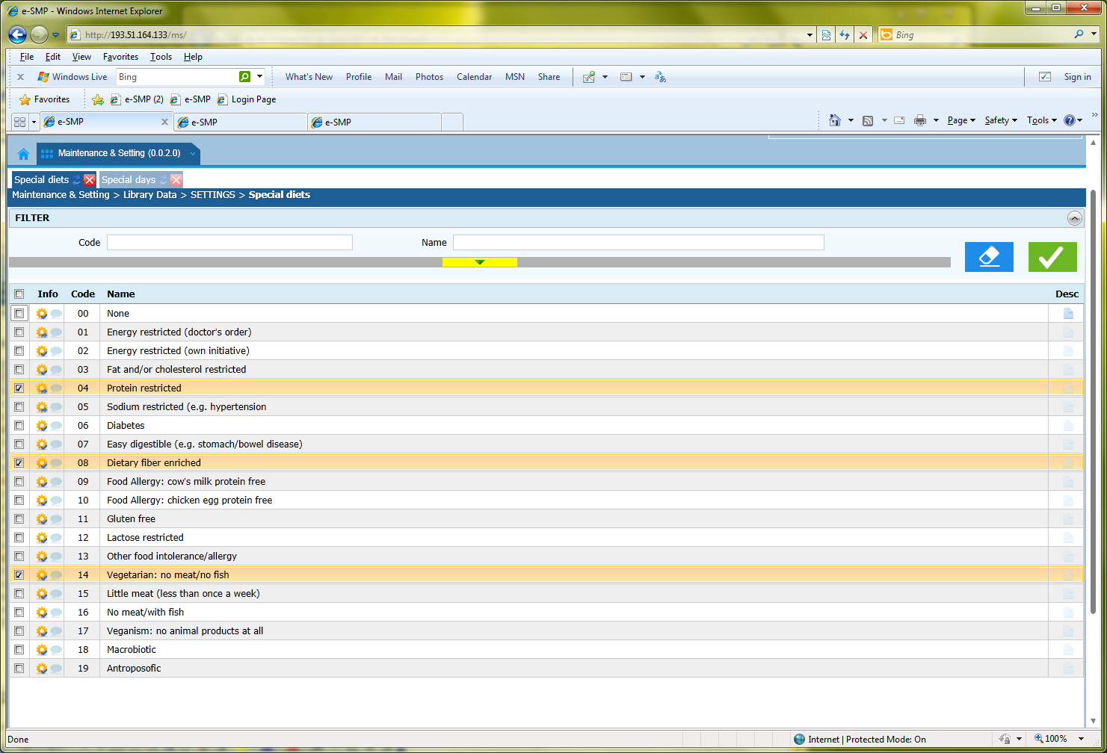
Then I type on the blue button and I have only 1 item selected in the middle of the list.
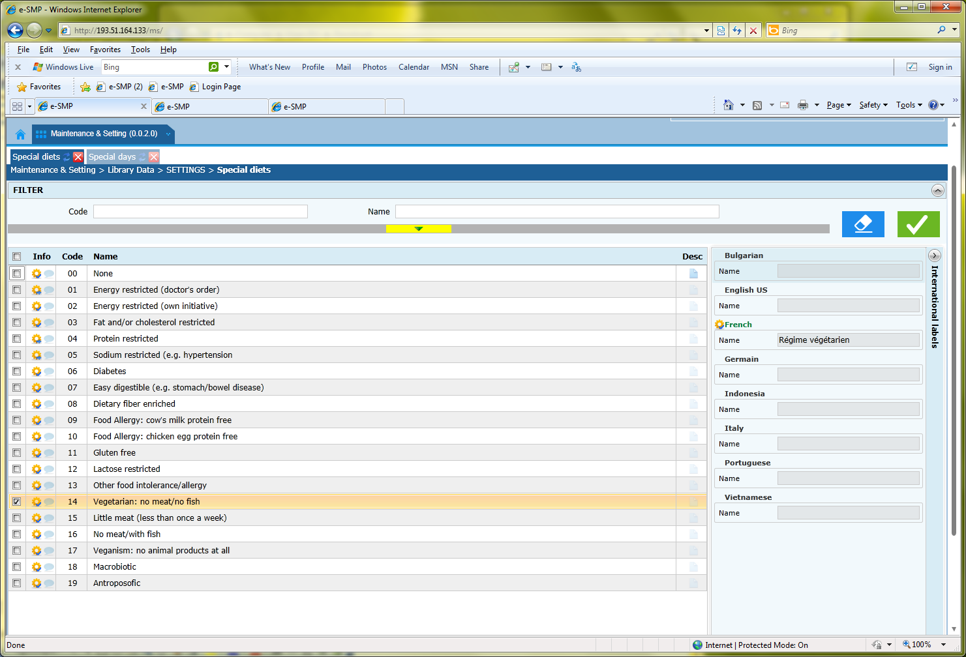

  - Fiche
    - I select 1 item in the list and I double click on it, the fiche is opened in editable mode. I return to the ‘liste’. I double click on another item (now 2 checkbox are selected). The fiche is opened on this second item but not editable. Can you change this and let the fiche editable? Each time, we double click on an item; the fiche has to be opened in editable mode.

    - Show changes: An item moved from “Validated” to “to be approved”. I open its fiche. All the fields are editable. I select the “show changes” bottom. The current and previous values are displayed. Can you let the part “current data” editable as well as the international labels? It can be important for the user, to see the previous values to update the current one (not only by clicking on ‘revert’). For this, it is necessary to add the blue buttom “exit without save” and to display the translation as in the fiche.

  - Mass translation:
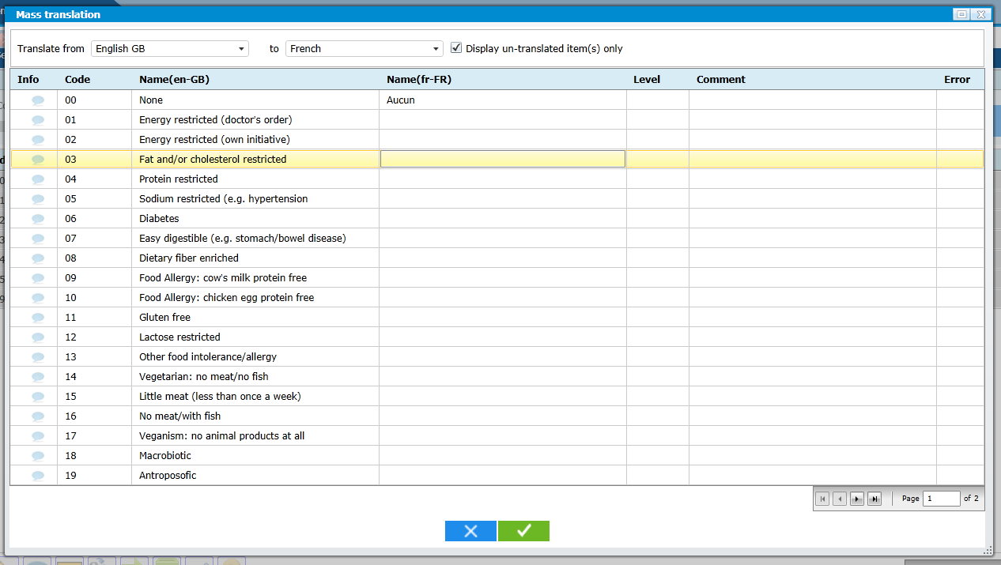
    - Can you add the same approach as in the list by adding the possible sort the data by clicking on the column name? For example, when a label is entered twice, it is important to sort them (column Name(fr-Fr) here).
    - Column Info:
- We can open this field by moving with the tab key and it should not.
- The status “validated” is automatically attributed if we save. How to modify a status?
- Why we have the icon comment as it is already on displayed in the comment column?
- This column is relevant only if the checkbox “display un-translated item” is not selected
- In the checklist file, the status, level and comment are displayed after the Name(fr-FR). Why the status is in front of the record?
- Can we have a tooltip for status as in list screen but without the comment as it is already visible?
    - Column Error: what is it?
    - I enter twice the same name and save the list. 1 error icon is displayed and it will be better to have this icon on the 2 repeated labels
    - The controls are done only when we have done a Save. We would like to have each time the user moves to another record. To have the error icon as soon as possible.
    - I enter twice the same name and save the list. 1 error icon is displayed. It seems that the other entered labels (without error) are not saved. Just after, I click on the arrow to open the second page. I save it. Nothing appends. I return to the previous page (with error) and I don’t have the error nether the other entered records (without error).
To avoid all these types of errors can you:
- Save the record when the user moves to another one.
- Before changing of page ask to the user if he/she want to save the entered record.

- Special day screen

